Hybrid approach based on machine learning and predictive inventory management with continuous inventory tracking, implemented in a responsive web based decision making system

Abstract
Continuous inventory management is a major challenge for commercial enterprises. Traditional methods such as Wilson's model (EOQ) can be used to determine economic order quantities, but they do not take into account dynamic changes in demand or potential shortages. This article proposes a hybrid approach combining machine learning models (Random Forest, Support Vector Machine, Gradient Boosting via Stacking) with the principles of mathematical inventory management to reliably predict future demand and optimize future orders. The models are integrated into a responsive decision-making web application that allows real-time visualization of key indicators: at-risk products, quantities to order, expected shortages, and average inventory. Experimental results show that this approach improves forecast accuracy and enables proactive order planning, while reducing costs associated with shortages and overstocking.
Keywords: Predictive management, Machine learning, Stacking, Responsive web application.

1. INTRODUCTION
Deterministic inventory theory plays a central role in operations research and optim (François BLONDEL, 1998)ization. One of the most iconic analytical models is the Economic Order Quantity (EOQ) model. This model is based on the assumption of known, constant annual demand that is independent of inventory levels.
In this context, the total annual cost associated with an ordering policy of size Q is given by:
(1)
$$C\left(Q\right)=\frac{D}{Q}C_{l}+\frac{Q}{2}C_{s}$$
Where :
- $D>0$represents annual demand,
- $C_{l}>0$ is the fixed cost of placing an order, and
- $C_{s}>0$is the annual unit cost of ownership.
The function C(Q) is strictly convex for $Q>0$car $\frac{d^{2}c(Q)}{dQ^{2}}=\frac{2DC_{l}}{Q^{3}}>0,$
which guarantees the existence of a single overall minimum.
The first order condition $\frac{dC(Q)}{dQ}=-\frac{DC_{l}}{Q^{2}}+\frac{C_{s}}{2}=0$
Leads to the well known analytical solution:
$Q^{*}=\sqrt{\frac{2DC_{l}}{C_{s}}}$
(2)
Thus, the optimal quantity depends exclusively on the demand parameter D. Any error in its estimation has a direct impact on the optimal value obtained.
We note in particular that: $\frac{∂Q^{*}}{∂D}=\frac{1}{2}\sqrt{\frac{2C_{l}}{C_{s}}}\frac{1}{\sqrt{D}}>0$
which shows that Q* is an increasing function of demand and highlights the sensitivity of the model to this parameter.
In real-world contexts, annual demand is not known with certainty and must be estimated from historical data. This issue does not call into question the deterministic structure of the model, but raises the question of the optimal estimation of parameter D.
In this work, we propose integrating machine learning techniques to estimate annual demand from observed data in order to predict the optimal quantity to order (Miclet, 2009). Three supervised methods are considered: support vector machines (SVM), random forests, and gradient boosting. Predictive performance is evaluated using the following indicator $R^{2}$, MAE and RMSE.
The estimated value $\hat{D}$ is then incorporated into the analytical expression of the model EOQ.
$Q_{ML}^{*}=\sqrt{\frac{2\hat{D}C_{l}}{C_{s}}},$
This approach bridges the gap between traditional analytical modeling and modern data-driven methods without altering the theoretical structure of the model EOQ.
2. METHODOLOGY
2.1 Traditional inventory management methods
Continuous inventory management is based on constantly monitoring stock levels in order to trigger replenishment orders at the right time. Unlike the periodic inventory system, where stocks are checked at regular intervals, continuous inventory allows for a more dynamic and responsive response to fluctuations in demand.

2.1.1 Mathematical formalism of inventory management
Consider an inventory whose evolution follows a continuous dynamic, where demand and supply must be planned with precision, i.e., known in advance.
Let the main variables be as follows :
- S_{t}: Stock level at time t.
- D_{t}: Estimated demand at time t.
- Q_{t}: Replenishment quantity decided at time t.
- P(x): Prediction function based on the Stacking model.
- L(St): Storage-related cost function (storage, stockout, ordering costs).
- C_{m}: Cost of maintaining stock.
- C_{r}: Cost of stockouts.
- C_{o}: Ordering costs.
- F_{i} (x): Predictions from base models i (SVM, RF, GB)
- M(x): Metamodel combining predictions from base models.
Considering these variables, we believe the following:
- Modeling the forecast of the quantity to be ordered with Stacking aggregates the predictions of several models, for example $M\left(x\right)=g(f_{1}\left(x\right),f_{2}\left(x\right),…f_{n}\left(x\right))$
Where g () is an aggregation function (this could be linear regression, neural network, etc.)
- The stock evolution equation: Stock will be updated based on demand and replenishment using the formula below:
$S_{t+1}=S_{t}+Q_{t}-D_{t}$

- Cost optimization :
We seek to minimize total costs $L (S_{t})$ defined by :
${L (S}_{t})=C_{m}.S_{t}^{+}+C_{l}.S_{t}^{-}+C_{0}.1_{0t}>0$
Where :
- $S_{t}^{+}:$max ($S_{t}$,0) represents excess stock
- $S_{t}^{-}:$max (${-S}_{t}$,0) represents stock shortage
- $1_{0t}>0$: is an indicator function activated when an order is placed
Finally, the objective is to find the best combination of classifiers (stacking) that minimizes the total cost of inventory management while ensuring an optimal supply level.
Therefore
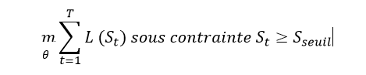(4)
where
- $θ are the parameters of the models f_{i}\left(x\right) and the metamodel M\left(x\right).$
- $S_{seuil}$ is a minimum stock threshold that must be maintained to avoid stockouts.

2.1.2 Wilson's model without shortages
In this section, we assume that demand does not fluctuate over time under the assumptions outlined below, given that shortages are not permitted and demand is uniform over time (CHERMAK, 2016) (Heizer J., 2020).
For each time unit and each item in stock, a unit storage cost 𝐶𝑆 ≥ 0 must be paid for each unit of time.
We set:
D: demand (consumption); Q*: optimal economic quantity; P: unit purchase price for each item purchased; t: holding rate (annual),
N: number of orders, and therefore
(5)
$$N=\frac{D}{Q}$$
$Q=\frac{D}{N}$
and

Cl: cost of placing an order (launch cost); if one order is placed, it will cost C, and if two orders are placed, it will cost 2C...
We have
𝐶_{𝑆}: the storage cost
𝑪_{l}: the launch cost
𝑺: the safety stock

$$Q_{E}=\sqrt{\frac{2C×D}{P×t}}=\sqrt{\frac{2C×D}{C_{s}×θ}}$$

(6)

And in summary
$$Q_{E}=\sqrt{\frac{2DC_{l}}{C_{s}}}$$

(7)

2.1.3 Wilson's model with shortages
This model allows for shortages and manages them by taking into account the associated costs, such as disruption costs (lost sales, customer dissatisfaction) and recovery costs (speeding up orders or offering discounts to compensate for the disruption) (CHERMAK, 2016).
We set:
𝜃 is the inventory management period, and
T is the period: $T=\frac{θ}{N}$
C: Cost of ownership per item and per unit of time.
And
D: Demand
C_{l}: Cost of placing an order.
$N =\frac{θ}{T}$ number of orders.
C_{s}: Cost of ownership per item and per unit of time.
C_{p}: Shortage cost per item and per unit of time.
S: Active inventory
S – Q: inventory during the period 𝑇2 (shortage)

$Q_{E}=\sqrt{\frac{2DC_{l}}{C_{s}}\left(\frac{C_{s}+C_{p}}{C_{p}}\right)}$
(8)

2.2.1 Support Vector Machine (SVM)
SVM is a robust algorithm that is particularly effective for classification problems with high-dimensional data. It is used in stacking as a base model (level 0) (Sani, 2026), il apporte une perspective axée sur la séparation optimale des classes, utile pour améliorer la diversité des prédictions combinées (O. Bousquet, 2001).
Its mathematical representation is:
$\left\{x_{i},y_{i}\right\}{}_{i}^{n}{=1}$ with $x_{i}∈ R^{p}$ et $y_{i}∈-1,+1$
SVM seeks a hyperplane:
:
$f\left(x\right)=ω^{T}x+b$ that maximizes the margin.
Optimization problem (hard margin)
$\min_{w,b}\frac{1}{2}\left\|ω\right\|$² under constraints:
$$yi(ω^{T}x+b)≥1,∀_{i}$$
Kernel version case
(8)
$$f\left(x\right)=\sum_{i=1}^{n}{∝_{i}}y_{i}K\left(x_{i},x\right)+b$$
2.2.2. Random Forest (RF)
Random Forest is an ensemble model based on bagging, known for its robustness and ability to capture complex relationships in data (Rakotomalala R., 2015) . Its role in stacking as a base classifier is to provide a vision based on decision rules, thus complementing the predictions of the SVM (Breiman, 2001).
Its mathematical notation is
$$\hat{f}\left(x\right)=\frac{1}{T}\sum_{t=1}^{T}{f_{t}(x)}$$
Where :
- $f_{t}(x)$ is the decision tree
- T : number of trees.
In classification, majority voting is as follows :
$\hat{y}=mode\left\{f_{1}\left(x\right),f_{2}\left(x\right),…f_{T}\left(x\right),\right\}$
In regression :
(9)
$$\hat{y}=\frac{1}{T}\sum_{t=1}^{T}{f_{t}}\left(x\right)$$
Its objective is to reduce variance (N. Marref Master's thesis. Batna, 2013).

2.2.3. Gradient Boosting (GB)
Gradient Boosting is a powerful algorithm that gradually optimizes performance by correcting errors made by previous models (C.M., 2006). ). It performs very well for complex predictions thanks to its iterative approach, offers fine adjustment to data, and is capable of handling nonlinear relationships.
Its mathematical representation is :
$$F\left(x\right)=\sum_{m=1}^{M}{γ_{m}h_{m}(x)}$$
where :
- $h_{m}(x)$ is the weak tree
- $γ_{m}$ is the optimal coefficient
It seeks to minimize the loss function
$$F^{*}=\arg{\min_{F}\sum_{i=1}^{n}{L(y_{i},F(x_{i}}}))$$
(10)

2.2.4 Stacking
Stacking is a method that consists of training a meta-model on the predictions of several base models. Mathematically, if $f_{K}\left(x\right)$represents the prediction of the k-th model, then the final model is written as$F\left(x\right)=g(f_{1}\left(x\right),(f_{2}\left(x\right),…(f_{K}\left(x\right))$,, where g is learned by minimizing a loss function on the combined predictions. It therefore combines several base models (base learners) via a meta-model.
$D=\left\{x_{i},y_{i}\right\}{}_{i}^{n}{=1}$, $y_{i}ϵR\left(regression\right)ou y_{i}∈ -1,1 (classification)$
We train K models:
$$f_{1}\left(x\right), f_{2}\left(x\right),…f_{K}\left(x\right)$$
Each model then produces a new matrix: $z_{ik}=f_{k}\left(x_{i}\right)$
And we then construct a new matrix:
$$Z=\left[\begin{aligned}\begin{matrix}f_{1}\left(x_{1}\right) & f_{2}\left(x_{1}\right)… & f_{K}\left(x_{1}\right) \\ f_{1}\left(x_{2}\right) & f_{2}\left(x_{2}\right)… & \\ ⋮ & ⋮ & ⋮\end{matrix} \\ f_{1}\left(x_{n}\right) f_{2}\left(x_{n}\right) … f_{K}\left(x_{n}\right)\end{aligned}\right]$$
This matrix becomes a new explanatory variable.
We train a meta-model g(.) on:
$$\left\{(Z_{i},y_{i}\right\}n_{i=1}$$
The final model is:
(11)
$F\left(x\right)=g(f_{1}\left(x\right),(f_{2}\left(x\right),…(f_{K}\left(x\right))$
These three models will be trained separately and combined by stacking to optimize continuous inventory management in the next section of the results presentation. The same section will also present the web application that will handle the predictions made after training the models so that they can be displayed in a graphical user interface.
3. Results and Discussion
3.1 Exploratory Data Analysis (EDA)
This is a crucial step in machine learning, which involves gaining an in-depth understanding of the data before training the models.
A) Presentation of the dataset structure
A dataset was extracted from a merchandise inventory management system used by large commercial enterprises available on Kaggle, including information related to products, sales, orders, dates, restocking statuses, etc. The dataset includes the following data: product_id, product_category, daily_demand, transaction_cost, unit_storage_cost, unit_shortage_cost, delivery_time, current_stock, orders_in_progress, shortage_threshold, annual_demand, Q_star, product_name.
Table 1 : Overview of the dataset

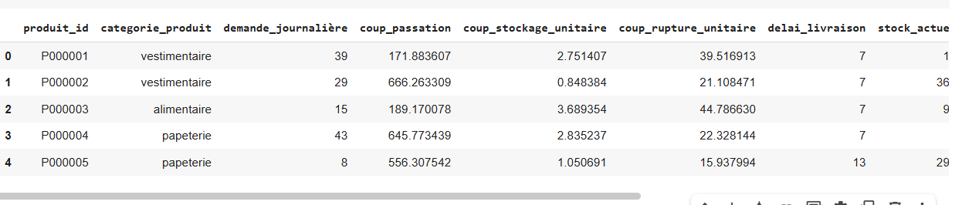

B) Verification
We provide the results of the verification of the dataset size, data types, missing values, and duplicates.
Our dataset has 50,000 rows and each variable's type is clearly displayed. The results show that the dataset is in excellent condition, as all columns have 0 missing values (NaN), meaning that no data is missing and the probability of failure in model training or analysis is minimal. We also note that the number of duplicates is 0, which indicates that each column is truly unique, so there is no risk of observations skewing the statistics or even the models. Below is a table presenting these results :
#dataset dimensions
print("dataset Size :", df.shape)
# Column types
print("\ndataset Size:\n", df.dtypes)

# check for missing values
print("\nMissing values per column:\n", df.isnull().sum())

# check for duplicates
print("\nNumber of duplicates:", df.duplicated().sum())

Table 2: Verification of data types and NaN

Column | Type de données | Valeurs manquantes
product_id | Object | 0
product_category | Object | 0
daily_demand | int64 | 0
transfer_cost | float64 | 0
unit_storage_cost | float64 | 0
unit_shortage_cost | float64 | 0
delivery_time | int64 | 0
current_stock | int64 | 0
order_in_progress | int64 | 0
shortage_threshold | int64 | 0
annual_demand | int64 | 0
Q_star | float64 | 0
product_name | Object | 0

Data set size | (50000,13)
Number of duplicates | 0

C) Analysis of the correlation between variables
This part is very important because it helps us detect linear relationships between variables (it is positive when both variables increase one after the other; negative when one variable increases and the other decreases; and when it is close to 0, it means that there is no correlation); reduce redundancy (when two variables are highly correlated); improve model performance (by removing or combining highly correlated variables); and guide feature selection (to identify the most useful variables for prediction, particularly those that are well correlated with the target variable).
Here are the results of our analysis :
# Correlation between numerical variables
corr = df[numeric_cols].corr()
plt.figure(figsize=(12,8))
sns.heatmap(corr, annot=True, fmt=".2f", cmap='coolwarm')
plt.title("corrélation matrix")
plt.show()

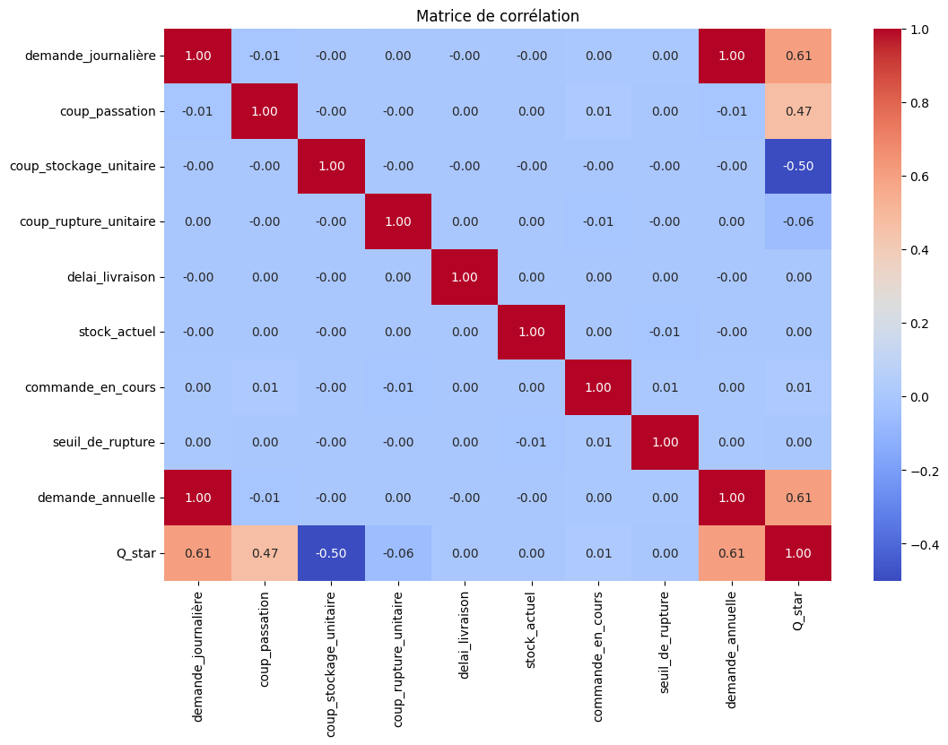
Table 3 : Correlation matrix
3.2. Modeling, classifier results, and discussion
This subsection presents the modeling process for the classification algorithms used in our work. It involves training different classifiers on the preprocessed data in order to compare their performance and identify the most suitable model for stacking. We will also detail the training parameters, the evaluation metrics used, and the results obtained for each model.
A comparative analysis of these performances will allow us to draw relevant conclusions about the predictive capacity of each classifier tested.
3.2.1 Modeling
This study follows several essential methodological steps to evaluate the effectiveness of SVM, Random Forest (RF), and Gradient Boosting (GB) algorithms in the intelligent prediction of stock movements. These steps structure the analysis process and ensure the reliability of the results obtained in the context of automated inventory management.
3.2.1.1 Stacking architecture
It operates under the architecture below, which illustrates the general presentation of the stacking model, where several models are combined to improve overall predictive performance. At the input, we have the initial characteristics (transaction cost, unit storage cost, daily and annual demand, shortage cost, etc.). These characteristics undergo preprocessing before being trained. At level 0, the three selected heterogeneous base learners are trained in parallel. For the prediction block, each of the three models produces an individual prediction of Q*. These predictions become new features for the second-level model and therefore $X→\left[ŶSVM,ŶRF, ŶGB\right]$. Finally, the meta-model (stacking) combines the predictions of the base models to produce the final optimized prediction.
Formally, it learns a function : $Ŷfinal=∝_{1}ŶSVM+∝_{2}ŶSRF+∝_{3}ŶGB$
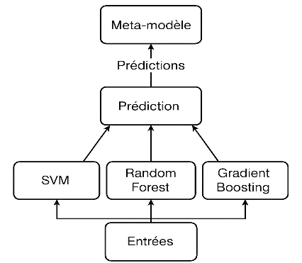
Fig 1 : The different stages of the study

3.2.2.2 Evaluation metrics
Metrics are used to evaluate the performance of a model on a given dataset. Thus, to evaluate the performance of our models and stacking, the following regression metrics are used (Mohammed R., 2024).
A. MAE : Mean Absolute Error
MAE measures the average of the absolute differences between predicted values and actual values. It provides a direct assessment of the accuracy of predictions (Maddineni V.K., 2024). It is calculated using the formula below :
(12)
$$MAE=\frac{1}{n}\sum_{i=1}^{n}{\left|y_{i}-ŷ_{i}\right|}$$

B. RMSE : Root Mean Squared Error
RMSE is similar to MAE, but it penalizes large errors more heavily. It is calculated using the following formula :
(13)
$RMSE=\sqrt{\frac{1}{n}\sum_{i=1}^{n}{(y_{i-}ŷ_{i})}}$²

In general, with this metric, an error of one unit and an error of 10 units do not carry the same weight, i.e., large errors are heavily penalized.
In inventory management, a high RMSE can indicate critical prediction errors for certain products, with a risk of overstocking or significant shortages. It is useful for monitoring products with high demand or high volatility.
C. R² : Coefficient of Determination
It indicates what proportion of the variance in the data is explained by the model. It is calculated using the following formula:
$$R^{2}=1-\frac{\sum{y_{i}-Ŷ_{i})^{2}}}{\sum{y_{i}-ȳ)^{2}}}$$

(14)

The choice of our three metrics is not random; it is real and significant in the sense that MAE helps adjust replenishment thresholds as it calculates the average error; RMSE avoids massive shortages as it calculates the average error with a penalty on large errors; and finally, R2 indicates the reliability of predictions by verifying the overall quality of the model.
3.2.2 Model training results
We recall the three models used: SVM (Support Vector Machine), Random Forest, and Gradient Boosting (Y. T. d. D. Yann Guermeur, 1997. ). The prediction results of these three models are used as input parameters for the metamodel in predicting economic bursts.
A) Loading the dataset
# Load the file
df = pd.read_csv("dataset_gestion_stock_RAFALE ECO.csv")
# Aperçu
df.head()
Table 4: Data set: dataset
As mentioned in the preceding sub-points, our dataset contains several data points, and here we have only displayed the first five lines of the necessary input variables.
b) Data evaluation and training of basic models
The comparative performance of the evaluated models highlights the clear superiority of ensemble methods over the basic SVM model. Indeed, the Random Forest model achieves the best scores in terms of accuracy, with an MAE of 28.33, an RMSE of 42.46, and a coefficient of determination R² of 0.9986, reflecting excellent predictive power. The Gradient Boosting model also performs very well (R² = 0.9968), although slightly less well than Random Forest. In contrast, the SVM model has much higher errors (MAE = 726.13, R² = 0.23), revealing the inadequacy of this approach for the problem of predicting the economic quantity to order (Q_star). These results highlight the value of using ensemble algorithms in a complex inventory management context, where the relationships between economic variables can be nonlinear and intertwined.
Table 5: Model training results
 | Modèle | MAE | RMSE | R²
0 | SVM | 726.133641 | 993.773662 | 0.231229
1 | Random Forest | 28.333291 | 42.461710 | 0.998596
2 | Gradient Boosting | 47.1978898 | 64.352163 | 0.996776

c) Results of model combination (stacking)
The result of stacking is as follows:
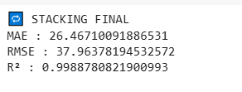
Table 6: Stacking results
 | Modèle | MAE | RMSE | R²
0 | SVM | 726.133641 | 993.773662 | 0.231229
1 | Random Forest | 28.333291 | 42.461710 | 0.998596
2 | Gradient Boosting | 47.197898 | 64.352163 | 0.996776
3 | Stacking | 26.4671009 | 37.963781 | 0.9988781
e) Evaluation of models
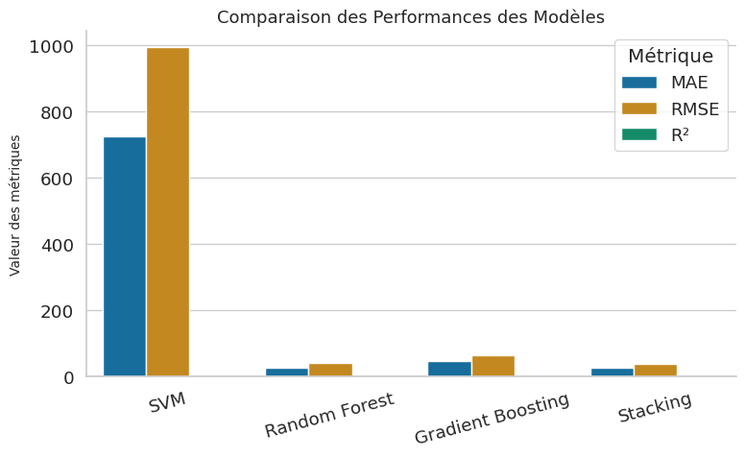
Fig. 2: Graph comparing model performance

3.2.3. Interpretation of results
A comparative analysis of the performance of individual models (SVM, Random Forest, Gradient Boosting) and the combined model using stacking highlights the relevance of the ensemble approach adopted. The evaluation metrics used (MAE, RMSE, and R²) enable the accuracy of the economic predictions generated by each algorithm to be assessed. The SVM model shows relatively poor results, with an MAE of 726.13 and an RMSE of 993.77, reflecting a significant error in predictions, and a coefficient of determination R² of only 0.23, indicating that the model explains very little of the variance in the target data. This behavior may be due to the sensitivity of SVM to the dimensionality and distribution of the data.
In contrast, the Random Forest and Gradient Boosting models show much better performance, with R² values of 0.9986 and 0.9968, respectively, reflecting the models' very good ability to predict how much will actually need to be ordered. However, the Gradient Boosting model has a higher MAE (47.19) and RMSE (64.35) than Random Forest (MAE: 28.33; RMSE: 42.46), suggesting a certain sensitivity to local variations in the data, which is typical of boosting methods.
The stacking model, combining these three classifiers, stands out for its optimal performance. It has the lowest MAE (26.47) and RMSE (37.96), while achieving the best R² (0.9989). These results demonstrate that the stacking approach not only reduces prediction errors, but also improves the robustness and generalization of the model by capturing the complementarity of the base models.
As such, stacking is an effective strategy in the context of predicting economic function in continuous inventory management, outperforming each of the underlying models individually. This performance gain validates the value of a hybrid approach based on the judicious combination of several supervised classifiers.
3.3 Implementation of the application
This second sub-section is devoted to the practical implementation of the web application.
3.3.1 General application architecture
The application developed is based on a client–server architecture, widely adopted in modern information systems. This architecture allows for a clear separation of responsibilities between the presentation layer and the data processing layer. The backend is implemented using the Django framework, combined with Django REST Framework, and handles data management, the execution of inventory management rules, and the integration of machine learning models. The frontend is developed with Next.js, a framework based on React and JavaScript, and is responsible for the user interface and the visualization of decision-making indicators. The database system used is Postgres. Communication between the frontend and backend is carried out via REST API web services, enabling structured and secure data exchange in JSON format. This approach promotes system modularity and facilitates future development.
Here are some of the libraries used and an excerpt from the code with the application's main graphical interfaces.
import pandas as pd
from rest_framework.views import APIView
from rest_framework.response import Response
from rest_framework import status
from django.utils.dateparse import parse_date
from .models import ProduitData
from .serializers import ProduitSerializer
from sklearn.ensemble import GradientBoostingRegressor
from sklearn.model_selection import train_test_split
import numpy as np
from rest_framework.permissions import AllowAny
from rest_framework.parsers import MultiPartParser, FormParser
from .models import Commande
from datetime import datetime
from django.db.models import F
import os
class UploadCSVView(APIView):
permission_classes = (AllowAny,)
parser_classes = [MultiPartParser, FormParser]

def post(self, request, format=None):
csv_file = request.FILES.get('file')
if not csv_file:
return Response({"error": "No file uploaded"}, status=400)

try:
df = pd.read_csv(csv_file)

# Créer les objets Django
objs = [
ProduitData(
produit_id=row['produit_id'],
categorie_produit=row['categorie_produit'],
coup_passation=row['coup_passation'],
coup_stockage_unitaire=row['coup_stockage_unitaire'],
coup_rupture_unitaire=row['coup_rupture_unitaire'],
delai_livraison=row['delai_livraison'],
stock_actuel=row['stock_actuel'],
demande_jour = row['demande_journalière'],
commande_en_cours=row['commande_en_cours'],
seuil_de_rupture=row['seuil_de_rupture'],
demande_annuelle=row['demande_annuelle'],
Q_star=row['Q_star'],
libelle_produit=row['libelle_produit'],
) for _, row in df.iterrows()
]
ProduitData.objects.bulk_create(objs)
return Response({"message": "File uploaded and data saved successfully"})
except Exception as e:
return Response({"error": str(e)}, status=400)
class UploadCSVCommandesView(APIView):
permission_classes = (AllowAny,)
parser_classes = [MultiPartParser, FormParser]

def post(self, request, format=None):
csv_file = request.FILES.get('file')
if not csv_file:
return Response({"error": "No file uploaded"}, status=400)

try:
# Lire le CSV avec pandas
df = pd.read_csv(csv_file)

# Supprimer toutes les données précédentes (optionnel)
Commande.objects.all().delete()

# Insertion en masse pour optimiser
Commande.objects.bulk_create(objs)

return Response({"message": "File uploaded and data saved successfully"})

except Exception as e:
return Response({"error": str(e)}, status=400)
BASE_DIR = os.path.dirname(os.path.abspath(__file__))
MODEL_DIR = os.path.join(BASE_DIR, "ml_models")

# Charger le modèle une seule fois
best_model_path = os.path.join(MODEL_DIR, "best_model.pkl")
best_model = joblib.load(best_model_path)
class PredictDemandView(APIView):
permission_classes = (AllowAny,)

def get(self, request):
# Charger les données directement
produits = list(
ProduitData.objects.order_by('?')[:1240].values(
"id", "produit_id", "libelle_produit", "categorie_produit",
"delai_livraison", "stock_actuel", "commande_en_cours",
"seuil_de_rupture", "demande_jour",
"coup_passation", "coup_stockage_unitaire", "coup_rupture_unitaire",
"demande_annuelle", "Q_star"
)
)

if not produits:
return Response({"error": "Aucun produit en base"}, status=status.HTTP_404_NOT_FOUND)

df = pd.DataFrame(produits)

# Renommer proprement pour éviter accents/confusions
df = df.rename(columns={
"demande_jour": "demande_journalière"
})

# Features cohérents avec entraînement
features = ["demande_journalière", "coup_passation", "coup_stockage_unitaire", "coup_rupture_unitaire"]
X = df[features].copy().astype(float)

# Prédictions vectorisées
y_pred = best_model.predict(X)
D_hat = np.clip(y_pred, 1e-6, None)

# Paramètres Wilson
S = X["coup_passation"].values
H = np.clip(X["coup_stockage_unitaire"].values, 1e-6, None)
P_eff = np.clip(X["coup_rupture_unitaire"].values * 1.2, 1e-6, None)

Q_star_hat = np.sqrt((2 * D_hat * S * (H + P_eff)) / (H * P_eff))
Q_s_hat = (Q_star_hat * P_eff) / (H + P_eff)
Q_p_hat = (Q_star_hat * H) / (H + P_eff)

# Résultats
df["demande_predite_annuelle"] = np.round(D_hat, 0)
df["Q_star_calcule"] = np.round(Q_star_hat, 2)
df["stock_moyen"] = np.round(Q_s_hat, 2)
df["penurie_moyenne"] = np.round(Q_p_hat, 2)
df["Qté/jour"] = np.round(D_hat / 365, 0)
df["Qté/semaine"] = np.round(D_hat / 52, 0)
df["Qté/mois"] = np.round(D_hat / 12, 0)
df["recommande_commander"] = np.where(df["stock_actuel"] < Q_s_hat, "Oui", "Non")

# Nouveau champ : quantité à commander par jour pour atteindre stock moyen
df["quantite_a_commander_jour"] = np.where(
df["stock_moyen"] > df["stock_actuel"],
df["stock_moyen"] - df["stock_actuel"],
0
).round(0)

# Total quantité à commander par jour pour tous les produits
total_quantite_jour = int(df["quantite_a_commander_jour"].sum())

results = df[[
"produit_id","categorie_produit", "libelle_produit", "demande_predite_annuelle",
"Q_star_calcule", "stock_moyen", "penurie_moyenne", "Qté/jour",
"Qté/semaine", "Qté/mois", "recommande_commander"
]].to_dict(orient="records")

# Ajouter le total dans la réponse
return Response(results
)
from rest_framework import generics
class ProductListAPIView(generics.ListAPIView):
permission_classes = (AllowAny,)
queryset = ProduitData.objects.all().order_by('id')
serializer_class = ProduitSerializer

# Classe dashboard ou tableau de bord
from rest_framework.views import APIView
from rest_framework.response import Response
from rest_framework.permissions import AllowAny
from .models import ProduitData
from django.db import models

class Dashboard(APIView):
permission_classes = (AllowAny,)

def get(self, request):
produits = ProduitData.objects.all()
total_produits = produits.count()

# 1️⃣ Produits à risque
produits_a_risque = produits.filter(
stock_actuel__lte=models.F('seuil_de_rupture')
)

nb_produits_risque = produits_a_risque.count()

# 2️⃣ Quantité totale à commander (UNIQUEMENT produits à risque)
quantite_totale = 0
for p in produits_a_risque:
manque = p.seuil_de_rupture - p.stock_actuel
if manque > 0:
quantite_totale += manque

# 3️⃣ Quantité moyenne à commander
quantite_moyenne = (
quantite_totale / nb_produits_risque
if nb_produits_risque > 0 else 0
)

# 4️⃣ Ruptures prévues corrigées
ruptures_prevues = 0
for p in produits:
consommation = p.demande_jour * p.delai_livraison
if p.stock_actuel - consommation <= 0:
ruptures_prevues += 1

return Response({
"total_produits": total_produits,
"produits_a_risque": nb_produits_risque,
"quantite_moyenne_a_commander": round(quantite_moyenne, 2),
"ruptures_prevues": ruptures_prevues
})
# APPI PRIORITE
from rest_framework.views import APIView
from rest_framework.response import Response
from rest_framework.permissions import AllowAny
from .models import ProduitData
import numpy as np

class PrioriteIntelligenteView(APIView):
permission_classes = (AllowAny,)

def get(self, request):
produits = ProduitData.objects.all()

data = []

for p in produits:
# Sécurité
stock = max(p.stock_actuel, 1)
seuil = max(p.seuil_de_rupture, 1)

# Score de risque simple et interprétable
score_risque = round((seuil - stock) / seuil, 2)

# Priorité intelligente
if stock < seuil and score_risque >= 0.5:
priorite = "urgent"
niveau = 3
elif stock < seuil:
priorite = "warning"
niveau = 2
else:
priorite = "stable"
niveau = 1

data.append({
"produit_id": p.produit_id,
"libelle_produit": p.libelle_produit,
"stock_actuel": p.stock_actuel,
"seuil_rupture": p.seuil_de_rupture,
"score_risque": score_risque,
"priorite": priorite,
"niveau_priorite": niveau
})

return Response(data)


Fig. 3: Main interface of the application

Fig. 4: Exploratory analysis
Comment
The application's front end has been designed to offer a clear and intuitive interface. The dashboard displays summary indicators such as the total number of products, the number of products at risk, the average quantity to be ordered, and expected stockouts. Other detailed information is available in the application.
The solution developed makes several major contributions. It improves the accuracy of inventory management decisions, reduces the risk of shortages, and optimizes order quantities. The integration of machine learning also allows for better anticipation of future needs, thereby enhancing the overall performance of the system.
4. Conclusion
The main objective of this work was to explore the contribution of machine learning techniques to optimizing inventory management, based on the theoretical foundations of Wilson's deterministic model. The study aims to improve traditional inventory management methods by integrating artificial intelligence approaches to enhance the accuracy of decisions related to procurement and economic order quantity planning.
With this in mind, we proposed a hybrid approach based on a combination of several supervised learning algorithms, including Support Vector Machine (SVM), Random Forest, and Gradient Boosting, integrated within a Stacking architecture. This ensemble learning strategy leverages the specific strengths of each base model to improve the generalization ability and overall robustness of the predictive system.
The performance of the proposed model was evaluated using several statistical indicators, including the coefficient of determination (R²), mean absolute error (MAE), and root mean square error (RMSE). The experimental results show that the stacking-based approach achieves a higher level of performance than individual models, reducing prediction errors and improving the reliability of estimates for inventory management decisions.
Beyond the theoretical and algorithmic aspects, this work has also resulted in the development of a responsive web application designed to facilitate the operational use of the proposed model in a real-world inventory management environment. This application allows users to view data, make predictions, and obtain recommendations regarding optimal order quantities, while offering an interface that can be adapted to different types of devices (computers, tablets, and smartphones). This application dimension is a major asset in bringing scientific results closer to the practical needs of managers and organizations.
Thus, the joint integration of machine learning models and modern digital tools opens up new perspectives for improving inventory management systems in increasingly dynamic environments. The proposed approach demonstrates that a judicious combination of classical mathematical models and artificial intelligence techniques can contribute to more efficient and reliable decision-making.
Looking ahead to future work, it would be useful to enhance this approach by integrating real-time data, exploring more advanced learning methods, particularly deep learning techniques, or developing hybrid architectures that incorporate probabilistic models capable of better accounting for demand uncertainty. Extending this solution to large-scale decision support systems could also be a promising avenue for industrial and commercial applications.
Disclaimer (Artificial Intelligence)
Author(s) hereby declare that NO generative AI technologies such as Large Language Models (ChatGPT,
COPILOT, etc) and text-to-image generators have been used during writing or editing of this manuscript.
Competing Interests
Authors have declared that no competing interests exist.

References
Breiman, L. (2001). Random Forests. Machine Learning, 45(1), 5–32.
C.M., B. (2006). « Pattern Recognition and Machine Learning ». Springer.
Cha, H.-J. M.-C.-W. (2021). «Comparison of Random Forest and Gradient Boosting Machine Models for Predicting Demolition Waste Based on Small Datasets and Categorical Variables,». International Journal of Environmental Research and Public Health.
CHERMAK, S. (2016). Gestion des stocks : modèle de Wilson avec pénurie. Paris VII: Disponible sur https://www.youtube.com/watch?v=hyxHL54sP0E et http://www.e-ace.fr , .
François BLONDEL. (1998). Production Management. Paris: 2nd edition Dunod.
Heizer J., R. B. (2020). Operations management. 13th ed. Pearson Education.
Islam, T. &. (2025). Ensemble Learning for Healthcare: A Comparative Analysis of Hybrid Voting and Ensemble Stacking in Obesity Risk Prediction. Preprint.
Lamara, B. (2016). Mémoire de Fin d'Etude de Master Professionnel sur "Gestion des stocks au sein de l’EATIT". REPUBLIQUE ALGERIENNE DEMOCRATIQUE ET POPULAIRE: UNIVERSITE MOULOUD MAMMERI DE TIZI OUZOU,Faculté des Mathématique et Informatique .
Maddineni V.K., K. N. (2024). Anhancing microgrid performance prediction with attention-based deep learning models . https://arxiv.org/abs/2407.14984.
Miclet, A. C.-.. (2009). Artificial Learning: Concepts and Algorithms. Paris: Ed.Eyrolles, 2nd edition.
Mohammed R., S. M. (2024). Machine Learning Avaluation Metric Discrepancies across Programming Languages and Their Components:Needd for Standardization. Institute of Electrical and Electronics Engineers (IEEE).
N. Marref Master's thesis. Batna, A. 2. (2013). “Incremental Learning & Support Vector Machines. Algeria: Mustafa Ben Boulaid University,.
O. Bousquet. (2001). Introduction aux Support Vector Machines (SVM), Centre de Mathématiques. Appliquées,. Orsay: Ecole Polytechnique Palaiseau.
Rakotomalala R. (2015). « Bagging– RandomForest – Boosting ».
Sani, R. S. (2026). Stacking Ensemble Model berbasis SVM, Random Forest, dan XGBoost untuk Klasifikasi Emosi dari Sinyal EEG. Jurnal Sains Informatika Terapan .
Y. T. d. D. Yann Guermeur, C. o. (1997. ). s: University of Paris VI, Available at https://www.thèse.fr, . Paris.
Zhang H.-w., W. Y.-r. (2024). Using machine learning to develop a stacking ensemble learning model for the CT radiomics classification of brain metastases. Scientific Reports,. 14, 28575. https://doi.org/10.1038/s41598-024-80210-x.
N. Guebaili, Combination of unsupervised classifiers. Master's thesis, Souk Ahras: Mohamed Chérif
Messaadia University, 2019.
K. E. A. M. C. Benyahia, “Towards an unsupervised classification approach for meteorological
parameters.” Master's thesis, Souk Ahras, Algeria: Mohamed Chérif Messaadia University, 2016.
Misina, S. "Incremental learning for e-mail classification". Computational Intelligence,, Heidelberg,: Berlin,, 2006.
http://www.logistiqueconseil.org/Articles/Logistique/Methode-pareto-20-80-abc.htm. (s.d.).
M. Albardan, Thèse de doctorat sur Combinaison robuste à la dépendance entre classifieurs dans un contexte d'apprentissage décentralisé, Lille: Université de Lille Disponible sur https://www.theses-agelgerie.com, 2018.
S. Mustière, "Apprentissage supervisé pour la généralisation cartographique". Thèse de doctorat,, Paris, France,: université de Paris 6., 2001

