Integrated Management of Purple Blotch of Onion: A Review

Abstract
Allium cepa L., commonly known as onion, is the most widely grown and valuable vegetable crop in the world with regard to both its culinary and medicinal applications. Its productivity and quality are drastically affected by various biotic stresses, of which one of the most significant is purple blotch caused by the fungal pathogen Alternaria porri and resulting in a serious foliar disease with respect to yield and marketability. The disease appears as elliptical, depressed, and purplish lesions on leaves and flower stalks, ultimately resulting in blight and early senescence. In optimal conditions like high humidity and moderate temperatures, the disease can result in 60–70% yield loss. As a whole, the integration of traditional and contemporary strategies within a site-specific and environmentally friendly context holds potential for preventing the effects of purple blotch and promoting onion productivity on a sustainable basis.
Keywords: Purple blotch, Integrated disease management (IDM), fungicides, Biocontrol agents, Resistant varieties.

1. Introduction
Onion (Allium cepa L.) is a world crop of significance, grown extensively for its culinary utility, nutritional content, and medicinal aspects (Teshika, et al., 2019). It is a staple part of everyday meals in numerous countries and a rich source of vitamins, flavonoids, and sulfur compounds responsible for beneficial health effects. India is a major producer and exporter of onion, and also contributes largely to the international market (Pareek, et al., 2017). Although its economic importance, onion production is plagued by various challenges, mainly of biotic origin, of which the most common and debilitating are fungal diseases (Sagar, et al., 2022).
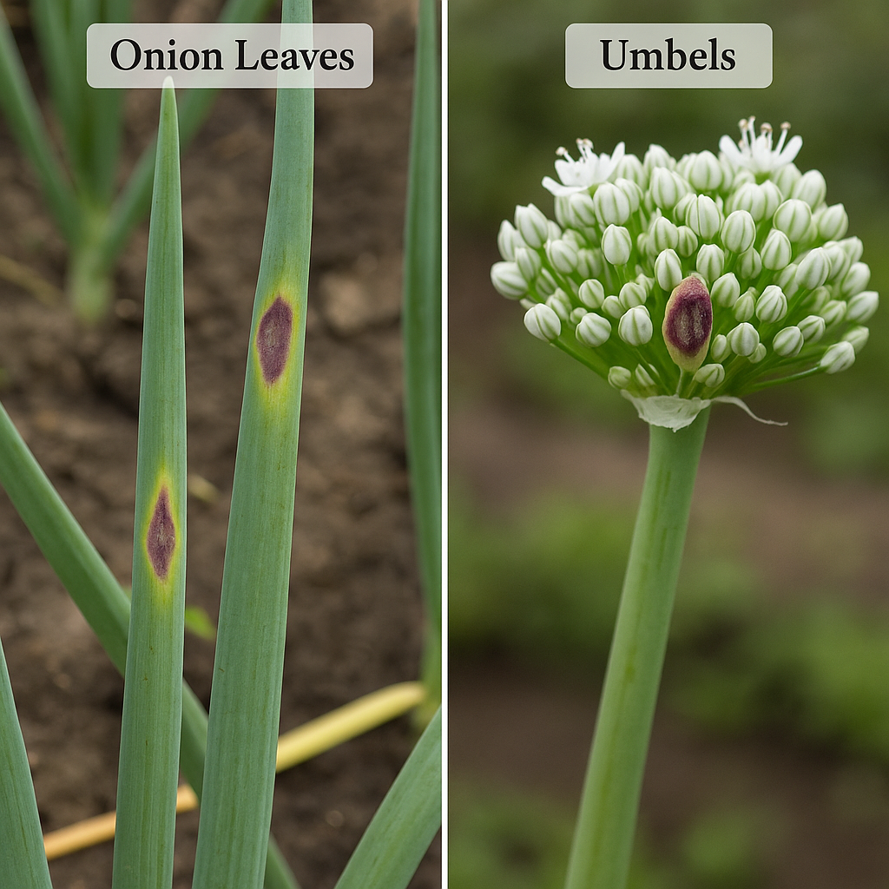
Figure 1--Image of Purple blotch of onion
Of the fungal diseases of onion, purple blotch, which is incited by Alternaria porri (Ellis) Cif., is one of the most debilitating and widespread leaf diseases, especially in the subtropical and tropical agro-climatic regions (Havey, 1993). The disease infects onion crops at any development stage, but particularly at bulb formation and seed production. It occurs as minute water-soaked spots on leaves, which elongate into elliptical or oblong elliptical spots with purplish concentric rings with yellow halos (Chakraborty, et al., 2022). As the disease advances, infected leaves show chlorosis, necrosis, and eventually senescence, weakening the photosynthetic activity of the plant and causing significant loss in yield, which can extend up to 60–70% under favorable environmental conditions (Ochar, and Kim, 2022).
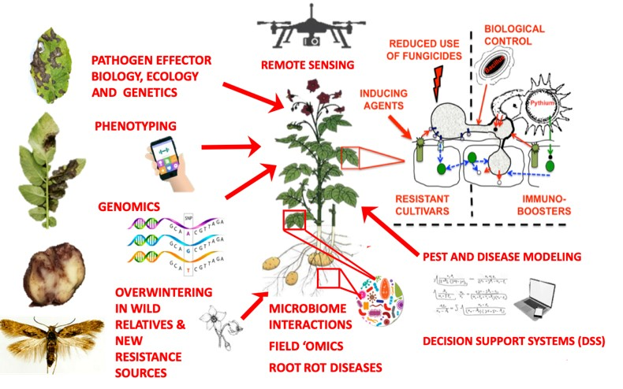
Figure 2-Integrated Plant Disease Management (IDM) (Image Source: https://www.slu.se/en/departments/plant-protection-biology/research/integrated-plant-protection/)
Prevalence and severity of purple blotch depend on relatively high humid conditions (over 80%), moderate temperatures (22–30°C), rain, dew, and poor air movement, all of which enhance the sporulation and spread of the pathogen (Kim, et al., 2023). The polycyclic character of the disease combined with airborne conidial dispersion complicates its control once the disease has developed in the field. In addition, monoculture cropping and the absence of resistant varieties are additional factors contributing to the situation (Dar, et al., 2020).
Against this backdrop of challenges, there is a pressing need to embrace a comprehensive and integrated approach to disease management that integrates cultural, biological, chemical, and host resistance methods (Yadav, et al., 2017). This review seeks to consolidate information on the purple blotch disease of onion, its etiology, epidemiology, and symptomatology, and discuss the various integrated management systems being applied as well as point out potential future directions for climate-resilient and sustainable disease control.
Control of purple blotch is more complex because it is polycyclic in nature and has interaction with other environmental factors. Therefore, a sustainable control can only be achieved by an Integrated Disease Management (IDM) approach. This review integrates recent development in the etiology, epidemiology, and symptomatology of the disease, as well as the involvement of host-pathogen-environment interactions in disease expression (Sarnobat, et al., 2020). It also summarizes different control strategies for:
Cultural practices (crop rotation, field sanitation, proper spacing),
- Biological control through the use of antagonistic fungi and bacteria like Trichoderma spp. and Pseudomonas fluorescens,
- Chemical control with fungicides like mancozeb, azoxystrobin, and propiconazole,
- Host resistance through finding and breeding resistant genotypes.
In addition, the review delves into upcoming trends like the application of plant extracts, nano-formulations, and synergistic approaches involving a combination of methods to achieve overall disease suppression (Ara, et al., 2021). There is also special emphasis placed on the consequences of climate change on disease processes and the necessity of region-specific, adaptive management practices (HASAN, 2020).
2. Etiology and Epidemiology of Disease
Purple blotch, due to Alternaria porri (Ellis) Cif., is a destructive leaf disease that has great impact on onion (Allium cepa L.) crop production. The pathogen is a necrotrophic fungus that kills the host tissue and feeds on the dead tissue (Suheri, et al., 2001). It can infect a large number of Allium species, such as onion, garlic, and leek. The fungus only persists in the form of conidia or latent mycelium in contaminated plant residues and soil and serves as the source of inoculum for subsequent cropping season (Dar, et al., 2020).
Environmental factors play a significant role in the epidemiology of A. porri. The pathogen is favoured by favourable temperatures of 20°C to 30°C, and higher relative humidity of more than 80%, especially in the presence of long leaf wetness by dew, rain, or sprinkler irrigation (Ravichandran, 2012). These conditions induce sporulation, conidial germination, and penetration into host tissue. The late vegetative to bulb enlargement stages are typically when disease outbreaks are most frequently seen, with the crop canopy dense and microclimatic humidity high (DANGI, 2018).
Symptoms
The signs of Alternaria porri purple blotch are very distinctive and mainly occur on the leaves, seed stalks, and occasionally on onion bulbs. Onion may become infected at any growth stage, though severity of the symptoms usually develops in later stages of plant growth under favorable conditions for the pathogen development (Agale, et al., 2014).
The first symptoms typically occur on the older leaves and stalks of the seed as small, water-soaked lesions, which may be whitish or light brown. The early lesions are sometimes hard to observe but soon increase in size under conducive environmental conditions (Bock, 1964).
When the disease is advanced, the lesions become more intense and extend into elliptical or oblong blotches with well-demarcated purplish-brown centers enclosed in clear-cut yellow or light green halos. The lesions can be variable in size, from a few millimeters to several centimeters long, depending on the cultivar and environment. The concentric ring pattern of the lesion is characteristic of purple blotch (Manjunathagowda, et al., 2022).
During severe infection, the lesions fuse, encrusting wide areas of leaf surface, resulting in extensive leaf blight. Infected leaves start to wilt from the top downwards, often referred to as top-down wilting, and then prematurely dry and defoliate. It not only lowers the photosynthetic capacity of the plant but also negatively affects bulb formation and development, resulting in severe yield losses (Parwan, et al., 2025).
In seed crops, the symptoms of the disease are also observed on the flowering stalks (umbels). Infected stalks can develop purplish lesions, similar to those developed in seed, which disrupts pollen viability, seed set, and seed quality. In extreme conditions, stalk collapse is a result of total seed loss (Zaki, et al., 2021).
Symptom severity is usually determined by a number of contributing factors, including mechanical damage, nutrient disorders (particularly nitrogen deficiency), insect damage, and extended leaf wetness. Such factors not only predispose the plants to infection but also improve the pathogen's penetration and colonization of tissues. Early recognition of the symptoms is imperative for intervention and implementation of correct integrated disease management practices to reduce crop loss (Zaman, et al., 2014).
Disease Cycle
Alternaria porri, the pathogen responsible for purple blotch of onion, has a monocyclic and polycyclic nature in its disease cycle. This enables the pathogen to start primary infections at an early stage of the season and induce repeated secondary infection cycles later, especially under optimal environmental conditions (Bayoumi, et al., 2019).
The pathogen exists mainly during cropping seasons in the form of conidia or resting mycelium in infected crop residues retained in the field. Besides debris, it also can survive in soil particles and on alternate or volunteer hosts as a source of inoculum for new crops. Survival longevity in crop residues greatly contributes to the annual occurrence and accumulation of inoculum levels (Schwartz, et al., 2006).
Upon the onset of favorable environmental conditions, especially temperatures in the range 20–30°C and relative humidity above 80%, the resting conidia become active. Primary infection is initiated when wind-dispersed conidia are blown from infected residues and settle on the healthy leaves of onion plants. The spores germinate on the leaf surface and invade the host tissue either through natural stomata or wounds inflicted by mechanical injury or insect feeding (ALI, 2008).
After establishment of infection, the fungus colonizes the tissue quickly, causing the lesions to be necrotic and serve as inoculum sources for secondary infections. The pathogen generates copious amounts of conidia on these lesions, particularly in high humidity. Conidia are spread by wind, rain splash, overhead irrigation, and even insect vectors, helping in the secondary transmission of the disease. This polycyclic character facilitates multiple infection cycles within the growing season, and disease build-up becomes epidemic in nature if uncontrolled (Asghar, et al., 2025).
Points of infection entry are most often related to physical damage to plant tissue, such as that brought on by mechanical processes, pruning, intercultural practices, or insectory attacks. These wounds afford a ready path by which the pathogen can gain entry and colonize the host (Yadav et al., 2017).
In general, a thorough knowledge of the disease cycle, involving the processes of pathogen survival mechanisms, primary inoculum buildup, and secondary dissemination modes, is crucial for IDM strategy development and implementation and also for the establishment of efficient and sustainable IDM approaches. Interference with critical phases in the disease cycle residue management, inoculum reduction, and preventing secondary spread is the basis of effective purple blotch management (Gupta et al., 1988).
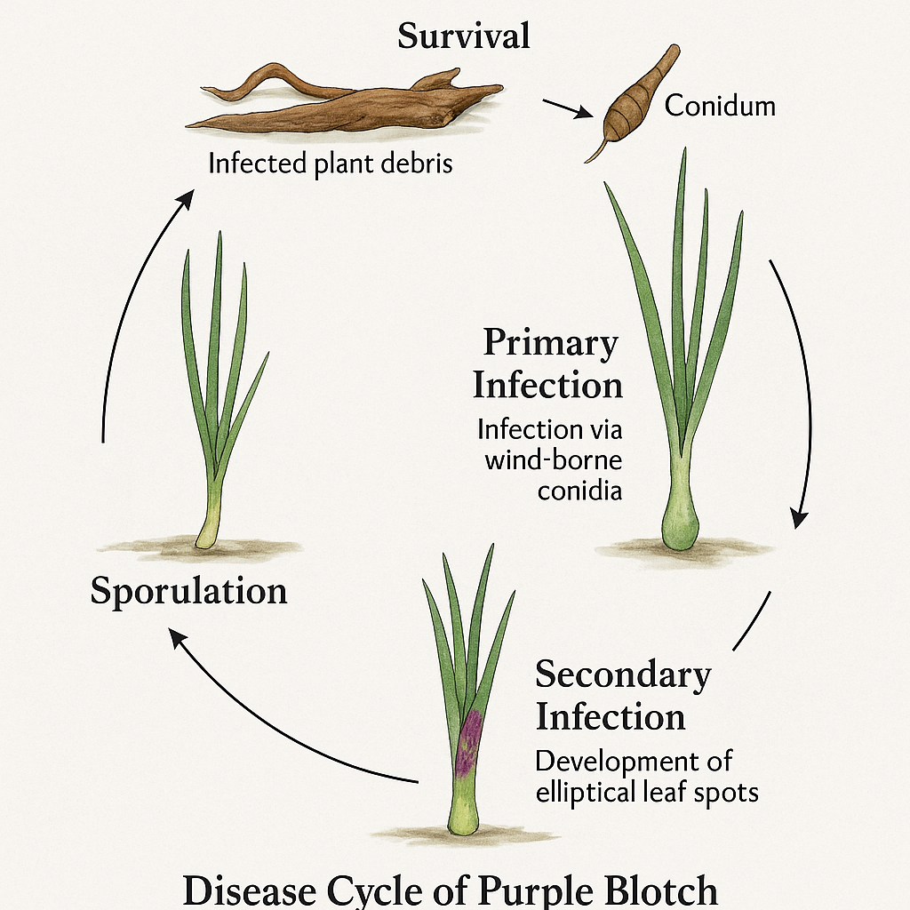
Figure-3- Disease cycle of Purple Blotch
3. Economic Impact
Purple blotch, which is a disease caused by Alternaria porri, is a major threat to the commercial onion production in key growing areas, mainly in tropical and subtropical regions. Besides damaging the amount of marketable yield, the disease also reduces bulb quality, directly affecting farmer revenues and supply chain economics (Nainwal, 2013).
Under favorable weather conditions, particularly under continuous high humidity and moderate temperatures, the disease can result in yield losses from 30% up to as much as 60%, depending on management practices, cultivar susceptibility, stage of the crop, and other factors. The losses are worst during bulb enlargement and seed production, when there is high nutrient requirement for the plant and its physiological susceptibility (KIBRIA, 2010).
In seed production crop areas, the effect of purple blotch is even more serious. Seed stalk (umbel) infection may result in inferior pollen viability, seed development abortion, and decreased seed viability and germination rates, seriously disrupting the amount and quality of produced seeds. It causes ripple economic impacts not only within the current cropping season but also in subsequent cropping cycles owing to a lack of access to quality planting materials (Samal, 2022).
The financial impact of purple blotch also encompasses higher protection costs for plants, with farmers often making repeated use of chemical fungicides to control the disease, though in most cases with little success and costly environmental impacts. Where integrated disease management options are not well adopted, excessive reliance on fungicides adds to higher costs of production, pathogen resistance, and residue loads on fruits and vegetables.
4. Integrated Disease Management (IDM)
Efficient and sustainable disease management of purple blotch of onion involves an integrated strategy, where several methods are integrated in order to minimize pathogen inoculum, suppress initiation of the disease, and hinder further propagation. Integrated Disease Management (IDM) not only maximizes the efficacy of disease control but also reduces the tendency towards overuse of chemical fungicides, thus promoting environmental and economic sustainability (RASHID, 2010).
4.1. Cultural Practices
Cultural management is the first line of defense against disease by minimizing the initial inoculum and making the environment unhealthy for pathogen establishment and propagation. These include:
Crop rotation with non-host plants like cereals (wheat, maize, sorghum) for 2–3 years breaks the disease cycle and minimizes inoculum in the soil. Sanitation in the field is essential; destruction and burning of infected crop residues, shed leaves, and volunteer onion plants eliminate overwintering habitats of A. porri. Optimal plant spacing enhances air movement, decreases humidity in the canopy, and decreases the duration of leaf wetness thus preventing conidial germination and infection. Early sowing to miss times of maximum temperature and humidity conducive to disease (late vegetative to bulb formation stages) can assist in avoiding serious infections (Isaboke, et al., 2024). Good drainage and preventing overhead irrigation can decrease moisture retention on the leaves (Awad et al., 1978).
4.2. Host Plant Resistance
The use of resistant or moderately resistant lines is a cost-effective and environmentally friendly approach to IDM (Munyaneza, et al., 2010). While no onion is totally immune to purple blotch, there are some genotypes that have been found to be moderately tolerant:
Moderately resistant varieties like Arka Kalyan, Arka Niketan, Bhima Super, Bhima Shakti, and Bhima Shweta have had lower disease severity under field conditions (Jhala, et al., 2017). Breeding programs have been initiated to locate and introgress resistance genes through both traditional hybridization and molecular marker-assisted selection. Germplasm and wild relatives of onion are being screened for resistance characters for long-term disease management (Shilpakumari, et al., 2011).
4.3. Chemical Control
Chemical fungicides are still one of the most commonly embraced strategies, especially under severe disease pressure. Their application must, however, be strategic and in combination with other approaches to avoid resistance accumulation (Asghar, et al., 2025).
Generally suggested fungicides and concentrations are:
- Mancozeb (0.25%) – a broad-spectrum protectant fungicide.
- Difenoconazole (0.05%) – a triazole systemic fungicide with curative properties.
- Azoxystrobin + Tebuconazole (0.1%) – a blend providing both systemic and protectant activity.
- Chlorothalonil (0.2%) – a contact fungicide for protective sprays.
Spray schedule: Fungicide sprays should start at the onset of symptoms, followed by repeated sprays at 10–15 day intervals depending upon intensity of the disease and weather (GORE, 2019).
Resistance management is essential. Rotating fungicides with contrasting modes of action (FRAC codes) minimizes the risk of getting A. porri strains that are resistant to fungicides (Younas, et al., 2021).
4.4. Biological Control
Biological control agents are a promising environmentally friendly alternative to chemical fungicides, and some antagonistic microorganisms have been proven promising against Alternaria porri:
Trichoderma spp. (T. harzianum, T. viride) are efficient biocontrol fungi that interfere with and parasitize the disease agent, in addition to inducing plant defense. Pseudomonas fluorescens and Bacillus subtilis are plant growth-promoting rhizobacteria that yield antifungal metabolites (Abo-Zaid, et al., 2025). These biocontrol agents may be used as seed treatment, soil amendments, or foliar sprays to suppress the pathogen load and increase plant resistance. Also, botanical extracts like neem oil, garlic extract, and onion extract exhibit inhibitory activity against A. porri in laboratory and field situations and can be included as part of organic disease management programs (Saini, et al., 2024).
4.5. Integrated Approaches
Combined use of several management components has produced synergistic effects against purple blotch. Experiments and field trials have demonstrated that the integration of moderately resistant cultivars with chemical fungicides or bioagents gives rise to much lower disease severity and incidence (Dar, et al., 2020).
For instance, foliar application of Mancozeb along with Trichoderma harzianum on resistant cultivars has been reported with the lowest Percent Disease Index (PDI) and highest yield performance. These combined modules not only limit the intensity of the disease but also minimize fungicide burden, enhance soil health, and promote long-term sustainability (Hossain, 2000).
5. Recent Advances
There have been great advances in recent years in the understanding and control of purple blotch disease of onion with the integration of contemporary tools and technologies. The developments have enhanced the accuracy, punctuality, and sustainability of disease control measures, particularly under fluctuating climatic conditions (Dar, et al., 2020).

Table-1: Key Components of IDM for Purple Blotch
Component | Strategy/Example | Impact
Cultural Practices | Crop rotation, sanitation, spacing | Reduces primary inoculum
Host Resistance | Arka Kalyan, Bhima Super | Lowers susceptibility
Chemical Control | Mancozeb, Difenoconazole, Azoxystrobin + Tebuconazole | Suppresses pathogen growth
Biological Control | Trichoderma harzianum, neem extract | Eco-friendly suppression
Integrated Approach | Resistant variety + fungicide + biocontrol | Synergistic effect, lowest PDI

5.1. Molecular Diagnostics
The advent of polymerase chain reaction (PCR)-based diagnostic methods has made it possible to detect Alternaria porri in onion tissues early, with a high degree of accuracy even before any symptoms are visible. Molecular tests based on species-specific DNA sequences enable quick and accurate identification of the pathogen from infected leaves, bulbs, and seeds. This makes quarantine operations, planting material screening, and epidemiological work easier. Such approaches are being incorporated into regular disease surveillance and pathogen monitoring schemes, facilitating timely interventions (Dar, et al., 2020).S
5.2. Marker-Assisted Selection (MAS)
Plant molecular biology and genomics have been sped up by the advances in the mentioned field. Marker-assisted selection (MAS) is increasingly being researched for finding and introgressing A. porri resistance genes from tolerant germplasm to elite cultivars (Nanda, et al., 2016). Quantitative trait loci (QTLs) linked to disease resistance are being mapped as part of efforts to increase the efficiency and accuracy of onion breeding programs. Genomic selection and high-throughput phenotyping combined are likely to further simplify the process of developing varieties resistant to purple blotch.
5.3. Decision Support Systems (DSS)
The application of Decision Support Systems (DSS) utilizing real-time weather, disease models, and prediction tools has made chemical application schedules more efficient. These systems process climatic parameters including temperature, humidity, rainfall, and leaf wetness duration to forecast disease development and occurrence, thus enabling farmers and extension officers to optimize the timing of fungicide application. The DSS method minimizes unnecessary use of pesticides, reduces input expenses, and curtails environmental risks while maintaining efficient disease management.
These new advances in technology create a scientific basis for the development of climate-resilient, cost-effective, and environmentally friendly strategies for purple blotch management. Further incorporation of these tools into farmer-friendly platforms and mobile-based systems will enhance precision disease management in onion production.
6. Challenges and Future Directions
Although much has been learned about the etiology and management of purple blotch disease of onion, a number of challenges remain that confine the application and long-term success of integrated disease management (IDM) practices. These challenges need to be addressed to achieve sustainable production of onion, especially with the changing environment and socio-economic scenario.
6.1. Challenges
Over-Reliance on Chemical Fungicides
The ongoing and indiscriminate application of fungicides is a serious issue. Such reliance not only results in the development of fungicide-resistant Alternaria porri strains, but also pollutes the environment, causes build-ups on crops, and has non-target effects on beneficial microorganisms. Moreover, frequent sprays raise the cost of production and have health hazards for growers and consumers.
Limited Availability of Resistant Varieties
While a number of onion genotypes possess partial resistance to purple blotch, commercially acceptable cultivars that integrate high resistance, high potential yield, and consumer-desirable qualities (e.g., bulb shape, color, storage quality) are currently not available. The genetic resistance base is narrow, and resistance breeding is complicated by the biennial flowering habit, genetic complexity, and poor seed set in onion.
Climate Change and Shifting Disease Patterns
Climate fluctuation, specifically temperature, humidity, and rainfall fluctuations, has a large impact on purple blotch epidemiology. Shifts in agro-climatic conditions can prolong the survival of the pathogen, enhance the severity of disease, and change host-pathogen relationships, thus creating the need for developing climate-resilient IDM modules that are region- and season-sensitive.
Low Farmer Awareness and Technical Capacity
Farmers in most onion-producing areas lack adequate knowledge of IDM concepts. Limited access to training facilities, diagnostic equipment, and recent extension services hinders timely and effective implementation of IDM components. This leads to variability in practice and the diminished efficacy of control interventions.
6.2. Future Directions
In order to address the challenges outlined above and make management of purple blotch sustainable in the long term, the following interventions are suggested:
Development of Multi-Resistant, High-Yielding Varieties
Future breeding programs must aim at pyramiding several resistance genes through cutting-edge biotechnological tools like MAS, genomic selection, and CRISPR-mediated gene editing. Interspecific crosses with wild Allium relatives can also offer new sources of resistance.
Improvement of Climate-Smart IDM Packages
There is a critical necessity to create dynamic, location-specific IDM modules that are adapted to regional agro-climatic conditions. The use of real-time disease forecasting models, weather-based schedules of fungicide applications, and precision application technology will be critical to control purple blotch in evolving climates.
Promotion of Eco-Friendly Alternatives
More focus should be given to the formulation and field evaluation of biopesticides, plant extracts, and microbial antagonists that minimize the use of chemical fungicides while promoting environmental and food safety.
Strengthening Farmer Education and Extension Services
Capacity development through training initiatives, on-site demonstrations, and online advisory platforms can enable farmers to implement IDM practices effectively. Participatory research and community-based disease monitoring systems can also augment local adaptation and scalability of control strategies.
Generally, a multidisciplinary solution involving plant pathology, breeding, biotechnology, climatology, and extension sciences is needed to tackle the multifaceted challenges caused by purple blotch. Research investment, policy aid, and stakeholder involvement will be crucial in facilitating the sustainable and lucrative production of onion in the coming years.

Table 2: Challenges and Future Directions in the Integrated Management of Purple Blotch of Onion
S. No. | Challenges | Description | Future Directions | Suggested Interventions
1. | Over-Reliance on Chemical Fungicides | Excessive fungicide use leads to resistance in Alternaria porri, environmental pollution, and higher production costs. | Promotion of eco-friendly and safe disease management alternatives. | Development and use of biopesticides, microbial antagonists, and integrated chemical use strategies.
2. | Limited Availability of Resistant Varieties | Lack of commercially viable varieties that combine high resistance with yield and quality traits. | Breeding of multi-resistant and high-yielding varieties. | Use of MAS, CRISPR gene editing, and incorporation of resistance from wild Allium species.
3. | Climate Change and Shifting Disease Patterns | Fluctuating temperature, humidity, and rainfall affect pathogen survival and disease severity. | Development of climate-resilient IDM modules. | Use of real-time weather-based DSS, disease forecasting models, and precision fungicide scheduling.
4. | Low Farmer Awareness and Technical Capacity | Inadequate understanding and access to IDM practices among farmers. | Strengthening extension services and farmer training. | On-site demonstrations, digital platforms, participatory research, and community-based monitoring.
5. | Fragmented Research and Policy Support | Lack of interdisciplinary coordination and policy-level facilitation. | Integrated, policy-supported, multi-stakeholder approach. | Investment in R&D, incentivizing eco-friendly inputs, and inclusion in national horticulture missions.

7. Conclusion
Purple blotch, which is brought about by Alternaria porri, remains one of the most economically devastating onion diseases, particularly in tropical and subtropical onion-producing areas. Its effect on both bulb yield and seed quality poses a critical limitation to sustainable onion production. The pathogen's persistence in crop residues, rapid spread under favorable conditions, and resistance to chemical treatment demand a full and long-term management strategy. Integrated Disease Management (IDM) is the best and environmentally friendly solution to address purple blotch. An effectively implemented IDM program that integrates the use of moderately resistant varieties, judicious use of fungicides, biological control agents, and cultural practices like early sowing, rotation of crops, and field sanitation can largely control the incidence and severity of the disease. Of these, synergistic application of resistant cultivars with fungicides or antagonistic biocontrol agents has been found especially effective in reducing the Percent Disease Index (PDI) and enhancing crop health and yield. Albeit with multiple management strategies being available, issues like the development of fungicide resistance, absence of common resistant cultivars, and variable climate patterns still continue to impede control measures. In addition, poor knowledge among farmers and inappropriate adoption of IDM components at the farm level diminishes the effectiveness of control measures.
Concurrently, attention must be paid to farmer training, capacity building, and promotion of sustainable practices through efficient extension systems. The use of decision support tools, molecular diagnostics, and digital agriculture platforms can further augment the precision and timeliness of disease management interventions.
In summary, an integrated and collective effort by plant pathologists, breeders, extension workers, and farmers is crucial for limiting losses caused by purple blotch. Enhancing such collaborative efforts will not only assist in enhancing the productivity of onions but also in the long-term sustainability and profitability of onion-based farming systems.
Reference
Abo-Zaid, A. H., Abdel-Wahab, H., EL-Samman, M. G. E. R., & Helmy, K. G. (2025). Evaluation of Botanical and Biological Control Strategies Against Onion Purple Blotch Disease in Egypt. Egyptian Journal of Phytopathology, 53(2), 73-89.
Agale, R. C., Kadam, J. J., Joshi, M. S., & Borkar, P. G. (2014). Symptomatology of purple blotch disease of onion and exploration of fungicides, phytoextract and bio-agents against causal fungus Alternaria porri. History, 11(31), 63-69.
ALI, M. H. (2008). Control of purple blotch complex of onion through fertilizer and fungicide application (Doctoral dissertation, Dept. of Plant Pathology).
Ara, M. R., Masud, M. M. H., Akter, K., Islam, M. R., & Ahmmed, A. N. F. (2021). Integrated management of purple blotch disease complex for onion seed production in bangladesh. Bangladesh Journal of Agriculture, 31-44.
Asghar, M., Atiq, M., Ali, M. U., Kachelo, G. A., Khan, N. A., Naveed, K., ... & Rajput, N. A. (2025). Investigating the biochemical variations in onion leaves due to purple blotch disease and its management through induced resistance. PLoS One, 20(5), e0323067.
Awad, M. A., El-Shenawy, Z., Omran, A. F., & Shatla, M. N. (1978). Cultural practices in relation to purple blotch disease of onion. Scientia Horticulturae, 9(3), 237-243.
Bayoumi, Y., Taha, N., Shalaby, T., Alshaal, T., & El-Ramady, H. (2019). Sulfur promotes biocontrol of purple blotch disease via Trichoderma spp. and enhances the growth, yield and quality of onion. Applied Soil Ecology, 134, 15-24.
Bock, K. R. (1964). Purple blotch (Alternaria porri) of onion in Kenya. Annals of Applied Biology, 54(3), 303-311.
Chakraborty, A. J., Uddin, T. M., Matin Zidan, B. R., Mitra, S., Das, R., Nainu, F., ... & Emran, T. B. (2022). Allium cepa: a treasure of bioactive phytochemicals with prospective health benefits. Evidence‐Based Complementary and Alternative Medicine, 2022(1), 4586318.
DANGI, R. (2018). Epidemiology and Management of Purple Blotch in Onion (Doctoral dissertation, M. Sc. Thesis. Department of Plant Pathology, Dr Yashwant Singh Parmar University of Horticulture and Forestry Solan, Nauni. 43p).
Dar, A. A., Sharma, S., Mahajan, R., Mushtaq, M., Salathia, A., Ahamad, S., & Sharma, J. P. (2020). Overview of purple blotch disease and understanding its management through chemical, biological and genetic approaches. Journal of Integrative Agriculture, 19(12), 3013-3024.
GORE, P. (2019). CHEMICAL MANAGEMENT OF BULB ROT AND PURPLE BLOTCH OF ONION (Doctoral dissertation, Dr. Panjabrao Deshmukh Krishi Vidyapeeth, Akola, Maharashtra.).
Gupta, RBL and Pathak, V. N. (1988). Yield losses in onions due to purple blotch disease caused by Alternaria porri. Phytophylactica, 20(1), 21-24.
HASAN, M. (2020). Management of purple blotch complex of onion (Allium cepa) for seed production (Doctoral dissertation, DEPARTMENT OF PLANT PATHOLOGY).
Havey, M. J. (1993). Onion: Allium cepa L. In Genetic improvement of vegetable crops (pp. 35-49). Pergamon.
Hossain, M. M. (2000). An integrated approach to the control of purple blotch of onion seed-crop (Doctoral dissertation, University of Rajshahi).
Isaboke, K. M., Muraya, M. M., Mwangi, M. J., & Ogolla, F. O. (2024). Assessment of onion farming practices and purple blotch disease knowledge among farmers in varied agro-ecological zones of Nyeri County, Kenya. Archives of Agriculture and Environmental Science, 9(1), 36-43.
Jhala, P., Mali, B. L., & Meena, M. K. (2017). Effective management of purple blotch of onion caused by Alternaria porri (Ellis) through host resistance, fungicides and botanicals. Int. J. Curr. Microbiol. App. Sci, 6(5), 1737-1745.
KIBRIA, M. G. (2010). SCREENING OF DIFFERENT ONION VARIETIES AGAINST" Alternaria porri" CAUSING PURPLE BLOTCH DISEASE.
Kim, S. H., Yoon, J. B., Han, J., Seo, Y. A., Kang, B. H., Lee, J., & Ochar, K. (2023). Green onion (Allium fistulosum): an aromatic vegetable crop esteemed for food, nutritional and therapeutic significance. Foods, 12(24), 4503.
Manjunathagowda, D. C., Selvakumar, R., Shilpashree, S., Anjanapa, M., Dutt, R., Sharath, M. N., ... & Mahajan, V. (2022). Purple blotch disease of onion (Allium cepa): perspective and prospects.
Munyaneza, J. E., Crosslin, J. M., Buchman, J. L., & Sengoda, V. G. (2010). Susceptibility of different potato plant growth stages to purple top disease. American Journal of Potato Research, 87(1), 60-66.
Nainwal, D. (2013). Studies on seed borne aspects of Alternaria porri (Ellis) Cifferi, the causal agent of purple blotch of onion, its molecular characterization and disease management (Doctoral dissertation, PhD. Thesis Govind Ballabh Pant University of Agriculture and Technology, Pantnagar–263 145,(Udham Singh Nagar), Uttarakhand, INDIA).
Nanda, S., Chand, S. K., Mandal, P., Tripathy, P., & Joshi, R. K. (2016). Identification of novel source of resistance and differential response of Allium genotypes to purple blotch pathogen, Alternaria porri (Ellis) Ciferri. The Plant Pathology Journal, 32(6), 519.
Ochar, K., & Kim, S. H. (2023). Conservation and global distribution of onion (Allium cepa L.) germplasm for agricultural sustainability. Plants, 12(18), 3294.
Pareek, S., Sagar, N. A., Sharma, S., & Kumar, V. (2017). Onion (allium cepa L.). Fruit and Vegetable Phytochemicals: Chemistry and Human Health, 2nd Edition, 1145-1162.
Parwan, S., Banyal, D. K., & Sharma, S. (2025). Epidemiological factors affecting purple blotch (Alternaria porri) progression in garlic. Himachal Journal of Agricultural Research, 137-143.
RASHID, M. (2010). EFFECT OF CHEMICALS AND ENVIRONMENT FRIENDLY COMPONENTS FOR THE MANAGEMENT OF PURPLE BLOTCH OF ONION.
Ravichandran, S. (2012). Epidemiology and management of purple blotch of onion caused by Alternaria porri (ellis) cif. Department of Plant Pathology college of Agriculture, University of Agricultural Sciences, Dharwad.
Sagar, N. A., Pareek, S., Benkeblia, N., & Xiao, J. (2022). Onion (Allium cepa L.) bioactives: Chemistry, pharmacotherapeutic functions, and industrial applications. Food Frontiers, 3(3), 380-412.
Saini, S., Raj, K., Kumar, R., & Saini, A. K. (2024). Potency of formulated biocontrol agents from lab to field: a sustainable approach for onion purple blotch suppression. Journal of Plant Pathology, 1-13.
Samal, D. (2022). Prevalence and management of purple blotch of onion caused by Alternaria porri L.
Sarnobat, D. H., Zanajre, S. R., Surywanshi, A. V., & Shela, V. R. (2020). Purple blotch of onion and its management. International journal of chemical studies, 8(2), 839-845.
Schwartz, H. F., Gent, D. H., & Bartolo, M. E. (2006). Purple blotch.
Shilpakumari, M. V., Pramodh, H. P., Gowda, R. V., Balol, B. G., Divya, B. L., & Narendrappa, T. (2011). Evaluation of onion genotypes for disease resistance to purple blotch under field conditions. Research Journal of Agricultural Sciences, 2(4), 964-966.
Suheri, H., & Price, T. V. (2001). The epidemiology of purple leaf blotch on leeks in Victoria, Australia. European Journal of Plant Pathology, 107(5), 503-510.
Teshika, J. D., Zakariyyah, A. M., Zaynab, T., Zengin, G., Rengasamy, K. R., Pandian, S. K., & Fawzi, M. M. (2019). Traditional and modern uses of onion bulb (Allium cepa L.): a systematic review. Critical reviews in food science and nutrition, 59(sup1), S39-S70.
Yadav, R. K., Singh, A., Jain, S., & Dhatt, A. S. (2017). Management of purple blotch complex of onion in Indian Punjab. International Journal of Applied Sciences and Biotechnology, 5(4), 454-465.
Younas, M., Atiq, M., Rajput, N. A., Abbas, W., Bashir, M. R., Ahmad, S., ... & Ahmad, I. (2021). Induction of resistance in onion against purple leaf blotch disease through chemicals. Asian Journal of Agriculture and Biology, 2021(04).
Zaki, S. N., Ahmed, M., Ahsan, M., Zai, S., Anjum, M. R., & Din, N. U. (2021). Image-based onion disease (purple blotch) detection using deep convolutional neural network. Image (IN), 12(5), 448-458.
Zaman, Z., Habib, A., Javed, N., Khan, S. A., Iqbal, M., & Ihsan, J. (2014). ASSESSMENT OF YIELD LOSSES CAUSED BY PURPLE BLOTCH DISEASE IN ONION (ALLIUM CEPA L.) AND ITS MANAGEMENT. Pakistan Journal of Phytopathology, 26(2).

