Phytochemical Profiling and Acute Oral Toxicity Assessment of Hydro-Ethanolic Extract of Whole-Plant of Artemisia annua in Wistar albino rat

ABSTRACT
Aims: Artemisia annua (family Asteraceae) is widely recognized for its rich phytochemical profile and strong antiparasitic properties. The plant contains several pharmacologically active compounds, the most prominent being artemisinin, a hydrophobic sesquiterpene lactone responsible for its potent antiparasitic effects.
Methodology: In the present study, whole-plant material of A. annua was procured from a local Ayurvedic medicine shop, authenticated, and processed into fine powder using a pulverizer. The powder was subjected to cold hydro-ethanolic maceration, and the resulting extract was evaporated at room temperature and stored in airtight vials for subsequent analyses.
Results: Hydro-ethanolic extraction yielded 6.45% crude extractability, indicating efficient recovery of phytochemicals under the extraction conditions. The extract was greenish-brown, solid and sticky, bitter in taste, and pleasant in odour, consistent with known organoleptic characteristics of A. annua extracts. Qualitative phytochemical screening of extracts prepared in twelve different solvents revealed the presence of alkaloids, flavonoids, saponins, tannins, sterols, sesquiterpene lactones, reducing sugars, glycosides, and phenolics, reflecting a broad spectrum of bioactive constituents. These compounds, particularly sesquiterpene lactones, contribute to the plant’s documented antiparasitic activity against Theileria, Babesia, Trypanosoma, Eimeria, and gastrointestinal nematodes, highlighting its importance in veterinary parasitology. Acute oral toxicity of the hydro-ethanolic extract was assessed in Wistar albino rats following OECD guideline 420. Animals received 300, 2000, and 5000 mg/kg body weight and were observed for 14 days. No mortality, behavioural abnormalities, or clinical signs of toxicity were observed at any dose.
Conclusion: These findings demonstrate that the hydro-ethanolic extract of A. annua is non-toxic and well tolerated, supporting its safe use and potential as a natural antiparasitic agent in veterinary medicine.
Keywords: Artemisia annua, Artemisinin, Phytochemical analysis, Wistar rat, Acute toxicity
1. INTRODUCTION
Artemisia annua L. is a medicinal plant of major pharmacological importance, widely studied for its rich secondary metabolite profile. Recent investigations confirm that the plant contains sesquiterpene lactones (artemisinin and its precursors), flavonoids, phenolic acids, and volatile terpenoids that contribute to its antimalarial, antioxidant, anti-inflammatory, and antimicrobial activities (Swamikannu et al., 2025). Molecular studies have shown that transcription factors regulating glandular trichome development directly influence artemisinin biosynthesis, linking plant morphology with metabolite production (Yuan et al., 2025). Furthermore, a doctoral thesis demonstrated that environmental factors and chemotype variation significantly affect artemisinin yield, emphasizing the importance of optimized cultivation strategies (Kam, 2020).
Recent phytochemical profiling studies of Artemisia annua L. have expanded our understanding of its complex secondary metabolite composition beyond artemisinin alone. Comprehensive analyses using gas chromatography–mass spectrometry (GC-MS), high-performance liquid chromatography–high resolution mass spectrometry (HPLC-HRMS/MS), and near-infrared spectroscopy have identified a diverse array of metabolites including monoterpenes, sesquiterpenes, flavonoids, phenolic acids, and coumarins in A. annua and related species (Abdallah et al., 2025; Trifan et al., 2022; Abate et al., 2021). A recent comparative profiling study employing integrated GC-MS, HPTLC, and NIR spectroscopy detected over 48 volatile compounds in A. annua essential oils, along with chemical markers such as artemisinin, coumarins, phenolic acids, and flavonoids that facilitate species discrimination and quality control (Abdallah et al., 2025).
Multi-omics metabolic analysis using LC-MS and GC-MS has also uncovered extensive metabolite networks, revealing alterations in flavonoids, terpenoids, and other secondary metabolites related to developmental and genetic factors (Qin et al., 2024). Additionally, LC-HRMS/MS profiling across multiple Artemisia species documented 15 phenolic acids, 26 flavonoids, and 14 sesquiterpene lactones, highlighting the broad phytochemical diversity within the genus and the antioxidant and bioactive potential of A. annua extracts (Trifan et al., 2022). These contemporary profiling efforts are crucial for standardizing extracts, guiding metabolic engineering, and enabling novel bioactivity research.
Acute oral toxicity assessment is a critical component of preclinical safety evaluation, determining the potential adverse effects and median lethal dose (LD₅₀) of herbal extracts when administered orally. Studies conducted on A. annua L. following OECD acute toxicity guidelines have demonstrated a wide margin of safety. Hydroethanolic extracts administered orally to rodents at doses up to 2000–5000 mg/kg body weight produced no mortality or severe clinical signs, indicating that the extract can be classified as practically non-toxic (Lagarto, 2020). A doctoral thesis further confirmed the absence of acute toxic manifestations and significant body-weight changes following high oral doses, supporting the safe oral use of A. annua in experimental models (Kam, 2020).
Hence, considering the above facts, the present research study was conducted to study phyto-chemical analysis after extraction of Artemisia annua and acute toxicity studies in Wistar albino rats.
2. MATERIALS & METHODS
The research work was carried out in the Department of Veterinary Clinical Medicine, Ethics and Jurisprudence and Department of Veterinary Pharmacology and Toxicology of College of Veterinary and Animals Sciences, MAFSU, Parbhani. The acute toxicity studies were performed in CPCSEA registered animal house facility after approval of Institutional Animal Ethics Committee (IAEC) of COVAS, Parbhani.
2.1 Extraction of A. annua
A. annua was procured from a local Ayurvedic medicine shop and authenticated by an expert taxonomist. The whole plant material was processed into a fine powder using a pulverizing machine. Freshly prepared powder (20 g) was subjected to cold hydro-ethanolic extraction by immersing it in 100 ml of hydro-ethanolic solvent (40% distilled water and 60% ethanol) in a tightly stoppered flask. The mixture was kept at room temperature for 48 hours with continuous agitation at 150 rpm in an orbital shaker. After extraction, the contents were filtered through muslin cloth, and the residue was rinsed with a small volume of the same solvent and re-filtered. The combined filtrate was further filtered through Whatman No. 1 filter paper and exposed to ultraviolet light for 12 hours. The filtrate was then transferred to a pre-weighed Petri dish and allowed to evaporate at room temperature for solvent removal. The concentrated extract was stored in airtight screw-cap vials in a desiccator until further use. The hydro-ethanolic whole-plant extract of A. annua was used for subsequent experiments (Fig. 1-2).
2.2 Phytochemical analysis of A. annua
For phytochemical analysis, A. annua plant material was extracted using twelve different solvents of varying polarity, namely acetic acid, acetone, benzene, chloroform, distilled water, ethyl acetate, ethanol, hexane, hydro-ethanol, methanol, petroleum ether, and xylene. The resulting extracts were qualitatively screened for the presence of major phytochemical constituents following standard procedures described by Roberts et al. (1981) and Harborne (1984).
For the estimation of phytochemical constituents, a series of qualitative tests were performed on the Artemisia annua extracts. Carbohydrates were assessed using Molisch’s test, while reducing sugars were detected using Fehling’s solution and Benedict’s reagent. Monosaccharides were determined by Barfoed’s test, and hexose sugars were evaluated using Seliwanoff’s and cobalt chloride tests. Proteins and amino acids were identified through Biuret, Millon’s, xanthoproteic, and ninhydrin tests. Tannins and phenols were detected using ferric chloride and lead acetate tests. Glycosides were assessed by Legal’s test, Keller-Killiani test, and Borntrager’s test. Saponins were detected using the foam (frothing) test. Phytosterols and triterpenoids were evaluated through Salkowski and Liebermann-Burchard tests. Alkaloids were identified using Mayer’s, Wagner’s, Hager’s, and Dragendorff’s tests. Flavonoids were detected using sodium hydroxide, lead acetate, and ferric chloride tests. Anthraquinones and phenolics were examined using Borntrager’s and ferric chloride tests, respectively. These tests collectively provided a comprehensive qualitative profile of the bioactive constituents present in A. annua (Fig. 3).
2.3 Acute oral toxicity studies
The acute oral toxicity study of A. annua extract was conducted in Wistar rats in accordance with OECD guideline 420 (Acute Oral Toxicity—Fixed Dose Procedure) (OECD, 2002). Healthy Wistar rats of either sex, weighing between 180 and 220 g, were used for the study. The rats were procured from the CPCSEA-registered small laboratory animal facility, Resource Section, College of Veterinary and Animal Sciences (COVAS), Parbhani. Prior to the initiation of the study, the experimental protocol was reviewed and approved by the Institutional Animal Ethics Committee (IAEC) of COVAS, Parbhani. The extract of A. annua was administered orally to the rats at doses of 300, 2000, and 5000 mg/kg BW. Following administration, the animals were closely observed for the first 24 hours for any immediate signs of toxicity and mortality. Subsequently, they were monitored daily for a period of 14 days to record any delayed toxic effects. Observations included general behaviour, agility, feed and water intake, locomotor activity, muscular tremors, convulsions, and other clinical signs of toxicity. The overall health and well-being of the rats were continuously assessed to determine the safety profile of the hydro-ethanolic extract of A. annua (Fig. 4).
3. RESULTS AND DISCUSSION
Hydro-ethanolic solvent is widely recognized as one of the most effective solvents for extracting bioactive compounds from crude plant material; therefore, in the present study, it was selected for the extraction of the whole plant of A. annua to ensure optimal recovery of phytochemicals. Using this method, 100 g of A. annua powder yielded an average of 6.45 g of extract, corresponding to a percent extractability of 6.45%, indicating efficient recovery of phytochemicals under the applied extraction conditions. The hydro-ethanolic extract was greenish-brown in colour, solid and sticky in consistency, bitter in taste, and pleasant in odour, consistent with the known organoleptic characteristics of A. annua extracts (Table 1).
Qualitative phytochemical screening indicated that the hydro-ethanolic solvent extracted the widest range of phytochemical constituents, with strong positive reactions (+++) for flavonoids, tannins, sesquiterpene lactones, and glycosides. Ethanol also showed broad extraction ability across multiple compound classes. Non-polar solvents such as hexane and petroleum ether selectively extracted sterols and sesquiterpene lactones, while showing minimal extraction of polar compounds. Chloroform effectively extracted alkaloids, saponins, and sterols. In contrast, distilled water and acetic acid exhibited limited extraction, primarily yielding phenolics and flavonoids. Overall, screening using twelve different solvents confirmed the presence of alkaloids, flavonoids, saponins, tannins, sterols, sesquiterpene lactones, reducing sugars, glycosides, and phenolics in A. annua (Table 2).
In accordance with OECD guideline 420, oral administration of Artemisia annua extract at dose levels of 300, 2000, and 5000 mg/kg body weight produced no mortality or treatment-related clinical signs of toxicity in Wistar rats. All animals survived and remained clinically normal throughout the 14-day observation period, with no evidence of acute toxic effects.
The selection of a hydro-ethanolic solvent for extracting Artemisia annua in the present study aligns with findings that solvent polarity markedly influences phytochemical recovery. Mixed hydro-alcoholic systems, such as ethanol–water, enhance the extraction of a broad range of secondary metabolites compared with single-solvent systems, supporting efficient recovery of phenolics and flavonoids that contribute to antioxidant potential. For example, methanol and ethanol extracts of A. annua leaves exhibited higher total phenolic and flavonoid contents and stronger antioxidant activity across multiple assays, demonstrating the effectiveness of alcohol-based solvents in phytochemical extraction (Gavarić et al., 2025). Such phenolic and flavonoid compounds are recognized for their radical-scavenging and health-promoting properties. Other studies have noted that extraction solvent choice significantly affects the qualitative and quantitative profile of phytoconstituents and associated biological activities in Artemisia species, with hydro-alcoholic mixtures often providing broader phytochemical coverage than purely polar or non-polar solvents (Liu et al., 2023). These findings corroborate the rich phytochemical profile observed in the hydro-ethanolic extract of A. annua in the current work (Iqbal et al., 2012).
The solvent-dependent variation in phytochemical profiles observed in this study aligns with current research demonstrating that solvent polarity critically influences the extraction of secondary metabolites in Artemisia annua. Hydro-ethanolic and ethanolic solvents efficiently solubilize a broad spectrum of polar and mid-polar constituents, including flavonoids, phenolic acids, and sesquiterpene lactones, which are often associated with antioxidant and anti-inflammatory activities (Abate et al., 2021; Chebbac et al., 2023). Ethanolic extraction at different concentrations has been shown to enhance the recovery of artemisinin, flavonols, phenolic acids, and low-molecular phenolics compared with aqueous or less polar solvents, consistent with the strong qualitative results (+++) recorded here (Abate et al., 2021). Studies comparing solvent efficacy also report that non-polar solvents preferentially extract lipophilic compounds such as sterols and certain terpenoids, while highly polar solvents yield predominantly phenolics and flavonoids, further validating the solvent-dependent profiles in the present screening (Iqbal et al., 2012; Siddiqui et al., (2018); Trifan et al., 2022).
The bioactive sesquiterpene lactones in Artemisia annua, especially artemisinin, contribute not only to antimalarial activity but also exhibit inhibitory effects against other protozoan parasites. Artemisinin and related compounds have demonstrated in vitro activity against Trypanosoma cruzi and Trypanosoma brucei rhodesiense, indicating potential trypanocidal properties beyond Plasmodium species (Mishina et al., 2007). Additionally, A. annua and its phytochemicals have shown promising anticoccidial effects; dietary supplementation with A. annua leaf powder significantly reduced oocyst output and lesion scores in coccidiosis models in broiler chickens and lambs, highlighting its utility against Eimeria infections in livestock (Liu et al., 2025; Coroian et al., 2022). Recently A. annua has demonstrated potential effects against sub-clinical bovine tropical theileriosis (Siddiqui et al., 2026). These findings support the broad antiparasitic potential of A. annua constituents and underscore the need for further research to elucidate mechanisms and optimize therapeutic applications in veterinary parasitology.
The absence of mortality and treatment-related clinical signs following oral administration of Artemisia annua extract up to 5000 mg/kg body weight indicates a high margin of safety under acute exposure conditions. Similar findings have been reported in earlier toxicological evaluations, where hydro-ethanolic and ethanolic extracts of A. annua produced no lethality or significant behavioural, neurological, or systemic toxicity in rodents at doses up to 5000 mg/kg, suggesting an LD₅₀ greater than this limit (Lagarto et al., 2020; Siddiqui et al., 2018). Additionally, comprehensive safety assessments of A. annua–derived preparations have demonstrated minimal acute toxicity, supporting their classification as practically non-toxic when administered orally (Ferreira et al., 2010). The present findings are consistent with OECD guideline 420 criteria and support the continued preclinical development of A. annua extracts for pharmacological applications (OECD, 2002).
The results of the present study revealed that Artemisia annua extract contains a wide range of phytoconstituents, which may collectively contribute to its diverse pharmacological activities. The presence of multiple bioactive classes suggests possible synergistic interactions that could enhance therapeutic efficacy. However, the current findings are limited to qualitative assessment, and comprehensive quantitative analysis is warranted. Further studies are therefore required to evaluate different extracts from various plant parts of A. annua and to systematically investigate their pharmacological activities through in-vitro and in-vivo models.
4. CONCLUSIONS
Artemisia annua contains a diverse range of bioactive phytochemicals, with hydro-ethanolic extraction yielding the most comprehensive profile. Acute oral toxicity in Wistar rats (OECD 420) showed the extract is safe up to 5000 mg/kg with no adverse effects. These results support its therapeutic potential, warranting further pharmacological and mechanistic studies.

ETHICAL APPROVAL
The research work protocol has been approved by the Institutional Animal Ethics Committee (IAEC), College of Veterinary and Animal Sciences, Parbhani and Board of Studies of Maharashtra Animal and Fishery Sciences University, Nagpur and the experiment was performed according to internationally accepted standards of ethical guidelines for animal use and care.
Disclaimer (Artificial Intelligence)
Authors hereby declare that NO generative AI technologies such as Large Language Models (ChatGPT, COPILOT, etc.) and text-to-image generators have been used during the writing or editing of this manuscript.
REFERENCES
Abate, G., Zhang, L., Pucci, M., Morbini, G., Mac Sweeney, E., Maccarinelli, G., Ribaudo, G., Gianoncelli, A., Uberti, D., Memo, M., Lucini, L., & Mastinu, A. (2021). Phytochemical analysis and anti-inflammatory activity of different ethanolic phyto-extracts of Artemisia annua L. Biomolecules, 11(7), 975. https://doi.org/10.3390/biom11070975
Abdallah, I. I., Mahmoud, H. A., El-Sebakhy, N. A., & Mahgoub, Y. A. (2025). Comparative phytochemical profiling and authentication of four Artemisia species using integrated GC-MS, HPTLC and NIR spectroscopy approach. BMC Chemistry, 19(1), 100. https://doi.org/10.1186/s13065-025-01467-5
Chebbac, K., Benziane Ouaritini, Z., El Moussaoui, A., Chalkha, M., Lafraxo, S., Bin Jardan, Y. A., Nafidi, H. A., Bourhia, M., & Guemmouh, R. (2023). Antimicrobial and antioxidant properties of chemically analyzed essential oil of Artemisia annua L. (Asteraceae) native to Mediterranean area. Life, 13(3), 807. https://doi.org/10.3390/life13030807
Coroian, M., Pop, L. M., Popa, V., Friss, Z., Oprea, O., Kalmár, Z., Pintea, A., Borșan, S.-D., Mircean, V., Lobonțiu, I., Militaru, D., Vârban, R., & Györke, A. (2022). Efficacy of Artemisia annua against coccidiosis in broiler chickens: A field trial. Microorganisms, 10(11), 2277. https://doi.org/10.3390/microorganisms10112277
Ferreira, J. F. S., Luthria, D. L., Sasaki, T., & Heyerick, A. (2010). Flavonoids from Artemisia annua L. as antioxidants and their potential synergism with artemisinin against malaria and cancer. Molecules, 15(5), 3135–3170. https://doi.org/10.3390/molecules15053135
Gavarić, N., Aćimović, M., Kladar, N., et al. (2025). Unlocking the bioactivity of sweet wormwood (Artemisia annua L., Asteraceae) ethanolic extract: Phenolics, antioxidants, and cytotoxic effects. Pharmaceutics, 17(7), 890.
Harborne, J. B. (1984). Phytochemical methods: A guide to modern techniques of plant analysis. Chapman & Hall.
Iqbal, S., Younas, U., Chan, K. W., Zia-Ul-Haq, M., & Ismail, M. (2012). Chemical composition of Artemisia annua L. leaves and antioxidant potential of extracts as a function of extraction solvents. Molecules, 17(5), 6020–6032. https://doi.org/10.3390/molecules17056020
Kam, M. Y. Y. (2020). Enhancement of artemisinin production in Artemisia annua L. (PhD thesis). University of Nottingham.
Lagarto, A., Tillán, J., Chung, F., & Rodríguez, M. (2020). Safety evaluation of Artemisia annua extract in acute, short-term and genotoxicity studies. Mendeley Data (Version 1). https://doi.org/10.17632/wbykhd7fp8.1
Liu, S., Li, S., Cheng, S., Liu, M., Li, J., Li, S., Li, X., Zhang, L., & Jian, F. (2025). Effect of Artemisia annua on anticoccidial action, intestinal microbiota and metabolites of Hu lambs. BMC Veterinary Research, 21(1), 41. https://doi.org/10.1186/s12917-025-04493-6
Liu, X., Renzengwangdui, Tang, S., Zhu, Y., Wang, M., Cao, B., Wang, J., Zhao, B., & Lu, H. (2023). Metabolomic analysis and antibacterial and antioxidant activities of three species of Artemisia plants in Tibet. BMC Plant Biology, 23(1), 208. https://doi.org/10.1186/s12870-023-04219-6
Mishina, Y. V., Krishna, S., Haynes, R. K., & Meade, J. C. (2007). Artemisinins inhibit Trypanosoma cruzi and Trypanosoma brucei rhodesiense in vitro growth. Antimicrobial Agents and Chemotherapy, 51(5), 1852–1854. https://doi.org/10.1128/AAC.01544-06
OECD. (2002). Test No. 420: Acute oral toxicity – Fixed dose procedure. OECD Publishing. https://doi.org/10.1787/9789264070943-en
Qin, W., Li, Y., Liu, H., Yan, X., Hu, X., Chen, T., Rahman, S. U., Cao, J., Zheng, H., Li, L., & Tang, K. (2024). Integrated multi-omics profiling reveals a landscape of dramatic metabolic defect in Artemisia annua. Horticulture Research, 11(8), uhae174. https://doi.org/10.1093/hr/uhae174
Roberts, R. M., Gilbert, J. C., & Wingrove, A. S. (1981). Modern experimental organic chemistry (3rd ed., pp. 495–505). Saunders College.
Siddiqui, M. F. M. F., Waghmare, S. P., Chepte, S. D., Ali, S. S., & Shaikh, S. R. (2026). Evaluation of phyto-therapeutic efficacy of Artemisia annua and Calotropis procera against bovine tropical theileriosis. Tropical Animal Health and Production, 58(2), 57. https://doi.org/10.1007/s11250-026-04867-4
Siddiqui, M. F. M. F., Waghmare, S. P., Hajare, S. W., Ingole, R. S., Deshmukh, S. G., Chepte, S. D., & Ali, S. A. (2018). Phytochemical analysis and acute toxicity studies of Artemisia annua in Swiss albino mice. Journal of Pharmacognosy and Phytochemistry, 7(4), 1893–1895.
Swamikannu, B., Umapathy, V. R., Natarajan, P. M., Nandini, M. S., Stylin, A. G. S. Q., Vimalarani, V., & Rajinikanth, S. (2024). Unlocking the therapeutic benefits of Artemisia annua: A comprehensive overview of its medicinal properties. Journal of Pharmacy & Bioallied Sciences, 16(Suppl 5), S4248–S4253. https://doi.org/10.4103/jpbs.jpbs_1250_24
Trifan, A., Zengin, G., Sinan, K. I., Sieniawska, E., Sawicki, R., Maciejewska-Turska, M., Skalikca-Woźniak, K., & Luca, S. V. (2022). Unveiling the phytochemical profile and biological potential of five Artemisia species. Antioxidants, 11(5), 1017. https://doi.org/10.3390/antiox11051017
Yuan, M., Sheng, Y., Bao, J., Wu, W., Nie, G., Wang, L., & Cao, J. (2025). AaMYC3 bridges the regulation of glandular trichome density and artemisinin biosynthesis in Artemisia annua. Plant Biotechnology Journal, 23(2), 315–332. https://doi.org/10.1111/pbi.14449

Table 1. Physical characteristics and extraction yield of hydro-ethanolic extract of Artemisia annua plant
Extraction  Method | Solvent | Yield | Extractability  Efficiency | Physical  State | Colour | Taste | Odour | Consistency with  A. annua
Crude/ Cold Extraction | Hydro-ethanol | 6.45% | Efficient recovery under the applied conditions | Solid and sticky | Greenish-brown | Bitter | Pleasant | Matches reported organoleptic characteristics

Table 2. Qualitative Phytochemical analysis of extract of Artemisia annua plant
Solvent | Active Principles
Solvent | Alkaloids | Flavonoids | Anthraquinone | Amino Acid | Protein | Saponin | Tannins | Sterol | Sesquiterpene Lactones | Reducing Sugar | Glyosides | Phenolics
Acetic acid | - | + | - | - | - | + | + | - | + | - | - | ++
Acetone | - | + | - | - | - | - | - | - | ++ | - | - | +
Benzene | - | - | - | - | - | + | - | ++ | ++ | - | ++ | +
Chloroform | + | - | - | - | - | ++ | - | +++ | ++ | - | + | ++
Ethyl acetate | - | + | - | - | - | - | - | + | + | - | - | +
Ethanol | ++ | ++ | - | - | - | - | ++ | + | ++ | - | + | ++
Hexane | - | - | - | - | - | + | - | +++ | +++ | - | + | -
Hydro-ethanol | ++ | +++ | - | - | - | ++ | +++ | ++ | +++ | - | +++ | +++
Methanol | + | ++ | - | - | - | + | + | ++ | + | - | + | ++
Petroleum ether | - | - | - | - | - | ++ | - | +++ | +++ | - | + | -
Xylene | - | ++ | - | - | - | + | ++ | - | ++ | - | - | ++
Water | - | + | - | - | - | - | + | - | - | - | - | +
- Nil; + Mild; ++ Moderate; +++ Abundance

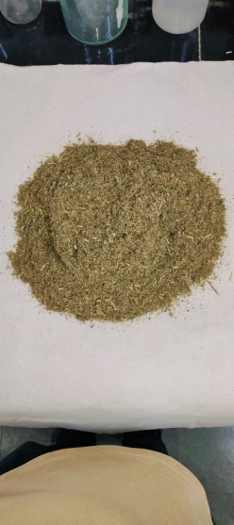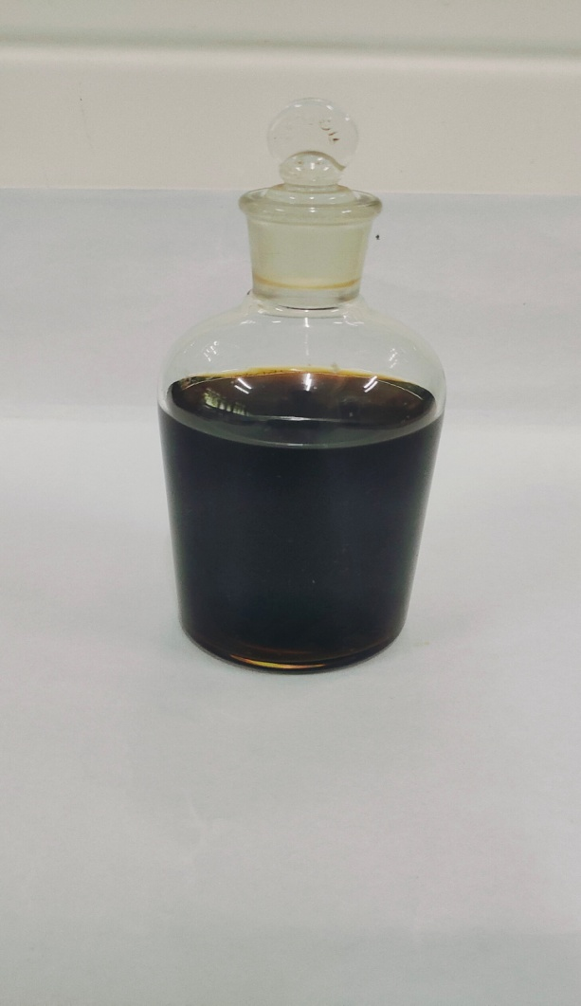
Fig. 1: Grinded A. annua whole plant Fig. 2: Extracted A. annua

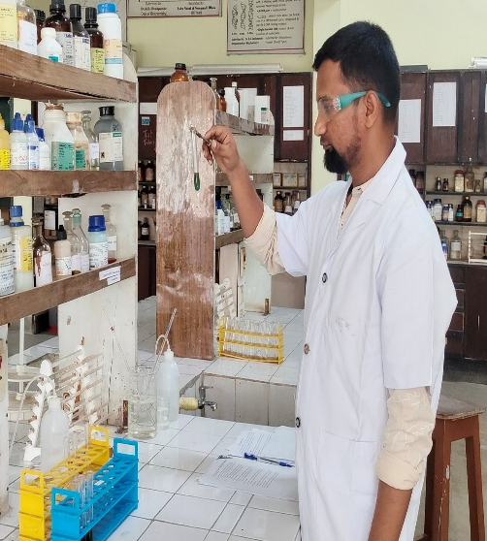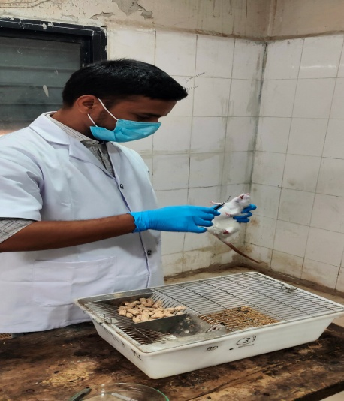
Fig. 3: Phytochemical analysis of A. annua Fig. 4: Administration of A. annua extract

