Revival of Viable but Non-Culturable (VBNC) Soil Bacteria Using Micrococcus luteus Culture Supernatant with Resuscitation Promoting Factor

ABSTRACT
A major limitation in environmental microbiology is the inability to culture a large fraction of microbial communities due to dormancy and entry into the viable-but-non-culturable (VBNC) state, leading to the great plate count anomaly. Resuscitation-promoting factors (Rpf) have emerged as promising tools to overcome this; however, their functional application in complex soil systems remains underexplored. In this study, supernatant-derived Rpf (SRpf) was extracted at optimal growth phase and functionally validated through protein profiling and peptidoglycan hydrolytic activity assays. The resuscitation potential of SRpf was evaluated using sterile soil bioaugmentation model containing VBNC Micrococcus luteus, and non-sterile soil models. Recovery was assessed using culturability-based methods on R2A and SA media alongside metabolic activity assays to distinguish physiological revival from artefactual growth.
SRpf treatment resulted in a significant, time-dependent increase in colony-forming units and metabolic activity across all model systems compared to controls, confirming genuine cellular reactivation. Notably, combined application of SRpf with sublethal concentrations of lysozyme revealed a synergistic enhancement of resuscitation efficiency, highlighting the role of controlled cell wall modulation in microbial revival. Five isolates were obtained as the resuscitated soil bacteria and their identification was carried out.
Keywords: Resuscitation-promoting factor (Rpf), Viable-but-non-culturable (VBNC) bacteria, Resuscitation, Bioaugmentation, dormancy, microbial revival
INTRODUCTION
About 90% of the soil microorganisms are uncultivable on standard media used for enumeration. The inability to form colonies on agar plate is termed as the great plate count anomaly wherein microscopic count of bacteria far exceed colony forming units on agar plates (Staley and Konopka, 1985; Stewart, 2012). One of the major explanations for this discrepancy is the presence of bacteria that enter the Viable but Non-Culturable (VBNC) state, a condition in which cells remain metabolically active and alive, yet fail to grow on conventional media (Oliver, 2005; Pinto et al., 2015). The VBNC state is now recognised as a widespread survival strategy employed by bacteria. It is defined by three main characteristics, namely, non-culturability, continued viability and reversibility. Conventional techniques such as plate counts underestimate viable populations, while molecular methods like metagenomics and qPCR detect nucleic acids but cannot confirm cellular activity or viability, leaving organisms as abstract data points (Emerson and Wilson, 2009; Carini et al., 2016). Vital staining assays, such as those based on membrane integrity, are prone to overestimations, as damaged cells may retain intact membranes while metabolically inactive cells may remain undetected (Davey, 2011). One promising tool is the resuscitation-promoting factor (Rpf), first discovered in Micrococcus luteus.
Rpf (Resuscitation Promoting Factor) is a small, secreted protein that acts by hydrolyzing peptidoglycan, thereby producing muropeptide fragments that serve as signaling molecules to stimulate the resumption of growth in dormant bacteria. (Mukamolova et al., 1998; Keep et al., 2006). It is a muralytic protein very similar to lytic transglycoslylases originally identified in Micrococcus luteus that has since been shown to be widespread across several bacterial taxa, especially within the phylum Actinobacteria (Mukamolova et al., 1998; Keep et al., 2006). Rpf (resuscitation-promoting factor) is a 19KDa bacterial cytokine found in Gram-positive bacteria with high GC content (Mukamolova et al.,1998) that assists in the resuscitation of dormant bacteria. Because of its ability to revive non-growing cells, it has been described as the first bacterial “cytokine” (Mukamolova et al., 1998).
Structurally, Rpf possesses a lysozyme-like domain capable of cleaving the β-(1→4) glycosidic bonds in peptidoglycan, thereby subtly remodeling bacterial cell walls. This controlled enzymatic activity is thought to generate muropeptide fragments that act as signaling molecules, stimulating dormant or viable-but-non-culturable (VBNC) cells to resume growth (Zviagilskaya et al., 2018). All Rpf proteins share a conserved ~70 amino acid Rpf domain, which is both necessary and sufficient for their biological activity (Cohen-Gonsaud et al., 2005). This domain adopts a lysozyme-like fold, with a conserved glutamate residue that is critical for catalytic activity (Mukamolova et al., 2006). The core domain of Rpf is called the RV1009 core domain which has similarity with the type C domain of lysosome. In addition to the core domain, Rpfs frequently contain accessory domains that enhance substrate interaction and activity. These include LysM domains that facilitate peptidoglycan binding, LytM domains with endopeptidase activity, and other less-characterized domains such as G5 and DUF348, which may influence substrate specificity or localization (Keep et al., 2006).
A second hypothesis, the signaling molecule model, proposes that Rpfs release muropeptides that function as signaling molecules. These fragments can be sensed by Ser/Thr protein kinases such as PrkC and PknB, which initiate downstream signaling cascades to trigger resuscitation, as demonstrated in Bacillus and Mycobacterium (shown in figure 4) (Shah et al., 2008). In contrast, Streptomyces species appear to utilize Rpf-mediated signaling independent of these kinases (Keep et al., 2006). Additionally, synergistic action with other enzymes has been observed; for example, in M. tuberculosis, RpfB interacts with the endopeptidase RipA, co-localizing at the septum and cooperatively hydrolyzing both the glycan backbone and peptide stems of peptidoglycan to drive cell division (Hett et al., 2008).
Resuscitation-promoting factor (Rpf) and Rpf-like cytokines have been identified in several Gram-positive and Gram-negative bacteria (Senoh et al., 2012). Rpf has been consistently reported to resuscitate and stimulate the growth of dormant bacteria across diverse taxa, including both Gram-positive and Gram-negative representatives. The Rpf from M. luteus has been shown to resuscitate and stimulate genera such as Corynebacterium, Bacillus, Rhodococcus, Pseudomonas, Arthrobacter, and Alcaligenes (Ding & Yokota, 2010; Nikitushkin et al., 2011).
Rpf, although first discovered in M. luteus, similar Rpf-like compounds, which are now called RpfA-E, that were discovered in M. tuberculosis were originally studied in the context of pathogenesis and tuberculosis latency. This was studied from the perspective that dormant pathogens can evade detection and standard culturing techniques, only to resuscitate under favourable conditions. (Keep et al., 2006; Nikitushkin et al., 2015). However, research done in the sector of environmental microbiology, especially soil biology, is poorly studied (Lopez-Marin et al, 2021). Interestingly, Gram-negative bacteria such as Vibrio, Salmonella, and Escherichia coli possess analogues like YeaZ, although these proteins often differ structurally and mechanistically from classical Rpfs (Aramini et al., 2008).
However, a significant limitation lies in the stability of the purified Rpf protein. Previous work demonstrated that both purified Rpf protein and recombinant Rpf from Micrococcus luteus lose significant activity within a week when stored at 4 °C (Su et al., 2013b). Moreover, supernatants of M. luteus cultures are known to contain not only Rpf but also several other functionally similar proteins, homologues of Rpf, often referred to as Rpf-like proteins or resuscitation-promoting factor-like effectors, have been identified containing a conserve muralytic domain. Supernatant aso contains muropeptides as well as broken fragments of peptidoglycan that bind to the receptors to stimulate the revival (Mukamolova et al., 2006). Consequently, the use of culture supernatants containing Rpf (commonly referred to as SRpf) is considered a more effective strategy than employing purified protein alone, since SRpf harnesses the synergistic activity of multiple bioactive factors (Su et al., 2013a; Yu et al., 2020). Some of which may mimic or enhance the activity of Rpf itself (Mukamolova et al., 2006; Su et al., 2013a).
Rpf has demonstrated remarkable potential in enhancing pollutant degradation. Studies have shown that it accelerates the revival of bacteria required for the biodegradation of phenol and the removal of nutrients by their activity (Su et al., 2018; Bai et al., 2020). Rpf plays a pivotal role in expanding the cultivability of microorganisms. Supplementation with Rpf can significantly increase both the abundance and taxonomic diversity of culturable bacteria from environmental samples, leading to the isolation of novel or previously uncultured species. Such a study was seen in Lopez-Marin et al., 2021, where more that 12 novel isolates from soil were discovered. In clinical microbiology, Rpf is highly relevant due to its role in terminating latency in Mycobacterium tuberculosis, raising both therapeutic and diagnostic considerations (Mukamolova et al., 2010; Shleeva et al., 2015). For chronic infections, such as those caused by Pseudomonas aeruginosa in cystic fibrosis patients, Rpf could resuscitate dormant bacterial cells, rendering them susceptible to antibiotic treatment (Keep et al., 2006). Recent work by Lopez Marin et al. (2021) demonstrated the practical utility of Rpfs in enhancing soil bacterial culturability. The authors utilized an M. luteus culture supernatant containing active Rpf (SRpf) to treat compost soil suspensions and compared the outcomes with controls.
Rpfs act as muralytic enzymes that cleave peptidoglycan, specifically the β-(1,4) glycosidic bond between N-acetylglucosamine (GlcNAc) and N-acetylmuramic acid (MurNAc). Unlike classical lysozymes, Rpfs function as lytic transglycosylases, generating 1,6-anhydromuropeptides without the use of water (Cohen-Gonsaud et al., 2005). This activity has been demonstrated through a range of in vitro assays, including zymography, fluorescamine-labeled cell wall hydrolysis, and MUF-tri-NAG substrate cleavage (Mukamolova et al., 2006). Peptidoglycan hydrolytic activity was assessed using Remazol Brilliant Blue-labelled peptidoglycan (RBB-PG) prepared from heat-killed Micrococcus luteus cell walls, following established protocols (Uehara et a., 2009; Priyadarshini et al., 2007; Hayashi et al., 1975).
In this study, SRpf extracted from M. luteus using the previous methods used by Lopez-Marin et al., 2021 and Mukamolova et al. is applied to environmental soil samples as a direct strategy to overcome the great plate count anomaly. (shown in figure 5) The increase in the cell count is backed up with metabolic viability evidence using TTC and Resazurin assay at different time points. Resuscitated isolates were identified, and their biochemical tests were performed to determine the most probable genera. By resuscitating dormant microbial populations, this work creates a unique opportunity to transform “invisible” microbes into culturable isolates, thereby unlocking access to their physiology, metabolic pathways, and ecological roles. This is not simply an incremental advance; it is a paradigm-shifting approach that bridges the long-standing divide between culture-independent sequencing data and culture-dependent functional microbiology. Furthermore, the bioaugmentation framework with known bacterial isolate of M. luteus reintroduced into sterile soil, rendered VBNC before the treatment with SRpf, allowed to propose a proof of concept that SRpf can restore and maintain microbial communities.
A novel research study was performed to understand the synergistic and antagonistic activity of culture supernatant containing Rpf with crude lysozyme extracted from egg white using a combinatorial approach. The study was aimed to contribute in understanding the sub-lethal concentration of lysozyme that can aid in the enhanced Rpf activity. Synergy was inferred when the combined treatment produced a significantly greater resuscitation response than either agent administered individually.
Overall, this dissertation underscores that classical microbiology remains indispensable, and that challenges such as microbial uncultivability are not terminal barriers but solvable limitations when approached with refined biological insight and innovative methodologies.
MATERIALS AND METHODS
- Cultivation of Micrococcus luteus and Preparation of Culture Supernatant Containing Rpf
Micrococcus luteus was cultivated in lactate minimal medium (LMM) which is composed of: 8.75g/L lithium lactate (sigma-Aldrich), 0.005g/L biotin, 0.02g/L L-methionine, 0.04g/L thiamine, 1g/L ionosine, 4g/L NH₄Cl, 1.4g/L KH₂PO₄, 0.03 g/L MgSO₄ supplemented with trace elements solution (1.5 mL per liter of medium: 0.375 g CuSO₄·5H₂O, 0.785 g MnCl₂·4H₂O, 0.029 g Na₂MoO₄·2H₂O, 0.089 g ZnSO₄·7H₂O, 0.183 g FeSO₄·7H₂O). Seed culture was prepared by transferring pure culture into a 250 mL flask containing 80mL LMM incubated on shaker for 36h. 4% v/v from the seed culture used to inoculate in 200 mL of LMM medium. (Su et al., 2014). The growth of cultures was monitored spectrophotometrically at 600 nm (Abs₆₀₀) to determine the point of maximum Rpf protein content (Abs₆₀₀ ≈ 2.9), after which cells were separated from the supernatant by centrifugation at 5,000 × g for 20 minutes. The recovered supernatant was further sterilized through a 0.22 µm membrane filter. To generate both active and inactive resuscitation-promoting fractions, half of the concentrated supernatant was boiled producing ISRpf, while the other half was refrigerated at 4°C producing SRpf. Both SRpf and ISRpf were washed five times with phosphate-buffered saline (PBS, pH 7.4). The final protein fractions were diluted to 1X (volume equivalent to original culture) and 0.5X for experimental use. (Lopez Marin et al., 2021).
- Total Protein Concentration
Total protein concentration in the Rpf-containing supernatant was determined using the Folin–Lowry method..
- Determination of Rpf Activity
Peptidoglycan hydrolytic activity was assessed using Remazol Brilliant Blue-labelled peptidoglycan (RBB-PG) prepared from heat-killed Micrococcus luteus cell walls, following established protocols (Uehara et a., 2009; Priyadarshini et al., 2007; Hayashi et al., 1975). Briefly, M. luteus biomass was harvested and subjected to SDS boiling (4 % SDS, boiling 15 min) to isolate sacculi, which were then washed extensively with deionized water until supernatants were clear. The sacculi were then covalently labelled by incubating them with 20 mM Remazol Brilliant Blue R dissolved in 0.25 M NaOH with gentle rotation at room temperature for overnight, protected from light. Following labelling, excess dye was removed by repeated centrifugation (20,000 × g, 15 min) and washing until the rinse supernatant was colorless. The resulting RBB-PG was resuspended in 50 mM sodium phosphate buffer (pH 6.2) to a final concentration of 10 mg/mL (wet-weight equivalent). For the assay, 180 µL aliquots of RBB-PG were incubated with 20 µL of SRpf (active supernatant) or heat-inactivated SRpf (ISRpf) at 30 °C for varying time intervals (e.g., 1, 2, and 4 h). Controls included buffer alone and complete dye-release controls wherein RBB-PG was treated with 0.25 M NaOH to determine the maximum releasable dye. Upon completion of incubation, the reactions were centrifuged at 13,000 × g for 10 min to pellet insoluble substrate, and the absorbance of the supernatant was measured at 595 nm. All reactions were performed in triplicate. Activity data were plotted as relative percentage dye released over time to compare SRpf and ISRpf, and the presence of Rpf in SRpf preparations was confirmed.
- Bioaugmentation of Sterile Soil with Model Bacterial Strain
Silt soil samples are collected from garden, agricultural field and home plant pot, sieved, and used for both bioaugmentation and microbial revival from soil experiments. Sterile soil is prepared by autoclaving at 180°C for three hours and subsequently inoculated with a model bacterial strain (Micrococcus luteus) grown in half-strength lysogeny broth (LB) to an Abs₆₀₀ of 1. The cells are washed in 0.85% NaCl to remove residual growth medium and inoculated into sterile soil at a ratio of 1 mL culture to 5 g soil in 50ml PBS. Inoculated soils are incubated for one month until no growth was observed on agar plates, rendering the bacteria viable but non-culturable (VBNC) before treatment with SRpf, ISRpf, or PBS as a control. (Lopez-Marin et al., 2021). Bioaugmented soil was plated using miles misra plate method on both SA and R2A plates for the dilutions of 10⁻⁶, 10⁻⁷, 10⁻⁸ at 28°C for 3 days before counting the colonies formed. The process is repeated for 0 h, 24h, and 72h.
- Enumeration of Soil Bacteria
For enumeration of soil bacteria (for non-sterile soil), 9 mL of the treatments each [1×SRpf, 0.5×SRpf, 1×ISRpf, 0.5×ISRpf, PBS] in triplicates are added to 1g of soil in 50mL tubes, agitated for 24 hrs at room temperature and the soil suspensions are serially diluted till 10⁻⁸ and the last three dilutions are plated by miles and misra method on R2A and SA agar for 0 h, 24 h, and 72 h.
- Metabolic Assays
Formazan equivalents were calculated using a standard curve generated by complete reduction of known concentrations of TTC, followed by solubilization of formazan in DMSO. Absorbance was measured at 485 nm, and sample values were interpolated from the standard curve and expressed as TTC–formazan equivalents. For resazurin assay, 20µM resazurin stock solution in sterile PBS was prepared. The standard curve was prepared by taking various resazurin concentrations with an interval of 4µM and diluent as PBS with 1 mL of M. luteus culture suspension added to each tube and incubated in dark for 24 h and measured at an O.D of 570nm.
- Concentration-dependent modulatory effect of Lysozyme on Rpf
Lysozyme was extracted from egg white using ion-exchange chromatography, and the concentration of the lysozyme was determined spectrophotometrically. In a 96-well plate, two fold dilution of the lysozyme was added along with the treatments. Combinatorial effects were evaluated following incubation under assay-specific conditions.
- Identification of Resuscitated Organisms
Resuscitated soil microorganisms were isolated through repeated subculturing until pure cultures were obtained. A total of five representative isolates were selected for characterization. Preliminary identification was performed using Gram staining and standard biochemical tests according to Bergey’s Manual of Systematic Bacteriology.
- Statistical Analysis
All experiments were conducted in triplicate. Statistical analyses were performed using RStudio software. Two-way analysis of variance (ANOVA) was used to evaluate the effects of treatment and incubation time, followed by Tukey’s post hoc test for multiple comparisons. Differences were considered statistically significant at p < 0.05. Growth and resuscitation kinetics were modelled using the Gompertz equation.
RESULTS
- Preparation of culture supernatant with Rpf
Growth of M. luteus in lactate minimal medium (LMM) was found to have reached an OD₆₀₀ of approximately 2.9 within one week, consistent with previously published reports (Su et al., 2014). Filtration and concentration using a centrifuge and a 0.22 µm syringe filter successfully enriched proteins. Autoclaving half of the obtained supernatant effectively yielded an inactive control fraction (ISRpf) with equivalent protein concentration but without biological activity (López-Marín et al., 2021). The supernatant fractions were divided into 1X and 0.5X concentrations of both SRpf and ISRpf.
- Total protein concentration
Total protein content of the SRpf and ISRpf preparations was quantified using the Folin–Lowry assay.
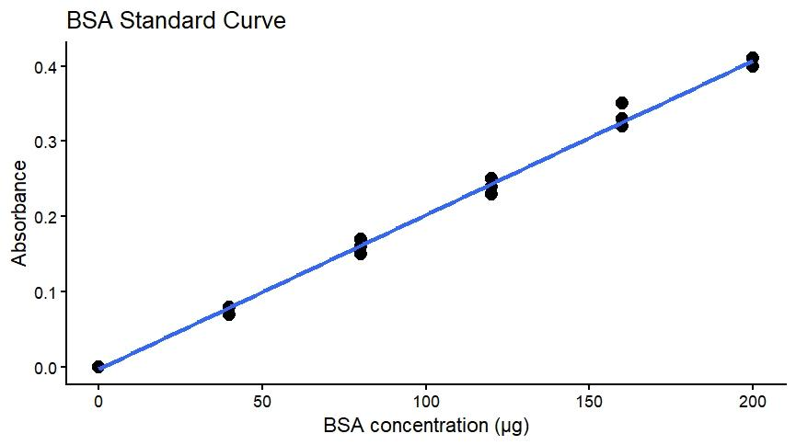
Graph 1: Standard BSA calibration curve for protein estimation. A standard curve was generated using bovine serum albumin (BSA) in the range of 0–200 µg/mL. Absorbance was measured spectrophotometrically and plotted against BSA concentration. Data points represent mean absorbance values (± SD, where applicable). Linear regression analysis showed a strong linear relationship between protein concentration and absorbance (y = 0.002x; R² = 0.9997), and this equation was used to calculate total protein concentrations of the test samples.
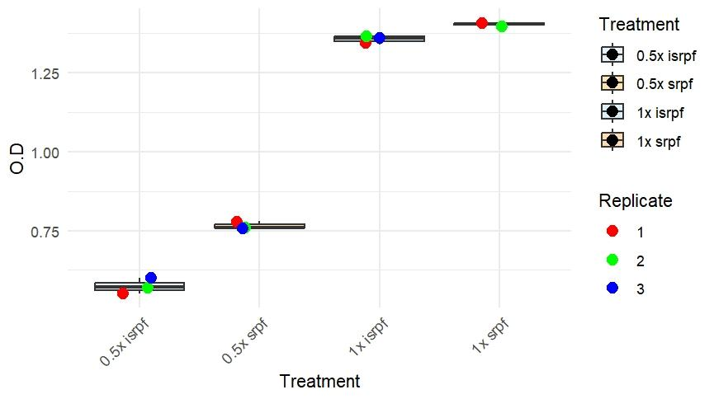
Graph 2: Total protein concentration of SRpf and ISRpf preparations.
Total protein content of supernatant resuscitation-promoting factor (SRpf) and inactivated SRpf (ISRpf) samples at 0.5× and 1× concentrations was quantified using the BSA standard curve. Bars represent mean protein concentration expressed in µg/mL (± SD). The 1× preparations exhibited higher protein content compared to their respective 0.5× dilutions, reflecting concentration-dependent differences between active and inactivated supernatant fractions.
- Rpf activity Assessed by RBB–Peptidoglycan Hydrolysis Assay
Proteins in the 15–20 kDa range, corresponding to the molecular weight of Rpf was determined using SDS PAGE.
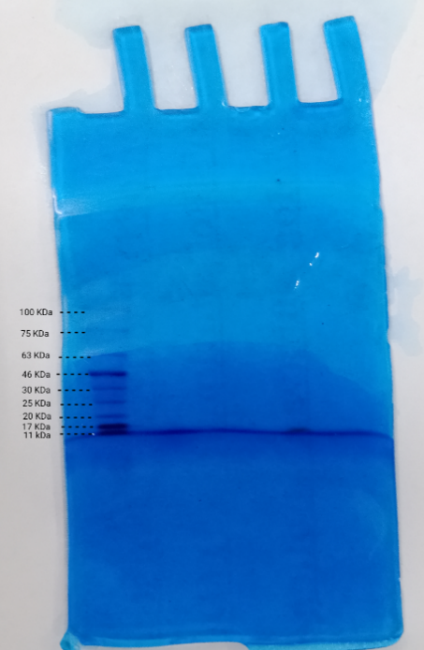
Figure 1.:SDS–PAGE profile of SRpf preparation.
Proteins were separated by SDS–PAGE and stained with Coomassie Brilliant Blue. The third lane containing SRpf shows a distinct protein band between 11 and 17 kDa, as estimated using a pre-stained molecular weight marker (11–100 kDa), indicating the presence of a low–molecular weight protein component.
Peptidoglycan hydrolytic activity was assessed using Remazol Brilliant Blue-labelled peptidoglycan (RBB-PG) prepared from heat-killed Micrococcus luteus cell walls, following established protocols (Uehara et a., 2009; Priyadarshini et al., 2007; Hayashi et al., 1975). Peptidoglycan hydrolytic activity of SRpf and ISRpf preparations was evaluated using the RBB–peptidoglycan dye release assay. Complete chemical hydrolysis with NaOH resulted in 100% dye release across all time points and was used as the reference control (Graph 3).
SRpf preparations exhibited a pronounced, time-dependent increase in dye release, with the 1× SRpf fraction showing relative dye release values of approximately 58%, 156%, and 200% at 1, 2, and 4 h, respectively. In contrast, the 0.5× SRpf fraction displayed lower but comparable time-dependent activity, reaching approximately 129% dye release at 4 h. These results demonstrate both time- and concentration-dependent peptidoglycan hydrolytic activity of SRpf.
Heat-inactivated preparations (ISRpf) showed substantially reduced activity compared to active SRpf at corresponding concentrations. The 1× ISRpf fraction exhibited moderate dye release at 2 h and 4 h, while the 0.5× ISRpf fraction displayed minimal activity throughout the incubation period. The marked reduction in dye release following heat inactivation indicates that the observed hydrolytic activity is largely attributable to a heat-labile protein component, consistent with resuscitation-promoting factor activity.
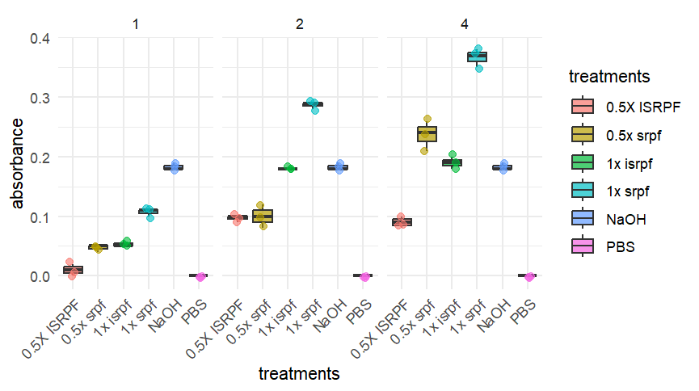
Graph 3: Boxplots represent absorbance values for six treatments—0.5× ISPRF, 1× ISPRF, 0.5× SRPF, 1× SRPF, NaOH, and PBS—measured at three time points (1, 2, and 4 hours). Each point corresponds to an individual replicate, and the boxes show the interquartile range with median lines. Colors indicate treatment type as shown in the legend.
- Bioaugmentation of sterile soil
Prior to treatment, no detectable colony formation was observed on either SA or R2A agar, confirming loss of culturability in bioaugmented sterile soil. Following treatment, SRpf-treated samples exhibited a marked increase in culturable cell counts compared to ISRpf and PBS controls. At 24 h post-treatment, a significant increase in CFU was observed in SRpf-treated soil, with further enhancement detected at 72 h (graph 4). The SRpf treatment consistently resulted in higher CFU recovery across all time points.
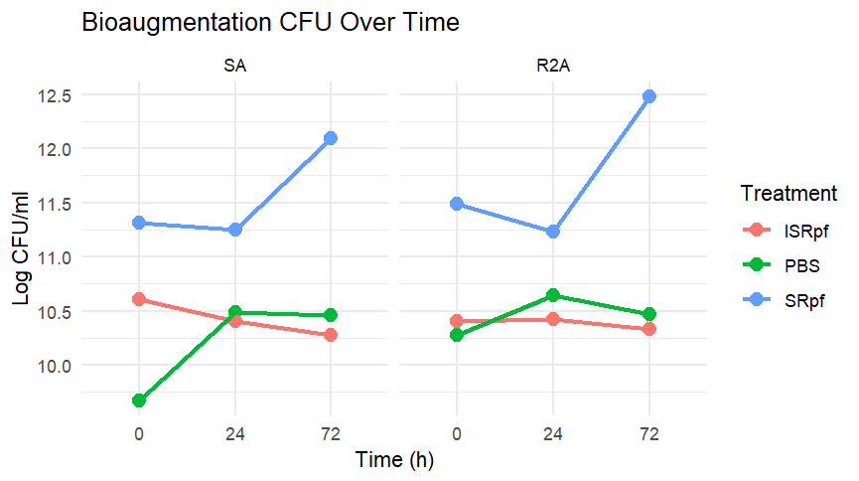
Graph 4: comparative analysis of the treatments when plated on both the kinds of media along with the relative increase in log cfu observed in SRpf treatment compared to the controls.
- Enumeration of soil bacteria
SRpf treatment showed enhanced colony recovery beyond PBS controls, particularly on R2A agar, which is more favourable for relatively faster growing organisms. It was observed that the PBS control treatment remained below the detection of limit throughout all the 6 samples and the ISRpf remained near the baseline, both 0.5x and 1x. however the SRpf of 1x and 0.5 x concentration showed enhanced recovery with a distinct increase beyond the upper limit of detection after 72 hours.
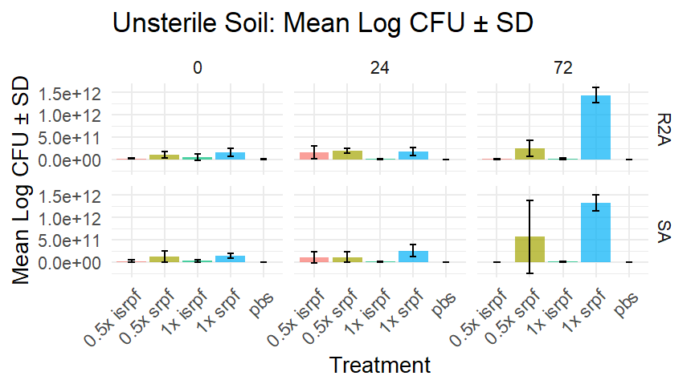
Graph 05: Showing mean log cfu of all the samples taken for all the treatments at the three timepoints using SA and R2A agar.
Metabolic assay
A standard TTC-formazan curve was established to generate a standard linear regression line for calculating the concentrations of the reduced TTC from the treatment test samples. (graph 6) Bacterial metabolic activity was evaluated at 0 h, 24 h, and 72 h using the TTC reduction assay, expressed as absorbance values (graph 8). At 0 h, all treatments showed relatively lower TTC reduction, indicating limited initial metabolic activity across samples S1–S6. Among the treatments, 1× ISRpf and 1× SRpf exhibited higher TTC–formazan levels compared to their respective 0.5× concentrations, suggesting a concentration-dependent effect at the initial time point. At 24 h, a marked increase in TTC reduction was observed across all treatments and samples. The increase was more pronounced in the 1× ISRpf and 1× SRpf treatments, with TTC–formazan concentrations generally ranging between ~300 and 430 µg/mL. The 0.5× SRpf treatment also showed a consistent increase relative to 0 h, whereas 0.5× ISRpf resulted in comparatively lower but progressively increasing TTC reduction. By 72 h, TTC–formazan levels were further elevated in most samples, indicating sustained and enhanced metabolic activity over time. The highest TTC reduction values were consistently observed in the 1× SRpf treatment, reaching approximately 420–560 µg/mL across samples, followed by 1× ISRpf. In contrast, both 0.5× treatments showed moderate increases, remaining lower than their corresponding 1× concentrations.
A clear time-dependent increase in TTC reduction was evident from 0 h to 72 h across all treatments, with both ISRpf and SRpf displaying concentration-dependent effects. SRpf treatments, particularly at 1× concentration, demonstrated consistently higher metabolic activity at all time points compared to ISRpf.
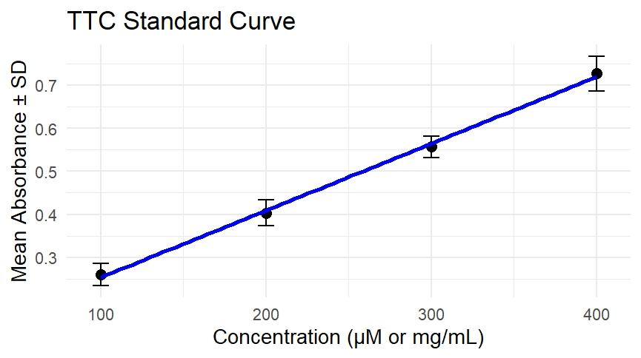
Graph 6: TTC formazan equivalents standard curve in µg/mL. Data points represent mean absorbance values (± SD, where applicable). Linear regression analysis showed a strong linear relationship between TTC-formazan equivalents and absorbance (y = 0.0019x
R² = 0.9938), and this equation was used to calculate the concentrations of the test samples.
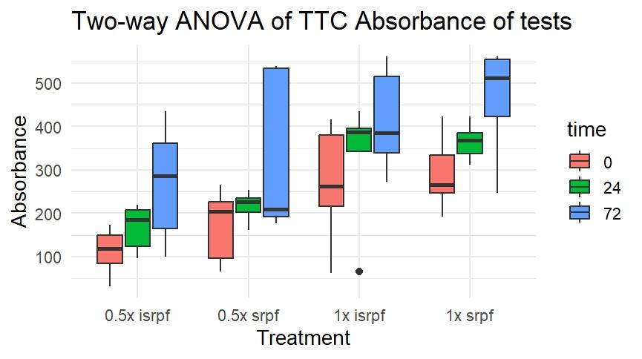
Graph 7: Time-dependent as well as concentration-dependent increase in viability was seen from (A) to (C). Bacterial metabolic activity was assessed at 0, 24, 72 h using the TTC reduction assay for six samples (S1–S6) treated with inactivated SRpf (ISRpf) and active SRpf at 0.5× and 1× concentrations. Viability is expressed as TTC–formazan equivalents (µg/mL). Bars represent mean values ± SD.
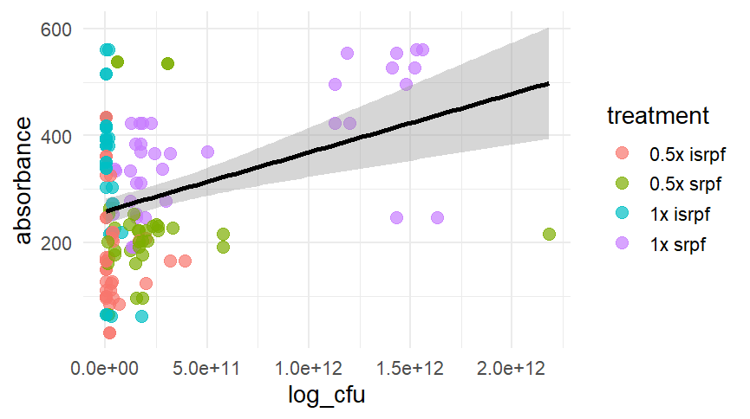
Graph 8: Scatter plot of absorbance versus log-transformed CFU counts for different treatments. Points are color-coded by treatment concentration and type. The black line represents the linear regression with a 95% confidence interval (shaded gray).
Metabolic activity was assessed using the resazurin reduction assay at 0, 24, and 72 h, expressed as absorbance values (graph, 9). At 0 h, all samples exhibited relatively low baseline resorufin formation, with higher values observed for the 1× treatments compared to their respective 0.5× concentrations. Among the treatments, 1× SRpf consistently showed greater resazurin reduction across samples.
At 24 h, resorufin levels increased across all treatments and samples, indicating enhanced metabolic activity over time. The increase was more pronounced in the 1× ISRpf and 1× SRpf treatments, with resorufin concentrations generally ranging between ~30 and 40 µM. In contrast, both 0.5× treatments showed moderate but consistent increases relative to 0 h.
By 72 h, a further elevation in resazurin reduction was observed across all samples. The highest resorufin concentrations were consistently recorded for the 1× treatments, particularly 1× SRpf, reaching approximately 45–55 µM. Overall, the data demonstrate a clear time-dependent and concentration-dependent increase in metabolic activity, with SRpf treatments exhibiting higher resazurin reduction compared to ISRpf at equivalent concentrations.
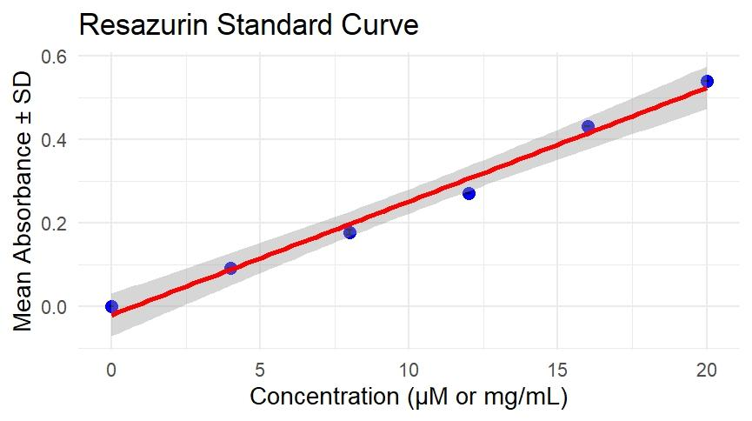
Graph 9: standard resazurin-resorufin equivalent curve is established.
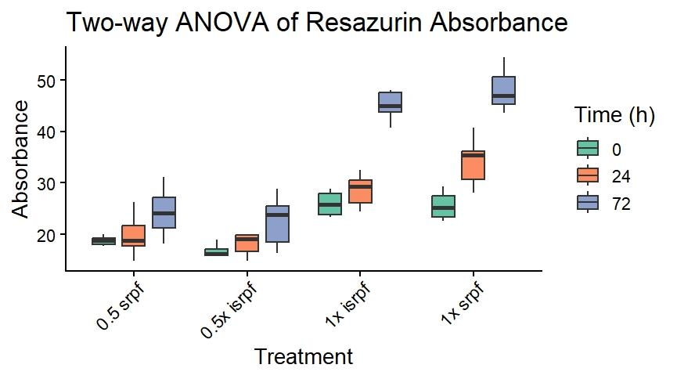
Graph 9: Bacterial metabolic activity was evaluated at 0, 24, 72 h using the resazurin reduction assay for six samples (S1–S6) treated with inactivated SRpf (ISRpf) and active SRpf at 0.5× and 1× concentrations. Viability is expressed as relative resazurin, resorufin units resulting from the reduction of resazurin to resorufin. Bars represent mean values ± SD.
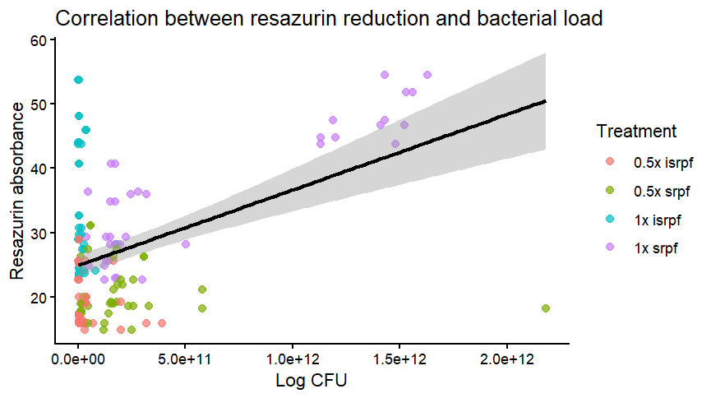
Graph 10: Scatter plot of absorbance versus log-transformed CFU counts for different treatments. Points are color-coded by treatment concentration and type. The black line represents the linear regression with a 95% confidence interval (shaded gray).
- Concentration-dependent modulatory effect of Lysozyme on Rpf
The effect of lysozyme alone on the growth of cells were observed using TTC assay and the absorbance was seen as given in the graph 11. The effect of varying lysozyme concentrations on ISRpf and SRpf activity was assessed by normalizing all readings to the corresponding Rpf-alone controls, which were defined as 100% relative activity. Across the tested concentration range, the presence of lysozyme resulted in a concentration-dependent alteration of Rpf activity, with relative values remaining below the Rpf-alone baseline for all conditions tested. For ISRpf, relative activity exhibited a non-linear response, with higher values observed at intermediate lysozyme concentrations and a gradual decline at both higher and lower concentrations. A similar concentration-dependent pattern was observed for SRpf; however, the magnitude and position of peak relative activity differed between ISRpf and SRpf and between the 0.5× and 1× preparations. Notably, none of the lysozyme-treated conditions exceeded the corresponding Rpf-alone controls, indicating the absence of enhancement beyond baseline Rpf activity.
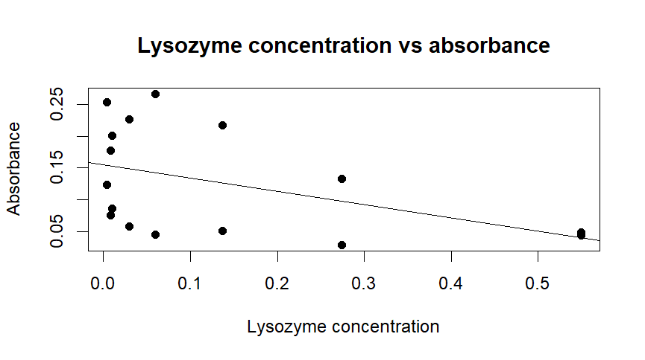
Graph 11: scatter plot of absorbance versus lysozyme concentration. The line represents the linear regression, showing that as concentration decreased, the absorbance increased.
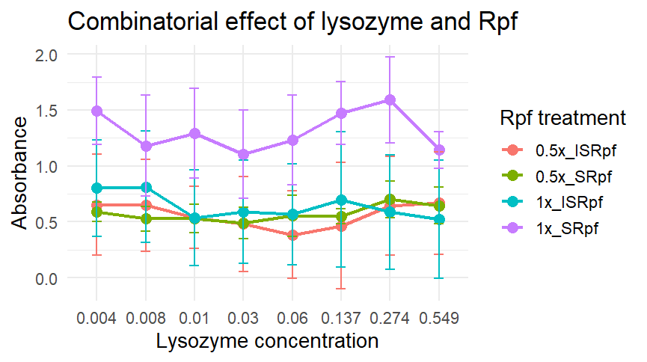
Graph 12: absorbance versus lysozyme concentration. Different treatments are color-coded. There is a significant higher absorbance observed for 1x SRpf.
- Identification of resuscitated soil bacteria
Five resuscitated colonies were selected from SA agar plates of 72 h from the sample 1, 2, 3 and 4 plates. The colonies were purified on nutrient agar plates showing growth after 48 h incubation. Isolate 1 was a gram-positive rod, while the other four isolates were gram-negative rods, lactose non-fermenters. The colony characteristics of the isolates were observed. The isolates were plated on GYC, cetrimide, rhizobium, Burk’s medium, ashby’s medium and CRYEMA and was found that isolate 2 grew on CRYEMA and isolate 3 grew on cetrimide indicating that it is non-pigment producing Pseudomonas aeruginosa, isolate 4 grew on both GYC and CRYEMA while on rhizobium agar isolate 5 was seen to grow. Biochemical tests were performed for all the isolates and the following results were observed in table 1.
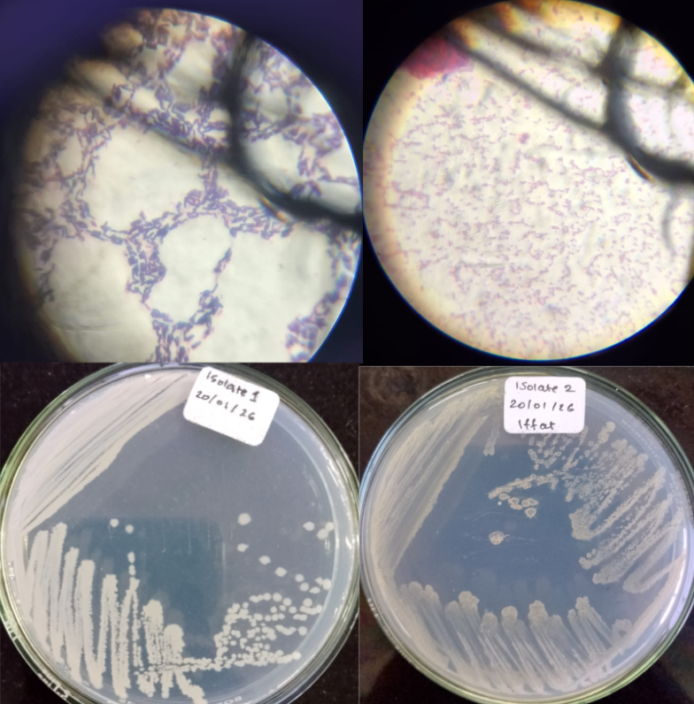
Figure 2: purified colonies of isolates on nutrient agar after 48 h, along with their Gram staining, were observed for isolates 1 and 2.
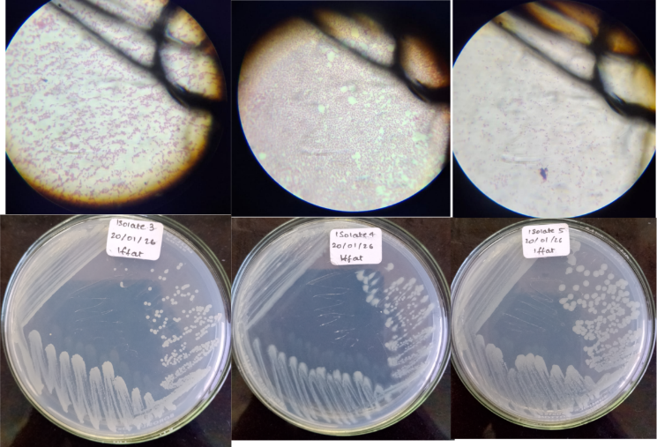
Figure 3: Purified colonies of isolates 3, 4 and 5 obtained on nutrient agar after 48 h, along with their respective Gram’s staining, were observed.

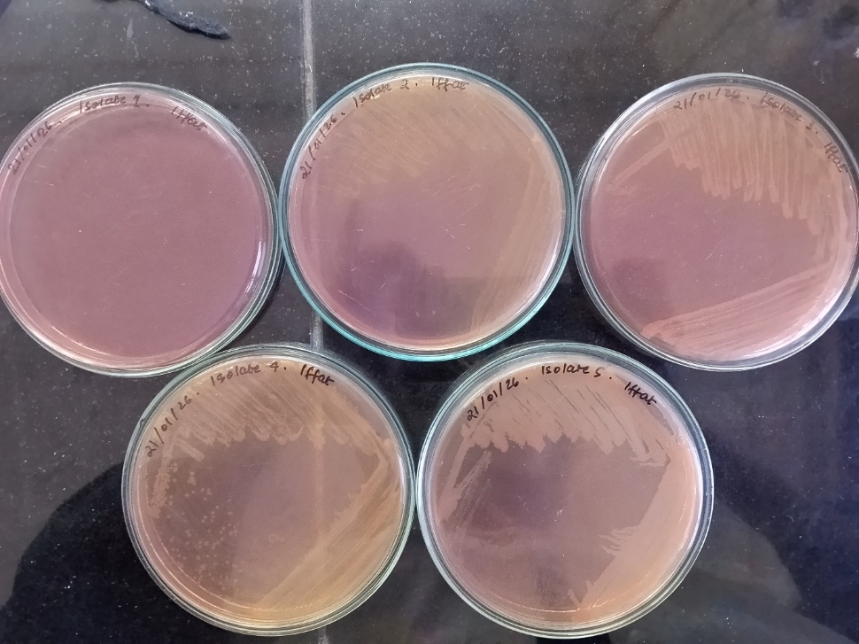
Figure 4: Isolate 1, top left was observed not to grow on MacConkey’s agar as it is gram positive, while all the other isolates were observed to be lactose non-fermenters.
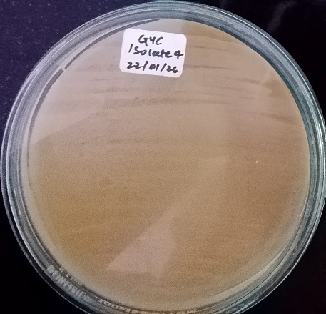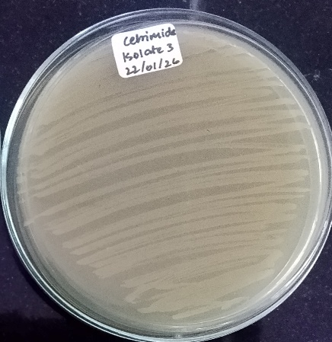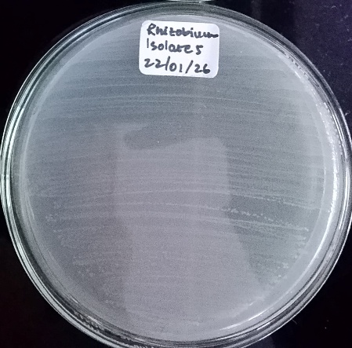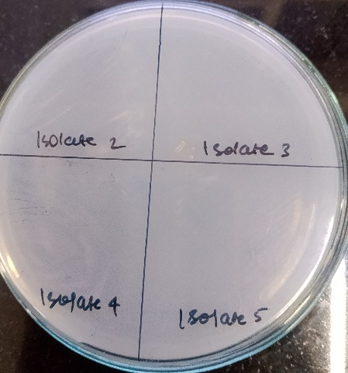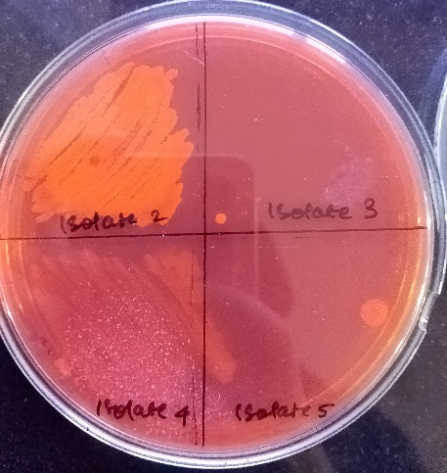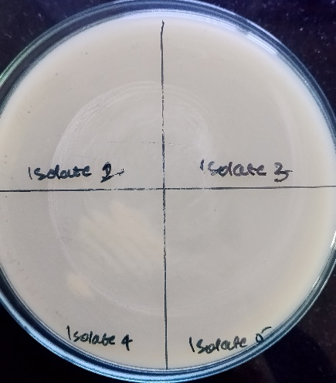
Figure 5: (top left and bottom right) isolate 4 was observed to have grown on GYC agar, (top middle) isolate 3 was observed to have grown on Cetrimide agar, (top right) isolate 5 on rhizobium agar, (bottom left) none of the isolates were seen to grown on Ashby’s mannitol agar, (bottom middle) only isolate 2 and 4 were observed to have grown on CRYEMA, (bottom right) is GYC agar with observed colonies in isolate 4.

Table 1: The expected organisms according to Bergey’s manual.
Isolates | Isolate 1 | Isolate 2 | Isolate 3 | Isolate 4 | Isolate 5
Expected organism | Bacillus circulans | Sphingomonas | Pseudomonas aeruginosa | Comamonas (beta proteobacteria) | Rhizobium spp. (alpha proteobacteria)

- Statistical analysis:
Linear regression analysis was performed to generate standard curves, which showed a strong linear relationship between concentration and absorbance across the tested range (R² > 0.99). Two-way ANOVA revealed a significant effect of treatment (p < 0.05) and incubation time (p < 0.05) on bacterial culturability. A significant interaction between treatment and time was also observed (p < 0.05), indicating that the effect of treatment varied across incubation periods. Post hoc Tukey analysis showed that Rpf-treated samples exhibited significantly higher CFU counts compared to the PBS control at 24 h (p < 0.05), with the highest response observed at the 1× concentration. Pearson correlation analysis demonstrated a significant positive correlation between metabolic activity and culturability (r = 0.78, p < 0.01), indicating that increased metabolic activity was associated with higher CFU recovery.
DISCUSSION
The present study systematically investigates the extraction, functional validation, and application of resuscitation-promoting factors (Rpf) in restoring culturability and metabolic activity of dormant and viable-but-non-culturable (VBNC) bacterial populations in soil systems. By integrating biochemical characterization, functional assays, controlled microcosm experiments, and environmentally relevant soil models, this work provides a comprehensive evaluation of SRpf-mediated resuscitation and its synergistic modulation using sublethal lysozyme.
In this study, Rpf activity was derived from culture supernatant rather than purified protein preparations. This strategy was adopted based on both functional and practical considerations. Purified Rpf proteins are known to lose their effect within one week of storage as previously stated by Su et al., 2009 and Yu et al., 2010 exhibit structural instability, rapid loss of activity during downstream processing, and susceptibility to denaturation, which can compromise reproducibility and biological relevance. Moreover, Rpf in its native extracellular milieu are able to retain their functional conformation and activity. Additionally, bacterial supernatants are likely to contain additional bioactive molecules, including Rpf-like muralytic enzymes, signaling peptides, and accessory factors that may act synergistically to promote resuscitation. (Su et al., 2009 and Yu et al., 2010, Mukamolova et al., 2006) This more holistic approach closely mimics natural microbial signaling environments, particularly in soil ecosystems where extracellular enzymes and diffusible signals collectively regulate dormancy and revival. Thus, the use of supernatant-derived Rpf (SRpf) enhances both biological realism and translational applicability of the findings. (Su et al., 2013b, 2009 and Yu et al., 2010)
SRpf was harvested at an optical density (OD₆₀₀) of 2.9, corresponding to late exponential to early stationary growth phase. This growth phase is widely associated with maximal secretion of extracellular proteins involved in stress response, survival, and intercellular signaling. (Lopez-Marin et al., 2021) Previous studies have reported that Rpf production peaks during this transition phase, where bacterial populations actively modulate dormancy and resuscitation pathways. Selecting OD₆₀₀ 2.9 therefore ensured optimal yield of functionally active SRpf while maintaining consistency across experimental batches. (Lopez Marin et al., 2021).
SDS–PAGE analysis of the SRpf preparation revealed a prominent protein band at approximately 17 kDa. This molecular weight falls within the reported range of Rpf proteins (16–18 kDa), providing supportive evidence for the presence of Rpf-like proteins in the extracted supernatant. (Mukamolova et al.,1998) While SDS–PAGE alone does not confirm protein identity or functionality, the observed band strengthens the biochemical basis of subsequent functional assays. For a more qualitative approach, zymography could have been performed to determine the functional activity of the Rpf. (Mukamolova et al., 2006) For a more quantitative approach, the muralytic activity of SRpf was functionally confirmed using the Remazol Brilliant Blue–labelled peptidoglycan (RBB–PG) assay. (Hett. et al., 2007) Significant dye release observed in SRpf-treated samples indicated active peptidoglycan hydrolysis, a defining characteristic of resuscitation-promoting factors. Rpf-mediated controlled muralysis facilitates cell wall remodeling, allowing dormant or VBNC cells to regain physiological flexibility required for metabolic reactivation and cell division. There was ISRpf showing a significant reading of hydrolysis indicating that SRpf was poorly inactivated. The RBB–PG assay therefore provided direct functional evidence that the extracted SRpf retained biological activity, justifying its application in downstream resuscitation experiments and confirming that observed effects were not merely due to nonspecific protein presence. (Hett et al., 2007).
A sterile soil bioaugmentation incorporating Micrococcus luteus rendered VBNC for 30 days was employed to evaluate SRpf-mediated resuscitation under controlled conditions. M. luteus is a well-established model organism for dormancy and resuscitation studies due to its robust VBNC response under prolonged stress. The bioaugmentation process was carried out as a proof of concept that Rpf can effectively resuscitate VBNC cells. Resuscitation after introduction of treatments, was carried out using miles and misra plating on R2A and SA agar. Both are nutrient limiting media however, SA (soil agar) was made to mimic the natural soil environment, allowing the slow-growing bacteria to enumerate. It was observed that on R2A enhanced recovery was seen within 24 h incuation however, SA required a 3-day incubation to produce colonies of these slow-growing bacteria. Natural soils harbour diverse microbial communities, the majority of which exist in dormant or VBNC states and remain inaccessible to conventional cultivation techniques. The enhanced microbial recovery observed following SRpf treatment underscores its capacity to stimulate revival within indigenous communities. To distinguish between mere colony formation and genuine physiological revival, CFU-based measurements were complemented with metabolic activity assays. A positive correspondence between increased CFU counts and elevated metabolic activity confirmed that SRpf-mediated resuscitation reflects true cellular reactivation. Samples treated with inactivated SRpf (ISRpf) exhibited measurable metabolic activity despite reduced CFU recovery. This suggests that ISRpf inactivation was incomplete, allowing partial stimulation of cellular metabolism without full restoration of division capacity. Such findings are consistent with the presence of viable but poorly culturable cells, reinforcing the concept that metabolic activation and culturability are not always synchronous.This observation further validates the importance of combining metabolic and plating-based assessments when evaluating resuscitation processes. (Lopez-Marin et al., 2021)
Although lysozyme and Rpf exert mechanistically opposing effects on peptidoglycan structure, lysozyme inducing aggressive hydrolysis and Rpf mediating controlled muralysis, their combined application was explored to identify sublethal lysozyme concentrations that enhance SRpf activity. Synergistic enhancement observed at specific lysozyme concentrations suggests that mild cell wall loosening can facilitate SRpf-mediated resuscitation without inducing cell lysis. When normalised to Rpf-alone controls, the presence of lysozyme did not enhance Rpf activity beyond baseline levels, indicating the absence of synergistic interaction. Instead, lysozyme exerted a concentration-dependent modulatory effect, with relative activity approaching but not exceeding Rpf-alone levels at intermediate concentrations. This suggests that while limited peptidoglycan hydrolysis may be tolerated, excessive or insufficient lysozyme activity interferes with optimal Rpf function.
The absence of synergistic enhancement in the presence of lysozyme suggests that Rpf-mediated activity is highly dependent on the structural integrity and controlled remodeling of the peptidoglycan layer. Rpf proteins are proposed to act as specialized muralytic enzymes that generate specific peptidoglycan fragments functioning as resuscitation signals, rather than causing extensive cell wall degradation. In contrast, lysozyme catalyzes broad and non-specific cleavage of β-(1,4)-glycosidic linkages within peptidoglycan, which may prematurely exhaust or alter the availability of Rpf-accessible substrates. Excessive or poorly timed peptidoglycan hydrolysis by lysozyme could therefore interfere with optimal Rpf–substrate interactions, leading to reduced functional efficiency. The concentration-dependent nature of this interference, with relative activity approaching but not exceeding Rpf-alone levels at intermediate lysozyme concentrations, suggests that limited cell wall weakening may be tolerated, whereas extensive or insufficient hydrolysis disrupts the finely regulated Rpf-mediated resuscitation process. These findings support the concept that bacterial resuscitation relies on precise enzymatic modulation of the cell envelope rather than indiscriminate lytic activity.
Identification of five resuscitated isolates was carried out with the help of Bergey’s manual and it was expected that isolate one was Bacillus circulans, isolate 2 was expected to belong to Sphingomonas spp., isolate 3 was Pseudomonas aeruginosa, isolate 4 was seen to be belonging to beta proteobacteria, Comamonas and isolate 5 was seen to belong in alpha proteobacteria called Rhizobium spp.
The observed significant effects of treatment and incubation time demonstrate that bacterial resuscitation is influenced by both external stimulation and physiological state. The interaction between these factors suggests that Rpf activity is not instantaneous but increases as cells transition out of dormancy. Enhanced culturability in Rpf-treated samples, particularly at higher concentrations, aligns with previous reports describing Rpf as a key mediator of peptidoglycan remodeling and cellular reactivation. Furthermore, the positive association between metabolic activity and CFU recovery supports the notion that metabolic reawakening is a prerequisite for successful resuscitation of VBNC cells.
CONCLUSION
This study demonstrates that supernatant-derived resuscitation-promoting factors (SRpf) effectively restore the culturability and metabolic activity of dormant and viable-but-non-culturable (VBNC) bacterial populations in soil systems. Extraction of SRpf from culture supernatant preserved native biological activity and enabled functional validation through muralytic assays, protein profiling, and resuscitation experiments across controlled and environmentally relevant models. The observed recovery in both sterile and non-sterile soil bioaugmentation, supported by concordant increases in CFU counts and metabolic activity, confirms genuine physiological revival rather than artefactual growth.
Importantly, the identification of synergistic enhancement between SRpf and sublethal concentrations of lysozyme highlights the potential of combinatorial strategies to optimize resuscitation efficiency without compromising cell viability. Differential responses observed between active and inactivated SRpf treatments further emphasize the complex relationship between microbial viability and culturability. Collectively, these findings provide experimental evidence that the long-standing challenge of microbial uncultivability can be addressed through biologically informed resuscitation approaches, reinforcing the continued relevance of cultivation-based microbiology in environmental and applied microbial research.

REFERENCES
- Bai, Y., Wang, J., Chen, J., Li, X., & Su, J. (2020). Resuscitation-promoting factor enhances microbial activity and nutrient removal in wastewater treatment systems. Bioresource Technology, 307, 123234. https://doi.org/10.1016/j.biortech.2020.123234
- Carini, P., Marsden, P. J., Leff, J. W., Morgan, E. E., Strickland, M. S., & Fierer, N. (2016).
Relic DNA is abundant in soil and obscures estimates of soil microbial diversity. Nature Microbiology, 2, 16242. https://doi.org/10.1038/nmicrobiol.2016.242
- Cohen-Gonsaud, M., Barthe, P., Bagnéris, C., Henderson, B., Ward, J., Roumestand, C., & Keep, N. H. (2005). The structure of resuscitation-promoting factor domains reveals a lysozyme-like fold. Journal of Biological Chemistry, 280(41), 39579–39589. https://doi.org/10.1074/jbc.M506239200
- Davey, H. M. (2011). Life, death, and in-between: Meanings and methods in microbiology. Applied and Environmental Microbiology, 77(16), 5571–5576. https://doi.org/10.1128/AEM.00744-11
- Ding, L., & Yokota, A. (2010). Distribution of resuscitation-promoting factor–like proteins in bacteria. Microbiology, 156(10), 2920–2930. https://doi.org/10.1099/mic.0.040600-0
- Hett, E. C., Chao, M. C., Deng, L. L., & Rubin, E. J. (2008). A mycobacterial enzyme essential for cell division interacts with resuscitation-promoting factor. Journal of Bacteriology, 190(18), 6088–6095. https://doi.org/10.1128/JB.00400-08
- Keep, N. H., Ward, J. M., Cohen-Gonsaud, M., & Henderson, B. (2006).
Wake up! Peptidoglycan lysis and bacterial non-growth states. Trends in Microbiology, 14(6), 271–276. https://doi.org/10.1016/j.tim.2006.04.003
- López-Marín, M. A., Goberna, M., Pascual, J. A., & Verdú, M. (2021).
Resuscitation-promoting factors expand the culturable diversity of soil bacteria. Environmental Microbiology, 23(5), 2612–2626. https://doi.org/10.1111/1462-2920.15476
- Mukamolova, G. V., Turapov, O. A., Kazarian, K., Telkov, M., Kaprelyants, A. S., Kell, D. B., & Young, M. (2010). The Rpf gene of Mycobacterium tuberculosis encodes an essential resuscitation factor. Journal of Bacteriology, 192(21), 5715–5722. https://doi.org/10.1128/JB.00770-10
- Nikitushkin, V. D., Demina, G. R., Shleeva, M. O., & Kaprelyants, A. S. (2011).
Peptidoglycan fragments stimulate resuscitation of dormant mycobacteria. Antonie van Leeuwenhoek, 99(3), 527–536. https://doi.org/10.1007/s10482-010-9522-9
- Nikitushkin, V. D., Shleeva, M. O., & Kaprelyants, A. S. (2015).
Resuscitation-promoting factors and bacterial dormancy. Microbiology, 161(3), 403–412. https://doi.org/10.1099/mic.0.000030
- Oliver, J. D. (2005). The viable but nonculturable state in bacteria. Journal of Microbiology, 43(Special Issue), 93–100.
- Pinto, D., Santos, M. A., & Chambel, L. (2015). Thirty years of viable but nonculturable state research: Unsolved questions. Critical Reviews in Microbiology, 41(1), 61–76. https://doi.org/10.3109/1040841X.2013.794127
- Shleeva, M. O., Kondratieva, T. K., Rubakova, E. I., & Kaprelyants, A. S. (2015).
Mycobacterial resuscitation-promoting factors and their role in latency. Tuberculosis, 95(5), 526–534. https://doi.org/10.1016/j.tube.2015.05.007
- Staley, J. T., & Konopka, A. (1985). Measurement of in situ activities of nonphotosynthetic microorganisms in aquatic and terrestrial habitats. Annual Review of Microbiology, 39, 321–346. https://doi.org/10.1146/annurev.mi.39.100185.001541
- Stewart, E. J. (2012). Growing unculturable bacteria. Journal of Bacteriology, 194(16), 4151–4160. https://doi.org/10.1128/JB.00345-12
- Su, J., Liu, X., Li, Y., Ding, L., & Yokota, A. (2009). Effects of resuscitation-promoting factor on bacterial recovery. Microbiology Research, 164(6), 60
- Su, J., Liu, X., Ding, L., & Yokota, A. (2013a). Resuscitation of viable but nonculturable bacteria using culture supernatants. Microbial Ecology, 65(4), 863–870. https://doi.org/10.1007/s00248-013-0198-4
- Su, J., Liu, X., Li, Y., & Yokota, A. (2014). Production dynamics of resuscitation-promoting factor in Micrococcus luteus. Applied Microbiology and Biotechnology, 98(9), 4203–4213. https://doi.org/10.1007/s00253-014-5560-5
- Zviagilskaya, R. A., Demina, G. R., & Kaprelyants, A. S. (2018). Mechanisms of bacterial dormancy and resuscitation. Microbiology, 87(1), 1–14. https://doi.org/10.1134/S0026261718010032
-----------------------------------------------------------------------------------

