Case report
Incidental Finding of Polycystic Kidneys in a Persian Cat with Lower Urinary Tract Disease –A Case Report

Abstract
Urinary obstruction is a common emergency in cats and may be exacerbated by underlying conditions such polycystic kidney disease (PKD). This case highlights the diagnosis and management of a Persian cat with lower urinary tract disease (LUTD) and incidental PKD. A two-year-old male Persian cat presented with a two-day history of urinary obstruction, anorexia, and absence of defecation. Clinical examination revealed a distended urinary bladder, congested penile mucosa, and sand-like particles at the penile tip. Ultrasonographic evaluation confirmed LUTD associated with PKD, characterized by multiple renal cysts. A Tomcat catheter was used to relieve 40 mL of reddish urine, after which comprehensive diagnostic evaluations were conducted. The treatment regimen comprised intravenous administration of amoxicillin-clavulanate, pantoprazole, ondansetron, and fluid therapy, followed by oral antibiotics, phosphate binders, and nephroprotective agents. By day five, the cat exhibited improved appetite, reduced bladder distension, and stable renal function; however, persistent leukocytosis necessitated further treatment with enrofloxacin. By day 20, substantial clinical improvement was evident, with normalized serum creatinine and decreased phosphorus levels. This case highlights the importance of early diagnosis and a multidisciplinary therapeutic approach in effectively managing feline LUTD complicated by incidental PKD.
Keywords: Azotemia, Lower urinary tract disease, Persian cat, Polycystic kidney disease, Ultrasonography

Introduction
Polycystic Kidney Disease (PKD) is a hereditary disorder that affects both humans and animals, including domestic cats. In felines, it is inherited as an autosomal dominant trait and is characterized by the presence of multiple fluid-filled cysts developing within the kidney tissue. These cysts may occur in either one or both kidneys. Although the kidneys are primarily involved, cystic changes have also been documented in other organs such as the liver, pancreas, and seminal vesicles (Bosje et al., 1998). The disease is particularly common in Persian cats and closely related breeds but isolated cases have also been reported in other breeds, indicating the importance of broader genetic monitoring (Gendron et al., 2013). The cysts are typically present from birth or develop soon after and gradually enlarge and increase in number with age. In the initial stages, PKD frequently remains clinically silent and diagnosis often occurs at an average age of around seven years. As the condition advances, affected cats may begin to show clinical manifestations associated with chronic kidney disease (CKD), including lethargy, increased thirst, increased urination, dehydration and elevated blood nitrogen levels (Noori et al., 2013).
Many cases of PKD are discovered incidentally during ultrasonographic examinations conducted for conditions unrelated to the kidneys. The development of the disease in cats has been linked mainly to mutations in the PKD1 gene and less frequently, in PKD2 (Bilgen et al., 2020). Despite these genetic associations, the exact molecular processes responsible for cyst formation are not yet fully clarified. Abnormal proliferation of renal tubular epithelial cells, disturbances in fluid secretion and structural changes in the extracellular matrix are considered important factors that contribute to the initiation and enlargement of cysts (Sharma et al., 2019).
Ultrasonography and genetic testing are commonly utilized methods for the diagnosis of PKD. Among these, ultrasound examination is considered a reliable, non-invasive and widely available technique for identifying renal cysts. According to the criteria described by Schirrer et al. (2021), these cysts generally appear as clearly defined, round, anechoic structures situated within the renal cortex or at the corticomedullary junction. Nevertheless, some ultrasonographic findings, such as the medullary rim sign, are not specific indicators of PKD because they can also be observed in healthy cats. The renal resistive index (RRI) has also been investigated as a parameter to assess renal blood flow and perfusion in affected animals. Furthermore, additional abnormalities of the urinary tract detected during evaluation may not necessarily be directly associated with PKD but could represent concurrent conditions related to aging. For instance, Bonazzi et al. (2007) documented chronic cystitis in about 29.5% of cats examined during PKD screening.
Management of PKD in cats is primarily supportive in nature. Once clinical signs develop, treatment becomes difficult and generally follows therapeutic approaches commonly used for chronic kidney disease (CKD). These measures may include administration of subcutaneous fluids to correct dehydration, use of phosphate-binding agents, implementation of appropriate dietary modifications, and supplementation with omega-3 fatty acids such as docosahexaenoic acid (DHA) to support renal function. The present case report describes the incidental identification of PKD through ultrasonographic examination in a Persian cat that was initially evaluated for feline lower urinary tract disease (FLUTD). This report outlines the diagnostic findings and the integrated management strategy adopted in this case, with the objective of adding to the currently limited but expanding clinical information available on feline PKD.
Case report
A two-year-old male Persian cat with a body weight of approximately 5 kg was brought to the Medicine Outpatient Unit at the University Veterinary Hospital, Kokkalai, Kerala, India with a two-day history of anuria. The owner additionally reported that the cat had shown complete loss of appetite and had not passed feces during this period. During clinical examination, the animal appeared lethargic and depressed. The conjunctival mucous membranes were pale roseate in color, peripheral lymph nodes were within normal limits on palpation and the rectal temperature was slightly below normal at 100.1°F. Palpation of the abdomen caused discomfort and revealed a small but tense urinary bladder. Examination of the external genital region showed congested penile mucosa along with fine sand-like material adhering to the penile tip, suggestive of crystalluria or possible urethral obstruction.
Hematological and serum biochemical investigations were subsequently performed (Table 1). Abdominal ultrasonography demonstrated a markedly enlarged urinary bladder containing numerous hyperechoic particles. Evaluation of the kidneys further revealed multiple fluid-filled cystic structures; four well-defined cysts were observed in each kidney, mainly located near the corticomedullary junction (Fig. 1–4). No cystic alterations were detected in the liver or other abdominal parenchymal organs. Based on ultrasonographic diagnostic criteria, the identification of more than two cysts in each kidney was indicative of bilateral PKD.
To alleviate the urinary obstruction, a tomcat catheter was aseptically placed and secured to the preputial skin. Approximately 40 mL of pinkish-to-reddish urine was evacuated, indicating hematuria likely resulting from mucosal irritation or obstruction. The urine sample was submitted for sediment examination, bacterial culture and antimicrobial susceptibility testing (Table 2). Considering the clinical presentation, ultrasonographic findings and laboratory results, the case was diagnosed as feline lower urinary tract disease (FLUTD) with concurrent incidental bilateral PKD.

Treatment And Discussion
Therapeutic management was initiated with intravenous administration of amoxicillin–clavulanate at a dose of 12.5 mg/kg, pantoprazole at 1 mg/kg, and ondansetron at 0.5 mg/kg. Fluid therapy was also provided to correct dehydration and maintain adequate renal perfusion. Subsequently, the cat was started on oral medications, including amoxicillin–clavulanate (12.5 mg/kg twice daily), syrup Reneagis® (0.5 mL/kg once daily) as a renal supportive supplement and sevelamer tablet (20 mg/kg twice daily) to control elevated serum phosphorus levels.
After five days of treatment, noticeable clinical improvement was observed. The cat showed better appetite, increased alertness, and restoration of normal urination. Following stabilization, the urinary catheter was removed. Biochemical evaluation performed on the fifth day demonstrated a decrease in serum creatinine levels, indicating improvement in azotemia, although serum phosphorus remained elevated, warranting continued use of phosphate-binding therapy.
Follow-up ultrasonography revealed decreased bladder distension, while renal imaging continued to show multiple bilateral cortical cysts consistent with PKD. The renal resistive index was measured at approximately 0.7, which falls within the higher end of the normal range and suggested that renal perfusion was not acutely compromised. Aerobic urine culture did not yield bacterial growth after 72 hours of incubation; however, oral antibiotic therapy was maintained as a preventive measure.
By the tenth day of treatment, the cat showed continued clinical recovery, accompanied by marked decreases in both serum creatinine and phosphorus concentrations. Nevertheless, hematological evaluation still revealed leukocytosis with neutrophilia (Table 1), which was suggestive of persistent subclinical inflammation or a possible secondary infection. In view of this finding, enrofloxacin tablet was administered at a dosage of 5 mg/kg for five days, despite the negative culture results, considering the possibility of anaerobic or intracellular pathogens and the limited sensitivity associated with routine culture techniques. Additionally, prazosin at a dose of 1 mg twice daily was prescribed to relieve any remaining lower urinary tract obstruction by facilitating relaxation of the urethral smooth musculature. To provide continued renal support and assist in phosphate control, syrup Pronefra® was also introduced at 1 mL once daily.
By day 20, hematological parameters had normalized, with total leukocyte counts returning to the reference range. Serum creatinine and phosphorus concentrations also declined to normal levels. The owner was advised to maintain long-term administration of Pronefra to help slow the progression of chronic kidney disease. This case highlights the significance of prompt and intensive supportive management in addressing post-renal azotemia caused by urethral obstruction in a cat concurrently affected by PKD. The therapeutic approach proved effective in resolving the acute azotemic episode and improving the overall clinical condition of the patient.
A study conducted by Volta and colleagues reported that supportive parenteral treatment, including fluid therapy and H2-receptor blockers, resulted in clinical improvement in a Chartreux cat affected by Polycystic Kidney Disease; however, the study did not provide data regarding long-term outcomes (Volta et al., 2010). Similarly, Nivy and co-workers observed short-term clinical improvement in PKD-affected cats following intracystic administration of Enrofloxacin, although recurrent episodes of acute kidney injury were later documented, illustrating the challenges of treating infections in kidneys with structural abnormalities (Nivy et al., 2015). In the present case, the normalization of azotemia despite the continued presence of renal cysts indicates that renal function may recover once post-renal obstruction is effectively relieved. A similar observation was described in a case involving feline idiopathic cystitis and uroabdomen associated with PKD, where renal parameters returned to normal following appropriate therapeutic management (Chandran et al., 2024).
Ultrasonographic examination continues to be regarded as the most sensitive non-invasive diagnostic modality for detecting PKD in cats (Debruyn et al., 2012), while also assisting in the identification of associated complications such as urinary tract obstruction. Additionally, PKD in felines has occasionally been reported alongside renal tumors, including lymphoma and renal cell carcinoma (Podell et al., 1992; Adams et al., 2018). Accordingly, future investigations should aim to further elucidate the underlying pathological mechanisms of PKD in feline patients with emphasis on identifying the factors that precipitate the transition from subclinical disease to overt clinical manifestations including the mechanisms responsible for progressive elevations in serum creatinine. Additionally, research is warranted to better understand the capacity for recovery following acute renal insults in kidneys that are structurally altered by cystic degeneration and determining the minimum proportion of functional nephrons required to sustain adequate physiological renal function in cats affected by PKD. Such insights may contribute significantly to improving prognostic assessment and therapeutic strategies.
Conclusions
LUTD in cats is a common condition with a wide range of clinical manifestations. In this case, a cat presented with anorexia and a distended bladder, and diagnostic work-up including catheterization, blood work, and ultrasonography revealed post-renal azotemia, hyperphosphatemia, and multiple renal cysts indicative of concurrent PKD. Therapeutic management with antibiotics, antacids, phosphate binders, and renal supportive care led to marked clinical improvement. This case highlights the importance of early diagnosis and targeted intervention in managing LUTD, especially when complicated by structural renal anomalies like PKD. Ultrasonography and serial biochemical profiling played a pivotal role in guiding therapy and monitoring recovery. However, the presence of renal cysts poses a persistent risk for recurrent urinary tract infections and progressive renal dysfunction. Therefore, long-term follow-up involving regular imaging, renal function assessment, and individualized medical management remains critical to ensuring the ongoing health and quality of life of affected animals.

Parameters | Day 1 | Day 5 | Day 10 | Day 20
Total leucocyte count (10³/µL) | 22.84 | 25.62 | 25.85 | 19.52
Neutrophils (10³/µL) | 18.57 | 22.87 | 22.1 | 15.41
Lymphocytes (10³/µL) | 3.5 | 1.21 | 2.35 | 3.43
Monocytes (10³/µL) | 0.18 | 1.16 | 1.18 | 0.46
Eosinophils (10³/µL) | 0.48 | 0.30 | 0.129 | 0.14
Total erythrocyte count (10⁶/µL) | 7.59 | 9.76 | 8.97 | 5.75
Hemoglobin (g/dL) | 11 | 14.5 | 13.1 | 8.2
Hematocrit (%) | 33.2 | 44.3 | 45.1 | 24.4
Platelets | 56 | 95 | 101 | 178
Serum Creatinine (mg/dL) | 10 | 7.8 | 5.8 | 0.9
Serum Phosphorus (mg/dL) | 7.8 | 14.2 | 10.7 | 6.1

Table 1. Complete blood count and serum biochemical analysis of Persian cat with LUTD and incidental PKD.

Parameters | Day 1
Urobilinogen | +++
Glucose | +
Bilirubin | ++
Ketone bodies | ++
Blood | ++
pH | 6
Protein | +++
Nitrate | +
Leucocyte | ++
Specific gravity | 1.040
Sediment cytology | Few pus cells were noticed
Bacterial culture and sensitivity | No growth was noticed

Table 2. Urinalysis of Persian cat with LUTD and incidental PKD.

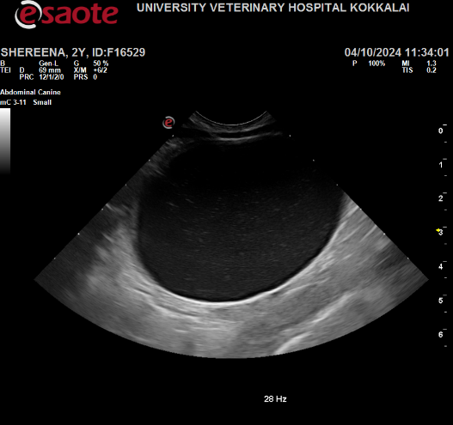

Figure 1. Ultrasonogram of Urinary bladder of Persian cat with LUTD and incidental PKD. Distended urinary bladder with hyperechoic specs inside anechoic urine.

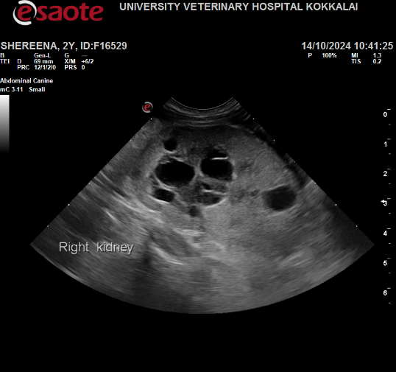
Figure 2. Ultrasonogram of right kidney of Persian cat with LUTD and incidental PKD. Multiple anechoic cysts with thin walls located in the renal cortex.

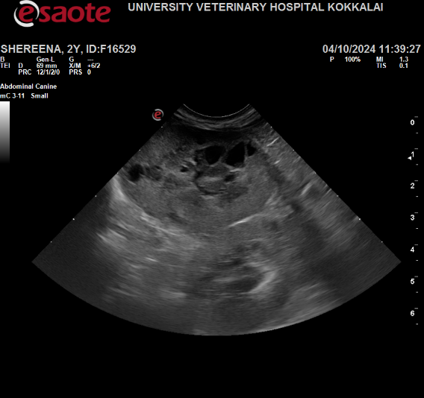
Figure 3. Ultrasonogram of left kidney of Persian cat with LUTD and incidental PKD. Multiple anechoic cysts with thin walls located in the renal cortex.

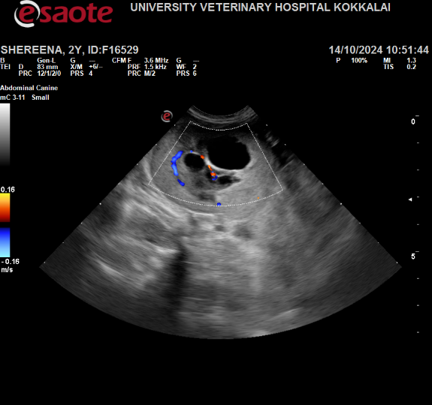
Figure 4. Doppler ultrasonogram of right kidney of Persian cat with LUTD and incidental PKD. Doppler indicates the presence of vessels around the cysts.

References
- Adams, D. J., Demchur, J. A., & Aronson, L. R. (2018). Renal cell carcinoma in a cat with polycystic kidney disease undergoing renal transplantation. Journal of Feline Medicine and Surgery Open Reports, 4(1),1-6.
- Bilgen, N., Bişkin Türkmen, M., Çınar Kul, B., Isparta, S., Şen, Y., Akkurt, M. Y., & Bars, Z. (2020). Prevalence of PKD1 gene mutation in cats in Turkey and pathogenesis of feline polycystic kidney disease. Journal of veterinary diagnostic investigation, 32(4), 549-555.
- Bonazzi, M., Volta, A., Gnudi, G., Bottarelli, E., Gazzola, M., & Bertoni, G. (2007). Prevalence of the polycystic kidney disease and renal and urinary bladder ultrasonographic abnormalities in Persian and Exotic Shorthair cats in Italy. Journal of Feline Medicine and Surgery, 9(5), 387-391.
- Bosje, J. T., Van den Ingh, T. S. G. A. M., & Van der Linde‐Sipman, J. S. (1998). Polycystic kidney and liver disease in cats. Veterinary Quarterly, 20(4), 136-139.
- Chandran, P. S., Nithin, B., & Sindhu, O. K. (2024). Polycystic kidney disease with concurrent uroabdomen in a persian cat: A case study. International Journal of Veterinary Sciences and Animal Husbandry, 9(5): 431-434.
- Debruyn, K., Haers, H., Combes, A., Paepe, D., Peremans, K., Vanderperren, K., & Saunders, J. H. (2012). Ultrasonography of the feline kidney: technique, anatomy and changes associated with disease. Journal of feline medicine and surgery, 14(11), 794-803.
- Gendron, K., Owczarek-Lipska, M., Lang, J., & Leeb, T. (2013). Maine Coon renal screening: ultrasonographical characterisation and preliminary genetic analysis for common genes in cats with renal cysts. Journal of feline medicine and surgery, 15(12), 1079-1085.
- Nivy, R., Lyons, L. A., Aroch, I., & Segev, G. (2015). Polycystic kidney disease in four British shorthair cats with successful treatment of bacterial cyst infection. Journal of Small Animal Practice, 56(9), 585-589.
- Noori, Z., Moosavian, H. R., Esmaeilzadeh, H., Vali, Y., & Fazli, M. (2019). Prevalence of polycystic kidney disease in Persian and Persian related-cats referred to Small Animal Hospital, University of Tehran, Iran. Iranian Journal of Veterinary Research, 20(2), 151-162.
- Podell, M., DiBartola, S. P., & Rosol, T. J. (1992). Polycystic kidney disease and renal lymphoma in a cat. Journal of the American Veterinary Medical Association, 201(6), 906-909.
- Schirrer, L., Marín-García, P. J., & Llobat, L. (2021). Feline polycystic kidney disease: an update. Veterinary Sciences, 8(11), 269-273.
- Sharma, M., Reif, G. A., & Wallace, D. P. (2019). In vitro cyst formation of ADPKD cells. In Methods in Cell Biology,153: 93–111.
- Volta, A., Manfredi, S., Gnudi, G., Gelati, A., & Bertoni, G. (2010). Polycystic kidney disease in a Chartreux cat. Journal of feline medicine and surgery, 12(2), 138-140.

