Global Genetic Diversity, Codon Usage Bias, and Population Differentiation in the E2 Gene of Classical Swine Fever Virus

Abstract
The E2 gene of Classical swine fever virus (CSFV) is a major structural glycoprotein responsible for viral attachment, host interaction, and immune response. To understand its molecular evolution, 568 global E2 gene sequences were analyzed for genetic diversity, codon usage bias, mutational pressure, and gene flow. The gene exhibited moderate diversity with 75 polymorphic sites, 120 mutations, and 207 haplotypes. Despite high haplotype diversity (Hd = 0.9789), the moderate nucleotide diversity (π = 0.098) and negative neutrality indices (Tajima’s D = -1.39, Fu’s Fs = -3.92) indicate purifying selection maintaining structural conservation. Codon usage analysis revealed a preference for A/T-ending codons and moderate bias (ENC = 43-55), primarily shaped by mutational rather than translational pressure. The narrow GC content range (44-52%) and balanced PR2 distribution confirmed compositional stability. Population genetic analysis showed low differentiation among Asia, Europe, and the Americas, but high divergence with Africa (F<sub>ST</sub> = 0.81-0.83, D² = 0.325-0.397), suggesting limited gene flow and long-term evolutionary isolation. Principal component analysis further distinguished African isolates as genetically unique, while Eurasian and American populations formed a cohesive cluster. Overall, the E2 gene of CSFV demonstrates high haplotypic richness, moderate codon bias, and strong evolutionary constraint driven by mutational pressure and purifying selection. These findings highlight the gene’s compositional stability and its critical role in maintaining antigenic integrity, offering valuable insights for CSFV molecular surveillance, evolutionary studies, and vaccine development.
Keywords: Classical swine fever virus, E2 gene, Genetic diversity, Codon usage bias, Mutational pressure

Introduction
Classical Swine Fever Virus (CSFV), a member of the genus Pestivirus within the family Flaviviridae, is the causative agent of Classical Swine Fever (CSF), a highly contagious disease that affects domestic pigs and wild boars, leading to significant economic losses in the global swine industry (Lowings et al., 1996). The virus possesses a positive-sense single-stranded RNA genome of approximately 12.3 kb, encoding a single polyprotein that is co- and post-translationally processed into structural and nonstructural proteins (Fatima et al., 2021). Among these, the envelope glycoprotein E2 plays a critical role in virus attachment, host immune recognition, and induction of neutralizing antibodies, making it one of the most important determinants of virulence, host range, and antigenic diversity. Consequently, genetic variability within the E2 gene serves as a key molecular marker for phylogenetic classification, epidemiological tracing, and vaccine design (Risatti et al., 2005).
Extensive studies have demonstrated that the E2 region exhibits high sequence diversity across global CSFV isolates, driven by mutation, recombination, and differential selection pressures (Nguyen et al., 2021). Understanding the patterns of nucleotide diversity, codon usage, and population structure in this gene can therefore provide valuable insights into viral evolution, adaptation, and global transmission dynamics (Wang et al., 2022). In particular, codon usage bias reflects the interplay between mutational pressure and translational selection, influencing viral fitness and host adaptation. Similarly, analyses of gene flow and genetic differentiation across populations help to elucidate how geographical separation, trade routes, and control measures have shaped the current distribution of CSFV genotypes (Jitobaom et al., 2020).
In this study, we conducted a comprehensive molecular evolutionary analysis of 575 E2 gene sequences representing globally distributed CSFV isolates. We assessed the extent of nucleotide and haplotype diversity, codon usage bias, and patterns of gene flow and population differentiation across continents. Neutrality tests and codon bias indices were used to infer the evolutionary forces acting on the E2 gene, while pairwise genetic distance and principal component analyses provided insights into global population structure. Together, these analyses offer a detailed understanding of the genetic variability, evolutionary dynamics, and population connectivity of CSFV, contributing to improved molecular epidemiology and control strategies.
Materials and Methods
Sequence retrieval and dataset preparation
A comprehensive dataset of Classical swine fever virus (CSFV) sequences was retrieved from the NCBI GenBank database. Complete E2 gene sequences (Supplementary table 1) were collected to ensure broad coverage of global diversity. A total of 558 sequences were retrieved from 34 countries, India (137 sequences), China (49), Vietnam (43), Taiwan (41), Mongolia (4), Columbia (32), Venezuela (4), Italy (34), Japan (10), Cuba (14), Russia (11), Indonesia (2), Laos (4), South Korea (42), Peru (17), Australia (21), France (44 ), South Africa (1), Serbia (2), Germany (4), USA(1), Hungary (1), Slovakia (1), Thailand (4), Romania(5), Bulgaria (9 ), Latvia (1), Lithuania (10), Croatia (4), Israel (1), Switzerland (1), Mexico (1), Bangladesh (2) and Nepal (1). The final dataset comprised 575 sequences covering all known geographical regions and collection periods.
Multiple sequence alignment
Sequences were aligned using the MUSCLE algorithm implemented in MEGA version 11.0 (Tamura et al., 2021) with codon alignment optimized for protein-coding regions. Manual corrections were performed for hypervariable sites to maintain alignment accuracy. The alignment was trimmed to equal lengths across isolates to ensure comparability in downstream analyses.
Genetic diversity analysis
Genetic diversity parameters were assessed for individual gene region E2 dataset DnaSP 6.0 (Rozas et al., 2017). The estimates included the number of polymorphic sites, mutations, haplotypes, haplotype diversity, nucleotide diversity, theta values, average nucleotide differences, and insertion-deletion (InDel)-related indices (Mills et al., 2006). In addition, sequence conservation values were calculated to evaluate the overall variability and evolutionary dynamics among the CSFV isolates.
Codon usage analysis
The codon usage pattern of the selected protein-coding region (1-1336 bp) was analyzed using DNsp software. The nucleotide sequence was verified to contain a complete open reading frame (ORF) comprising a single exon without any intronic or flanking noncoding regions. The analysis included calculation of various codon usage indices such as the Effective Number of Codons (ENC), Codon Bias Index (CBI), and Scaled Chi-square (SChi²) to assess the extent of codon usage bias. The GC content was estimated for the entire coding sequence (G+Cc) as well as for position-specific sites, including the second codon position (GC2) and synonymous third codon positions (GC3s). Relative synonymous codon usage (RSCU) values were computed automatically within DNsp to determine codon frequency distributions.
Gene flow studies
The aligned sequences of E2 gene were uploaded in the DnaSP v6, calculated haplotype diversity (Hs), within-population nucleotide diversity (Ks) and average nucleotide differences between populations (Kxy). Genetic differentiation was assessed using haplotype frequency-based statistics (Gst, DeltaSt and GammaSt) and sequence divergence-integrated measures (Nst, Fst). Average nucleotide divergence (Dxy) and net divergence (Da) were also computed to evaluate inter-population genetic distances (Coates, 1988).
Statistical analysis
All statistical analyses related to genetic diversity and population structure were conducted using data generated from DnaSP and MEGA 11 and analyzed further in Microsoft Excel and R software (version 4.x).
Results
Genetic Diversity and Neutrality Analysis of the E2 Gene in CSFV
The genetic diversity parameters estimated from 568 E2 gene sequences (1-1336 bp region) of Classical Swine Fever Virus (CSFV) reveal a moderate level of genetic variation within the global population. The GC content (48%) confirms a slightly AT-rich composition, consistent with viral mutational bias. Out of the total sequence alignment, 75 polymorphic sites and 120 total mutations (Eta) were identified, generating 207 distinct haplotypes. The high haplotype diversity (Hd = 0.9789) indicates substantial genetic differentiation among isolates, while the relatively moderate nucleotide diversity (π = 0.098) suggests that despite high haplotype richness, the overall nucleotide-level differences remain limited. The average number of nucleotide differences (k = 8.99) supports this observation, implying frequent point mutations but strong conservation in key gene regions.
The neutrality tests reveal negative values for Tajima’s D (-1.39), Fu’s Fs (-3.92), and *Fu and Li’s D (-5.35) **, all indicative of an excess of low-frequency polymorphisms. These results suggest that the E2 gene has likely undergone recent population expansion or purifying selection, where deleterious mutations are being selectively removed. The negative Tajima’s D, in particular, supports the hypothesis of non-neutral evolution, potentially reflecting strong functional constraints on the E2 protein, which is crucial for viral attachment and immune evasion. Collectively, these findings indicate that while the E2 gene of CSFV displays high haplotypic diversity, it remains genetically conserved under purifying selection, ensuring the maintenance of its essential biological function across global viral populations (Fig. 1, Table 1).
Codon usage bias and mutational pressure
The codon usage analysis of the E2 gene among Classical Swine Fever Virus (CSFV) isolates reveals a clear pattern of non-random synonymous codon usage, indicating the presence of codon usage bias. The predominance of A- or T-ending codons, such as AAA (lysine), GAA (glutamate), and TTT (phenylalanine), highlights the AT-rich nature of the viral genome. The mean GC content across the E2 gene sequences was approximately 46.3%, with GC content at the third codon position (GC3) averaging 44.8%, confirming an overall AT bias. The effective number of codons (ENC) values ranged between 45.2 and 49.7, suggesting a moderate level of codon bias, primarily influenced by mutational rather than translational forces. This indicates that mutational pressure, rather than strong selection for translational efficiency, drives codon usage in the E2 gene. Furthermore, the consistent codon patterns across isolates reflect a high level of conservation, consistent with the E2 gene’s critical structural and antigenic role in CSFV. Despite the dominance of mutational pressure, minor variations in codon preferences were observed among isolates, implying subtle lineage- or geography-specific evolutionary effects. For instance, the relative synonymous codon usage (RSCU) values for preferred codons such as AAA, GAA, and TTT were notably higher (> 1.4), while those for GC-ending codons like GGC and CGC were lower (< 0.7), reflecting an overall bias toward AT-ending codons. Multivariate analyses such as principal component analysis (PCA) of codon frequencies often explain over 65% of total variation in the first two components, with isolates clustering according to country or sub genotype. This pattern suggests that while codon usage in the E2 gene is largely governed by compositional constraints, slight regional differences may result from host adaptation and evolutionary divergence. Overall, the E2 gene of CSFV exhibits moderate codon bias, strong compositional stability, and limited evidence of translational selection - supporting its evolutionary conservation and role in viral persistence (Fig. 2, table 2).
Effective Number of Codons (ENC)
The Effective Number of Codons (ENC) analysis of the E2 gene among Classical Swine Fever Virus (CSFV) isolates revealed moderate codon usage bias across all geographic groups, with ENC values ranging approximately between 43 and 55. Lower ENC values indicate stronger codon bias, while higher values suggest more random codon usage. Most isolates, particularly from China, India, and Vietnam, clustered around 46-48, signifying a consistent and moderate level of codon bias. This uniformity across major groups implies that the E2 gene codon usage is primarily shaped by mutational pressure rather than intense natural selection. A few groups, such as Indonesia, Hungary, and Romania, showed slightly wider dispersion of ENC values, reflecting minor lineage-specific or geographically influenced variations in codon preference.
Overall, the ENC distribution suggests that CSFV maintains a conserved codon usage pattern, supporting the genetic and structural stability of the E2 gene across global isolates. The moderate bias and narrow ENC range indicate that mutation bias (AT-rich genome composition) is the dominant force determining codon usage, while translational selection plays a relatively minor role. This evolutionary stability in codon composition reinforces the functional importance of the E2 gene, which remains conserved to ensure proper viral replication and antigenic performance, despite regional genomic diversification (Fig. 3).
ENC-GC3 Relationship
The relationship between the Effective Number of Codons (ENC) and the GC content at the third codon position (GC3) reveals important insights into the forces shaping codon usage bias in the E2 gene of Classical Swine Fever Virus (CSFV). In the plot, most isolates cluster within a narrow ENC range of 43-55 and GC3 values between 35% and 50%, regardless of country. This strong clustering pattern indicates that mutational pressure, rather than natural selection, is the dominant factor influencing codon usage. A clear trend shows that as GC3 increases, ENC values remain relatively stable, implying that changes in nucleotide composition (particularly GC content) do not strongly affect overall codon bias. Such a pattern is typical of RNA viruses with constrained genome evolution, where base composition bias is more influential than translational selection in shaping codon patterns.
The close grouping of isolates from diverse geographical origins-such as China, India, Vietnam, and others-suggests a conserved codon usage strategy across global CSFV populations. The absence of a wide ENC-GC3 dispersion or strong correlation indicates that the E2 gene’s codon bias is primarily governed by mutational constraints rather than host-driven selection for translational optimization. This reflects the gene’s functional conservation and its role as a structural protein essential for viral attachment and immune recognition. Overall, the ENC-GC3 plot demonstrates that the E2 gene evolves under compositional constraints with limited adaptive codon selection, ensuring genetic stability across diverse lineages and supporting the evolutionary persistence of CSFV (Fig. 4).
GC Content Distribution Analysis
The GC content distribution of the E2 gene among Classical Swine Fever Virus (CSFV) isolates shows a narrow range between 44% and 52%, with a pronounced peak around 48-49%, as seen in the histogram. This indicates that the E2 gene exhibits remarkable compositional uniformity across isolates from diverse geographical origins, including China, India, Vietnam, and several other countries. The predominance of sequences clustered around 48-49% GC content suggests that the E2 gene has a moderate AT-rich composition, which aligns with the general nucleotide bias of RNA viruses. Such compositional consistency across isolates implies strong mutational constraints acting on the E2 gene, maintaining its base composition over time despite global distribution and genetic diversity.
The limited spread in GC content also indicates that mutation pressure, rather than selection for translational efficiency, plays the dominant role in shaping the codon usage and nucleotide composition of the E2 gene. Countries showing minor deviations in GC content-such as China and India-likely represent isolates from slightly different subgenotypes or evolutionary lineages, but the overall conservation suggests minimal regional divergence. This stability reflects the functional importance of the E2 glycoprotein, which is under strong purifying selection to preserve its structural and antigenic roles. Hence, the GC content distribution analysis confirms that CSFV E2 gene evolution is largely neutral and compositionally constrained, contributing to the virus’s long-term genetic stability and persistence across global pig populations (Fig. 5).
Parity Rule 2 (PR2) Bias Plot Analysis
The Parity Rule 2 (PR2) bias plot of the E2 gene among Classical Swine Fever Virus (CSFV) isolates provides insights into the balance between nucleotide composition at the third codon position. The majority of isolates cluster around the center of the plot, where GC bias ≈ 0.5 and AT bias ≈ 0.5, indicating that the frequencies of G and C, as well as A and T, are nearly equal. This pattern reflects a balanced mutation pressure at the third codon position and suggests that no strong directional selection favors one nucleotide over another. The close distribution around the central axis implies that the E2 gene is evolving under neutral mutational constraints, maintaining compositional stability across global isolates.
A few isolates deviate slightly from the center, particularly with GC bias > 0.55 or AT bias > 0.55, which may indicate weak asymmetric mutation pressure or localized selection acting on specific lineages, such as those from China or India. However, the overall distribution remains tight and symmetrical, confirming that mutational pressure dominates over translational or natural selection in shaping the codon usage of the E2 gene. This equilibrium in base composition supports the idea that the E2 gene is highly conserved and functionally constrained, reflecting its essential structural and immunogenic role in the virus. Hence, the PR2 plot demonstrates that mutation bias rather than selective bias governs nucleotide composition, contributing to the genetic stability of CSFV across its global population (Fig. 6).
Gene flow and gene differentiation
Pairwise population genetic analysis among global populations revealed distinct patterns of gene flow and divergence. Populations separated by large geographic distances, such as South America-Africa and Australia-Africa, exhibited the highest genetic differentiation (Fst = 0.81-0.83, Dxy = 0.71-0.75, Da = 0.57-0.63), indicating minimal gene flow and long-term evolutionary isolation. In contrast, geographically closer or historically connected populations, such as Europe-North America, showed low divergence (Fst = 0.10, Dxy = 0.54, Da = 0.05), suggesting substantial genetic exchange. Asian populations displayed moderate divergence with Europe and North America (Fst= 0.06-0.16) but higher differentiation from Australia and South America, reflecting both regional connectivity and isolation. Similarly, South American populations exhibited moderate differentiation with Europe and North America, but extreme divergence with Africa, indicating limited gene flow. Overall, these patterns highlight that genetic divergence generally increases with geographic separation, while gene flow is highest between populations in close proximity or with historical connectivity, shaping the global distribution of genetic variation.
The PCA plot illustrates the genetic divergence (Fst) among populations from different continents, with each point representing a continental group based on two principal components summarizing genetic variation. African populations (red) are positioned distinctly along the second principal component, indicating the highest level of genetic differentiation from other continents. In contrast, Asian (blue), European (orange), and North American (purple) populations cluster closely together in the lower part of the plot, reflecting relatively low genetic divergence among them. South America (green) and Australia (brown) occupy the upper right region, suggesting moderate differentiation from the other groups. Overall, the plot highlights that African populations are the most genetically distinct, while populations from Eurasia and North America share greater genetic similarity (Fig. 7a)
The pairwise genetic distance (D²) analysis revealed clear patterns of relatedness and divergence among Classical Swine Fever Virus (CSFV) populations across different continents. Populations from Asia, Europe, North America, and South America showed very low D² values (ranging from 0.002 to 0.014), indicating close genetic relatedness and suggesting possible historical or recent genetic exchange among these regions. Moderate differentiation was observed between Asian and Australian populations (D² = 0.073) and between Europe and Africa (D² = 0.044), reflecting partial genetic separation. In contrast, high D² values were recorded between African populations and those from South America (D² = 0.325) and Australia (D²=0.397), highlighting pronounced genetic divergence and evolutionary isolation of African strains. Overall, the D² matrix suggests that Asia, Europe, and the Americas form a genetically cohesive cluster, whereas Africa represents a distinct lineage with substantial differentiation, and Australia occupies an intermediate position between the two major clusters (Fig. 7b, Table 2).
Discussion
The genetic diversity analysis of the E2 gene (1-1336 bp) from 568 global Classical swine fever virus (CSFV) isolates revealed moderate variation, with 48% GC content indicating a slightly AT-rich genome typical of RNA viruses (Bhaskar et al., 2015). The detection of 75 polymorphic sites, 120 mutations, and 207 haplotypes, along with high haplotype diversity (Hd = 0.9789) but moderate nucleotide diversity (π = 0.098), suggests frequent synonymous substitutions maintaining structural conservation (Zhang et al., 2018). Despite substantial haplotypic diversity, the low nucleotide divergence and average nucleotide difference (k = 8.99) indicate functional constraint on the E2 glycoprotein, which is essential for viral attachment and immune evasion (Risatti et al., 2005). Negative neutrality indices-Tajima’s D (-1.39), Fu’s Fs (-3.92), and Fu and Li’s D (-5.35) **-imply excess low-frequency polymorphisms, consistent with purifying selection or population expansion (Fu & Li, 1993).
The codon usage and compositional analyses of the E2 gene among global Classical swine fever virus (CSFV) isolates reveal a predominantly AT-rich genome with moderate codon usage bias, largely shaped by mutational pressure rather than translational selection. The consistent preference for A- or T-ending codons (e.g., AAA, GAA, and TTT) and moderate GC content (~46%) indicate that the E2 gene follows the mutational tendencies typical of RNA viruses, which often exhibit AT enrichment due to the error-prone nature of RNA-dependent RNA polymerases (Patil et al., 2021). The observed ENC values (43-55) and limited ENC-GC3 variability confirm that codon usage bias in E2 is primarily driven by nucleotide compositional constraints rather than selective forces for translational efficiency. Similar findings in pestiviruses and other RNA viruses suggest that mutational pressure acts as the dominant evolutionary force maintaining genetic uniformity (An et al., 2018). The narrow GC content distribution (~48-49%) across isolates from diverse geographic origins further supports the strong compositional conservation and purifying selection acting on E2, reflecting its vital role in viral infectivity, attachment, and immune evasion (Zhang et al., 2018).
The Parity Rule 2 (PR2) bias and ENC-GC3 relationship analyses reinforce that mutation bias predominates in shaping E2 evolution, with most isolates clustering symmetrically around central values (GC bias ≈ 0.5; AT bias ≈ 0.5), indicating balanced nucleotide substitution patterns. Such equilibrium reflects the absence of strong directional selection, implying that E2 is subject to neutral or purifying evolutionary pressures to maintain its structural and antigenic integrity (Chen, 2013; Shivaraj et al., 2015). While minor regional deviations-particularly among isolates from China and India-may represent lineage-specific adaptations or subtle host-driven influences, the overall compositional stability underscores the evolutionary constraint of the E2 glycoprotein. This stability is crucial for preserving immunogenic epitopes targeted by neutralizing antibodies and for maintaining the functional fitness of CSFV across diverse pig populations (Postel et al., 2019). Collectively, the results confirm that the E2 gene of CSFV evolves under strong mutational constraint with limited adaptive evolution, ensuring its long-term antigenic and structural conservation-an essential consideration for vaccine design and viral monitoring.
he gene flow and differentiation analyses among global Classical swine fever virus (CSFV) populations reveal a clear pattern of geographically structured genetic variation shaped by both historical connectivity and spatial isolation. High pairwise F<sub>ST</sub> values (0.81-0.83) between distant continental populations such as South America-Africa and Australia-Africa indicate strong genetic differentiation and limited gene flow, reflecting long-term evolutionary separation (Postel et al., 2019). Such pronounced divergence in African populations likely results from restricted animal trade, limited viral movement, and prolonged regional circulation of endemic lineages (Ganges et al., 2020; Salgado-Ruíz & Jaramillo-Hernández, 2022; Singh et al., 2017; Zhou, 2019). In contrast, the low F<sub>ST</sub> (0.10) and minimal absolute divergence (D<sub>xy</sub> = 0.54, D<sub>a</sub> = 0.05) between European and North American isolates suggest extensive genetic exchange, possibly driven by historical livestock trade and shared vaccine lineage introductions (Bhaskar et al., 2015). Asian populations displayed intermediate differentiation (0.06-0.16), consistent with regional transmission networks and recent outbreaks that connect genetically related strains across countries such as China, India, and Vietnam. These findings align with previous studies indicating that CSFV gene flow mirrors trade routes and pig movement patterns, leading to region-specific but interconnected evolutionary clusters (An et al., 2018).
Principal component and pairwise genetic distance (D²) analyses further confirm that CSFV populations form three major evolutionary clusters: (i) Asia-Europe-North America-South America as a genetically cohesive group, (ii) Africa as a distinct divergent lineage, and (iii) Australia occupying an intermediate position. The strong separation of African isolates along the second principal component underscores their unique evolutionary trajectory and minimal genetic admixture with other continents, possibly reflecting founder effects and long-term localized evolution (Choe et al., 2020; Khairullah et al., 2024). The close clustering of Eurasian and American populations (D² = 0.002-0.014) suggests either recent common ancestry or continuous genetic exchange facilitated by global pig trade and vaccine strain dissemination. Meanwhile, the moderate divergence observed between Asia and Australia (D² = 0.073) indicates partial connectivity but independent regional evolution due to geographical barriers (Gong et al., 2016). Collectively, these results suggest that while CSFV maintains a relatively conserved global gene pool, gene flow dynamics and genetic differentiation are largely determined by host movement, trade interactions, and regional biosecurity practices. The evolutionary cohesion of Eurasian-American lineages contrasts with the genetic isolation of African strains, reflecting distinct epidemiological histories and emphasizing the need for continent-specific surveillance and control strategies to mitigate transboundary viral spread.
Conclusion
The E2 gene of CSFV shows moderate genetic diversity but strong evolutionary conservation shaped mainly by mutational pressure and purifying selection. Despite numerous haplotypes, nucleotide variation remains low, indicating functional constraint on the glycoprotein. Codon usage is AT-biased and compositionally stable across global isolates. Gene flow analysis revealed close genetic relatedness among Asia, Europe, and the Americas, while African isolates remain distinct, reflecting long-term isolation. These results highlight the evolutionary stability of the E2 gene and its central role in maintaining CSFV’s antigenic integrity, providing insights valuable for global surveillance and vaccine development.
Data availability
No datasets were generated or analyzed during the current study.
Declarations
Conflict of interest
The authors declare no competing interests.
Ethical approval
Not applicable.
Informed consent
Not applicable, as this study does not involve any human and animal participation
References
An, D.-J., Lim, S., Choe, S., Kim, K.-S., Cha, R. M., Cho, I.-S., Song, J.-Y., Hyun, B.-H., & Park, B.-K. (2018). Evolutionary dynamics of classical swine fever virus in South Korea: 1987-2017. Veterinary Microbiology, 225, 79-88.
Bhaskar, N., Ravishankar, C., Rajasekhar, R., Sumod, K., Sumithra, T. G., John, K., Mini, M., Ravindran, R., Shaji, S., & Aishwarya, J. (2015). Molecular typing and phylogenetic analysis of classical swine fever virus isolates from Kerala, India. Virusdisease, 26(4), 260-266.
Chen, Y. (2013). A comparison of synonymous codon usage bias patterns in DNA and RNA virus genomes: quantifying the relative importance of mutational pressure and natural selection. BioMed Research International, 2013(1), 406342.
Choe, S., Le, V. P., Shin, J., Kim, J.-H., Kim, K.-S., Song, S., Cha, R. M., Park, G.-N., Nguyen, T. L., & Hyun, B.-H. (2020). Pathogenicity and genetic characterization of Vietnamese classical swine fever virus: 2014-2018. Pathogens, 9(3), 169.
Coates, D. J. (1988). Genetic diversity and population genetic structure in the rare chittering grass wattle, Acacia anomala Court. Australian Journal of Botany, 36(3), 273-286.
Fatima, M., Luo, Y., Zhang, L., Wang, P.-Y., Song, H., Fu, Y., Li, Y., Sun, Y., Li, S., & Bao, Y.-J. (2021). Genotyping and molecular characterization of classical swine fever virus isolated in China during 2016-2018. Viruses, 13(4), 664.
Fu, Y.-X., & Li, W.-H. (1993). Statistical tests of neutrality of mutations. Genetics, 133(3), 693-709.
Ganges, L., Crooke, H. R., Bohórquez, J. A., Postel, A., Sakoda, Y., Becher, P., & Ruggli, N. (2020). Classical swine fever virus: the past, present and future. Virus Research, 289, 198151.
Gong, W., Wu, J., Lu, Z., Zhang, L., Qin, S., Chen, F., Peng, Z., Wang, Q., Ma, L., & Bai, A. (2016). Genetic diversity of subgenotype 2.1 isolates of classical swine fever virus. Infection, Genetics and Evolution, 41, 218-226.
Jitobaom, K., Phakaratsakul, S., Sirihongthong, T., Chotewutmontri, S., Suriyaphol, P., Suptawiwat, O., & Auewarakul, P. (2020). Codon usage similarity between viral and some host genes suggests a codon-specific translational regulation. Heliyon, 6(5).
Khairullah, A. R., Effendi, M. H., Moses, I. B., Fauzia, K. A., Puspitasari, Y., Riwu, K. H. P., Fauziah, I., Raissa, R., Silaen, O. S. M., & Wibowo, S. (2024). Classical swine fever: Unveiling the complexity through a multifaceted approach. Open Veterinary Journal, 14(10), 2497.
Lowings, P., Ibata, G., Needham, J., & Paton, D. (1996). Classical swine fever virus diversity and evolution. Journal of General Virology, 77(6), 1311-1321.
Nguyen, N. H., Nguyen, B. T. P., Do, D. T., Nguyen, T. Q., Nguyen, D. T. M., & Nguyen, M. N. (2021). Genetic diversity and molecular characterization of classical swine fever virus envelope protein genes E2 and Erns circulating in Vietnam from 2017 to 2019. Infection, Genetics and Evolution, 96, 105140.
Patil, S. S., Indrabalan, U. B., Suresh, K. P., & Shome, B. R. (2021). Analysis of codon usage bias of classical swine fever virus. Veterinary World, 14(6), 1450.
Postel, A., Nishi, T., Kameyama, K., Meyer, D., Suckstorff, O., Fukai, K., & Becher, P. (2019). Reemergence of classical swine fever, Japan, 2018. Emerging Infectious Diseases, 25(6), 1228.
Risatti, G. R., Borca, M. V, Kutish, G. F., Lu, Z., Holinka, L. G., French, R. A., Tulman, E. R., & Rock, D. L. (2005). The E2 glycoprotein of classical swine fever virus is a virulence determinant in swine. Journal of Virology, 79(6), 3787-3796.
Rozas, J., Ferrer-Mata, A., Sánchez-DelBarrio, J. C., Guirao-Rico, S., Librado, P., Ramos-Onsins, S. E., & Sánchez-Gracia, A. (2017). DnaSP 6: DNA sequence polymorphism analysis of large data sets. Molecular Biology and Evolution, 34(12), 3299-3302.
Salgado-Ruíz, J. S., & Jaramillo-Hernández, D. A. (2022). Some epidemiology and immunopathology considerations of classical swine fever. MVZ Cordoba, 27(1), e2361.
Shivaraj, D. B., Patil, S. S., Rathnamma, D., Hemadri, D., Isloor, S., Geetha, S., Manjunathareddy, G. B., Gajendragad, M. R., & Rahman, H. (2015). Genetic clustering of recent classical swine fever virus isolates from Karnataka, India revealed the emergence of subtype 2.2 replacing subtype 1.1. VirusDisease, 26(3), 170-179.
Singh, V. K., Rajak, K. K., Kumar, R., Raut, S. D., Saxena, A., Muthuchelvan, D., Singh, R. K., & Pandey, A. B. (2017). Changing pattern of classical swine fever virus genogroup from classical 1.1 to emerging 2.2 in India. VirusDisease, 28(2), 174-181.
Tamura, K., Stecher, G., & Kumar, S. (2021). MEGA11: molecular evolutionary genetics analysis version 11. Molecular Biology and Evolution, 38(7), 3022-3027.
Wang, Q., Lyu, X., Cheng, J., Fu, Y., Lin, Y., Abdoulaye, A. H., Jiang, D., & Xie, J. (2022). Codon usage provides insights into the adaptive evolution of mycoviruses in their associated fungi host. International Journal of Molecular Sciences, 23(13), 7441.
Zhang, H., Leng, C., Tian, Z., Liu, C., Chen, J., Bai, Y., Li, Z., Xiang, L., Zhai, H., & Wang, Q. (2018). Complete genomic characteristics and pathogenic analysis of the newly emerged classical swine fever virus in China. BMC Veterinary Research, 14(1), 204.
Zhou, B. (2019). Classical swine fever in China-an update minireview. Frontiers in Veterinary Science, 6, 187.

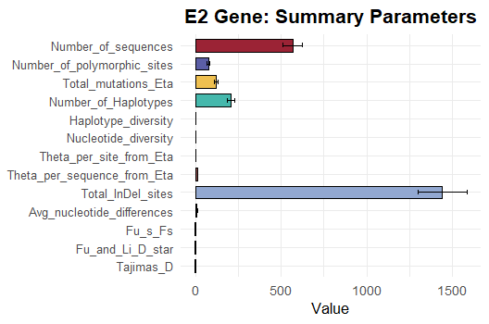

Figure 1: Genetic diversity parameters of the Classical Swine Fever Virus (CSFV) E2 gene.

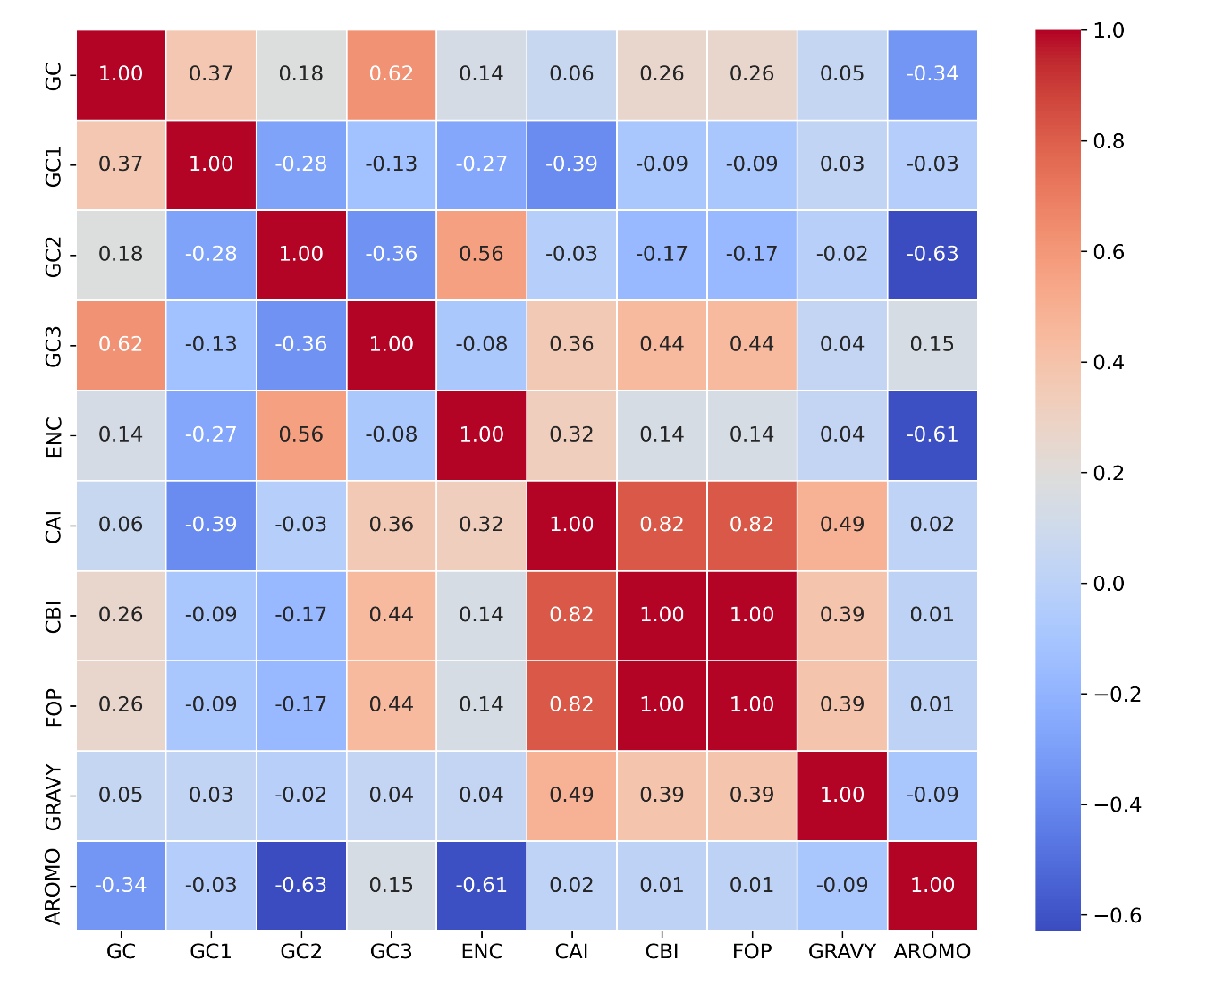

Figure 2: Hierarchical clustering heatmap of codon usage frequencies (z-score normalized) among Classical swine fever virus (CSFV) E2 gene sequences

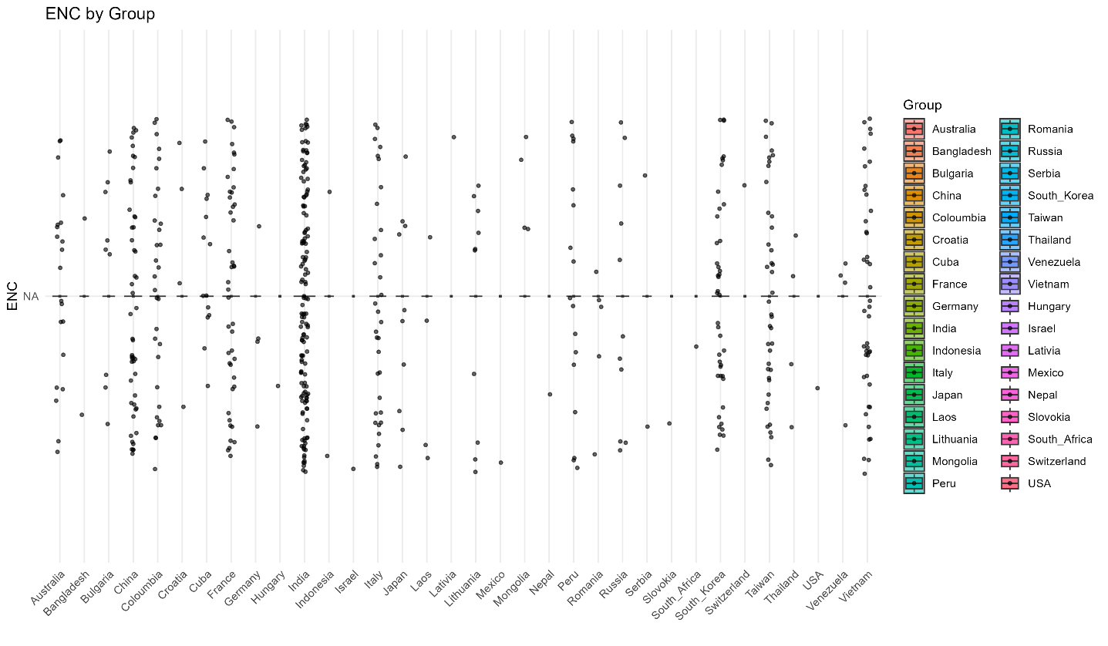
Figure 3: Effective Number of Codons (ENC) by Group

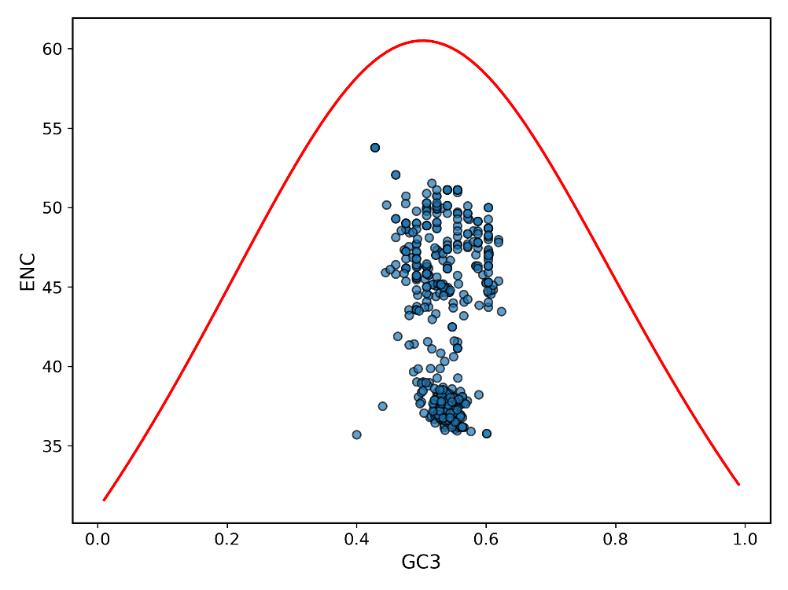

Figure 4: Relationship between Effective Number of Codons (ENC) and GC3 content

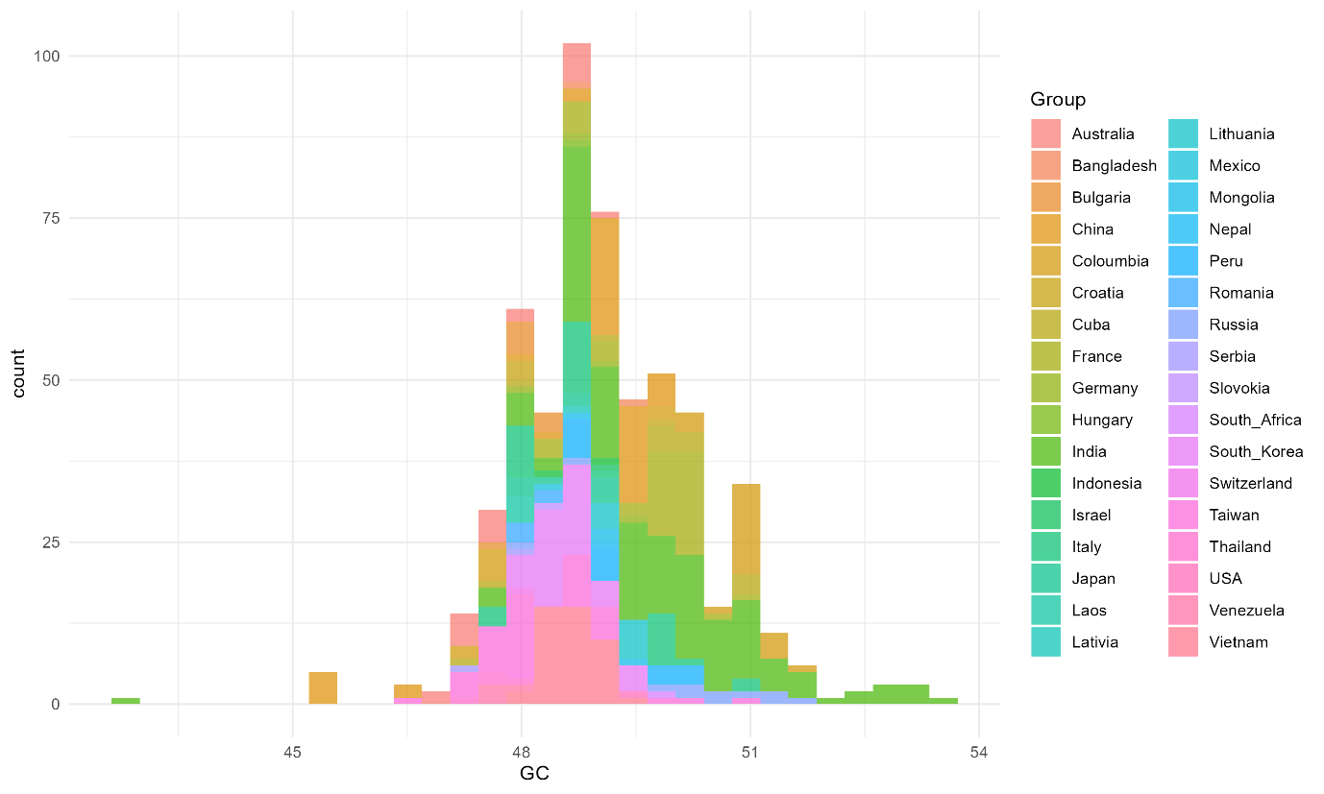
Figure 5: Distribution of GC content across global E2 gene isolates of CSFV

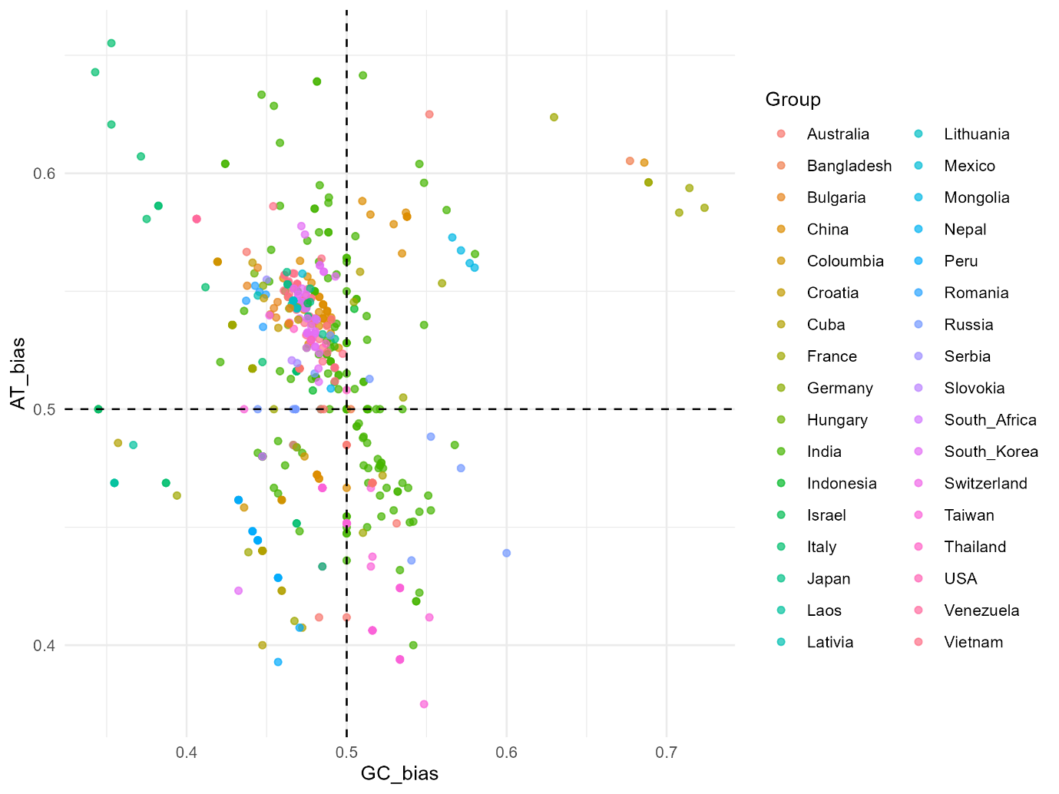
Figure 6: Parity Rule 2 (PR2) Bias Plot of the E2 Gene in Classical Swine Fever Virus (CSFV)

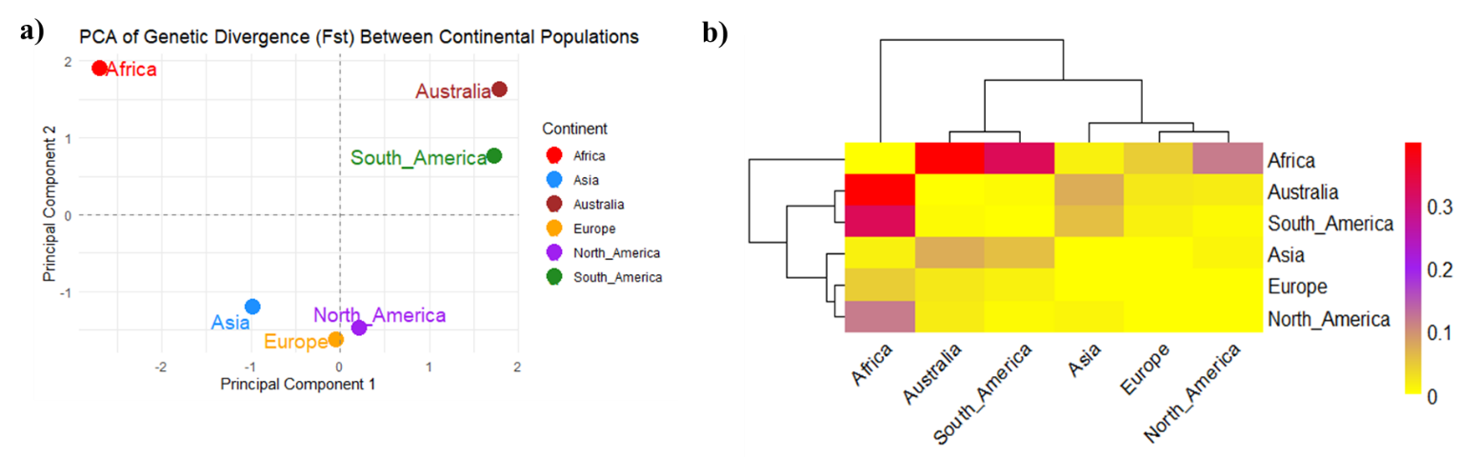
Figure 7: Genetic Divergence Among Continental Populations, a: PCA plot based on pairwise Fst values showing genetic differentiation among six continental populations. Africa and Australia are more divergent, while Asia, Europe, and North America cluster closely. b: Clustered heatmap of D² genetic distances illustrating genetic relationships among populations. Warmer colors indicate higher genetic divergence, with Asia, Europe, and North America forming a closely related cluster.

Table 1: Genetic diversity of E2 sequences collected from 34 countries
Parameters | E2
Number of sequences | 575
Selected region | 1-1336
G+C content (%) | 48
Number of polymorphic Site | 115
Total number of mutations, Eta | 345
Number of Haplotypes | 344
Haplotype (gene) diversity | 0.9
Nucleotide diversity | 0.57
Theta (per site) from Eta | 0.43
Theta (per sequence) from Eta | 49.77
Total number of InDel sites | 1219
Average number of nucleotide differences | 65.8
Fu's Fs statistic | -176.16
Fu and Li's D* test statistic | 3.79
Tajima's D | 0.96

Table 2: Pairwise population genetic differentiation and gene flow indices among global CSFV populations based on E2 gene sequences
Population 1 | Population 2 | Hs | Ks | Kxy | Gst | DeltaSt | GammaSt | Nst | Fst | Dxy | Da
Asia | South_America | 0.99 | 60.35 | 69.59 | 0.01 | 0.06 | 0.1 | 0.44 | 0.4 | 0.61 | 0.24
Asia | Europe | 0.99 | 65.56 | 68.43 | 0.01 | 0.02 | 0.03 | 0.07 | 0.06 | 0.6 | 0.04
Asia | North_America | 0.99 | 66.58 | 70.96 | 0.02 | 0.01 | 0.02 | 0.17 | 0.16 | 0.62 | 0.1
Asia | Australia | 0.99 | 64.21 | 72.03 | 0.01 | 0.03 | 0.05 | 0.51 | 0.44 | 0.63 | 0.27
Asia | Africa | 1 | 66.98 | 53.79 | 0.11 | 0 | 0 | 0.25 | 0.24 | 0.47 | 0.11
South_America | Europe | 0.96 | 47.8 | 53.11 | 0.02 | 0.05 | 0.11 | 0.21 | 0.27 | 0.46 | 0.12
South_America | North_America | 0.91 | 24.5 | 43.4 | 0.05 | 0.03 | 0.14 | 0.21 | 0.21 | 0.38 | 0.08
South_America | Australia | 0.93 | 15.79 | 21.63 | 0.03 | 0.02 | 0.15 | 0.19 | 0.3 | 0.19 | 0.06
South_America | Africa | 0.94 | 16.57 | 81.91 | 0.1 | 0.04 | 0.23 | 0.92 | 0.81 | 0.71 | 0.57
Europe | North_America | 0.95 | 59.95 | 62.46 | 0.03 | 0.01 | 0.03 | 0.04 | 0.1 | 0.54 | 0.05
Europe | Australia | 0.96 | 54.39 | 53.71 | 0.02 | 0.04 | 0.07 | 0.36 | 0.31 | 0.47 | 0.14
Europe | Africa | 0.97 | 60.29 | 62.68 | 0.11 | 0.01 | 0.01 | 0.5 | 0.39 | 0.55 | 0.21
North_America | Australia | 0.88 | 30.03 | 47.31 | 0.07 | 0.07 | 0.22 | 0.17 | 0.31 | 0.41 | 0.13
North_America | Africa | 0.83 | 47.52 | 72.22 | 0.1 | 0.08 | 0.17 | 0.63 | 0.54 | 0.63 | 0.34
Australia | Africa | 0.91 | 13.72 | 86.62 | 0.09 | 0.11 | 0.49 | 0.93 | 0.83 | 0.75 | 0.63

