Role of Weed Hosts in the Epidemiology of Chilli Leaf Curl Virus (ChiLCV) in Chilli Ecosystems

Abstract
Chilli (Capsicum annuum L.) is an economically important spice crop cultivated widely in tropical and subtropical regions. However, its productivity is severely affected by viral diseases, among which chilli leaf curl disease caused by begomoviruses is one of the most destructive. The present study was undertaken to investigate the role of weed hosts in the epidemiology of Chilli leaf curl virus (ChiLCV) in chilli ecosystems around Bengaluru. Field surveys were conducted in major chilli-growing regions including Kolar, Chikkaballapura and Bengaluru districts. Several weed species growing in and around chilli fields were collected and examined for virus-like symptoms. Typical symptoms such as yellowing, leaf curling, puckering, mosaic and stunting were observed in many weed species. Molecular detection using ChiLCV coat protein (ChiLCV-CP) specific primers confirmed the presence of begomovirus infection in several weed hosts. The results indicate that weeds present in chilli ecosystems serve as potential reservoirs of ChiLCV and contribute to disease spread through whitefly vectors. The study highlights the importance of weed management in reducing virus inoculum and minimizing the spread of chilli leaf curl disease.
Keywords: Begomovirus, Chilli Leaf Curl Virus, Weed Hosts, Epidemiology, PCR Detection, Whitefly.

Introduction
Chilli (Capsicum annuum L., Family: Solanaceae) is one of the most important spice crops cultivated worldwide due to its culinary, medicinal and economic importance (Dhaliwal et al., 2014; FAO, 2021; Sakthivel et al., 2025). India is among the leading producers of chilli, and the crop contributes significantly to agricultural income. However, chilli production is frequently affected by several diseases caused by fungi, bacteria, nematodes and viruses that reduce both yield and fruit quality (Jagdale & Ghosh, 2019).
Among viral diseases, chilli leaf curl disease caused by begomoviruses has emerged as one of the most serious threats to chilli cultivation in many countries (Kenyon et al., 2014; Kumar et al., 2011). Begomoviruses belong to the family Geminiviridae and possess circular single-stranded DNA genomes encapsidated in twinned icosahedral particles (Nawaz-ul-Rehman & Fauquet, 2009 : Brown et al., 2015). These viruses are transmitted by the whitefly Bemisia tabaci in a persistent circulative manner (Bedford et al., 1994; Senanayake et al., 2012). Infected chilli plants typically exhibit symptoms such as upward leaf curling, puckering, vein thickening, yellowing and severe stunting, which ultimately lead to substantial yield losses (; Kumar et al., 2011: Kenyon et al., 2014).
The epidemiology of begomoviruses is greatly influenced by the presence of alternate host plants. Weeds growing in and around crop fields often act as reservoirs for plant viruses and facilitate their survival during off-season periods (Varma & Malathi, 2003 : Seal et al., 2006). These weeds also provide favorable habitats for whitefly vectors and thereby enhance virus transmission to cultivated crops (Muniyappa & Veeresh, 1984; Anokhe et al., 2018). Several weed species such as Parthenium hysterophorus, Ageratum conyzoides, Sida spp., and Euphorbia spp. have been reported to harbor begomoviruses and contribute to the persistence of viral diseases in agricultural ecosystems (Mishra et al., 2020 : Pandey et al., 2022).
Molecular detection techniques such as polymerase chain reaction (PCR) have significantly improved the detection and characterization of begomoviruses from both cultivated crops and alternate host plants (Briddon et al., 2003; Khan & Khan, 2017). PCR-based detection enables the identification of virus reservoirs and facilitates better understanding of virus epidemiology in crop ecosystems (Madhu Kiran et al., 2021).
Considering the importance of alternate hosts in the epidemiology of begomoviruses, the present study was undertaken to identify weed species associated with chilli ecosystems and to determine their potential role in the epidemiology of Chilli leaf curl virus in the Bengaluru region.
Materials and Methods
Survey of chilli ecosystems
Field surveys were conducted during the chilli growing season in major chilli-producing regions around Bengaluru including Kolar, Chikkaballapura and Bengaluru districts. Several chilli fields and surrounding areas such as bunds, irrigation channels and uncultivated lands were inspected for the presence of weeds and virus-like symptoms.
Collection of weed samples
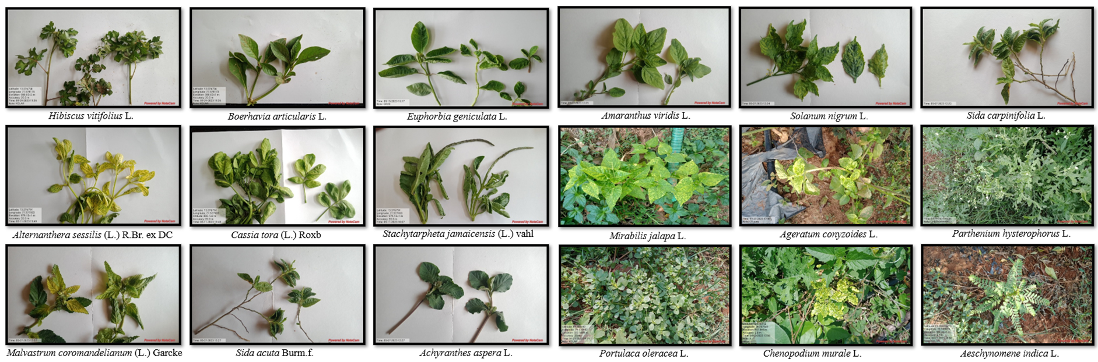
During the survey, both symptomatic and asymptomatic weed plants growing within and around chilli fields were collected for further analysis. Various weed species belonging to different plant families were observed in the chilli ecosystem. The weed hosts collected during the survey included Parthenium hysterophorus, Amaranthus viridis, Hibiscus vitifolius, Solanum nigrum, Sida acuta, Portulaca oleracea, Boerhavia erecta, Cassia tora, Stachytarpheta jamaicensis, Alternanthera sessilis, Euphorbia geniculata, Malvastrum coromandelianum, Achyranthes aspera, Ageratum conyzoides, Chenopodium murale, Solanum americanum, Mirabilis jalapa, Sida carpinifolia, Synedrella nodiflora, Acalypha indica, Commelina benghalensis and Aeschynomene indica. Collected samples were labeled and transported to the laboratory for symptom observation and molecular analysis. Representative weed samples collected during the survey are shown in Fig. 1.
Fig.1: Typical begomovirus symptoms observed on weed host plants in chilli ecosystem in and around Bengaluru
Symptom observation
The collected weed samples were examined carefully for virus-like symptoms. Symptoms such as leaf yellowing, curling, puckering, mosaic patterns and stunting were recorded.
DNA extraction
Total genomic DNA was extracted from leaf tissues of collected weed samples using the CTAB method described by Doyle and Doyle (1990). Approximately 100 mg of leaf tissue was ground in extraction buffer and incubated under appropriate conditions. The DNA was purified using chloroform-isoamyl alcohol and precipitated with isopropanol. The DNA pellet was washed with ethanol and finally dissolved in TE buffer for further molecular analysis.
PCR detection of ChiLCV
PCR amplification was carried out using Chilli leaf curl virus coat protein (ChiLCV-CP) specific primers for the detection of begomovirus infection in weed samples. The reaction mixture consisted of template DNA, forward and reverse primers, PCR buffer, dNTPs and Taq DNA polymerase. Amplification was performed in a thermal cycler using standard cycling conditions. The amplified products were separated by agarose gel electrophoresis and visualized under UV illumination following the method described by Sambrook and Russell (2001).
Results and Discussion
Symptomatology of begomovirus infection in weed hosts
During the field survey, several weed species growing in and around chilli fields exhibited typical symptoms associated with begomovirus infection. The symptoms observed included yellowing of leaves, upward curling, puckering, mosaic patterns and stunted growth. Among the weed hosts observed, Parthenium hysterophorus, Sida acuta, Solanum nigrum, Alternanthera sessilis, Euphorbia geniculata, Ageratum conyzoides and Malvastrum coromandelianum frequently exhibited virus-like symptoms. The distribution of weed species and associated symptoms observed during the survey are summarized in Table 1.

Table 1: Weed hosts showing begomovirus-like symptoms in chilli ecosystems around Bengaluru
District | Taluk | Weed species | Family | Observed symptoms
Kolar | Srinivaspur | Parthenium hysterophorus | Asteraceae | Yellowing, curling, mosaic
Kolar | Srinivaspur | Amaranthus viridis | Amaranthaceae | Yellowing
Kolar | Srinivaspur | Hibiscus vitifolius | Malvaceae | Curling
Kolar | Srinivaspur | Solanum nigrum | Solanaceae | Yellowing, curling
Kolar | Srinivaspur | Sida acuta | Malvaceae | Yellowing, curling
Chikkaballapura | Chinthamani | Alternanthera sessilis | Amaranthaceae | Yellowing, curling
Chikkaballapura | Chinthamani | Euphorbia geniculata | Euphorbiaceae | Curling, puckering
Chikkaballapura | Chinthamani | Malvastrum coromandelianum | Malvaceae | Yellowing, curling
Chikkaballapura | Chinthamani | Ageratum conyzoides | Asteraceae | Yellowing, curling
Chikkaballapura | Chikkaballapura | Solanum americanum | Solanaceae | Yellowing, curling
Kolar | Srinivaspura | Sida carpinifolia | Malvaceae | Yellowing
Kolar | Mulbagal | Acalypha indica | Euphorbiaceae | Yellowing, curling
Bengaluru Urban | Bengaluru North | Cassia tora | Fabaceae | Yellowing, curling

The occurrence of these symptoms suggests that these weeds may serve as alternate hosts for begomoviruses in chilli ecosystems. Similar findings have been reported in earlier studies where several weed species were identified as reservoirs of begomoviruses in vegetable cropping systems (Varma & Malathi, 2003; Pandey et al., 2022).
Molecular detection of ChiLCV in weed samples
PCR amplification using ChiLCV coat protein specific primers produced expected DNA fragments in several weed samples, confirming the presence of begomovirus infection. The PCR products were analyzed through agarose gel electrophoresis and the amplified bands were visualized under UV illumination. The PCR results indicate that several weed hosts present in chilli ecosystems harbor ChiLCV and can serve as reservoirs of the virus.
The presence of begomoviruses in weed hosts has been reported earlier in several cropping systems and is known to play an important role in disease epidemiology (Mishra et al., 2020; Madhu Kiran et al., 2021). Weeds that remain in the field throughout the year can maintain virus populations during non-cropping seasons. The PCR amplification results for ChiLCV detection in weed samples are presented in Fig.2.
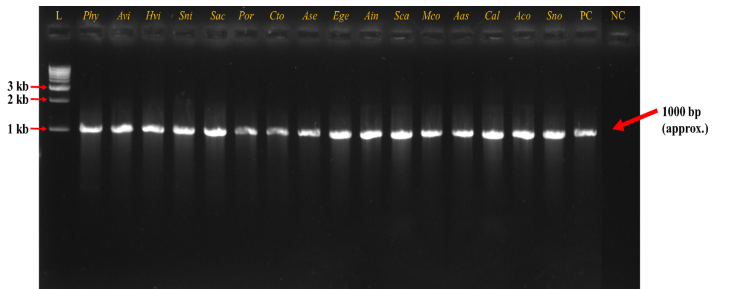
Fig.2. PCR amplified ChiLCV-CP in weed samples collected from different locations.
L – DNA ladder; PC – Positive control; NC – Negative control.
Phy – Parthenium hysterophorus; Avi – Amaranthus viridis; Hvi – Hibiscus vitifolius; Sni – Solanum nigrum; Sac – Sida acuta; Por – Portulaca oleracea; Cto – Cassia tora; Ase – Alternanthera sessilis; Ege – Euphorbia geniculata; Ain – Aeschynomene indica; Sca – Sida carpinifolia; Mco – Malvastrum coromandelianum; Aas – Achyranthes aspera; Cal – Calyptocarpus vialis; Aco – Ageratum conyzoides; Sno – Synedrella nodiflora.

Role of weeds in virus epidemiology
Weeds growing around chilli fields play a significant role in the epidemiology of begomoviruses. These plants can harbor viruses without severe symptoms and act as reservoirs of infection. Whiteflies feeding on infected weed hosts acquire the virus and subsequently transmit it to healthy chilli plants. The presence of these weed reservoirs therefore facilitates the persistence and spread of chilli leaf curl disease in agricultural ecosystems (Bedford et al., 1994; Senanayake et al., 2012).
Effective management of weeds surrounding chilli fields is therefore essential to reduce virus inoculum and minimize disease spread.
Conclusion
The present study demonstrated that several weed species associated with chilli ecosystems around Bengaluru harbor Chilli leaf curl virus. Symptom observations and molecular detection confirmed that weeds such as Parthenium hysterophorus, Ageratum conyzoides, Sida acuta, Euphorbia geniculata and Alternanthera sessilis act as potential reservoirs of ChiLCV. These weeds play a crucial role in virus survival and spread through whitefly vectors (Fig.3). Therefore, proper weed management along with vector control strategies is essential to reduce the incidence of chilli leaf curl disease in chilli cultivation.
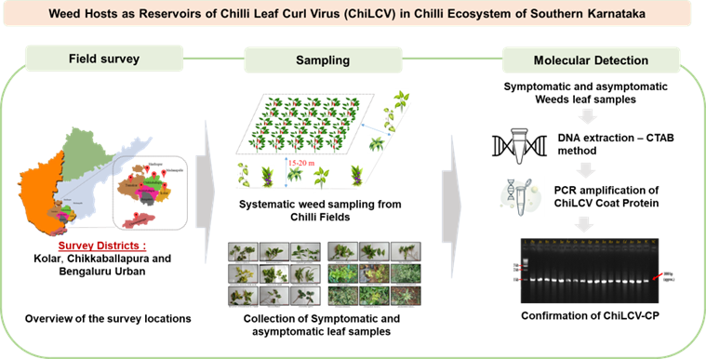Fig 3. Workflow illustrating survey locations, weed host sampling, symptom observation, and PCR detection of ChiLCV in chilli ecosystems.
References
Anokhe, A., Jangid, K., & Sharma, P. (2018). Transmission efficiency of mungbean yellow mosaic virus by different cryptic species of Bemisia tabaci. Archives of Phytopathology and Plant Protection, 51(1–2), 67–80.
Banerjee, M. K., & Kalloo, G. (1987). Inheritance of resistance to leaf curl virus in tomato. Euphytica, 36(2), 581–586.
Bedford, I. D., Briddon, R. W., Brown, J. K., Rosell, R. C., & Markham, P. G. (1994). Geminivirus transmission and biological characterization of Bemisia tabaci populations. Annals of Applied Biology, 125(2), 311–325.
Briddon, R. W., Bull, S. E., Mansoor, S., Amin, I., & Markham, P. G. (2003). Universal primers for the PCR-mediated amplification of DNA β. Molecular Biotechnology, 20, 315–318.
Briddon, R. W., & Stanley, J. (2006). Subviral agents associated with plant single-stranded DNA viruses. Virology, 344(1), 198–210.
Brown, J. K., Zerbini, F. M., Navas-Castillo, J., Moriones, E., Ramos-Sobrinho, R., Silva, J. C., & Varsani, A. (2015). Revision of begomovirus taxonomy based on pairwise sequence comparisons. Archives of Virology, 160(6), 1593–1619.
Chakraborty, S., Pandey, P. K., Banerjee, M. K., Kalloo, G., & Fauquet, C. M. (2003). Tomato leaf curl Gujarat virus: A new begomovirus species causing leaf curl disease of tomato in India. Archives of Virology, 148(7), 1489–1499.
Dhaliwal, M. S., Jindal, S. K., & Dhaliwal, P. S. (2014). Chilli: Production, processing and value addition. Indian Journal of Horticulture, 71(3), 403–408.
Doyle, J. J., & Doyle, J. L. (1990). Isolation of plant DNA from fresh tissue. Focus, 12, 13–15.
FAO. (2021). FAOSTAT statistical database. Food and Agriculture Organization of the United Nations.
Ghanem, G. A. (2003). Okra leaf curl virus: Transmission by the whitefly Bemisia tabaci. Annals of Applied Biology, 142(2), 205–210.
Hussain, M., Mansoor, S., Iram, S., Zafar, Y., & Briddon, R. W. (2004). First report of chilli leaf curl virus infecting chilli in Pakistan. Plant Pathology, 53(6), 794.
Jagdale, S. S., & Ghosh, D. K. (2019). Viral diseases of chilli: A review. International Journal of Current Microbiology and Applied Sciences, 8(4), 1915–1925.
Jha, A., & Raychaudhuri, S. P. (1956). Mosaic disease of chilli in India. Indian Phytopathology, 9, 11–16.
Kenyon, L., Kumar, S., Tsai, W. S., & Hughes, J. (2014). Virus diseases of peppers. Plant Disease, 98(1), 1–17.
Khan, M. S., & Khan, J. A. (2017). Molecular characterization of a begomovirus infecting chilli in India. Virus Genes, 53(3), 472–480.
Kumar, S., Singh, A. K., & Singh, M. (2011). Chilli leaf curl virus: A major threat to chilli production. Archives of Phytopathology and Plant Protection, 44(10), 1–12.
Madhu Kiran, P., Venkataravanappa, V., Reddy, C. L., & Reddy, M. K. (2021). Molecular detection and characterization of chilli leaf curl virus infecting chilli. Journal of Plant Pathology, 103(1), 185–194.
Mishra, G. P., Kumar, R., & Singh, A. K. (2020). Genetic diversity and recombination analysis of begomoviruses infecting chilli. Virus Research, 283, 197983.
Muniyappa, V., & Veeresh, G. K. (1984). Plant virus diseases transmitted by whiteflies in India. Advances in Virus Research, 29, 1–44.
Nawaz-ul-Rehman, M. S., & Fauquet, C. M. (2009). Evolution of geminiviruses and their satellites. FEBS Letters, 583(12), 1825–1832.
Pandey, P., Sharma, S., & Singh, R. (2022). Genetic diversity of begomoviruses infecting chilli in India. Virus Research, 307, 198–210.
Sakthivel, M., Nath, R., Marimuthu Elangovan, S. S., & Anithaa, V. (2025). Field evaluation of fungicides and bio-products for management of Fusarium wilt in chilli (Capsicum annum L.). Plant Archives, 25(1), 2124-2132.
Seal, S., van den Bosch, F., & Jeger, M. (2006). Factors influencing begomovirus evolution and emergence. Virus Research, 119(2), 151–161.
Senanayake, D. M. J. B., Varma, A., & Mandal, B. (2012). Virus–vector relationships of chilli leaf curl virus. Plant Pathology, 61(3), 447–456.
Varma, A., & Malathi, V. G. (2003). Emerging geminivirus problems: A serious threat to crop production. Annals of Applied Biology, 142(2), 145–164.

