Genetic Divergence and Population Structure in Sprouting Broccoli (Brassica oleracea var. italica Plenck) Revealed Through Cluster and Principal Component Analyses.

ABSTRACT

The present investigation was carried out on 28 genotypes of broccoli (Brassica oleracea var. italica Plenck) at the Experimental Vegetable Farm, ETC Malangpora, Pulwama, during the Rabi season of 2023. The trial was laid out in a Randomized Complete Block Design (RCBD). To evaluate genetic divergence and identify promising genotypes, Principal Component Analysis (PCA) and cluster analysis were utilized. Three principal components (PC1 to PC3) with eigenvalues greater than one accounted for 88.66% of the total phenotypic variation. Traits like curd weight (0.97%), curd depth (0.96%), and curd yield (0.97%) contributed predominantly to PC1, while total soluble solids (0.91%) and acidity (0.83%) influenced PC2. PC3 was primarily explained by plant height (0.55%) and curd diameter (0.12%). Based on cluster analysis, the genotypes were grouped into four distinct clusters, indicating substantial genetic diversity. Cluster 1 comprised the most genotypes (12), followed by cluster 2 (11), while clusters 3 and 4 included three and one genotype(s), respectively. The highest inter-cluster distance was observed between clusters 1 and 4 (1159.60), highlighting significant divergence, while the lowest was between clusters 1 and 2 (77.81). The analysis of cluster means provided essential insights for selecting diverse and superior genotypes for future breeding efforts.
Keywords: principle component analysis (PCA), cluster mean, Broccoli, Randomised compelete block design.

INTRODUCTION
Broccoli (Brassica oleracea var. italica Plenck) is a vital cole crop of the Brassicaceae (Cruciferae) family, possessing a diploid chromosome number of 18. The term “broccoli” originates from the Italian word Brachium, meaning “arm” or “branch” (Thakur et al.,2016). Like other cole crops, it descends from Brassica oleracea var. sylvestris—also known as wild cabbage or colewort—through domestication involving natural selection and genetic variation (Chaves Junior et al.,2021). Broccoli is highly regarded for its rich content of sulforaphane, a compound with anti-cancer properties. It is also praised for its taste, flavor and nutritional value, earning it the title of the "Crown Jewel of Nutrition" (Kour, 2020). Nutritionally, broccoli is an excellent source of vitamin A (2500 I.U.), vitamin C (113 mg), protein (3.6 g), carbohydrates (5.9 g) and minerals like phosphorus (382 mg), calcium (103 mg) and sodium (15 mg) per 100g of edible portion. Among cole crops, broccoli stands out as the richest source of protein. Research suggests that a high intake of broccoli can reduce the risk of cancer, because of its glucoraphanin compounds, which also help prevent heart diseases (Allen and Allen, 2007). Additionally, the crop is known to provide protection against chronic ailments such as cancer, cardiovascular diseases and age-related vision loss (Habib et al., 2013).
In India, broccoli has seen a surge in popularity, especially in tourist regions like Kashmir, where demand in hotels and restaurants has grown. It is primarily cultivated in hilly areas such as Himachal Pradesh, Uttarakhand, Jammu & Kashmir, the Nilgiri Hills, and parts of the Northern plains (Habib et al.,2013). Globally, broccoli and cauliflower together are grown on about 1,357.18 thousand hectares, with an annual production of 25,531.27 thousand metric tonnes (Anonymous, 2020a). In India, the area under these crops is around 459 thousand hectares, producing approximately 8,844 thousand metric tonnes (Anonymous, 2020b). Specifically, In Himachal Pradesh, broccoli occupies 490.20 hectares, with a production of about 11,232.23 metric tonnes annually (Anonymous, 2020c). Cluster analysis and Principal Component Analysis (PCA) in broccoli serve as essential tools for classifying genotypes into distinct groups based on their morphological, physiological, and yield-related characteristics. These methods play a crucial role in evaluating genetic diversity, which is fundamental for developing effective breeding strategies. Cluster analysis groups genotypes with similar traits, aiding in the identification of those with superior agronomic potential and yield attributes. This information is valuable for selecting genetically diverse parents for hybridization programs. Conversely, PCA simplifies complex datasets by identifying the most influential traits contributing to overall variability. By extracting principal components that explain the highest proportion of variation, PCA provides insights into trait associations and their impact on yield and quality. Furthermore, these analytical approaches help visualize genotype distribution within a multidimensional space, enhancing the understanding of genetic relationships. The findings from cluster and PCA analyses are instrumental in selecting promising genotypes for crop improvement and assessing their adaptability to diverse environmental conditions.
MATERIAL AND METHODS
A set of 28 genetically diverse broccoli (Brassica oleracea var. italica) genotypes was evaluated during the Rabi season of 2023 at the Experimental Vegetable Farm, ETC Malangpora, Pulwama. The trial was laid out in a Randomized Complete Block Design (RCBD) with appropriate replications to enhance the accuracy and reliability of the results. Standard agronomic practices were followed uniformly throughout the growing season. Observations were recorded on various morphological, physiological, and yield-attributing traits including plant height, plant spread, number of leaves, leaf area, curd diameter, curd weight, curd depth, days to curd initiation, days to first curd harvest, total soluble solids (TSS), ascorbic acid, total carotenoids, dry matter, and overall yield.
Cluster analysis was carried out using the agglomerative hierarchical method (Ward’s method) in R software, with Euclidean distance as the dissimilarity metric. A dendrogram (Fig.1) was generated to determine the optimal number of clusters, enabling the classification of genotypes into groups with similar trait profiles. Principal Component Analysis (PCA) was also performed in R to reduce data dimensionality and identify key traits contributing to total variability. Eigenvalues, factor loadings, and cumulative variance were computed, and a biplot was constructed to illustrate the distribution of genotypes and trait associations. The combined use of PCA and clustering offered valuable insights into genetic divergence and helped identify potential genotypes for breeding programs.
The selection strategies for broccoli improvement Principal Component Analysis (PCA) was employed based on the correlation matrix to examine interrelationships among various correlated quantitative traits. This method allowed the transformation of correlated variables into a new set of uncorrelated components, known as principal components (PCs), as outlined by Johnson and Wichern (1988). By identifying traits that contributed most to overall variability, this approach provided a strategic basis for selecting superior genotypes, thereby enhancing the efficiency of broccoli improvement programs.

RESULTS AND DISCUSSION
Using Ward’s method, cluster analysis grouped the 28 broccoli genotypes into four well-defined clusters, reflecting substantial genetic variability. The lowest intra-cluster distance was recorded in Cluster 2 (77.81), suggesting a high level of genetic uniformity among its genotypes. In contrast, Cluster 4, containing only a single genotype, exhibited an intra-cluster distance of 0.00. The widest inter-cluster distance was observed between Clusters 3 and 4 (1159.60), indicating considerable genetic divergence. This level of variation suggests that crosses between these two clusters may yield high heterosis.
Trait-wise analysis revealed that Cluster 3 exhibited the highest average curd weight (350.21 g), followed by Cluster 2 (187.02 g), while Cluster 4 had the lowest mean curd weight (93.64 g). Similarly, curd yield per plant peaked in Cluster 3 (144.71 g), emphasizing its potential for productivity enhancement. Regarding maturity, Cluster 3 included the earliest maturing genotypes (86.64 days to first harvest), whereas Cluster 4 showed delayed maturity (103.21 days). Additionally, Cluster 3 recorded the maximum curd diameter (12.46 cm), a trait favoured for market appeal. These findings support the strategic selection of Cluster 3 genotypes for breeding programs aimed at improving yield and early maturity. Significant variation in quality traits was observed among the different clusters. Cluster 3 recorded the highest ascorbic acid content (77.03 mg/100g), underlining its nutritional importance. Cluster 4 had the maximum dry matter content (17.84%), while total carotenoid content was also highest in Cluster 3 (3.12 mg/100g), indicating its strong antioxidant potential. As noted by Falconer (1964), greater genetic divergence among parents often enhances the potential for heterosis in hybrids. Therefore, selecting genetically distant genotypes for hybridization can be a strategic approach to exploit heterotic effects. Incorporating such diverse genotypes into breeding programs not only broadens the genetic base but also supports the development of improved cultivars. Given that increasing yield and associated traits remains a primary objective in plant breeding, assessing genetic diversity across clusters in relation to these traits is crucial for informed selection (Gupta et al.,2023).
Multivariate techniques such as Principal Component Analysis (PCA) are highly effective for simplifying complex data by converting correlated traits into uncorrelated principal components (PCs). Significant components are typically identified based on eigenvalues greater than one, as they capture more variance than individual original traits (Jadhav et al.,2023). PCA thus plays a critical role in pinpointing major contributors to genetic variation, aiding in efficient genotype selection and trait improvement strategies. The scree plot (Figure 2) depicts the proportion of variance explained by each principal component. The first principal component (PC1) accounts for a substantial 73.4% of the total variation, followed by PC2, which explains an additional 10%. The remaining components contribute less significantly, with PC3 and PC4 accounting for 5.2% and 3.2% of the variance, respectively. Since the combined variance explained by the first two components exceeds 80%, they are considered sufficient to capture the essential structure and variation within the dataset.
Eigenvectors associated with each principal component provide insights into the influence of individual traits (Table 1). Traits with higher eigenvector values within a specific component have a greater impact on that component. In the present study, plant spread (0.96), number of leaves (0.93), curd diameter (0.75), and dry matter content (0.92) showed strong loadings on PC1, indicating their significant contribution to the observed variability among genotypes. Ascorbic acid (0.91) was predominantly associated with PC2, while curd diameter (0.12) had a notable loading on PC3.A two-dimensional biplot (Figure 3) was constructed to visually represent the relationships among morphological and quality traits. Traits positioned in the same direction indicate positive correlations, assisting in trait-based genotype grouping for breeding applications.

Fig.1: Dendrogram dividing genotypes of broccoli into FOUR clusters by wards method
G15
G24
G26
G27
G28
G21
G5
G14
G22
G23
G4
G10
G13
G7
G12
G6
G8
G16
G1
G2
G18
G19
G17
G25
G3
G20
G9
G11
0
200
400
600
800
1000
1200
1400
Height
(Figure 2) Principal componenet analysis –scree plot of the data base present in broccoli genotypes (Brassica oleracea var. italica plenck)
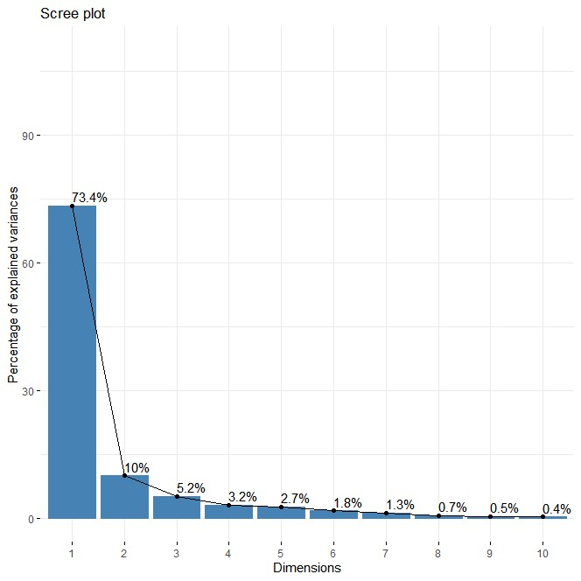

Fig. 3: Relationship among 20 characters in (Brassica oleracea var. italica Plenck ) germplasm by 2D scatter for first two principal components
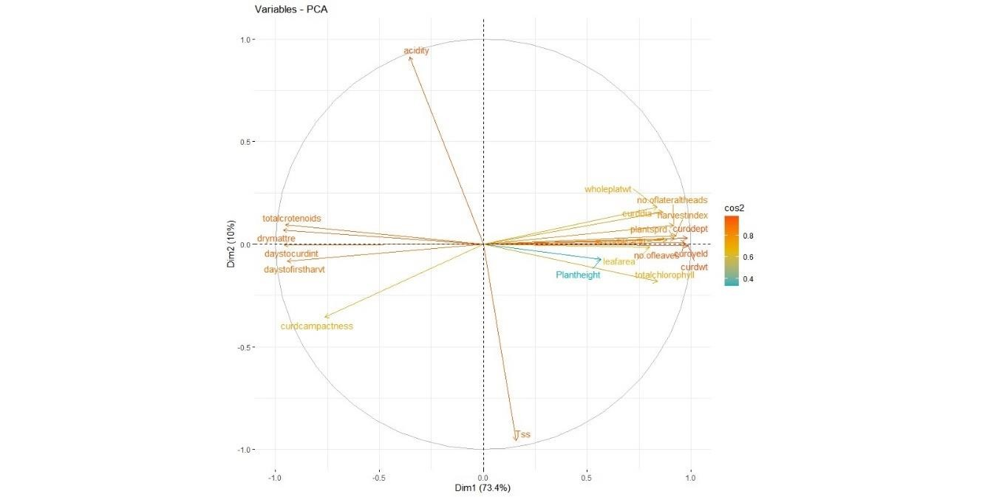

Figure 4: Distribution of various genotypes among first 2 PC’s explaining trait contributions
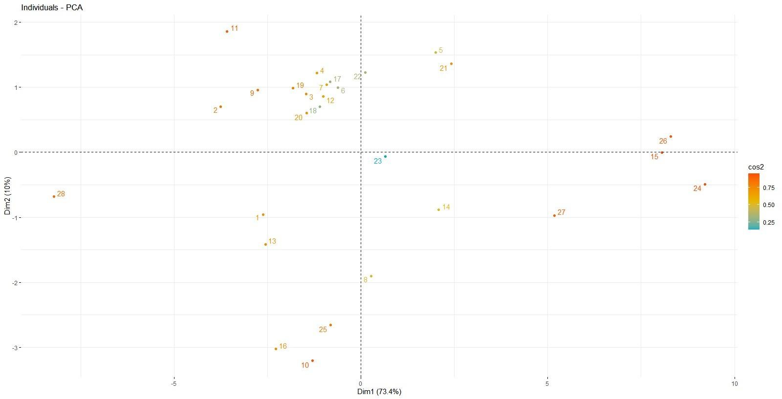

Figure 5: Cluster plot and silhouette diagram explaining cluster formation and PCA


-5
0
5
10
-3
-2
-1
0
1
2
Component 2
28
27
24
10
13
21
12
7
8
4
16
20
25
17
2
0.0
0.2
0.4
0.6
0.8
1.0
n = 28
4
clusters
C
j
j
:
n
j
|
a
v
e
i
C
j
s
: 12 |
0.39
1
0.54
: 11 |
2
0.64
3
: 4 |
4
0.00
: 1 |

Table 1: Latent vectors for various quantitative and quality traits in (Brassica oleracea var, italica L. ) genotypes
Parameters | Dim.1 | Dim.2 | Dim.3
Plant height | 0.32 | 0.0056 | 0.55
Number of leaves | 0.93 | 0.00087 | 0.005
Plant spread | 0.84 | 0.00066 | 0.00065
Curd diameter | 0.75 | 0.024 | 0.12
Curd depth | 0.96 | 0.00096 | 0.000056
Curd weight | 0.97 | 0.000025 | 0.013
Days to curd initiation | 0.92 | 0.000010 | 0.010
Days to first harvest | 0.89 | 0.0067 | 0.0044
Number of lateral heads | 0.84 | 0.0085 | 0.011
Leaf area | 0.64 | 0.0002 | 0.059
TSS | 0.02 | 0.91 | 0.028
Ascorbic acid | 0.77 | 0.00044 | 0.076
Dry matter | 0.92 | 0.0047 | 0.0043
Total carotenoids | 0.90 | 0.0089 | 0.034
Curd yield | 0.97 | 0.000019 | 0.013
Whole plant weight | 0.70 | 0.033 | 0.0057
Acidity | 0.12 | 0.83 | 0.000042
Harvest index | 0.86 | 0.0018 | 0.017
Total chlorophyll | 0.70 | 0.032 | 0.065
Curd compactness | 0.58 | 0.12 | 0.0098
Eigen value | 14.67 | 2.00 | 1.04
Percentage variance | 73.33 | 10.03 | 5.23
Cumulative percentage variance | 73.39 | 83.43 | 88.66

The clustering of the traits in the same direction suggests strong positive correlations, whereas those positioned in opposite directions exhibit negative correlations. For instance, plant spread, curd diameter, and total carotenoids were grouped closely, indicating their mutual influence on PC1.The distribution of genotypes along the first two principal components (PCs) (Figure 4) offers valuable insights into the genetic variability among broccoli accessions. Genotypes positioned farther apart indicate greater genetic divergence, making them potential candidates for hybridization programs. Conversely, genotypes clustering closely together exhibit similar trait expressions, which can be beneficial for selection in breeding programs targeting specific attributes. The PCA results (Figure 5) highlight that traits such as plant spread, curd diameter, and dry matter content play a crucial role in genetic differentiation among broccoli genotypes. The traits identified through PCA—particularly those contributing significantly to variation—should be prioritized in yield-focused breeding programs. PCA also aids in selecting genetically diverse genotypes with high heterotic potential for hybrid development, consistent with the findings of Sinha et al. (2021). In a related study on carrot using the Partitioning Around Medoids (PAM) clustering method with four clusters (k = 4), the first two principal components explained 80.5% of the total variation. The cluster plot showed clear separation in some groups, while others overlapped slightly. Component 1 contributed to the spread of the largest cluster, while a smaller, distinct group was positioned on the right. Silhouette analysis revealed variable cluster cohesion, with an average silhouette width of 0.47, indicating moderate clustering strength. The best-defined cluster had a silhouette width of 0.64, while others showed weaker internal consistency.
CONCLUSION
Principal Component Analysis (PCA) successfully reduced data dimensionality while retaining 88.66% of the total variance through the first three components. PC1 (73.33%) was mainly influenced by curd weight, curd depth, plant spread, and total carotenoids, indicating their major role in genetic variability. PC2 (10.03%) and PC3 (5.23%) were associated with TSS, acidity, and plant height. The scree plot and biplot confirmed that a few principal components sufficiently capture data structure, aiding in trait prioritization and genotype differentiation. Cluster analysis grouped genotypes based on trait similarity, revealing clear genetic divergence. These clusters provide a valuable resource for selecting parents to exploit heterosis. A moderate silhouette width of 0.47 indicated fair clustering efficiency, with some overlap observed between groups. Overall, the integration of PCA and clustering proved effective in identifying elite genotypes and guiding selection in broccoli breeding programs.
REFERENCES
Allen, R. G. and Allen, C. T. 2007. The effects of glucoraphanin in broccoli on cancer prevention and heart disease. Journal of Nutritional Science 12(3), 200-210.
Anonymous.2020a. State-level area and production statistics (2019–20). National Horticulture Board, Government of India.2020.
Anonymous. (2020b). State-level area and production statistics (2019–20). National Horticulture Board, Government of India. 2019-20
Anonymous. (2020c). Area and production of broccoli in Himachal Pradesh. Directorate of Agriculture, Shimla, Himachal Pradesh.
Chaves Junior, O. J., Zeffa, D. M.,Constantino, L. V., Giacomin, R. M., Siqueira, R. G. B., Silva, G. A. B., Nogueira, A. F., Goncalves, L. S. A., & Ventura, M. U. (2021). Genetic variability among broccoli genotypes based on biochemical and molecular traits. Horticultura Brasileira, 39(3), 288–293.
Falconer, D. S., & Mackay, T. F. C. (1996). Introduction to quantitative genetics (4th ed.). Longman.
Gupta, A., Sharma, R., Singh, P., & Kumar, V. (2023). Genetic diversity assessment for yield and associated traits in crop plants using cluster analysis. Journal of Plant Breeding and Genetics, 15(2), 123–135.
Habib, K., Ahmad, N., Sofi, P. A., Khan, S. H. and Shafi, T. 2013. Genetic variability and trait association in sprouting broccoli (Brassica oleracea var. italica Plenck) under temperate Kashmir valley conditions. Journal of Applied Horticulture 15(3): 211-14
Jadhav, R. A., Mehtre, S. P., Patil, D. K., & Gite, V. K. (2023). Multivariate analysis using D² and principal component analysis in mung bean [Vigna radiata (L.) Wilczek] for study of genetic diversity. Legume Research, 46(1), 10–17.
Johnson, R. A., & Wichern, D. W. (1988). Applied multivariate statistical analysis (2nd ed.). John Wiley & Sons.
Kour, R. 2020. Performance of different varieties of broccoli under agro climatic conditions of Doda. Indian Research Journal of Genetics and Biotechnology 12(2): 144-47.
Silhouettes, Rousseeuw, (1987). Silhouettes: A graphical aid to the interpretation and validation of cluster analysis. Journal of Computational and Applied Mathematics, 20, 53–65.
Sinha, A., Singh, P., Bhardwaj, A., & Verma, R. B. (2021). Principal component analysis approach for comprehensive screening of tomato germplasm under polyhouse condition. Journal of Experimental Agriculture International, 43(9), 67–72.
Ward, J. H. (1963). Hierarchical grouping to optimize an objective function. Journal of the American Statistical Association, 58(301), 236–244.

