The Fogg behavior model: How COVID-19 triggered to the transformation in health seeking behavior among respondents

Abstract
Every year brings its own challenges, but the year (2020) had been more demanding than most. On 8 January 2020, a new virus was identified as the cause of the pneumonia by Chinese scientists. On 11th March 2020, the World Health Organization labeled the disease as COVID-19, which stands for corona virus disease 2019. The Covid-19 pandemic has had a profound impact on people's lives across the globe. India faced a series of challenges and implemented various strategies to combat the virus and during pandemic behavioral changes was evident as individuals adapted to new norms of social distancing, mask-wearing, and hygiene practices. In the study, cross-sectional impact on the health seeking behavior of rural people and how the transformation in their behavior occurred during COVID-19 into two districts viz. Hisar and Sirsa was observed. The results revealed that health seeking behaviors varied significantly during the COVID 19 pandemic with highest adherence observed in changes to daily routines, escape from anxiety, stress coping strategy/pandemic nervousness/ boredom (WMS - 2.67) in district Hisar while in district Sirsa highest adherence was seen in changes to daily routines of wearing masks (WMS - 2.89). The Fogg behavior model was applied to evaluate the transformation of behavior among respondents towards health in both the districts. It was applied on the elements for which the respondents felt change and followed them in order to break the chains for spread of COVID-19.In Hisar change was seen in elements like ‘fluids’(B = MAT), ‘modes’, ‘hand wash’ B ≠ MAT) ‘transmission’ (B = MAT) and ‘daily routine’ (B = MAT), whereas in district Sirsa, changes were seen in elements like ‘modes’(B = MAT), ‘fluids’ (B = MAT), daily routine’ (B ≠ MAT) and ‘transmission’(B = MAT).
Keywords: COVID-19, Fogg behavior model, health-seeking behavior, challenges

INTRODUCTION
COVID – 19 pandemic had become an everyday topic of discussion throughout the world making people still remember the deaths and recoveries. Since the birth of civilization humans had experienced health issues due to changes in the quality of panch maha tatvas i.e Bhoomi (earth), Jal (water), Akash (Sky), Agni (fire) and vayu (air), which adversely affect human health or wellbeing (Pevey et. al 2017). The COVID-19 pandemic, an unprecedented global health crisis, disrupted daily life and significantly influenced behavior across multiple domains. In spite of national and international efforts for more than one year, the pandemic continued to spread unabated and has taken a heavy toll on human health and economy. In the context of health seeking behavior, the pandemic became a key trigger for individuals to reassess their habits, perceptions, and motivations regarding health. Health seeking behavior is often understood as any activity undertaken by individuals who found themselves with a health-related problems or illness with the aim of seeking an appropriate remedy and the people would become more active than before towards their food habits and if somehow the virus continues to sustain in any other variants viz. (Alpha (UK, 2020), Beta (South Africa, 2020), Gamma (Brazil, 2020), Delta (India, 2021), Omicron (South Africa, 2022) and Omicron sub-variants (BA.4, BA.5 2022) with the same symptoms like those of COVID-19, then also people continued to take strict precautions to build their immunity and till date also the scene could be observed at hospitals and other public places.
In response to the pandemic, several critical measures related to preventive practices, such as increased intake of fluids, willing to spend time on healthcare, masks to overcome fear of catching infection, self-isolation and so on were adopted by respondents in order to stop the chain of person-to-person transmission during the pandemic. On the contrary, Fogg Behavior Model (FBM) proposed by Dr. B.J. Fogg, offered a robust framework to understand the transformation in any kind of behavior among people by breaking them down into three key components: motivation, ability, and trigger. This model helps to elucidate how and why people adapted their health-seeking practices during the pandemic.
METHODOLOGY
The study was conducted in rural areas of district Hisar and Sirsa. Two blocks of Hisar, Hisar-I and Hisar-II and Ellenabad and Rania block from district Sirsa were selected randomly.Two villages i.e. Arya Nagar and Mayyar from each block (Hisar) whereas Talwara Khurd and Badaguda from (Sirsa) were selected randomly. Thus, a total of four villages were selected randomly to draw the sample on COVID-19. Fifty respondents from adulthood to above 60 years of age were selected from each preferred village. Thus, the sample constituted for the study was 200 respondents selected purposively who suffered from COVID-19. With the help of Deputy Civil Surgeon (COVID) (Rep.) Chief Medical Officer, Civil Hospital, Hisar and Deputy Chief Medical Officer, Civil Hospital, Sirsa, the list was procured to draw the area for sample. The respondents were selected on the basis of inclusive and exclusive criteria. In inclusive criteria, respondents selected were the ones who gave their consent, were exposed or diagnosed with the virus and utilized healthcare/GP whereas in exclusive criteria respondents selected were the ones who refused to give their consents, suffered with any disease such as depression and mental illness and were on the medication and who were exposed from the virus but did not utilized healthcare/neither consulted general practitioner. The interview schedule was discussed thoroughly with experts from Department of Preventive and Social Medicine, Agrasen Medical College, Agroha, Civil hospital Hisar and Sirsa, the suggestions were incorporated in the schedule accordingly and modified.
Data were collected with the help of interview schedule. Participants were informed that the participation in the survey was voluntary and all the information collected would be used for research only and kept strictly confidential. Once informed of the above, participants could choose to participate in or withdraw from the survey. Those willing gave their consent in written.

RESULTS AND DISCISSION
Health seeking behavior measures adopted by respondents in district Hisar and Sirsa
The categories for health seeking behavior were established and the number of responses obtained for each adopted health-seeking measure by the respondents for the total measures enlisted were taken on three point continuum ‘Adherence’, ‘Neutral’ and ‘Not at all adherence’ with the weights assigned as ‘3’ ‘2’ and ‘1’ each respectively. Further weighted mean scores were calculated. The scores ranged between WMS (2.34 – 3.00) showed ‘adherence’, between WMS (1.67 – 2.33) depicted ‘neutral adherence’ and scores between WMS (1 - 1.66) showed ‘not at all adherence’ to health seeking behavior measures.
Fogg behavior model given by Dr. B.J Fogg was applied to evaluate the transformation in the behavior of respondents during COVID-19.

Table 1: Health seeking behavior measures adopted by respondents of district Hisar n=100

Measures | Adherence  3 | Neutral  2 | Not at all adherence  1 | MS | WMS
- Building plate around healthy choices as COVID-19 spread through droplets generated when an infected person coughs or sneezes discharge from nose etc. | 39 | 16 | 31 | 180 | 1.80
- Increased intake of fluids | 42 | 34 | 20 | 274 | 2.74
- Limited alcohol intake | 22 | 46 | 12 | 124 | 1.24
- Avoid/quit tobacco usage and smoking | 35 | 22 | 19 | 168 | 1.68
- Ready to go to hospital in case of health problem | 52 | 30 | 8 | 224 | 2.24
- Willing to spend more time on healthcare | 74 | 19 | 7 | 267 | 2.67
- Willing to spend money on healthcare | 19 | 33 | 48 | 138 | 1.38
- Fluids (in the form of water, Kadha, coconut water, green tea, tulsi, and giloy) to remain hydrated to reduce the risk of respiratory diseases/ improve immunity | 65 | 20 | 8 | 223 | 2.23
- Repeated hand wash before touching any person or object to safe from infection | 17 | 28 | 55 | 162 | 1.62
- Masks to overcome fear of catching infection | 48 | 34 | 8 | 220 | 2.20
- Stopping the chain of person-to-person transmission/self-isolation | 52 | 29 | 3 | 217 | 2.17
- Use health announcements broadcasted from various web platforms /consultancy and advice on WhatsApp, texts, and ringtone messages.  - Mandatory usage as instructions from the government/ signals displayed at different places by Panchayats  - Signals and advertisements showing proper washing of vegetables and fruits/avoiding directly touching any person or packets/safety signs at building entrance/reminders from public health cell and containment zones  - Messages motivating to maintain social distancing/quarantine/state public warning via focus groups, surveys | 64 | 11 | 17 | 220 | 2.20
- Free /low-cost/ easy to wear/ easily accessible as infections distributed by the Government and various agencies  - Availability & Accessibility of masks/testing for COVID-19  - Easy to wash hands properly for at least twenty seconds rather to get into contact with COVID and maintain hygiene also  - Borrow alcohol/buy from the market in black  - Recommended and suggested by friends/ virtual family gatherings/habit/social isolation | 78 | 17 | - | 268 | 2.68
- Change in daily routine, escape from anxiety, stress coping strategy /pandemic nervousness/boredom | 78 | 22 | - | 278 | 2.78
- Physical effort (Ease of putting mask) | 71 | 16 | - | 245 | 2.45
High (2.34 – 3.00), Medium (1.67 – 2.33), Low (1.67 – 2.33)
Table 1 highlighted about the health seeking behavior among respondents during the COVID-19 pandemic. The data indicated varying intensity of adherence to health-seeking behaviors during the COVID-19 pandemic. In Hisar, the highest adherence was observed for the change in daily routine, escape from anxiety, stress coping strategy /pandemic nervousness/boredom (WMS - 2.78) followed by increased intake of fluids (WMS - 2.74), free /low-cost/ easy to wear/ easily accessible as infections distributed by the Government and various agencies, availability and accessibility of masks/testing for COVID-19, easy to wash hands properly for at least twenty seconds rather to get into contact with COVID and maintain hygiene also, borrow alcohol/buy from the market in black (WMS - 2.68), willing to spend time on healthcare (WMS - 2.67), physical effort (Ease of putting mask) (WMS - 2.45), ready to go to hospital in case of health problem (WMS - 2.24), fluids (in the form of water, kadha, coconut water, green tea, tulsi, and giloy) to remain hydrated to reduce the risk of respiratory diseases/ improve immunity (WMS - 2.23), use health announcements broadcasted from various web platforms /consultancy and advice on whatsApp, texts, and ringtone messages, mandatory usage as instructions from the government/ signals displayed at different places by Panchayats, signals and advertisements showing proper washing of vegetables and fruits/avoiding directly touching any person or packets/safety signs at building entrance/reminders from public health cell and containment zones, messages motivating to maintain social distancing/quarantine/state public warning via focus groups, surveys (WMS - 2.20), stopping the chain of person-to-person transmission/self-isolation (WMS= 2.17), building plate around healthy choices as COVID -19 spread through droplets generated when an infected person coughs or sneezes discharge from nose etc (WMS - 1.80), avoided/quitted tobacco usage and smoking (WMS - 1.68), repeated hand wash before touching any person or object to safe from infection (WMS - 1.62). Conversely, the lowest adherence was seen in limiting alcohol intake (WMS - 1.24) and willingness to spend money on healthcare (WMS - 1.38). Similar findings were reported by Brooks et al. (2020) stated that changes in daily routine and stress coping strategies were common as people adapted to new realities during the pandemic. World Health Organization (2020) emphasized the importance of staying hydrated to maintain overall health during the pandemic. Rehm & Shield (2019) also highlighted that excessive alcohol consumption had been linked to weaken immune responses and making it crucial to limit intake during the pandemic.

Table 2: Overall health seeking behavior measures adopted by respondents of district Hisar

Category | Range | Adopted measures
High (adherence) | (2.34 – 3.00) | 5
Medium (neutral) | (1.67 – 2.33) | 7
Low (not at all adherence) | (1 – 1.66) | 3

The data in table 2 depicted about the overall health seeking behavior measures adopted by the respondents which resulted that for the (7) measures the respondents fell into the medium (neutral) category (1.67 – 2.33) indicating that individuals were likely to sought medical care or preventive measures but not as consistently as needed during pandemic. For the (5) measures, the respondents fell into the high (adherence) category (2.34 – 3.00) which depicted that respondents adopted strong and proactive health-seeking behavior measures. It meant that respondents were likely to be very engaged with health seeking behavior measures as they were consistently seeking medical or preventive care during pandemic and for the (3) measures the respondents fell into the low (not at all adherence) category (1 – 1.66) indicating they adopted fewer health seeking behavior measures and may not had actively sought medical help or followed preventive health measures consistently during the pandemic.
Table 3: Health seeking behavior measures adopted by respondents of district Sirsa n=100
Measures | Adherence  3 | Neutral  2 | Not at all adherence  1 | MS | WMS
- Building plate around healthy choices as COVID-19 spread through droplets generated when an infected person coughs or sneezes discharge from nose etc. | 47 | 33 | 8 | 215 | 2.15
- Increased intake of fluids | 55 | 27 | 11 | 230 | 2.30
- Change in daily routine/escape from anxiety, stress coping strategy /pandemic nervousness/boredom | 34 | 16 | 8 | 142 | 1.42
- Avoid/quit tobacco usage and smoking | 28 | 14 | 12 | 124 | 1.24
- Ready to go to hospital in case of health problem | 67 | 22 | 7 | 252 | 2.52
- Willing to spend more time on healthcare | 78 | 14 | 6 | 268 | 2.68
- Willing to spend money on healthcare | 64 | 15 | 18 | 240 | 2.40
- Fluids (in the form of water, Kadha, coconut water, green tea, Tulsi, and Giloy) to remain hydrated to reduce the risk of respiratory diseases/ improve immunity | 71 | 10 | 17 | 250 | 2.50
- Repeated hand wash before touching any person or object to safe from infection | 26 | 31 | 18 | 158 | 1.58
- Masks to overcome fear of catching infection | 66 | 18 | 7 | 241 | 2.41
- Messages motivating to maintain social distancing/state public warning via focus group surveys | 76 | 14 | 3 | 259 | 2.59
- Availability & accessibility of masks/testing for COVID-19 | 81 | 12 | - | 267 | 2.67
- Recommended and suggested by friends/ family group gatherings/habit/social isolation | 77 | 19 | - | 269 | 2.69
- Change in routine of wearing masks | 89 | 11 | - | 289 | 2.89
- Willingness to buy alcohol/availability in remote locations | 81 | 12 | - | 267 | 2.67
High (2.34 – 3.00), Medium (1.67 – 2.33), Low (1.67 – 2.33)
In district Sirsa, the highest adherence was observed in the change in routine of wearing masks (WMS - 2.89) followed by recommendation and suggestion by friends/ family group gatherings/habit/social isolation to get away from stress (WMS - 2.69), willing to spend time on healthcare(WMS - 2.68), availability & accessibility of masks/testing for COVID-19 and willingness to buy alcohol/availability in remote locations (WMS - 2.67) each respectively, messages motivating to maintain social distancing/state public warning via focus group surveys (WMS= 2.59), ready to go to hospital in case of health problem (WMS - 2.52), fluids (in the form of water, Kadha, coconut water, green tea, Tulsi, and Giloy) to remain hydrated to reduce the risk of respiratory diseases/ improve immunity (WMS - 2.50), masks to overcome fear of catching infection (WMS - 2.41), willingness to spend money on healthcare (WMS - 2.40), increased intake of fluids (WMS - 2.30), building plate around healthy choices as COVID-19 spread through droplets generated when an infected person coughs or sneezes discharge from nose etc (WMS - 2.15), repeated hand wash before touching any person or object to safe from infection (WMS - 1.58), change in daily routine/escape from anxiety, stress coping strategy /pandemic nervousness/boredom (WMS - 1.42) and the lowest adherence was seen in avoided/quitted tobacco usage and smoking (WMS - 1.24).

Table 4: Overall health seeking behavior measures adopted by respondents of district Sirsa

Category | Range | Adopted measures
High (Adherence) | (2.34 – 3.00) | 10
Medium (neutral) | (1.67 – 2.33) | 2
Low (not at all adherence) | (1 – 1.66) | 3

The data in table 4 depicted that for the (10) measures the respondents fell into the high (adherence) category (2.34 – 3.00) which depicted that respondents adopted strong and proactive health-seeking behavior measures. For the (3) measures, the respondents fell into the low (not at all adherence) category (1 – 1.66) indicating they adopted fewer health seeking behavior measures and may not had actively sought medical help or followed preventive health measures consistently during the pandemic and for the (2) measures the respondents fell into the medium (neutral) category (1.67 – 2.33) indicating that individuals were likely to sought medical care or preventive measures but not as consistently as needed during pandemic.
Fogg behavior model on health seeking behavior during COVID-19
The study was well versed with the Fogg Behavior Model developed by Dr. B.J. Fogg for understanding how behavior were initiated, changed and maintained by the respondents during COVID-19. As the Fogg behavior model (FBM) could be effectively applied to cross-sectional study to understand the influence of health related behavior. For the study, this model was used to evaluate the transformation in behavior of respondents towards health during COVID-19 in both the districts i.e. Hisar and Sirsa due to the advertisements, boards, signals and campaigns organized by the Govt. , NGO’s and other institutions.
Based on this model health seeking measures were designed to reflect that model’s three theoretical elements i.e. motivation, ability and trigger must occur at the same time for a behavior to change but if any of the one element was absent or towards lower side then no transformation of behavior occurred. The measures were designed so that a person gets motivated (internal desire) and had the ability (how easy or difficult for someone to perform the behavior) and triggered to take action (initiate) in an effective manner. These changes in behavior of respondents directly/indirectly helped in reducing the number of positive cases in the family and the society in both the districts Hisar and Sirsa.
The criteria for applying the Fogg behavior model in study were selecting the respondents who responded for the elements for which they felt change and followed them in order to break the chains for spread of COVID-19. Those elements included – ‘fluids’, ‘modes’ hand wash, transmission and daily routine. The respondents ranged between low to high which means towards low there was lack of change in behavior whereas the respondents towards medium to high range depicted change in behavior. So we could conclude that the change in behavior was observed among respondents but with little variations i.e. for some aspects total change and for some lack of change.

Table 5: Transformation of health seeking behavior of respondents in district Hisar during COVID-19
Elements | Motivation  (M) | Ability  (A) | Trigger  (T) | Transformation/behavioral change
Fluids | Increased intake of fluids | Fluids (in the form of water, Kadha, coconut water, green tea, Tulsi, and Giloy) to remain hydrated to reduce the risk of respiratory diseases/ improve immunity | Use health announcements broadcasted from various web platforms /consultancy and advice on WhatsApp, texts, and ringtone messages. | Change was seen  (B =MAT)
 | (2.74) | (2.23) | (2.20)
Modes | Masks to overcome fear of catching infection | Free /low-cost/ easy to wear/ easily accessible as infections distributed by the Government and various agencies | Mandatory usage as instructions from the government/  signals displayed at different places by panchayat | Change was seen  (B = MAT)
 | (2.20) | (2.68) | (2.20)
Hand wash | Repeated hand wash before touching any person or object to safe from infection | Easy to wash hands properly for at least twenty seconds rather to get into contact with COVID and maintain hygiene also | Signals and advertisements showing proper washing of vegetables and fruits/avoiding directly touching any person or packets/Safety Signs at building entrance/reminders from public health cell and containment zones | Lack of Change  (B ≠ MAT)
Hand wash | (1.62) | (2.68) | (2.20)
Transmission | Stopping the chain of person-to-person transmission/Self-isolation | Availability & accessibility of masks/testing for COVID-19 | Messages motivating to maintain social distancing/quarantine/State public warning via focus groups, surveys | Change was seen  (B = MAT)
 | (2.17) | (2.68) | (2.20)
Daily routine | Change in daily routine, escape from Anxiety, distress coping strategy /pandemic nervousness/boredom | Borrow alcohol/buy from the black market | Recommended and suggested by friends/ virtual family gatherings/habit/Social isolation | Change of seen  (B =MAT)
 | (2.78) | (2. 68) | (2.68)
*Fogg behavior model

The data in table 3 depicted transformations in behavior of respondents in district Hisar for increased intake of fluids as majority of the respondents were with high extent for ‘motivation’ (WMS – 2.74) followed by ‘ability’ medium extent with (WMS – 2.23) and ‘triggered’ (WMS – 2.20). So, respondents underwent behavioral change during COVID-19. For masks to overcome fear of catching infection, change in behavior was observed among respondents with medium extent for ‘motivation’ (WMS – 2.20) followed by high extent for ‘ability’ (WMS – 2.68) and medium extent for trigger (WMS – 2.20), So change in behavior was prevalent during COVID-19 among respondents whereas ‘motivation’ among respondents for repeated hand wash before touching any person or object to be safe from infection was at low extent (WMS – 1.62) but ‘ability’ was at high extent (WMS – 2.88) and ‘trigger’ was at medium extent (WMS – 2.20), So there was lack of change during COVID-19 among respondents. For stopping the chain of person-to-person transmission/self isolation, change in behavior was observed among respondents with medium extent for ‘motivation’ (WMS – 2.17) followed by high extent for ‘ability’ (WMS – 2.68) and medium extent for trigger (WMS – 2.20). So, change in behavior was observed during COVID-19 among respondents. For change in daily routine, escape from Anxiety, distress coping strategy /pandemic nervousness/boredom change in behavior was observed among respondents with high extent for ‘motivation’ (WMS – 2.78) , ‘ability’ (WMS – 2.68) and ‘trigger’ (WMS - 2.68). Thus we could conclude that change in behavior was observed during COVID-19 among respondents. The similar results were accounted by Smith et al. (2021) who applied the Fogg behavior model to public health compliance and found that higher motivation (fear of illness) and easier ability (access to masks) increased compliance with mask-wearing guidelines and prompts such as public health announcements which were critical in initiating behavior change. Lee and Kim (2021) also applied this model on digital engagement during COVID-19 and found that motivations like social connection and boredom relief, coupled with simplified digital interfaces, (ability) increased the use of digital platforms and notifications and trending content served as effective prompts.
Table 6: Transformation of health seeking behavior of respondents during COVID-19 in district Sirsa
Elements | Motivation  (M) | Ability  (A) | Trigger  (T) | Transformation/  behavioral change
Modes | Masks to overcome fear of  catching infection | Change in the routine of wearing Masks | Signals and advertisements showing instructions to wear for safety/avoiding direct contacting people /Safety Signs at building entrance/Reminders from public health cell and containment zones | Change was seen  (B = MAT)
 | (2.41) | (2.89) | (2.69)
Fluids | Increased intake of fluids | Spend money on treatments & precautions /willing to spend more time on health | Mandatory usage as instructions from the government/  Signals displayed at different places by panchayat | Change was seen  (B = MAT)
 | (2.30) | (2.68) | (2.67)
Transmission | Stopping the Chain of person-to-person transmission | Availability and Accessibility of Masks/Testing for COVID-19 | Messages motivating to maintain social distancing/State Public Warning via Focus group Surveys | Change was seen  (B = MAT)
 | (2.40) | (2.67) | (2.59)
Daily routine | Change in daily routine/escape from anxiety, Stress coping strategy /pandemic nervousness/boredom | Willingness to buy alcohol/availability in remote locations | Recommended and suggested by friends/ family group gatherings/habit/social isolation | Lack of Change  (B ≠ MAT)
Daily routine | (1.42) | (2.67) | (2.69)

The data in table 6 depicted transformations in behavior of respondents in district Sirsa. For using masks to overcome fear of catching infection, change in behavior was observed among respondents with high extent for ‘motivation’ (WMS – 2.41) followed by high extent for ‘ability’ (WMS – 2.89) and high extent for trigger (WMS – 2.69), So, respondents underwent behavioral change during COVID-19 whereas increased intake of fluids, change in behavior was observed among respondents with high extent for ‘motivation’ (WMS – 2.44) followed by ‘ability’ medium extent with (WMS – 2.68) and ‘triggered’ (WMS – 2.67). So, change in behavior was prevalent during COVID-19 among respondents. For stopping the chain of person-to-person transmission/self isolation, change in behavior was observed among respondents with high extent for ‘motivation’ (WMS – 2.40) followed by high extent for ‘ability’ (WMS – 2.67) and high extent for trigger (WMS – 2.59). So, change in behavior was observed during COVID-19 among respondents. For change in daily routine, escape from anxiety, distress coping strategy /pandemic nervousness/boredom change in behavior was observed among respondents with low extent for ‘motivation’ (WMS – 1.42) , ‘ability’ (WMS – 2.67) and ‘trigger’ (WMS - 2.69). So, there was lack of change in behavior was observed during COVID-19 among respondents.
Thus, fogg behavior model helped in understanding that precautionary health measures were being taken by respondents as awareness had been created through campaigns and advertisements etc which are generic but the effect was observed when these were applied by the respondents in their behavior.
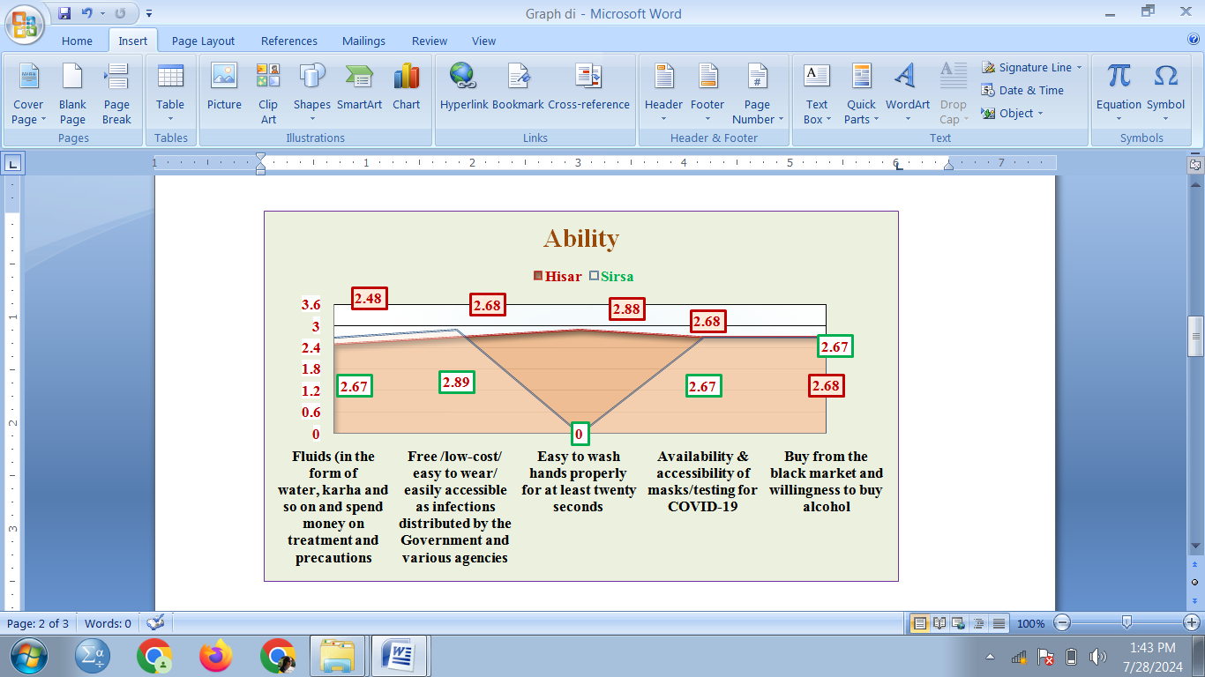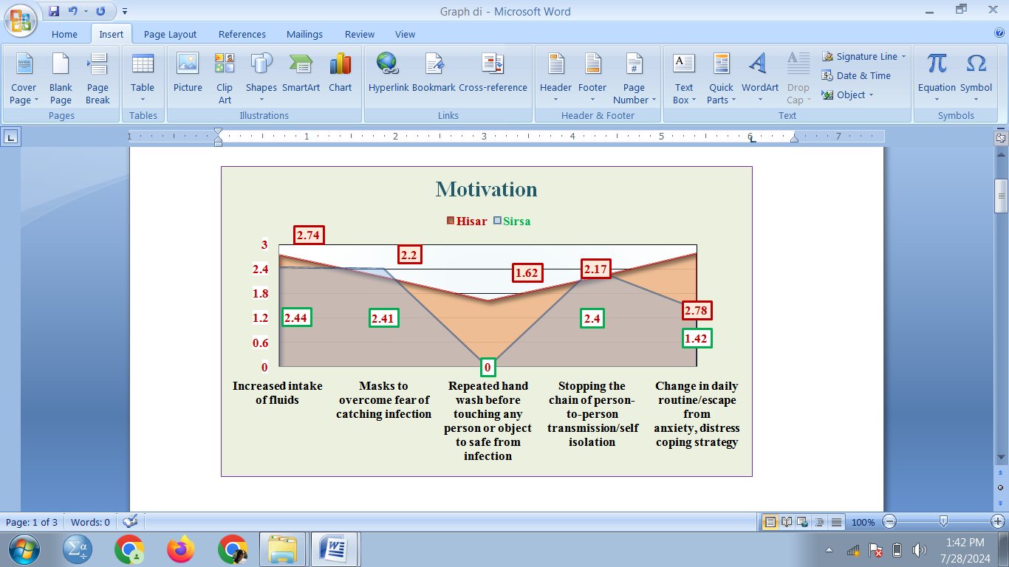
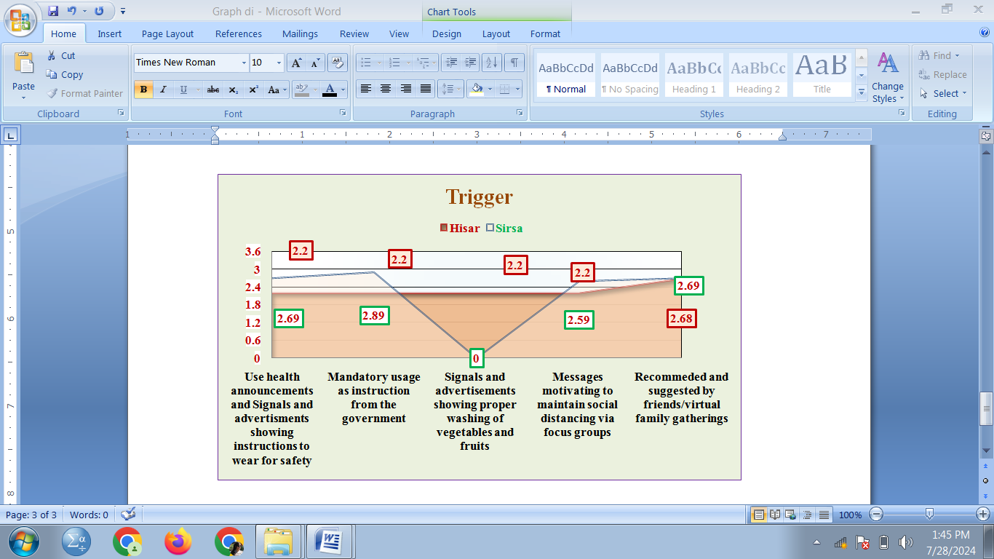

Fig 1: Health seeking behavior during COVID-19 (Fogg behavior model)

Conclusion
The COVID-19 pandemic had forced the government to implement strict policies to control the spread of the virus. As the respondents were ordered to stay at home and measures like mask wearing, social distancing, intake of fluids etc were encouraged and all non-essential store were closed, although medical services were exempted from these restrictions, access to them was restricted and closely monitored with check points during the pandemic. While the importance of measures was widely recognized they are likely to directly or indirectly hamper the visit to GP/friends/neighbors and other places.
The Fogg behavior model helped in understanding the behavior transformation for health measures taken by the respondents as the model focused on three main factors that affect behaviors (motivation, ability and trigger) which implied that it was easy to apply and follow. This made the model particularly suitable for guiding human adjustments feedback or changing circumstances that helped in reduction of number of positive cases during pandemic. Though the virus continued in different variants such as Alpha (UK, 2020), Beta (South Africa, 2020), Gamma (Brazil, 2020), Delta (India, 2021), Omicron (South Africa, 2022) Omicron sub-variants (BA.4, BA.5 2022) and beyond. Each variant's characteristics such as transmissibility and severity can evolve as the virus mutates by time and has cautioned the people to follow the health seeking measures as and when they feel or faced the symptoms like those during COVID-19. Also continuous dialogue with the people about the current and emerging situations of the region, they are residing will help to face the challenges in future more efficiently and effectively.
REFERNCES
Brooks, S. K., Webster, R. K., Smith, L. E., Woodland, L., Wessely, S., Greenberg, N., and Rubin, G. J. (2020). The psychological impact of quarantine and how to reduce it: rapid review of the evidence. The Lancet, 395(10227), 912-920. DOI: 10.1016/S0140-6736(20)30460-8
Pevey H.S., Rowe, D.R., Tchobanoglous, G., (2017) A textbook of environmental engineering. MC Graw Hill education, New York, PP: 1 – 20
Rehm, J., and Shield, K.D. (2019).Alcohol consumption in India, alcohol policy, and implementation of the National Drug and Alcohol Policy in India. Journal of Global Health, 9(1), 010304.
World Health Organization.(2020). Coronavirus disease (COVID-19) advice for the public: Mythbusters.WHO.
Smith, L., Jacob, L., Trott, M., Yakkundi, A., Butler, L., Barnett, Y., and Tully, M. A. (2021). The association between screen time and mental health during COVID-19: A cross-sectional study. Psychiatry Research, 292, 113333.
Lee, H., & Kim, S. (2021). Enhancing Digital Engagement During the Pandemic: An Application of the Fogg Behavior Model. Journal of Digital and Social Media Marketing,9(2), 143-157.

