Original Research Article
Screening of ciprofloxacin and gentamicin residues in pork sold in Guwahati City and its periphery and validation by Ultra-Fast Liquid Chromatography-UV/Vis

ABSTRACT
The antimicrobial residues are the undesirable substances that has the ability to persist through the food chain and harm the health of the consumers. The present study aims to detect the presence of ciprofloxacin and gentamicin residues in pork sold in Guwahati City and its surrounding areas and validation by Ultra-Fast Liquid Chromatography system-UV/Vis. A microbial inhibition assay using the endospores of Bacillus subtilis MTCC 441 as the test organism was used to initially screen out 261 pork samples. Of these, 80 pork samples were subjected to further screening using the UFLC system-UV/Vis (Model: Shimadzu Prominence LC-20AD, Detector: SPD-20A-UV/Vis; RP C18 Column: (BDS Premium, 250 mm x 4.6 mm, 5 µm) to confirm the residues in the pork samples.
During the preliminary screening, no sample tested positive for antimicrobial residues with the exception of 3 (three) samples that were suspected of having the antimicrobial residues. On further screening using the UFLC system-UV/Vis, it revealed that one sample (1.25%) tested positive for ciprofloxacin residue, but none of the samples tested positive for gentamicin residue. The ciprofloxacin residue was 0.039 µg/g, which is much below the MRL threshold recommended by Codex Alimentarius. Therefore, considering the detection of only 1.25% ciprofloxacin residue and the absence of gentamicin residue, it can be concluded that these antimicrobial substances are not abused in the pig husbandry practices in the areas under investigation.

Keywords: Antimicrobial Residue, Ciprofloxacin, Gentamicin, Pork, NER, UFLC-UV/Vis

1. INTRODUCTION
The application of antimicrobial compounds in the livestock farming is beneficial and has been effectively used for the growth promotion, meta-phylaxis and prophylaxis. Additionally, it is also employed to alter the physiological processes of the animals raised exclusively for food purposes, thus, ensuring the food's safety (Falowo and Akimoladun, 2019). Many classes of the antimicrobial that are commonly used for the treatment of diseases in humans are also effectively employed in the production of food animal. Among those are several classes of Tetracyclines, Streptomycin, Aminoglycosides, Quinolones and other substances (Landoni and Albarellos, 2015; Alhaji et al., 2018). While, the use of antimicrobial compounds in food animal production are vastly helpful, however, their indiscriminate use has led in the deposition of harmful antimicrobial residues that can harm human health because these residues persist through the food web (Chirag et al.,2013; Beyene, 2016). The consumer’s health is put into risk if the residue levels in the foods surpasses the recommended daily consumption and maximum residue limits (MRLs) (Samanidou and Nisyriou, 2008; WHO, 2014). The presence of these antimicrobial residues in meat above the MRLs can either occur due to preslaughter treatment of the food animals and also due non-compliance in the withdrawal period of the particular compounds prior to slaughter.
In recent years, among the antimicrobial compound, antibiotic residues in meat have become a growing concern in India (Waghamare et al., 2020). India accounts for 3% of the global use of agricultural antibiotics, making it one of the top consumers of antibiotics in the world. It is predicted that, by the end of 2030, the use of antibiotics in animal production would be double in India and over 67% globally (Van Boeckel et al., 2015). Several authors reported the detection of Tetracycline group of antibiotic residues in pork sold in different markets of North-eastern states of India (Gogoi et al., 2017; Roy et al., 2019 and Debbarma et al., 2025). Roy et al. (2016) and Roy et al. (2019) in their studies reported the detection of 4.18% and 6.8% ciprofloxacin residues in pork samples marketed in the North Eastern Region of India alarming the pork consumers of the region. Thus, the present study was undertaken to monitor the presence of Ciprofloxacin and Gentamicin residues in the pork sold in different markets of Guwahati city and its adjoining areas.
2. MATERIALS AND METHODS
2.1 Location and the duration of the research work
The research work was carried out in the laboratory of All India Coordinated Research Project (AICRP) on Post-Harvest Engineering and Technology (PHET), Department of Livestock Products Technology, Assam Agricultural University, Khanapara, Guwahati, Assam for a period of 18 months effective from April, 2021 to September, 2022.
2.2 Sources and collection of the samples
Pork samples were randomly collected from 3 districts of Assam (Kamrup Metropolitan, Kamrup Rural and Morigaon district) and a district of Meghalaya (Ri-Bhoi district) that usually supply meat (pork) to the population of Guwahati city. All the 261 samples were aseptically collected in a separate plastic pouch and carried in chilled condition to the laboratory of the AICRP on Post- Harvest Engineering and Technology, Department of Livestock Products Technology, Assam Agricultural University, Khanapara, Guwahati, Assam and thereafter stored in deep freezer at -20°C until used in the study.
2.3 Bacterial culture
A pure freeze-dried culture of Bacillus subtilis MTCC 441 procured from Microbial Type Culture Collection and Gene Bank (MTCC), CSIR Institute of Microbial Technology, Chandigarh was used as a test microbial culture in the study. The bacterial culture was initially harvested in a sterile nutrient broth and then sub-cultured thrice before use. The culture was then stored at 4°C until further use.
2.4 Instrumentation
The Ultra-Fast Liquid Chromatography system (Model: Shimadzu Prominence LC-20AD, Detector-SPD-20A-UV/Vis) equipped with RP C18 Column (BDS Premium, 250 mm x 4.6 mm, 5 µm) was used for the detection of antimicrobial residues. A mobile phase consisting of 0.05 M Na₂HPO_{4:} Acetonitrile: Methanol (70: 10: 20 v/v/v) at pH 8.0 was freshly prepared. The flow rate of the mobile phase was adjusted as 1.0 ml/min in an isocratic mode. The wavelength of the detector was adjusted as 230 nm. The volume for injection was kept as 20 µl, and the temperature of column thermostat was set at 40°C.
2.5 Bacteriological media, chemicals and reagents
Muller Hinton Agar, Nutrient Agar, Nutrient broth, Gentamicin disc (GEN), Ciprofloxacin hydrochloride monohydrate, Gentamicin sulphate and Di-sodium hydrogen phosphate for used in the study were procured from Hi-Media while, Acetonitrile, Methanol and HPLC grade water were procured from Qualigens. For the analysis, the mobile phase consisting of 0.05 M Na₂HPO_{4:} Acetonitrile: Methanol (70: 10: 20 v/v/v) at pH 8.0 was freshly prepared and filtered through 0.22 μm cellulose filter and were stored at 4°C until used.
2.6 Harvesting and preparation of bacterial spore suspension
A freshly made sterile nutrient agar plate was streaked with a strong inoculum of Bacillus subtilis MTCC 441. To induce sporulation, the plates were incubated at 30°C for 10 days in a BOD incubator. After the incubation, the colonies were gathered in a 15 ml sterile centrifuge tube, and the volume was adjusted up to 10 ml with a sterile normal saline. The tube containing the culture was then heated at 70°C for 10 minutes in a water bath to kill the vegetative cells. After completion of heating, the suspension was centrifuge at 3000 rpm for 10 minutes, and the clear supernatant was disposed of. To create a pure suspension of the endospores, an additional 10 ml of sterile normal saline was added and centrifuged, and the process was repeated twice. Prior to usage, the suspension turbidity was adjusted to match the 0.5 McFarland standard solution (≈1.5 × 108 CFU/ml)

2.7 Preparation of the test plates
Muller-Hinton agar was made in a conical flask and autoclaved for 15 minutes at 15 psi. After cooling to approximately 45°C, 0.1 ml of spore suspension inoculum (1.5 108 CFU/ml) was mixed with 100 ml of agar. In a sterilized petri dish, 15–20 ml of the molten agar was poured and set aside to cool. The test plates were used on the same day they were prepared or they were stored at 4°C and utilized within a week.
2.8 Preparation of standard solutions
Ten milligrams of the individual standard were dissolved in 10 ml of methanol: HPLC grade water (@1:1, v/v) (1000 µg/ml) and kept in an amber coloured volumetric flask separately. A standard working solution of 3.0, 2.0, 1.0, 0.5 and 0.1 μg/ml was prepared separately by diluting the stock solution with methanol. As it is unstable at room temperature, hence prepared daily and stored at 4°C.
2.9 Preliminary screening of the antimicrobial residues in pork
The preliminary screening for the antimicrobial residues in the pork samples was carried out by the method developed by Wasch et al. (1998) with minor adjustments. Briefly, a disk-shaped slice of meat measuring 8 mm in diameter and 2 mm in thickness were made from the meat sample while still frozen. The disk-shaped slice of meat was placed on the opposite ends of the plate and were incubated at 37°C for 24 hours. The formation of a transparent/clear zone/ring measuring ≥2 mm was considered positive. However, a zone of ˂1 mm was regarded as negative, while a zone of 1-2 mm was considered as doubtful. The zone of inhibition was determined by using the formula πr2, and the mean of two inhibition zones' areas were calculated.
2.10 Confirmation of antimicrobial residues in pork samples by ultra-fast liquid chromatography (UFLC)
The UFLC system (UFLC: Shimadzu Prominence LC-20AD, Detector-SPD-20A (UV/Vis; RP C18 Column: BDS Premium, 250 mm × 4.6 mm, 5 μm) was used to detect the residues of ciprofloxacin and gentamicin in the pork samples. This was done in accordance with the method developed by Lakew et al. (2022) with minor modification.
2.11 Preparation of the sample
The frozen meat samples that had been stored were thawed. The meat was cut using a scissors into thin pieces after removing the fascia and excess fat. A pestle and mortar were used to grind 10 g of each sample into a fine paste. A representative sample (10 g) along with an equal volume of HPLC-grade water was taken in a glass beaker and homogenized at 7500 rpm in a tissue homogenizer for 1.5 minutes.
2.12 Extraction, clean-up and filtration of the samples
A beaker was filled with 2 g of the representative sample. After adding 10 mL of the extraction solvent (acetonitrile: methanol at a 10:20 ratio, v/v), the mixture was homogenized for 1.5 minutes at 7000 rpm in a tissue homogenizer. The mixture was ultra-sonicated for 15 cycles at 30-second intervals, maintaining a low temperature using the crushed ice. The sonicated samples were centrifuged for 5 minutes at 3500 rpm in a refrigerated centrifuge machine; the clear supernatant was transferred into a 20 mL glass beaker using a syringe filter (0.2 μm) and then dried in a hot air oven at 40°C. The concentrated or dried residues were re-dissolved with 1 mL methanol and filled into the HPLC autosampler vials. To analyse the residues, a 20 μL sample was fed into the UFLC system.
3. RESULTS AND DISCUSSION
3.1 Preliminary screening of antimicrobial residues in pork samples
A total of 261 pork samples collected from 3 districts of Assam and 1 district of Meghalaya were preliminary screened by microbial inhibition technique using Bacillus subtilis MTCC 441 as a test organism to detect antimicrobial residues in the pork samples. The result of the preliminary screening is presented in Table 1 and the graphical presentation shown in Fig. 1. The screening test revealed that none of the pork samples have antimicrobial residue which could inhibit the growth of the test organism, except 3 samples (1 from Kamrup rural and 2 others from Ri-Bhoi district) which were doubtful to have traces of antimicrobial residues.
The result of the present study was in the line of Wasch et al. (1998) who reported the detection of antimicrobial residues by microbial inhibition assay. The microbial inhibition assay or agar diffusion technique is a cheap screening method to detect antimicrobial residues when large numbers of samples are to be covered. They are essentially a qualitative screening test that detects any tissues/substance with the property of bacterial inhibition. But this method is less sensitive as it could not provide a clear zone of inhibition in 3 doubtful samples which agree with the observation of Javadi et al. (2011).
3.2 Detection of antimicrobial residues by Ultra-fast liquid chromatography/Vis (UFLC/Vis)
All the 80 pork samples collected from 3 districts of Assam (Kamrup metropolitan, Kamrup rural and Morigaon) and 1 district (Ri-Bhoi) of Meghalaya were screened by UFLC system to confirm the presence of Ciprofloxacin (CIP) and Gentamicin (GEN). All the positive samples were compared with recommended MRL values of Codex Alimentarius.
3.2.1 Detection of Ciprofloxacin (CIP) residues
The samples were screened by UFLC technique to detect CIP residues in the pork samples. The result of the screening test by UFLC system is presented in Table 2 and the graphical representation are shown in Fig. 2. Out of 80 samples screened, only 1 sample (1.25%) was detected positive for CIP residue. The concentration of CIP residue was 0.039 µg/g which is well below the MRL value recommended by Codex Alimentarius.
The results obtained in the present study was in agreement with the reports of Roy et al. (2016) and Roy et al. (2019) who also reported the presence of CIP residues in pork samples collected from different states of North-Eastern region of India. However, positivity rate of CIP residues registered by them (4.18-6.8%) were much higher than the one obtained in this study.
Ramatla et al. (2017) further reported the detection of CIP residues in pigs’ liver and kidney samples which were in the range of 0.043 to 0.356 µg/g with an overall detection in 8% of the samples screened, but none of the muscle samples were positive for CIP residue.

3.2.2 Detection of gentamicin (GEN) residues
The procured pork samples were screened by the UFLC technique to detect GEN residues in pork. The result of the screening test (UFLC system) is presented in Table 2. Out of the 80 samples screened, none of the sample detected positive for GEN residues, although a preliminary field survey revealed the use of GEN now and then in the treatment of pig diseases in piggeries of the state and other pig farms of NER. On the contrary, Kang et al. (2011) reported the detection of GEN residues in 4 pork samples out of 250 samples collected from Busan, South Korea although the concentration level of the same was within the MRL of Codex Alimentarius.
4. CONCLUSION
Based on the results obtained in this study, it can be concluded that the status of Ciprofloxacin and Gentamicin residues in pork that were marketed in the 3 districts of Assam and 1 district of Meghalaya so far is low in number with an overall detection of 1.25% for CIP residue. This indicates that the animals (pigs) were treated judiciously with antibiotics and their complete withdrawal periods was followed before sacrificing the animals. Thus, the pork marketed in the above-mentioned districts of Assam and Meghalaya area that supply pork is comparatively safe for consumption. However, periodic screening of the pork samples and mass awareness drive should be carried out so the farmers can produce a healthy pig for human consumption.
INFORMED CONSENT
All animal procedures for experiments were approved by the Committee of Experimental Animal care and handling techniques were approved by the University of Animal Care Committee.
DISCLAIMERS
The views and conclusions expressed in this article are solely those of the authors and do not necessarily represent the views of their affiliated institutions. The authors are responsible for the accuracy and completeness of the information provided, but do not accept any liability for any direct or indirect losses resulting from the use of this content.
DISCLAIMER (ARTIFICIAL INTELLIGENCE)
The author(s) hereby declare that no generative AI technologies such as Large Language Models (ChatGPT, COPILOT, etc) and text-to-image generators have been used during writing or editing of this manuscript.
COMPETING INTERESTS
The authors declares that there is no competing of interest for publication of this article.
REFERENCES
Alhaji, N.B.; Haruna, A.E.; Muhammad, B.; Lawan, M.K. and Isola, T.O. (2018). Antimicrobials usage assessments in commercial poultry and local birds in North-central Nigeria: Associated pathways and factors for resistance emergence and spread. Prev. Vety. Medicine, 154: 139-147.
Beyene, T. (2016). Veterinary drug residues in food-animal products: Its risk factors and potential effects on public health. J. Vet. Sci. Technol., 7(1): 1-7.
Chirag, M.M.; Hitesh B.P and Shailesh K.M. (2013). Animal husbandry practice to contaminants and residues of chemical in animal origin foods and health hazard. Int. J. Mol. Vet. Res., 3: 55-56
Falowo, A.B. and Akimoladun, O.F. (2019). Veterinary Drug Residues in Meat and Meat Products: Occurrence, Detection and Implications, IntechOpen.
Gogoi, R.; Roy, D.C. and Sinha, S. (2017). Determination of chlortetracycline residues in swine tissues using high performance liquid chromatography. The Pharma Innovation, 6(3): 34-36.
Javadi, A. (2011). Effect of roasting, boiling and microwaving cooking method on doxycline residues in edible tissues of poultry by microbial method. African J. Pharmacy and Pharmacology, 5: 1034-1037.
Landoni, M.F. and Albarellos, G. (2015). The use of antimicrobial agents in broiler chickens. The Vety. J., 205: 21-27.
Lakew, A.; Assefa, T.; Woldeyohannes, M.; Megersa, N. and Chandravanshi, B.S. (2022). Development and validation of liquid chromatography method for simultaneous determination of multiclass seven antibiotic residues in chicken tissues. BMC chemistry, 16(1), 1-15.
Roy, D.C.; Gogoi, R. and Laskar, S.K. (2016). Ciprofloxacin Residue Determination in Pork of North East States of India. British Journal of Pharmaceutical and Medical Research, 1(2): 86-88.
Roy D. C., Kafle A., Laskar S. K. and Roy R. K. (2019). Ciprofloxacin Residue in Marketed Pork of North-East India. Journal of Pharmacy and Pharmacology, 7:119-123.
Roy, D.C; Kafle, A; Laskar, S. K; and Roy, R. K. (2019). Residual analysis of oxytetracycline in marketed pork of North-East India. World J. Pharmaceutical Res., 8(1):953-957
Ramatla, T.; Ngoma, L.; Adetunji, M. and Mwanza, M. (2017). Evaluation of antibiotic residues in raw meat using different analytical methods. Antibiotics, 6(4), 34: 1-17.
Kang, Y.W; Joo, H.J; Kim, Y.S; Cho, Y.J; Kim, H.Y; Lee, G.H; and Kim, M. (2011). Analysis and monitoring of residues of aminoglycoside antibiotics in livestock products. Korean Journal of Food Science and Technology, 43(1):1-5
Debbarma, P., Laskar, S.K., Das, A., Choudhury, S., Upadhyay, S., Barman, N.N. and Kalita, D.J. (2025). Screening of Oxytetracycline and Tetracycline Residues in Pork Marketed in Guwahati City and its Adjoining Areas and Confirmation by Ultra-fast Liquid Chromatography-UV/Vis. Asian Journal of Dairy and Food Research. 1-6. doi: 10.18805/ajdfr.DR-2255.
Samanidou, V. and Nisyriou, S. (2008). Multiresidue methods for confirmatory determination of antibiotics in milk. J. Separation Sci., 31(11): 2068-2090.
Van Boeckel, T.P.; Brower, C.; Gilbert, M.; Grenfell, B.T.; Levin, S.A.; Robinson, T.P.; Teillant, A. and Laxminarayan, R. (2015). Global trends in antimicrobial use in food animals. Proceedings of the National Academy of Sciences, 112: 5649-5654
Waghamare, R.N., Paturkar, A.M., Vaidya, V.M., Zende, R.J., Kumar, A. and Bedi, J.S. (2020). Screening of antimicrobial residues and confirmation of doxycycline in samples collected from chicken farms and processing units located around Mumbai, India. Indian Journal of Animal Research. 54(11): 1415 1421. doi: 10.18805/ijar.B-3899.
Wasch, K. D.; Okerman, L.; Brabander, H. D.; Van Hoof, J.; Croubels, S. and Backer, P. D. (1998). Detection of residues of tetracycline antibiotics in pork and chicken meat: correlation between results of screening and confirmatory tests. Analyst, 123(12): 2737-2741.
World Health Organization, (2014). Evaluation of certain veterinary drug residue in food. Tech. Rep. Ser., 988:7–32.

Table 1. Preliminary screening of the antimicrobial residues in the pork samples
Sources of samples | No. of samples screened | No. of positive samples | No. of doubtful samples
Kamrup Metro, Assam | 95 | ND | ND
Kamrup Rural, Assam | 53 | - | 1
Morigaon, Assam | 51 | - | -
Ri-Bhoi, Meghalaya | 62 | - | 2
Total | 261 | ND | 3
ND-Not detected

Table 2. Detection of Ciprofloxacin (CIP) and Gentamicin (GEN) residues in pork by UFLC/Vis
Sources of samples | No. of sample screened | No. of positive samples detected |  | Concentration of the positive samples (µg/g) |  | No. of samples above MRL
Sources of samples | No. of sample screened | CIP | GEN | CIP | GEN | CIP | GEN
Kamrup Metro, Assam | 20 | ND | ND | - | - | Nil | Nil
Kamrup Rural, Assam | 20 | 1 | -do- | 0.039 | - | -do- | -do-
Morigaon, Assam | 20 | ND | -do- | - | - | -do- | -do-
Ri-Bhoi, Meghalaya | 20 | -do- | -do- | - | - | -do- | -do-
Total | 80 | 1 | Nil | 0.039 | - | Nil | Nil

ND-Not detected

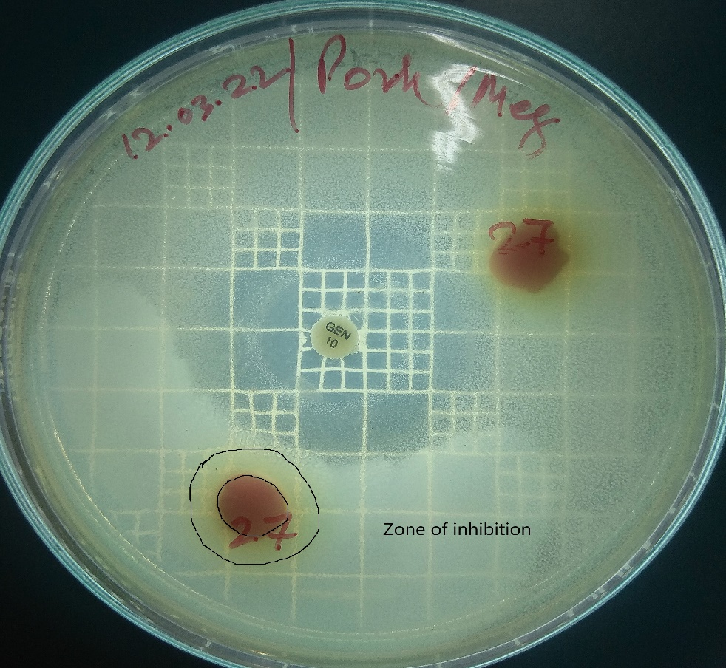

Fig. 1. Inhibition zone (diameter˂2 mm) of antimicrobial residues in the doubtful pork sample

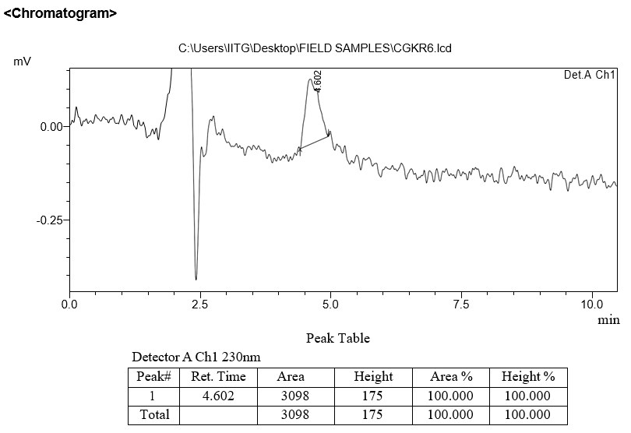
Fig. 2. Chromatogram of Ciprofloxacin (CIP) residue in pork sample

