Application of Laser Treatment on Bio-Commercial Traits of the Silkworm, Bombyx mori L.: A Comprehensive Review

Abstract
The domesticated silkworm, Bombyx mori L., represents one of the most economically valuable insects in global sericulture. Beyond silk production, it serves as a powerful experimental model in genetics, radiation biology and developmental physiology. The application of laser irradiation and other ionizing and non-ionizing radiations has gained increasing importance in silkworm improvement programmes aimed at inducing beneficial mutations, enhancing biological efficiency and improving commercial traits. This review synthesizes experimental findings on the impact of laser and radiation exposure on embryonic development, mutation induction, growth performance, morphological variation, haemolymph biochemistry, silk gland integrity and economic traits such as cocoon weight, shell ratio and filament length.
Evidence from multiple studies indicates that early embryonic stages are highly sensitive to irradiation, whereas controlled low-dose exposure during specific developmental windows may stimulate growth and silk productivity. The phenomenon of radiation hormesis has been repeatedly documented in bivoltine and multivoltine races. However, high-dose exposure induces mortality, morphological abnormalities and protein degradation. Genetic variability in radiation resistance further provides opportunities for breeding radiation-tolerant strains. Integration of laser-based techniques with molecular genetics and antioxidant supplementation strategies offers promising avenues for future sericulture biotechnology.
Keywords: Laser irradiation, mutation breeding, radiation hormesis, silk gland, haemolymph proteins, cocoon traits, radiation resistance
1. Introduction
The silkworm Bombyx mori L. has been domesticated for thousands of years for silk production and remains the backbone of sericulture industries in countries such as India, China and Japan. India is the second largest producer of silk globally, with major contributions from Karnataka and other southern states under the guidance of the Central Silk Board.
Because of its short life cycle, well-characterized genome and ease of rearing, B. mori has become an important laboratory model for studying mutagenesis, developmental biology and stress physiology. Radiation biology studies in silkworms date back several decades, Tanaka, 1934 was the first one to induce mutations in silkworm. In sericulture, radiation is mainly used to evolve superior quality silkworm breeds through the induction of useful mutations and elevation of resistance against diseases. particularly summarized by Tazima (1984), who described the genetic effects of ionizing and non-ionizing radiations in silkworm breeding.
Salam et al., 1995 Radiations are not only pertained to induce mutations and harmful effects in silkworm, but also they have stimulatory effects at low levels with reference to biological and commercial trails of Bombyx mori.L. Murakami et al., 2006 Several attempts have also been made to induce beneficial mutations in silkworm by utilizing both ionizing rays like alpha, beta, gamma rays, X-rays and neutrons and non-ionizing rays ultra violet rays. Some of these have been proved to be useful to the sericulture industry.
Laser technology has enabled precision exposure with controlled wavelength, duration and intensity. Unlike conventional radiation sources, lasers provide localized and stage-specific irradiation, making them valuable tools in mutation breeding and physiological studies.
2. Concept and Principle of LASER
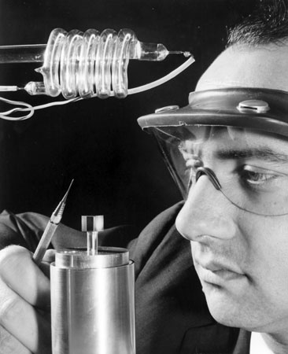
Photo 1 : Theodore H. Maiman

LASER (Light Amplification by Stimulated Emission of Radiation) produces coherent, monochromatic and highly directional light. The first functional laser was developed by Theodore H. Maiman in 1960, based on foundational work by Arthur L. Schawlow and Charles H. Townes

Characteristics Relevant to Biological Systems

- Coherence – synchronized photon emission
- Mono-chromaticity – single wavelength
- High intensity – concentrated energy
- Directionality – precise targeting
These properties allow controlled irradiation of silkworm eggs, larvae and pupae.
Working principle of LASER
A laser oscillator usually comprises an optical resonator (laser resonator, laser cavity) in which light can circulate (e.g. between two mirrors), and within this resonator a gain medium (e.g. a laser crystal), which serves to amplify the light. Without the gain medium, the circulating light would become weaker and weaker in each resonator round trip, because it experiences some losses, e.g. upon reflection at mirrors. However, the gain medium can amplify the circulating light, thus compensating the losses if the gain is high enough. The gain medium requires some external supply of energy – it needs to be “pumped”, e.g. by injecting light (optical pumping) or an electric current (electrical pumping → semiconductor lasers). The principle of laser amplification is stimulated emission.
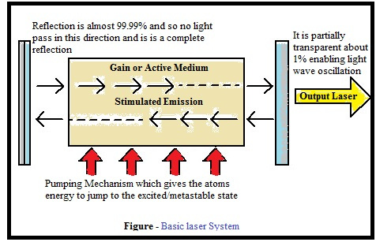
Fig. 1 : Basic laser system
Types of laser
Generally, the active medium of a solid-state laser consists of a glass or crystalline "host" material, to which is added a "dopant" such as neodymium, chromium, erbium,[1] thulium[2] or ytterbium.[3] Many of the common dopants are rare-earth elements, because the excited states of such ions are not strongly coupled with the thermal vibrations of their crystal lattices (phonons), and their operational thresholds can be reached at relatively low intensities of laser pumping.
In solid-state lasers, light energy is used as pumping source. Light sources such as flashtube, flash lamps, arc lamps, or laser diodes are used to achieve pumping. Semiconductor lasers do not belong to this category because these lasers are usually electrically pumped and involve different physical processes. Some solid-state lasers can also be tunable using several intracavity techniques, which employ etalons, prisms, and gratings, or a combination of these.Titanium-doped sapphire is widely used for its broad tuning range, 660 to 1080 nanometers. Alexandrite lasers are tunable from 700 to 820 nm and yield higher-energy pulses than titanium-sapphire lasers because of the gain medium's longer energy storage time and higher damage threshold.
Dye lasers were independently discovered by P. P. Sorokin and F. P. Schäfer A dye laser is laser that uses an organic dye as the lasing medium, usually as a liquid solution. Compared to gases and most solid state lasing media, a dye can usually be used for a much wider range of wavelengths, often spanning 50 to 100 nanometers or more. The wide bandwidth makes them particularly suitable for tunable lasers and pulsed lasers. The dye rhodamine 6G, for example, can be tuned from 635 nm (orangish-red) to 560 nm (greenish-yellow), and produce pulses as short as 16 femtoseconds.
List 1 : Laser gain medium and their Operational light
Laser gain medium and type | Operational light
Ruby laser ( Solid state Laser) | 694.3 nm (near infrared)
Titanium sapphire (Ti:sapphire) laser | 650-1100 nm (visible and infrared rays)
Cerium-doped lithium strontium aluminum fluoride (Ce:LiSAF) laser | ~280 to 316 nm (ultraviolet rays)
Chromium-doped chrysoberyl (alexandrite) laser | Typically tuned in the range of 700 to 820 nm (visible and infrared rays)
Dye lasers | 390-435 nm (stilbene), 460-515 nm (coumarin 102), 570-640 nm (rhodamine 6G), many others
Semiconductor laser diode (general information) | 0.4-20 μm, depending on active region material
GaN | 0.4 μm
Quantum cascade laser | Mid-infrared to far-infrared
Hybrid silicon laser | Hybrid silicon laser Mid-infrared
samarium laser | X-rays at 7.3 nm wavelength
Semiconductor lasers play an important role in our everyday life. These lasers are very cheap, compact size and consume low power. Semiconductor lasers are also known as laser diodes. Semiconductor lasers are different from solid-state lasers. In solid-state lasers, light energy is used as the pump source whereas, in semiconductor lasers, electrical energy is used as the pump source. In semiconductor lasers, a p-n junction of a semiconductor diode forms the active medium or laser medium. The optical gain is produced within the semiconductor material.
Applications of laser
Communications: besides fiber-optic communication, lasers are used for free-space optical communication, including laser communication in space.
Industry: cutting including converting thin materials, welding, material heat treatment, marking parts (engraving and bonding), additive manufacturing or 3D printing
Military: marking targets, guiding munitions, missile defense, electro-optical countermeasures (EOCM), lidar, blinding troops, firearms sight.
Law enforcement: Lasers are used for latent fingerprint detection in the forensic identification field
Medicine: Laser medicine and Lasers in cancer treatment
Picture 1 : Diagrammatic drawing of the UV-laser irradiation system for Bombyx mori eggs.
UV-laser irradiations were carried out on the ACAS 470 work station (Meridian) equipped with a 5 W argon ion laser tuned to the 355 nm line, a 16-bit microcomputer and an inverted microscope (IMT-2, Olympus) equipped with a motorized X-Y microscope stage. The laser beam is directed to the microscope system by a set of adjustable mirrors; the objective lens system delivers a focused laser beam to the sample plane and also collects fluorescent radiation from the specimen (Fig. 1). Irradiations were carried out using the area raster program provided by the ACAS microcomputer system.
With this program, the size and shape of the irradiation areas were controlled by changing parameters for stage movement such as the width of the raster scan, the distance between scan lines (step size) and the number of lines in the raster (scans). For fate mapping in this study, irradiations of an area of 145×173 µm were accomplished by setting the parameters as follows: width, 145 µm; step size, 0.25 µm; scans, 690. The speed of stage movement was 0.5 mm/second, thus an irradiation of the 145×173 µm area took approximately 200 seconds. UV energy incident at the egg surface, which was measured directly for each experiment by an ultraviolet meter (DM-365N, Spectronics) on the microscope stage, was 1.8-2.8 mW/cm2 (Myohora, 1995).
Fig 2 . Development of a new method for collecting silkworm larvae hemolymph by laser beam incision
Fig 3. Laser beam incision on different region of silkworms
CO2 laser device: CO2 laser device was designed by modeling after a medical laser knit. for efficient non-contact perforation and incision of the silkworm integument. Schematic diagram of laser device is shown in Fig 1. The device is a water-cooled CO, laser generator that radiates infrared rays from a nozzle. The outline of the device is shown in Fig1. To protect the condensing lens from contamination by hemolymph or smoke released during incision, clean air (0.1 Mpa) was sprayed from the nozzle while the laser was on, and the focal length was set 30 mm longer than usual, to 93.5 miii. Si1kworms: Silkworm used were hybrid races. "Shin-asagiri" and "Ariake". which were reared on artificial diet in all larval period. Female and male larvae were separated on the first day of the 5th instar. Laser beam incision and collecting the hemolymph.
The silkworms (4 and 5 days of' the 5th instar) were anesthetized for 20 minutes at a low temperature (0 C) to be rod like and semi-stiffened before fixing them on laser device. To examine the relationship between the region of the incision and the volume of hemolymph collected, larvae were irradiated with the laser beam straight along the median line of the integument in the center of the dorsal, lateral and ventral areas near the 8th segment of each silkworm. To incise the silkworm integument linearly by approximately 1 cm. larva was placed on a belt conveyor moving horizontally at a rate of 2.5 cm/sec. The laser at a power of 3-5 W for 0.5 or 0.7 seconds applied to the center of the posterior dorsal area of the larvae (Fig. 2). Each larva was weighed before incision. One minute after incision, the hemolvmph was spout out, and any residual hemolymph left on the body's surface was wiped off. The silkworm was then reweighed. The decrease in weight was regarded as the weight of the hemolymph collected from the silkworm. (Toru, 2002).
Mutation Induction in Bombyx mori.L
Laser and heavy-ion irradiation have been successfully used to induce somatic mutations. Kotani et al. (2002) observed white spot mutations in black striped strains due to mutation in the dominant PS gene following X-ray and heavy-ion irradiation.
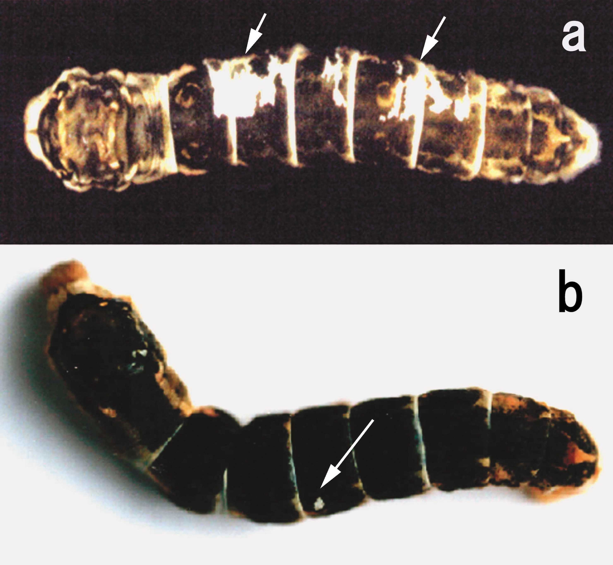
Picture 2: Bombyx mori L.
Somatic mutation appears as a white spot (arrows) on black integument of 5th instar larvae from X-ray or heavy ion beam irradiated eggs of the silkworm, Bombyx mori. This white spot is caused by mutation of the P^{S} gene.
Sample material : Black striped strain of Bombyx mori. with dominant gene P^{S}
Mutation frequency was dose-dependent and influenced by linear energy transfer (LET). Microbeam irradiation studies (Sakashita et al., 2009) further confirmed targeted mutation induction. Diapause eggs irradiated with X-rays or heavy ion particles were kept for 2 or 3 months at 5°C to terminate dia- pause, and then incubated for 12 days at 25°C to obtain newly hatched larvae. Larvae were reared until the 3rd day of 5th instar. The number of the larvae with a white spot (Figs. 2a and 2b) was then counted. Incidence of the somatic mutation was calculated by dividing the number of larvae with a white spot by the total number (300) of larvae. Spontaneous mutation was not detected in all experiments as back ground.
Irradiation of eggs with 1.0 Gy of X- rays at 2 or 5 h after oviposition induced somatic mutation in about 5%, including mosaic larvae (Fig. 2a) in addition to black-striped larvae with a white spot (Fig. 2b). With irradiation from 10 h after oviposition, the only mutations observed were larvae with one white spot. Thereafter, incidence of mutation increased with embryonic development during the initiation of diapause, but decreased gradually as diapause state proceeded. Conversely, when some of these eggs were treated with HCl solution to avoid entrance into the diapause state, incidence of somatic mutations increased compared to that in diapausing eggs.
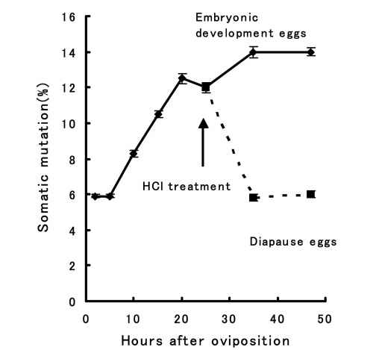
Picture 3 : Changes in the frequency of somatic mutation in 5th instar larvae from X-ray irradiated eggs during early embryogenesis.
In diapause-destined eggs (diapause eggs), Eggs gradually stop the embryonic development about 24 h after oviposition, and enter into diapause state. Around this time, eggs are treated to hatch artificially using heated HCl (sp. gr., 1.075, 46°C, 5 min) to continue embryogenesis for about 10 days (embryonic developing eggs). Eggs were irradiated with 1.0 Gy of X-rays at the indicated times.
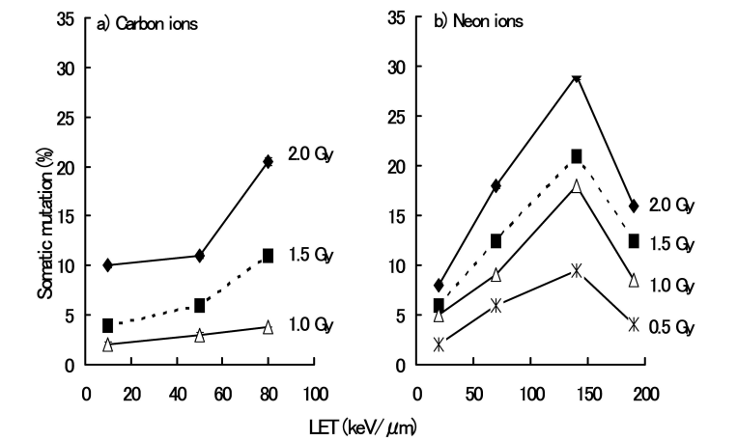
Fig 4 . Dependency of the incidence of somatic mutation on both dose and LET of carbon and neon ion particles
Silkworm eggs were irradiated with carbon ion particles (290 MeV/u). b) Eggs were kept at 25°C for the first 15 days after ovipositional, then transferred to 0°C. This maintains an almost constant sorbitol content for at least 200 days, meaning that, eggs remain in the diapause state5). These eggs were irradiated using neon ion particles (400 MeV/u).
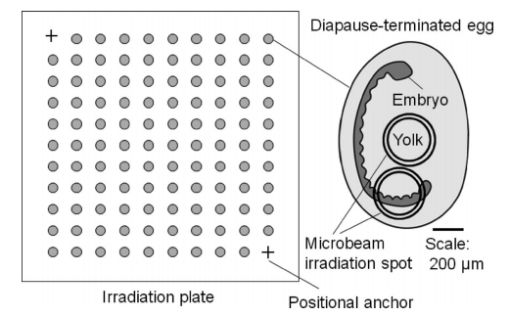
Fig 5 : A line sketch representing the irradiation plate and a diapause-terminated egg of the silkworm.
A line sketch representing the irradiation plate and a diapause-terminated egg of the silkworm. The size of the irradiation plate is 10 mm × 10 mm × 0.1 mm (plastic film), where anchors for the positional database and a total of 98 diapause terminated eggs were set as indicated. The long axis of the diapause-terminated egg is about 1.2 mm in size, and an embryo exists in one side of a diapause-terminated egg. (Sakashita et al, 2009)
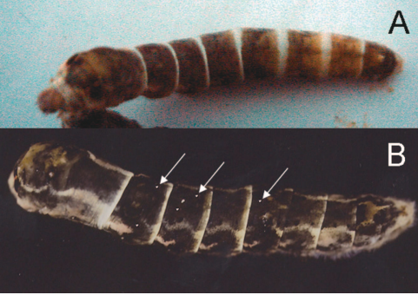
Fig 6 : Typical example of a somatic mutation with a white spot
  - Non-irradiated larva B. irradiated larva following heavy-ion irradiation
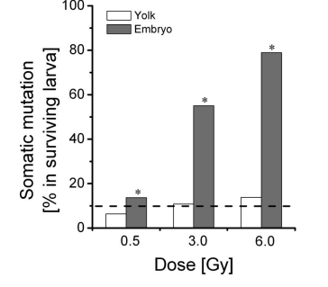
Fig 7 : . Somatic mutation following micro-beam irradiation
The number of eggs tested for microbeam irradiation was as follows: non-irradiated (n = 196), 0.5 Gy (n = 196), 3.0 Gy (n = 392) and 6.0 Gy (n = 196) for embryo irradiation; 0.5 Gy (n = 98), 3.0 Gy (n = 294), and 6.0 Gy (n = 196) for yolk irradiation. The dashed lines display the level of non-irradiated control. The asterisks indicate significant differences between yolk- and embryo-irradiated animals (p < 0.05).

Over all Role of LASER to induce mutation in silkworm Interpretation
Low-dose - manageable mutation frequency
High-dose - increased lethality and developmental defects
Genetic background influences susceptibility
This confirms the potential of laser-based mutation breeding for trait improvement.
Impact on Embryonic Development
Embryonic stage plays a crucial role in radiation response.
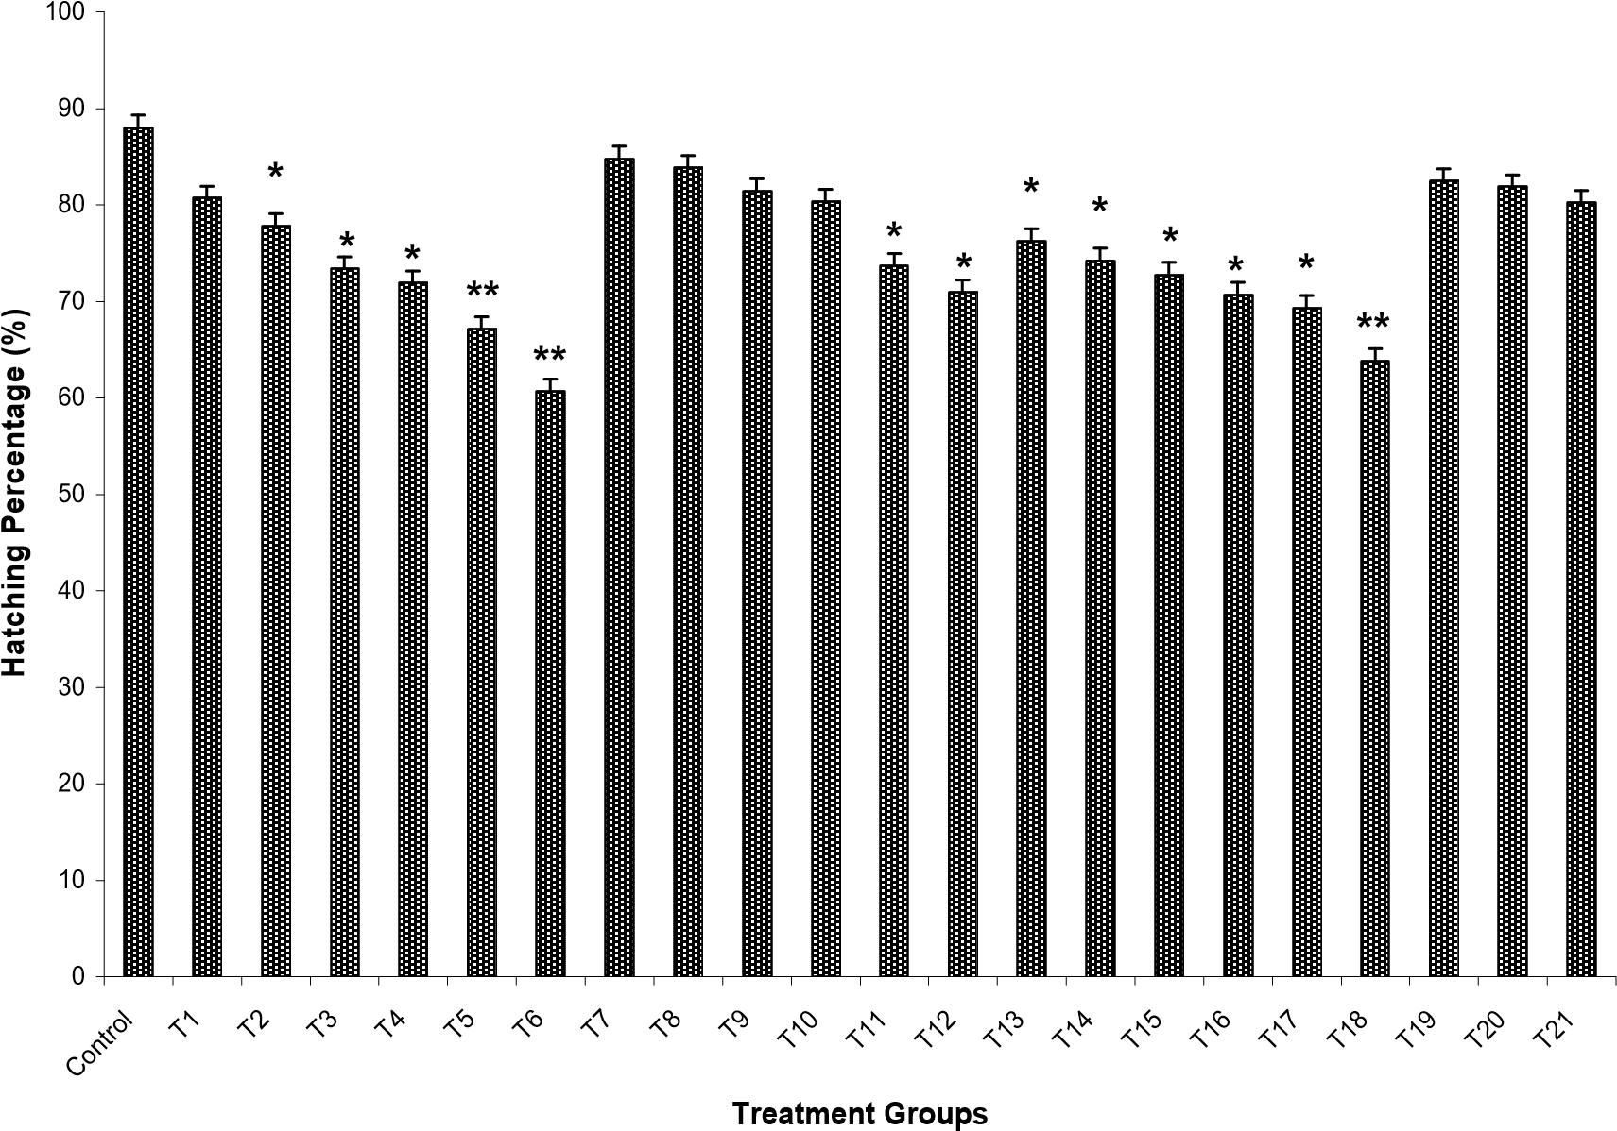
Fig 8 : Effect of fourth harmonic UV laser on hatching of embryo of Bombyx mori
- T1 to T6 (10,20,30,40,50&60 sec) - irradiation of 2 hr old embryo,
- T7 to T12 (10,20,30,40,50&60 sec)-irradiation of 8 hr old embryos,
- T13 to T18 (10,20,30,40,50&60 sec)- irradiation of 16 hr old embryos,
- T19-T21 (10, 20&30 sec) – irradiation of 24 hr old embryos.
Graph Interpretation: Hatchability vs UV Duration
The first generated graph demonstrates declining hatchability with increased exposure duration (10–60 sec) 10–20 sec minimal reduction beyond 40 sec sharp decline, 60 sec severe embryonic damage
Hosagoudar (2010) reported similar stage-specific sensitivity in NB4D2 breed. Early embryos (2 hr) were more vulnerable than 16–24 hr embryos. Mathavan (1982) observed the Effects of X-ray irradiation on fertilization, hatchability and mortality of the developing eggs of Bombyx mori.L near complete mortality in 1-hr-old eggs exposed to X-rays, confirming age-dependent susceptibility.
Hennberry 1963 studied the percent mortality of silkworm eggs exposed to gamma radiation 1, 4 or 7 days after termination of diapause. He found that, Silkworm eggs in early stages of post-diapause development were more susceptible to radiation than eggs in later stages of post-diapause development.

Impact of laser on the growth and development of silkworm Bombyx mori L.
Effect of UV- laser on the biological traits of a multivoltine variety (Urboshi-1) of the silkworm Bombyx. mori. UV-radiation exposed at pupal stage indicating that UV- radiation can be effective in improving different of traits of B. mori, especially pupa exposed for about one minute gives best results indicating that UVradiation can be effective in improving different economic traits of B. mori (Ali, et al., 2010). The positive effect of low energy laser on the general physiology of silkworm growth, development and commercial traits. Low-energy laser radiation was found to have a stimulating effect on cell (Hosagoudar, 2010)
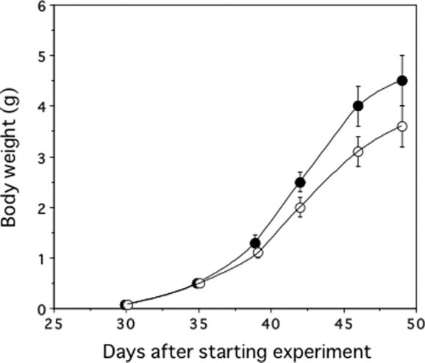

Fig 9 : Changes in body weight of silkworms. Indicate control group; , radiation-emitting sheet group. n ¼ 55 for both groups
Above graph shows the changes in the body weight of the silkworm larvae over time. The silkworms grown on the radiation emitting sheets became larger than those of the control groups on day 39 and thereafter (P < .001). On day 42, the mean body weight was 2.5 (0.2) g for the radiation sheet group and 2.0 (0.2) g for the control group (P < .001). On day 49, they were 4.5 (0.5) and 3.6 (0.4) g, respectively (P < .001). Breeding on low-dose-radiation-emitting sheets promoted the growth of silkworms.(Shibamoto et al., 2017)
Kamelia et al., 1995 studied the effect of irradiation of Bombyx mori eggs on biological charecters. The low doses of gamma irradiation, during the last two days of embryogenesis, have a stimulation effect on the growth of the larvae.Similarly Bharathi and yugen 2001 studied the effect of radiation in silkworm Bombyx mori. Fifth instar larval duration (days), weight of fully-grown larva (g), % of dead larvae, cocoon weight (g), shell weight (g), shell ratio (%), eclosion (days) and fecundity (number) in control and experimental (UV-light for 30 minutes, 60 minutes and 120 minutes) silkworm, Bombyx mori. L. Values are the mean of 10 individual observations. Effect of UV light for 30 minutes was congenial for the larval growth, per cent survival, eclosion, fecundity, cocoon characters and silk quality of two popular bivoltine hybrids of silkworm, Bombyx mori L.
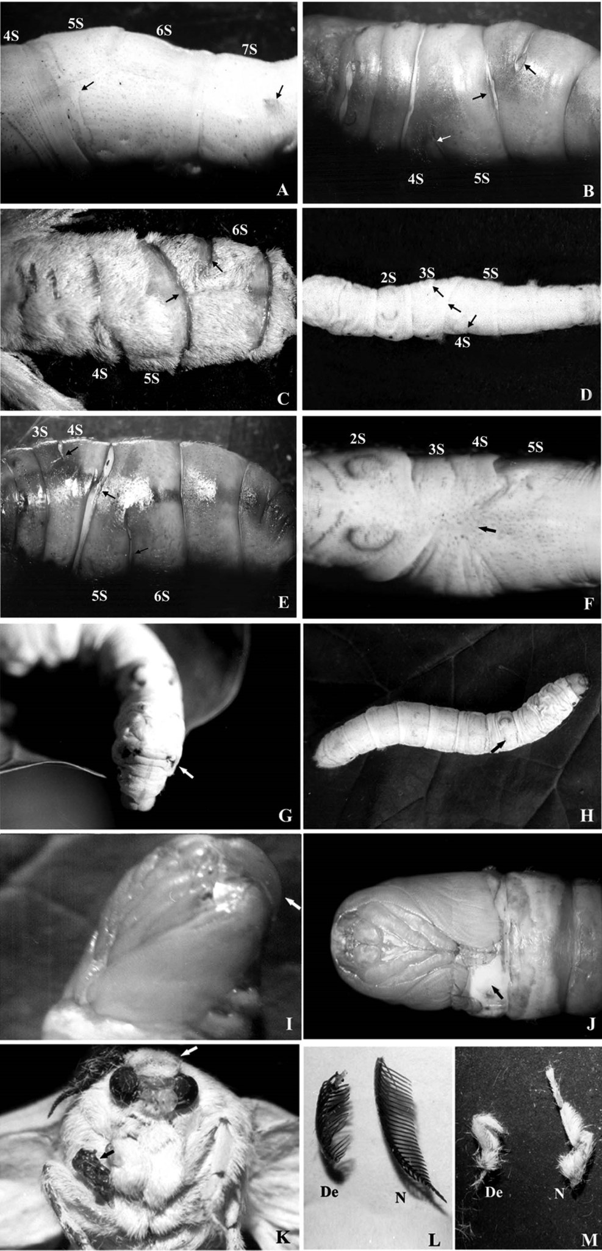
Fig 10 : Structural polymorphisms induced in NB4D2 breed of silkworm Bombyx mori by UV laser light irradiation
. 16 h-old embryos exposed for 90 sec resulted in larva (A), pupa (B) and adult (C) explicit asymmetric fusions of the 4th abdominal segment with 5th segment (arrows). An extra caudal horn on the 7th abdominal segment in larva is indicated by an arrow (A). 8 h-old embryos exposed for 90 sec showed larva (D) and pupa (E) with asymmetric fusion of the 3rd abdominal segment with 4th segment (arrows). 16 h embryos exposed for 180 sec resulted in larva with complex asymmetric fusion of abdominal segments (F, arrow). 16 h embryo irradiated for 150 sec resulted in larva with P₂ degree of P gene expression for eye spot markings on the 2nd thorasic segment (G, arrow). Arrow in H denotes missing of one crescent larval marking in a larva derived from a 16-h embryo irradiated for 180 sec. Arrow denotes transposition antennal bud in the pupa (I, arrow) and arrow in J denotes shortened wing pad derived from a 2-h embryo irradiated for 180 sec.
In moths derived from 16 h embryos irradiated for 180 sec (K, L, M) a moth with one missing antennae (white arrow) and the other deformed was seen (K). Black arrow in K indicates deformed prothorax leg. In addition defective antennae (De) along with normal antennae (N) occurred in irradiated population (L) as well as defective legs (De) along with normal legs (N) from irradiated embryos (M). Magnification of images were as follows: A – 4x, B – 1.5x, C – 1.5x, D – 2x, E – 1.6x, F – 4.2, G – 2x, H – 1.5x, I – 3.5x, J – 5x, K – 10x, L – 8x, M–7x. (Manjunatha et al.,2011).
Also the frequency of defective larvae following UV irradiation of different area sizes showed that, Larval defects are more when the larvae were irradiated at early embryonic stage and area of irradiation should be considered because large size of irradiation the percent of defective larva are more also mortality rate was more (Myohara, 1994).
This supports the concept of radiation hormesis, where:
Low dose → stimulatory effect
High dose → inhibitory effect
Ali et al. (2010) reported improved biological traits in Urboshi-1 variety after short UV exposure at pupal stage. Shibamoto et al. (2017) demonstrated enhanced growth using low-dose radiation-emitting sheets.
Haemolymph and Biochemical Changes
Table. 1 : Quantitative analysis of hemolymph protein bands from larva and pupae of Silkworm, Bombyx mori using densitometry

Stage of hemolymph sample | Name  of the protein band | Doses of EBI in Gray (Gy) |  |  |  |  |  | One way ANOVA  analysis
Stage of hemolymph sample | Name  of the protein band | Control | 20 | 40 | 60 | 80 | 100 | F | P
Relative density of larval hemolymph protein† | 40 kDa | 1.0 ± 0.0a | 2.33 ± 0.08a | 5.46 ± 0.41a | 2.38 ± 0.16a | 2.17 ± 0.13a | 2.35 ± 0.13a | 1.175 | NS*
Relative density of Pupal hemolymph  protein† | Lipophorin (Lp)  Vitellogenin (Vg) Storage protein (Sp) | 1.0 ± 0.0a  1.0 ± 0.0a  1.0 ± 0.0a | 1.02 ± 0.00a  0.90 ± 0.00b  0.77 ± 0.00b | 0.76 ± 0.00b  0.44 ± 0.01c  0.58 ± 0.00c | 0.66 ± 0.01c  0.47 ± 0.02c  0.40 ± 0.00d | 0.61 ± 0.02c  0.26 ± 0.02d  0.41 ± 0.00d | 0.35 ± 0.00d 0.20 ± 0.03d  0.43 ± 0.01d | 937.7  591.3  4699 | <0.05  <0.05  <0.05
 | 30 kDa protein  (30 kDa) | 1.0 ± 0.0a | 0.90 ± 0.05a | 0.49 ± 0.02b | 0.52 ± 0.02b | 0.48 ± 0.02b | 0.59 ± 0.05b | 74.74 | <0.05

Means followed by same letters in rows are not significantly different at P = 0.05 using Tukey’s pairwise comparisons. Degree of freedom for every variable is 17. The P – value indicates the significance at <0.05 using One way ANOVA analysis. NS-indicates non-significant. NS* indicates the unequal variances show the significance at <0.05 using Welch F test
Tamilnadu white × NB4D2
- Any kind of stimulus/radiation stress on the insect immediately reflects on the hemolymph protein expression.
- Similarly, the hemolymph protein expression at 40 kDa was observed in the EBI treated larvae.
- The pupal hemolymph proteins (six day old pupa developed EBI treated 5th instar larvae) including lipophorin, vitellogenin, storage protein and 30 kDa proteins were significantly reduced

Radiation stress affects haemolymph protein expression.
Protein Response Graph Interpretation
Altered SDS-PAGE banding pattern
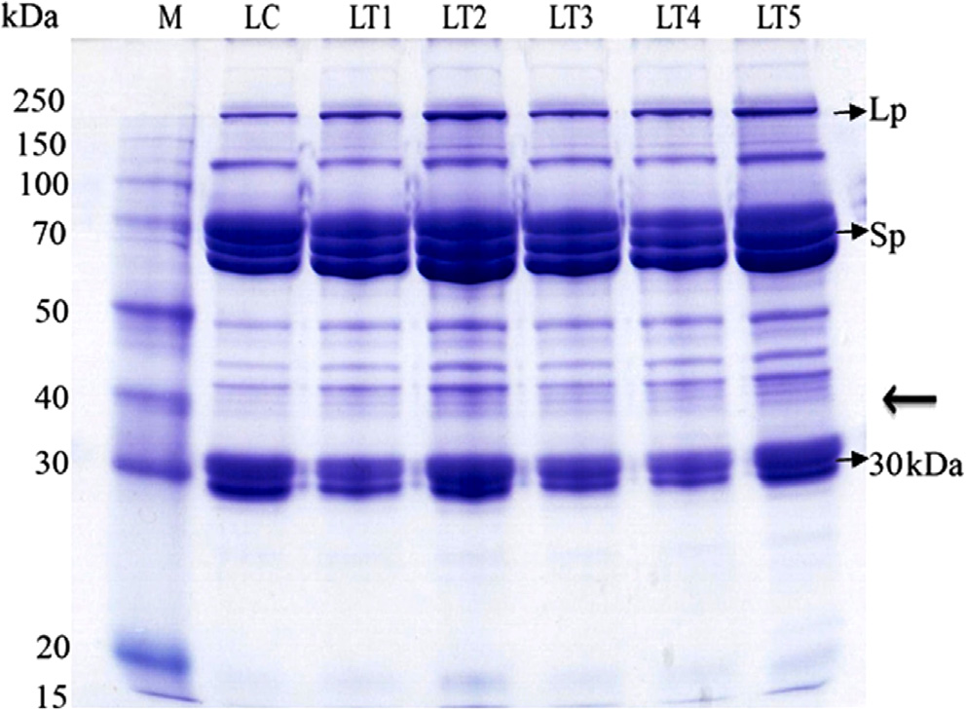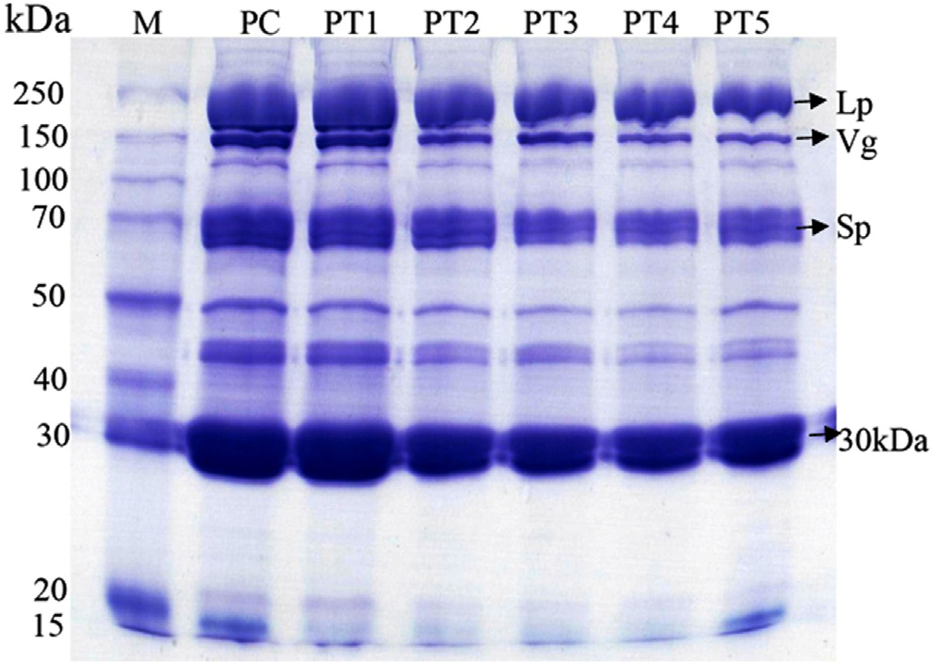
Plate 2 : SDS–PAGE pattern of pupal hemolymph protein (Six days old pupa developed from control and EBI treated larvae) of silkworm, B. mori (PC pupae control; PT1-20 Gy; PT2-40 Gy; PT3-60 Gy; PT4-80 Gy; PT5-100 Gy. Lane M stands for Protein ladder purchased from Thermo scientific, USA).

Plate 1 : SDS–PAGE pattern of larval hemolymph proteins (two days old 5th instar larvae) of control and EBI treated silkworm, B. mori (LC-larvae control; LT1-20 Gy; LT2-40 Gy;CLT3-60 Gy; LT4-80 Gy; LT5-100 Gy. Lane M stands for Protein ladder

The generated graph shows gradual decline in haemolymph protein levels with increasing radiation dose.Manikannan et al. (2017) observed, Reduced 30 kDa protein- Decline in lipophorin and storage proteins
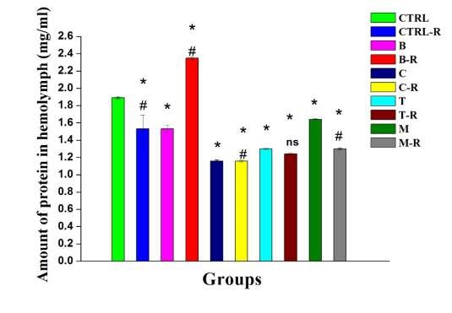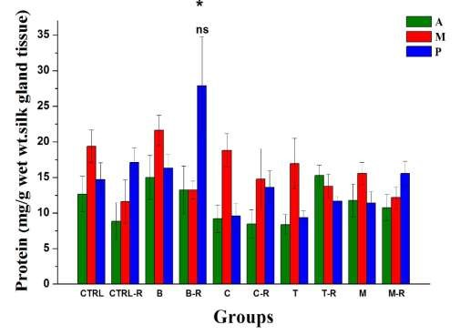
Fig 11 : Changes in the levels of protein of hemolymph (A) and silk gland (B) of Bombyx mori upon exposure to radiation and antioxidants.
Values are mean ± SE of fifth instar larvae (n=10). Symbol '*' represents the significant difference (P<0.05) between control group worms (Ctrl) and control group worms exposed to radiation (Ctrl-R), control group worms (ctrl) and groups of worm fed with mulberry leaves sprayed with antioxidants viz., beetroot (B) fed, beetroot fed cum radiation exposed worms (B-R), carrot (C) fed, carrot fed cum radiation exposed worms (C-R), turmeric (T) fed and turmeric fed cum radiation exposed worms (T-R), mehndi (M) fed, mehndi fed cum radiation exposed worms (M-R). Symbol '#' represents the significant difference between Ctrl and Ctrl-R, and B and B-R, C and C-R, T and T-R, and M and M-R; ‘ns’ represents non-significant between groups. Results reported that A-anterior, M-middle and P-posterior region of silk gland reported antioxidant supplementation (beetroot, carrot, turmeric) mitigated protein degradation (Radha et al. (2020)) This suggests oxidative stress as a major mechanism.
Silk Gland and Morphological Alterations
UV laser irradiation induced: Effect of UV-laser on the economic traits of a multivoltine variety (Urboshi-1) of the silkworm B. mori. UV-radiation exposed at pupal stage indicating that UV- radiation can be effective in improving different of traits of B. mori, especially pupa exposed for about one minute gives best results reported by Ali at al., (2010). Whereas Hosagoudar et al., (2010) reported that, effect of fourth harmonic UV laser (picosecond) on economic characters NB4D2 breed of silkworm Bombyx mori such as cocoon weight shell weight and shell ratio have showed that, A decrease in bio-commercial traits in the batches exposed to the fourth harmonic laser, and the high-energy radiation had an inhibiting effect. Also similar results observed by Kamelia et al., (1995) on effect of irradiation of Bombyx mori eggs on economic charecters The greatest stimulatory effect for all the mentioned traits was achieved when the eggs were exposed to a dose of 1 Gy followed by 0.5 then 0.2 Gy. The exposure of eggs to a dose of 1 Gy is not difficult technologically and may be recommended for cultivation of irradiated biotechnology with the aim of enlarging productivity of silk production.
Radha et al., 2020 studied the changes in cocoon traits in Bombyx mori upon radiation exposure and supplemented diet with antioxidants. They found that, synergistic effect of both antioxidants and radiation on the tissues of silk gland especially anterior, middle and posterior regions of the body were noted along with the biochemical changes, which are of great significance as they are involved in silk performance during the spinning of the cocoon as the silk gland cells synthesize the silk protein fibroin in the posterior region of silk gland, a key protein of silk filament. Also the commercial traits such as raw silk length, weight, thickness were increased in the experimental groups while the mortality rate was more in control and radiation exposed control group larvae. This proves the larvae upon exposure to radiation and fed with antioxidants highly beneficial for the silk yield. Bharathi and yugen, (2001) reported the effect of UV light for 30 minutes was congenial for the larval growth, per cent survival, eclosion, fecundity, cocoon characters and silk quality of two popular bivoltine hybrids of silkworm, Bombyx mori. L.
Effect of radiation on silk fibroin
The gamma radiation on silk fibroin fibers showed that the physical and mechanical properties of silk fibroin had been altered; i.e., the color was gradually darkened, the scent was stronger, and the ductility and tensile strength were reduced.

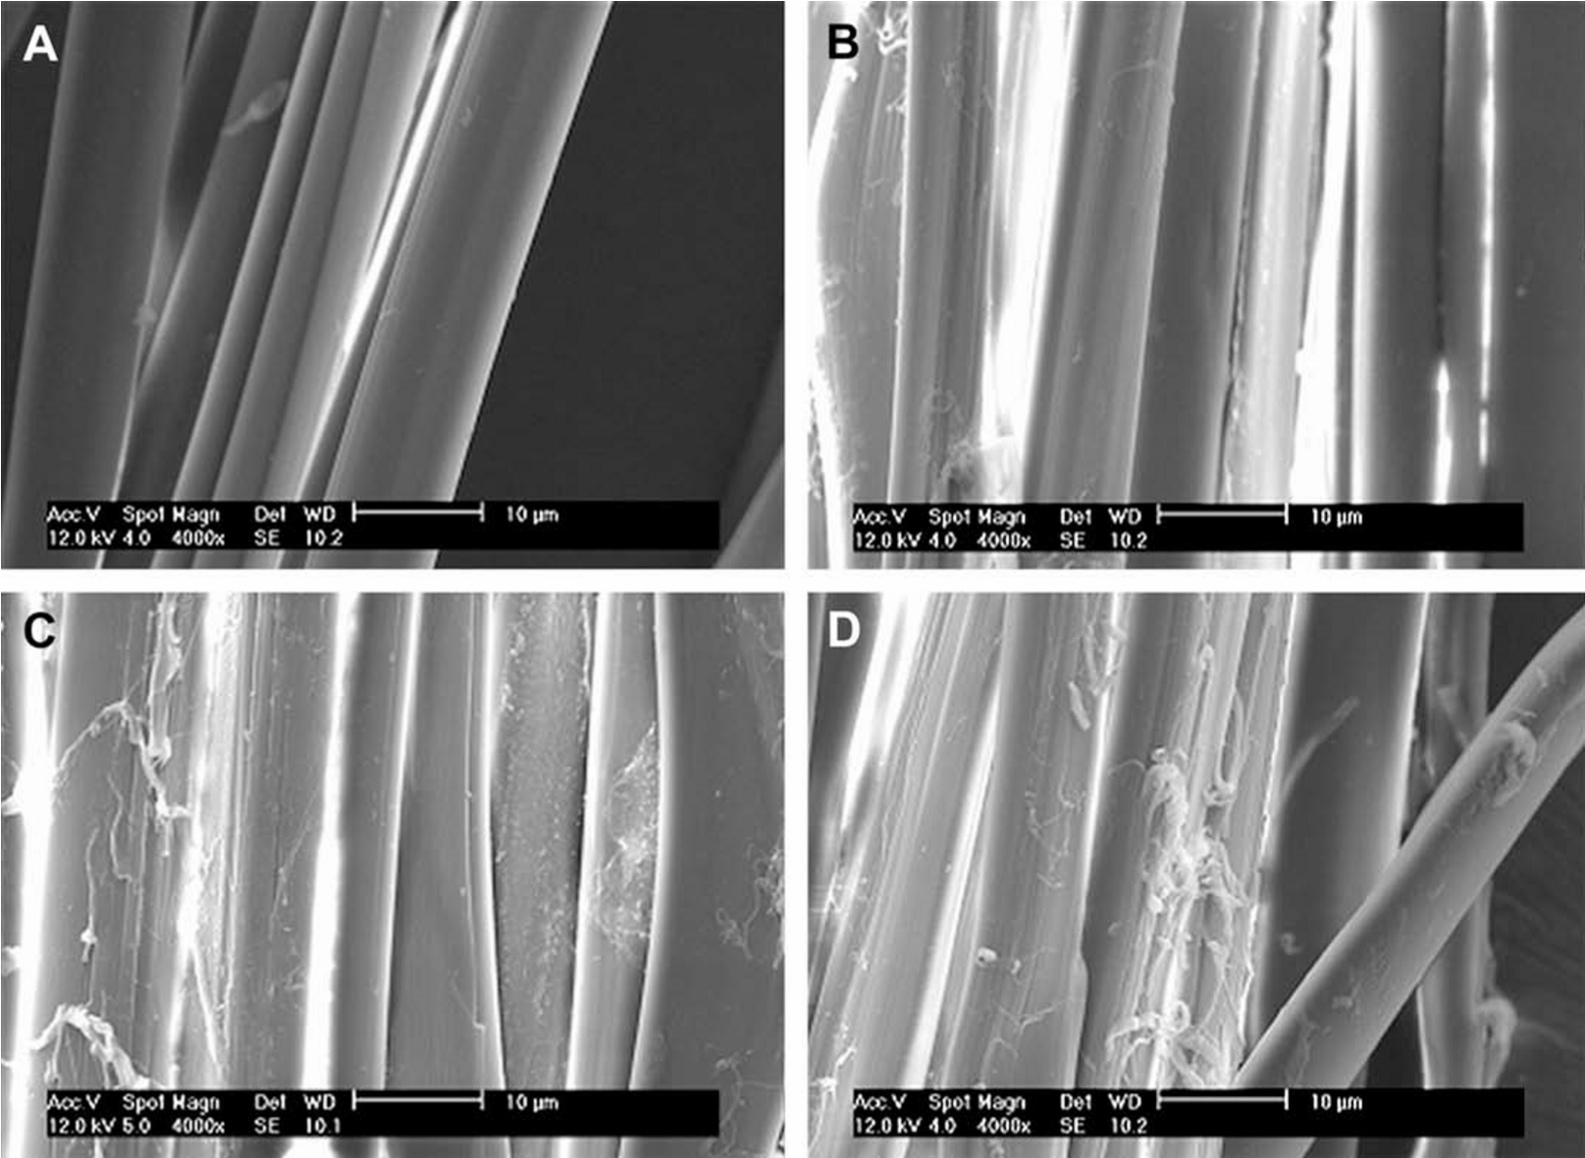
Fig 12 : SEM images of silk fibroin fibers after gamma irradiation: (A) unirradiated fibers, (B) 300 kGy, (C) 600 kGy, and (D) 900 kGy.
The SEM images in Fig. 1 show an increase of erosion and cleft formation on fibroin fibers exposed to increasing dosages of radiation. This indicates a structural change of silk fibroin after irradiation. The gamma radiation on silk fibroin fibers showed that the physical and mechanical properties of silk fibroin had been altered; i.e., the color was gradually darkened, the scent was stronger, and the ductility and tensile strength were reduced. The SEM images in Fig. 1 showed an increase of erosion and cleft formation on fibroin fibers exposed to increasing dosages of radiation. This indicates a structural change of silk fibroin after irradiation (Kojthung et al., 2008).
Radha et al. (2020) observed Structural degradation increases with radiation dosage, where changes in anterior, middle and posterior silk gland regions responsible for fibroin synthesis.
The low dose of irradiation increase the cocoon traits, stimulation is most effective in certain dose range. In case of urbashi variety the dose is 4-5Gy for fourth instar larvae. It also proved that low dose gamma laser has stimulating effect on mulberry silkworm (Hossain et al., 2006).
9. Radiation Resistance and Genetic Inheritance
Takahashi (2006) screened multiple strains and observed significant variation in radiation sensitivity.
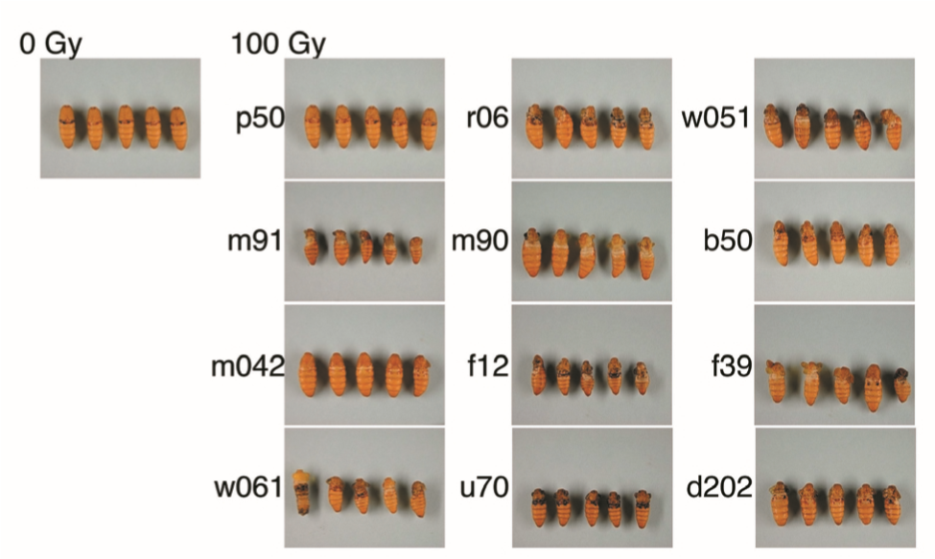
Fig 13 : Screening for radiation sensitivity using twelve silkworm strains based on the morphological variation of the wing. The irradiation was carried out on day 3 of the fifth instar.
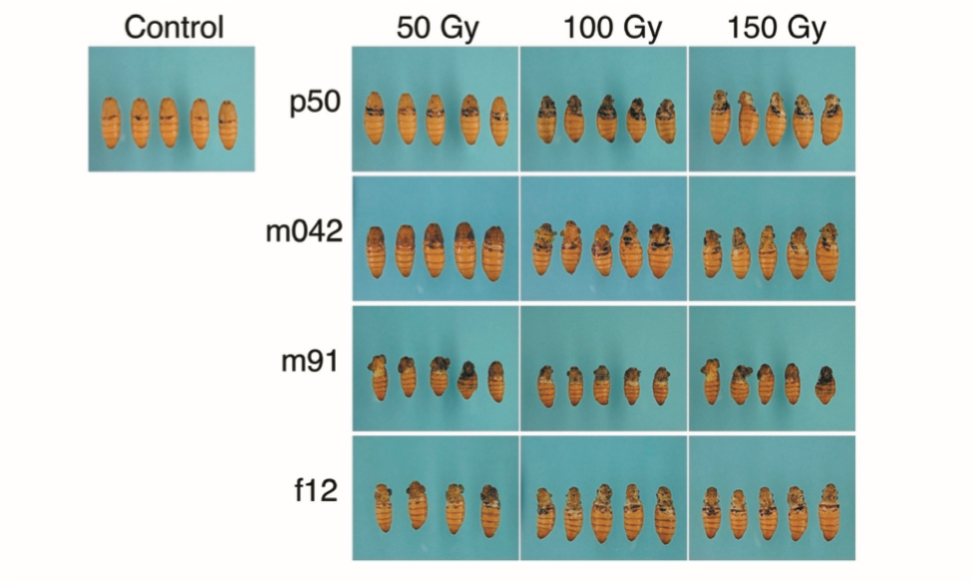
Fig 14 : Comparison of susceptibility against γ–irradiation between resistant and sensitive silkworm strains. The irradiation was carried out on day 2 of the fifth instar. The radiation sensitivity was evaluated by observing the morphological variation of the wing
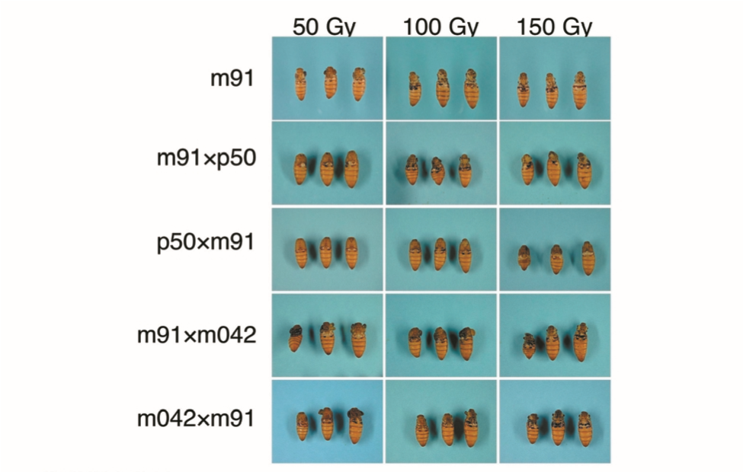
Fig 15 : Comparison of susceptibility against γ–irradiation between F1 generations from reciprocal crosses using the strains m91/p50 and m91/m042. Each of F1 from the indicated reciprocal crosses was irradiated on day 2 of the fifth instar. The radiation sensitivity was evaluated by observing the morphological variation of the win

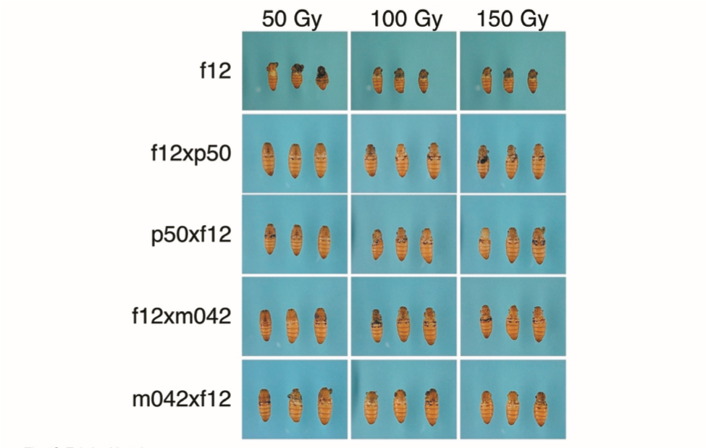
Fig 16 : Comparison of susceptibility against γ–irradiation between F1 generations from reciprocal crosses using the strains f12/p50 and f12/m042. Each of F1 from the indicated reciprocal crosses was irradiated on day 2 of the fifth instar. The radiation sensitivity was evaluated by observing the morphological variation of the wing.
Reciprocal cross experiments confirmed heritable radiation tolerance. Selection of resistant strains can support mutation breeding programmes.
Conclusion
Laser irradiation has emerged as a promising tool in sericulture research for improving the biological and commercial traits of Bombyx mori. The studies reviewed indicate that the effects of laser and other radiation treatments are highly dependent on exposure dose, developmental stage and genetic background of the silkworm. Early embryonic stages show greater sensitivity to irradiation, often resulting in reduced hatchability and developmental abnormalities at higher doses. However, controlled low-dose irradiation has demonstrated stimulatory effects on larval growth, cocoon characters and overall silk productivity, supporting the concept of radiation hormesis. Radiation exposure also induces somatic mutations and morphological variations, providing valuable genetic variability that can be utilized in mutation breeding programmes. At the physiological level, changes in haemolymph protein profiles and silk gland activity indicate that radiation stress influences metabolic pathways involved in silk production. Furthermore, the heritable nature of radiation tolerance among silkworm strains highlights the potential for developing radiation-resistant lines through selective breeding. Overall, laser-based irradiation, when carefully optimized, offers a valuable approach for enhancing productivity and genetic improvement in sericulture, though further research integrating molecular and biochemical approaches is required to fully exploit its potential.
References
Ali M., Rahman S. M., Rahman M. S. and Rashid M. A., 2010, Effect of UV-laser on biological and economic traits of multivoltine silkworm (Bombyx mori L.).
Hennberry T. J., 1963, Gamma radiation effects on post-diapause silkworm eggs.
Hosagoudar G. N., 2010, Effect of nano and picosecond UV laser irradiation on biological and economic traits of Bombyx mori L.
Hossain M. A., Rahman S. M. and Islam M. N., 2006, Effect of radiation dose on cocoon traits of silkworm.
Kamelia N., El-Shamy M. and El-Sherif S., 1995, Effect of irradiation of Bombyx mori eggs on biological and economic characters.
Kotani E., Furusawa T. and Banno Y., 2002, Somatic mutation induced by heavy-ion irradiation in silkworm.
Manikannan P., Murugan K. and Kumar S., 2017, Quantitative analysis of haemolymph proteins in irradiated silkworm.
Radha N., Ramesh V. and Krishnaprasad K., 2020, Effect of radiation and antioxidant diet on silk gland structure and economic traits of Bombyx mori.
Sakashita T., Furusawa T. and Banno Y., 2009, Microbeam irradiation induced somatic mutation in silkworm.
Shibamoto Y., Nakamura H. and Kato S., 2017, Growth promotion under low-dose radiation.
Takahashi S., 2006, Radiation resistance and inheritance in silkworm strains.
Tazima Y., 1984, The Genetics of the Silkworm.

