Effects of plant growth regulators on in vitro growth and callus induction OF Mint (Mentha arvensis L. – Lamiaceae)

Abstract
Introduction: Mentha arvensis L. – Lamiaceae (M. arvensis) is a medicinal plant belonging to the Lamiaceae family and is widely used in the pharmaceutical, cosmetic, and food industries due to its essential oils and bioactive compounds, particularly flavonoids. In vitro culture techniques have been increasingly applied for the rapid propagation and quality improvement of medicinal plants. However, the effects of different plant growth regulators on shoot multiplication, root induction, and secondary metabolite accumulation in M. arvensis have not been fully clarified.
Aim: To establish an optimized protocol for culturing in vitro M. arvensis and inducing callus by optimizing plant growth regulators.
Results: In particular, M. arvensis explants were cultured on the MS medium supplemented with different amounts of BA solution for shoot multiplication. After data analysis, a promising concentration of BA was obtained at 0.4 mg/L, which enhanced the quality of M. arvensis’s shoots. Besides, the most effective rooting of M. arvensis sample on the medium supplemented with 0.4 mg/L IBA, resulting in a significant increase in root length (2.44 ± 0.15 cm) and rise of roots per explant (68.12 ± 4.55). NAA and IAA also enhanced root quality and quantity. Additionally, a combination of full-strength MS solution with 2 mg/L Picloram rapidly developed the size of callus while declining the oxidation of callus. Moreover, both in vitro plantlets and callus extraction indicated the high content of bioactive compounds like flavonoids and essential oils. The total flavonoid content was determined by applying US-Vis spectrophotometry, and the total oil was measured by GC–MS analysis.
Concusion: the optimized procedure of tissue culture is suitable for in vitro breeding of M. arvensis and can be used as the data for further studies on biomass production and the improvement of bioactive compounds

Keywords: M. arvensis; in vitro culture; shoot multiplication; root induction; flavonoid content

1. Introduction
The genus M. arvensis, which belongs to the Lamiaceae family, includes numerous aromatic and medicinal plants cultivated worldwide. Main components of this genus comprise essential oils and secondary metabolites such as flavonoids, phenolic acids, and terpenoids, which exhibit antioxidant, antimicrobial, and anti-inflammatory properties. Among the notable species is M. arvensis, commonly known as peppermint, which holds significant economic and pharmaceutical value. This species is widely used in herbal remedies, food flavorings, and pharmaceuticals because of its essential oil and bioactive compounds (McKay and Blumberg, 2006; Panche et al., 2016; Burt, 2004).
Traditional propagation methods for M. arvensis primarily rely on vegetative techniques, which often face challenges such as low economic viability, lengthy propagation times, seasonal dependency, and susceptibility to pests and diseases. These factors can adversely affect crop uniformity and the quality of raw materials for medicinal applications. To overcome these limitations and scale up production, alternative propagation methods need to be explored. Tissue culture has emerged as a promising technique for fast and efficient large-scale propagation of medicinal plants. In vitro cultivation allows for plant growth under controlled conditions, independent of environmental factors. This method also provides opportunities to manipulate plant growth regulators to control morphology and enhance regeneration efficiency. Therefore, evaluating an effective system is essential for the sustainable production of medicinal plants (George et al., 2008).
Plant growth regulators play a significant role in regulating in vitro plant development. Cytokinin, such as BA, is known to promote shoot development, while auxins such as α-naphthaleneacetic acid (NAA), indole-3-butyric acid (IBA), and indole-3-acetic acid (IAA) are commonly used to stimulate the development of roots. Many studies have shown that the type and concentration of these regulators can differentially influence shoot formation, root development, and root length. However, optimal hormonal conditions tend to be species-specific and therefore warrant further investigation (George et al., 2008).
In addition to facilitating plant regeneration, in vitro culture also has potential for secondary metabolite synthesis. Flavonoids, an important group of bioactive compounds in the Lamiaceae family, contribute to a wide range of biological effects. The accumulation of flavonoids can be influenced by environmental conditions, growth regulators, and plant developmental stage. While there is a wealth of in vitro studies on the propagation of M. arvensis species, the effects of cytokinin and auxin on the regeneration capacity and flavonoid content of M. arvensis remain unclear (Panche et al., 2016; George et al., 2008). This study aimed to develop an in vitro protocol for M. arvensis and to investigate the effects of plant growth regulators on shoot multiplication, root growth, callus induction, and secondary metabolite production.
This study focuses on shoot development and the impact of BA, while the roles of NAA, IBA, and IAA in root formation, callus formation under different auxin conditions (2,4-D, NAA, and Picloram) and flavonoid production in callus tissues were also evaluated. In addition, in vitro explants were extracted to figure out the amount of flavonoid content and oil content. The result of this research will be valuable for optimizing in vitro propagation methods and advancing understanding of the biological activity and large-scale production of compounds derived from M. arvensis.

2. Materials and Methods

2.1 Materials
The plant material used in this study is M. arvensis, belonging to the Lamiaceae family. In vitro samples were taken from stock cultures maintained under sterile laboratory conditions. Healthy and uniform plants were selected as materials for the experiments to ensure consistency between experiments (McKay and Blumberg, 2006; George et al., 2008). Nodal segments containing a single axillary bud were excised from in vitro plantlets and used as explants for shoot multiplication experiments. For rooting experiments, regenerated shoots with suitable length and healthy appearance were selected from the multiplication stage (George et al., 2008).

2.2 Culture media and culture conditions
Murashige and Skoog, MS (Murashige and Skoog, 1962) basal medium was used for all experiments. The medium was supplemented with 20 g/L sucrose as a carbon source and solidified with agar (8 g/L). The pH of the medium was adjusted to approximately 5.8 – 6.0 before the culture was sterilized at 121 °C for 20 minutes.
All cultures were incubated in a growth room under controlled environmental conditions at a temperature of 25 ± 2 °C. A photoperiod of 16 hours light and 8 hours dark was applied, with light intensity maintained at approximately 40 - 50 µmol m⁻² s⁻¹ using white lamps.

2.3 Effect of BA on shoot multiplication
To investigate the effect of BA (6-benzyladenine) on shoot multiplication, nodal explants were cultured on the MS medium supplemented with different concentrations of BA. The MS medium without plant growth regulators was used as the control treatment. In detail, this medium concluded: MS solution(full-strength); sucrose 20 g/L; agar 8 g/L; 1 g/L activated charcoal; pH 5.8–6.0, especially the concentration of BA ranging from 0 to 1.0 mg/L to determine the development of samples. All measurements were performed in replicates to ensure the reliability of the results.
Each treatment consisted of multiple explants cultured under identical conditions. After a fixed culture period (4 weeks), shoot regeneration was evaluated. The parameters recorded included the average number of shoots per explant, average shoot length, and average number of leaves per shoot. In addition, contaminated samples were eliminated in the data analysis. These parameters were used to evaluate the effect of BA on shoot multiplication. The experimental design for shoot multiplication followed previously published protocols with minor modifications (George et al., 2008).

2.4 Effect of auxins on root formation
For root formation, in vitro shoots obtained from the control treatment of the shoot multiplication stage were used as explants. In detail, shoots with a similar length were chosen to be transferred to the MS medium containing different auxins. Three auxins were tested in this study: NAA, IBA, and IAA, each at different concentrations. Hormone-free MS medium was used as the control. The culture medium used in this experiment was supplemented with MS solution, sucrose 20 g/L, agar 8 g/L, 1 g/L activated charcoal, and pH 5.8–6.0. Each auxin was added to the medium at concentrations of 0, 0.1, 0.2, 0.3, 0.4, and 0.5 mg/L, with an auxin-free medium serving as the control. All measurements were performed in replicates to ensure the reliability of the results.
Root formation was observed after a certain culture period (4 weeks). The efficiency of each hormone was evaluated based on morphological parameters, including the average number of roots, average root length, mean root length, and number of leaves per sample. Then, the ANOVA test was applied to determine if these hormones improved the development of M. arvensis’s roots. The experimental design for root formation was based on previously published protocols, with minor modifications (Sinha et al., 2016).

2.5 Callus induction
Leaves were cut and transferred to different media comprising three treatments: (i) ½ MS and MS + 1-2 mg/L 2,4-D; (ii) ½ MS and MS + 1-2 mg/L NAA; (iii) ½ MS and MS + 1-2 mg/L Picloram to investigate the effect of these auxins on callus size development compared with the callus grown in the medium without auxin. Each treatment was repeated three times. After 14 days, the development of callus was recorded for data analysis. Callus samples induced on 2,4-D–containing medium were collected for flavonoid analysis using the UV–Vis spectrophotometric method.

2.6 Analysis of flavonoid content
The total flavonoid content (TFC) of in vitro explants and callus was determined by the analytical laboratory at the University of Science using the UV-Vis method, as described by Chang et al. (2002). Shoots grown on the control medium (MS + 0 mg/L BA) during the shoot multiplication stage were dried at 60°C for 2 days before extraction and subsequent analysis using a UV-Vis spectrophotometer. To minimize the error, each mentioned sample was measured in three replications. Specifically, TFC was expressed as mg QE/g DW, using quercetin as the calibration standard.

2.7 Essential oil extraction and GC–MS analysis
An ex vitro sample provided by the external laboratory was used as the control. The material was collected from fresh shoots grown on the control medium (MS + 0 mg/L BA) during the shoot multiplication stage. Individual compounds were identified by mass spectral comparison with standard libraries in the GC-MS system. The amount of each compound was measured as a percentage (%) of the total peak area in this system. To examine the quality of oil extracted from in vitro samples, the control sample was an ex vitro sample provided by the external laboratory, and each sample was peformed triplicate.

2.8 Experimental design and data analysis
Each treatment in shoot multiplication and root formation included ten samples; however, non-contaminated samples were used for data analysis. With the callus induction, each treatment was repeated three times. In detail, data from non-contaminated samples were analyzed by the one-way ANOVA, and Tukey’s HSD test was applied.

3. Results

3.1 Effect of BA on in vitro shoot multiplication
In the context of M. arvensis, the impact of BA (6-benzyladenine) was evaluated for stem explants cultured on the MS medium supplemented with various concentrations of BA. The addition of BA considerably improved shoot multiplication, as evidenced in Table 1 by the comparison to the control.
The control sample produced very few shoots, shorter shoot length, and fewer leaves per sample. In contrast, adding BA solution improved axillary shoot multiplication, espilcally samples were treated with 0.4 mg/L BA. However, increasing the BA concentration more than 0.4 mg/L led to a decrease in the quantity of shoots. Morphological differences among treatments were shown in Figure 1.
Table 1. Effects of BA concentrations on in vitro shoot regeneration parameters of M. arvensis after 4 weeks of culture.
BA (mg/L) | Shoots/explant | Shoot length (cm) | Nodes/shoot | Leaves/shoot
0.0 | 2.40 ± 0.22ᵃᵇ | 2.58 ± 0.21ᵇ | 3.70 ± 0.50 ^{c} | 6.20 ± 0.47 ^{b}
0.1 | 2.30 ± 0.26ᵇ | 3.73 ± 0.51ᵃᵇ | 3.90 ± 0.46 ^{c} | 9.60 ± 1.03 ^{ab}
0.2 | 2.30 ± 0.45ᵇ | 3.90 ± 0.44ᵃᵇ | 4.40 ± 0.48 ^{b} | 9.80 ± 0.92 ^{ab}
0.3 | 2.00 ± 0.33ᵇ | 3.54 ± 0.45ᵃᵇ | 3.44 ± 0.47 ^{c} | 8.67 ± 0.94 ^{ab}
0.4 | 2.20 ± 0.20ᵇ | 3.77 ± 0.48ᵃᵇ | 5.40 ± 0.40 ª | 12.00 ± 1.06 ª
0.5 | 2.10 ± 0.18ᵇ | 3.72 ± 0.27ᵃᵇ | 3.10 ± 0.53 ^{c} | 8.40 ± 1.07 ^{ab}
0.6 | 2.50 ± 0.22ᵃ | 3.71 ± 0.38ᵃᵇ | 3.60 ± 0.52 ^{c} | 9.30 ± 1.10 ^{ab}
0.7 | 2.30 ± 0.26ᵇ | 4.09 ± 0.50ᵃ | 4.20 ± 0.39 ^{b} | 10.10 ± 0.74 ^{ab}
0.8 | 2.10 ± 0.23ᵇ | 3.63 ± 0.37ᵃᵇ | 4.70 ± 0.26 ^{b} | 10.50 ± 0.56 ª
0.9 | 2.40 ± 0.22ᵃᵇ | 3.57 ± 0.38ᵃᵇ | 3.80 ± 0.49 ^{c} | 9.80 ± 1.16 ^{ab}
1.0 | 2.33 ± 0.17ᵃᵇ | 3.13 ± 0.24ᵇ | 4.22 ± 0.55 ^{b} | ± 0.85 ^{ab}
Note: The data are expressed as mean ± standard deviation. Means in the same column with different letters are significantly different (p < 0.05) according to duncans multiple range test.
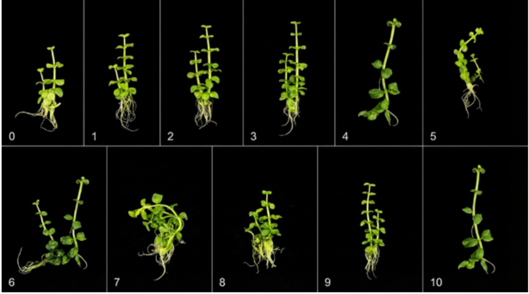
Figure 1. Representative images showing the effect of BA on in vitro shoot growth of M. arvensis after 4 weeks of culture: (0) control; (1) 0.1 mg/L BA; (2) 0.2 mg/L BA; (3) 0.3 mg/L BA; (4) 0.4 mg/L BA; (5) 0.5 mg/L BA; (6) 0.6 mg/L BA; (7) 0.7 mg/L BA; (8) 0.8 mg/L BA; (9) 0.9 mg/L BA; (10) 1 mg/L BA

3.2 Root induction under different auxin treatments (NAA, IBA, and IAA)
Rooting of regenerated shoots of M. arvensis was evaluated on the MS medium supplemented with various concentrations of NAA, IBA, and IAA. The performance of root formation was assessed based on the number of roots, root length, and number of leaves per sample. The MS medium without plant growth regulators was used as the control. These data were recorded and are summarized in Table 2.
Shoots in the control sample showed poor rooting, producing few and short roots. Shoots grown on NAA-supplemented media produced limited roots, while shoots treated with IAA produced shorter roots compared with those cultured on IBA-supplemented media. Moreover, the best performance of rooting was obtained at 0.4 mg/L IBA. Then, each treatment with a specific concentration of auxin was repeated ten times; however, contaminated samples were excluded from the data analysis. Morphological differences among the control and auxin treatments are shown in Figure 2 and are consistent with the quantitative data presented in Table 2.
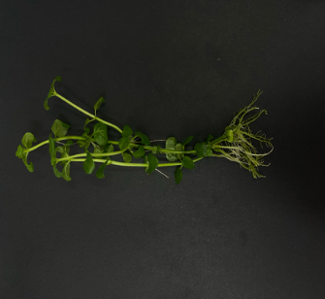
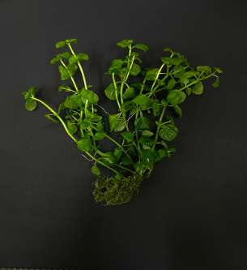
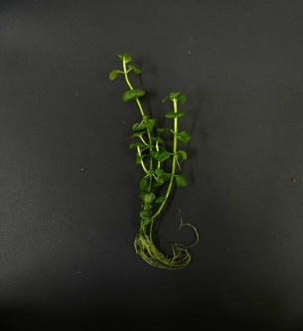
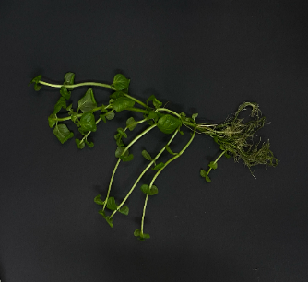
A
C
D
B

Figure 2. Representative images showing the effect of auxins on in vitro root induction of M. arvensis after 4 weeks of culture, A) Root formation (control); (B) Root formation with NAA (0.4 mg/L); (C) Root formation with IBA (0.4 mg/L); (D) Root formation with IAA (0.4 mg/L)
Table 2. Effect of NAA, IBA, and IAA concentrations on in vitro root induction and growth of M. arvensis (after 4 weeks). Values are means ± SE (n = 5–8).
Treatment | Auxin (mg/L) | Root number | Root length (cm) | Leaves/plantlet
Control | 0.0 | 13.80 ± 0.58ᵈ | 2.22 ± 0.13ᵇ | 9.00 ± 0.92ᶜ
NAA | 0.1 | 21.62 ± 0.84ᶜ | 2.23 ± 0.17ᵇ | 8.29 ± 0.61ᶜ
NAA | 0.2 | 24.71 ± 4.54ᶜ | 2.73 ± 0.15ᵃᵇ | 8.21 ± 1.28ᶜ
NAA | 0.3 | 22.00 ± 1.26ᶜ | 2.60 ± 0.24ᵃᵇ | 11.12 ± 2.31ᵇ
NAA | 0.4 | 27.50 ± 2.14ᶜ | 2.74 ± 0.09ᵃᵇ | 8.69 ± 0.35ᶜ
NAA | 0.5 | 22.67 ± 2.11ᶜ | 2.53 ± 0.13ᵇ | 10.12 ± 1.62ᵇ
IBA | 0.1 | 42.56 ± 3.89ᵇ | 2.98 ± 0.21ᵃ | 8.37 ± 0.56ᶜ
IBA | 0.2 | 53.44 ± 4.29ᵇ | 2.45 ± 0.16ᵇ | 8.53 ± 0.42ᶜ
IBA | 0.3 | 67.71 ± 5.73ᵃ | 1.99 ± 0.14ᶜ | 11.34 ± 1.92ᵇ
IBA | 0.4 | 68.12 ± 4.55ᵃ | 2.44 ± 0.15ᵇ | 8.54 ± 0.48ᶜ
IBA | 0.5 | 65.25 ± 5.82ᵃ | 2.60 ± 0.13ᵃᵇ | 10.82 ± 1.75ᵇ
IAA | 0.1 | 33.90 ± 4.67ᵇ | 1.89 ± 0.05ᶜ | 10.46 ± 0.66ᵇ
IAA | 0.2 | 29.88 ± 4.29ᶜ | 2.25 ± 0.22ᵇ | 9.13 ± 0.69ᶜ
IAA | 0.3 | 33.20 ± 3.07ᵇ | 2.15 ± 0.11ᵇ | 10.41 ± 0.99ᵇ
IAA | 0.4 | 41.67 ± 3.95ᵇ | 2.05 ± 0.11ᵇ | 10.42 ± 0.55ᵇ
IAA | 0.5 | 35.38 ± 3.68ᵇ | 2.26 ± 0.15ᵇ | 12.72 ± 1.56ᵃ
Note: The data are expressed as mean ± standard deviation. Means in the same column with different letters are significantly different (p < 0.05) according to duncans multiple range test.

3.3 Total flavonoid content of dried in vitro plantlets
The total flavonoid content of dried in vitro plantlets of M. arvensis was determined using a spectrophotometric method. Dried plant material was used for the analysis, and the samples were processed and measured by an external analytical laboratory. Therefore, the results were presented in the form of quantitative data without morphological or visual documentation.
The flavonoid content was calculated based on a standard calibration curve and expressed as equivalents of the standard compound. The quantitative results obtained from the analysis are summarized in Table 3. The total flavonoid content was 4.66 mg QE/g DW. This value represents the flavonoid level detected in the dried plantlet sample under the experimental conditions.
Table 3. Total flavonoid content of in vitro-grown M. arvensis (dry sample).
Sample | Parameter | Unit | Result | Method
M. arvensis | TFC | mg QE/g DW | 4.66 | UV-Vis

3.4 Essential oil content of dried in vitro plantlets
The essential oil content of dried in vitro plantlets of M. arvensis was analyzed after the drying process. Before the main analysis, a headspace (HS) GC–MS screening was conducted to obtain a preliminary profile of volatile compounds present in the samples. Subsequently, essential oil extracted from dried plantlets was analyzed under total distillation (TD) conditions using GC–MS for qualitative and quantitative evaluation.
This analysis identified a total of eleven volatile compounds in the essential oil extracted from dried in vitro plantlets (Table 4). The detected components mainly belonged to the monoterpene and oxygenated monoterpene groups, which are commonly reported as characteristic constituents of M. arvensis species. Among the identified compounds, cyclohexanone derivatives and monoterpenes such as α-pinene, β-myrcene, D-limonene, and eucalyptol (1,8-cineole) were recorded (Figure 4).
Table 4: Essential oil content of 100g dried in vitro plantlets of M. arvensis
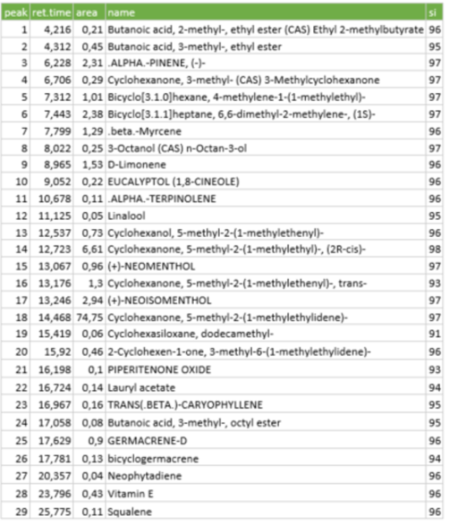

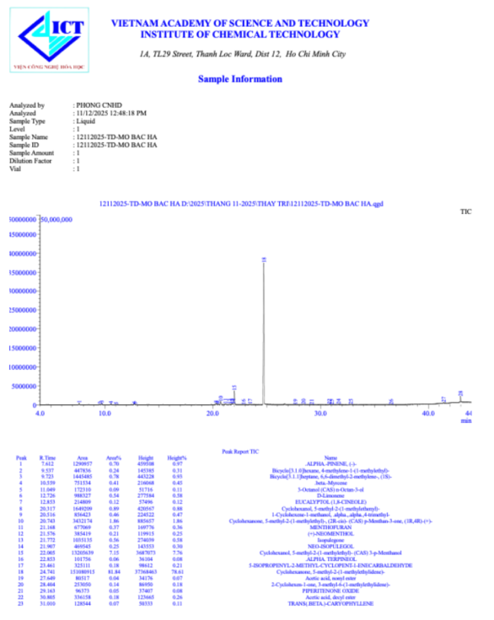
Figure 4. The result of the oil content of explants by GC-MS analysis

3.5 Callus formation of M. arvensis
Leaves of in vitro samples of M. arvensis were cultured with 2,4-D, NAA, or Picloram. Each callus induction treatment was performed in triplicate. After 14 days, the data on callus induction were recorded in Table 5. Callus formation was recorded after the culture period, and variations in callus response were observed among treatments. To compare with the control, it is difficult to deny the role of auxin in initiating callus of M. arvensis. The induced callus differed in appearance among treatments, ranging from compact to friable textures and from pale yellow to light brown in color. Some treatments produced well-developed callus, while others resulted in moderate callus formation. Representative callus morphology under different treatments is shown in Figure 5.
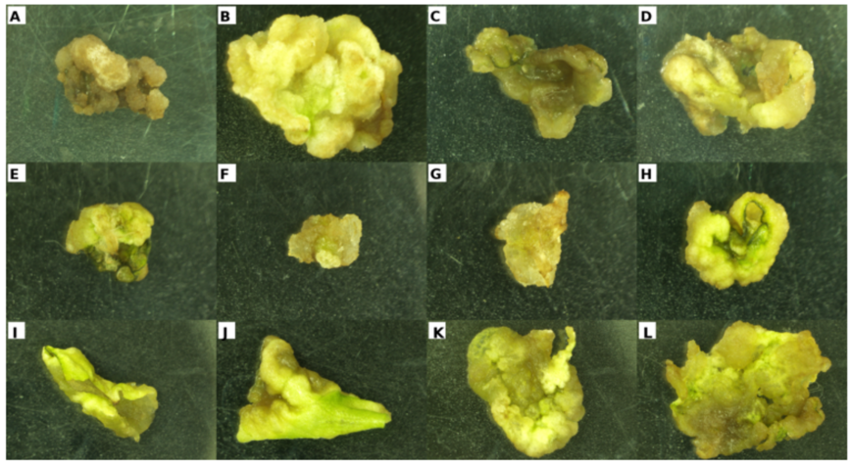
Figure 5. Callus induction. (A) ½ MS + 1 mg/L 2,4-D; (B) MS + 1 mg/L 2,4-D; (C) ½ MS + 2 mg/L 2,4-D; (D) MS + 2 mg/L 2,4-D; (E) ½ MS + 1 mg/L NAA; (F) MS + 1 mg/L NAA; (G) ½ MS + 2 mg/L NAA; (H) MS + 2 mg/L NAA, (I) ½ MS + 1 mg/L Picloram; (J) MS + 1 mg/L Picloram; (K) ½ MS + 2 mg/L Picloram; (L) MS + 2 mg/L Picloram

Callus size varied significantly depending on auxin type and concentration (Table 5). Among the treatments, MS medium supplemented with 2 mg/L picloram produced the largest callus (8.02 ± 0.92 mm), which was significantly higher than other treatments (p < 0.05). Callus induced under this condition was compact to friable and pale yellow in color. Treatments containing 2,4-D resulted in moderate callus sizes (6.57–7.04 mm), with mostly compact calli and low browning. In contrast, NAA treatments produced smaller callus sizes (5.53–6.90 mm) without browning, and calli were generally compact and light yellow.

Table 5. Effect of hormone in formation of M. arvensis callus
Medium | Treatment | Mean of size of callus (mm) | % Browning callus
½ MS | 1 mg/L 2,4-D | 6.81 ± 0.76ᵇ | Low
MS | 1 mg/L 2,4-D | 7.04 ± 0.68ᵇ | Low
½ MS | 2 mg/L 2,4-D | 6.75 ± 0.67ᵇ | Low
MS | 2 mg/L 2,4-D | 6.57 ± 1.38ᵇᶜ | Very low
½ MS | 1 mg/L NAA | 5.86 ± 0.86ᶜ | None
MS | 1 mg/L NAA | 6.69 ± 0.23ᵇ | None
½ MS | 2 mg/L NAA | 6.90 ± 0.56ᵇ | None
MS | 2 mg/L NAA | 5.53 ± 0.84ᶜ | None
½ MS | 1 mg/L Picloram | 7.09 ± 0.37ᵇ | None
MS | 1 mg/L Picloram | 7.65 ± 0.10ᵃᵇ | None
½ MS | 2 mg/L Picloram | 5.92 ± 0.26ᶜ | None
MS | 2 mg/L Picloram | 8.02 ± 0.92ᵃ | None
Note: The data are expressed as mean ± standard deviation. Means in the same column with different letters are significantly different (p < 0.05) according to duncans multiple range test.
The total flavonoid content of M. arvensis callus was determined using a UV–Vis method and expressed as milligrams per gram of dry weight. Callus samples used for flavonoid analysis were obtained from in vitro–induced calli and analyzed as whole callus tissues. The results showed that the total flavonoid content (TFC) in callus reached 2.67 mg QE/g DW (Table 6). This result confirms that flavonoids were successfully accumulated in callus tissues derived from M. arvensis under in vitro conditions. All measurements were performed on dried callus samples, and the obtained value represents the flavonoid content of the analyzed sample. The analytical result provides quantitative evidence of secondary metabolite production in callus tissues of M. arvensis
Table 6. The result of the oil content of the callus by GC-MS analysis
Sample | Parameter | Unit | Result | Method
M. arvensis | TFC | mg QE/g DW | 2.67 | UV-Vis

4. Discussion
This chapter interprets the findings presented in Chapter 3 and places them in the context of published micropropagation and phytochemical studies on M. arvensis species. The discussion focuses on (i) the response of single-node explants to BA during shoot multiplication, (ii) the comparative rooting performance of NAA, IBA, and IAA, and (iii) the total flavonoid level quantified from dried in vitro plantlets. Where appropriate, practical implications for rapid propagation and future optimization are highlighted.

4.1 Interpretation of BA response during in vitro shoot multiplication
The induction and growth of shoots represent a crucial stage in the in vitro propagation of M. arvensis, as successful shoot establishment directly determines the efficiency of subsequent multiplication and rooting stages. In the present study, the addition of BA to the culture medium significantly influenced shoot initiation and shoot growth parameters, including shoot number, shoot length, and leaf development. Compared to the hormone-free control, BA-treated explants exhibited enhanced shoot formation, suggesting that exogenous cytokinin supplementation could overcome apical dominance and promote shoot development in M. arvensis (George et al., 2008; Taiz et al., 2015).
Shoot initiation was observed in all BA-supplemented treatments, whereas the control treatment showed limited shoot formation, highlighting the dependence of shoot induction on cytokinin availability (George et al., 2008; Taiz et al., 2015). The response of explants, however, varied markedly with BA concentration. At lower concentrations, BA stimulated shoot initiation but produced relatively few shoots and moderate shoot growth. This suggests that although cytokinin was present, the concentration may not have been sufficient to activate dormant axillary buds or sustain vigorous shoot development fully (Taiz et al., 2015). In contrast, intermediate BA concentrations promoted more consistent shoot initiation and improved shoot growth, as reflected by increased shoot number and better shoot elongation.
Shoot length was also influenced by BA concentration, showing a clear concentration-dependent trend. At optimal BA levels, shoots exhibited balanced elongation and normal morphology, characterized by well-expanded leaves and healthy green coloration. However, at higher BA concentrations, shoot elongation was reduced, and shoots appeared shorter and more compact. This inhibitory effect on shoot elongation at elevated cytokinin levels has been widely reported and is often attributed to excessive stimulation of cell division at the expense of cell elongation. As a result, although shoot initiation may still occur, overall shoot quality can be compromised (George et al., 2008; Taiz et al., 2015).
The observed effects of BA on shoot growth can be explained by its role in regulating the endogenous hormonal balance within plant tissues (Taiz et al., 2015). Cytokinin, such as BA, promotes cell division and shoot meristem activity by increasing cytokinin-to-auxin ratios, thereby releasing axillary buds from apical dominance (Taiz et al., 2015; George et al., 2008). However, when cytokinin levels exceed the optimal range, normal hormonal homeostasis may be disrupted, leading to reduced elongation and abnormal shoot morphology. In the present study, the reduced shoot length observed at higher BA concentrations likely reflects such a hormonal imbalance, which limits the ability of shoots to undergo coordinated growth and differentiation.
Leaf development is another important indicator of shoot quality, as it reflects the physiological status of regenerated shoots. In this study, BA treatments that promoted optimal shoot growth also resulted in better leaf formation, with leaves appearing larger and more numerous compared to those in the control treatment. Adequate leaf development is essential for photosynthetic activity and nutrient accumulation, which are critical for sustaining further growth and successful root induction (Taiz et al., 2015). Conversely, treatments with excessively high BA concentrations produced shoots with smaller or clustered leaves, which may negatively affect subsequent developmental stages.
The results obtained in this study are consistent with previous findings on M. arvensis species and other members of the Lamiaceae family. Sinha et al. (2016) reported that BA significantly enhanced shoot initiation and growth in M. arvensis, with optimal concentrations promoting increased shoot number and acceptable shoot length. Similarly, George et al. (2008) noted that moderate cytokinin concentrations favored shoot growth, while higher levels often resulted in compact shoots with reduced elongation. These studies support the concentration-dependent effects of BA observed in the present work and emphasize the importance of optimizing cytokinin levels for effective shoot development.
Overall, the results of this study indicated that BA plays a critical role not only in shoot multiplication but also in the early stages of shoot initiation and growth in M. arvensis. An appropriate BA concentration is essential to achieve a balance between shoot induction, elongation, and leaf development. The findings from this section provide a foundation for understanding the subsequent shoot multiplication responses discussed in Section 4.2 and underscore the importance of carefully optimized cytokinin treatments in developing an efficient in vitro propagation protocol for M. arvensis.

4.2 Comparative rooting performance of NAA, IBA, and IAA
In the present study, the application of BA had a clear and consistent influence on the shoot multiplication of M. arvensis. Compared to the hormone-free control, all BA-supplemented treatments promoted shoot initiation and proliferation to varying degrees, supporting the essential role of cytokinin in the regulation of shoot development under in vitro conditions (George et al., 2008; Taiz et al., 2015). The response of explants, however, was strongly dependent on BA concentration, indicating that shoot multiplication in M. arvensis is highly sensitive to cytokinin levels.
Among the tested treatments, BA at 0.4 mg/L resulted in the highest shoot multiplication rate, as evidenced by an increased number of shoots per explant and improved overall shoot development. At lower BA concentrations, shoot induction was observed but remained limited, suggesting that the cytokinin level was insufficient to fully stimulate axillary bud activation (Taiz et al., 2015). In contrast, higher BA concentrations led to a reduction in shoot multiplication efficiency and negatively affected shoot morphology. This pattern suggests the existence of an optimal BA concentration range for shoot proliferation in M. arvensis, beyond which cytokinin-induced stress may suppress normal growth (George et al., 2008).
The promotive effect of BA on shoot multiplication can be explained by its role in regulating cell division and apical dominance (George et al., 2008; Taiz et al., 2015). BA is known to enhance mitotic activity in meristematic tissues and to stimulate the outgrowth of axillary buds by reducing the inhibitory effects of endogenous auxins produced at the shoot apex (Taiz et al., 2015). At an appropriate concentration, BA alters the endogenous auxin-to-cytokinin ratio, favoring shoot initiation and proliferation. In the present study, BA at 0.4 mg/L likely provided a hormonal balance that effectively promoted bud break while maintaining normal shoot differentiation and elongation.
At higher BA concentrations, the reduced shoot multiplication observed may be attributed to hormonal imbalance and cytokinin-related physiological disorders. Excessive cytokinin levels have been reported to interfere with normal cell differentiation, resulting in compact shoots, reduced elongation, or abnormal tissue development. George et al. (2008) reported that high cytokinin concentrations can lead to hyperhydricity, reduced vascular development, and decreased shoot quality in in vitro cultures. Although severe abnormalities were not observed in this study, the reduced shoot performance at higher BA levels suggests that excessive cytokinin may have limited the capacity of explants to sustain active and organized shoot growth.
In addition to shoot number, shoot quality is a critical factor in successful micropropagation, as it directly affects subsequent rooting and acclimatization stages (George et al., 2008). In this study, shoots produced at 0.4 mg/L BA exhibited better elongation and healthier morphology compared to those cultured at higher BA concentrations. Well-developed shoots with adequate length and normal leaf formation are more suitable for root induction, as they possess sufficient physiological maturity and endogenous resources to support further development. Therefore, the superior shoot quality observed at 0.4 mg/L BA further supports the selection of this concentration as the most suitable under the present experimental conditions in M. arvensis.
The findings of this study are consistent with previous findings reported for M. arvensis and other plant species (Sinha et al., 2016; George et al., 2008). Sinha et al., (2016) reported that moderate BA concentrations significantly enhanced shoot multiplication in M. arvensis, whereas higher concentrations reduced shoot elongation and resulted in compact growth. Similar concentration-dependent responses have been described in tissue culture systems, where appropriate cytokinin levels promoted shoot proliferation, while excessive concentrations adversely affected shoot morphology and regeneration efficiency (George et al., 2008). These findings further support the importance of optimizing BA concentration to achieve efficient shoot multiplication in M. arvensis under in vitro conditions.
Furthermore, the concentration-dependent response observed in this study highlights the importance of optimizing plant growth regulator levels for each specific species and experimental system. Although BA is widely used as an effective cytokinin in micropropagation protocols, its optimal concentration can vary depending on explant type, physiological state, and culture conditions. The results of the present study emphasize that empirical optimization is necessary to achieve maximum shoot multiplication efficiency without compromising shoot quality.
Overall, the results demonstrated that BA plays a crucial role in regulating shoot multiplication in M. arvensis, with 0.4 mg/L identified as the most suitable concentration among the treatments tested. This concentration not only promoted a higher number of shoots but also maintained favorable shoot morphology, providing suitable explants for subsequent rooting experiments. The optimized shoot multiplication response observed in this study forms an important foundation for the development of an efficient and reproducible in vitro propagation protocol for M. arvensis and contributes to the sustainable production of this economically and medicinally important plant.

4.3 Total flavonoid content of dried in vitro plantlets: meaning and comparison
Flavonoids are an important class of plant secondary metabolites with roles in pigmentation, UV protection, defense responses, and antioxidant activity. In M. arvensis, flavonoids contribute to the overall bioactivity and can complement essential oil constituents in medicinal and functional applications. Because in vitro culture conditions can differ markedly from field conditions (light intensity, nutrient availability, and stress exposure), quantifying flavonoid levels in tissue-cultured plantlets is useful for understanding the phytochemical potential of propagated material.
In this study, the total flavonoid content of dried in vitro-grown whole-plant biomass was quantified as 4.66 mg quercetin equivalent per gram of dry weight (mg QE/g DW) (Figure 3). The aluminum chloride colorimetric assay is a widely used approach for total flavonoid estimation and typically expresses results relative to a quercetin standard curve (Chang et al., 2002). A detailed example of this workflow, including preparation of quercetin standards and measurement of absorbance after reaction with aluminum chloride, has been described in the literature (Chandra et al., 2014).
When compared with published values, the measured flavonoid level is within a plausible range but direct comparison should be made cautiously because reported values depend strongly on (i) extraction solvent (e.g., ethanol, methanol, water), (ii) sample type (leaf-only vs whole-plant), (iii) expression basis (per gram of extract vs per gram of plant dry weight), and (iv) assay conditions (wavelength, reaction time, and standard). For instance, an herbal infusion study that included M. arvensis reported flavonoid levels in the range of approximately 0.76–1.39 mg QE/g in infusion powders and suggested that M. arvensis may have lower flavonoid content than certain co-infused species under those conditions (Minh et al., 2023). Differences in plant age, drying method, and extraction protocol could reasonably account for higher values in the present work.
An additional point is that the aluminum assay does not quantify all flavonoid subclasses equally. It mainly measures compounds that form stable complexes with AlCl₃ (often flavones and flavonoids), and the response factor can differ among individual compounds. Because the assay expresses result as quercetin equivalents, the reported value should be interpreted as a comparative estimate rather than an absolute concentration of every flavonoid molecule present (Chang et al., 2002; Nurlinda et al., 2021). For a thesis-level conclusion, it is good practice to report key quality indicators (standard curve linearity, replicate agreement) and, if possible, confirm trends using a complementary antioxidant assay or chromatographic profiling in future work.
A notable feature of the present assay is that the biomass was obtained from in vitro plantlets, which may have distinct metabolic profiles compared with field-grown plants. In vitro plantlets are often grown under lower irradiance and relatively stable conditions, which may reduce the environmental stimuli that normally upregulate phenylpropanoid metabolism. Conversely, tissue culture conditions can also create specific stresses (e.g., sucrose-rich medium, growth regulator exposure) that may enhance certain secondary metabolites. Therefore, the detected flavonoid level likely reflects the net outcome of these culture factors rather than a direct representation of field phytochemistry.
The result provided two practical implications. First, it confirms that in vitro propagation can yield biomass with measurable flavonoid accumulation, supporting the potential of tissue-cultured M. arvensis as a starting material for further phytochemical studies. Second, it motivates future optimization: if the goal is to maximize flavonoid content, experimental factors such as light quality/intensity, elicitors, or moderate stress treatments could be introduced during the final in vitro stage, followed by validation using the same standardized assay (Chang et al., 2002; Nurlinda et al., 2021).

4.4. Essential oil composition of dried in vitro plantlets
The essential oil extracted from dried in vitro plantlets of M. arvensis contained a diverse range of volatile compounds, as identified by GC–MS analysis. The detected components mainly belonged to the monoterpene and oxygenated monoterpene groups, which are characteristic constituents of mint essential oils (Kokkini et al., 1995; Verma et al., 2010).
The presence of compounds such as α-pinene, β-myrcene, limonene, eucalyptol, and menthofuran is consistent with previously reported essential oil profiles of M. arvensis species (Chauhan et al., 2009; Lawrence, 2007). These compounds are known to contribute to the distinctive aroma and biological properties of mint essential oils (Lawrence, 2007; Verma et al., 2010).
Variations in relative composition compared with literature data may be attributed to differences in plant material, culture conditions, and processing methods (Kokkini et al., 1995; Verma et al., 2010). In vitro culture environments could influence secondary metabolite pathways, potentially leading to qualitative and quantitative differences in essential oil composition (Chauhan et al., 2009).
Overall, the essential oil profile obtained in this study confirms that dried in vitro plantlets of M. arvensis retain the capacity to produce characteristic volatile compounds, supporting their potential value for further phytochemical studies (Verma et al., 2010).

4.5 Callus induction of M. arvensis
Explant material from M. arvensis cultured on MS media supplemented with various growth regulators—specifically 2,4-D, NAA, and Picloram—exhibited distinct morphological characteristics of callus formation across different treatment conditions. Callus typically emerged at the explant incision site during the early stages of culture, subsequently spreading and developing to varying degrees depending on the type and concentration of auxin used.
Morphological observations indicated that callus induced by 2,4-D and picloram generally exhibited a pale yellow to yellowish-green hue, with a soft to slightly porous texture. In contrast, treatments utilizing NAA produced a callus that was more compact and displayed a heterogeneous surface structure. Some samples developed a granular or rough texture, while others maintained a more continuous and consistent appearance. Mild browning was noted in certain treatments, particularly in regions exposed to prolonged environmental conditions or in older tissue of the explant. The extent of browning and the morphology of the callus varied with different treatments, suggesting a potential auxin-induced influence on callus characteristics.

In general, the three growth regulators—2,4-D, NAA, and Picloram—were effective in initiating callus formation on M. arvensis explants, although the morphology and degree of callus development were contingent on the specific treatments applied. This study not only investigated the formation and morphology of callus but also provided a foundation for further research into callus growth and the characterization of biocompounds

4.6 Overall significance, limitations, and recommended next steps
Overall, the present findings support a practical micropropagation workflow for M. arvensis using nodal explants: a BA-based multiplication stage that improves vegetative vigor, followed by an auxin-based rooting stage where IBA provides the strongest rhizogenic response. Together, these steps are consistent with published protocols for M. arvensis and M. arvensis species more broadly (Gomes et al., 2015; Soni et al., 2016). The addition of a phytochemical endpoint (total flavonoid content) adds value by linking propagation outcomes to potential bioactive compound accumulation.
Several limitations should be acknowledged in interpreting these outcomes. First, the multiplication response was assessed mainly within a single culture window and a limited BA concentration range. Because the multiplication rate in M. arvensis can improve after multiple subcultures (Gomes et al., 2015), it is possible that bigger differences would emerge with longer-term subculturing and a slightly broader cytokinin range. Second, the rooting evaluation focused on in vitro traits (root number/length) without an ex vitro acclimatization trial in the current dataset. Since survival depends on both root functionality and post-transfer management, future work should include acclimatization performance (survival percentage, growth rate) as a primary endpoint.
Third, callus induction was included in this thesis, and the corresponding results are presented and discussed in Sections 3.5 and 4.5. The callus experiments showed that auxins such as 2,4-D, NAA, and picloram were effective in inducing callus formation, with noticeable differences in callus morphology and degree of development among treatments. However, the present study focused mainly on qualitative and semi-quantitative evaluation of callus formation, including callus induction frequency, morphology, and browning, without further investigation of callus-mediated regeneration or biochemical characterization of callus tissues. According to the original proposal, further optimization of callus culture—such as the use of organic additives (e.g., activated charcoal or coconut water), detailed callus quality indices, and evaluation of regeneration potential—represents a valuable direction for future studies. These aspects were not addressed in the present thesis in order to maintain a clear focus on micropropagation and phytochemical evaluation of whole in vitro plantlets.
Finally, the flavonoid result should be interpreted as a baseline measurement for in vitro-grown whole-plant biomass under the current culture regime. Given that the phytochemical phase can be applied for a myriad of uses and systematic usage, e.g., for (i) in vitro leaves grown at laboratory temperature; (ii) ex vitro leaves grown within a natural/quasi-natural environment. Or leaf-only or whole-plant isolated samples (iii) should be obtained to compare differences in concentration and potency of phytochemicals. (iv) Alternative extraction solvents are also possible; for this, aluminum assay is used in all the tests, and results will be collected using mg QE/g DW (Chang et al., 2002; Nurlinda et al., 2021). This study gives an integrated framework for propagation and evaluation, and therefore may be interesting. The phenomenon described for plant propagation was also true for the experiment of M. arvensis. It confirmed the in-situ forecasts based on the available seedlings at a given level of production. Later, these seedlings can also be employed to explore these more complex, production phytochemicals. Furthermore, in the next work, adaptation and alteration of the cultivation strategy of M. arvensis will be investigated as well as evaluated to raise general quality and to accumulate flavonoids with a direct correlation with practical end-effect to further optimize the kernel/root ratio.

5. Conclusion
This study established an in vitro micropropagation procedure for M. arvensis plants using cultures. Bud propagation was effective on MS media with an additional 0.4 mg/L BA, showing the optimal balance of bud quality. Root induction of regenerated shoots was successfully obtained on MS medium supplemented with auxins. Among the tested auxins, IBA at 0.4 mg/L produced the strongest rhizogenic response, resulting in well-developed roots with favorable length and morphology. With callus formation, MS + 2 mg/L Picloram-supplemented media developed the callus initiation while decelerating the oxidation of callus cells. The amount of flavonoid content from the callus (2.67 mg/g dried explant) showed that the callus still extracted secondary metabolite compounds under in vitro conditions. In addition, the total flavonoid content and essential oil content measured from the dried in vitro culture seedlings provide baseline reference data on secondary metabolite accumulation under the applied culture conditions. These results suggested that the optimized procedure of tissue culture is suitable for in vitro breeding of M. arvensis and can be used as the data for further studies on biomass production and the improvement of bioactive compounds

REFERENCES
- Burt, S. (2004). Essential oils: Their antibacterial properties and potential applications in foods—A review. International Journal of Food Microbiology, 94(3), 223–253. https://doi.org/10.1016/j.ijfoodmicro.2004.03.022
- Chang, C.-C., Yang, M.-H., Wen, H.-M., & Chern, J.-C. (2002). Estimation of total flavonoid content in propolis by two complementary colorimetric methods. Journal of Food and Drug Analysis, 10(3), 178–182. https://doi.org/10.38212/2224-6614.2748
- Chandra, S., Khan, S., Avula, B., Lata, H., Yang, M. H., ElSohly, M. A., & Khan, I. A. (2014). Assessment of total phenolic and flavonoid content, antioxidant properties, and yield of aeroponically and conventionally grown leafy vegetables and fruit crops: A comparative study. Evidence-Based Complementary and Alternative Medicine, 2014, Article 253875. https://doi.org/10.1155/2014/253875
- Chauhan, R. S., Kaul, M. K., Shahi, A. K., Kumar, A., Ram, G., & Tawa, A. (2009). Chemical composition of essential oils in Mentha spicata L. accession [IIIM (J) 26] from North-West Himalayan region, India. Industrial Crops and Products, 29(2–3), 654–656. https://doi.org/10.1016/j.indcrop.2008.12.003
- George, E. F., Hall, M. A., & De Klerk, G.-J. (2008). Plant propagation by tissue culture (3rd ed.). Springer.
- Gomes, H. T., Bartolomeu, A., & Romano, A. (2015). Micropropagation of mint (Mentha arvensis spp.). Plant Cell, Tissue and Organ Culture, 122(1), 1–15. https://doi.org/10.1007/s11240-015-0752-5
- Kokkini, S., Karousou, R., & Lanaras, T. (1995). Essential oils of spearmint (carvone-rich) plants from the island of Crete (Greece). Biochemical Systematics and Ecology, 23(4), 425–430. https://doi.org/10.1016/0305-1978(95)00021-L
- Lawrence, B. M. (Ed.). (2007). Mint: The genus Mentha. CRC Press. https://doi.org/10.1201/9780849307980
- McKay, D. L., & Blumberg, J. B. (2006). A review of the bioactivity and potential health benefits of peppermint tea (Mentha piperita L.). Phytotherapy Research, 20(8), 619–633. https://doi.org/10.1002/ptr.1936
- Minh, T. T. L., Kieu, L. T. B., Mai, S. T. T., Ngoc, D. L. B., Thuy, L. T. B., Quyen, N. T., Anh, T. T., Huy, L. V., Phong, N. V., Duyen, C. T. M., Minh, N. H., & Gontier, E. (2023). Addition of Mentha arvensis in infusions of Cleistocalyx operculatus improves the hedonic score and retains the high antioxidant and anti-lipid-peroxidation effects. Applied Sciences, 13(5), Article 2873. https://doi.org/10.3390/app13052873
- Murashige, T., & Skoog, F. (1962). A revised medium for rapid growth and bio assays with tobacco tissue cultures. Physiologia Plantarum, 15(3), 473–497. https://doi.org/10.1111/j.1399-3054.1962.tb08052.x
- Nurlinda, A., Rahayu, S., & Widodo, W. (2021). Effect of plant growth regulators on callus induction and flavonoid content of Mentha arvensis. Biodiversitas, 22(3), 1456–1463. https://doi.org/10.13057/biodiv/d220345
- Panche, A. N., Diwan, A. D., & Chandra, S. R. (2016). Flavonoids: An overview. Journal of Nutritional Science, 5, e47. https://doi.org/10.1017/jns.2016.41
- Sinha, P., Singh, R., & Sharma, M. (2016). In vitro regeneration and shoot multiplication of Mentha arvensis. International Journal of Advanced Research, 4(6), 1123–1130.
- Soni, V., Sharma, A., & Swarnkar, P. L. (2016). Clonal propagation and evaluation of peroxidase activity during in vitro rhizogenesis in Mentha arvensis L. Journal of Plant Development, 23, 53–60.
- Taiz, L., Zeiger, E., Møller, I. M., & Murphy, A. (2015). Plant physiology and development (6th ed.). Sinauer Associates.
- Verma, P., Saini, N., & Kaur, J. (2010). Effect of growth regulators on in vitro shoot proliferation of Mentha arvensis. Indian Journal of Biotechnology, 9, 67–72.

