Correlation Study between Cane Yield and Attributing Traits and Their Path Analysis in Early Maturing Sugarcane Clones

Abstract
The present investigation was undertaken to assess the relationship between cane yield and its contributing traits through correlation and path coefficient analysis in early maturing sugarcane clones. The study involved evaluation of key growth and juice quality parameters including germination percentage at 45 days after planting (DAP), number of shoots at 120 DAP, plant height at harvest, cane diameter at harvest, number of shoots at harvest, number of millable canes at harvest, purity percentage at 8-month stage, extraction percentage, and Commercial Cane Sugar (CCS). Correlation analysis revealed that cane yield exhibited significant and positive associations with number of shoots at 120 DAP (0.926), germination percentage at 45 DAP (0.881), CCS (0.862), extraction percentage (0.785), cane diameter at harvest (0.754), number of shoots at harvest (0.502), number of millable canes at harvest (0.494), and purity percentage at 8-month stage (0.394). These strong associations indicate that both early growth parameters and juice quality traits substantially influence cane productivity. Path coefficient analysis further partitioned the correlation coefficients into direct and indirect effects. CCS (t/ha) exerted the highest positive direct effect on cane yield, followed by pol percentage in juice at the 10-month stage, brix percentage at the 8-month stage, purity percentage at the 8-month stage, plant height at harvest, number of shoots at 120 DAP, germination percentage at 45 DAP, and extraction percentage. In contrast, brix percentage at the 10-month stage showed the highest negative direct effect on cane yield, along with purity percentage at the 10-month stage, pol percentage at the 8-month stage, single cane weight, number of millable canes at harvest, number of shoots at harvest, and cane diameter at harvest. Among indirect effects, plant height at harvest contributed the maximum positive indirect influence on cane yield, whereas cane diameter at harvest contributed substantially to negative indirect effects through other associated traits. The findings highlight the complex interrelationship among growth and juice quality traits in determining cane yield. CCS (t/ha), pol percentage, and plant height emerged as the most decisive traits for yield improvement. Therefore, these characters should be given due emphasis in selection strategies aimed at developing high-yielding early maturing sugarcane varieties.

Keywords
Early maturing clones; Cane yield; Correlation; Path coefficient analysis; CCS (t/ha); Juice quality traits

INTRODUCTION
Sugarcane (Saccharum spp.), a member of the family Poaceae, is one of the most important commercial crops cultivated in tropical and subtropical regions of the world. It is believed to have originated in Southeast Asia and was known in ancient India as “ikshu,” valued for its sweetness and medicinal properties. Through the efforts of Arab traders, sugarcane spread to the Mediterranean region and later to the Americas during the colonial period, ultimately becoming a globally significant crop for sugar, bioethanol, jaggery, and other value-added products. India is the second-largest producer of sugarcane in the world after Brazil. During 2021–22, sugarcane was cultivated in approximately 5.098 million hectares in India with a production of 430.5 million tonnes and an average productivity of 88.44 t ha⁻¹. In contrast, the state of Bihar occupies about 0.219 million hectares under sugarcane cultivation, producing 13.97 million tonnes with a comparatively lower productivity of 66.25 t ha⁻¹ (DES, Ministry of Agriculture & Farmers Welfare, 2021–22). The lower productivity in Bihar and other subtropical regions necessitates the development of improved, high-yielding, and early maturing varieties suited to regional agro-climatic conditions. In the subtropical belt of India, early maturing sugarcane varieties are preferred over mid-late and late maturing varieties due to their early harvest, superior juice quality, higher sugar recovery, and premium price realization by farmers. Early maturing clones also facilitate timely crushing in sugar mills, improve sugar recovery in the initial phase of the crushing season, and enhance overall economic returns. Consequently, breeding programs in subtropical India emphasize the development of high-yielding early maturing varieties with improved juice quality parameters such as Brix, Pol, purity, and Commercial Cane Sugar (CCS). Cane yield is a complex quantitative trait governed by multiple interrelated morphological and quality attributes. Direct selection for yield alone is often less effective due to its polygenic nature and strong environmental influence. Therefore, understanding the association among yield and its component traits becomes essential for effective selection. Correlation analysis provides information about the degree and direction of association between characters, whereas path coefficient analysis partitions correlation coefficients into direct and indirect effects, thereby identifying the most influential traits contributing to yield. In view of the above, the present investigation was undertaken to study the correlation between cane yield and its contributing growth and juice quality traits in early maturing sugarcane clones, and to determine their direct and indirect effects through path coefficient analysis. The findings of this study will aid in identifying key selection indices for enhancing cane yield in early maturing sugarcane breeding programmes under subtropical conditions.
MATERIALS AND METHODS
The material comprised seventeen genotypes including two checks which were planted in Randomized Block Design with two replications followed each genotype in six rows with six meters row length and a gap of 0.90 meters between each row. For planting, three budded sets from the canes' top half were utilized. In pursuit of achieving an improved harvest, the crop was meticulously planted using the furrow planting technique, while adhering to all the recommended package of practices. Observations were recorded for the traits namely, germination at 45 DAP (%), no. of shoots at 120 DAP (000/ha), plant height at harvest (cm), cane diameter at harvest (cm), single cane weight at harvest (kg), no. of shoots before harvest (000/ha), no. of millable canes at harvest (000/ha), juice quality (brix, sucrose and purity percentage at 8th& 10th month stages), extraction percentage at harvest (%), CCS (t/ha) and cane yield (t/ha). For the cane attributes, clones were randomly picked and observed from each plot containing one genotype in each replication, while the NMC, CCS, and yield were noted on a per-plot basis. For Juice quality at 8th& 10th month stages, two stalks in each plot were randomly collected and juice was extracted by crusher machine and the extracted juice was filtered through a fine muslin cloth and collected in 500 c.c. cylinder. The degree of brix in juice was recorded by brix hydrometer Standardized at 20°C. Each sample's juice was measured out to be about one hundred ml, and then 1-1.5g of basic anhydrous lead acetate was added to it in a beaker. The mixture was then agitated and allowed to stand for a while in order to precipitate the insoluble material. Clear filtrate juice was obtained after the precipitated contaminants were removed by filtration. The 20 cm long polarimeter tube was filled with the clear filtered juice. The polarimeter's body housed this tube, and the reading was taken. The appropriate brix and pol measurements were used to compute the juice's sucrose content using the Schmitz table. The above procedure was practiced twice at 8th and 10th month stage and Brix and Pol percentage were recorded.
Purity % was determined at 8th and 10th months after planting. Following formula is used to determine the purity percentage.
$$Purity Percentage= \frac{Pol \% in Juice}{Brix \% in Juice} ×100$$
Extraction percentage is the amount of juice extracted from total cane weight. It can be calculated using following formula.
$$Extraction \%= \frac{juice weight obtained from cane}{total cane weight} ×100$$
To calculate CCS % the following formula was used.
$$CCS \%=\left[ S-\left(B-S\right) ×0.4\right] ×0.73$$
Where, S - Sucrose % and B- Brix %
To calculate CCS (t/ha), following formula was used.
$$CCS\left(t/{ha}\right)= \frac{CCS \% ×Yield (t/{ha})}{100}$$
Simple correlation coefficients were computed at genotypic and phenotypic levels between pair of characters adopting following formula given by Al-Jibouriet al. (1958) as well as Panse and Sukhatme (1967) while for path analysis, the procedure was adopted from Wright (1921) and Dewey and Lu (1959).

RESULTS AND DISCUSSION
For each of the characteristics under study, the correlation coefficient between the pair of characters was determined at the genotypic and phenotypic levels presented in tables 1. The statistics correlation coefficient (r), which is a ratio of the covariance between the two variables and the geometric mean of their variances, is used to determine the strength of link between two traits. The simple correlation coefficient's value covers from -1 to +1, with the extreme values denoting complete connection, meaning that all of one character's variability can be explained by a linear function of the other. The cane yield showed significantly and positive correlation with the traits namely number of shoots at harvest (0.502), number of shoots at 120 DAP (0.926), germination percentage at 45 DAP (0.881), CCS (0.862), extraction percentage (0.785), cane diameter (0.754) and quantity of millable cane (0.494) while it showed a significant and positive correlation (0.394) with purity % at 8-month stage. From table 1 it was found that, a positive and significant correlation existed between cane yield and other characters viz. germination percentage, number of tillers at 120 days, plant height, cane diameter, extraction percentage, number of shoots at harvest, number of millable cane at harvest, and CCS. Kumar and Kumar (2014) also found a similar interrelationship between cane yield and other traits like cane diameter, plant height, and NMC. Similarly, Chaudhary and Joshi (2005) and Singh et al. (2005) found a similar correlation of yield with NMC and SCW. The CCS (t/ha) had shown a significant positive correlation with germination percentage, the number of tillers at 120 days, plant height at harvest, cane diameter at harvest, purity%, extraction%, number of millable cane at harvest, single cane weight, and cane yield. Masri et al. (2022) and Anbanandan et al. (2020) likewise revealed a very significant and positive association between cane yield and CCS. Parihar (2020) and Guruprasad et al. (2015) found a similar association of CCS and cane yield with NMC, SCW and plant height. In order to increase the output of sucrose and cane yield, indirect selection for these traits will be useful.
From table 2, it can be observed the correlation coefficient is separated into direct and indirect effects using path coefficient analysis. The characters CCS, pol % in juice at 10 month stage, brix % at 8 month stage, purity % at 8 month stage, plant height, number of shoots at 120 DAP, germination % and extraction % showed direct positive effect on cane yield. A similar result of direct effect of CCS and brix % on yield was also found in the study of Anbanandan et al. (2020). Whereas the characters brix % at 10 month stage, purity % at 10 month, pol % at 8 month, single cane weight, number of millable cane, number of shoots at harvest and cane diameter showed direct negative effect on cane yield. Parihar (2020) also found a comparable result for cane height, cane diameter, extraction percentage, and CCS percentage. As we know if there is more no. of shoots more will be the competition, so less will be the yield. Therefore the number of shoots at harvest and number of millable cane show a negative direct effect on yield.
Among the sixteen traits nine traits viz. germination % at 45 DAP, number of shoots at 120 DAP, plant height at harvest, cane diameter at harvest, purity % at 8 month stage, extraction %, number of shoots at harvest, number of millable cane at harvest and CCS (t/ha) showed highly significant and positive correlation with cane yield. This indicates these characters play a great role in improvement of cane yield.
The characters CCS (t/ha) showed highest and positive direct effect on cane yield followed by pol % in juice at 10 month stage, brix % at 8 month stage, purity % at 8 month stage, plant height at harvest, number of shoots at 120 DAP, germination % at 45 DAP and extraction % while brix % at 10 month stage had maximum negative direct effect on yield followed by purity % at 10 month stage, pol % in juice at 8 month stage, single cane weight, number of millable cane at harvest, number of shoots at harvest and cane diameter at harvest. Maximum indirect positive effect on yield exhibited by plant height while maximum indirect negative effect on yield showed by cane diameter at harvest.

CONCLUSION
Cane yield showed highly significant and positive correlation with the characters namely germination % at 45 DAP, number of shoots at 120 DAP, plant height at harvest, cane diameter at harvest, purity % at 8 month stage, extraction %, number of shoots at harvest, number of millable cane at harvest and CCS (t/ha). These traits indicates their impotence in crop improvement for cane yield. Under Path coefficients analysis the characters CCS (t/ha), pol % in juice at 10 month stage, brix % at 8 month stage, purity % at 8 month stage, plant height at harvest, number of shoots at 120 DAP, germination % at 45 DAP and extraction % showed positive direct effect on cane yield as well as maximum indirect positive effect on yield exhibited by plant height.

Table 1: Correlation matrix for sixteen characters of seventeen early maturing sugarcane clones
 | S@120D | PH | CD | B@8 | P@8 | Pu@8 | B@10 | P@10 | Pu@10 | SCW | E% | S@H | NMC | CCS | Yield
G@45D | 0.815** | 0.88** | 0.679** | -0.194 | 0.109 | 0.365* | -0.341* | -0.219 | 0.192 | 0.347* | 0.823** | 0.313 | 0.348* | 0.757** | 0.881**
S@120D |  | 0.827** | 0.634** | -0.065 | 0.13 | 0.252 | -0.29 | -0.298 | 0.006 | 0.257 | 0.708** | 0.517** | 0.484** | 0.732** | 0.926**
PH |  |  | 0.838** | -0.042 | 0.233 | 0.368* | -0.37* | -0.231 | 0.221 | 0.351* | 0.787** | 0.347* | 0.391* | 0.804** | 0.939**
CD |  |  |  | 0.058 | 0.276 | 0.323 | -0.307 | -0.099 | 0.31 | 0.415* | 0.675** | 0.121 | 0.187 | 0.696** | 0.754**
B@8 |  |  |  |  | 0.676** | -0.128 | 0.161 | 0.055 | -0.159 | 0.241 | -0.112 | 0.036 | -0.152 | 0.015 | 0.011
P@8 |  |  |  |  |  | 0.642** | -0.002 | 0.101 | 0.145 | 0.139 | -0.008 | 0.058 | 0.16 | 0.345* | 0.292
Pu@8 |  |  |  |  |  |  | -0.168 | 0.077 | 0.356* | -0.055 | 0.126 | 0.047 | 0.374* | 0.457** | 0.394*
B@10 |  |  |  |  |  |  |  | 0.754** | -0.397* | 0.094 | -0.283 | -0.211 | -0.284 | -0.006 | -0.302
P@10 |  |  |  |  |  |  |  |  | 0.303 | 0.1 | -0.266 | -0.367* | -0.233 | 0.291 | -0.211
Pu@10 |  |  |  |  |  |  |  |  |  | 0.005 | 0.039 | -0.208 | 0.087 | 0.418* | 0.145
SCW |  |  |  |  |  |  |  |  |  |  | 0.384* | -0.276 | -0.662** | 0.343* | 0.314
E% |  |  |  |  |  |  |  |  |  |  |  | 0.353* | 0.248 | 0.616** | 0.785**
S@H |  |  |  |  |  |  |  |  |  |  |  |  | 0.653** | 0.285 | 0.502**
NMC |  |  |  |  |  |  |  |  |  |  |  |  |  | 0.369* | 0.494**
CCS |  |  |  |  |  |  |  |  |  |  |  |  |  |  | 0.862**
** 1% level of significance, * 5 % level of significance

Symbol: Days after planting (DAP). Thousand/ ha(000/ha), Germination % at 45 DAP (G@45DAP), No. of shoots (000/ha) at 120 DAP(S@120 DAP), Plant Height at harvest (PH),Cane diameter at harvest (CD),Single cane weight at harvest (SCW),Number of millable canes(NMC),Brix% at 8 month stage(B@8),Brix % at 10 month stage(B@10),Pol % in juice at 8 month stage(P@8),Pol % in juice at 10 month stage(P@10),Purity % at 8 month stage(Pu@8),Purity % at 10 month stage(Pu@10),Extraction %( E%), Commercial cane sugar (CCS) and Cane yield(CD)

Table 2: Path coefficient matrix of sixteen characters of early maturing sugarcane clones on Yield t/ha
 | G@45D | S@120D | PH | CD | B@8 | P@8 | Pu@8 | B@10 | P@10 | Pu@10 | SCW | E% | S@H | NMC | CCS | r with Yield  (t/ha)
G@45D | 0.018 | 0.034 | 0.124 | -0.009 | -0.080 | -0.054 | 0.131 | 0.326 | -0.082 | -0.192 | -0.057 | 0.013 | -0.013 | -0.051 | 0.821 | 0.929**
S@120D | 0.016 | 0.038 | 0.116 | -0.008 | -0.036 | -0.038 | 0.074 | 0.262 | -0.125 | 0.022 | -0.040 | 0.012 | -0.020 | -0.065 | 0.718 | 0.927**
PH | 0.016 | 0.032 | 0.137 | -0.010 | -0.017 | -0.090 | 0.108 | 0.339 | -0.090 | -0.191 | -0.058 | 0.013 | -0.014 | -0.053 | 0.831 | 0.955**
CD | 0.014 | 0.026 | 0.126 | -0.011 | 0.020 | -0.114 | 0.099 | 0.334 | -0.066 | -0.252 | -0.077 | 0.013 | -0.007 | -0.026 | 0.758 | 0.837**
B@8 | -0.005 | -0.005 | -0.008 | -0.001 | 0.293 | -0.249 | -0.022 | -0.150 | 0.011 | 0.167 | -0.040 | -0.002 | 0.000 | 0.024 | -0.035 | -0.021
P@8 | 0.003 | 0.004 | 0.035 | -0.004 | 0.206 | -0.354 | 0.165 | -0.022 | 0.035 | -0.074 | -0.024 | 0.000 | -0.003 | -0.023 | 0.365 | 0.311*
Pu@8 | 0.009 | 0.011 | 0.058 | -0.004 | -0.025 | -0.229 | 0.254 | 0.130 | 0.036 | -0.279 | 0.009 | 0.003 | -0.004 | -0.057 | 0.554 | 0.466**
B@10 | -0.007 | -0.011 | -0.053 | 0.004 | 0.050 | -0.009 | -0.038 | -0.878 | 0.293 | 0.287 | -0.016 | -0.005 | 0.008 | 0.040 | 0.024 | -0.312*
P@10 | -0.004 | -0.013 | -0.034 | 0.002 | 0.009 | -0.034 | 0.025 | -0.713 | 0.361 | -0.132 | -0.019 | -0.005 | 0.015 | 0.037 | 0.261 | -0.244
Pu@10 | 0.005 | -0.001 | 0.038 | -0.004 | -0.071 | -0.038 | 0.103 | 0.366 | 0.069 | -0.688 | -0.002 | 0.001 | 0.010 | -0.010 | 0.377 | 0.155
SCW | 0.006 | 0.009 | 0.048 | -0.005 | 0.071 | -0.051 | -0.013 | -0.087 | 0.042 | -0.010 | -0.165 | 0.007 | 0.008 | 0.092 | 0.365 | 0.318*
E% | 0.014 | 0.028 | 0.107 | -0.009 | -0.043 | -0.004 | 0.048 | 0.252 | -0.099 | -0.042 | -0.065 | 0.017 | -0.012 | -0.030 | 0.619 | 0.781**
S@H | 0.007 | 0.023 | 0.057 | -0.003 | 0.003 | -0.031 | 0.030 | 0.211 | -0.167 | 0.214 | 0.040 | 0.006 | -0.032 | -0.087 | 0.280 | 0.550**
NMC | 0.007 | 0.018 | 0.054 | -0.002 | -0.052 | -0.059 | 0.107 | 0.257 | -0.099 | -0.052 | 0.112 | 0.004 | -0.021 | -0.136 | 0.332 | 0.470**
CCS | 0.015 | 0.027 | 0.114 | -0.008 | -0.010 | -0.129 | 0.140 | -0.021 | 0.094 | -0.258 | -0.060 | 0.010 | -0.009 | -0.045 | 1.003 | 0.863**
R square = 0.9999, Residual effect square = 0.0089
Symbol: Days after planting (DAP). Thousand/ ha(000/ha), Germination % at 45 DAP (G@45DAP), No. of shoots (000/ha) at 120 DAP(S@120 DAP), Plant Height at harvest (PH),Cane diameter at harvest (CD),Single cane weight at harvest (SCW),Number of millable canes(NMC),Brix% at 8 month stage(B@8),Brix % at 10 month stage(B@10),Pol % in juice at 8 month stage(P@8),Pol % in juice at 10 month stage(P@10),Purity % at 8 month stage(Pu@8),Purity % at 10 month stage(Pu@10),Extraction %( E%), Commercial cane sugar (CCS) and Cane yield(CD)

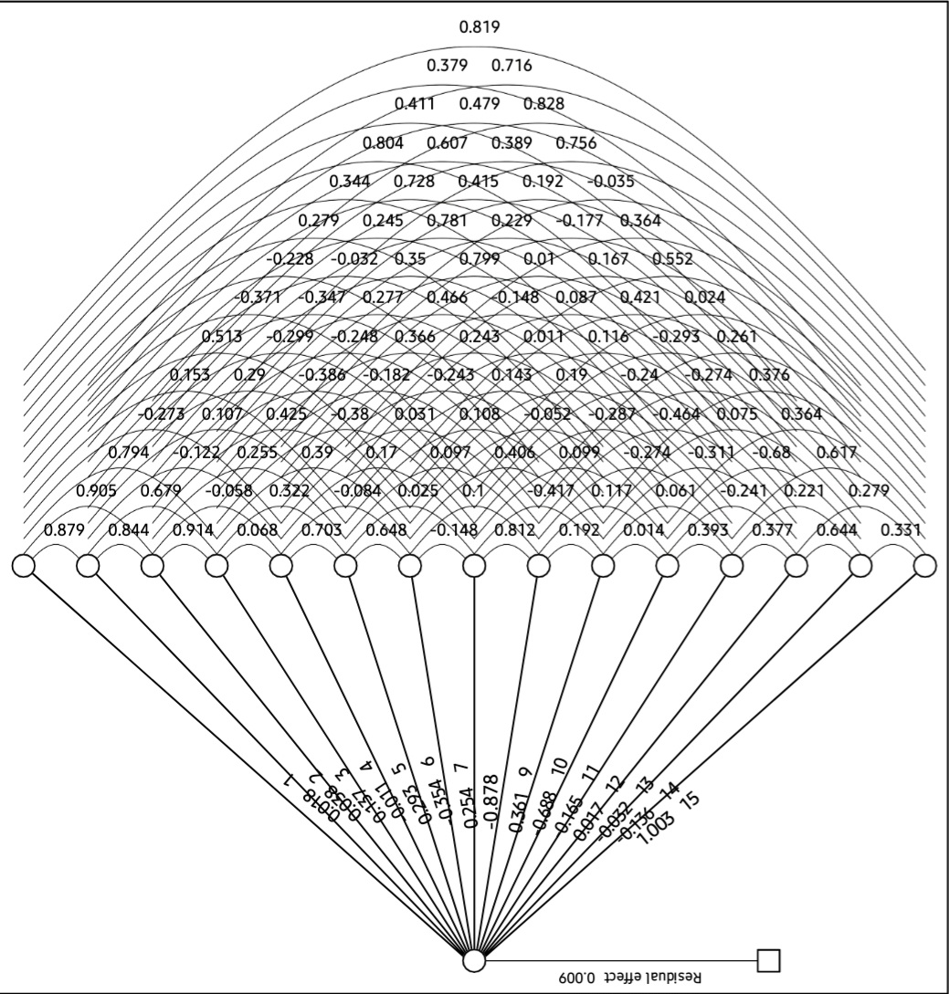
Fig. 1: Path diagram for Yield (t/ha)

References
Ahmed, K. I., Patil, S. B., Moger, N. B., Hanumaratti, N. G. and Nadgouda, B. T. (2019). Correlation and path analysis in sugarcane hybrid clones of proven cross. Journal of Pharmacognosy and Phytochemistry, 8(2): 781-783.
Alam, M. N., Nath, U. K., Karim, K. M. R., Ahmed, M. M. and Mitul, R. Y. (2017).Genetic variability of exotic sugarcane genotypes. Scientifica.
Anbanandan, V., Karthikeyan, P., Narayanan, R., Ranjithrajaram, S. and Reddy, J. P. (2020).Path coefficient analysis in sugarcane genotypes. Plant Archives, 20(1): 1847-1848.
Anbanandan, V., Narayanan, R., Karthikeyan, P. and Reddy, S. R. J. P. (2020).ASSOCIATION ANALYSIS IN SUGARCANE (SACCHARUM OFFICINARUM L.)HYBRIDS. Plant Archives, 20(1): 1629-1630.
Barbosa, R. P., Neto, F. A., Gravina, L. M., Gravina, G. A., Portela, M. G. T. and Bezerra, A. A. C. (2017). Early selection of sugarcane using path analysis. Genet Mol Res, 16(1): gmr16019038.
Brasileiro, B. P., Peternelli, L. A. and Barbosa, M. H. P. (2013).Consistency of the results of path analysis among sugarcane experiments. Crop Breeding and Applied Biotechnology, 13, 113-119.
Chaudhary, R. R. and Joshi, B. K. (2005).Correlation and path coefficient analyses in sugarcane. Nepal Agriculture Research Journal, 6, 28-34.
Guruprasad, H., Nagaraja, T. E., Uma, M. S., Patel, V. N. and Anand, M. (2015). Character Association and Path Analysis for cane and sugar yield in selected Clones of Sugarcane (Saccharum officinarum L.). Trends in Biosciences, 8(6): 1466-1469.
Kang, M. S., Miller, J. D. and Tai, P. Y. P. (1983).Genetic and phenotypic path analyses and heritability in sugarcane 1. Crop Science, 23(4): 643-647.
Kang, M. S., Sosa, O. and Miller, J. D. (1989). Path analyses for percent fiber, and cane and sugar yield in sugarcane. Crop science, 29(6): 1481-1483.
Khan, I. A., Bibi, S., Yasmin, S., Khatri, A., Seema, N. and Abro, S. A. (2012). Correlation studies of agronomic traits for higher sugar yield in sugarcane. Pak. J. Bot, 44(3): 969-971.
Kumar, D. and Kumar, S. (2014). Correlation and path coefficient analysis in sugarcane germplasm under subtropics. Progressive Agriculture, 14(2): 312-317.
Mali, S. C. and Patel, A. I. (2013).Correlation and heritability studies in sugarcane. AGRES–An International e-Journal, 2(4): 466-471.
Masri, M. I., El–Taib, A. B. A. and Abu-El-lail, F. F. B. (2022).Genetic and phenotypic correlation and path coefficient analysis for traits in sugarcane. SVU-International Journal of Agricultural Sciences, 4(2): 53-64.
Parihar, R. (2020). Character association and path coefficient analysis for cane yield and quality characters in fourth clonal generation (C4) of Sugarcane (Saccharum sp. complex). Journal of Crop and Weed, 16(1): 256-260.
Ranga, A. D., Kumar, V. and Darvhankar, M. S. (2019). Correlation Studies and Path Analysis of Agronomic Traits for Higher Cane Yield in Sugarcane. Annals of Agri-Bio Research, 24(1): 57-61.
Silva, L. A., Teodoro, P. E., Peixoto, L. A., Assis, C., Gasparini, K., Barbosa, M. H. P. and Bhering, L. L. (2017). Selecting sugarcane genotypes by the selection index reveals high gain for technological quality traits.
Singh, R. K., SudhirPratap, S. and Singh, S. B. (2005). Correlation and path analysis in sugarcane ratoon. Sugar Tech, 7(4): 176-178.
Tahir, M., Khalil, I. H., McCord, P. H. and Glaz, B. (2014).Character association and selection indices in sugarcane.
Thippeswamy, S., Kajjidoni, S. T., Salimath, P. M. and Goud, J. V. (2003).Correlation and path analysis for cane yield, juice quality and their component traits in sugarcane. Sugar tech, 5, 65-72.
***

