Original Research Article
Synthesis and Characterization of Chitosan Nanoparticles Derived from Fungal and Crustacean Sources

ABSTRACT
Chitosan, a deacetylated biopolymer derived from chitin, has attracted considerable research interest owing to its biocompatibility, biodegradability, and broad applicability in medical, agricultural, and environmental systems. Conventional chitosan production relies predominantly on crustacean shells, which may contain allergenic proteins and exhibit seasonal variability. Fungal sources, particularly edible mushrooms, offer a sustainable, contaminant-free alternative for chitin and chitosan extraction. The present study investigates Pleurotus ostreatus as a fungal source for chitin and chitosan production and compares the physicochemical characteristics of nanoparticles synthesized from fungal-derived and crustacean-derived commercial chitosan. Chitin extracted from P. ostreatus represented 5–7% of dry fungal biomass, and subsequent alkaline deacetylation yielded 70% chitosan, aligning with previously reported ranges for Basidiomycetes. Crustacean-derived commercial chitosan nanoparticles (ChNPs) and fungal-derived chitosan nanoparticles (F. ChNPs) were synthesized using the ionotropic gelation method with sodium tripolyphosphate (TPP). Particle size analysis indicated that fungal-derived ChNPs (21.47 nm) were distinctly smaller than crustacean-derived ChNPs (31.56 nm), likely due to the higher purity and potentially lower molecular weight of fungal-derived chitosan, which enhances ionic crosslinking efficiency. SEM imaging confirmed successful nanoparticle formation, revealing irregular, unevenly distributed, and highly aggregated morphologies typical of TPP-crosslinked chitosan systems. FTIR spectra validated the presence of major functional groups associated with chitosan–TPP interactions, including O–H stretching (3100–3300 cm⁻¹), N–H bending (1626–1633 cm⁻¹), and C–O stretching (1063–1064 cm⁻¹). XRD analysis showed prominent diffraction peaks near 2θ ≈ 18°, indicating reduced crystallinity and effective nanoparticle formation. Overall, the study demonstrates that P. ostreatus is a viable and efficient non-animal source of chitosan and that fungal-derived chitosan produces smaller nanoparticles with desirable chemical and crystalline features. These findings underscore the potential of fungal chitosan as an eco-friendly and functionally superior alternative to conventional crustacean-derived commercial chitosan for applications in nanotechnology, biomedicine, and sustainable agriculture.

Keywords: Chitin and chitosan yield; Fungal chitosan; Chitosan nanoparticles; Synthesis; Characterization

- INTRODUCTION
Chitosan is a deacetylated derivative of chitin, which has gained remarkable fascination as a functional biopolymer with diverse applications in food, agriculture, cosmetics, medicine, pharmaceutics, paper production, and water purification due to its unique physicochemical and biological properties (Philibert et al., 2017; Singh et al., 2021; Piekarska et al., 2023). Structurally, both are linear copolymers composed of β-(1→4)-linked N-acetyl-D-glucosamine (GlcNAc) and D-glucosamine (GlcN) units in varying proportions (Kadokawa et al., 2015). Chitin, a structural polysaccharide found naturally in the exoskeletons of arthropods, cephalopod endoskeletons, and fungal cell walls, is usually alkalinely N-deacetylated to generate chitosan (Butnariu, 2023).
Traditionally, crustacean shells, particularly shrimp and crab wastes, have served as the main commercial sources of chitin and chitosan (Sabu et al., 2022). However, crustacean-derived chitosan may contain residual proteins such as tropomyosin, myosin light chain, and arginine kinase, which are known allergens (Iqbal et al., 2024). These limitations have stimulated growing interest in alternative, non-animal sources of chitin and chitosan, particularly fungi and mushrooms, which provide a safer, more sustainable, and easily cultivable option (Iber et al., 2022).
Fungi, especially those belonging to the Zygomycota, Ascomycota, and Basidiomycota divisions, contain chitin as a key structural component of their cell walls (Singara Charya, 2015; Kosal, 2023). Particularly in mushrooms, belonging to the Basidiomycetes group - such as Pleurotus ostreatus (Oyster mushrooms) have been recognized as promising candidates for chitin and chitosan extraction due to their abundance, ease of cultivation, and short growth cycles (Ayser et al., 2024). Moreover, fungal chitosan is typically free from mineral impurities and allergenic proteins, enabling extraction under milder chemical conditions with lower environmental impact and reduced production cost (Araújo et al., 2020).
The synthesis of chitosan nanoparticles (CNPs) primarily utilizes strategies such as ionic gelation, where the interaction of protonated amino groups of chitosan interacts with negatively charged cross-linkers like tripolyphosphate (TPP) facilitates the formation of stable nano-sized particles (Khoerunnisa et al., 2021; Mikušová and Mikuš, 2021). Characterization techniques such as Particle size analysis (PSA), Scanning Electron Microscope (SEM), Fourier Transform Infrared Spectroscopy (FTIR), and X-ray diffraction analysis (XRD) are routinely employed to assess nanoparticle particle size distribution, surface morphology, functional groups, and crystallinity.
This study explores fungi as a sustainable source of chitin and chitosan, which have both scientific and industrial significance. An improved understanding of their extraction efficiency and physicochemical characteristics may broaden the potential applications of fungal-derived chitosan, particularly as a biocompatible and eco-friendly alternative to animal-derived polymers.
The goal of the current work is to extract chitin and chitosan from fungal sources and to synthesize chitosan nanoparticles from both fungal-derived and crustacean-derived commercial chitosan. Their structural and functional characteristics were analyzed using advanced analytical techniques such as Particle Size Analysis (PSA), Scanning Electron Microscopy (SEM), Fourier Transform Infrared Spectroscopy (FTIR), and X-ray Diffraction (XRD).
- MATERIALS AND METHODS
2.1 Materials
In this study, the Oyster mushroom (Pleurotus ostreatus) as a fungal source was selected for the extraction of chitosan. Mushrooms were collected from the Mushroom production unit of the Instructional farm, College of Agriculture (CoA), Vellayani, Thiruvananthapuram. The mushroom samples were cleaned and dehydrated for 48 hrs in a hot air oven at 50 °C. A blender was used to grind the dried samples into a fine powder, and the powdered samples were sieved using a 30-mesh sieve before chitin extraction. The extracted chitosan and commercial chitosan from marine source (Low MW) extrapure, 10-150m.Pas, 90% DA (SRL) was also taken for chitosan nanoparticle synthesis.
Glacial acetic acid, sodium hydroxide (NaOH), and hydrochloric acid (HCl) were acquired from the Department of Plant Pathology, CoA, Vellayani. The analytical quality of sodium tripolyphosphate (TPP) having technical grade 85% was purchased from Sigma-Aldrich. The water used in all of the studies was distilled and deionized water.
2.2 Methods
2.2.1 Extraction of Chitin and Chitosan from Fungal Sources
The powdered mushroom sample (20 g) was used to extract the chitin through the demineralization process. The demineralization process was done by treating the sample with 250 mL of 2M HCl solution at 60°C for 15 hours in a glass beaker. The samples were rinsed with distilled water after demineralization, followed by filtration using Whatman no 1 filter paper. This process was followed by a deproteinization step to eliminate protein residues from the mushroom. The deproteination was carried out by treating the sample with 2M NaOH solution at 85°C in a glass beaker for 24-hour. Following this, samples were rinsed with distilled water until their pH was neutral. A decolorization procedure utilizing a 1:2:4 mixture of chloroform, methanol, and distilled water was carried out on the sample for an hour. Following another rinse with distilled water, the samples were dried at 65°C in a hot air oven till the sample becomes dry. Chitosan was produced through deacetylation by refluxing the chitin samples separated in the previous stage with 60% NaOH for 4 h at 130°C. Following this procedure, the samples underwent filtering and distilled water washing until their pH was neutral. The resulting chitosan was dried in an oven set at 65°C for 5 hours.
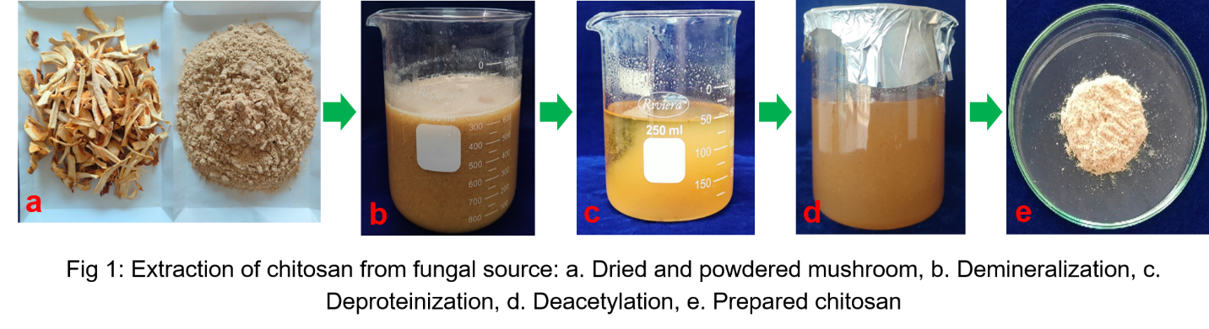
2.2.2 Yield of Extracted Chitin and Chitosan
The method provided by Sousa et al. (2025) was used to compute the chitosan yield (%) on a dry-weight basis, with minor adjustments:
$Chitosan Yield \left(\%\right)=\frac{Weight of dried chitosan (g)}{Weight of dried mushroom powder (g)}X 100$
2.2.3 Synthesis of Chitosan Nanoparticles
Chitosan nanoparticles were synthesized using a bottom-up approach from fungal-derived and crustacean-derived commercial chitosan. Ionic gelation was used to carry out the synthesis, and sodium tripolyphosphate (TPP) was used as a crosslinking agent. 0.1% fungal-derived chitosan and crustacean-derived commercial chitosan were separately mixed in a magnetic stirrer with 1% acetic acid solution for half an hour until a clear chitosan solution was obtained. Then pH was maintained at 4.6 by adding 1% NaOH to the chitosan solution. A 0.1% TPP solution was prepared by using deionized water and mixed well in a magnetic stirrer till it was mixed properly. The TPP solution was then gradually added to a chitosan solution while being stirred by a magnetic stirrer (Chitosan solution: TPP was 3:1). The ChNP were formed by adding 0.1% TPP (w/v) drop by drop under magnetic stirring. Then the ChNP was filtered through Whatman no.1 filter paper. After filtration ChNP solution was centrifuged at 10,000rpm for 10 minutes in a 50ml centrifuge tube to get the nanoparticles. ChNPs were settled at the bottom of the tube, which was collected by removing supernatant and then oven-dried at 65 °C to get the ChNP powder.
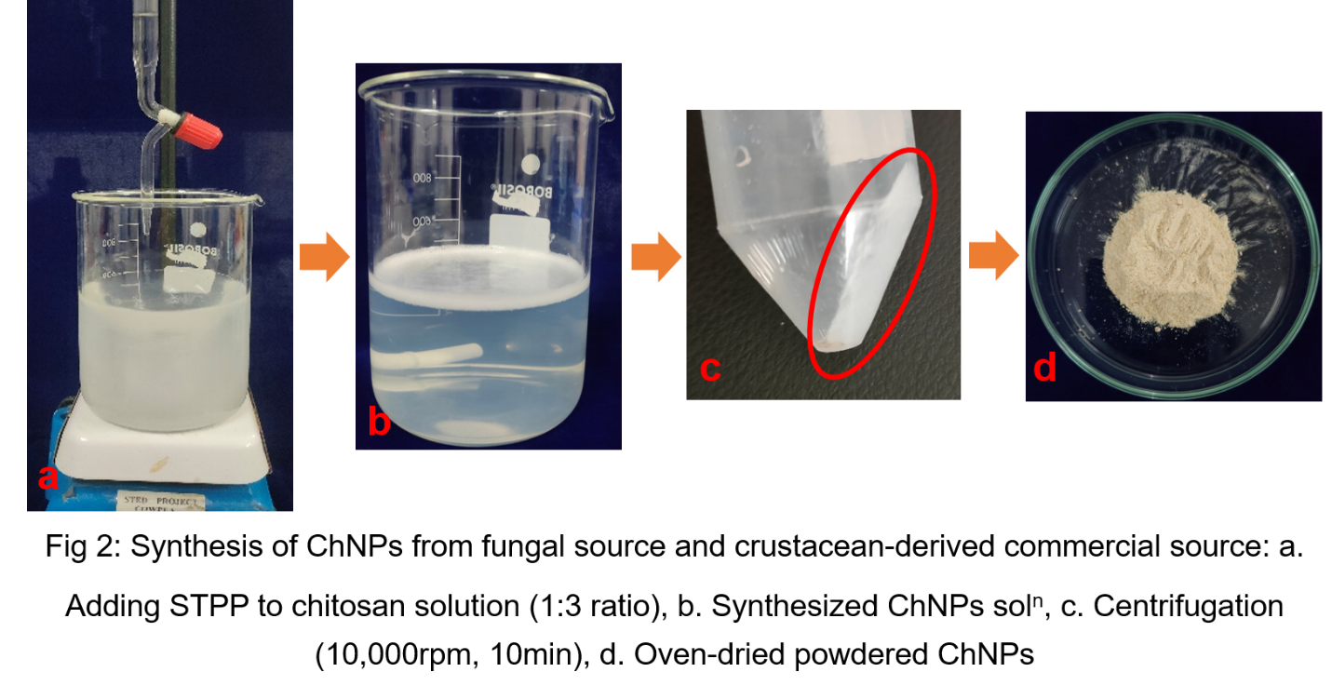
2.2.4 Characterization of Chitosan Nanoparticles
The presence of functional groups by FTIR, crystallographic structure by XRD, and SEM was utilized to analyze the surface morphologies of the mushroom-derived chitosan nanoparticles and crustacean-derived commercial chitosan nanoparticles. The CSIR-National Institute for Interdisciplinary Science and Technology (NIIST), located in Thiruvananthapuram, Kerala, India, conducted all of the analyses.
- RESULTS AND DISCUSSION
3.1 Extraction and Characterization of fungal-derived chitin and Chitosan
3.1.1 Yield of Chitin and Chitosan from a fungal source
The chitin yield from Pleurotus ostreatus was found to be 5–7% of the dry weight, while the subsequent chitosan yield obtained after deacetylation was approximately 70%. These findings are comparable to previous reports in fungal systems, where Phyllophora ribis yielded 7.9% chitin and 75.3% chitosan, and Lactarius vellereus showed 11.4% chitin with 73.1% chitosan conversion (Erdogan et al., 2017). In contrast, crustacean shells generally possess higher chitin content ranging from 13–42% (Synowiecki & Al-Khateeb, 2003). Likewise, it was found that several insect species' dry weight chitin concentrations ranged from 2.59% to 36% (Zainol et al., 2020; Kaya et al., 2015). Similar to crustaceans and insects, the chitin concentrations of fungi vary greatly between species. The dry weight chitin concentrations of the mycelium of microfungi species from various phyla ranged from 2.3 to 42.0%, according to Synowiecki and Al-Khateeb (2003). The chitin concentration of a few cultivated macrofungi under the Basidiomycota phylum was examined by Vetter (2007), where the chitin concentrations of Agaricus bisporus, Pleurotus ostreatus, and Lentinula edodes were 7.31%, 2.8%, and 6.55% for the stipes and 6.67%, 3.78%, and 8.07% for the pileus, respectively. According to Kaya et al. (2015), the dry weight chitin content of the medicinal fungus Fomitopsis pinicola was 30.11 percent, and its chitosan production was 71.75 percent. According to Kaya et al. (2015), the lichen species Xanthoria parietina, which is made up of algae and fungus, has a dry weight chitin content of 4.23%.
The relatively lower yield in mushroom-derived chitin is attributed to the complex polysaccharide matrix of the fungal cell wall, where β-1,3-glucans and chitin microfibrils are tightly interlinked (Fraga et al., 2020; Tamura, 2021; Shibu et al., 2025). Such associations hinder efficient extraction compared to crustacean sources. Nevertheless, fungal-derived chitosan offers significant advantages - namely, the absence of allergenic proteins, better solubility, and non-animal origin, which are crucial for biomedical and agricultural applications (Kumar et al., 2025; Seidler et al., 2024).
Furthermore, ease of cultivation, rapid biomass production, and eco-friendly extraction make Pleurotus ostreatus a viable alternative to crustacean sources. The variation in yield may also be influenced by species, substrate composition, growth stage, and extraction conditions (Vetter, 2007).

    - Synthesis and characterization of fungal-derived and crustacean-derived Chitosan nanoparticles
Commercially sourced crustacean-derived and fungal-derived chitosan nanoparticles synthesized using the ionic gelation technique with sodium tripolyphosphate (TPP) successfully formed smooth, fine white powders with highly aggregated, irregular spherical nano-scale structures. This morphology is consistent with earlier reports demonstrating that chitosan–TPP nanoparticles typically exhibit spherical to quasi-spherical shapes with varying degrees of aggregation due to strong intermolecular hydrogen bonding and electrostatic interactions among polymer chains (Mikušová and Mikuš 2021; El-Sayed and Elshaarawy 2025). The aggregation observed in both samples is also a common outcome during drying, as chitosan nanoparticles possess high surface energy that promotes particle–particle adhesion (Gokce et al., 2014).
A clear difference in nanoparticle sizes was observed between the two chitosan sources. Nanoparticles synthesized from crustacean-derived commercial chitosan averaged 31.56 nm, while those synthesized from mushroom-derived fungal chitosan were significantly smaller at 21.47 nm. This difference can be ascribed to the intrinsic physicochemical properties of fungal chitosan. Fungal-derived chitosan is widely reported to exhibit higher purity, higher degree of deacetylation (DD), and often lower molecular weight compared to traditional commercial crustacean-derived chitosan (Isibor, 2024; Tedesco et al., 2025). These parameters strongly influence nanoparticle formation during ionic gelation.
Table 1: Particle size analysis (PSA) of synthesized nanoparticles: a) crustacean-derived ChNPs; b) Fungal ChNPs
Nanoparticles | Particle size (nm)
A) Crustacean-derived ChNPs | 31.56
B) Fungal-derived ChNPs | 21.47

SEM analysis of both crustacean-derived and fungal-derived chitosan nanoparticles further confirmed the successful formation of nano-sized structures through the ionic gelation method. The SEM micrographs revealed irregular, unevenly distributed, and highly aggregated particles in both nanoparticle formulations. According to Rajabimashhadi et al. (2025), the ChNPs formulation shows large, asymmetrical aggregates with harsh-defined borders at low magnification. ChNPs made with TPP often have these morphological characteristics because of the strong electrostatic contacts between the protonated amino groups of chitosan and the polyanionic phosphate groups of TPP lead to cross-linking, which commonly results in irregular and aggregated nanoparticle (Khoerunnisa et al., 2021; Desai, 2016).
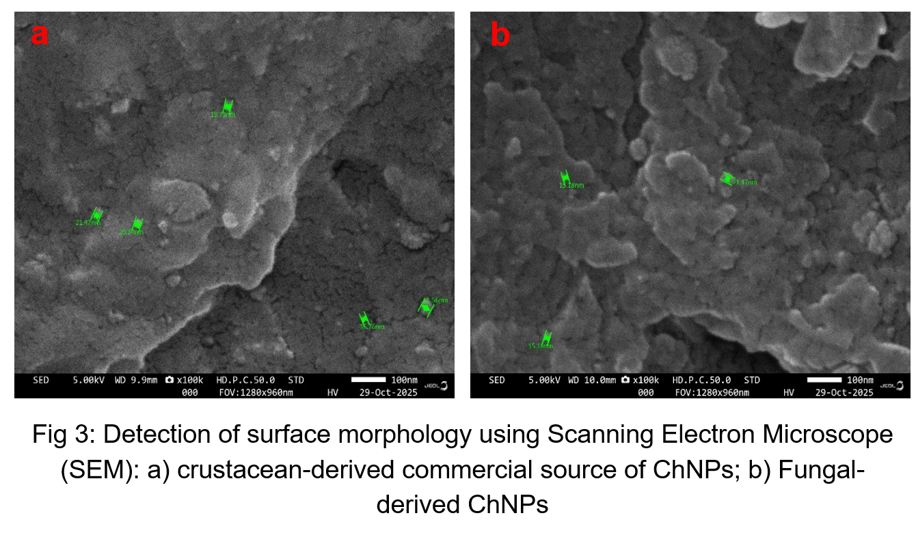
The chemical structure and bonding of ChNPs made from commercial chitosan obtained from crustaceans (Fig. 3a) and from a fungal source (Fig. 3b) were ascertained using FTIR spectroscopy. The primary absorption bands in the ChNPs' FTIR spectra were located at 3100–3300, 2930, 1626, 1538, 1378, 1064, and 515 cm⁻¹, respectively. The stretching vibration of -OH was responsible for the strong and wide absorption band seen at 3181 and 3261 cm⁻¹. The –OH bonding shown in the ChNPs' FTIR spectra between 3100 cm⁻¹ and 3550 cm⁻¹ verified the hydrophilic nature of the ChNPs, which was suggested by the amount of water they contained. The methylene's asymmetric stretching vibration in the ChNPs was represented by the absorption band at 2930 cm-1 (Keogh et al., 2010). After TPP was added, the bending vibration of N–H in the chitosan/TPP nanoparticles produced the absorption band at 1626 and 1633 cm-1 (Vimal et al., 2012). An aliphatic nitro compound's N–O stretching might be attributed to the bands with centers at 1532, 1538 cm⁻¹, and 1378 cm⁻¹. (Mohammadpourdounighi et al., 2010). According to Li et al. (2008), the main alcohol's C–O stretching vibration showed the peak between 1063 and 1064 cm⁻¹. The absorption band at 515 cm⁻¹ indicated the presence of bromoalkanes.
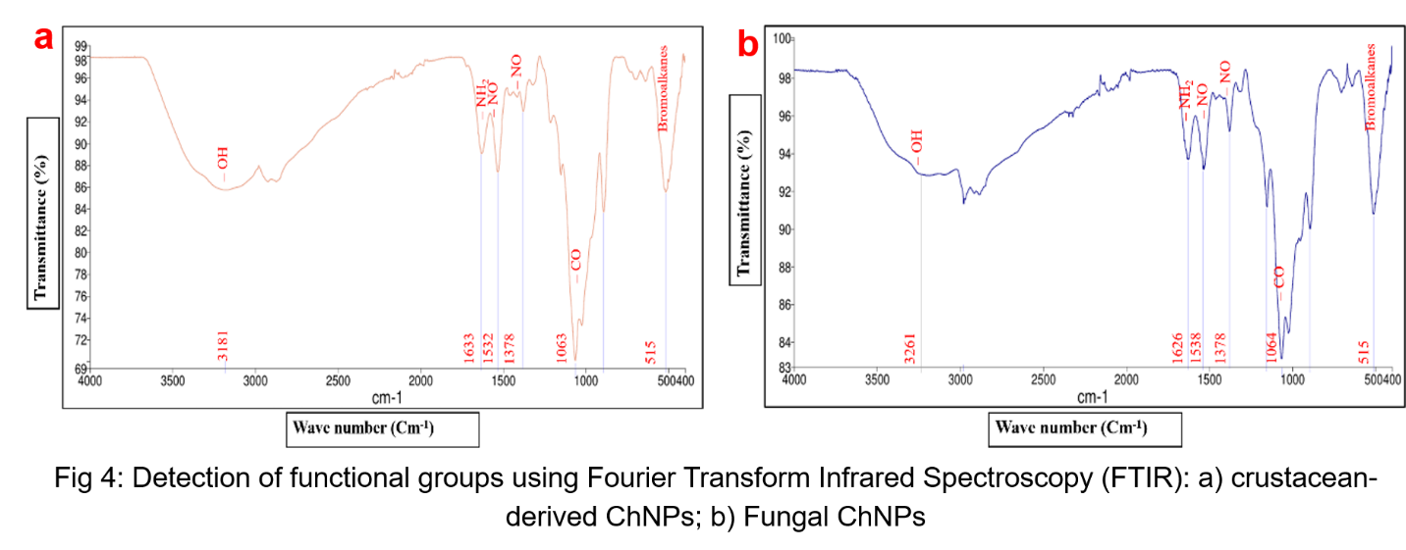
X-ray diffraction (XRD) was utilized to investigate the structural characteristics of chitosan nanoparticles throughout a 2θ range of 0° - 80°. XRD patterns (Fig. 4a, 4b) of both crustacean-derived ChNPs and Fungal ChNPs displayed several peaks around 2θ = 10.98°, 17°, 18.9°, 23.99°, 26.67°, indicating the decrease in crystallinity and showing the amorphous nature of nanosized chitosan; nearly similar peaks were observed by Hariprasath et al. (2025). These peaks come from TPP diffraction patterns, which are closely linked to the ionic interactions between chitosan's amine groups and TPP counterions (Khoerunnisa et al., 2021). The reduction in crystallinity compared to raw chitosan implies effective nanoparticle formation, as the crosslinking with TPP disrupts the regular arrangement of chitosan chains (Manuel Laza, J. 2016). According to Hariprasath et al. (2025), the amorphous nature of 50.3% of the nanoparticles indicates that the ionic gelation synthesis was successful. Crosslinking and nanoscale dispersion disturb the order of the polymer chain, which lowers the crystallinity.
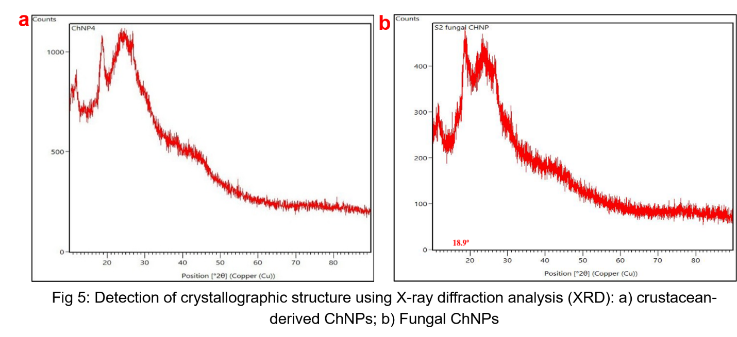
- Conclusion
The present study successfully demonstrated that Pleurotus ostreatus as an efficient, sustainable, and non-animal source of chitin and chitosan, offering a promising substitute to crustacean-derived polymers. The fungal biomass yielded 5–7% chitin and 70% chitosan after deacetylation, values consistent with previously reported ranges for Basidiomycetes. Although fungal chitin yields are typically lower than crustacean sources, the absence of allergenic proteins, ease of cultivation, and reduced environmental impact highlight the advantages of fungal-derived chitosan for industrial and biomedical applications. Chitosan nanoparticles synthesized from both fungal-derived and crustacean-derived chitosan using the ionic gelation method exhibited successful nanoparticle formation, as confirmed by particle size analysis, SEM, FTIR, and XRD. Notably, fungal-derived ChNPs displayed a smaller particle size (21.47 nm) compared to crustacean-derived ChNPs (31.56 nm), which can be ascribed to the higher purity and promising physicochemical characteristics of fungal chitosan. SEM analyses revealed aggregated and irregular morphologies typical of TPP-crosslinked nanoparticles, while FTIR spectra validated the presence of characteristic functional groups involved in chitosan–TPP interactions. XRD analysis indicated reduced crystallinity, confirming effective nanoparticle synthesis and structural reorganization upon crosslinking. Overall, the findings affirm that fungal-derived chitosan not only matches but, in some characteristics, surpasses crustacean-derived chitosan in its ability to form nano-sized particles with desirable structural and functional features. This study underscores the possibility of chitosan produced from mushrooms as an eco-friendly, biocompatible, and cost-effective material for applications in nanotechnology, drug delivery, environmental remediation, and sustainable agriculture. Further research exploring its biological activity, stability, and application-specific performance could expand its utility across multiple scientific and industrial domains.
- References
Araújo, D., Ferreira, I. C., Torres, C. A., Neves, L., & Freitas, F. (2020). Chitinous polymers: extraction from fungal sources, characterization and processing towards value‐added applications. Journal of Chemical Technology & Biotechnology, 95(5), 1277-1289.
Ayser, M., Tonny, W., Hernandez, I. S., Kuriakose, R., Smith, J. D., Wallaert, S. J., & Balan, V. (2024). Fractionating chitin-glucan complex and coproducts from Pleurotus Ostreatus mushrooms. Waste and Biomass Valorization, 15(5), 2897-2910.
Butnariu, M. (2023). Biological and chemical aspects of chitosan. In Chitosan nanocomposites: bionanomechanical applications (pp. 27-54). Singapore: Springer Nature Singapore.
Desai, K. G. (2016). Chitosan nanoparticles prepared by ionotropic gelation: An overview of recent advances. Critical Reviews™ in Therapeutic Drug Carrier Systems, 33(2).
El-Sayed, W. N., & Elshaarawy, R. F. (2025). Origanum syriacum oil-loaded carboxymethyl chitosan polyelectrolyte nanoparticles: Box–Behnken design optimization of nano-encapsulation, physicochemical, and therapeutic properties. Polymer Bulletin, 82(8), 3321-3351.
Erdogan, S., Kaya, M., & Akata, I. L. G. A. Z. (2017, February). Chitin extraction and chitosan production from cell wall of two mushroom species (Lactarius vellereus and Phyllophora ribis). In AIP Conference Proceedings (Vol. 1809, No. 1, p. 020012). AIP Publishing LLC.
Fraga, S. M., & Nunes, F. M. (2020). Agaricus bisporus by-products as a source of chitin-glucan complex enriched dietary fibre with potential bioactivity. Applied Sciences, 10(7), 2232.
Gokce, Y., Cengiz, B., Yildiz, N., Calimli, A., & Aktas, Z. (2014). Ultrasonication of chitosan nanoparticle suspension: Influence on particle size. Colloids and Surfaces A: Physicochemical and Engineering Aspects, 462, 75-81.
Hariprasath, T. K., Manogaran, Y., Duraisamy, R., Ganapathy, D., & Ramasamy, P. (2025). Ionic gelation synthesis and characterization of Chitosan nanoparticles from Sepia aculeata cuttlebone and their in-vitro antimicrobial activity against oral pathogens. Discover Chemistry, 2(1), 312.
Iber, B. T., Kasan, N. A., Torsabo, D., & Omuwa, J. W. (2022). A review of various sources of chitin and chitosan in nature. Journal of Renewable Materials, 10(4), 1097.
Iqbal, N., Ganguly, P., Yildizbakan, L., Raif, E. M., Jones, E., Giannoudis, P. V., & Jha, A. (2024). Chitosan Scaffolds from Crustacean and Fungal Sources: A Comparative Study for Bone-Tissue-Engineering Applications. Bioengineering, 11(7), 720.
Isibor, P. O. (2024). Nanochitosan Synthesis, Optimization, and Characterization. In Nanochitosan-Based Enhancement of Fisheries and Aquaculture: Aligning with Sustainable Development Goal 14–Life Below Water (pp. 65-112). Cham: Springer Nature Switzerland.
Kadokawa, J. I., Shimohigoshi, R., Yamashita, K., & Yamamoto, K. (2015). Synthesis of chitin and chitosan stereoisomers by thermostable α-glucan phosphorylase-catalyzed enzymatic polymerization of α-D-glucosamine 1-phosphate. Organic & Biomolecular Chemistry, 13(14), 4336-4343.
Kaya, M., Lelešius, E., Nagrockaitė, R., Sargin, I., Arslan, G., Mol, A., & Bitim, B. (2015). Differentiations of chitin content and surface morphologies of chitins extracted from male and female grasshopper species. PloS one, 10(1), e0115531.
Keogh RC, Robinson APW, Mullins IJ. Pollination aware: the real value of pollination in Australia. Canberra, Australia: Rural Industries Research and Development Corporation; 2010.
Khoerunnisa, F., Nurhayati, M., Dara, F., Rizki, R., Nasir, M., Aziz, H. A., & Opaprakasit, P. (2021). Physicochemical properties of TPP-crosslinked chitosan nanoparticles as potential antibacterial agents. Fibers and Polymers, 22(11), 2954-2964.
Kosal, E. (2023). The Fungi Kingdom. Introductory Biology: Ecology, Evolution, and Biodiversity.
Kumar, R., Guleria, A., Padwad, Y. S., Srivatsan, V., & Yadav, S. K. (2025). Smart proteins as a new paradigm for meeting dietary protein sufficiency of India: a critical review on the safety and sustainability of different protein sources. Critical Reviews in Food Science and Nutrition, 65(18), 3496-3545.
Li, P., Dai, Y. N., Zhang, J. P., Wang, A. Q., & Wei, Q. (2008). Chitosan-alginate nanoparticles as a novel drug delivery system for nifedipine. International journal of biomedical science: IJBS, 4(3), 221.
Manuel Laza, J. (2016). Covalently and ionically crosslinked chitosan nanogels for drug delivery. Current pharmaceutical design, 22(22), 3380-3398.
Mikušová, V., & Mikuš, P. (2021). Advances in chitosan-based nanoparticles for drug delivery. International journal of molecular sciences, 22(17), 9652.
Mohammadpourdounighi, N., Behfar, A., Ezabadi, A., Zolfagharian, H., & Heydari, M. (2010). Preparation of chitosan nanoparticles containing Naja naja oxiana snake venom. Nanomedicine: Nanotechnology, Biology and Medicine, 6(1), 137-143.
Philibert, T., Lee, B. H., & Fabien, N. (2017). Current status and new perspectives on chitin and chitosan as functional biopolymers. Applied biochemistry and biotechnology, 181(4), 1314-1337.
Piekarska, K., Sikora, M., Owczarek, M., Jóźwik-Pruska, J., & Wiśniewska-Wrona, M. (2023). Chitin and chitosan as polymers of the future—obtaining, modification, life cycle assessment and main directions of application. Polymers, 15(4), 793.
Rajabimashhadi, Z., Masi, A., Bagheri, S., Mele, C., Colangelo, G., Paladini, F., & Pollini, M. (2025). Development and Characterization of Chitosan Microparticles via Ionic Gelation for Drug Delivery. Polymers, 17(19), 2603.
Sabu, S., Sasidharan, A., & Venugopal, V. (2022). Influence of isolation conditions on the physicochemical and biological properties of chitosan and chitosan oligosaccharides from marine crustacean shell wastes. In Chitooligosaccharides: prevention and control of diseases (pp. 333-352). Cham: Springer International Publishing.
Seidler, Y., Rimbach, G., Lüersen, K., Vinderola, G., & Ipharraguerre, I. R. (2024). The postbiotic potential of Aspergillus oryzae–a narrative review. Frontiers in Microbiology, 15, 1452725.
Shibu, R. P., Sagala, S. L., Zhao, B., Eason, I., Berton, P., & Shamshina, J. L. (2025). Chitin nanowhiskers from diverse biomasses: the role of feedstock in material properties. Green Chemistry, 27(48), 15529-15547.
Singara Charya, M. A. (2015). Fungi: an overview. Plant Biology and Biotechnology: Volume I: Plant Diversity, Organization, Function and Improvement, 197-215.
Singh, R., Upadhyay, S. K., Singh, M., Sharma, I., Sharma, P., Kamboj, P., & Khan, F. (2021). Chitin, chitinases, and chitin derivatives in biopharmaceutical, agricultural, and environmental perspective. Biointerface Res. Appl. Chem, 11(3), 9985-10005.
Sousa, I. C., Teixeira, S. C., Souza Jr, M. V. D., Conde, M. B., Bailon, G. R., Cardoso, S. H., & Soares, N. D. F. (2025). Sustainable Extraction and Multimodal Characterization of Fungal Chitosan from Agaricus bisporus. Foods, 14(16), 2785.
Synowiecki, J., & Al-Khateeb, N. A. (2003). Production, properties, and some new applications of chitin and its derivatives.
Tamura, K. (2021). Functional dissection of beta-glucan utilization by prominent human gut symbionts (Doctoral dissertation, University of British Columbia).
Tedesco, F., Biundo, A., Caporusso, A., Pisano, I., Siesto, G., Pietrafesa, R., & Capece, A. (2025). Chitosan-based strategies as eco-friendly solutions for controlling Brettanomyces bruxellensis contamination in wine production. Frontiers in Microbiology, 16, 1631987.
Vetter, J. (2007). Chitin content of cultivated mushrooms Agaricus bisporus, Pleurotus ostreatus and Lentinula edodes. Food Chemistry, 102(1), 6-9.
Vimal G, Taju KSN, Nambi S, et al. Synthesis and characterization of CS/TPP nanoparticles for oral delivery of gene in fish. Aquaculture. 2012;358 359:14–22.
Zainol Abidin, N. A., Kormin, F., Zainol Abidin, N. A., Mohamed Anuar, N. A. F., & Abu Bakar, M. F. (2020). The potential of insects as alternative sources of chitin: An overview on the chemical method of extraction from various sources. International Journal of Molecular Sciences, 21(14), 4978.

