Original Research Article
Evaluation of Drinking Water Suitability of Mamadapur Lake, Vijayapura District, Based on the Water Quality Index

ABSTRACT
The present study evaluated the water quality of Mamadapur Lake located in Babaleshwar taluk of Vijayapuraa district, Karnataka, for drinking purpose using Water Quality Index. Surface water samples were collected at monthly intervals from July 2024 to June 2025 and analyzed for major physicochemical parameters. The mean pH value was 7.51, indicating a slightly alkaline nature within the permissible range of 6.5 to 8.5. Dissolved oxygen varied from 4.1 to 6.3 mg/L with an average of 5.33 mg/L. Biological oxygen demand ranged between 1.9 and 5.12 mg/L with a mean value of 3.12 mg/L. Chemical oxygen demand fluctuated from 19 to 23 mg per L. The average alkalinity and hardness were 96.14 mg/L and 106.15 mg/L, respectively. Total dissolved solids and total suspended solids recorded mean values of 223 mg/L and 34 mg/L, both within acceptable limits. Nitrate concentration remained low, averaging 0.17 mg/L. The overall Water Quality Index was calculated as 95.12, indicating excellent water quality. The results confirm that the lake water is suitable for drinking and domestic purposes.
INTRODUCTION
Water is among the most abundant and vital natural resources on Earth (Kannel et al., 2007). Although it covers nearly 75% of the planet’s surface, only about 5% is available as freshwater for human use. Rainfall contributes to this supply, but much of it is lost through natural processes such as evaporation, transpiration, and evapotranspiration. A portion infiltrates the ground to recharge aquifers, while the rest is stored in lakes, ponds, and reservoirs (Nayek et al., 2017). High-quality water is essential not only for drinking and domestic needs but also for agriculture, industry, and commerce (Lyngdoh and Kayang, 2015). Lakes, in particular, play a crucial role in sustaining these activities. However, rapid urbanization and population growth have led to the degradation and disappearance of many lakes. Pollution further diminishes water quality, with contaminants seeping into groundwater and spreading to low-lying areas through percolation and influent seepage (Suthar et al., 2010). While industrialization and urbanization are inevitable drivers of national development, they also pose significant challenges to water sustainability (Mishra et al., 2009).
One of the most reliable and widely adopted methods for assessing water quality is the Water Quality Index (WQI) (Ewaid et al., 2020). Cerqueira et al. (2020) analyzed the effects of land-use changes on streams and rivers in north-eastern Brazil, concluding that urbanization significantly impacts the water quality of the Cachoeira River. Advanced modeling techniques such as Artificial Neural Networks (ANN), Multi-Linear Regression (MLR), and Adaptive Neuro-Fuzzy Inference Systems (ANFIS) have been employed to estimate the WQI of the Yamuna River in India (Gaya et al., 2020). Similarly, Al-Adhaileh and Alsaade (2021) implemented ANFIS-based algorithms to predict WQI for efficient monitoring of drinking water. In Malaysia, Yaseen et al. (2018) modeled the WQI of the Selangor River using hybrid intelligence approaches, including ANFIS integrated with subtractive clustering, grid partitioning, and fuzzy C-means clustering. Another study by Gazzaz et al. (2012) developed an ANN-based model for WQI calculation and forecasting in the Kinta River, Malaysia.
Most water quality investigations rely heavily on WQI, as it is considered a convenient and effective tool for evaluating the influence of various parameters on water quality. The index is derived from multiple water quality indicators and regional standards. The primary objective of the present study was to assess the water quality of Mamadapur lake. This investigation aims to support the conservation of natural resources in urban environments and facilitate proper monitoring and rejuvenation of these lakes.
The term water quality encompasses both the water column and the physical channel necessary to sustain aquatic life. The federal Clean Water Act emphasizes protecting the chemical, physical, and biological integrity of the nation’s waters, highlighting the need to assess not only water quality but also the habitats that support aquatic organisms. However, with rapid urbanization, this vital natural resource is increasingly threatened by pollution (Bharati et al., 2016). The quality of lakes, reservoirs, and rivers is determined by physico-chemical and biological parameters. The Water Quality Index (WQI) provides an overall measure of water quality at a specific location and time, based on multiple parameters. Monitoring water quality is essential for tracking pollution and evaluating management strategies (Singh and Jayakumar, 2016). WQIs are generally classified into physico-chemical indices, derived from chemical and physical data, and biological indices, based on biological observations. In this study, WQI was calculated using hydrochemical parameters to assess the area’s water quality.
Mamadapur Lake, located in Babaleshwar taluk of Vijayapuraa, (16° 538419 N latitude and 75° 610672 E longitude) of Karnataka state, India, is a historic 16th-century waterbody built by Adil Shahi kings (Fig. 1). The Lake is known as ‘kere’, in the native language Kannada. The primary objective of the present study was to assess the water quality of Mamadapur lake to provide information on the physio-chemical parameters of Mamadapur Lake and its suitability for human consumption based on computed water quality index (WQI).
MATERIALS AND METHODS
Study area
The present study has been carried out in Mamadapur lake to evaluate water quality for drinking purpose. It was originally built during the Adil Shahi period, once spanned a maximum storage height of approximately 7.6 meters with a submergence area of 864 acres and an irrigated command area of about 674 acres. The lake was recently selected for rejuvenation under the Karnataka State government’s ambitious project. The water from this lake is mainly used for drinking and other domestic purposes.
Figure 1: Map of study area (Mamadapur Lake)
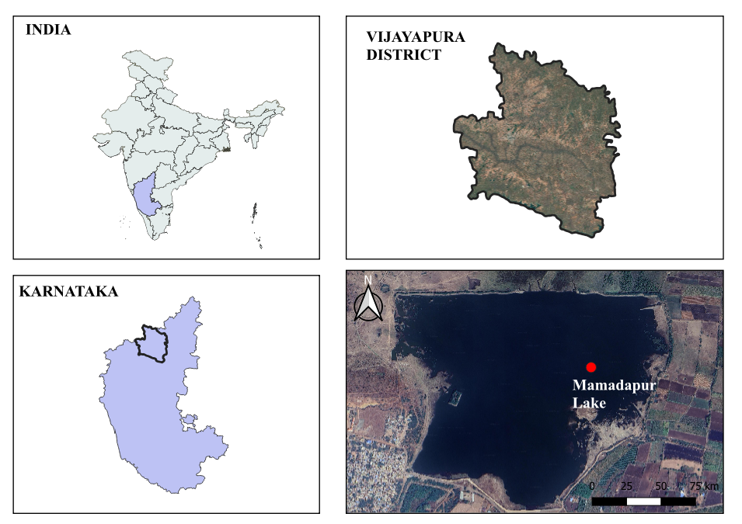
Composite surface water samples were collected at monthly intervals from Mamadapur Lake (Fig. 1) during the period July 2024 to June 2025. A range of physicochemical parameters was analyzed, including pH, dissolved oxygen, biochemical oxygen demand, chemical oxygen demand, alkalinity, hardness, total dissolved solids, total suspended solids, and nitrate concentration. The measurement of pH was carried out directly at the sampling site to ensure accuracy, whereas biochemical oxygen demand was determined using the Winkler method with separate 300 mL bottles prepared for incubation. All samples were transported to the laboratory in dark ice boxes to minimize temperature fluctuations and prevent exposure to sunlight, thereby maintaining sample integrity. Laboratory analyses of the physicochemical variables were conducted in accordance with the Standard Methods for the Examination of Water and Wastewater (APHA, 1998). The Water Quality Index was subsequently calculated using the drinking water quality standards recommended by the World Health Organization, providing an integrated assessment of the suitability of Mamadapur Lake water for human consumption.
Calculation of WQI
$$WQI=\frac{ÓQ_{n}w}{Ów_{n}}$$
Where:
- Q_{n} = Water quality rating
$$Q_{n}=100×\frac{V_{n}-V_{i}}{S_{n}-V_{i}}$$
- V_{n} = Actual value of the parameter in the water sample
- V_{i} = Ideal value ((0 for all parameters except pH and DO which is 7.0 and 14.6 mg/l, respectively)
- S_{n} = Standard value
- w_{n} = Unit weight of the parameter
$$w_{n}=\frac{K}{S_{n}}$$
- K = Constant, calculated as
$$K=\frac{1}{{\frac{1}{S}}_{1}{+\frac{1}{S}}_{2}+…{\frac{1}{S}}_{n}}$$
Classification of WQI according to CCME (2005).
RESULTS AND DISCUSSION
Several investigations have evaluated lake water quality through the analysis of physicochemical parameters (Giriyappanavar et al., 2013), as the overall condition of aquatic systems is largely determined by their chemical composition. Among these parameters, pH serves as a fundamental indicator of water suitability for domestic, agricultural, and ecological purposes. In Mamadapur Lake, the mean pH value was recorded at 7.51, consistently reflecting alkaline conditions throughout the study period. The highest pH value of 8.1 was observed in September, while all recorded values remained within the desirable limits prescribed by the Bureau of Indian Standards, thereby indicating acceptable water quality in terms of acidity and alkalinity balance.
Dissolved oxygen concentrations, which are critical for sustaining aquatic life and maintaining ecological balance, fluctuated between 4.1 and 6.3 mg/L. Maximum levels were observed in February, coinciding with the summer season, whereas the lowest concentration was recorded in June. These findings are consistent with earlier reports from Ramsagar Reservoir in Madhya Pradesh, as documented by Garg et al. (2009), highlighting seasonal influences on oxygen dynamics. Biological oxygen demand, a parameter that reflects the degree of organic matter pollution and microbial activity (Kumar and Bahadur, 2009), exhibited values ranging from 1.9 mg/L in May to 5.12 mg/L in December. The elevated BOD levels during winter months suggest increased organic loading, possibly linked to anthropogenic inputs and reduced microbial degradation rates. Chemical oxygen demand, which provides a broader measure of oxidizable pollutants, varied between 19 and 23 mg/L. The lowest COD value was recorded in November, while the highest concentration occurred in June. These fluctuations point to seasonal variations in pollutant influx and organic matter decomposition, underscoring the dynamic nature of Mamadapur Lake’s water quality.
The average alkalinity of Mamadapur Lake was found to range between 75.0 and 112 mg/L, values that are consistent with earlier observations reported for Almatti Reservoir in Karnataka (Hulyal and Kaliwal, 2011). Alkalinity plays a crucial role in buffering aquatic systems against pH fluctuations, and the observed range indicates a stable environment supportive of aquatic life. Water hardness varied between 70 and 129 mg/L, with a mean value of 106 mg/L. Based on the classification proposed by Sawyer (1960), these values categorize the lake water as moderately hard, a condition that is generally acceptable for domestic use and does not pose significant health concerns. Total dissolved solids (TDS) and total suspended solids (TSS) were recorded within the ranges of 20–320 mg/L and 9–69 mg/L, respectively. According to the Bureau of Indian Standards (BIS 10500, 2012), the desirable limit for TDS in drinking water is 500 mg/L, which may be extended up to 2000 mg/L in the absence of alternative sources (Dubey et al., 2014). The values observed in Mamadapur Lake therefore fall well within permissible limits, suggesting that the lake water is suitable for consumption from the perspective of dissolved and suspended solids. Nitrate concentrations were relatively low, ranging from 0.02 to 0.4 mg/L, with an average value of 0.17 mg/L. These concentrations are indicative of minimal nutrient enrichment and suggest limited anthropogenic input of nitrogen compounds. The low nitrate levels further reflect the absence of significant eutrophication risk during the study period, thereby supporting the ecological stability of Mamadapur Lake.
Water quality assessment of Mamadapur lake
Table 1: WQI classification by CCME (2005).
WQI | Quality | Description
95–100 | Excellent | Water quality is protected with virtual absence of threat or impairment; conditions very close to natural or desirable levels.
89–94 | Very good | Water quality is protected with a slight presence of threat or impairment; conditions close to natural or pristine levels.
80–88 | Good | Water quality is protected with only minor degree of threat or impairment; conditions depart from natural or desirable levels.
60–79 | Fair | Water quality is usually protected but occasionally threatened or impaired; conditions sometimes depart from natural or desirable levels.
45–59 | Poor (Marginal) | Water quality is frequently threatened or impaired; conditions sometimes often depart from natural or desirable levels.
0–44 | Very poor | Water quality is almost always threatened or impaired; conditions sometimes usually depart from natural or desirable levels (Unsuitable for drinking).

Table 2 : WQI of Mamadapur lake water (all values except pH are in mg/l).
Parameter | Actual Average Value | Standard Value | Recommended Agency | 1/S_{n} | W_{n} | Q_{n} | Q_{n}W_{n}
pH | 7.51 | 6.5–8.5 | ICMR / BIS | 0.1176 | 0.1805 | 55.56 | 10.03
DO | 5.33 | 5 | ICMR / BIS | 0.2000 | 0.3068 | 105.00 | 32.21
BOD | 3.12 | 5 | WHO / ICMR | 0.2000 | 0.3068 | 75.00 | 23.01
COD | 19.65 | 10 | WHO | 0.1000 | 0.1534 | 180.00 | 27.61
Alkalinity | 96.14 | 200 | BIS | 0.0050 | 0.00767 | 48.00 | 0.37
Hardness | 106.15 | 200 | WHO | 0.0050 | 0.00767 | 50.00 | 0.38
TDS | 223.00 | 500 | WHO / BIS | 0.0020 | 0.00307 | 45.00 | 0.14
TSS | 34.00 | 500 | WHO | 0.1176 | 0.00307 | 6.50 | 0.02
Nitrate | 0.17 | 50 | WHO | 0.2000 | 0.03068 | 0.20 | 0.01
Overall WQI = 95.12
The Water Quality Index (WQI) condenses complex analytical data into a single value that subjectively represents overall water quality. This rating system enhances simplicity and public understanding. Various WQI models have been proposed in the literature, with comparative evaluations reported (Cude, 2001). Depending on its intended application, a WQI may be tailored for specific water bodies or designed as a general index applicable to all waters intended for human consumption.
Water Quality Index (WQI)
In the present study, the calculated WQI of Mamadapur Lake was 95.12 (Table 2), indicating excellent water quality. This score reflects conditions that are virtually free from threats or impairments, closely resembling natural or desirable levels (CCME, 2005). In comparison, Thakor et al. (2011) reported a WQI below 75 for Pariyej Lake, Gujarat; Bharamal and Korgaonkar (2014) recorded 75.82 for Palnekond Reservoir in Sawantwadi; and Alaka (2014) observed 76.27 in Bargaon Reservoir, Maharashtra.

REFERENCE
- Alaka P A (2014) An assessment of water quality of Borgaon reservoir in Sangli district of Maharashtra, India. Int. Res. J. Environ. Sci. 3(5), 48-53.
- APHA (1998) Standard methods for the examination of water and waste water. (20 ed.). American Public Health Association, Washington D.C.
- Bharamal D L and Korgaonkar D S (2014) Determination of water quality index of Palnekond reservoir in Sawantwadi Taluka, Sindhudurg. Int. J. Curr. Microbiol. App. Sci. 3(6), 819-830.
- Bharathi, H. R., Manjappa, S., Suresh, T., & Suresh, B. (2016). Evaluation of water quality index of water bodies Channarayapatna taluk, Karnataka region, India. International Journal of Applied Sciences and Biotechnology, 4(4), 475-482.
- CCME (Canadian Council of Ministers of the Environment) (2005) Standard Methods
- Cude C G (2001) Oregon water quality index: A tool for evaluating water quality management effectiveness. J. American Water Research Assoc. 37, 125-137.
- Dubey R K, Hussain J, Malhotra N and Mehta A (2014) Ground water quality and water quality index of Dwarka district of National capital of India. I J R E T 3(4), 85-93.
- Garg R K, Rao R J and Saksena D N (2009) Water quality and conservation management of Ramsagar reservoir, Datia, Madhya Pradesh. J. Exp. Biol. 30(5), 909-916.
- Giriyappanavar B S and Patil R R (2013) Water Quality Assessment of Gullava Reservoir of Belgaum District Using NSF-WQI. I J S R. 2(4), 71-72.
- Hulyal S B and Kaliwal B B (2011) Seasonal Variations in Physico Chemical Characteristics of Almatti Reservoir of Bijapur district, Karnataka State. I J E P 1(1), 58-67.
- I. Lyngdoh, H. Kayang, Physico-chemical and bacteriological characteristics of Umiam Lake, Meghalaya, India, c.
- Kumar A Bahadur (2009) Physico-chemical Studies on the Pollution Potential of River Kosi at Rampur (India). World J. Agricult. Sci. 5(1), 1-4.
- M. Hmoud Al-Adhaileh, F. Waselallah Alsaade, Modelling and Prediction of Water Quality by Using Artificial Intelligence, Sustainability 13 (8) (2021) 4259.
- M.S. Gaya, S.I. Abba, A.M. Abdu, A.I. Tukur, M.A. Saleh, P. Esmaili, N.A. Wahab, Estimation of water quality index using artificial intelligence approaches and multi-linear regression, Int. J. Artif. Intell. ISSN 2252 (2020) 8938.
- Mishra, A., Mukherjee, A., & Tripathi, B. D. (2009). Seasonal and temporal variations in physico-chemical and bacteriological characteristics of River Ganga in Varanasi
- N.M. Gazzaz, M.K. Yusoff, A.Z. Aris, H. Juahir, M.F. Ramli, Artificial neural network modelling of the water quality index for Kinta River (Malaysia) using water quality variables as predictors, Mar. Pollut. Bull. 64 (11) (2012) 2409 2420
- P.R. Kannel, S. Lee, Y.S. Lee, S.R. Kanel, S.P. Khan, Application of water quality indices and dissolved oxygen as indicators for river water classification and urban impact assessment, Environ. Monit. Assess. 132 (1) (2007) 93–110.
- S. Nayek, I.H. Choudhury, S. Roy, Water quality assessment of two constructed lakes (Aritar lake & Chaya taal lake) in Sikkim during winter & summer season, Int. J. Adv. Res 5 (7) (2017) 1411–1417. Materials Today: Proceedings xxx (xxxx) xxx
- S. Suthar, J. Sharma, M. Chabukdhara, A.K. Nema, Water quality assessment of river Hindon at Ghaziabad, India: impact of industrial and urban wastewater, Environ. Monit. Assess. 165 (1) (2010) 103–112.
- S.H. Ewaid, S.A. Abed, N. Al-Ansari, R.M. Salih, Development and Evaluation of a Water Quality Index for the Iraqi Rivers, Hydrology. 7 (3) (2020) 67.
- Sawyer C H (1960) Chemistry for sanitary Engineers. McGraw Hill Book Co., New York.
- Singh, A. K., & Jayakumar, S. (2016). Water quality assessment of Kanwar Lake, Begusarai, Bihar, India. Imperial Journal of Interdisciplinary Research, 2(4), 793-803.
- T.C. Cerqueira, R.L. Mendonça, R.L. Gomes, R.M. de Jesus, D.M.L. da Silva, Effects of urbanization on water quality in a watershed in north-eastern Brazil, Environ. Monit. Assess. 192 (1) (2020) 1–17.
- Thakor S J, Bhoi D K, Dabhi H R, Pandya S N and Nikitaraj B C (2011) Water Quality Index (W.Q.I.) of Pariyej Lake Dist. Kheda – Gujarat. Curr. World Environ. 6(2), 225- 231.
- Z.M. Yaseen, M.M. Ramal, L. Diop, O. Jaafar, V. Demir, O. Kisi, Hybrid adaptive neuro-fuzzy models for water quality index estimation, Water Resour. Manag. 32 (7) (2018) 2227–2245.

