Studies and selection in F4 segregating population of Bread Wheat (Triticum aestivum L.)

ABSTRACT
The present investigation was carried out for 14 traits in 42 genotypes of bread wheat (Triticum aestivum. L) in which GCV, PCV, heritability, genetic advance, correlation coefficient and path coefficient analysis were studied. The GCV is higher for plant height, test grain weight and high PCV was observed in biological yield per plant followed by number tillers per plant, number of productive tillers per plant, test grain weight and plant height. High heritability was recorded for days to maturity followed by chlorophyll content, ear weight and plant height. High heritability and medium genetic advance observed in traits such as plant height and High heritability. Correlation coefficient analysis results showed that biological yield per plant was having high positive and significant association with grain yield per plant followed by test weight, whereas harvest index showed negative significant association with grain yield per plant at both genotypic and phenotypic level. The results of path analysis showed highest positive direct effect was imposed by biological yield per plant followed by harvest index, number of grains per ear, days to maturity, days to 50% heading, number of tillers per plant, chlorophyll content, spike length and plant height on grain yield.
Key words :- Heritability, Genetic advance , Coefficient analysis, Covariance, Path analysis.

1.Introduction
Wheat is a major growing cereal crop that belongs to the family Poaceae. (Mourad et al.,2019) and genus Triticum. Wheat is popularly known as ‘king of cereals’ due to its high productivity and contribution to international food grain trade. Wheat is originated from Middle East Asia. It is an allohexaploid species, consisting of 21 chromosome pairs organized in three sub genomes, A, B and D(AABBDD) i.e., 2n = 6x = 42 (Sears, 1952). Triticum aestivum L. is a member of the Graminaceae family, Triticinea sub-tribe, and Triticum genus (Scheeren, 2011). Each genome is derived from a distinct species: Triticum urartu is the AA genome, Aegilops speltoides is the BB genome, and Aegilops tauschii is the DD genome (Brenchley et al., 2012).Of the thousands of varieties known most important are common wheat (Triticum aestivum) followed by durum wheat (T. durum) and Emmer wheat (T. dicoccum) with 95% production followed by 4% and 1%, used for making bread, pasta, macaroni and suji respectively.
In 2020 and 2021, worldwide annual wheat production reached a record of 776.7 Mt (FAO 2022) with China and India as the top two producers. In 2022, the area planted was officially estimated as 34.3 million hectares (FAO, 2022) & wheat production is about 99 million metric tonnes which is 10-15 % down from estimated production (FAS, 2022). The starchy endosperm of mature wheat grain consists of 55-75% carbohydrates and 10–20% storage proteins (Gillies et al., 2012).
Knowledge of genetic variability, extent of trait transfer to further generation and character association is important for breeding for the overall development of the crop. Therefore, keeping these points in consideration the present investigation included the study of heritability, genetic advance, correlation, and path analysis using methods given by (Hanson et.al.,1956), (Johnson et.al.,1955), (Al Jibouri et.al.,1958), (Dewey and Lu, 1959).

2.Material and methods
The present trial (Rabi season 2021-22) of investigation was carried out with 37 genotypes (segregation population F4 generation) & 5 checks in Augmented Block Design at Research Farm of department of Genetics and Plant Breeding, School of Agriculture, Lovely Professional University, Phagwara, Punjab. These 37 genotypes along with 5 checks were sown in 4 blocks containing 15 plot (10 treatments and 5check) for each block. Each plot consists of three rows with 2m length with spacing 5cm within the rows and 22.5 cm between the rows.
Five plants were selected randomly for each genotype including check varieties and the data was recorded for days to 50% 50% heading , days to maturity, plant height(cm), number of tillers per plant, number of productive tillers per plant, spike length(cm), number of spikelets per ear, ear weight(g), number of grains per ear, test weight(g), biological yield per plant(g), grain yield per plant(g), harvest index(%)and chlorophyll content(%). Statistical analysis was performed for mean performance and testing significance of various traits and analysis of variance is developed (Federer, 1956), (Burton,1952), methodology for GCV, PCV is provided (Burton and Devane, 1953), heritability for broad sense and genetic advance is provided by (Hanson et.al.,1956), (Johnson et.al.,1955), Correlation and path coefficient analysis are estimated using the method given by (Al Jibouri et.al.,1958), (Dewey and Lu, 1959).
List 1- List of genotypes and corresponding check varieties
S.no | List of genotypes | List of check varieties
1. | DBW90 ×MP3382 | IC 534755
2. | DBW93 ×MP3382 | IC 82296
3. | DBW-107×MP3382 | IC 107910
4. | DBW110×MP 3382 | IC 104586
5. | RUJ4037×MP3382 | IC 107910

Traits considered for analysis: -
Days to 50 percent heading, days to maturity, plant height, number of tillers per plant, number of productive tillers per plant, spike length, number of spikelets per ear, ear weight, number of grains per ear, test weight, grain yield per plant, biological yield per plant, harvest index, chlorophyll content.
Statistical analysis: -
Analysis of variance and coefficient of variance, heritability, and genetic progress for augmented were performed using R studio programme on the basis of data collected for each quantitative character. Correlation coefficient analysis provide interrelationship among the traits considered and grain yield and the direct and indirect influence of a trait on grain yield can be assed with path analysis, both parameters were analysed using software INDOSTAT 9.3 version.
Result and Discussion
The analysis of variance for forty-two genotypes showed that the genotypes were genetically variable and exhibits a wide range of variability among fourteen traits under study and the variation due to blocks is highly significant for plant height, number of grains per ear, grain yield per plant, harvest index but non-significant for remaining traits (Table 1). Similar results were reported by (Ibrahim,2019), (Hassani et.al., 2022), (Sood et.al.,2022), The variation in check varieties is significant in days to 50% heading , days to maturity, plant height. Similar results were reported by (Goregaonkar et.al.,2022).
Parameters such as GCV, PCV, heritability, genetic advance, and genetic advance as percent of mean were analysed. The GCV ranged from 1.47 to 12.4 and the PCV ranged from 2.29 to 19.65. High PCV was observed in biological yield per plant (19.65) followed by number tillers per plant (18.9), number of productive tillers per plant (18.23), test grain weight (15.61) and plant height (14.62). The GCV is higher for plant height (12.4), test grain weight (10.15). Similar findings were reported by (Avinashe et.al.,2017), (Saini et al., 2017) and (Ozukum et.al.,2019), indicating that the PCV was greater than GCV for all the traits which reflecting the existing range of variability within the genotypes in expression of traits was not only due to genotypic effect but also due to environmental effect.
The magnitude of expression of traits was determined by heritability of those traits for next generation. The results of heritability varied from days to maturity (86.31%) to number of tillers per plant (3.51%). High heritability was recorded for days to maturity (86.31%) followed by chlorophyll content (78.81%), ear weight (78.51%) and plant height (71.97%) and Moderate heritability was recorded for number of grains per ear (60.53%), spike length (51.07%), number of spikelets per ear (47.44%), test grain weight (42.28%) and number of productive tillers per plant (40.76%), Low heritability was recorded for harvest index (31.62%), grain yield per plant (30.12%). biological yield per plant (18.22%) and days to heading (14.33%). Where lowest heritability was observed for number of tillers per plant (3.51%). Similar findings were reported by (Ozukum et.al.,2019), (Khan and Hassan.,2017), (Wahidy et al., 2016) suggesting that high heritability results estimated for the traits are presided by additive genes and selection for traits would be rewarding whereas low heritability estimated showed preponderance of non-additive gene action. Heritability for various traits showing various levels like low, medium, high are represented in figure 1.
Genetic advance as percent of mean is high in plant height (21.7%) and Medium genetic advance as percent of mean was observed by chlorophyll content (13.65%) followed by test grain weight (13.62%), followed by ear weight (12.87%) and number of grains per ear (12.7%). Low genetic advance as percent of mean was observed by spike length (9.61%) followed by number of spikelets per ear (8.73%), number of productive tillers per plant (7.65%), grain yield per plant (7.42%), biological yield per plant (7.39%), harvest index (6.7%), days to maturity (4.08%), number of tillers per plant (1.37%) and days to heading (1.15). Similar findings reported by (Goregaonkar et.al.,2022). These results indicate that the traits showed high genetic advance are govern by additive genes whereas traits showing low genetic advance are presided by non-additive genes, selection of traits which shows additive gene action are rewarding.
High heritability and medium genetic advance observed by traits such as plant height indicating improvement for these traits can be done through direct selection, High heritability and low genetic advance noted by days to maturity, chlorophyll content and ear weight. Moderate heritability and low genetic advance was reported for number of grains per ear. Similar results were reported by (Kaur et.al.,2019). This reveals the traits showed high heritability and low genetic advance is indicative of non-additive gene action it means the effect is due to environmental influence rather than genotype.
The correlation coefficient analysis for 14 traits under study are presented in (Table 3). The results estimates reported that biological yield per plant (0.9125, 0.9043) followed by test weight (0.6639,0.6550) showed positive significant association with grain yield per plant. Similar findings were reported by (Chaudhary et.al.,2020),( Verma et.al., 2019) and (Singh et.al.,2021), whereas harvest index showed negative significant association with grain yield per plant (-0.6455, -0.5931) and highest positive significant correlation observed for number of tillers per plant (0.9396, 0.9360), biological yield per plant (0.9125,0.9043), followed by number of spikelets per ear (0.8942,0.8916), days to heading (0.8329,0.8352) and test weight (0.8015,0.7696). Days to heading showed positive significant correlation with days to maturity (0.8329,0.8352). Similar findings were reported by (Mecha et al.,2017), (Patel et.al.,2020). Days to maturity showed negative significant correlation with number of spikelets per ear (-0.3183, -0.3083). Plant height showed positive significant association with number of tillers per plant (0.4559,0.4365) and number of productive tillers per plant (0.3508,0.3307). Number of tillers per plant showed positive significant association with number of productive tillers per plant (0.9396,0.9360) and ear weight (0.3444, 0.3509). Number of productive tillers per plant showed positive significant association with ear weight (0.3633,0.3529). Spike length showed positive significant association with number of spikelets per ear (0.3936,0.3969) and number of grains per ear (0.4494,0.4498). Number of spikelets per ear showed positive significant association with number of grains per ear (0.8942, 0.8916). Similar findings were reported by (Moulali, et.al, 2022). Test weight showed positive significant association with biological yield per plant (0.8015,0.7967), whereas negative significant association with harvest index (-0.7907, -0.7696). Biological yield per plant showed negative significant association with harvest index (-0.8924, -0.8710) at both genotypic and phenotypic level. Correlation coefficient is used for analysing character association i.e., the traits biological yield and test weight showed positive correlation association with grain yield which helps in selection for further crop improvement. By analysing the extent of association between various morphological traits a breeder can produce high yielding varieties through their research.
Path coefficient analysis estimates direct and indirect effects of correlation and relative contributions of different traits (Figure-2) (Table 4). The path coefficient analysis showed highest positive direct effect was imposed by biological yield per plant (1.6684) followed by harvest index (0.8050), number of grains per ear (0.1807), days to maturity (0.1518), days to 50% heading (0.1284), number of tillers per plant (0.1105), chlorophyll content (0.0464), spike length (0.0293) and plant height (0.0186).The highest negative direct effect was imposed by number of spikelets per ear (-0.1338), number of productive tillers per plant (-0.0870), test weight (-0.0732) and ear weight (-0.0211).Similar findings were reported by (Rajput, 2018),(Pooja et.al.,2018), (Kumar, 2020), Similar findings were reported by Moulali, et.al, 2022 for all the traits except for test weight. Days to 50% heading exhibited positive indirect effect via biological yield (0.0255), test weight (0.0250), spike length (0.0136) and number of spikelets per ear (0.0117); days to maturity showed positive indirect effect via days to 50% heading (0.1264), harvest index (0.0360) and chlorophyll content (0.0226); number of tillers per plant exhibited positive indirect effect via plant height (0.0504), ear weight (0.0381), days to 50% heading (0.0163) and number of productive tillers per plant (0.1039); spike length exhibited positive negative effect via number of grains per ear (0.0132), number of spikelets per ear (0.0115). Similar findings were reported by Moulali, et.al, 2022 for all the traits except for test weight, harvest index, ear weight.
Number of spikelets per ear exhibited positive indirect effect via days to maturity (0.0426), chlorophyll content (0.0352) and days to 50% heading (0.0122); number of grains per ear exhibited positive indirect effect via number of spikelets per ear (0.1616), spike length (0.0812), test weight (0.0260) and number of productive tillers per plant (0.0144);test weight exhibited positive indirect effect via harvest index (0.0579), days to 50% heading (0.0143) and days to maturity (0.0111);biological yield per plant exhibited positive indirect effect via test weight (1.3372), plant height (0.3160), chlorophyll content (0.1277) and number of grains per ear (0.0405); harvest index exhibits positive indirect effect via days to maturity (0.1909), days to 50% heading (0.1872), ear weight (0.0981), number of tillers per plant (0.0692), number of productive tillers per plant (0.0686) and spike length (0.0293).Similar findings were reported by (Rajput,2018),(Pooja et.al.,2018), (Moulali, et.al, 2022).The direct and indirect effects of different traits on dependable trait i.e. grain yield per plant were represented in figure-2.
Therefore, the genotypes under study exhibiting high heritability for traits such as days to maturity, chlorophyll content, ear weight and plant height. High heritability and medium genetic advance reported in plant height. Positive and significant correlation reported for traits such as biological yield per plant and test weight with grain yield per plant and in path coefficient analysis positive direct effects showed by traits such as biological yield per plant, followed by harvest index, number of grains per ear, days to maturity, days to 50% heading, number of tillers per plant, chlorophyll content, spike length, plant height. so, selection of traits which showed high heritability, genetic advance, positive correlation, and positive direct effect viz; biological yield per plant, test weight can improve total grain yield of wheat.
Conflict of Interest
Author declares that no conflict of interest.

REFERENCES

Al Jibouri, H., Miller, P. A., & Robinson, H. F. (1958). Genotypic and environmental variances and covariances in an upland Cotton cross of interspecific origin 1. Agronomy journal, 50(10), 633-636.
Avinashe, H. A., Dubey, N., & Shukla, R. S. (2017). Genetic analysis for economic traits in wheat under timely and very late sown conditions. International journal pure and applied bioscience, 5(5), 157-162.
Brenchley, R., Spannagl, M., PfeifeR, M., Barker, G. L. A., D’Amore, R., Allen, A. M., ... Hall, N. (2012). Analysis of the bread wheat genome using whole-genome shotgun sequencing. Nature, 491, 705-710. https://doi.org/10.1038/nature11650
Burton, G. W., and Devane, D. E. (1953). Estimating heritability in tall fescue (Festucaarundinacea) from replicated clonal material 1. Agronomy journal, 45(10), 478-481.
Burton, G.W., Quantitative inheritance of grasses. In: Proceedings 6th International Grassland Congress. 1952; 1:273-283.
Chaudhary, V., Kumar, S., Singh, S., Prasad, J., Jeena, A. S., & Upreti, M. C. (2020). Variability, character association and path analysis in wheat (Triticum aestivum L.). Journal of Pharmacognosy and Phytochemistry, 9(3), 1859-1863.
Dewey, D.I., and Lu, K.H. (1959). A Correlation and Path Coefficient Analysis of Components of Crested Wheatgrass Seed Production. Agronomy Journal, 51, 515-518
FAO. (2022). Food Outlook – Biannual Report on Global Food Markets. Rome. https://doi.org/10.4060/cb9427en
Federer, W.T. (1956). Augmented (or hoonuiaku) designs. Hawaiian Planters’ Record LV;(2):191-208.
Gillies, S.A., Futardo, A., Henry, R.J. (2012). Gene expression in the developing aleurone and starchy endosperm of wheat. Plant Biotechnology Journal, 10:668-679.
Goregaonkar, P., Avinashe, H. A., and. Dubey, N. (2022). Studies on correlation and path analysis in segregating population of Bread Wheat (Triticum aestivum L.) Agriculture Mechanization in Asia, Volume 53, Issue 05, May 2022.
Hanson, W., D.Robinson, H. F., and Comstock, R. E. (1956). Biometrical studies of yield segregating population Korean lespandeza. Agron. J., 48:268-272.
Mourad, A. M., Alomari, D.Z., Alqudah, A.M. (2019). Recent advances in wheat (Triticum spp.) breeding. In: Al-Khayri M, Jain SM, Johnson DV, editors. Advances in Plant Breeding Strategies: Cereals Vol. 5. New York (NY): Springer International Publishing; p. 559–593.
Hassani, İ., Nimbal, S., Singh, V., & Noori, A. (2022). Genetic Variability Analysis and Correlation Studies of Bread Wheat (Triticum aestivum L.) Genotypes. Ekin Journal of Crop Breeding and Genetics, 8(2), 139-145.
https://www.fas.usda.gov/data/india-grain-and-feed-update-30.
Ibrahim, A.U. (2019). Genetic variability, Correlation and Path analysis for Yield and yield components in F6 generation of Wheat (Triticum aestivum Em. Thell.). IOSR Journal of Agriculture and Veterinary Science., 12(1):17-23.
Johnson, H. W., Robinson, H. F., & Comstock, R. E. (1955). Genotypic and phenotypic correlations in soybeans and their implications in selection 1. Agronomy journal, 47(10), 477-483.
Kaur, S., Avinashe, H. A., Dubey, N., Kalubarme, S., & Kumar, M. (2019). Assessment of genetic variability and association analysis for yield and yield attributing traits in bread wheat (Triticum aestivum L.). Plant Archives, 19(1), 1261-1267.
Khan, S. A., and Hassan, G. (2017). Heritability and correlation studies of yield and yield related traits in bread wheat. Sarhad Journal of Agriculture, 33(1): 103-107.
Kumar, A. (2020). Genetic variability and character association in wheat.
Mecha, B., Alamerew, S., Assefa, A., Assefa, E., & Dutamo, D. (2017). Correlation and path coefficient studies of yield and yield associated traits in bread wheat (Triticum aestivum L.) genotypes. Advances in Plants & Agriculture Research, 6(5), 226-235.
Moulali, S., Hulle, A., Dubey, N., Avinashe, H., Sachan, S. (2022). Genetic parameters studies in segregation population of bread wheat (Triticum aestivum L.). Agricultural Mechanization in Asia, Volume 53, Issue 06, June 2022.
Mourad, A.M., Alomari, D.Z., Alqudah, A.M. (2019). Recent advances in wheat (Triticum spp.) breeding. In: Al-Khayri M, Jain SM, Johnson DV, editors. Advances in Plant Breeding Strategies: Cereals Vol. 5. New York (NY): Springer International Publishing; p. 559–593.
Ozukum.W., Avinashe, H.A., Dubey, N., Kalubarme.s., Kumar.M. (2019). Correlation and path coefficient analysis in bread wheat (Triticum aestivum. L)Plant Archives Vol. 19 No. 2, 2019 pp. 3033-3038.
Patel, D. P., Kulkarni, G. U., Ghadage, N. C., & Sharma, L. K. (2020). Correlation and Path analysis for Seed Yield in Bread Wheat (Triticum aestivum L.). Indian Journal of Pure & Applied Biosciences, 8(5), 524-530.
Pooja, C., Singh, V., & Yadav, S. (2018). Path coefficient and correlation studies of yield and yield associated traits in diverse genotypes of bread wheat (Triticum aestivum L.). International Journal of Chemical Studies, 6, 73-76.
Rajput, R. S. (2018). Correlation, path analysis, heritability and genetic advance for morphophysiological character on bread wheat (Triticum aestivum L.). Journal of Pharmacognosy and phytochemistry, 7(2), 107-112.
Saini, M. (2017). Shweta. Genetic variability, heretability, correlation co-efficient and path analysis of yield and yield contributing traits in bread wheat (Triticum aestivum L.). International Journal of Plant Sciences, 12(2), 173-180.
Sears, E.R. (1952). Homoeologous chromosomes in Triticum aestivum. Genetics 37: 624.
Singh, A., Pandey, J., Singh, S., Singh, R. P., & Singh, R. K. (2021). Correlation and path coefficient analysis for yield and yield attributing traits in advanced bread wheat (Triticum aestivum L.) Lines. The Pharma Innovation Journal 2021, 10(8): 482-488.
Sood, T., Basandrai, D., Rana, V., & Basandrai, A. K. (2021). Genetic diversity analysis for various agromorphological, yield and yield related traits in wheat (Triticum aestivum L.). Himachal Journal of Agricultural Research, 46(2), 136-144.
Verma, S.P., Pathak, V.N., and Verma, O.P. (2019). Interrelationship between Yield and its Contributing Traits in Wheat (Triticum aestivum L.). International Journal of Current Microbiology and Applied Sciences,8(2): 3209-3215.
Wahidy, S., and Lavanya, G.R. (2016). Genetic variability for seed yield and its component characters in wheat (Triticum aestivum L.) International Journal of Multidisciplinary Research and Development, 3(7): 21-23.

Source | Df | X1 | X2 | X3 | X4 | X5 | X6 | X7 | X8 | X9 | X10 | X11 | X12 | X13 | X14
Block (ignoring Treatments) | 3 | 9.4 ns | 4.02 ns | 517.56 ** | 0.62 ns | 1.16 ns | 0.45 ns | 1.67 ns | 0.13 ns | 33.06 * | 6.59 ns | 3.28 ** | 45.37 ns | 31.79 * | 17.96 ns
Treatment (eliminating Blocks) | 41 | 35.92 * | 13.62 ** | 250.55 ** | 2.68 ns | 1.4 ns | 0.52 ns | 1.66 ns | 0.04 ns | 15.24 ns | 35.63 ns | 0.62 ns | 26.51 ns | 6.05 ns | 12.75 ns
Treatment: Check | 4 | 73.63 ** | 11.07 ** | 1055.05 ** | 4.57 ns | 3.18 ns | 0.33 ns | 0.47 ns | 0.09 ns | 4.72 ns | 43.94 ns | 0.57 ns | 25.56 ns | 5.58 ns | 4.49 ns
Treatment: Test and Test vs. Check | 37 | 31.85 * | 13.9 ** | 163.57 ** | 2.47 ns | 1.2 ns | 0.54 ns | 1.79 ns | 0.04 ns | 16.37 ns | 34.73 ns | 0.63 ns | 26.61 ns | 6.1 ns | 13.64 ns
Error | 12 | 11.49 | 1.21 | 40.93 | 1.49 | 1.58 | 0.26 | 0.95 | 0.08 | 0.52 | 18.04 | 1.58 | 0.95 | 0.26 | 29.24
CV | _ | 3.53 | 0.84 | 7.51 | 17.46 | 22.86 | 6.45 | 6.52 | 16.04 | 6.36 | 11.59 | 9.85 | 6.52 | 8.61 | 13.65
Table 1 Analysis of variance for yield and yield attributing traits in bread wheat.

ns P > 0.05; * P <= 0.05; ** P <= 0.01
X1: Days to 50% heading , X2: Days to maturity, X3: Plant height, X4: Number of tillers per plant, X5: number of productive tillers per plant, X6: spike length X7: Number of spikelets per ear, X8: Ear weight, X9: Number of grains per ear, X10: Test weight, X11: Grain yield per plant, X12: Biological yield per plant, X13: Harvest index, X14: Chlorophyll content.

Table -2 Genetic Variability parameters for yield and yield attributing traits in bread wheat.
Trait | Range | Minimum | Mean | GCV | PCV | Heritability (h²) (%) | Genetic Advance | Genetic Advance Mean %
Trait | Maximum
Days to 50% Heading | 104.75 | 86.00 | 94.28 | 1.47 | 3.88 | 14.33 | 1.08 | 1.15
Days to Maturity | 134.75 | 125.00 | 129.73 | 2.13 | 2.29 | 86.31 | 5.29 | 4.08
Plant Height | 107.94 | 54.14 | 82.68 | 12.4 | 14.62 | 71.97 | 17.94 | 21.7
Number of Tillers per Plant | 10.60 | 4.60 | 6.58 | 3.54 | 18.9 | 3.51 | 0.09 | 1.37
Number of Productive Tillers per Plant | 8.60 | 3.80 | 5.25 | 2.84 | 18.23 | 40.76 | 1.62 | 7.65
Spike Length | 9.84 | 6.70 | 8.04 | 6.52 | 9.12 | 51.07 | 0.77 | 9.61
Number of Spikelets Per Ear | 18.00 | 12.00 | 15.1 | 6.14 | 8.92 | 47.44 | 1.32 | 8.73
Ear Weight | 2.08 | 1.45 | 1.79 | 7.81 | 11.02 | 78.51 | 1.65 | 12.87
Number of Grains Per ear | 52.40 | 32.40 | 43.01 | 7.91 | 10.17 | 60.53 | 5.46 | 12.7
Test Grain Weight | 47.90 | 24.70 | 35.8 | 10.15 | 15.61 | 42.28 | 4.88 | 13.62
Biological Yield Per plant | 38.88 | 19.08 | 26.58 | 8.39 | 19.65 | 18.22 | 1.96 | 7.39
Grain Yield Per plant | 9.14 | 5.63 | 7.23 | 6.55 | 11.94 | 30.12 | 0.54 | 7.42
Harvest Index | 32.71 | 21.75 | 27.62 | 5.78 | 10.28 | 31.62 | 1.85 | 6.7
Chlorophyll Content | 45.47 | 30.65 | 39.6 | 6.38 | 9.73 | 78.81 | 2.61 | 13.65

 |  | X1 | X2 | X3 | X4 | X5 | X6 | X7 | X8 | X9 | X10 | X11 | X12 | X13 | X14
X1 | G | 1.000 | 0.8329** | 0.0972 | 0.1477 | 0.1388 | -0.1056 | -0.0915 | 0.0250 | 0.0265 | -0.1948 | -0.1984 | 0.2325 | 0.0871 | -0.1080
 | P | 1.000 | 0.8352** | 0.0801 | 0.1446 | 0.1443 | -0.0986 | -0.0844 | 0.0260 | 0.0257 | -0.1838 | -0.2020 | 0.2343 | 0.0904 | -0.1098
X2 | G |  | 1.000 | -0.0071 | 0.0633 | 0.0054 | -0.2464 | -0.3183* | -0.0565 | -0.2609 | -0.1518 | -0.1278 | 0.2371 | 0.1492 | 0.0363
 | P |  | 1.000 | -0.0264 | 0.0639 | 0.0146 | -0.2366 | -0.3083* | -0.0433 | -0.2595 | -0.1391 | -0.1316 | 0.2360 | 0.1492 | 0.0273
X3 | G |  |  | 1.000 | 0.4559** | 0.3508* | 0.0077 | -0.0716 | 0.1772 | -0.0987 | 0.1764 | 0.1894 | -0.1625 | 0.2050 | 0.1950
 | P |  |  | 1.000 | 0.4365** | 0.3307* | -0.0006 | -0.0689 | 0.1363 | -0.0938 | 0.1605 | 0.1876 | -0.1531 | 0.2051 | 0.1948
X4 | G |  |  |  | 1.000 | 0.9396** | 0.1149 | 0.0223 | 0.3444* | -0.0215 | 0.0833 | -0.0188 | 0.0860 | 0.0760 | 0.0525
 | P |  |  |  | 1.000 | 0.9360** | 0.1200 | 0.0249 | 0.3509* | -0.0195 | 0.0776 | -0.0235 | 0.0679 | 0.0587 | 0.0278
X5 | G |  |  |  |  | 1.000 | 0.1981 | 0.0971 | 0.3633* | 0.0796 | 0.0303 | -0.0455 | 0.0852 | 0.0343 | -0.0020
 | P |  |  |  |  | 1.000 | 0.2064 | 0.1088 | 0.3529* | 0.0836 | 0.0250 | -0.0604 | 0.0738 | 0.0223 | -0.0352
X6 | G |  |  |  |  |  | 1.000 | 0.3936** | -0.0244 | 0.4494** | 0.0086 | -0.1453 | 0.0364 | -0.0357 | -0.1854
 | P |  |  |  |  |  | 1.000 | 0.3969** | -0.0201 | 0.4498** | 0.0063 | -0.1533 | 0.0310 | -0.0412 | -0.1977
X7 | G |  |  |  |  |  |  | 1.000 | 0.0394 | 0.8942** | 0.0687 | -0.0418 | -0.0201 | -0.2633 | -0.1085
 | P |  |  |  |  |  |  | 1.000 | 0.0162 | 0.8916** | 0.0566 | -0.0614 | -0.0211 | -0.2627 | -0.1362
X8 | G |  |  |  |  |  |  |  | 1.000 | 0.0380 | -0.1208 | -0.0166 | 0.1218 | 0.1409 | 0.0634
 | P |  |  |  |  |  |  |  | 1.000 | 0.0266 | -0.0996 | 0.0005 | 0.0927 | 0.1159 | 0.0631
X9 | G |  |  |  |  |  |  |  |  | 1.000 | 0.1438 | 0.0243 | -0.1464 | -0.2678 | -0.0810
 | P |  |  |  |  |  |  |  |  | 1.000 | 0.1357 | 0.0160 | -0.1468 | -0.2682 | -0.0919
X10 | G |  |  |  |  |  |  |  |  |  | 1.000 | 0.8015** | -0.7907** | 0.1051 | 0.6639**
 | P |  |  |  |  |  |  |  |  |  | 1.000 | 0.7967** | -0.7696** | 0.1121 | 0.6550**
X11 | G |  |  |  |  |  |  |  |  |  |  | 1.000 | -0.8924** | 0.0765 | 0.9125**
 | P |  |  |  |  |  |  |  |  |  |  | 1.000 | -0.8710** | 0.0811 | 0.9043**
X12 | G |  |  |  |  |  |  |  |  |  |  |  | 1.000 | 0.0119 | -0.6455**
 | P |  |  |  |  |  |  |  |  |  |  |  | 1.000 | 0.0305 | -0.5931**
X13 | G |  |  |  |  |  |  |  |  |  |  |  |  | 1.000 | 0.1795
 | P |  |  |  |  |  |  |  |  |  |  |  |  | 1.000 | 0.1968
Table -3 Genotypic and Phenotypic correlation of coefficient among 14 traits in bread wheat.

*, ** = Significant at 5% and 1% probability levels, respectively.
X1: Days to 50% heading , X2: Days to maturity, X3: Plant height, X4: Number of tillers per plant, X5: number of productive tillers per plant, X6: spike length X7: Number of spikelets per ear, X8: Ear weight, X9: Number of grains per ear, X10: Test weight, X11: Biological yield per plant, X12: Harvest index, X13: Chlorophyll content, X14: Grain yield per plant. [G – genotypic coefficient of correlation, P – Phenotypic Coefficient of Correlation]

Table -4 Path Coefficient analysis showing direct and indirect effect on dependable trait in bread wheat.

 | X1 | X2 | X3 | X4 | X5 | X6 | X7 | X8 | X9 | X10 | X11 | X12 | X13 | X14
X1 | 0.1284 | -0.1069 | -0.0125 | -0.0190 | -0.0178 | 0.0136 | 0.0117 | -0.0032 | -0.0034 | 0.0250 | 0.0255 | -0.0298 | -0.0112 | -0.1080
X2 | 0.1264 | 0.1518 | -0.0011 | 0.0096 | 0.0008 | -0.0374 | -0.0483 | -0.0086 | -0.0396 | -0.0230 | -0.0194 | 0.0360 | 0.0226 | 0.0363
X3 | 0.0018 | -0.0001 | 0.0186 | 0.0085 | 0.0065 | 0.0001 | -0.0013 | 0.0033 | -0.0018 | 0.0033 | 0.0035 | -0.0030 | 0.0038 | 0.1950
X4 | 0.0163 | 0.0070 | 0.0504 | 0.1105 | 0.1039 | 0.0127 | 0.0025 | 0.0381 | -0.0024 | 0.0092 | -0.0021 | 0.0095 | 0.0084 | 0.0525
X5 | -0.0121 | -0.0005 | -0.0305 | -0.0817 | -0.0870 | -0.0172 | -0.0084 | -0.0316 | -0.0069 | -0.0026 | 0.0040 | -0.0074 | -0.0030 | -0.0020
X6 | -0.0031 | -0.0072 | 0.0002 | 0.0034 | 0.0058 | 0.0293 | 0.0115 | -0.0007 | 0.0132 | 0.0003 | -0.0043 | 0.0011 | -0.0010 | -0.1854
X7 | 0.0122 | 0.0426 | 0.0096 | -0.0030 | -0.0130 | -0.0527 | -0.1338 | -0.0053 | -0.1196 | -0.0092 | 0.0056 | 0.0027 | 0.0352 | -0.1085
X8 | -0.0005 | 0.0012 | -0.0037 | -0.0073 | -0.0077 | 0.0005 | -0.0008 | -0.0211 | -0.0008 | 0.0026 | 0.0004 | -0.0026 | -0.0030 | 0.0634
X9 | 0.0048 | -0.0471 | -0.0178 | -0.0039 | 0.0144 | 0.0812 | 0.1616 | 0.0069 | 0.1807 | 0.0260 | 0.0044 | -0.0264 | -0.0484 | -0.0810
X10 | 0.0143 | 0.0111 | -0.0129 | -0.0061 | -0.0022 | -0.0006 | -0.0050 | 0.0088 | -0.0105 | -0.0732 | -0.0587 | 0.0579 | -0.0077 | 0.6639
X11 | -0.3310 | -0.2133 | 0.3160 | -0.0313 | -0.0759 | -0.2425 | -0.0697 | -0.0277 | 0.0405 | 1.3372 | 1.6684 | -1.4888 | 0.1277 | 0.9125
X12 | 0.1872 | 0.1909 | -0.1308 | 0.0692 | 0.0686 | 0.0293 | -0.0162 | 0.0981 | -0.1178 | -0.6365 | -0.7183 | 0.8050 | 0.0096 | -0.6455
X13 | 0.0040 | 0.0069 | 0.0095 | 0.0035 | 0.0016 | -0.0017 | -0.0122 | 0.0065 | -0.0124 | 0.0049 | 0.0036 | 0.0006 | 0.0464 | 0.1795

Residual effect = 0.1235
X1: Days to 50% heading , X2: Days to maturity, X3: Plant height, X4: Number of tillers per plant, X5: number of productive tillers per plant, X6: spike length X7: Number of spikelets per ear, X8: Ear weight, X9: Number of grains per ear, X10: Test weight, X11: Biological yield per plant, X12: Harvest index, X13: Chlorophyll content, X14: Grain yield per plant.

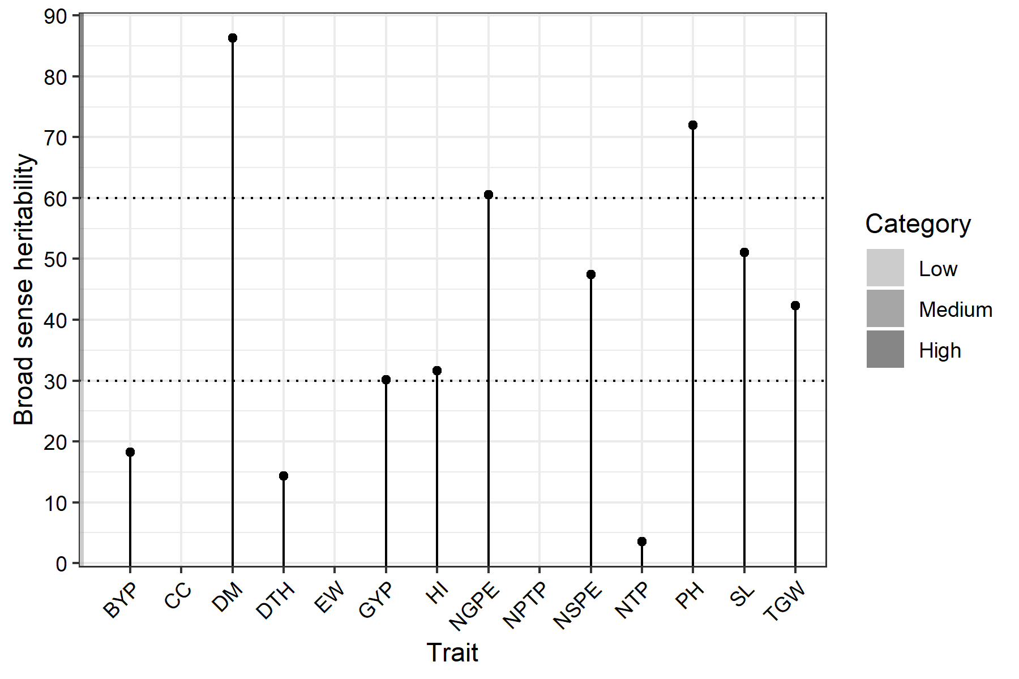
Figure -1 Variation in broad sense heritability among the traits studied.
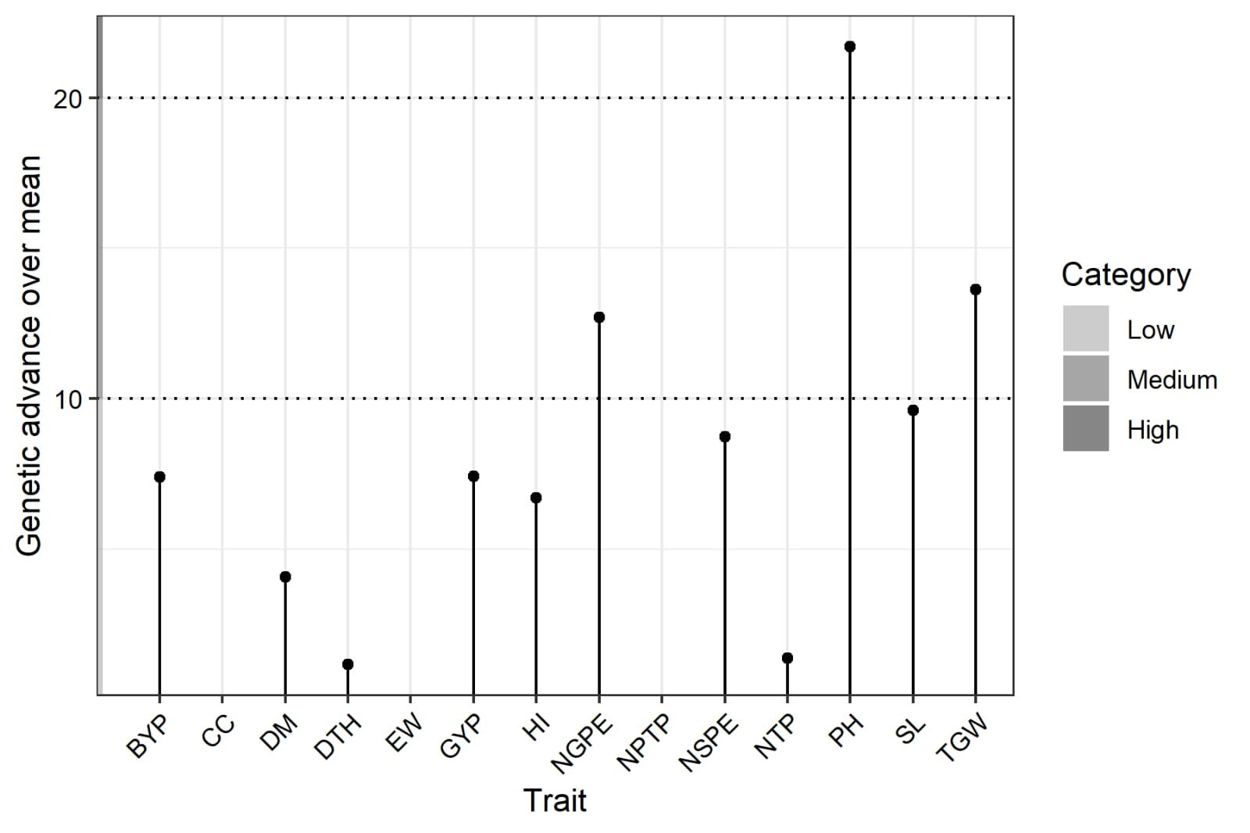
Figure -2 Genetic advance of 14 traits under study
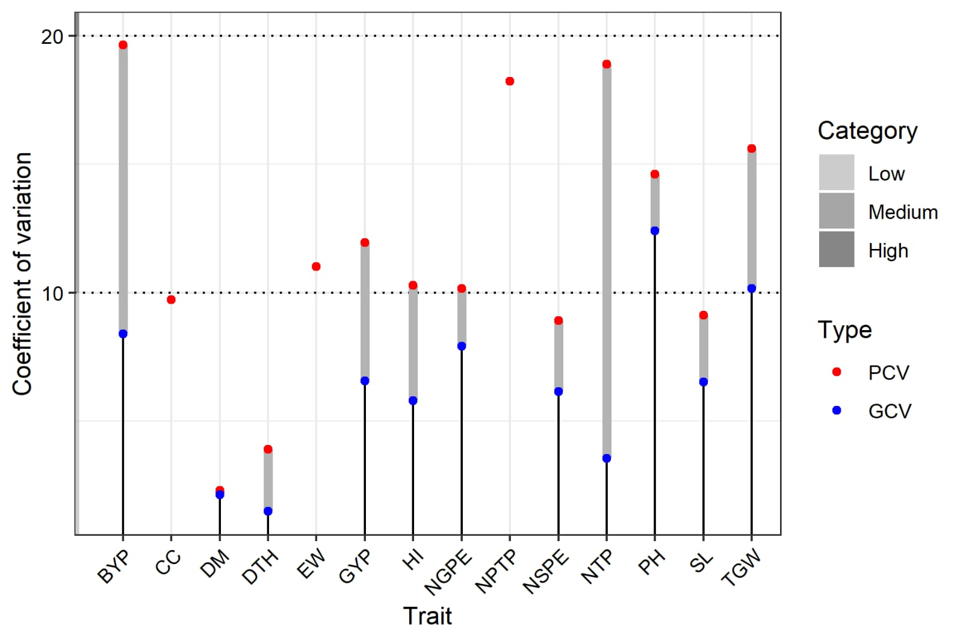
Figure 3: - Coefficient of variation for 14 traits under study
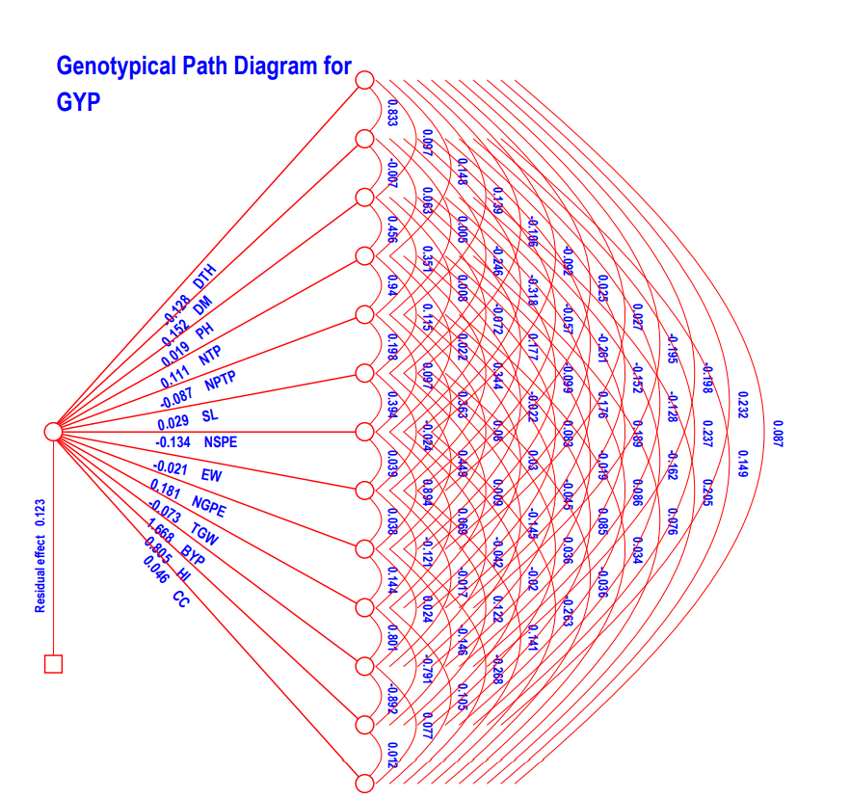

Figure - 4 Genotypic Path coefficient analysis diagram for grain yield per plant.

