RELATIONSHIP BETWEEN HAEMOGLOBIN GENOTYPE AND MALARIA IN PATIENTS ATTENDING CLINICS IN ILE-IFE, OSUN STATE NIGERIA

ABSTARCT
A Study of the relationship between haemoglobin genotype and malaria Parasite infestation was carried out on malaria infected patients at Obafemi Awolowo University Teaching Hospital Complex Ile –Ife. A total of one hundred (100) blood samples of malaria infected patients were collected from various age groups and both sexes. Electrophoresis technic was used to determine haemoglobin genoptype and haemoglobin genotype AA,AS, AC, SC, SS were used as control. A total of 100 samples comprising of 70, AA, 17, AS, 5, SS, 5, AC and 3, SC were found to be percentage of each haemoglobin genotype. A significance difference was observed between male and female patients infected with malaria parasite (p>0.05). It was also observed that children had higher prevalence of malaria infection than adults. This study shows increased malaria parasitaemia in Hb AA while Hb AS,SS,AC shows significant reduction in malaria parasitaemia, this shows that abnormal haemoglobin trait naturally confer a level of degree of immunity to malaria parasitaemia in individual with abnormal haemoglobin.
Keywords: Haemoglobin, genotype, plasmodiasis, malaria, mp

INTRODUCTION
Plasmodiasis is one of the major causes of debilitating sicknesses, mobidity and mortality in endemic regions in the tropics, with under-5 children and pregnant women being the most vulnerable (Onohuean, et al., 2021). About a quarter of a billion cases of malaria is estimated to occur annually and millions of malaria-caused mortalities. Disproportionately, majority of all malaria cases and about 93% of malaria-linked fatalities are recorded in sub-Saharan African. In fact, thirty Sub-Saharan Africa nations are said to account for 90% of malaria deaths, worldwide. Ethiopia, DR Congo, and Uganda have been said to be responsible for Nigeria, nearly 50% of all global malaria deaths (WHO, 2015; 2022).
According to WHO estimates Africa leads in malaria infection (90%), followed by South-East Asia (7%) and Eastern Mediterranean (2%). Four in 100 of cases in Africa are caused by Plasmodium vivax, but outside African this could be as high as 36%. For example, it is the predominant Plasmodium variant in the Americas (64%), 30% in South-East Asia and 40% in the Eastern Mediterranean. Majority of cases of vivax-caused malaria happen in South-East Asia (58%). Plasmodium falciparum still remains the main cause of malaria in sub-Saharan Africa in general and in Nigeria in particular. Going by some estimates, 9 out of 10 Nigerians are at risk of malaria, the remaining 3% who are not at risk are those who live in the malaria free highlands (Lema et al., 2021).
Malaria is a complex parasitemia influenced by lots of yet-to-be-fully understood host genetic variables (Amodu et al., 2019; Egan, 2018; Driss et al., 2011; Band et al., 2022). Control of haemoglobin synthesis is inherited from both parents, thus a normal adult can be depicted as having Hb genotype AA, sickle cell trait AS, sickle cell anaemia (homozygote HbS disease, SS) or SC. In Africa, between 20 – 40 % of the population are heterozygous (Issa et al., 2026; Adigwe et al., 2023) and in United States 0.1 – 0.2 % of black Americans have sickle cell anaemia (SCA) and approximately 8% are heterozygous. (Derebail et al., 2010).
Malaria resistance by sickle trait ( genotype Hb AS) has served as the prime example of genetic selection for over half a century, and it probably involves innate factors such as the reduced ability of Plasmodium falciparum parasites to grow and multiply in Hb AS erythrocytes (Zakaria et al., 2023 )
This study aimed to find out the relationship between haemoglobin genotype and malaria parasite infestation and establish possibility of haemoglobin genotype confer immunity against malaria infection.

Methods

Study Population
One hundred (100) patients suspected of malaria infection regardless of their age, sex, ethnicity, and economic status were consecutively recruited into the study

Sample Collection and Analysis
Two milliliters (2ml) of blood were collected by from the subjects through venepuncture in EDTA bottle.
Haemoglobin Electrophoresis
The heamoglobin genotypes of the subjects were determined through cellulose acetate electrophoresis at alkaline PH.

MP Films
Both thin and thick films were made for the detection of malaria parasites in the subjects’ blood samples. They were both stained with Giemsa stain, using the dilution appropriate for each film type, after which the films were examined with x100 objective of the microscope

Results and discussion
The findings from this study were present in the table and figures. Table 1shows the age of patients compared with severity of malaria in each of the genotype in severity of infection among the study population.
Table 2 shows percentage of severity in each of haemoglobin genotype while figure 2 shows age group in coparison with haemoglobin genotype amongpatients.
Table 3 shows sex and malaria parasite infestation among patients.

Table 1: Age Comparison with severity of malaria in each Haemoglobin Genotype

Age(yr) Severity Haemoglobin Genotype
AA AS SS AC SC
1-5 + 15(16.0%) 11(15.7%) 1(5.9%) 1(20.0%) 1(20.0%) 1(20.0%)

6-10 + 18(19.1%) 10(14.3%) 3(17.6%) 3(60.0%) 1(20.0%) 1(33.3%)

11-15 +19(20.2%) 13(18.6%) 1(5.9%) 1(20.0%) 3(60.0%) 1(33.3%)

16-20 +11(11.7%) 8(11.4%) 3(17.6%) 0 0 0

21-25 +8(8.5%) 0 0 0 0 0

26-30 +9(9.6%) 8(11.4%) 1(5.9%) 0 0 0

31-35 +9(9.6%) 9(12.9%) 0 0 0 0

36-40 +4(4.3%) 2(2.9%) 2(11.8%) 0 0 0

44-45 +1(1.1%) 1(1.4%) 0 0 0 0

TABLE 2: Haemoglobin genotype by severity of malaria parasite

Haemoglobin Genotype Severity of Malaria Parasite (Positive (+/++)

AA 70(70.0%)
AS 17(17.0%)
SS 5(5.0%)
AC 5(5.0%)
SC 3(3.0%)
Total 100(100%)

Table 3: Sex and Haemoglobin Genotype and malaria parasite infestation among patients.

Sex Haemoglobin Genotype
AA AS SS AC SC Total
Male 40(80.0%) 6(11.11%) 4(7.40%) 3(5.56%) 1(1.85%) 54(54%)

Female 30(65.2%) 11(23.1%) 1(2.17%) 2(4.34%) 2(4.34%) 46(46%)

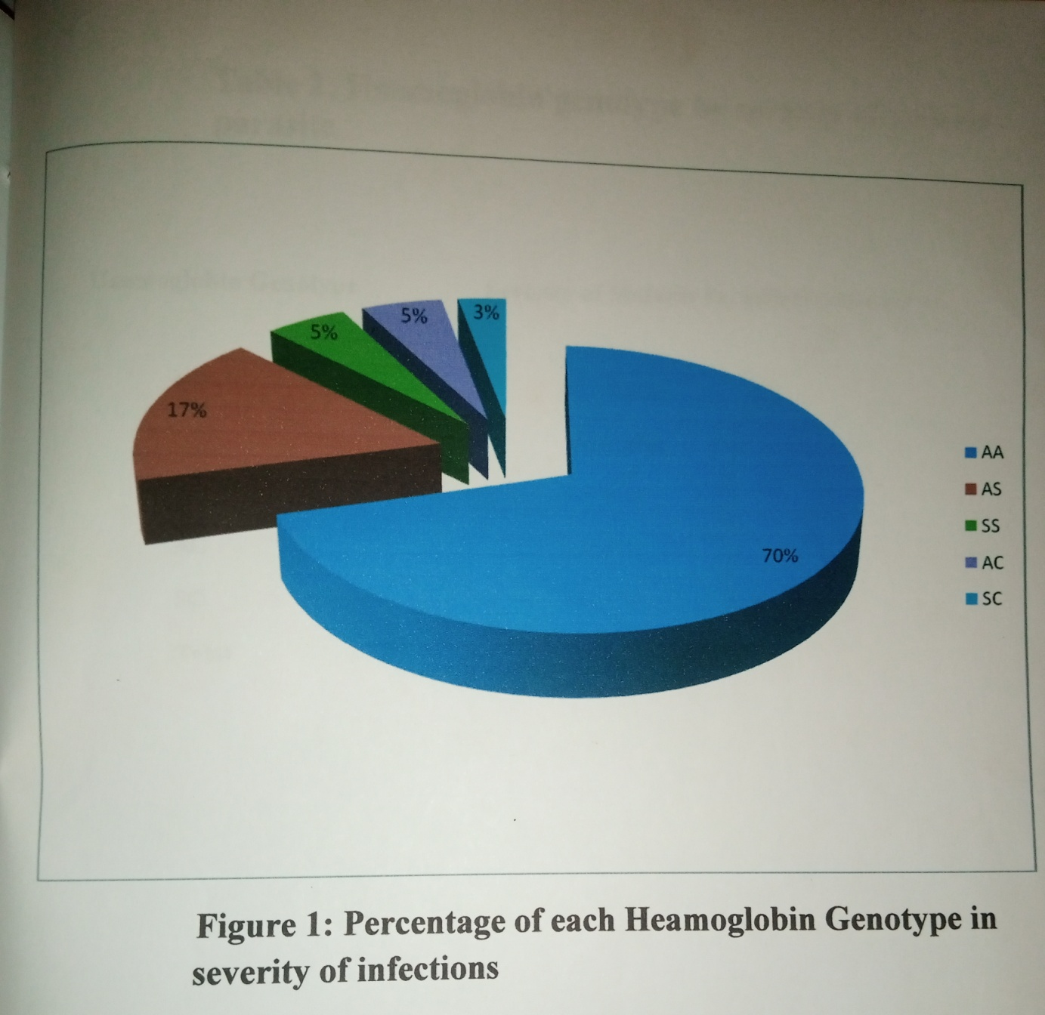

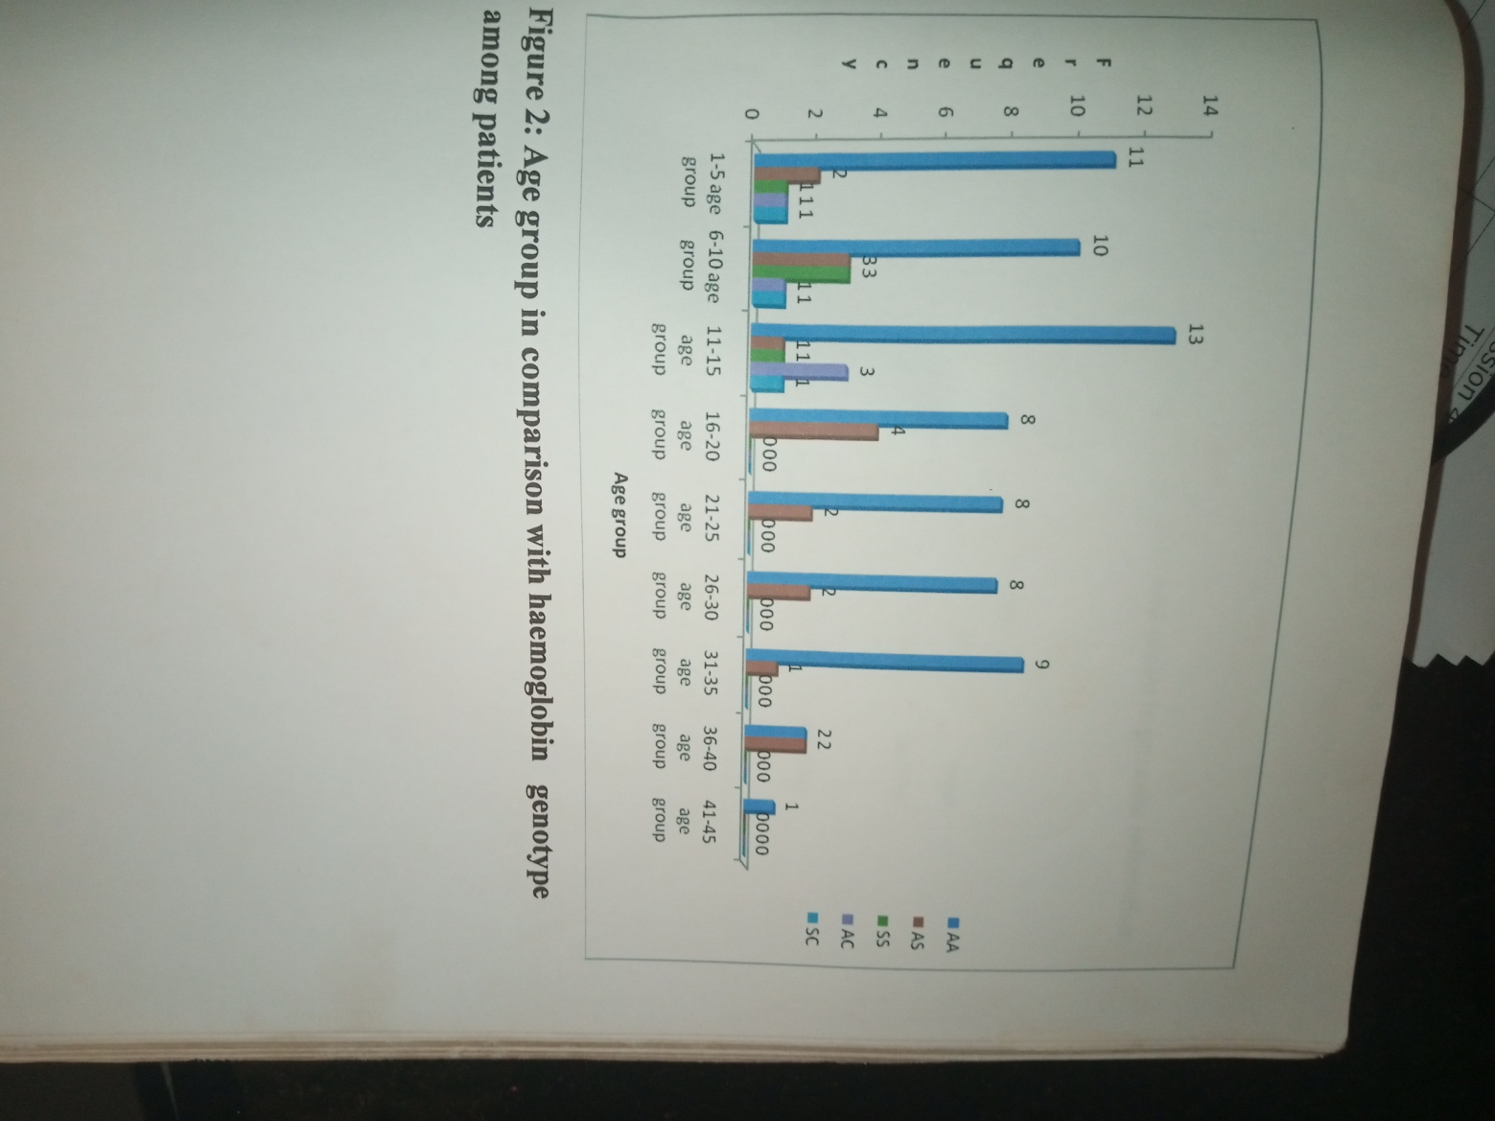

As in most parts of Southwestern Nigeria, Ile-Ife, the study location is an malaria endemic area and the high prevalence of malaria parasitemia among the subjects is indicative of active transmission of malaria in the study area. The high prevalence of malaria parasitemia among the subjects is attributable to a number of factors; high breeding rate of the mosquitoes -the vector- and high transmission rates throughout the year most especially during the rainy season(Singh et al., 2004) Other contributory factors might be clogged drainages, high humidity, favourable temperature, rural-urban migration which often results disruption in the ecosystem, densely populated residential areas etc (Aribodor et al., 2003). Also, ignorance, poverty, poor hygiene and poor town planning contribute to high burden of plasmodiasis in endemic areas . Oparaocha (2003) in his study reported as high as 88.8% prevalence in Ikwuano LGA Abia State, Nigeria, Aribodor et al., (2003) a prevalence of 76% among the residents of Azia in Anambra State, Nigeria, but 66.0% in Ndiowu community of Anambra State, Nigeria. Ejezie(1983) reported 85%, while Kalu et al., (2012) 71.43% in their own studies.
The results of this study showed a higher prevalence in males (54%) more than females (46%). This aligns with the findings of other researchers (Nwaorgu and Orajaka, 2011 and Nmadu et al., 2015, who in their own studies found that gender did not significantly affect malaria prevalence. It does appear that immune response to malaria parasitemia is not in significantly affected by gender, since both sexes are similarly exposed to mosquito bites. Though in practical terms, males are more exposed to mosquitoes than females because males stay late at nights, stay longer outdoors at the time mosquitoes are more active.

This current study shows that malaria is present in all age-brackets in endemic area, prevalence rates differ among age-brackets. The prevalence of malaria parasitemia increased from 16% in 1-5 age-bracket, to 19% in 6-10 and then 20.2% in 11-15, but decreased consistently thereafter dipping to 1.1% in the 44-45 age-bracket.
This compares with World Malaria Report (WHO, 2015) and Yahaya et al., (2012) who reported higher prevalence in 0-5 bracket. This of course, is understandable because under-five children and pregnant women are more vulnerable to malaria. Out of the estimated 584000 global malaria deaths in 2013, approximately 78% were in under-five children (WHO, 2015). The spike in prevalence between 0-5 and 6-10 age bracket has been attributed to the gradual loss of maternal antibodies and the development of acquired immunity. Just as increased parasite density among teens compared to adults has been attributed to the fact that they spend longer time outside both day and night thus exposing them to more mosquito bites (Lema et al., 2021). Elderly persons tend to stay more indoors than outdoors and sleep under mosquito nets or fumigated room/insecticides-treated room (Tela et al., 2015)
This study entailed the conduct of haemoglobin electrophoresis so as to know the interaction between haemoglobin genotype and malaria parasite immunity.
The mechanism by which haemoglobin genotype protects against malaria has been the subject of speculation for so many years, to some extent, it probably relates to the physical characteristics of hemoglobin erythrocytes, a number of studies suggest that haemoglobin genotype may also enhance the acquisition of natural immunity, such as Hb AS.
Homozygous (HbSS) persons most certainly develop sickle cell disease (SCD) with its attendant mortality. However, persons with sickle cell trait (SCT) ie HbAS are summarily asymptomatic. HbAS also tends to confer immunity against severe falciparum malaria (> 90%), with a 60% reduction in overall mortality, though HbAS does not actually confer immunity against falciparum infection (Taylor et al., 2012). These protective mechanisms are not yet properly understood, but seem to have to do with the inability of HbAS red cells to sustain falciparum survival at the low oxygen tensions (Archer el al., 2018; Cholera et al., 2008; Lansche et al., 2018). Decreased adhesion of HbAS infected red cell to microvascular endothelial cells has also been identified as contributing to the protection HbAS seem to confer against severe malaria (Sachez et al., 2019; Kilian et al., 2015; Petersen, 2021).
However, establishing this relationship is challenging because immunity to malaria is hard to measure, as no single immune response has been described that reliably predicts protective immunity. As a result, immunity to malaria is usually defined as the ability to control new infections to a level at which they fail to reach a clinical threshold. (Thomas, et al, 2005)
The findings of this study also revealed that malaria was present in all the genotypes (Figure 1), though the prevalences differed among the haemoglobin genotypes. Genotype HbAA (70%) had the highest prevalence, followed by genotype HbAS (17%), while genotype HbSC (3%) had the lowest prevalence. AS 17(17.0%) SS 5(5.0%) AC 5(5.0%). This indicates that Plasmodium spp can infect all the three major haemoglobin genotypes HbA, HbS an HbC, this compares with the findings of Lema et al., (2015) and Paul et al., (2002)
Higher incidence of malaria parasite infestation 19(20.2%) was noticed among the age group of 11 to 15 years as indicated in table 1 and had AA 13(18.6%) as their haemoglobin genotype. Patients within the age-range 1 to 20 years had higher infection of malaria parasite compared to those above 20 years of age. That is, children with Hb AA were found to be more infected with malaria parasite than those with AS and AC. Those who were Hb AS and AC had lower infection rate and parasite count than those with Hb AA. This is similar to the findings Anumudu, et al (2006).

Sex distribution also had significant impact on malaria parasite with haemoglobin genotype (Table 3). There was a statistically significant difference (P<0.05) between incidence among males 54(54.0%) compared to female 46(46.0%). Though some studies suggest that HbAA children have lower parasite density than HbAC children. In Ghana, where there is a relatively higher prevalence of HbS and HbC, a study also reported greater protection against severe malaria among HbAS children (May, 2007). It has be reported that that parasite-induced sickling of AS erythrocytes reduce invasion and impact development of malaria parasites.
This current study aligns with several other studies that the protective effect of HbAS is essentially the outcome of impaired intracellular transport and infected erythrocytes (IE) surface display of PfEMP1, thus resulting in reduced cytoadhesion and enhanced splenic removal of IEs (Diakite et al., 2016).
Conclusion
This study shows increased malaria parasitaemia in HbAA while Hb AS, SS, AC shows significant reduction in malaria parasitaemia. Therefore, this study in concurrence with lots of similar studies, has been able to establish the fact that heterozygous or homozygous presence of HbS and HbC confers protection against the severe plasmodiasis.

References
Adigwe OP, Onoja SO, Onavbavba G. (2023): A critical review of sickle cell disease burden and challenges in sub-Saharan Africa. J Blood Med, 14:367–76. https://doi.org/10.2147/JBM.S406196.
Anumudu, C.I, Adepoju, A. Adeniran, M, Adeoye O, Kassim A, Oyewole, I. and Nwasu, R. I, (2006) Malaria prevalence and Treatment sickling Behaviour of young Nigerian Adults Annals of African Medicine vol. 5 No 2 pg 82-88.
Archer NM, Petersen N, Clark MA, Buckee CO, Childs LM, Duraisingh MT (2018): Resistance to Plasmodium falciparum in sickle cell trait erythrocytes is driven by oxygen-dependent growth inhibition. Proc Natl Acad Sci 115:7350–7355
Cholera R, Brittain NJ, Gillrie MR, Lopera-Mesa TM, Diakite SA, Arie T, Krause MA, Guindo A, Tubman A, Fujioka H, Diallo DA, Doumbo OK, Ho M, Wellems TE, Fairhurst RM (2008): Impaired cytoadherence of Plasmodium falciparum-infected erythrocytes containing sickle hemoglobin. Proc Natl Acad Sci 105:991–996
Diakite SA, Ndour PA, Brousse V, Gay F, Roussel C, Biligui S, Dussiot M, Prendki V, Lopera-Mesa TM, Traore K, Konate D, Doumbia S, Cros J, Dokmak S, Fairhurst RM, Diakite M, Buffet PA. (2016): Stage-dependent fate of Plasmodium falciparum-infected red blood cells in the spleen and sickle-cell trait-related protection against malaria. Malar J 15:482
Derebail VK, Nachman PH, Key NS, Ansede H, Falk RJ, Kshirsagar AV(2010): High prevalence of sickle cell trait in African Americans with ESRD. J Am Soc Nephrol 21(3):413-7. https://doi:10.1681/ASN.2009070705
Issa, A., Ibrahim, O.R., Ibraheem, R.M. et al (2026): Prevalence of sickle cell disease and sickle cell traits among children and adolescents in Nigeria: a systematic review and meta-analysis. Syst Rev 15, 32. https://doi.org/10.1186/s13643-025-03029-1
Lansche C, Dasanna AK, Quadt K, Frohlich B, Missirlis D, Tetard M, Gamain B, Buchholz B, Sanchez CP, Tanaka M, Schwarz US, Lanzer M. (2018): The sickle cell trait affects contact dynamics and endothelial cell activation in Plasmodium falciparum- infected erythrocytes. Commun Biol 1:211
Kilian N, Srismith S, Dittmer M, Ouermi D, Bisseye C, Simpore J, Cyrklaff M, Sanchez CP, Lanzer M (2015): Hemoglobin S and C affect protein export in Plasmodium falciparum-infected erythrocytes. Biol Open 4:400–410
Petersen JEV, Saelens JW, Freedman E, Turner L, Lavstsen T, Fairhurst RM, Diakite M, Taylor SM. (2021): Sickle-trait hemoglobin reduces adhesion to both CD36 and EPCR by Plasmodium falciparum-infected erythrocytes. PLoS Pathog 17:e1009659
Sanchez CP, Karathanasis C, Sanchez R, Cyrklaff M, Jager J, Buchholz B, Schwarz US, Heilemann M, Lanzer M. (2019): Single-molecule imaging and quantification of the immune-variant adhesin VAR2CSA on knobs of Plasmodium falciparum-infected erythrocytes. Commun Biol 2:172
Taylor SM, Parobek CM, Fairhurst RM (2012): Haemoglobinopathies and the clinical epidemiology of malaria: a systematic review and meta-analysis. Lancet Infect Dis 12:457–468
Zakaria Seidu, Michael F. Ofori, Lars Hviid, Mary Lopez-Perez (2023): Impact of sickle cell trait hemoglobin in Plasmodium falciparum-infected erythrocytes. bioRxiv https://doi.org/10.1101/2023.07.28.551025

Onohuean H, Alagbonsi AI, Usman IM et al (2021): Annona muricata Linn and Khaya grandifoliola C.DC. Reduce Oxidative Stress In Vitro and Ameliorate Plasmodium berghei-Induced Parasitemia and Cytokines in BALB/c Mice. J. Evidence-Based Integr. Med. 26, 1–10
WHO. Malaria [Internet]. Fact sheet-Malaria (2022): Available at: www.who.int/news-room/fact-sheets/detail/malaria

World Health Organization (2015): World Malaria Report 2015
Available: http://www.who.int/malaria/publications/world-report-2015/en/ISBN:9789241565158
Amodu O, Shah BN, Ademola S, Tayo B, Gordeuk VR. Relationship of Host Genetic Factors with Severe Malaria in Nigerian Children. Blood (2019).
Egan ES. Beyond Hemoglobin: Screening for Malaria Host Factors. Trends Genet. (2018).
Driss A, Hibbert JM, Wilson NO, Iqbal SA, Adamkiewicz TV, Stiles JK. Genetic polymorphisms linked to susceptibility to malaria. Malar. J. (2011).
Band G, Leffler EM, Jallow M et al. Malaria protection due to sickle hemoglobin depends on parasite genotype. Nature (2022).
Hedrick PW. Population genetics of malaria resistance in humans. Heredity (Edinb). (2011).
Hemming-Schroeder E, Zhong D, Machani M et al. Ecological drivers of genetic connectivity for African malaria vectors Anopheles
gambiae and An. arabiensis. Sci. Rep. (2020).
Kariuki SN, Williams TN. Human genetics and malaria resistance. Hum. Genet. (2020).
Lema SY, Kabiru A, Yahaya MA and Fana AS (2021): Age Groups and Haemoglobin Genotypes Influence Malaria Occurrence among Patients in Sokoto Specialist Hospital, Sokoto State, Nigeria. South Asian Journal of Parasitology 4(1): 8-16

Singh B, Kim Sung L, Matusop A (2004): A large focus of naturally acquired Plasmodium knowlesi infections in human beings. Lancet, 363(9414):17-24.
Aribodor DN, Njoku OO, Eneanya CA, Onyali IO (2003): Studies on prevalence of malaria and management practices of Azia Community of Anambra State, South-East Nigeria. Nigeria Journal of Parasitology 24:33-38.
Ejezie GC (1983): The Nigerian environment and parasitic infection. Folia Parasitology. (PRAHA) 30:80-95.
Oparaocha ET (2003): The impact of haemoglobin level and concomitant infection of malaria parasitaemia and on-set of fever during malaria attack in Ikwuano Local Government Area of Abia State, Nigeria. Nigerian Journal of Parasitology, 24:25-32

Nwaorgu OC, Orajaka BN. (2011): Prevalence of malaria among children 1-10years old in communities in Awka North Local Government Area, Anambra State South- East Nigeria. African Research Review, 5(5):264-281.
Nmadu PM, Peter E, Alexander P, Koggie AZ, Maikanti JI (2015): The prevalence of malaria in children between ages 2-15 visiting Gwarinpa General Hospital Life-camp, Abuja, Nigeria. Journal of Health Science, 5(3):47-51.
World Health Organization (2015): Malaria in children under-five.
Available at: http://www.who.int/malaria/areas/high_risk_groups/children/en/
Tela IA, Modibbo MH, Adamu LH, Taura MG (2015): Prevalence of malaria infection among ABO blood groups in Jamaˈare, Nigeria, Journal of Applied Research. 1(e):2394-6709:255-262

