Case report

CUTANEOUS FORM OF TRANSMISSIBLE VENEREAL TUMOR (TVT) IN A GERMAN SHEPHERD DOG: CASE REPORT

.
ABSTRACT

Canine Transmissible Venereal Tumor (CTVT), historically known as Sticker's sarcoma, represents a unique contagious round-cell neoplasm that primarily affects the external genitalia of dogs. While the genital form remains frequently encountered in routine veterinary practice, extragenital or purely cutaneous presentations are comparatively rare and often complicate the diagnostic process due to their atypical distribution. This case report documents an unusual manifestation of cutaneous TVT in a 4-year-old intact male German Shepherd dog. The patient presented with multiple ulcerated, nodular lesions prominently distributed on the muzzle, periocular region, dorsal trunk, and limbs, accompanied by concurrent bilateral corneal opacity. A definitive diagnosis was promptly achieved through Fine Needle Aspiration Cytology (FNAC), which revealed high cellularity comprising characteristic round cells containing distinct, pathognomonic cytoplasmic vacuoles. The underlying etiology was determined to be autoinoculation, resulting from the animal's licking behavior involving a previously healed genital tumor site. A targeted therapeutic course of Vincristine sulfate, administered intravenously at 0.025 mg/kg once weekly for four weeks, yielded a complete clinical cure, achieving total regression of all skin lesions alongside complete resolution of the ocular symptoms. This report underscores the critical necessity of including TVT in the differential diagnosis for nodular dermatological diseases and reaffirms the exceptional efficacy of vincristine chemotherapy for extragenital manifestations.

Keywords: Canine Transmissible Venereal Tumor (CTVT), Cutaneous, Extragenital, Vincristine, Autoinoculation, Cytology.

1. INTRODUCTION

Canine Transmissible Venereal Tumor (CTVT) is a remarkable case in veterinary oncology: a clonally transmissible cancer where the neoplastic cells themselves serve as the infectious agent [8]. Predominant in tropical and subtropical regions, it spreads mainly through coitus, causing primary lesions on the genital mucosa [1]. Transmission extends beyond the genital tract, however, with extragenital sites like the oral cavity, nasal passages, and skin becoming infected via social behaviors such as sniffing, licking, or direct contact with tumorous tissue [5].
Primary cutaneous TVT without concurrent genital lesions is rare. It usually stems from metastasis or, in animals with prior genital involvement, autoinoculation [7]. This case study details the clinical progression, cytological confirmation, and successful chemotherapeutic treatment of generalized cutaneous TVT in a German Shepherd dog.

2. Presentation of Case
2.1 Case history and signalment
A 4-year-old intact male German Shepherd dog was presented to our veterinary clinic with the primary complaint of multiple rapidly spreading cutaneous masses accompanied by progressive ocular cloudiness that had ultimately resulted in complete blindness. The owner provided a detailed history, reporting that the lesions had initially manifested as small, discrete nodules localized on the muzzle and in the periorbital region around the eyes. Over time, these nodules proliferated extensively, disseminating to various other regions across the body. Notably, the patient had a documented clinical history of a previous genital Transmissible Venereal Tumor (TVT). However, the owner observed that the dog frequently engaged in licking behavior directed at the affected cutaneous areas, which suggested a plausible mechanism for mechanical autoinoculation and transfer of the tumor cells.

2.2 Clinical examination
A comprehensive physical examination revealed numerous firm, erythematous cutaneous nodules distributed across multiple sites, with diameters ranging from 0.5 cm to 1 cm in size. The lesions demonstrated a distinctive pattern of heavy concentration on the nasal bridge, periocular region (specifically involving the eyelids), and muzzle, accompanied by more scattered nodules appearing on the dorsal aspect of the trunk as well as on the limbs [ Figure:1, 2]. Several of these masses exhibited a characteristic cauliflower-like morphology with notably friable surfaces that displayed a pronounced tendency to hemorrhage easily upon even gentle manipulation a clinical presentation highly consistent with extragenital manifestations of Transmissible Venereal Tumor (TVT) [1, 6]. Additionally, bilateral corneal opacity was prominently noted on ophthalmic examination. This opacity was attributed to chronic mechanical irritation combined with the infiltrative pressure exerted by the encroaching periocular masses, which collectively led to complete blindness in the affected dog. Despite the extensive dermatological involvement observed throughout the examination, the dog remained bright, alert, and responsive in demeanor, exhibiting no systemic signs of illness or generalized debilitation.
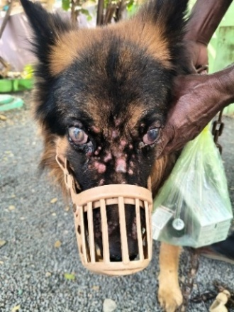 | 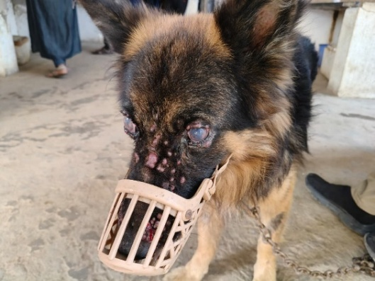
Figure 1: multiple erythematous nodules | Figure 2: corneal opacity can be noticed

2.3 Diagnosis
To establish a definitive diagnosis, Fine Needle Aspiration Cytology (FNAC) was performed on the nodular lesions. The aspirates yielded high cellularity. The cells were discrete, round-to-oval in shape, and featured round, eccentrically located nuclei with coarse chromatin patterns [7]. A critical diagnostic feature observed was the presence of clear, punctate vacuoles within the cytoplasm of the neoplastic cells [4] [Figure:3]. The morphological characteristics were diagnostic for the Cutaneous form of Transmissible Venereal Tumor.

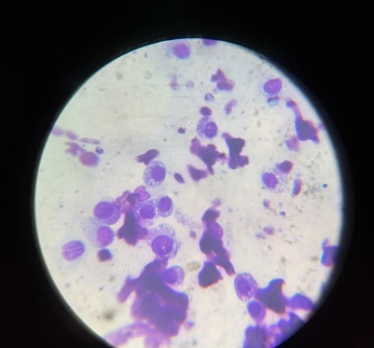
Figure 3 : FNAC of the Facial Nodule

2.4 Treatment protocol
A standardized chemotherapy regimen utilizing the antineoplastic agent Vincristine sulfate was promptly instituted to address the generalized cutaneous TVT. The drug was administered via intravenous injection at a precise dose rate of 0.025 mg/kg body weight, following established protocols [1]. This treatment schedule was meticulously adhered to, with administrations repeated once weekly for a total duration of 4 consecutive weeks. Throughout the therapeutic course, the patient underwent vigilant clinical monitoring for common adverse effects associated with Vincristine therapy, such as gastrointestinal distress, lethargy, or other potential toxicities—none of which were observed in this case, indicating excellent tolerance to the regimen.

3. DISCUSSION
The response to Vincristine sulfate therapy proved both rapid and highly significant, demonstrating the characteristic chemosensitivity of CTVT:
A marked and pronounced regression was observed specifically in the nodules located on the dorsal aspect of the trunk, with visible reduction in size and number.
The facial lesions exhibited slight but noticeable initial improvement immediately following administration of the 1st dose. By subsequent evaluations, the facial and periocular nodules had substantially regressed, showing dramatic diminution in both size and prominence. Concurrently, there was marked clearance of the bilateral corneal opacity as the physical obstruction and chronic mechanical irritation from the regressing periocular masses were effectively removed. However, the buphthalmos-associated eye blindness persisted despite these improvements [Figure 4 & 5]. The distinctive pattern of cutaneous distribution observed in this particular case is best explained by the established theory of autoinoculation. It is hypothesized that the dog mechanically transferred viable neoplastic tumor cells from the original healed genital site to various cutaneous locations through its grooming behavior and repetitive licking activities [3.5]. This rapid and complete resolution of lesions across multiple sites strongly supports the existing veterinary literature regarding the exceptional sensitivity of Transmissible Venereal Tumor (TVT) to vinca alkaloid chemotherapy. Consequently, Vincristine remains the single-agent treatment of choice for CTVT, consistently delivering cure rates exceeding 90% across both genital and extragenital presentations [2,3].

 | 
Figure 4&5: After Treatment

4. CONCLUSION
This case serves as an important clinical reminder that Canine Transmissible Venereal Tumor (CTVT) should be routinely included in the differential diagnosis for dogs presenting with multifocal or generalized cutaneous nodules, particularly in those patients with a documented history of prior TVT involvement in any form. The presence of characteristic cytoplasmic vacuoles observed in cytological preparations from fine-needle aspirates provides a reliable, pathognomonic confirmatory diagnostic feature that distinguishes this neoplasm from other dermatological differentials. In this instance, chemotherapy with Vincristine sulfate demonstrated excellent therapeutic efficacy against the extragenital form of the disease, ultimately achieving complete clinical remission of all cutaneous lesions along with significant improvement in the animal's ocular health—specifically the resolution of corneal opacity—and a marked enhancement in its overall quality of life [6].

References

- Ganguly, B., Das, U., & Das, A. K. (2016). "Canine transmissible venereal tumour: a review." Veterinary and Comparative Oncology, 14(1), 1-12.

- Hantrakul, S., Klangkaew, N., Kunakornsawat, S., Tansatit, T., Poapolathep, A., Kumagai, S., & Poapolathep, S. (2014). Clinical pharmacokinetics and effects of vincristine sulfate in dogs with transmissible venereal tumor (TVT). Journal of Veterinary Medical Science, 76(12), 1549-1553.

- Huppes, R. R,. (2014). "Peripheral, cutaneous and genital transmissible venereal tumor in a dog." Acta Scientiae Veterinariae, 42.

- Kumar, K., Jha, A. K., Ray, K., Gautam, A. K., & Singh, D. (2021). Diagnosis of TVT with cell cytology and efficacy of treatment with Vincristine Sulfate in non-descriptive Indian canine breeds. Indian Journal of Animal Research, 55(11), 1352-1355.

- Marahatta, S., Lamsal, K., Joshi, R. P., & Shrestha, B. (2020). A Case Study of Canine Transmissible Venereal Tumour in Community Dog. Journal of the Institute of Agriculture and Animal Science, 323-327.

- Preet, G. S., Sidhu, S., Dhaliwal, K. S., Singh, J., & Kaur, J. (2021). Atypical cutaneous transmissible venereal tumour in dog-a case report.

- Rezaei, M., Azizi, S., & Shahheidar, M. (2016). "Primary cutaneous transmissible venereal tumor in a dog." Comparative Clinical Pathology, 25, 663-665.

- Strakova, A., & Murchison, E. P. (2014). "The changing epidemiology of canine transmissible venereal tumour." Journal of Small Animal Practice, 55(9), 459-460.

