Study on Genetic Variability and Diversity in Indian Mustard (Brassica juncea L.) Genotypes with Special Reference to Oil Content under Timely and Late Sowing Environments in Doon Valley

ABSTRACT
Aim: The present study was conducted to assess the significance of genetic variability and diversity among genotypes of Indian mustard (Brassica juncea L.) under timely and late-sowing environments in the Doon Valley.
Study Design: Randomized block design with 3 replications of 30 genotypes of Indian mustard.
Place and Duration of Study: The field experiments were conducted during the 2024-25 Rabi season on the Jigyasa University campus. 30 genotypes of Indian mustard were sown in two sowing environments, i.e., timely sowing on 30th October 2024 and late sowing on 30th November 2024
Methodology: Thirty genotypes were grown under uniform agronomic practices with a spacing of 70 × 30 cm. Five representative plants per genotype per replication were selected to record data on growth, phenology, physiological indices (RWC, MSI, PELWL), leaf area index at different stages, and yield attributes, including seed and oil yields, ANOVA, genetic variability analysis (PCV, GCV, ECV, hBS, GAM), and diversity analysis through cluster analysis and intra- and inter-cluster distance.
Results: The oil content percentage was higher under timely sowing than late sowing. Genotypes such as Varuna, RGN-48, RB-50, and Shivalik maintained relatively high oil content even under late-sowing conditions, indicating heat-stress tolerance. ANOVA showed highly significant effects (p < 0.01), indicating significant genetic variability among all traits of genotypes under timely and late sowing. Higher values of PCV than GCV indicate environmental influence. High heritability along with genetic advance over the mean, indicating the role of additive action of genes and the advantage of the direct selection scope. Genetic diversity analysis was performed by clustering 30 genotypes into 6 groups to emphasize genetic diversity. Lowest intra-cluster distances indicate high similarity among genotypes within the cluster. The highest intra-cluster distance suggests high variability among genotypes within the cluster. Analysis of inter-cluster distance suggests suitability for interbreeding.
Conclusion: The study confirmed that a timely sowing environment is more favourable for growth & development and for yield performance, whereas a late-sowing environment is associated with terminal heat stress, which adversely affects overall crop performance.

Keywords: Genetic Variability, Genetic Diversity, Terminal Heat Stress, Cluster Analysis, Heritability, Genetic Advance Over Mean

1.0 INTRODUCTION
Indian mustard (Brassica juncea L.) is one of the most significant edible oilseed crops in the genus Brassica and family Brassicaceae. India is the 3rd-largest producer of these oilseeds, accounting for 14% of worldwide production after Canada and China. In India, mustard oilseed crops are the most widely cultivated and economically important after soybeans. Indian mustard is primarily grown in agro-climatic zones, including the hill regions of the north-western & north-eastern regions and the plain regions of the southern region, under mixed climatic conditions, such as rainfed and irrigated agricultural systems. Among the several species of Rapeseed mustard, Indian mustard (Brassica juncea) is the dominant member, cultivated in 80% of areas. According to reports published by ICAR-Indian Institute of Rapeseed-Mustard Research, during FY 2023-24, Indian mustard was cultivated in 30.3% of the total oilseed area and contributed 33.2% of the overall oilseed yield in India.
According to the report, rapeseed mustard recorded a high yield of 13.2 million tonnes (131.4 lakh tonnes) in FY 2023-24, exceeding the previous FY yield of 12.64 million tonnes (126.43 lakh tonnes), making it the largest oilseed-producing crop in India. During the same FY, the productivity of Indian mustard reached approximately 1443 kg/ha, exceeding the previous FYs oilseed productivity, which was approximately 1314 kg/ha in India. Among all mustard-producing states of India, Rajasthan sustain its top position, contributing approximately 45-49 %, after Haryana 12.44 %, Madhya Pradesh 11.32%, Uttar Pradesh 10.60% and West Bengal 7.53% respectively. Overall, approximately 74% of the mustard-producing region of India is irrigated, helping to maintain a consistent yield even under unfavourable environmental conditions.
Sowing time is critical for optimal growth and development. Timely sowing yields higher yields, whereas late sowing poses environmental challenges, including terminal heat stress. Due to multiple cropping, Indian mustard is sown until late November. Late-sown Indian mustard is exposed to low temperature during the vegetative stage, whereas high temperature during the terminal stages
2.0 METHODOLOGY
The present study was conducted to assess genetic variability and divergence in Indian mustard (Brassica juncea L.) under timely and late-sowing environments in the Doon Valley. The field experiments were conducted during the 2024-25 Rabi season on the campus of Jigyasa University. The experiment field is 18 kilometres from Dehradun. The geographically experimental site is situated at 640 meters above sea level, 31°21ʹ50ʺ N and 78°18ʹ27ʺ E.
Field experiments were designed using a randomized block design with three replications, as shown in Table 1. A total of 30 genotypes of Indian mustard (Brassica juncea L.) were evaluated. The experimental field covered a total area of 189 square meters (1,890,000 square centimetres), with plot dimensions of 21 meters in length (2100 centimetres) and 9 meters in width (900 centimetres). The crop was planted at a spacing of 0.7 meters (70 centimetres) between rows and 0.3 meters (30 centimetres) between plants within a row.
30 genotypes of Indian mustard were sown in two sowing environments, i.e. timely sowing on 30th October 2024 and late sowing on 30th November 2024, to study the impact of terminal heat stress on traits, especially yield and its attributes. Both field experiments were treated uniformly to ensure more emphasis on temperature variation.
The 5 best-performing plants of each genotype were selected across 3 replications for data collection. 23 traits were selected for study, i.e., Plant Height (PH), Length of main shoot (LMS), Primary Branches (PB), Secondary Branches (SB), Silique per plant (SPP), Silique on Main Shoot (SMS), Percent survival at 20 DAS (PS at 20 DAS), Percent survival at 30 DAS (PS at 30 DAS), Days to initial flowering (DIF), Days to 50% flowering (DFF), Leaf area index 30 DAS (LAI 30 DAS), Leaf area index 60 DAS (LAI 60 DAS), Leaf area index 90 DAS (LAI 90 DAS), Days to maturity (DM), Seed per silique (SPP), Oil content % (OC), Oil yield per plant (OYP), 1000-seed weight (TSW), Seed yield per plant (SYP), Biological yield per plant (BYP), Percent excised leaf water loss (PELWL), Relative Water Content (RWC), and Membrane stability index (MSI). Oil content was analyzed following the Soxhlet Extraction Method.
Analysis of variance, genetic variability analysis (GCV, PCV, ECV, hBS, GAM), and genetic diversity analysis (mean cluster performance, intra- & inter-cluster distances) were performed on the collected data using appropriate tools.
Table 1: List of Genotypes of Indian Mustard (Brassica juncea L.) in RBD (Randomized Block Design).
Row N. | Replication-1 |  | Replication-2 |  | Replication-3
Row N. | Sr. N. | Genotypes | Sr. N. | Genotypes | Sr. N. | Genotypes
Row 1 | 1 | Arawali | 30 | Vardan | 15 | PM-29
Row 2 | 2 | BR-40 | 29 | Varuna | 14 | Patan Mustard
Row 3 | 3 | CS-54 | 28 | Shivalik | 13 | Pusa Mahak
Row 4 | 4 | CS-60 | 27 | RH-1230 | 12 | Pusabold
Row 5 | 5 | Gujrat Mustard-2 | 26 | RH-406 | 11 | Maya
Row 6 | 6 | Geeta | 25 | RGN-48 | 10 | Kranti
Row 7 | 7 | JD-6 | 24 | RB-50 | 9 | Krishna
Row 8 | 8 | Kanti | 23 | RGN-73 | 8 | Kanti
Row 9 | 9 | Krishna | 22 | RCC-4 | 7 | JD-6
Row 10 | 10 | Kranti | 21 | RH-119 | 6 | Geeta
Row 11 | 11 | Maya | 20 | Pusa Vijay | 5 | Gujrat Mustard-2
Row 12 | 12 | Pusabold | 19 | Pusa Bahar | 4 | CS-60
Row 13 | 13 | Pusa Mahak | 18 | PM-30 | 3 | CS-54
Row 14 | 14 | Patan Mustard | 17 | PM-24 | 2 | BR-40
Row 15 | 15 | PM-29 | 16 | PM-22 | 1 | Arawali
Row 16 | 16 | PM-22 | 15 | PM-29 | 30 | Vardan
Row 17 | 17 | PM-24 | 14 | Patan Mustard | 29 | Varuna
Row 18 | 18 | PM-30 | 13 | Pusa Mahak | 28 | Shivalik
Row 19 | 19 | Pusa Bahar | 12 | Pusabold | 27 | RH-1230
Row 20 | 20 | Pusa Vijay | 11 | Maya | 26 | RH-406
Row 21 | 21 | RH-119 | 10 | Kranti | 25 | RGN-48
Row 22 | 22 | RCC-4 | 9 | Krishna | 24 | RB-50
Row 23 | 23 | RGN-73 | 8 | Kanti | 23 | RGN-73
Row 24 | 24 | RB-50 | 7 | JD-6 | 22 | RCC-4
Row 25 | 25 | RGN-48 | 6 | Geeta | 21 | RH-119
Row 26 | 26 | RH-406 | 5 | Gujrat Mustard-2 | 20 | Pusa Vijay
Row 27 | 27 | RH-1230 | 4 | CS-60 | 19 | Pusa Bahar
Row 28 | 28 | Shivalik | 3 | CS-54 | 18 | PM-30
Row 29 | 29 | Varuna | 2 | BR-40 | 17 | PM-24
Row 30 | 30 | Vardan | 1 | Arawali | 16 | PM-22
3.0 ENVIRONMENTAL CHANGES
Overall temperature data analysis indicates that the temperature during timely sowing exhibited a different pattern of variation. Ambient temperature decreased gradually from the germination stage to the flowering stage, then increased slowly during pod formation to the plant maturity stage. The peak maximum temperature during germination (week 1) was 35°C and decreased to 23°C by the flowering stage (week 8), whereas the minimum temperature decreased from 20°C to 5°C. After the flowering stage, a rise in maximum and minimum temperatures was observed. The maximum temperature increased to 30°C, and the minimum temperature to 15°C by the maturity stage.
Table 2: Weekly Temperature (°C) Variations during the Growth and Development Stages of Timely Sown Indian Mustard (Brassica juncea)
Week No. | Date Range | Max. Tmax | Min. Tmax | Max. Tmin | Min. Tmin | Mean Tmax | Mean Tmin
1 | 30/10-05/11-2024 | 35 | 31 | 20 | 15 | 33.29 | 16.17
2 | 06/11-12/11-2024 | 31 | 28 | 19 | 17 | 29.43 | 18.14
3 | 13/11-19/11-2025 | 27 | 22 | 17 | 10 | 24.86 | 14.29
4 | 20/11-26/11-2024 | 29 | 26 | 13 | 10 | 27.43 | 10.86
5 | 27/11-03/12-2024 | 29 | 26 | 11 | 8 | 27.29 | 9.71
6 | 04/12-10/12-2024 | 27 | 21 | 12 | 6 | 23.57 | 8.29
7 | 11/12-17/12-2024 | 23 | 21 | 7 | 4 | 21.86 | 5.43
8 | 18/12-24/12-2024 | 23 | 13 | 9 | 5 | 20.14 | 6.86
9 | 25/12-31/12-2024 | 23 | 13 | 13 | 8 | 16.86 | 9.57
10 | 01/01-07/01-2025 | 19 | 12 | 9 | 8 | 15.43 | 8.14
11 | 08/01-14/01-2025 | 22 | 15 | 10 | 4 | 17.71 | 7.00
12 | 15/01-21/01-2025 | 25 | 15 | 11 | 6 | 19.43 | 8.57
13 | 22/01-28/01-2025 | 25 | 23 | 9 | 5 | 23.57 | 7.43
14 | 29/01-04/02-2025 | 23 | 20 | 11 | 7 | 21.86 | 9.43
15 | 05/02-11/02-2025 | 27 | 23 | 10 | 8 | 25.00 | 9.00
16 | 12/02-18/02-2025 | 28 | 24 | 11 | 9 | 25.86 | 10.14
17 | 19/02-25/02-2025 | 28 | 23 | 13 | 10 | 25.29 | 11.00
18 | 26/02-04/03-2025 | 29 | 23 | 17 | 10 | 24.86 | 13.57
19 | 05/03-11/03-2025 | 32 | 23 | 17 | 8 | 28.43 | 13.14
20 | 12/03-18/03-2025 | 32 | 24 | 17 | 13 | 29.43 | 14.71
21 | 19/03-25/03-2025 | 37 | 32 | 17 | 4 | 34.14 | 15.57
Source: https://www.accuweather.com/en/in/sherpur/3008767/weather-forecast/3008767

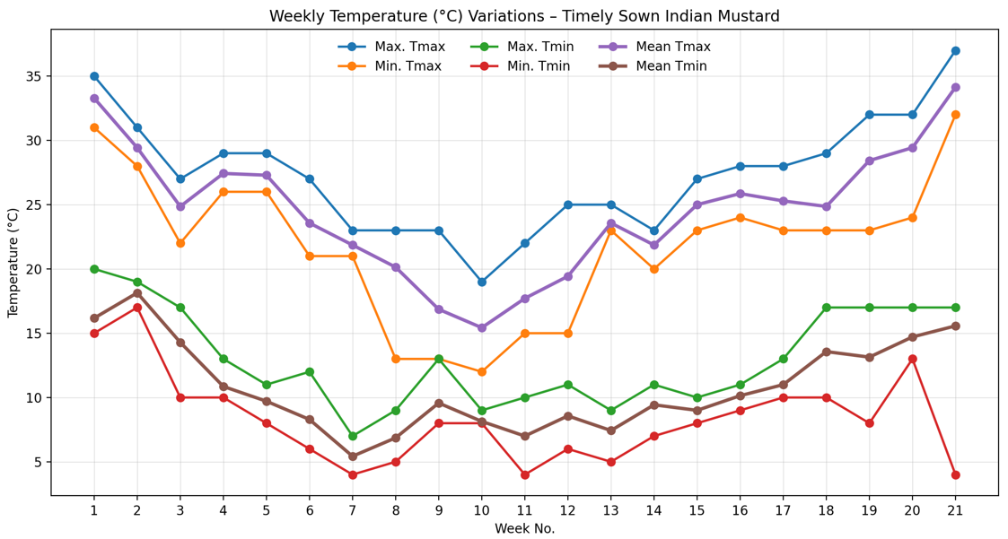
Fig. 1: The graph shows weekly variation in maximum, minimum, and mean temperature under timely-sowing environments.
On the other hand, temperature data analysis of late sowing also exhibited a different variation pattern. Ambient temperature decreased gradually from the germination stage to the vegetative stage, then increased slowly during stem elongation to the plant maturity stage. The peak maximum temperature during germination (week 1) was 29°C and decreased to 17°C by the vegetative stage (week 5), whereas the minimum temperature decreased on a similar pattern to 5°C. After the vegetative stage, a rise in both maximum and minimum temperatures was observed from the stem-elongation stage onward, leading toward terminal heat stress. The maximum temperature increased to 41°C, and the minimum temperature to 19°C by the maturity stage.

Table 3: Weekly Temperature (°C) Variations during the Growth and Development Stages of Late-Sown Indian Mustard (Brassica juncea)
Week No. | Date Range | Max. Tmax | Min. Tmax | Max. Tmin | Min. Tmin | Mean Tmax | Mean Tmin
1 | 30/11-6/12/2024 | 29 | 24 | 12 | 8 | 26.71 | 10.14
2 | 7-13/12/2024 | 24 | 21 | 8 | 5 | 22.00 | 6.71
3 | 14-20/12/2024 | 23 | 20 | 7 | 5 | 21.86 | 5.71
4 | 21-27/12/2024 | 23 | 13 | 9 | 5 | 19.43 | 7.43
5 | 28/12-03/01/2025 | 17 | 13 | 13 | 8 | 14.71 | 9.71
6 | 04-10/01/2025 | 19 | 12 | 9 | 4 | 16.00 | 7.29
7 | 11-17/01/2025 | 22 | 15 | 10 | 6 | 18.00 | 7.71
8 | 18-25/01/2025 | 25 | 16 | 11 | 8 | 22.29 | 9.14
9 | 26/01-01/02/2025 | 24 | 22 | 10 | 5 | 23.14 | 7.00
10 | 02-08/02/2025 | 23 | 20 | 11 | 8 | 22.00 | 9.71
11 | 09-15/02/2025 | 27 | 24 | 11 | 8 | 25.71 | 9.43
12 | 16-22/02/2025 | 28 | 23 | 13 | 9 | 26.14 | 10.71
13 | 23/02-01/03/2025 | 29 | 21 | 17 | 10 | 24.86 | 13.29
14 | 02-08/03/2025 | 29 | 23 | 13 | 8 | 25.57 | 11.00
15 | 09-15/03/2025 | 32 | 24 | 17 | 15 | 29.71 | 15.29
16 | 16-22/03/2025 | 34 | 29 | 17 | 12 | 31.29 | 14.43
17 | 23-29/03/2025 | 39 | 32 | 21 | 15 | 35.14 | 17.43
18 | 30/03-05/04/2025 | 39 | 30 | 19 | 14 | 35.00 | 15.71
19 | 06-12/04/2025 | 41 | 36 | 26 | 19 | 38.86 | 22.00
Source: https://www.accuweather.com/en/in/sherpur/3008767/weather-forecast/3008767

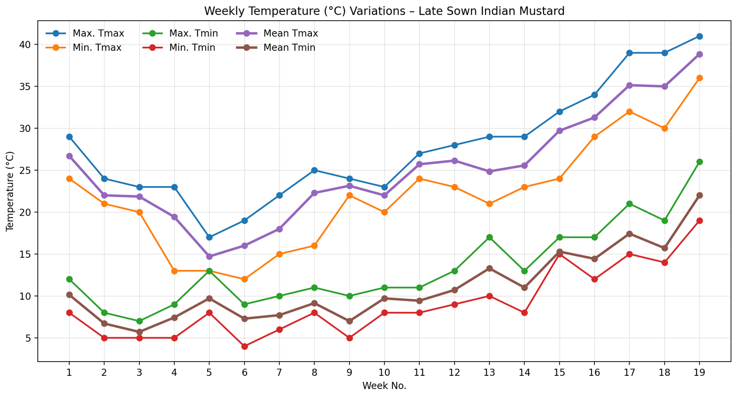
Fig. 2: The graph shows weekly variation in maximum, minimum, and mean temperature under late-sowing environments
Comparative temperature variation patterns between timely and late sown, timely sown Indian mustard exposed to higher temperatures in the early growth and development stages, and lower temperatures during subsequent stages, whereas late sown genotypes were exposed to lower temperatures initially, but significantly higher heat stress during terminal growth and development stages, such as reproductive and maturity stages.
Table 04: Temperature (°C) Variations Across Growth Stages of Timely and Late Sown Indian Mustard (Brassica juncea)
Growth Stages | Timely Sowing |  |  |  | Late Sowing
Growth Stages | Max. Tmax | Min. Tmax | Max. Tmin | Min. Tmin | Max. Tmax | Min. Tmax | Max. Tmin | Min. Tmin
Germination | 35 | 31 | 20 | 15 | 29 | 24 | 12 | 8
Seedling Stage | 31 | 28 | 19 | 17 | 24 | 21 | 8 | 5
Vegetative (Rosette) Stage | 29 | 22 | 17 | 8 | 23 | 12 | 13 | 4
Stem Elongation (Bolting) | 27 | 21 | 12 | 4 | 25 | 15 | 11 | 6
Flowering Stage | 23 | 12 | 13 | 4 | 27 | 20 | 11 | 5
Pod Formation | 25 | 15 | 11 | 5 | 28 | 23 | 13 | 9
Seed Filling Stage | 28 | 23 | 11 | 8 | 32 | 21 | 17 | 8
Physiological Maturity & Harvesting Stage | 37 | 23 | 17 | 4 | 41 | 29 | 26 | 14

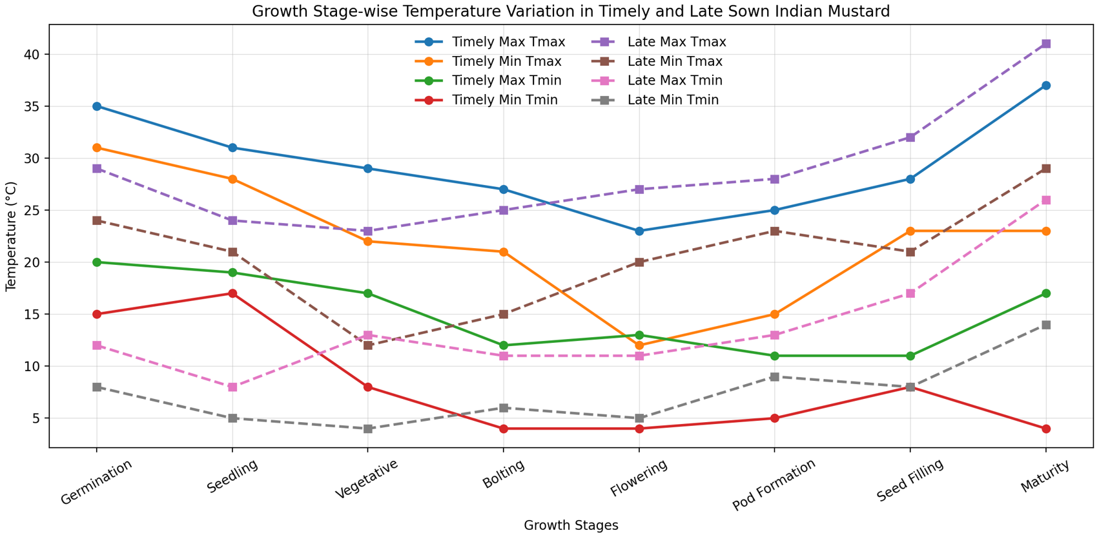
Fig. 3: The graph shows growth stage-wise variation in maximum, minimum, and mean temperature under timely and late-sowing environments

4.0 RESULT AND DISCUSSION
4.1 Variation in Oil Content Percentage under Timely and Late Sowing Environment
The oil content percentage of 30 genotypes of Indian mustard (Brassica juncea L.) was higher under timely sowing than late sowing. The mean value of oil content percentage reduced from 41.64 (timely sowing) to 38.18 (late sowing). The range of the maximum and minimum oil content percentages (41.17-42.27%) was very narrow with low CV (0.66), indicating consistent performance of genotypes under timely sowing. In a late-sowing environment, the range (36.30-41) was comparatively wider, even with a comparatively lower CV (0.14). Genotypes such as Varuna, RGN-48, RB-50, and Shivalik maintained relatively high oil content even under late-sowing conditions, indicating heat-stress tolerance.
Table 5: Variation in Oil Content Percentage under Timely and Late Sowing Environment
S. N | Genotypes | Oil Content %  (Timely Sowing) | Oil Content %  (Late Sowing)
1 | Arawali | 41.17 | 37.13
2 | BR-40 | 41.37 | 38.23
3 | CS-54 | 42.07 | 38.03
4 | CS-60 | 41.73 | 37.23
5 | Gujrat Mustard-2 | 41.17 | 36.83
6 | Geeta | 41.27 | 37.33
7 | JD-6 | 41.97 | 39.00
8 | Kanti | 41.73 | 38.23
9 | Krishna | 41.53 | 37.63
10 | Kranti | 41.80 | 38.50
11 | Maya | 42.13 | 38.60
12 | Pushabold | 41.53 | 39.30
13 | Pusa Mahak | 41.27 | 37.03
14 | Patan Mustard | 41.17 | 36.50
15 | PM-29 | 41.37 | 38.23
16 | PM-22 | 42.03 | 38.03
17 | PM-24 | 41.37 | 37.33
18 | PM-30 | 41.57 | 37.53
19 | Pusa Bahar | 41.27 | 38.13
20 | Pusa Vijay | 41.37 | 38.23
21 | RH-119 | 41.70 | 36.60
22 | RCC-4 | 41.60 | 37.53
23 | RGN-73 | 41.17 | 38.03
24 | RB-50 | 42.10 | 39.37
25 | RGN-48 | 42.27 | 40.00
26 | RH-406 | 42.07 | 38.70
27 | RH-1230 | 41.53 | 39.20
28 | Shivalik | 41.77 | 39.30
29 | Varuna | 42.23 | 41.00
30 | Vardan | 41.77 | 38.60
Mean |  | 41.64 | 38.18
Range |  | 41.17-42-27 | 36.50-41.00
CV |  | 0.66 | 0.14
CD (5%) |  | 0.45 | 0.09

4.2 ANOVA (Analysis of Variance)
All 23 traits of 30 genotypes of Indian mustard sown under a timely-sowing environment showed highly significant effects (p < 0.01) in the analysis of variance, indicating significant genetic variability among treatments. All morphological, phenological, yield, and physiological traits responded significantly to treatments. Most traits exhibited low replication effects and error variance, indicating good experimental precision. Overall, the analysis revealed sufficient variability for effective selection and yield improvement.
Table 6: Analysis of variance (ANOVA) of twenty-three traits of thirty genotypes of Indian mustard under timely sowing environments
S. N | Traits | Replicate (df=2) | Treatments (df=29) | Error (df=58)
1 | Height (cm) | 114.01 | 638.60** | 96.11
2 | Length of main shoot(cm) | 2.01 | 150.15** | 2.26
3 | Primary Branches (Nos.) | 5.34 | 2.15** | 2.23
4 | Secondary Branches (Nos.) | 1.01 | 2.69** | 1.41
5 | Silique/ Plant (Nos.) | 141.38 | 1216.33** | 0.23
6 | Silique o main shoot (Nos.) | 66.81 | 50.08** | 1.16
7 | Percent Survival @ 20 DAS | 806.04 | 549.11** | 152.80
8 | Percent Survival 30 DAS | 900.95 | 617.16** | 124.72
9 | Days to initial flowering (Nos.) | 38.54 | 37.71** | 1.12
10 | Days to 50% flowering (Nos.) | 40.88 | 39.41** | 0.92
11 | Days to Maturity (Nos.) | 35.34 | 20.71** | 0.64
12 | Seed/Silique (Nos.) | 12.14 | 4.97** | 1.18
13 | Oil Content (%) | 15.55 | 0.36** | 0.07
14 | Oil Yield (g)/Plant | 3.86 | 0.46** | 0.03
15 | 1000-Seed Weight(g) | 0.10 | 0.31** | 0.00
16 | Biologic Yield(g)/Plant | 237.47 | 117.54** | 67.94
17 | PELWL (%) | 0.92 | 9.18** | 0.00
18 | RWC (%) | 4.49 | 34.25** | 0.00
19 | Membrane Stability Index (MSI) | 4.92 | 39.10** | 0.00
20 | Leaf Area Index 30 DAS | 0.03 | 0.04** | 0.00
21 | Leaf Area Index 60 DAS | 0.28 | 0.56** | 0.00
22 | Leaf Area Index 90 DAS | 0.30 | 0.18** | 0.00
23 | Seed Yield(g)/ Plant | 13.14 | 6.09** | 8.34

Following the same pattern as in timely sowing, all 23 traits of 30 Indian mustard genotypes sown under a late-sowing environment also showed highly significant effects (p < 0.01) in the analysis of variance, indicating significant genetic variability among treatments. Also, all morphological, phenological, yield, and physiological traits responded significantly to treatments. Most traits exhibited low replication effects and error variance, indicating good experimental precision. Overall, the analysis revealed sufficient variability for effective selection and yield improvement.

Table 7: Analysis of variance (ANOVA) of twenty-three traits of thirty genotypes of Indian mustard under late sowing environments
S. N | Traits | Replicate (df=2) | Treatments (df=29) | Error (df=58)
1 | Height (cm) | 56.04 | 154.91** | 44.37
2 | Length of main shoot (cm) | 43.60 | 79.52** | 0.22
3 | Primary Branches (Nos.) | 0.21 | 2.65** | 2.13
4 | Secondary Branches (Nos.) | 0.54 | 2.15** | 1.44
5 | Silique/Plant (Nos.) | 192.68 | 2885.90** | 0.72
6 | Silique on main shoot (Nos.) | 87.30 | 65.73** | 0.90
7 | Percent Survival @ 20 DAS | 0.86 | 292.639** | 52.71
8 | Percent Survival 30 DAS | 26.76 | 198.63** | 67.14
9 | Days to initial flowering (Nos.) | 56.21 | 11.76** | 0.83
10 | Days to 50% flowering (Nos.) | 63.54 | 9.55** | 0.88
11 | Days to Maturity (Nos.) | 49.88 | 8.27** | 1.57
12 | Seed/Silique (Nos.) | 5.91 | 4.08** | 0.84
13 | Oil Content (%) | 3.31 | 3.17** | 0.00
14 | Oil Yield (g)/Plant | 1.86 | 0.30** | 0.06
15 | 1000-Seed Weight (g) | 0.10 | 0.27** | 0.00
16 | Biological Yield (g)/Plant | 321.09 | 52.06** | 44.69
17 | PELWL (%) | 0.83 | 12.83** | 0.00
18 | RWC (%) | 4.81 | 32.38** | 0.00
19 | Membrane Stability Index (MSI) | 3.78 | 15.20** | 0.00
20 | Leaf Area Index 30 DAS | 0.03 | 0.01** | 0.00
21 | Leaf Area Index 60 DAS | 0.21 | 0.32** | 0.00
22 | Leaf Area Index 90 DAS | 0.24 | 0.290** | 0.00
23 | Seed Yield (g)/Plant | 13.51 | 8.26** | 5.65

4.3 Genetic Variability Analysis
The genetic variability analysis of 23 traits across 30 genotypes of Indian mustard sown under a timely-sowing environment indicated higher PCV than GCV, indicating the significance of genetic factors and a minor environmental influence. Some traits like the length of main shoot, silique per plant, silique on main shoot, percent survival at 20 & 30 DAS, membrane stability index, leaf area index 30, 60 & 90 DAS exhibited high heritability along with genetic advance over the mean, indicating the role of additive action of gene and advantage of direct selection scope. Main yield-related traits, such as seed and oil yields, exhibited average heritability and genetic advance over the mean, indicating scope for improvement through selection. Another trait, such as primary & secondary branches, biological yield per plant, exhibited comparatively lower heritability and genetic advance over the mean, indicating significant environmental impact. The conclusion of the overall remarks mentioned above is that there are presence of significant genetic variability and a good scope for yield improvement through genetic selection, among 30 genotypes of Indian mustard sown under a timely sowing environment

Table 8: Genetic variability analysis of twenty-three traits of thirty genotypes of Indian mustard under timely sowing environments
Sl. No. | Traits | GCV | PCV | ECV | hBS | GAM
1 | Height (cm) | 10.8846 | 11.8096 | 7.94 | 84.95 | 20.6662
2 | Length of main shoot (cm) | 15.7506 | 15.8707 | 3.38 | 98.49 | 32.2008
3 | Primary Branches (Nos.) | 2.6164 | 13.9406 | 24.57 | 53.52 | 1.0116
4 | Secondary Branches (Nos.) | 8.4526 | 12.2659 | 15.40 | 47.49 | 11.9991
5 | Silique / Plant (Nos.) | 6.7976 | 6.7983 | 0.16 | 99.98 | 14.0018
6 | Silique on main shoot (Nos.) | 8.5942 | 8.6951 | 2.29 | 97.69 | 17.4986
7 | Percent Survival @ 20 DAS | 16.5423 | 19.4718 | 17.79 | 72.17 | 28.9503
8 | Percent Survival @ 30 DAS | 21.6338 | 24.219 | 18.86 | 79.79 | 39.8085
9 | Days to initial flowering (Nos.) | 8.3471 | 8.4738 | 2.53 | 97.03 | 16.938
10 | Days to 50% flowering (Nos.) | 7.3786 | 7.4666 | 1.98 | 97.66 | 15.0207
11 | Days to Maturity (Nos.) | 1.7353 | 1.7629 | 0.54 | 96.89 | 3.5188
12 | Seeds / Silique (Nos.) | 7.9172 | 9.0631 | 7.64 | 76.31 | 14.2473
13 | Oil Content (%) | 0.7514 | 0.8412 | 0.66 | 79.78 | 1.3826
14 | Oil Yield (g)/Plant | 4.7057 | 4.8408 | 1.97 | 94.49 | 9.4231
15 | 1000-Seed Weight (g) | 7.8295 | 7.8295 | 0.00 | 100.00 | 16.1287
16 | Biological Yield (g)/Plant | 7.1257 | 10.969 | 14.44 | 42.2 | 9.5358
17 | PELWL (%) | 8.9636 | 8.9647 | 0.25 | 99.97 | 18.4627
18 | RWC (%) | 3.7672 | 3.7673 | 0.05 | 100.00 | 7.7602
19 | Membrane Stability Index (MSI) | 23.1282 | 23.1284 | 0.15 | 100.00 | 47.6438
20 | Leaf Area Index 30 DAS | 13.7141 | 13.7147 | 0.21 | 99.99 | 28.2499
21 | Leaf Area Index 60 DAS | 12.1665 | 12.1668 | 0.16 | 99.99 | 25.0622
22 | Leaf Area Index 90 DAS | 5.3753 | 5.3753 | 0.00 | 100.00 | 11.0732
23 | Seed Yield (g)/Plant | 4.2968 | 7.0901 | 14.36 | 86.73 | 5.3643

The analysis of the genetic variability of 23 traits of 30 genotypes of Indian mustard sown under a late-sowing environment exhibited varying degrees of GCV and PCV. Traits such as silique per plant, membrane stability index, length of main shoot, and leaf area index exhibited high GCV and PCV, indicating significant variability. High heritability and genetic advance over the mean of the silique per plant, silique on main shoot, oil content, 1000-seed weight, PELWL, RWC, MSI, and leaf area index, suggesting the significance of additive gene action and good selection scope. Survival at 20 & 30 DAS and yield-related traits exhibited comparatively lower heritability and genetic advance over the mean. Biological and seed yield revealed low heritability and genetic advance over the mean, suggesting significant environmental influence.
Table 9: Genetic variability analysis of twenty-three traits of thirty genotypes of Indian mustard under late sowing environments
Sl. No. | Trait | GCV | PCV | ECV | hBS | GAM
1 | Height (cm) | 6.260 | 7.410 | 6.870 | 71.400 | 10.890
2 | Length of main shoot (cm) | 16.530 | 16.550 | 1.510 | 99.700 | 34.010
3 | Primary Branches (Nos.) | 10.130 | 22.870 | 35.510 | 19.600 | 9.250
4 | Secondary Branches (Nos.) | 6.800 | 11.810 | 16.720 | 33.100 | 8.060
5 | Silique / Plant (Nos.) | 21.060 | 21.060 | 0.580 | 99.970 | 43.380
6 | Silique on main shoot (Nos.) | 13.960 | 14.060 | 2.850 | 98.600 | 28.560
7 | Percent Survival @ 20 DAS | 15.650 | 17.280 | 12.700 | 82.000 | 29.190
8 | Percent Survival @ 30 DAS | 13.100 | 16.110 | 16.220 | 66.200 | 21.960
9 | Days to initial flowering (Nos.) | 5.420 | 5.630 | 2.590 | 92.900 | 10.770
10 | Days to 50% flowering (Nos.) | 4.210 | 4.420 | 2.320 | 90.800 | 8.270
11 | Days to Maturity (Nos.) | 1.110 | 1.230 | 0.930 | 81.100 | 2.060
12 | Seeds / Silique (Nos.) | 8.480 | 9.520 | 7.490 | 79.400 | 15.570
13 | Oil Content (%) | 2.690 | 2.700 | 0.140 | 99.900 | 5.550
14 | Oil Yield (g)/Plant | 8.460 | 9.530 | 7.580 | 78.900 | 15.490
15 | 1000-Seed Weight (g) | 7.900 | 7.900 | 0.000 | 100.000 | 16.270
16 | Biological Yield (g)/Plant | 4.350 | 11.550 | 18.540 | 14.200 | 3.370
17 | PELWL (%) | 9.460 | 9.460 | 0.140 | 99.990 | 19.480
18 | RWC (%) | 3.690 | 3.690 | 0.040 | 100.000 | 7.600
19 | Membrane Stability Index (MSI) | 20.940 | 20.940 | 0.440 | 99.990 | 43.120
20 | Leaf Area Index 30 DAS | 12.350 | 12.350 | 0.000 | 100.000 | 25.430
21 | Leaf Area Index 60 DAS | 12.140 | 12.140 | 0.110 | 100.000 | 25.000
22 | Leaf Area Index 90 DAS | 9.770 | 9.770 | 0.000 | 100.000 | 20.130
23 | Seed Yield (g)/Plant | 9.670 | 17.190 | 24.620 | 31.600 | 11.200

4.4 Genetic Diversity Analysis
4.4.1 Cluster Analysis
4.4.1.1 Cluster mean performance (Timely Sowing)
Cluster analysis of 30 genotypes of Indian mustard sown under a timely-sowing environment showed a significant variability among six clusters. The highest plant height, length of main shoot, 1000-seed weight, leaf area index (30, 60 & 90 DAS), and seed yield per plant were recorded in cluster V. Cluster VI showed the highest silique per plant, oil yield, days to first & fifty percent flowering, and maturity, but lower RWC and percent survival at 30 DAS. Cluster III showed the highest silique per plant, while cluster II exhibited a high percentage of survival at 20 & 30 DAS and a comparatively higher seed yield. In brief, Clusters V and II performed well in terms of yield improvement under timely sowing conditions.
4.4.1.2 Cluster mean performance (Late Sowing)
Cluster analysis of 30 Indian mustard genotypes sown under a late-sowing environment exhibited significant variability among six clusters. Cluster V showed the highest silique per plant, oil yield, biological yield, and seed yield per plant, as well as high RWC. Cluster VI showed the highest silique per plant and secondary branches, but lower seed yield and leaf area index. Cluster III showed the highest oil content, 1000-seed weight, percent survival, and membrane stability index. In brief, in a late-sowing environment, clusters V and III performed well in terms of yield improvement.
Table 10: Cluster mean performance for twenty-three traits of thirty genotypes of Indian mustard under timely sowing environments
Cluster | No of genotypes | Height (cm) | Length of main shoot(cm) | Primary Branches | Secondary Branches | Silique/ Plant | Silique of main shoot | Percent Survival @ 20 DAS | Percent Survival 30 DAS | Days to initial flowering | Days to 50% flowering | Days to Maturity | Seed/ Silique
1 | 5 | 117.467 | 44.267 | 5.933 | 7.467 | 268.933 | 43.800 | 54.889 | 46.223 | 41.667 | 48.667 | 148.133 | 15.800
2 | 5 | 119.733 | 39.467 | 6.667 | 8.200 | 276.133 | 43.400 | 82.221 | 72.444 | 40.667 | 46.533 | 148.867 | 15.000
3 | 9 | 117.111 | 42.926 | 5.667 | 7.926 | 311.556 | 49.704 | 67.777 | 58.519 | 43.593 | 50.519 | 149.333 | 13.741
4 | 7 | 129.143 | 47.619 | 6.238 | 7.619 | 299.000 | 47.143 | 77.619 | 66.190 | 39.524 | 45.857 | 149.381 | 13.190
5 | 2 | 166.167 | 57.000 | 5.833 | 7.833 | 309.500 | 48.333 | 77.223 | 71.665 | 40.000 | 48.000 | 149.500 | 13.500
6 | 2 | 115.000 | 42.500 | 6.500 | 6.500 | 322.167 | 49.833 | 45.555 | 24.998 | 47.333 | 54.333 | 149.000 | 14.667

Table 10. Continued ….
Cluster | No of genotypes | Oil Content (%) | Oil Yield (g)/Plant | 1000-Seed Weight(g) | Biologic Yield(g)/Plant | PELWL (%) | RWC (%) | Membrane Stability Index (MSI) | Leaf Area Index 30 DAS | Leaf Area Index 60 DAS | Leaf Area Index 90 DAS | Seed Yield(g)/ Plant
1 | 5 | 41.593 | 7.719 | 4.207 | 56.340 | 20.053 | 90.083 | 16.000 | 0.774 | 3.139 | 4.466 | 19.000
2 | 5 | 41.840 | 8.183 | 4.267 | 60.773 | 18.947 | 91.813 | 18.707 | 0.862 | 3.643 | 4.670 | 20.600
3 | 9 | 41.563 | 8.127 | 4.044 | 57.748 | 19.178 | 89.435 | 14.726 | 0.836 | 3.475 | 4.684 | 20.185
4 | 7 | 41.662 | 8.128 | 4.124 | 55.271 | 20.086 | 89.410 | 15.924 | 0.907 | 3.889 | 4.680 | 20.095
5 | 2 | 41.633 | 8.350 | 4.617 | 54.817 | 17.983 | 90.667 | 10.333 | 0.965 | 3.890 | 4.990 | 21.500
6 | 2 | 41.467 | 8.453 | 3.817 | 55.083 | 20.683 | 84.725 | 15.050 | 0.835 | 3.387 | 4.730 | 20.000
Table 11: Cluster mean performance for twenty-three traits of thirty genotypes of Indian mustard under late sowing environments
Cluster | No of genotypes | Height (cm) | Length of main shoot(cm) | Primary Branches | Secondary Branches | Silique/ Plant | Silique of main shoot | Percent Survival @ 20 DAS | Percent Survival 30 DAS | Days to initial flowering | Days to 50% flowering | Days to Maturity | Seed/ Silique
1 | 8 | 94.67 | 28.38 | 4.58 | 6.83 | 125.00 | 32.92 | 48.47 | 43.89 | 34.67 | 40.00 | 134.54 | 12.21
2 | 7 | 94.43 | 30.81 | 3.52 | 7.24 | 136.05 | 32.76 | 59.52 | 51.43 | 35.90 | 40.57 | 134.71 | 12.33
3 | 2 | 100.83 | 31.50 | 5.17 | 7.50 | 95.50 | 20.17 | 70.56 | 63.89 | 35.00 | 40.67 | 134.83 | 12.50
4 | 8 | 96.50 | 31.04 | 4.21 | 7.04 | 161.54 | 34.63 | 60.56 | 53.89 | 35.46 | 40.96 | 135.67 | 12.17
5 | 4 | 104.00 | 37.25 | 3.50 | 7.67 | 185.50 | 37.75 | 58.33 | 50.28 | 34.92 | 39.67 | 133.42 | 12.67
6 | 1 | 101.33 | 30.00 | 4.00 | 8.00 | 239.67 | 38.00 | 51.11 | 44.44 | 33.67 | 39.67 | 134.67 | 10.67

Table 11. Continued….
Cluster | No of genotypes | Oil Content (%) | Oil Yield (g)/Plant | 1000-Seed Weight(g) | Biologic Yield(g)/Plant | PELWL (%) | RWC (%) | Membrane Stability Index (MSI) | Leaf Area Index 30 DAS | Leaf Area Index 60 DAS | Leaf Area Index 90 DAS | Seed Yield(g)/ Plant
1 | 8 | 38.61 | 3.28 | 3.94 | 36.39 | 22.15 | 89.74 | 10.53 | 0.57 | 2.81 | 3.28 | 9.83
2 | 7 | 37.75 | 3.30 | 3.90 | 35.91 | 22.24 | 87.63 | 10.79 | 0.50 | 2.57 | 3.09 | 9.48
3 | 2 | 39.75 | 2.98 | 4.32 | 30.38 | 19.18 | 90.47 | 15.32 | 0.54 | 2.86 | 3.25 | 7.33
4 | 8 | 37.99 | 3.42 | 3.65 | 36.14 | 21.34 | 88.33 | 10.06 | 0.53 | 2.72 | 3.06 | 9.42
5 | 4 | 37.88 | 3.57 | 3.69 | 37.91 | 22.81 | 90.87 | 10.28 | 0.56 | 2.89 | 3.47 | 11.08
6 | 1 | 37.33 | 3.63 | 3.87 | 37.73 | 23.00 | 87.60 | 10.63 | 0.47 | 1.99 | 2.80 | 10.33

4.4.2 Intra- and Inter-Cluster Distances
4.4.2.1 Intra- and Inter-Cluster Distances under Timely Sowing Environments
Cluster II exhibited the lowest intra-cluster distance, indicating high similarity among genotypes within the cluster, whereas cluster VI showed the highest intra-cluster distance, suggesting high variability among genotypes within the cluster. In terms of inter-cluster distance, high divergence was observed between clusters V & VI, followed by clusters II & VI, indicating the cluster pairs are highly divergent genetically and suitable for interbreeding.
Table 12: Intra- and Inter-Cluster Distances under Timely Sowing Environments
 | Cluster1 | Cluster2 | Cluster3 | Cluster4 | Cluster5 | Cluster6
Cluster1 | 22.45
Cluster2 | 39.46 | 16.76
Cluster3 | 46.80 | 42.12 | 26.87
Cluster4 | 44.75 | 28.35 | 23.11 | 24.92
Cluster5 | 73.51 | 61.17 | 54.09 | 40.57 | 29.65
Cluster6 | 59.31 | 77.43 | 42.41 | 60.46 | 79.61 | 32.36

Table 13: Most and Least Representative Genotypes under Timely Sowing Environment
Clusters No. | Most Representative Genotypes | Least Representative Genotypes
Cluster1 | RGN-48 | Krishna
Cluster2 | Kranti | Varuna
Cluster3 | PM-30 | CS-54
Cluster4 | Pushabold | RCC-4
Cluster5 | RGN-73 | RGN-73
Cluster6 | Gujrat Mustard-2 | Kranti

4.4.2.2 Intra- and Inter-Cluster Distances under Late Sowing Environments
Clusters II & IV exhibited the lowest intra-cluster distance, indicating high similarity among genotypes within the cluster, whereas cluster VI showed the highest intra-cluster distance, suggesting high variability among genotypes within the cluster. In terms of inter-cluster distance, high divergence was observed between clusters III & VI, followed by clusters II & VI and clusters I & VI, indicating the cluster pairs are highly divergent genetically and suitable for interbreeding.
Table 14: Intra- and Inter-Cluster Distances under Late Sowing Environments
 | Cluster1 | Cluster2 | Cluster3 | Cluster4 | Cluster5 | Cluster6
Cluster1 | 0
Cluster2 | 17.77 | 12.56
Cluster3 | 45.23 | 46.93 | 16.76
Cluster4 | 40.02 | 25.86 | 69.78 | 11.87
Cluster5 | 63.23 | 51.26 | 94.37 | 26.82 | 18.23
Cluster6 | 115.08 | 104.63 | 148.27 | 79.59 | 55.68 | 22.54

Table 15: Most and Least Representative Genotypes under Late Sowing Environment
Clusters No. | Most Representative Genotypes | Least Representative Genotypes
Cluster1 | RH-1230 | Shivalik
Cluster2 | BR-40 | Pushabold
Cluster3 | Kranti | Kranti
Cluster4 | Maya | Pusa Bahar
Cluster5 | PM-22 | Kanti
Cluster6 | Geeta | Geeta

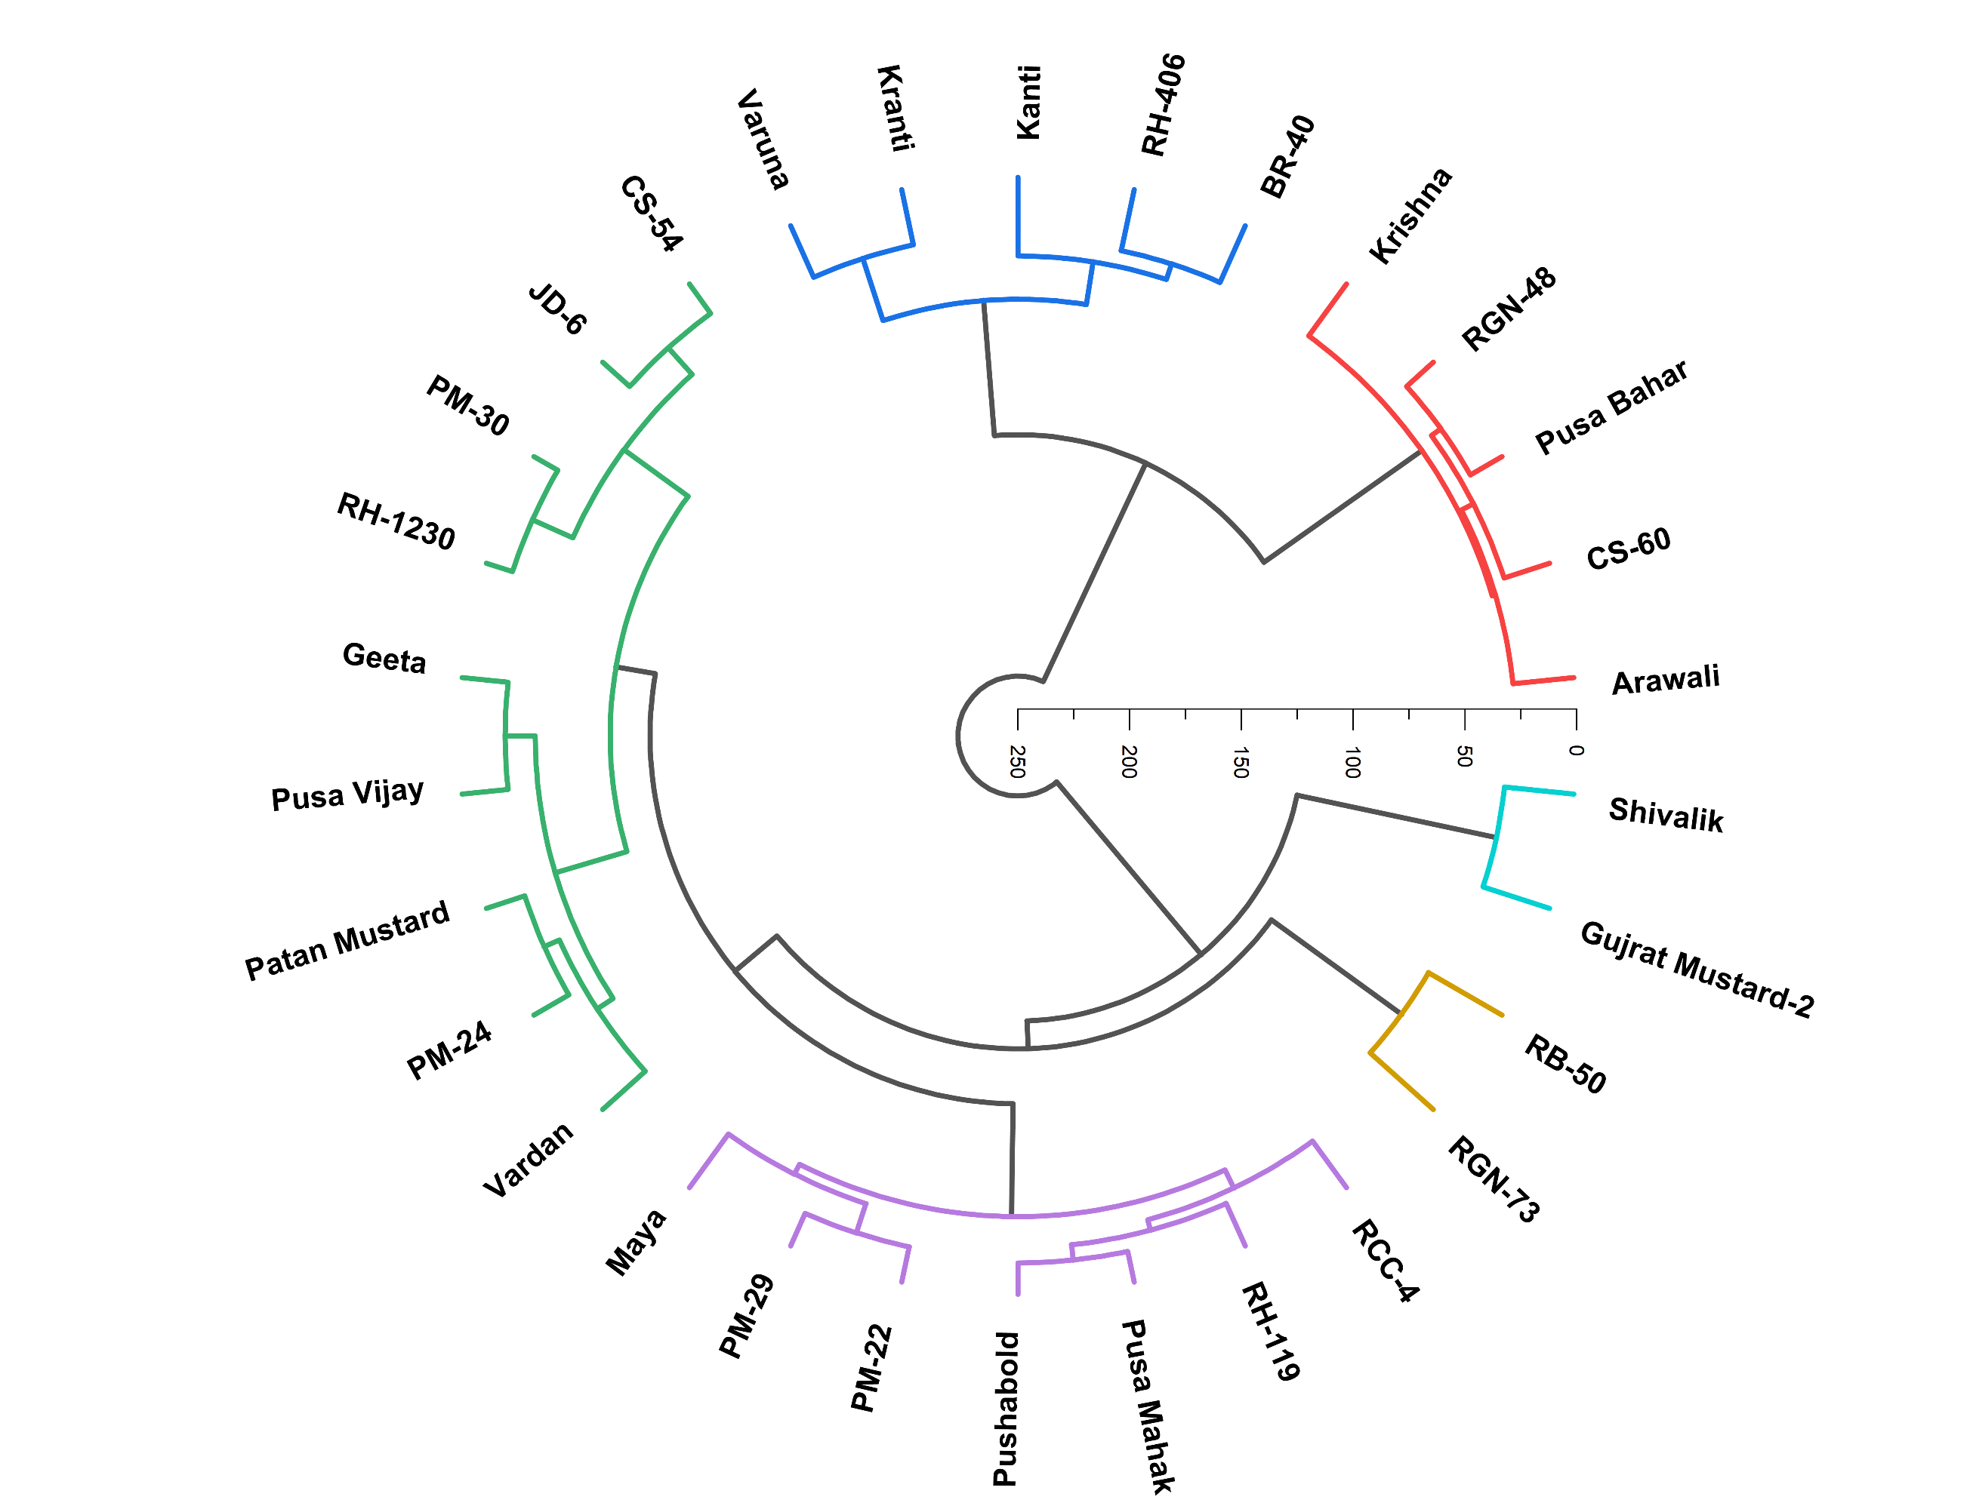
Fig.4: The dendrogram showed genetic divergence among genotypes of Indian mustard sown under a timely sowing environment. Genotypes were grouped into clusters based on various traits, in which genotypes within a cluster exhibit genetic similarity, whereas inter-cluster genotypes exhibit high genetic divergence. Gujrat Mustard-2, RGN-73, Pusabold, and Kranti are placed in distant clusters, indicating their importance as diverse parents in interbreeding programs.

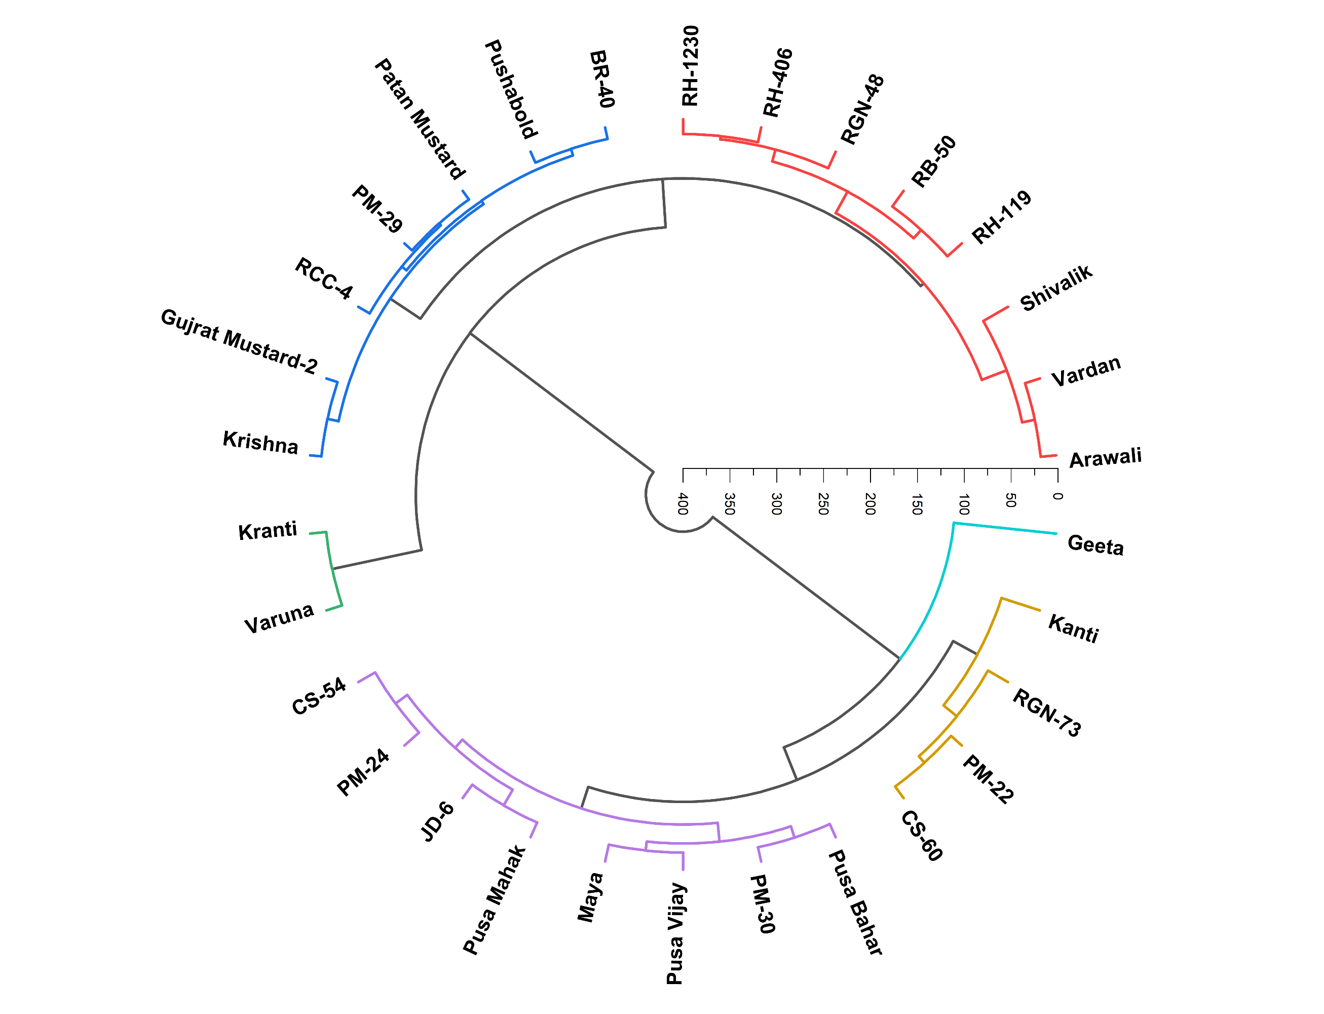
Fig. 5: The dendrogram showed genetic divergence among genotypes of Indian mustard sown under a late sowing environment. Genotypes were grouped into clusters based on various traits, in which genotypes within a cluster exhibit genetic similarity, whereas inter-cluster genotypes exhibit high genetic divergence. Aravali, Shivalik, RGN-73, Kanti, Gujrat Mustard-2, and Varuna are placed in distant clusters, indicating their importance as diverse parents in interbreeding programs.

5.0 CONCLUSION
The present study exhibited significant genetic variability and diversity among 30 genotypes of Indian mustard (Brassica juncea L.), studied under timely (30th October 2024) and late (30th November 2024) sowing environments in Doon Valley. Both sowing environments present distinct temperature patterns at various stages of growth and development of crops. Timely sown crops were exposed to a comparatively cooler climate in later stages of growth and development, whereas late-sown crops were exposed to terminal heat stress (up to ~41°C at the maturity stage).
The oil content percentage of 30 genotypes of Indian mustard (Brassica juncea L.) was higher under timely sowing than late sowing. Genotypes such as Varuna, RGN-48, RB-50, and Shivalik maintained relatively high oil content even under late-sowing conditions, indicating heat-stress tolerance.
All 23 traits of 30 genotypes of Indian mustard sown under timely and late-sowing environments showed highly significant effects (p < 0.01) in the analysis of variance, indicating significant genetic variability among treatments. All morphological, phenological, yield, and physiological traits responded significantly to treatments. Most traits exhibited low replication effects and error variance, indicating good experimental precision. Overall, the analysis revealed sufficient variability for effective selection and yield improvement.
The genetic variability analysis of 23 traits across 30 genotypes of Indian mustard sown under timely and late-sowing environments showed higher PCV than GCV, indicating the significance of genetic factors and environmental influences. In a timely sowing environment, traits like the length of main shoot, silique per plant, silique on main shoot, percent survival 20 & 30 DAS, membrane stability index, leaf area index 30, 60 & 90 DAS and, in late sowing environment silique per plant, silique on main shoot, oil content, 1000-seed weight, PELWL, RWC, MSI, and leaf area index exhibited high heritability along with genetic advance over the mean, indicating the role of additive action of gene and advantage of direct selection scope
Genetic diversity analysis was performed by clustering 30 genotypes into 6 groups to emphasize genetic diversity. Under timely-sowing environments, clusters V and II, and under late-sowing environments, clusters V and III performed well in terms of yield improvement. Under timely sowing, cluster II, and under late sowing, clusters II & IV exhibited the lowest intra-cluster distances, indicating high similarity among genotypes within the cluster. Cluster VI showed the highest intra-cluster distance under a timely-sowing environment, and cluster VI under a late-sowing environment, suggesting high variability among genotypes within the cluster. Analysis of inter-cluster distance under timely sowing showed high divergence between clusters V & VI, followed by clusters II & VI, whereas under late sowing, the divergence was between clusters III & VI, followed by clusters II & VI and clusters I & VI, suggesting suitability for interbreeding.
Overall, the conclusion was that a timely sowing environment is more favourable for growth & development and for yield performance, whereas a late-sowing environment is associated with terminal heat stress, which adversely affects overall crop performance.

REFERENCES
A., Kumar, V., & Nagarjun, P. (2025). Unlocking the Genetic Potential of Indian Mustard (Brassica juncea L.): A Review on Advances in Breeding Approaches. Agricultural Science Digest - A Research Journal. https://doi.org/10.18805/ag.d-6254
Choudhary, R., Singh, J., Barela, A., Patel, T., & Yadav, P. K. (2025). Assessment of Genetic Variability and Heritability in Indian Mustard (Brassica juncea L.) Genotypes. Journal of Advances in Biology & Biotechnology, 28(7), 436–443. https://doi.org/10.9734/jabb/2025/v28i72562
Pandey, B., Yadav, R., Ramawat, N., Vishwakarma, H., & Pandey, S. (2024). Optimization of sowing dates in Indian mustard (Brassica juncea L.) to combat yield losses caused by high temperature at reproductive stage. Plant Science Today, 11(1), 81–92. https://doi.org/10.14719/pst.2605
Perween, S., Kumar, A., Chakraborty, M., Ahmad, E., Mahto, C., & Barnwal, M. (2024). Assessment of Genetic Variability and Diversity in Indian Mustard (Brassica juncea L.) under Timely and Late Sown Conditions. Journal of Advances in Biology & Biotechnology, 27(10), 331–341. https://doi.org/10.9734/jabb/2024/v27i101457
Bhandari, D., & Singh, A. (2023). Genetic Divergence in Leafy Mustard (Brassica juncea var. rugosa) Germplasm Grown under Tarai Condition of Uttarakhand. Indian Journal of Agricultural Research, 57(4), 448–452. https://doi.org/10.18805/IJARe.A-5795
Gupta, A., Chauhan, S., Tyagi, S. D., & Singh, S. (2023). Genetic Variability, Heritability, Genetic Advance and Cluster Analysis in Indian Mustard (Brassica juncea L. Czern & Coss.) Under Timely and Late Sown Conditions. International Journal of Plant & Soil Science, 35(19), 292–301. https://doi.org/10.9734/ijpss/2023/v35i193554
Gupta, D., Punia, S., Gothwal, D., Ram, M., Mittal, G., & Kumar, A. (2023). Evaluation of Heat Tolerance Genotypes in Indian Mustard [Brassica juncea (L.) Czern & Coss] based on Heat Susceptibility Index. Biological Forum-An International Journal, 15(11), 230.
Pandey, A., Rahangdale, P., Singh Gaur, R., Singh, B., & Professor, A. (2521). RESEARCH ON GENETIC VARIABILITY IN INDIAN MUSTARD [BRASSICA JUNCEA] YIELD AND RELATED FEATURES. Www.Irjmets.Com @International Research Journal of Modernization in Engineering. www.irjmets.com
Chugh, P., Sharma, P., Sharma, R., & Singh, M. (2022a). Study on heat stress indices and their correlation with yield in Indian mustard genotypes under diverse conditions. Indian Journal of Genetics and Plant Breeding, 82(2), 186–192. https://doi.org/10.31742/IJGPB.82.2.7
Kannaujiya, T., KUMAR Chaudhary, A., Nath, S., Mishra, G., Kumar Chaudhary, A., Gupta, R., Kumar Gupta, A., & Vimal, S. (2022a). Genetic Diversity Analysis in Indian Mustard [Brassica juncea (L.) Czern and Coss.] Genotypes. Biological Forum-An International Journal, 14(2), 1571–1574. https://www.researchgate.net/publication/362162861
Sehgal, A., Reddy, K. R., Walne, C. H., Barickman, T. C., Brazel, S., Chastain, D., & Gao, W. (2022a). Individual and Interactive Effects of Multiple Abiotic Stress Treatments on Early-Season Growth and Development of Two Brassica Species. Agriculture (Switzerland), 12(4). https://doi.org/10.3390/agriculture12040453
Patel, P. B., Patel, P. J., Patel, J. R., & Patel, P. C. (2021). Elucidation of genetic variability and inter-relationship studies for seed yield and quality traits in Indian mustard [Brassica juncea (L.) Czern and Coss]. Electronic Journal of Plant Breeding, 12(2), 589–596. https://doi.org/10.37992/2021.1202.083
Dwivedi, S., & Mishra, R. (2020a). Study of Yield Contributing Characters of Mustard. International Journal of Current Microbiology and Applied Sciences, 9(10), 2503–2510. https://doi.org/10.20546/ijcmas.2020.910.300
OP, P., DK, Y., N, Singh, N, Saini, S, V., & . Y. (2020). Deciphering selection criteria for Indian mustard (Brassica juncea L.) encountering high-temperature stress during post-reproductive phase. International Journal of Chemical Studies, 8(4), 2497–2502. https://doi.org/10.22271/chemi.2020.v8.i4ac.10007
Kumar, A. (2018). Effect of Different Sowing Dates on Yield and Yield Attributes of Indian Mustard (Brassica juncea L.) Genotypes. International Journal of Pure & Applied Bioscience, 6(2), 848–853. https://doi.org/10.18782/2320-7051.6264
Kumari, A., & Kumari, V. (2018). Genetic Variability and Divergence Studies for Seed Yield and Component Characters in Indian Mustard [Brassica juncea (l.) Czern. & coss.] Over Environments. International Journal of Current Microbiology and Applied Sciences, 7(07), 3376–3388. https://doi.org/10.20546/ijcmas.2018.707.393
Sharma, D., Nanjundan, J., Singh, L., Singh, S. P., Parmar, N., Sujith Kumar, M. S., Singh, K. H., Mishra, A. K., Singh, R., Verma, K. S., & Thakur, A. K. (2020). Genetic diversity in leafy mustard (Brassica juncea var. rugosa) as revealed by agro-morphological traits and SSR markers. Physiology and Molecular Biology of Plants, 26(10), 2005–2018. https://doi.org/10.1007/s12298-020-00883-2
Sree, P. R. (2022). A review on impacts of high temperature stress on Indian mustard (Brassica juncea). www.botanyjournals.com
Ram, B., Singh, V. v, Singh, B. K., Kumar, A., & Singh, D. (2015). COMPARATIVE TOLERANCE AND SENSITIVE RESPONSE OF INDIAN MUSTARD (Brassica juncea L. Czern and Coss) GENOTYPES TO HIGH TEMPERATURE STRESS. In SABRAO Journal of Breeding and Genetics (Vol. 47, Issue 3).
Saleem, N., Ahmad Jan, S., Jawaad Atif, M., Khurshid, H., Ali Khan, S., Abdullah, M., Jahanzaib, M., Ahmed, H., Ullah, S. F., Iqbal, A., Naqi, S., Ilyas, M., Ali, N., & Rabbani, M. A. (2017). Multivariate Based Variability within Diverse Indian Mustard (&lt;i&gt;Brassica juncea&lt;/i&gt; L.) Genotypes. Open Journal of Genetics, 07(02), 69–83. https://doi.org/10.4236/ojgen.2017.72007
Singh, R., Singh, Y., & Singh, S. (2017). Yield, quality and nutrient uptake of Indian mustard (Brassica juncea) under sulphur and boron nutrition. In Annals of Plant and Soil Research (Vol. 19, Issue 2).
Prasad Scholar, G., Prasad, G., & Patil, B. (2018). Genetic variability and heritability studies for yield and attributes in Indian mustard. ~ 519 ~ Journal of Pharmacognosy and Phytochemistry, 7(5), 519–522.
Singh, S., Dwivedi, A. K., tosh, A., Kumar, O., & Kumar, K. (2018a). Genetic Divergence Analysis in Indian mustard (Brassica juncea L.). International Journal of Current Microbiology and Applied Sciences, 7(06), 2496–2503. https://doi.org/10.20546/ijcmas.2018.706.296
Singh, V. V., Garg, P., Meena, M. L., Meena, H. S., medha, P., Kumar, A., & Rai, P. K. (2018). Evaluation and Identification of Promising Lines for Rain Fed Conditions in Indian mustard (Brassica juncea L.). International Journal of Current Microbiology and Applied Sciences, 7(12), 3590–3597. https://doi.org/10.20546/ijcmas.2018.712.406
Studies on genetic diversity in Indian mustard (Brassica Juncea Czern & Coss) for morphological characters under changed climate in the mid-hills of Himalayas. (2018a). The Pharma Innovation Journal, 7(7), 290–296. www.thepharmajournal.com
Studies on genetic diversity in Indian mustard (Brassica Juncea Czern & Coss) for morphological characters under changed climate in the mid-hills of Himalayas. (2018b). The Pharma Innovation Journal, 7(7), 290–296. www.thepharmajournal.com
Godara, O., Singh, A., Choudhary, S., Fagodiya, R. K., & Kakraliya, B. L. (2017). Membrane stability index of Indian mustard (Brassica juncea L Czern & Coss). ~ 1067 ~ International Journal of Chemical Studies, 5(4).
Sharma, P., & Sardana, V. (2014). Screening of Indian mustard (Brassica juncea) for thermo tolerance at seedling and terminal stages. In Journal of Oilseed Brassica (Vol. 5).
Singh, M., Rathore, S. S., & Raja, P. (2014). Physiological and Stress Studies of Different Rapeseed-Mustard Genotypes Under Terminal Heat Stress. In International Journal of Genetic Engineering and Biotechnology. ISSN 0974 (Vol. 3073, Issue 2). http://www.irphouse.com
Ram, B., Meena, H. S., Singh, V. v, Singh, B. K., Nanjundan, J., Kumar, A., Singh, S. P., Bhogal, N. S., & Singh, D. (2014a). High temperature stress tolerance in Indian mustard (Brassica juncea) germplasm as evaluated by membrane stability index and excised-leaf water loss techniques. In Journal of Oilseed Brassica (Vol. 5, Issue 2).
Meena, D. R., Chauhan, J. S., Singh, M., Singh, K. H., & Meena, M. L. (2013). Genetic variation and correlations among physiological characters in Indian mustard (Brassica juncea L.) under high temperature stress. Indian Journal of Genetics and Plant Breeding, 73(1), 101–104. https://doi.org/10.5958/j.0019-5200.73.1.015
Roy, S. K., Haque, S., Kale, V. A., Asabe, D. S., & Dash, S. (2011). Variability and character association studies in rapeseed-mustard (Brassica sp.) 1 1 2. In Journal of Crop and Weed (Vol. 7, Issue 2).

