Exploring Allelic Variation between Rice Parental Lines via SSR-Based Genotyping

Abstract
Rice is a fundamental staple crop, and its long-term viability is challenged by climate change-driven water scarcity and yield stagnation. Conventional breeding strategies are often limited by the low heritability of grain yield under moisture stress, necessitating the integration of molecular markers to enhance selection efficiency. This study performed a systematic genomic studies of two contrasting parental lines, HUR-917 (recurrent parent) and IR18A1145 (drought-tolerant donor), to identify informative allelic variations. A 100% amplification efficiency and 158 polymorphic markers, or a 25.68% polymorphism rate, were identified during the study by examining 584 SSR markers scattered over the 12 rice chromosomes. Notably, chromosome 3 provided the highest absolute number of polymorphic loci (18), including markers near the critical qDTY_{3.2} region. Chromosome 8 exhibited the highest polymorphism frequency at 32.65%. The codominant nature of these identified SSRs enables precise differentiation between homozygous and heterozygous states, facilitating rapid Recurrent Parent Genome Recovery. These findings establish a robust molecular framework for marker-assisted backcrossing (MABC) and the targeted introgression of drought-resilient QTLs such as DRO1 and qDTY_{12.1}. This research provides a critical genomic foundation for developing high-yielding, stable rice varieties suited for future water-limited agricultural environments.
Keywords: Drought tolerance, SSR markers, Parental polymorphism, Rice (Oryza sativa), Marker-assisted breeding
Introduction
Many people indulge in rice as a staple diet, which gives households, especially those from an underprivileged background, the vital nutrition they need. To sustain human nutrition, provide food security, and contribute to global food and nutritional security, it is essential. To meet the dietary needs of a diversified and climate-risked population, it is necessary to design a single rice grain variety that can satisfy a range of dietary and nutritional requirements (Alam et al., 2024). Despite rice is an essential diet for millions of households worldwide, its long-term viability is in risk on account of spectrum factors, including the rapid changing climate, the growing water crisis, the low nutrient application efficiency, the lack of labour, the rise in methane emissions, the stagnation of yields, and the detrimental effects of rice crops on the soil environment in post-rice crops (Nawaz et al., 2022). Rice farming has always been largely dependent on ample water supplies, notably in lowland irrigated systems. Future rice production depends heavily on water-limited habitats, such as rainfed lowland and upland environments, due to rising rivalry for freshwater, climate change-driven rainfall variability, and an upsurge of drought-prone areas (Swami et al., 2012). The rising amount of greenhouse gases in the atmosphere is expected to cause a 1.4–5.8°C increase in the global mean air temperature between 1990 and 2100. According to due diligence, the sea level may increase by one meter or more in the twenty-first century, which would negatively impact one billion people by the year 2050 (Fahad et al., 2019).
Rice is extremely vulnerable to water stress. Efforts to produce rice with less water may result in lower yields (Tuong & Bouman, 2003). Rice production becomes progressively constrained by a growing shortage of moisture brought on by climate change, depleting groundwater supplies, and conflicting demands from the urban and industrial sectors (Serraj et al., 2011). Improving rice productivity in water-limited environments is a strategic priority, as these systems occupy a large proportion of rice-growing areas but consistently produce lower yields due to water stress (Hussain et al., 2022). Sustainable yield increases must originate from improved adaptation to water shortage instead of gaining from greater water inputs, because there is limited opportunity for greater irrigation. Recent studies demonstrate that increasing rice yield in water-limited environments can be accomplished by combining drought-tolerant cultivars with effective nutrition and water management, offering a viable pathway for sustaining rice production in a hotter and drier future (Cheng et al., 2025).
Conventional breeding has historically relied on phenotypic selection (PS) to identify drought-tolerant cultivars. This approach is often limited by its intensive labour requirements and low selection efficiency (Mapari et al., 2024). Because drought tolerance is a complex, polygenic mechanism regulated by hundreds of genes and extensive physiological pathways, concentrating solely on physical features provides substantial barriers (Guadarrama‐Escobar et al., 2024). A primary limitation of phenotypic selection is the low heritability of grain yield under moisture stress, coupled with high genotype-by-environment (GxE) interactions that make visual assessments unreliable across varying field conditions. The assessment of stable tolerance traits in the field is challenged by the regional variety of soil factors and the erratic nature of climatic drought restrict precision phenotyping in the field (Anilkumar et al., 2023). The capacity to maximize output in a number of backdrops may be limited when phenotypic selection alone unintentionally favours drought avoidance strategies like early blooming over true physiological tolerance (Guadarrama‐Escobar et al., 2024). The time-consuming nature of traditional selection also prevents the rapid development of varieties needed to keep pace with global food demand.
To overcome these constraints, the integration of molecular markers has revolutionized crop improvement strategies. The integration of molecular markers into breeding programs expedites the genotype screening process and significantly reduces the time needed to achieve genetic gains (Rezk et al., 2024). Genetic discoveries that reveal precise genes linked to significant traits enable targeted breeding efforts (Singha et al., 2024). These tools are essential for diverse applications, including genome mapping, varietal fingerprinting, and the assessment of genetic diversity within populations (Mondal et al., 2014). By providing a more precise and reliable measure of genetic relationships than phenotypic data alone, molecular markers enable breeders to select diverse parental lines with greater accuracy, which is a prerequisite for effective hybrid breeding and successful gene introgression (Naaz et al., 2022). Marker-assisted selection (MAS) using Simple Sequence Repeat (SSR) markers provides a high-precision alternative, enabling breeders to identify desirable allelic variations as early as the seed or seedling stage, regardless of environmental stressors (Mapari et al., 2024). SSRs, also known as microsatellites, are among the most popular and reliable molecular markers used in rice research, consisting of short DNA motifs, typically 1–6 base pairs long, that are repeated in tandem and distributed densely throughout the eukaryotic genome (Rahman et al., 2012). SSR markers are particularly valued for their high polymorphism and reliability in distinguishing genetic variants between parental lines (Styer et al., 2024). The co-dominant nature of SSRs enables the detection of both alleles at a specific locus, allowing for the clear differentiation between homozygous and heterozygous individuals (Gonzaga et al., 2015). SSRs provide consistent results across different laboratory settings and experimental trials, making them a robust tool for universal data storage and comparison (Nivedita et al., 2024). By exploring allelic variation via SSR-based genotyping, researchers can identify specific quantitative trait loci (QTLs) for grain yield under drought (qDTYs), bridging the performance gap left by phenotypic selection alone (Bordeos et al., 2025). The high degree of allelic variance provides superior informative power, allowing for the precise identification of unique varieties and the establishment of fine-scale pedigree relationships even with a relatively small number of markers (Gaballah et al., 2021). This study seeks to characterize the allelic diversity within key rice parental lines, providing a genomic foundation for the development of stable, drought-resilient varieties suited for future agricultural challenges.
The parental polymorphism survey serves as the foundational genomic audit in MAS and QTL introgression programs for rice. It entails evaluating potential parent lines using a wide range of molecular markers, such as SSRs or SNPs, to detect unique DNA variants at particular loci (Gull et al., 2025). The systematic identification of allelic variations is essential for monitoring the inheritance of specific traits and concurrently recovering the genetic background of the elite recurrent parent. The main aim of a polymorphism survey is to establish a molecular framework that distinguishes the donor parent (DP) from the recurrent parent (RP) throughout the 12 rice chromosomes (Badri et al., 2022). Contemporary breeding frequently entails the examination of numerous markers; for example, an analysis of 651 SSR markers may indicate a variety of roughly 17.4% between progenitors, yielding a selection of polymorphic markers for subsequent evaluation (Badri et al., 2022).
Polymorphism confirmation is critical because MAS relies entirely on the statistical association between a molecular marker and a phenotypic trait (Sharma et al., 2025). A marker is ineffective for differentiating between the donor and recurrent alleles in segregating populations if it is monomorphic (Ray et al., 2025). Parental polymorphism provides information on i) Differentiating Genotypes ii) Gene Pyramiding Accuracy iv) Quickening Recurrent Parent Genome (RPG) Recuperation iv) Elimination of linkage Drag.
The genetic architecture, physiological responses, and breeding usefulness of drought-tolerant donor genotypes and elite sensitive cultivars are essentially different. Under ideal or high-input conditions, elite susceptible cultivars usually evolve by intense selection for high yield, uniformity, and market-preferred traits. This frequently leads to decreased genetic diversity for stress-adaptive traits and increased sensitivity to water deficit; during drought, they typically display shallow root systems, limited osmotic adjustment, impaired stomatal regulation, accelerated senescence, and significant yield penalties because of disrupted photosynthesis and reproductive failure (Dos Santos et al., 2022). On the other hand, drought-tolerant donors, typically landraces, wild relatives, or stress-adapted lines, are distinguished by their larger and deeper root systems, improved water-use efficiency, osmoprotectant accumulation, enhanced antioxidant defence mechanisms, and activation of stress-responsive regulatory networks, which allow for better maintenance of growth and yield in water-limited environments (Kumari et al., 2021). Modern climate-resilient crop development is supported by the intentional combination of drought-tolerant donors, which offer the genetic foundation for resilience under moisture stress, and elite sensitive cultivars, which collectively represent high productivity under favourable settings (Farooq et al., 2024). The objective of this study is to detect and quantify allelic variation between two contrasting rice parental lines using SSR markers linked to drought-related genomic regions. This analysis aims to identify polymorphic loci and informative alleles that can support precise parental selection and strengthen marker-assisted breeding for drought tolerance.
Materials and Methods
Experimental Site and Plant Materials
The current study was carried out at two distinct sites: the ICAR-National Rice Research Institute (ICAR-NRRI), Cuttack, Odisha, India, and the Agricultural Research Farm, Institute of Agricultural Sciences, Banaras Hindu University, Varanasi, Uttar Pradesh, India. Rabi 2022–23 marked the beginning of the field experiment crop season at the ICAR National Rice Research Institute (NRRI), Cuttack. Table 1 summarizes the characteristics of the parents HUR- 917 (Recurrent Parent) and IR18A1145 (Drought donor). The detailed workflow of the study is as follows (Figure 1):
DNA Extraction
Young, tender, and healthy leaf tissues were harvested separately from individual genotypes at the 25-30 days seedling stage for genomic DNA isolation. Genomic DNA was isolated following the CTAB (cetyltrimethylammonium bromide) method. Leaf samples were finely chopped and homogenized using 100 µl of CTAB extraction buffer in a Geno-grinder set at 1000 rpm for 10 minutes. Each tube received an additional 700 µl of extraction buffer, and it was then incubated for 30 minutes at 65 °C. After adding an equal quantity of chloroform: isoamyl alcohol (24:1) to the lysate, it was centrifuged for 15 minutes at 12,000 rpm. After transferring the supernatant to a new 1.5 ml tube, 800 µl of cold isopropanol was added in order to precipitate the DNA. The following day, the samples were centrifuged at 12,000 rpm for 18 minutes at 24 °C after being gently inverted and incubated overnight at -20 °C. After draining the supernatant and adding about 200 μl 70% ethanol to the particle without disturbing the DNA pellet, the particle was centrifuged once more for ten minutes at 24⁰C and 100,000 rpm. The pellet was allowed to air dry overnight at room temperature before being dissolved in 50–100 μl of 1X TE buffer. DNA purity was assessed using the Nanodrop assay.
Marker Selection & PCR Amplification
PCR amplification was performed in an Eppendorf thermal cycler using 680 SSR markers covering all 12 chromosomes in rice in a 10 µl reaction volume containing 1 µl template DNA (100 ng/µl), 0.5 µl each of forward and reverse primers, 4 µl of 2× Emerald Takara master mix, and 4 µl nuclease-free water. The thermal profile consisted of an initial denaturation at 94 °C for 5 min, followed by 35 cycles of denaturation at 94 °C for 1 min, annealing at 55 °C for 1 min, and extension at 72 °C for 1 min, with a final extension at 72 °C for 7 min and hold at 4 °C. Amplified products were resolved on 2.5% agarose gel electrophoresis. Ten microliters of PCR product, along with 2 µl of a 100 bp DNA ladder, were loaded and run at 100 V for approximately 1.5 hours. Bands were visualized under UV light using a Bio-Rad Gel Doc EZ Imager, and banding patterns were scored relative to the 100 bp ladder.
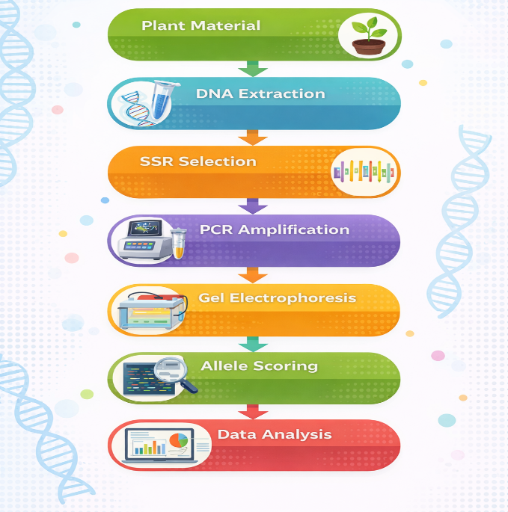
Figure 1: Workflow of Experimental Methodology
Table 1: Pedigree, agronomic features and description of parental rice genotypes
Characteristics | HUR 917  (Recurrent Parent) | IR18A1145  (Donor Parent)
Parentage | Selection from Dehradun Basmati selection-13 | IRRI-156/IR11A293
Source | BHU, Varanasi  Elite Cultivar | IRRI-ISARC  IRRI Advanced line
Yield (q/ha) | 40-45 | 35-40
Days to maturity (Days) | 135-140 | 120-125 days
Grain type | Medium Slender grain, aromatic | Long slender grain, Non-aromatic
Plant height (cm) | 105-110cm | 110-115cm
Resistance/Tolerance | Moderately tolerant to BLB, Stem Borer | Moderately tolerant to Drought

Allele Scoring and Data Analysis
The amplified SSR fragments were examined under ultraviolet light after electrophoretic separation to see if distinct and repeatable bands were formed. To prevent experimental bias, only distinct and reliably amplified bands were taken into account for the score. The size of each band was calculated by comparing its migration distance to a molecular weight reference of a 100 bp DNA ladder. For every marker–genotype combination, alleles were documented in base pairs. Different allele sizes between the two parental lines at a particular SSR location were regarded as polymorphic for the purposes of assessing parental polymorphism, whilst equal allele sizes were regarded as monomorphic. When necessary, a binary data matrix was created by designating "1" for the presence of particular alleles and "0" for their absence. The ratio of polymorphic markers to all screened markers, multiplied by 100, was used to determine the percentage of polymorphism. Foreground and background selection in marker-assisted breeding are two examples of downstream applications where markers with obvious polymorphism were given priority after being determined to be informative. Ambiguous or weak bands were removed from the final dataset to ensure reliability, and scoring was performed twice separately to verify consistency. Allelic variation, marker informativeness, and total parental genomic difference at drought-associated loci were then summarized using the assembled allele dataset. The percentage of polymorphism was calculated by using the formula:
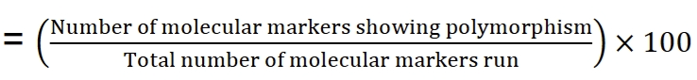
The R-statistical software was used to visualize the marker data. Based on the physical positions of markers provided in the row and column data matrix, GGT produced a visualisation of the distribution of 150 polymorphic markers along the chromosome length according to their physical positions (cM).
Results & discussion
Overview of Marker Screening and Amplification Success
The genomic landscape of the parental rice lines was evaluated using a comprehensive suite of 584 SSR markers distributed across all 12 chromosomes. This dense marker survey aimed to identify polymorphic loci suitable for tracking drought-tolerance traits. The distribution of markers was strategically mapped, with the highest concentration of surveyed loci on chromosome 2 (>60 markers) and the lowest on chromosome 7 (approximately 38 markers). The distribution of these polymorphic markers was not uniform across the 12 chromosomes (Figure 2, Figure 3), with chromosome 3 exhibiting the highest number of polymorphic SSRs at 18 markers. In contrast, chromosomes 4 and 7 recorded the lowest, each possessing only 9 polymorphic markers. This high density of polymorphic markers mirrors findings by Tushara et al. (2024), where Chromosome 3 was also found to be the most polymorphic (36.7%). In terms of percentage, chromosome 8 displayed the highest polymorphism rate at 32.65%, followed by chromosome 11 at 32.56% and chromosome 3 at 32.14%. Conversely, the lowest polymorphism percentage was observed on chromosome 4, yielding a rate of only 18.75%, followed by chromosome 2 at 22.95%. This contrasts sharply with other genetic backgrounds, where Chromosome 4 was identified as the most polymorphic (e.g., 40.96% in Habde et al., 2020). In absolute terms, chromosome 3 provided the highest number of scorable polymorphic markers (18), which is particularly significant given the presence of the drought-related locus qDTY_{3.2} in this region.
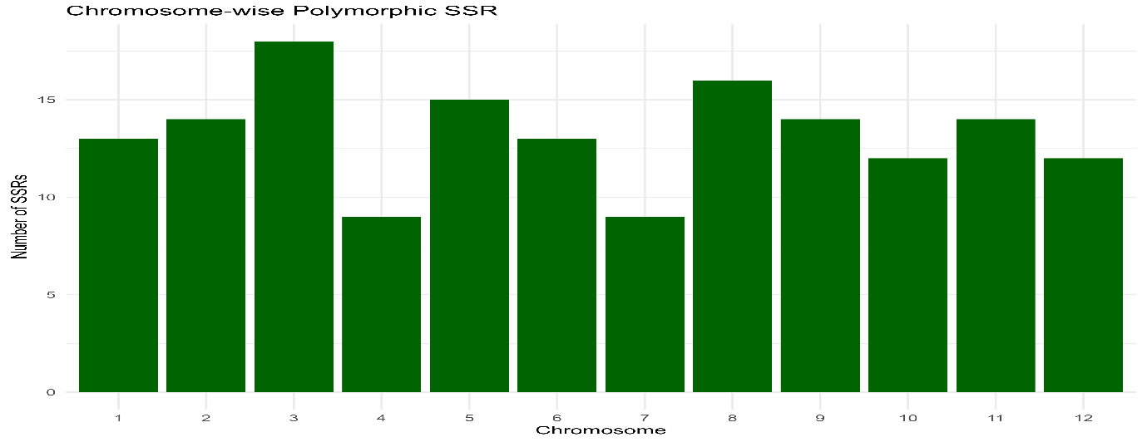
Figure 2: Chromosome-wise distribution of polymorphic SSR markers between the parental lines
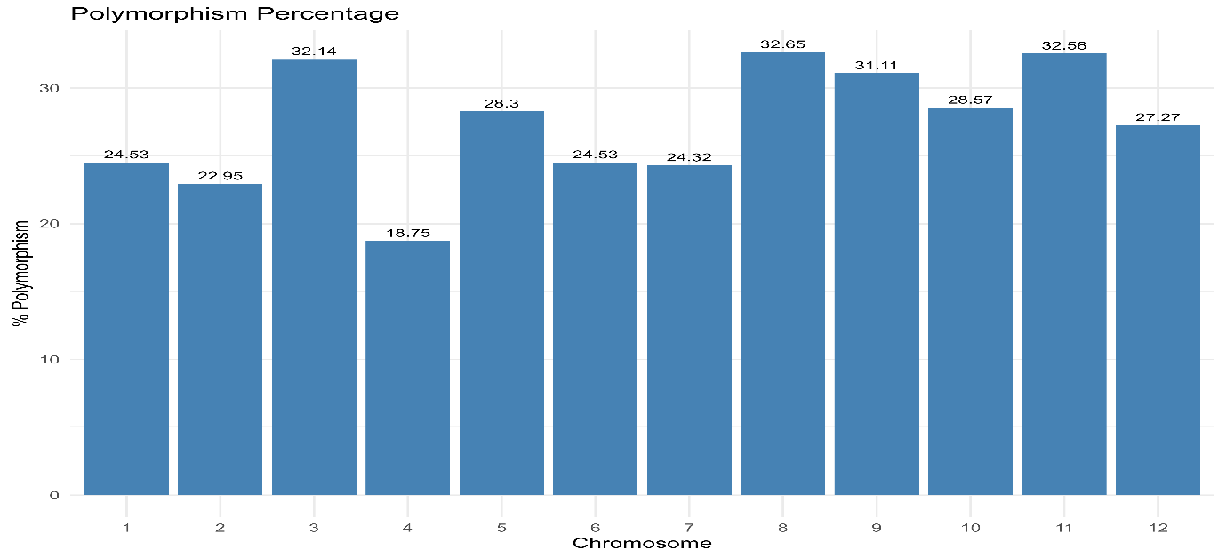
Figure 3: Percentage polymorphism of SSR markers across rice chromosomes
The identified polymorphism rate of 25.68% is highly comparable to the 28.2% reported in studies involving BPT5204/RP2068-18-3-5 and the 29.02% observed between Rajendra kasturi and URG-30 (Tushara et al., 2024). The rate in this study is significantly higher than the 17.65% and 17.1% rates recorded in populations where both parents were strictly indica lines (Ishwarya Lakshmi et al., 2021; Singh et al., 2022). This indicates that although both HUR-917 and IR18A1145 likely originate from an indica background, they exhibit adequate allelic variation, possibly attributable to HUR-917’s descent from Dehradun Basmati selections, to support a vigorous breeding effort. However, this diversity remains lower than studies involving traditional landraces, such as the cross between Jyothi and Chuvannamodan, which exhibited an average polymorphism of 40.86% (Francies et al., 2023).
Marker Amplification Efficiency and Band Clarity
The screening process yielded an amplification efficiency of 100%, as every one of the 584 markers surveyed was successfully amplified and subsequently categorized as either monomorphic (426 markers) or polymorphic (158 markers) [Figure 4, Table 2]. This total success rate in PCR amplification is a significant indicator of high genomic DNA quality, suggesting the extracted template was free from inhibitory phenolic compounds or polysaccharides often found in rice tissues. Furthermore, the universal success of the RM-series primers across the genome highlights exceptional primer specificity; the forward and reverse sequences (e.g., RM243 on chromosome 1 and RM511 on chromosome 12) demonstrated high affinity for their target flanking regions without yielding non-specific background noise.
Anomalies: Null Alleles and Ambiguous Bands
Visual records indicate the presence of null alleles in specific lanes where no visible PCR product was formed despite successful amplification in neighbouring lanes (Figure 4). These null alleles typically suggest a mutation or deletion at the primer binding site in one parent, which can itself serve as a useful, though dominant, polymorphism. These null alleles can effectively serve as dominant markers to differentiate genotypes, a strategy also explored in the development of submergence-tolerant varieties (Hidayatun et al., 2021). Additionally, some ambiguous bands or "stuttering" were observed, characterized by faint shadow bands adjacent to the primary allele. This phenomenon is a known characteristic of SSRs, particularly those with dinucleotide repeat motifs such as the (AT)47 motif in RM10855, where Taq polymerase may slip during the replication of long repetitive stretches (Majhi et al., 2022). This underscores the imperative of employing high-resolution electrophoresis for precise scoring, especially for Class I SSRs, which are recognized for their hypervariability yet susceptibility to such abnormalities (Habde et al., 2020). While technically a lack of amplification, these often function as dominant polymorphisms that can still differentiate genotypes, a strategy also observed in surveys for submergence tolerance (e.g., marker RM317) (Hidayatun et al., 2021).

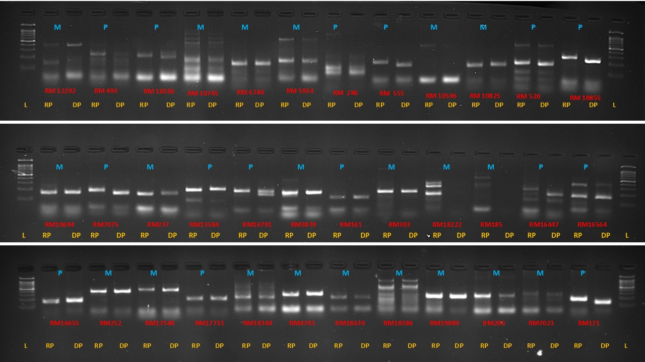
Figure 4: Representation of the polymorphism and monomorphism of the SSR markers between the two parents, HUR-917 (recurrent) and IR18A1145 (donor). M: Monomorphic, P: polymorphic. RP: Recurrent Parent, DP: Donor Parent, L: 100bp Ladder.
Table 2: Chromosome-wise distribution and polymorphism efficiency of SSR markers between HUR-917 and IR18A1145
Marker Name | Chr No. | Product Size(bp) | Position (cM) | FORWARD | REVERSE | Repeat Motif
RM1329 | 1 | 151 | 18.8 | GAGCTCAATCGAATCTAGACC | ATTGACATTCCTTTGCTTTG | (AG)20
RM493 | 1 | 211 | 79.7 | TAGCTCCAACAGGATCGACC | GTACGTAAACGCGGAAGGTG | (CTT)9
RM10855 | 1 | 355 | 57.65 | CCAAACAAGATGTAGTGGGAACATCC | CAAGATGATCAGTGGGCTATTCTTGG | (AT)47
RM572 | 1 | 159 | 69.9 | CGGTTAATGTCATCTGATTGG | TTCGAGATCCAAGACTGACC | (TC)14
RM12292 | 1 | 449 | 177.14 | ATGAGACGATGAAAGCCTCAAGC | GTGGGACAAGCAAATTGAAACG | (TA)38
RM10596 | 1 | 263 | 38.89 | CAACAACCTGGCAGAGAATTTCG | CTGCACGTGATGTCAGAGTTCG | (TA)31
RM11069 | 1 | 279 | 79.39 | GGTACAATGAAGCTTGGCAACG | CGGTGGAGTAGAACCACGAAGC | (GA)47
RM10695 | 1 | 294 | 45.01 | CCTTCGACTCCATGAAACAAACG | TCTCTTTGCCCTAACCCTATGTCC | (AAT)23
RM10793 | 1 | 123 | 51.52 | GACTTGCCAACTCCTTCAATTCG | TCGTCGAGTAGCTTCCCTCTCTACC | (ATAG)7
RM10694 | 1 | 194 | 44.96 | TTTCCCTGGTTTCAAGCTTACG | AGTACGGTACCTTGATGGTAGAAAGG | (AC)18
RM319 | 1 | 134 | 150.5 | ATCAAGGTACCTAGACCACCAC | TCCTGGTGCAGCTATGTCTG | (GT)10
RM3604 | 1 | 153 | 26.8 | ATGTCAGACTCCGATCTGGG | TCTTGACCTTACCACCAGGC | (GA)13
RM7075 | 1 | 155 | 73.1 | TATGGACTGGAGCAAACCTC | GGCACAGCACCAATGTCTC | (ACAT)13
RM6942 | 2 | 271 | 57.9 | ACTAGAAAAATGCCCGTGCG | TTTGAGACGATCGAACTCCC | (TTA)44
RM5706 | 2 | 195 | 109.3 | AGTGCGCTACTACTCGGTCC | GTATCATTTCGTCGAACGGG | (AAT)21
RM12309 | 2 | 472 | 0.5 | AAAGGTACGGTGGCCCAAACTCG | ATGGCAGGCAGGAAGTTCATCG | (AT)39
RM13584 | 2 | 286 | 97.88 | TCCATCTTCACAATCAGCAACC | CCCTGTAACAATGTTGAGAACACC | (AT)41
RM7288 | 2 | 146 | 42.4 | GAGCGAGCTATACCACCGTGACC | ATCGCGTCCAAGAAAGGTGTCG | (ATCT)9
RM13910 | 2 | 188 | 123.17 | GAGCGAGCTATACCACCGTGACC | ATCGCGTCCAAGAAAGGTGTCG | (AG)29
RM13477 | 2 | 129 | 89.85 | ACGGAGAAGGCGAGGAGGATGG | ATGGCGCCTGCTACGACTGTCC | (GGA)7
RM555 | 2 | 223 | 34.7 | TTGGATCAGCCAAAGGAGAC | CAGCATTGTGGCATGGATAC | (AG)11
RM236 | 2 | 191 | 10.8 | GCGCTGGTGGAAAATGAG | GGCATCCCTCTTTGATTCCTC | (CT)18
RM12548 | 2 | 340 | 16.65 | AGTTAGGGAAGCTGGTGCATGG | ATTATATCGCGAACGAGCAAGAGG | (AT)46
RM279 | 2 | 174 | 17.3 | GCGGGAGAGGGATCTCCT | GGCTAGGAGTTAACCTCGCG | (GA)16
RM207 | 2 | 118 | 191.2 | CCATTCGTGAGAAGATCTGA | CACCTCATCCTCGTAACGCC | (CT)25
RM110 | 2 | 156 | 6.9 | TCGAAGCCATCCACCAACGAAG | TCCGTACGCCGACGAGGTCGAG | (GA)15
RM213 | 2 | 139 | 186.4 | ATCTGTTTGCAGGGGACAAG | AGGTCTAGACGATGTCGTGA | (CT)17
RM426 | 3 | 150 | 157.3 | ATGAGATGAGTTCAAGGCCC | AACTCTGTACCTCCATCGCC | (CA)10
RM16238 | 3 | 196 | 148.64 | GCAGCGCATCATTGTATTAAGG | GGACACTAAATCAGAAACCCATGC | (ATT)24
RM14931 | 3 | 476 | 52.9 | GCTTCACGCACATATTGCCTTCC | ATCCTCCCACTCCCAAATTATCTCC | (AC)67
RM14735 | 3 | 295 | 38.34 | AATTAACTAGTGAGCACCCGATGG | CGGTCACAAAGTGCCAGTACC | (AT)42
RM15404 | 3 | 160 | 92.17 | TTTGGCAAGGCTATCTTCTCTGG | GGAGAGCCGAAACTATTTGATTGG | (AT)39
RM3525 | 3 | 179 | 136.5 | ACACTCTCAGCTCATCAAGACC | GGGCAAGTGGTCAAATCTTG | (CT)33
RM14698 | 3 | 365 | 34.68 | TAGATCGTCTTTGTCGTAGAGC | TAGTCACGAAGCTATGTGTTGC | (TA)39
RM520 | 3 | 247 | 191.6 | AGGAGCAAGAAAAGTTCCCC | GCCAATGTGTGACGCAATAG | (AG)10
RM15583 | 3 | 174 | 103.19 | CCCAAATAGTCACCAGCATTATCG | TTGCCTGTGCAACCTTATGAACC | (TA)44
RM2334 | 3 | 155 | 115.6 | CATGCATCTGATCTGATTAT | TGTGAAGAGTACAAGTAGGG | (AT)25
RM227 | 3 | 106 | 156.3 | ACCTTTCGTCATAAAGACGAG | GATTGGAGAGAAAAGAAGCC | (CT)10
RM15326 | 3 | 248 | 85.25 | TGAATCTACCGCTCTACTTGTGG | AAACAGTGCATCCTTCTTGTGG | (TA)29
RM15035 | 3 | 371 | 59.74 | TTCGTGATCGGTCATCCATCC | AGATTCATATGCTGCGCTGTTACC | (TA)45
RM16153 | 3 | 264 | 143.5 | TGGTTGTGGTATAGCACGGTAAGC | TGACCCAAGGAGATACTAGGTTGC | (TG)56
RM15203 | 3 | 477 | 69.34 | ATGGTGAGACGACAGAACAGATGC | GACGCGCTTTGTGTTTCTTGG | (AT)40
RM231 | 3 | 182 | 15.7 | CCAGATTATTTCCTGAGGTC | CACTTGCATAGTTCTGCATTG | (CT)16
RM15791 | 3 | 86 | 117.88 | AGTAAGTTTGCCGCGGAGGAAGC | CTCCTTGTCGATCACCACCATCG | (GAG)8
RM16033 | 3 | 152 | 134.34 | TACCTTATCCCGATTGCTCAAGG | TAAGAGAAAGCCTTCCCGACTCC | (GAC)7
RM16791 | 4 | 279 | 73.57 | GGCTGCTTCAGAGCGTTTGTAGG | AAATACGCCATCAAGTTGCACACC | (ATA)12
RM16913 | 4 | 391 | 80.52 | GTGTACGTGTTGGCTCTCTGTACG | GATGTTGCTTGTGCTGCAACC | (TAT)51
RM16655 | 4 | 138 | 55.8 | CCTTGGAAGCTGGAACTTCACC | GGCTCTTAGGTTAGATCCCACACG | (CGG)7
RM16447 | 4 | 310 | 19.63 | CGGGTCTGTCTTTCAGTTTGC | AGTGGCGTACTTGCTCTACTGC | (AT)30
RM16569 | 4 | 351 | 39.62 | ATAGACTTCACCCGGTACAACG | CTGGTATCGACATCGGCTAGG | (AT)31
RM518 | 4 | 171 | 25.5 | CTCTTCACTCACTCACCATGG | ATCCATCTGGAGCAAGCAAC | (TC)15
RM335 | 4 | 104 | 21.5 | GTACACACCCACATCGAGAAG | GCTCTATGCGAGTATCCATGG | (CTT)25
RM17620 | 4 | 423 | 139.44 | ACCATCTCGTATTTGGCTCATCC | AACATGCACTGGATGATCTCTCG | (TA)34
RM5320 | 4 | 137 | 87.1 | CCTGAGCTGTACAAGCAAAC | CAGATTCTTGGGAGAAATCC | (TC)12
RM5844 | 5 | 195 | 37.5 | TGACTAACGTGGCATCCATG | GCTAGGAGCCATTGTCGAAG | (ATA)22
RM440 | 5 | 169 | 92.7 | CATGCAACAACGTCACCTTC | ATGGTTGGTAGGCACCAAAG | (CTT)22
RM17710 | 5 | 168 | 0.19 | GACGAGGCAGGCGATGATAAGG | CAGCACCTCAAGCGTCCTAACC | (AAG)15
RM18157 | 5 | 117 | 32.63 | TCATATGGAGCAGTCAGAAACAGC | TGTTTGAGAATCACAGCTCTCTCG | (AC)11
RM18913 | 5 | 487 | 98.77 | CAAGATCTTTGCAACTGAGGAAGG | TTGCTACTTCGTGTTGTCACTCTACG | (AT)27
RM18413 | 5 | 180 | 64.33 | AAGACATACCGCATGAGAATGG | AGCTCTCTCCTCAGTCTCTCACG | (TC)13
RM3476 | 5 | 132 | 97.72 | GATTCTCGTCGTAATCAAGA | ATCCACGGTTAAGATAAATG | (CT)22
RM122 | 5 | 227 | 1.28 | GAGTCGATGTAATGTCATCAGTGC | GAAGGAGGTATCGCTTTGTTGGAC | (GA)7A(GA)2A(GA)11
RM5970 | 5 | 120 | 101.5 | CCCATCTGGTTCACCTTCAC | AGGAGCAGCCTTTTGTCTTC | (CAT)8
RM592 | 5 | 270 | 31.4 | TCTTTGGTATGAGGAACACC | AGAGATCCGGTTTGTTGTAA | (ATT)20
RM1386 | 5 | 197 | 81.95 | TATTCAAGGTTGGCTGCCTC | CAATCACTCCATGGCTGATG | (AG)42
RM3853 | 5 | 138 | 31.5 | ATGTGCCCTTATACAAGGCC | GTGAGCTCATAGAGCAGCCC | (GA)24
RM3870 | 5 | 193 | 91.2 | TACATCTCCGGCGTTTACAC | CCAAGGTTGAAACAGGAAGC | (GA)32
RM421 | 5 | 234 | 137.2 | AGCTCAGGTGAAACATCCAC | ATCCAGAATCCATTGACCCC | (AGAT)6
RM6360 | 5 | 230 | 115.7 | GCTCGGATCAATCGAGCTC | TTTCCAGCAAGATCGACGC | (GAA)11
RM469 | 6 | 105 | 2.2 | AGCTGAACAAGCCCTGAAAG | GACTTGGGCAGTGTGACATG | (AG)15
RM510 | 6 | 122 | 20.8 | AACCGGATTAGTTTCTCGCC | TGAGGACGACGAGCAGATTC | (GA)15
RM20378 | 6 | 288 | 99.69 | ATGTCCTTCTTCGAGATTGCTTCG | AGAGCCCAACATATAGCGGATGC | (AT)13
RM276 | 6 | 149 | 40.3 | CTCAACGTTGACACCTCGTG | TCCTCCATCGAGCAGTATCA | (AG)8A3(GA)33
RM6273 | 6 | 199 | 0.53 | TGCCTTCGCACTCCAGTC | GACGAGAAGATCCTTGTCGG | (CTC)11
RM6734 | 6 | 197 | 29.1 | TGAGCAGTCTGCAGATGACC | GCTTGGACTTGGAGTCTTGG | (TAT)20
RM19985 | 6 | 191 | 68.8 | AGCAGATATCACACACAGCATTGG | GGAGCTTCATTTGTGATGAACCTAGC | (TA)29
RM19469 | 6 | 296 | 16.6 | TTCCTTTCCTTGGGTCATATCC | ATCGAGTCAGAGAGTGGCTTGG | (GA)36
RM19771 | 6 | 281 | 37.02 | AACCAATGCACACTTCTTCTGTGC | CAACTGTAGAGGTTGGAATGATCTGC | (AT)47
RM204 | 6 | 169 | 25.1 | CACGACGACGACGAGCAGCAGC | GCTCGAGGGAGAGCGACCTGCC | (CT)44
RM162 | 6 | 211 | 108.3 | AACTGCCAGCAAAACCAGG | ATCGTGGGTAGTGTGTGTGT | (AC)20
RM253 | 6 | 141 | 37 | TCCTTCAAGAGTGCAAAACC | GCATTGTCATGTCGAAGCC | (GA)25
RM20377 | 6 | 279 | 99.68 | GTGTGTGATGTGCATGTTTCTGC | CATGTGATGCCCTGTAGGAACC | (CT)33
RM336 | 7 | 154 | 94.5 | CTTACAGAGAAACGGCATCG | GCTGGTTTGTTTCAGGTTCG | (CTT)18
RM432 | 7 | 187 | 43.5 | TTCTGTCTCACGCTGGATTG | AGCTGCGTACGTGATGAATG | (CATC)9
RM8044 | 7 | 113 | 99.16 | AGTACTTGTCTCCTTAGCAG | CAATATTCACTCAACTCTCA | (CTT)18
RM6326 | 7 | 222 | 99.16 | TAGCTTGGTTCGGTCAAACC | ACCAGATTGTTAGCAACCCG | (CTT)18
RM20775 | 7 | 181 | 0.21 | GGTGTTCATCTTTGTTGAGTCAGG | AGGATACAGCGCACCAGATTAGC | (AT)45
RM21693 | 7 | 462 | 79.96 | GCACAGACCAGAACTTTCTTCG | TGGCGAGTGTAGATGTAATTGG | (AT)44
RM5847 | 7 | 194 | 81.05 | TGAGATGAGAGATAGACTCC | AACAGATGAAGGCTATTTTA | (ATA)16
RM21521 | 7 | 267 | 65.51 | TACTCGAGCAGGCAGAGCAACC | AGCATAGTCATCCAACCGAGACAGC | (AT)40
RM3456 | 7 | 161 | 49.42 | CGTCGACCATCTCTCCCTC | TGGGGAGCAAAGGAAAGC | (CT)20
RM152/OSR34 | 8 | 151 | 9.4 | CGAATCGAATCCAAGGCGG | CTGGATTCCTCATCGCCTT | (GGC)10
RM80 | 8 | 142 | 103.7 | TTGAAGGCGCTGAAGGAG | CATCAACCTCGTCTTCACCG | (TCT)25
RM1109 | 8 | 198 | 72.2 | TCAAAATCACGTGTATGTAAGC | TTTACAAAGGACAGAGGGC | (AG)12
RM23345 | 8 | 228 | 98.69 | GAGATCCTGCACATCTTTGAGACC | TGTGCCACGAAACAAATCTAGGC | (TA)27
RM22273 | 8 | 282 | 3.48 | AGTGACAGCATCAGCATGTTGTTTGG | TTAAGCTGGCACTGCACTTGAAGG | (TA)35
RM22523 | 8 | 437 | 20.94 | CGTGCTTAATTACCTGGCTTCG | GCACGTATTCACAGCTAGCAACC | (TA)48
RM22459 | 8 | 119 | 16.1 | ACCACCGCGACTTCAGTTCTCC | CGGAGGTGTTGGTGGAAGAGG | (CTT)11
RM22688 | 8 | 424 | 36.3 | CTTCGATCTCTTGCCTGGATACC | CCATTTCGTTGGGTTTCAGTCC | (ATT)28
RM23060 | 8 | 126 | 78.88 | CAGCAGCTGCCTCAGTGTCACC | AACGTTGTCGGTGAAGGTCCATCC | (CAT)14
RM8271 | 8 | 225 | 45.8 | TCTTGAGAAATCTGCCATTC | ACTGATGTGCATTTCGTC | (AG)32
RM502 | 8 | 266 | 121.8 | GCGATCGATGGCTACGAC | ACAACCCAACAAGAAGGACG | (TG)10
RM404 | 8 | 236 | 69 | CCAATCATTAACCCCTGAGC | GCCTTCATGCTTCAGAAGAC | (GA)33
RM256 | 8 | 127 | 101.5 | GACAGGGAGTGATTGAAGGC | GTTGATTTCGCCAAGGGC | (CT)21
RM5353 | 8 | 177 | 96.6 | ACCCTCGATCTCCTAGGCTG | TCTACTCCAAACCCATTGCC | (TC)13
RM7356 | 8 | 158 | 78.5 | CCAAGGACACATATGCATGC | GCAATTCATGGCGCTGTTC | (CTAT)6
RM444 | 9 | 162 | 3.3 | GCTCCACCTGCTTAAGCATC | TGAAGACCATGTTCTGCAGG | (AT)12
RM285 | 9 | 205 | 1.8 | CTGTGGGCCCAATATGTCAC | GGCGGTGACATGGAGAAAG | (GA)12
RM24337 | 9 | 442 | 62.13 | CCATTCTACTCTCTGCCTACCAACC | CCTCCATCCCAATATACCTATCATCC | (AT)19
RM24594 | 9 | 240 | 79.11 | CTGGTGAACGACTTGGACTTGC | ACAATCAGCCAGACGCTTATTCC | (AT)35
RM245 | 9 | 150 | 112.3 | ATGCCGCCAGTGAATAGC | CTGAGAATCCAATTATCTGGGG | (CT)14
RM23911 | 9 | 269 | 29.52 | TGCCTGCACTTATCTCTTGATGC | GATGAACCTAAAGGGCAGTTTCC | (TG)13
RM215 | 9 | 148 | 99.4 | CAAAATGGAGCAGCAAGAGC | TGAGCACCTCCTTCTCTGTAG | (CT)16
RM24240 | 9 | 169 | 56.24 | ATGCAACCTCCTCCATCATAAGG | TGCTGCTCCTACCTCACTCACC | (GA)15
RM23744 | 9 | 308 | 11.94 | CTTAATACTCCGACGTAACAGTGG | CCTGACTAAATGGAGCTTCTTCC | (CT)37
RM24071 | 9 | 153 | 43 | TACTGAAGGCCAAGGAAGAGGTAGC | GAGACTATGGTGTGGCGTCAATGG | (GT)20
RM24542 | 9 | 266 | 74.48 | ATCCACAAGAGCACCGATGAGG | TGACCTGGTAGTGGTGAGTGTGC | (TA)51
RM7424 | 9 | 210 | 60.8 | GGCCATGATGCAGCAGCAGA | CACTCGCAGCAGCAGCCG | (GGAT)6
RM242 | 9 | 225 | 73.3 | GGCCAACGTGTGTATGTCTC | TATATGCCAAGACGGATGGG | (CT)26
RM201 | 9 | 158 | 81.2 | CTCGTTTATTACCTACAGTACC | CTACCTCCTTTCTAGACCGATA | (CT)17
RM25661 | 10 | 479 | 77.58 | TCTCTACCTGGCGTCCACTAGTTCG | AGGTGGACGTGCTCGATCTGC | (TA)37
RM184 | 10 | 219 | 58.3 | ATCCCATTCGCCAAAACCGGCC | TGACACTTGGAGAGCGGTGTGG | (CA)7
RM171 | 10 | 328 | 55 | AACGCGAGGACACGTACTTAC | ACGAGATACGTACGCCTTTG | (GATG)5
RM216 | 10 | 146 | 17.6 | GCATGGCCGATGGTAAAG | TGTATAAAACCACACGGCCA | (CT)18
RM222 | 10 | 213 | 11.3 | CTTAAATGGGCCACATGCG | CAAAGCTTCCGGCCAAAAG | (CT)18
RM269 | 10 | 182 | 69.6 | GAAAGCGATCGAACCAGC | GCAAATGCGCCTCGTGTC | (GA)17
RM6364 | 10 | 163 | 0.27 | GTTCATTTCGTCCTTCTCGG | TCTCGATTCTTCCTTCTCCG | (GAA)13
RM25051 | 10 | 387 | 18.14 | GGTAACAAGGTTGATCGTGTGC | AGATGAGGTGTCGCCTTACCC | (AT)22
RM25207 | 10 | 210 | 38.6 | TCACAGGGATATCTCATTCACAGC | ACGTGTCACACATACAAGTGATGC | (TA)35
RM25735 | 10 | 386 | 82.01 | AGGCAGGCAAGCAGTAGTTTCG | ATCAAGATCAGGAGCCGCAAGG | (AAG)25
RM25404 | 10 | 264 | 58.79 | GCAACGGTTCTCCTTCCACTACC | CCATGATAGCGTTAGCCATAAACG | (AT)35
RM4477 | 10 | 114 | 103.1 | AGTAAACATGTCTTCGGGAT | CAGTGCATATTCCACTGGTA | (TA)20
RM26362 | 11 | 232 | 32.88 | ATCCGTCCTAGAATACTTGTCG | CATCCGTCCTAAATTAGTAGCC | (ATT)10
RM21 | 11 | 157 | 85.7 | ACAGTATTCCGTAGGCACGG | GCTCCATGAGGGTGGTAGAG | (GA)18
RM330 | 11 | 177 | 60.9 | CAATGAAGTGGATCTCGGAG | CATCAATCAGCGAAGGTCC | (CAT)5
RM27132 | 11 | 488 | 100.25 | GAATCAAGGATAGACACGAAGG | TCTAAGTTCTACCACCACAACC | (AT)42
RM26860 | 11 | 265 | 78.84 | TGGCTCCATGATTGAAGTTTGC | GGTCTCAATAAGAGGGCAAGATATGG | (AT)31
RM26616 | 11 | 277 | 58.24 | GTGGAGGACGGTGATGGAGAAGC | ATTTCTTGACCGCCGCTGATTCC | (AT)45
RM26459 | 11 | 194 | 41.69 | TAACCTATATCCCGCAGCAAAGC | TATGGGATCTGTACCCGTCATGC | (TA)43
RM26550 | 11 | 273 | 49.87 | GGGAAACATGGAAGAACACTCTAGC | CAAGCATTTGCAGCATTCAAGG | (AT)40
RM7283 | 11 | 183 | 37.37 | GGGGCATATAACGCAAACAC | ATTTTAGGAGGCTCACGTGG | (ATCT)13
RM286 | 11 | 110 | 1.57 | GGCTTCATCTTTGGCGAC | CCGGATTCACGAGATAAACTC | (GA)16
RM120 | 11 | 173 | 41.7 | CACACAAGCCCTGTCTCACGACC | CGCTGCGTCATGAGTATGTA | (GA)9TAG(ATC)4
RM144 | 11 | 237 | 123.2 | TGCCCTGGCGCAAATTTGATCC | GCTAGAGGAGATCAGATGGTAGTGCATG | (ATT)11
RM536 | 11 | 243 | 55.1 | TCTCTCCTCTTGTTTGGCTC | ACACACCAACACGACCACAC | (CT)16
RM332 | 11 | 183 | 27.9 | GCGAAGGCGAAGGTGAAG | CATGAGTGATCTCACTCACCC | (CTT)5-12-(CTT)14
RM19 | 12 | 226 | 20.9 | CAAAAACAGAGCAGATGAC | CTCAAGATGGACGCCAAGA | (ATC)10
RM235 | 12 | 124 | 102.8 | AGAAGCTAGGGCTAACGAAC | TCACCTGGTCAGCCTCTTTC | (CT)24
RM12 | 12 | 184 | 109.1 | TGCCCTGTTATTTTCTTCTCTC | GGTGATCCTTTCCCATTTCA | (GA)21
RM5364 | 12 | 148 | 48.98 | GTATTACGCTCGATAGCGGC | GTATCCTTTCTCGCAATCGC | (TC)13
RM28472 | 12 | 330 | 94.25 | GCTATGAACCTGTACACATGTAGG | GAGCACCATAACAATCAGTTGC | (GA)15
RM270 | 12 | 108 | 91.3 | GGCCGTTGGTTCTAAAATC | TGCGCAGTATCATCGGCGAG | (GA)13
RM28157 | 12 | 497 | 71.27 | GCTTAATTTCTGACAGACCAGTGC | GATCTAAACACAGCCTTCCTTGG | (TTA)36
RM27840 | 12 | 508 | 32.82 | TTTGCGTGCTAGGGAGATTAGC | CATTATGTACTTACTCCCTCCCTTCC | (TAT)37
RM27638 | 12 | 294 | 16.55 | AGATTCCCATCCGTTAGGAAAGC | GATGCACATGCACTTGTAGTTCC | (AT)43
RM28089 | 12 | 260 | 63.16 | GGGAGGACACCTGTGTAAGTAGG | GGTTCAAATGAGACCCAATTCC | (ATC)12
RM28048 | 12 | 93 | 57.81 | TTCAGCCGATCCATTCAATTCC | GCTATTGGCCGGAAAGTAGTTAGC | (CGC)8
RM511 | 12 | 130 | 59.8 | CTTCGATCCGGTGACGAC | AACGAAAGCGAAGCTGTCTC | (GAC)7
SSR Reliability: Codominance and Locus Specificity
The reliability of the identified polymorphic markers (ranging from 18.75% on chromosome 4 to 32.65% on chromosome 8) is fundamentally rooted in their locus specificity and codominant inheritance. Unlike dominant markers, the codominant nature of SSRs allows for the clear differentiation of homozygous and heterozygous states in segregating populations. This specificity is underscored by the unique primer sequences and defined product sizes (e.g., RM1329 at 151 bp and RM24987 at 767 bp) provided in the genomic database. These attributes make the 158 polymorphic markers identified in this study highly dependable tools for marker-assisted selection (MAS) and the precise introgression of drought-tolerant QTLs such as DRO1 and qDTY_{12.1}.
Analysis of the genetic structure of these polymorphic markers revealed a diverse range of repeat motifs, with a significant prevalence of dinucleotide repeats. The observed polymorphism level of approximately 27% serves as a critical molecular proxy for the genetic divergence between HUR-917 and IR18A1145. In rice breeding, the rate of polymorphism is directly linked to genetic distance; a moderate-to-high rate indicates that the two parents are sufficiently distinct to allow for the effective tracking of genomic segments. Frequently observed dinucleotide sequences included (AG)n, (AT)n, (TA)n, (GA)n, and (CT)n, exemplified by markers like RM243 (AG)18 and RM10855 (AT)47. This genetic distance is the foundation of breeding utility, as it ensures that the donor line (IR18A1145) can contribute unique alleles for drought tolerance that are absent in the elite background (HUR-917).
Codominant SSRs exhibit differences in amplicon size, in contrast to dominant markers, which simply show whether a band is present or absent (Meshram et al., 2021). This is critical in backcross breeding, as it allows for the identification of "H" (heterozygous) individuals in early generations (like BC₁F₁) to ensure the target QTL is maintained while simultaneously selecting for "A" (recurrent parent) alleles at other loci to accelerate Recurrent Parent Genome Recovery (RPGR) (Chukwu et al., 2022). The preference for SSR codominance is echoed across multiple studies, including those targeting Brown Planthopper (BPH) resistance (Ishwarya Lakshmi et al., 2021), heat stress tolerance in NERICA cultivars (Ravikiran et al., 2020), and the development of triple stress-tolerant versions of Improved White Ponni (Muthu et al., 2020). Codominance is referred to as a "marker of choice" in each of these situations since it offers more insightful information than phenotypic selection alone.
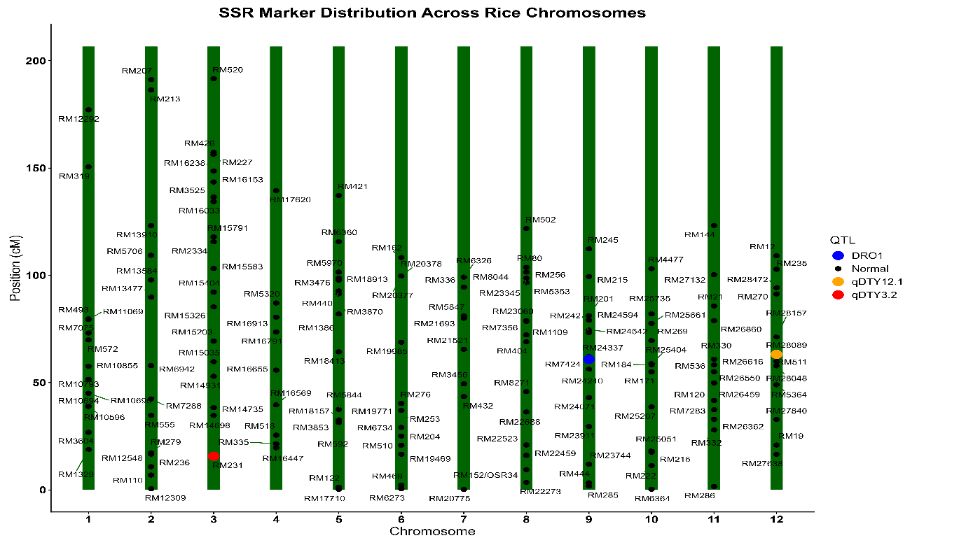
Figure 5: Linkage map of polymorphic marker
The observed polymorphism rate is consistent with expectations for a cross between an elite cultivar and an advanced donor line. While both lines belong to Oryza sativa, their differing selection histories, one for yield stability in favourable conditions and the other for physiological resilience under stress, typically result in significant genomic variation at loci governing abiotic stress response. A polymorphism rate exceeding 25% is generally considered sufficient for high-precision marker-assisted backcrossing (MABC), confirming that HUR-917 and IR18A1145 constitute an ideal parental pair for the development of next-generation, drought-resistant rice varieties.
The identification of 158 polymorphic markers significantly strengthens downstream QTL mapping and the development of Near-Isogenic Lines (NILs). High-resolution mapping requires a dense set of markers to define the boundaries of introgressed segments (Figure 5). These findings have profound implications for MAS, as they provide a dense, reliable set of tools for discriminating between parental genotypes. Furthermore, the proximity of specific polymorphic markers to documented drought-tolerance loci such as RM231 near qDTY_{3.2}, RM242 near DRO1, and RM511 near qDTY_{12.1} is critical for the targeted development of drought-tolerant rice varieties. This high level of polymorphism allows breeders to efficiently track and combine multiple beneficial alleles, enhancing rice resilience in water-stressed environments.
Conclusion
Developing drought-tolerant rice is of paramount importance in modern breeding to ensure global food security against the challenges of climate change. This study highlights the essential role of molecular marker technologies in transforming traditional breeding into a more precise and time-effective process, thereby significantly improving breeding efficiency. The identification of 158 polymorphic markers provides a robust genomic resource for the targeted introgression of major drought-tolerant QTLs, including DRO1 and various qDTY loci. By utilizing these markers in marker-assisted selection, breeders can accurately verify the presence of stress-resilient traits without the need for extensive field-based phenotypic screening. Ultimately, the outcomes of this study establish a critical foundation for the creation of new drought-resistant rice varieties, which will be instrumental in maintaining stable yields in drought-prone agricultural regions.
Ethical Approval
The work described in this manuscript does not require experiments on live animals. However, the project was evaluated and approved by the national ethics committee before the start of research activities.
Disclaimer (Artificial Intelligence)
The author (s) hereby declare that no generative AI technologies such as Large Language Models (ChatGPT, COPILOT, etc.) and text-to-image generators have been used during the writing or editing of this manuscript.
Competing Interests
The authors have declared that no competing interests exist.
References
Alam, M., Lou, G., Abbas, W., Osti, R., Ahmad, A., Bista, S., Ahiakpa, J.K. and He, Y. (2024). Improving rice grain quality through ecotype breeding for enhancing food and nutritional security in Asia–Pacific region. Rice, 17(1), 47.
Anilkumar, C., Sah, R.P., Beena, R., Azharudheen TP, M., Kumar, A., Behera, S., Sunitha, N.C., Pradhan, S.K., Reshmi Raj, K.R., C, P. and Marndi, B.C. (2023). Conventional and contemporary approaches for drought tolerance rice breeding: Progress and prospects. Plant Breeding, 142(4), 418-438.
Badri, J., Lakshmidevi, G., JaiVidhya, L.R.K., Prasad, M.S., Laha, G.S., Lakshmi, V.J., Isetty, S.R., Padmashree, R., Balakrishnan, D., Varanasi, Y.V.P. and Jukanti, A.K. (2022). Multiparent-derived, marker-assisted introgression lines of the elite Indian rice cultivar,‘Krishna Hamsa’show resistance against bacterial blight and blast and tolerance to drought. Plants, 11(5), 622.
Bordeos, A., Henry, A., Pocsedio, A., Dixit, S., Lai, M. H., & Leung, H. (2025). qDTY introgression to improve the drought tolerance of Taiwanese japonica rice variety Tainan 11. Journal of Crop Improvement, 1-26.
Cheng, A., Lau, J.Y., Mazumdar, P., Baisakh, N., Harikrishna, J.A., Osman, N., Mispan, M.S., Zain, N.A.M., Sethuraman, G. and Kongchum, M. (2025). Innovation in drought-resilient agriculture: The rise of aerobic rice system. Heliyon, 11(12).
Chukwu, S.C., Rafii, M.Y., Oladosu, Y., Okporie, E.O., Akos, I.S., Musa, I., Swaray, S., Jalloh, M. and Al-Mamun, M. (2022). Genotypic and phenotypic selection of newly improved putra rice and the correlations among quantitative traits. Diversity, 14(10),812.
Dos Santos, T. B., Ribas, A. F., de Souza, S. G. H., Budzinski, I. G. F., & Domingues, D. S. (2022). Physiological responses to drought, salinity, and heat stress in plants: a review. Stresses, 2(1), 113-135.
Fahad, S., Adnan, M., Noor, M., Arif, M., Alam, M., Khan, I.A., Ullah, H., Wahid, F., Mian, I.A., Jamal, Y. and Basir, A. (2019). Major constraints for global rice production. In Advances in rice research for abiotic stress tolerance, 1-22. Woodhead Publishing.
Farooq, M., Wahid, A., Zahra, N., Hafeez, M. B., & Siddique, K. H. (2024). Recent advances in plant drought tolerance. Journal of Plant Growth Regulation, 1-33.
Francies, R. M., Mathew, D., & Beena, R. (2023). Evaluation for Parental Polymorphism and Identification of Microsatellites Linked to Drought Tolerance in Rice (Oryza sativa L.). Int. J. Plant Soil Sci, 35(22), 275-284.
Gaballah, M. M., Fiaz, S., Wang, X., Younas, A., Khan, S. A., Wattoo, F. M., & Shafiq, M. R. (2021). Identification of genetic diversity among some promising lines of rice under drought stress using SSR markers. Journal of Taibah University for Science, 15(1), 468-478.
Gonzaga, Z. J., Aslam, K., Septiningsih, E. M., & Collard, B. C. (2015). Evaluation of SSR and SNP markers for molecular breeding in rice.
Guadarrama‐Escobar, L.M., Hunt, J., Gurung, A., Zarco‐Tejada, P.J., Shabala, S., Camino, C., Hernandez, P. and Pourkheirandish, M. (2024). Back to the future for drought tolerance. New Phytologist, 242(2), 372-383.
Gull, M., Shikari, A.B., Khan, G.H., Sofi, P.A., Ahanger, M.A., Reddy, B.S., Jukanti, A., Zargar, S.M., Mohiddin, F.A., Wani, S.H. and Ashraf, S. (2025). Marker assisted introgression of blast resistance genes into Heritage Red Rice Landrace “Zag” of Western Himalayan Kashmir. Physiological and Molecular Plant Pathology, 139, 102820.
Habde, S., Singh, S. K., Mounika, K., Khaire, A., Singh, D. K., & Majhi, P. K. (2020). Study of allelic variation at genome wide SSR loci in parents of mapping population for high grain zinc in rice (Oryza sativa L.).
Hidayatun, N., Nafisah, & Utami, D. W. (2021, November). Polymorphism parental survey in three Indonesia improved varieties to support development of new submergence tolerant varieties. In IOP Conference Series: Earth and Environmental Science (Vol. 911, No. 1, p. 012012). IOP Publishing.
Hussain, T., Hussain, N., Tahir, M., Raina, A., Ikram, S., Maqbool, S., Fraz Ali, M. and Duangpan, S. (2022). Impacts of drought stress on water use efficiency and grain productivity of rice and utilization of genotypic variability to combat climate change. Agronomy, 12(10), 2518.
Ishwarya Lakshmi, V. G., Sreedhar, M., Lakshmi, V. J., Gireesh, C., & Vanisri, S. R. S. (2021). Parental polymorphism survey using genome-wide SSR markers for brown planthopper resistance in rice. The Pharma Innovation, 10(6), 622-629.
Kumari, V.V., Roy, A., Vijayan, R., Banerjee, P., Verma, V.C., Nalia, A., Pramanik, M., Mukherjee, B., Ghosh, A., Reja, M.H. and Chandran, M.A.S. (2021). Drought and heat stress in cool-season food legumes in sub-tropical regions: Consequences, adaptation, and mitigation strategies. Plants, 10(6), 1038.
Majhi, P.K., Singh, S.K., Anandan, A., Khaire, A.R., Korada, M., Habde, S.V., Singh, D.K., Bhagvan, A.P., Jayasudha, S. and Singh, A., 2022. Parental polymorphism survey for evaluation and selection of contrasting parents for drought tolerance in rice (Oryza sativa L.) by using SSR markers. Int J Environ Clim, 12(11), pp.2507-2519.
Mapari, A. R., & Mehandi, S. (2024). Enhancing crop resilience: advances and challenges in marker-assisted selection for disease resistance. J. Adv. Biol. Biotechnol, 27(7), 569-580.
Meshram, P., Bhandarkar, S., Banerjee, S., Saxena, R.R., Sah, R.P., Parikh, M., Rana, D.K. and Nair, S.K., 2021. Parental polymorphic survey for BPH resistant genes in rice (Oryza sativa L.). The Pharma Innovation, 10(6), pp.1224-1230.
Mondal, T. K., & Ganie, S. A. (2014). Identification and characterization of salt responsive miRNA-SSR markers in rice (Oryza sativa). Gene, 535(2), 204-209.
Muthu, V., Abbai, R., Nallathambi, J., Rahman, H., Ramasamy, S., Kambale, R., Thulasinathan, T., Ayyenar, B. and Muthurajan, R. (2020). Pyramiding QTLs controlling tolerance against drought, salinity, and submergence in rice through marker assisted breeding. PloS one, 15(1), e0227421.
Naaz, S., Pandey, V., & Yadav, H. K. (2022). Evaluation of genetic diversity in rice (Oryza sativa L. ssp. Indica) accessions using SSR marker. Vegetos, 35(4), 961-968.
Nawaz, A., Rehman, A. U., Rehman, A., Ahmad, S., Siddique, K. H., & Farooq, M. (2022). Increasing sustainability for rice production systems. Journal of Cereal Science, 103, 103400.
Nivedha, R., Manonmani, S., Kalaimagal, T., Raveendran, M., & Kavitha, S. (2024). Assessing the genetic diversity of parents for developing hybrids through morphological and molecular markers in rice (Oryza sativa L.). Rice, 17(1), 17.
Rahman, M. M., Rasaul, M. G., Hossain, M. A., Iftekharuddaula, K. M., & Hasegawa, H. (2012). Molecular characterization and genetic diversity analysis of rice (Oryza sativa L.) using SSR markers. Journal of crop improvement, 26(2), 244-257.
Ravikiran, K.T., Gopala Krishnan, S., Vinod, K.K., Dhawan, G., Dwivedi, P., Kumar, P., Bansal, V.P., Nagarajan, M., Bhowmick, P.K., Ellur, R.K. and Bollinedi, H. (2020). A trait specific QTL survey identifies NL44, a NERICA cultivar as a novel source for reproductive stage heat stress tolerance in rice. Plant Physiology Reports, 25(4), 664-676.
Ray, B. P., Nath, U. K., Azad, A. K., Rohman, M. M., & Hassan, L. (2025). Development of submergence tolerance introgression lines (ILs)-F 5 using major Sub1QTL on chro9 from BRRI dhan52 in rice (Oryza sativa L.) through Marker-Assisted Selection (MAS).
Rezk, A. A., Mohamed, H. I., & El-Beltagi, H. S. (2024). Genetic variability and diversity analysis in Oryza sativa L. genotypes using quantitative traits and SSR markers. Saudi Journal of Biological Sciences, 31(3), 103944.
Serraj, R., McNally, K. L., Slamet-Loedin, I., Kohli, A., Haefele, S. M., Atlin, G., & Kumar, A. (2011). Drought resistance improvement in rice: an integrated genetic and resource management strategy. Plant Production Science, 14(1), 1-14.
Sharma, S., Shukla, S., Mishra, R., Sanu, K., Mishra, G., Paliwal, S., Chauhan, S. and Mishra, N. (2025). Marker assisted selection-a crucial technique to facilitate modern plant breeding. Advances in Plant Biotechnology, 1, 188-207.
Singh, S.K., Majhi, P.K., Anandan, A., Korada, M., Habde, S.V., Khaire, A.R., Singh, D.K., Jayasudha, S., Singh, A. and Bhagvan, A.P., 2022. Microsatellites based parental polymorphism survey for moisture stress in Rice (Oryza sativa L.) between the parental genotypes HUR-1309 and CR Dhan 801. Emergent Life Sciences Research, 8, 248-258.
Singha, L., Bhattacharyya, P., Sharma, P.K., Bisane, R.D., Krishna, V.A., Singh, A., Lal, J.P. and Singh, S.K. (2024). Genome-Assisted Breeding and Genome-Wide Association Studies for Rice Improvement. In Climate-Smart Rice Breeding (125-149). Singapore: Springer Nature Singapore.
Styer, A., Pettinga, D., Caddell, D., & Coleman-Derr, D. (2024). Improving rice drought tolerance through host-mediated microbiome selection. bioRxiv, 2024-02.
Swamy, B. M., & Kumar, A. (2012). Sustainable rice yield in water short drought prone environments: conventional and molecular approaches. Irrigation systems and practices in challenging environments. INTECH Publishers, Croatia, 149-168.
Tuong, T. P., & Bouman, B. A. (2003). Rice production in water-scarce environments.
Tushara, M., Krishnaveni, B., Radhika, K., Roja, V., Lakshmi, V. J., & Kumar, A. A. (2024). SSR based parental polymorphism survey for marker assisted backcross breeding in rice (Oryza sativa L.). THE ANDHRA AGRICULTURAL JOURNAL, 71(3), 303-311.

