Identification of Colletotrichum species associated with Mango Anthracnose Disease (MAD) and its Management

Abstract:
Anthracnose disease caused by Colletotrichum spp., is a major constraint to mango production worldwide. In this study, disease samples collected from nurseries of Kolar region of Karnataka state during rainy season 2024/25 were analysed and BLASTn sequence identity of the ITS1, 5.8S rDNA, and ITS2 regions revealed the presence of three species: Colletotrichum gloeosporioides (98% similarity), C. asianum (99% similarity), and C. siamense (99.5% similarity) associated with mango anthracnose disease (MAD). On potato dextrose agar medium, the colonies exhibited dense, white to ash-gray, fluffy growth with hyaline conidia measuring 11.50–18.20 × 3.20–5.10 µm. The bioagent Trichoderma viride-1 exhibited greater reduction (69.76%) of mycelial growth of the pathogen. Plant extracts, Pongamia pinnata seed extract (69.47%) and Azadirachta indica seed extracts (69.06%) exhibited strong antifungal activity. There is highly significant differences (p < 0.001) were observed among the tested fungicides. Propineb was the most effective contact fungicide, with a mean inhibition of 52.95 per cent. Among the systemic and combi-product fungicides maximum mean inhibition recorded in tebuconazole + trifloxystrobin (75.97%), followed by tebuconazole (72.08%) and propiconazole (68.81%). The present study highlights the species diversity underlying with mango anthracnose, emphasizing its complex etiology, and provides critical insights for developing integrated disease management strategies.
Key words: fungal disease, diversity, biocontrol, botanicals, fungicides, disease management
Introduction
Mango anthracnose disease (MAD) caused by Colletotrichum sp. is one of the most devastating diseases affecting mango-growing regions worldwide (Dofuor et al., 2023). Symptoms on leaves appear irregular, necrotic, and often surrounded by chlorotic halos, while twig infections can lead to dieback (Dofuor et al., 2023; Sayiprathap et al., 2018a; Cheng et al., 2022; Tovar-Pedraza et al., 2020) (Figure 1).. Several species of Colletotrichum has been found to be associated with the anthracnose disease of mango (Dofuor et al., 2023; Tovar-Pedraza et al., 2020; Mo et al., 2018; Li et al., 2019). Accurate identification of the plant pathogen species is critical to understand the epidemiology of mango anthracnose (Cai et al., 2009). Characterization of the ITS region (ITS1-5.8S-ITS2) provides a reliable tool for species delineation and phylogenetic analysis due to its high variability among fungi (White et al., 1990).
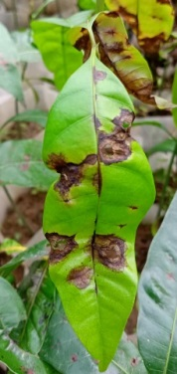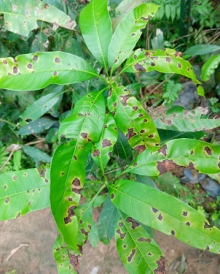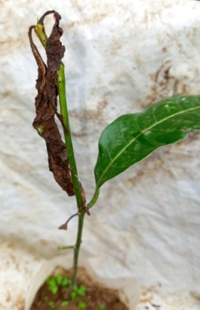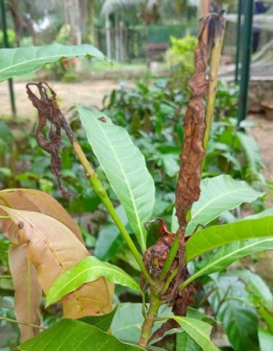
Figure 1. Typical symptoms of mango anthracnose disease (MAD) on seedlings: irregular, necrotic spots with chlorotic halos and twig infections with dieback.
Anthracnose disease management relies on multiple strategies, with fungicides receiving the most attention. However the fungicides pose a resistance risk: for instance, C. gloeosporioides has developed resistance to benzimidazole fungicides in Taiwan and Japan (Chung et al., 2010; Tashiro et al., 2012). To mitigate resistance, combining systemic and contact fungicides with different modes of action is required (Corkley et al., 2022). Alternatively, bioagents and botanicals exhibit strong antagonistic effects against C. gloeosporioides and other pathogens (Udhayakumar et al., 2019; Zin et al., 2020; Niazi et al., 2022; Kankam et al., 2022; Niazi et al., 2022; Haider et al., 2020; Alemu et al., 2014). Integrating these methods is crucial for developing a sustainable and economically viable disease management strategy. Kolar district is the largest mango-producing region in Karnataka (Saripalle, 2019). However, limited research has focused on the etiology and integrated management of the disease. The present study aimed to identify Colletotrichum species and to assess the efficacy of selected bioagents, botanicals, and fungicides to determine the most effective management options.
2. Materials and Methods
Disease sample collection, pathogen isolation and pathogenicity test
Anthracnose disease infected mango samples were collected from nurseries of Kolar region of Karnataka state in zip-lock bags and transported to the laboratory for analysis. Pathogen was isolated on potato dextrose agar (PDA) medium and pure cultures were obtained by single spore isolation. Pathogenicity was confirmed using detached-leaf assays as described by Grice et al. (2023) on healthy mango leaves (cv. Totapuri). Disease progression was monitored for 8-10 days post-inoculation (DPI). Upon the development of disease symptoms, the pathogen was re-isolated from symptomatic leaf tissues following the same protocol and confirmed based on cultural, morphological and microscopic studies.
DNA isolation, polymerase chain reaction (PCR) and phylogeny
Total genomic DNA was extracted from mycelia using the Macherey-Nagel NucleoSpin® Plant II Kit (Germany), following the manufacturers protocol. The internal transcribed spacer (ITS) region was amplified using universal primers ITS1 and ITS4 as described by White et al. (1990). PCR amplification was performed in a 25 µL reaction volume containing 12.5 µL of 2× PCR master mix (Takara), 1 µL each of forward and reverse primers (10 µM), 2 µL of template DNA and 8.5 µL of nuclease-free water. The thermal cycling conditions consisted of initial denaturation at 94°C for 3 min; 30 cycles of denaturation at 94°C for 20 s, annealing at 55°C for 30 s, and extension at 72°C for 45 s; followed by a final extension at 72°C for 7 min. The amplicons were purified and Sanger sequenced (Eurofins Labs, India). The nucleotide homology searches were done with the BLASTn sequence analysis of the NCBI and the phylogenetic tree was constructed by MEGA 12 (Kumar et al., 2024) using the neighbor-joining m ethod with 1000 bootstrap.
Screening of bioagents by dual-culture plate technique
Pure cultures of eight isolates of three biocontrol agents such as Trichoderma sp. Pseudomonas sp. and Bacillus sp. were used. The antagonistic activity of bioagents against C. gloeosporioides was evaluated using the dual-culture plate technique as described by Dennis et al. (1971). The colony radius of both bioagents and the pathogen were measured in two directions and the average was recorded. The percentage inhibition of pathogen growth was calculated using the following formula Vincent et al. (1947).
Per cent Inhibition (PI) | = | (C-T) | x | 100
Per cent Inhibition (PI) | = | C | x | 100
Where, PI= per cent inhibition of radial growth; C=diameter of Colletotrichum in the control plate; T=diameter in the dual-culture plate. The effectiveness of bioagents were scored as 1 = low antagonistic (I < 51%), 2 = moderate antagonistic (I = 51-60%), 3 = high antagonistic (I = 61-75%), and 4 = very high antagonistic (I > 75%) (Bogumił et al., 2013).
Evaluation of botanicals and fungicides
A total of ten plant materials were used, fresh plant parts were collected, washed, shade dried and ground into a fine powder. For each botanical, 100 g of the powdered material was mixed in 100 ml of distilled water (w/v) at ambient temperature for 24 hours. The mixture was filtered through muslin cloth followed by Whatman No. 1 filter paper, and stored as stock solutions. PDA medium (150 mL/flask) was added with concentrations of 5%, 10%, and 20% (w/v) and poured (15 mL/plate) into 90 mm sterile Petri plates. Similarly four contact, six systemic and five combi-products fungicides were used for the study. The active ingredient of each chemical from the formulation was used to prepare 50, 100 and 250 ppm concentrations for systemic and combi-products and 100, 250 and 500 ppm for contact fungicides. The poisoned food technique (Shrevelle, 1961) was used to assess the efficacy of botanicals and fungicides in-vitro. Plates were inoculated with 5 mm fresh mycelial discs of C. gloeosporioides, Control plates were prepared with PDA containing sterile distilled water. Each treatment included three replicates. After incubation for 8-10 days, radial growth was measured once controls showed full growth, and percent inhibition was calculated as described earlier (Vincent, 1947).
Data analysis
The percent inhibition of mycelial growth data was arcsine transformed to normalize and subjected to analysis of variance (ANOVA) to determine statistical significance. All statistical analyses were performed using R (version 2024.12.1+563). Data visualization and graphs were plotted using the original (non-transformed) mean data.
3. Results and Discussion
Morphological and microscopic studies
A total of ten Colletotrichum isolates were obtained from symptomatic mango tissues (leaves and young twigs) collected from nurseries in Kolar region (Karnataka state) (Table 1) during 2024/25. On PDA medium, the pathogen colonies exhibited dense, white to ash-grey, fluffy growth. The conidia were hyaline, uninucleate, and cylindrical with both ends rounded, measuring 11.50-18.20 × 3.20-5.10 µm.
Table 1. Colletotrichum isolates obtained in the present study along with their geographic location and ITS sequence GenBank accession numbers
Nursery Location | Isolate code | Colletotrichum Sp. | GenBank Accession No.
Mulabagil (13.109354°N 78.373954° E) | ATH-1 | C. asianum | PV523164
Mulabagil (13.109354°N 78.373954° E) | ATH-2 | C. asianum | PV523165
Srinivaspur (13.349944° N 78.178554° E) | ATH-3 | C. gloeosporioides | PV523166
Srinivaspur (13.349944° N 78.178554° E) | ATH-4 | C. gloeosporioides | PV523167
Srinivaspur (13.349944° N 78.178554° E) | ATH-5 | C. gloeosporioides | PV523168
Srinivaspur (13.349944° N 78.178554° E) | ATH-6 | C. gloeosporioides | PV523169
Kolar (13.132225° N 78.178757° E) | ATH-7 | C. siamense | PV523170
Kolar (13.132225° N 78.178757° E) | ATH-8 | C. siamense | PV523171
Kolar (13.132225° N 78.178757° E) | ATH-9 | C. gloeosporioides | PV523172
Kolar (13.132225° N 78.178757° E) | ATH-10 | C. gloeosporioides | PV523173
Phylogenetic analysis and distribution of Colletotrichum species
BLASTn sequence analysis identified three Colletotrichum species associated with mango anthracnose. Among the ten isolates, six were identified as C. gloeosporioides, two as C. asianum and two as C. siamense. In the Mulabagil region, the samples were detected with C. asianum; in the Srinivaspur region, all the isolates were C. gloeosporioides; whereas in the Kolar region, a mixed infection of both C. gloeosporioides and C. siamense was observed (Table 1). Phylogenetic analysis revealed that all three species formed distinct clusters, with C. siamense clustering closely with C. gloeosporioides (Figure 2). Multiple Colletotrichum species associated with mango anthracnose has been reported from different parts of the world including East India, Mexico, Thailand, Taiwan, China (Tovar-Pedraza et al., 2020, Li et al., 2019; Wu et al., 2020; Rattanakreetakul et al., 2023; Ganesan et al., 2024). The distribution and prevalence of specific Colletotrichum species may be influenced by environmental conditions, host genotypes, and management practices, as evidenced by the variability in species composition across geographical regions.
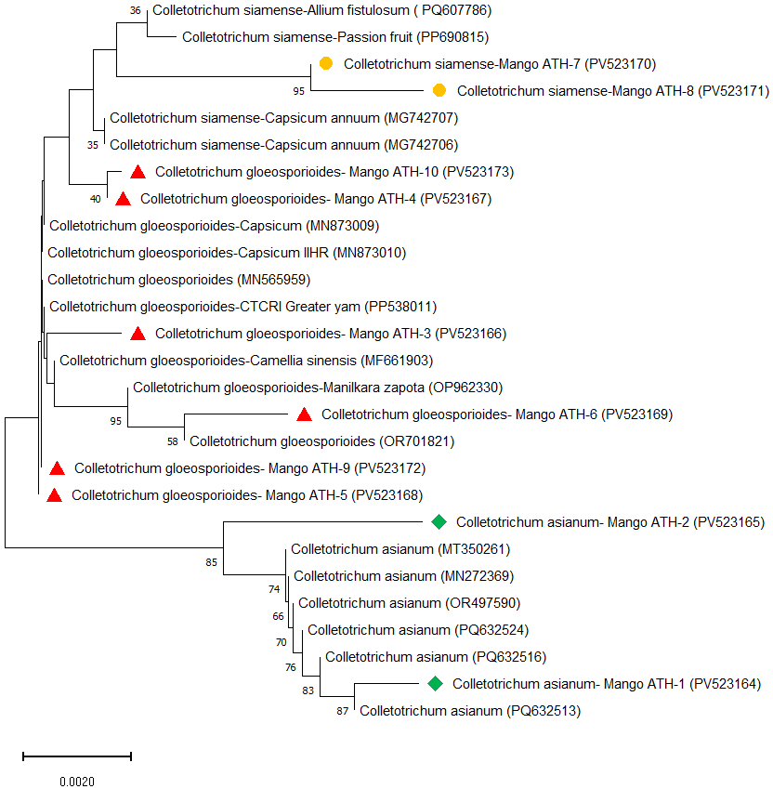
Figure 2. Phylogenetic analysis of ITS (ITS1 5.8S rRNA, ITS2) sequences of Colletotrichum sp. in the present study (●♦▲) along with available corresponding sequences from NCBI-GenBank. The GenBank accession numbers are given in parentheses. The scale bar represents 0.002 substitutions per nucleotide position.
Antagonistic effect of bioagents and botanicals against of C. gloeosporioides
There was a highly significant difference (p <0.001) among the tested bioagents (Table 2). Trichoderma viride-1 recorded maximum inhibition of 69.76 per cent with an antagonistic activity score of three (very high antagonistic activity), this was followed by T. harzianum-1 (59.96%). However, the least mycelial inhibition was recorded in B. pumulis (44.91%) with an antagonistic activity score of one (low antagonistic activity). The effectiveness of Trichoderma can be attributed to multiple mechanisms such as mycoparasitism, competition, antibiosis, and induction of plant defense responses, which enable it to suppress pathogen growth and enhance host resistance (Benítez et al., 2004; Cortes-Penagos et al., 2007; Guzmán-Guzmánet et al., 2023).
Table 2. In-vitro efficiency of bioagents against Colletotrichum gloeosporioides
Sl. No. | Bioagents* | Mean Inhibition (%) ± SE | Antagonistic activity score
1 | Bp | 44.91 (42.08) | 1
2 | Bs | 48.66 (44.23) | 1
3 | Pf-1 | 54.46 (47.56) | 2
4 | Pf-2 | 57.56 (49.35) | 2
5 | Th-1 | 59.96 (50.51) | 2
6 | Th-2 | 58.03 (49.62) | 2
7 | Tv-1 | 69.76 (56.65) | 3
8 | Tv-2 | 50.75 (59.56) | 2
P (F> 0.05) |  | <0.001
LSD (0.05) |  | 1.682
*Bp=Bacillus pumilis; BS=Bacillus subtilis; Pf= pseudomonas fluorescence; Th=Trichoderma harzianum; Tv-Trichoderma viride. Values in parentheses are arcsine-transformed. Statistical analysis was performed on transformed data using one-way ANOVA.
There was a highly significant difference (p <0.001) among the antifungal effects of botanicals on mycelial inhibition of C. gloeosporioides (Table 3, Figure 3).
At 5 per cent concentration, more than 50 per cent inhibition was recorded in the extracts of Azardirecta indica (58.36%), Pongamia pinnata (58.10 %), Morinda citrifolia (54.23%) and Leucas aspera (51.93%). At 10 per cent concentration, P. pinnata (70.43%) recorded maximum per cent inhibition on par with A. indica (69.63 %). Similarly, at 20 per cent concentration both P. pinnata (79.90%) and A. indica (79.20%) come out as effective botanicals in inhibition of mycelial growth.
Interestingly, Allium cepa has been less effective at five per cent (21.23%) but became effective at 10 per cent (53.16%) and 20 per cent (66.05%) concentrations. The present finding is in line with observations in which A. indica exhibited maximum per cent inhibition (100%) of mycelial growth of Colletotrichum boninense infecting beans (Kushaha et al., 2024). In another study, extracts from Ruta chalepensis and A. sativum showed prominent inhibition of growth in C. gloeosporioides, with an inhibition of 83.70 per cent and 78.14 per cent, respectively (Worku et al., 2025).
Table 3. Antagonistic activity of plant extracts against Colletotrichum gloeosporioides by poison food technique
Botanical | Mean Inhibition (%) ± SE |  |  | Mean
Botanical | 5% | 10% | 20% | Mean
Allium cepa | 33.93 (35.63) | 38.93 (38.60) | 55.80 (48.34) | 42.88 (40.85)
Allium sativum | 21.23 (27.42) | 53.16 (46.82) | 66.05 (54.37) | 46.81 (42.87)
Aquilaria khasiana | 6.83 (15.02) | 38.03 (38.08) | 40.13 (39.3) | 28.33 (30.80)
Azadirachta indica | 58.36 (49.82) | 69.63 (56.56) | 79.20 (62.88) | 69.06 (56.42)
Eucalyptus globules | 20.13 (26.65) | 40.53 (39.54) | 43.51 (41.27) | 34.72 (35.92)
Leucas aspera | 51.93 (46.11) | 52.40 (46.38) | 57.10 (49.08) | 53.81 (47.19)
Morinda citrifolia | 54.23 (47.43) | 55.86 (48.37) | 60.70 (51.19) | 56.93 (48.99)
Ocimum sanctum | 38.76 (38.49) | 51.96 (46.13) | 54.64 (47.66) | 48.45 (44.09)
Pongamia pinnata | 58.10 (49.66) | 70.43 (57.08) | 79.90 (63.4) | 69.47 (56.71)
Zingeiber officinale | 27.46 (31.6) | 35.50 (36.56) | 54.83 (47.78 ) | 39.26 (38.64)
Source of Variation | df | F-value | p-value*
Botanical | 9 | 340.83 | <0.001
Concentration | 2 | 781.45 | <0.001
Botanical × Concentration | 18 | 35.12 | <0.001
Values in parentheses are arcsine-transformed. Statistical analysis was performed on transformed data using two-way ANOVA. *highly significant. bold values indicate the most effective botanicals.
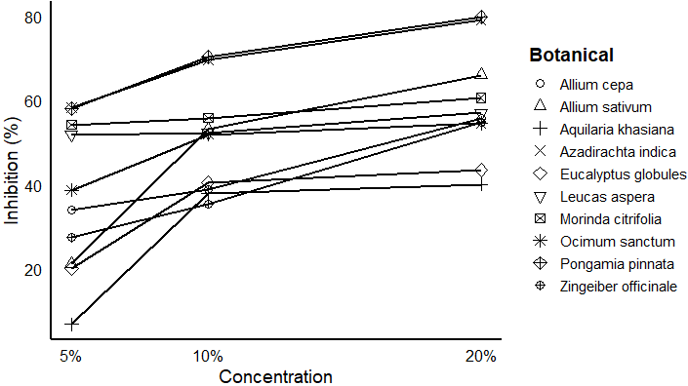
Figure 3. Antagonistic activity of ten botanicals on mycelial growth of C. gloeosporioides.
Efficacy of synthetic fungicides against C. gloeosporioides
The tested fungicides and their concentrations have highly significant differences (p <0.001) Table 4 and Figure 4). Propineb has been identified as an effective contact fungicide for inhibiting mycelial growth with a mean inhibition of 52.95 per cent. Among the systemic and combi product fungicides, maximum mean per cent inhibition of mycelial growth was recorded in tebuconazole + trifloxystrobin combination (75.97%) followed by, tebuconazole (72.08%) and propiconazole (68.81%). Interestingly, carbendazim + iprodione (61.61%) combination showed significant inhibition of mycelial growth, however carbendazim + mancozeb combination (23.65%) carbendazim (25.63%) alone are not effective in inhibiting mycelial growth. Several studies have been demonstrated that hexaconazole, propiconazole, combination of tebuconazole + trifloxystrobin found very effective in inhibition of mycelial growth of C. gloeosporioides (Inayat et al., 2014; Verme et al., 2023; Padsala et al 2025). sterol biosynthesis inhibitors (SBI) group of fungicides such as tebuconazole, propiconazole, hexaconazole, propiconazole, difenconazole belongs to chemical group triazole targets C14 demethylase in sterol biosynthesis which possess medium risk represent one of the most potent classes of fungicides available to the grower for the control of many economically important pathogens (FRAC, accessed on 15 October 2024).

Table 4. In-vitro evaluation of fungicides against C. gloeosporioides using poison food technique
Commercial name | Active ingredient (a.i.) | Per cent inhibition @ concentrations (a.i.) |  |  | Mean inhibition
Contact fungicides |  | 100 ppm | 250 ppm | 500 ppm | Mean inhibition
Captan | Captan 50WP | 20.30 (26.72) | 36.23 (37.01) | 48.90 (44.37) | 35.14 (36.03)
Antracol | Propineb 70 %WP | 45.60 (42.47) | 53.43 (46.97) | 59.83 (50.67) | 52.95 (46.70)
Dithane M- 45 | Mancozeb 75 % WP | 5.46 (13.43) | 12.07 (20.29) | 40.50 (39.52) | 19.34 (24.41)
Blitox | Copper oxy chloride 50% WP | 3.03 (10.01) | 8.97 (17.37) | 13.33 (21.41) | 8.44 (16.26)
Systemic and Combi product fungicides |  | 50 ppm | 100 ppm | 250 ppm
Amistar | Azoxystrobin 25% SC | 7.10 (15.44) | 34.00 (35.67) | 53.00 (46.72) | 31.37 (32.61)
Bavistin | Carbendazim 50% WP | 10.53 (18.90) | 23.47 (28.97) | 42.90 (40.92) | 25.63 (29.60)
Contaf | Hexaconazole 5% EC | 45.89 (42.64) | 52.97 (46.70) | 65.17 (53.83) | 54.68 (47.72)
Tilt | Propiconazole 25% EC | 60.97 (51.34) | 71.07 (57.47) | 74.40 (59.61) | 68.81 (56.14)
Score | Difenoconazole 25 % EC | 49.23 (44.56) | 63.63 (52.91) | 67.97 (55.53) | 60.28 (51.00)
Folicur | Tebuconazole 25.9% EC | 65.83 (59.06) | 73.57 (61.24) | 76.83 (54.24) | 72.08 (58.18)
Avtar | Hexaconazole + Zineb 72% WP | 43.93 (41.51) | 50.93 (45.53) | 53.83 (47.20) | 49.56 (44.75)
SAAF | Carbendazim + Mancozeb 75% WP | 10.27 (18.67) | 23.67 (29.10) | 37.00 (37.47) | 23.65 (28.41)
Quintol | Carbendazim + Iprodione 50% WP | 53.27 (46.87) | 65.03 (53.76) | 66.53 (54.66) | 61.61 (51.76)
Ridomil MZ Gold | Metalaxyl + Mancozeb 72% WP | 40.73 (39.66) | 43.10 (41.03) | 54.50 (47.58) | 46.11 (42.76)
Nativo | Tebuconazole + Trifloxystrobin 75% WP | 70.07 (56.84) | 75.07 (60.06) | 82.77 (65.51) | 75.97 (60.80)
Source of Variation |  | df | F-value | p-value*
Chemical |  | 14 | 1063.89 | <0.001
Concentration |  | 3 | 924.16 | <0.001
Chemical x Concentration |  | 27 | 35.31 | <0.001
Statistical analysis was performed on transformed data using two-way ANOVA.
Values in the parenthesis are arcsine transformed. *highly significant. Bold values indicate best fungicides in each category

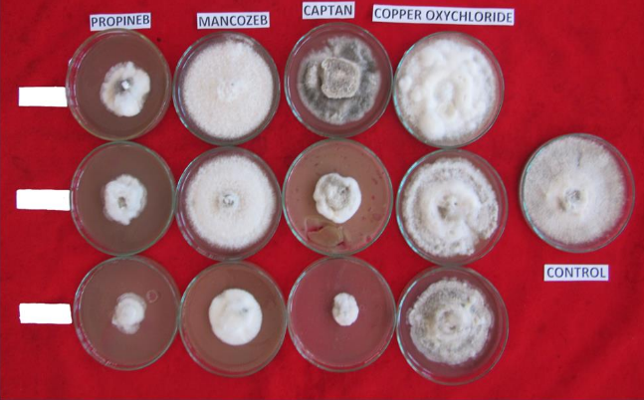
b)
a)
100 ppm

250ppm

500 ppm

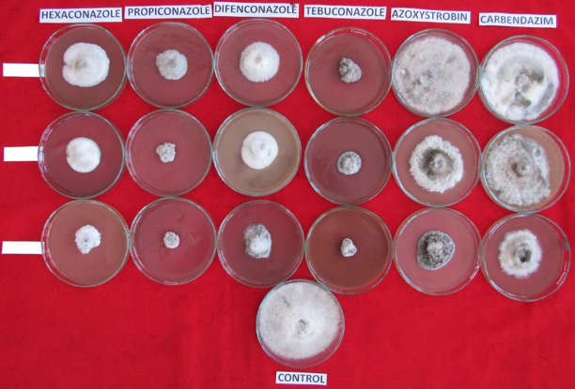
c)
50 ppm

100 ppm

250 ppm
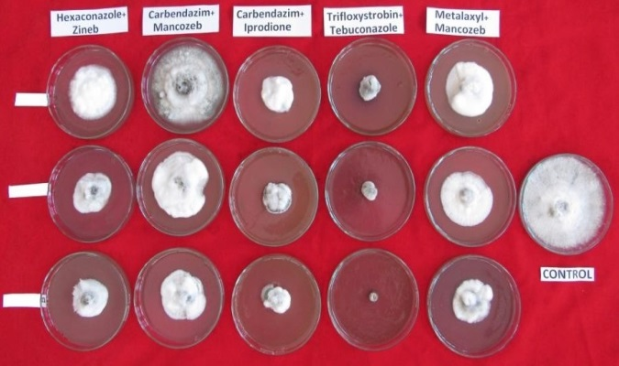
50 ppm

100 ppm

250 ppm
Figure 4. In-vitro evaluation of contact (a); systemic (b); and combi product (c) fungicides against C. gloeosporioides using poison food technique.
Conclusions
Anthracnose disease is considered to be most devastating disease of mango causing severe losses. The present study revealed complex etiology of MAD including C. gloeosporioides, C. asianum and C. siamense with C. gloeosporioides is being the most common species. Bioagent Trichoderma viride-1 found to be most effective in suppressing the mycelial growth (69.76%) of the fungus. Plant extracts such as Pongamia pinnata seed extract (69.47%) and Azadirachta indica seed extracts (69.06%) were showed promising antifungal activity. Among the fungicide propineb was the most effective contact fungicides, under systemic and cobmibi product tebuconazole + trifloxystrobin (75.97%) is the most effective followed by tebuconazole (72.08%) and propiconazole (68.81%). These inputs can be useful for developing precise detection tools and developing integrated management strategies.
Declarations
Ethics Statement: Not applicable
Informed Consent: Not applicable
Data Availability: The gene sequence data generated in this study have been deposited in the NCBI GenBank database under the accession numbers PV523164, PV523165, PV523166, PV523167, PV523168, PV523169, PV523170, PV523171, PV523172, and PV523173. These data are publicly accessible at https://www.ncbi.nlm.nih.gov/

COMPETING INTERESTS DISCLAIMER:
Authors have declared that they have no known competing financial interests OR non-financial interests OR personal relationships that could have appeared to influence the work reported in this paper.

References:
- Dofuor AK, Quartey NKA, Osabutey AF, et al. Mango anthracnose disease: the current situation and direction for future research. Front Microbiol. 2023;14:1168203. doi:10.3389/fmicb.2023.1168203
- Kamle M, Kumar P. Colletotrichum gloeosporioides: pathogen of anthracnose disease in mango (Mangifera indica L.). In: Current Trends in Plant Disease Diagnosis and Management Practices. Cham: Springer; 2016:207–219. doi:10.1007/978-3-319-27312-9_9
- Sayiprathap BR, Ekabote SD, Narayanaswamy H, Ravindra H, Adivappar N. Survey for the severity of anthracnose disease of mango (Mangifera indica L.) in nurseries of Karnataka state during Kharif 2015–16. Int J Pure Appl Biosci. 2018a;6(1):1139–1141. doi:10.18782/2320-7051.6112
- Cheng YJ, Wu YJ, Lee FW, et al. Impact of storage condition on chemical composition and antifungal activity of pomelo extract against Colletotrichum gloeosporioides and anthracnose in postharvest mango. Plants (Basel). 2022;11:2064. doi:10.3390/plants11152064
- Tovar-Pedraza JM, Mora-Aguilera JA, Nava-Diaz C, et al. Distribution and pathogenicity of Colletotrichum species associated with mango anthracnose in Mexico. Plant Dis. 2020;104:137–146. doi:10.1094/PDIS-01-19-0178-RE
- Mo J, Zhao G. Identification and characterization of Colletotrichum species associated with mango anthracnose in Guangxi, China. Plant Dis. 2018;102(7).
- Li Q, Bu J, Shu J, et al. Colletotrichum species associated with mango in southern China. Sci Rep. 2019;9:18891. doi:10.1038/s41598-019-54809-4
- Cai L, Hyde KD, Taylor PWJ, et al.. A polyphasic approach for studying Colletotrichum. Fungal Divers. 2009;39:183–204.
- White TJ, Bruns T, Lee S, Taylor J. Amplification and direct sequencing of fungal ribosomal RNA genes for phylogenetics. In: Innis MA, Gelfand DH, Sninsky JJ, White TJ, eds. PCR Protocols: A Guide to Methods and Applications. San Diego, CA: Academic Press; 1990:315–322. doi:10.1016/B978-0-12-372180-8.50042-1
- Inayat S, Ullah A, Anwar A, Kaleem A. In vitro evaluation of fungicides against mango anthracnose caused by Colletotrichum gloeosporioides. Am J Biomed Life Sci. 2024;12(2):16–21. doi:10.11648/j.ajbls.20241202.11
- Shivakumar KV, Palaiah P, Mallesh SB, Sunkad G, Pampanna Y. Efficacy of fungicides and bioagents against Colletotrichum gloeosporioides causing anthracnose of mango (Mangifera indica L.). Environ Ecol. 2018;36(1A):221–225.
- Uddin SM, Talukder SH, Afroz M, Moon NJ. Management of anthracnose disease of mango caused by Colletotrichum gloeosporioides: a review. Acta Sci Agric. 2018;2(10).
- Sayiprathap BR, Ekabote SD, Adivappar N, Narayanaswamy H, Ravindra H. Screening of fungicides against anthracnose disease of mango on nursery seedlings. Int J Chem Stud. 2018b;6(4):1494–1497.
- Chung WH, Chung WC, Peng MT, Yang HR, Huang JW. Specific detection of benzimidazole resistance in Colletotrichum gloeosporioides from fruit crops by PCR-RFLP. New Biotechnol. 2010;27:17–24. doi:10.1016/j.nbt.2009.10.004
- Tashiro N, Manabe K, Ide Y. Emergence and frequency of highly benzimidazole-resistant Colletotrichum gloeosporioides, pathogen of Japanese pear anthracnose, after discontinued use of benzimidazole. J Gen Plant Pathol. 2012;78:221–226. doi:10.1007/s10327-012-0375-9
- Corkley I, Fraaije B, Hawkins N. Fungicide resistance management: maximizing the effective life of plant protection products. Plant Pathol. 2022;71:150–169.
- Udhayakumar R, Muthukumar A, Usharani S. In vitro evaluation of bacterial antagonists against mango anthracnose pathogen Colletotrichum gloeosporioides. Multilogic Sci. 2019;8(28).
- Zin NA, Badaluddin NA. Biological functions of Trichoderma spp. for agriculture applications. Ann Agric Sci. 2020;65:168–178. doi:10.1016/j.aoas.2020.09.003
- Niazi M, Karuna K, Somashekar YM, Padmashri HS. Evaluation of botanicals and bioagents against Colletotrichum gloeosporioides (Penz.) Penz & Sacc. causing anthracnose of mango. Mysore J Agric Sci. 2022;56(4):277–288.
- Kankam F, Larbi-Koranteng S, Adomako J, et al. Anthracnose disease of mango: epidemiology, impact and management options. In: Current and Emerging Challenges in the Diseases of Trees. London: IntechOpen; 2022.
- Haider E, Khan MA, Atiq M, Shahbaz M, Yaseen S. Phytoextracts as management tool against fungal diseases of vegetables. Int J Biosci. 2020;16:303–314. doi:10.12692/ijb/16.3.303-314
- Alemu K, Ayalew A, Woldetsadik K. Antifungal activity of plant extracts and their applicability in extending the shelf-life of mango fruits. Food Sci Qual Manag. 2014;33:47–53
- Saripalle M. Market awareness and profitability: case study of mango production in Karnataka, India. Econ Polit Wkly. 2019;54(4):52–59.
- Grice KRE, Bally ISE, Wright CL, et al. Mango germplasm screening for the identification of sources of tolerance to anthracnose. Australas Plant Pathol. 2023;52:27–41. doi:10.1007/s13313-022-00899-0.
- Edgar RC. MUSCLE: multiple sequence alignment with high accuracy and high throughput. Nucleic Acids Res. 2004;32(5):1792–1797. doi:10.1093/nar/gkh340
- Kumar S, Stecher G, Suleski M, Sanderford M, Sharma S, Tamura K. MEGA12: Molecular evolutionary genetic analysis version 12 for adaptive and green computing. Mol Biol Evol. 2024;41(12):msae263. doi:10.1093/molbev/msae263
- Dennis C, Webster J. Antagonistic properties of species-groups of Trichoderma. Trans Br Mycol Soc. 1971;57(1):41–48. doi:10.1016/S0007-1536(71)80078-5
- Vincent JM. Distribution of fungal hyphae in the presence of certain inhibitors. Nature. 1947;159:850.
- Bogumił A, Sas L, Lisek A, Trzcinski P, Harbuzov A. Identification of new Trichoderma strains with antagonistic activity against Botrytis cinerea. Folia Hortic. 2013;25(2):123–132. doi:10.2478/fhort-2013-0014
- Shrevelle VG. The Nature and Use of Modern Fungicides. Minnesota, USA: Burgess Publishing Company; 1961:308.
- Wu CJ, Chen HK, Ni HF. Identification and characterization of Colletotrichum species associated with mango anthracnose in Taiwan. Eur J Plant Pathol. 2020;157:1–15. doi:10.1007/s10658-020-01964-4
- Rattanakreetakul C, Keawmanee P, Bincader S, et al. Two newly identified Colletotrichum species associated with mango anthracnose in central Thailand. Plants (Basel). 2023;12:1130. doi:10.3390/plants12051130
- Ganesan S, Kumari N, Sahu S, et al. Characterization of Colletotrichum species causing new pre-harvest anthracnose symptoms on mango in eastern India. Australas Plant Pathol. 2024;53:239–252. doi:10.1007/s13313-024-00973-9
- Benítez T, Rincón AM, Limón MC, Codón AC. Biocontrol mechanisms of Trichoderma strains. Int Microbiol. 2004;7:249–260.
- Cortes-Penagos C, Olmedo-Monfil V, Herrera-Estrella A. The nature of fungal mycoparasitic biocontrol agents. In: Biological Control of Plant Diseases. Binghamton, NY: Haworth Food & Agricultural Products Press; 2007:327–353.
- Guzmán-Guzmán P, Kumar A, de los Santos-Villalobos S, et al. Trichoderma species: our best fungal allies in the biocontrol of plant diseases—a review. Plants (Basel). 2023;12:432. doi:10.3390/plants12030432
- Kushaha T, Mkindi A, Mbega E, Stevenson P, Belmain S. Botanical extracts control the fungal pathogen Colletotrichum boninense in smallholder production of common bean. Phytopathol Res. 2024;6:235. doi:10.1186/s42483-024-00235-y.
- Worku S, Alemu K, Tsedaley B. Combining plant extracts and hot water treatments for the management of postharvest mango anthracnose (Colletotrichum gloeosporioides). Sci Rep. 2025;15:5074. doi:10.1038/s41598-025-89587-9
- Verma S, Sahu S, Choudhary A, Panchouli LK. In vitro and in vivo evaluation of fungicides against Colletotrichum gloeosporioides (Penz. & Sacc.) in mango. Int J Plant Soil Sci. 2023;35(21):758–762. doi:10.9734/ijpss/2023/v35i214039
- Padsala J, Patel P, Kandoriya P, Prajapati A. In vitro assessment of fungicidal efficacy against Colletotrichum gloeosporioides Penz & Sacc. Plant Arch. 2025;25(2):1815–1820. doi:10.51470/PLANTARCHIVES.2025.v25.supplement-2.229
- Fungicide Resistance Action Committee (FRAC). (https://www.frac.info/frac-teams/working-groups/sbi-fungicides/#open-tour). Accessed on 15 October 2024.

