Efficient and Cost-Effective DNA Extraction methods from Pearl millet leaves

Abstracts
DNA extraction is very tedious process of different plant species because the presence of secondary metabolites and huge amounts of phenol that create the difficulty of DNA isolation. In molecular biology the DNA isolation is very crucial steps and their application viz. gene amplification, DNA restriction digestion, and gene cloning. A simple cost-effective and efficient method are required for isolation of genomic DNA of Bajra. The present work relatively rapid, simple, cost-effective, time saving, methods for DNA isolation from old and young leaves of Bajra genotypes without using liquid nitrogen in extraction buffer. Using this methods, high quality and quantity of genomic DNA was get from (were taken)1.0 g of old and young leaves and extracted total genomic DNA was amplified by employing SSR markers, which produced reproducible results. This protocol resolves the basic problems of DNA degradation, RNA contamination, and low DNA yield due to binding and/or co-precipitation with starches and complex polysaccharides.
Keywords: DNA; PCR; Grasses, DNA extraction and marker assisted selection (MAS)
Introduction
Pearl millet (Pennisetum glaucum L.) is a major crop grown mainly in the arid and semiarid regions of Asia and Africa. In India bajra (Pearl millet) is the 4th most widely grown food crop after rice, wheat and maize. It’s an important small grained C₄ plant belongs to the grass family poaceae (graminae) and subfamily panicoideae. Pearl millet is a diploid (2n=2x=14), cross pollinated, high tillering, polymorphic has a short life cycle, a large genome size approximately 1.76 GB and an outbreeding nature [1]. Pearl millet has several nutritional properties compared to other cereal grains (Figure 1) and excellent source of inorganic and organic nutrients and a cost-effective source of energy.
Total nucleic acids isolation is prerequisite steps in evaluation of genetic diversity, marker-assisted selection (MAS), Genetic purity analysis, quantative trait loci (QTL) analysis, conformation of transgenic and germplasm identification in modern breeding programs. High throughput molecular studies like MAS, QTL mapping and other genomic analyses often necessitate processing hundreds to thousands of samples required rapid and cost-effective DNA isolation protocols. Several researchers [2, 3, 4, 5,6] have explain DNA isolation protocols are mostly used in plant biotechnology and/or plant molecular biology, but available different methods comparatively expensive, used hazardous chemicals, time consuming, involved multiple steps, required expensive enzymes and used liquid nitrogen for grinding the samples [5, 7, 8].
Various research (3-7) has defined DNA isolation technique play key role in molecular biology and plant biotechnology. The DNA isolation many methods are available but they are relatively costly, involved hazardous reagents, time consuming, require multiple procedural steps, even utilize expensive enzymes and often depend on liquid nitrogen for sample grinding.
The Cetyl-trimethyl-ammonium bromide (CTAB) is most commonly used surfactants in DNA isolation include the lyses of cell wall and cell membrane, which release the genetic material into extraction buffer. CTAB protocols are very famous methods for plants DNA isolation, including other organism such as bacteria, Fungi, nematods, and animals [9, 10, 11, 12]. Though CTAB protocols have been widely used and effective isolated total genomic DNA from various plant species, they are time consuming, laborious, simple, and cost effective especially in resource limited laboratories [6, 13, 14, 15]. Some protocols have been informed to reduce the DNA isolation steps but required more amount of plant tissue samples, phenol, beta-merceptaethanol and liquid N₂ [16]. The modified CTAB isolation protocols employing high concentration of salts to used removed polysaccharides because huge quantity of polysaccharide in samples the problematic at the time of PCR reaction.
A number of protocols are available and are being developed for extraction of genomic DNA from plants. While, diverse plants contain different amounts of DNA, high-quality nucleic acids is a requirement for marker assisted selection, biotechnological application, molecular biology practices such as DNA restriction digestion, gene cloning, PCR amplification, DNA fingerprinting, southern blotting etc. Different total genomic DNA isolation methods have been developed for pearl millets [23, 24]. But extraction of high molecular weight, high quality genomic DNA from pearl millet having higher amounts of polysaccharides, polyphenols, secondary metabolites is a major problem and big challenge in PCR amplification. However, in the protocols provided by [17, 18, 19], the concentrations of nucleic acids from cereal crops viz. rice, wheat and maize were relatively low. Therefore, a protocol for extracting genomic DNA from young or old, fresh leaves samples that is applicable to a variety of plants, regardless of the complexity of their genomes is presented. The objective of this study was to develop a simple an efficient and rapid method to isolate DNA under normal laboratory condition from small amount of tissue for large number of samples.

Material and Methods
Materials
In current study we were used the Bajra [Pennisetum glaucum (L.) R. Br.] plant material of young (Figure 2) stage top most miner developed leaf grown in fields conditions for isolation of DNA. All leaves sample were collected from grown in fields conditions Pearl millet 15 day to 3-month-old plants, collected leaf sample wrapped in aluminum foil and kept at environmental temperature or ice pack.
Primers
Isolated genomic DNA were amplified with SSR markers and specific primers (Table: 1.0).
Table 1.0 List of four SSR primers pairs utilized for amplification of pearl millet genomic DNA extracted from five entries used in the study.

Primers | Forward | Reverse
IPES0034 | CCACAGGAGGAAAGAACACC | AGCACCGTGAACACAACAAC
IPES0012 | TCAAATGCACGCCTAAGAAA | TCACCCGAAATGTCACAAGA
ICMP3028 | ACGATTCTTCGTCGTTCCAG | ATACGATACGCGCGAGCTAC
ICMP3013 | TGTGGGAGAGAGGAGAGTCC | CGCGAGATGATGTGTGGT

Reagents
- 1M Tris-HCl (prepared using 7.88 g Tris-HCl dissolved in 45 ml deionized water & pH 8.0 adjusted using 2N HCl and/or 3M NaOH solution, makeup the 60 ml volume with double distilled water).
- 0.5M EDTA (pH 8.0) (prepared using 9.34 g of EDTA dissolved in 40 ml de-ionized water and 50 ml final volume makeup with de-ionoized water).
- The 3M NaOH and 2N HCl solution was used to adjust the pH to 8.0.
- The 2.0 M NaCl (23.16 g NaCl added into 70 ml of de-ionized water and adjudged the final volume to 100 mL with de-ionized water);
- 3% CTAB (3 g CTAB dissolved into 100 ml de-ionized water);
- 2 % PVP (2 g PVP dissolved into 100 ml de-ionized water)
- 70% ethanol (70 ml absolute ethanol mixed with 30 ml de-ionized water.
- The 3X extraction buffers was prepared by using 3 % (w/v) CTAB solutions 2.5 % PVP, 1MTris-HCl (pH8.0), 0.5M EDTA (pH 8.0), and 2.05M NaCl (Table-2). Another solution chloroform: isoamyl alcohol (24:5) (CI) (Table 3), stock and working solution of 50X TAE (Tris-acetate- EDTA) buffer were prepared as Table 4.0, and 1X TE buffer (Table 5) their composition and preparation are available.
DNA extraction procedure
The young leaves were collected from 30 to 35 days old plants raised in the field, wrapped in aluminium foil and kept immediately in a box containing ice. 0.5-1.0-gram fresh young leaves (Figure 2) sample were grind in mortar and pastel in 1000 µl 3X preheated extraction buffer and 1000 µl extraction buffer added after grind the samples.
Table 2: Composition (only for 100ml) and Preparation of 3X CTAB extraction Buffer.
Reagent | Weight in gram | Stock Solution | Final Concentration in 100 ml | 100 ml preparation
NaCl | 12.0 | 5.13 M | 2.05 M | 40 ml
EDTA | 4.65 | 0.5 M | 20 mM | 10 ml
Tris-HCl | 3.94 | 1.0 M | 100 mM | 10 ml
PVP | 2.5 (w/v) | --- | 2.5 % | 2.5 g
CTAB | 3 (w/v) | --- | 3 % | 3.0 g
Double Distilled Water |  | --- | --- | 40 ml*
Final Volume |  |  |  | 100 ml
*Water amount more or less as required to maintain 100 ml final volume.

Table 3: Composition of fresh Chloroform: Isoamyl alcohol (24: 5)
S.N. | Reagents | - preparation
 | Chloroform | 82.76 ml
 | Isoamyl alcohol | 17.24 ml
Total |  | 100.0 ml
*Note store in refrigerators at -4 ℃
Table 4: preparation of the 50X and 1X TAE Buffer
S.N. | Reagent | 2 Litre 50X Buffer | 1 litre 1 X TAE Buffer
 | Tris Base (pH 8.0) | 484.80 g | 20.0 ml TAE + 980.0 ml double distilled water DDH₂O
 | Glacial Acetic Acid | 114.60 ml | 20.0 ml TAE + 980.0 ml double distilled water DDH₂O
 | EDTA (0.5M) at pH 8.0 | 200.00 ml | 20.0 ml TAE + 980.0 ml double distilled water DDH₂O

Table 5: Composition and Preparation of the 1X TE Buffer
S. N. | Reagents | Stock Solution (M) | Final Concentration (mM) | 250 ml preparation
 | Tris-HCl (pH 8.0) | 1.0 | 10 mM | 2.5 ml
 | EDTA (pH 8.0) | 0.5 | 1.0 | 0.5 ml
 | dd H2O | ---- | --- | 247 ml
Final volume |  |  |  | 250 ml

The homogenised mixture transfer in 2.0 ml eppendorf centrifuged tube and the content were mixed gently by swirling and inverting the tube and incubated at 65 ˚C in water bath for 45 min to 1 hour with occasional mixing at 10 to 15 min interval. The tube was taken supernatant and equal volume of Chloroform: isoamylalcohol (24:5) was added [22, 23, 24, 25]. The content was mixed by inversion tube and centrifuged at 10,000 rpm for 10 min. The clear supernatant aqueous layer was transferred to new tubes and re-extracted with an equal volume of CI and centrifuged at 10,000 rpm for 10 min. The supernatant was transferred into new tubes mix 2/3 volume of isopropanol was added and mixed gently by inverting the Eppendorf tube and placed at -20 ˚C for 40 min. Genomic DNA was pelleted by centrifuging at 10,000 rpm for 10 min and the pellet was wash with 400 µl 70% ethanol and centrifuge at 10,000 rpm for 5 min. The DNA pelleted was air dried and dissolved in 30 µl TE buffer by gentle tapping and isolated genomic DNA was stored at -20 ˚C for further use.

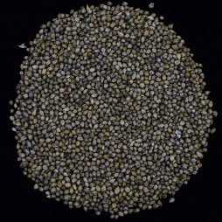  Baif Bajra | 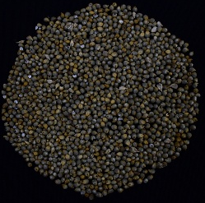  Giant Bajra | 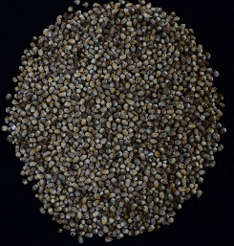  Moti Bajra | 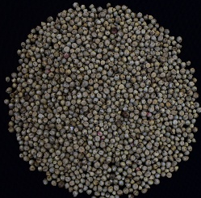  Nutrifeed Bajra | 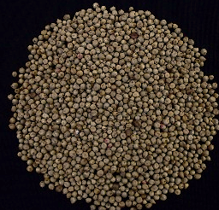  Rajko
Figure 1: Depicted the picture of selected seed of Bajra varieties.
Determination of isolated DNA quality purity and yield,
The concentration of extracted nucleic acids (ng/ul) were determined on wavelength of 260 nm and 280 nm using nanodrop. Purity of DNA was estimated by ratio of absorbance at 260 nm wavelength and 280 nm (Table 6). The determination of quality of isolated DNA is essential to assess the suitability of good quality DNA for PCR amplification. The isolated genomic DNA samples were subjected to electrophoresis through agarose gel to assess the quality of DNA isolated from the young leaves of plant achieve from the genotypes under evaluation in the present study. The DNA sample 3 µl were mixed with 1/8th volume of 6 X DNA gel loading dye and was loaded onto 0.8 % agarose gel containing of ethidium bromide (EtBr), in a submarine horizontal electrophoresis unit filled with 1X TAE buffer. Electrophoresis was carried out at 50V for 35 min. The gel was viewed under UV light to detect the quality of DNA. The DNA fragments were visualized as fluorescent bands because of fluorescence of ethidium bromide intercalated between major groves nitrogenous bases of DNA under UV light. Appearance of a single, sharp band of high molecular weight without smearing indicated the extraction of a good quality DNA sample with uniform segment size and less damage during extraction process.
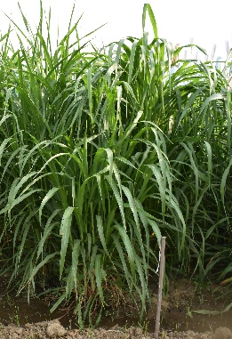  Baif Bajra | 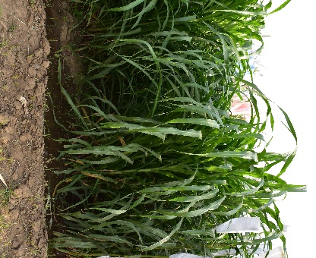  Giant Bajra | 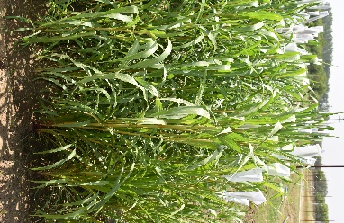  Moti Bajra | 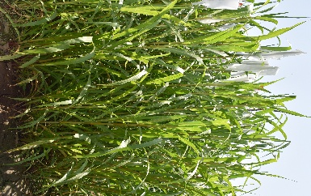  Nutrifeed Bajra | 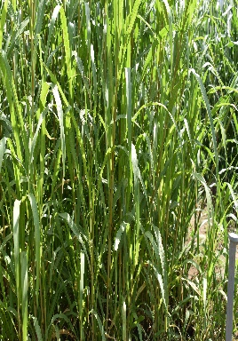  Rajko
Figure 2: Plant leaves sample used for Genomic DNA isolation
Table 6 Quality determination of DNA by the spectrophotometer
Sl. No | Pedigree | A260 | A280 | A260/A280 Ratio | DNA Concentration (ng/ml)
1 | Baif Bajra | 0.040 | 0.022 | 1.818 | 100.0
2 | Gaint Bajra | 0.043 | 0.023 | 1.869 | 107.5
3 | Nutrifeed Bajra | 0.039 | 0.021 | 1.857 | 97.5
4 | Moti Bajra | 0.042 | 0.022 | 1.909 | 105.0
5 | Rajko | 0.039 | 0.020 | 1.950 | 104.8
Separation of amplified genomic DNA through agarose gel electrophoresis
Amplification of DNA was carried out using standard protocol of polymerase chain reaction (PCR) adjusted to laboratory conditions. The amplification was carried out in a thermal cycler using 15 μl of reaction mixture (Table 7). The reaction mixture was prepared by varying the components involved in composition of reaction mixture. The primer vials were centrifuged before and after the addition of 1X TE buffer to the vials. After dilution the concentration of each primer stock solution was obtain as 100 μM. The diluted primers were stored at -20 ⁰C.
Table 7: Composition of PCR reaction mixture (15 μl)
Sl. No. | Components | Volume (μl)
1 | Water (Protese and Nuclease free) | 3.5
2 | 5X PCR Buffer | 3.0
3 | MgCl₂ (10 mM) | 1.6
4 | dNTPs (200 μM) | 3.0
5 | Primer F (5 μM) | 0.8
6 | Primer R (5 μM) | 0.8
7 | Taq DNA polymerase (1 unit) | 0.8
8 | Template DNA (Diluted1 : 9 (DNA:H2O)) | 1.5
 | Total | 15.0 µl
The polymerase chain reaction was performed with the help of microsatellite sites based 3 pairs of forward and reverse simple sequence repeat (SSR) primers. The amplification was carried out in a thermo-cycler using the program standardized for this purpose. The amplified product was separated using 2.0% agarose gel with ethidium bromide as staining reagent. The amplified product with expected product size above 100 bp was subjected to 2% gel electrophoresis at 70 V for an hour and then visualized and documented in gel documentation system. The size of the amplified product was estimated with the help of a 100 bp ladder.
Result and Discussion
The superior quality of genomics DNA per sample was obtained from young leaves of five pearl millets (Pennisetum glaucum) genotypes and amplified using four SSR markers viz. IPES0034, IPES0012, ICMP3013 and ICMP3028. The amplified products were observed in all samples tested with little variation in intensity of the amplified bands. After amplification IPES0034 produced 250 to 270 bp, IPES0012 produced 200 to 230 bp, ICMP3013 produced 150 to 180 bp, and ICMP3028 produced 170 to 180 bp polymorphic product and allelic size difference, 20, 30, 30 and 10 bp respectively (Figure 4) [24, 25]. Here is described a simple, easy, cost effective and reproducible procedure for PCR amplification of pearl millets genomic DNA, that also is applicable for other plant genomes.
DNA samples prepared using the extraction procedures lane 1. Baif Bajra, 2. Gaint Bajra 3. Nutrifeed Bajra 4. Moti Bajra and 5. Rajko bajra genomic DNA in Figure 3 were subjected to PCR amplification using different primers viz. IPES0034, IPES0012, ICMP3013, and ICMP3028 respectively. All the genomic DNA samples produced a clear, sharp, and reproducible PCR product when the primers were used for PCR amplification (Figure 4).
Different type of DNA isolation and purification protocols are available for plants however, the better results were obtained with those utilized CTAB [1, 5, 7, 16, 19, 20]. In this experiment is concerned with minor modification of CTAB method to isolated and purified genomic DNA without using liquid nitrogen (N₂), β-mercaptoethanol, and phenol. The salt (NaCl) concentration was high (2.05 M) which extracted good quantity genomic DNA. The main function of NaCl in extraction buffer is the removal of glycoproteins, proteins and carbohydrates which are associated with genomic DNA. High concentration of polyvinylpyrrolidon form H-Bond with phenolic metabolites and prevent the plant genomic DNA contamination by phenolic metabolites [16, 17,18, 19, 21, 23]. There are several advantages in using genomic DNA extraction protocol is suitable for polymerase chain reaction (PCR) genotyping, which can be employed for the recognition of alleles in diverse genetic, breeding and biotechnological approaches, viz. marker assisted selection (MAS), quantative trait loci (QTL), genetic mapping, and Transgenic screening, mutant introgression [13, 18, 21, 24]. All four microsatellite markers show very good amplification and polymorphism with the DNA extracted through this method. Therefore, this method should be recognizing as a good rapid and inexpensive method for DNA extraction from pearl millets leaves.

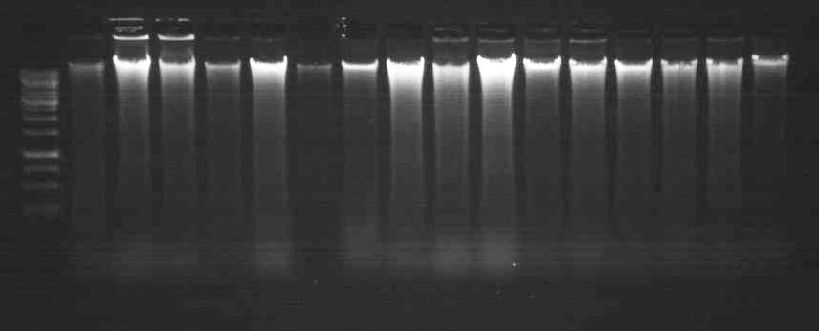
Figure 3: Crude genomic DNA isolated from five different varieties (1. Baif Bajra 2. Gaint Bajra 3. Nutrifeed Bajra 4. Moti Bajra 5) isolated from young leaves of Pearl millet.

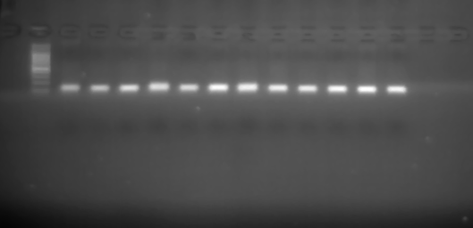  M 1 2 3 4 5  A  100 bp  1.5 Kb | 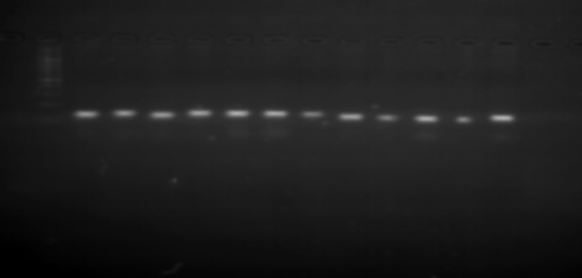  M 1 2 3 4 5  B  100 bp  1.5 Kb
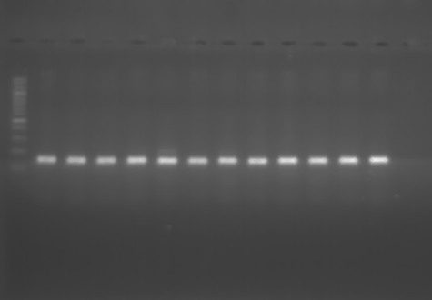  100 bp  M 1 2 3 4 5  C  1.5 Kb | 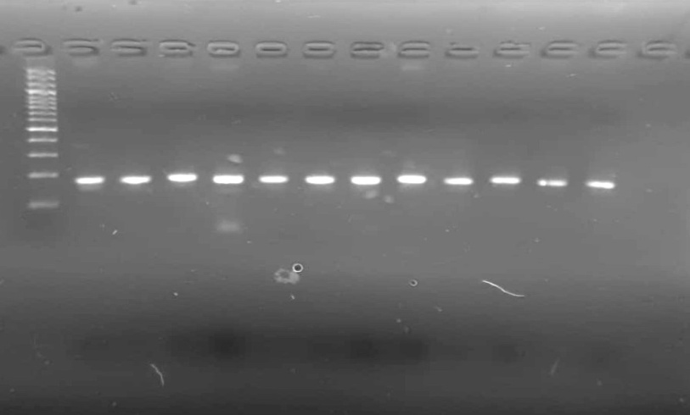  D  M 1 2 3 4 5  1.5 Kb  100 bp

Figure 4: Amplification of genomic DNA with selected four different primers A. IPES0034 B. IPES0012 C. ICMP3013 D. ICMP3028 with M= Marker and selected five genotypes 1. Baif Bajra 2. Gaint Bajra 3. Nutrifeed Bajra 4. Moti Bajra and 5. Rajko respectively.
Conclusions
In summary, the procedure for pearl millets total genomic DNA extraction described here could be a trusted and reliable protocol to work well for analysis without using liquid nitrogen, 2-mercaptoethanol and Phenols. High salt (NaCl) concentration cause protein to denature and aggregate making to easier to separate from DNA. NaCl provide positive charged ions (Na⁺) that prevents DNA strands from repelling (DNA strand negative charged due to phosphate backbone) each other.

REFERENCES
- Varshney, R. K., Shi, C., Thudi, M., Mariac, C., Wallace, J., Qi, P., et al. (2017). Pearl millet genome sequence provides a resource to improve agronomic traits in arid environments. Nat. Biotechnol. 35, 969. doi: 10.1007/s00122-011-1580-1.
- Jena, K. K., and Mackill, D. J. (2008). Molecular markers and their use in marker‐assisted selection in rice. Crop science, 48(4): 1266-1276.
- Murray, M. G., and Thompson, W. F. (1980). Rapid isolation of high molecular weight plant DNA. Nucleic acids Res. 8: 4321-4325.
- Doyle, J. J. and Doyle, J. L. (1987). A rapid DNA isolation procedure for small quantities of fresh leaf tissue. Phytochem. Bull. 19: 11-15.
- Ahmadikhah, A. (2009). Rapid mini-prep DNA extraction method in rice (Oryza sativa). African journal of Biotechnology. 8(2).
- Ferdous, J., Hanafi, M. M., Rafii, M. Y., and Muhammad, K. (2012). A quick DNA extraction protocol: Without liquid nitrogen in ambient temperature. African Journal of Biotechnology. 11(27): 6956-6964.
- Sajib, A. A., Bhuiya, M. A. I., and Huque, R. (2017). A simple, efficient and rapid method for good quality DNA extraction from rice grains. Rice Science. 24(2): 119-122.
- Sharma R., John, S. J., Damgaard, D. M., and McAllister, T. A. (2003). Extraction of PCR-quality plant and microbial DNA from total rumen contents. BioTechniques 34: 92-97. 96-97.
- Caccavo, F., Lonergan, D. J., Lovely, D. R., Davis, M., Stolz, J. F., and Mclnerney, M. J. (1994). Geobacter sulfurreducens sp-nov, a hydrogen-oxidizing and acetate-oxidizing dissimilatory metal-reducing microorganism. Appl. Environ. Microbiol. 60: 3752-3759.
- Thuan, N. T. N., Bigirimana, J., Roumen, E., Straeten, D. V. D., and Hofte, M. (2006). Molecular and pathotype analysis of the rice blast fungus in North Vietnam. Eur. J. Plant Pathol. 114: 381-396.
- Mondino, E. A., Covacevich, F., Studdert, G. A., Pimentel, J. P., and Berbara, R. L. (2015). Extracting DNA of nematodes communities from Argentine Pampas agricultural soils. Anais da Academia Brasileira de Ciências, 87: 691-697.
- Shahjahan, R. M., Hughes, K. J., Leopold, R. A. and DeVault, J. D. (1995). Lower incubation temperature increases yield of insect genomic DNA isolated by the CTAB method. Biotechniques, 19: 332-334.
- Kumar, P., Kirti, S., Rani, R., & Singh, P. (2023). A Simplified, Efficient and Rapid DNA Extraction Protocol from Rice Grains and Leaf. International Journal of Plant & Soil Science, 35(21), 517-524. https://doi.org/10.9734/IJPSS/2023/v35i214005.
- Kang, H. W., Cho, Y. G., Yoon, U. H., and Eun, M. Y. (1998). A rapid DNA extraction method for RFLP and PCR analysis from a single dry seed. Plant Mol. Biol. Rep. 16: 90.
- Allen, G. C., Vergara, M. A. F., Krasnyanski, S., Kumar, S., and Thompson, W. F. (2006). A modified protocol for rapid DNA isolation from plant tissue using cetyltrimethylammonium bromide. Nature protocols 1: 2320-2325.
- Tussell, R. T., Ramayo, A. Q., Herrera, R. R., Saavedra, A. L. Brito, D. P. (2005). A fast simple and reliable high yielding method for DNA extraction from different plant species. Mol. Biol. 31: 137-139.
- Clark, K. A., and Krysan, P. J. (2007). Protocol: an improved high-throughput method for generating tissue samples in 96-well format for plant genotyping (Ice-Cap 2.0). Plant methods, 3(1), 1-8.
- Kumar, R., Kumar, P., Singh, B., Gangwar, L.K., Tomar, H., Tiwari, U., and Kumar, M. (2024). Molecular characterization of pea (Pisum sativum) genotypes by utilization of RAPD markers. Agriculture Association of Textile Chemical and Critical Reviews Journal. 212-220. https://doi.org/10.21276/AATCCReview.2024.12.04.212.
- Chunwongse, J., Martin, G. B. and Tanksley, S. D. (1993). Pre-germination genotypic screening using PCR amplification of half-seeds. Theor. Appl. Genet. 86: 694-698.
- Kang, T. J., and Yang, M. S. (2004). Rapid and reliable extraction of genomic DNA from various wild-type and transgenic plants. BMC Biotech. 4: 20.
- Suman, S. K., Kumar, M., Sharma, V. K., and Kumar, R. (2020). A modified and efficient CTAB genomic DNA extraction method from maize leaf for PCR analysis. Journal of Pharmacognosy and Phytochemistry, 9(4): 3418-3420.
- Kumar, P., Kirti S., Kiran, Gangwar, R. P. C. (2023). In vitro studies in Gymnema sylvestre (Gudmar)-A high value medicinal plant. In vitro, AMA, 54(04).
- Ambawat, S., Satyavathi, C. T., Meena, R. C., Meena, R., Khandelwal, V., Singh, S., & Geela, R. (2021). DNA Fingerprint of pearl millet hybrids [Pennisetum glaucum (L.) R. BR.] using SSR markers. The Pharma Innovation Journal, 10, 07-13.
- Nweke, O., Osuji, C., Mairo, I. H., & Onyenekwe, P. C. (2014). A simple and rapid leaf genomic DNA extraction method for pearl millet (Pennisetum glaucum LR Br). Journal of Applied Biotechnology, 2(2), 75-81.
- Zidani, S., Ferchichi, A., & Chaieb, M. (2005). Genomic DNA extraction method from pearl millet (Pennisetum glaucum) leaves. African Journal of Biotechnology, 4(8), 862-866.

