Structural Attributes, Species Diversity, and Carbon Storage Potential of Kanger Valley National Park, Chhattisgarh

Abstract
Kanger National Park home to a tropical dry deciduous forest which is in central India also which has great floral diversity and is a key carbon reservoir. In 2023 we did a study in that park which looked at tree species composition, structural features, diversity indices, biomass, and carbon stock in 3 representative sites within the park Tirathgarh, Kamanar, and Kudruwada. We recorded 27, 22, and 25 tree species in Tirathgarh, Kamanar and Kudruwada respectively with stand densities which ranged from 694.46 to 1166.69 stems/ha and basal areas from 19.23 to 26.25 m2/ha. Shorea robusta and Tectona grandis were the dominant species in all sites, but in Kudruwada Buchanania cochinchinensis had very high abundance. Species diversity reached its zenith at Tirathgarh (H′ = 3.42), while Kudruwada recorded maximum biomass (279.02 t·ha⁻¹; carbon stock = 117.33 t·ha⁻¹). When set against peer dry deciduous reserves nationwide, Kanger National Park exhibits analogous structural complexity and high biomass. These results underline the protected area’s regional ecological value. The data also suggest that the park could effectively contribute to broader carbon sequestration efforts.
Keywords: Kanger National Park; tree diversity; biomass; carbon stock; tropical dry deciduous forest; Shorea robusta.

1. Introduction
Protected areas play a critical role in the conservation of biological diversity through the maintenance of ecological processes, the conservation of genetic resources, and the preservation of key ecosystem services (Rodrigues et al., 2004). In the Indian context, tropical dry deciduous forests are one of the most extensive types of forests; however, they are also subject to high levels of human-induced disturbances such as selective cutting, grazing, fire, and land-use change (Champion & Seth, 1968). Even in protected areas, these disturbances can cause significant changes in forest structure, composition, and function.
Kanger Valley National Park (KVNP) in the Bastar area of Chhattisgarh is one of the most undisturbed remaining areas of tropical dry deciduous forests in central India. The park holds a diverse forest mosaic dominated by ecologically and economically important tree species such as Tectona grandis and Shorea robusta. Its topographic variability, edaphic heterogeneity, and microclimatic conditions support a high level of floristic diversity and the occurrence of several rare and endemic species. Floristic inventories have shown the park to have a high level of angiosperm diversity, emphasizing its importance as a regional biodiversity hotspot.
Although the significance of the botanical aspect has been acknowledged, there has been little quantitative research on the tree layer composition, diversity, and carbon content in KVNP in the peer-reviewed literature. The fundamental structural parameters of tree density, basal area, and Importance Value Index (IVI) are critical for understanding forest organization, changes over time, and dominant species (Curtis & McIntosh, 1950). Comparing studies on other tropical dry deciduous forests in eastern and central India reveals even greater variability in forest structure and biomass across sites, even within forests of the same type (Mansingh et al., 2025). Tree density in these forests varies from a few hundred to over a thousand per hectare, with large variations in basal area and carbon content. Such variability highlights the importance of localized, plot-level measurements for making meaningful ecological comparisons and forest management decisions.
Estimation of forest biomass and carbon stocks is also a critical component of global climate change mitigation strategies, such as REDD+ under the United Nations Framework Convention on Climate Change (UNFCCC, 2010). In tropical dry deciduous forests, such as those found in the tropics, biomass production and carbon sequestration are shaped by intricate relationships between soil properties, disturbance patterns, and species-specific life history traits (Murthy et al., 2013). With the high floristic diversity in KVNP and recent estimates of site-level biomass, a comprehensive, component-by-component assessment of carbon stocks, including aboveground biomass, belowground biomass, litter, and soil carbon, is both timely and necessary to include KVNP in regional and national carbon accounting.

In this respect, the current study seeks to (i) record the tree species composition and diversity at representative sites in Kanger Valley National Park, (ii) estimate key structural variables, such as tree density, basal area, and Importance Value Index, and (iii) estimate component-wise biomass and carbon stocks. Moreover, the results are situated in a wider ecological and conservation context by comparing with published data from other Indian national parks and tropical dry deciduous forests worldwide.
Methods
2.1 Study Area
The Bastar district of Chhattisgarh, India, is home to Kanger National Park (KNP), which is roughly 200 km² in size and lies between latitudes 18°40′–18°55′ N and longitudes 81°56′–82°15′ E. The park's undulating topography, steep escarpments, and many perennial streams define it as part of the Deccan Plateau biogeographic zone. With an average of 1520 mm of precipitation annually, mostly between June and September, the climate is tropical monsoonal. The average summer temperature is between 40 and 42 degrees Celsius, and the average winter temperature is between 10 and 15 degrees Celsius. There are pockets of sandy loam among the primarily lateritic soils. The vegetation fits Champion and Seth's (1968) classification of tropical dry deciduous forests.
2.2 Sampling Design
Field surveys were carried out during the dry season, which runs from February to April 2023, when it is possible to identify species phenologically. The selection of three representative sites—Kudruwada, Kamanar, and Tirathgarh—was based on their accessibility, lack of recent human disturbance, and representation of the park's main habitat types. Stratified random sampling was used to create a set of 10 × 10 m quadrats in each site in order to capture spatial heterogeneity.
2.3 Data Collection
All woody individuals with a diameter at breast height (DBH) ≥ 10 cm were enumerated and identified to species level using regional floras and validated by taxonomic experts. For each species, the following parameters were computed:
Frequency (F) = (Number of quadrats in which a species occurs / Total quadrats) × 100
Density (D) = Total individuals of species / Total sampled area (ha⁻¹)
Basal area (BA) = π × (DBH / 2)² (m²) for each tree, summed per species

2.4 Phytosociological Analysis
Importance Value Index (IVI) for each species was calculated as the sum of relative frequency, relative density, and relative basal area (Curtis & McIntosh, 1950).
2.5 Diversity Indices
Species diversity was quantified using:
Shannon–Wiener Index (H′) = −∑ (pi × ln pi)
Simpson’s Dominance Index (D) = ∑ pi²
Pielou’s Evenness Index (E) = H′ / ln S
Margalef’s Richness Index (R) = (S − 1) / ln N

where pi = proportion of individuals of the I th species, S = total species, N = total individuals.
2.6 Biomass and Carbon Stock Estimation
Above-ground biomass (AGB) was estimated using species-specific allometric equations from Brown (1997) and Chave et al. (2005) for tropical dry deciduous forests:
AGB (kg) = 0.0509 × ρ × DBH² × H
where ρ = wood density (g·cm⁻³), DBH = diameter at breast height (cm), and H = tree height (m). Below-ground biomass (BGB) was estimated as 26% of AGB (Cairns et al., 1997). Biomass was partitioned into bole, branch, leaf, and root components. Carbon content was assumed to be 50% of oven-dry biomass.
2.7 Data Analysis
Descriptive statistics and diversity indices were computed using MS Excel 2019 and PAST software (version 4.0). Site-level comparisons of diversity and biomass were interpreted in light of published benchmarks for similar ecosystems.
3. Results
Table 1. Structure of tree layer on Tirathgarh site
S.N. | Species | Frequency (%) | Density (stem/ha) | Abundance (stem/ha) | BA  (m2/ha) | RF (%) | RD (%) | RBA (%) | IVI
1 | Shorea robusta | 80 | 138.34 | 172.92 | 3.24 | 9.14 | 13.81 | 16.86 | 39.82
2 | Tectona grandis | 95 | 235.00 | 247.37 | 6.61 | 10.86 | 23.46 | 34.39 | 68.71
3 | Terminalia tomentosa | 75 | 68.33 | 91.11 | 1.32 | 8.57 | 6.82 | 6.84 | 22.24
4 | Pterocarpus marsupium | 75 | 76.67 | 102.22 | 0.99 | 8.57 | 7.65 | 5.13 | 21.36
5 | Litsea monopetala | 55 | 48.33 | 87.88 | 0.86 | 6.29 | 4.83 | 4.48 | 15.59
6 | Haldina cordifolia | 55 | 48.33 | 87.88 | 0.82 | 6.29 | 4.83 | 4.26 | 15.37
7 | Schleichera oleosa | 15 | 8.33 | 55.56 | 0.28 | 1.71 | 0.83 | 1.45 | 4.00
8 | Cleistocalyx operculatus | 40 | 20.00 | 50.00 | 0.40 | 4.57 | 2.00 | 2.11 | 8.67
9 | Sphaeranthus indicus | 75 | 85.00 | 113.34 | 1.01 | 8.57 | 8.49 | 5.27 | 22.33
10 | Syzygium cumini | 20 | 28.33 | 141.67 | 0.39 | 2.29 | 2.83 | 2.03 | 7.15
11 | Bauhinia variegata | 15 | 8.33 | 55.56 | 0.08 | 1.71 | 0.83 | 0.42 | 2.97
12 | Madhuca longifolia | 40 | 26.67 | 66.67 | 0.35 | 4.57 | 2.66 | 1.82 | 9.06
13 | Lannea coromandelica | 5 | 1.67 | 33.33 | 0.02 | 0.57 | 0.17 | 0.10 | 0.84
14 | Phyllanthus emblica | 15 | 8.33 | 55.56 | 0.08 | 1.71 | 0.83 | 0.41 | 2.96
15 | Cleistanthus collinus | 25 | 15.00 | 60.00 | 0.27 | 2.86 | 1.50 | 1.40 | 5.75
16 | Buchanania lanzan | 5 | 1.67 | 33.33 | 0.01 | 0.57 | 0.17 | 0.07 | 0.81
17 | Anogeissus latifolia | 50 | 60.00 | 120.00 | 0.79 | 5.71 | 5.99 | 4.12 | 15.82
18 | Dalbergia sissoo | 10 | 13.33 | 133.34 | 0.16 | 1.14 | 1.33 | 0.85 | 3.32
19 | Haldina cordifolia | 10 | 6.67 | 66.67 | 0.08 | 1.14 | 0.67 | 0.40 | 2.21
20 | Acacia catechu | 5 | 3.33 | 66.67 | 0.04 | 0.57 | 0.33 | 0.22 | 1.12
21 | Acacia chundra | 20 | 20.00 | 100.00 | 0.23 | 2.29 | 2.00 | 1.17 | 5.46
22 | Schleichera oleosa | 40 | 36.67 | 91.67 | 0.47 | 4.57 | 3.66 | 2.45 | 10.68
23 | Tamarindus indica | 10 | 5.00 | 50.00 | 0.04 | 1.14 | 0.50 | 0.23 | 1.87
24 | Terminalia arjuna | 5 | 3.33 | 66.67 | 0.04 | 0.57 | 0.33 | 0.22 | 1.12
25 | Ficus racemosa | 10 | 10.00 | 100.00 | 0.10 | 1.14 | 1.00 | 0.51 | 2.65
26 | Gardenia turgida | 10 | 11.67 | 116.67 | 0.28 | 1.14 | 1.16 | 1.46 | 3.77
27 | Butea monosperma | 15 | 13.33 | 88.89 | 0.25 | 1.71 | 1.33 | 1.33 | 4.37
 |  | 875 | 1001.69 | 2454.98 | 19.23 | 100 | 100 | 100 | 300

3.1 Species Composition and Structural Attributes
Table 1–3 shows that Tirathgarh, Kamanar, and Kudruwada recorded 27, 22, and 25 tree species, respectively. Although basal area ranged from 19.23 m²·ha⁻¹ (Tirathgarh) to 26.25 m²·ha⁻¹ (Kamanar), the copse density differed significantly between sites, i.e., 694.46 stems·ha⁻¹ in Kudruwada to 1166.69 stems·ha⁻¹ in Kamanar. These differences indicate maturity and stocking differences that are sitelocated.
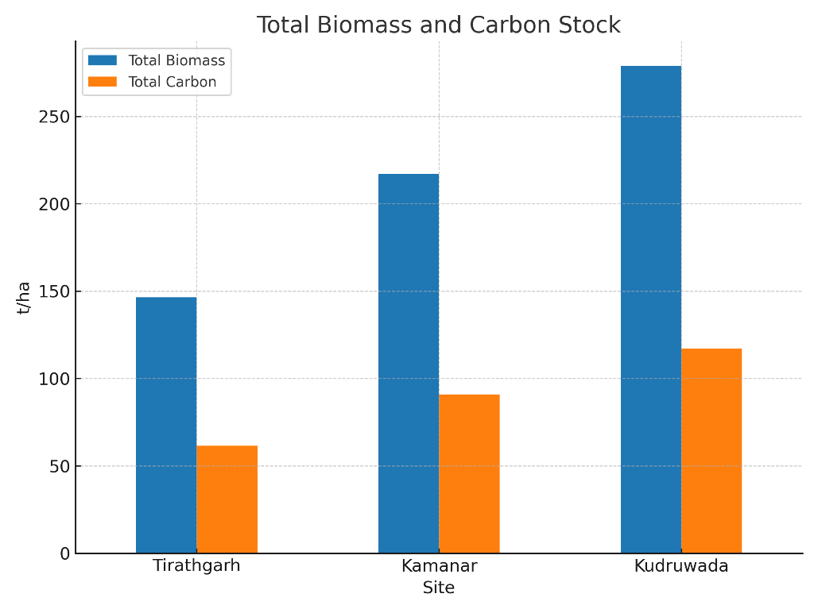

Fig. 1- Total Biomass and Carbon Stock.
Of all species Shorea robusta was ecologically of greatest importance at all the sites with maximum IVI of 86.05 at Kamanar to minimum IVI of 39.82 at Tirathgarh. In contrast to typical sal–teak dominance that characterizes the moist deciduous forests of central India, Tectona grandis exhibited co–dominance in terms of species IVI in Tirathgarh (68.71) and Kamanar (72.55), while Buchanania cochinchinensis was the second major species in Kudruwada (38.93).
In the relative frequency distribution (Fig..1), as a sorrel of rare ones [e.g., Ficus glomerata, Holarrhena pubescens, and Mangifera indica] were appeared occasionally (<10% frequency) may revealed the few available niche or the regeneration bottleneck but, a share of even more common species appeared in ≥75% of quadrats.
3.2 Diversity Indices
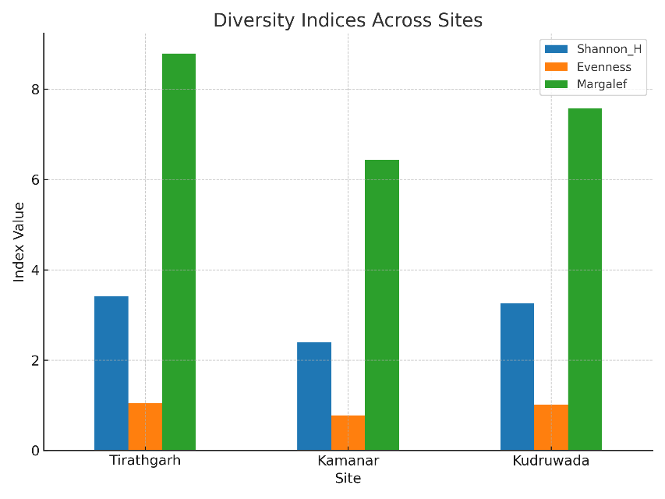
The diversity patterns of the three sites showed significant differences (Table 4; Fig. 2). Tirathgarh had the highest Shannon–Wiener index (H′) (3.42), Kudruwada came in second (3.25), and Kamanar ranked last (2.40). Tirathgarh (1.04) and Kudruwada (1.01) showed an even distribution of species, while Kamanar stood out with its noticeable unevenness (0.78). The evenness (E) values followed a similar trend.

Fig..2- Diversity Indices of all sites.

Kamanar (0.30) had a high concentration of canopy dominance among a few species. In contrast, Tirathgarh (0.17) had the lowest Simpson's dominance index (D), which points to low dominance pressure and more diversity. Margalef's richness index (R) placed Tirathgarh at the top (8.79), with Kudruwada (7.57) and Kamanar (6.43) following behind.3.2 Diversity Indices
The diversity patterns of the three sites showed significant differences (Table 4; Fig. 2). Tirathgarh had the highest Shannon–Wiener index (H′) (3.42), Kudruwada came in second (3.25), and Kamanar ranked last (2.40). Tirathgarh (1.04) and Kudruwada (1.01) showed an even distribution of species, while Kamanar stood out with its noticeable unevenness (0.78). The evenness (E) values followed a similar trend.
Kamanar (0.30) had a high concentration of canopy dominance among a few species. In contrast, Tirathgarh (0.17) had the lowest Simpson's dominance index (D), which points to low dominance pressure and more diversity. Margalef's richness index (R) placed Tirathgarh at the top (8.79), with Kudruwada (7.57) and Kamanar (6.43) following behind.

3.3 Biomass and Carbon Stock
Biomass estimates (Table 5; Fig. 3) ranged from 279.02 t·ha⁻¹ in Kudruwada to 146.54 t·ha⁻¹ in Tirathgarh. The carbon stocks for these areas were 117.33 t·ha⁻¹ and 61.51 t·ha⁻¹ . Kamanar showed values in between (217.16 t·ha⁻¹ biomass; 91.01 t·ha⁻¹ carbon stock).
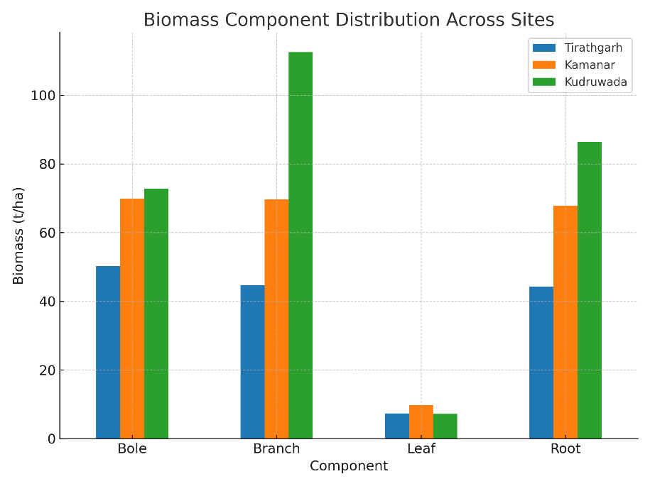

Fig. 3- Biomass Component Distribution of all Sites

The breakdown of biomass components (Fig..4) showed that bole biomass made up the largest part (38–46%) of the total biomass. Root biomass came next (22–26%) followed by branch biomass (18–25%), and leaf biomass (less than 7%). Kudruwada had the highest branch biomass (112.57 t·ha⁻¹), which points to the presence of older trees with wide crowns.

Branch biomass in Kamanar (SD = 33.64) and Kudruwada (SD = 25.37) showed the most variation among biomass components. This suggests structural differences due to species-specific growth patterns and trees of different ages in the same area.

3.4 Comparative Trends Across Sites
Tirathgarh and Kudruwada showed less control but more variety and balance. This points to mature ecosystems with a lower chance of losing biodiversity. Kamanar had the most trees, but two canopy species ruled. This hinted at the squashing of smaller species.

Kudruwada had decent species numbers, but its high plant mass came from a few big trees. So, the plant mass didn't match up with diversity patterns. In some guarded tropical dry forests that lose leaves, tree size and structure might matter more for storing carbon than the number of species. This shows how diversity and plant mass don't always go hand in hand in these woods.
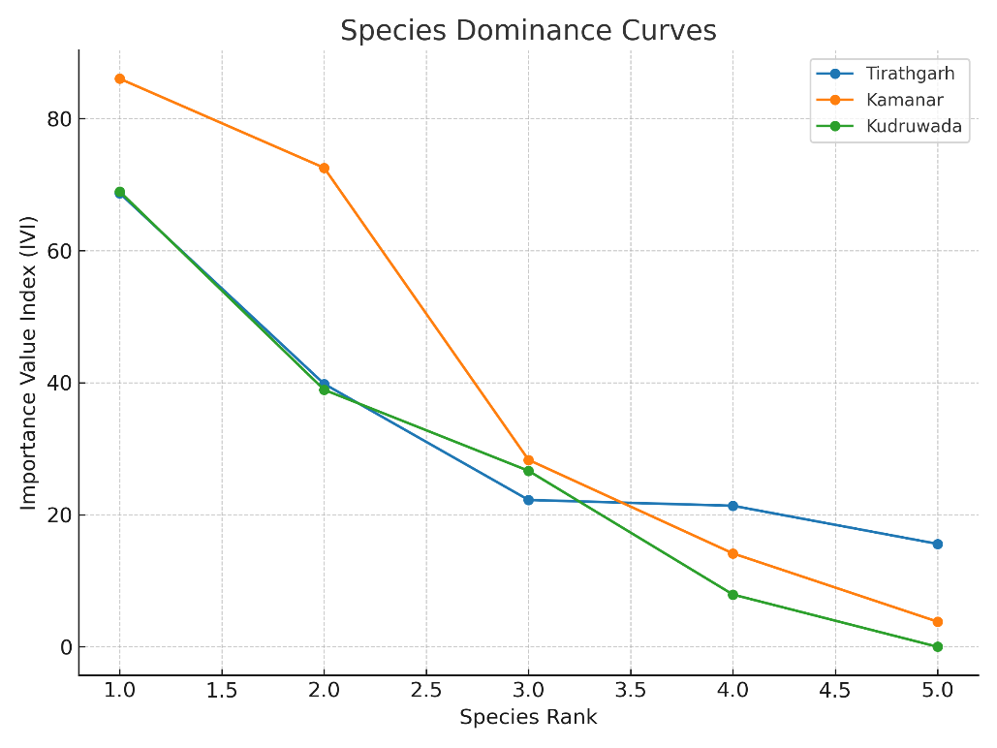

Fig. 4- Species Dominance Curves
4. Discussion
4.1 Species Composition and Dominance Patterns
The tree layer of Kanger National Park is composed of Shorea robusta and Tectona grandis which is in concurrence with the floristic composition of many dry deciduous forests of central India (Prasad et al., 2007; Singh & Singh, 1992). Unlike the normal dominance of sal–teak, Buchanania cochinchinensis has become a co-dominant in Kudruwada. This is consistent with site-specific edaphic and microclimatic issues favourable for NTFP-yielding plants (Rai et al., 2020). While episodic seedling mortality and herbivory have also been reported in other conserved deciduous forests, the relatively low abundance of some ecologically important plants including (Madhuca indica), Phyllanthus emblica and Ficus glomerata) indicated that at least some of these species may face challenges for regeneration (Sahu et al., 2012).
The designation of Tirathgarh and Kudruwada as equilibrium species stands, in which plenty is equally distributed among a number of species, is also confirmed by dominance-diversity curves. According to the resource-ratio hypothesis (Tilman, 1988), dominance of the canopy by the dominant species prevents the recruitment of intolerant subordinates to the shade, which is indicated by the steep curve of Kamanar, thus competitive exclusion.
4.2 Diversity Trends in Context
The Shannon-Wiener value (2.40–3.42) in our study was higher than that in the severely degraded stands (2.0; Mishra et al., 2018) but less than the range for that reported for the unaltered dry deciduous forest in India (2.1–3.6; Murthy et al., 2013; Sundarapandian & Swamy, 2000). The Communities of Tirathgarh and Kudruwada having evenness indices > 1.0 that are close to 1 tend to exhibit near equitable species distribution which is often linked to increased resistance under the stress conditions (Magurran 2004).
In contrast, Kamanar’s high dominance index (0.30) and low evenness (0.78) are consistent with findings from metal rich reserves where a few species of economic importance become abundant due to high natural site productivity or selective protection (Kumar et al., 2021). These trends emphasize the importance of tracking alpha diversity and dominance metrics for adaptive management in PA.
4.3 Biomass–Diversity Relationships
The biomass that was recorded (146.54-279.02 t·ha⁻¹) is within the range of biomass of other tropical dry deciduous forests in India which include Satpura Tiger Reserve (160-280 t·ha⁻¹; Tiwari et al., 2016) and Kanha National Park (180-260 t·ha⁻¹; Upadhyay et al., 2013). Kudruwada, with its large biomass and average species richness, not only supports the worldwide "big-tree" carbon storage concept by showing the disproportionate effect of large-diameter trees on the total carbon stock (Slik et al., 2013) but also exemplifies it.
The less strong correlation in Kudruwada implies that variation in size-structure, rather than diversity per se, can have a greater influence on biomass changes in mature stands while the positive correlation between diversity and biomass in Tirathgarh (high H′, moderate biomass) indicates the utilization of resources in a complementary manner by co-dominant species.
4.4 Conservation and Management Implications
According to REDD+ schemes, Kanger National Park is one of the most important sources of regional climate mitigation strategies because of its high biomass and carbon stock values especially in Kudruwada. Nevertheless, the presence of overdominance in a few species that leads to a decrease in long-term ecological stability Kamanar's uneven diversity and dominance patterns, therefore, require attention (Chisholm et al., 2013).
The first goal of management interventions is to promote the regeneration of rare and under-represented species by enrichment planting.
2. Monitor the populations of dominant species so as to prevent forest structure homogenisation.
3. Keep trees with big diameters that matter because they absorb a lot of carbon and are the main source of variety of life.
Continuing both conservation goals of KNP nature protection and climate change mitigation entails the need for prolong systematic observations that combine biodiversity and biomass measurements.
5. Conclusion
The present research offers the first comprehensive evaluation of the structural characteristics, biomass, carbon stock, and species diversity of trees at three representative locations in Kanger National Park. While all sites retain significant biodiversity and carbon storage, the results show that different ecological patterns emerge: Tirathgarh and Kudruwada show high diversity and structural balance, while Kamanar shows a very high stand density but decreased evenness as a result of Shorea robusta and Tectona grandis monopolising the canopy.
Kanger National Park is a major carbon reservoir in the central Indian landscape, as evidenced by its biomass and carbon stock values, which are on par with and occasionally higher than those reported from other tropical dry deciduous forests in India. Particularly in Kudruwada, disproportionately high biomass is supported because of the results emphasize the need to preserve structural and compositional heterogeneity in order to improve ecosystem resilience from a conservation standpoint. Maintaining the recruitment of under-represented species, protecting old-growth individuals, and making sure that biodiversity is not weakened by the dominance of a small number of canopy species should be the main goals of management interventions. Protecting and managing carbon-dense, biodiversity-rich sites like Kanger National Park will be essential to meeting both national biodiversity goals and global carbon sequestration commitments as anthropogenic pressures and climate change continue to threaten the integrity of tropical forests.
References
Brown, S. (1997). Estimating biomass and biomass change of tropical forests: A primer. FAO Forestry Paper 134, Food and Agriculture Organization of the United Nations, Rome.
Cairns, M. A., Brown, S., Helmer, E. H., & Baumgardner, G. A. (1997). Root biomass allocation in the world’s upland forests. Oecologia, 111, 1–11. [https://doi.org/10.1007/s004420050201]
Champion, H. G., & Seth, S. K. (1968). A revised survey of the forest types of India. Government of India Press, New Delhi.
Chave, J., Andalo, C., Brown, S.(2005). Tree allometry and improved estimation of carbon stocks and balance in tropical forests. Oecologia, 145, 87–99. [https://doi.org/10.1007/s00442-005-0100-x]
Chisholm, R. A., Muller-Landau, H. C., Abdul Rahman, K., et al. (2013). Scale-dependent relationships between tree species richness and ecosystem function in forests. Journal of Ecolog, 101(5), 1214–1224. [https://doi.org/10.1111/1365-2745.12132]
Curtis, J. T., & McIntosh, R. P. (1950). The interrelations of certain analytic and synthetic phytosociological characters. Ecology, 31(3), 434–455.
Kumar, A., Jhariya, M. K., & Raj, A. (2021). Floristic diversity and carbon sequestration potential in tropical deciduous forests of central India. Tropical Ecology, 62(3), 365–380.
Magurran, A. E. (2004). Measuring biological diversity. Blackwell Publishing, Oxford.
Mansingh, A., et al. (2025). Tree diversity, population structure, biomass accumulation, and carbon stock dynamics in tropical dry deciduous forests of Eastern India. BMC Ecology and Evolution. [https://doi.org/10.1186/s12862-025-02385-9]
Mishra, S., Singh, V., & Pathak, N. (2018). Impact of disturbance gradient on forest composition and regeneration in dry deciduous forests of Vindhyan highlands, India. Tropical Ecology, 59(3), 385–397.
Murthy, I. K., Gupta, M., Tomar, S.(2013). Estimating biomass and carbon sequestration of tropical dry deciduous forests: A case study from India. Forest Ecology and Management, 306, 167–175. [https://doi.org/10.1016/j.foreco.2013.06.027]
Netam, N., Singh, L., Tirkey, J., Painkra, D. S., Kashyap, K., & Toppo, S. (2024). Vegetation composition, tree diversity, biomass and carbon stock of Kanger Valley National Park. Ecology, Environment and Conservation, Vol. 30 (May Suppl. Issue), S108–S114.
Prasad, S. N., Hegde, M., & Hegde, R. (2007). Tree species diversity and composition in tropical dry deciduous forests of Bhadra Wildlife Sanctuary, Karnataka, India. Biodiversity and Conservation, 16, 2893–2913.
Rai, N. D., Ugle, P., & Ghate, R. (2020). Livelihoods and NTFP dependence in protected area landscapes: A case from central India. Environmental Management, 65(1), 45–57. [https://doi.org/10.1007/s00267-019-01248-w]
Rodrigues, A. S. L., Andelman, S. J., Bakarr, M. I. (2004). Effectiveness of the global protected area network in representing species diversity. Nature, 428, 640–643. [https://doi.org/10.1038/nature02422]
Sahu, S. C., Dhal, N. K., & Mohanty, R. C. (2012). Tree species diversity and soil nutrient status in tropical forests of Similipal Biosphere Reserve, Orissa, India. Tropical Ecology, 53(2), 163–168.
Singh, J. S., & Singh, S. P. (1992). Forest of Himalaya: Structure, functioning and impact of man. Gyanodaya Prakashan, Nainital.
Slik, J. W. F., Aiba, S., Brearley, F. Q., (2013). Large trees drive forest aboveground biomass variation in moist lowland forests across the tropics. Global Ecology and Biogeography, 22(12), 1261–1271. [https://doi.org/10.1111/geb.12092]
Sundarapandian, S. M., & Swamy, P. S. (2000). Forest ecosystem structure and composition along an altitudinal gradient in the Western Ghats, South India. Journal of Tropical Forest Science, 12(1), 104–123.
Tilman, D. (1988). Plant strategies and the dynamics and structure of plant communities. Princeton University Press.
Tiwari, A., Bhattacharya, P., & Raghubanshi, A. S. (2016). Carbon density and diversity of trees in tropical dry deciduous forests of India. Applied Ecology and Environmental Research, 14(4), 327–343.
Upadhyay, A., Shukla, G., & Singh, V. (2013). Carbon stock in forest floor and soil of tropical deciduous forests of central India. Journal of Forestry Research, 24(2), 377–382.

Table 2 Structure of tree layer on Kamanar site
S.N. | Species | Frequency (%) | Density (stem/ha) | Abundance (stem/ha) | BA  (m2/ha) | RF (%) | RD (%) | RBA (%) | IVI
1 | Shorea robusta | 93.75 | 358.34 | 382.23 | 11.67 | 10.87 | 30.71 | 44.46 | 86.05
2 | Tectona grandis | 100.00 | 352.09 | 352.09 | 8.08 | 11.59 | 30.18 | 30.78 | 72.55
3 | Terminalia alata | 100.00 | 112.50 | 112.50 | 1.86 | 11.59 | 9.64 | 7.07 | 28.31
4 | Pterocarpus marsupium | 18.75 | 6.25 | 33.33 | 0.29 | 2.17 | 0.54 | 1.10 | 3.81
5 | Cleistanthus collinus | 50.00 | 60.42 | 120.84 | 0.83 | 5.80 | 5.18 | 3.16 | 14.14
6 | Buchanania lanzan | 81.25 | 58.33 | 71.80 | 0.64 | 9.42 | 5.00 | 2.44 | 16.86
7 | Diospyros melanoxylon | 75.00 | 45.83 | 61.11 | 0.55 | 8.70 | 3.93 | 2.09 | 14.71
8 | Ceiba pentandra | 50.00 | 18.75 | 37.50 | 0.19 | 5.80 | 1.61 | 0.73 | 8.14
9 | Madhuca longifolia | 43.75 | 25.00 | 57.14 | 0.27 | 5.07 | 2.14 | 1.02 | 8.24
10 | Syzygium cumini | 43.75 | 27.08 | 61.91 | 0.51 | 5.07 | 2.32 | 1.93 | 9.33
11 | Holarrhena pubescens | 25.00 | 8.33 | 33.33 | 0.19 | 2.90 | 0.71 | 0.73 | 4.34
12 | Careya arborea | 31.25 | 12.50 | 40.00 | 0.13 | 3.62 | 1.07 | 0.49 | 5.18
13 | Schleichera oleosa | 31.25 | 18.75 | 60.00 | 0.27 | 3.62 | 1.61 | 1.03 | 6.26
14 | Diospyros montana | 6.25 | 2.08 | 33.33 | 0.02 | 0.72 | 0.18 | 0.06 | 0.97
15 | Mangifera indica | 6.25 | 2.08 | 33.33 | 0.04 | 0.72 | 0.18 | 0.14 | 1.04
16 | Anogeissus latifolia | 37.50 | 22.92 | 61.11 | 0.35 | 4.35 | 1.96 | 1.35 | 7.66
17 | Mallotus philippensis | 18.75 | 12.50 | 66.67 | 0.15 | 2.17 | 1.07 | 0.56 | 3.80
18 | Haldina cordifolia | 12.50 | 6.25 | 50.00 | 0.06 | 1.45 | 0.54 | 0.22 | 2.21
19 | Alstonia scholaris | 6.25 | 2.08 | 33.33 | 0.02 | 0.72 | 0.18 | 0.08 | 0.98
20 | Boswellia serrata | 12.50 | 6.25 | 50.00 | 0.07 | 1.45 | 0.54 | 0.25 | 2.23
21 | Strychnos nux-vomica | 6.25 | 2.08 | 33.33 | 0.02 | 0.72 | 0.18 | 0.09 | 0.99
22 | Garuga pinnata | 12.50 | 6.25 | 50.00 | 0.06 | 1.45 | 0.54 | 0.21 | 2.20
 |  | 862.50 | 1166.69 | 1834.91 | 26.25 | 100 | 100 | 100 | 300

Table 3 Structure of tree layer on Kudruwada site
S.N. | Species | Frequency (%) | Density (stem/ha) | Abundance (stem/ha) | BA  (m²/ha) | RF (%) | RD (%) | RBA (%) | IVI
1 | Shorea robusta | 83.33 | 122.22 | 146.67 | 9.97 | 9.43 | 17.60 | 41.93 | 68.96
2 | Cleistanthus collinus | 100.00 | 127.78 | 127.78 | 2.19 | 11.32 | 18.40 | 9.20 | 38.93
3 | Pterocarpus marsupium | 66.67 | 94.45 | 141.67 | 1.31 | 7.55 | 13.60 | 5.50 | 26.65
4 | Semecarpus anacardium | 16.67 | 11.11 | 66.67 | 0.12 | 1.89 | 1.60 | 0.50 | 3.99
5 | Mangifera indica | 16.67 | 5.56 | 33.33 | 0.59 | 1.89 | 0.80 | 2.50 | 5.19
6 | Diospyros montana | 83.33 | 72.22 | 86.67 | 1.38 | 9.43 | 10.40 | 5.80 | 25.64
7 | Grewia tiliaefolia | 33.33 | 11.11 | 33.33 | 0.57 | 3.77 | 1.60 | 2.38 | 7.75
8 | Gmelina arborea | 16.67 | 5.56 | 33.33 | 0.11 | 1.89 | 0.80 | 0.46 | 3.15
9 | Diospyros melanoxylon | 33.33 | 16.67 | 50.00 | 0.17 | 3.77 | 2.40 | 0.71 | 6.88
10 | Terminalia bellirica | 33.33 | 16.67 | 50.00 | 0.24 | 3.77 | 2.40 | 1.02 | 7.19
11 | Anogeissus latifolia | 50.00 | 44.45 | 88.89 | 1.12 | 5.66 | 6.40 | 4.70 | 16.76
12 | Albizia lebbeck | 16.67 | 5.56 | 33.33 | 0.39 | 1.89 | 0.80 | 1.64 | 4.33
13 | Sterculia urens | 16.67 | 5.56 | 33.33 | 0.97 | 1.89 | 0.80 | 4.07 | 6.76
14 | Madhuca longifolia | 33.33 | 22.22 | 66.67 | 1.83 | 3.77 | 3.20 | 7.70 | 14.67
15 | Terminalia alata | 33.33 | 11.11 | 33.33 | 0.60 | 3.77 | 1.60 | 2.54 | 7.91
16 | Grewia hirsuta | 50.00 | 22.22 | 44.45 | 0.73 | 5.66 | 3.20 | 3.05 | 11.91
17 | Careya arborea | 16.67 | 5.56 | 33.33 | 0.05 | 1.89 | 0.80 | 0.21 | 2.90
18 | Madhuca longifolia | 16.67 | 5.56 | 33.33 | 0.11 | 1.89 | 0.80 | 0.46 | 3.15
19 | Bombax ceiba | 16.67 | 5.56 | 33.33 | 0.05 | 1.89 | 0.80 | 0.19 | 2.88
20 | Firmiana colorata | 16.67 | 16.67 | 100.00 | 0.33 | 1.89 | 2.40 | 1.38 | 5.67
21 | Cassia fistula | 33.33 | 22.22 | 66.67 | 0.40 | 3.77 | 3.20 | 1.67 | 8.65
22 | Ziziphus mauritiana | 16.67 | 11.11 | 66.67 | 0.10 | 1.89 | 1.60 | 0.41 | 3.89
23 | Holarrhena pubescens | 16.67 | 5.56 | 33.33 | 0.09 | 1.89 | 0.80 | 0.38 | 3.06
24 | Vitex peduncularis | 16.67 | 5.56 | 33.33 | 0.05 | 1.89 | 0.80 | 0.19 | 2.88
25 | Aegle marmelos | 50.00 | 22.22 | 44.45 | 0.33 | 5.66 | 3.20 | 1.39 | 10.25
 |  | 883.33 | 694.46 | 1513.92 | 23.79 | 100 | 100 | 100 | 300

Table 4 Diversity Index of tree layer
Variables | Tirathgarh | Kamanar | Kudruwada
Density (stems/ha) | 1001.69 | 1166.69 | 694.46
Number of species | 27.00 | 22.00 | 25.00
Basal area (m²/ha) | 19.23 | 26.25 | 23.79
Shannon-Wiener index (H') | 3.42 | 2.40 | 3.25
Simpson's concentration index | 0.17 | 0.30 | 0.20
Pielou's evenness index (E) | 1.04 | 0.78 | 1.01
Margalef's index of species richness (D) | 8.79 | 6.43 | 7.57
Beta diversity (Bd) | 5.49 | 5.57 | 5.43

Table 5 Biomass and Carbon stock on Tree layer
Site | Biomass (t/ha) |  |  |  |  | Carbon Stock (t/ha)
Site | Bole | Branch | Leaf | Root | Total | Bole | Branch | Leaf | Root | Total
Tirathgarh | 50.20 | 44.72 | 7.37 | 44.25 | 146.54 | 21.84 | 20.43 | 3.44 | 15.81 | 61.51
SD | 19.55 | 21.53 | 3.14 | 17.89 | 58.76 | 8.50 | 9.83 | 1.47 | 6.39 | 24.77
Kamanar | 69.93 | 69.69 | 9.69 | 67.85 | 217.16 | 30.42 | 31.83 | 4.52 | 24.24 | 91.01
SD | 19.08 | 33.64 | 2.43 | 30.81 | 82.31 | 8.30 | 15.36 | 1.14 | 11.01 | 34.19
Kudruwada | 72.78 | 112.57 | 7.25 | 86.43 | 279.02 | 31.66 | 51.41 | 3.38 | 30.88 | 117.33
SD | 10.72 | 25.37 | 0.86 | 14.38 | 49.56 | 4.66 | 11.59 | 0.40 | 5.14 | 21.06

