Integrating PET, MRI, and EEG data with machine learning for differential diagnosis of neurodegenerative disorders

ABSTRACT:
Differentially diagnosing neurodegenerative diseases is still very challenging due to similar appearing symptoms and various disease mechanisms. There are various types of biomarkers such as MRI, PET, and EEG, all of which provide incomplete representations of the actual neurological processes that are taking place in a person's brain. They also do not usually allow us to differentiate between very similar syndromes that have similar symptoms. This review outlines the current evidence for the effective use of ML and the integration of PET, MRI, and EEG in the differential diagnosis of the 5 major neurodegenerative syndromes: Alzheimer's disease, Frontotemporal dementia, Dementia with Lewy bodies, Parkinson's disease, and Primary Progressive Aphasia. The use of multimodal imaging studies (neuroimaging techniques) and electrophysiological studies has been described. The use of classical and deep learning techniques, with particular focus on the data fusion methods, diagnostic accuracies, clinical applicability, and translational challenges that are associated with using each of the imaging modalities for the diagnosis of major neurodegenerative disorders has also been described. Information regarding the use of PET-MRI, EEG-MRI, and newly developed tri-modal PET-MRI-EEG approaches, as well as any concerns regarding explainability and validation issues has been addressed. Multimodal machine learning (ML) models yield better results than single-mode approaches across many different types of disorders (e.g. they produce better diagnostic accuracy as well as better discrimination of subtypes). PET imaging offers disease-specific information about metabolism at the cellular level and molecular structure, MRI provides images of the structural or microstructural deterioration (anatomy) of the brain (and other parts of the body), and EEG provides sensitive measures of how well synaptic and neuronal networks function. Machine learning provides a way to combine the information provided by these different modalities (to produce a more complete picture of the patient) by utilizing intermediate multimodal and attention-based multimodal architecture; however, there are challenges related to the clinical implementation of such models due to limitations in the size of datasets, variations across sites, insufficient standardization, interpretability issues, and regulatory obstacles. The machine learning-based multimodal integration of PET, MRI, and EEG is a very powerful and biologically relevant approach to improving the ability to determine the different types of neurodegenerative disorders that exist. Continued advancement in this area will require large, multi-site studies utilizing standardized acquisition protocols, explainable AI or machine learning systems, and the ability for each of these technologies to be incorporated into standard clinical practice. As these advancements happen, there is strong potential for multimodal ML to assist in identifying patients earlier, providing more accurate stratification of patients with particular diseases, and improving the overall outcome of patients with neurodegeneration.
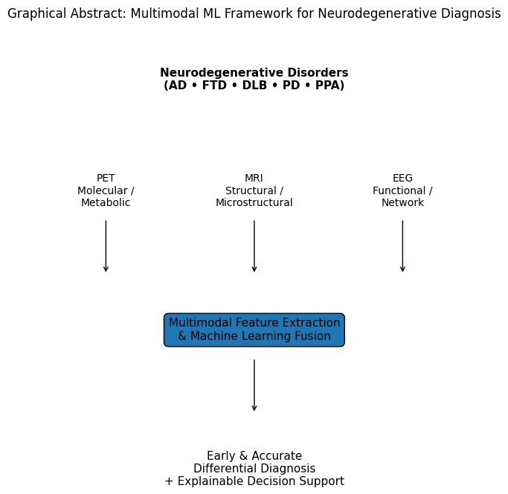
PIC 1. Graphical abstract
- INTRODUCTION:

Alzheimer’s disease (AD), frontotemporal dementia (FTD), Lewy body dementia (DLB), Parkinson’s disease (PD) and primary progressive aphasia (PPA) are all examples of neurodegenerative disorders that pose a serious diagnostic challenge due to their overlapping clinical presentations, heterogeneous pathologies, and variable rates of clinical change. Accurate differential diagnoses are essential, as differences in prognosis, therapeutic approaches, and eligibility for clinical trials exist among these neurodegenerative disorders and their related subtypes. In traditional diagnostic workflows, single modality biomarkers have been utilized to provide diagnostic information for the aforementioned disorders. Most commonly, structural MRI and FDG-PET serve as the single-modality biomarkers of choice. While structural MRI and FDG-PET have been demonstrated to provide valuable clinical information in instances where neurodegeneration is present, they do not adequately capture the complexities of neurodegeneration; that is, neurodegeneration occurs in different ways within each person and can include molecular pathology, structural atrophy, functional disruption, and electrophysiological dysfunction [1]. As a result, misclassification particularly between AD, FTD, and DLB remains common in early and prodromal stages. Over the past few years, the progress made in combining multiple modalities of imaging the brain as well as machine learning to analyze this imaging has created an opportunity to use PET, MRI, and EEG in conjunction with each other in order to provide new and unique supplemental information about the functioning and structure of the brain. For example, PET is able to show molecular and metabolic characteristics, MRI shows structural and microstructural changes, and EEG shows neuronal activity with very high time resolution. By using machine learning algorithms to combine these different types of data from PET, MRI, and EEG, multiple modalities of imaging support better differential diagnosis than would have been possible if using one technique alone [2, 3]. Using various machine learning techniques such as Support Vector Machines(SVM), Random Forest, Deep Neural Networks and Multimodal Transformers allows us to identify complex patterns that are generally unavailable using standard statistical methods as well as identify patterns that do not follow a linear model (i.e., nonlinear) [4]. These techniques are utilized more and more frequently in multimodal dataset applications to enhance diagnostic accuracy, subtype differentiation, and early detection of disease [18,19]. We will examine the use of integrated PETMREEEG1 methods combined with machine learning in the differential diagnosis of diseases caused by brain tissue degeneration. We will present a review of present knowledge and practice of integrative methods, current literature on performance and methods, ongoing challenges, and translational relevance for clinicians and researchers alike.
Table 1 Limitations of Unimodal Diagnostic Approaches in Neurodegenerative Disorders
Modality | Strengths | Key Limitations | Representative Evidence
MRI | Widely available; structural atrophy patterns | Limited molecular specificity; overlap between dementias | [1]
FDG-PET | Sensitive to metabolic dysfunction | Cost; radiation exposure; limited temporal resolution | [3]
EEG | Direct neuronal activity; high temporal resolution | Low spatial resolution; susceptibility to noise | [3]
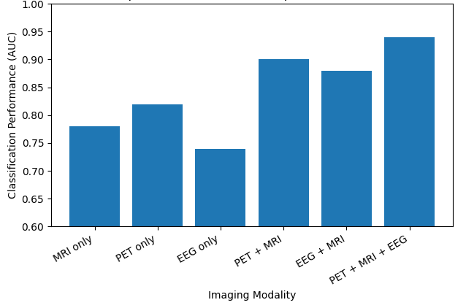
Figure 2 Diagnostic Performance of Unimodal vs Multimodal Models [3]
- Neurodegenerative Disorders Requiring Differential Diagnosis
Neurodegenerative diseases are a diverse group of diseases that are characterized by progressively losing neurons, accumulating proteins incorrectly and having a dysfunctional neuronal network [20]. While many of the diseases have different underlying pathologies, they often have similar clinical symptoms, especially during the early and prodromal stages of the disease. These similarities can lead to challenges in accurately diagnosing the disease. In particular, it is especially difficult to differentiate between Alzheimer’s disease (AD), frontotemporal dementia (FTD), dementia associated with Lewy bodies (DLB), Parkinson’s disease (PD) and primary progressive aphasia (PPA). Because of the difficulties associated with accurately diagnosing these conditions, there has been an increased use of multimodal imaging techniques and machine learning (ML) to identify disease-specific biomarker(s), which are in addition to conventional clinical assessments.
  - Alzheimer’s Disease (AD):
Alzheimer's (AD) is the most common neurodegenerative disease and is characterized by the presence of amyloid(plaque)s, neurofibrillary tangles composed of tau protein, synaptic dysfunction, and progressive shrinking of the cerebral cortex. AD is typically associated with an initial impairment of episodic memory, followed by the development of deficits in executive function and visuospatial processing. Many patients with early-stage AD will also have overlapping features of the other dementias, especially DLB and FTD, which can result in confusion about the clinical diagnosis. Structural magnetic resonance imaging (MRI) typically shows atrophy of the medial temporal lobes and hippocampus, while fluorodeoxyglucose positron emission tomography (FDG-PET) usually reveals a pattern of hypometabolism located in the temporoparietal regions of the brain. Electroencephalographic (EEG) studies have reported a consistent pattern of generalized slowing of the EEG and reduced functional connectivity. When MRI and PET are used together, machine learning algorithms will generally lead to higher classification accuracy for differentiating AD from controls and other dementias than would either modality used alone [3], the use of EEG to provide additional sensitivity to identify early synaptic dysfunction [5].
  - Frontotemporal Dementia (FTD):
FTD is a collection of disorders that are caused by deterioration within frontal and temporal areas of brain affecting behaviors, decision-making and communication. FTD is most commonly misdiagnosed as Alzheimer’s disease; this happens when individuals present with complaints about memory or an unclassified shift in their symptoms. An MRI of an individual with FTD will show focal atrophy predominantly located in the frontal and anterior temporal regions of the brain but this is complemented by decreased energy use seen in the same brain area on an FDG-PET. An Electroencephalograph (EEG) is frequently abnormal in individuals with FTD but these findings are typically not as pronounced or consistent compared to those of an individual with Alzheimer’s disease making it difficult to utilize EEG alone for diagnostic purposes. Nonetheless, the use of machine learning to combine multiple imaging modalities (such as MRI, FDG-PET and EEG) improves the ability to differentiate between the various types of FTD versus those of Alzheimer’s disease [6].
  - Dementia with Lewy Bodies (DLB):
DLB is identified through its various components: fluctuating levels of cognition, visual hallucinations, REM sleep behaviour disorder and parkinsonism characteristics. Frequently, DLB and AD have clinical symptom overlap early in the disease course, leading to frequent misdiagnosis of DLB patients. Although dopaminergic PET and SPECT imaging are helpful in DLB assessment, this imaging cannot detect some cases of DLB. EEG results of DLB patients typically indicate pronounced posterior slowing, and MRIs characteristically show that medial temporal structures are relatively spared compared to AD patients. By using ML classifiers combined with MRIs and EEG, a significant improvement in classification accuracy is achieved compared to using one type of modality on its own [2, 6].
  - Parkinson’s Disease and Parkinsonian Syndromes:
Motor symptoms caused by the loss of dopaminergic neurons are the way in which we commonly define parkinson’s, but increasingly we are considering it to be a complex, multisystem disorder, which has both cognitive and neuropsychiatric symptoms. It can be very difficult to distinguish parkinson’s from atypical parkinsonian syndromes and from dementia due to parkinson’s disease. Early stage MR findings in patients with PD are relatively subtle, while EEG shows the presence of altered oscillatory activity resulting from the basal ganglia-cortical network dysfunction. There are multimodal machine learning frameworks using data from both EEG and MR that show high accuracy for categorising parkinson’s disease and diagnosing patients in the early stages of the disease. This suggests that the use of electrophysiological data to identify these patients is useful to clinicians [7].
  - Primary Progressive Aphasia (PPA):
Progressive language impairment is associated with progressive aphasia, which is a type of neuromuscular degeneration. Primary progressive aphasia (PPA) may be difficult to differentiate between subtypes of PPA because of semantic, logopenic, and nonfluent/agrammatic characteristics. Differences between PPA subtypes can be accomplished using MRI; however, there can be additional diagnostic sophistication with evaluations using EEG due to problems related to temporal and language processing. Machine learning algorithms developed utilizing EEG features, in conjunction with imaging data, have exhibited good accuracy in distinguishing subtypes of PPA and separating patients with PPA from healthy individuals [8].
Table 2 Integrated Multimodal Biomarker–ML Framework for Neurodegenerative Disorders
Disorder | Key Differential Diagnostic Challenge | PET Biomarkers | MRI Biomarkers | EEG Biomarkers | Added Value of ML-Based Multimodal Integration
Alzheimer’s disease (AD) | Distinguishing from DLB & FTD in early stages | Temporoparietal hypometabolism; amyloid/tau | Hippocampal & medial temporal atrophy | Global slowing; reduced connectivity | Improves early diagnosis and AD vs FTD/DLB classification
Frontotemporal dementia (FTD) | Overlap with AD and psychiatric disorders | Frontal/anterior temporal hypometabolism | Focal frontal/temporal atrophy | Subtle or heterogeneous | ML captures non-linear multimodal patterns missed clinically
Dementia with Lewy bodies (DLB) | Misdiagnosis as AD | Occipital hypometabolism | Medial temporal preservation | Posterior dominant slowing | EEG–MRI fusion markedly improves AD vs DLB discrimination
Parkinson’s disease (PD) | Early-stage diagnosis & differentiation | Dopaminergic deficits | Minimal early structural change | Altered oscillatory dynamics | EEG–MRI ML models enhance early PD detection
Primary progressive aphasia (PPA) | Subtype differentiation | Variant-specific metabolism | Language-network atrophy | Abnormal temporal language responses | ML enables automated subtype discrimination

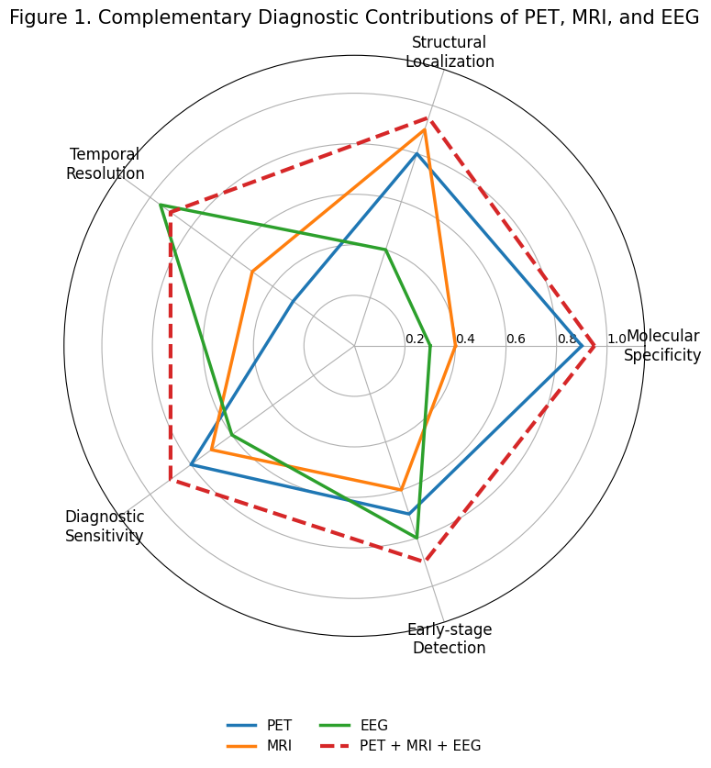
Figure 3 Complementary diagnostic contributions of PET, MRI, and EEG.
- Neuroimaging and Electrophysiological Modalities for Differential Diagnosis:
Multimodal integration of PET, MRI, and EEG is motivated by the fact that neurodegenerative disorders affect the brain across multiple biological scales, ranging from molecular pathology to large-scale network dysfunction. Each modality captures a distinct aspect of disease pathophysiology, and their complementary strengths form the foundation for machine learning–based multimodal diagnostic frameworks.
  - Positron Emission Tomography (PET):
Positron Emission Tomography (PET) provides information on the present state of metabolism and physiology in living organisms; therefore, PET has an advantage when it comes to identifying the specific pathological processes associated with certain diseases. When it comes to ‐PET as a tracer used by clinicians, the most common and widely used tracer in clinical practice is the fluorodeoxyglucose (recognized under the symbol) of carbon-18, which provides an indication of cerebral glucose metabolism (i.e., energy or glucose utilization) and is an indirect index of synaptic function. By way of example, various areas of cortical hypometabolism have been identified in neurodegenerative disorders, most notably the temporoparietal lobes for AD and the frontal lobes for frontotemporal dementia. In addition to the development of FDG-PET, the development of tailored-specific molecular probes directed towards proteins such as amyloid β, tau, and α-synuclein has increased the specificity of PET for diagnosing neurodegenerative disorders. The incorporation of PET and MRI provides greater availability to acquire both metabolic and anatomical information simultaneously using integrated PET/MRI by providing more accurate spatial registration and ultimately by facilitating the joint interpretation of the two imaging modalities. Review literature, both pictorial and written, summarises that integrated PET/MRI may represent a unique ima ging platform for the comprehensive evaluation of patients with dementia [9]. Machine learning studies consistently demonstrate that PET features contribute disproportionately to classification performance in multimodal models, particularly for distinguishing AD from other dementias [10].
  - Magnetic Resonance Imaging (MRI):
Despite its widespread use and ability to determine characteristics of the structural (anatomy) and microstructural (molecules) changes in the brain, MRI is still the primary method used to assess neurodegenerative diseases. Regional atrophy (loss of volume) patterns related to different neurodegenerative diseases (e.g., loss of hippocampal volume related to Alzheimer’s disease (AD) and focal atrophy of the frontal or temporal lobes associated with frontotemporal dementia (FTD)) have been developed using standard structural MRI scans.

More advanced methods of using MRI scans (e.g., diffusion tensor imaging, cortical thickness measurements, and radiomic analyses) have increased the diagnostic capacity of MRI scans by showing changes within tissue that are too subtle to be seen using conventional methods. The use of machine learning (ML) models created with radiomic analyses of MRI scans has been shown to detect early stages of neurodegenerative diseases more accurately than using conventional imaging methods, especially when combined with PET scans [10]. Deep learning architectures trained on MRI data have demonstrated strong performance in early diagnosis and prediction of disease progression; however, MRI alone often lacks molecular specificity, resulting in overlap between different dementia syndromes [4].
  - Electroencephalography (EEG):
EEG gives a real-time way of measuring electrical activity of neurons with high temporal accuracy (milliseconds), which is particularly sensitive to disruption at the level of synapsis or the network. EEG usually shows slowing of the dominant frequency and changes in connection between areas/functions and abnormal oscillations in neurodegenerative disorders. Several systematic reviews indicate that EEG is an increasingly important biomarker for non-invasively describing the early stages of Alzheimer’s Disease; therefore, it becomes very important when combined with machine learning technologies for detecting early diseases [5, 8].
  - Rationale for Multimodal Integration:
Together, PET, MRI, and EEG assess complementary aspects of patient evaluations, providing an integrated space for use in ML environments. Specifically, while PET establishes the molecular pathology for diagnosis, MRI determines purposeful variables to engage assessments of potential structural damage, and EEG traces rapid functional changes that precede noticeable atrophy. Studies using multivariate/multimodal methods focused on combining these modalities have demonstrated improved diagnostic accuracy and prognostic predictions than the traditional use of unimodal analyses alone [11].
- Machine Learning Methods for Multimodal Neurodegenerative Diagnosis:
The complexity and heterogeneity of neurodegenerative disorders demand analytical approaches capable of modeling non-linear, high-dimensional, and cross-modal relationships. Machine learning (ML) has therefore emerged as a central methodological pillar for extracting clinically meaningful patterns from PET, MRI, and EEG data, particularly in differential diagnosis where traditional statistical methods often fail.
  - Classical Machine Learning Approaches
Most early Machine Learning (ML) research on neurodegeneration utilized classical supervised models, such as Support Vector Machines (SVMs), Random Forests (RFs), k-Nearest Neighbors (kNN), and Logistic Regression. These classical models have relied on feature sets that were constructed by hand from imaging/electrophysiological data (e.g., regional volumes, metabolic activity, spectral power, connectivity measures). The main reason why classical ML has performed well in EEG-based diagnosis is largely due to the smaller sample sizes of subjects and the organized representation of features in the study sample. For example, the authors conducted a pilot study with multiple ML methods on resting-state EEG data to provide the basis for discriminating between possible cases of primary progressive aphasia and healthy controls; they found that the graph-based features from the EEG contributed most significantly to the classification results [12]. Similarly, classical ML classifiers trained on combined EEG and MRI features have shown moderate but reliable diagnostic accuracy in differentiating dementia subtypes, highlighting their interpretability and robustness in low-data regimes [13].
  - Deep Learning for Neurodegenerative Imaging:
Deep Learning (DL) techniques are able to overcome many of the shortcomings of traditional Machine Learning (ML) techniques, and one of them is the automatic hierarchical feature representation learning process that they employ on either raw or minimally processed data directly from the environment. CNN architectures are being used in the area of image-based data for the majority of applications and are especially used for medical imaging (e.g. MRI) and pharmaceutical imaging (e.g. PET); whereas, attention and recurrent architectures are being used for the application of EEGs. The most recent demonstration of the capability of multimodal DL architecture to leverage EEG temporal dynamic analysis with MRI spatial property analysis was demonstrated through a cross-modal attention framework that allows for successful early detection of Alzheimer's disease and mild cognitive impairment [14]. This study illustrates how DL architectures can explicitly model modality-specific inductive biases, such as spatial locality in MRI and temporal structure in EEG. Deep neural networks are particularly effective in early diagnosis and disease conversion prediction, but their clinical translation is constrained by data requirements, training instability, and limited interpretability [15].
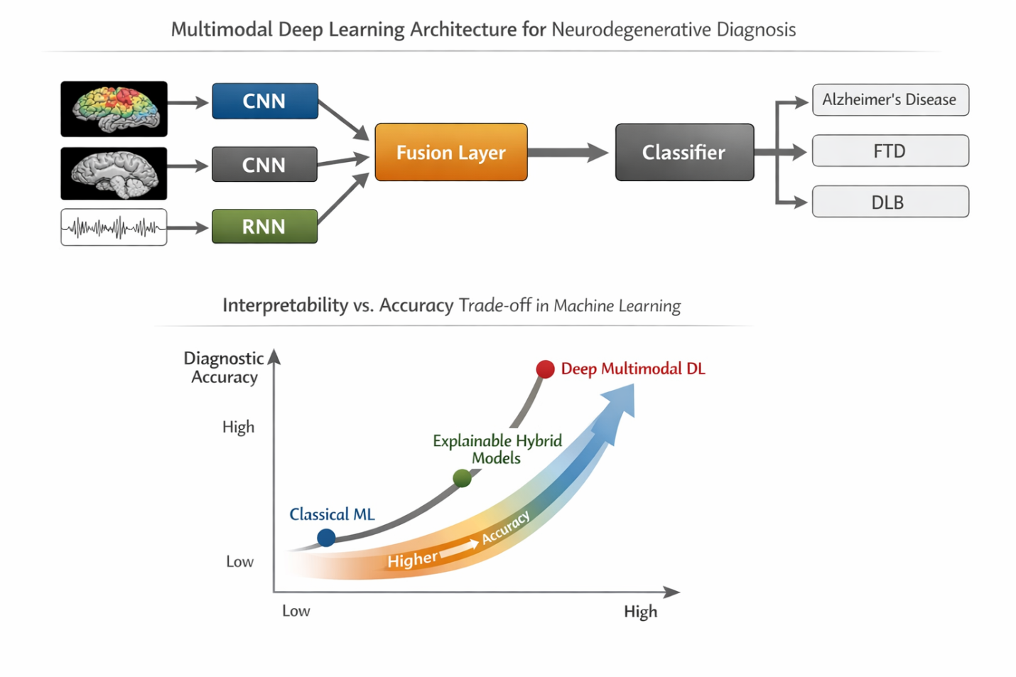
Figure 4 Multimodal machine learning architecture for PET–MRI–EEG integration
- Multimodal PET–MRI–EEG Integration: Case Studies and Empirical Evidence:
The integration of PET, MRI, and EEG within machine learning frameworks has transitioned from conceptual promise to empirical validation across multiple neurodegenerative disorders. Case studies and cohort-based investigations consistently demonstrate that multimodal approaches outperform unimodal and bimodal models in differential diagnosis, disease staging, and progression prediction. This section synthesizes representative evidence across major clinical use cases.
  - Alzheimer’s Disease vs Normal Aging and Mild Cognitive Impairment:
The differentiation between Alzheimer's disease (AD) and cognitionably normal aging and mild cognitive impairement (MCI) has been one of the primary applications of multimodal integration (an area of research that focuses on bringing together information derived from various types of imaging). Many PET-MRI models show excellent capacity for distinguishing AD from normal aging and MCI based on both metabolic and structural measures, particularly within the temporoparietal and limbic regions [4]. There is substantial evidence that multimodal PET-MRI models have better accuracy than each modality alone, particularly for predication of early disease and conversion predication [4, 10]. EEG integration further enhances sensitivity to early synaptic dysfunction, particularly in preclinical and prodromal stages, where structural changes may be subtle [5, 9].
  - EEG–MRI Integration for Functional–Structural Coupling:
By integrating EEG and MRI technologies, EEG-MRI integration minimizes one of the major limitations of PET-MRI i.e., obtaining measurements of the temporal dynamics of neuronal activity that can occur very rapidly and may precede changes in metabolism or structure that can be detected by PET or MRI, respectively. Multimodal EEG-MRI approaches have been particularly useful for disorders that exhibit significant network dysfunction (e.g., dementia with Lewy bodies [DLB] and mild cognitive impairment). In addition, machine learning models developed using EEG spectral features and structural indices derived from MRI provide an improved ability to identify people with either Alzheimer's disease (AD) or DLB than can be achieved with a single modality. This is consistent with the notion that there are distinct patterns of functional slowing and structural preservation that are informative when these measures are considered together [2, 11, 16].
Table 3 Representative Multimodal Case Studies in Neurodegenerative Diagnosis
Modalities | Disorders | ML Approach | Key Outcome
PET + MRI | AD vs FTLD | SVM (ROI-based) | ~94% accuracy
PET + MRI | Dementia (mixed) | Integrated imaging | Improved clinical confidence
EEG + MRI | AD vs DLB | Logistic regression / SVM | ↑ classification vs unimodal
EEG + MRI | MCI-LB vs MCI-AD | Random forest | Comparable to EEG alone
EEG + MRI (+ others) | Mixed ND | GNN-based multimodal DL | ↑ AUC, precision

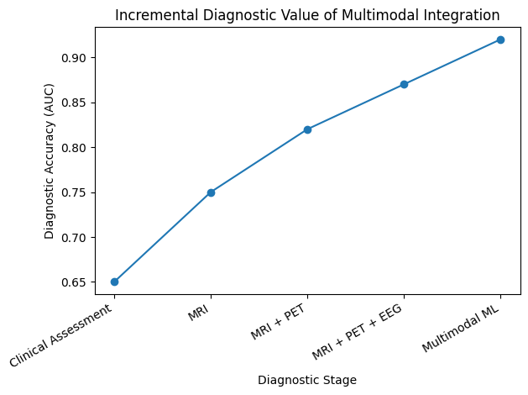
Figure 5 Incremental Diagnostic Value of Multimodal Integration
- Clinical Translation, Challenges, and Future Directions for Multimodal ML Diagnosis
The rapid methodological progress in multimodal PET–MRI–EEG machine learning has not yet translated into routine clinical adoption. Bridging this gap requires addressing technical, clinical, ethical, and regulatory challenges while embedding these systems into realistic diagnostic workflows. This section synthesizes current barriers and outlines practical pathways toward clinical deployment.
  - Integration into Clinical Diagnostic Workflows:
Successfully implementing multimodal ML systems into routine clinical practice requires them to integrate fully into existing clinical diagnostic processes, rather than act as solely functional research tools. In practice, neurodegenerative diagnoses take place in stages with clinical assessment precedes structural MRI. Only the two imaging modalities of PET and EEG will be used selectively where the diagnosis is uncertain. The most realistic manner in which to implement multimodal ML frameworks will therefore be within decision support layers to enhance or supplement clinician judgement. Existing integrated PET/MRI platforms are currently accepting a multimodal approach to imaging, effectively decreasing spatial misalignment while also simplifying the preprocessing pipeline [9].
  - Generalizability, Data Bias, and Site Variability
Due to limited generalizability, a key challenge for clinical translation is that most published multimodal machine learning studies utilize small, single-center datasets with stringent inclusion criteria; thus, their reported performance is often exaggerated compared to broader clinical settings. Systematic reviews in frontotemporal dementia and other conditions have repeatedly identified small sample sizes, class imbalances, and lack of external validation as primary sources of bias within the studies. Additionally, scanner differences, variability in acquisition protocols, and variability in preprocessing pipelines create domain shifts that significantly hinder ML performance between different sites. Multivariate neuroimaging studies show that harmonization strategies and cross-site validation must be established to promote robustness [6, 11].
  - Regulatory, Ethical, and Practical Barriers
From a regulatory perspective, multimodal ML systems for neurodegenerative diagnosis qualify as high-risk medical devices, requiring rigorous validation, reproducibility, and post-deployment monitoring. Ethical challenges include data privacy, informed consent for secondary data use, and algorithmic bias affecting underrepresented populations. AI-focused neuroimaging reviews highlight the need for standardized protocols, transparent model reporting, and longitudinal validation before clinical approval [17].
Conclusions:
The differential diagnosis for neurodegenerative disorders is a significant challenge due to overlapping clinical symptoms, multiple neuroanatomical substrates for many of the diseases, and the lack of sensitivity of single-modality biomarkers. This article introduces PET, MRI, and EEG data into a multimodal machine-learning framework and shows how this biologically-based framework can assist clinicians in their efforts to diagnose neurodegenerative disorders by integrating molecular, structural, and functional characteristics of neurodegeneration. Machine-learning algorithms utilizing multiple modalities (PET, MRI, and/or EEG) have been shown to consistently outperform traditional and unimodal diagnostic criteria for Alzheimer’s disease, front-temporal dementia, dementia with Lewy Bodies (DLB), Parkinson’s disease and primary progressive aphasia (PPA), as well as other neurodegenerative conditions. PET provides disease-specific metabolic and molecular information, MRI provides precise anatomical and microstructural contextualization of the disease processes, and EEG provides information about rapid neuronal and network-level dysfunction that frequently precede the structural changes typically associated with these types of diseases. Multimodal machine-learning platforms leverage data from heterogeneous sources to create a single unified diagnostic representation with improved accuracy, improved robustness, and advanced signatures of neurodegeneration.
Although there have been many advances made, widespread clinical implementation is still very limited. This is due to the many challenges faced by the use of Machine Learning in the clinical space, including: the use of small and biased datasets, variability between sites, a lack of standardization in acquisition/processing protocols, limited interpretability of the models, and regulatory and ethical issues. Addressing these challenges will require a coordinated effort toward large-scale multi-center data sharing, machine learning models that are explainable-by-design, harmonization approaches, and prospective clinical validation. In addition, multimodal Machine Learning systems should be utilized as clinical decision support tools that augment, not replace, clinical expert decision-making. In addition, with integrated PET–MRI systems, scalable EEG acquisition, federated learning, and explainable artificial intelligence working together, the potential for translation looks promising. Given sufficient validation and clinical integration, multimodal PET–MRI–EEG Machine Learning could drastically enhance the way neurodegenerative disorders are diagnosed and treated by allowing for more timely intervention, improved and more accurate classification of the disease, and ultimately improved outcomes for patients.

References:
1. Young, P.N.E., et al., Imaging biomarkers in neurodegeneration: current and future practices. Alzheimer's Research & Therapy, 2020. 12(1): p. 49.
2. Colloby, S.J., et al., Multimodal EEG-MRI in the differential diagnosis of Alzheimer's disease and dementia with Lewy bodies. Journal of Psychiatric Research, 2016. 78: p. 48-55.
3. Dukart, J., et al., Combined Evaluation of FDG-PET and MRI Improves Detection and Differentiation of Dementia. PLOS ONE, 2011. 6(3): p. e18111.
4. Lu, D., et al., Multimodal and Multiscale Deep Neural Networks for the Early Diagnosis of Alzheimer’s Disease using structural MR and FDG-PET images. Scientific Reports, 2018. 8(1): p. 5697.
5. Ehteshamzad, S., Assessing the Potential of EEG in Early Detection of Alzheimer’s Disease: A Systematic Comprehensive Review (2000–2023). Journal of Alzheimer's Disease Reports, 2024. 8(1): p. 1153-1169.
6. Dattola, S., et al., Frontotemporal dementia: a systematic review of artificial intelligence approaches in differential diagnosis. Frontiers in Aging Neuroscience, 2025. Volume 17 - 2025.
7. Alrawis, M., S. Al-Ahmadi, and F. Mohammad, Bridging Modalities: A Multimodal Machine Learning Approach for Parkinson’s Disease Diagnosis Using EEG and MRI Data. Applied Sciences, 2024. 14(9): p. 3883.
8. Dial, H., et al., Application of machine learning and temporal response function modeling of EEG data for differential diagnosis in primary progressive aphasia. Scientific Reports, 2025. 15(1): p. 29539.
9. Jena, A., et al., Integrated 18F-fluorodeoxyglucose positron emission tomography magnetic resonance imaging (18F-FDG PET/MRI), a multimodality approach for comprehensive evaluation of dementia patients: A pictorial essay. Indian J Radiol Imaging, 2015. 25(04): p. 342-352.
10. Hao, X., et al., Multimodal radiomics of cerebellar subregions for machine learning-driven Alzheimer’s disease diagnosis. Frontiers in Aging Neuroscience, 2025. Volume 17 - 2025.
11. Górriz, J.M., E. Iglesias-González, and J. Ramirez, Multivariate Approaches in Neuroimaging: Assessing the Connectome of Alzheimer’s Disease. Journal of Alzheimer’s Disease, 2018. 65(3): p. 693-695.
12. Moral-Rubio, C., et al., Application of Machine Learning to Electroencephalography for the Diagnosis of Primary Progressive Aphasia: A Pilot Study. Brain Sciences, 2021. 11(10): p. 1262.
13. Tan, J.H.K., et al., 558 - Multimodal EEG-MRI in the diagnosis of mild cognitive impairment with lewybodies. International Psychogeriatrics, 2021. 33: p. 97-98.
14. Chen, Y., et al. Toward Robust Early Detection of Alzheimer’s Disease via an Integrated Multimodal Learning Approach. in ICASSP 2025 - 2025 IEEE International Conference on Acoustics, Speech and Signal Processing (ICASSP). 2025.
15. Abdulhameed Al-Atroshi, S.J., et al., Continuous Learning for Automated Early-Stage Alzheimer’s Detection Using MRI and Spike Neural Signals. Advances in Human-Computer Interaction, 2025. 2025(1): p. 6632102.
16. Tan, J., et al., 558 - Multimodal EEG-MRI in the diagnosis of mild cognitive impairment with lewybodies. International Psychogeriatrics, 2021. 33: p. 97-98.
17. Kumar, R., et al., Artificial Intelligence-Based Methodologies for Early Diagnostic Precision and Personalized Therapeutic Strategies in Neuro-Ophthalmic and Neurodegenerative Pathologies. Brain Sciences, 2024. 14(12): p. 1266.
18. Nayana, B. R., Pavithra, M. N., Chaitra, S., Bhuvana Mohini, T. N., Stephan, T., Mohan, V., & Agarwal, N. (2025). EEG-based neurodegenerative disease diagnosis: comparative analysis of conventional methods and deep learning models. Scientific Reports, 15(1), 15950.
19. Khan, P., Kader, M. F., Islam, S. R., Rahman, A. B., Kamal, M. S., Toha, M. U., & Kwak, K. S. (2021). Machine learning and deep learning approaches for brain disease diagnosis: principles and recent advances. Ieee Access, 9, 37622-37655.
20. Velmurugan, S., Waheeda, S., Kulanthaivel, L., & Subbaraj, G. K. (2025). Applications of machine learning and multimodal integration for the early diagnosis of neurodegenerative diseases. World Academy of Sciences Journal, 7(6), 115.

