Case report

COMPREHENSIVE MULTIDISCIPLINARY MANAGEMENT OF AMELOGENESIS IMPERFECTA IN AN ADOLESCENT PATIENT: A CASE REPORT

Abstract
Amelogenesis Imperfecta (AI) is a hereditary disorder of enamel formation characterized by defective mineralization, altered tooth morphology, discoloration, and increased caries risk. Managing AI in paediatric patients is challenging due to short clinical crowns, weakened enamel, and high aesthetic demands.
This case report describes the comprehensive management of a 12-year-old female patient with amelogenesis imperfecta presenting with generalized yellow discoloration, molar hypomineralization, short anatomic crowns, and deep carious lesions involving multiple permanent molars. The mandibular right first permanent molar with carious pulp exposure was endodontically traeted. To enhance clinical crown height and facilitate definitive restorations, diode LASER–assisted crown lengthening was performed on all permanent molars. Stainless steel crowns were subsequently placed on all eight permanent molars to restore function and protect compromised tooth structure.
For esthetic rehabilitation, conventional surgical gingivectomy was carried out in the maxillary anterior region from right premolar to left premolar, followed by direct composite veneering. The multidisciplinary approach resulted in satisfactory functional rehabilitation and improved esthetics. Early diagnosis and individualized, minimally invasive treatment planning are essential for improving oral health outcomes and quality of life in children with Amelogenesis Imperfecta.
Keywords: Amelogenesis Imperfecta, crown lengthening, diode laser, stainless steel crowns, composite veneering, paediatric dentistry.
Introduction
Amelogenesis Imperfecta (AI) is a group of inherited developmental disorders affecting enamel formation of both primary and permanent dentitions. It is characterized by qualitative and quantitative defects in enamel, leading to hypoplasia, hypomineralization, altered tooth morphology, discoloration, hypersensitivity, and an increased susceptibility to dental caries and tooth wear. The prevalence of AI varies globally, ranging from 1:700 to 1:14,000, depending on the population studied and diagnostic criteria used.^{1,2}

Children affected by AI often present with short clinical crowns, esthetic concerns, and functional limitations, which can significantly impact oral health–related quality of life.³ Management is particularly challenging in pediatric and adolescent patients due to ongoing growth, large pulp chambers, and the need for long-term durable restorations. Treatment goals typically focus on preserving tooth structure, controlling sensitivity and caries, improving function, and enhancing aesthetics, while maintaining periodontal health.⁴
A multidisciplinary treatment approach is often required, involving preventive, endodontic, periodontal, and restorative interventions. Crown lengthening procedures may be indicated to increase clinical crown height and facilitate full-coverage restorations. LASER-assisted techniques offers advantages such as improved haemostasis, precision, and patient comfort.⁵ Stainless steel crowns remain a reliable restorative option for compromised permanent molars in children, providing durability and protection until definitive adult restorations can be considered.⁶
This case report describes the comprehensive multidisciplinary management of a 12-year-old female patient with Amelogenesis Imperfecta, highlighting the role of LASER -assisted crown lengthening, full-coverage restorations, and aesthetic rehabilitation.

Case Description and Management
A 13-year-old female patient reported to the Department of Paediatric and Preventive Dentistry , Government dental College , Thiruvananthapuram, with the chief complaint of generalized yellow discoloration of teeth, multiple carious lesions, pain, and mobility of the lower right first permanent molar. The patient also complained of generalized tooth sensitivity.
The medical and family histories were non-contributory. The mother reported that the primary dentition was extensively carious and exfoliated prematurely and the permanent teeth also erupted with similar yellow discoloration.
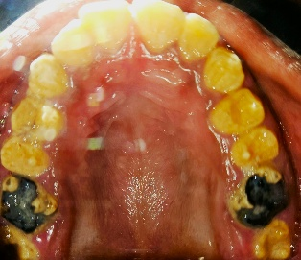
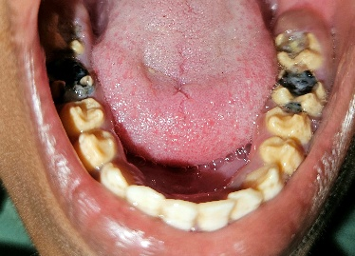
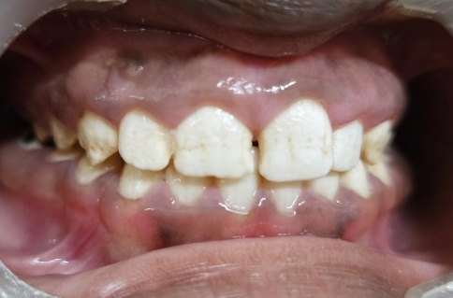
On clinical examination, features suggestive of generalized Amelogenesis Imperfecta were evident, with hypomineralized molars. Deep dentinal caries were observed in 36,37 and 47, with pulpally involved 46 exhibiting mild mobility. Dentinal caries was present in 16 and 26 and lesions were in arrested condition .Generalized gingival hyperplasia was present, which resulted in reduced clinical crown height and excessive gingival display (gummy smile).

Figure 1: Pre-operative intra-oral view shows discoloured and chipped off teeth, caries involved molars with enamel breakdown
Figure 2: Orthopantomogram revealed poor radiographic contrast between enamel and dentin. Pulpal involvement with periapical bone loss in relation to 46 and deep carious lesions in 47, 36, and 37
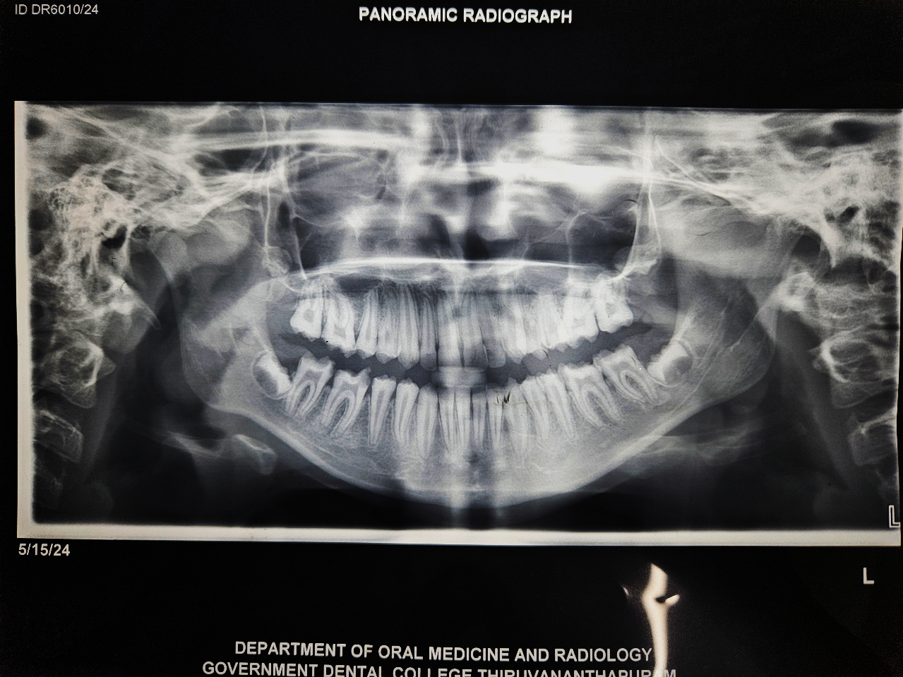
After obtaining informed consent from the parents, the following treatment plan was executed:
- Endodontic treatment of 46.
- Restoration on 16,26,36,37,46 and 47 with composite resin.
- Combined LASER-assisted and conventional gingivectomy to increase clinical crown height.
- Stainless steel crowns on 16, 17, 26, 27, 36, 37, 46, and 47.
- Direct composite veneering of maxillary anterior teeth(14-24) for aesthetic rehabilitation.
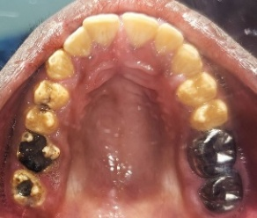
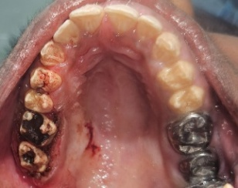
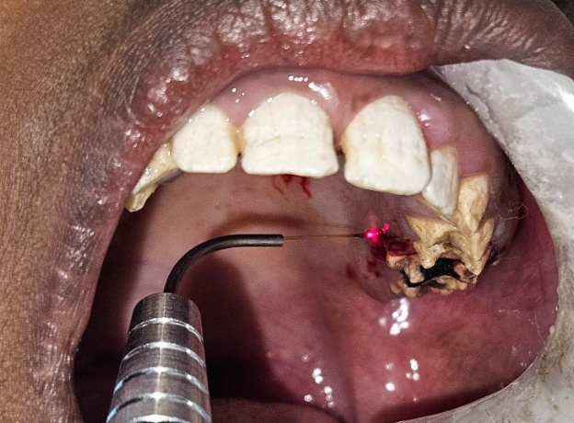
c
b
a
Figure 3: (a)LASER assisted gingivectomy of first quadrant for crown elongation of 16 and 17,b) Pre and post images (c)of surgical area shows elongated clinical crown of 16 and 17
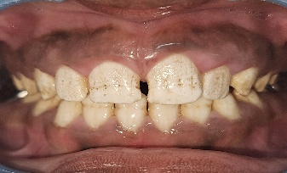
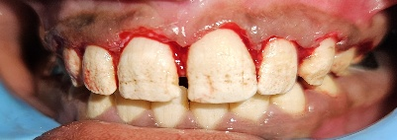
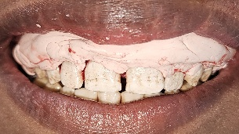
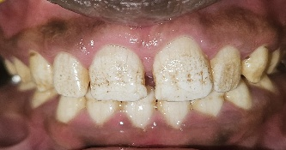
b
d
a
c

Figure 4: a) Pre-surgical image showing excessive gingival displayb)Conventional gingivectomy performed in relation to the 14–24 region.c ) Coe-Pak periodontal dressing placed after gingivectomy.d) Post-surgical follow-up after one week.

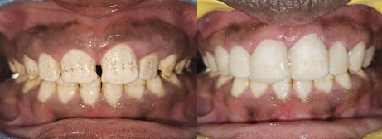
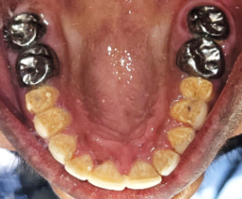
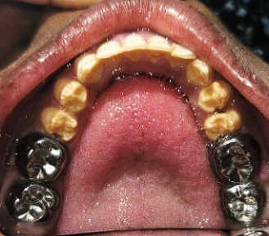
b
a

d
c

Figure 5: (a,b)Pre and post images of composite veneering from 14 to 24. (c,d) Post treatment intra oral view shows SS Crown placed in 16,17,26,27,36,37,46,47

Follow-up and Outcomes
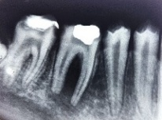
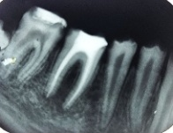
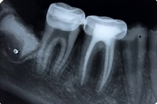
At six-months follow-up, the root canal–treated tooth (46) demonstrated satisfactory periapical bone healing and resolution of mobility. Overall functional and esthetic outcomes were favourable.
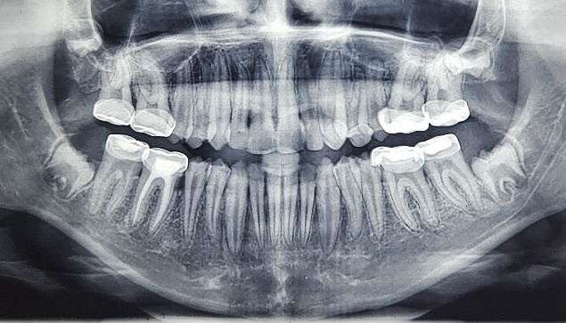
Figure 6: IOPAR of 46 shows furcation involvement and boneloss . Post obturation IOPAR of 46. Six month Follow up radiograph shows bone formation.

Figure 7: Panoramic radiograph after completion of treatment shows SS crown on 16,17,26,27,36,37,46,47 ,root canal treated 46 with periapical bone formation , composite veneered 14-24 region

The comprehensive full-mouth rehabilitation resulted in significant improvement in the patient’s esthetics and oral function. The aesthetic and functional restoration of anterior teeth using composite veneers, and the management of excessive gingival display via gingivectomy led to marked enhancement in facial appearance (Figure 5). This led to marked enhancement of patient’s confidence and self-esteem, evident during subsequent follow-up visits and also as reported by the patient and her parents.
Discussion
Amelogenesis Imperfecta (AI) represents a heterogeneous group of inherited enamel defects affecting both the primary and permanent dentitions. It occurs in the absence of systemic involvement and demonstrates autosomal dominant, autosomal recessive, or X-linked inheritance patterns. The condition is clinically classified into hypoplastic, hypomaturation, hypocalcified, and mixed variants based on phenotypic presentation and radiographic findings^{1,2}.
d
b
The present case exhibited generalized yellow discoloration, reduced enamel mineralization, increased tooth sensitivity, rapid caries progression, and early exfoliation of primary teeth—features consistent with a hypomineralized variant presentation. Compromised enamel integrity in AI predisposes teeth to plaque accumulation, structural breakdown, dentinal hypersensitivity, and early pulpal involvement^{4,7}.
Gingival hyperplasia and excessive gingival display observed in this patient may be secondary to chronic plaque-induced inflammation, passive eruption, and reduced clinical crown height. Periodontal tissue management is often essential in AI cases to achieve optimal restorative and aesthetic outcomes ⁸.
Early intervention is crucial in paediatric patients with AI to prevent extensive tissue destruction and preserve occlusal vertical dimension. Full-coverage restorations are widely recommended for young permanent molars to protect structurally compromised enamel. Stainless steel crowns (SSCs) provide durability, full coronal coverage, and cost-effectiveness, particularly in high caries-risk children ^{4,9}. In the present case, SSCs restored form and function while preventing further enamel breakdown.
Endodontic management was indicated for 46 due to pulpal exposure and periapical bone loss. Teeth affected by AI generally respond favourably to conventional endodontic therapy when appropriately restored and sealed^{7,10}. The satisfactory periapical healing at 6-month follow-up in the present case supports this observation.
Surgical crown lengthening plays an important role in improving restorative retention and aesthetic harmony in AI patients with excessive gingival coverage. Laser-assisted gingivectomy offers advantages such as reduced bleeding, enhanced visibility and decreased postoperative discomfort¹¹. In the present case, considering the chance for delayed wound healing associated with laser-assisted gingivectomy, a conventional scalpel technique was preferred in the maxillary anterior aesthetic zone to ensure faster healing and optimal gingival contouring.
Beyond structural rehabilitation, AI has a documented psychosocial impact. Children and adolescents frequently experience embarrassment, reduced self-confidence, and social withdrawal due to visible enamel defects and discoloration ³. Comprehensive oral rehabilitation significantly improves oral health–related quality of life and psychological well-being¹². In this case, full-mouth rehabilitation resulted in marked improvement in facial aesthetics, positively influencing the patient’s confidence and self-esteem as reported and observed follow-up visits.
Thus, early diagnosis, stringent preventive strategies, and a multidisciplinary treatment approach are essential for successful management of AI, while aiming to restore function, protect and preserve dental structures, and addressing the psychosocial concerns of children and adolescents.
Conclusion
Amelogenesis imperfecta presents significant functional and esthetic challenges in growing patients. Early diagnosis and a multidisciplinary treatment approach are essential to preserve tooth structure, restore function, and improve esthetics. Timely preventive, restorative, periodontal, and endodontic interventions can successfully rehabilitate affected dentition and enhance the patient’s oral health–related quality of life and psychological well-being.
Consent
Parental consent was obtained for all patients included in this case series

References
(1) Witkop, C. J. Amelogenesis Imperfecta, Dentinogenesis Imperfecta and Dentin Dysplasia Revisited: Problems in Classification. J Oral Pathology Medicine 1988, 17 (9–10), 547–553. https://doi.org/10.1111/j.1600-0714.1988.tb01332.x.
(2) Aldred, M.; Savarirayan, R.; Crawford, P. Amelogenesis Imperfecta: A Classification and Catalogue for the 21st Century. Oral Diseases 2003, 9 (1), 19–23. https://doi.org/10.1034/j.1601-0825.2003.00843.x.
(3) Coffield, K. D.; Phillips, C.; Brady, M.; Roberts, M. W.; Strauss, R. P.; Wright, J. T. The Psychosocial Impact of Developmental Dental Defects in People with Hereditary Amelogenesis Imperfecta. The Journal of the American Dental Association 2005, 136 (5), 620–630. https://doi.org/10.14219/jada.archive.2005.0233.
(4) SeowBDS, W. K. Clinical Diagnosisand Managemenstrategies of Amelogenesis Imperfecta Variants.
(5) W. LJ. T. use of lasers in pediatric dentistry. J. D. Child. 2002;69(3):203–208. .
(6) Waggoner, W. F.; Nelson, T. Restorative Dentistry for the Primary Dentition. In Pediatric Dentistry; Elsevier, 2019; pp 304-328.e3. https://doi.org/10.1016/B978-0-323-60826-8.00022-5.
(7) Crawford, P. J.; Aldred, M.; Bloch-Zupan, A. Amelogenesis Imperfecta. Orphanet J Rare Dis 2007, 2 (1), 17. https://doi.org/10.1186/1750-1172-2-17.
(8) Bouvier D, Duprez JP, Bois D. Rehabilitation of Young Patients with Amelogenesis Imperfecta: A Report of Two Cases. ASDC J Dent Child. 1996;63:443–447.
(9) American Academy of Pediatric Dentistry. Guideline on restorative dentistry. AAPD Reference Manual. 2023.
(10) Sapir S, Shapira J. Clinical Solutions for Developmental Defects of Enamel and Dentin in Children. Pediatr Dent. 2001;23:330–336.
(11) Gontiya, G.; Bhatnagar, S.; Mohandas, U.; Galgali, S. Laser-Assisted Gingivectomy in Pediatric Patients: A Novel Alternative Treatment. J Indian Soc Pedod Prev Dent 2011, 29 (3), 264. https://doi.org/10.4103/0970-4388.85839.
(12) Hashem, A.; Kelly, A.; O’Connell, B.; O’Sullivan, M. Impact of Moderate and Severe Hypodontia and Amelogenesis Imperfecta on Quality of Life and Self-Esteem of Adult Patients. Journal of Dentistry 2013, 41 (8), 689–694. https://doi.org/10.1016/j.jdent.2013.06.004.

