Original Research Article

Knowledge, Attitude and Prevalence regarding Rubber Dam Usage Among Dental Undergraduate Students

ABSTRACT :

AIM :
The aim of this study is to determine the Knowledge, Attitude and Prevalence regarding Rubber Dam usage among Dental Undergraduate final year students and interns.

METHODOLOGY :
An e-questionnaire as Google forms was sent to final year students and interns. Eighteen questions were asked regarding the knowledge, attitude and awareness about the rubber dam and its usage, which also includes the demographic details of the respondents.

RESULTS :
A total of 213 dental students, including final-year students and interns, took part in the study. Most of them showed good understanding of rubber dam usage and agreed that it is the gold standard in endodontic procedures. Even though almost all participants had received preclinical training, only a few reported using rubber dams regularly in clinical practice. Patient discomfort and lack of awareness were the main reasons for not using them consistently. Overall, the results highlight a clear gap between what students know and what they actually practice in clinics.

CONCLUSION :
In conclusion, dental students exhibit good knowledge and a positive attitude toward rubber dam use in endodontics. However, despite adequate training, its regular clinical application remains limited. Strengthening clinical reinforcement and addressing perceived barriers may help improve consistent usage in practice.

KEYWORDS : Rubber dams , E- questionnaire, dental students

INTRODUCTION :

The restorative and endodontic procedures are done to treat tooth damage due to dental caries and dental trauma. The isolation of the tooth is primarily done to prevent salivary contamination, which results in proper bonding of the restorative material to the tooth, hence resulting in prevention of reinfection and restorative failure, and also protects the dentist and patient from unnecessary exposure to microorganisms (2).
Infection control is a critical factor that greatly influences the prognosis of endodontic treatment. To maintain a high standard of care, it is essential to prevent cross-contamination at every stage of the procedure. Currently, the rubber dam is considered the most effective method for tooth isolation and for preventing cross-contamination, making it an indispensable step during root canal treatment. International organizations such as the European Society of Endodontology and the American Association of Endodontists recognize the rubber dam as the gold standard in endodontic therapy.
A rubber dam was developed by Dr Sanford C Barnum on 15th March 1864, which was designed to isolate the tooth from the placement of gold foil(1).
It facilitates the treatment by isolating the tooth from saliva, blood, tongue, lips and cheeks, which can affect the effectiveness of the treatment and also prevents laceration of soft tissues from rotary and hand instruments. The primary advantage of the use of a rubber dam is preventing aspiration of instruments, medicaments and irrigating solutions used during an endodontic procedure(3)It also enhances the visibility of the operating field and helps in retraction of soft tissues, and hence it reduces cross-contamination during root canal procedures and acts as a barrier for the spread of infections.

The American Association of Endodontists guidelines state that the biomechanical preparation and obturation of root canals should be done as a proper aseptic technique by using rubber dam isolation wherever necessary(4)
The use of rubber dams is restricted by dentists due to lack of training, financial constraints, patient discomfort, lack of awareness and time required for its application(5).Although the use of rubber dams is universally accepted, dentists fail to use them in their daily practice.Understanding the perception of patients and the general public regarding the use of rubber dams in dentistry is essential for increasing awareness and enhancing acceptance of this important clinical tool.
The objective of this study is to determine the knowledge, attitude and prevalence of use of rubber dams among dental UG students ( final years and interns ).

MATERIALS AND METHODS :

An e-questionnaire cross-sectional study was conducted among undergraduate final year students and interns, which consisted of questions about demographic details, knowledge, attitude, awareness about rubber dams and their usage. A sample size of 200 was selected randomly, and the questions were sent as a Google Form through WhatsApp.
The completed questionnaires were collected and sent for statistical analysis to conclude the results. The questions that were asked :

1. Name
2. Age and Sex
3. Category
4. Rubber dam is primarily used for:
a) Retraction of the gingiva
b) Isolation of the operative field
c) Shade selection
d) Moisture control only
5. Rubber dam use is considered the gold standard during:
a) Oral prophylaxis
b) Tooth extraction
c) Endodontic procedures
d) Orthodontic treatment
6. One major advantage of a rubber dam is the prevention of:
a) Tooth discolouration
b) Instrument aspiration
c) Pulp necrosis
d) Tooth sensitivity
7. Rubber dam use helps in improving the success of root canal treatment by:
a) Reducing chairside time
b) Enhancing visibility and asepsis
c) Reducing cost
d) Eliminating the need for anaesthesia
8. Components of a rubber dam kit include all EXCEPT:
a) Rubber dam sheet
b) Clamp
c) Forceps
d) Apex locator
9. Can a rubber dam be used during restorative procedures?
a) Only posterior restorations
b) Only anterior restorations
c) Both anterior and posterior restorations
d) Only during RCT
10. Rubber dam isolation is contraindicated in:
a) Patients with latex allergy
b) Deep caries
c) Endodontic treatment
d) Restorative procedures
11. Rubber dam usage should be mandatory during endodontic procedures.
a) Agree
b)Strongly agree
c) Disagree
d) Strongly disagree
12. Rubber dam placement increases operator confidence
a) Agree
b)Strongly agree
c) Disagree
d) Strongly disagree
13. Rubber dam placement is too time-consuming for routine use.
a) Agree
b)Strongly agree
c) Disagree
d) Strongly disagree
14. Proper training can improve acceptance of rubber dam usage among students
a) Agree
b)Strongly agree
c) Disagree
d) Strongly disagree
15. Have you received preclinical training in rubber dam placement?
a) Yes
b) No
16. Do you routinely use rubber dams during endodontic procedures in clinics?
a) Always c) Sometimes
b) Often d) Never
17. The most common reason for not using a rubber dam is:
a) Lack of awareness
b) Patient discomfort
c) Lack of practice/training
d) Non-availability
18. Rubber dam usage improves patient safety and treatment quality.
a) Yes
b) No
c) Not sure

RESULT :

The total number of dental students who responded to the questionnaire was 213. Among these students, there were 123 final year students and 90 interns. Among them, 69.5% accepted that rubber dams are primarily used for isolation of the operating field, and 17.8% agreed that they are used for retraction of gingiva(refer to chart 1).About 99.1% students accepted that prevention of instrument aspiration is one of the major advantages(refer to Chart 2)Among them, 97.7% students felt that the use of a rubber dam is considered the gold standard during endodontic procedures, and about 98.1% felt that the use of a rubber dam helps in improving root canal treatment by enhancing visibility and asepsis(refer to Chart 3)About 67.7% students strongly agreed that using rubber dams is mandatory during endodontic procedures, and 61% agreed that using rubber dams increases operator confidence.Among 213 dental students, 205 students (96.2%) received preclinical training in the placement of rubber dams, and approximately 16% of the students used rubber dams during endodontic procedures sometimes.They responded that the most common reason for not using rubber dams is due to patient discomfort (39.4%) and lack of awareness (31.9%) (refer to Chart 4)About 65.3% of the students accepted that the usage of rubber dams improves patient safety and treatment quality.

Chart 1 Primary use of rubber dam
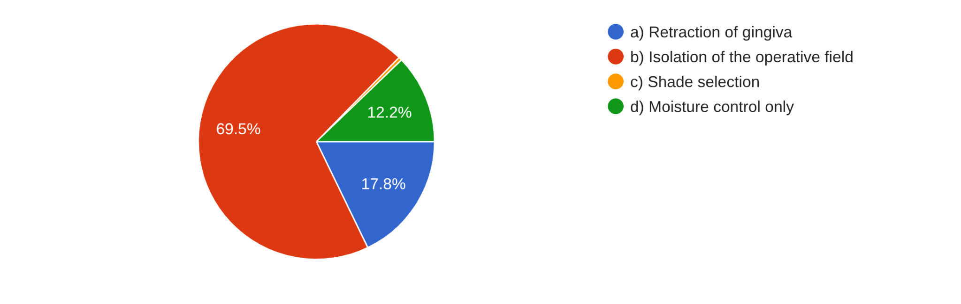

Chart 2 Major advantage of rubber dam is in prevention of
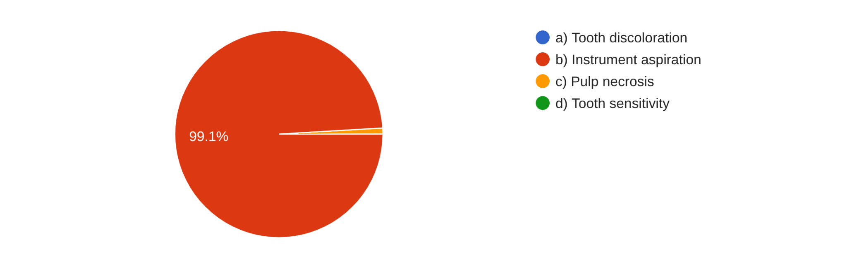
Chart 3 Rubber dam uses
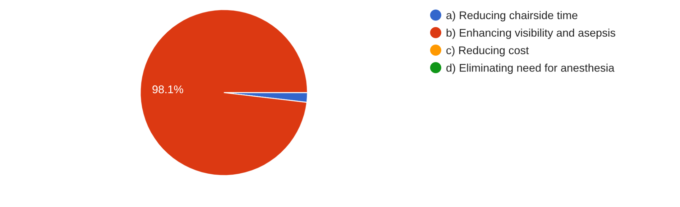
Chart 4 Barrier for rubber dam usage
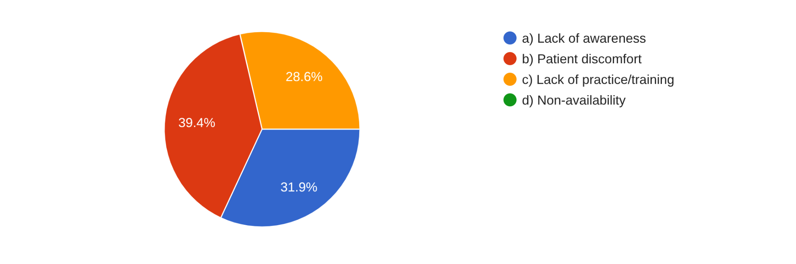
DISCUSSION :

A rubber dam, also known as a dental dam, is a thin sheet of size 6 inches square, usually made up of latex, which is used in dental procedures to isolate the operating field ( teeth ) from contamination of saliva, blood, etc. The armamentarium of a rubber dam usually consists of
- Rubber dam sheets
- Clamps or hooks
- Frame
- Forceps
- Dam Punch
- Dental floss
The American Association of Endodontists and the European Society of Endodontology recommend the use of rubber dams as the standard of care during nonsurgical root canal treatment. According to the quality guidelines issued by the European Society of Endodontology, the use of a rubber dam significantly improves the quality and success of endodontic treatment outcomes(4).During dental procedures, the tooth being treated should be properly isolated from the oral cavity. This helps reduce aerosols generated during treatment, prevents accidental aspiration of instruments or materials, and protects the tooth from contamination by saliva, which can otherwise reduce bonding strength. In addition, rubber dam isolation improves the efficiency of treatment by providing better access to the operative field, retracting soft tissues, and maintaining a clean and dry working area.Many patients are usually unaware of rubber dams before their dental visit. However, studies have shown that when patients are informed about the importance and benefits of rubber dam isolation before treatment, their acceptance and preference for procedures performed under rubber dam isolation increase significantly. At the same time, the level of discomfort or pain experienced during rubber dam placement may influence whether patients are willing to undergo the procedure in future treatments.Common methods used to isolate teeth during dental procedures include cotton rolls, saliva ejectors (straw-like suction tubes), and rubber dams(5).Cotton rolls are simple and inexpensive but require frequent replacement to maintain dryness. An alternative method is the rubber dam, which is a thin elastic sheet. During placement, the dentist punches a small hole in the sheet and positions it over the tooth being treated, creating a protective barrier around the tooth.Studies comparing rubber dams with cotton roll isolation have reported that restorations carried out under rubber dam isolation are more likely to remain intact and in satisfactory condition after six months compared to those performed using cotton rolls.However, the available evidence is still limited to determine whether this advantage continues beyond a six-month period. Similarly, when comparing rubber dam isolation with other systems such as the Isolite System, the current evidence is not strong enough to clearly conclude that rubber dam use results in better outcomes for tooth restorations.Several studies have shown that the use of a rubber dam can reduce nearly 70% of airborne particles within a three-foot radius of the operative field. In addition, rubber dams help limit the spread of aerosols and significantly reduce—sometimes even completely eliminate—the presence of salivary contaminants within the aerosol(5).Rubber dam placement is one of the primary steps in both endodontic and conservative dental procedures. Ideally, isolation is achieved by isolating a single tooth using a clamp that makes four-point contact with healthy tooth structure. However, in clinical practice, endodontists often encounter difficulties in achieving proper rubber dam isolation, especially in cases where it is challenging to secure and retain the clamp in the correct position.
Advantages of Using Rubber Dam During Restorative Procedures: It helps maintain a dry and clean working field.It also improves access and visibility of the operative area and reduces the chances of iatrogenic errors (Anabtawi et al., 2013).It prevents accidental aspiration or swallowing of endodontic instruments, medicaments, irrigating solutions, and debris by the patient (Glickman GM, Pettiette MT, 2006).It helps in retracting and protecting soft tissues such as the gingiva, tongue, lips, and cheeks from possible injury caused by rotary or hand instruments and endodontic medicaments (Pettiette MT).It considerably lowers the microbial load in aerosols produced by air turbines during endodontic procedures, thereby reducing the risk of cross-infection (Harrel SK, Molinari J., 2004).It enhances the performance of dental materials by preventing moisture contamination during restorative procedures.It increases clinical efficiency and productivity, while simplifying patient management by reducing the need to rinse debris from the mouth.It also helps in protecting dentists and dental assistants from infections that may be transmitted through the patient’s saliva (Harrel SK, Molinari J., 2004).Its use limits patient conversation during root canal treatment and encourages them to keep their mouth open (Bhuva B, Chong BS, Patel S., 2008).It also reduces the need for frequent replacement of cotton rolls caused by saliva accumulation or irrigating solutions.The contraindications for using rubber dam are patients with latex allergy,patients with asthma,certain psychological conditions or patient anxiety. (Ballal et al., 2013)
The instruments required for Rubber Dam Isolation are Rubber dam sheets available in different sizes and colors. In endodontic procedures, where isolation of a single tooth is usually required, a 5 × 5 inch sheet is generally sufficient, even for posterior teeth. A 6 × 6 inch sheet is more commonly used in restorative dentistry when multiple teeth need to be isolated simultaneously. These sheets are available in both light and dark colors. A rubber dam punch is used to create round holes of varying diameters (approximately 0.7–2 mm) in the rubber dam sheet, depending on the tooth that needs to be isolated. It is important to ensure that the punched hole is perfectly round and free from irregular edges. This can be checked by punching a hole in the sheet and gently stretching it in different directions; the rubber dam should not tear if the hole is properly made.The effectiveness of rubber dam isolation largely depends on selecting the appropriate clamp and positioning it correctly. Clamps are generally categorized as winged or wingless, and the method of placement differs slightly between these two types. In some situations, wingless clamps are preferred because they are less bulky and are easier to use in the posterior region, especially in patients with thick cheeks.Commonly used clamps include are Anterior teeth: IVORY #6, IVORY #9, IVORY #90N, IVORY #212S, IVORY #15, Premolars: IVORY #1, IVORY #2, IVORY #2A, Molars that are partially erupted or prepared for full crowns: IVORY #7, IVORY #14, Asymmetrical molars (especially second and third molars): IVORY #10, IVORY #11, IVORY #12A, IVORY #13A, Wingless clamps (used when wings obstruct the working field): IVORY #W8A, IVORY #26N.Rubber dam forceps are necessary to open the clamp and position it around the tooth. Ivory forceps are preferable, because they allow the dentist to apply direct pressure toward the gum, which is frequently necessary to position the clamp securely below the bulge of the tooth crown.A rubber dam frame is used to keep the rubber dam stretched and stable, allowing proper retraction of the lips and cheeks during dental procedures. Different types of frames are available. Some, such as the Young frame, are made of thin metal, while others like the Nygaard-Ostby and Starlite frames are made of plastic. Plastic frames have the advantage of being transparent compared to the Young frame, although they tend to be slightly bulkier. Earlier devices used to maintain tension in the dam, such as the Woodburg, Cogswell, Mitchell, and Fernald tensors, which relied on clips and elastic bands placed around the back of the neck, are now considered outdated and are no longer used in modern endodontic practice.Before placing the rubber dam, it is recommended to apply a lubricant such as Vaseline or soap to the inner surface of the sheet. This helps the dam slide smoothly over the contours of the teeth, pass more easily through the contact points, and adapt closely around the cervical region of the tooth.Rubber dam napkins are used to prevent direct contact between the rubber dam and the patient’s cheeks. They also help absorb saliva that accumulates beneath the dam through capillary action, thereby improving patient comfort and facilitating the procedure. Although their use is optional, they are particularly beneficial for patients who may have an allergy to the rubber material of the dam.
The barriers to the use of rubber dams are a lack of awareness, patient discomfort, a lack of practice/training and non-availability of rubber dams. In our study, about 39.4% responded that patient discomfort acts as the major barrier to rubber dam usage.In this study, the majority of the students have received the pre-clinical training in placing rubber dams, but only 16% of the students have used it sometimes during endodontic procedures. They considered patient discomfort followed by lack of awareness as the barrier to not using rubber dams in their routine clinical practices. This can be overcome by adequate patient education and motivation.
CONCLUSION :
Within the scope of this study, it can be understood that dental students generally possess good knowledge and a favourable attitude toward the use of rubber dams in endodontic procedures. Most of them are aware of its benefits and acknowledge it as the gold standard for isolation. However, even though the majority have received proper preclinical training, its routine use in clinical practice remains limited. This gap between what students know and what they actually practice seems to be mainly due to concerns about patient discomfort and insufficient awareness.Hence, placing more focus on strengthening clinical training, improving patient education, and implementing clear institutional guidelines may help translate knowledge into consistent practice, thereby enhancing patient safety and improving the overall quality of endodontic care.
REFERENCE :

1. Wang Y, Li C, Yuan H, et al. Rubber dam isolation for restorative treatment in dental patients. Cochrane Database Syst Rev 2016;9(9):CD009858.( DOI )

2. Sanghvi AM, Nagda RJ, Raju PJ. A cross-sectional study on frequency of rubber dam usage among dentists practicing in Maharashtra. India Saudi Endod J 2018;8(1):39–43.( DOI )

3. Ibhawoh LO, Enabulele JE. Rubber dam use during non-surgical endodontic treatment among a population of dentists in Edo State. Nig J Dent Res 2020;5(1):35–41 ( DOI )

4. Ammann P, Kolb A, Lussi A, Seemann R. Influence of rubber dams on objective and subjective parameters of stress during dental treatment of children and adolescents - a randomized controlled clinical pilot study. Int J Paediatr Dent. 2013;23:110–5. [DOI] [PubMed] [Google Scholar]

5. Kucukyilmaz E, Ozdemir T, Savas S. The effect of rubber dam on objective and subjective parameters of stress during dental treatment in children: a randomized clinical trial. BMC Oral Health. 2025 May 30;25(1):855. ( DOI ). PMID: 40448060; PMCID: PMC12125943.

6. Kaşıkçı S, Kolunsağ Özbek S. (2024). Evaluation of Rubber Dam Use in Endodontic Treatments in Terms of Patients’ Awareness Level, Acceptability, and Usage Experience. European Journal of Therapeutics, 30(4), 464–471.(DOI)

7. Endodontology Journal (2024). Sealing efficacy of various rubber dam barrier materials. Endodontology, 36(3), 221–226. (DOI)
8. Chandra P., Prasad R. (2024).Assessment of prevalence of using rubber dams for endodontic procedures by dental practitioners. Journal of Chemical Health Risks.(DOI)

9. Alam F., et al. (2025). Assessment of patients’ attitudes regarding the use of rubber dams in endodontic therapy. Journal of Khyber College of Dentistry.(DOI)

10. Harrel SK, Molinari J. Aerosols and splatter in dentistry: A brief review and infection control implications. J Am Dent Assoc. 2023;154(5):420-428.(DOI)
11. Samaranayake LP, Fakhruddin KS. Use of rubber dam for infection control in dental procedures. Int Dent J. 2024;74(2):185-192.(DOI)
12. Alhareky M, Tavares M. Amalgam restoration longevity when placed with rubber dam isolation: A systematic review. J Dent. 2023;131:104450.(PubMed)
13. Cochran MA, Miller CH, Sheldrake MA. The efficacy of the rubber dam as a barrier to microbial contamination during dental treatment. J Endod. 2023;49(8):1050-1056.(DOI)
14. Ahmad IA. Rubber dam usage for endodontic treatment: A review of clinical practice and patient safety. Saudi Dent J. 2024;36(1):45-51.(DOI)

