Original Research Article

Calculation of rice water requirements using the FAO -CROPWAT 8.0 model in the hydro- -agricultural development of the Agricultural Development Center (CDA) of the urban commune of Diffa

Abstract
This analytical agro -hydrological study, conducted at the Agricultural Development Center (CDA) in the Diffa commune (Diffa region, Niger), aimed to analyze the interactions between soil physical properties, climatic parameters, and irrigated rice cultivation data in order to estimate water requirements and optimize irrigation scheduling using the CROPWAT 8.0 model. The climatic and edaphic data used cover a dry season. Soil properties (clay-loam texture, water retention capacity, percolation) were characterized to assess their influence on water dynamics, while climatic parameters (temperature, relative humidity, wind, insolation) were used to calculate reference evapotranspiration ( ETo ). Rice cultivation parameters, with transplanting carried out on February 25, were integrated into the model to estimate crop evapotranspiration ( ETc ), effective rainfall, and net and gross irrigation requirements. The results show that, despite good water retention capacity, significant percolation losses (423.5 mm) reduce the potential efficiency of irrigation. Evaporative demand is particularly high between April and June, with temperatures exceeding 45°C, while the annual effective rainfall (288.4 mm) covers only a small portion of the water requirements. Total ETc reaches 1178.3 mm for only 16.3 mm of available rainfall, and the net irrigation requirement is estimated at 1506.8 mm, or 15,068 m³/ha, confirming the crop's near-total dependence on irrigation. These results highlight that the productivity of irrigated rice in Diffa relies primarily on controlled water management, requiring optimization of leveling, reduction of percolation losses and rigorous irrigation planning to ensure the sustainability of rice cultivation in a Sahelian context.
Keywords: Cropwat , Rice cultivation, Water requirements, Irrigation and Diffa
- INTRODUCTION
The Sahel is a vast transitional region between the Sahara Desert to the north and the Sudanese savanna to the south (Houérou, HN (2006)). Niger is one of the Sahel countries; this region covers a large part of the territory and is characterized by a semi-arid to arid climate, with low and irregular rainfall varying between 200 and 600 mm per year (Mahamane, L., Saadou, M., & Nonguierma, A. (2005)). These climatic conditions make agriculture vulnerable and highly dependent on climatic hazards.
Faced with these conditions beyond human control, irrigated agriculture is a fundamental pillar of food security and socio-economic development in this region. In this context, irrigated rice cultivation represents a strategic opportunity to improve food production.
In the Diffa region, the perimeter of the Agricultural Demonstration Center (CDA), located in the municipality of Diffa, in southeastern Niger, comprises five (5) out of sixteen (16) agricultural areas (AHAs) that have been developed in this region. The hydro-agricultural development of the CDA/CBLT was established to promote sustainable and resilient agriculture.
Rice cultivation is the main activity practiced in hydro-agricultural developments (AHA) (Boukar et al., 2024). It is practiced individually, both outside and within developed areas. Producers in the Diffa region carry out two rice production cycles, one in the rainy season and one in the dry season.
Irrigation is almost entirely gravity-fed, relying solely on the waters of the Komadougou River and Lake Chad. This dependence on surface water, primarily used for irrigation, complicates production and impacts rice yields. In some cases, flooding of the pumping station forces the suspension of cultivation until the waters recede.
Rice is a crop highly dependent on water (Musset, 1942). With increasing rainfall variability linked to climate change, the need for irrigation water is becoming increasingly unstable and uncontrollable for producers, who in most cases irrigate imprecisely, which can severely affect yields and water production at the pumping station. However, the scarcity of water resources due to climate change, competition between sectors, and evolving rainfall patterns necessitates new water management strategies ( Fageria , 2007).
Water management in these irrigated areas remains a major challenge. The irrigation regime—that is, the quantity, frequency, and distribution of irrigation water—directly influences rice growth, development, and yield. Inadequate irrigation can lead to water stress, yield losses, poor water resource management, and low irrigation efficiency. Conversely, optimized irrigation not only increases productivity but also conserves water resources, which are particularly precious in arid and semi-arid zones.
However, faced with the growing challenges of climate change, water resource variability, and population pressure, it is imperative to identify the most efficient and water-saving irrigation practices. Calculating water requirements for this area is therefore crucial to ensuring the sustainability of rice cultivation.
Cropwat software , which is software developed by the FAO (Food and Agriculture Organization of the United Nations), designed to help with irrigation planning and the assessment of crop water requirements, will be used (Wade et al., 2000).
The general objectives of this article are to model using CROPWAT 8.0 software to estimate crop water requirements (CWR) and irrigation planning (SI) in the rice paddy in the study area.
This research aims to fill this scientific gap by providing a solution for effective water management in this area. It is part of a strategy to optimize water management, enhance the value of existing hydro-agricultural infrastructure, and strengthen the resilience of rice production systems.

- MATERIALS AND METHODS
2.1 Site presentation:
This study was conducted at the level of the CBLT/CDA hydro-agricultural development in the urban commune of Diffa. The city is located in the far southeast of Niger, on the banks of the Komadougou River. Yobe , on the border with Nigeria, but also not far from Lake Chad and the border with Chad and northern Cameroon.
The area has a dry tropical climate, characterized by a long dry season from November to May, during which temperatures remain very high and rainfall is almost nonexistent. The rainy season, short and concentrated from June to September, brings significant rainfall only in July and August. The ombrothermic curve clearly illustrates this strong seasonality, with hot and dry conditions predominating for most of the year.
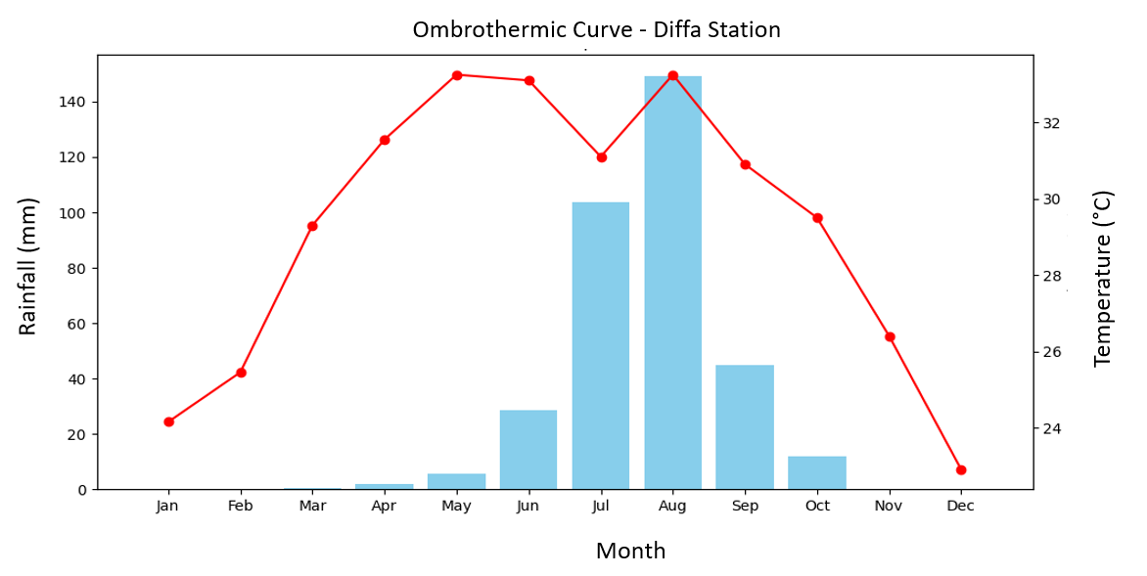
Figure 1: Ombrothermic curve on the climatic data of the area for the period from 2000 to 2020 (Data source: Diffa Station)

2.2 Particle size analysis and determination of soil texture
The soil texture study was carried out on 24 plots designated for the experiment, using composite sampling taken at a depth of 0–20 cm. This depth corresponds to the surface horizon most influenced by cultivation practices as well as by water and nutrient exchanges, due to its central role in the biological and physicochemical dynamics -of the soil ( Hartemink et al., 2020).
For each plot, five subsamples were collected according to a structured scheme including the four corners and the center, as described in Figure 2, in accordance with the principles of the composite method described in the Guide on Environmental Site Characterization (LE, EDSD, 2016). This approach reduces local variability and yields a homogeneous sample representative of the plot, as recommended by Gee & Or (2002). The subsamples -were then homogenized and packaged in bags, following the best practices for soil sampling and preservation described by Hillel (2004), before being transferred to the laboratory of the INRAN Regional Center for Agronomic Research for analysis.

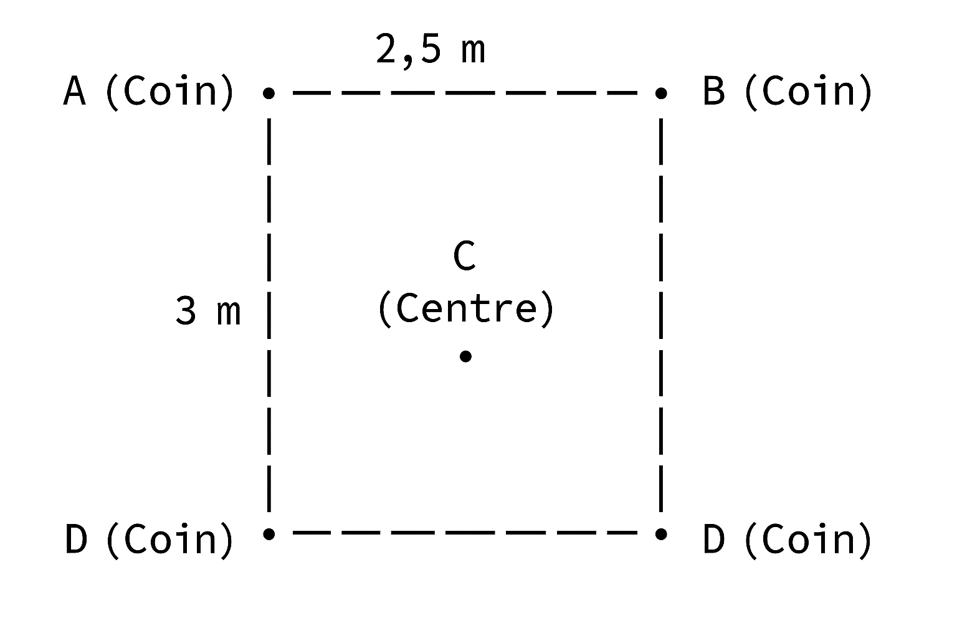
Figure 2 : Sampling plan on a plot
2.2 Climate data in CROPWAT 8.0
Meteorological data from 2000 to 2020 were collected and processed according to the requirements of CROPWAT 8.0 software. Average monthly data were calculated from daily data collected over 20 years at the Diffa Meteorological Station. These data include monthly averages of minimum and maximum temperatures, precipitation, relative humidity, wind speed, and sunshine. For each month from January to December, the values are integrated into the system as shown in Figure 3 for minimum and maximum temperatures, relative humidity, wind speed, and sunshine, and in Figure 4 for precipitation.
From the input data, the system calculated the reference evapotranspiration (ET₀ ) using the normalized Penman -Monteith FAO56 formula.
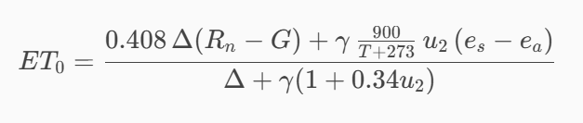
- ET ₀ : reference evapotranspiration (mm/day); e ₛ : saturation vapor pressure (kPa)
-R ₙ : net radiation at the surface of the canopy (MJ/m²/day);
- G: heat flux in the ground (MJ/m²/day)
- T: average daily air temperature at 2 m (°C)
- u₂ : wind speed at 2 m (m/s)

- eₐ: actual vapor pressure (kPa)
- (eₛ - eₐ) : vapor pressure deficit (kPa)
- Δ : slope of the vapor pressure – temperature curve (kPa/°C)
- γ : psychrometric constant (kPa/°C)
Figures 3 and 4 present the data processed and entered into the software at the Climate/ETO tabs and the precipitation for the period from 2000 to 2020 of the Diffa Meteorological Station.
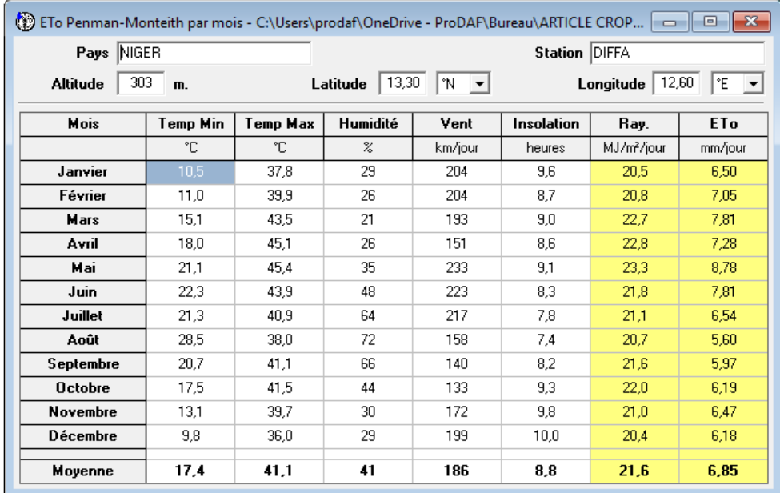
Figure 3: Introduction of monthly averages of minimum and maximum temperatures, relative humidity, wind speed and sunshine in CROPWAT 8.0.
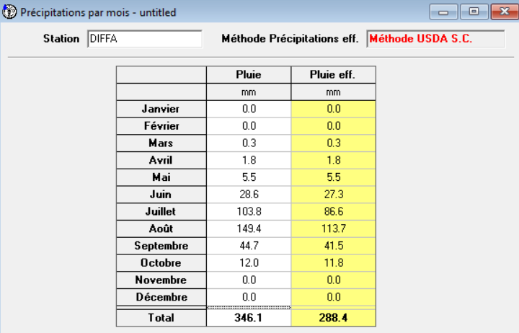
Figure 4: Input of precipitation data into CROPWAT 8.0 software
2.3 Soil data in CROPWAT 8.0
The methodology for defining soil parameters is based on the use of FAO technical reference data (Irrigation and Drainage Bulletin No. 56), adapted to the clay loam texture of the soil in the study area. To simulate water management, a water retention capacity (WRC) of 150 mm/ma was used, associated with an infiltration rate of 20 mm/d and a percolation rate of 2.7 mm/d. These standard values are confirmed by the research of S. Valet (1993), who demonstrated that the fine sedimentary soils of Niger have a high capacity for storing available water due to their richness in silt and clay. More specifically, S. Valet confirmed that the structure of these soils, although compact, allows for stable water reserves, thus limiting losses through deep drainage while maintaining prolonged available moisture for crops. This methodological approach ensures scientific consistency between international standards and the physical characteristics of Sahelian sedimentary soils.
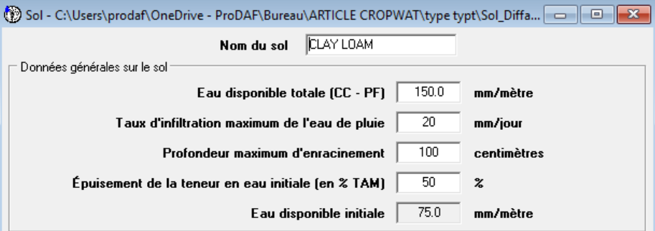
Figure 5: Input of soil data into CROPWAT 8.0 software
2.4 CROPWAT 8.0 Crop Data
The methodology adopted consists of maintaining standard (wet) crop coefficients as a reference base, while applying a climate correction to determine the adjusted (dry) Kc values specific to the Diffa site. In accordance with the guidelines of Allen et al. (1998), this mathematical correction specifically targets the mid-season phase. At this stage of the cycle, the crop reaches its full leaf development, resulting in maximum transpiration and extreme sensitivity to moisture deficit. By incorporating a minimum relative humidity of 21% and a wind speed of 2.36 m/s into the correction formula, the mid-season coefficient is thus increased to 1.35, ensuring an estimate of peak water requirements consistent with local aridity.
This adjustment to 1.35 for the mid-season phase is supported by the FAO climate correction formula, but also by the observations of Boureima et al. (2022) in Niger, which already recommend values higher than the standard (1.25) for areas less arid than Diffa.

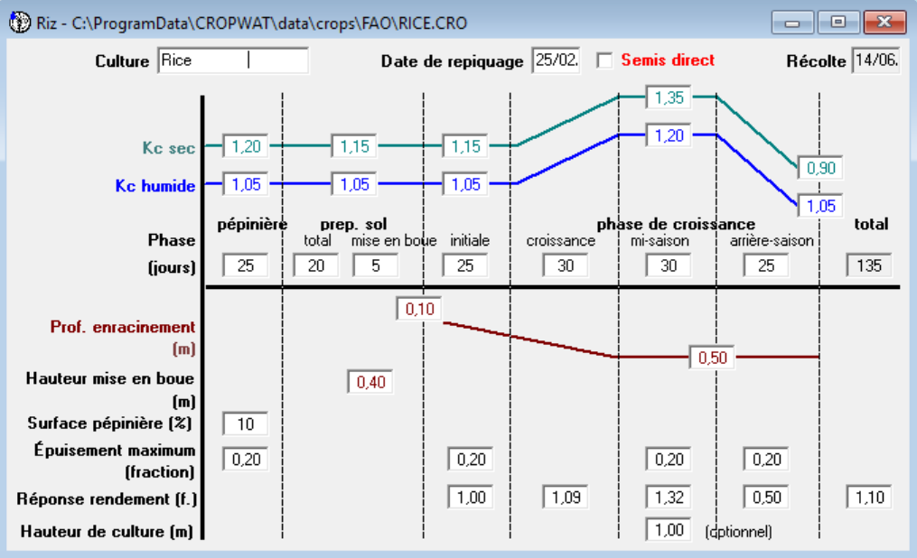
Figure 6: Input of crop data (rice) into CROPWAT 8.0 software
- RESULTS AND DISCUSSION
3.1 Soil Texture and USDA Classification
Particle size analysis performed in the laboratory shows that the soil studied is composed of 38.60% sand, 33.72% silt, and 27.68% clay. Integrating these proportions into the USDA textural triangle allows this soil to be classified as Clay Loam. The representative point of the sample is indeed located at the intersection of these ranges (point colored red in Figure 7), confirming its belonging to this textural category. According to Jabro et al. (2024), clay loam soils -exhibit favorable hydric and structural properties, including good water retention capacity and a balanced pore distribution, making them particularly well-suited to irrigated crops. Thus, the position of the point within the "Clay Loam" polygon of the textural triangle, as observed in the image, scientifically validates the agronomic interpretation and confirms the quality of this soil for the study area.
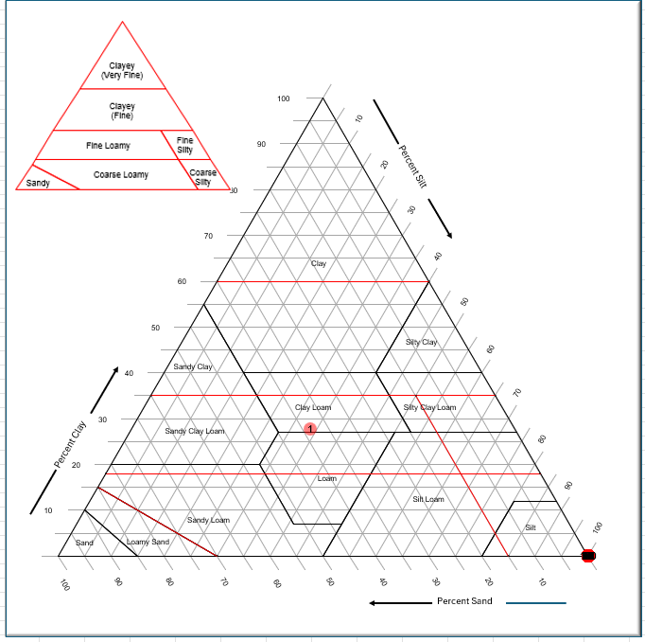
Figure 7: Presentation of the soil sample on the USDA textural triangle
3.2 Reference evapotranspiration (ETo)
Climate data from the Diffa station show strong seasonal variability. Minimum temperatures range on average from 10.5°C in January to 28.5°C in August, while maximum temperatures reach a peak of approximately 45°C between April and May. Humidity generally remains low, between 21% and 72%, with the highest values in August. Wind speeds fluctuate around 160–230 km/day, decreasing significantly towards the end of the year. Sunshine is generally high, around 8 to 9.6 hours per day, corresponding to an average annual solar radiation of 21.6 MJ/m²/day. Reference evapotranspiration (ETo) is highest in May (8.78 mm/day) and lowest in January (6.50 mm/day), with an annual average of approximately 6.85 mm/day, reflecting a high evaporative demand typical of the Sahelian climate.
ETo, defined as the evapotranspiration of a reference surface and not of a water surface ( Calanca et al., 2011), allows for a direct assessment of the atmosphere's evaporative demand. In this climatic context, only a fraction of the infiltrated rainwater remains available in the root zone, constituting effective precipitation; the rest is lost through runoff or percolation.

3.3 Effective Rain
Rainfall data from the Diffa station show a highly contrasting Sahelian regime, characterized by a long dry season and a short rainy season. From January to April, rainfall is almost nonexistent, before a slight increase in May (5.5 mm) and especially in June (28.6 mm). The rainy season reaches its peak in July (103.8 mm) and particularly in August (149.4 mm), which are the two wettest months of the year. Rainfall decreases rapidly from September (44.7 mm) and becomes very low again in October (12 mm), before ceasing completely in November and December. In total, the year recorded 346.1 mm of rainfall, of which 288.4 mm is considered effective rainfall, which corresponds to the water actually available for crops according to the USDA method.
Effective rainfall represents the proportion of precipitation actually available to crops after deducting losses through runoff, evaporation, and deep percolation (Dhouib, M. (2023)). According to Madi, Meddi , and Abdesselam (2018), effective rainfall corresponds to the fraction of precipitation that remains stored in the root zone and contributes directly to plant evapotranspiration, thus constituting a central element of water fluxes in the soil-plant-atmosphere system.

3.4 Water requirements of crops (Rice)
The results from the CROPWAT 8.0 simulation show that rice cultivation in Diffa, with a planting date of February 25th, exhibits a particularly high water demand throughout its growing cycle. Total evapotranspiration ( ETc ) reaches 1178.3 mm, reflecting the intensity of evaporative demand in this hot and dry Sahelian context. Effective rainfall remains limited to 16.3 mm for this period, covering only a small portion of the total needs. Consequently, the net irrigation requirement reaches 1506.8 mm, confirming an almost total dependence on irrigation to meet the crop's water requirements. This marked imbalance between effective rainfall and evaporative demand highlights the need for rigorous water management in the hydro - agricultural infrastructure of the city of Diffa, where rice remains a highly water-intensive crop and is particularly vulnerable to climate variability.
The total water requirement for rice over the entire growing cycle, simulated using the FAO -CropWat model for the agro-climatic conditions of Diffa, amounts to 1506.8 mm. This requirement includes evapotranspiration ( ETc) , the water depth necessary to maintain submersion, and losses due to percolation, after deducting effective rainfall.

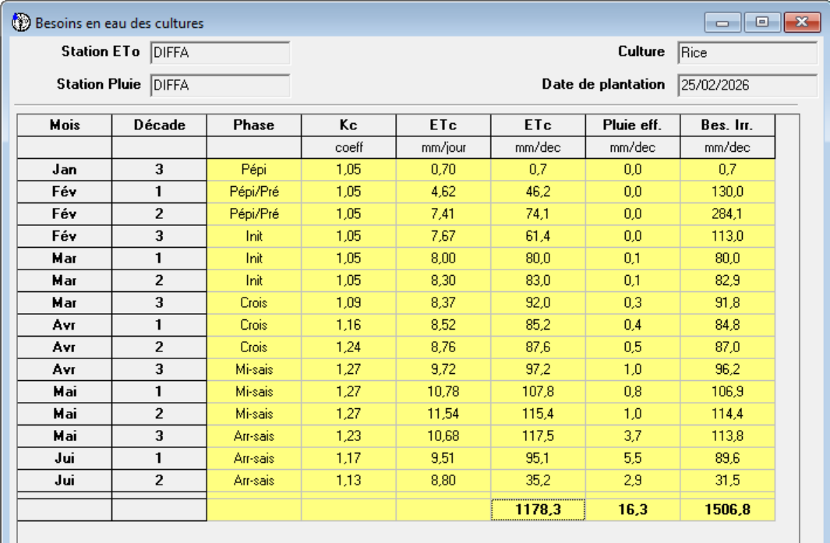
Figure 8: Presentation of rice water requirements
3.5 Irrigation schedule (actual irrigation volumes applied in the field)
The rice irrigation schedule simulated using CROPWAT 8.0 highlights the crop's strong dependence on irrigation under the agro-climatic conditions of Diffa. The data show a total gross irrigation of 2460.2 mm, of which 1722.1 mm was actually used by the crop, while percolation losses reached 423.5 mm, revealing significant infiltration into the clay-loam soil -. Effective rainfall remained low at the beginning of the season (16.8 mm over the entire cycle), contributing little to offsetting actual evapotranspiration. The actual water use by the crop (1017.9 mm) and the actual irrigation requirements (1001.1 mm) underscore that irrigated rice cultivation in Diffa requires strict and continuous water management to maintain water availability and meet the high water demands imposed by the region's hot and dry climate.
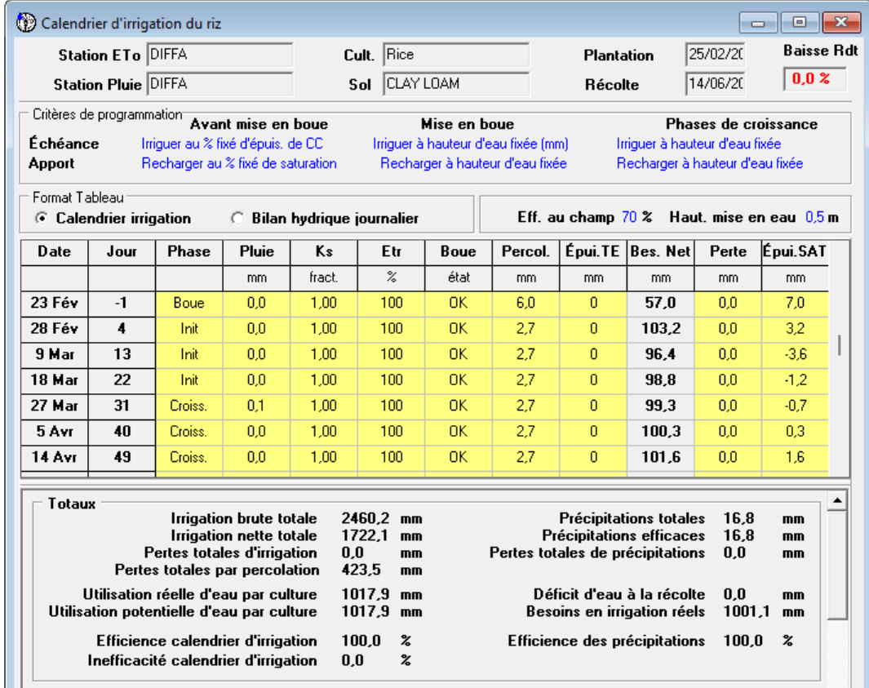
Figure 9: Results of rice irrigation programming on the site

- DISCUSSIONS
Particle size analysis places the sample in the Clay Loam class of the USDA textural triangle (38.6% sand, 33.72% silt, 27.68% clay). This texture is generally associated with high water retention capacity and relatively balanced porosity, conditions favorable to irrigated crops when properly managed. The work of Jabro et al. (2024) specifically highlights that clay loams -offer a favorable compromise between retention and conductivity, facilitating continuous water supply to crops while, in principle, limiting excessive losses through percolation.
In this case, the cumulative percolation of 448.7 mm observed during the irrigation program suggests, however, that field factors (imperfect leveling, cracking under dry conditions, irrigation intensity, water depth management) may negate the textural advantage. In rice cultivation, efficient soil compaction, well-maintained levees and dikes, and precision leveling (ideally laser) are known levers to reduce percolation and homogenize the water layer, consistent with the properties of this type of soil (Oke, al, 2025).
Climate data from 2000–2020 highlight a marked seasonality of evaporative accumulation (Eto), with peaks of 6.78 to 8.78 mm/d at the heart of the hot season (April–June), a period when maximum temperatures exceed 45°C and sunshine duration reaches 8.8 h/day, exacerbating evaporative demand. These results underscore that dry-season rice cultivation in Diffa takes place in an environment subject to high water demand, requiring continuous irrigation, especially during the critical April–June period when atmospheric water needs are at their highest. The high ETo values obtained here are consistent with those reported in other Sahelian regions. Yonaba et al. (2023) show that ETo frequently exceeds 7 mm/d during the hot season, while Etchanchu et al. (2025) confirm that this high atmospheric demand makes irrigated systems particularly vulnerable. The results show that of the 346.1 mm of annual rainfall, approximately 288.4 mm (or 83%) is actually usable by crops. This level is consistent with the well-drained soils typical of Sahelian zones, especially in climates with intense and irregular rainfall, as demonstrated by Ali & Mubarak (2017). The data also show a highly contrasting seasonal distribution, characteristic of the Sahelian climate. Total annual rainfall reaches 346.1 mm, with over 80% concentrated between July and September. This distribution is consistent with climatic observations in the central Sahel, where the wet season is short and dominated by the West African monsoon, while the rest of the year remains almost arid ( Hiernaux , P., et al., 2006).
Simulations of rice water requirements show that the crop is subject to particularly high water demands in the Diffa climate. Cumulative evapotranspiration ( ETc ) reaches 1178.3 mm for the entire growing cycle, while effective rainfall is very low (16.3 mm), covering only a marginal portion of the needs. Thus, the net irrigation requirement amounts to 1506.8 mm, reflecting a strong dependence of the crop on supplemental water provided by irrigation infrastructure. The most water-intensive growth phases correspond to the mid-season stage, where crop coefficients ( Kc ) peak between 1.21 and 1.27, resulting in daily ETc exceeding 10 mm/day. This concentration of needs during the months of April to June coincides with a period of very low rainfall, reinforcing the need for rigorous irrigation management. Overall, these results confirm that, under the agro-climatic conditions of the Sahel, more specifically Diffa, the Irrigated rice production relies almost exclusively on controlled water supply, and any variation in resource availability can significantly affect crop performance (Dancette, et al, 2000).
From an operational standpoint, the irrigation schedule highlights massive water applications at the beginning of the cycle for soil accumulation, followed by sustained applications during growth and mid- -season. Total gross irrigation reached 2460.2 mm, with net irrigation of 1722.1 mm and percolation losses of 423.5 mm in a -clay-loam soil. These losses, expected in rice cultivation, underscore the importance of managing water depths and application frequency to limit deep percolation while avoiding water stress .
CONCLUSION
The results from the CROPWAT 8.0 simulation show that irrigated rice cultivation in the Diffa region operates in a climatic environment with particularly high atmospheric water demand, resulting in a total evapotranspiration ( ETc ) requirement of 1178.3 mm for a cycle beginning on February 25th. This value represents the amount of water needed to ensure the complete physiological functioning of one hectare of rice throughout its entire cycle. When this water demand is applied to a cultivated area of 1 ha, it corresponds to a total volume of approximately 11,783 m³ of water, illustrating the scale of the needs in a Sahelian context characterized by extreme temperatures and high evaporation. Despite an annual rainfall of 346.1 mm, of which 288.4 mm are theoretically effective, only a small fraction coincides with the most demanding growth stages of the rice, exacerbating the gap between natural water supply and the crop's water demand. The irrigation requirement is 1506.8 mm over the production cycle. Based on this calculated irrigation requirement (1506.8 mm), the volume required for an experimental plot of 7.5 m² was estimated at 11.32 m³ for the entire growing cycle. The significant volume of water required thus demonstrates the severe climatic constraints affecting irrigated rice cultivation in Diffa and underscores the central role of the water balance in understanding the functioning and vulnerability of rice-growing systems in the Sahelian zone.
CONFLICT OF INTEREST
The authors declare that they have no conflict of interest.

COMPETING INTERESTS DISCLAIMER:
Authors have declared that they have no known competing financial interests OR non-financial interests OR personal relationships that could have appeared to influence the work reported in this paper.
REFERENCES
- Ali, M.H., & Mubarak, S. (2017). Effective rainfall estimation methods for field crops: An overview, analysis and new formulation . Asian Research Journal of Agriculture, 7(1), 1–12. https://doi.org/10.9734/ARJA/2017/36812 .
- Allen, RG, Pereira, LS, Raes, D., & Smith, M. (1998). Crop evapotranspiration: Guidelines for computing crop water requirements (FAO Irrigation and Drainage Paper No. 56). Food and Agriculture Organization of the United Nations (FAO).
- Bacci11, M. (2016). Chapter 4 Variabilities and climate change and their impacts on rainfed crops in the Tillabéri region , Niger. Maurizio Bacci11, Katiellou Gaptia Lawan12. Climate risk and adaptation in the Tillabéri Region , Niger , 99.
- Boukar, MCM, Issa, S., Kellou, KKB, Saley, MD, Wang, K., Bagana , MMC, ... & Ali, M. (2024). Characterization of UV-absorbing mycosporin -like amino acids in the freshwater cyanobacterium Nostoc calcicola . Biotechnology Journal International , 28 (5), 16-25.
- Calanca , P., Smith, P., Holzkämper , A., & Ammann, C. (2011). Reference evapotranspiration and its application in agrometeorology. Swiss Agricultural Research , 2 (4), 176-183.
- Clearinghouse, TAAT (2021). Climate-smart agricultural technologies for the Sahel and the Horn of Africa. Technical Report Series 009. Gates Open Res , 5 (162), 162.
- Dancette , C., et al. (2000). The main irrigated rice farming systems in the PSI intervention area. In For sustainable development of irrigated agriculture in the Sudano --Sahelian zone (pp. 34–46). PSI -CORAF / CIRAD / IRD.
- Etchanchu , J., Demarty , J., Dezetter , A., Farhani, N., Thiam, PB, Allies, A., Bodian, A., Boulet, G., Chahinian, N., Diop, L., Mainassara , I., Ndiaye, PM, Ollivier, C., Olioso, A., & Roupsard , O. (2025). Multiscale analysis of existing actual evapotranspiration products over agropastoral Sahel . Journal of Hydrology , 651, 132585. https://doi.org/10.1016/j.jhydrol.2024.132585.
- Fageria , N.K. (2007). Green management in crop production. Journal of plant nutrition , 30 (5), 691-719.
- FAO (1998): Crop Evapotranspiration - Guidelines for computing crop water requirements. Irrigation and Drainage Paper No. 56. (Source for global standard values).
- Gee, G.W., & Or, D. (2002). 2.4 Particle - size analysis. Methods of soil analysis: Part 4 physical methods , 5 , 255-293.
- Hartemink , AE, Zhang, Y., Bockheim, JG, Curi, N., Silva, SHG, Grauer-Gray, J., Lowe, DJ, & Krasilnikov, P. (2020). Soil horizon variation: A review . Advances in Agronomy. https://doi.org/10.1016/bs.agron.2019.10.003.
- Hiernaux , P., & Le Houérou, HN (2006). The routes of the Sahel. Sécheresse , 17 (1-2), 51-71.
- Jabro, J., Stevens, W., Iversen, W., Sainju , U., Allen, B., Dangi, S., & Chen, C. (2024). Soil-water retention curves and pore-size distribution in a clay loam under different tillage systems . Land, 13 (12), 1987. https://doi.org/10.3390/land13121987 .
- LE, EDSD (2016). Guide on the environmental characterization of sites in the context of risk assessment for the environment and human health volume 1 guidelines.
- MADI, M., MEDDI, M., & ABDESSELAM, B. (2018). Rational management of rainwater and water flows in the soil-plant-atmosphere system in the Upper Cheliff basin, Algeria. IAV Hassan II , 6 (4).
- Mahamane, L., Saadou, M., & Nonguierma, A. (2005). Determination of the degree of bioclimatic aridity of seven localities in the department of Tillabéri (southwest Niger): classification into bioclimatic zones. Sécheresse , 16 (2), 107-114.
- Musset, R. (1942). Rice in the world. Journal of traditional agriculture and applied botany , 22 (247), 151-180.
- Oke, A., Atengdem, PB, Zemadim, B., & Cofie, O. (2025). Land preparation for irrigated rice cultivation in West Africa . International Water Management Institute (IWMI), 4 p.
- Valet, S. (1993): Study of soils and the agricultural suitability of land in Niger. ORSTOM/IRD technical reports. (Source confirming the available water capacity and the behavior of clay-loam soils in the Sahelian zone).
- Wade, M., Legoupil, JC, & Poussin, JC (2000). Tools to aid discussion, negotiation and decision-making for effective management of hydro-agricultural developments. PSI-CORAF.
- Yonaba, R., Tazen , F., Cissé, M., Adjadi Mounirou, L., Belemtougri , A., Ouedraogo, VA, Koïta , M., Niang, D., Karambiri, H., & Yacouba, H. (2023). Trends, sensitivity and estimation of daily reference evapotranspiration (ET ₀ ) using limited climate data: regional focus on Burkina Faso in the West African Sahel . Theoretical and Applied Climatology , 153, 947–974. https://doi.org/10.1007/s00704-023-04507-z.

