Original Research Article
Ameliorative Effect of Humic Acid Extracted from Imperata cylindrica Compost on Selected Chemical Properties of Soil from Coastal Region

.
ABSTRACT

Acid Inceptisols are commonly found in coastal region of Bengkulu Province, Indonesia. This particular soil faces serious problem such as low pH, high aluminum (Al) saturation and low fertility. Humic acid extracted from cogon grass (Imperata cylindrica) benefits to improve chemical properties of the soil. The present study aims to evaluate the effect of humic acid derived from cogon grass compost on the improvement of selected chemical properties of soil from coastal region. The study employed Completely Randomized Design (CRD) with treatments of humic acid dosages consisting of 0 (control), 1, 2, 3, and 4 g kg⁻¹. Each treatment was replicated 3 times. The experimental procedure was carried out by incorporating 0.1 kg of air-dried soil with assigned rate of humic acid in a 100 ml plastic bin. The mixer was incubated for 14 days with additional distilled water to maintain field capacity moisture content. After the incubation, the soil was analyzed for selected soil chemical properties. The result indicated that the application of humic acid at a rate of 4 g kg⁻¹ substantially increased soil organic-C by 49%, available P by 58%, exchangeable K by 33%, and cation exchange capacity (CEC) by 51.4% compared to control. However, soil pH significantly declined with the application of humic acid, thereby an application rate of 1-2 g kg⁻¹ is adequate to prevent further decrease in soil pH. In addition, humic acid application had no prominent effect on soil total N, C/N ratio and electrical conductivity (EC) of the soil. These findings suggest that humic acid extracted from cogon grass compost has strong potential to improve acid Inceptisols in coastal regions, thereby supporting sustainable agricultural management.

Keywords: Acid Inceptisols, Coastal region, Cogon grass, humic acid

- INTRODUCTION

Acidic coastal soils often face chemical constraint for plant productivity. The main limitation is related to low to very low soil pH with high aluminum (Al) and iron (Fe) saturation. Madueke et al. (2021) reported that soils from coastal Nigeria range extremely low pH (< 4.4) to slightly acidic (6.1). High acidity of the soil is related to high Al and Fe saturation, causing plant toxicity and P fixation (Mabagala, F. S. and Mng’ong’o (2022). Acidic soils are also commonly found in coastal area of Bengkulu. Study by Muktamar et al. (2024) suggested that Inceptisols from coastal area is very acidic with pH of 4.22 and exchangeable Al of 1.45 cmol kg⁻¹. Moreover, coastal acid soils also face other problem including low cation exchange capacity (CEC), low organic matter and deficiency of essential plant nutrients. Previous studies confirmed that acidic soils from coastal area exhibit low CEC, base saturation, organic matter, and available nutrients such as N, P, K, Ca, and Mg (Muktamar et al., 2022; Putri and Herlambang, 2025; Ukaegbu and Nnawuihe, 2020). These constraints cause acidic soils from coastal environment requires the addition of ameliorant such as as humic acid to improve their fertility for sustainable productivity. Humic acid can be derived from cogon grass (Imperata cylindrica) compost.

Cogon grass widely spreads in tropical region including Indonesia with capability of fast growth in marginal and degraded land (Hidayat et al. 2018). In Indonesia, this weed reaches 8.5 million ha and adaptive to acidic soil and marginal land, yielding biomass ranging 8 to 20 ton ha⁻¹ (Garrity et al., 1996; Goshadrou, 2019), making it potential as a raw organic material for compost. Use of cogon grass as source of humic acid benefits to reduce the impact on crop cultivation and environmental problem.
Humic acid effectively improve chemical properties of degraded soils. This compound has complex molecular structure with actively functional groups such carboxyl (-COOH), phenolic (Ar-OH) and hydroxyl (-OH) which interact with soil particles, nutrients and biological system (Nabi et al., 2025). The interaction significantly improves soil fertility through particular mechanisms such as improvement of soil CEC, water retention, and soil aggregate formation and stabilization (Sari et al., 2025). Previous studies showed that the application of humic acid increases pH, organic matter, CEC, available P, exchangeable K, Ca and Mg, and decrease Al and Fe saturation (Ren et al., 2022; Matheus and Kantur, 2025). Additionally, in environmental remediation such as post mining lands or heavy metal polluted sediment, humic acid can act as a heavy metal chelating agent. Carboxyl and phenolic functional groups in humic acid bond heavy metals to form stable organo metal complexes (Spark, 2003). This process enables to reduce their mobility, bioavailability and potential toxicity in the soil (Wu et al., 2017; Wang et al., 2025; Barzgar et al., 2025).
Humic acid may be extracted from various raw materials, such manures, sawdust, sewage sludge, green waste, and food waste. The chemical composition and resulting properties of the humic acid are intrinsically dependent to the nature of the source material (Guo et al. 2019). Our study focuses on humic acid derived from cogon grass compost using acid Inceptisols from coastal region. These weeds are abundantly found in marginal land and has high potential as an alternative raw material for humic acid. However, information on humic acid from this particular weed compost and its effectiveness in improving soil chemical properties of acid Inceptisols is very limited, particularly in reducing Al saturation, increasing CEC and releasing fixed P in the soil. This study is essential to fill the research gap and to offer a local resourced based solution to the rehabilitation of acid marginal lands. Therefore, the study is intended to evaluate the effect of humic acid extracted from cogon grass compost on selected chemical properties of soil from coastal region.

2. material and methods

2.1. Soil Sample Collection

Soil was sampled from oil palm plantation in Air Napal District, North Bengkulu Regency, Bengkulu Province at altitude of 10 m above sea level. The soil was classified as Inceptisols. Ten kg of sample was compositely collected from 5 spots at the depth of 0-20 cm, then air-dried for two days at Greenhouse, Faculty of Agriculture, University of Bengkulu. Air-dried sample was ground, sieved with 0.5 mm screen. A portion of sample was taken for initial characteristics of the soil. The initial characteristics of the soil were 22.9 g kg⁻¹ organic carbon, 2.90 g kg⁻¹ total soil nitrogen, 4.34 mg kg⁻¹ available P, 0.35 cmol kg⁻¹ exchangeable K, 15.89 cmol kg⁻¹ CEC, pH of 4.54 and EC of 61.5 uS m⁻¹. Also, the soil contained 60.32% clay, 20.84% silt and 18.84% sand (Suci et al., 2025).

2.2. Composting and Humic Acid Fractionation Procedure

Cogon grass was collected from Crop Production Experiment Station, University of Bengkulu at an altitude of 15 m above sea level. Approximately 50 kg of weed was taken, chopped 3-5 cm pieces and air dried for two days. The biomass contained 52.69% C, 0.87% N, 0.01% P, 1.19% K, 10% cellulose, 12% hemicellulose, 68% lignin with C/N ratio of 60.56. Chopped biomass was homogeneously mixed with 1 kg of cattle manure and bio-activator, then placed in composting bin. The mixer was incubated for 6 weeks with turning every week. At the end of incubation, the matured compost was air dried and sieved with 0.5 mm screen. The characteristics of the compost were 33.83% C, 1.37% N, 0.95% P, 2.47% K, 4% cellulose, 2% hemicellulose, 44% lignin, 5.69% humic acid, and 3.75% fulvic acid, with C/N ratio of 31.39 and pH of 8.37.

Humic acid fractionation was prepared as follows: 200 g of cogon grass compost was mixed with 200 ml of 0.1N NaOH in a 500 ml Erlenmeyer, then shaken for 24 h. After shaking, 6 ml NaCl was added and incubated for 24 h, before filtered using Whatman paper. The filtrate was acidified to pH 1-2 using sulfuric acid. The solution, then was heated in a water bath at 60 ºC, before incubated another 24 h. The solution was filtered using Whatman paper and the remaining solid (humic acid) was collected and oven dried at 60 ºC until achieving constant weight. The extraction process was repeated until sufficient humic acid was collected for the experiment.

2.3. Treatment and Experimental Procedure

The study used Completely Randomized Design (CRD) with treatment of humic acid extracted from cogon grass (Imperata cylindrica) compost at a rate of 0 (control), 1, 2, 3 and 4 g kg⁻¹ of soil. Each treatment was replicated 3 times. The experimental procedure was carried out as follows: 0.1 kg of soil sample was homogeneously mixed with particular rate of humic acid and placed in a 100 ml plastic bin. Distilled water was added until reaching the field capacity moisture content. All assigned bins were randomly positioned in 1.5 wooden rack at room temperature in the laboratory. The mixture was incubated for 14 days with added distilled water every two days to maintain field capacity. At the end of experiment, soil sample was collected form each assigned bin, air dried and ground. Before soil analysis, soil sample was sieved with 0.5 mm screen. Soil analysis included organic-C using Walkley and Black method, total nitrogen with Kjedahl method, available P using Bray I method, exchangeable K with flame-photometer after extraction using 1N ammonium acetate, pH at 1:1 ratio of soil and distilled water using pH meter and CEC with extraction 1N ammonium acetate method.

2.4. Analysis of Data

Data analysis used variance analysis with ANOVA at 5% level. When significant differences were attained, further test was carried out using DMRT at significant level of 5%.

3. results and discussion

3.1. Soil pH and Total Nitrogen

This study assessed the influence of humic acid derived from cogon grass (Imperata cylindrica) compost on selected chemical properties of acid Inceptisols from the coastal region of Bengkulu. Variance analysis showed that humic acid significantly affected soil pH, organic-C, available P, exchangeable K, and CEC (p<0.05) of Inceptisols, but did not influence total N, C/N ratio, and EC (p>0.05). As indicated in Figure 1a, humic acid application reduced soil pH by 0.14 and 0.30 units at rates of 1 and 4 g kg⁻¹, respectively, compared to the control. Notably, the pH reduction observed with the 1 g kg⁻¹ treatment was not significantly different from those achieved with 2 and 3 g kg⁻¹.

Decreasing soil pH due to humic acid addition to the soil is associated with 2 significant processes. First, humic acid has 2 essential functional groups, carboxyl (COOH) and phenolic (Ar-OH) with acid properties. Both functional groups ionize and release hydrogen ions (Sposito, 2008; Tan, 2014). The humic acid solubility increases with increasing soil pH; on the other hand, it declines with decreasing soil pH (Yang et al. 2025; Mohammed et al., 2025). Secondly, Acid Inceptisols used in this experiment has relatively low buffering capacity, indicated by low CEC, therefore, addition of humic acid instantly lowers soil pH.

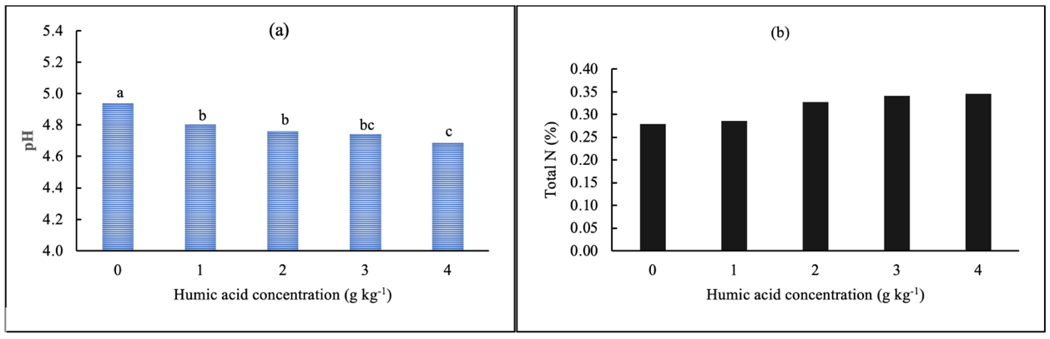
Note: Values represented by bars sharing the same letter are not significantly different

Figure 1. The effect of humic acid on soil pH (a) and total soil nitrogen (b) in Inceptisols

Figure 1b indicates that humic acid application did not significantly increase soil total N. This result might be related to insignificant nitrogen content of humic acid used in this study. Characterization of cogon grass compost showed that nitrogen content was modest (1.37%) with high content of lignin (44%). Also, nitrogen in humic acid such as aminoquinone nitrogens (Thorn and Cox, 2009) with complex structure decomposes very slowly in soil, therefore, at time range of the experiment, it has no effect on soil N. Study by Rahayu et al. (2021) also showed that humic acid application did not influence nitrogen content in soil. According to Ma et al. (2024), the effectiveness of humic acid was dependent on climatic condition and soil properties where optimal response was observed in region of high rainfall and temperature, in soil with a moderate pH and low total nitrogen.

3.2. Soil Organic Carbon and C/N Ratio

The study also revealed that humic acid application increased soil organic-C by 49% at a rate of 4 g kg⁻¹ compared to control, even though there were insignificantly different at 1-4 g kg⁻¹ (Figure 2a). This result indicates that humic acid directly contributes carbon to the soil as also reported in previous studies (Santi et al., 2024; Guo et al., 2025). However, study by Hartina et al. (2025) showed that humic application did not affect organic-C of acid soil with low initial content of organic-C and CEC. This different result might be related to higher preliminary soil organic carbon and CEC of the soil used in this study. Figure 2b indicates that C/N ratio ranged 8.43 to 11.13 and was not different among rates of humic acid application. This result of study suggests that soil organic carbon and nitrogen content varied proportionally during the experiment, resulting in insignificant effects among humic acid rates.

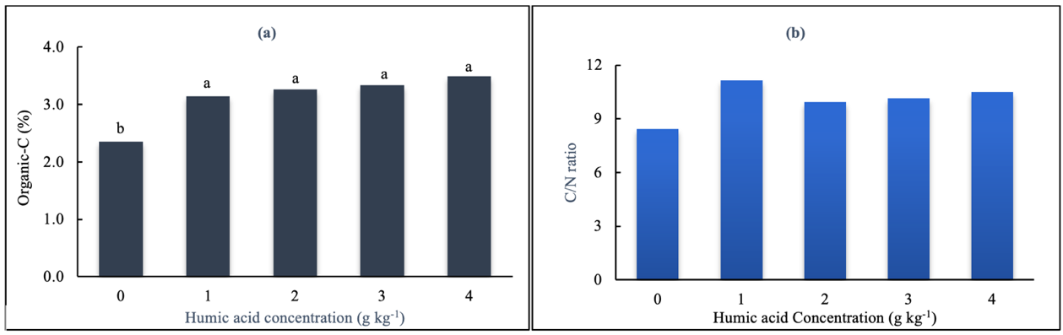
Note: Values represented by bars sharing the same letter are not significantly different

Figure 2. Organic carbon in soil (a) and C/N ratio under different rate of humic acid in Inceptisols

3.3. Soil Available Phosphorus and Potassium

Additionally, humic acid application prominently increased available P in soil (Figure 3a). Application of humic acid at 3 g kg⁻¹ exhibited the greatest available P in soil, corresponding to 58% increase over the control; however, it was not significantly different from that of 2 g kg⁻¹ rate. An increase in available P is associated with exchange of phosphate in soil colloid with carboxy and phenolic from humic acid, releasing it to soil solution (Yuan et al. 2023). Another possible mechanism is formation of stable organo-metal complex where carboxyl and phenolic in humic acid covalently bond Fe and Al from metal phosphate (FePO₄ or AlPO₄), releasing phosphate to soil solution (Jing et al., 2023). Humic acid also stimulates phosphatase enzyme to breakdown organic into inorganic P. Study by Israa et al. (2024) confirmed that humic acid extracted from wheat straw, alfalfa leaves, goat waste and poultry waste increased activities of phosphatase enzyme. Result of this study is in-line with that reported by Li et al. (2019) where humic application increased available P by 14.3%.

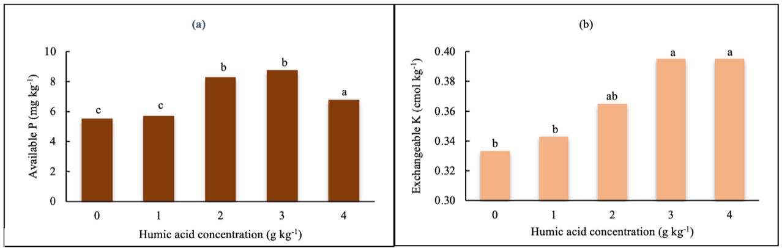
Note: Values represented by bars sharing the same letter are not significantly different
Figure 3. The influence of humic acid on available P (a) and exchangeable K (b) in Inceptisols

Applying humic acid derived from cogon grass also significantly enhanced exchangeable K (Figure 3b). The greatest increase was observed at 4 g kg⁻¹ even though it was not statistically different from 2 or 3 g kg⁻¹. Exchangeable K increased by 33% at 4 g kg⁻¹ over control. Increasing K content in soil might be related to conversion of K mineral in soil. The application of humic acid increased the activity of bacteria (Chen et al., 2023). Potassium solubilizing bacteria are able to solubilize K minerals through the production of organic and inorganic acids, chelation, and exchange reactions (Etesami et al., 2017). Previous study also confirmed that application of humic acid increased exchangeable K in soils (Li et al., 2019; Ren et al., 2022).

3.4. Soil Cation Exchange Capacity and Electrical Conductivity

Moreover, CEC of the soil significantly increased under the application of humic acid (Figure 4a). The application at 3 g kg⁻¹ resulted in the highest CEC, which was statistically on par with the 4 g kg⁻¹ rate but markedly greater than the control, representing an increase in 51.4%. Humic acid is rich in functional groups, particularly carboxyl (COOH) and phenolic (Ar-OH) which play a prime role in the acid properties (Lamar et al., 2024; Nabi et al., 2025). Hydrogen dissociation of these functional groups supplies negative charged sites in the soil, consequently increasing CEC. This result is in-line with previous studies where humic acid application significantly increase CEC in sand and soil (Xu et al., 2021; Suwardi et al., 2019). However, the application of humic did not markedly affect electrical conductivity (Figure 4b). This result is different from reported by Wang et al. (2024) where humic acid application reduced EC of the soil. Future research is necessary to investigate the effect of humic acid on EC of soils with different characteristics.

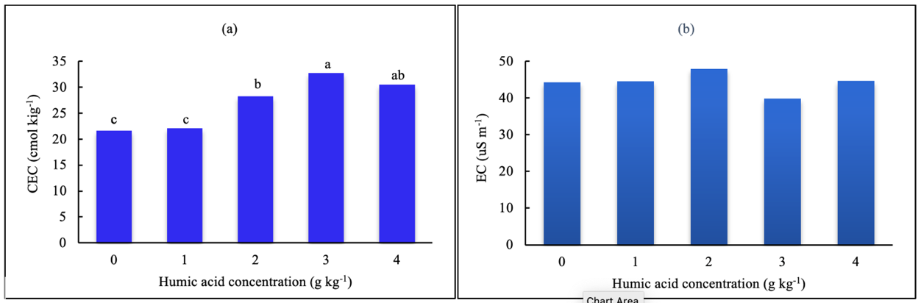
Note: Values represented by bars sharing the same letter are not significantly different

Figure 4. Cation exchange capacity (a) and electrical conductivity (b) following the application of humic acid in Inceptisols.

4. Conclusion

The application of humic acid extracted from cogon grass (Imperata cylindrica) benefits to the improvement of chemical properties of acid Inceptisols as demonstrated by increases in soil organic-C, available P, exchangeable K and CEC of the soil. Compared to the control, humic acid application at a rate of 4 g kg⁻¹ enhances soil organic-C increased by 49%, available P by 58%, exchangeable K by 33% and CEC by 51.4%. Nonetheless, soil pH prominently decreased with increasing doses of humic acid. In addition, humic acid did not significantly influence on soil total N, C/N ratio and soil EC. An application rate of 1-2 g kg⁻¹ is sufficient for improving soil properties while preventing an extreme decrease in soil pH which could negatively affect on nutrient dynamic in the soil. These findings are valuable for the management of acid Inceptisols in coastal region, thereby contributing to sustainable agriculture development

DISCLAIMER (ARTIFICIAL INTELLIGENCE

Author(s) hereby declare that no generative AI technologies have been used during the writing or editing of this manuscript.

Competing interests

Authors have declared that no competing interest exist

COMPETING INTERESTS DISCLAIMER:
Authors have declared that they have no known competing financial interests OR non-financial interests OR personal relationships that could have appeared to influence the work reported in this paper.

References

Barzgar, Z., Towfighi, H., Gerdelidani, A. F., Shahbasi, K., Heidari, A., Etesami, H., Verrillo, M., Savy, D., & Spaccini, R. (2025). Molecular determinants of humic and fulvic acids in enhancing micronutrient availability in calcareous soils: a comparative study on Fe, Mn, Zn, and Cu dynamics. Scientific Reports 15, 34142, https://www.nature.com/articles/s41598-025-06678-3

Chen, M., Gowthaman, S., Nakashima, K., Takano, C., & Kawasaki, S. (2023). Effects of humic acid on process macrobial induced carbonate precipitation. Proceedings of the 9ICEG 9th International Congress on Environmental Geotechnics 25-28 June, 2023, Chania, Greece. https://www.issmge.org/uploads/publications/116/117/ICEG2023-84.pdf

Etesami, H., Emami, S. & Alikhani, A. (2017). Potassium solubilizing bacteria (KSB): Mechanisms, promotion of plant growth, and future prospects A review. Journal of Soil Science and Plant Nutrition 17(4): 897-911. https://www.scielo.cl/pdf/jsspn/v17n4/art05.pdf

Garrity, D. P., Soekardi, M., van Noordwijk, M., de la Cruz, R., Pathak, P. S., Gunasena, H.P. M., van So, N., Huijun, G., & Majid, N. M. (1996). The Imperata grasslands of tropical Asia: area, distribution, and typology. Agroforestry System 36: 3-29. https://link.springer.com/article/10.1007/BF00142865

Goshadrou, A. (2019). Bioethanol production from cogongrass by sequential recycling of black liquor and wastewater in a mild-alkali pre-treatment. Fuel 258, 116141. https://www.sciencedirect.com/science/article/abs/pii/S0016236119314954

Guo, Z., Gao, J., Lv, T., Zheng, Y., Deng, C., Sun, X., Y, S., Wang, C., & Deng, Y. (2025). Humic Acid Enhances Soil Fertility and Microbial Diversity Under Optimized Nitrogen Fertilization in Quinoa Rhizosphere. Plants 14(24), 3850, https://www.mdpi.com/2223-7747/14/24/3850

Guo, X., Liu, H. & Wu, S. (2019). Humic substances developed during organic waste composting: Formation mechanisms, structural properties, and agronomic functions. Science of the Total Environment, 662, 501-510. DOI: 10.1016/j.scitotenv.2019.01.137

Hartina, Monkham, T., Vityakon, P., & Sukitprapanon, T., S. (2025). Scientific Report 15, 4350. https://www.nature.com/articles/s41598-025-89132-8

Hidayat, S., Bakar, M. S. A., Yang, Y., Phusunti, N., & Bridgwater, A. V. (2018). Characterisation and Py-GC/MS analysis of Imperata Cylindrica as potential biomass for bio-oil production in Brunei Darussalam. Journal of Analytical and Applied Pyrolysis 134: 510-519. https://www.sciencedirect.com/science/article/abs/pii/S0165237018302262

Israa, A. Y., Al-Jaberi, M. M., & Abdulkareem, M. A. (2024). Effect of humic acids extracted from different organic sources and inoculation of bacillus subtilis or aspergillus niger in alkaline phosphatase activity in calcareous soil. SSEJPH 00-00-2024. https://www.google.com/url?sa=t&source=web&rct=j&opi=89978449&url=http://www.seejph.com/index.php/seejph/article/download/980/676/1385&ved=2ahUKEwiez9Pd0vaSAxVFRmwGHRO8Dh0QFnoECEEQAQ&usg=AOvVaw1LObrzaWaE_37HlfQHksqS

Jing, J., Zhang, S., Yun, L. Li, Y., Zhang, Y., Ye, X., Zhang, L., Xiong, Q., Wang, Y., & Zhao, B. (2023). Effects of incorporating different proportions of humic acid into phosphate fertilizers on phosphorus migration and transformation in soil. Agronomy 13(6), 1576. https://doi.org/10.3390/agronomy13061576

Lamar, R. T., Gralian, J., Hockaday, W. C., Jerzykiewicz, M., & Monda, H. (2024). Investigation into the role of carboxylic acid and phenolic hydroxyl groups in the plant biostimulant activity of a humic acid purified from an oxidized sub-bituminous coal. Frontier in Plant Science 15. https://doi.org/10.3389/fpls.2024.1328006

Li, Y., Fang, F., Wei, J., Wu, X., Cui, R., Li, G., Zheng, F. & Tan, D. (2019). Humic acid fertilizer improved soil properties and soil microbial diversity of continuous cropping peanut: A Three-Year Experiment Scientific Report 9, 12014. https://www.nature.com/articles/s41598-019-48620-4

Ma, Y., Cheng, X., & Zhang, Y. (2024). The impact of humic acid fertilizers on crop yield and nitrogen use efficiency: A meta-analysis. Agronomy, 14(12), 2763. https://doi.org/10.3390/agronomy14122763

Mabagala, F. S. & Mng’ong’o. (2022). On the tropical soils; The influence of organic matter (OM) on phosphate bioavailability. Saudi Journal of Biological Sciences 29: 2635-2641. https://doi.org/10.1016/j.sjbs.2022.02.056

Madueke, C.O., Okore, I. K., Maduekeh, E. C., Onunwa, A. O., Okafor, M. J., Nnabuehe, E. C., Nwosu, B., Nwaiwu, C. J., & Nwosu, T. V. (2021). Characterization and land evaluation of three tropical rainforest soils derived from the coastal plain sands of southeastern Nigeria. Agro-Science 20(2): 25-36. DOI: 10.4314/as.v20i2.5

Matheus, R. & Kantur, D. (2025). Effectiveness of organic fertilizer enriched with humic acid on soil chemical quality, nutrient uptake, and shallot yield in calcareous soils. Jurnal Teknik Pertanian Lampung14(1): 309-318. https://jurnal.fp.unila.ac.id/index.php/JTP/article/view/9977/pdf

Mohammed, I., Kodaolu, B., Audette, Y., Smith, S. & Longstaffe, J. (2025). Acid-base properties of humic acid from soil amended with different organic amendments over 17 years in a long-term soil experiment. Soil. Sci. Soc. Am. J. 89(3): 1-11. https://acsess.onlinelibrary.wiley.com/doi/epdf/10.1002/saj2.70074

Muktamar, Z., Zanovid, V., Hermawan, B., Anandyawati, Utami, K., & Setyowati, N. (2024). The availability of soil N, P, K, and mustard yield after the application of liquid organic fertilizer from household waste in Ultisols. International Journal of Plant and Soil Science 36(5):135-142. https://doi.org/10.9734/ijpss/2024/v36i54510

Muktamar, Z., Setyowati, N., Anandyawati, & Utami, K. 2022. Characterization of soils from the coastal rural area of Bengkulu, Indonesia for agricultural land. International Journal of Agriculture and Biological Sciences. 6:1-11 (Sept-Oct). http://dx.doi.org/10.5281/zenodo.7421526

Nabi, F., Sarfaraz, A., Kama, R., Kanwal, R., & Li, H. (2025). Structure-based function of humic acid in abiotic stress alleviation in plants: A Review. Plants 14(13), 1916. https://doi.org/10.3390/plants14131916

Putri, T. S. I. C. & Herlambang, S. (2025). Soil quality along a distances gradient from shorelines in Samas coastal sandy land, Bantul, Yogyakarta. Soil and Water Journal 22(1): 19-25. https://jurnal.upnyk.ac.id/index.php/jta/article/view/15272/7177.

Okaegbo, E. P. & Nnawuihe, C. O. (2018). Assessing landuse effect on soil properties in the Coastal plains sand, Imo State, Nigeria. African Journal of Agricultural Research 16(6): 850-859. https://academicjournals.org/journal/AJAR/article-abstract/8C2A1A163891

Rahayu, R., D., Mindari, W. & Arifin, M. (2021). The effectiveness of silica and humic acid on nitrogen availability and rice plant growth in sandy soil. Agritrop 19(2): 99-106. https://jurnal.unmuhjember.ac.id/index.php/AGRITROP/article/view/5976/3686

Ren, H., Islam, M. S., Wang, H., Guo, H., Wang, Z., Qi, X., Zhang, S., Guo, J., Wang, Q., & Li, B. (2022). Effect of Humic Acid on Soil Physical and Chemical Properties, Microbial Community Structure, and Metabolites of Decline Diseased Bayberry. International Journal of Molecular Sciences 23(23), 14707. https://doi.org/10.3390/ijms232314707

Santi, M. A., Somboon, S., Thip-Amat, S., Sukitprapanon, T. S., & Lawongsa, P. (2024). Effects of humic acid application on bacterial diversity under maize cultivation. Agrosystems, Geosciences & Environment 7(3): 1-17. https://doi.org/10.1002%2Fagg2.20547

Sari, S. A., Aulia, A. C., Kim, Y., Son, D., Kim, M. G., Kim, W. Y., &Cha, J. Y. (2025). Mechanistic insights into humic acid-mediated enhancement of crop productivity and stress tolerance. Journal of Korean Society of Grassland and Forage Science 45(4):275-284. https://doi.org/10.5333/KGFS.2025.45.4.275

Spark, D. L. (2003). Environmental Soil Chemistry. 2 ndEd. Academic Press. New York.

Sposito, G. (2008). The Chemistry of Soils (2nd ed.). Oxford University Press.

Suci, Y. T. E., Muktamar, Z. Fahrurrozi, F., Setyowati, N., Utami, K., Oujiwati, H., & Alnopri. (2025). The use of Sphagneticola trilobata L. and Melastoma affine D. composts to improve certain soil chemical properties and sweet corn growth and yield. Int. J. Ag and Env. Res. 11(1): 183-199. https://ijaer.in/2025files/ijaer_11__12.pdf

Suwardi, S., Cholili, N., & Anwar, S. (2019). Application of humic substance with zeolite as carrier to increase the production of water spinach (Ipomea reptans poir). IOP Conferences Series: Earth and Environmental Science 393, 012020. https://iopscience.iop.org/article/10.1088/1755-1315/393/1/012020/pdf

Tan, K. H. (2014). Humic Matter in Soil and the Environment: Principle and Controversies. CRC Press. London. https://api.pageplace.de/preview/DT0400.9781482234466_A23416614/preview-9781482234466_A23416614.pdf

Thorn, K.A., & Cox, L. (2009) N-15 NMR spectra of naturally abundant nitrogen in soil and aquatic natural organic matter samples of the International Humic Substances Society: Organic Geochemistry, 40(4): 484-499, https://doi.org/10.1016/j.orggeochem.2009.01.007

Ukaegbu, E. P. & Nnawuihe, C. O. (2020). Assessing land use effect on soil properties in the coastal plain sand, Imo State, Nigeria. African Journal of Agricultural Research 16(6): 850-859. https://journal-backups.lon1.digitaloceanspaces.com/uploads/main/article/8c2a1a163891.pdf

Wang, X., Ding, J., Wang, J., Han, L., Tan, J., Liu, J., & Ge, X. (2025). Humic acid enhances the soil amelioration effect of biochar on saline–alkali soils in Cotton Fields. Agronomy 15, 2412. https://www.mdpi.com/2073-4395/15/10/2412

Wang, M., Song, G., Zheng, Z., Song, Z., Mi, X., Hua, J., & Wang, Z. (2024). Effect of humic substances on the fraction of heavy metals and microbial response. Scientific Report 14, 11206. https://www.nature.com/articles/s41598-024-61575-5#:~:text=Abstract,outcomes%20were%20not%20entirely%20consistent.

Wu, S., Li, R., Peng, S., Liu, Q., & Zhiu, X. (2017). Effect of humic acid on transformation of soil heavy metals. IOP Conf. Ser.: Mater. Sci. Eng. 207, 012089. https://iopscience.iop.org/article/10.1088/1757-899X/207/1/012089

Xu, J., Mohamed E., Li, Q., Lu, T., Yu, H. & Jiang, W. (2021). Effect of humic acid addition on buffering capacity and nutrient storage capacity of soilless substrates. Frontier in Plant Science 12, https://doi.org/10.3389/fpls.2021.644229

Yang, X., Zhang, J., Mostofa, K. M. G., Mohinuzzaman, M., Teng, H. H., Senesi, N., Senesi, G. S., Yuan, J., Liu, Y., Li, S. L., Li, X., Wang, B., & Liu, C. Q. (2025). Solubility characteristics of soil humic substances as function of pH: mechanism and biomechanical perspectives. Biogeosciences 22(7): 1745-1765. https://doi.org/10.5194/bg-22-1745-2025

Yuan, Y., Tang, C., Jin, Y., Cheng, K., & Yang, F. (2023). Contribution of exogenous humic substances to phosphorus availability in soil-plant ecosystem: A review. Critical Review in Environmental Science and Technology 53(10): 1085-1102. https://doi.org/10.1080/10643389.2022.2120317

