Genetic Variability and Temperature Stress Response of Indian Mustard (Brassica juncea L.) under Early and Timely Sowing Environment in Doon Valley

ABSTRACT
Aims: The study aims to evaluate the genetic variability and divergence in response to temperature stress in early and timely sowing conditions in Doon Valley.
Study Design: The field tests employed an Augmented Randomised Complete Block Design (ARCBD) featuring two sowing conditions in pots.
Place and Duration of Study: The study took place at the Jigyasa University campus in the Doon Valley, Uttarakhand, India, during the 2023–24 Rabi season.
Methodology: 100 genotypes of Indian mustard were planted in pots using an Augmented Randomised Complete Block Design. The pots were placed in two different sowing environments: early and timely sowing. In five blocks, 95 of the 100 Indian mustard genotypes were planted as test treatments and 5 as check treatments. All blocks were treated identically in both sowing settings. Along with temperature, data on morphological, phenological, yield, and physiological traits were regularly recorded. After harvesting, statistical tests were performed to examine PCV, GCV, ECV, hBS, and GAM.
Results: The mean values for all morphological, phenological, yield, and physiological traits are mostly the same across the two sowing environments. However, the lower CVs, narrower trait ranges, and minimal environmental effects for many traits in ES show that these traits are more stable, uniform, and reliable for testing genetic variability under temperature stress. Across genotypes, ES traits exhibited lower ECV, elevated broad-sense heritability, and genetic advancement over the mean, with negligible differences between PCV and GCV. This indicates robust genetic control with minimal environmental influence, resulting in stable environmental adaptation and enhanced selection response.
Conclusion: The research findings suggest that early sowing is more appropriate for stable trait expression, genetic variability assessment, and effective selection of temperature-resilient genotypes of Indian mustard (Brassica juncea L.), particularly in the Doon Valley, despite the fact that timely sowing in optimal-temperature environments promotes growth, development, and productivity.

Keywords: Genetic Diversity, Temperature Stress, Early and Timely Sowing, Genetic Advance, Genetic Heritability

1.0 INTRODUCTION
Indian mustard (Brassica juncea L.) is one of the most significant oilseed crops in the genus Brassica and family Brassicaceae. India is the 3rd-largest producer of these oilseeds, accounting for 14% of global production behind only Canada and China. Nationally, Indian mustard oilseed crops are the most used and economically important after soybean. Indian mustard is predominantly grown in areas classified as agro-climatic zones, including the hill regions of the north-western & north-eastern and the plain regions of the southern area under mixed climatic conditions, such as rainfed and irrigated agricultural approaches. Among the several species of Rapeseed mustard, Indian mustard (Brassica juncea) is the dominant member, cultivated in 80% of areas. According to reports published by ICAR-Indian Institute of Rapeseed-Mustard Research, during the FY 2023-24, Indian mustard was cultivated in 30.3% area of the total oilseed area and contributed 33.2 % overall oilseed yield in India.
According to the published report, rapeseed mustard recorded a record yield of 13.2 million tonnes (131.4 lakh tonnes) in FY 2023-24, exceeding the previous FY yield of 12.64 million tonnes (126.43 lakh tonnes), making it the highest oilseed yield crop in India. During the same FY, the productivity of Indian mustard reached approximately 1443 kg/ha, exceeding the previous FYs oilseed productivity, which was approximately 1314 kg/ha in India. Among all mustard-producing states of India, Rajasthan sustain its top position, contributing approximately 45-49 %, after Haryana 12.44 %, Madhya Pradesh 11.32%, Uttar Pradesh 10.60% and West Bengal 7.53% respectively. Overall, approximately 74% of the mustard-producing region of India is irrigated, helping to maintain a consistent yield even under unfavourable environmental conditions.
Indian mustard is a highly valuable oilseed due to its higher yield potential and oil content percentage, achieved through appropriate agronomic practices & management. Among these agronomic practices and management practices, sowing time plays an essential role in crop yield. Timely sowing leads to appropriate growth & development of vegetative and reproductive parts, respectively, and ultimately to good yield. Sowing date variations expose the crop to different environmental conditions at the same location, thereby influencing growth, development, and yield. Variations in sowing time led to temperature variations, affecting overall crop growth and developmental phases.
2.0 MATERIAL AND METHOD
The field trial of the study was conducted on the Jigyasa University campus in Dehradun, Uttarakhand, during the Rabi season of 2023-24. 100 genotypes of Indian mustard were sourced from various adequate sources. 100 genotypes of Indian mustard were sown in an augmented randomized complete block design as test and check treatments. In two sowing environments, i.e., early sowing on 26th September 2023 and timely sowing on 26th October 2023. Out of 100 genotypes of Indian mustard, 95 were sown as test treatments and 5 as check treatments. All test treatments were divided into 5 blocks. Each block contains 19 genotypes with 5 checks as shown in Table 1.
The same agronomic practices were applied on all blocks to maintain uniformity in early and timely sowing. All trait data on morphology, phenology, yield, and physiology, along with temperature, were recorded in accordance with the guidelines. After harvesting, statistical analysis was conducted to evaluate PCV, GCV, ECV, hBS, and GAM.

Table 1: List of Test and Check Treatments Evaluated in a Five-Block Design at ARCBD
 | Block 1 | Block 2 | Block 3 | Block 4 | Block 5
Test Treatments | Ashirwad  Arawali  Brijraj  Bhagirathi  BR-40  CS-52  CS-54  CS-56  CS-60  DRMR-1165.40  DRMR-IJ-31  DRMR-150-35  DRMR-59  DRMR-2136  DRMR-2017-15  EC-165232  EC-765954  EC-765563  EC-206754 | EC-520747  EC-491596  EC-764646  EC-491779  EC-765856  EC-33571  EC-765451  EC-399318  EC-206723  EC-766061  EC-765865  EC-491579  EC-481011  EC-482983  EC-765800  EC-765459  Gujrat Mustard-1  Gujrat Mustard-2  Gujrat Mustard-3 | PR-21  PR-19  PBR-210  PM-28  Pusa Bold  Pusa Mahak  Patan Mustard  PM-25  PM-26  PM-29  PM-27  PM-22  PM-24  PM-30  Pusa Vijay  Pusa 6012  RH-119  RH-749  RCC-4 | JD-6  Jawahar Mustard-3  Jawahar Mustard-2  Jawahar Mustard-1  Jagannath  Krishna  Laxmi  Maya  NRCDR-601  NDRE-4  NRCHB-101  NRCDR-2  Pusa Tarak  Pusa Jaykishan  PR-20  Pusa Agarni  PM-32  PM-21  PM-725 | RH-819  RGN-73  RH-30  RH-725  RB-50  Radhika  RGN-48  RH-406  RH-781  RH-0116  RH-1235  RB-24  RH-1230  Saurabh  Shivalik  Shivani  Vasundhara  Vaibhav  Vardan
Check Treatment | Kanti  Kranti  Pusa Bahar  Varuna  Geeta | Kanti  Kranti  Pusa Bahar  Varuna  Geeta | Kanti  Kranti  Pusa Bahar  Varuna  Geeta | Kanti  Kranti  Pusa Bahar  Varuna  Geeta | Kanti  Kranti  Pusa Bahar  Varuna  Geeta

3.0 WEEKLY TEMPERATURE PATTERN ANALYSIS (SEP 2023-MAR 2024)
Indian mustard germplasm sown on 26th September 2023 (early sowing) and 26th October 2023 (timely sowing) was exposed to distinct temperature patterns that significantly influenced crop growth and development.
An early-sown crop of Indian mustard exposed to high temperature >35 °C (mean max.) during the early stages of growth and development, particularly the seedling and early vegetative stages, exhibits reduced active duration of vegetative growth. Comparatively timely sown crop of Indian mustard exposed to moderate temperature 28–32 °C during early establishment stages, maximum mean 22–25 °C & minimum 7–10 °C during flowering and siliqua formation stages, which is comparatively more favourable condition. These thermal regimes are comparatively optimal for the better performance of Indian mustard.
Conclusively, early sown crops are exposed to high temperature stress during the early stages of growth and development, while timely sown crops are exposed to comparatively favourable temperatures. The temperature data in Table 2 clearly show that timely sowing on 26th October 2023 produced a more favourable thermal regime than early sowing on 26th September 2023.
Table 2: Weekly Mean and Actual Temperature Variation (September 2023 – March 2024)
Week | Date Range | Max. Mean (°C) | Min. Mean (°C) | Max. Actual (°C) | Min. Actual (°C)
1 | 26 Sep – 02 Oct 2023 | 35.14 | 22.00 | 26.00 | 19.00
2 | 03 – 09 Oct 2023 | 35.29 | 21.00 | 37.00 | 20.00
3 | 10 – 16 Oct 2023 | 35.00 | 20.29 | 37.00 | 16.00
4 | 17 – 23 Oct 2023 | 30.14 | 16.43 | 32.00 | 16.00
5 | 24 – 30 Oct 2023 | 32.57 | 15.57 | 34.00 | 14.00
6 | 31 Oct – 06 Nov 2023 | 31.00 | 15.43 | 32.00 | 13.00
7 | 07 – 13 Nov 2023 | 28.86 | 14.00 | 31.00 | 12.00
8 | 14 – 20 Nov 2023 | 29.00 | 12.71 | 31.00 | 12.00
9 | 21 – 27 Nov 2023 | 26.00 | 11.71 | 28.00 | 9.00
10 | 28 Nov – 04 Dec 2023 | 24.29 | 11.57 | 26.00 | 9.00
11 | 05 – 11 Dec 2023 | 24.71 | 8.71 | 27.00 | 7.00
12 | 12 – 18 Dec 2023 | 22.29 | 7.00 | 23.00 | 6.00
13 | 19 – 25 Dec 2023 | 22.57 | 6.57 | 25.00 | 5.00
14 | 26 Dec 2023 – 01 Jan 2024 | 15.14 | 8.86 | 22.00 | 7.00
15 | 02 – 08 Jan 2024 | 11.86 | 6.86 | 16.00 | 6.00
16 | 09 – 15 Jan 2024 | 13.00 | 4.71 | 15.00 | 3.00
17 | 16 – 22 Jan 2024 | 13.14 | 4.86 | 17.00 | 3.00
18 | 23 – 29 Jan 2024 | 16.14 | 5.71 | 22.00 | 4.00
19 | 30 Jan – 05 Feb 2024 | 20.00 | 9.86 | 23.00 | 9.86
20 | 06 – 12 Feb 2024 | 23.00 | 6.86 | 25.00 | 5.00
21 | 13 – 19 Feb 2024 | 26.43 | 9.14 | 30.00 | 7.00
22 | 20 – 26 Feb 2024 | 26.00 | 10.43 | 28.00 | 8.00
23 | 27 Feb – 04 Mar 2024 | 26.43 | 12.43 | 30.00 | 10.00
24 | 05 – 11 Mar 2024 | 26.57 | 10.00 | 31.00 | 9.00
25 | 12 – 18 Mar 2024 | 30.83 | 12.86 | 31.00 | 10.00
Source: https://www.accuweather.com/en/in/sherpur/3008767/weather-forecast/3008767

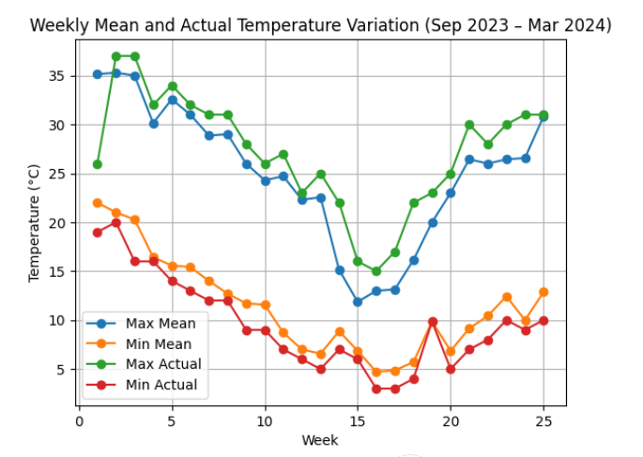
Fig.1: The graph indicates the weekly variation of temperature form last week of September 2023 to the 3rd week of March 2024. Both mean and actual maximum temperature exhibited the declining trend from the end of September, reaching their lowest value during mid-winter (week 14-16), followed by a gradual increase in late February and March. The same trend was observed for minimum temperatures, with the lowest values recorded during the winter weeks.

4.0 RESULTS AND DISCUSSION
4.1 Descriptive Statistical Analysis of Test & Check Treatments

Statistical analysis of test & check treatments for morphological (PH, LMS, PB, SB, SPP), phenological (DIF, DFF, DM), yield, & its attributes (SMS, SS, TSW, SYP, BYP, HI, OYP, OC) and physiological (PS@20 &30 DAS, PELWL, RWC, MSI) traits was performed for early sown (ES) and timely sown (TS) genotypes of Indian mustard as indicated in Table 3. Comparative statistical analysis of mean-value traits of early- and timely-sown genotypes indicated stable performance across sowing times; however, differences were observed in CV (Coefficient of Variance), CD@5% (Critical Difference), and range, indicating the influence of sowing environment on trait expression.

4.1.1 Morphological Traits
All morphological traits, such as plant height (PH), length of main shoot (LMS), number of primary branches (PB), and secondary branches (SB), showed only minor differences in mean values between early and timely sowing conditions. CV (Coefficient of Variance) values for PH and LMS in the early-sowing test and check treatments are 1.73% and 4.35%, respectively, which are much lower than those for the timely-sowing test and check treatments, suggesting greater uniformity under early sowing. The same pattern was observed in SPP and SMS for the early-sowing test and check treatments, indicating more stable reproductive organ development.
4.1.2 Phenological Traits
The mean PS value at 20 & 30 DAS was similar across both environments, but the CV & CD values for early sowing were slightly lower, indicating better survival of the test and check treatments. DIF, DFF, and DM exhibited minimal differences in mean values; however, DM had a CV of 3.17%, which was higher under timely sowing conditions, indicating greater environmental variability in crop duration.
4.1.3 Yield and Yield-Related Traits
Mean performance of SYP, BYP, HI, and TSW across the test and check treatments in both sowing environments was very similar, but early sowing exhibited lower CV, indicating more consistent yield expression. OC and OYP were slightly higher in timely sowing, but the difference in margins was very low.
4.1.4 Physiological Traits
Physiological variables such as RWC, MSI, and PELWL showed slightly higher mean values in the early-sowing test and check treatments. CV values for RWC are 1.44% in early sowing and 3.43% in timely sowing, suggesting better physiological stability and moisture retention, which help mitigate stress effects.
Overall, across all test and check treatments, early sowing morphological, phenological, yield, and physiological traits showed more consistent performance, with lower CV, CD, and range values and similar mean trait values compared with timely sowing.
Table 3: Comparative Statistical Analysis of Early and Timely Sown Genotypes of Indian Mustard (Brassica juncea L.)
Traits | Sowing Environment | Mean | Range | CV | CD@5% | SE | SD
PH | ES | 104.24 | 79.51–124.71 | 1.73 | 4.61 | 0.88 | 8.8
PH | TS | 103.83 | 82.74–121.45 | 3.8 | 10.13 | 0.87 | 8.75
LMS | ES | 36.33 | 20.36–53.96 | 4.35 | 4.01 | 0.59 | 5.9
LMS | TS | 36.26 | 20.45–52.75 | 5.23 | 4.82 | 0.59 | 5.92
PB | ES | 4.69 | 3.05–7.57 | 8.62 | 1.07 | 0.09 | 0.93
PB | TS | 4.7 | 2.96–7.49 | 9.86 | 1.22 | 0.09 | 0.93
SB | ES | 5.86 | 3.17–8.76 | 11.22 | 1.72 | 0.12 | 1.19
SB | TS | 5.87 | 3.15–8.96 | 11.84 | 1.82 | 0.12 | 1.23
SPP | ES | 134.03 | 70.60–202.20 | 1.67 | 5.63 | 3.13 | 31.3
SPP | TS | 134.26 | 71.48–209.94 | 2.67 | 9.05 | 3.13 | 31.33
SMS | ES | 28.84 | 15.20–40.20 | 5.68 | 4.1 | 0.61 | 6.09
SMS | TS | 28.66 | 14.98–40.85 | 5.36 | 3.85 | 0.61 | 6.12
PS@20 DAS | ES | 78.34 | 50.46–100.58 | 2.02 | 4.04 | 1.04 | 10.41
PS@20 DAS | TS | 78.46 | 48.20–104.25 | 2.58 | 5.17 | 1.07 | 10.72
PS@30 DAS | ES | 59.52 | 47.97–84.21 | 2.49 | 3.75 | 0.86 | 8.56
PS@30 DAS | TS | 59.24 | 46.00–83.21 | 3.21 | 4.81 | 0.88 | 8.82
DIF | ES | 47.9 | 36.80–54.96 | 3.07 | 3.72 | 0.31 | 3.1
DIF | TS | 47.9 | 36.45–55.18 | 4.32 | 5.24 | 0.34 | 3.38
DFF | ES | 59.4 | 53.36–66.16 | 2.52 | 3.79 | 0.35 | 3.53
DFF | TS | 59.55 | 51.17–69.04 | 3.33 | 5.04 | 0.41 | 4.06
DM | ES | 162.14 | 156.52–165.52 | 1.2 | 4.97 | 0.22 | 2.2
DM | TS | 161.63 | 150.43–170.87 | 3.17 | 13.04 | 0.54 | 5.38
SS | ES | 13.3 | 10.00–18.00 | 7.76 | 2.67 | 0.19 | 1.86
SS | TS | 13.31 | 9.56–18.00 | 7.74 | 2.66 | 0.19 | 1.88
SYP | ES | 6.5 | 3.41–10.47 | 6.19 | 1.02 | 0.15 | 1.48
SYP | TS | 6.52 | 3.26–11.06 | 7.08 | 1.17 | 0.15 | 1.55
OC | ES | 38.44 | 36.80–40.94 | 2.26 | 2.23 | 0.1 | 0.98
OC | TS | 38.53 | 35.46–41.22 | 3.61 | 3.56 | 0.13 | 1.34
OYP | ES | 2.5 | 1.30–3.96 | 7.59 | 0.48 | 0.06 | 0.58
OYP | TS | 2.49 | 1.34–4.01 | 7.34 | 0.47 | 0.06 | 0.57
TSW | ES | 3.59 | 2.98–4.62 | 6.37 | 0.58 | 0.04 | 0.36
TSW | TS | 3.6 | 2.84–4.63 | 7.4 | 0.68 | 0.04 | 0.38
BYP | ES | 33.63 | 25.97–45.91 | 4.59 | 3.94 | 0.38 | 3.84
BYP | TS | 33.59 | 25.66–46.60 | 6.25 | 5.34 | 0.38 | 3.84
HI | ES | 19.35 | 10.70–31.50 | 6.28 | 3.09 | 0.39 | 3.93
HI | TS | 19.41 | 11.15–30.32 | 7.54 | 3.72 | 0.39 | 3.93
PELWL | ES | 29.52 | 17.30–38.01 | 4.96 | 3.64 | 0.43 | 4.27
PELWL | TS | 29.61 | 17.32–38.87 | 5.16 | 3.8 | 0.43 | 4.35
RWC | ES | 87.46 | 71.93–96.75 | 1.44 | 3.22 | 0.46 | 4.58
RWC | TS | 86.97 | 71.18–100.86 | 3.43 | 7.64 | 0.5 | 4.95
MSI | ES | 11.18 | 5.59–19.31 | 9.51 | 2.84 | 0.3 | 3.03
MSI | TS | 11.22 | 5.40–19.52 | 10.71 | 3.21 | 0.31 | 3.09
PH- Plant Height  LMS- Length of Main Shoot  PB- Primary Branch  SB- Secondary Branch  SPP- Silique per Plant  SMS- Silique on Main Shoot  PS@20 DAS- Percent Survival at 20 Day of Sowing  PS@30 DAS- Percent Survival at 30 Day of Sowing  DIF- Days to Initiation of Flower  DFF- Days to 50% Flowering  SS- Seed/Silique  SYP- Seed Yield/Plant  OC-Oil Content Percentage  OYP-Oil Yield/Plant |  |  |  | TSW-1000-Seed Weight  BYP- Biological Yield/Plant  HI- Harvest Index  PELWL-Percent Excised Leaf Water Loss  RWC- Relative Water Content  MSI-Membrane Stability Index  ES-Early Sowing  TS- Timely Sowing  CV- Coefficient of Variance  CD- Critical Difference  SE- Standard Error  SD- Standard Deviation

4.2 Genetic Variability Analysis

The genetic variability analysis includes GCV, PCV, ECV, h²BS, and GAM for traits in the test and check treatments of early and timely sowing as indicated in Table 4. GCV and PCV showed a degree of genetic variability. A small difference between GCV and PCV indicates minimal environmental impact, whereas a large difference indicates significant environmental impact. ECV measures the proportion of variability attributable to environmental factors. h²BS estimates the proportion of phenotypic variance attributable to genetic factors. GAM exhibits the expected improvement from selection, and high GAM, along with heritability, suggests a good chance of improving the trait through breeding.

4.2.1 Morphological Traits

The ECV of PH in ES was 1.74%, slightly lower than the TS ECV of 3.83%, suggesting more growth uniformity under ES. ECV 4.24% of the LMS of ES was also comparatively lower than TS ECV 5.22%. SPP and SMS of ES exhibited low ECV, with slightly higher h²BS, and GAM indicated stable reproductive traits under ES.

4.2.2 Phenological Traits

ES exhibited lower ECV and higher h²BS for survival traits. DM exhibited more ECV 3.17% in TS than ES ECV 1.20%, suggesting a greater impact of environmental factors on DM under timely sowing. ECV of DIF and DFF shows lower ECV in ES, suggesting stable performance.

4.2.3 Yield Traits

Yield traits such as SYP, BYP, and HI of ES exhibited lower ECV, indicating stable yield performance. Oil content h²BS is very low in ES but higher ECV 3.43% & GCV 20.54% in TS, suggesting the influence of environmental factors on oil content under timely sowing.

4.2.4 Physiological Traits

RWC and MSI had higher h²BS and GAM and lower ECV under ES, suggesting better physiological stability. PELWEL has lower ECV but higher GCV.

In brief, all ES traits showed lower ECV, higher h²BS, and GAM than TS. This indicates that early sowing exhibited stable morphological, phenological, yield, and physiological performance in ES in the Doon Valley.

Table 4: Comparative Genetic Variability Analysis of Early and Timely Sown Genotypes of Indian Mustard (Brassica juncea L.)

Traits | Sowing Environment | Mean | GCV | PCV | ECV | hBS | GAM
PH | ES | 104.24 | 8.41 | 8.59 | 1.74 | 95.9 | 16.99
PH | TS | 103.83 | 8.03 | 8.9 | 3.83 | 81.44 | 14.95
LMS | ES | 36.33 | 15.7 | 16.29 | 4.34 | 92.89 | 31.23
LMS | TS | 36.26 | 15.35 | 16.22 | 5.22 | 89.63 | 29.98
PB | ES | 4.69 | 15.88 | 18.22 | 8.93 | 75.96 | 28.56
PB | TS | 4.7 | 14.77 | 17.95 | 10.2 | 67.72 | 25.08
SB | ES | 5.86 | 15.25 | 19.12 | 11.53 | 63.62 | 25.09
SB | TS | 5.87 | 15.26 | 19.52 | 12.16 | 61.16 | 24.63
SPP | ES | 134.03 | 22.78 | 22.84 | 1.65 | 99.48 | 46.88
SPP | TS | 134.26 | 22.83 | 22.99 | 2.65 | 98.67 | 46.79
SMS | ES | 28.84 | 19.94 | 20.71 | 5.59 | 92.71 | 39.62
SMS | TS | 28.66 | 20.09 | 20.77 | 5.29 | 93.53 | 40.08
PS@20 DAS | ES | 78.34 | 13.4 | 13.55 | 2.03 | 97.76 | 27.33
PS@20 DAS | TS | 78.46 | 13.79 | 14.03 | 2.59 | 96.6 | 27.95
PS@30 DAS | ES | 59.52 | 14.27 | 14.49 | 2.48 | 97.08 | 29.01
PS@30 DAS | TS | 59.24 | 14.63 | 14.97 | 3.19 | 95.46 | 29.49
DIF | ES | 47.9 | 5.25 | 6.07 | 3.05 | 74.7 | 9.36
DIF | TS | 47.9 | 4.99 | 6.59 | 4.3 | 57.4 | 7.8
DFF | ES | 59.4 | 5.43 | 5.98 | 2.51 | 82.47 | 10.18
DFF | TS | 59.55 | 5.99 | 6.85 | 3.33 | 76.45 | 10.81
DM | ES | 162.14 | 0.52 | 1.31 | 1.2 | 15.52 | 0.42
DM | TS | 161.63 | 1.06 | 3.34 | 3.17 | 10.06 | 0.69
SS | ES | 13.3 | 10.45 | 13.09 | 7.89 | 63.71 | 17.2
SS | TS | 13.31 | 10.51 | 13.12 | 7.86 | 64.15 | 17.37
SYP | ES | 6.5 | 21.89 | 22.74 | 6.16 | 92.67 | 43.48
SYP | TS | 6.52 | 22.48 | 23.55 | 7.04 | 91.07 | 44.25
OC | ES | 38.44 | 0.48 | 2.33 | 2.28 | 4.18 | 0.2
OC | TS | 38.53 | 20.54 | 3.43 | 3.63 | 87.65 | 34.87
OYP | ES | 2.5 | 21.94 | 23.21 | 7.59 | 89.3 | 42.77
OYP | TS | 2.49 | 21.81 | 23.01 | 7.34 | 89.82 | 42.64
TSW | ES | 3.59 | 7.73 | 10.02 | 6.38 | 59.47 | 12.29
TSW | TS | 3.6 | 7.54 | 10.57 | 7.41 | 50.91 | 11.1
BYP | ES | 33.63 | 10.18 | 11.17 | 4.6 | 83.05 | 19.15
BYP | TS | 33.59 | 9.48 | 11.35 | 6.25 | 69.72 | 16.33
HI | ES | 19.35 | 19.2 | 20.2 | 6.27 | 90.36 | 37.65
HI | TS | 19.41 | 18.66 | 20.12 | 7.53 | 86.01 | 35.7
PELWL | ES | 29.52 | 12.51 | 13.42 | 4.85 | 86.94 | 24.07
PELWL | TS | 29.61 | 12.45 | 13.44 | 5.05 | 85.89 | 23.81
RWC | ES | 87.46 | 4.85 | 5.07 | 1.45 | 91.81 | 9.6
RWC | TS | 86.97 | 4.32 | 5.53 | 3.45 | 60.95 | 6.95
MSI | ES | 11.18 | 22.97 | 25.05 | 9.99 | 84.1 | 43.47
MSI | TS | 11.22 | 22.67 | 25.3 | 11.23 | 80.29 | 41.9
PH- Plant Height  LMS- Length of Main Shoot  PB- Primary Branch  SB- Secondary Branch  SPP- Silique per Plant  SMS- Silique on Main Shoot  PS@20 DAS- Percent Survival at 20 Day of Sowing  PS@30 DAS- Percent Survival at 30 Day of Sowing  DIF- Days to Initiation of Flower  DFF- Days to 50% Flowering  SS- Seed/Silique  SYP- Seed Yield/Plant  OC-Oil Content Percentage  OYP-Oil Yield/Plant |  |  |  | TSW-1000-Seed Weight  BYP- Biological Yield/Plant  HI- Harvest Index  ELWL-Percent Excised Leaf Water Loss  RWC- Relative Water Content  MSI-Membrane Stability Index  ES-Early Sowing  TS- Timely Sowing  GCV- Genotypic Coefficient of Variation  PCV- Phenotypic Coefficient of Variation  ECV- Environmental Coefficient of Variation  hBS- Broad Sense Heritability  GAM- Genetic Advance as Percent of Mean

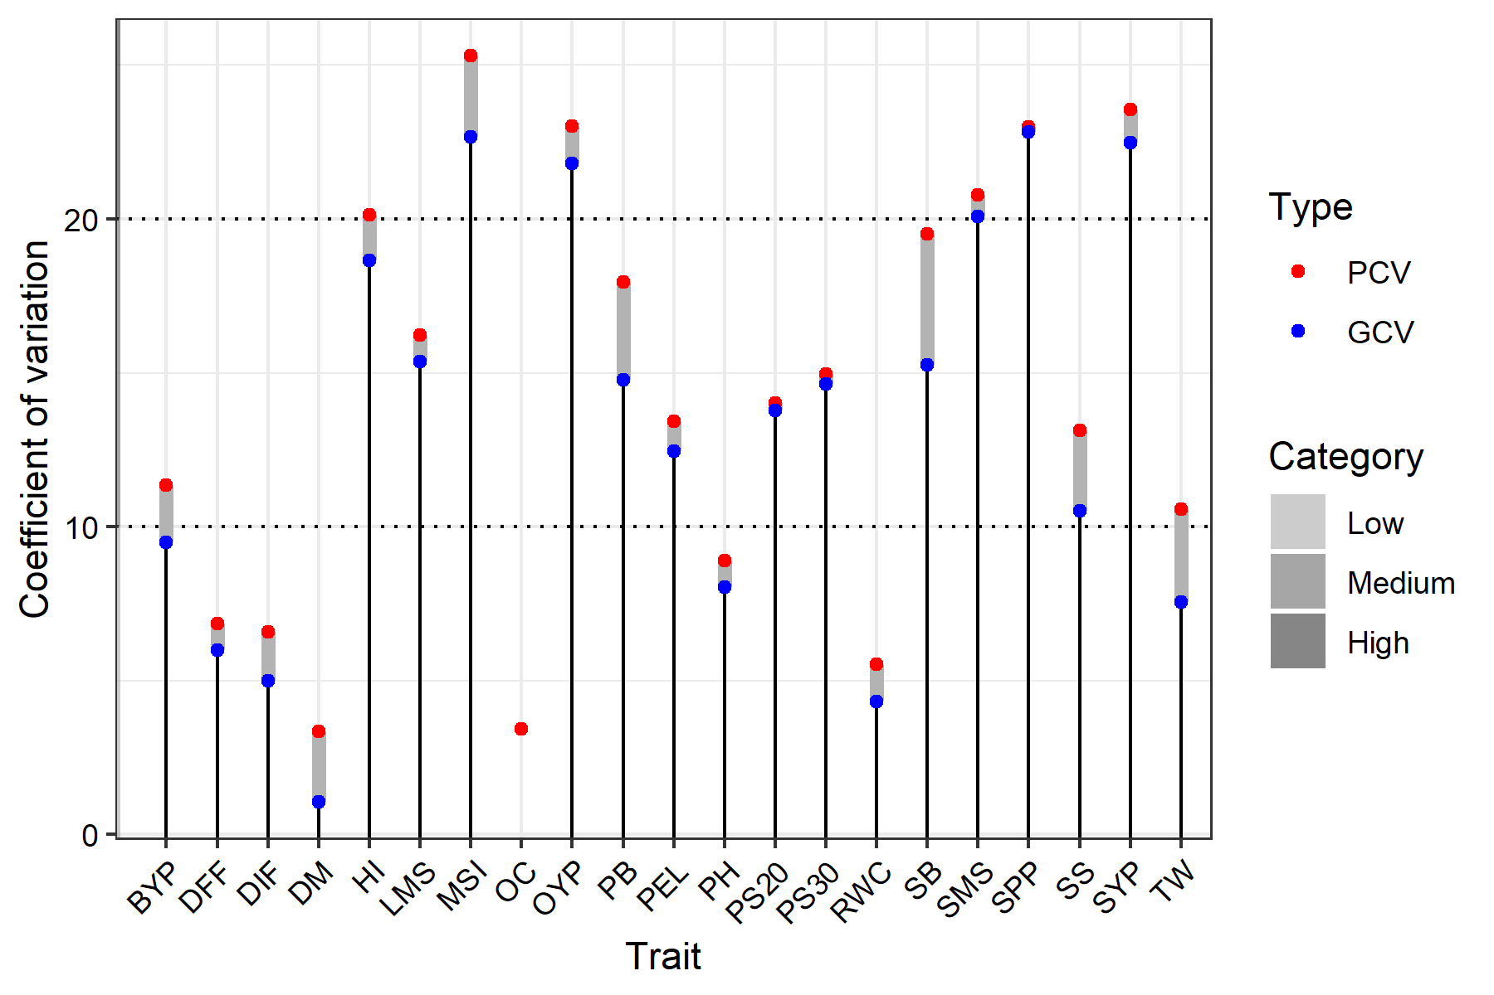

Fig.2: The graph indicates the gravity of variation of PCV and GCV across the TS condition. In general, PCV values were slightly higher than GCV values across all traits, suggesting that environmental factors influence their expression. Among all traits, MSI, OYP, SPP, SYP, and SMS exhibited high PCV and GCV, suggesting significant genetic variation.

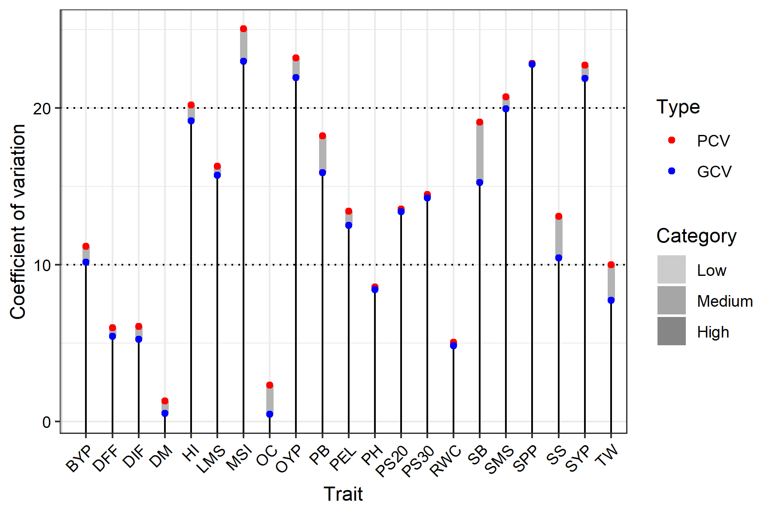

Fig.3: The graph indicates the gravity of variation of PCV and GCV across the ES condition. In general, PCV values were slightly higher than GCV values across all traits, suggesting that environmental factors influence their expression. Among all traits, MSI, OYP, SPP, SYP, and SMS exhibited high PCV and GCV, suggesting significant genetic variation.

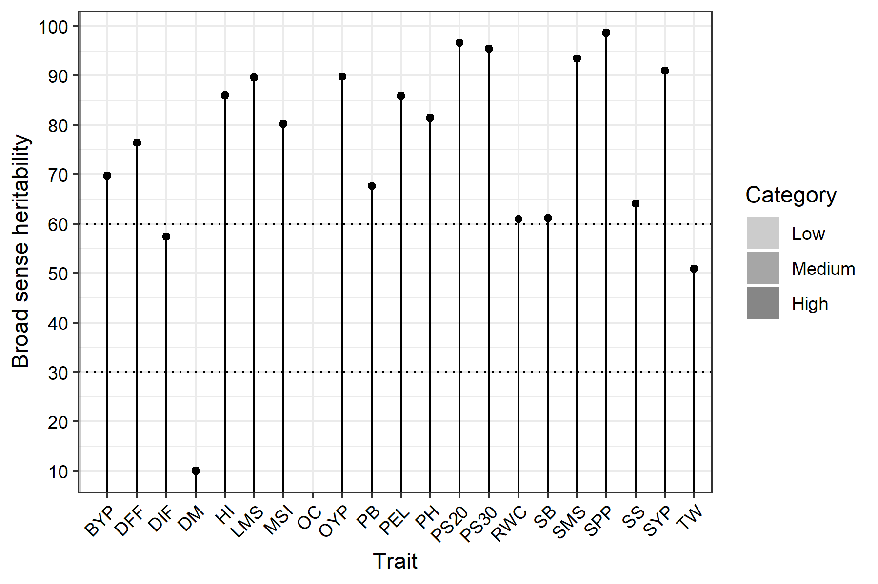

Fig. 4: The graph indicates the level of hBS (Broad Sense Heritability) across all traits in the TS condition. High hBS was observed in LMS, OYP, PS@20 and 30, SMS, SPP, and SYP, suggesting strong genetic control, minimal environmental influence and stable environmental adaptation.

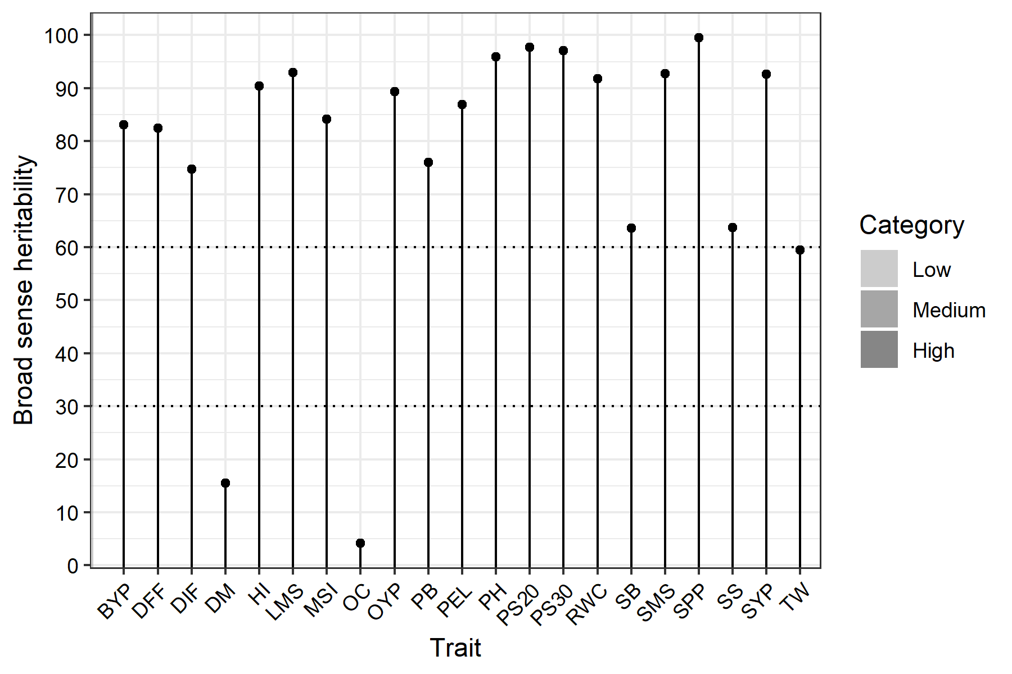

Fig. 5: The graph indicates the level of hBS (Broad Sense Heritability) across all traits in the ES condition. High hBS was observed in LMS, HI, PH, OYP, PS@20 and 30, RWC, SMS, SPP, and SYP, suggesting strong genetic control, minimal environmental influence, and stable environmental adaptation.

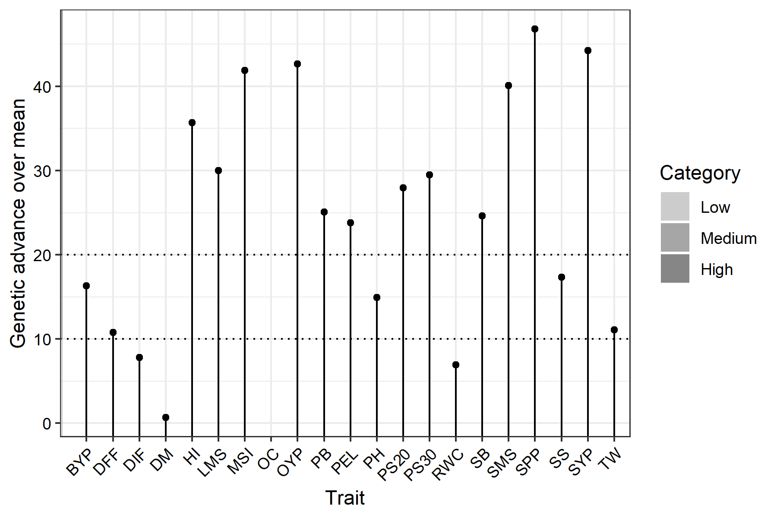

Fig.6: The indicates GAM (Genetic Advance Over Mean) across all traits in TS. High GAM was observed in HI, LMS, MSI, OYP, SMS, SB, SPP, and SYP, suggesting the dominance of additive gene action, which is an indicator of effective trait responses during selection and minimal environmental influence.

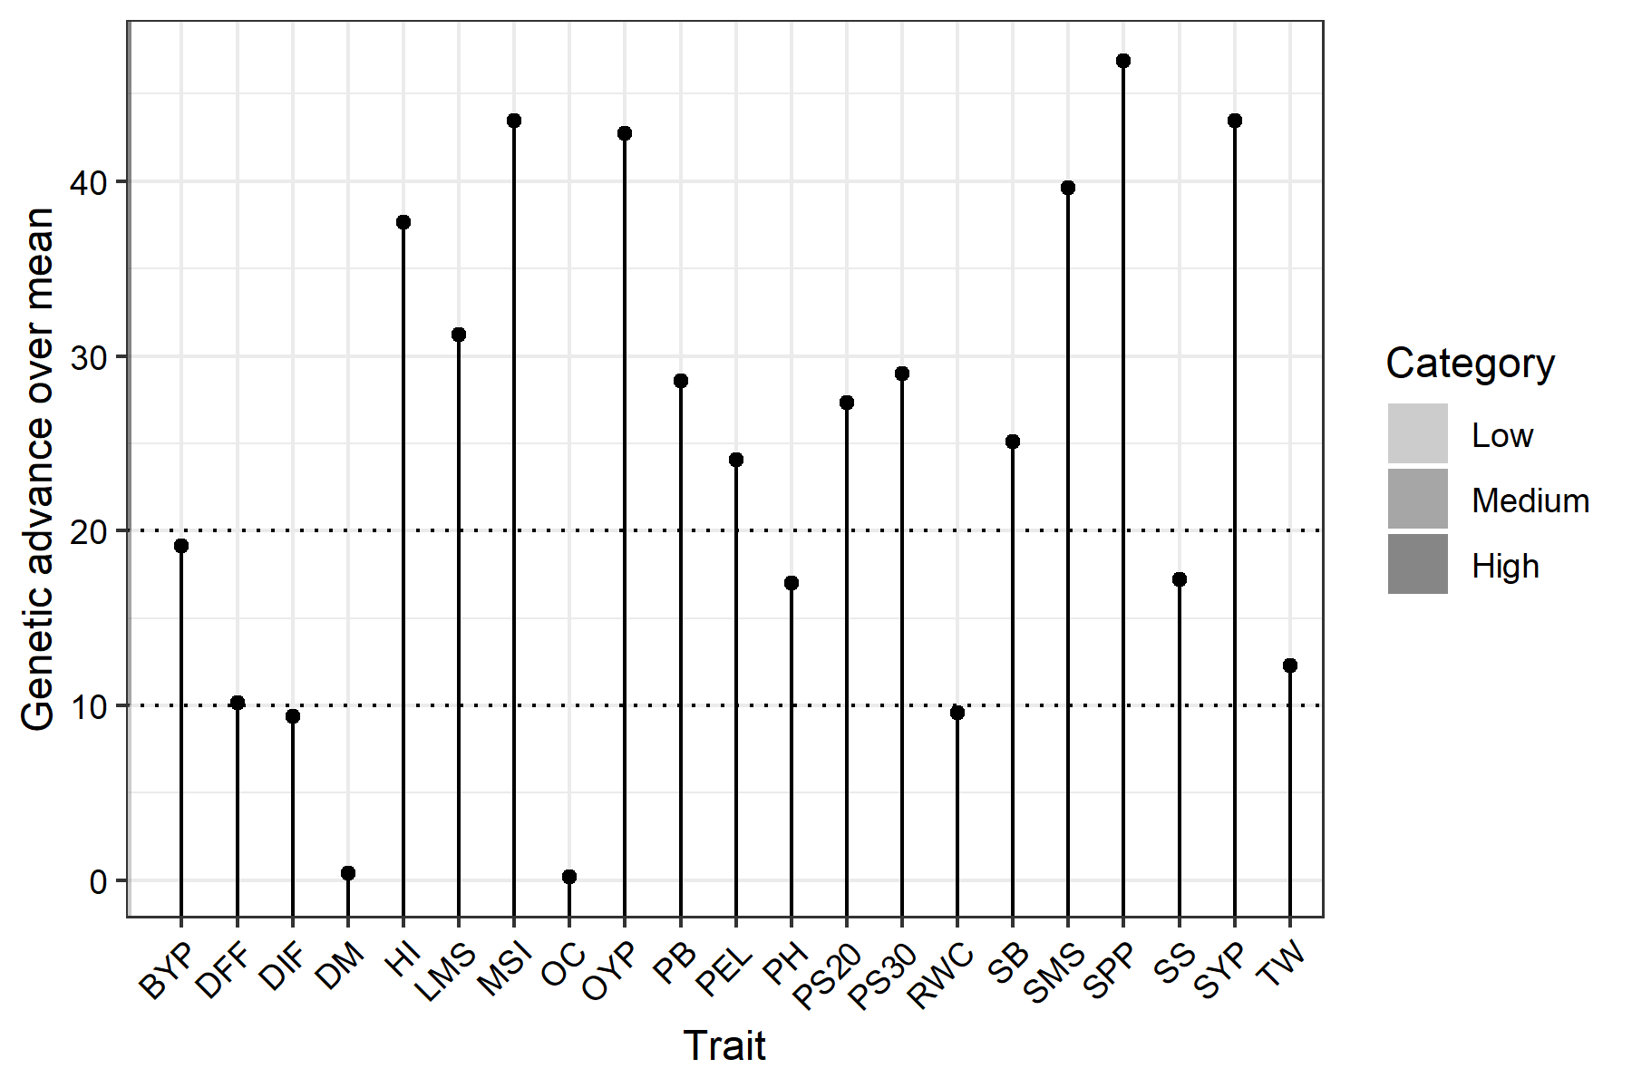

Fig.7: The indicates GAM (Genetic Advance Over Mean) across all traits in ES. High GAM was observed in HI, LMS, MSI, OYP, SMS, SPP, and SYP, suggesting the dominance of additive gene action, which is an indicator of effective trait responses during selection and minimal environmental influence.

4.3 Check Treatment Statistics

Five check treatments (Kanti, Kranti, Varuna, Pusa Bahar & Geeta) were sown at random in each block along with the test treatments. To serve as a benchmark for performance evaluation under ES and TS. Below are comparative statistical analyses of morphological, phenological, yield, and physiological traits.

4.3.1 Morphological Traits

The comparative statistical analysis of morphological traits under ES and TS conditions showed minor differences between the two environments across all check treatments. Overall, TS resulted in slightly higher mean values for PH, LMS, PB, SB, SPP, and SMS. Among the check treatments, Kanti consistently recorded the highest values for most morphological traits, followed by Pusa Bahar and Varuna; Kranti recorded the lowest values. The low standard error (SE) observed in both sowing environments indicated good experimental precision.

Table 5: Comparative Statistical Analysis of Morphological Traits of Check Treatment (5 replications) under early and timely sowing (ES Vs TS)

Plant Height | ES (Early Sowing) |  |  |  | TS (Timely Sowing)
Treatment | Means | SE | Min | Max | Means | SE | Min | Max
GEETA | 105.47 | 0.92 | 103 | 108 | 104.68 | 1.49 | 99.9 | 108.42
KANTI | 115.53 | 0.92 | 113 | 118 | 118.05 | 1.64 | 113.25 | 121.57
KRANTI | 98.07 | 0.71 | 96 | 100 | 98.09 | 1.67 | 91.92 | 101.58
PUSA BAHAR | 115.07 | 0.71 | 113 | 117 | 115.15 | 2.01 | 111.18 | 122.7
VARUNA | 111.07 | 0.71 | 109 | 113 | 112.28 | 1.88 | 106.95 | 116.4
Length of Main Shoot | ES (Early Sowing) |  |  |  | TS (Timely Sowing)
Treatment | Means | SE | Min | Max | Means | SE | Min | Max
GEETA | 31.8 | 0.86 | 29 | 34 | 31.31 | 0.51 | 30.15 | 32.9
KANTI | 43 | 0.71 | 41 | 45 | 43.84 | 0.81 | 41.15 | 45.25
KRANTI | 33 | 0.71 | 31 | 35 | 33 | 0.8 | 30.32 | 34.53
PUSA BAHAR | 38 | 0.71 | 36 | 40 | 37.32 | 1.08 | 35.07 | 41.34
VARUNA | 34 | 0.71 | 32 | 36 | 33.85 | 0.87 | 30.7 | 35.51
Primary Branches | ES (Early Sowing) |  |  |  | TS (Timely Sowing)
Treatment | Means | SE | Min | Max | Means | SE | Min | Max
GEETA | 4.2 | 0.19 | 3.6 | 4.7 | 4.14 | 0.22 | 3.45 | 4.74
KANTI | 7.57 | 0.25 | 6.9 | 8.2 | 7.49 | 0.28 | 6.62 | 8.11
KRANTI | 5.33 | 0.17 | 4.9 | 5.8 | 5.28 | 0.18 | 4.76 | 5.85
PUSA BAHAR | 6.14 | 0.16 | 5.6 | 6.5 | 6.08 | 0.18 | 5.47 | 6.56
VARUNA | 5.35 | 0.19 | 4.8 | 5.8 | 5.3 | 0.25 | 4.77 | 6.06
Secondary Branches | ES (Early Sowing) |  |  |  | TS (Timely Sowing)
Treatment | Means | SE | Min | Max | Means | SE | Min | Max
GEETA | 4.71 | 0.3 | 3.8 | 5.5 | 4.71 | 0.26 | 3.9 | 5.51
KANTI | 8.04 | 0.33 | 7.1 | 9 | 8.21 | 0.39 | 7.33 | 9.35
KRANTI | 7.39 | 0.27 | 6.7 | 8.1 | 7.21 | 0.29 | 6.6 | 7.95
PUSA BAHAR | 6.59 | 0.24 | 6 | 7.2 | 6.67 | 0.16 | 6.24 | 7.04
VARUNA | 7.43 | 0.3 | 6.6 | 8.2 | 7.4 | 0.4 | 6.36 | 8.58
Silique/Plant | ES (Early Sowing) |  |  |  | TS (Timely Sowing)
Treatment | Means | SE | Min | Max | Means | SE | Min | Max
GEETA | 180.6 | 1.5 | 177 | 185 | 182.12 | 3.13 | 172.99 | 189.44
KANTI | 137 | 1.14 | 134 | 140 | 140.42 | 0.95 | 138.58 | 143.66
KRANTI | 70.6 | 0.93 | 68 | 73 | 71.48 | 1.18 | 69.14 | 75.47
PUSA BAHAR | 140.8 | 0.86 | 138 | 143 | 141.01 | 1.78 | 137.35 | 146.89
VARUNA | 101 | 1.14 | 98 | 104 | 100.57 | 1.26 | 97.17 | 104.21
Silique on Main Shoot | ES (Early Sowing) |  |  |  | TS (Timely Sowing)
Treatment | Means | SE | Min | Max | Means | SE | Min | Max
GEETA | 29.8 | 0.86 | 27 | 32 | 30.33 | 0.85 | 28.07 | 32.74
KANTI | 36 | 0.71 | 34 | 38 | 36.07 | 0.9 | 33.41 | 38.59
KRANTI | 15.2 | 0.58 | 14 | 17 | 14.98 | 0.52 | 13.56 | 16.35
PUSA BAHAR | 29 | 0.71 | 27 | 31 | 29.06 | 0.91 | 27.28 | 32.44
VARUNA | 21 | 0.71 | 19 | 23 | 20.51 | 0.58 | 19.18 | 22.14

4.3.2 Phenological Traits

The comparative statistical analysis of phenological traits under ES and TS conditions showed minor differences between the two environments across all check treatments. Overall, TS resulted in slightly higher mean values for DIF and DFF. DM showed minimal differences between ES and TS, suggesting a stable maturity duration across both sowing environments. Among checks, Varuna performed well in DIF, whereas Kranti took the longest time to reach flowering and maturity.

Table 6: Comparative Statistical Analysis of Phenological Traits of Check Treatment (5 replications) under early and timely sowing (ES Vs TS)

Days to Initial Flowering | ES (Early Sowing) |  |  |  | TS (Timely Sowing)
Treatment | Means | SE | Min | Max | Means | SE | Min | Max
GEETA | 44.6 | 0.51 | 43 | 46 | 44.89 | 0.93 | 42.13 | 47.02
KANTI | 50 | 0.71 | 48 | 52 | 50.64 | 0.91 | 48.14 | 53.79
KRANTI | 51 | 0.71 | 49 | 53 | 51.32 | 1.34 | 48.43 | 55.33
PUSA BAHAR | 48.4 | 0.51 | 47 | 50 | 49.59 | 0.44 | 48.4 | 50.79
VARUNA | 36.8 | 0.58 | 35 | 38 | 36.45 | 0.72 | 34.58 | 38.73
Days to 50% Flowering | ES (Early Sowing) |  |  |  | TS (Timely Sowing)
Treatment | Means | SE | Min | Max | Means | SE | Min | Max
GEETA | 59 | 0.71 | 57 | 61 | 59.37 | 0.41 | 58.46 | 60.48
KANTI | 55.8 | 0.58 | 54 | 57 | 57.1 | 0.67 | 55.16 | 59.12
KRANTI | 60 | 0.71 | 58 | 62 | 60.79 | 0.93 | 57.35 | 62.82
PUSA BAHAR | 59.2 | 0.58 | 58 | 61 | 60.55 | 1.34 | 56.61 | 63.86
VARUNA | 54.8 | 0.58 | 53 | 56 | 55.41 | 0.8 | 53.69 | 57.4
Days to Maturity | ES (Early Sowing) |  |  |  | TS (Timely Sowing)
Treatment | Means | SE | Min | Max | Means | SE | Min | Max
GEETA | 158.8 | 0.86 | 156 | 161 | 157.46 | 2.47 | 152.52 | 165.01
KANTI | 160.8 | 0.58 | 159 | 162 | 160.41 | 2.29 | 153.16 | 165.52
KRANTI | 163 | 1.14 | 160 | 166 | 165.96 | 1.92 | 160.42 | 170.35
PUSA BAHAR | 162.2 | 0.8 | 160 | 164 | 162.16 | 1.87 | 156.35 | 167.8
VARUNA | 161.8 | 0.58 | 160 | 163 | 160.6 | 1.77 | 156.18 | 164.81

4.3.3 Yield Traits

The comparative statistical analysis of yield traits for the check treatment under ES and TS conditions showed minor differences between the two sowing environments. TS exhibited improved SYP, OYP, and TSW across most check treatments, whereas OC and BYP were comparable across both environments. Among check treatments, Varuna performed well for SYP, OC, OYP and TSW, followed by Kanti, whereas Krant exhibited lower SYP. Low SE indicated good experimental precision.

Table 7: Comparative Statistical Analysis of Yield Traits of Check Treatment (5 replications) under early and timely sowing (ES Vs TS)

Seed/Silique | ES (Early Sowing) |  |  |  | TS (Timely Sowing)
Treatment | Means | SE | Min | Max | Means | SE | Min | Max
GEETA | 11.6 | 0.51 | 10 | 13 | 11.81 | 0.64 | 9.57 | 13.23
KANTI | 15 | 0.45 | 14 | 16 | 14.52 | 0.36 | 13.46 | 15.41
KRANTI | 17 | 0.45 | 16 | 18 | 17.01 | 0.46 | 15.69 | 18.42
PUSA BAHAR | 11.4 | 0.4 | 10 | 12 | 11.24 | 0.38 | 9.95 | 12.25
VARUNA | 18 | 0.45 | 17 | 19 | 18 | 0.33 | 17.05 | 18.66
Seed Yield/Plant | ES (Early Sowing) |  |  |  | TS (Timely Sowing)
Treatment | Means | SE | Min | Max | Means | SE | Min | Max
GEETA | 6.49 | 0.14 | 6.2 | 6.9 | 6.57 | 0.18 | 6.25 | 7.18
KANTI | 6.94 | 0.19 | 6.4 | 7.4 | 6.88 | 0.23 | 6.08 | 7.42
KRANTI | 4.43 | 0.18 | 4 | 4.9 | 4.44 | 0.18 | 4.04 | 5.01
PUSA BAHAR | 5.83 | 0.16 | 5.3 | 6.2 | 5.82 | 0.12 | 5.44 | 6.14
VARUNA | 7.69 | 0.18 | 7.2 | 8.2 | 7.71 | 0.27 | 7.13 | 8.48
Oil Content % | ES (Early Sowing) |  |  |  | TS (Timely Sowing)
Treatment | Means | SE | Min | Max | Means | SE | Min | Max
GEETA | 39.44 | 0.31 | 38.5 | 40.3 | 40.06 | 0.66 | 37.91 | 41.23
KANTI | 40.18 | 0.42 | 39 | 41.2 | 39.82 | 0.54 | 38.23 | 41.35
KRANTI | 40.14 | 0.47 | 39 | 41.4 | 38.73 | 0.56 | 37.43 | 40.42
PUSA BAHAR | 39.48 | 0.35 | 38.7 | 40.4 | 39.18 | 0.36 | 38.26 | 40.2
VARUNA | 40.94 | 0.26 | 40 | 41.5 | 40.27 | 0.66 | 38.35 | 42.15
Oil Yield/Plant | ES (Early Sowing) |  |  |  | TS (Timely Sowing)
Treatment | Means | SE | Min | Max | Means | SE | Min | Max
GEETA | 2.55 | 0.07 | 2.38 | 2.78 | 2.53 | 0.06 | 2.31 | 2.64
KANTI | 2.79 | 0.1 | 2.54 | 3.05 | 2.75 | 0.09 | 2.44 | 2.98
KRANTI | 1.78 | 0.09 | 1.57 | 2.02 | 1.83 | 0.1 | 1.6 | 2.1
PUSA BAHAR | 2.3 | 0.06 | 2.14 | 2.5 | 2.26 | 0.06 | 2.06 | 2.39
VARUNA | 3.15 | 0.08 | 2.96 | 3.4 | 3.13 | 0.06 | 3 | 3.29
1000-Seed Weight | ES (Early Sowing) |  |  |  | TS (Timely Sowing)
Treatment | Means | SE | Min | Max | Means | SE | Min | Max
GEETA | 3.28 | 0.09 | 3 | 3.5 | 3.27 | 0.09 | 2.91 | 3.47
KANTI | 3.3 | 0.11 | 3 | 3.6 | 3.28 | 0.11 | 2.97 | 3.58
KRANTI | 3.8 | 0.11 | 3.5 | 4.1 | 3.84 | 0.16 | 3.37 | 4.22
PUSA BAHAR | 3.46 | 0.07 | 3.2 | 3.6 | 3.42 | 0.07 | 3.27 | 3.63
VARUNA | 4.24 | 0.09 | 4 | 4.5 | 4.24 | 0.12 | 3.85 | 4.54
Biological Yield/Plant | ES (Early Sowing) |  |  |  | TS (Timely Sowing)
Treatment | Means | SE | Min | Max | Means | SE | Min | Max
GEETA | 35.4 | 0.67 | 33.2 | 37.2 | 34.97 | 0.74 | 32.07 | 36.27
KANTI | 38.56 | 0.66 | 36.9 | 40.1 | 37.7 | 0.86 | 35.57 | 40.09
KRANTI | 34.26 | 0.73 | 32.4 | 36 | 34.01 | 1.18 | 31.15 | 37.46
PUSA BAHAR | 25.97 | 0.61 | 24.1 | 27.4 | 25.66 | 0.44 | 24.62 | 26.73
VARUNA | 35.17 | 0.65 | 33.5 | 36.9 | 35.17 | 0.84 | 32.44 | 37.37
Harvest Index | ES (Early Sowing) |  |  |  | TS (Timely Sowing)
Treatment | Means | SE | Min | Max | Means | SE | Min | Max
GEETA | 19.78 | 0.56 | 18 | 21.2 | 19.98 | 0.77 | 17.46 | 21.73
KANTI | 18.18 | 0.44 | 17.1 | 19.4 | 18.22 | 0.59 | 16.55 | 20.19
KRANTI | 12.83 | 0.56 | 11.5 | 14.3 | 12.62 | 0.66 | 11.09 | 14.39
PUSA BAHAR | 23.01 | 0.45 | 21.5 | 24 | 23.16 | 0.25 | 22.54 | 23.79
VARUNA | 22.11 | 0.6 | 20.7 | 23.8 | 21.98 | 0.63 | 19.88 | 23.68

4.3.4 Physiological Traits

A comparative statistical analysis of physiological traits across the check treatments of ES and TS revealed only minor differences between the two sowing environments. Most physiological traits exhibited stable mean values in ES and TS. Among checks, Pusa Bahar had the highest PELWL, while Kanti and Varun showed the highest RWC and MSI. PS at 20 & 30 improved in TS for most check treatments. SE values showed reliable measurements.

Table 8: Comparative Statistical Analysis of Physiological Traits of Check Treatment (5 replications) under early and timely sowing (ES Vs TS)

PELWL | ES (Early Sowing) |  |  |  | TS (Timely Sowing)
Treatment | Means | SE | Min | Max | Means | SE | Min | Max
GEETA | 23.78 | 0.68 | 21.6 | 25.4 | 23.49 | 0.88 | 20.62 | 25.79
KANTI | 26.9 | 0.47 | 25.8 | 28.1 | 27 | 0.67 | 24.62 | 28.38
KRANTI | 22.51 | 0.67 | 20.8 | 24.1 | 22.63 | 0.78 | 20.87 | 24.51
PUSA BAHAR | 37.28 | 0.62 | 35.7 | 38.9 | 37.46 | 0.44 | 36.05 | 38.52
VARUNA | 17.3 | 0.63 | 15.2 | 18.9 | 17.32 | 0.67 | 15.57 | 19.15
RWC | ES (Early Sowing) |  |  |  | TS (Timely Sowing)
Treatment | Means | SE | Min | Max | Means | SE | Min | Max
GEETA | 86.36 | 0.77 | 83.9 | 88.4 | 85.69 | 1.24 | 82.85 | 89.61
KANTI | 96.22 | 0.62 | 94.2 | 97.5 | 95.63 | 0.63 | 93.58 | 97.46
KRANTI | 91.38 | 0.64 | 89.8 | 93.2 | 92.43 | 1.54 | 87.28 | 95.5
PUSA BAHAR | 89.34 | 0.62 | 87.3 | 91 | 88.45 | 1.83 | 83.02 | 94.2
VARUNA | 85.89 | 0.56 | 84 | 87.1 | 87.25 | 0.84 | 85.14 | 89.69
MSI | ES (Early Sowing) |  |  |  | TS (Timely Sowing)
Treatment | Means | SE | Min | Max | Means | SE | Min | Max
GEETA | 9.19 | 0.4 | 7.9 | 10.2 | 9.24 | 0.37 | 8.27 | 10.43
KANTI | 17.77 | 0.34 | 16.8 | 18.6 | 17.73 | 0.44 | 16.3 | 19.08
KRANTI | 16.74 | 0.59 | 15.2 | 18.2 | 16.55 | 0.75 | 14.47 | 18.68
PUSA BAHAR | 11.22 | 0.38 | 9.9 | 12 | 11.04 | 0.39 | 9.94 | 11.97
VARUNA | 17.95 | 0.57 | 16.4 | 19.5 | 17.93 | 0.65 | 16.01 | 19.87
PS @ 20 DAS | ES (Early Sowing) |  |  |  | TS (Timely Sowing)
Treatment | Means | SE | Min | Max | Means | SE | Min | Max
GEETA | 84.07 | 0.69 | 82 | 86 | 85.11 | 1.08 | 82.71 | 88.2
KANTI | 83.09 | 0.82 | 80.5 | 85 | 83.52 | 0.36 | 82.31 | 84.31
KRANTI | 83.07 | 0.71 | 81 | 85 | 82.2 | 0.91 | 80.69 | 85.4
PUSA BAHAR | 83.07 | 0.71 | 81 | 85 | 84.06 | 1.17 | 81.57 | 87.76
VARUNA | 67.13 | 0.67 | 65 | 69 | 67.94 | 0.77 | 65.64 | 69.56
PS @ 30 DAS | ES (Early Sowing) |  |  |  | TS (Timely Sowing)
Treatment | Means | SE | Min | Max | Means | SE | Min | Max
GEETA | 50.8 | 0.86 | 48 | 53 | 50.27 | 1.18 | 46.89 | 54.26
KANTI | 51.1 | 0.71 | 49 | 53 | 50.3 | 0.74 | 47.83 | 52.38
KRANTI | 66.53 | 0.92 | 64 | 69 | 67.61 | 0.52 | 66.36 | 69.13
PUSA BAHAR | 50.7 | 0.8 | 48 | 52.5 | 49.77 | 0.88 | 46.46 | 51.37
VARUNA | 66.23 | 0.76 | 64 | 68 | 65.7 | 0.88 | 62.87 | 68.11

Across all check treatments, ES and TS showed only minor differences. TS got an advantage by improving morphological traits. Among check treatments, Kanti performed well across most morphological traits; Varuna performed best for SYP, OC, OYP, TSW, and DIF, whereas Kranti performed longer for DIF and DM. Pusa Bahar performed well for PELWL, while Kanti and Varuna performed well for RWC and MSI. Overall, the low SE indicated good experimental precision and reliability.

5.0 CONCLUSION

The present study was conducted to analyse the impact of genetic variability and temperature stress on 100 genotypes of Indian mustard (Brassica juncea L.) across two sowing environments (ES and TS) in the Doon Valley. The weekly temperature analysis (starting on 26th September 2023) showed that early-sown genotypes were exposed to high temperatures (>35 °C mean maximum) during the seedling and early vegetative stages, whereas timely-sown genotypes had comparatively favourable environmental conditions, particularly during establishment, flowering, and siliqua formation.

Across two sowing environments, mean values for all morphological, phenological, yield, and physiological traits are largely similar; however, lower CVs, narrower trait ranges, and minimal environmental effects for many traits in ES indicate more stable, uniform, and reliable expression for evaluating genetic variability under temperature stress. Across genotypes, ES traits showed lower ECV, high broad-sense heritability, and genetic advance over the mean, with minimal differences between PCV & GCV, suggesting strong genetic control due to minimal environmental influence, leading to stable environmental adaptation and improved selection response.

Although timely sowing environments aligned with more suitable temperatures support better reproductive efficiency, seed-filling stages, and productivity, the research findings indicate that early sowing is more suitable for stable trait expression, genetic variability assessment, and effective selection of temperature-resilient genotypes of Indian mustard (Brassica juncea L.), especially in the Doon Valley.

COMPETING INTERESTS DISCLAIMER:
Authors have declared that they have no known competing financial interests OR non-financial interests OR personal relationships that could have appeared to influence the work reported in this paper.

REFERENCES

Patil, C., Wadeyar, B. S., D, S. C., & H, A. V. (2026). Comparative Correlation Analysis in M\(_2\) Populations of Horse Gram (Macrotyloma uniflorum [Lam.] Verdc.) Generated Using Ethyl Methane Sulphonate (EMS) and Sodium Azide (SA). Journal of Advances in Biology & Biotechnology. https://doi.org/10.9734/jabb/2026/v29i23609

A., Kumar, V., & Nagarjun, P. (2025). Unlocking the Genetic Potential of Indian Mustard (Brassica juncea L.): A Review on Advances in Breeding Approaches. Agricultural Science Digest - A Research Journal. https://doi.org/10.18805/ag.d-6254

Kumar, S., Kumari, R., Chaurasiya, S., Yadav, S., Gautam, B., Singh, S., Devi, N. & Mishra, S. (2025). Synergistic effects of nitrogen and sulphur on the agronomic performance and quality characteristics of Indian mustard (Brassica juncea L.). International Journal of Research in Agronomy 8(1), pp. 193-196. https://doi.org/10.33545/2618060X.2025.v8.i1c.2373
M., F., A., B., E., C., D., D., W., S., K., D., & F., G. (2024). The predictability of fluctuating environments shapes the thermal tolerance of marine ectotherms and compensates narrow safety margins. https://doi.org/10.1038/s41598-024-77621-1

Aravind, J., Mukesh Sankar, S., Wankhede, D. P., and Kaur, V. (2023). augmentedRCBD: Analysis of Augmented Randomised Complete Block Designs. R package version 0.1.7, https://aravind-j.github.io/augmentedRCBD/https://cran.r-project.org/package=augmentedRCBD.

Pandey, A., Rahangdale, P., Singh Gaur, R., Singh, B., & Professor, A. (2521). RESEARCH ON GENETIC VARIABILITY IN INDIAN MUSTARD [BRASSICA JUNCEA] YIELD AND RELATED FEATURES. Www.Irjmets.Com @International Research Journal of Modernization in Engineering. www.irjmets.com
Pandey, B., Yadav, R., Ramawat, N., Vishwakarma, H., & Pandey, S. (2024). Optimization of sowing dates in Indian mustard (Brassica juncea L.) to combat yield losses caused by high temperature at reproductive stage. Plant Science Today, 11(1), 81–92. https://doi.org/10.14719/pst.2605
Choudhary, R., Singh, J., Barela, A., Patel, T., & Yadav, P. K. (2025). Assessment of Genetic Variability and Heritability in Indian Mustard (Brassica juncea L.) Genotypes. Journal of Advances in Biology & Biotechnology, 28(7), 436–443. https://doi.org/10.9734/jabb/2025/v28i72562
Bhandari, D., & Singh, A. (2023). Genetic Divergence in Leafy Mustard (Brassica juncea var. rugosa) Germplasm Grown under Tarai Condition of Uttarakhand. Indian Journal of Agricultural Research, 57(4), 448–452. https://doi.org/10.18805/IJARe.A-5795
Choudhary, B. R., Solanki, Z. S., & Kumhar, S. R. (n.d.). Diversity analysis in Indian mustard (Brassica juncea Czern & Coss.).
Chugh, P., Sharma, P., Sharma, R., & Singh, M. (2022a). Study on heat stress indices and their correlation with yield in Indian mustard genotypes under diverse conditions. Indian Journal of Genetics and Plant Breeding, 82(2), 186–192. https://doi.org/10.31742/IJGPB.82.2.7
Dwivedi, S., & Mishra, R. (2020a). Study of Yield Contributing Characters of Mustard. International Journal of Current Microbiology and Applied Sciences, 9(10), 2503–2510. https://doi.org/10.20546/ijcmas.2020.910.300
Godara, O., Singh, A., Choudhary, S., Fagodiya, R. K., & Kakraliya, B. L. (2017). Membrane stability index of Indian mustard (Brassica juncea L Czern & Coss). ~ 1067 ~ International Journal of Chemical Studies, 5(4).
Gupta, A., Chauhan, S., Tyagi, S. D., & Singh, S. (2023). Genetic Variability, Heritability, Genetic Advance and Cluster Analysis in Indian Mustard (Brassica juncea L. Czern & Coss.) Under Timely and Late Sown Conditions. International Journal of Plant & Soil Science, 35(19), 292–301. https://doi.org/10.9734/ijpss/2023/v35i193554
Gupta, D., Punia, S., Gothwal, D., Ram, M., Mittal, G., & Kumar, A. (2023). Evaluation of Heat Tolerance Genotypes in Indian Mustard [Brassica juncea (L.) Czern & Coss] based on Heat Susceptibility Index. Biological Forum-An International Journal, 15(11), 230.
Kannaujiya, T., KUMAR Chaudhary, A., Nath, S., Mishra, G., Kumar Chaudhary, A., Gupta, R., Kumar Gupta, A., & Vimal, S. (2022a). Genetic Diversity Analysis in Indian Mustard [Brassica juncea (L.) Czern and Coss.] Genotypes. Biological Forum-An International Journal, 14(2), 1571–1574. https://www.researchgate.net/publication/362162861
Kumar, A. (2018). Effect of Different Sowing Dates on Yield and Yield Attributes of Indian Mustard (Brassica juncea L.) Genotypes. International Journal of Pure & Applied Bioscience, 6(2), 848–853. https://doi.org/10.18782/2320-7051.6264
Kumari, A., & Kumari, V. (2018). Genetic Variability and Divergence Studies for Seed Yield and Component Characters in Indian Mustard [Brassica juncea (l.) Czern. & coss.] Over Environments. International Journal of Current Microbiology and Applied Sciences, 7(07), 3376–3388. https://doi.org/10.20546/ijcmas.2018.707.393
Meena, D. R., Chauhan, J. S., Singh, M., Singh, K. H., & Meena, M. L. (2013). Genetic variation and correlations among physiological characters in Indian mustard (Brassica juncea L.) under high temperature stress. Indian Journal of Genetics and Plant Breeding, 73(1), 101–104. https://doi.org/10.5958/j.0019-5200.73.1.015
OP, P., DK, Y., N, Singh, N, Saini, S, V., & . Y. (2020). Deciphering selection criteria for Indian mustard (Brassica juncea L.) encountering high-temperature stress during post-reproductive phase. International Journal of Chemical Studies, 8(4), 2497–2502. https://doi.org/10.22271/chemi.2020.v8.i4ac.10007
Patel, P. B., Patel, P. J., Patel, J. R., & Patel, P. C. (2021). Elucidation of genetic variability and inter-relationship studies for seed yield and quality traits in Indian mustard [Brassica juncea (L.) Czern and Coss]. Electronic Journal of Plant Breeding, 12(2), 589–596. https://doi.org/10.37992/2021.1202.083
Perween, S., Kumar, A., Chakraborty, M., Ahmad, E., Mahto, C., & Barnwal, M. (2024). Assessment of Genetic Variability and Diversity in Indian Mustard (Brassica juncea L.) under Timely and Late Sown Conditions. Journal of Advances in Biology & Biotechnology, 27(10), 331–341. https://doi.org/10.9734/jabb/2024/v27i101457
Prasad Scholar, G., Prasad, G., & Patil, B. (2018). Genetic variability and heritability studies for yield and attributes in Indian mustard. ~ 519 ~ Journal of Pharmacognosy and Phytochemistry, 7(5), 519–522.
Ram, B., Meena, H. S., Singh, V. v, Singh, B. K., Nanjundan, J., Kumar, A., Singh, S. P., Bhogal, N. S., & Singh, D. (2014a). High temperature stress tolerance in Indian mustard (Brassica juncea) germplasm as evaluated by membrane stability index and excised-leaf water loss techniques. In Journal of Oilseed Brassica (Vol. 5, Issue 2).
Ram, B., Singh, V. v, Singh, B. K., Kumar, A., & Singh, D. (2015). COMPARATIVE TOLERANCE AND SENSITIVE RESPONSE OF INDIAN MUSTARD (Brassica juncea L. Czern and Coss) GENOTYPES TO HIGH TEMPERATURE STRESS. In SABRAO Journal of Breeding and Genetics (Vol. 47, Issue 3).
Roy, S. K., Haque, S., Kale, V. A., Asabe, D. S., & Dash, S. (2011). Variability and character association studies in rapeseed-mustard (Brassica sp.) 1 1 2. In Journal of Crop and Weed (Vol. 7, Issue 2).
Saleem, N., Ahmad Jan, S., Jawaad Atif, M., Khurshid, H., Ali Khan, S., Abdullah, M., Jahanzaib, M., Ahmed, H., Ullah, S. F., Iqbal, A., Naqi, S., Ilyas, M., Ali, N., & Rabbani, M. A. (2017). Multivariate Based Variability within Diverse Indian Mustard (&lt;i&gt;Brassica juncea&lt;/i&gt; L.) Genotypes. Open Journal of Genetics, 07(02), 69–83. https://doi.org/10.4236/ojgen.2017.72007
Sehgal, A., Reddy, K. R., Walne, C. H., Barickman, T. C., Brazel, S., Chastain, D., & Gao, W. (2022a). Individual and Interactive Effects of Multiple Abiotic Stress Treatments on Early-Season Growth and Development of Two Brassica Species. Agriculture (Switzerland), 12(4). https://doi.org/10.3390/agriculture12040453
Sharma, D., Nanjundan, J., Singh, L., Singh, S. P., Parmar, N., Sujith Kumar, M. S., Singh, K. H., Mishra, A. K., Singh, R., Verma, K. S., & Thakur, A. K. (2020). Genetic diversity in leafy mustard (Brassica juncea var. rugosa) as revealed by agro-morphological traits and SSR markers. Physiology and Molecular Biology of Plants, 26(10), 2005–2018. https://doi.org/10.1007/s12298-020-00883-2
Sharma, P., & Sardana, V. (2014). Screening of Indian mustard (Brassica juncea) for thermo tolerance at seedling and terminal stages. In Journal of Oilseed Brassica (Vol. 5).
Singh, M., Rathore, S. S., & Raja, P. (2014). Physiological and Stress Studies of Different Rapeseed-Mustard Genotypes Under Terminal Heat Stress. In International Journal of Genetic Engineering and Biotechnology. ISSN 0974 (Vol. 3073, Issue 2). http://www.irphouse.com
Singh, R., Singh, Y., & Singh, S. (2017). Yield, quality and nutrient uptake of Indian mustard (Brassica juncea) under sulphur and boron nutrition. In Annals of Plant and Soil Research (Vol. 19, Issue 2).
Singh, S., Dwivedi, A. K., tosh, A., Kumar, O., & Kumar, K. (2018a). Genetic Divergence Analysis in Indian mustard (Brassica juncea L.). International Journal of Current Microbiology and Applied Sciences, 7(06), 2496–2503. https://doi.org/10.20546/ijcmas.2018.706.296
Singh, V. V., Garg, P., Meena, M. L., Meena, H. S., medha, P., Kumar, A., & Rai, P. K. (2018). Evaluation and Identification of Promising Lines for Rain Fed Conditions in Indian mustard (Brassica juncea L.). International Journal of Current Microbiology and Applied Sciences, 7(12), 3590–3597. https://doi.org/10.20546/ijcmas.2018.712.406
Sree, P. R. (2022). A review on impacts of high temperature stress on Indian mustard (Brassica juncea). www.botanyjournals.com

