Review Article
Scientific dynamics and applications of vermicomposting: bibliometric analysis and review of technical approaches

.
ABSTRACT

The objective of this study was to analyze the dynamics and trends of research on vermicomposting in order to identify areas that have not been explored and to guide future investigations. A bibliometric review was carried out using publications from Scopus, analyzed on R and visualized with VOSviewer. The results show continued growth in publications between 1983 and 2024, with a peak of over 200 documents in 2021. Out of 2570 studies, 611 deal with waste recovery and 111 with the reduction of heavy metals, indicating the under-exploration of the latter subject. The species Eisenia fetida dominates the uses with 70 percent, followed by Eudrilus eugeniae with 20 percent. The most studied substrates are plant and food residues. The most widely used methods are drum and bed vermicomposting, accounting for 36 and 31 percent of the studies, respectively. Geographical analysis shows that India and China produce the most publications, while in Africa Egypt and South Africa are the most active. The evolution of keywords reveals a shift from research focused on soil biology to soil fertility, heavy metal reduction, sludge and biochar. Limits include low substrate diversity and few publications on heavy metals. This analysis provides a basis for guiding future research and developing new methods to improve the sustainability and management of organic waste.

Keywords: vermicomposting, bibliometrics, waste, heavy metals, worms.

1. INTRODUCTION

Vermicomposting is a specific type of composting process that involves the use of earthworms to break down organic matter into nutrient-rich compost (Meza-Márquez et al., 2014). According to Wang et al. (2023), this approach can contribute to waste management but also to the reduction of potentially toxic heavy metals, which can compromise soil fertility and food security. In a global context where urban organic waste production is expected to reach 3.4 billion tonnes by 2050 (Kaza et al., 2018; Wowrzeczka, 2021) and where soil contamination by heavy metals is a major global problem (Li et al., 2019), vermicomposting appears to be a promising solution combining sustainable waste management and soil quality restoration. This issue is particularly important in Africa, where rapid population growth, accelerated urbanization and agricultural intensification are generating increasing amounts of organic waste (Hussein et al., 2022).
Despite the recognized potential of vermicomposting, the available knowledge on its impact, particularly on the reduction of heavy metals in waste, remains insufficiently explored. Several studies have attempted to map this area of research. Krein et al. (2023) conducted a bibliometric analysis of studies on slow-release fertilizers, including vermicomposting, without specifically focusing on technical aspects and decontamination capabilities. Similarly, Ghorbani and Sabour (2021) identified trends to assess global scientific output on vermicompost research from 1993 to 2017 and explain its many benefits for the environment and waste management, but their analysis remains general and does not identify specific methodological gaps. Beyond global scientific trends in vermicomposting, Baligah et al. (2024) also examined the effectiveness of this amendment in reducing water stress in plants and bioremediation of contaminated sites.
However, several major gaps remain in scientific literature. Indeed, no bibliometric research has systematically examined the different vermicomposting techniques and their comparative effectiveness. Windrows, stacked bins, continuous and batch systems have distinct operational characteristics, but their performance in reducing heavy metals has never been comprehensively summarized. According to Garg et al. (2006), the types of waste treated by vermicomposting vary considerably, including household waste, agricultural residues, sewage sludge and even industrial waste. However, there is no comprehensive synthesis that clearly identifies which vermicomposting substrates are most studied and which remain under-explored. Finally, the diversity of earthworm species used for vermicomposting remains poorly documented, especially in Africa. While Eisenia fetida and Eisenia andrei dominate the scientific literature due to their ease of breeding in temperate climates, many species adapted to the tropical African climate are neglected.
This bibliometric research aims to provide answers to several fundamental questions. On the one hand, it seeks to determine how scientific output on vermicomposting has evolved globally and in Africa. This question is justified by the need to situate research dynamics over time, assess whether this field is attracting growing interest, and identify the pivotal periods that have marked its development. It also aims to identify areas of interest in vermicomposting. Secondly, it is necessary to answer the question: which species of lombricidae are most studied and which have the best heavy metal reduction capabilities for different types of waste? This question helps to identify understudied but potentially promising species, particularly among native African species. A third question concerns the vermicomposting techniques most frequently used in scientific literature and the types of waste that have been the subject of the greatest number of studies. Thus, this bibliometric analysis is unique in that it combines several dimensions of analysis.

2. material and methods

2.1. Database search
The search for sources was targeted at covering a comprehensive range of relevant scientific publications. The sources used to identify articles relevant to the study topic were Scopus, Google Scholar and Web of Science. The specific keywords selected to optimize the search were: vermicomposting, composting, heavy metals, bioavailability and waste. The online documentation of the Institute for Rural Development (IDR) was also explored. Search equations were set up using Boolean operators (AND, OR, NOT) to refine the results. For the search for documents on vermicomposting, the lines associated with the Booleans and the objectives pursued are summarized in Table 1.
Table 1: Search for keywords on the theme of vermicomposting
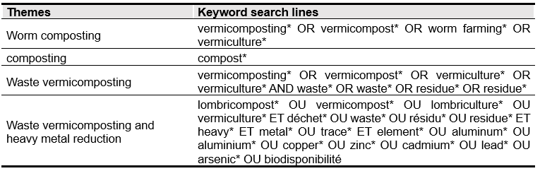
2.2. Extraction of bibliometric data
To extract the data required for this study, it was first necessary to access the sources through the academic institution Research4Life. Once connected, the advanced search function of each online library was used to formulate specific queries based on the keywords identified in Table 1. After conducting the search, filters were applied to refine the results according to criteria such as publication date, document type and research field. The databases were downloaded in Zotero (RIS) format and imported into Zotero in order to remove any duplicates and converted back into Excel CSV (semicolon separator) format, which is compatible with R.

2.3. Bibliometric analysis methods
The bibliographic data were analyzed using the Bibliometrix package on R version 4.5.1. After installing the package, the database in Excel CSV format was imported in R and then prepared for analysis using the cleaning and transformation functions available in Bibliometrix. The biblioAnalysis function was used to perform a basic bibliometric analysis and obtain an overview of publications and general trends. This function generated a summary of the main characteristics of bibliographic data.
The vosviewer 1.6.20 software was used to explore the relationships between vermicomposting and other research fields related to waste management and heavy metals. To this end, keyword co-occurrence diagrams were created to facilitate the visualization of connections between different key terms and concepts. The results were interpreted by examining the visualizations and statistics obtained to identify key trends, gaps in research and opportunities for future studies.
Key information on vermicomposting methods, types of vermicomposters and waste used, as well as the experimental results reported in each study, was organized using PDFviewer version 2.5 software, thanks to its document management and section and keyword tracking functions. Thematic analysis was performed using Excel spreadsheet version 2508. This thematic analysis resulted in the creation of graphs highlighting trends and limitations in current research.

3. results and discussion

3.1. Results of the bibliometric analysis
3.1.1. Comparison between vermicomposting, vermiculture and composting
Vermicomposting, vermiculture and composting are three practices associated with organic waste management, but they are often confused. This confusion can lead to the inappropriate use of one instead of another, hence the need to distinguish them clearly, as shown in Table 2. The aim of vermicomposting is to transform organic matter into vermicompost through the action of earthworms, mainly of the species Eisenia fetida. The term ‘vermicomposting’ is also used to refer to this practice.
The vermicomposting process is characterized by the relatively rapid decomposition of organic waste and the production of a nutrient-rich soil conditioner. The end product is generally used to improve soil fertility while reducing the volume of organic waste. Although vermicomposting promotes the reproduction of earthworms, it should not be confused with vermiculture, which is the breeding of worms for reproduction, fishing, animal feed or research purposes. However, the use of the two terms can be similar when worms, together with vermicompost, are a valuable product of the process.
Composting, on the other hand, is an aerobic, biological and controlled process of degradation and stabilization of organic matter into compost. It does not rely on the specific action of earthworms, but on that of micro-organisms and sometimes certain larvae. The duration of the process varies depending on the method used and the treatment conditions. The compost obtained, like vermicompost, is used to enrich the soil and reduce the amount of organic waste. From an environmental perspective, vermicomposting and composting contribute directly to waste reduction and soil quality improvement, while vermiculture has an indirect effect by providing the worms needed for these processes. Each of these practices thus has a specific and complementary role to play in sustainable organic matter management strategies.
Composting, on the other hand, is an aerobic, biological and controlled process of degradation and stabilisation of organic matter into compost. It does not rely on the specific action of earthworms, but on that of micro-organisms and sometimes certain larvae. The duration of the process varies depending on the method used and the treatment conditions. The compost obtained, like vermicompost, is used to enrich the soil and reduce the amount of organic waste. From an environmental perspective, vermicomposting and composting contribute directly to waste reduction and soil quality improvement, while vermiculture has an indirect effect by providing the worms needed for these processes. Each of these practices thus has a specific and complementary role to play in sustainable organic matter management strategies.

Table 2: Comparison between vermicomposting, vermiculture and composting
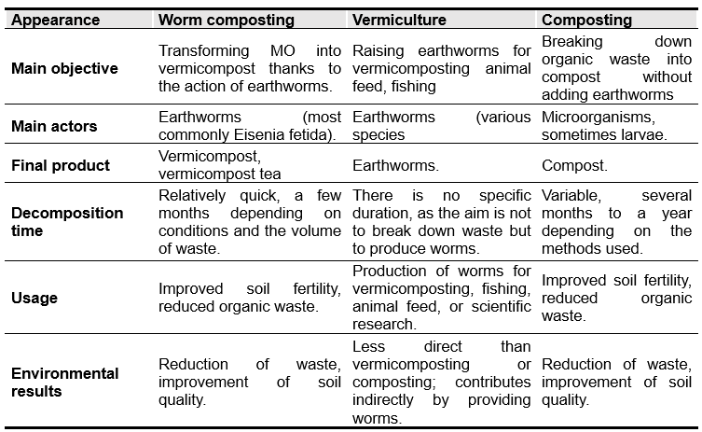

3.1.2. Evolution and specificities of research on composting and vermicomposting
The co-occurrence diagram highlights word frequency and publication periods to identify current concepts. The node ‘composting’ occupies a central position, indicating that research on this topic dates back to before 2012. Composting is a focal point for studies on waste management and soil fertility, with links to “soil”, “compost” and “manure”. Recent concepts, such as “food waste” and “earthworm”, reflect the growing interest in food waste recovery and vermicomposting after 2016. The terms “biodegradation” and “waste treatment” show a focus on organic waste treatment between 2014 and 2016. The diagram also shows that composting is frequently associated with heavy metal management and bioremediation, while vermicomposting focuses on biological and nutritional soil improvement through the action of earthworms, as revealed by the links to “earthworm” and 'Eisenia fetida ".
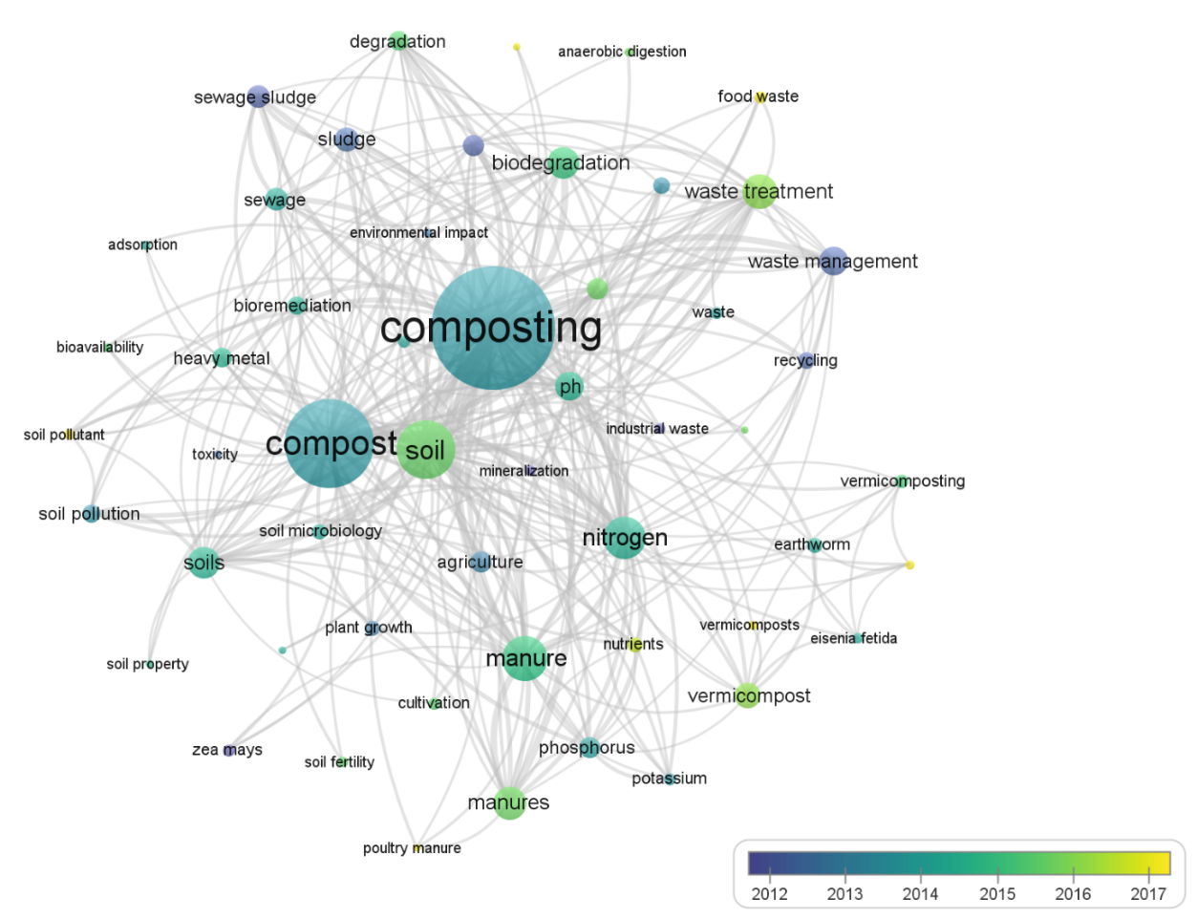
Figure 1: Diagram of keyword co-occurrences

3.1.3. Areas of application of composting and vermicomposting in research
The radar chart represents a bibliometric analysis based on the co-occurrence of terms associated with composting and vermicomposting (Figure 2). It highlights the areas of research where each process is most relevant. Composting is frequently associated with the themes of waste management, soil fertility and pollution, which shows that studies focus on its effectiveness in treating several types of waste and reducing pollution. In comparison, vermicomposting is more often linked to aspects such as soil fertilisation and waste management. However, although both processes are being explored for their potential to reduce pollution and soil contamination, composting seems to be more closely linked to this specific issue.
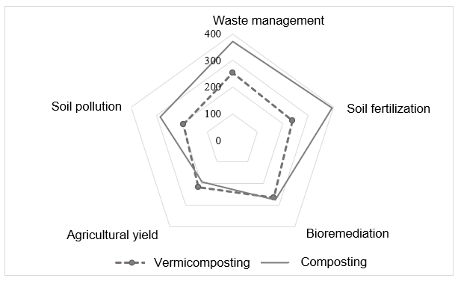
Figure 2: Areas of interest in composting and vermicomposting research

3.1.4. Evolution of publications over time
The evolution of publications on vermicomposting between 1983 and 2024 is divided into three categories: vermicomposting, vermicomposting of waste, and vermicomposting of waste and reduction of heavy metals through vermicomposting (Figure 3).
The analysis showed an increase in the number of publications over the years, particularly after 1999. Before this period, fewer than 10 documents per year were published. From 2008 onwards, there was a resurgence with more than 50 publications per year. This growth accelerated until 2021, when the total number of publications exceeded 200 documents per year with a diversity of objectives in the application of vermicomposting.
Of the 2,570 studies on vermicomposting, 611 focused specifically on its application in waste recovery, compared to 111 that focused solely on reducing heavy metal concentrations in vermicompost. Studies on vermicomposting in general dominated throughout the period in question (1983-2024). Publications on waste recovery through vermicomposting gained interest from 2000 onwards, with four publications. This trend increased significantly after 2008, reaching 48 documents in 2022.
The use of vermicomposting in reducing heavy metals in waste is the least represented, with fewer than 10 documents published per year. However, in 2011, 2014, 2020 and 2021, significant growth was also observed, with a number of publication rate varying between 10 and 11 documents per year. However, since 2023, interest in the subject has been declining.

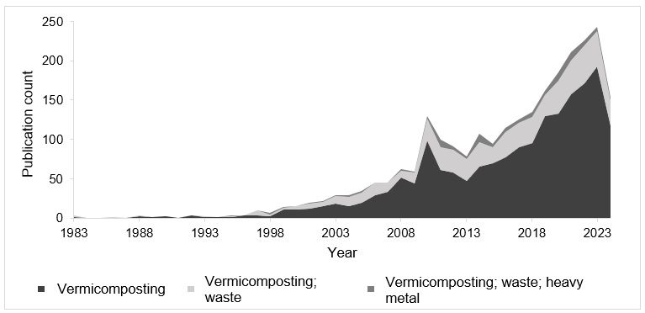
Figure 3: Trend in publications on vermicomposting of waste over time

3.1.5. Trends in publications by country worldwide
Publications in the field of vermicomposting also vary from country to country (Figure 5). Bibliometric analysis shows that India is by far the country that publishes the most documents related to this topic, with nearly 195 documents. China follows with around 78 documents, while Spain ranks third with 28 publications. Other countries, such as Brazil, Iran, Poland, the United States and Malaysia, each have between 15 and 30 documents. On the other hand, countries such as the Czech Republic, Mauritius, Canada, Mexico, Pakistan, Saudi Arabia and Australia show less interest and a more recent emergence in the field of vermicomposting. They each have fewer than 10 publications. Overall, the graph reveals a high concentration of research on vermicomposting in Asian countries such as China and India, while the rest of the countries show a less dominant distribution on a global scale.
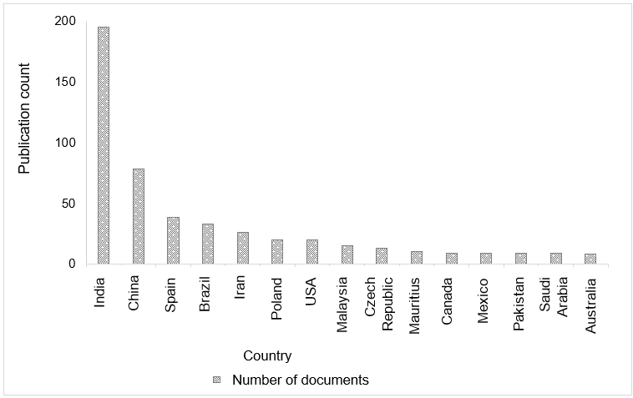
Figure 4: Trend in publications on vermicomposting by country worldwide

3.1.6. Publication trends by country in Africa
The distribution of publications on vermicomposting by country in Africa varies greatly (Figure 6). Egypt and South Africa stand out as the most active countries in this field, with seven publications each, highlighting significant research activity in these regions. Namibia, Nigeria and Zambia follow with 3 to 4 publications each. Ghana, with around 2 documents, is in an intermediate position. Finally, countries such as Burkina Faso, Côte d'Ivoire, DRC, Ethiopia and Morocco each have 1 publication.
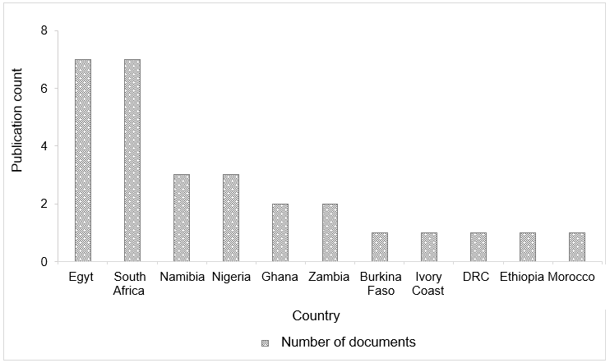
Figure 5: Trend in publications on vermicomposting in Africa

3.1.7. Evolution of research on vermicomposting
The graph illustrates the evolution of the main research topics related to vermicomposting between 1995 and 2025. The analysis highlights a gradual dynamic structured in three main phases. During the period prior to 2005, the frequency of publications remained low, reflecting the exploratory nature of the field. The few occurrences mainly concern earthworm species such as Eudrilus eugeniae and Eisenia fetida, revealing an initial interest in the biological and ecological aspects of the vermicomposting process. From 2010 onwards, the themes began to consolidate and diversify. The keywords ‘soil fertility’, ‘organic fertiliser’, “growth” and ‘yield’ became more recurrent, indicating an increased focus on agronomic applications. This phase corresponded to an intensification of research aimed at evaluating the potential of vermicompost as an organic fertiliser and its effects on plant productivity and soil quality.
From 2015 onwards, new themes emerged around the terms ‘heavy metals’ and ‘sewage sludge’. This development reflects a growing awareness of environmental and health issues. Studies then focused on the ability of vermicomposting to reduce or stabilise heavy metals present in organic substrates, with a view to sustainable urban and agricultural waste management. The most recent period, between 2020 and 2025, is marked by the rise in importance of the keyword ‘biochar’. This trend indicates a reorientation of the scientific field towards integrated approaches that combine vermicomposting and biochar to improve soil structure, increase carbon sequestration and enhance the sustainability of agricultural production systems.
A diachronic analysis of publications on vermicomposting highlights a shift in scientific priorities, from an exploratory approach focused on worm biology to the integration of innovative agronomic and environmental solutions. Recent work emphasises the need for integrated approaches, combining vermicomposting, biochar and pollutant management, to meet the challenges of agricultural sustainability and food security.
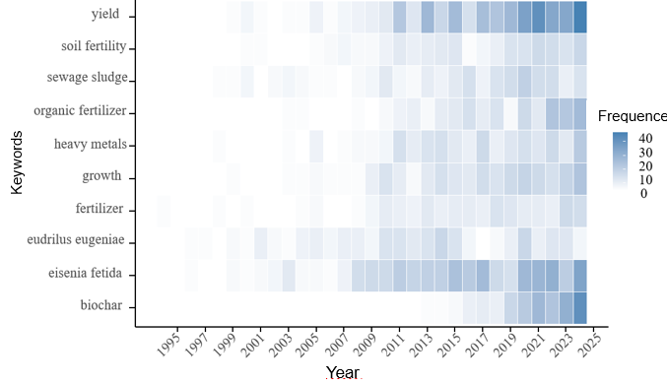
Figure 6: Research topics related to vermicomposting

3.1.8. Vermicomposting techniques and processes
The studies cover various vermicomposting methods (Figure 7). The most studied method is drum vermicomposting, accounting for 36% of studies. Bed vermicomposting follows with 31%. Trench or pit vermicomposting and windrow vermicomposting methods account for 13% and 12% of studies, respectively. Finally, bin vermicomposting is the least explored method, with only 8% of studies. These data highlight the preferences and priorities of researchers in exploring these different methods.
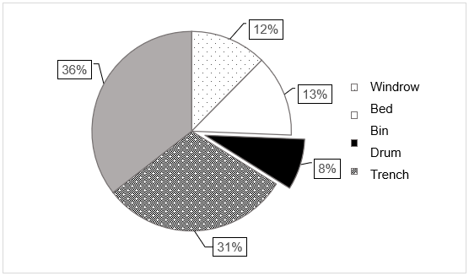
Figure 7: Percentage of studies concerned by each type of vermicomposting method

3.1.9. Description of the different types of vermicomposting
There are four main vermicomposting systems, which differ in terms of their scale of use, advantages and technical constraints. The bin system (vermi-bin), mainly used in domestic and urban contexts, is characterized by its simplicity, considerable modularity and low space requirements. However, it is limited by the small volume of material it can process. The bed system (vermi-bed) is better suited to farms and semi-industrial units. It can process larger volumes while remaining relatively simple to manage, although it requires more labour and a significant amount of space.
The windrow system, like the principle of composting in elongated piles, is intended for larger-scale operations. It offers high processing capacity and promotes good natural aeration, but it has greater variability in internal conditions and makes it more difficult to control moisture and temperature. The drum system, used in industrial or experimental facilities, ensures rapid decomposition through mechanical mixing and control of process parameters. Its main disadvantages are the high cost of equipment, technical complexity and the risk of cross-contamination. Finally, the trench system, which is now marginal, remains a low-cost solution suitable for rural areas. However, it offers limited control over composting conditions and poor reproducibility of results.
Table 3: Advantages and limitations of different vermicomposting systems
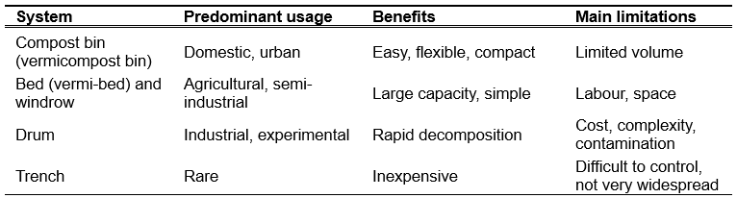
3.1.10. Species of lombricidae used for vermicomposting
The graph illustrates the distribution of earthworm species used in vermicomposting across various studies and practices. It clearly shows that Eisenia fetida is by far the most widely used species, accounting for around 70% of applications. This species, known for its great ability to adapt to various organic substrates, tolerates significant variations in temperature and humidity. It reproduces rapidly and tolerates promiscuity well, which explains its popularity in domestic and industrial systems.
In second place, Eudrilus eugeniae, often called the giant African worm, accounts for about 20% of uses. It is particularly effective in tropical regions, where high temperatures favour its biological activity. However, it is more sensitive to cold, which limits its use in temperate zones.
Species such as Perionyx excavatus and Eisenia andrei also have high biodegradation potential, but their environmental adaptability is more limited. Eisenia andrei, which is very similar to Eisenia fetida in terms of morphology and physiology, prefers more humid environments rich in fresh organic matter. Perionyx excavatus, on the other hand, thrives mainly in tropical environments with high nitrogen content. The species Dendrobaena veneta and Lumbricus rubellus are sometimes used for moderate-temperature composting trials, as they tolerate cold better but decompose organic matter more slowly.
Finally, the other species mentioned, such as Lumbricus rubellus, Metaphire posthuma, Amyntas spp., Aporrectodea caliginosa, Allolobophora chlorotica and Octolasion lacteum, are very poorly represented due to their lower efficiency in breaking down organic matter. Their use remains sporadic, often linked to specific local conditions (natural soils rather than environments rich in organic waste).
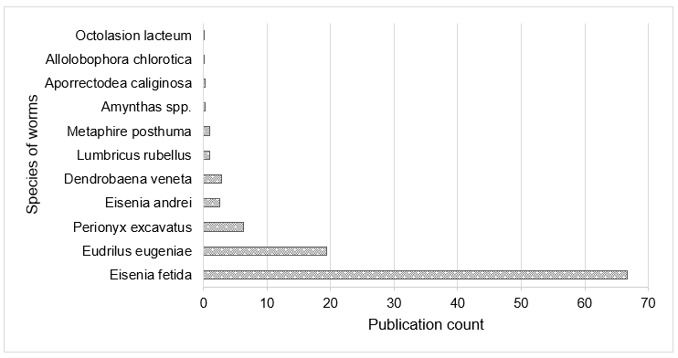

Figure 8: Distribution of the main species of worms used in vermicomposting

3.2. Discussion of bibliometric analysis results
3.2.1. Publication trends on vermicomposting
Analysis of publication trends shows an increase in research on vermicomposting over the last three decades, with exponential growth in studies after the 2000s. This increase can be attributed to an awareness of the environmental benefits of vermicomposting, particularly in the sustainable management of organic waste and soil restoration. According to the study by Ghorbani & Sabour (2021), the number of publications has grown significantly, particularly in developing countries such as India and China, which have dominated the field due to the adoption of national waste management policies. This growth has also been accompanied by increased interest in the use of vermicomposting in the reduction and stabilization of heavy metals, although this field is still relatively young. Latin American countries such as Brazil, Mexico and Colombia also stand out for their relatively modest annual publications. Krein et al. (2023) explain this case of Latin American countries by the development of research on the contribution of vermicomposting to bioenergy and biofuels in connection with concepts such as the circular economy and the bioeconomy.
In comparison, contributions from African countries are low, with Egypt and South Africa leading the way, but there is still largely untapped research potential in other countries on the continent, such as Burkina Faso, Côte d'Ivoire and the Democratic Republic of Congo. Indeed, while a few African authors focus mainly on the transformation of organic waste into vermicompost, the last decade has seen an increase in the applications of vermicomposting in developed countries.
Furthermore, bibliometric analyses have revealed that most studies on vermicomposting focus on the recovery of crop residues and manure, which explains the high number of publications related to the fields of agricultural and environmental sciences.

3.2.2. Evolution of research topics on vermicomposting
Recent research on vermicomposting focuses on topics such as soil fertilization, sustainable agriculture, waste management and heavy metals, which contrasts with the findings of Ghorbani & Sabour (2021), who identified a more pronounced fragmentation in their bibliometric analysis (1993-2017). This development suggests that the field is maturing towards a more integrated and systemic approach to vermicomposting, moving beyond the compartmentalised vision that prevailed in previous decades.
The interest in research on Eisenia fetida confirms the observations of Dominguez & Edwards (2011), who described this species as a ‘universal model organism’. The link between the biodegradation of organic matter and worms is consistent with the conclusions of Blouin et al. (2013), who consider lombricidae to be ecosystem engineers. However, while the latter emphasised physical changes in the soil, our analysis reveals a strong association with biochemical processes.
The use of worms as heavy metal remediators represents a major development. However, Ghorbani & Sabour (2021) identify it as a secondary theme, whereas our analysis positions it as a major focus. Our perceptions confirm the observations of Lin et al. (2016) and Bhat et al. (2018) on the growing interest in earthworms for bioremediation. This complementarity illustrates a systemic approach aligned with the principles of the circular economy (Lacy & Rutqvist, 2015). This thematic evolution, which positions bioremediation by lombricidae as a central focus of research, reflects a gradual convergence between fundamental approaches and sustainability requirements. However, analysis of the methodological frameworks reveals a disconnect between scientific orientations and practices implemented in the field.

3.2.3. Gap between research priorities and vermicomposting practices
The dominance of drum and bed methods differs from the observations of (Enebe & Erasmus, 2023). According to the latter, vermicomposting in bins is the most common method because it is easier to set up and requires less space and labour but is limited to domestic production. This discrepancy highlights a gap between scientific research priorities and the operational needs of practitioners, particularly in developing countries. The increased interest in drum systems can be explained by the optimisation of parameter control (Monroy et al., 2009). However, Yadav & Garg (2011) pointed out that their high costs make them unsuitable for low-income producers. This situation reveals a contrast between efficiency and social accessibility.
Regarding trench and bed vermicomposting, Dada (2024) argues that they are much more suitable for small-scale producers. They explain this by the fact that these types of vermicomposting can easily be set up in their gardens or small plots, reducing the need for equipment and specialized labour. About bin vermicomposting, Enebe & Erasmus (2023) point out that despite the popularity of vermicomposting bins among the public, they attract little interest in scientific research. According to Zeller et al. (2019), this situation can be explained by the increased focus of research on industrial vermicomposting technologies, to the detriment of domestic or small-scale approaches. Furthermore, Ducasse et al. (2022) and Vuković et al. (2021) also revealed that scientific research has focused mainly on the fundamental aspects of the vermicomposting process, such as biodegradation, microbial communities and substrate optimisation, rather than on the comparative evaluation of different types of systems.

3.2.4. Hegemony of Eisenia fetida in scientific research
The dominance of Eisenia fetida supports the observations of Domínguez (2004), who revealed strong growth in research on the species despite calls for diversification (Jouquet et al., 2010; Brown et al., 2006). They criticized this experimental monoculture of Eisenia fetida, to the detriment of other earthworm species. They added that this situation contributes to establishing Eisenia fetida as a model species, leading to sometimes overreaching extrapolations of the results obtained. However, research by Decaëns et al. (2008) showed that native species often outperform Eisenia fetida. Similarly, the work of Lavelle et al. (2016) in West Africa revealed that native species of Dichogaster remained active during the dry season, whereas Eisenia fetida enters diapause during critical periods, questioning its effectiveness.
Despite the optimistic predictions of Gajalakshmi et al. (2005) regarding the adoption of Eudrilus eugeniae in the tropics, few studies have focused on this species, probably due to the dominance of institutions from temperate countries in scientific production. This trend, centered on Eisenia fetida, directly affects the choice of substrates studied, which must necessarily be compatible with the species’ requirements to ensure the success of the experiment. Thus, certain types of waste, such as straw and leaf residues, dominate scientific literature on vermicomposting at the expense of livestock and industrial wastes.

3.2.5. Limitations of current research on heavy metal remediation through vermicomposting
Although recent research highlights the potential of vermicomposting to reduce metal contamination, several methodological limitations compromise the validity and generalization of the results. According to Singh et al. (2015), one of the main weaknesses lies in the heterogeneity of protocols, such as substrate/biomass ratios, duration (30 to 180 days), moisture (60–85%), temperature (15–30 °C), and feeding frequency, which prevents any reliable comparison. Moreover, most studies do not distinguish the mechanisms responsible for the reduction of metals in substrates, which may result from bioaccumulation, leaching, complexation, or simple dilution (Sizmur & Hodson, 2009).
Temporal and spatial scales also constitute a limitation. Indeed, most experiments are short-term (60–120 days) and conducted in laboratories, which does not allow for the assessment of the long-term stability of metal immobilization. Some stabilized metals can be remobilized after application to the soil (Alvarenga et al., 2008), and field conditions often reduce effectiveness by 30 to 50% (Soobhany et al., 2015).
Moreover, the chemical characterization of metals remains incomplete. Most studies only measure total concentrations, without considering speciation, which is crucial for bioavailability and toxicity (Gao et al., 2020; De Paiva Magalhães et al., 2015). The fate of contaminated worms and the residual toxicity of vermicompost are also poorly explored. According to K. Wang et al. (2018), worms can accumulate metals up to twenty times their initial concentration, which could pose an ecological risk.
Finally, the complex interactions between metals, organic matter, microorganisms, and worms are poorly understood, and the lack of predictive models necessitates the use of costly empirical tests. Moreover, studies reporting failures are rarely published, which creates a biased, overly optimistic view of the process's effectiveness (Dirnagl & Lauritzen, 2010).

4. Conclusion

Vermicomposting is a promising approach for the sustainable management of organic waste and the improvement of soil fertility. This technique makes use of natural resources, reduces the environmental impact of waste, and contributes to more resilient agricultural systems. The primary objective of this study was to analyze the dynamics and trends of research on vermicomposting in order to highlight methodological and thematic gaps and to guide future research toward areas that are still underexplored. Bibliometric analysis reveals that research initially focused on the biology and ecology of earthworms, before expanding to agronomic and environmental applications, such as soil fertility, sludge management, pollutant reduction, and the association with biochar. Despite these advances, certain limitations remain.
The diversity of substrates studied remains low, the topic of heavy metal reduction is still little explored, and performance evaluations at different scales of application are limited. Research prospects should prioritize the diversification of substrates and treatment methods, the assessment of long-term effectiveness on soil quality and food safety, and the integration of economic and social aspects. Interdisciplinary studies and international cooperation will help optimize practices and adapt systems to local contexts. Public policies should support the adoption of suitable technologies and promote the dissemination of knowledge in order to maximize the environmental and agronomic benefits of vermicomposting. This study thus provides a foundation for guiding future research and strengthening the sustainability of organic waste management systems.

COMPETING INTERESTS DISCLAIMER:
Authors have declared that they have no known competing financial interests OR non-financial interests OR personal relationships that could have appeared to influence the work reported in this paper.

References

Alvarenga, P., Gonçalves, A. P., Fernandes, R. M., De Varennes, A., Vallini, G., Duarte, E., & Cunha-Queda, A. C. (2008). Evaluation of composts and liming materials in the phytostabilization of a mine soil using perennial ryegrass. Science of The Total Environment, 406(1‑2), 43‑56. https://doi.org/10.1016/j.scitotenv.2008.07.061
Bhat, S. A., Singh, S., Singh, J., Kumar, S., Bhawana, & Vig, A. P. (2018). Bioremediation and detoxification of industrial wastes by earthworms : Vermicompost as powerful crop nutrient in sustainable agriculture. Bioresource Technology, 252, 172‑179. https://doi.org/10.1016/j.biortech.2018.01.003
Blouin, M., Hodson, M. E., Delgado, E. A., Baker, G., Brussaard, L., Butt, K. R., Dai, J., Dendooven, L., Peres, G., Tondoh, J. E., Cluzeau, D., & Brun, J. ‐J. (2013). A review of earthworm impact on soil function and ecosystem services. European Journal of Soil Science, 64(2), 161‑182. https://doi.org/10.1111/ejss.12025
Dada, E. O. (2024). Vermiculture and vermicomposting : twin earthworm technologies, suitable for households and smallholder farmers to convert wastes to wealth – a narrative review. FUDMA Journal of Agriculture and Agricultural Technology, 10(1), 134‑143. https://doi.org/10.33003/jaat.2024.1001.17
De Paiva Magalhães, D., Da Costa Marques, M. R., Baptista, D. F., & Buss, D. F. (2015). Metal bioavailability and toxicity in freshwaters. Environmental Chemistry Letters, 13(1), 69‑87. https://doi.org/10.1007/s10311-015-0491-9
Decaëns, T., Margerie, P., Aubert, M., Hedde, M., & Bureau, F. (2008). Assembly rules within earthworm communities in North-Western France—A regional analysis. Applied Soil Ecology, 39(3), 321‑335. https://doi.org/10.1016/j.apsoil.2008.01.007
Dirnagl, U., & Lauritzen, M. (2010). Fighting Publication Bias : Introducing the Negative Results Section. Journal of Cerebral Blood Flow & Metabolism, 30(7), 1263‑1264. https://doi.org/10.1038/jcbfm.2010.51
Domínguez, J. (2004). State-of-the-Art and New Perspectives on Vermicomposting Research. In C. Edwards (Éd.), Earthworm Ecology (p. 401‑424). CRC Press. https://doi.org/10.1201/9781420039719.ch20
Dominguez, J., & Edwards, C. A. (2011). Biology and ecology of earthworm species used for vermicomposting. In Vermiculture technology : Earthworms, organic wastes, and environmental management (1re édition, p. 27‑40). CRC Press, Taylor & Francis Group. https://jdguez.webs.uvigo.es/wp-content/uploads/2012/01/Biology-and-Ecology-of-Earthworm-species-used-for-Vermicompostimg.pdf
Ducasse, V., Capowiez, Y., & Peigné, J. (2022). Vermicomposting of municipal solid waste as a possible lever for the development of sustainable agriculture. A review. Agronomy for Sustainable Development, 42(5), 89. https://doi.org/10.1007/s13593-022-00819-y
Enebe, M. C., & Erasmus, M. (2023). Vermicomposting technology—A perspective on vermicompost production technologies, limitations and prospects. Journal of Environmental Management, 345, 118585. https://doi.org/10.1016/j.jenvman.2023.118585
Gao, L., Gao, B., Xu, D., & Liu, L. (2020). DGT : A promising technology for in-situ measurement of metal speciation in the environment. Science of The Total Environment, 715, 136810. https://doi.org/10.1016/j.scitotenv.2020.136810
Garg, P., Gupta, A., & Satya, S. (2006). Vermicomposting of different types of waste using Eisenia foetida : A comparative study. Bioresource Technology, 97(3), 391‑395. https://doi.org/10.1016/j.biortech.2005.03.009
Ghorbani, M., & Sabour, M. R. (2021a). Global trends and characteristics of vermicompost research over the past 24 years. Environmental Science and Pollution Research, 28(1), 94‑102. https://doi.org/10.1007/s11356-020-11119-x
Ghorbani, M., & Sabour, M. R. (2021b). Global trends and characteristics of vermicompost research over the past 24 years. Environmental Science and Pollution Research, 28(1), 94‑102. https://doi.org/10.1007/s11356-020-11119-x
Hussein, L., Uren, C., Rekik, F., & Hammami, Z. (2022). A review on waste management and compost production in the Middle East–North Africa region. Waste Management & Research: The Journal for a Sustainable Circular Economy, 40(8), 1110‑1128. https://doi.org/10.1177/0734242X211068236
Jouquet, P., Plumere, T., Thu, T. D., Rumpel, C., Duc, T. T., & Orange, D. (2010). The rehabilitation of tropical soils using compost and vermicompost is affected by the presence of endogeic earthworms. Applied Soil Ecology, 46(1), 125‑133. https://doi.org/10.1016/j.apsoil.2010.07.002
Kaza, S., Yao, L. C., Bhada-Tata, P., & Van Woerden, F. (2018). What a Waste 2.0 : A Global Snapshot of Solid Waste Management to 2050. Washington, DC: World Bank. https://doi.org/10.1596/978-1-4648-1329-0
Krein, D. D. C., Rosseto, M., Cemin, F., Massuda, L. A., & Dettmer, A. (2023). Recent trends and technologies for reduced environmental impacts of fertilizers : A review. International Journal of Environmental Science and Technology, 20(11), 12903‑12918. https://doi.org/10.1007/s13762-023-04929-2
Lacy, P., & Rutqvist, J. (2015). The Product Life-Extension Business Model : Products that Are Built to Last. In P. Lacy & J. Rutqvist, Waste to Wealth (p. 68‑83). Palgrave Macmillan UK. https://doi.org/10.1057/9781137530707_6
Lavelle, P., Spain, A., Blouin, M., Brown, G., Decaëns, T., Grimaldi, M., Jiménez, J. J., McKey, D., Mathieu, J., Velasquez, E., & Zangerlé, A. (2016). Ecosystem Engineers in a Self-organized Soil : A Review of Concepts and Future Research Questions. Soil Science, 181(3/4), 91‑109. https://doi.org/10.1097/SS.0000000000000155
Li, C., Zhou, K., Qin, W., Tian, C., Qi, M., Yan, X., & Han, W. (2019). A Review on Heavy Metals Contamination in Soil : Effects, Sources, and Remediation Techniques. Soil and Sediment Contamination: An International Journal, 28(4), 380‑394. https://doi.org/10.1080/15320383.2019.1592108
Lin, Z., Bai, J., Zhen, Z., Lao, S., Li, W., Wu, Z., Li, Y., Spiro, B., & Zhang, D. (2016). Enhancing pentachlorophenol degradation by vermicomposting associated bioremediation. Ecological Engineering, 87, 288‑294. https://doi.org/10.1016/j.ecoleng.2015.12.004
Meza-Márquez, J. M., Nava-López, J. A., & Ramírez-Morales, K. (2014). Fisiología de la coagulación. Revista Mexicana de Anestesiologia, 37, S382‑S386. Scopus.
Monroy, F., Aira, M., & Domínguez, J. (2009). Reduction of total coliform numbers during vermicomposting is caused by short-term direct effects of earthworms on microorganisms and depends on the dose of application of pig slurry. Science of The Total Environment, 407(20), 5411‑5416. https://doi.org/10.1016/j.scitotenv.2009.06.048
Sizmur, T., & Hodson, M. E. (2009). Do earthworms impact metal mobility and availability in soil? – A review. Environmental Pollution, 157(7), 1981‑1989. https://doi.org/10.1016/j.envpol.2009.02.029
Soobhany, N., Mohee, R., & Garg, V. K. (2015). Comparative assessment of heavy metals content during the composting and vermicomposting of Municipal Solid Waste employing Eudrilus eugeniae. Waste Management, 39, 130‑145. https://doi.org/10.1016/j.wasman.2015.02.003
Ul Baligah, H., Chesti, M. H., Ahmed Baba, Z., Mir, S., Wani, F. J., Bhat, J. A., & Khan, I. M. (2024). Vermicomposting technology as a dynamic strategy to mitigate environmental crisis : A bibliometric study of last three decades. Environmental Technology, 1‑15. https://doi.org/10.1080/09593330.2024.2339191
Ulloa-Murillo, L. M., Villegas, L. M., Rodríguez-Ortiz, A. R., Duque-Acevedo, M., & Cortés-García, F. J. (2022). Management of the Organic Fraction of Municipal Solid Waste in the Context of a Sustainable and Circular Model : Analysis of Trends in Latin America and the Caribbean. International Journal of Environmental Research and Public Health, 19(10). Scopus. https://doi.org/10.3390/ijerph19106041
Vuković, A., Velki, M., Ečimović, S., Vuković, R., Štolfa Čamagajevac, I., & Lončarić, Z. (2021). Vermicomposting—Facts, Benefits and Knowledge Gaps. Agronomy, 11(10), 1952. https://doi.org/10.3390/agronomy11101952
Wang, J., Mao, H., Wang, X., & Zhou, J. (2023). Combinable Multi-storey Adaptive Monitoring System for Composting Fermentation Temperature. Nongye Jixie Xuebao/Transactions of the Chinese Society for Agricultural Machinery, 54(2), 359‑367. Scopus. https://doi.org/10.6041/j.issn.1000-1298.2023.02.037
Wang, K., Qiao, Y., Zhang, H., Yue, S., Li, H., Ji, X., & Liu, L. (2018). Bioaccumulation of heavy metals in earthworms from field contaminated soil in a subtropical area of China. Ecotoxicology and Environmental Safety, 148, 876‑883. https://doi.org/10.1016/j.ecoenv.2017.11.058
Wowrzeczka, B. (2021). City of Waste—Importance of Scale. Sustainability, 13(7), 3909. https://doi.org/10.3390/su13073909
Yadav, A., & Garg, V. K. (2011). Industrial wastes and sludges management by vermicomposting. Reviews in Environmental Science and Bio/Technology, 10(3), 243‑276. https://doi.org/10.1007/s11157-011-9242-y
Zeller, V., Towa, E., Degrez, M., & Achten, W. M. J. (2019). Urban waste flows and their potential for a circular economy model at city-region level. Waste Management, 83, 83‑94. https://doi.org/10.1016/j.wasman.2018.10.034

