Case Report

Ulcerated Infantile Hemangioma of the Upper Lip Mimicking a Cleft Lip: A Diagnostic Dilemma

.
ABSTRACT:
Introduction: Infantile hemangiomas (IH) are the most common benign vascular tumors of infancy and typically appear during the early postnatal period. Although most IH follow a benign course, ulceration occurs in a significant proportion, particularly in lesions involving high-risk areas such as the perioral region. Ulcerated IH may present diagnostic challenges as they can mimic other ulcerative conditions, including pyoderma gangrenosum or invasive fungal infections.
Case report: We report a case of a 30-day-old male infant who presented with an ulcerated lesion of the upper lip producing a cleft lip–like appearance. The lesion evolved from an erythematous patch noted in the philtrum during the second week of life and rapidly progressed to ulceration. Initial differentials included pyoderma gangrenosum and fungal infection. However, careful review of serial photographs taken during the neonatal period revealed a precursor lesion characteristic of IH, leading to a clinical diagnosis. The infant was treated with systemic antibiotics for secondary infection along with oral propranolol and topical timolol, resulting in significant clinical improvement.
Conclusion: This case highlights the importance of recognizing precursor lesions and maintaining a high index of suspicion for IH in atypical ulcerative presentations. Early diagnosis, aided by photographic documentation and accurate clinical chronology, is essential for timely management and prevention of functional and cosmetic morbidity.

Keywords: Hemangioma, Vascular Malformations, Infant, Newborn, Skin Diseases

1. INTRODUCTION:

Introduction: Infantile hemangiomas (IH) are the most common benign vascular tumours in infancy [1]. Globally, the prevalence of IH in infants ranges from 2–10% [1], although Indian studies have reported lower prevalence rates (0.1% to 0.28%) [2]. Approximately 16% to 23% of IHs develop ulceration during the proliferative phase [2]. Perioral IH and IH involving the lips are classified as “high-risk IH” because they have a higher likelihood of ulceration and bleeding, thereby causing subsequent scarring and disfigurement, especially in younger infants [3]. An ulcerated hemangioma, particularly when presenting late, may resemble other skin lesions such as pyoderma gangrenosum (PG) or fungal infections [4]. We describe a case of a 30-day-old infant who presented with an ulcerated hemangioma resulting in a cleft lip–like appearance.

2. Case presentation:
A 30-day-old infant boy presented to our centre with an ulcerated lesion on the upper lip that resembled a cleft lip. The parents had initially noticed an erythematous raised patch in the philtrum area on day 10 of life. According to them, the lesion spread over the next few days to involve the upper lip and the lower part of the nose. Subsequently, it developed a blackish discoloration and rapidly ulcerated to its present condition. Due to the lesion, the baby was unable to latch and hence the mother had to switch from direct breast feeding to expressed milk given via wati-spoon. There was no history of nasal discharge, respiratory distress, fever, or similar lesions elsewhere on the body. The infant was the firstborn of a non-consanguineous union and had an uneventful antenatal period. He was born full term by normal vaginal delivery, with a birth weight of 2.5 kg. There were no perinatal complications, and he was discharged on day 3 of life. There was no family history of similar skin lesions, congenital anomalies, or unexplained deaths.
On examination, the infant was vitally stable, alert, and playful. His current weight (2.89 kg) and length (48 cm) were both well below –3 SD on the WHO and IAP combined growth charts. His head circumference was appropriate for his length and age. Local examination revealed a defect of the upper lip extending through the philtrum, with crusted, granulating margins and surrounding circumferential erythema (Figure 1). Examination of the nasal and oral cavities was normal. There were no other cutaneous lesions, and systemic examination was within normal limits.
The clinical differential diagnoses included PG and invasive fungal infections. However, due to the rapid neonatal onset, and in the absence of other systemic features or risk factors indicating an inborn error of immunity (IEI), PG or invasive fungal infections seemed less likely. Laboratory investigations showed a hemoglobin level of 11.6 g/dL, a white blood cell count of 11,760 cells/mm³ with neutrophilic predominance, and a platelet count of 7.31 lakh cells/mm³. C-reactive protein (CRP) was elevated at 12.26 mg/dL. Liver and renal function tests were within normal limits. However, careful review of serial photographs of the child taken at birth and during the first week of life revealed a small bluish-black discoloration involving the philtrum in a photograph taken on the first day of life, which gradually became erythematous over subsequent days (Figures 2a and 2b). This was highly suggestive of a precursor lesion, which is commonly seen in IH. Based on these findings, a clinical diagnosis of ulcerated IH was made. Since the clinical evolution of the lesion established an evident clinical diagnosis, further imaging or histopathological investigations were not pursued.
A swab from the lesion grew Klebsiella pneumoniae. Blood cultures and evaluation for primary immunodeficiency were negative. The child was treated with piperacillin–tazobactam (100 mg/kg/day in three divided doses) for 14 days. He was also started on oral propranolol (1 mg/kg/day) with gradual dose escalation and topical timolol drops (0.5%), twice daily, for the management of IH. With therapy, the child showed resolution of erythema and development of healthy granulation tissue around the margins of the lesion by the time of discharge. He was subsequently referred to the plastic and reconstructive surgery unit for surgical correction and rehabilitation of the defect.

3. discussion:

Infantile hemangiomas are usually not visible at birth, show proliferative growth during infancy, and may be associated with syndromes such as PHACES (Posterior fossa malformations, Hemangioma, Arterial anomalies, Cardiac anomalies, Eye anomalies, and Sternal clefts or supraumbilical abdominal raphe) and LUMBAR (Lower body infantile hemangioma, Urogenital anomalies, Myelopathy, Bony defects, Anorectal malformations, and Renal anomalies) syndromes [5]. It is important to differentiate IH from congenital hemangiomas (CH), as CH are fully formed at birth, usually involute rapidly or remain unchanged, and are not associated with syndromes or significant complications [6].
IH can be clinically classified based on depth (superficial, deep, or mixed) or pattern of involvement (focal, multifocal, segmental, or indeterminate) [1]. Furthermore, “high-risk” IH, are seen in approximately 10%–15% of cases and are defined as lesions that that pose a high risk of ulceration, bleeding, infection, disfigurement, or obstruction of vital organs (airway, eyes, etc.) [3]. Ulceration, as a complication, is seen in approximately 16% of all IH cases [2]. Underlying mechanisms remain poorly understood, although rapid vascular proliferation, resultant friction and ischemia as well as concomitant infection all play a contributory role. [1].
Proper characterization of IH is essential, as certain features warrant specialized evaluation. For example, in cases of large segmental IH involving the face or scalp, guidelines recommend neuroimaging and cardiac evaluation with a 2D echocardiogram to rule out PHACES syndrome. The presence of more than five cutaneous IH is associated with an increased likelihood of associated hepatic hemangiomas. Additionally, IH in the “beard area” are associated with a higher risk of airway hemangiomas [3]. Awareness of these features helps in early recognition and timely treatment which significantly reduces morbidity.
Management of IH is multimodal and individualized based on the size, location, phase, and presence of complications. Currently available treatment options include oral propranolol (with or without topical timolol maleate for superficial lesions), pulsed-dye laser therapy for ulceration or residual changes, and systemic corticosteroids. Surgical excision is reserved for persistent deformities or refractory cases [7].
In the present case, careful observation of photographs taken during the first week of life was instrumental in establishing the diagnosis and excluding other differentials such as PG and fungal infections. Various types of precursor lesions have been described in IH, including pale patches, erythematous macules, telangiectatic macules, and blue bruise-like lesions [8]. Recognition of these precursor lesions allows for early diagnosis and timely initiation of appropriate therapy. Similar case reports from India and other countries have described comparable diagnostic challenges [4, 5]. There have also been reports of neonates with ulcerated IH being referred for evaluation of a suspected cleft lip similar to our case [5, 6].

4. Conclusion:

This case highlights the importance of photographic documentation and eliciting accurate chronology in establishing the correct diagnosis. Awareness of the clinical features of IH is essential for developing a high index of suspicion for associated complications. Management of IH is multidisciplinary and requires coordinated care among multiple specialists to achieve optimal outcomes.

Consent

All authors declare that ‘written informed consent was obtained from the patient (or other approved parties) for publication of this case report and accompanying images. A copy of the written consent is available for review by the Editorial office/Chief Editor/Editorial Board members of this journal."

Ethical approval (where ever applicable)

Ethical approval from institutional ethics committee of hospital was obtained for publication.

References

- Bandera AI, Sebaratnam DF, Wargon O, Wong LC. Infantile hemangioma. Part 1: Epidemiology, pathogenesis, clinical presentation and assessment. J Am Acad Dermatol. 2021 Dec 1;85(6):1379-92.
- Mendiratta V, Jabeen M. Infantile hemangioma: an update. Indian J. Dermatol. Venereol. Leprol. 2010 Sep 1;76:469.
- Krowchuk DP, Frieden IJ, Mancini AJ, Darrow DH, Blei F, Greene AK et al. Clinical practice guideline for the management of infantile hemangiomas. Pediatrics. 2019 Jan 1;143(1):e20183475.
- Marquart E, Weiss D, Batinic K, Wiesner T, Rohrbeck J, Arnoldner T et al. Completely ulcerated infantile hemangioma: a diagnostic challenge. Wiener klinische Wochenschrift. 2025 May 22:1-4.
- Paulpandian R, Nithishwar K, Nithishwar Sr K. Cleft Lip Appearance Secondary to Ulcerating Hemangioma. Cureus. 2025 Jun 9;17(6).
- Neri I, Piccolo V, Russo T, Bianchi A, Patrizi A. Congenital primarily ulcerated hemangioma mimicking cleft lip. J. Pediatr. 2013 Apr 1;162(4):882-883
- Sebaratnam DF, Wong LC, Wargon O. Infantile hemangioma. Part 2: management. Journal of the J Am Acad Dermatol. 2021 Dec 1;85(6):1395-404.
- Jing FZ, Villalpando BK, Tollefson MM. Infantile hemangioma precursor lesions on day of life 1: A Mayo Clinic retrospective case series. Pediatr. Dermatol. 2024 Nov;41(6):1053-6.

Figures:

Figure 1 Figure 2a Figure 2b

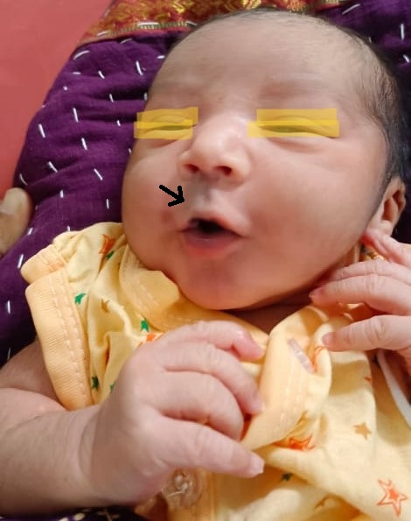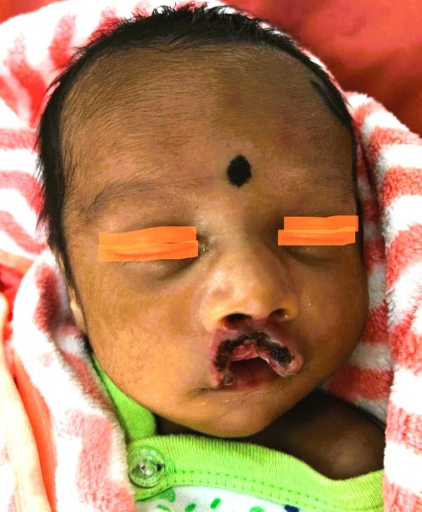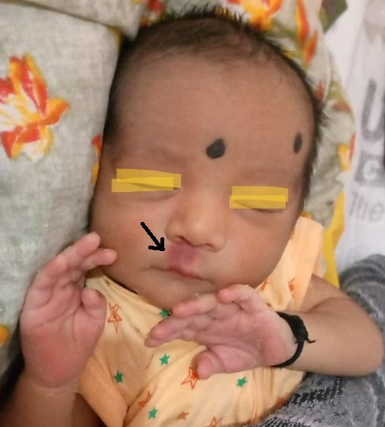

Figure 1: Ulcerated IH. Lesion as seen at presentation (day 30 of life)
Figure 2a: Photograph of infant taken on day 1 of life showing ‘precursor lesion’ of IH as denoted by black arrow mark.
Figure 2b: Photograph of infant taken on day 3 of life showing evolution of precursor lesion as denoted by black arrow mark.

