Case report
Concurrent Deep Vein Thrombosis and Pulmonary Embolism following Total Knee Replacement associated with Over-the-Counter NSAID use and interruption of thromboprophylaxis

.
ABSTRACT

Aim: This case study explores the consequences of unsupervised consumption of over-the-counter (OTC) medications in a patient following total knee replacement (TKR). It specifically focuses on how interruption of prescribed thromboprophylaxis contributed to the development of venous thromboembolism (VTE).
Presentation of Case: A 67-year-old woman with a history of type 2 diabetes mellitus and hypertension underwent an elective right total knee replacement procedure. After discharge, she was advised to continue oral anticoagulant therapy as part of thromboprophylaxis. To relieve postoperative pain, the patient independently used diclofenac obtained over the counter. Following its use, she experienced epigastric discomfort, dizziness, and mild bleeding from the surgical site. Concerned about these symptoms, she decided to omit one dose of her anticoagulant medication and also reduced her level of physical activity. Within three days, she developed swelling in the calf along with tachycardia (110 beats per minute) and decreased oxygen saturation (SpO₂ 89%). Further diagnostic evaluation confirmed the presence of right popliteal deep vein thrombosis along with segmental pulmonary embolism.

Discussion: The sequence of events in this case highlights the risks associated with unsupervised OTC medication use. Diclofenac, when taken together with anticoagulant therapy, can increase the possibility of bleeding complications. The patient’s fear of bleeding led to non-adherence to anticoagulant therapy, while reduced mobility further increased the likelihood of thrombus formation. Together, these factors created a clinical situation that facilitated the development of VTE.

Conclusion: This case emphasizes that uncontrolled use of OTC analgesics may lead to significant drug interactions and adverse outcomes that interfere with essential postoperative therapies such as thromboprophylaxis. Effective patient education at discharge, proper medication review, and the involvement of clinical pharmacists are important measures to reduce the risk of such complications.

Keywords: Total Knee Replacement; Venous Thromboembolism; Deep Vein Thrombosis; Pulmonary Embolism;
Over-the-counter NSAIDs; Medication Adherence; Drug-Drug Interactions; Clinical Pharmacist.

1. INTRODUCTION

Venous thromboembolism (VTE), which includes deep vein thrombosis (DVT) and pulmonary embolism (PE), is a serious complication that can occur after total knee replacement (TKR). The development of VTE is mainly related to Virchow’s triad, which includes endothelial injury, venous stasis, and a hyper-coagulable state. To reduce this risk, clinical guidelines recommend the use of pharmacological thromboprophylaxis along with early mobilization after surgery.
However, the success of these preventive measures depends largely on patient adherence to treatment. Postoperative pain may lead some patients to use over-the-counter (OTC) analgesics without medical advice. Non-steroidal anti-inflammatory drugs (NSAIDs) such as diclofenac or ibuprofen are commonly used for pain relief, but they may cause gastrointestinal irritation and increase the risk of bleeding, particularly when taken with anticoagulant therapy. Because of these effects, some patients may stop or skip their anticoagulant medication, which can create a temporary pro-thrombotic state during recovery.
Pain management outside the hospital is therefore an important but often overlooked factor in postoperative care. This case highlights the need for proper discharge counseling, careful medication review, and early involvement of clinical pharmacists to ensure safe medication use in patients undergoing orthopedic surgery.

2. Presentation of Case
A 67-year-old woman was admitted to the orthopedic department for elective right total knee replacement due to advanced osteoarthritis. She had a history of progressive knee pain, stiffness, and limited mobility for nearly nine years. Her medical history included type 2 diabetes mellitus for twelve years and hypertension for ten years. She was taking metformin 500 mg twice daily, glimepiride 2 mg once daily, amlodipine 5 mg once daily, telmisartan 40 mg once daily.
The patient underwent right total knee replacement under spinal anesthesia. The surgery and immediate postoperative period were uneventful. According to hospital protocol, pharmacological thromboprophylaxis with low-molecular-weight heparin was started after surgery. Before discharge, she was advised to continue oral anticoagulant therapy and encouraged to begin early mobilization and physiotherapy.
Two days after discharge, the patient experienced severe pain and swelling at the operated knee. Without consulting her physician, she took diclofenac, an OTC NSAID, for pain relief while continuing the anticoagulant medication. Within 24 hours, she developed epigastric discomfort, dizziness, and mild oozing from the surgical wound. Because she was worried about bleeding, she skipped one dose of her anticoagulant and significantly reduced her physical activity.
Three days later, she presented to the emergency department with increasing pain and swelling of the operated leg, along with calf tenderness, shortness of breath, and mild chest discomfort.
On examination, the right calf was swollen and tender. Her heart rate was 110 beats per minute and oxygen saturation on room air was 89%. Laboratory investigations showed elevated D-dimer levels. Doppler ultrasonography confirmed acute thrombosis in the right popliteal vein, and computed tomography pulmonary angiography revealed segmental pulmonary embolism.
A diagnosis of concurrent DVT and PE following total knee replacement was made. The patient was immediately treated with therapeutic low-molecular-weight heparin, oxygen therapy, and supportive care. Oral anticoagulant therapy was restarted under close monitoring. Diclofenac was discontinued and paracetamol was prescribed for pain management.
The patient was counseled regarding strict adherence to anticoagulant therapy, avoidance of self-medications particularly NSAID and the importance of early mobilization and regular follow-up. Her condition gradually improved so she was discharged in stable condition.
3. discussion

The main objective of postoperative care after Total Knee Replacement (TKR) is to prevent venous thromboembolism (VTE) while ensuring effective pain control that allows early mobilization. This case demonstrates how unsupervised use of over-the-counter (OTC) medication can interfere with these goals and contribute to serious complications.
The Role of NSAIDs and Prophylaxis Interruption
Non-steroidal anti-inflammatory drugs (NSAIDs) are commonly used during orthopedic recovery because they provide effective pain relief and reduce the need for opioid analgesics. Despite these benefits, their use without medical supervision can lead to complications. In the present case, the patient independently used diclofenac, which resulted in gastrointestinal discomfort and concern about possible bleeding while she was receiving anticoagulant therapy. These symptoms made the patient focus more on relieving pain than on maintaining the protective effect of anticoagulation, leading her to interrupt the prescribed thromboprophylaxis. The sequence of events suggests that the patient’s pain was not adequately controlled or that the prescribed pain management plan was not fully understood, which encouraged the use of OTC medication.
Drug-Drug Interactions and Patient Perception
Many patients believe that medications available over the counter are completely safe. However, combining NSAIDs with anticoagulants such as Factor Xa inhibitors or LMW heparin can significantly increase the risk of bleeding. In this case, the patient’s decision to stop her anticoagulant therapy highlights a lack of awareness regarding the importance of continuous prophylaxis. It also indicates that the anticoagulant was not perceived as an essential medication, while the analgesic was viewed as necessary for immediate symptom relief.
The Role of Delayed Mobilization
Early mobilization is a key factor in preventing VTE because it improves venous circulation and reduces venous stasis. When pain is poorly controlled, patients may limit their physical activity. If reduced mobility occurs together with interruption of anticoagulant therapy, the likelihood of developing deep vein thrombosis and pulmonary embolism increases considerably.
Mechanism of action
In this patient, the OTC NSAID diclofenac inhibited the cyclo-oxygenase enzyme, particularly COX-1, resulting in decreased synthesis of thromboxane A₂ and reduced platelet aggregation. At the same time, the prescribed anticoagulant acted on the coagulation cascade and decreased thrombin formation. The combined effect of platelet inhibition from the NSAID and anticoagulation therapy increased the risk of bleeding, which was clinically evident as wound oozing and gastrointestinal discomfort.
Although the patient was discharged with appropriate anticoagulant therapy, the unsupervised use of diclofenac during this period increased the tendency for bleeding because both medications affected platelet activity and coagulation pathways. The wound oozing and gastrointestinal symptoms that followed caused the patient to skip one dose of her anticoagulant medication and significantly reduce her mobility. The interruption of anticoagulant therapy together with decreased movement created conditions favorable for venous stasis and thrombosis. Consequently, the patient developed deep vein thrombosis that later progressed to pulmonary embolism.
Therefore, in this case the NSAID itself did not directly produce thrombosis. Instead, it indirectly contributed to venous thromboembolism by triggering bleeding symptoms, which led to interruption of anticoagulant therapy and reduced physical activity.
4.CONCLUSION
The occurrence of both deep vein thrombosis and pulmonary embolism in this patient represents a preventable medication-related complication. Successful recovery after total knee replacement depends not only on surgical technique but also on appropriate postoperative pharmacological management. Careful medication review, structured discharge counseling, and guidance from clinical pharmacists are important to ensure that patients understand the need for strict adherence to anticoagulant therapy and avoidance of unsupervised self-medication. These measures can help reduce the risk of thromboembolic complications following orthopedic surgery.

Consent

Written informed consent was obtained from the patient for the publication of this case report. A copy is available for review by the Editorial Office

Ethical approval

According to the institutional policies, formal ethical committee approval was not necessary for reporting this single patient case. The study was conducted in accordance with the principles outlined in the Declaration of Helsinki, and patient confidentiality and anonymity were maintained throughout the documentation and reporting process.

References

- Anderson, D. R., Morgano, G. P., Bennett, C., Brignardello-Petersen, R., Chaibi, A., & Duceppe, E. et al. (2019). American Society of Hematology 2019 guidelines for management of venous thromboembolism: prevention of VTE in surgical hospital patients. Blood Advances, 3(23), 3898-3944.
- Falck-Ytter, Y., Francis, C. W., Johanson, N. A., Curley, C., Dahl, O. E., & Schulman, S. et al. (2012). Prevention of VTE in orthopedic surgery patients: Antithrombotic Therapy and Prevention of Thrombosis, 9th ed: American College of Chest Physicians Evidence-Based Clinical Practice Guidelines. Chest, 141(2 Suppl), e278S-e325S.
- Lanas, A., & Chan, F. K. L. (2017). Peptic ulcer disease. The Lancet, 390(10094), 613-624.
- Moore, N., Pollack, C., & Butkerait, P. (2015). Adverse drug reactions and drug–drug interactions with over-the-counter NSAIDs. Therapeutics and Clinical Risk Management, 11, 1061-1075.
- Pashikanti, L., & Von Ah, D. (2012). Impact of early mobilization on glycemic control and manual muscle test in patients after total knee replacement. Oncology Nursing Forum, 39(1), 105-112.
- Schjerning Olsen, A. M., Gislason, G. H., McGettigan, P., Fosbøl, E., Sørensen, R., & Hansen, M. L. et al. (2015). Association of NSAID use with risk of bleeding and cardiovascular events in patients receiving antithrombotic therapy after myocardial infarction. JAMA, 313(8), 805-814.
- Zhai, Z., Kan, Q., Li, W., Qin, X., Qu, J., & Shi, Y. et al. (2014). VTE risk assessment and prophylaxis in Chinese patients: a post hoc analysis of the AIDA study. Chest, 146(5), 1314-1325.
- Encke, A., & Kopp, I. (2015). Prevention of Venous Thromboembolism. Deutsches Ärzteblatt International, 112(37), 620-625.
- Bhatt, D. L., Scheiman, J., Abraham, N. S., Antman, E. M., Chan, F. K. L., & Furberg, C. D. et al. (2008). ACCF/ACG/AHA 2008 expert consensus document on reducing the gastrointestinal risks of antiplatelet therapy and NSAID use. Journal of the American College of Cardiology, 52(18), 1502-1517.
- Agboola, I. A., Adebayo, O., & Owoeye, D. O. (2018). The Role of the Pharmacist in the Management of Venous Thromboembolism. Journal of Pharmaceutical Care and Health Systems, 5(1), 1-5.
- Dahl OE, Caprini JA, Colwell CW Jr, et al. Fatal pulmonary embolism after total knee arthroplasty: a contemporary analysis. J Arthroplasty. 2005;20(1):70-74.
- Eriksson BI, Quinlan DJ, Weitz JI. Comparative pharmacodynamics and pharmacokinetics of oral direct thrombin and factor Xa inhibitors in development. Clin Pharmacokinet. 2009;48(1):1-22.
- Knijff-Dutmer EA, Martens J, Nijhuis A, et al. Effects of diclofenac on platelet functions in healthy volunteers and patients with rheumatoid arthritis. Rheumatology (Oxford). 1999;38(11):1082-1086.
- Laporte JR, Ibañez L, Vidal X, et al. Upper gastrointestinal bleeding associated with the combined use of low-dose aspirin or anticoagulants with non-aspirin non-steroidal anti-inflammatory drugs. Drug Saf. 2004;27(6):411-420.
- Osterberg L, Blaschke T. Adherence to medication. N Engl J Med. 2005;353(5):487-497.
- Sostres C, Gargallo CJ, Arroyo MT, et al. Adverse effects of non-steroidal anti-inflammatory drugs (NSAIDs, aspirin and coxibs) on lower gastrointestinal tract. Best Pract Res Clin Gastroenterol. 2010;24(2):121-132.
- Tafur A, Caprini JA. Perioperative management of antithrombotic therapy: an update. Med Clin North Am. 2012;96(2):281-300.
- Wells PS, Anderson DR, Rodger M, et al. Derivation of a simple clinical model to categorize patients probability of pulmonary embolism: increasing the Wells score's utility with soluble fibrin-helper. Thromb Haemost. 2000;83(3):416-420.

Tables:

Table.1: Medication Timeline with Missed Doses Leading to Thromboembolic Event

Phase | Day | Time | Drug | Dose | Route | Status | Remarks
Post-TKR | Day 0 | 8 AM | Enoxaparin | 40 mg | SC | Given | Post-op prophylaxis
Post-TKR | Day 1 | 8 AM | Enoxaparin | 40 mg | SC | Given
Post-TKR | Day 2 | 8 AM | Enoxaparin | 40 mg | SC | Given
Post-TKR | Day 3 | 8 AM | Enoxaparin | 40 mg | SC | Given
Post-TKR | Day 4 | 8 AM | Enoxaparin | 40 mg | SC | Given
Routine | Daily | 8 AM | Metformin | 500 mg | PO | Given | DM
Routine | Daily | 8 AM | Glimepiride | 1 mg | PO | Given | DM
Routine | Daily | 9 AM | Amlodipine | 5 mg | PO | Given | HTN
Routine | Daily | 9 AM | Telmisartan | 40 mg | PO | Given | HTN
Home | Day 5 | 8 AM | Apixaban | 2.5 mg | PO | Given | Discharge Rx
Home | Day 5 | 8 PM | Apixaban | 2.5 mg | PO | Given
Home | Day 6 | 8 AM | Apixaban | 2.5 mg | PO | Missed | Fear of bleeding
Home | Day 6 | 9 AM | Diclofenac | 50 mg | PO | Self taken | OTC
Home | Day 6 | 3 PM | Diclofenac | 50 mg | PO | Self taken
Home | Day 6 | 9 PM | Diclofenac | 50 mg | PO | Self taken
Home | Day 7 | - | Apixaban | 2.5 mg | PO | Not taken | Wound ooze
Home | Day 8 | - | Anticoagulant | - | - | Not taken | Immobilization
DVT/PE | Day 1 | 8 AM | Enoxaparin | 60 mg | SC | Given | Therapeutic dose
DVT/PE | Day 1 | 8 AM | Oxygen | 4 L/min | Inhalation | Given | SpO2 89%
DVT/PE | Day 1 | 9 AM | Pantoprazole | 40 mg | IV | Given | GI protection
DVT/PE | Day 1 | 10 AM | Paracetamol | 650 mg | PO | Given | Pain
DVT/PE | Day 1 | 8 PM | Enoxaparin | 60 mg | SC | Given
DVT/PE | Day 2-4 | 8 AM & 8 PM | Enoxaparin | 60 mg | SC | Given | BD
DVT/PE | Day 5 | 8 AM | Apixaban | 10 mg | PO | Given | Treatment dose
DVT/PE | Day 5 | 8 PM | Apixaban | 10 mg | PO | Given
DVT/PE | Day 6-11 | 8 AM & 8 PM | Apixaban | 10 mg | PO | Given | 7 days
DVT/PE | Day 12 onward | 8 AM & 8 PM | Apixaban | 5 mg | PO | Given | Maintenance

Figures:

Fig.1: Clinical Risk Transition Across Perioperative Anticoagulation Phases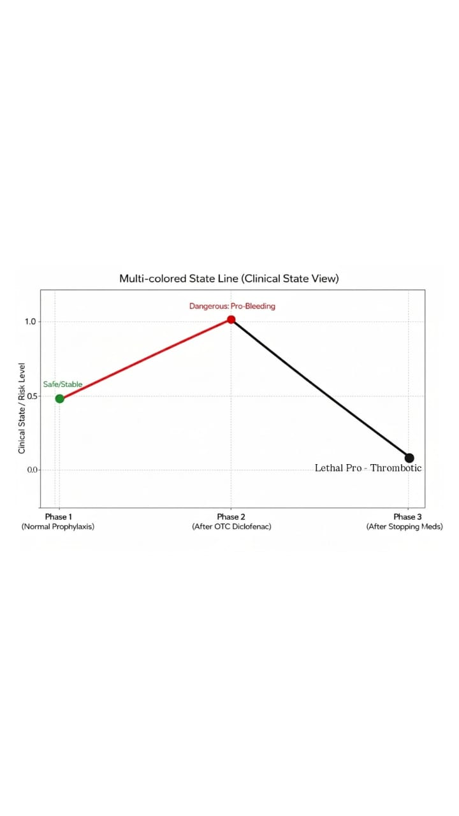

Fig.2: Clinical Presentation of Acute Pulmonary Embolism: Tachycardia and Hypoxemia Distribution
