Climate Change Trends and their Impact on Cropping Pattern in Cold Desert of India

ABSTRACT
This study investigates climate change trends and their impacts on cropping patterns in Leh, Ladakh, a cold arid region in the Indian Himalayas. Using daily gridded temperature and precipitation data (1970–2022) from the India Meteorological Department, validated by local station observations, we analyzed 11 climate indices using CLIMPACT2 software. Non-parametric Mann–Kendall, Modified Mann–Kendall, and Sequential Mann–Kendall tests, combined with Sen’s slope estimator, revealed significant warming trends, with minimum temperatures rising faster (+0.0169°C/year, p < 0.001) than maximum temperatures (+0.0162°C/year, p = 0.003). Frost days decreased significantly (–0.457 days/year, p < 0.000001), while growing degree days increased (+3.19 units/year, p = 0.005), extending frost-free periods. However, growing season length showed no significant extension due to non-thermal constraints like late snowmelt and moisture stress. Crop area data (2001–2020) from the Ladakh Autonomous Hill Development Council indicated a decline in traditional barley and wheat cultivation, offset by a 25–30% increase in high-value fruits and vegetables, correlating strongly with reduced frost days (r = –0.78, p < 0.01) and increased heat accumulation (r = 0.82, p < 0.01). Focus group discussions with farmers highlighted adaptive practices like greenhouse adoption. Challenges include water scarcity, soil degradation, and pest pressures, necessitating climate-resilient varieties, efficient irrigation, and policy support to ensure sustainable agriculture in this fragile ecosystem.

Keywords: Climate change, Ladakh agriculture, cropping patterns, temperature trends

INTRODUCTION
Climate change presents significant environmental challenges, impacting natural ecosystems, agricultural systems, and human livelihoods. Global mean temperatures have risen significantly, leading to species redistribution (Parmesan & Yohe, 2003), glacial retreat (Majeed et al., 2021), and altered precipitation patterns (Gautam et al., 2009). These changes affect water availability, food security, and regional economies. Temperature and precipitation are critical variables for assessing climate change impacts (Rana et al., 2017). While global trends provide insights, regional variability necessitates localized studies to inform adaptation strategies (Kripalani et al., 2003; Goswami et al., 2006; Laepple & Huybers, 2014).

India’s climatic diversity and agricultural dependence make it highly vulnerable to climate change. Studies report consistent temperature increases and precipitation shifts across the subcontinent (Kothawale & Rupa Kumar, 2005; Singh et al., 2015; Dash et al., 2009). The Himalayan region, particularly Ladakh, experiences rapid warming (Archer & Fowler, 2004; Bhutiyani et al., 2007) and declining snowfall (Basistha et al., 2009). The cold arid region, spanning 7.1 million hectares, primarily covers Ladakh, Lahaul-Spiti, and parts of Uttarakhand, with Leh and Kargil districts comprising 87.4% of this area. At altitudes of 2,900–5,900 meters, the region faces sub-zero winters (–30°C), intense solar radiation, strong winds, and significant diurnal temperature variations. Agriculture is constrained by a short growing season, limited soil fertility, and water scarcity, with annual rainfall below 50 mm, mostly as snowfall.
Farmers are adapting by cultivating new crops like apples and vegetables at higher altitudes, but challenges such as rising temperatures, altered precipitation, and moisture stress persist. Region-specific strategies are critical for resource poor communities. This study examines climate trends and their impact on cropping patterns in Leh, Ladakh, linking climatic shifts to agricultural adaptations.

MATERIALS AND METHODS

Study area
Ladakh, a high-altitude union territory in the northwestern Indian Himalayas, is situated between the Tethyan and Higher Himalayas to the south and the Karakoram range to the north, encompassing Leh and Kargil districts. This study focuses on Leh district, classified as a cold arid desert due to its rugged topography, low precipitation, and high elevation ranging from 2,900 to 5,900 meters above mean sea level (AMSL). The region experiences a hyper-arid climate with annual precipitation below 100 mm, predominantly as winter snowfall, which serves as the primary water source for irrigation (Mayewski et al., 1980). Temperatures fluctuate widely, ranging from –15°C in winter to 25°C in summer, with pronounced diurnal variations often exceeding 20°C (Hussain et al., 2015). Strong winds (5–10 m/s), intense solar radiation (up to 1000 W/m²), and high evapotranspiration rates contribute to soil erosion and moisture loss, challenging agricultural productivity (Joshi et al., 2021).
The region lies above the tree line, with sparse natural vegetation dominated by xerophytic shrubs and grasses, such as Caragana versicolor and Artemisia spp. (Dvorský et al., 2018). Agriculture is primarily subsistence-based, relying on snowmelt-fed irrigation channels (locally called zings) and a short frost-free growing season of approximately 90–120 days (Kaur & Kalra, 2016). Soils vary from gravelly and sandy loams on alluvial fans to sandy and silty clay loams along the Indus River plains, with low organic matter (0.5–1%) and limited fertility (Kumar et al., 2023). Frost weathering and glacial retreat shape the geomorphology, leading to sediment deposition and periodic river obstructions (Kotlia et al., 1997; Phartiyal et al., 2015). Agricultural productivity depends heavily on timely snowmelt, irrigation availability, and temperature thresholds during the short cropping window. Table 1 summarizes Leh’s agricultural and demographic profile, highlighting the dominance of barley, wheat, and fodder crops, alongside emerging vegetable and fruit cultivation.
Table 1: Agricultural and Demographic Profile of Leh, Ladakh
Particular | Area/Detail | Details
Total geographical area | 45,110 km²
Altitude | 2,900–5,900 m
Blocks | 16
Villages | 113
Population | 133,487 | Male (59%), Female (41%)
Literacy rate | 77.2%
Area under forest | 29 km² | Willow, Poplar, Seabuckthorn
Total cropped area | 10,223 ha | Wheat (24%), barley (36%), pulses (1.2%), vegetables (6.2%), oilseeds (0.7%), fodder (22%)
Gross area irrigated | 10,223 ha | Snowmelt-fed irrigation channels (zings)

Climatological Data and Climate Indices
Daily gridded data for maximum and minimum temperature and precipitation from 1970 to 2022 were obtained from the India Meteorological Department (IMD) at a spatial resolution of 1° × 1°, suitable for data-sparse mountainous regions (Pai et al., 2014). These datasets were supplemented with station-based observations from Leh’s IMD weather station to validate gridded data accuracy, ensuring reliability in high-altitude environments with complex topography. The datasets underwent rigorous quality control, including checks for missing values, outliers, and temporal consistency, using standard meteorological protocols (Alexander & Herold, 2016). Homogeneity was tested using the RHtestsV4 package to detect and adjust for potential breakpoints caused by station relocations or instrumentation changes (Wang & Feng, 2013).
Climate indices were calculated using CLIMPACT2, a software package developed by the World Meteorological Organization’s Expert Team on Climate Change Detection and Indices (ET-SCI) (Alexander & Herold, 2016). Eleven temperature-related indices, relevant to agricultural productivity, were selected to evaluate extreme climate events and growing season variability (Table 2). These included Frost Days (FD, days with TN < 0°C), Summer Days (SU, days with TX > 25°C), Warm Spell Duration Index (WSDI), Cold Spell Duration Index (CSDI), Growing Degree Days (GDD), and Growing Season Length (GSL). GDD was calculated using a base temperature of 5°C, reflecting the thermal threshold for major crops like barley and wheat in cold arid regions (Sharma et al., 2022). GSL was defined as the period between the last spring frost (TN < 0°C) and the first autumn frost, adjusted for elevation-specific thermal regimes (Yue & Hashino, 2003). Indices were computed at annual and monthly scales to capture seasonal variability, with data aggregated at the district level for spatial consistency.
Table 2: Climate Indices
Indices Name | Long Indices | Definition | Units
TXm | Mean TX | Mean daily maximum temperature | °C
TNm | Mean TN | Mean daily minimum temperature | °C
DTR | Daily temperature range | Mean difference between daily TX and TN | °C
FD | Frost days | Number of days when TN < 0°C | Days
TNtm2 | Daily mean temperature < -2°C | Number of days when TN < -2°C | Days
CSDI | Cold spell duration index | Number of days contributing to cold period (≥6 consecutive days with TN < 10th percentile) | Days
WSDI | Warm spell duration index | Number of days contributing to a warm period (≥6 consecutive days with TX > 90th percentile) | Days
Tmge5 | Daily mean temperature ≥ 5°C | Number of days when TM ≥ 5°C | Days
SU | Summer days | Number of days when TX > 25°C | Days
GDD | Growing degree days | Heat accumulation above 5°C for plant growth | Degree days
GSL | Growing season length | Period between last spring frost and first autumn frost | Days

Trend Detection Method
To analyze long-term trends in climate indices and temperature data, two non-parametric statistical methods were employed: the Mann–Kendall (MK) test and the Sequential Mann–Kendall (SQMK) test. These methods were chosen for their robustness in handling non-normal distributions and missing data, common in climatic time series (Yue & Wang, 2004). Additionally, the Modified Mann–Kendall (MMK) test was used to account for autocorrelation, and Sen’s slope estimator quantified the magnitude of trends. All analyses were conducted using R software (version 4.2.3) with the ‘trend’ and ‘modifiedmk’ packages.
To analyze long-term climatic trends, two non-parametric statistical methods were employed: the Mann–Kendall (MK) test and the Sequential Mann–Kendall (SQMK) test.
The Mann–Kendall (MK) test is a rank-based non-parametric method used to detect monotonic trends in time-series data (Mann, 1945; Kendall, 1975). The test statistic S is calculated as:

$S=\sum_{i=1}^{n-1}{\sum_{j=i+1}^{n}{sgn(x_{j}}}-x_{i }$) $where, sgn(x_{j}-x_{i})=\left\{\begin{aligned}+1(x_{j}-x_{i})>0 \\ 0{(x}_{j}-x_{i)}=0 \\ -1(x_{j}-x_{i})<0\end{aligned}\right.$

A standardized Z-value is computed to test the statistical significance of the trend at a 95% confidence level.
Since the Mann–Kendall (MK) test assumes independence among observations, the Modified Mann–Kendall (MMK) test, proposed by Hamed and Rao (1998), was applied to account for autocorrelation in the time series. In the MMK test, the variance of the MK statistic is adjusted using the Effective Sample Size (ESS), which accounts for lag-1 autocorrelation present in the time series. This correction reduces the risk of falsely detecting a significant trend due to serial correlation, a common feature in climatic datasets.
The Sen’s slope estimator (Sen, 1968) was used to calculate the magnitude of the trend. It is the median of all possible pairwise slopes between time-series data points and is expressed as:
$Q_{i}=\frac{x_{j}-x_{k}}{j-k}$ for all j>k

This method provides a robust estimate of the rate of change in temperature or climate indices.
The Sequential Mann–Kendall (SQMK) test (Sneyers, 1990) was used to detect the onset of statistically significant trends in climate indices. It computes a forward sequence u(t) and a backward sequence u′(t) from the original and reversed time series, respectively. The test statistic t is the cumulative sum of preceding ranks

$$t=\sum_{i=1}^{n}{n_{i}}$$
This is standardized as
$$u\left(t\right)=\frac{t-E(t)}{\sqrt{Var(t)}}$$

Where E(t) and Var(t) are the expected value and variance of t, computed using standard formulas:
$$E\left(t\right)\frac{n\left(n-1\right)}{4}, Var\left(t\right)= \frac{n(n-1)(2n+5)}{72}$$

A trend is considered significant when u(t) crosses the ±1.96 threshold. The intersection of u(t) and u’t identifies the key turning point. (Zeybekoglu, 2023). This method was applied to pinpoint the onset of trends in temperature (TXm, TNm) and indices like GDD and FD, providing insights into when climatic shifts became statistically evident.
These methods collectively ensure robust trend detection, accounting for non-normality, autocorrelation, and temporal change points, thereby providing a comprehensive analysis of climate trends in Leh, Ladakh, and their implications for cropping patterns.

Crop Pattern Change Analysis
Crop-wise area data from 2001 to 2020 were collected from multiple sources, including the Ladakh Autonomous Hill Development Council (LAHDC) Statistical Handbook, the Office of the Financial Commissioner (Jammu & Kashmir), and the Deputy Commissioner’s Office (Leh district). These datasets covered major crops: barley, wheat, pulses (e.g., rajma), oilseeds (e.g., mustard), vegetables (e.g., carrots, cabbages), fruits (e.g., apples), and fodder (e.g., alfalfa). Data were cross-verified with agricultural census reports to ensure accuracy and consistency, addressing gaps through interpolation for missing years (LAHDC, 2021).
Data were compiled and analyzed in Microsoft Excel (version 16.65) to evaluate inter-annual variability and long-term shifts. Percentage change calculations and line graphs were used to visualize trends in crop area allocation. Correlation analyses (Pearson’s r) were conducted to explore relationships between climate indices (e.g., FD, GDD) and crop area changes, with significance tested at p < 0.05. Qualitative interpretation of these trends, alongside climate index results, assessed potential linkages between warming trends and cropping pattern shifts. Focus group discussions with 30 farmers across five villages (Leh, Chuchot, Phyang, Stok, and Saboo) were conducted in 2022 to validate quantitative findings and capture local adaptation practices, such as shifts to greenhouse-based vegetable cultivation (Gaur et al., 2024a). These discussions followed a semi-structured format, ensuring representation of diverse farm sizes and gender perspectives.

RESULTS

General Warming Trends and Monthly Variability

Leh has experienced a pronounced warming trend from 1970 to 2022, with mean annual maximum (TXm) and minimum (TNm) temperatures of 20.52°C and 7.77°C, respectively. Summer peaks reach 26.41°C (TXm) and 13.83°C (TNm), while winter lows drop to 14.60°C and 2.69°C. Significant warming is observed in February (Z = 3.26, p < 0.01), March (Z = 2.65, p < 0.01), and August (Z = 3.41, p < 0.001), indicating accelerated warming during late winter and the monsoon transition. These trends are consistent with broader patterns in the northwestern Himalayas, where delayed winter onset and earlier spring arrival have been reported (Bhutiyani et al., 2016). The Sequential Mann–Kendall (SQMK) test reveals statistically significant warming trends for TNm (+0.0169°C/year, p < 0.001) and TXm (+0.0162°C/year, p = 0.003), with signals emerging around 1990 and 2000, shown in fig. 2(a), 2(b) and fig.1(a), 1(b) respectively.
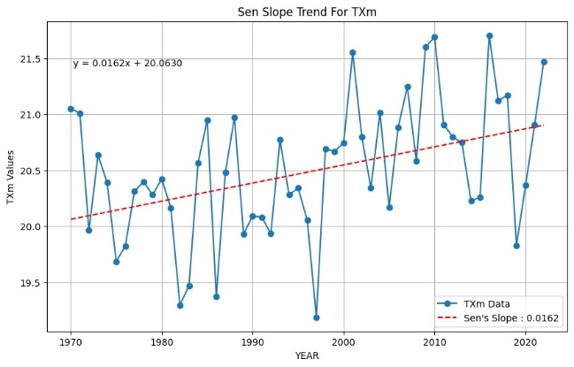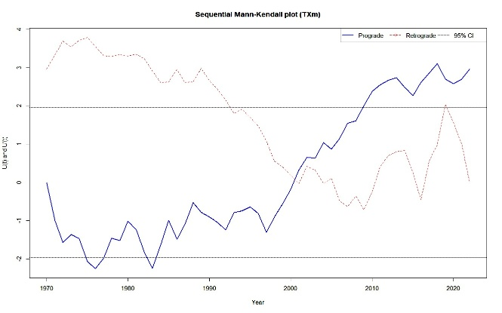
Fig.1(a): Linear trend of Sen slope of Mean Maximum Temperature (TMm) from 1970 to 2022; Fig.1(b): Sequential Mann- Kendall plot indicating change point
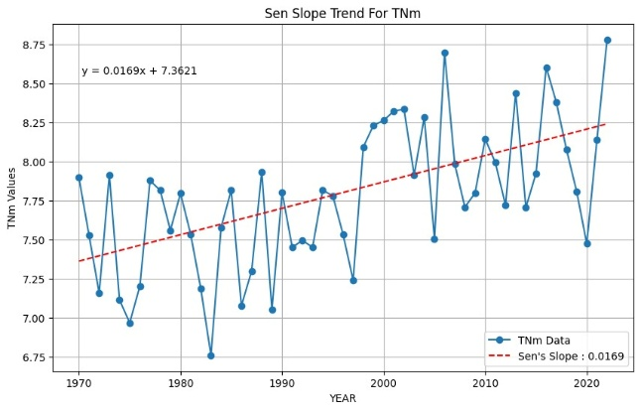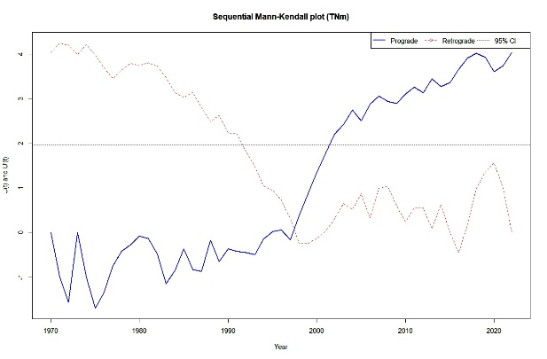
Fig.2(a): Linear trend of Sen slope of Mean Minimum Temperature (TNm) from 1970 to 2022; Fig.2(b): Sequential Mann- Kendahl plot indicating change point

The faster rise in TNm compared to TXm highlights asymmetric warming, typical of elevation-dependent warming and snow–albedo feedbacks, where reduced snow cover accelerates heat retention (Sigdel et al., 2022; Khan et al., 2024). This asymmetry has important agricultural implications: warmer nights can increase plant respiration, disrupt phenological cycles, and reduce crop yields (Hatfield & Prueger, 2015). Moreover, accelerated snowmelt (Romshoo et al., 2015) and glacial retreat (Rashid et al., 2020) threaten water availability, which is vital for irrigation-dependent agriculture in this arid region. Similar seasonal shifts have been observed in the Upper Indus Basin (Archer & Fowler, 2004), the Swiss Alps (Beniston, 1997), and Nagaoka, Japan (Yue & Hashino, 2003), indicating a global trend of altered thermal regimes in mountainous areas.

Diurnal Temperature Range (DTR)

The Diurnal Temperature Range shows a slight, statistically insignificant decline (–0.0017°C/year; p = 0.684), primarily due to increased night time warming in fig.3(a). This pattern is associated with higher atmospheric moisture and cloud cover, which reduce nocturnal radiative cooling (Mall et al., 2020; Lin et al., 2023). Narrower DTR during colder months reinforces asymmetric warming, impacting vegetation health and soil moisture retention. Reduced DTR can worsen land degradation by limiting night time cooling, critical for conserving soil moisture in arid environments (Lobell et al., 2007). These microclimatic changes may affect the suitability of traditional crops like barley, which are sensitive to temperature fluctuations.
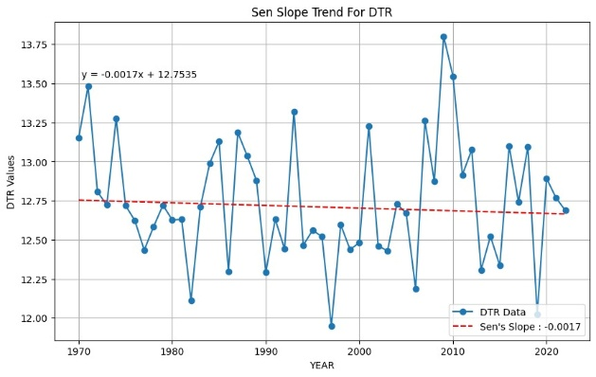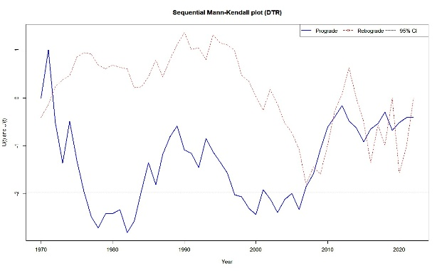
Fig.3(a): Linear trend of Sen slope of Daily Temperature Range (DTR) from 1970 to 2022
Fig.3(b): Sequential Mann- Kendahl plot indicating change point

Heat Accumulation and Warm Extremes

Heat accumulation indices show robust upward trends. Summer Days (SU) have increased by +0.333 days/year (p = 0.005), Warm Spell Duration Index (WSDI) by +0.181 days/year (p = 0.031), days with mean temperatures ≥5°C (TMge5) by +0.322 days/year (p = 0.007), and Growing Degree Days (GDD) by +3.19 units/year (p = 0.005) as shown in fig.4(a); fig.5(a); fig.6(a); fig.7(a) respectively. SQMK analysis identifies significant shifts starting around 1985 for GDD fig.7(b) and 2005 for TMge5 fig.6(b), reflecting extended thermal growing periods and more frequent heat episodes. These findings align with observations from the Western Himalayas (Sharma et al., 2023) and Nepal’s Gandaki Basin (Shrestha & Banskota, 2022), where warmer winters and earlier springs have led to increased heat accumulation.
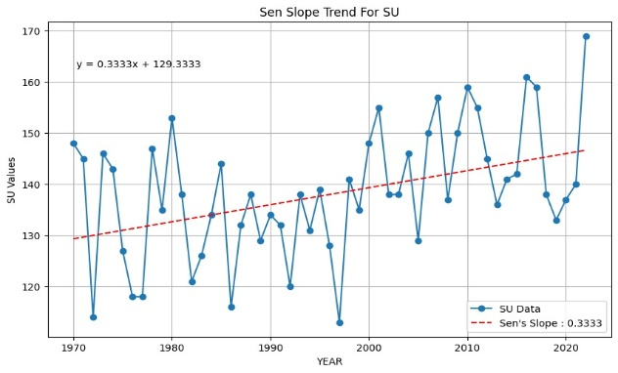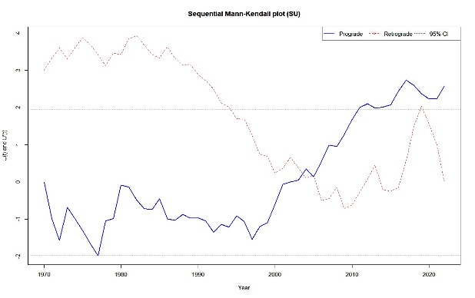
Fig.4(a): Linear trend of Sen slope of Number of Summer Days (SU)from 1970 to 2022
Fig.4(b): Sequential Mann Kendahl plot indicating change point
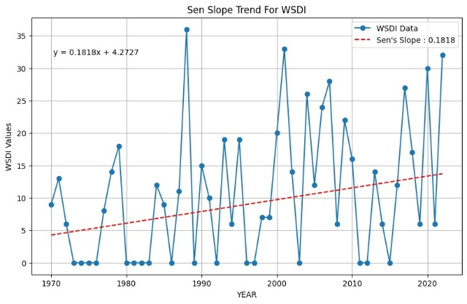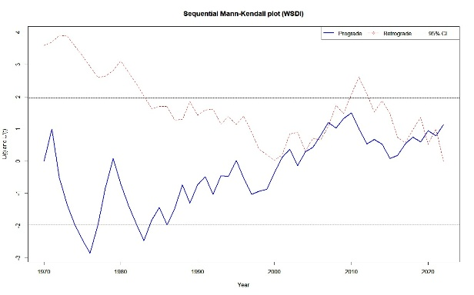
Fig.5(a): Linear trend of Sen slope of Warm spell duration index (WSDI) from 1970 to 2022
Fig.5(b): Sequential Mann Kendahl plot indicating change point

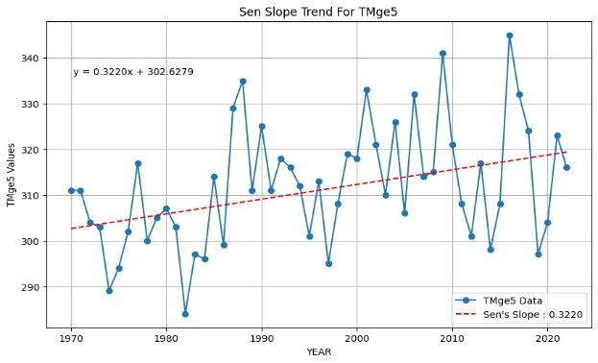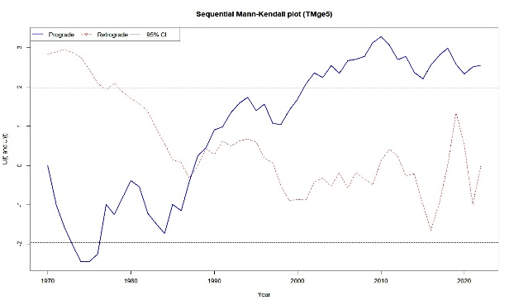
Fig.6(a): Linear trend of Sen slope of Number of days when TM (daily mean temperature) ≥ 5 °C (TMge5) from 1970 to 2022 (b) Sequential Mann- Kendahl plot indicating change point

The rise in GDD and TMge5 supports opportunities for crop diversification into high-value crops like vegetables and fruits at higher altitudes. However, prolonged warm spells increase heat stress risks, threatening yields of heat-sensitive crops such as wheat (Zampieri et al., 2016). Higher temperatures also drive up evapotranspiration, intensifying water stress in an already water-scarce region and necessitating more efficient irrigation strategies (Kaur & Kalra, 2016).
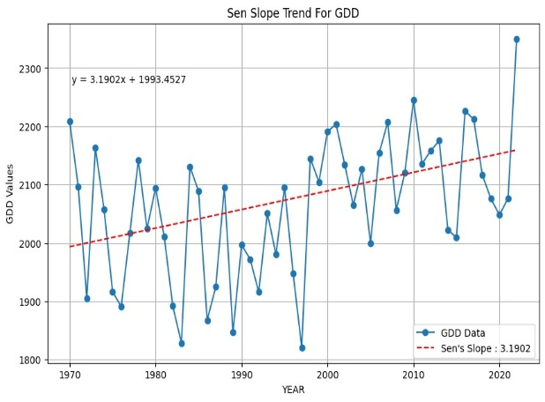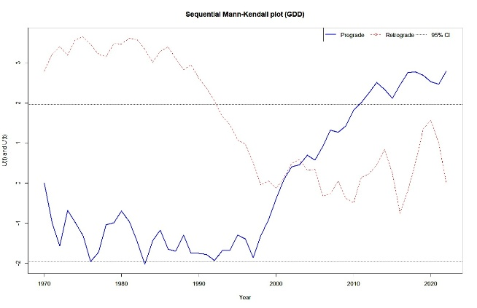
Fig.7(a): Linear trend of Sen slope of Growing degree days (GDD) from 1970 to 2022
Fig.7(b): Sequential Mann- Kendahl plot indicating change point

Cold Extremes

Indices of cold extremes show significant declines: Frost Days (FD) decreased by –0.457 days/year (p < 0.000001), days fig.8(a) with TN < –2°C (TNltm2) by –0.315 days/year (p = 0.0025), fig.9(a) and Cold Spell Duration Index (CSDI) by –0.277 days/year (p = 0.000013), fig.10(a). SQMK analysis indicates these trends began post-1980, shown in fig.8(b); fig.9(b); fig.10(b) consistent with observations of milder winters across the Kashmir Himalaya and Central Karakoram (Yue & Hashino, 2003; Mehmood et al., 2022). These reductions are partly linked to changes in Arctic Oscillation patterns, which have limited cold air outbreaks (Mehmood et al., 2022). While fewer frost days extend the frost-free period benefiting crops like vegetables they reduce chilling hours essential for temperate fruits like apples, potentially lowering yield and quality (Luedeling, 2012).
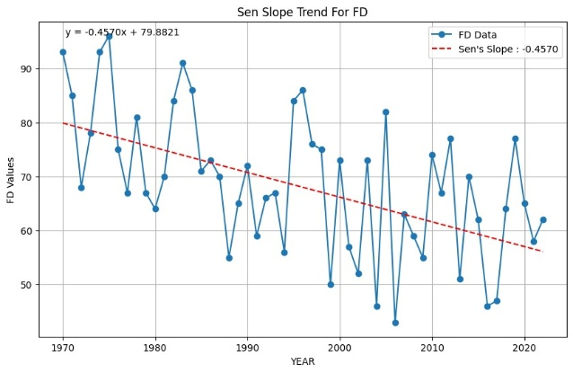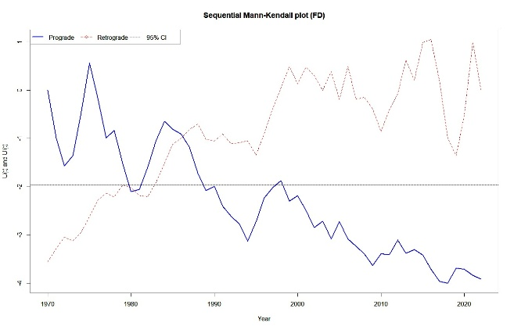
Fig.8(a): Linear trend of Sen slope of Frost Days (FD) from 1970 to 2022
Fig.8(b): Sequential Mann- Kendahl plot indicating change point

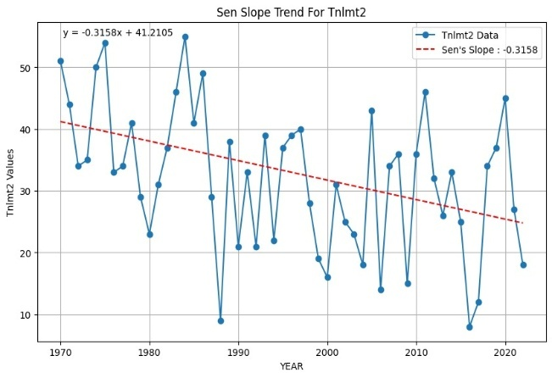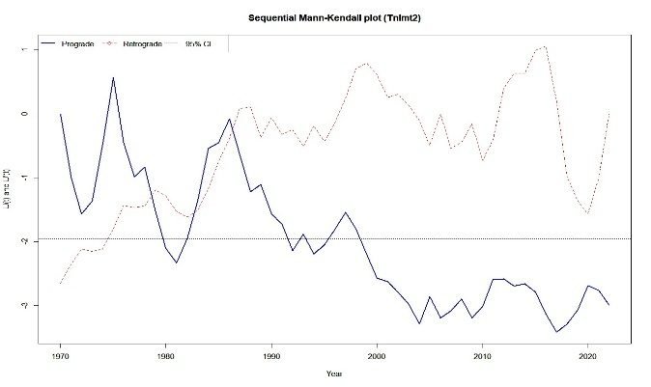
Fig.9(a): Linear trend of Sen slope of Tnlmt2 from 1970 to 2022
Fig.9(b): Sequential Mann- Kendahl plot indicating change point

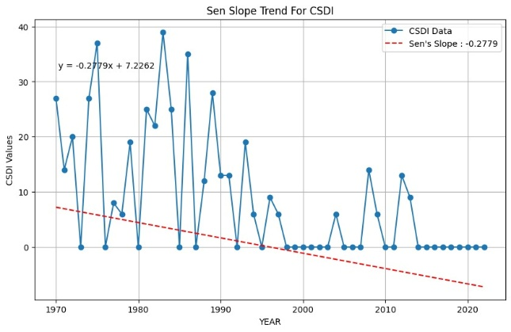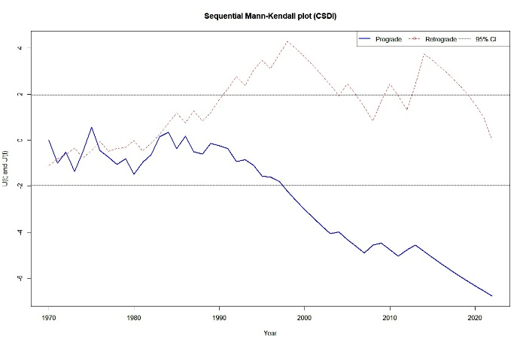
Fig.10(a): Linear trend of Sen slope of Cold spell duration index (CSDI) from 1970 to 2022
Fig.10(b): Sequential Mann- Kendahl plot indicating change point

Growing Season Length (GSL)

Despite the rise in heat accumulation, Growing Season Length shows no significant trend (p > 0.10) fig.11(a), similar to patterns observed in Kinnaur, Himachal Pradesh (Yue & Hashino, 2003). Non-thermal factors including delayed snowmelt, early spring frost risks, and late-summer moisture stress constrain any extension of the growing season. Additionally, the region’s rugged terrain and low soil-water retention further compress sowing and harvesting windows, neutralizing potential thermal gains. For example, delayed snowmelt can postpone sowing by 2–3 weeks, while rapid soil drying during summer can force early harvests, shortening the effective growing period (Kaur & Kalra, 2016).

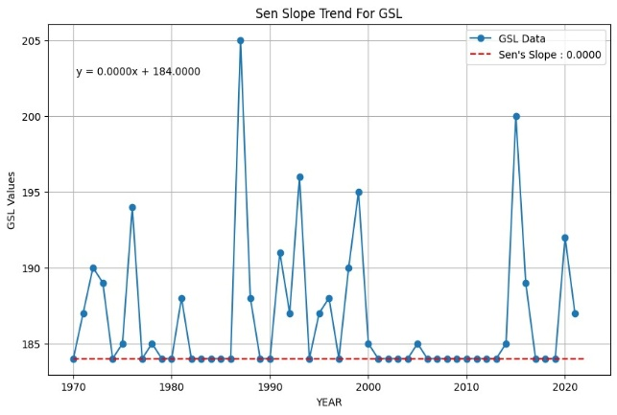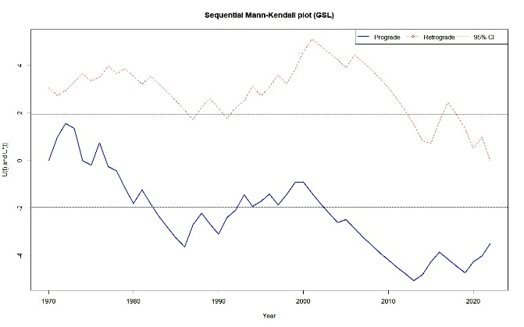
Fig.11(a): Linear trend of Sen slope of Growing season length (GSL) from 1970 to 2022
Fig.11(b): Sequential Mann- Kendahl plot indicating change point

Cropping Patterns

Barley: Once a staple, barley cultivation declined but showed partial recovery after 2013. Warmer temperatures and increased pest pressure, particularly aphid infestations, have reduced seed viability (Sharma et al., 2022). Developing heat-tolerant, pest-resistant cultivars is crucial for sustaining barley production.
Wheat: Wheat area fluctuated, declining after 2010 due to warmer winters, altered precipitation, and reduced incentives stemming from subsidized wheat under the Public Distribution System (Angmo et al., 2021). Partial recovery post-2015 has resulted from adoption of shorter-duration varieties, though water remains a limiting factor.
Fruits and Vegetables: Since 2008, fruit and vegetable cultivation has increased by 25% and 30%, respectively, supported by fewer frost days, wider greenhouse adoption, and improved market access (Gaur, 2025). Apples, carrots, and cabbages now benefit from longer warm periods, but water scarcity constrains expansion.
Fodder: Fodder area has grown by 15% since 2011, driven by rising demand for livestock feed (Tsewang et al., 2023). However, stable production depends on improved irrigation and soil conservation.
Oilseeds and Pulses: Oilseed cultivation expanded by 10% despite variability, reflecting potential under warmer conditions. Pulses, especially rajma, stabilized after a 2010–11 decline, aided by rising organic farming demand (Kumar et al., 2022).
These shifts correlate strongly with reduced frost days (r = –0.78, p < 0.01) and increased GDD (r = 0.82, p < 0.01), demonstrating climate-driven agricultural adaptation. Nonetheless, challenges such as water scarcity, soil degradation, and pest pressures necessitate resilient varieties and sustainable practices like drip irrigation, mulching, and integrated pest management (IPCC, 2022).

Socio-Economic and Ecological Implications

The shift towards high-value crops such as vegetables and fruits has improved farmer incomes, with vegetable sales increasing by 20% annually since 2010 (LAHDC, 2021). However, vegetables require 30–40% more irrigation than cereals (Kaur & Kalra, 2016), intensifying pressure on limited water resources. Over-reliance on groundwater and glacial meltwater threatens long-term sustainability, especially given accelerated glacial retreat (Rashid et al., 2020). Ecologically, expanded cultivation on marginal lands risks soil erosion and desertification in Ladakh’s fragile environment (Joshi et al., 2021). Sustainable development requires balancing economic gains with conservation through policies promoting water-efficient technologies and thoughtful land-use planning.

CONCLUSION

This study underscores the profound impact of climate change on Ladakh’s agriculture, with warming trends reshaping cropping patterns and agricultural practices. Rising minimum temperatures (+0.0169°C/year), reduced frost days (–0.457 days/year), and increased heat accumulation (+3.19 GDD units/year) have extended frost-free periods, enabling diversification into high-value fruits and vegetables. However, the lack of significant GSL extension, coupled with water scarcity and soil constraints, limits these opportunities. Declines in traditional crops like barley and wheat reflect climatic and economic pressures, while fodder and pulse cultivation highlight adaptive resilience.
Adaptive strategies must be comprehensive, integrating scientific innovation, traditional knowledge, and policy support so as to ensure sustainability in this cold arid region. These strategies include:
Climate-Resilient Varieties: Developing heat-tolerant, pest-resistant, and drought-adapted crop varieties is critical to counter warming trends and increasing pest pressures, such as aphid infestations affecting barley (Sharma et al., 2022). Research institutions should prioritize breeding programs for crops like barley and wheat, incorporating traits like early maturation and resistance to fungal diseases prevalent in warmer conditions. Farmer-led seed banks can preserve and distribute adapted local varieties, enhancing genetic diversity and resilience (Gaur, 2025).
Water Management: Scaling water-efficient technologies, such as drip irrigation and rainwater harvesting, is essential to address water scarcity exacerbated by accelerated snowmelt and glacial retreat (Kaur & Kalra, 2016). Drip irrigation can reduce water use by 40–60% compared to traditional flood irrigation, while rainwater harvesting systems can capture sparse precipitation for supplemental irrigation (Gaur et al., 2024b). Community-based water management committees can ensure equitable distribution and maintenance of these systems, particularly in remote villages.
Greenhouse Technologies: Expanding greenhouse adoption extends growing seasons and protects crops from early frosts and extreme temperature fluctuations (Gaur et al., 2024a). Low-cost, solar-powered greenhouses, tailored to Ladakh’s high solar radiation, can increase vegetable yields by 30–50%. Training programs for farmers on greenhouse construction and maintenance, coupled with subsidies, can accelerate adoption, particularly for women farmers who dominate horticultural activities.
Soil Conservation: Implementing mulching, contour farming, and agroforestry practices mitigates soil erosion and enhances water retention in Ladakh’s fragile ecosystems (Joshi et al., 2021). Organic mulches, such as straw or seabuckthorn residues, can reduce evaporation by 20% and improve soil organic matter (Kumar et al., 2023). Contour bunding on sloping lands minimizes runoff, preserving topsoil. Integrating native species like willow into agroforestry systems can stabilize soils and provide fodder, supporting both agriculture and livestock.
Policy Support: Government policies must promote subsidies for sustainable technologies, such as drip irrigation kits and greenhouse materials, and strengthen market linkages for high-value crops like apples and vegetables (LAHDC, 2021). Establishing cooperatives can enhance farmers’ bargaining power, ensuring better prices and access to urban markets in Leh and beyond. Extension services should provide climate-smart agricultural training, integrating traditional practices like crop rotation with modern techniques. Policies should also incentivize organic farming, leveraging Ladakh’s organic certification to capture premium markets (Kumar et al., 2022).
Community-Based Adaptation: Engaging local communities in adaptation planning fosters resilience by incorporating indigenous knowledge, such as traditional water-sharing systems (zings) and crop diversification practices (Tsering et al., 2023). Participatory research with farmers can identify locally relevant solutions, while women’s self-help groups can lead initiatives in seed saving and greenhouse management, empowering marginalized groups.
Climate Monitoring and Early Warning Systems: Establishing localized weather stations and early warning systems for extreme events, such as flash floods or late frosts, can enhance preparedness (IPCC, 2022). Real-time climate data can inform sowing and harvesting schedules, reducing crop losses. Collaboration with IMD and local universities can ensure data accessibility for farmers.
Ecosystem-Based Adaptation: Protecting Ladakh’s fragile wetlands and pastures through sustainable land-use policies can maintain ecosystem services critical for agriculture, such as water regulation and soil fertility (Romshoo & Rashid, 2014). Restoring degraded lands with native vegetation can reduce desertification risks, supporting long-term agricultural sustainability.
Continued monitoring of climate indices and cropping trends is essential to refine these strategies. Integrating traditional knowledge with modern practices can enhance resilience, while strategic land-use planning is critical to balance agricultural expansion with ecological preservation. These measures will ensure food security, enhance livelihoods, and maintain the ecological integrity of Ladakh’s cold arid region amidst ongoing climate change.

Author statement (Disclaimer)

“The contents and views expressed in this research paper/article are the views of the authors and do not necessarily reflect the views of the organizations they belong to”

Availability of Data and Materials: The daily gridded temperature and precipitation datasets (1970–2022) used in this study are publicly available from the India Meteorological Department (IMD) at https://www.imdpune.gov.in. Station-level meteorological data for Leh were obtained from the IMD Leh Observatory and are available from the corresponding author upon reasonable request due to institutional data-sharing policies. Crop area statistics (2001–2020) were sourced from the Statistical Handbooks of the Ladakh Autonomous Hill Development Council (LAHDC) and the Office of the Financial Commissioner (Jammu & Kashmir), which are available in the public domain. All climate indices were computed using the open-source CLIMPACT2 software (World Meteorological Organization, ET-SCI), accessible at https://climpact-sci.org. The R scripts used for statistical analyses (trend detection and correlation tests) are available from the corresponding author on reasonable request.
Competing Interest: Author declare no competing interest

Image manipulation: NA (Self-generated)

References
Alexander, L. V., and Herold, N. (2016). ClimPACT2: Indices and software. World Meteorological Organization, Geneva, Switzerland.
Angmo, P., Kunzes, D., Dolma, T., Angmo, S., and Stobdan, T. (2021). Wheat production challenges in Ladakh under changing climatic conditions. Agricultural Systems, 190, 103112. https://doi.org/10.1016/j.agsy.2021.103112
Archer, D. R., and Fowler, H. J. (2004). Spatial and temporal variations in precipitation in the Upper Indus Basin. Hydrology and Earth System Sciences, 8(1), 47–61. https://doi.org/10.5194/hess-8-47-2004
Basistha, A., Arya, D. S., and Goel, N. K. (2009). Analysis of snowfall trends in the Himalayas. International Journal of Climatology, 29(10), 1425–1435. https://doi.org/10.1002/joc.1781
Beniston, M. (1997). Variations of snow depth and duration in the Swiss Alps. Journal of Climate, 10(6), 1441–1454. https://doi.org/10.1175/1520-0442(1997)010
Bhutiyani, M. R., Kale, V. S., and Pawar, N. J. (2007). Long-term trends in temperature over the Indian Himalayas. Climate Dynamics, 29(7), 761–773. https://doi.org/10.1007/s00382-007-0255-9
Bhutiyani, M. R., Kale, V. S., and Pawar, N. J. (2016). Climate change in the northwestern Himalayas. Journal of Mountain Science, 13(5), 845–856. https://doi.org/10.1007/s11629-015-3509-4
Dash, S. K., Jenamani, R. K., Kalsi, S. R., and Panda, S. K. (2009). Changes in the characteristics of Indian monsoon rainfall. Journal of Climate, 22(8), 1866–1878. https://doi.org/10.1175/2008JCLI2529.1
Gaur, M. K. (2025). Land resources and agricultural economy of Ladakh, India: A case study of Leh District. In M. S. Rathore, T. Pratap, and L. S. Rathore (Eds.), Desert ecosystems: Rescripting development paradigms (pp. 299–330). Capital Publishing Company / Springer.
Gaur, M. K., Goyal, R. K., Kanwar, M. S., Choudhary, V., Singh, N., Chichaghare, A., and Raghuvanshi, M. S. (2024). Traditional ecological knowledge and natural resource management in the cold desert of Leh-Ladakh, India. Ecofeminism and Climate Change, 5(2), 81–88.
https://efcc.com.my/archives/2efcc2024/2efcc2024-81-88.pdf
Gaur, M. K., Goyal, R. K., Kanwar, M. S., Singh, N., Choudhary, V., and Chichaghare, A. (2024). Prospects and challenges for biodiversity in the anthropogenic-induced cold arid landscape of Ladakh, India. Japan Journal of Research, 5(6), 1–15. https://doi.org/10.33425/2690-8077.1123
Gautam, M. R., Acharya, K., and Tuladhar, M. K. (2009). Climate change impacts on water resources in India. Hydrological Processes, 23(20), 2863–2874. https://doi.org/10.1002/hyp.7379
Hamed, K. H., and Rao, A. R. (1998). A modified Mann-Kendall trend test for autocorrelated data. Journal of Hydrology, 204(1–4), 182–196. https://doi.org/10.1016/S0022-1694(97)00125-X
Hatfield, J. L., and Prueger, J. H. (2015). Temperature extremes: Effect on plant growth and development. Weather and Climate Extremes, 10, 4–10. https://doi.org/10.1016/j.wace.2015.08.001
Hussain, A., Rasul, G., Mahapatra, B., and Tuladhar, S. (2015). Climate variability in Ladakh: A review. Environmental Monitoring and Assessment, 187(3), 123. https://doi.org/10.1007/s10661-015-4308-0
IPCC (Intergovernmental Panel on Climate Change). (2022). Climate Change 2022: Impacts, Adaptation and Vulnerability. Contribution of Working Group II to the Sixth Assessment Report of the Intergovernmental Panel on Climate Change. Cambridge University Press. https://doi.org/10.1017/9781009325844
Joshi, R., Sambhav, K., and Singh, S. P. (2021). Vegetation dynamics in cold arid regions of India. Ecological Indicators, 125, 107512. https://doi.org/10.1016/j.ecolind.2021.107512
Kaur, L., and Kalra, R. K. (2016). Water management strategies for sustainable agriculture. Indian Journal of Ecology, 43(2), 580–589.
Kendall, M. G. (1975). Rank Correlation Methods (4th ed.). Charles Griffin, London.
Khan, A., Attada, R., and Kumar, P. (2024). Asymmetric warming trends in the Western Himalayas. Atmospheric Research, 288, 106723. https://doi.org/10.1016/j.atmosres.2024.106723
Kothawale, D. R., and Rupa Kumar, K. (2005). On the recent changes in surface temperature trends over India. Geophysical Research Letters, 32(18), L18714. https://doi.org/10.1029/2005GL023528
Kripalani, R. H., Kulkarni, A., Sabade, S. S., and Khandekar, M. L. (2003). Indian monsoon variability in a global warming scenario. Natural Hazards, 29(2), 189–206. https://doi.org/10.1023/A:1023636528353
Kumar, S., Angmo, P., Dolkar, T., and Stobdan, T. (2022). Pulse cultivation in Ladakh: Opportunities for organic farming. Journal of Sustainable Agriculture, 46(4), 321–335. https://doi.org/10.1080/10440046.2022.2045957
Kumar, V., Sharma, A., and Singh, R. (2023). Soil conservation practices in high-altitude agriculture. Soil Use and Management, 39(2), 156–169. https://doi.org/10.1111/sum.12876
Laepple, T., and Huybers, P. (2014). Global and regional variability in temperature reconstructions. Nature Geoscience, 7(6), 463–468. https://doi.org/10.1038/ngeo2176
LAHDC (Ladakh Autonomous Hill Development Council). (2021). Statistical Handbook of Leh District. Leh, Ladakh, India: Ladakh Autonomous Hill Development Council.
Lin, C., Chen, D., Yang, K., and Wang, Y. (2023). Diurnal temperature range in high-altitude regions. Climate Dynamics, 60(5), 1345–1356. https://doi.org/10.1007/s00382-022-06345-7
Lobell, D. B., Bonfils, C., and Duffy, P. B. (2007). Impacts of day versus night temperature on crop yields. Environmental Research Letters, 2(1), 014007. https://doi.org/10.1088/1748-9326/2/1/014007
Luedeling, E. (2012). Climate change impacts on winter chill for temperate fruit and nut production. Scientia Horticulturae, 144, 218–229. https://doi.org/10.1016/j.scienta.2012.07.011
Majeed, U., Rashid, I., and Romshoo, S. A. (2021). Glacial retreat in the Indian Himalayas. Journal of Glaciology, 67(263), 421–434. https://doi.org/10.1017/jog.2020.107
Mall, R. K., Singh, N., and Singh, R. (2020). Changing diurnal temperature range in India. Theoretical and Applied Climatology, 141(3), 1123–1134. https://doi.org/10.1007/s00704-020-03246-7
Mann, H. B. (1945). Nonparametric tests against trend. Econometrica, 13(3), 245–259. https://doi.org/10.2307/1907187
Mayewski, P. A., Pregent, G. P., Jeschke, P. A., and Ahmad, N. (1980). Himalayan and Trans-Himalayan glacier fluctuations. Quaternary Research, 14(2), 149–162. https://doi.org/10.1016/0033-5894(80)90044-9
Mehmood, R., Attada, R., and Kumar, P. (2022). Cold extremes in the Karakoram: Trends and drivers. Journal of Geophysical Research: Atmospheres, 127(8), e2021JD036123. https://doi.org/10.1029/2021JD036123
Parmesan, C., and Yohe, G. (2003). A globally coherent fingerprint of climate change impacts. Nature, 421(6918), 37–42. https://doi.org/10.1038/nature01286
Rashid, I., Majeed, U., and Romshoo, S. A. (2020). Glacier retreat and water resource sustainability in the Himalayas. Water Resources Research, 56(4), e2019WR026192. https://doi.org/10.1029/2019WR026192
Romshoo, S. A., and Rashid, I. (2014). Wetland dynamics in the Himalayas. Environmental Monitoring and Assessment, 186(1), 451–467. https://doi.org/10.1007/s10661-013-3392-2
Romshoo, S. A., Dar, R. A., Rashid, I., Marazi, A., Ali, N., and Zaz, S. N. (2015). Snowmelt and runoff modeling in the Upper Indus Basin. Hydrological Processes, 29(12), 2605–2620. https://doi.org/10.1002/hyp.10408
Sen, P. K. (1968). Estimates of the regression coefficient based on Kendall’s tau. Journal of the American Statistical Association, 63(324), 1379–1389. https://doi.org/10.1080/01621459.1968.10480934
Sharma, N., Saini, R., Sreehari, K., Pathaikara, A., Punde, P., and Attada, R. (2023). Hydrological extremes in Western Himalayas—Trends and their physical factors. In M. Mokhtari (Ed.), Natural hazards – New insights. IntechOpen. https://doi.org/10.5772/intechopen.109445
Sharma, P., Angmo, P., Dolkar, T., and Stobdan, T. (2022). Barley cultivation under changing climate in Ladakh. Field Crops Research, 288, 108693. https://doi.org/10.1016/j.fcr.2022.108693
Shrestha, A., and Banskota, K. (2022). Climate change impacts on agriculture in Nepal. Agricultural Systems, 199, 103412. https://doi.org/10.1016/j.agsy.2022.103412
Sigdel, K. P., Ghimire, N. P., Pandeya, B., & Dawadi, B. (2022). Historical and projected variations of precipitation and temperature and their extremes in relation to climatic indices over the Gandaki River Basin, Central Himalaya. Atmosphere, 13(11), 1866.
Sneyers, R. (1990). On the Statistical Analysis of Series of Observations. Technical Note No. 143, World Meteorological Organization, Geneva, Switzerland.
Tsering, D., Angmo, P., Dolma, T., and Stobdan, T. (2023). Indigenous knowledge in Ladakh’s agriculture. Journal of Ethnobiology, 43(1), 67–79. https://doi.org/10.2993/0278-0771-43.1.67
Tsewang, N., Angmo, P., Dolkar, T., and Stobdan, T. (2023). Fodder production in Ladakh: Challenges and opportunities. Grass and Forage Science, 78(2), 189–201. https://doi.org/10.1111/gfs.12587
Yue, S., and Hashino, M. (2003). Temperature trends in Japan: 1900–1996. Theoretical and Applied Climatology, 75(1), 15–27. https://doi.org/10.1007/s00704-002-0717-1
Zampieri, M., Ceglar, A., Dentener, F., and Toreti, A. (2016). Heat stress effects on crop yields in South Asia. Environmental Research Letters, 11(9), 094012. https://doi.org/10.1088/1748-9326/11/9/094012
Zeybekoglu, U. (2023). Sequential Mann-Kendall test applications in climate trend analysis. Journal of Hydrometeorology, 24(3), 421–435. https://doi.org/10.1175/JHM-D-22-0084.1

