Original Research Article

Seasonal Variability in Thermal Indices and Heat Use Efficiency of Maize under Varietal and Nutrient Management in Tarai Region of Uttarakhand

Abstract
Maize (Zea mays L.) is an important cereal crop whose development and yield are strongly influenced by temperature and seasonal climatic conditions. The present study was conducted at the N.E. Borlaug Crop Research Centre, Pantnagar during the winter season (November 2024-April 2025) and spring season (February 2025-June 2025) to evaluate the seasonal variation in thermal indices and thermal use efficiency of maize under different varieties and nutrient management levels. The experiment was laid out in a split-plot design with three maize varieties (PCM-04, DKC-9081 and DKC-9188) and four nutrient management levels. Temperature-based agrometeorological indices such as Growing Degree Days (GDD), Heliothermal Units (HTU), Photothermal Units (PTU) and Heat Use Efficiency (HUE) were computed to assess crop development and yield performance. The results showed that spring maize accumulated higher thermal units and produced higher grain yield (9373.04 kg ha⁻¹) compared to winter maize (7305.00 kg ha⁻¹). Similarly, mean GDD (1691.45 °C Day), HTU (14327.25) and PTU (21830.23) were higher in spring maize than winter maize (1303.38 °C Day, 9824.29 and 14733.81, respectively). Among the treatments, V3F4 (DKC-9188 with recommended dose of fertilizer) recorded the highest grain yield (10,513.33 kg ha⁻¹ in winter and 12,456.67 kg ha⁻¹ in spring) along with maximum thermal accumulation. Regression analysis revealed a positive relationship between grain yield and thermal indices. The study highlights that improved varieties combined with appropriate fertilizer management enhance thermal resource utilization and maize productivity under different seasonal conditions.
Keywords: Agrometeorological indices, Growing degree days, Heat use efficiency, Seasonal variability and Maize yield
- Introduction
Maize (Zea mays L.) is one of the most important cereal crops cultivated across a wide range of Agro-climatic regions of the world. It belongs to the family Poaceae (Gramineae) and genus Zea and originated from Central and South America. Owing to its highest genetic yield potential among cereals, maize is commonly referred to as the “Queen of Cereals” (Choudhari and Channappagouda, 2015). Its wide adaptability allows cultivation under diverse soil types, climatic conditions and management practices and it is currently grown in about 160 countries worldwide.
With the global population projected to reach nearly 9 billion by 2050, food demand is expected to increase by about 85%, requiring a substantial rise in crop productivity to ensure food security (Raza et al., 2019; Janni et al., 2024). However, ongoing climate change has intensified the frequency and severity of extreme weather events such as drought, heat stress and strong winds, posing serious challenges to agricultural sustainability and food production (Wang et al., 2018; Edreira et al., 2013). These changes are increasingly affecting maize yield and stability, raising concerns about future food security.
Grain yield in maize is determined by the interactive effects of genetic potential (Ma et al., 2015), climatic factors such as solar radiation, temperature and precipitation (Feng et al., 2021; Yang et al., 2020) and agronomic practices including planting density, sowing time, row spacing and fertilization strategies (Zhang Ming et al., 2018; Yang et al., 2010).
In India, maize cultivation has expanded steadily over the last decade, highlighting its growing importance in national agriculture. During 2023-24, maize was cultivated on about 10.89 million hectares in India, an increase from 10.52 million hectares recorded in the previous year. A major share of maize cultivation occurred during the Kharif season, accounting for nearly 78.8% (8.58 million hectares) of the total maize area, while about 2.31 million hectares were grown during the Rabi season. Compared to the previous year, the Kharif maize area increased by 3.8%, while the Rabi maize area increased by 2.1%. The major Kharif maize-growing states include Madhya Pradesh, Karnataka, Rajasthan and Maharashtra, whereas Bihar, Maharashtra and Tamil Nadu are the leading states for Rabi maize cultivation (ANGRAU, 2024).
Rabi maize is increasingly gaining importance in India due to its higher yield potential under irrigated conditions. Unlike kharif maize, the crop experiences lower pest pressure and more favourable radiation conditions during winter. The longer crop duration (150-170 days) and availability of controlled irrigation allow better utilization of solar radiation and thermal time, which often results in higher productivity compared to kharif maize (Singh et al., 2003). Because of these advantages, Rabi maize is increasingly promoted in eastern and southern India to strengthen food and feed security and to improve farm income (Agrawal et al., 2019).

Spring maize, which is sown in late winter and harvested during late spring or early summer, has also expanded in irrigated regions of northern India, including parts of Punjab, Haryana and western Uttar Pradesh. This expansion is mainly driven by cropping system intensification and the use of residual soil moisture or irrigation after wheat harvest. Research indicates that improved planting methods, appropriate variety selection and efficient irrigation management significantly enhance the productivity and profitability of spring maize under irrigated conditions (Singh and Vashist, 2016). However, the expansion of spring maize in regions facing groundwater stress highlights the need for careful water management to ensure sustainability. Overall, the increasing contribution of Rabi and spring maize has strengthened India’s maize production system by diversifying cropping seasons, improving yield stability and ensuring a continuous supply of maize for food, feed and industrial uses beyond the monsoon period (Ministry of Agriculture and Farmers Welfare, 2024; ANGRAU, 2024).
Several temperature-based agrometeorological indices are used to assess crop phenology, growth and yield, including growing degree days, heliothermal units, photothermal units and heat use efficiency (Choudhary et al., 2018). Crop biomass accumulation and developmental changes during the growing season are largely governed by climatic factors, particularly temperature. Each crop has specific thermal requirements for attaining different phenophases and the duration between successive growth stages depends on the accumulation of heat units or GDD at each stage (Bhat et al., 2015; Wani et al., 2023).
Knowledge of growing degree days (GDD) and their derived indices such as HTU, PTU and HUE forms the basic foundation for understanding crop phenology and identifying appropriate sowing windows for different crop varieties under varying spatial and temporal conditions (Sreenivas et al., 2010). These indices are widely used to describe and compare the phenological behaviour of crops under specific environmental conditions (Fealy and Fealy, 2008; Matzarakis et al., 2007; Soler et al., 2005).
In maize, temperature and photoperiod are the two key environmental factors regulating crop development. Temperature response is defined by critical thresholds such as base temperature and optimum temperature, at which maize exhibits minimum and maximum development rates, respectively. Commonly assumed base and optimum temperature pairs for maize include 10°C and 30°C, as well as 8°C and 34°C (Jamsheed et al., 2023). The relationship between temperature and maize development is described using empirical or process-based approaches and these thermal functions are widely used in crop simulation models.
Overall, maize growth and yield are influenced by the interaction between environmental conditions and crop management practices (Porter, 2005; Wahid et al., 2007). Accurate estimation of accumulated growing degree days enables prediction of crop developmental stages and phenological events, thereby supporting timely and effective crop management decisions (Parthasarathi et al., 2013). Although several studies have examined the influence of temperature on maize phenology, limited information is available regarding seasonal variation in thermal indices and their interaction with varietal performance and nutrient management under the Tarai conditions of Uttarakhand. Understanding these relationships is important for optimizing crop management strategies and improving heat use efficiency under varying seasonal environments. Therefore, the present study was undertaken to evaluate the seasonal variability in thermal indices and heat use efficiency of maize under different varieties and nutrient management levels.
- Materials and Methods
2.1 Site Description
The study was conducted at the N.E. Borlaug Crop Research Centre of G.B. Pant University of Agriculture and Technology, Pantnagar, situated in the Tarai belt at the foothills of the Shivalik range of the Himalayas in the Kumaon division at 29°3′ N latitude and 79°31′ E longitude, with an average altitude of 243m (see Fig: 1). Pantnagar, located in Udham Singh Nagar district, serves as the primary food-producing region of Uttarakhand State, experiencing two major cropping seasons, namely Kharif and Rabi. The predominant crops in the region include rice, wheat, sugarcane, mustard and soybean.
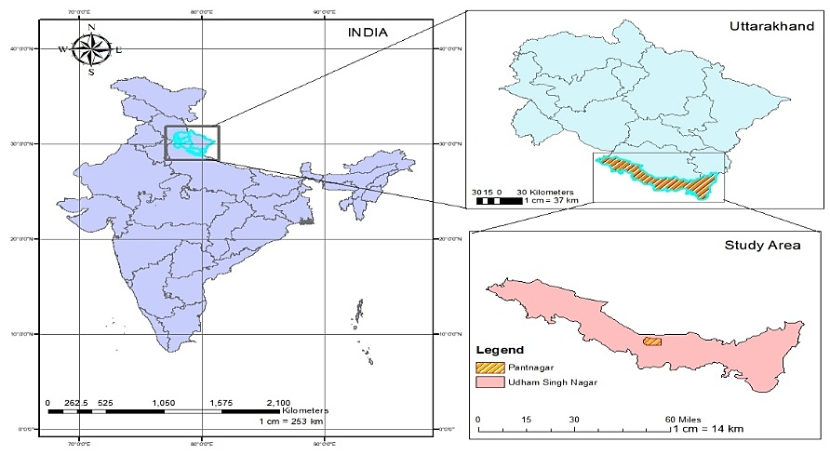
Fig. 1: Location map of the experimental site
Udham Singh Nagar district exhibits a climate characterized by sub-tropical humid and sub-humid conditions, featuring three distinct seasons: summer, monsoon and winter. Summer temperatures can reach up to 42°C, while winter temperatures range between 3°C and 6°C. The annual total rainfall in the district is approximately 1300 mm, with 80-85% of it occurring during the monsoon season and the remainder distributed across the non-monsoon period.
2.2 Experimental Details
The experiment was conducted in a split-plot design with two factors. Factor A consisted of three maize varieties, namely PCM-04 (V₁), DKC-9081 (V₂) and DKC-9188 (V₃), which were assigned to the main plots. Factor B comprised four nutrient management levels allocated to the subplots: T₁ - Control (no fertilizer), T₂ - Vermicompost (80:20), T₃ - Poultry manure (80:20) and T₄ - Recommended dose of inorganic fertilizers (RDF). The interaction between varieties and nutrient management levels resulted in twelve treatment combinations (3 × 4), namely V₁T₁, V₁T₂, V₁T₃, V₁T₄, V₂T₁, V₂T₂, V₂T₃, V₂T₄, V₃T₁, V₃T₂, V₃T₃ and V₃T₄. The recommended package of practices for maize cultivation in the region was followed throughout the experimental period.
2.3 Details of Treatment
The sowing of maize during the winter (2024-25) and spring (2025) seasons was carried out after completing the necessary field preparation operations. In the winter season, pre-sowing irrigation was applied on 08 November 2024 to ensure adequate soil moisture for seed germination. The field was then prepared by harrowing and levelling on 18 November 2024, followed by the layout of experimental plots on 19 November 2024. The basal dose of nitrogen (N), phosphorus (P) and potassium (K) fertilizers was applied on 20 November 2024 and the maize crop was sown on the same day (20 November 2024) under suitable soil moisture conditions.
Similarly, during the spring season of 2025, pre-sowing irrigation was applied on 02 February 2025 to maintain adequate soil moisture for sowing. The field was prepared by harrowing and levelling on 18 February 2025 and the experimental layout was completed on 19 February 2025. The basal application of N, P and K fertilizers was carried out on 20 February 2025 and sowing of maize was performed on the same day (20 February 2025) to ensure proper crop establishment under favourable field conditions.
2.4 Temperature-Based Indices
2.4.1 Growing degree days (GDD)
Cumulative growing degree days were calculated by adding the daily mean temperature above base temperature, expressed in °C by using the following formula:
$$GDD=\frac{Tmax+Tmin}{2}-Tb$$
Where, Tmax = Daily maximum temperature (°C), Tmin = Daily minimum temperature (°C), Tb = Minimum threshold/base temp. (For maize Tbase = 8°C) (Tollenaar et al., 1979; Kiniry and Ritchie, 1983, Ritchie and Nesmith. 1991)
2.4.2 Photothermal units (PTU)
Photothermal units are calculated as the product of daily growing degree days and maximum possible sunshine hours, which are then summed up for the crop season as follows:
$$PTU = GDD × Day length (°C day hours)$$
2.4.3 Heliothermal units (HTU)
These are calculated as the product of daily growing degree days and actual bright sunshine hours, which are then summed up for the crop season as follows:
$$HTU = GDD × Actual bright sunshine hours (°C day hours)$$
2.4.4 Heat Use Efficiency (HUE)
It measures the amount of yield produced per unit of heat accumulated during the growing season. A higher HUE value indicates that the crop is more efficient in utilizing thermal energy, while a lower value suggests less efficient use of heat for biomass or yield production.
$$HUE=\frac{Grain Yield}{Accumulated GDD}$$
Where, HUE = Heat Use Efficiency, Grain yield = Yield (kg ha⁻¹) and Accumulated GDD = Accumulated Growing Degree Days during the crop growth period (°C Day)
2.5 Weather conditions during the growing seasons (2024-25) at Pantnagar
The weather conditions at the experimental site during the maize growing seasons of 2024 and 2025 are presented in figures 2 and 3, respectively. The figures showed the variation in important meteorological parameters such as maximum and minimum temperature, rainfall and sunshine hours during the crop growth period.
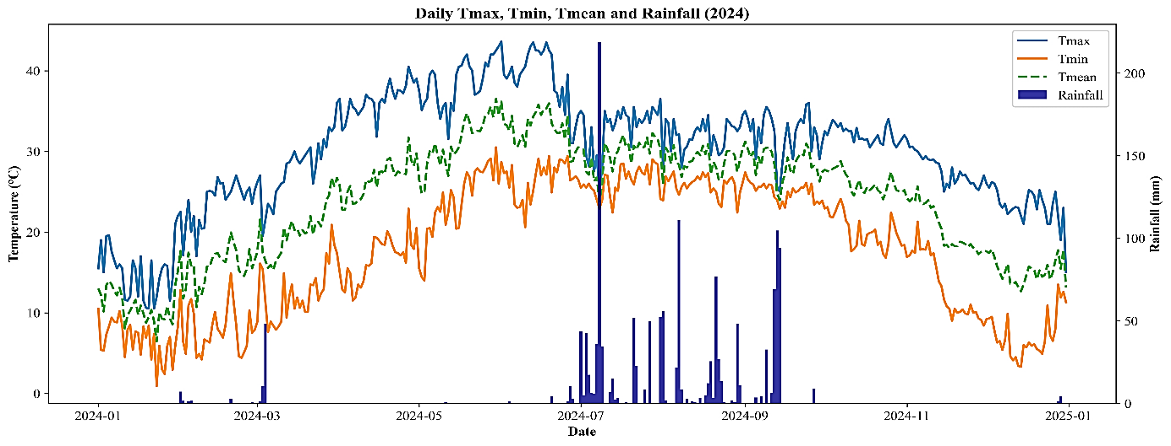
Fig. 2: Weather conditions at the experimental site 2024
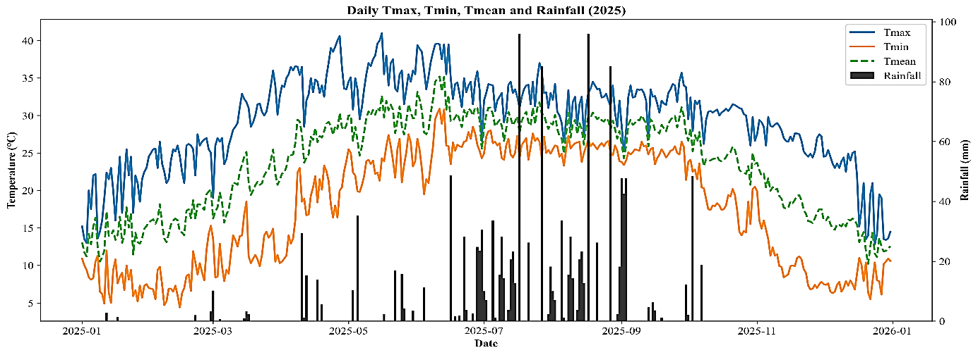
Fig. 3: Weather conditions at the experimental site 2025
- Result and discussion:
3.1 Phenological Development of Maize under Different Treatments
The number of days taken to attain different phenophases in winter maize as shown in table 1 and figure 4 varied among the treatment combinations from V1T1 to V3T4, indicating that treatments significantly influenced crop growth and development. The emergence stage occurred within 9 to 13 days after sowing, where the longest duration was recorded under V1T1 and V3T1 (13 days), while the earliest emergence was observed under V3T3 and V3T4 (9 days), which may be attributed to favourable soil temperature and moisture conditions that enhanced rapid germination and seedling establishment. The knee-high stage was attained between 50 - 63 days after sowing, with the earliest occurrence in V2T1 (50 days) and the longest duration in V3T4 (63 days), reflecting variation in vegetative growth among treatments. Tasseling occurred between 82 - 99 days, where V2T1 recorded the earliest tasseling (82 days) while V3T4 took the longest time (99 days), indicating differences in reproductive development influenced by environmental conditions. Similarly, the silking stage occurred between 93 - 109 days, whereas the milking and dough stages were attained between 111-125 days and 121-136 days, respectively. Physiological maturity was reached between 132 - 151 days after sowing, where the earliest maturity was recorded in V2T1 (132 days) and the longest duration were taken by V3T4 (151 days). These variations in phenological stages among treatments may be attributed to differences in temperature regime, moisture availability and management practices that regulate crop development and accumulation of thermal units during the crop growth period. Similar findings regarding variation in maize phenology due to environmental conditions and crop management practices have also been reported by Vanaja et al. (2017), Dadapeer et al. (2020) and Sreenivas et al. (2010), who reported that temperature and crop growing environment significantly influence the duration of vegetative and reproductive stages in maize.
Table 1: Number of days taken to attain different phenophases in Winter Maize
 | V1T1 | V1T2 | V1T3 | V1T4 | V2T1 | V2T2 | V2T3 | V2T4 | V3T1 | V3T2 | V3T3 | V3T4
Emergence | 13 | 11 | 10 | 10 | 12 | 11 | 10 | 10 | 13 | 10 | 9 | 9
Knee high | 53 | 55 | 57 | 60 | 50 | 52 | 54 | 57 | 56 | 58 | 60 | 63
Tasseling | 85 | 89 | 92 | 96 | 82 | 86 | 89 | 93 | 88 | 92 | 95 | 99
Silking | 96 | 100 | 102 | 106 | 93 | 97 | 99 | 103 | 99 | 103 | 105 | 109
Milking | 115 | 117 | 119 | 122 | 111 | 113 | 115 | 118 | 118 | 120 | 122 | 125
Dough | 125 | 127 | 129 | 133 | 121 | 123 | 125 | 129 | 128 | 130 | 132 | 136
Maturity | 136 | 141 | 143 | 146 | 132 | 137 | 139 | 142 | 140 | 146 | 148 | 151
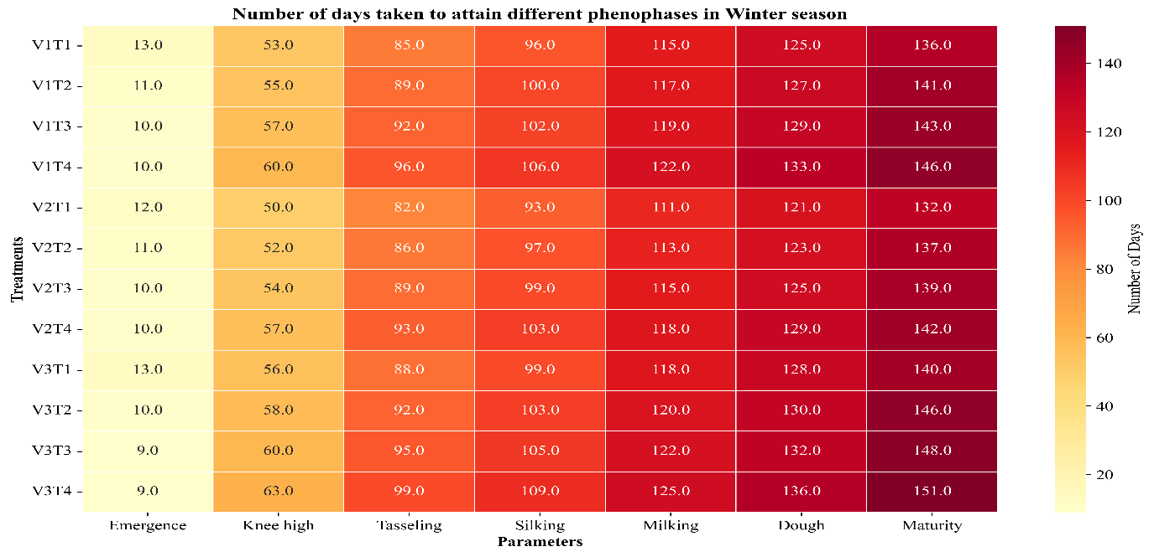
Fig. 4: Heatmap showing the number of days taken to attain different phenological stages of winter maize under different variety-fertilizer combinations
The number of days taken to attain different phenophases in spring maize shown in table 2 and figure 5 varied among the treatment combinations from V1T1 to V3T4, indicating that treatments significantly influenced crop growth and development. The emergence stage occurred within 8 to 11 days after sowing, where the earliest emergence was recorded in V2T4 and V3T4 (8 days), while the longest duration was observed in V1T1, V2T1 and V3T1 (11 days), which may be attributed to variations in soil temperature and moisture conditions affecting germination and early seedling establishment. The knee-high stage was attained between 33 - 42 days after sowing, with the earliest occurrence in V1T1 (33 days) and the longest duration in V3T4 (42 days), indicating differences in vegetative growth rate among treatments. Tasseling occurred between 47 - 60 days after sowing, where the earliest tasseling was observed in V1T1 (47 days) while V3T4 required the longest duration (60 days). Similarly, the silking stage appeared between 54 - 69 days, followed by the milking and dough stages which were attained between 66-81 days and 76-92 days, respectively. Physiological maturity occurred between 92 - 110 days after sowing, with the earliest maturity recorded under V1T1 (92 days) and the longest duration under V3T4 (110 days). The variations in phenological stages among treatments may be attributed to differences in temperature regime, thermal unit accumulation and crop management practices that regulate maize growth and development. Similar findings have been reported in recent studies on spring maize which indicated that sowing date and temperature significantly influence the duration of vegetative and reproductive phases, phenology and yield formation of maize crops (Tsimba et al., 2013; Cao et al., 2024 and Bamboriya et al., 2025).
Table 2: Number of days taken to attain different phenophases in Spring Maize
 | V1T1 | V1T2 | V1T3 | V1T4 | V2T1 | V2T2 | V2T3 | V2T4 | V3T1 | V3T2 | V3T3 | V3T4
Emergence | 11 | 10 | 10 | 9 | 11 | 10 | 9 | 8 | 11 | 10 | 9 | 8
Knee high | 33 | 34 | 36 | 38 | 35 | 36 | 38 | 40 | 37 | 38 | 40 | 42
Tasseling | 47 | 50 | 53 | 55 | 50 | 53 | 56 | 58 | 52 | 55 | 58 | 60
Silking | 54 | 57 | 60 | 64 | 57 | 60 | 63 | 67 | 59 | 62 | 65 | 69
Milking | 66 | 69 | 72 | 76 | 69 | 72 | 75 | 79 | 71 | 74 | 77 | 81
Dough | 76 | 79 | 82 | 86 | 79 | 82 | 85 | 89 | 81 | 84 | 87 | 92
Maturity | 92 | 95 | 99 | 103 | 96 | 99 | 103 | 107 | 100 | 102 | 106 | 110

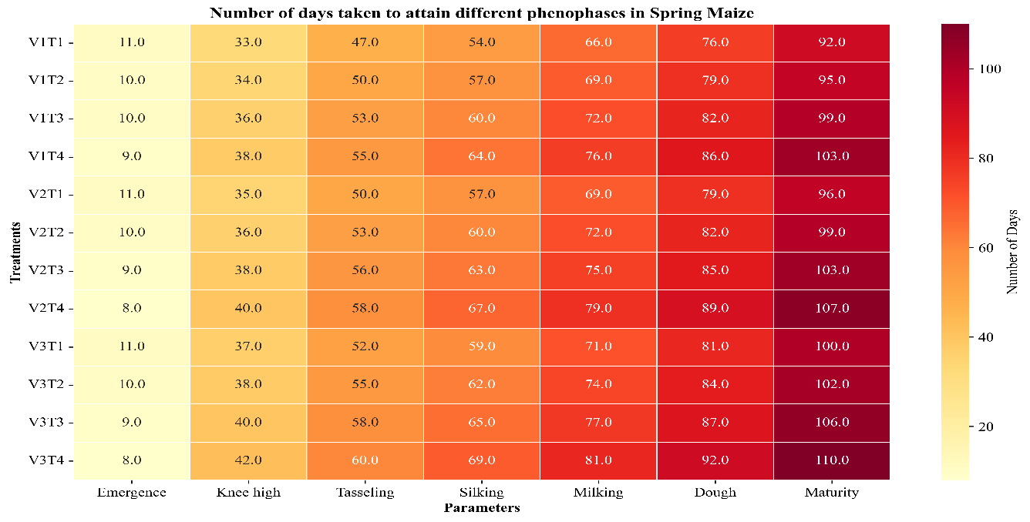
Fig. 5: Heatmap showing the number of days taken to attain different phenological stages of spring maize under different variety-fertilizer combinations.
  - Accumulation of Thermal Indices in Maize
The heatmap of Growing Degree Days accumulation across treatments and phenophases in winter maize (figure 6) shows a clear increasing trend of thermal time from emergence to maturity. The accumulated GDD ranged from about 93.7-132.0 °C days at emergence and gradually increased through vegetative and reproductive stages, reaching 1146.1-1472.2 °C days at physiological maturity. Early phenological stages such as emergence and knee-high required comparatively lower heat units, while later stages such as tasseling, silking, milking and maturity required progressively higher GDD values. Among the treatments, treatment 12 (V3T4) showed the highest thermal accumulation at maturity (1472.2 °C days), followed by treatments 11 and 4, indicating that these treatments required greater thermal time to complete their growth cycle. In contrast, treatment 5 (V2T1) recorded the lowest GDD accumulation at maturity (1146.1 °C days), suggesting a comparatively shorter crop duration. The gradual increase in GDD from vegetative to reproductive phases indicates that maize development is strongly regulated by thermal time, where each phenological stage requires a specific amount of accumulated heat units to progress to the next stage. Variations in accumulation of GDD among treatments may be attributed to differences in crop management practices, micro-climatic conditions and cultivar characteristics that influence temperature utilization and crop development. Similar findings have been reported in several studies where maize phenology and crop duration were closely associated with accumulated growing degree days and thermal conditions during the growing season (Jamsheed et al., 2023 and Ge et al., 2022).
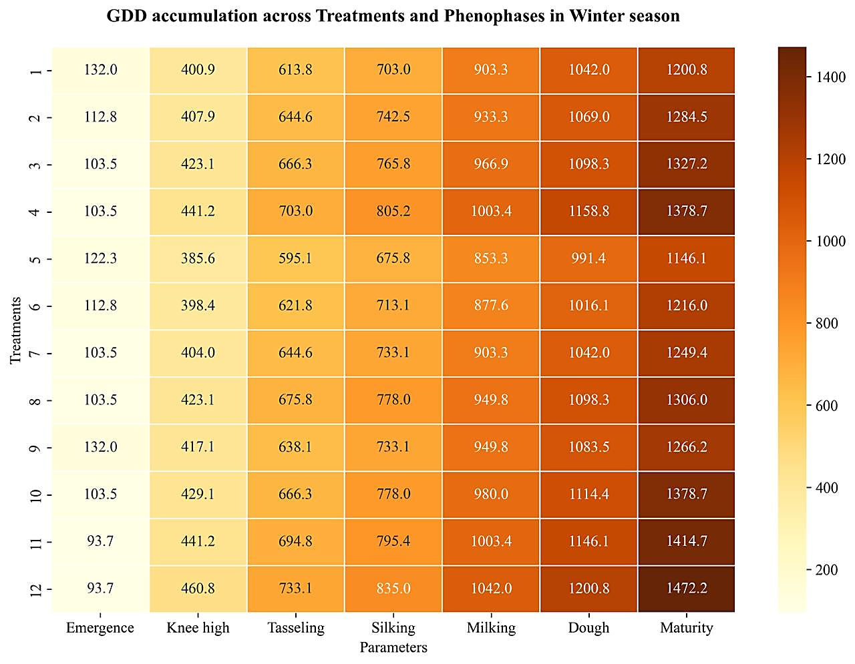
Fig. 6: Heatmap of GDD accumulation across treatments and phenophases in winter maize
The heatmap of GDD accumulation across treatments and phenophases in spring maize in figure 7 shows a gradual increase in thermal time from emergence to physiological maturity across all treatments. The accumulated GDD ranged from 76.2 - 111.7 °C days at emergence, increased to 375.8 - 506.0 °C days at the knee-high stage and further to 583.2 - 825.2 °C days at tasseling and 712.5 - 1009.4 °C days at silking, indicating progressive thermal requirements for vegetative and reproductive development. During grain filling stages, GDD accumulation increased to 946.3 - 1248.4 °C days at milking and 1153.8 - 1500.0 °C days at dough stage, while the highest values were observed at physiological maturity (1500.0 - 1848.7 °C days). Among the treatments, T12 (1848.7 °C days) and T8 (1829.2 °C days) recorded the highest heat unit accumulation at maturity, whereas T1 (1500.0 °C days) showed the lowest accumulation, indicating variation in crop duration and thermal requirements among treatments. The progressive increase in GDD across phenophases indicates that maize growth and development are strongly governed by accumulated thermal units above the base temperature and each developmental stage requires a specific amount of heat units for completion, which has been widely reported in maize phenology studies (Kumudini et al., 2014).
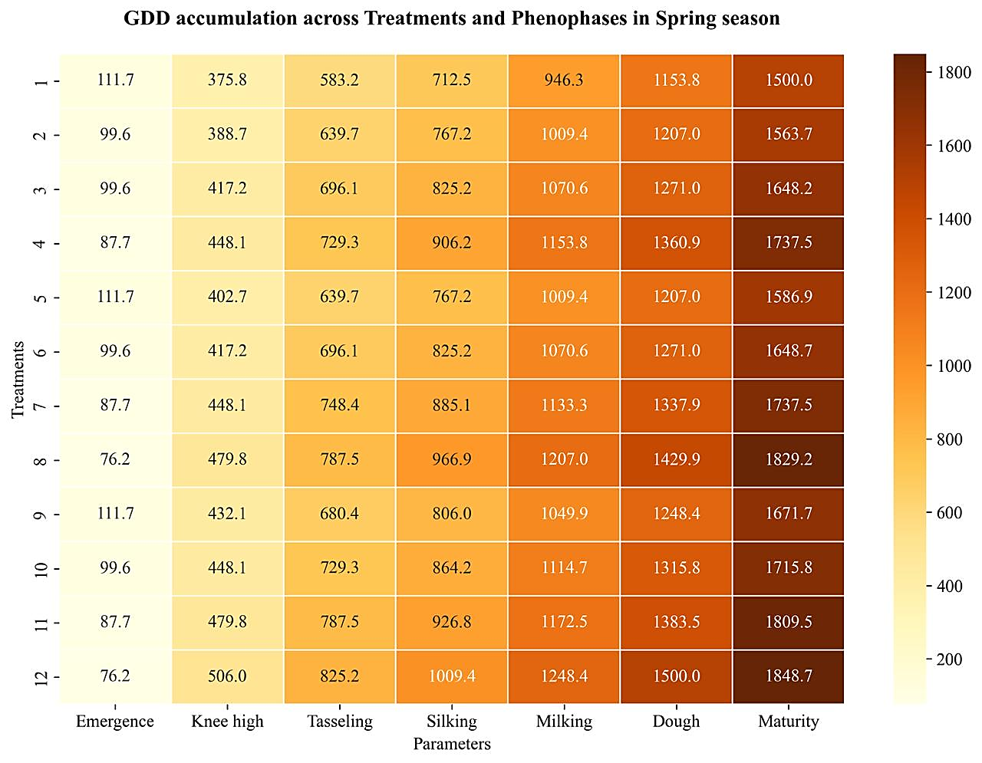
Fig. 7: Heatmap of GDD accumulation across treatments and phenophases in spring maize
The heatmap of Heliothermal Unit (HTU) accumulation across treatments and phenophases in winter maize as shown in figure 8 indicates a steady rise in HTU values as the crop progresses from emergence to physiological maturity. The HTU values were comparatively lower during the emergence stage (636.5 - 928.4), reflecting the lower combined influence of temperature and sunshine hours during early crop establishment. As the crop entered the knee-high stage, HTU increased to 2351.9 - 2704.4, indicating higher energy requirements for vegetative growth. A further increase in HTU was observed during tasseling (3642.2 - 4751.5) and silking (4312.6 - 5400.1) stages, suggesting that reproductive development requires greater thermal and radiative energy. During the grain development stages, HTU accumulation increased markedly, ranging from 5558.0 - 7319.8 at milking and 6798.8 - 8893.9 at dough stage. The maximum HTU accumulation occurred at physiological maturity (8319.5 - 11363.1), where Treatment 12 (V3T4) recorded the highest value (11363.1) followed by Treatment 11 (10868.9), indicating longer crop duration and greater utilization of thermal and solar energy, whereas Treatment 5 showed the lowest HTU (8319.5) suggesting comparatively earlier maturity. The increasing trend of HTU across phenophases highlights the importance of combined temperature and sunshine hours in regulating maize growth and development, which determine crop phenology and energy use efficiency under different growing environments (Kumudini et al., 2014).
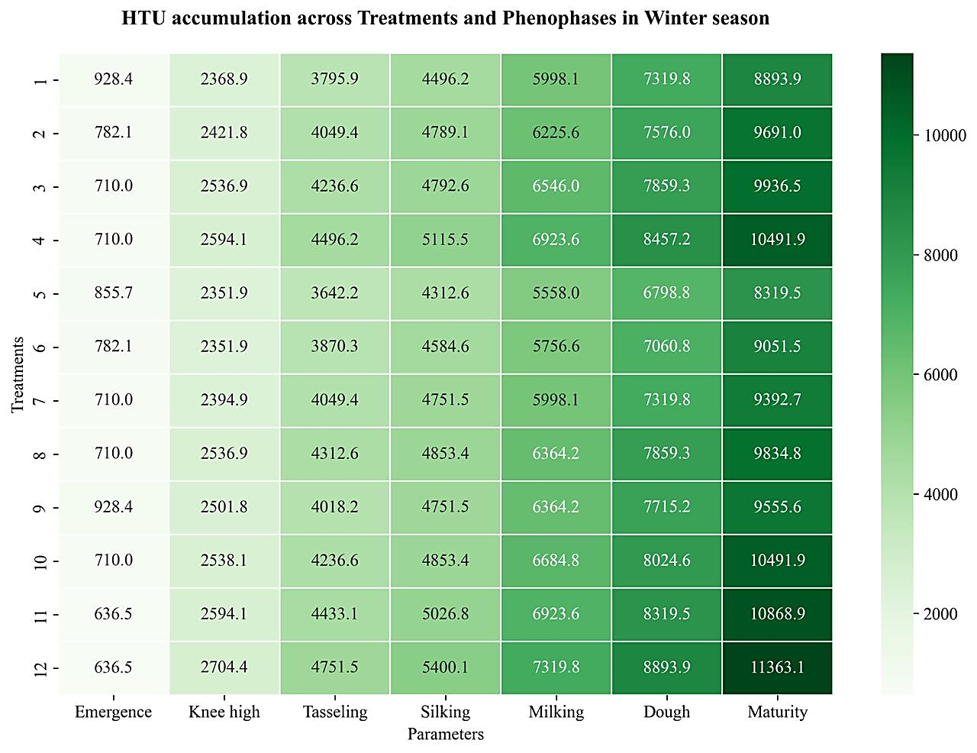
Fig. 8: Heatmap of HTU accumulation across treatments and phenophases in winter maize
The heatmap of Heliothermal Units accumulation across treatments and phenophases in spring maize in figure 9 shows a consistent increase in HTU from emergence to physiological maturity across all treatments. HTU values were lowest at emergence (552.5 - 616.8) and increased at the knee-high stage (3083.2 - 4361.3) due to higher energy demand for vegetative growth. Further increases were observed during tasseling (5156.1 - 7313.2) and silking (6255.3-9000.0) stages, indicating greater thermal and solar radiation requirements during reproductive development. The milking (8575.9 - 10781.0) and dough stages (9955.6 - 12851.0) recorded higher HTU values due to active grain filling. The highest HTU accumulation occurred at physiological maturity (12851.0 - 15858.3), with treatment 12 (V3T4) recording the maximum value, indicating greater HTU requirement and longer crop duration, while Treatment 1 recorded the lowest HTU suggesting earlier maturity. This trend indicates that maize phenological development is strongly influenced by the combined effects of temperature and sunshine hours (Kumudini et al., 2014).
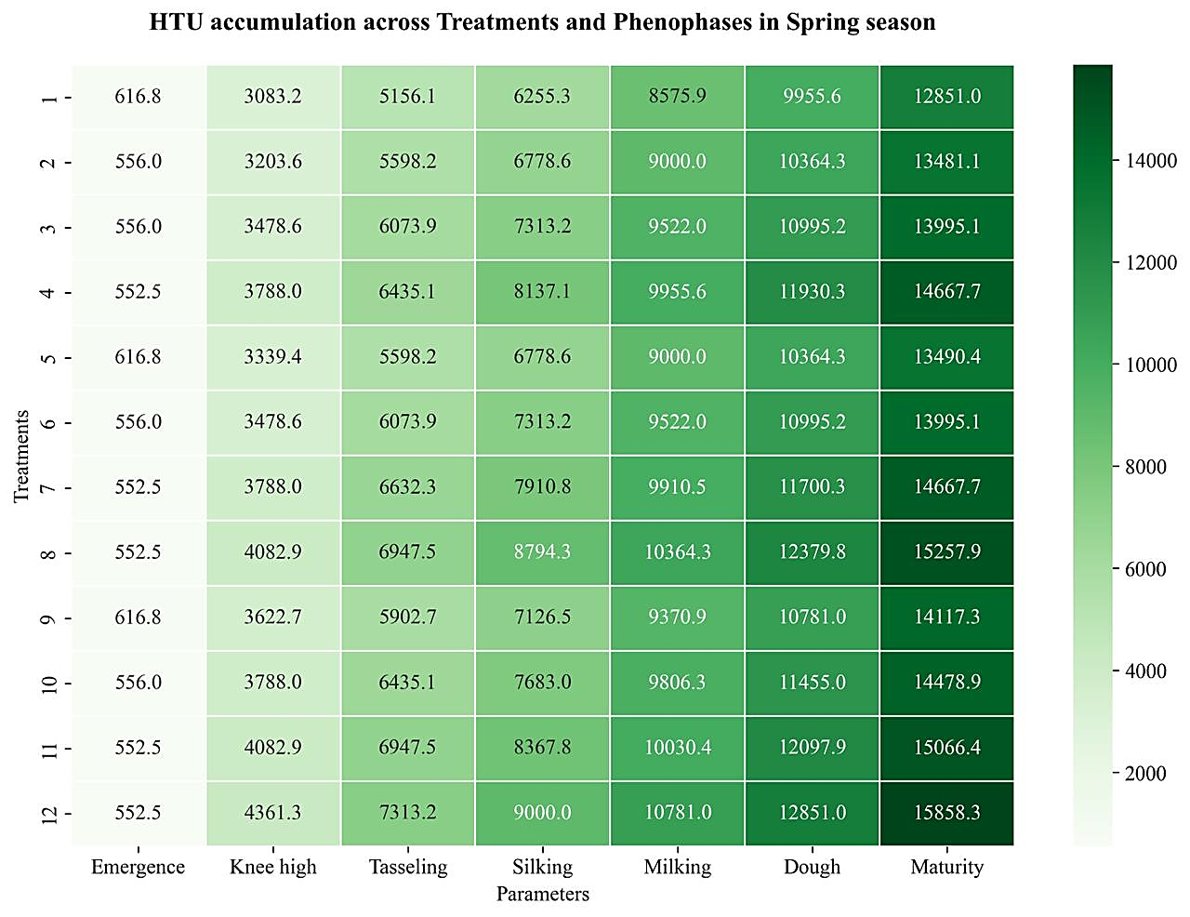
Fig. 9: Heatmap of HTU accumulation across treatments and phenophases in spring maize
The heatmap of Photothermal Units (PTU) accumulation across treatments and phenophases in winter maize in figure 10 indicates a continuous increase in PTU values as the crop progresses through successive growth stages. The lowest PTU accumulation was observed at the emergence stage (987.4 - 1387.1), reflecting the lower photothermal requirement during early crop establishment. As the crop advanced to the knee-high stage, PTU values increased to 4006.1 - 4794.8, indicating greater utilization of temperature and day length during vegetative growth. A further rise in PTU was recorded during the tasseling (6244.8 - 7798.4) and silking (7145.8 - 8982.0) stages, showing increased photothermal energy requirement during the reproductive phase. During grain development, PTU accumulation increased markedly to 9197.1 - 11465.7 at milking and 10850.1 - 13432.2 at dough stage. The highest PTU accumulation occurred at physiological maturity (12748.6 - 16894.5), where treatment 12 (V3T4) recorded the maximum PTU (16894.5) followed by Treatment 11 (16151.0), indicating higher photothermal energy utilization and longer crop duration, whereas Treatment 5 recorded the lowest PTU (12748.6) suggesting comparatively earlier maturity. This progressive increase in PTU across phenophases demonstrates that maize phenological development is strongly influenced by the combined effects of temperature and photoperiod during the crop growth period, which regulate crop development and growth rate (Kumudini et al., 2014).
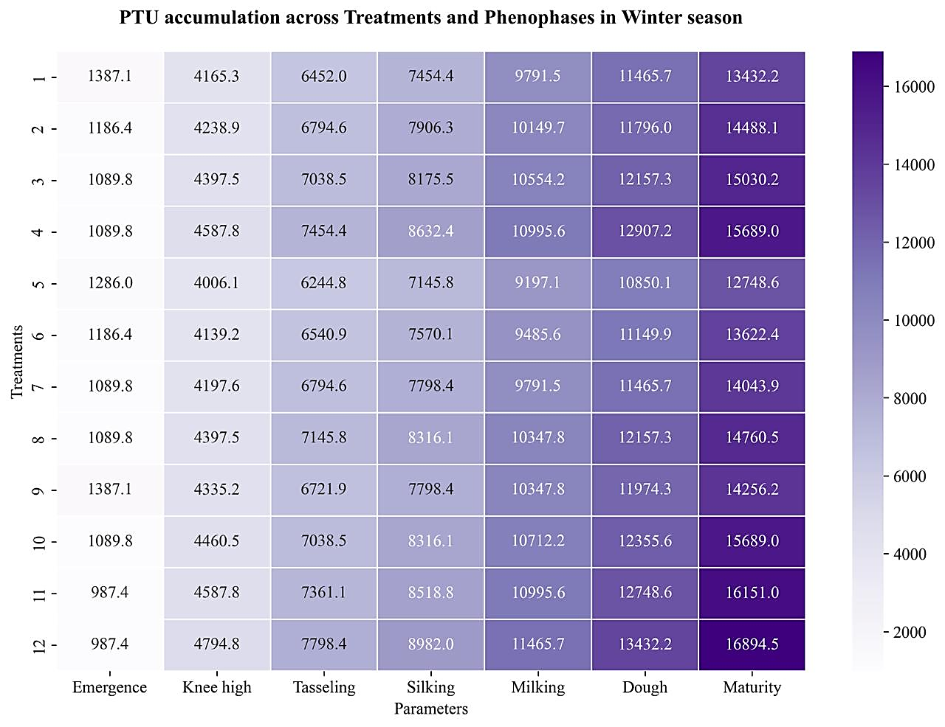
Fig. 10: Heatmap of PTU accumulation across treatments and phenophases in winter maize
The heatmap of Photothermal Units (PTU) accumulation across treatments and phenophases in spring maize as shown in fig-11indicates a steady increase in PTU values as the crop advances from emergence to physiological maturity, indicating the combined influence of temperature and day length on crop growth. PTU accumulation was lowest at the emergence stage (867.8 - 1277.6) and increased markedly by the knee-high stage (4427.2 - 6035.8) due to greater photothermal energy requirement during vegetative growth. As the crop progressed to the reproductive phase, PTU values further increased during tasseling (7005.4 - 10105.8) and silking (8650.5 - 12519.3) stages. Higher PTU accumulation was observed during grain development stages, ranging from 11687.5 - 15713.5 at milking and 14440.6 - 19138.1 at dough stage. The maximum PTU values were recorded at physiological maturity (19138.1 - 24554.4), where Treatment 12 (V3T4) showed the highest accumulation, indicating greater photothermal requirement and longer crop duration, while Treatment 1 recorded comparatively lower PTU, suggesting earlier maturity. The increasing PTU trend across phenophases highlights the importance of combined temperature and photoperiod in regulating maize phenology and crop development under spring growing conditions (Andrade et al., 2005).
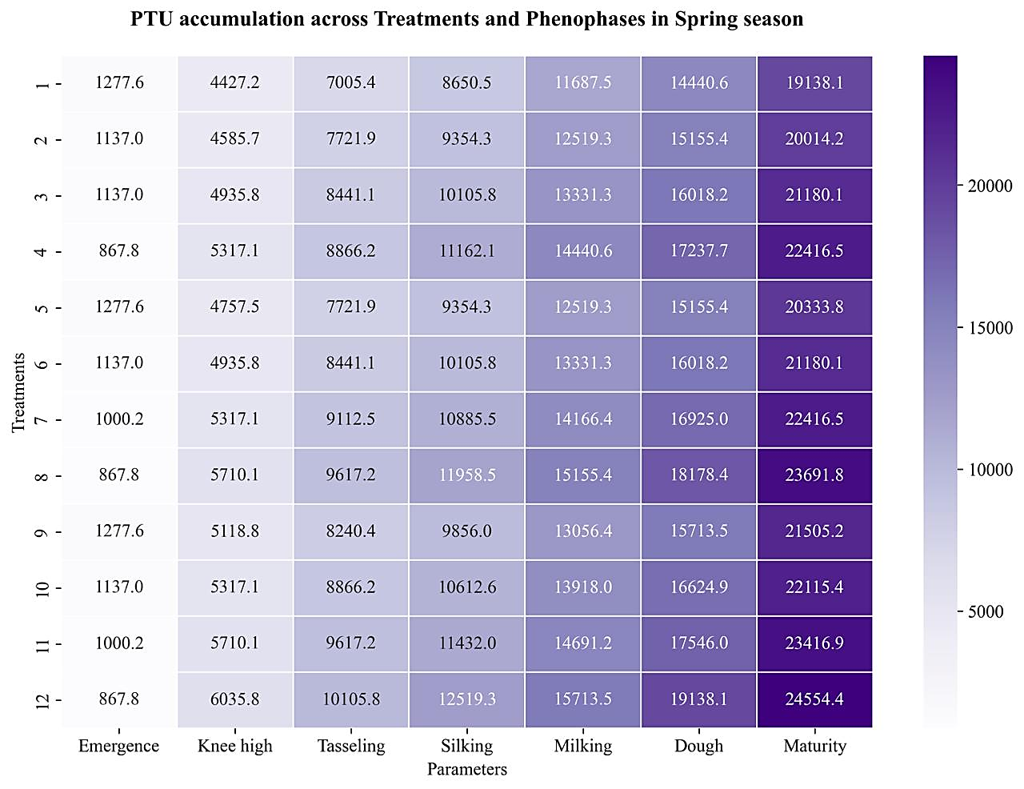
Fig. 11: Heatmap of PTU accumulation across treatments and phenophases in spring maize
3.3 Thermal Use Efficiency of Maize under Different Varieties and Nutrient management levels
The table 3 and figure 12 shows the thermal use efficiency of winter and spring maize in terms of Heat Use Efficiency (HUE), Heliothermal Use Efficiency (HTUE) and Photothermal Use Efficiency (PTUE) under different varieties and nutrient management levels. Among the varieties, V3 recorded the highest HUE, HTUE and PTUE in winter maize (5.79, 0.76 and 0.51 kg ha⁻¹ °C Day⁻¹, respectively) as well as in spring maize (6.21, 0.74 and 0.48 kg ha⁻¹ °C Day⁻¹), whereas V1 recorded the lowest values, indicating better utilization of accumulated thermal units by V3 for biomass and yield production. The differences among varieties were statistically significant, with CD (P = 0.05) values of 0.47, 0.06 and 0.04 for HUE, HTUE and PTUE, respectively, in winter maize and 0.38, 0.05 and 0.03 in spring maize. Under nutrient management levels, the highest HUE, HTUE and PTUE was recorded with F4 in winter maize (6.87, 0.90 and 0.60 kg ha⁻¹ °C Day⁻¹ respectively) and also for spring maize highest HUE, HTUE and PTUE (6.15, 0.72 and 0.48 kg ha⁻¹ °C Day⁻¹ respectively) were observed at F4 nutrient management level, while F1 recorded the lowest efficiency. The differences among nutrient management treatments were statistically significant with CD (P = 0.05) values of 0.60, 0.08 and 0.05 for HUE, HTUE and PTUE, respectively, in winter maize and 0.426, 0.05 and 0.03 in spring maize. This indicates that higher nutrient management levels improved the ability of crop to convert accumulated heat units into grain yield. Similar results regarding higher thermal use efficiency under improved nutrient management and superior cultivars have also been reported in maize and other crops (Sreenivas et al., 2010; Kumudini et al., 2014).
Table 3: Thermal use efficiency
 | Winter Maize |  |  |  | Spring Maize
Treatments | HUE  (kg/ha/°C Day) | HTUE (kg/ha/°C Day) | PTUE  (kg/ha/°C Day) |  | HUE  (kg/ha/°C Day) | HTUE (kg/ha/°C Day) | PTUE  (kg/ha/°C Day)
 | Varieties
V1 | 5.17 | 0.69 | 0.46 |  | 4.99 | 0.58 | 0.39
V2 | 5.62 | 0.75 | 0.50 |  | 5.28 | 0.63 | 0.41
V3 | 5.79 | 0.76 | 0.51 |  | 6.21 | 0.74 | 0.48
SEm+ | 0.12 | 0.02 | 0.01 |  | 0.10 | 0.01 | 0.01
CD at p-0.05 | 0.47 | 0.06 | 0.04 |  | 0.38 | 0.05 | 0.03
 | Fertilizer
F1 | 2.94 | 0.40 | 0.26 |  | 3.88 | 0.46 | 0.30
F2 | 6.02 | 0.80 | 0.53 |  | 6.05 | 0.71 | 0.45
F3 | 6.28 | 0.83 | 0.55 |  | 5.93 | 0.70 | 0.46
F4 | 6.87 | 0.90 | 0.60 |  | 6.15 | 0.72 | 0.48
SEm+ | 0.20 | 0.03 | 0.02 |  | 0.143 | 0.017 | 0.01
CD at p-0.05 | 0.6 | 0.08 | 0.05 |  | 0.426 | 0.05 | 0.03
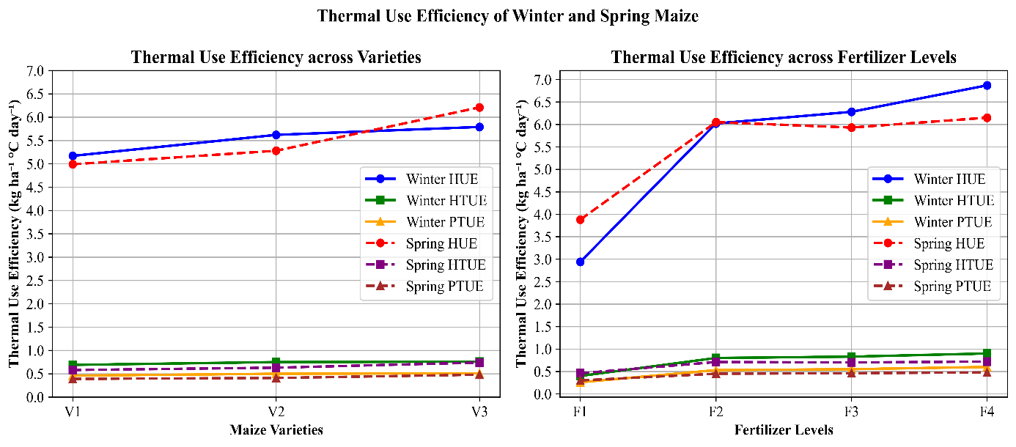
Fig. 12: Thermal Use Efficiency of Maize under Different Varieties and Nutrient management levels in Winter and Spring Seasons

3.4 Relationship between Grain Yield and Thermal Indices (GDD, HTU and PTU) of winter and spring maize
The table 4 represents the relationship between grain yield and thermal indices (GDD, HTU and PTU) of winter and spring maize. In general, spring maize recorded higher values of yield and thermal indices compared to winter maize, indicating greater thermal accumulation during the spring season. Among the treatments, V3F4 recorded the highest grain yield in both seasons (10,513.33 kg ha⁻¹ in winter and 12,456.67 kg ha⁻¹ in spring) along with the highest accumulated GDD, HTU and PTU, whereas V2F1 recorded the lowest yield in winter (3,123.00 kg ha⁻¹) and V1F1 recorded the lowest yield in spring (4,845.45 kg ha⁻¹). The results indicate that higher nutrient management levels combined with improved varieties enhanced thermal accumulation and grain yield, suggesting better utilization of available heat units for crop growth and development. Overall, the V3F4 treatment showed superior performance in both seasons, reflecting the combined effect of improved variety and higher nutrient level on maize productivity and thermal index accumulation.
The figure 13 illustrates the relationship between grain yield and thermal indices (GDD, HTU and PTU) in winter and spring maize using regression analysis. In both seasons, grain yield showed a positive linear relationship with the accumulated thermal indices, indicating that higher thermal accumulation during the crop growth period contributed to increased maize productivity. In winter maize, yield was moderately correlated with GDD (R² = 0.64), HTU (R² = 0.65) and PTU (R² = 0.64), suggesting that about 64% of the variation in yield could be explained by these thermal indices. In spring maize, the relationships were slightly stronger, with R² values of 0.70 for GDD, 0.72 for HTU and 0.70 for PTU, indicating a stronger influence of thermal conditions on yield during the spring season. The higher coefficient of determination in spring maize suggests that temperature and solar radiation played a more significant role in determining crop yield during the spring growing season compared to winter. Overall, the results indicate that grain yield increases with increasing accumulation of thermal units and HTU showed the strongest association with yield among the thermal indices, highlighting the importance of combined temperature and sunshine hours in maize productivity.

Table 4: Relationship between yield and thermal indices of winter and spring maize
 | Winter Maize |  |  |  |  | Spring Maize
Treatment | Yield (kg/ha) | GDD  (°C Day) | HTU | PTU |  | Yield (kg/ha) | GDD  (°C Day) | HTU | PTU
V1F1 | 4023.30 | 1200.8 | 8893.92 | 13432.2 |  | 4845.45 | 1500.0 | 12851.0 | 19138.1
V1F2 | 7512.77 | 1284.5 | 9691.05 | 14488.1 |  | 8949.00 | 1563.7 | 13481.1 | 20014.2
V1F3 | 7113.47 | 1327.2 | 9936.52 | 15030.2 |  | 8991.67 | 1648.2 | 13995.1 | 21180.1
V1F4 | 8446.67 | 1378.7 | 10491.9 | 15689.0 |  | 9617.00 | 1737.5 | 14667.7 | 22416.5
V2F1 | 3123.00 | 1146.1 | 8319.54 | 12748.6 |  | 6496.67 | 1586.9 | 13490.4 | 20333.8
V2F2 | 6996.67 | 1216.0 | 9051.48 | 13622.4 |  | 9456.67 | 1648.7 | 13995.1 | 21180.1
V2F3 | 8358.27 | 1249.4 | 9392.67 | 14043.9 |  | 9606.00 | 1737.5 | 14667.7 | 22416.5
V2F4 | 9572.33 | 1306.0 | 9834.76 | 14760.5 |  | 10526.00 | 1829.2 | 15257.9 | 23691.8
V3F1 | 3471.00 | 1266.2 | 9555.63 | 14256.2 |  | 7210.00 | 1671.7 | 14117.3 | 21505.2
V3F2 | 8913.13 | 1378.7 | 10491.9 | 15689.0 |  | 12003.33 | 1715.8 | 14478.9 | 22115.4
V3F3 | 9616.00 | 1414.7 | 10868.9 | 16151.1 |  | 12318.00 | 1809.5 | 15066.4 | 23416.9
V3F4 | 10513.33 | 1472.2 | 11363.1 | 16894.5 |  | 12456.67 | 1848.7 | 15858.3 | 24554.4

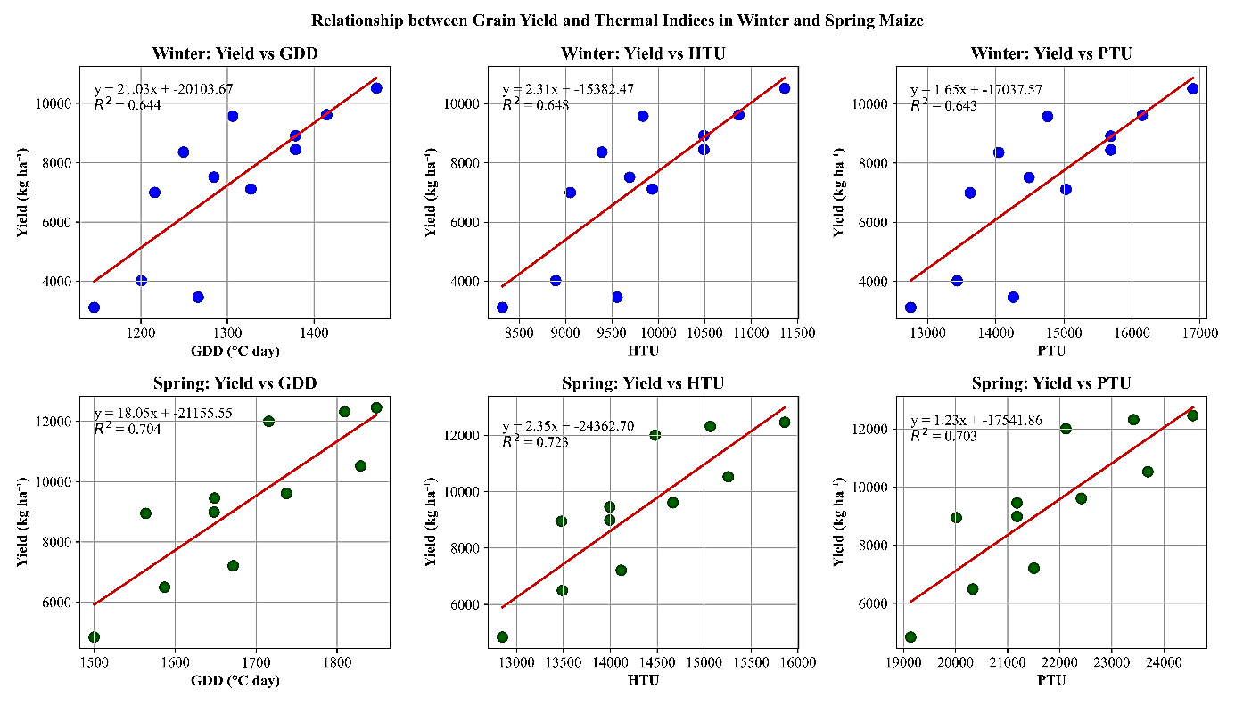Fig. 13: Relationship between grain yield and thermal indices (GDD, HTU and PTU) in winter and spring maize based on regression analysis.
3.5 Seasonal comparison of grain yield and accumulated thermal indices in winter and spring maize
The seasonal comparison indicates that spring maize recorded higher grain yield (9,373.04 kg ha⁻¹) and greater accumulation of thermal indices (GDD, HTU and PTU) compared to winter maize. The higher GDD (1691.45 °C Day), HTU (14327.25) and PTU (21830.23) observed in the spring season suggest that maize experienced greater thermal energy, solar radiation and longer day length, which enhanced crop growth, dry matter accumulation and ultimately grain yield. In contrast, the relatively lower values of these indices in winter maize indicate reduced thermal accumulation due to lower temperature and shorter sunshine duration, resulting in comparatively lower yield. Similar results have been reported by Shingne et al. (2020) who observed that higher accumulation of agrometeorological indices such as GDD, HTU and PTU significantly improved maize growth and productivity. Likewise, Jamsheed et al. (2023) reported a positive relationship between thermal indices and maize grain yield, indicating that higher thermal accumulation enhances crop development and yield formation. These findings support the present results, suggesting that spring maize, which accumulated greater thermal units and solar radiation, produced higher grain yield compared to winter maize.
Table 5: Comparison of thermal indices and grain yield between winter and spring maize
 | Winter Maize | Spring Maize
Yield (Kg/ha) | 7305.00 | 9373.04
Mean Growing Degree Day (GDD) | 1303.38 | 1691.45
Mean Heliothermal Unit (HTU) | 9824.29 | 14327.25
Mean Photothermal Unit (PTU) | 14733.81 | 21830.23
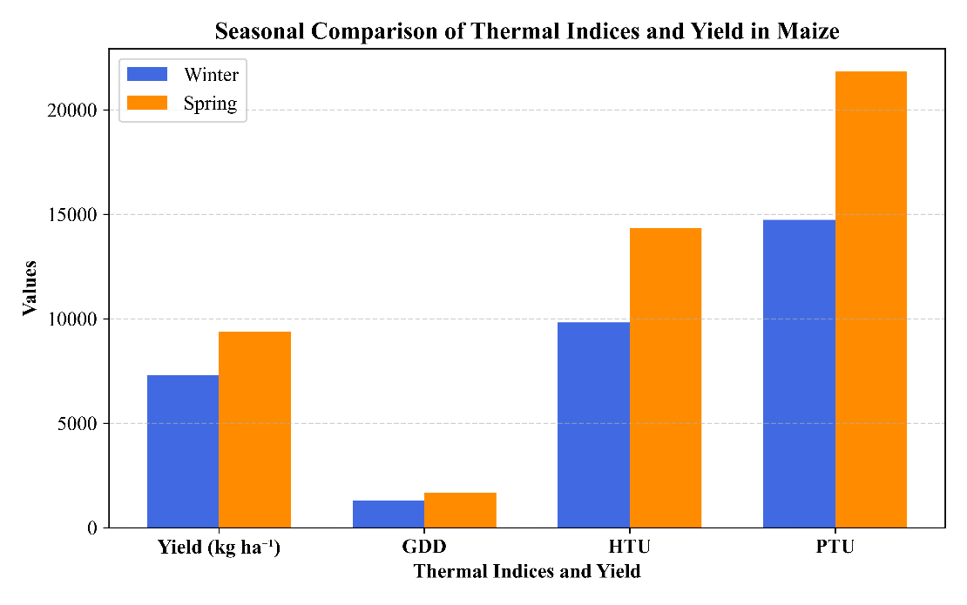
Fig. 14: Seasonal comparison of grain yield and accumulated thermal indices (GDD, HTU and PTU) in winter and spring maize
Conclusion
The study demonstrated that maize growth, phenology and yield are strongly influenced by the accumulation of thermal indices such as GDD, HTU and PTU. Spring maize recorded higher thermal accumulation with mean values of 1691.45 °C Day (GDD), 14327.25 (HTU) and 21830.23 (PTU) and produced higher grain yield (9373.04 kg ha⁻¹) compared to winter maize, which accumulated 1303.38 °C Day (GDD), 9824.29 (HTU) and 14733.81 (PTU) with a yield of 7305.00 kg ha⁻¹. Among the treatment combinations, V₃F₄ (DKC-9188 with recommended dose of fertilizer) recorded the highest grain yield of 10513.33 kg ha⁻¹ in winter and 12456.67 kg ha⁻¹ in spring, along with higher thermal accumulation and thermal use efficiency. The highest heat use efficiency was also observed under the F₄ nutrient management level, indicating improved conversion of accumulated heat units into grain yield. These findings suggest that the adoption of improved maize varieties along with optimum nutrient management can enhance thermal resource utilization and significantly improve maize productivity under different seasonal environments.
References
Agrawal, S., Kumar, S., Singh, D., Dutta, S. K. and Kumar, S. 2019. Growth and yield enhancement of rabi maize through identification of best timing for herbicide application. Int. J. Chem. Stud., 7(4): 1131–1134.
Andrade, F. H., Sadras, V. O., Vega, C. R. C. and Echarte, L. 2005. Physiological determinants of crop growth and yield in maize, sunflower and soybean. J. Crop Improv., 14(1–2): 51–101.
ANGRAU (Acharya N. G. Ranga Agricultural University). 2024. Maize outlook: June–May 2023–24. ANGRAU.
Bamboriya, S. D., Sepat, S., Kumar, R., Jat, S. L., Rakshit, S. and Zaidi, P. H. 2025. Optimization of sowing time to mitigate heat stress in spring maize (Zea mays L.) in Indo-Gangetic plains of India. Field Crops Res.
Bhat, T. A., Ahmad, L. and Kotru, R. 2015. Relation between agrometeorological indices, crop phenology and yield of rice genotypes as influenced by real-time N management. J. Agrometeorol., 17(1): 90–97.
Cao, Z. Y., Chen, Z. H., Tang, B., Zeng, Q., Guo, H. L., Huang, W. H. et al. 2024. Effects of sowing date on maize phenology, morphology and yield formation in a hot subtropical monsoon region. Field Crops Res., 309: 109309.
Choudhari, V. V. and Channappagouda, B. B. 2015. Effect of organics on morpho-physiological traits and grain yield of maize (Zea mays L.). The Bioscan, 10(1): 339–341.
Choudhary, D., Singh, R., Dagar, C. S., Kumar, A. and Singh, S. 2018. Temperature-based agrometeorological indices for Indian mustard under different growing environments in western Haryana, India. Int. J. Curr. Microbiol. App. Sci., 7(1): 1025–1035.
Dadapeer, B. H., Sridhara, S. and Gopakkali, P. 2020. Crop weather relationships of maize (Zea mays L.) under different sowing windows and hybrids. Int. J. Environ. Clim. Change, 10(11): 87–94.
Edreira, J. R. and Otegui, M. E. 2013. Heat stress in temperate and tropical maize hybrids: a novel approach for assessing sources of kernel loss in field conditions. Field Crops Res., 142: 58–67.
Fealy, R. and Fealy, R. M. 2008. Spatial variation in degree days derived from locational attributes for the 1961–1990 period. Ir. J. Agric. Food Res., 47: 1–11.
Feng, Y., Cui, X., Shan, H., Shi, Z., Li, F., Wang, H. et al. 2021. Effects of solar radiation on photosynthetic physiology of barren stalk differentiation in maize. Plant Sci., 312: 111046.
Ge, J., Xu, Y., Zhao, M., Zhan, M., Cao, C., Chen, C. and Zhou, B. 2022. Effect of climatic conditions caused by seasons on maize yield, kernel filling and weight in central China. Agronomy, 12(8): 1816.
Government of India, Ministry of Agriculture and Farmers Welfare. 2024. Final estimates of area and production of principal crops 2023–24. Directorate of Economics and Statistics.
Jamsheed, B., Bhat, T. A., Saad, A. A., Nazir, A., Fayaz, S., Eldin, S. M. et al. 2023. Estimation of yield, phenology and agro-meteorological indices of quality protein maize (Zea mays L.) under different nutrient omissions in temperate ecology of Kashmir. J. King Saud Univ. Sci., 35(7): 102808.
Janni, M., Maestri, E., Gullì, M., Marmiroli, M. and Marmiroli, N. 2024. Plant responses to climate change and implications for food security. Front. Plant Sci., 14: 1297569.
Kiniry, J. R., Ritchie, J. T. and Musser, R. L. 1983. Dynamic nature of the photoperiod response in maize. Agron. J., 75(4): 700–703.
Kumudini, S., Andrade, F. H., Boote, K. J., Brown, G. A., Dzotsi, K. A., Edmeades, G. O. et al. 2014. Predicting maize phenology: intercomparison of functions for developmental response to temperature. Agron. J., 106(6): 2087–2097.
Ma, D. L., Xie, R. Z., Zhang, F. L., Li, J., Li, S., Long, H. et al. 2015. Genetic contribution to maize yield gain among different locations in China. Maydica, 60(1): 1–8.
Matzarakis, A., Ivanova, D., Balafoutis, C. and Makrogiannis, T. 2007. Climatology of growing degree days in Greece. Clim. Res., 34(3): 233–240.
Parthasarathi, T., Velu, G. and Jeyakumar, P. 2013. Impact of crop heat units on growth and developmental physiology of future crop production: a review. Res. Rev. J. Crop Sci. Technol., 2(1): 1–11.
Porter, J. R. 2005. Rising temperatures are likely to reduce crop yields. Nature, 436(7048): 174.
Raza, A., Razzaq, A., Mehmood, S. S., Zou, X., Zhang, X., Lv, Y. and Xu, J. 2019. Impact of climate change on crops adaptation and strategies to tackle its outcome: a review. Plants, 8(2): 34.
Ritchie, J. T. and Nesmith, D. S. 1991. Temperature and crop development. In: Modeling Plant and Soil Systems. ASA, Madison, USA. pp. 5–29.
Shingne, S. V., Asewar, B. V. and Raut, G. B. 2020. Agrometeorological indices of hybrid maize (Zea mays L.) under different weather conditions. Int. J. Curr. Microbiol. App. Sci., 9(9): 310–317.
Singh, M. and Vashist, K. K. 2016. Enhancing productivity of spring maize (Zea mays L.) through planting methods, varieties and irrigation levels in Punjab. Indian J. Agron., 61(3): 348–353.
Singh, R. N., Sutaliya, R., Ghatak, R. and Sarangi, S. K. 2003. Effect of higher application of nitrogen and potassium over recommended level on growth, yield and yield attributes of late sown winter maize (Zea mays L.). Crop Res., 26(1): 71–74.
Soler, C. T., Sentelhas, P. C. and Hoogenboom, G. 2005. Thermal time for phenological development of four maize hybrids grown off-season in a subtropical environment. J. Agric. Sci., 143(2–3): 169–182.
Sreenivas, G., Reddy, M. D. and Reddy, D. R. 2010. Agrometeorological indices in relation to phenology of aerobic rice. J. Agrometeorol., 12(2): 241–244.
Tollenaar, M., Daynard, T. B. and Hunter, R. B. 1979. Effect of temperature on rate of leaf appearance and flowering date in maize. Crop Sci., 19(3): 363–366.
Tsimba, R., Edmeades, G. O., Millner, J. P. and Kemp, P. D. 2013. Effect of planting date on maize phenology, thermal time durations and growth rates in a cool temperate climate. Field Crops Res., 150: 145–155.
Vanaja, M., Sathish, P., Kumar, G. V., Razzaq, A., Vagheera, P., Lakshmi, N. J. et al. 2017. Elevated temperature and moisture deficit stress impact on phenology, physiology and yield responses of hybrid maize. J. Agrometeorol., 19(4): 295–300.
Wahid, A., Gelani, S., Ashraf, M. and Foolad, M. R. 2007. Heat tolerance in plants: an overview. Environ. Exp. Bot., 61(3): 199–223.
Wang, L., Liao, S., Huang, S., Ming, B., Meng, Q. and Wang, P. 2018. Increasing concurrent drought and heat during the summer maize season in Huang–Huai–Hai Plain, China. Int. J. Climatol., 38(7): 3177–3190.
Wani, S., Kanth, R. H., Bhat, T. A., Adar, Z., Rehman, U. et al. 2023. Spatial and temporal arrangement of hybrid maize for assessment of phenology and agrometeorological indices. J. Agrometeorol.
Yang, J. S., Gao, H. Y., Liu, P., Li, G., Dong, S. T., Zhang, J. W. and Wang, J. F. 2010. Effects of planting density and row spacing on canopy apparent photosynthesis of high-yield summer corn. Acta Agron. Sin., 36(7): 1226–1233.
Yang, Y., Guo, X., Hou, P., Xue, J., Liu, G., Liu, W. et al. 2020. Quantitative effects of solar radiation on maize lodging resistance mechanical properties. Field Crops Res., 255: 107906.
Zhang, M., Tao, C., Latifmanesh, H. and Zhang, W. J. 2018. Effects of plant density on maize spike differentiation, kernel set and grain yield formation in Northeast China. J. Integr. Agric., 17(8): 1745–1757.

