Original Research Article

Challenges and Institutional Barriers in Implementing Carbon Market Initiatives among Pastoralist Communities: Experiences from Ngaremara, Northern Kenya

Abstract
Carbon market initiatives have been promoted as mechanisms to enhance climate resilience and provide economic benefits to vulnerable communities. However, their successful implementation is often hindered by governance, institutional, and socio-cultural challenges. This study examines the barriers to effective carbon market implementation among pastoralist communities in Ngaremara, Isiolo County, Kenya. Using a survey-based approach, the research explores stakeholder participation, benefit-sharing mechanisms, financial accessibility, and policy-related obstacles that affect project success. Findings indicate that 62.9% of respondents reported conflicts over benefit-sharing, while 33.5% felt excluded from decision-making processes. Additionally, 70% cited difficulties in accessing technical expertise and financial resources, limiting the scalability of carbon market benefits. Socio-cultural factors such as trust issues (52%) and conflicting pastoralist traditions (30.8%) further constrained project adoption. The study concludes that governance weaknesses, inadequate financial structures, and limited community engagement pose significant obstacles to carbon market success. Addressing these barriers requires strengthening participatory governance, improving financial support mechanisms, and integrating culturally adaptive strategies to ensure equitable and sustainable benefits for pastoralist communities.
Keywords: participatory governance; financial accessibility; policy gaps; trust-building; traditional land-use systems; dryland adaptation

Introduction
Carbon market initiatives have emerged as important tools for climate change mitigation and sustainable development, offering financial incentives to communities that engage in carbon sequestration activities such as afforestation, rangeland restoration, and improved land management (IPCC, 2021; Atela et al., 2015). These initiatives can enhance rural economies, improve environmental outcomes, and strengthen climate resilience. However, their success depends heavily on governance structures, institutional frameworks, and socio-economic contexts (Mathur et al., 2014; Bond et al., 2020).
Effective governance has been identified as a critical determinant of carbon market success. In many African pastoralist communities, land tenure insecurity, lack of transparency, and weak stakeholder engagement hinder equitable benefit-sharing (Bernard & Adkins, 2014; Mburu, 2015). Communal land tenure systems complicate ownership rights and revenue distribution, often leading to elite capture and exclusionary practices (Little, 1996; Munene, 2019; Wako, 2022). When communities are excluded from decision-making, projects face mistrust, disputes, and resistance (Herr et al., 2019).
Socio-cultural factors also shape carbon market adoption. Pastoralist economies are deeply tied to livestock and traditional grazing practices, and conservation measures can be perceived as threats to livelihoods (Little, 1996; Mathur et al., 2014). Conflicts between modern conservation policies and indigenous knowledge systems can slow project uptake, while skepticism persists due to past development programs that failed to deliver tangible benefits (Atela et al., 2015; Wako, 2022).
Financial and technical barriers are equally significant. Many pastoralist households face difficulties accessing credit, microfinance, or reinvestment opportunities needed to participate in carbon markets (Bond et al., 2020; Bryan et al., 2018). Limited technical capacity in areas such as carbon measurement, emissions reporting, and pricing negotiations further constrains participation (Mathur et al., 2014; Mburu, 2015).
Although global and regional studies highlight these governance, financial, and socio-cultural barriers, there remains limited empirical research focusing specifically on pastoralist communities in Kenya, particularly for rangeland-based carbon projects. Most existing research centers on forestry-based carbon initiatives, leaving a gap in understanding how carbon markets function in dryland ecosystems.
In Ngaremara, Isiolo County, carbon market projects have been introduced to promote sustainable land use and generate financial benefits for local communities. However, obstacles such as restricted participation, conflicts over benefit-sharing, and insufficient technical and financial support have constrained their success. This study addresses these gaps by examining the governance, institutional, and socio-cultural barriers to carbon market implementation in Ngaremara. By identifying key constraints and proposing targeted interventions, it aims to inform the design of more inclusive, effective, and sustainable carbon market models for pastoralist and other dryland communities.

Methodology

Study Area
This study was conducted in Ngaremara, Isiolo County, Kenya, a semi-arid region where pastoralism is the primary livelihood. The region faces significant climate variability, land tenure challenges, and increasing resource competition, making it a suitable case for examining governance and institutional barriers to carbon market implementation (Mburu, 2015). Carbon market initiatives in Ngaremara focus on planned grazing, afforestation, and community-led conservation projects, but challenges related to participation, benefit-sharing, and financial accessibility persist (Munene, 2019). The figure below shows the map of the study area:
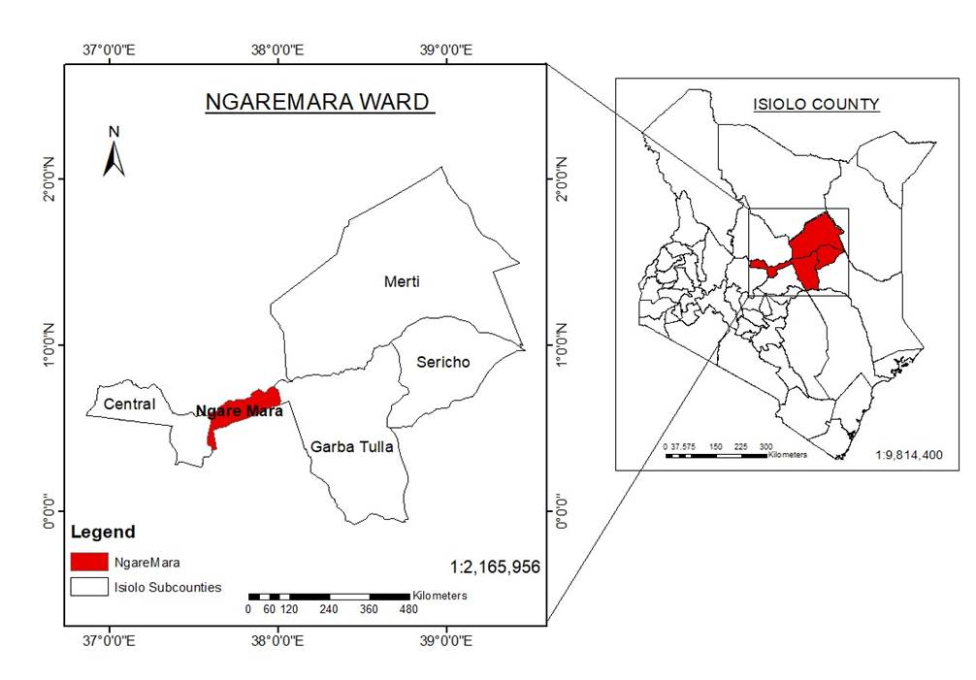

Figure 1: GIS map of Isiolo North Constituency, Kenya
Research Design
The study adopted a cross-sectional survey approach to collect both quantitative and qualitative data on the governance, institutional, and socio-cultural factors influencing carbon market implementation. This design was chosen because it allows for the examination of relationships between reported challenges and household-level socio-economic indicators at a single point in time, while also incorporating narrative accounts from respondents to enrich understanding.
Sampling and Data Collection
A stratified random sampling method was applied to ensure balanced representation of households with differing types of involvement in carbon market activities. The final sample comprised 367 households, a number determined through statistical sample size calculations that accounted for the total population of Ngaremara and targeted a 95% confidence level with a reasonable margin of error.
Data Collection Procedures
Data gathering involved several complementary techniques. Structured household questionnaires were used to capture demographic characteristics, participation status, experiences with governance processes, benefit-sharing arrangements, and socio-cultural dynamics affecting project adoption. Field observations provided additional insights into community interactions and cultural practices relevant to land use and project engagement. Contextual information was also drawn from secondary sources, including published studies, policy frameworks, and project records. Data entry during the field phase was facilitated through the use of Open Data Kit (ODK) software.
Data Analysis
Quantitative responses were analyzed using descriptive statistics, correlation, and regression analysis to examine relationships between governance challenges, institutional barriers, and livelihood outcomes. Group differences were tested using independent samples t-tests and Wilcoxon rank-sum tests to assess the effect of reported challenges on household livelihood scores. Qualitative data was analyzed thematically, with emerging themes organized around governance gaps, socio-cultural factors, and policy constraints.
Ethical Considerations
Ethical clearance was obtained from Kenyatta University’s Graduate School, and research authorization was granted by the National Commission for Science, Technology, and Innovation (NACOSTI). Participation was voluntary, with informed consent obtained from all respondents. Privacy and confidentiality were strictly upheld, and all interactions were conducted with cultural sensitivity and respect for local traditions.

Results and Discussion

Stakeholder Participation and Community Engagement
Out of the 367 surveyed households, 82.8% reported attending community meetings related to carbon market initiatives. However, only 42% indicated that they were meaningfully involved in project decisions, and 33.5% reported being completely excluded from decision-making processes.

Institutional and Governance Barriers
Conflicts over benefit-sharing were reported by 62.9% of respondents. Additionally, 70% cited difficulties in accessing technical expertise and financial resources required for effective participation in carbon market activities. Land tenure insecurity and unclear policies were noted as contributing to disputes over ownership and rights to carbon revenues.

Financial and Technical Barriers
A total of 56.1% of respondents were unaware of financial mechanisms available to support participation in carbon markets. Furthermore, 70% experienced difficulty in accessing credit or other funding sources for conservation activities. Although 76.3% of respondents had received some form of training, 57.5% considered these training programs inadequate for enabling them to fully benefit from carbon market opportunities. The figure below indicates top five challenges that were reported in CMI participation:
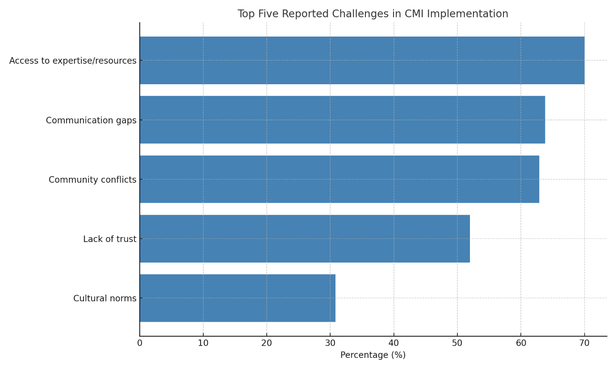
Fig 2: Top Five Reported Challenges in CMI Implementation

Socio-Cultural Barriers and Trust Issues
Lack of trust in project implementers was reported by 52% of respondents. Additionally, 30.8% stated that traditional pastoralist customs conflicted with project land-use requirements, such as restrictions on grazing areas.

Policy Gaps and Regulatory Challenges
While 56.1% of respondents were aware of existing government policies on carbon markets, only 28.1% believed these policies effectively supported community participation. The challenges reported have been grouped in the figure below:
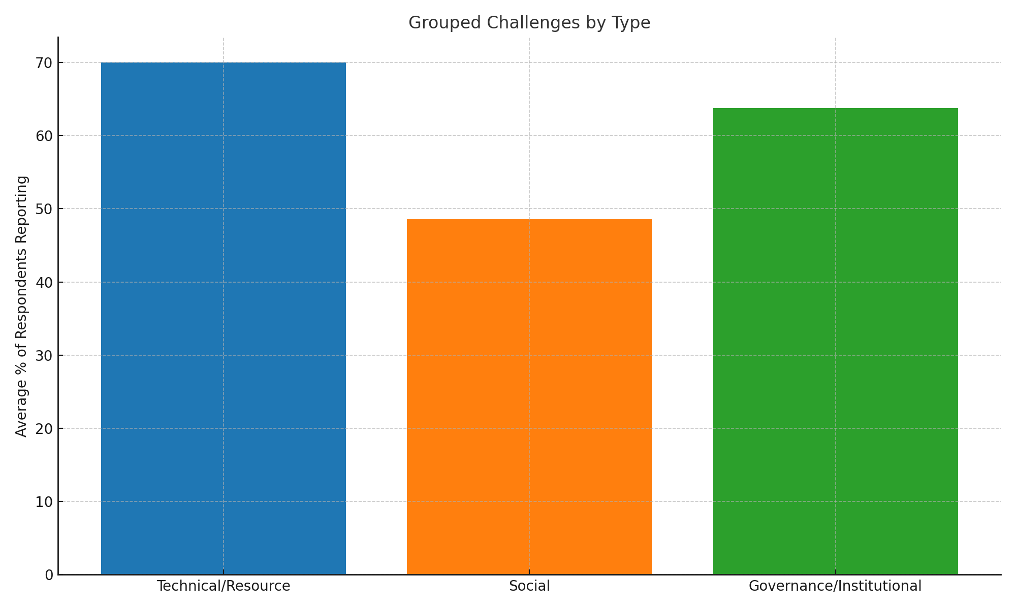
Figure 3: Grouped Challenges by Type
Hypothesis Testing
Independent samples t-tests showed that households facing implementation challenges had significantly lower livelihood scores (mean difference = –0.394, p < 0.001). This result was confirmed by the Wilcoxon rank-sum test (p < 0.001), indicating a robust negative association between challenges encountered and livelihood outcomes.
Table 1: t-test & Wilcoxon test Results
Test | Comparison | Mean Difference | Test Statistic | P-value | 95% CI Lower | 95% CI Upper
T-test | Livelihood Score ~ Encountered Challenges | -0.394 | -4.829588 | 0.000 | -0.554 | -0.233
Wilcoxon test | Livelihood Score ~ Encountered Challenges |  | 9,956.500000 | 0.000

Discussion
This study reveals that while carbon market initiatives in Ngaremara, Isiolo County, hold potential for enhancing livelihoods and climate resilience, their effectiveness is significantly undermined by a combination of governance weaknesses, institutional barriers, and socio-cultural constraints. These findings reinforce earlier research showing that equitable and transparent governance is a cornerstone of successful climate finance interventions (Bernard & Adkins, 2014; Bryan et al., 2018).
The limited meaningful participation in decision-making (42% involvement) highlights persistent gaps in community engagement. Similar patterns have been observed in other pastoralist regions, where project implementers often prioritize engagement with local elites or formal leaders over broader grassroots involvement (Mathur et al., 2014). Such exclusionary practices erode trust and create resistance, which can compromise project sustainability. Strengthening participatory governance structures — for example, through the inclusion of women, youth, and traditional elders in decision-making — could enhance legitimacy and local ownership of carbon market activities.
Conflicts over benefit-sharing, reported by 62.9% of respondents, underscore the challenges posed by communal land tenure systems without clear revenue distribution frameworks. Previous studies indicate that without formalized benefit-sharing agreements, carbon revenues risk being captured by a few individuals or administrative bodies, leaving intended beneficiaries with little incentive to participate (Munene, 2019; Wako, 2022). Addressing these conflicts requires both legal clarity on carbon rights and operational mechanisms for transparent disbursement of funds.
Financial and technical constraints emerged as equally critical barriers. The lack of awareness about financial mechanisms (56.1%) and difficulties in accessing credit (70%) mirror findings in other dryland contexts, where financial exclusion limits the ability of households to invest in conservation measures (Bond et al., 2020). Moreover, while training is being provided, the perception among 57.5% of respondents that it is insufficient reflects a mismatch between training content and the practical skills required for participation. Context-specific training — delivered in local languages, using practical demonstrations, and tailored to the pastoralist way of life — could significantly improve uptake and effectiveness.
Socio-cultural barriers, including trust deficits (52%) and conflicts between pastoralist customs and carbon market requirements (30.8%), point to a deeper need for cultural alignment in project design. Previous interventions that failed to acknowledge local traditions or imposed external land-use rules without negotiation have met similar resistance (Little, 1996; Atela et al., 2015). Engaging cultural leaders and embedding indigenous knowledge in project frameworks could foster greater acceptance and mitigate conflicts.
The statistical analysis further confirms that households experiencing these challenges consistently report lower livelihood scores. This aligns with the hypothesis that structural and cultural obstacles directly reduce the potential benefits of carbon markets. It also signals that without targeted reforms in governance, finance, and community engagement, scaling carbon market benefits will remain difficult.
These findings suggest that while carbon markets offer a viable pathway for integrating climate action with livelihood improvement in pastoralist settings, their success is contingent upon inclusive governance, accessible financing, culturally responsive design, and sustained capacity-building. Policymakers, project implementers, and development partners must therefore address these systemic gaps to ensure that carbon markets in dryland regions deliver on their promise of equitable and sustainable development.
Conclusion and Recommendations
Conclusion
This study demonstrates that the implementation of carbon market initiatives in Ngaremara, Isiolo County, is constrained by a combination of governance weaknesses, financial exclusion, technical capacity gaps, and socio-cultural barriers. While carbon markets hold promise as a climate finance mechanism that can support sustainable land management and improve pastoralist livelihoods, their current design and delivery models in this context limit their potential impact.
The evidence shows that limited participation in decision-making, conflicts over benefit-sharing, and inadequate policy support undermine trust and equity in carbon market operations. Furthermore, barriers to financial access and the lack of practical, context-relevant training hinder meaningful engagement by households. Socio-cultural factors, including mistrust of implementers and misalignment with pastoralist traditions, further reduce community buy-in. These systemic challenges collectively reduce the livelihood benefits households can derive from carbon markets, as confirmed by the statistical association between reported challenges and lower livelihood scores. For carbon markets to achieve their intended outcomes in pastoralist settings, they must be restructured to prioritize inclusivity, transparency, cultural sensitivity, and long-term capacity-building.

Recommendations
- Strengthening community participation and inclusive governance: Ensuring active engagement of local communities in decision-making can enhance trust and participation. Establishing transparent governance structures that involve community elders, women, and youth can improve benefit-sharing and reduce conflicts.
- Developing clear land tenure and benefit-sharing policies: Addressing land tenure insecurity through legal recognition of community land rights is essential. Transparent benefit-sharing mechanisms, with defined revenue distribution models, should be formalized to prevent elite capture and inequities.
- Improving financial accessibility and market linkages: Developing accessible microfinance models, community investment funds, and reinvestment mechanisms can enhance participation. Strengthening direct payments to households rather than centralized fund management may increase trust and engagement.
- Expand training and technical capacity-building: Providing tailored training programs on carbon measurement, financial literacy, and sustainable land management can empower pastoralist communities. Training efforts should be delivered in local languages and adapted to cultural contexts.
- Align carbon market policies with pastoralist land-use systems: National and county-level climate finance policies should integrate rangeland conservation into carbon credit frameworks. Developing policies that support flexible, mobile pastoralism while incorporating sustainable grazing practices is crucial for success.

References
Asquith, N. M., Vargas Ríos, M. T., & Smith, J. (2002). Can forest-protection carbon projects improve rural livelihoods? Analysis of the Noel Kempff Mercado climate action project, Bolivia. Mitigation and Adaptation Strategies for Global Change, 7(4), 323–337. Retrieved from https://www.cifor-icraf.org/knowledge/publication/1273/
Atela, J. O., Minang, P. A., Quinn, C. H., & Duguma, L. A. (2015). Implementing REDD+ at the local level: Assessing the key enablers for credible mitigation and sustainable livelihood outcomes. Journal of Environmental Management, 157, 238–249. https://doi.org/10.1016/j.jenvman.2015.04.015
Bernard, F., & Adkins, B. (2014). Community-based conservation and carbon markets: A critical analysis. Global Environmental Change, 24, 53-64. https://doi.org/10.1016/j.gloenvcha.2013.11.007
Bond, I., Millar, I., & Ramos, C. (2020). Governance challenges in carbon market implementation: Lessons from sub-Saharan Africa. Environmental Policy and Governance, 30(2), 129-144. https://doi.org/10.1002/eet.1885
Bryan, E., Ringler, C., Okoba, B., Roncoli, C., Silvestri, S., & Herrero, M. (2018). Adaptive capacity and climate resilience of Kenyan smallholder farmers. Climate Risk Management, 4, 43–54. https://doi.org/10.1016/j.crm.2014.10.004
Herr, D., Blum, M., Himes-Cornell, A., & Sutton-Grier, A. (2019). The role of blue carbon in climate adaptation and sustainable development. Frontiers in Marine Science, 6, 237. https://doi.org/10.3389/fmars.2019.00237
IPCC. (2021). Climate Change 2021: The Physical Science Basis. Contribution of Working Group I to the Sixth Assessment Report of the Intergovernmental Panel on Climate Change. Cambridge University Press. Retrieved from https://www.ipcc.ch/report/ar6/wg1/
Little, P. D. (1996). Pastoralism, biodiversity, and the shaping of savanna landscapes in East Africa. Africa, 66(1), 37–51. https://doi.org/10.2307/1161510
Mathur, V. N., Afionis, S., Paavola, J., Dougill, A. J., & Stringer, L. C. (2014). Experiences of host communities with carbon market projects: Towards multi-level climate justice. Climate Policy, 14(1), 42–62. https://doi.org/10.1080/14693062.2013.861728
Mburu, C. W. (2015). Factors influencing implementation of selected donor-funded projects in Kenya: The case of World Vision Isiolo County, Kenya (Master's thesis). University of Nairobi. Retrieved from http://erepository.uonbi.ac.ke/handle/11295/90505
McCarthy, J., & Di Gregorio, M. (2007). Climate change adaptation, rural institutions, and development. World Development, 35(3), 341–363. https://doi.org/10.1016/j.worlddev.2006.10.008
Mukami, D. M. (2016). Carbon markets and livelihood sustainability in dryland regions: Evidence from Kenya (Doctoral dissertation). Kenyatta University. Retrieved from https://ir-library.ku.ac.ke/
Munene, M. W. (2019). Factors influencing management of rangelands by pastoral communities in Gotu, Ngaremara ward, Isiolo County, Kenya (Master's thesis). University of Nairobi. Retrieved from http://erepository.uonbi.ac.ke/handle/11295/106751
Wako, A. G. (2022). Socio-economic impacts of carbon projects in Northern Kenya: An assessment of governance structures and equity in benefit-sharing (Master’s thesis). University of Nairobi. Retrieved from http://erepository.uonbi.ac.ke/

