Occurrence of Dipterocarpus Fossil wood and leaf in the Eastern Siwalik sector of Sarkaghat Area, Himachal Pradesh: Phytogeographical Implications

ABSTRACT
Palaeobotanical investigations of plant megafossils, including fossil woods and leaf impressions, from the Middle Siwalik sediments of the Sarkaghat area in the Himalayan foothills of Himachal Pradesh, India, have revealed the presence of petrified wood and leaves belonging to the Southeast Asian genus Dipterocarpus C. F. Gaertn. (family Dipterocarpaceae). The fossil wood has been identified as Dipterocarpoxylon siwalicus Prakash, while the leaf impressions are assigned to Dipterocarpus miocenicus Prasad & Gautam.
A comparison with the present-day distribution of closely related extant species of Dipterocarpus shows that these taxa no longer occur in the Himalayan foothills of Himachal Pradesh. Instead, they are currently confined to the evergreen forests of Southeast Asia. This distribution pattern suggests that increasing arid conditions after the Miocene likely led to the local extinction of these taxa in the region. Based on fossil evidence and the biogeographical distribution of comparable living species, the phytogeographical implications of this finding are discussed. It is further inferred that Dipterocarpus migrated into the area from Southeast Asia during the early Miocene and subsequently disappeared due to the development of unfavourable climatic conditions.
Key-words- Plant megafossils , Fossil wood, Leaf impression, Middle Siwalik, Sarkaghat, Mandi District, Himachal Pradesh, Phytogeographical implications.

1. INTRODUCTION

The Himalayan foothills are predominantly composed of Neogene sedimentary deposits collectively designated as the Siwalik Group. These deposits extend for about 2400 km from the Potwar Plateau in the northwest to the Brahmaputra Valley in the northeast, with an average width of 20–25 km (Ranga Rao et al., 1979). The Siwalik succession holds great geological and palaeobotanical significance, as it records major tectonic and climatic events associated with Himalayan orogeny. The principal phase of Himalayan uplift initiated during the Middle Miocene and persisted until the Pleistocene, profoundly altering regional physiography and facilitating the diversification and expansion of angiospermous vegetation across the Indian subcontinent.
The Siwalik sediments have yielded rich assemblages of plant megafossils—petrified and carbonized woods, as well as leaf, fruit, and seed impressions—that provide valuable insights into Neogene vegetation dynamics and palaeoclimates. Extensive palaeobotanical investigations have been conducted mainly in the central Siwalik sector (Awasthi, 1992; Prasad, 2008), whereas the western Siwalik has received comparatively limited attention, with notable contributions from Nalagarh (Prakash, 1975, 1979; Yadav, 1989), Jawalamukhi and Ranital (Ghosh and Ghosh, 1958; Lakhanpal, 1967–1969; Lakhanpal and Awasthi, 1992), and Bilaspur (Prasad, 2006).
In light of this paucity of data from the western Siwalik, the present investigation documents new plant megafossils from the Middle Siwalik sediments of Sarkaghat, Mandi District, Himachal Pradesh. The collection, comprising fossil leaf and fruit impressions along with carbonized and semi-silicified woods, reveals the occurrence of two species belonging to Dipterocarpus C. F. Gaertn. (Dipterocarpaceae). Their detailed description and phytogeographical significance are discussed herein.

2.GEOLOGICAL SET UP OF STUDY AREA

The Siwalik represents clastic sediments of fresh water molasses which accumulated in a long narrow fore deep formed due to rising of the Himalaya. It ranges in age from Middle Miocene to Middle Pleistocene and accumulated under four different environments namely lacustrine, channel and flood plains, outwash plain and piedmont with frequent diachronous shift. The whole Siwalik is divided in to lower, middle and upper Siwaliks. Lithologically, the Siwalik is made up of coarsely bedded sandstones, sand rock, clay and conglomerates. In Sarkaghat area there is occurrence of conglomerates beds among the Middle Siwalik sequence which possesses abundant carbonized fossil woods.
The Sarkaghat Anticline is exposed in the northeastern part of the Kangra re-entrant within the Himachal Sub-Himalaya, along the northward-dipping Main Boundary Fault (MBF). It forms a prominent regional structure in the Paleogene–Siwalik belt of the western Sarkaghat area, Mandi district, Himachal Pradesh. The anticline plunges northwestward and is bounded by the NNW–SSE trending Awah Devi–Lamba Graon syncline to the south and the Main Boundary Fault to the north. On the basis of lithological associations, grain size, degree of compaction, and internal bed geometry, five distinct and mappable lithostratigraphic units of the Siwalik Group have been identified within the MBF related Sarkaghat Anticline. These include the Nahan Formation of the Lower Siwalik Subgroup; the Dewal and Mohargarh formations of the Middle Siwalik Subgroup; and the Pinjor and Kalar formations of the Upper Siwalik Subgroup.
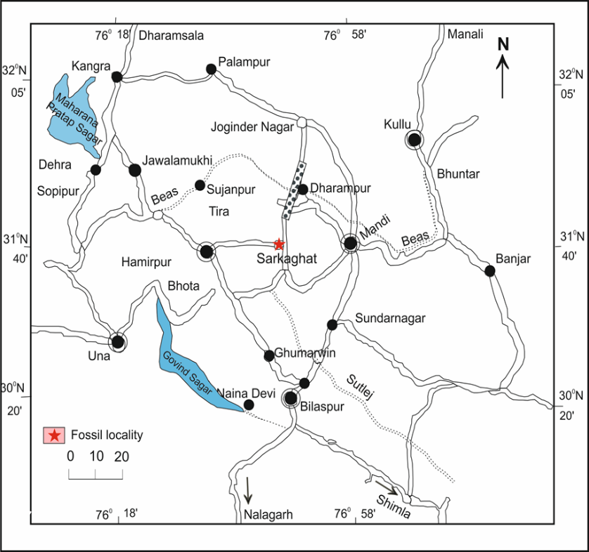
The fossil locality, Sarkaghat (N 31° 44' 26” E 76° 43'33”) lies along the National Highway 70 very near to Sarkaghat area of Mandi District, Himachal Pradesh (Fig. 1). The fossil leaf bearing bed (Fig. 2) is a part of middle Siwalik Sarkaghat anticline. About 8 km from the leaf fossil site is the Nalad Khad section (lat. 31°46’N, long. 76°43’E) which has been magnetostratigraphically studied and dated by earlier workers, Brozovic and Burbank (2000). The Nalad Khad section, the source of the fossil wood material, is located on the western limb of the Sarkaghat anticline within the Jawalamukhi thrust sheet. It comprises thick units of fine- to coarse-grained, dark grey, indurated, multistoried sandstones with intercalated red, yellow, and brown pedogenic mudstones (Cande and Kent, 1995). In the Sarakagahat area the rocks of Sirmur Group and Siwalik Group are also exposed.
Fig. 1. Map showing location of the study area in Sarkaghat, Mandi district, Himachal Pradesh, India

The lithostratigraphy of each formation is given below:
In the Sarkagahat area the rocks of Sirmur Group and Siwalik Group is also exposed, the lithostratigraphy of the formations is given below:
List 1--Lithostratigraphy of the formations
Group | Formation | Member | Lithology
Siwalik | Upper Siwalik | B | Predominantly massive conglomerate with red and orange clay as matrix and minor sandstone and earthy buff and brown clay stone
 |  | A | Sandstone, clay and conglomerate alternation
 | Middle Siwalik | B | Massive sandstone with minor conglomerate and local variegated Claystone
 |  | A | Predominantly medium to coarse – grained sandstone and red clay alternation, soft pebble with subordinate claystone, locally thick prism of conglomerate
 | Lower Siwalik | B | Alternation of fine to medium – grained sporadically pebble sandstone, calcareous cement and predominant chocolate and maroon claystone in the middle part
 |  | A | Red and mauve clay stone with thin intercalations of medium to fine-grained sandstone
Sirmur | Kasauli/ Dharamshala |  | Massive sandstone, subordinate shale
 | Dagsai | Pabo | Alternation of sandstone and clay
 |  | Chimnun | Red and purple claystone with subordinate siltstone
 | Subathu | B | Red, green and indigo blue colored mudston, shale,quartzarenite
 |  | A | Green shale, foraminiferal limestone and oyster marls, quartzarenite, local carbonaceous shale, calcareaous sandstone

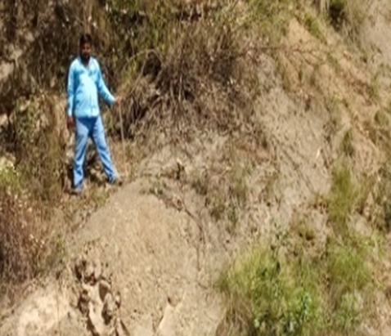
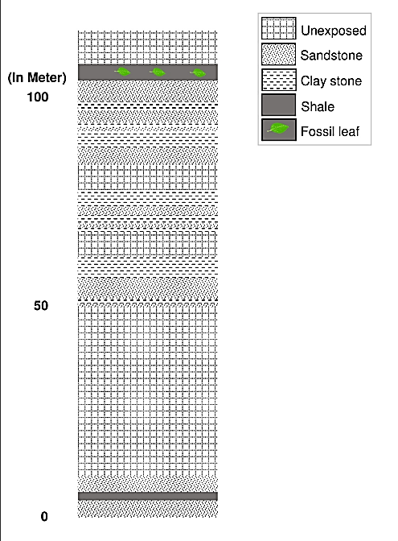
Fig.2. Fossil leaf bearing bed in Middle Siwalik section, near Sagoti Bridge on Sarkaghat - Dharampur Road,
Mandi district, Himachal Pradesh, India.
Fig. 3. Lithocolumn of the Middle Siwalik
section exposed near Sagoti Bridge
(31º 44.265´:76 º.43.339´) near Sarkaghat
from where leaf impressions were collected.

3. MATERIAL AND METHODS
The Siwalik rocks are widely exposed along the Himalayan foothills in Mandi District, Himachal Pradesh. Plant megafossils, including fossil woods and impressions of leaves, fruits, and seeds, were collected from several fossiliferous localities in and around the Sarkaghat area of the district. The petrified fossil wood described in the present study was collected from the Nalad Khad section near the manufacturing bridge (31°45.519′N, 76°42.576′E), located approximately 17 km from Sarkaghat along the Sarkaghat–Dharampur Road, Mandi District, Himachal Pradesh. In addition, numerous carbonized wood fragments were observed embedded within the multistoried sandstone beds of the Sarkaghat area and its surroundings. However, due to the absence of preserved anatomical features, these specimens could not be identified.
The leaf impression specimens were collected from Middle Siwalik strata exposed in a road-cutting section (31°44.265′N, 76°43.339′E), situated about 7 km from Sarkaghat town on the left side of the main road leading to Dharampur (Figs. 2, 3).
For anatomical study, the petrified wood specimens were cut into thin slices along transverse (TS), tangential longitudinal (TLS), and radial longitudinal (RLS) planes using a diamond-edged blade. These slices were subsequently ground into thin sections on a grinding disc with successive grades of carborundum powder. The prepared thin sections were examined in detail under a high-power microscope, and identification was carried out by comparison with modern taxa using published literature and reference slides of modern woods housed in the Xylarium of the Birbal Sahni Institute of Palaeosciences, Lucknow. The leaf impressions were examined morphologically under a low-power microscope and identified through comparison with herbarium specimens preserved at the Central National Herbarium, Howrah, West Bengal. The descriptive terminology of Hickey (1973) and Dilcher (1974) was followed for the systematic description of the leaf impressions. Photographs of leaves from closely related modern taxa are included to highlight their resemblance to the fossil specimens. All fossil material, along with the corresponding photographs and negatives, has been deposited in the Museum of the Birbal Sahni Institute of Palaeosciences, Lucknow.

4. SYSTEMATICS OF FOSSIL PLANTS

1. Fossil wood
Family: Dipterocarpaceae
Genus:Dipterocarpoxylon Holden emend. Den Berger, 1927
Dipterocarpoxylon siwalicus Prakash, 1975
(Figures A-G)
1927 Dipterocarpoxylon Holden emend. Den Berger, p. 495
1975 Dipterocarpoxylon siwalicus Prakash, p. 193; Plate 1, Figs 1–3.
2016 Dipterocarpoxylon siwalicus Prasad and Gautam, p. 252; Plate 1, Figs 1–3.
Material: The present study is based on a single specimen of petrified wood that exhibits well-preserved secondary xylem.
Description: Wood diffuse–porous. Growth rings indistinct. Vessels are mostly medium-sized, with tangential diameters ranging from 145 to 235 µm and radial diameters from 175 to 380 µm. They occur predominantly as solitary elements and are oval in outline, becoming occasionally elliptic due to compression during fossilization. Vessel frequency ranges from 5 to 8 per square millimetre. Tyloses are present. Vessel elements measure 180–570 µm in length, with truncate to tailed end walls. Perforation plates are simple, while intervessel pits are not observed (Fig. 5A, C). Vasicentric trachieds present, paratracheal, slightly bigger than neighboring parenchyma cells in cross section (Fig. 5C). Parenchyma mostly apotracheal, diffuse and diffuse aggregate and surrounding the gum canal, paratracheal parenchyma scanty, present around vessels, parenchyma cells also found around gum duct (Figs. 5A, C). Xylem rays 1-5 (6) seriate, 5-10 rays per mm, rays heterocellular, sheath cells generally present on the both flanks of the rays (Figs. 5 E, F). Fibres are libriform, thick-walled, and non-septate, with interfibre pits not observed (Fig. 5E). Gum canals are vertically oriented and occur singly or in pairs, and occasionally form short tangential bands comprising two to five canals. They are small in size, uniformly distributed throughout the secondary xylem, measure 55–85 µm in diameter, and are round to oval in outline (Fig. 5B).
Specimen: BSIP Museum specimen no. 41235.
Horizon and Age: Middle Siwalik Formation, Upper Miocene.
Locality: Nalad Khad section, near manufacturing bridge (31º 45.519´:76º 42.576´) about 17 km from Sarkaghat on Sarkaghat – Dharampur Road, Mandi District, H.P.
Remarks: The occurrence of vertically oriented gum canals, together with vasicentric tracheids, heterogeneous xylem rays, and diffuse to diffuse-in-aggregate axial parenchyma, indicates a close affinity of the fossil wood with members of the family Dipterocarpaceae. Furthermore, the presence of small, scanty, and predominantly solitary gum canals, along with mostly large, solitary vessels and broad, heterogeneous xylem rays bearing sheath cells on one or both flanks, strongly supports its resemblance to the modern woods of the genus Dipterocarpus C. F. Gaertn. A detailed comparative analysis between the fossil material and thin sections of modern woods of this genus reveals a close similarity with the extant species Dipterocarpus indicus Bedd. (BSIP Wood Slide No. 308; synonym D. turbinatus C. F. Gaertn.). This similarity is evident in the size and distribution pattern of vessels and parenchyma, the structure of xylem rays, and the type and arrangement of vertical gum canals.
Numerous fossil woods attributed to the extant genus Dipterocarpus C. F. Gaertn. have been reported from Cenozoic sediments in India and elsewhere (Table 1). Several of these show close similarity to the present fossil wood, particularly in vessel shape, size, and distribution, as well as in the presence of 1–6-seriate xylem rays. These include Dipterocarpoxylon chowdhurii Ghosh (1956) from Assam, D. siwalicus Prakash (1975) from the Siwalik deposits of Nalagarh, Himachal Pradesh, D. malvii Ghosh & Ghosh (1959) from Kutch, D. schenkii Felix (Schweitzer, 1958) from the Tertiary of Java, D. anisopteroides (Schweitzer, 1958) from the Tertiary of western Java, and D. javanicum (Hofman) Schweitzer (1958) from the Tertiary of western Java.
With the exception of D. siwalicus Prakash, all of these fossil woods differ from the present specimen in having larger gum canals and slightly more abundant parenchyma. Comparative analysis shows that the closest affinity of the present fossil wood is with Dipterocarpoxylon siwalicus Prakash, especially in vessel morphology and distribution, parenchyma characters, and the nature of the xylem rays and gum canals. In both specimens, the fibres are thick-walled and non-septate.
Based on these shared anatomical features, the present fossil wood is assigned to Dipterocarpoxylon siwalicus Prakash. In addition, both D. siwalicus Prakash and the present fossil material closely resemble the same modern species, Dipterocarpus indicus Bedd.

2. Fossil leaf
Family: Dipterocarpaceae Blume
Genus: Dipterocarpus C. F Gaertn.
Dipterocarpus miocenicus Prasad and Gautam, 2016
(Figures. A- E)
2016 Dipterocarpus miocenicus Prasad and Gautam, p. 254, pl. 3, fig. 1; pl. 4, fig.1
Material: This is represented by three, incomplete and well-preserved leaf impressions. Two small specimens show basal portion of fossil leaf.
Description: The leaf is symmetrical and ovate, with preserved sizes ranging from 17.3 × 10.0 cm and 15.0 × 11.0 cm to smaller specimens measuring 4.0 × 6.0 cm and 3.5 × 6.0 cm. The apex is slightly broken, while the base varies from obtuse to lobate ; margin is entire; petiole is present in the smaller specimens, thick and up to 0.7 cm long ; venation is craspedodromous ; primary vein is single, prominent, stout, and straight ; up to ten pairs of secondary veins are visible, spaced 0.7–2.1 cm apart, with the basal secondaries more closely placed;veins are alternate to sub-opposite, diverging at acute angles of less than 50° to 60°, running straight before curving near the margin, and remain unbranched ; tertiary veins are fine, percurrent, and nearly straight to sinuous, occasionally branched; originate mostly at right angles, oblique to the midvein, and are predominantly alternate and closely spaced.
Specimen: BSIP Museum specimen no. 41247, 41283-41284.
Locality: Sagoti Bridge Section near Bawali (31º 44.265´:76 º.43.339´) about 7 km from Sarkaghaton on Sarkaghat- Dharampur Road, Mandi District, Himachal Pradesh, India.
Hortzon and Age: Middle Siwalik, Upper Miocene.
Remarks: The species is characterized by an ovate leaf shape, an obtuse to lobate base, an entire margin, and craspedodromous venation. Additional diagnostic features include closely spaced basal secondary veins that diverge at acute angles and curve markedly near the margin , as well as tertiary veins that are predominantly right-angled in origin, percurrent, usually straight, and occasionally branched.
These characters are commonly observed in the extant leaves of the genus Dipterocarpus C. F. Gaertn. (family Dipterocarpaceae). A detailed examination of herbarium sheets of all available extant species of Dipterocarpus Gaertn. f. indicates that the present fossil leaves show the closest resemblance to those of the living species Dipterocarpus obtusifolius Teysm. (C.N.H. Herbarium Sheet Nos. 50556, 2114; Fig. 5F), matching almost all observed morphological characters.
To date, nine fossil leaf–based form species of the genus Dipterocarpus C. F. Gaertn. have been reported from the Siwalik deposits of India and Nepal. These include Dipterocarpus siwalicus, recorded from Balugoloa, Himachal Pradesh (Lakhanpal and Guleria, 1987); Oodlabari, Darjeeling District, West Bengal (Antal and Prasad, 1996); the Siwalik sediments of Kathgodam, Uttarakhand (Prasad, 1994); the Surai Khola area, western Nepal (Awasthi and Prasad, 1990); and the Lower Siwalik beds of the Koilabas area, western Nepal (Prasad, 1990).

Other reported species include Dipterocarpus koilabasensis from the Koilabas area (Prasad et al., 1999) and the Arjun Khola area of Nepal; Dipterocarpus suraikholaensis from the Siwalik deposits of Surai Khola (Prasad and Pandey, 2008) and the Arjun Khola area of western Nepal (Prasad and Gautam, 2016); and Dipterocarpus miogracilis from the Tanakpur area, Uttarakhand (Prasad et al., 2017). In addition, Dipterocarpus miocenicus, D. nepalensis, and D. churensis have been described from the Siwalik deposits of the Arjun Khola area, western Nepal (Prasad and Gautam, 2019). Dipterocarpus palaeoindicus was reported from the Middle Siwalik of the Arjun Khola area, Nepal (Prasad and Gautam, 2019), while Dipterocarpus dindoriensis was described from the Dindori–Umaria area, Madhya Pradesh (Khan et al., 2020).

Comparison of the present fossil leaf with previously described material reveals a close similarity to the fossil leaf of Dipterocarpus miocenicus Prasad and Gautam (2019), with both specimens sharing nearly all observed morphological characters. On this basis, the present fossil leaf is assigned to the same species, D. miocenicus.
The genus Dipterocarpus C. F. Gaertn. comprises approximately 69 species distributed across the Indo-Malayan region, South India, East Bengal, Assam, the Andaman Islands, Sri Lanka, and Myanmar. Among these, Dipterocarpus obtusifolius Teysm. is an evergreen tree occurring in tropical forests of Southeast Asia, including the Andaman Islands, Myanmar, Thailand, Cambodia, Vietnam, and Peninsular Malaysia (Brandis, 1971; Gamble, 1972; Mabberley, 1997).

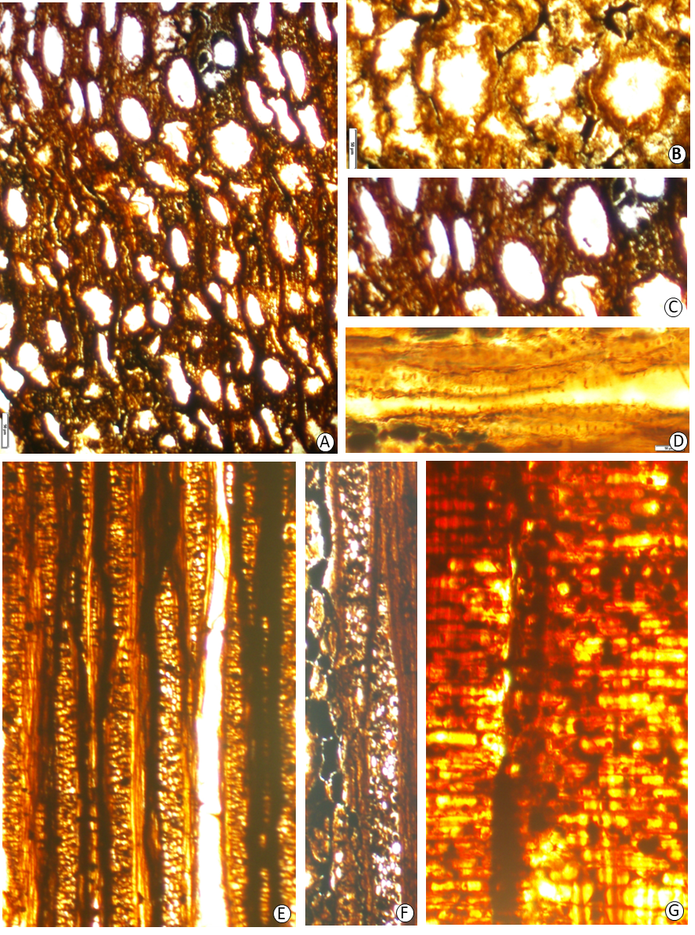
Figure 4. Dipterocarpoxylon siwalicus Prakash 1975-A. Cross section of fossil wood showing nature of vessels, parenchyma and gum canals. Slide no. SKG 155-I. B. Cross section of fossil wood magnified to show detail of gum canals and parenchyma.Slide no. . SKG 155-I. C. Cross section of fossil wood magnified to show nature of vessels and parenchyma. Slide no. SKG 155-I.D. Tangential longitudinal section showing nature of vasicentric tracheids. Slide no. SKG 155-II. E. Tangential longitudinal section showing nature of xylem rays, fibre and parenchyma. Slide no. SKG 155-II.F. Tangential longitudinal section magnified to show detail of xylem rays. Slide no. SKG 155-II.G. Radial longitudinal section of fossil wood showing heterogeneous xylem rays. Slide no. SKG 155-III.

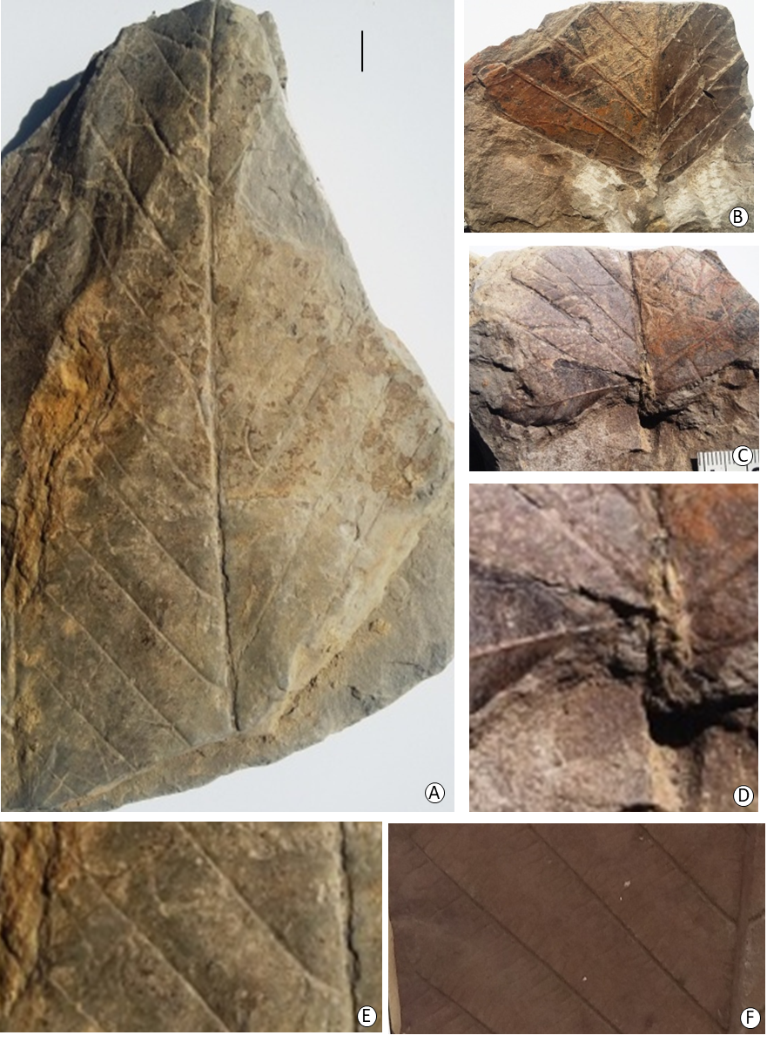
Figure 5. Dipterocarpus miocenica Prasad & Gautam- 2016.A. Fossil leaf showing shape, size and venation
pattern. B.S.I.P Museum specimen no. 41247. B, C. Other fossil leaves showing nature of leaf base. B.S.I.P Museum specimen no. 41283-41284. D. Basal part of fossil leaf magnified to show the nature of lobate base. E. Part of fossil leaf magnified to show details of venation. F. Part of modern leaf, Dipterocarpus obtusifolius Teysm magnified to show similar details of venation.

Table 1- Dipterocarpus F. Gaertn. from Cenozoic sediments of India and abroad

FOSSIL TAXA | HORIZON/AGE | LOCALITY | REFERENCE
Dipterocarpoxylon  Acrotense  Awasthi | Cuddalore Series,  Mio-Pliocene | Murattandichavade  Near Pondicherry, South India | Awasthi, 1980
D. bolpurense  Ghosh & Roy | Upper Miocene  Tipam series,  Upper Miocene  Namsang bed,  Upper Miocene-Pliocene | Santiniketan, Birbhum District, West Bengal  Bisalgarh, near Agartala, Tripura  Deomali, Arunachal Pradesh | Ghosh & Roy, 1979  Mehrotra & Bhattacharya, 2002  Awasthi & Mehrotra, 1997
D. kalagarhensis  Trivedi & Ahuja | Lower Siwalik,  Middle Miocene | Kalagarh, U.P. | Trivedi & Ahuja, 1980
D. malavii  Ghosh & Ghosh, 1959 | Pliocene | Mothala District, Katchch | Ghosh & Ghosh, 1959
D. malavii  Ghosh & Ghosh, 1959 | Kankavati Series,  Pliocene | Kutch, Gujarat | Guleria, 1983
D. malavii  Ghosh & Ghosh | Lower Lalgarh Formation | Silai River section, West Bengal | Bera & Banerjee, 1990
D. kalaicharparense  Eyde | Middle Tertiary  Tippam Series, Upper Miocene | Garo Hills Meghalaya  Namchik River beds, Tirap District, Arunachal Pradesh | Eyde, 1963  Awasthi & Mehrotra, 1997
D. kalaicharparense  Eyde | Tippam Series,  Upper Miocene | Jairampur, Jirap Distt., Arunachal Pradesh | Awasthi & Mehrotra, 1997
D. nalagarhense  Prakash | L. Siwalik, Middle Miocene | Nalagarh,  Himachal Pradesh | Prakash, 1975
D. nungarhense  Trivedi & Ahuja | Lower Siwalik, Middle Miocene | Nungargh Nala, Kalagarh, U. P. | Trivedi and Ahuja, 1980
D. parabaudii  Prakash | Lower-Middle Siwalik,  Middle Mio- Pliocene | Kalagarh, U. P. | Prakash, 1978
D. parabaudii  Prakash | Lower Siwalik,  Middle Miocene | Laxmi River Section, Bhutan | Prasad & Tripathi, 1999
D. pondicherriense  Awasthi | Cuddalore Series,  Miocene-Pliocene | Pondichery, South India | Awasthi, 1974
D. pondicherriense  Awasthi | Kankavati Series,  Pliocene | Kutch, Gujarat | Guleria, 1983
D. premacrocarpum  Prakash | Lower Siwalik,  Middle Miocene | Khokhra, near Nalagarh, Himachal Pradesh | Prakash, 1975
D. siwalicus Prakash | Lower Siwalik,  Lower Churia Formation | Nalagarh, H.P.  Arjun Khola, Nepal | Prakash, 1975  Prasad & Gautam, 2016
D. surengii Prakash | Lower Middle Siwalik,  Middle Miocene- Pliocene | Kalagarh U.P., Pauri Garhwal | Prakash, 1981
D. jammuense Guleria & Srivastava | Middle Siwalik  Shumar Formation | Jammu, J & K.  Jaisalmer District, Rajasthan | Guleria & Srivastava, 2001  Shukla et al., 2013
Dipterocarpoxylon sp. Rawat | Middle Siwalik series,  Upper Miocene-Pliocene | Mohand, U.P. | Rawat, 1964
Dipterocarpoxylon cuddalorense Navale | Cuddalore Series  Mio-Pliocene | Near Pondicherry, South India | Navale, 1963
Fossil wood cf.  Dipterocarpus sp. Navale | Miocene | Neyveli Lignite deposits, South India | Navale, 1963
Fossil wood cf.  Dipterocarpus sp. Navale | Miocene | Neyveli Lignite deposits, South India | Navale, 1974
Fossil wood cf Dipterocarpus turbinatus Guleria | Mar Formation,  Plio-Pleistocene | Bikaner, Rajasthan | Guleria, 1996
Fossil wood cf.  Dipterocarpus sp. Guleria | Shumar Formation | Jaisalmer District, Rajasthan | Guleria, 1986
Fossil wood cf.  Dipterocarpus sp. Antal et al. | Lower Siwalik,  Middle Miocene | Oodlabari, West Bengal | Antal et al., 1998
Fossil wood cf.  Dipterocarpus sp. Prasad & Khare | Middle Siwalik, Mio-Pliocene | Haridwar, U.P. | Prasad & Khare, 1994
Dipterocarpus siwalicus Lakhanpal & Guleria | Lower Siwalik,  Middle- Miocene | Balugoloa near Jawalamukhi, H.P. | Lakhanpal & Guleria, 1987
Dipterocarpus siwalicus Lakhanpal & Guleria | Middle Siwalik, Mio-Pliocene | Oodlabari, West Bengal | Antal & Prasad, 1996
 | Lower Siwalik,  Middle- Miocene | Balia River Section, Kathgodam, U.P. | Prasad, 1994
 | Lower Siwalik,  Middle- Miocene | Koilabas, Nepal | Prasad, 1990
 | Lower Siwalik,  Middle- Miocene | Suraikhola, Nepal | Awasthi & Prasad, 1990
 | Lower Siwalik,  Middle- Miocene | Laxmi River Section, Bhutan | Prasad & Tripathi, 2000
 | Middle Siwalik series, Mio-Pliocene | Surkhet area, Far western Nepal | Prasad & Pradhan, 1998
Dipterocarpus suraikholaensis Prasad & Pandey | Middle Siwalik  Lower Siwalik  Lower Siwalik  L. Churia Formation | Surai Khola, Nepal  Tanakpur, Uttarakhand  Sirmur District, H.P.  Arjun Khola, Nepal | Prasad & Pandey,2008  Prasad et al., 2017  Prasad, 2012  Prasad et al., 2019
Dipterocarpus koilabasensis Prasad et al. | Lower Siwalik,  Middle- Miocene  Middle Siwalik | Koilabas, Nepal  Tanakpur, Uttarakhand | Prasad et al., 1999  Prasad et al., 2017
Dipterocarpus churiense Prasad & Gautam | Lower churia Formation | Arjun Khola, Nepal | Prasad & Gautam, 2016
D. miiocenicus Prasad & Gautam | Lower Churia Formation | Arjun Khola, Nepal | Prasad & Gautam, 2016
D.nepalensis Prasad & Gautam | Lower Churia Formation | Arjun Khola, Nepal | Prasad & Gautam, 2016
D. miogracilis Prasad et al. | Lower Siwalik | Tanakpur, Uttarakhand | Prasad et al., 2017
D. palaeoindicus Prasad et al. | Lower Churia Formation | Arjun Khola, Nepal | Prasad et al., 2019
Dipterocarpus sp.Srivastava et al. | Middle Siwalik | Eastern Nepal | Srivastava et al., 2017
Dipterocarpoxylon goepperti Krausel | Tertiary | Western Java | Schweitzer, 1958
D. krauseli (Den Berger)Edwards | Pliocene | Western Java | Schweitzer, 1958
D. schenki (Felix) Schweitzer | Tertiary | Western Java | Schweitzer, 1958
D. resiniferum Schweitzer | Pliocene | Western Java | Schweitzer, 1958
D. porosum Krausel | Upper Cretaceuos | England | Schweitzer, 1958
D. javanicum (Hofman) Schweitzer | Tertiary | Western Java | Schweitzer, 1958
D. gracile Schweitzer | Pliocene | Western Java | Schweitzer, 1958
D. perforatum Schweitzer | Quaternary | Sumatra | Schweitzer, 1958
D. anisopteroides  Schweitzer | Pliocene | Western Java | Schweitzer, 1958
Dipterocarpoxylon sp. Schweitzer, | Tertiary | Java & Sumatra | Schweitzer, 1958
Dipterocarpus antiqus Heer, | Tertiary | Sumatra | Heer, 1883
D. atavinus Heer | Tertiary | Sumatra | Heer, 1883
Phyllites dipterocarpoides Crie | Pliocene | Western Java | Crie, 1888
Dipterocarpus  nordenskioldi Geyler | Tertiary | Sumatra | Krausel, 1929
Dipterocarpus  labuanus Krausel | Tertiary | Sumatra | Krausel, 1929
Dipterocarpaciophyllum  sumatrense Krausel | Tertiary | Sumatra | Krausel, 1929
Dipterocarpus  Verbekianus (fruit)Heer | Tertiary | Sumatra | Heer, 1874
Pollen of Dipterocarpus and  Dryobalanops | Tertiary and Quaternary | N.W. Borneo | Muller, 1964
Dipterocarpoxylon tertiarum Prakash, | Mio-Pliocene | Myanmar | Prakash, 1973
D. chowdhurii Prakash, | Mio-Pliocene | Myanmar | Prakash, 1973
Dipterocarpoxylon  africanum Bancraft | Tertiary | Near Mount Elgon, East Africa | Bancraft, 1933
Dipterocarpoxylon  africanum Schweitzer | Plio-Plistocene | Somali and East Africa | Schweitzer, 1958
Dipterocarpophyllum humei | Nubian sandstone, Tertiary | Egypt | Schweitzer, 1958
D. zeraibense Schweitzer | Nubian sandstone, Tertiary | Egypt | Schweitzer, 1958
D. scevelianum | Tertiary | East Africa | Chiarugi, 1933
D. giubense | Tertiary | East Africa | Chiarugi, 1933
D. somalense | Plio-Pleistocene | East Africa | Chiarugi, 1933

5. RESULT AND DISCUSSION
The study on the plant fossils from Siwalik sediments of Sarkaghat area, Himachal Pradesh, India revealed the presence of a petrified fossil wood and leaf impression belonging to the phytogeographical important genus, Dipterocarpus C. F. Gaertn. of the family Dipterocarpaceae. Dipterocarpaceae is a family of 17 genera approximately 500 species of mainly low land rain forests. It belongs specially to tropical Asia. About 350 species distributed in South-East Asia (India, Sri Lanka, Myanmar, Malaya, Philippines, Mollucca, Celebes and New Guinea (Fig. 5). Besides, there are two genera, Monotes and Marquesia which are distributed in tropical Africa.
Dipterocarpus C. F. Gaertn. is rather large genus with about 80 species, widely distributed in the Indo-Malayan region. The range of its distribution is from South India and Ceylon in the west to the Philippines in the east. More than 13 species are distributed in the India, Mayanmar and Sri Lanka. Dipterocarpus indicus Bedd. (Syn. D. turbinatus Dyer) which shows close resemblance with the fossil wood grows in the west coast evergreen forests from North Kanara southwards. It is a common tree in the Tellichery Ghats of the North Malabar Division, and Travancore. It also occurs in the Andamans, Assam, Myanmar, Bangladesh, Cochin-China and Thailand (Chowdhury and Ghosh, 1958). However, Dipterocarpus obtusifolius Teysm. with with fossl leaf shows closest affinity is an evergreen tree distributed in the tropical forests of South east Asian regions including Andaman Islands, Myanmar, Thailand, Combodia, Vietnam and peninsular Malaysia (Brandis,1971; Gamble, 1972; Mabberley, 1997).

From a phytogeographical perspective, Dipterocarpaceae represents an important tropical plant family. The distribution patterns of both extant and fossil representatives indicate a predominantly pantropical range, with a major centre of diversity in tropical Asia. An exception to this pattern is represented by the genera Marquesa and Monotes, which are restricted to the African region. Available fossil evidence (Table 1) suggests that the family was already established by the early Middle Oligocene (Merrill, 1923; Müller, 1970). Lakhanpal (1974) proposed a possible origin of Dipterocarpaceae in western Malaysia, a region that presently supports nearly two-thirds of extant dipterocarp species (Desch, 1957) and is also comparatively rich in fossil records (Lakhanpal, 1974; Bande and Prakash, 1986).
Dispersal of dipterocarps from western Malaysia has been suggested to have occurred eastward toward the Philippines and northward through Myanmar into the Indian subcontinent. Such northward movement may have taken place during the Early Miocene, when intermittent land connections between Malaya, Myanmar, and eastern India are thought to have existed. The recorded abundance of dipterocarpaceous taxa, including Dipterocarpus, Anisoptera, Isoptera, Shorea, Hopea, and Dryobalanops, in Miocene–Pliocene deposits of eastern and southern India is consistent with a wider regional distribution during this interval and may reflect subsequent dispersal toward Sri Lanka via the Himalayan foothill region.
The occurrence of dipterocarpaceous remains—such as fossil woods, leaves, fruits, and impressions—in the Himalayan foothills (Prasad, 2008; Prasad et al., 2016) and in Tertiary deposits of Africa (Bancroft, 1933; Chiarugi, 1933; Table 1) further suggests the possibility of westward dispersal from the Indian region into Africa, potentially through Arabian land corridors, as previously proposed (Lakhanpal, 1970; Seward, 1935).
Climatic changes associated with increasing seasonality after the Late Miocene and during the Pliocene may have led to less favourable conditions for dipterocarps across much of the Indian subcontinent. This likely contributed to their progressive decline, along with other moisture-dependent angiosperm taxa, from large parts of India, except in the southern and northeastern regions where suitable climatic conditions persist. The presence of two fossil species of Dipterocarpus documented in the present study is consistent with this broader palaeobiogeographic interpretation
6. CONCLUSION
The present investigation of plant fossils from the Siwalik sediments of the Sarkaghat area, Himachal Pradesh, documents the occurrence of petrified fossil wood and leaf impressions attributable to the genus Dipterocarpus C. F. Gaertn. (family Dipterocarpaceae). Modern comparable species, such as Dipterocarpus indicus Bedd. and D. obtusifolius Teysm., are no longer found in the Siwalik region or the Himalayan foothills, although they presently occur in other parts of India and across Southeast Asia.
The presence of evergreen dipterocarps in the Himalayan foothills during Mio–Pliocene times indicates that the region supported warm, humid climatic conditions and dense evergreen forest vegetation. Such vegetation is typically associated with high and relatively evenly distributed rainfall, suggesting the influence of a stronger or more equable monsoonal regime during this interval compared to the present day.
The occurrence of dipterocarpaceous remains in the Siwalik sediments of Himachal Pradesh implies a wider northward extension of humid tropical vegetation under favourable climatic conditions prior to major Himalayan uplift. Progressive tectonic uplift of the Himalaya, coupled with intensification and increased seasonality of the Indian monsoon during the Late Miocene and Pliocene, likely led to marked changes in precipitation patterns. These changes may have resulted in a shift from evergreen to mixed deciduous vegetation in the Himalayan foothills, ultimately restricting dipterocarps to regions with persistently high rainfall.
The abundance of dipterocarps in Miocene–Pliocene deposits of eastern and southern India (Table 1), along with their continued presence in Sri Lanka, is consistent with their preference for humid monsoonal environments and suggests dispersal through regions that maintained favourable moisture regimes.
Fossil records indicate that the family Dipterocarpaceae was originated by the early Middle Oligocene (Merrill, 1923; Müller, 1970), with a probable centre of origin in western Malaysia, where nearly two-thirds of extant dipterocarp species occur today. From this region, dipterocarps likely dispersed eastward toward the Philippines and northward through Myanmar into the Indian subcontinent. This northward migration may have taken place during the Early Miocene (around 22 Ma), when land connections between Malaya, Myanmar, and eastern India existed and monsoonal circulation was developing or intensifying, facilitating the expansion of humid tropical forests.
DISCLAIMER (ARTIFICIAL INTELLIGENCE)
The author(s) hereby declare that no generative artificial intelligence tools were used in writing or editing of this manuscript
COMPETING INTERESTS
Authors have declared that no competing interests exist.

REFERENCE
Antal, J. S., & Prasad, M. (1996). Dipterocarpaceous fossil leaves from Ghish River section in Himalayan foot-hills near Oodlabari, Darjeeling District, West Bengal. Palaeobotanist, 43, 73–77.​
Antal, J. S., Prasad, M., & Khare, E. G. (1998). In situ fossil woods of Dipterocarpus Gaertn. in the Himalayan foot hills of Darjeeling District, West Bengal, India. Biological Memoirs, 25, 25–28.​
Awasthi, N. (1974). Occurrence of some dipterocarpaceous woods in the Cuddalore Series near Pondicherry. Palaeobotanist, 21(3), 339–351.​
Awasthi, N. (1992). Changing pattern of vegetation through Siwalik succession. Palaeobotanist, 40, 312–327.​
Awasthi, N., & Mehrotra, R. C. (1993). Further contribution to the Neogene flora of North-east India and significance of the occurrence of African element. Geophytology, 23(1), 81–92.​
Awasthi, N., & Mehrotra, R. C. (1997). Some fossil dicotyledonous woods from the Neogene of Arunachal Pradesh, India. Palaeontographica, 245, 109–121.​
Awasthi, N., & Prasad, M. (1990). Siwalik plant fossils from Surai Khola area, Western Nepal. Palaeobotanist, 38, 298–318.​
Bancroft, H. (1933). A contribution to the geological history of the Dipterocarpaceae. Geologiska Föreningen i Stockholm Förhandlingar, 55(1), 59–100.​
Bande, M. B., & Prakash, U. (1986). The Tertiary flora of Southeast Asia with remarks on palaeoenvironment and phytogeography of the Indo-Malayan region. Review of Palaeobotany and Palynology, 49(3–4), 205–233.​
Bera, S., & Banerjee, M. (1990). A new species of Palmoxylon and accretionary structure in the petrified woods from lateritic sediments in the western part of Bengal Basin, India. Indian Journal of Earth Sciences, 17(1), 78–89.​
Brandis, D. (1971). Indian trees. Bishen Singh Mahendra Pal Singh.​
Brozović, N., & Burbank, D. W. (2000). Dynamic fluvial systems and gravel progradation in the Himalayan foreland. Geological Society of America Bulletin, 112(3), 394–412.​
Cande, S. C., & Kent, D. V. (1995). A new geomagnetic polarity time scale for the Late Cretaceous and Cenozoic. Journal of Geophysical Research, 100(B4), 6093–6095.​
Chiarugi, A. (1933). Legni fossili della Somalia Italiana. VI. Fossili dal Pliocene al Pleistocene. Palaeontographica, 32, 97–167.​
Chowdhury, K. A., & Ghosh, S. S. (1958). Indian woods (Vol. 1). Manager of Publications.​
Crie, M. I. (1888). Recherches sur la flore Pliocène de Java. Brill.
Den Berger, L. G. (1927). Unterscheidungsmerkmale von rezenten und fossilen Dipterocarpaceen-Gattungen. Bulletin du Jardin Botanique de Buitenzorg, 3(8), 495–498.​
Desch, H. E. (1957). Manual of Malayan timbers (Vol. 1). Malayan Forest Records, 15.​
Dilcher, D. L. (1974). Approaches to the identification of angiosperm leaf remains. Botanical Review, 40(1), 1–157.​
Eyde, R. H. (1963). A Shoreoxylon and two other Tertiary woods from the Garo Hills, Assam. Palaeobotanist, 11(1–2), 115–121.​
Gamble, J. S. (1972). A manual of Indian timbers. Bishen Singh Mahendra Pal Singh.​
Ghosh, P. K., & Roy, S. K. (1979). Dipterocarpoxylon bolparense sp. nov., a fossil wood of Dipterocarpaceae from the Tertiary of West Bengal, India. Current Science, 48(1), 49–50.​
Ghosh, S. S. (1956). On a fossil wood belonging to the genus Dipterocarpus. Science and Culture, 21, 691–692.​
Ghosh, S. S., & Ghosh, A. K. (1958). Anisopteroxylon jawalamukhiii sp. nov., a new fossil record from the Siwalik. Science and Culture, 24, 238–241.​
Ghosh, S. S., & Ghosh, A. K. (1959). Dipterocarpoxylon malvai sp. nov. – A new fossil record from the Pliocene of Kutch. Science and Culture, 25, 328–332.​
Guleria, J. S. (1983). Some fossil woods from the Tertiary of Kachchh, Western India. Palaeobotanist, 31(2), 109–128.​
Guleria, J. S. (1986). Fossil woods from the Tertiary sediments near Jaisalmer, Rajasthan and their bearing on the age of Shumar Formation. Special Indian Geophytological Conference, Pune (Abstract No. 108).​
Guleria, J. S. (1996). Occurrence of Dipterocarpus in the Mar Formation in Bikaner, Rajasthan, Western India. Palaeobotanist, 43(2), 49–53.​
Guleria, J. S., Gupta, S. S., & Srivastava, R. (2001). Fossil woods from Upper Tertiary sediments of Jammu region (Jammu and Kashmir), North-West India, and their significance. Palaeobotanist, 50(2–3), 225–246.​
Heer, O. (1874). Nachträge zur Miocene Flora Grönlands. Kungliga Svenska Vetenskapsakademiens Handlingar, 13(2), 1–29.​
Heer, O. (1883). Beiträge zur fossilen Flora von Sumatra. Neues Jahrbuch für Mineralogie, Geologie und Paläontologie, 28, 1–22.​
Hickey, L. J. (1973). Classification of the architecture of dicotyledonous leaves. American Journal of Botany, 60(1), 17–33.​
Khan, M. A., Spicer, R. A., Spicer, T. E. V., et al. (2020). Dipterocarpus (Dipterocarpaceae) leaves from the K–Pg of India: A Cretaceous Gondwana presence of the Dipterocarpaceae. Plant Systematics and Evolution, 306(1), Article 4.​
Krausel, R. (1929). Fossile Pflanzen aus dem Tertiär von Süd-Sumatra. Verhandelingen van het Geologisch Mijnbouwkundig Genootschap voor Nederland en Koloniën, 9(1), 1–44.​
Lakhanpal, R. N. (1967). Fossil Rhamnaceae from the Lower Siwalik beds near Jawalamukhi, Himachal Pradesh. Publications of the Centre of Advanced Study in Geology, Panjab University, 3, 23–26.​
Lakhanpal, R. N. (1968). A new fossil Ficus from the Siwalik beds near Jawalamukhi, Himachal Pradesh. Publications of the Centre of Advanced Study in Geology, Panjab University, 5, 17–19.​
Lakhanpal, R. N. (1969). Fossil Fissistigma from the Lower Siwalik near Jawalamukhi, India. In H. Santapau et al. (Eds.), J. Sen Memorial Volume (pp. 311–312).​
Lakhanpal, R. N. (1970). Tertiary flora of India and their bearing on the historical geology of the region. Taxon, 19(5), 675–694.​
Lakhanpal, R. N. (1974). Geological history of the Dipterocarpaceae. In R. N. Lakhanpal et al. (Eds.), Symposium on phytogeography of angiosperms (pp. 30–39). Birbal Sahni Institute of Palaeobotany.​
Lakhanpal, R. N., & Awasthi, N. (1992). New species of Fissistigma and Terminalia from the Siwalik sediments of Balugloa, Himachal Pradesh. Geophytology, 21, 49–52.​
Lakhanpal, R. N., & Dayal, R. (1966). Lower Siwalik plants from near Jawalamukhi, Punjab. Current Science, 35(8), 209–211.​
Lakhanpal, R. N., & Guleria, J. S. (1987). Fossil leaves of Dipterocarpus from the Lower Siwalik beds near Jawalamukhi, Himachal Pradesh. Palaeobotanist, 35, 258–262.​
Mabberley, D. J. (1997). The plant-book: A portable dictionary of the vascular plants (2nd ed.). Cambridge University Press.​
Mehrotra, R. C., & Bhattacharya, A. (2002). Wood of Dipterocarpus from a new locality of the Champa Nagar Formation of Tripura, India. Palaeobotanist, 51, 123–127.​
Merrill, E. D. (1923). Distribution of the Dipterocarpaceae. Philippine Journal of Science, 23, 1–32.​
Muller, J. (1964). A palynological contribution to the history of the Mangrove vegetation of Borneo. In C. M. Cranwell (Ed.), Ancient Pacific flora: The pollen story (pp. 33–42). University of Hawaii Press.​
Muller, J. (1970). Palynological evidence on early differentiation of angiosperms. Biological Reviews, 45(4), 417–450.​
Muller, J. (1981). Fossil pollen records of extant angiosperms. Botanical Review, 47(1), 1–142.​
Navale, G. K. B. (1963). Some silicified dipterocarpaceous woods from Tertiary beds of the Cuddalore Series near Pondicherry, India. Palaeobotanist, 11(1–2), 66–81.​
Navale, G. K. B. (1974). Botanical resolution of some microstructure of Neyveli lignite, South India. Palaeobotanist, 21(3), 359–364.​
Prakash, U. (1973). Fossil woods from the Tertiary of Burma. Palaeobotanist, 20(1), 48–70.​
Prakash, U. (1975). Fossil woods from the Siwalik beds of Himachal Pradesh, India. Palaeobotanist, 22, 192–210.​
Prakash, U. (1978). Fossil woods from the Lower Siwalik beds of Uttar Pradesh, India. Palaeobotanist, 25, 376–392.​
Prakash, U. (1981). Further occurrence of fossil woods from the Lower Siwalik, Uttar Pradesh, India. Palaeobotanist, 28–29, 374–388.​
Prasad, M. (1990). Some leaf impressions from the Lower Siwalik sediments of Koilabas, Nepal. Palaeobotanist, 37, 299–305.​
Prasad, M. (1994). Siwalik (Middle Miocene) leaf impressions from the foot-hills of the Himalaya, India. Tertiary Research, 15, 53–90
Prasad, M. (2006). Plant fossils from Siwalik sediments of Himachal Pradesh and their palaeoclimatic significance. Phytomorphology, 56(1–2), 9–22.
Prasad, M. (2008). Angiospermous fossil leaves from the Siwalik foreland basin and its palaeoclimatic implications. Palaeobotanist, 57, 177–215.
Prasad, M., Alok, Kannaujia, A. K., et al. (2017). Middle Miocene flora from Siwalik foreland basin of Uttarakhand, India and its phytogeographic and palaeoclimatic implications. Palaeobotanist, 66, 223–312.
Prasad, M., & Gautam, S. (2016). Dipterocarpaceous macrofossils from Churia Group of Arjun Khola area, Western Nepal and phytogeographical and palaeoclimatical implications. Palaeobotanist, 62(2), 247–270.
Prasad, M., Antal, J. S., Tripathi, P. P., & Pandey, V. K. (1999). Further contribution to the Siwalik flora from the Koilabas area, Western Nepal. Palaeobotanist, 48, 49–95.
Prasad, M., Gautam, S., Bhowmic, N., Kumar, S., & Singh, S. K. (2019). Miocene flora from the Siwalik of Arjun Khola area, Nepal and its palaeoclimatic and phytogeographic implications. Palaeobotanist, 68, 1–111.
Prasad, M., & Khare, E. G. (1994). Occurrence of Dipterocarpus Gaertn. in the Siwalik sediments of Hardwar, Uttar Pradesh. Biological Memoirs, 20(1), 51–54.
Prasad, M., Mohan, L., & Singh, S. K. (2012). First record of fossil leaves from Siwalik (Upper Miocene) sediments of Mandi District, Himachal Pradesh, India: Palaeoclimatic and phytogeographic implications. Palaeobotanist, 62(2), 165–180.
Prasad, M., & Pandey, S. M. (2008). Plant diversity and climate during Siwalik (Miocene-Pliocene) in the Himalayan foot-hills of western Nepal. Palaeontographica, 278B, 13–70.
Prasad, M., & Pradhan, U. M. S. (1998). Studies on plant fossils from the Siwalik sediments of Far eastern Nepal. Palaeobotanist, 48, 99–109.
Prasad, M., & Tripathi, P. P. (2000). Plant megafossils from the Siwalik sediments of Bhutan and their climatic significance. Biological Memoirs, 26, 6–19.
Ranga Rao, A., Khan, N. N., Venkatachala, B. S., & Sastri, V. V. (1981). Neogene Quaternary Boundary and the Siwalik. In Field Conference NIQ Boundary, India Proceeding (pp. 131–142).
Rawat, M. S. (1964). A new record of Dipterocarpoxylon from Siwalik Formation of Uttar Pradesh. Science and Culture, 30, 337–338.
Seward, A. C. (1935). Leaves of dicotyledons from the Nubian Sandstone of Egypt (pp. 1–21). Ministry of Finance Survey Department, Egypt.
Schweitzer, H. J. (1958). Die fossilen Dipterocarpaceen Hölzer. Palaeontographica, 150B, 1–66.
Shukla, A., Mehrotra, R. C., & Guleria, J. S. (2013). Emergence and extinction of Dipterocarpaceae in western India with reference to climate change: Fossil wood evidences. Journal of Earth System Science, 122(5), 1373–1386.
Srivastava, G., Adhikari, P., Mehrotra, R. C., Paudel, L., Uhl, D., & Paudayal, K. N. (2017). Dipterocarpus Gaertn. (Dipterocarpaceae) leaf from the Middle Siwalik of eastern Nepal and its phytogeographic and climatic significance. Journal of Nepal Geological Society, 53, 39–45.
Trivedi, B. S., & Ahuja, M. (1980). Dipterocarpoxylon nungarhensis n. sp. from Kalagarh (Bijnore District), India. Palaeobotanist, 26(3), 221–225.
Yadav, R. R. (1989). Some more fossil woods from the Lower Siwalik sediments of Kalagarh, Uttar Pradesh and Nalagarh, Himachal Pradesh. Palaeobotanist, 37, 52–62.
​

