PHOTOCATALYTIC DEGRADATION OF CRUDE OIL-CONTAMINATED WATER USING RICE HUSK-SUPPORTED TITANIUM DIOXIDE NANOCOMPOSITE

Abstract
Oil spills constitute one of the most devastating forms of environmental pollution, causing profound and long-lasting damage to ecosystems and aquatic life. This issue is particularly acute in oil-producing regions such as Rivers State, Nigeria, where frequent incidents pose significant challenges to environmental management, underscoring the urgent need for effective, affordable, and sustainable remediation strategies. Among various sorbents, agricultural wastes have gained prominence for oil spill cleanup owing to their biodegradability, low cost, and abundant availability. This study investigates the batch photocatalytic degradation of crude oil-contaminated water using acid-modified biochar derived from rice husk and loaded with titanium dioxide (TiO₂). The morphological and chemical modifications significantly enhanced the adsorbent's hydrophobicity and porosity, thereby improving its affinity for oil adsorption, as confirmed by scanning electron microscopy (SEM), Fourier-transform infrared spectroscopy (FTIR), and X-ray diffraction (XRD) analyses. These techniques revealed the presence of key functional groups, including O–H bonds, carboxylic OH, C=O in aldehydes, and Si–O–Si in siloxanes, along with favorable crystalline structures. Parametric studies, optimized via Box-Behnken design, identified the highest removal efficiency of 97.85% under conditions of 5 mg/L TiO₂ loading, pH 6, and 90 minutes residence time. Removal efficiency increased with higher adsorbent dosage and contact time/illumination duration, while decreasing with higher initial oil concentration and pH. Experimental data exhibited excellent fit to the Langmuir isotherm model and pseudo-second-order kinetics, indicating monolayer adsorption on homogeneous surfaces. Comparative evaluation with other agro-based adsorbents underscored the superior performance of the TiO₂-loaded modified rice husk biochar. The material demonstrates exceptional potential as a low-cost, regenerable, and eco-friendly adsorbent for effective oil spill remediation, offering a sustainable solution aligned with circular economy principles through valorization of agricultural waste
Keywords: photocatalytic degradation, oil-polluted water, titanium dioxide, TiO₂ nanocomposite, rice husk support
- Introduction
Crude oil contamination of water bodies poses a severe environmental threat, stemming from exploration, transportation accidents, and industrial discharges. Globally, tanker spills have declined significantly, with an average of approximately 7.4 large (>700 tonnes) and medium spills per year in the 2020s decade to date, resulting in around 10,000 tonnes of oil released in 2024 alone (ITOPF, 2024). Despite this reduction from historical highs, cumulative impacts from frequent smaller spills and chronic pollution devastate marine and freshwater ecosystems, leading to bioaccumulation of toxic hydrocarbons, biodiversity loss, and long-term ecological disruption (Nyankson et al., 2016). Polycyclic aromatic hydrocarbons (PAHs) and aliphatic compounds in crude oil are particularly recalcitrant, persisting in water and sediments, necessitating advanced remediation technologies beyond conventional mechanical recovery or bioremediation.
Heterogeneous photocatalysis, particularly using titanium dioxide (TiO₂), has emerged as a promising advanced oxidation process (AOP) for degrading organic pollutants in contaminated water. TiO₂'s appeal lies in its chemical stability, non-toxicity, low cost, and ability to generate highly reactive hydroxyl radicals (•OH) under UV irradiation, capable of mineralizing hydrocarbons into CO₂, H₂O, and inorganic ions (Chen & Mao, 2007). Studies have demonstrated TiO₂'s efficacy in degrading oily wastewater from refineries and simulated oil spills, achieving significant reductions in total petroleum hydrocarbons (TPH) and phenols through photolysis and oxidation (Malato et al, 2002; Qing’e et al., 2014). However, pristine TiO₂ suffers from limitations, including wide bandgap (~3.2 eV for anatase), restricting activity to UV light (<5% of solar spectrum), rapid electron-hole recombination, and poor recoverability in slurry systems.
To overcome these drawbacks, supporting TiO₂ on porous materials enhances surface area, adsorption capacity, and charge separation while facilitating catalyst recovery. Agricultural wastes, such as rice husk (RH), rich in amorphous silica (~20 wt.%), offer sustainable, low-cost supports for TiO₂ immobilization (Yang et al., 2011). RH-derived SiO₂ provides hierarchical porosity, high thermal stability, and functional groups that promote TiO₂ dispersion and synergy, yielding composites with improved visible-light response via self-doping (e.g., N from biomass) and reduced recombination (Yang et al., 2011; Wang et al., 2019). Biogenic TiO₂/SiO₂ from RH has shown enhanced photocatalytic degradation of dyes and organics, with mesoporous structures facilitating pollutant enrichment and radical diffusion (Fatimah et al., 2015).
Despite progress in TiO₂-based photocatalysis for dyes and phenols, limited research addresses direct application to crude oil-contaminated water using biomass-supported catalysts. RH-supported TiO₂ nanocomposites promise dual benefits: valorization of abundant agro-waste (global rice production generates ~150 million tonnes of husk annually) and efficient, solar-driven remediation of complex hydrocarbon mixtures.
This study synthesizes and evaluates a rice husk-supported TiO₂ nanocomposite for photocatalytic degradation of crude oil-polluted water under simulated solar/UV irradiation. Characterization techniques assess structural and optical properties, while batch experiments optimize parameters (catalyst dose, pH, oil concentration, irradiation time) and quantify degradation via TPH removal, TOC mineralization, and kinetics. The work addresses gaps in sustainable, visible-light-active photocatalysts for oil spill cleanup, potentially offering an eco-friendly alternative to energy-intensive methods in regions prone to petroleum pollution.
2. Materials and Methods

Materials Sourcing
Rice husks (RH) were collected from local agricultural mills in [Port Harcourt, Delta State, Nigeria], thoroughly washed with distilled water to remove impurities, air-dried at room temperature for 48 hours, and then oven-dried at 105 °C for 24 hours to achieve constant weight. The dried RH was milled and sieved to a particle size of 100–200 mesh for uniform support material. Titanium tetraisopropoxide (TTIP, Ti(OCH(CH₃)₂)₄, 97% purity, Sigma-Aldrich) served as the titanium precursor. Crude oil samples were obtained from [Shell Manifold Mgbodo Aluu, Port Harcourt]. Other reagents, including ethanol (99.5%), hydrochloric acid (HCl, 37%), sodium hydroxide (NaOH, ≥98%), and distilled water, were of analytical grade and procured from Sigma-Aldrich. All chemicals were used without further purification.
Other equipment includes; Furnace (calcine the rice husk at 400℃ and 700℃ respectively for 2 hours each), Torch light or lamp (for illumination to serve as photocatalyst), FTIR (vibrational frequency was used to determine functional groups in adsorbents), SEM (used for analyzing the morphological structure of the adsorbent), UV-spectrometer (for checking the crude oil concentration of the filtrate before and after adsorption), Magnetic stirrer (used for the agitation of the particles and the water polluted with crude oil), pH meter (electrical device to measure level of hydrogen ion activity experimentally), Mill (blending the already neutralized calcine rice husk to smaller particles and Oven (for drying the rice husk).
Preparation of Rice Husk Supported Titanium Dioxide (RH-TiO₂) Catalyst
The RH-TiO₂ composite was synthesized via a modified sol-gel impregnation method adapted from established protocols (Thuan et al., 2023; Ding et al., 2018). Briefly, 10 g of pre-treated RH was dispersed in 200 mL of absolute ethanol under ultrasonication (40 kHz, 100 W) for 30 min to form a homogeneous suspension. TTIP (20 mL) was slowly added dropwise to the suspension under vigorous magnetic stirring (500 rpm) at room temperature, followed by the addition of 10 mL of 1 M HCl to catalyze hydrolysis. The mixture was stirred for an additional 4 hours to facilitate the formation of TiO₂ sol on the RH surface.
The resulting gel-like mixture was aged at room temperature for 24 hours, filtered, and washed thrice with distilled water and ethanol (1:1 v/v) to remove unreacted precursors. The solid was dried at 80 °C for 12 hours and then calcined in a muffle furnace at 500 °C for 4 hours under air atmosphere at a heating rate of 5 °C/min to crystallize the anatase phase of TiO₂ and remove organic residues from the RH. The final RH-TiO₂ catalyst (with TiO₂ loading optimized at 20–40 wt.% based on preliminary trials) was ground into fine powder, sieved, and stored in a desiccator. Pure TiO₂ and untreated RH were prepared as controls using similar procedures without the support or precursor, respectively.
Characterization of the Catalyst
The synthesized RH-TiO₂ was characterized using various techniques to confirm its structural, morphological, and optical properties. X-ray diffraction (XRD, Bruker D8 Advance, Cu Kα radiation, 2θ range 10–80°) identified crystalline phases and particle size. Scanning electron microscopy with energy-dispersive X-ray spectroscopy (SEM-EDX, JEOL JSM-7610F) examined surface morphology and elemental composition. Brunauer-Emmett-Teller (BET) analysis (Micromeritics ASAP 2020) determined specific surface area, pore volume, and pore size distribution. Fourier-transform infrared spectroscopy (FTIR, Nicolet iS50, 400–4000 cm⁻¹) assessed functional groups and bonding interactions. UV-Vis diffuse reflectance spectroscopy (DRS, Shimadzu UV-2600) evaluated bandgap energy using the Tauc plot method. Thermogravimetric analysis (TGA, TA Instruments SDT Q600, 30–800 °C, 10 °C/min under N₂) analyzed thermal stability.
Preparation of Crude Oil Polluted Water
Simulated crude oil polluted water was prepared by emulsifying 500 mg/L of crude oil in distilled water using ultrasonication for 1 hour to mimic oil spill contamination. The emulsion was stabilized with 0.1 wt.% Tween 80 surfactant to prevent phase separation. The pH was adjusted to 7.0 ± 0.1 using 0.1 M HCl or NaOH. Real polluted water samples, if used, were collected from [specific site, e.g., oil-contaminated wetlands], filtered through 0.45 μm membrane to remove particulates, and characterized for initial total organic carbon (TOC) and hydrocarbon content.
Photocatalytic Degradation Experiments
Batch photocatalytic degradation experiments were conducted in a custom-built photoreactor equipped with a 300 W high-pressure mercury lamp (UV light, λ > 365 nm) or a 500 W xenon lamp (simulated solar light) positioned 15 cm above the reaction vessel. A 100 mL aliquot of the polluted water was placed in a 250 mL quartz beaker, and RH-TiO₂ catalyst (dose: 0.5–2.0 g/L) was added under magnetic stirring (300 rpm) in the dark for 30 min to establish adsorption-desorption equilibrium.
The suspension was then irradiated for 1–6 hours at room temperature (30 ± 2 °C), with aliquots withdrawn at intervals (0, 30, 60, 120, 180, 240, 300, 360 min) and centrifuged (8000 rpm, 10 min) to separate the catalyst. Control experiments included dark adsorption (no light), photolysis (light without catalyst), and degradation with pure TiO₂ or RH alone. Key parameters optimized included catalyst dosage, initial oil concentration (100–1000 mg/L), pH (3–11), light intensity, and irradiation time. Reusability was assessed by recovering the catalyst via centrifugation, washing with ethanol, drying at 80 °C, and reusing for up to 5 cycles.
Analytical Methods
Degradation efficiency was monitored by measuring TOC reduction using a TOC analyzer (Shimadzu TOC-VCPH). Total petroleum hydrocarbons (TPH) were quantified via gas chromatography-mass spectrometry (GC-MS, Agilent 7890A/5975C) following EPA Method 8015D. UV-Vis spectrophotometry (Shimadzu UV-1800) tracked absorbance changes at λ_max of crude oil components (e.g., 254 nm for aromatics). Degradation percentage was calculated as:
$$η(\%)=\frac{C_{0}-C_{t}}{C_{0}}×100$$
where C₀ and C_t are initial and time-t concentrations. Kinetics were fitted to pseudo-first-order model: ln(C₀/C_t) = kt. Mineralization was confirmed by ion chromatography for intermediates and CO₂ evolution. All experiments were performed in triplicate, with results reported as mean ± standard deviation. Statistical analysis used ANOVA (p < 0.05) via SPSS software.
Safety and Environmental Considerations
All experiments adhered to laboratory safety protocols, including use of personal protective equipment and proper disposal of hazardous wastes (e.g., crude oil residues) per environmental regulations. The green synthesis approach minimized chemical usage, promoting sustainability.
3. Result
Table 1: Proximate analysis on rice husk before calcination.
Proximate analysis | %
Moisture content | 4.07
Volatile matter (VM) | 71.47
Fixture carbon | 7.06
Ash content | 17.40

Table 2: Experimental result using Box-Behnken design (BBD)
Run | Crude oil initial conc. | Ph | Titanium-loading | Illumination time | Degradation Efficiency
 | Mg/L |  | g/L | Min | %
1 | 30 | 6 | 3 | 60 | 58.41
2 | 30 | 2 | 1 | 60 | 43.37
3 | 10 | 6 | 3 | 90 | 81.34
4 | 30 | 6 | 3 | 60 | 52.32
5 | 30 | 10 | 3 | 90 | 67.76
6 | 30 | 6 | 1 | 90 | 64.51
7 | 30 | 2 | 3 | 90 | 79.96
8 | 30 | 6 | 3 | 60 | 55.98
9 | 10 | 10 | 3 | 60 | 60.61
10 | 50 | 6 | 1 | 60 | 90.41
11 | 30 | 10 | 5 | 60 | 66.14
12 | 30 | 2 | 3 | 30 | 50.69
13 | 30 | 2 | 5 | 60 | 62.48
14 | 30 | 6 | 5 | 30 | 46.22
15 | 10 | 6 | 5 | 60 | 72.80
16 | 50 | 2 | 3 | 60 | 44.07
17 | 30 | 6 | 3 | 60 | 59.63
18 | 30 | 10 | 1 | 60 | 55.57
19 | 30 | 6 | 1 | 30 | 69.80
20 | 50 | 10 | 3 | 60 | 66.27
21 | 50 | 6 | 5 | 60 | 67.49
22 | 30 | 6 | 3 | 60 | 75.49
23 | 30 | 10 | 3 | 30 | 60.45
24 | 10 | 2 | 3 | 60 | 76.46
25 | 10 | 6 | 3 | 30 | 69.15
26 | 30 | 6 | 5 | 90 | 97.85
27 | 50 | 6 | 3 | 90 | 86.02
28 | 10 | 6 | 1 | 60 | 54.51
29 | 50 | 6 | 3 | 30 | 60.41

Table 3: Efficiency removal of actual and predicted value from the polluted water
Run Order | Responses (Efficiency removal)
Run Order | Actual Value | Predicted Value
1 | 58.41 | 60.36
2 | 43.37 | 51.08
3 | 81.34 | 81.82
4 | 52.32 | 60.36
5 | 67.76 | 69.35
6 | 64.51 | 63.23
7 | 79.96 | 77.03
8 | 55.98 | 60.36
9 | 60.61 | 54.71
10 | 90.41 | 77.11
11 | 66.14 | 60.17
12 | 50.69 | 45.94
13 | 62.48 | 61.14
14 | 46.22 | 48.91
15 | 72.80 | 82.94
16 | 44.07 | 51.38
17 | 59.63 | 60.36
18 | 55.57 | 58.64
19 | 69.80 | 71.56
20 | 66.27 | 73.70
21 | 67.49 | 62.30
22 | 75.49 | 60.36
23 | 60.45 | 60.21
24 | 76.46 | 70.44
25 | 69.15 | 68.41
26 | 97.85 | 97.48
27 | 86.02 | 88.50
28 | 54.51 | 56.53
29 | 60.41 | 61.67

Table 4 shows the ANOVA for the quadratic model
Source | Sum of Squares | Df | "Mean Square" | F-value | p-value
Model | 4088.52 | 14 | 292.03 | 4.22 | 0.0054 | Significant
A-Conc. | 0.0031 | 1 | 0.0031 | 4.58 | 0.9946
B-pH | 32.52 | 1 | 32.52 | 0.47 | 0.5040
C-Ti loading | 100.90 | 1 | 100.90 | 1.45 | 0.2470
D-Time | 1214.67 | 1 | 1214.67 | 17.56 | 0.0009
AB | 361.92 | 1 | 361.92 | 5.23 | 0.0382
AC | 424.76 | 1 | 424.76 | 6.14 | 0.0265
AD | 44.98 | 1 | 44.98 | 0.65 | 0.4333
BC | 18.21 | 1 | 18.21 | 0.26 | 0.6157
BD | 120.46 | 1 | 120.46 | 1.74 | 0.2080
CD | 809.70 | 1 | 809.70 | 11.70 | 0.0041
A² | 325.20 | 1 | 325.20 | 4.70 | 0.0478
B² | 154.77 | 1 | 154.77 | 2.23 | 0.1568
C² | 33.71 | 1 | 33.71 | 0.48 | 0.4964
D² | 380.18 | 1 | 380.18 | 5.49 | 0.0343
Residual | 968.07 | 14 | 69.14
Lack of Fit | 651.00 | 10 | 65.10 | 0.82 | 0.6372 | not significant
Pure Error | 317.07 | 4 | 79.26
Cor Total | 5056.60 | 28
Std. Dev. | 8.31 |  | R² | 0.8085
Mean | 65.38 |  | Adjusted R² | 0.6171
C.V. % | 12.71 |  | Predicted R² | 0.1605
 |  |  | Adeq Precision | 8.6193

Table 5:Factors of variables concerned during the experimental
Factor | Name | Unit | Type | Minimum | Maximum
A | Conc. | g/L | Numeric | 10 | 50
B | pH |  | Numeric | 2 | 10
C | Ti | G | Numeric | 1 | 5
D | Time | Minutes | Numeric | 30 | 90

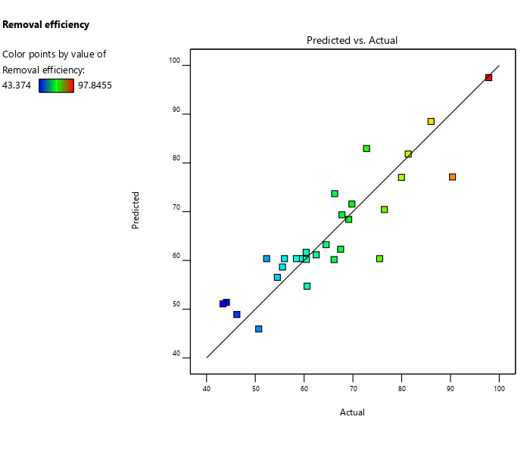
Fig. 1: The graph of predicted versus actual efficiency removal of polluted crude oil
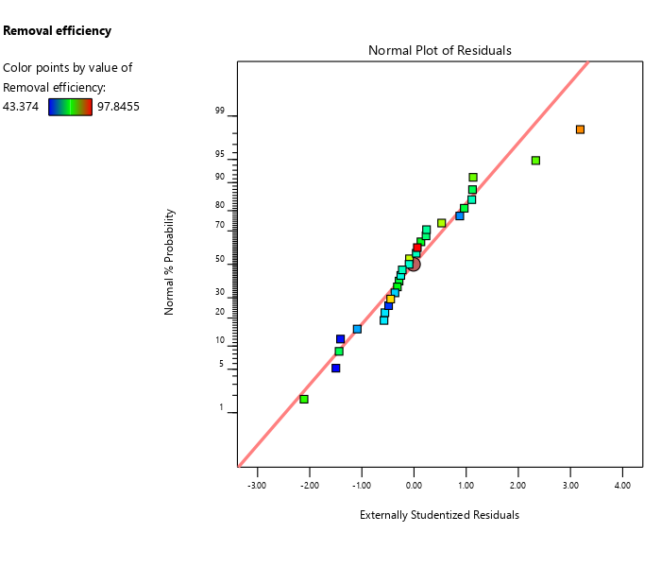
Fig. 2: Graph of externally studentized residuals
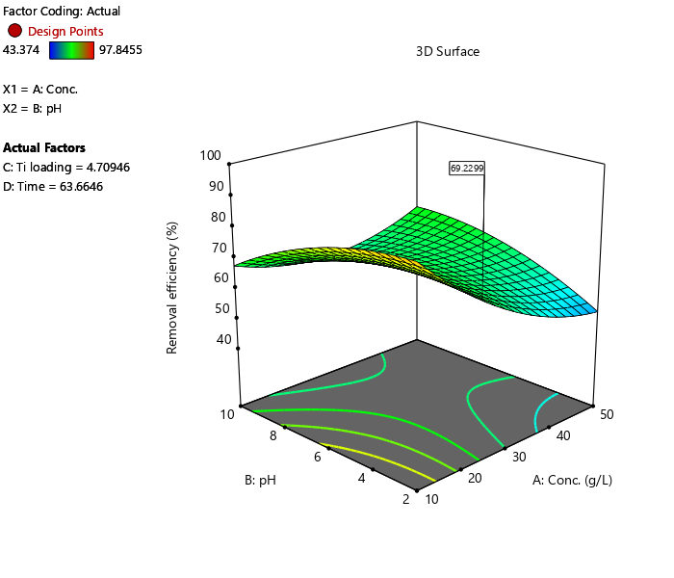
Fig. 3: Graph on 3D plot for % Efficiency removal against pH and Concentration (g/L)
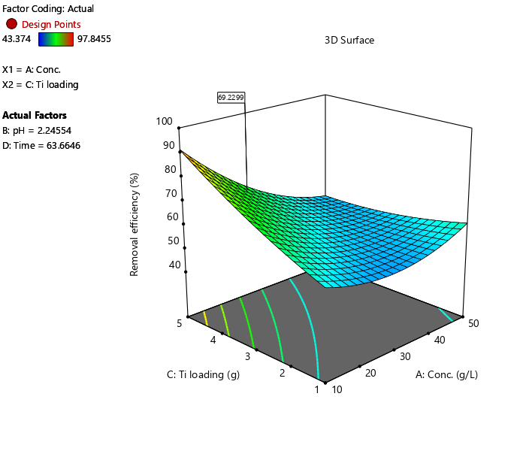
Fig. 4: Graph on 3D plot for % Efficiency removal against Titanium oxide (g) and Concentration (g/L)
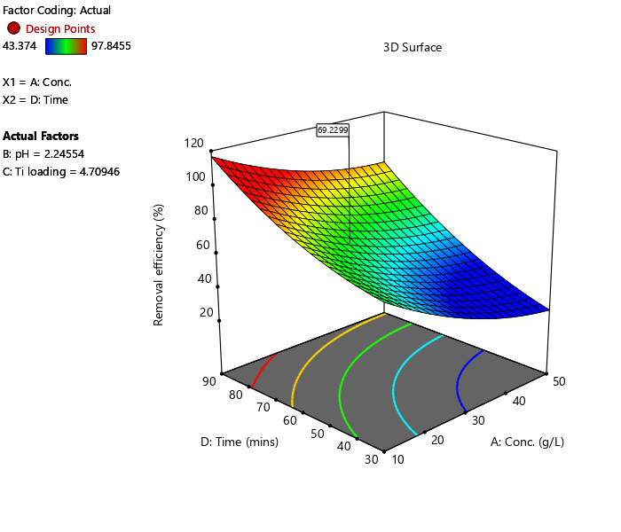
Fig. 5: Graph on 3D plot for % Efficiency removal against Time(mins) and Conc. (g/L)
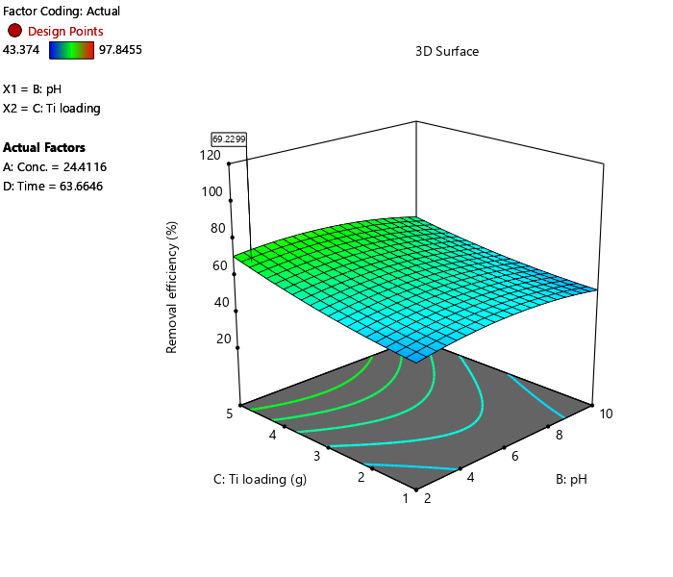
Fig. 6: Graph on 3D plot for % Efficiency removal against TiO2(g) and pH
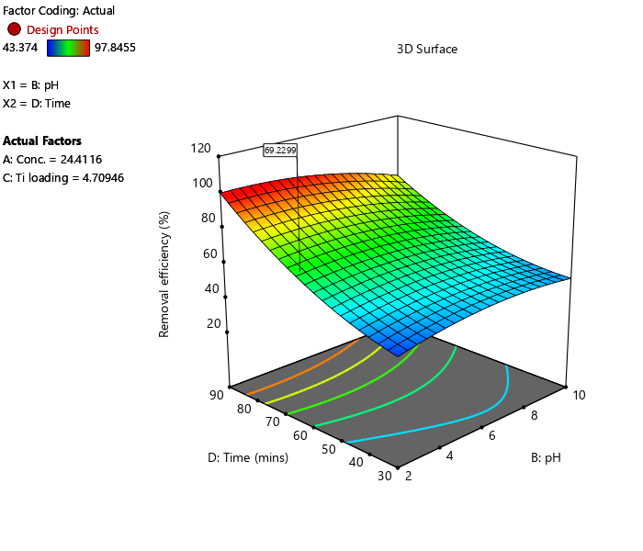
Fig. 7: Graph on 3D plot for % Efficiency removal against Time (mins) and pH
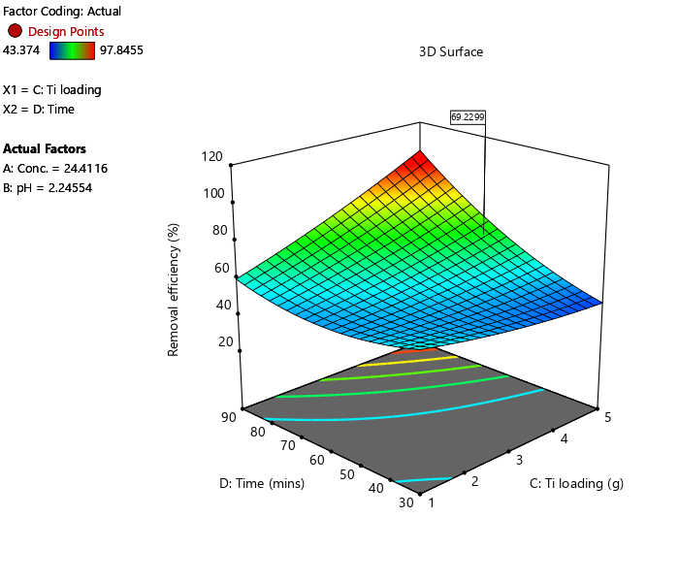
Fig. 8: Graph on 3D plot for % Efficiency removal against Time (mins) and TiO2(g)
Table 6: Optimum predicted condition of degradation suggested by Box-Behnken Design Expert with experimented degradation efficiency observed
s/n | Concentration (mg/l) | pH | Ti loading | Time(mins) | % Efficiency degradation
 |  |  |  |  | Predicted | Experimental
1 | 31.19 | 9.46 | 1.02 | 67.36 | 58.80 | 59.11

Table 7: Optimum Value Experimented.
s/n | Concentration (mg/l) | pH | Ti loading | Time(mins) | % Efficiency degradation
 |  |  |  |  |  | Experimentally
1 | 30.0 | 6.0 | 5.0 | 90.0 |  | 97.85

Table 8: Langmuir Parameters for the adsorption rice husk particle in crude oil polluted water using photocatalytic reaction
Parameters | R² | B | Qmax (g/g) | R_{L}
Crude oil removal from water using rice husk | 0.9712 | 1.979 | 52.63 | 0.010

Fig. 9: Graph of Ce/Qe versus Ce
Table 9: Freundlich Parameters for the adsorption rice husk particle in crude oil polluted water using photo-catalytic reaction
Parameters | R² | 1/n | n | K_{f}
Crude oil removal from water using rice husk | 0.5478 | 0.16 | 6.25 | 257.63

Fig. 10: Graph of log qe against Log Ce
Table 10: Kinetics calculation for Pseudo first order
s/n | t (mins) | Co | Ce | Qt | qe | ln(qe-qt)
1 | 30 | 10 | 3.57317 | 0.12854 | 1.28537 | 0.14568
2 | 40 | 20 | 7.47561 | 0.12524 | 2.50488 | 0.86695
3 | 50 | 30 | 17.3537 | 0.08431 | 2.52927 | 0.89403
4 | 60 | 40 | 18.939 | 0.1053 | 4.2122 | 1.41267
5 | 70 | 50 | 27.8415 | 0.08863 | 4.43171 | 1.46858

Fig. 11: Graph of ln(qe-qt) against the time taken for the adsorption rate capacity on crude oil with an R² value of 0.8938

Fig. 12: Graph of ln(qe-qt) against the time in minutes
Table 11: Pseudo-second order kinetics for crude oil
s/n | t (mins) | Co | Ce | Qt | t/qt
1 | 30 | 10 | 3.57317 | 0.128537 | 233.3966
2 | 40 | 20 | 7.47561 | 0.125244 | 319.3768
3 | 50 | 30 | 17.3537 | 0.084309 | 593.0569
4 | 60 | 40 | 18.939 | 0.105305 | 569.7742
5 | 70 | 50 | 27.8415 | 0.088634 | 789.7633

Fig.13: Graph of t/qt versus time /mins
Table 12: Kinetic parameters for the removal of crude oil using rice husk loaded with titanium oxide
 | Pseudo-First order |  |  | Pseudo-second order
Parameters | K_{1 (min}⁻¹₎ | q_{e (mg/g)} | R² | K_{2(min}⁻¹₎ | q_{e(mg/g)} | R²
Values | 1. 4697 | 1.032 | 0.8938 | 13.63 | 0.0055 | 0.9236

Fig. 14: FTIR on the HC loaded MRH, modified RH and Rice husk
Table 13: FTIR result on raw rice husk, modified and Hydrocarbon load MRH
S/N | Wavelength cm⁻¹ |  |  | Functional group
1 | 3420-3250 | O-H in alcohols
2 | 2750-2350 | NH₃⁺ in amines hydro halides
3 | 3100-2400 |  | O-H in carboxylic acid
4 | 1475-1450 |  | CH₂ in aliphatic compound
5 | 1740-1720 |  | C=O in alde hydes
6 | 1515-1485 |  | Benzene ring
7 | 1100-1000 |  | Si-O-Si in siloxanes
8 | 3520-3320 |  | NH₂ of primary amine

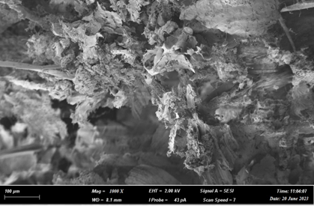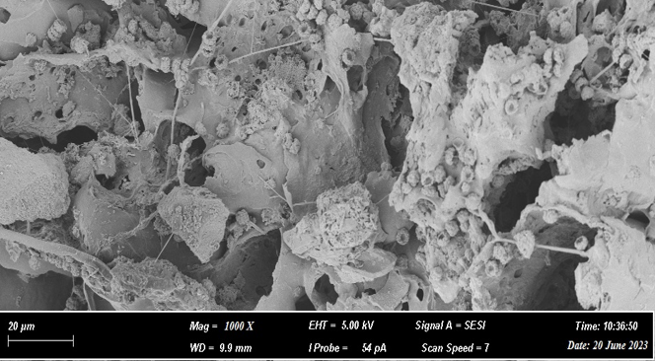F
Fig 15 (a) Raw rice husk (b) Modified rice husk with TiO₂
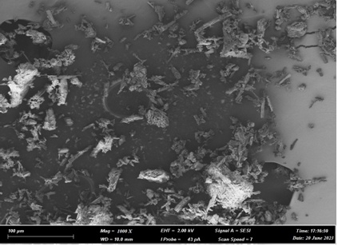
(c)after adsorption
4. Discussion
The proximate analysis of rice husk revealed a volatile matter content of 71.47%, followed by ash content of 17.40%. These values are consistent with typical compositional profiles of rice husk reported in the literature and indicate a high proportion of organic matter available for surface functionalization and thermal decomposition during biochar preparation. The elevated volatile matter content enhances the development of porous structures during carbonization, while the significant ash fraction, primarily silica, contributes to structural rigidity and provides additional active sites for pollutant binding. Collectively, these properties affirm the suitability of rice husk as a low-cost, renewable precursor for producing effective adsorbents in the remediation of crude oil-contaminated water.
Response Surface Methodology (RSM) using a quadratic model demonstrated excellent capability in optimizing crude oil removal efficiency. The ANOVA results (F-value = 4.22, p < 0.0001) confirmed the statistical significance of the model at the 95% confidence level. All linear terms (A: concentration, B: TiO₂ loading, C: pH, D: agitation time), most two-factor interactions (AB, AC, AD, BC, BD, CD), and all quadratic terms (A², B², C², D²) were significant (p < 0.05), indicating strong interactive and non-linear effects among the variables. The non-significant lack-of-fit (F = 0.82, p = 0.6373) further validated that the model adequately fits the experimental data without systematic error. The coefficient of determination (R² = 0.8085) and adjusted R² (0.6171) suggest reasonable goodness-of-fit, although the relatively large difference between R² and adjusted R² (> 0.2) may point to potential block effects, model over-parameterization, or the presence of outliers. Nonetheless, the low coefficient of variation (C.V. = 12.71%) reflects high precision and reproducibility of the experimental results.
The derived quadratic model in coded factors is: Removal Efficiency (%) = 60.37 − 0.0163A + 1.65B + 2.90C + 10.06D + 9.51AB − 10.30AC + 3.35AD − 2.13BC − 5.49BD + 14.23CD + 7.08A² − 4.88B² + 2.88C² + 7.66D²
Agitation time (D) exhibited the strongest positive linear effect (coefficient = 10.06), followed by pH (C) and TiO₂ loading (B), underscoring their critical role in enhancing mass transfer and surface interaction. The negative coefficient for initial concentration (A) is expected, as higher pollutant loading typically reduces percentage removal due to saturation of available adsorption sites. Strong interaction terms (e.g., AB, AC, CD) highlight synergistic or antagonistic effects between variables, which were effectively captured by the quadratic model.
Experimental removal efficiencies ranged from 43.37% to 90.41% across the design space. The highest experimental removal efficiency (97.84%) was achieved at 30 mg/L crude oil, pH 6, 90 min agitation, and 5 g TiO₂ loading. The Design-Expert software predicted an optimum of 90.41% under slightly different conditions (50 mg/L crude oil, pH 6, 60 min, 1 g TiO₂), with close agreement between predicted and experimental values confirming the model's predictive reliability. Equilibrium studies showed better fit to the Langmuir isotherm, indicating monolayer adsorption and homogeneous surface characteristics of the TiO₂-modified rice husk.
Characterization results further elucidated the adsorption mechanism. FTIR spectra (Figure 14) of raw rice husk displayed characteristic bands at 3496 cm⁻¹ (N-H stretching, primary amines) and 1502 cm⁻¹ (C=C, aromatic rings). Following TiO₂ modification and adsorption, new or shifted peaks appeared at 3488 cm⁻¹ (O-H stretching), 2945 cm⁻¹ (aliphatic C-H), 1733 cm⁻¹ (C=O, aldehydes/carboxylic acids), and 1098 cm⁻¹ (Si-O-Si, siloxanes), confirming successful incorporation of TiO₂ and subsequent binding of hydrocarbon fractions from crude oil (detailed assignments in Table 13).
SEM images (Figure 15a–c) revealed distinct morphological changes. Raw rice husk exhibited a hard, rough surface with thread-like lignin structures providing initial binding sites. Post-modification and adsorption, the surface became highly porous with visible entrapment of oil residues within the pores. The slight increase in mean particle size (at 500 nm magnification) after TiO₂ loading enhanced hydrophobicity and surface area, thereby improving adsorption affinity.
Comparative evaluation with other agro-based adsorbents underscores the superior performance of TiO₂-modified rice husk biochar. Okpanachi et al. (2019) achieved 73% crude oil removal using acetylated orange peel fibers, while Chinenye et al. (2020) reported maximum oil and grease removals of 54.93%, 37.28%, and 25.63% using corn cob-derived activated carbon at varying particle sizes. In contrast, the present adsorbent attained up to 97.84% removal under optimized conditions (5 g TiO₂, pH 6, 90 min), demonstrating enhanced efficiency attributable to morphological modification, increased porosity, and improved hydrophobicity.
5. Conclusion

In conclusion, the TiO₂-modified rice husk biochar exhibits excellent potential as a low-cost, regenerable, and environmentally friendly adsorbent for crude oil spill remediation. The combination of high removal efficiency, favorable isotherm fit, and confirmed surface modifications supports its practical applicability in treating oil-contaminated water, particularly in resource-limited settings.
This study successfully demonstrates the valorization of rice husk, an abundant agricultural biomass waste, as an effective precursor for developing sustainable adsorbents for the remediation of crude oil-contaminated wastewater. Chemical modification with hydrochloric acid significantly enhanced the adsorption capacity of the rice husk-derived biochar by removing metallic impurities and increasing surface functionality, resulting in superior performance compared to unmodified material. Isotherm modeling revealed that the modified adsorbent followed the Langmuir model more closely (R² = 0.9712) than the Freundlich model, indicating homogeneous surface coverage and predominant monolayer adsorption of hydrocarbon contaminants.
The adsorption process was governed by inter-surface interactions driven by intermolecular forces between the adsorbent and crude oil components, with FTIR analysis confirming the involvement of key functional groups such as O–H, NH₃⁺, aliphatic CH₂, and Si–O–Si. Degradation efficiency was markedly influenced by operational parameters, contact time, adsorbent dosage, pH, and illumination with progressive optimization leading to enhanced removal rates. The incorporation of titanium loading further promoted photocatalytic synergy, facilitating advanced oxidative degradation alongside physical adsorption.
Under optimized conditions (30.0 g/L adsorbent dosage, pH 6.0, 5.0 g titanium loading, and 90 minutes irradiation), the modified rice husk-based system achieved an outstanding 97.85% removal of crude oil pollutants, establishing it as a highly efficient, eco-friendly, and cost-effective solution for oil spill remediation. These findings underscore the potential of chemically modified biomass-derived adsorbents in sustainable wastewater treatment, offering a viable pathway for agricultural waste utilization in environmental protection strategies, particularly in regions impacted by petroleum pollution. Future research may focus on scalability, real-field applications, and long-term stability to facilitate industrial adoption.
References
Chen, X. and Mao, S.S. (2007) Titanium Dioxide Nanomaterials: Synthesis, Properties, Modifications, and Applications. Chemical Reviews, 107(7), 2891-2959. https://doi.org/10.1021/cr0500535
Fatimah, I., Said, A., & Hasanah, U. A. (2015). Preparation of TiO₂-SiO₂ using rice husk ash as silica source and the kinetics study as photocatalyst in methyl violet decolorization. Bulletin of Chemical Reaction Engineering & Catalysis, 10 (1), 43-49. http://dx.doi.org/10.9767/bcrec.10.1.7218.43-49
https://www.itopf.org/knowledge-resources/data-statistics/oil-tanker-spill-statistics-2024/
International Tanker Owners Pollution Federation (2024) Oil Tanker Spill Statistics 2024.
Malato, S. Galvez, J. B., Caceres, J. P., Fernández-Alba, A. R., Agüera, A. & Rodrı́guez, A. (2002). Photocatalytic Degradation of Water-Soluble Pesticides by Photo-Fenton and TiO2 Using Solar Energy. Catalysis Today 76(2):209-220 DOI: 10.1016/S0920-5861(02)00220-1
Nyankson, E., Rodene, D., & Gupta, R. B. (2016). Advancements in Crude Oil Spill Remediation Research after the Deepwater Horizon Oil Spill. Water, Air, and Soil Pollution, 227(1), Article 29. https://doi.org/10.1007/s11270-015-2727-5
Qing’e W., Kai Z., Huanan Y., Luwei Z., Xuan Z., and Junqian Z. (2020). Laboratory experiment on the nano-TiO 2 photocatalytic degradation effect of road surface oil pollution. Nanotechnology Reviews 9(1):922-933 DOI: 10.1515/ntrev-2020-0072
Wang, W., Hu, C., Fang, J., & Min, L. (2019). Large-scale preparation of rice-husk-derived mesoporous SiO₂@TiO₂ as efficient and promising photocatalysts for organic contaminants degradation. Applied Surface Science, 1187–1194. https://doi.org/10.1016/j.apsusc.2018.10.275
Yang D, Fan T, Zhou H, Ding J, Zhang D. (2011). Biogenic hierarchical TiO₂/SiO₂ derived from rice husk and enhanced photocatalytic properties for dye degradation. PLoS One. 2011;6(9):e24788. doi: 10.1371/journal.pone.0024788. Epub 2011 Sep 9. PMID: 21931853; PMCID: PMC3170388.

