Experimental Investigation on Solar Sprayer Vehicle for Agricultural Application

ABSTRACT
The increasing demand for sustainable and cost-effective agricultural technologies has created the need for innovative spraying solutions suitable for small and marginal farmers. This project presents the design, fabrication, and performance evaluation of a Farmer-Friendly Solar-Powered Boom Sprayer Vehicle developed at the College of Technology and Agriculture Engineering, Jodhpur. The system is designed to reduce manual labour, minimize chemical exposure, and eliminate dependence on fossil fuels and battery storage systems. The sprayer operates entirely on real-time solar energy using two 50W solar panels connected in series to supply power to a 24V DC diaphragm pump through a solar charge controller.The vehicle is equipped with a five-nozzle boom system that ensures uniform spray distribution across crop rows, achieving an effective spray width of approximately 1.8 meters. A 30–35 litre storage tank supplies the spraying liquid, providing about 22–25 minutes of continuous operation per refill. Performance testing under sunny field conditions confirmed stable voltage output (36–37V), consistent pump pressure (~80 PSI), and an open flow rate of 1.5 LPM. The system demonstrated the ability to cover approximately 315 m² per tank and nearly one acre within 90 minutes using five refills. Constructed with a lightweight mild steel chassis and repurposed materials, the vehicle is easy to manoeuvre and cost-effective, with an estimated total cost of ₹20,271. The battery-free operation simplifies maintenance and enhances environmental sustainability. Overall, the developed prototype proves that solar-powered spraying systems are practical, economical, and environmentally friendly alternatives to conventional fuel-based agricultural sprayers.

- INTRODUCTION
In India, there are many agricultural practices performed by farmer such as weeding, cultivation, ploughing, sowing, harvesting, threshing, and spraying, etc. Among these, spraying is one of the significant operation performed by farmer especially for protection of cultivated crop from different diseases, pests, funguses, and insects for them different nutrients, fungicides, insecticides, and pesticides are sprayed on cultivated crops for shelter. In developing country like India, the farmers are more concerned towards the quantitative and quality yield of agricultural products by controlling the weeds, insects and other diseases [1]. There are many traditional practices are employed for crop spraying such as dipping brushes, hand operated sprayer, electric sprayer, manual knapsack sprayer, manual sprinkling of chemical on leaves, etc. which faces some technological as well as economic constraints [2].
A sprayer is mainly mechanical model used to spray the fungicides, herbicides, fertilizers, and pesticides to protect the crop from some insects, pests etc. In spraying there is uniform distribution and utilization of liquid chemical on crops with a minimum economic and human effort [3]. Most farmers are used hand or fuel operated knapsack sprayer to accomplish this task, this traditional practice causes fatigue to farmer due to bulky structure, heavy fabrication, higher cost, etc. In India especially in Western Rajasthan two types of spraying are especially used firstly hand operated spray pump or knapsack sprayer and fuel operated sprayer among this a knapsack spray pump i.e. hand operated is most popular among the farmers [4]. The main limitation or drawback of knapsack sprayer is that farmer can’t use this sprayer for greater than 5 to 6 hours results in the farmer get tired. In similar way the fuel operated spray pumps consumes more fuel causes expensive, not easily available in country side area. In such a situation, there is need to move towards self-sustainable, renewable, ergonomically, environmentally, and economically feasible sprayer vehicle to overcome on the issues raised due to traditional spraying practices [5].
Therefore, for minimizing the present issues in sprayer such as increased cost, ununiformed spraying application, operator fatigue and time consumption, etc. here in present experimental investigation a farmer friendly solar powered sprayer vehicle was designed and developed by providing a low cost, energy efficient, environmentally friendly solution for small and marginal farmers [6]. The main aim of sprayer vehicle is to reduce the manual efforts, uniform spraying with large area covers, ergonomically sustainable solution. Here the solar panel mounted on the top of vehicle, not only exposure for solar radiation but also provide function as a roof for providing shade to farmer [7]. The performance evaluation of developed sprayer was examined under Methi (fenugreek) crop cultivation. The spraying performance on Methi (fenugreek) vegetable crop was performed for controlling weeds, minimising the diseases like powdery mildew, root rot, reducing pest such as aphids, and also provided a nutrients for growth regulator.
- MATERIAL AND METHODS
2.1 Design of solar sprayer vehicle
2.1.1 Selection of solar photo voltaic panel
In present study two polycrystalline type solar panels were used for conversion of sunlight into electricity. The energy generated from solar panel was used to operate the sprayer efficiently. The solar panel was fitted on roof top of the system, which act as a shelter to operator from highly intense heat radiation.
2.1.2 Selection of Solar Charge Controller
A solar charge controller play an important role in regulating the voltage and current received from solar panel. The position of charge controller is fixed in between solar panel and DC Pump. It was used to regulate proper voltage and current supply to pump for uniform spraying application.
2.1.3 Selection of Pump
A D.C. motor was used for pumping the liquid which operates spinning disc having 5000-5400 rpm. The DC Motor was fitted between solar charge controller and liquid storage tank. The pump operate efficiently with the produced current by solar panel and also confirms the continuous operation of spraying. Therefore, appropriate selection of DC pump ensures the sufficient supply of pressure across the all nozzles [8].
2.1.4 Selection of sprayer nozzles
A horizontal boom sprayer nozzles were selected for large covering of field area in a single pass of sprayer. Five spinning disc type nozzles were fitted in horizontal direction, which breaks the liquid into fine droplets. The fine droplet size of liquid is mainly influenced by flow rate and operating speed of disc. As the liquid comes inside the spinning disc which results in creation of centrifugal force which adds the velocity of liquid and convert into fine droplets.
2.1.5 Chassis, storage tank, and frame structure
A storage tank for liquid storage was fitted on the chassis of sprayer, a lightweight but robust frame houses all the models and enables for smooth movement inside the rows of farm. Here four wheels (two rear wheels for structure stability and two front turning wheels) were used for easy movement of sprayer vehicle. The material used in frame was mild steel with an elevated structure for mounting of solar panel enables for manual push design for easy travel between the rows of crop. The isometric view of designed solar sprayer vehicle is shown in Fig 1
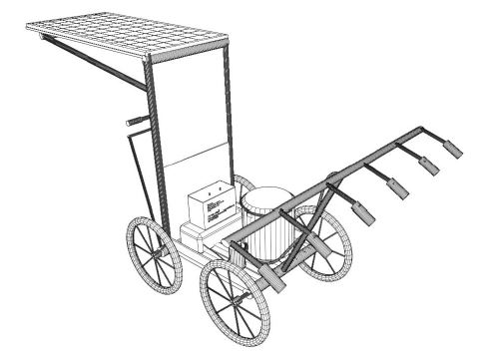
Fig.1 : Isometric View of designed solar sprayer vehicle
2.1.6 Performance of solar sprayer in field application
The developed sprayer was used for spraying performance on Methi (fenugreek) vegetable crop was performed for controlling weeds, minimising the diseases like powdery mildew, root rot, reducing pest such as aphids, and also provided a nutrients for growth regulator.
3.RESULTS AND DISCUSSION
3.1 Specifications of solar sprayer vehicle
In the present study, 02 highly efficient solar panels of 50 W capacity were used and connected in series to obtain about 24V+ DC to operate the DC pump. Two panels were fitted on the top of the frame, serving two purposes maximum sunlight capture and provides shelter to the operator. Additionally, a series connection provides sufficient voltage even under fluctuations in solar radiations. To control the supply of power from solar panel and regulate the working of pump a charge controller kypearII 10A 12V/24V was fitted in between them, which stabilize the power to the pump, also assure the real time operation of solar pump under different load conditions. For covering a larger field area in single travel of sprayer vehicle a horizontal boom sprayer equipped with five similar nozzles having a nozzle size about 1 mm connected with pressure pump which creates spray width of about 1.2 to 1.5 meters, these nozzle diameter of 1 mm ensures fine droplet size, efficient foliar application, minimum loss of chemicals, and enhancing the vegetable absorption [9]. The detail specifications are listed below in Table 1
Table 1: The detail specification of components used in development of solar sprayer
S. No. | Parameter | Value | Description
 | Total Solar Power (W) | 100.0 | Total Solar Power (W)
 | Pump Power Consumption (W) | 28.8 | Pump Power Consumption (W)
 | Tank Capacity (L) | 35.0 | Tank Capacity (L)
 | Spray Rate (LPM) | 1.5 | Spray Rate (LPM)
 | Total Spray Time (min) | 23.0 | Total Spray Time (min)
 | Spray Width (m) | 1.8 | Spray Width (m)
 | Area per Tank (m²) | 315.0 | Area per Tank (m²)
 | Operator Speed (km/h) | 1.5 | Operator Speed (km/h)
 | Spray Area per Min (m²) | 45.0 | Spray Area per Min (m²)
 | Time to Spray 1 Acre (min) | 90.0 | Time to Spray 1 Acre (min)
 | Tanks per Acre | 5.0 | Tanks per Acre

3.2 Performance of the sprayer in field
Five analogous nozzles mounted on horizontal boom sprayer vehicle were experimentally tested in the field by using solar pump which was operated by solar panels mounted on sprayer vehicle. The operating pressure of solar pump was in between 1-2 kg/cm^{2,} whereas a spray angle was provided around 30⁰ for uniform spraying and coverage of fine droplets on vegetable plot of Methi [10]. The test performance was enlisted in below mentioned Table 2 The developed solar sprayer vehicle is as shown in Figure 2
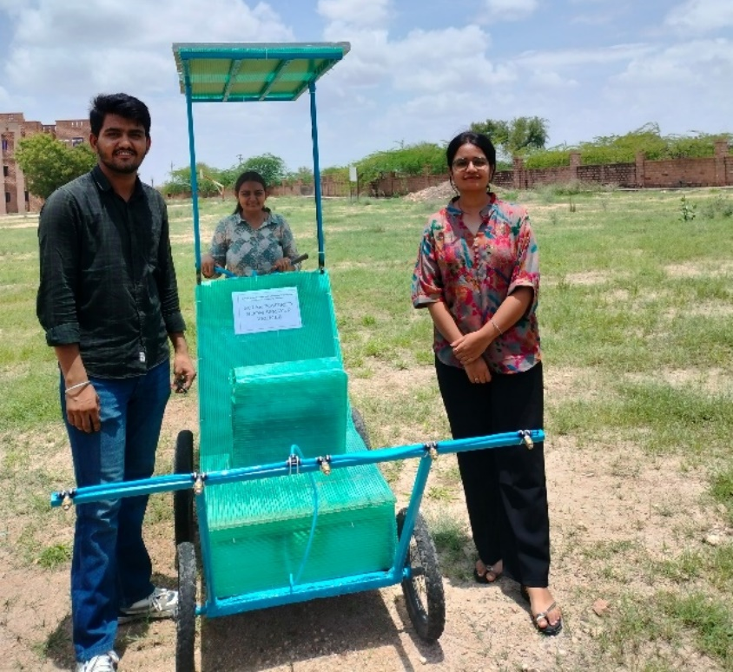
Fig. 2: Actual working view of developed solar sprayer vehicle
Table 2: The test performance of developed solar sprayer vehicle
S. No. | Test Conducted | Observations & Outcomes
 | Solar Panel Output | Delivered ~36–37V (in series) under peak sunlight, sufficient for continuous pump operation.
 | Pump Performance | Achieved a working pressure of ~80 PSI; continuous discharge with open flow ~1.5 LPM.
 | Spray Uniformity | All 5 nozzles sprayed evenly; minimal drift; spray width ~1.8 meters at 1.5 ft height.
 | Tank Duration | Complete tank emptied in approximately 22–25 minutes of continuous spraying.
 | Panel Heat Resistance | Panels remained within 50–60°C under sun – no performance drop observed.
 | Mobility & Handling | Easy maneuverability even when filled; wheels performed well on rough surfaces.
 | Pump Heating | Motor remained within safe range; no overcurrent or burnout even after 30 min use.
 | Protective Glass | Transparent shield over components reduced dust exposure and added durability.

3.3 Cost Estimation and Budgeting
A cost analysis was conducted to estimate the expenditure required for developing the prototype. The goal was to keep it affordable, especially for small and marginal farmers, without compromising quality and durability [11]. The total estimated cost required to develop a solar sprayer vehicle was to be around Rs. 20271.00 (Twenty Thousand Two Hundred and Seventy One). The detail cost analysis is listed below in Table 3
Table 3: The detail cost analysis of developed solar sprayer vehicle
S. No. | Component | Specification | Qty | Approx. Cost (INR)
1 | Solar Panels (INA) | 50W, 18.6V, 2.69A | 2 | ₹1680 × 2 = ₹3360
2 | Solar Charge Controller (Kypearll) | 10A, 12V/24V, LCD + USB | 1 | ₹600
3 | DC Pump, Coil Hose, Nozzle Set, Brass Fitting, QCR Plug, Tap | 24V, 1.5 LPM, 80–140 PSI, for pump and nozzles, with ¼ tee including GST | — | ₹4761
4 | Plastic Tank | 30–35 L capacity | 1 | ₹500
5 | Mild Steel (MS) and GI Pipes | Frame, boom, structure | — | ₹3,500
6 | Cycle Wheels and Handle | Scrap/reused | 4 | ₹700
7 | Transport Vehicle | From Workshop to House and house- Institute | — | ₹1000+2000= 3000
8 | Switches, Wiring, Connectors | Electric components | — | ₹350
9 | Waste Glass Shield | Reused from college lab | — | ₹0
10 | Paint, Primer | Finishing and protection | — | ₹500
11 | Welding Material & Instrument Price | For welding and cutting of structure & frame | — | ₹3000
Total (INR) |  |  |  | ₹20271

CONCLUSION
The Farmer-Friendly Solar-Powered Boom Sprayer Vehicle successfully demonstrates the practical application of renewable energy in small-scale agricultural operations. The system was designed, fabricated, and tested with a focus on affordability, efficiency, environmental sustainability, and user comfort. By eliminating the use of fossil fuels and battery storage, the sprayer operates entirely on direct solar energy, reducing operational costs and maintenance requirements while supporting clean energy adoption in rural farming communities. Performance testing validated the reliability of the system under real field conditions. The solar panels provided sufficient voltage and current to operate the 24V DC pump continuously during peak sunlight hours. The five-nozzle boom assembly ensured uniform spray distribution with minimal drift and consistent pressure. The vehicle demonstrated satisfactory field coverage, with each tank covering approximately 315 m² and one acre requiring about 90 minutes of operation. The lightweight chassis, adjustable spray boom, ergonomic handle design, and overhead solar panel mounting enhanced usability, stability, and operator comfort. In conclusion, the developed solar-powered boom sprayer is a viable, eco-friendly alternative to conventional fuel-operated spraying systems. It has strong potential for adoption among small and marginal farmers due to its simplicity, affordability, and effective performance. With future enhancements such as optional battery backup, motorized mobility, IoT-based monitoring, and expanded spray width, the system can be further upgraded into a semi-automated smart agricultural spraying solution suitable for modern precision farming practices.

REFERENCES
- Swami V, Chauhan DK, Santra P, Kothari K. Design and development of solar PV based power sprayer for agricultural use. Ann. Arid Zone. 2016;55:51-7.
- Yallappa D, Palled V, Veerangouda M. Development and evaluation of solar powered sprayer with multi-purpose applications. In2016 IEEE Global Humanitarian Technology Conference (GHTC) 2016 Oct 13 (pp. 1-6). IEEE.
- Chavan R, Hussain A, Mahadeokar S, Nichat S, Devasagayam D. Design and construction of solar powered agricultural pesticide sprayer. International Journal of Innovations & Advancement in Computer Science. 2015 Apr;4(4):145-50.
- Narate AM, Waghmare G. Design and fabrication of solar operated sprayer for agricultural purpose. InNational Conference on Innovative Trends in Science and Engineering 2016 (Vol. 4, No. 7, pp. 104-107).
- Alam N, Alam M. Solar Powered Sprayer-A review. Int. J. of Scientific & Eng. Res. 2019 May;10(5):1173-8.
- Basavaraj PR, Ajaykumar K, Swathi M. Development and evaluation of solar operated sprayer. Indian Journal of Ecology. 2020;47(11):245-8.
- Rai R, Khursheed R, Rehman SU, Jamil R. Sustainable Solar powered multi nozzle pesticide sprayer for improved production. International Journal of Pioneering Technology and Engineering. 2024 Jun 26;3(01):16-20.
- Banu S, Milufarzana MM, Islam MS, Roy SR. Design, development and performance evaluation of solar powered sprayer with water level indicator. Journal of Science and Technology. 2022 Dec 20;20(2):48-59.
- Poudel B, Sapkota R, Shah R, Subedi N, Krishna A. Design and fabrication of solar powered semi automatic pesticide sprayer. International Research Journal of Engineering and Technology. 2017:2073-7.
- El-Sayed AH, Kabany AF, Elhelew W. A Study on Pesticide Sprayer Powered by Solar Energy Appropriate for Small Farms. Arab Universities Journal of Agricultural Sciences. 2021 Aug 1;29(2):505-17.
- Mallan S, Karthick K, Cheran B, Karthickram S. Smart Solar Powered Agricultural Fertilizer Sprayer. InIOP Conference Series: Materials Science and Engineering 2021 Mar 1 (Vol. 1084, No. 1, p. 012072). IOP Publishing.

