VEGETATION HEALTH DYNAMICS AND THE IMPACTS ON CLIMATE CHANGE AND AGRICULTURE IN EBONYI STATE SOUTHEASTERN NIGERIA

ABSTRACT
This study investigates vegetation health dynamics and the impacts on climate change and agriculture in Ebonyi State Southeastern Nigeria using geospatial techniques covering a period 39 years (1986 to 2025). Normalized Difference Vegetation Index (NDVI) was used to assess the health of vegetation. The results indicate that No vegetation area increased slightly from 40.7808km² in 1986 to 40.7871km² in 2025 representing an increase of 0.02%. Low vegetation/degraded area increased significantly from 618.8688km² in 1986 to 1058.554km² in 2025 representing an increase of +71%. Stressed vegetation area decreased from 2636.77km² in 1986 to 2546.817m² in 2025 representing a decrease of -3.41%. Moderately healthy vegetation area decreased from 2469.672km² in 1986 to 2032.174km² in 2025 representing a decrease of -17.71% while healthy vegetation increased from 659.0556km² in 1986 to 746.9181km² in 2025 representing an increase of +13.33%. The largest increase was in low vegetation/degraded area (+71.05%) followed by healthy vegetation (+13.33%) while the largest decrease was in moderately healthy vegetation (-17.71%) followed by stressed vegetation (-3.41%). These findings provide valuable insights into the vegetation health dynamics and their implications for climate change and agriculture as well as ecosystem sustainability and resilience in Ebonyi State Southeastern Nigeria. The study contributes to our understanding of the impacts of climate change and human activities on vegetation dynamics and land cover transformation in the region, informing evidence-based decision-making and sustainable land management practices.

Key words: Vegetation health, Impacts, Agriculture, climate change, Environment.
- INTRODUCTION
The recent trends like global warming and population growth have necessitated the assessment of earth landscape transformation particularly the growing challenge on sustainable agriculture and food security as well as climate change mitigating measures adaptation. The recent decades have witnessed intensified man's activities trying to unravel nature's enormous resources applied in sustenance but pose a risk to the survival of other living organisms as well. Global climate change triggers temperature, precipitation pattern, and extreme event change with direct effect on vegetation growth and condition (IPCC, 2014). Impacts are manifested in the alteration of vegetation phenology, productivity, and structure with associated consequences on ecosystem function and services (Cleland et al., 2007). Vegetation health dynamics over time should be comprehended to estimate climate change impacts on ecosystems. Climate change and human activity have immensely reversed the trends of vegetation on the global scene (Myneni et al., 1997). Normalized Difference Vegetation Index (NDVI) has also been considered a critical tool to quantify vegetation state and dynamics through time (Pettorelli et al., 2005). Temporal NDVI data include information on long-term trends as well as vegetational responses to climate change (Li et al. 2023; Shoumik and Khan 2023; Verbesselt et al., 2010). Natural land cover, incorporates and contains a place's general climate, geology and soils, and already present biota over several decades or longer.
At shorter timescales, land cover can be altered by naturally occurring disturbances (e.g., storms, floods, fires, volcanic eruptions, landslides, and insects) and anthropogenic activities (e.g., road building, industrialization and urbanization, water diversion, deforestation or afforestation, population growth). These transitions can be considered improvements or degradations in land cover state, either positively or negatively, depending on perspective (Perez-Hoyos et al 2017; Sleeter et al 2018; Sterling et al 2013). Land cover affects or alters environmental conditions in one or more of the following manners: impacting other environmental processes like water quality, watersheds' hydrology, species and habitat composition, climate, and carbon storage; impacting mass and energy flux from surface to atmosphere and hence influencing weather and climate; impacting species and habitat, a component of ecological structure and function; altering hydrologic regimes, flood buffering, and watersheds' runoff (Sleeter et al 2018; Sterling et al 2013; Yasser and Vahid, 2025). Land use and land cover data are crucial to environmental comprehension and regulation, sustainable progress, and provision of assistance to programs of various choices, e.g., environmental planning, resource administration, and city planning. It provides base knowledge on environmental hazard appraisal, food availability, and reduction of natural hazards.

Thus on the basis of NDVI trends for a number of decades, researchers can map areas experiencing vegetation degradation, expansion, or shift in composition (Tucker et al., 2005). These assessments are important in guiding land management, conservation, and climate change mitigation policy (Boisvenue & Running, 2006). In a nation like Nigeria with diverse ecological zones, monitoring these processes is vital for evidence-based environmental management and sustainable development planning. This study therefore attempts to assess the temporal trend of land use land cover and vegetation health during the past thirty-nine (39) years (1986-2025 and its impact on climate change and agriculture in Ebonyi State Southeastern Nigeria using NDVI data at 1986, 2000, 2015, and 2025. NDVI is an index of vegetation density and health and indicates information on ecosystem trends and temporal change. Understanding the temporal trends of land cover and vegetation health in these States will aid in the identification of environmental trends, assessment of climate change effects, and formulation of targeted mitigation and adaptation measures.
Therefore this study will contribute to the body of knowledge on environmental monitoring and management in Nigeria with useful information for policymakers, researchers, and stakeholders in the environment.
Study Area
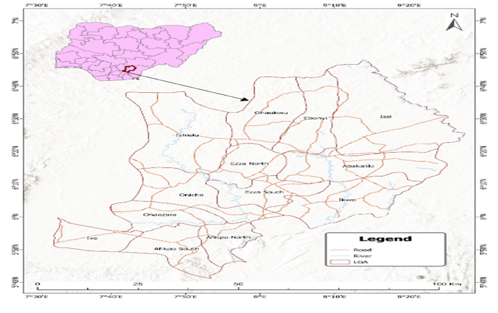
Figure 1: Geographical Location of Ebonyi State - Map of the Study Area

Ebonyi State was created on October 1, 1996 with Abakaliki as its capital. The state was calved out of the old Abakaliki Division of Enugu State and the old Afikpo Division of Abia State (Ibenegbu 2017). The name of the state was derived from the River Abonyi which flows through the north-central parts of the State. The state is located in the South Eastern part of Nigeria and lies approximately within latitudes 5/40’ and 6/45’N, and longitudes 7/30’ and 8/30’E (Hegazy and Kaloop, 2015). It has boundaries with Enugu State to the west, Benue State to the north, Cross River State to the east and Abia State to the south. The land area of the state is approximately 5,935 square kilometer (km²) and its inhabitants are Igbo. Ebonyi State has an estimated population of about 2,176,947 based on the 2006 National Population Census. The largest city in the State is Abakaliki, the state capital. Some important towns are Afikpo, Edda, Onueke, Nkalagu, Uburu, Onicha, Ishiagu, Amasiri and Okposi. The state has 13 Local Government Areas, 3 Senatorial Districts, 6 Federal Constituencies, 24 State Constituencies, and 171 Registration Areas/Wards (ABK 2021).
The state is divided between the Cross–Niger transition forests in the far south and the drier Guinean forest–savanna mosaic in the rest of the state. Ebonyi State has a humid tropical climate, with one rainy season and one dry season lasting for 8 and 4 months, respectively. The temperature typically ranges from 20 to 38 degrees Celsius during the dry season and from 16 to 28 degrees Celsius during the rainy season. Harmattan winds are common between December and January. The average annual temperature is 28 degrees Celsius, and the average annual humidity is 50-60%. The region receives an average annual precipitation of 2500mm (ES 2023; CE 2022)). Ebonyi State is mainly an agricultural region and a leading producer of rice, yam, potatoes, maize, beans, and cassava (EO 2020; MANR 2021). Rice is largely cultivated in Ikwo, yams in Izzi, with other regions in the state such as Amasiri, Edda and Ezillo making remarkable contributions as well. Effium and Ezzamgo lead in cassava production, and basket production in Ntezi. Ebonyi has several solid mineral resources, including lead, crude oil, and natural gas, but few large-scale commercial mining mines (Diagi B. Edewede 2018; EO 2025). Ebonyi State is called "the salt of the nation" for its huge salt deposit at the Okposi and Uburu Salt Lakes. There are also some tourist locations within the state prominent ones include Abakaliki Green Lake, Uburu Salt Lake, Unwana and Ikwo Beaches (ES 2020).

MATERIALS AND METHODS

Description of Data
This study relied primarily on open-source secondary datasets, particularly satellite imagery, to generate the key input parameters used in the analysis Normalized Difference Vegetation Index (NDVI) and Land Use/Land Cover (LULC) maps. Series of archived satellite imagery tiles from (Sentinel-2) were utilized in realizing the aims and objectives of this research study. Parameters - NDVI and LULC were generated from Sentinel-2 satellite data. Launched in the first quarter of 2014, the Sentinel-2 satellites have 13 spectral bands in the visible, near-infrared, and shortwave infrared part of the spectrum that can be applied in the fields of Land use Land cover mapping, water resources and disaster management, and agriculture monitoring to detect ground deformation and providing support for disaster management.

Table 1: Data and Data Sources
S/N | Parameters | Data | Sources | Period
1 | LULC | Sentinel-2 | Google Earth Engine https://explorer.earthengine.google.com | 2024
2 | NDVI | Sentinel-2 | Google Earth Engine https://explorer.earthengine.google.com | 2024
3 | Administrative map of Nigeria | Shape | Office of the Surveyor General https://osgof.gov.ng/products-services/
Table 2: Software, Tools, and Uses

S/N | Software | Applications
1 | ArcGIS version 10.8 | GIS analysis
2 | Google Earth Engine app | Rainfall, LULC, and NDVI

Map data
The maps procured for this study include: topographic and administrative maps covering the study area. These maps were used as ancillary data to aid field work, image classification and the compilation of maps produced in the research work. The Maps were scanned, geo-referenced, and sub-map to area of interest after which they were digitized in order to extract the needed thematic layer into the work geo-database.
Field Work
Ground truthing was also carried out to determine the nature of land use / land cover change and coordinates of site with the use of GPS. Historical land cover type and uses was also obtained via oral interviews on the field. In addition important observation were made and recorded while verification were made on the unclassified False Color Composite (FCC) image carried along, in order to resolve conflicting pixel representations. The information acquired aided the interpretation and classification of the various image and their general accuracy assessment.
Data Analysis and Interpretation
Five main methods of data analysis were adopted in the study.
- Cluster analysis
- Maximum Likelihood Classification
- Calculation of the Area in hectares of the resulting land cover types for each study year and subsequently comparing the results.
- Overlay Operations
- Error matrix and a Kappa analysis

The first two methods above were used for image classification to produce land cover map of the study area. The data were imagery of 2000, 2008, 2016 and 2024. Calculation of the Area in square kilometer assisted in identifying the percentage change, trend, and rate of change between the periods of investigation.

Land Cover Classification System
In this research, the FAO land cover classification system (LCCS) was used. Following the data and information acquired from the field, the land cover type of the study was generated. They included:
- Cultivated and Managed Terrestrial Area (Farm/Fallow land): This area refers to areas where the natural vegetative cover have been altered and replaced by other type of vegetative cover by human activities. This class encompasses all vegetative crops that are planted with the intent of harvesting.
- Natural/Semi Natural Vegetation: natural vegetative areas are defined as areas where the vegetative cover is in balance with biotic and abiotic forces of the biotope. Semi Natural vegetative areas are those not planted by human but are influenced by human actions.
- Artificial Surface and Associated Areas: this class defined areas that have artificial land cover as a result of human activities, these activities includes construction sites, extraction sites, as a result of mining and excavations and waste disposal waste areas.
- Bare areas described areas that do not have any artificial influence; these areas are those with very small litter or no vegetative cover at all such as rocks, bare sand and desert.
- Natural Water Bodies: these are areas that are naturally covered by water, such as streams, lakes, rivers, etc.
- Built-up areas: these include areas occupied by settlements/towns, companies, and infrastructures.
Development of a Classification Scheme
Based on the prior knowledge of the study area for over 14 years and a brief reconnaissance survey with additional information from previous research in the study area, the classification scheme was developed after FAO Land Cover Classification System (LCCS). They include Built-up area (BA), Cultivated Area (CA), Water body (WB), Vegetation (VE), Bare Land (BL), and Plantation Area (PL) as shown in Table 3.

Table 3: Classification Scheme
Code | Land Cover Categories
CA | Cultivated Area
VE | Vegetation Area
BU | Built-up Area
PL | Plantation Area
WB | Water bodies
BL | Bare Land

Supervised classification
The supervised classification is the essential tool used for extracting quantitative information from remotely sensed image data [Richards, 1993, p85]. Using this method, the analyst has available sufficient known pixels to generate representative parameters for each class of interest. This step is called training. Once trained, the classifier is then used to attach labels to all the image pixels according to the trained parameters. The most commonly used supervised classification is Maximum Likelihood Classification (MLC), which assumes that each spectral class can be described by a multivariate normal distribution. Five training sites were identified and further classified into the classes listed in the schema
Change Detection
One of the most common applications of change detection is determining urban land use change and assessing urban sprawl. This would assist urban planners and decision makers to implement sound solution for environmental management. A number of approaches have emerged and applied in various studies to determine the spatial extent of land cover changes. It has also been noted that different methods of detection produce different change maps (Araya and Cabral 2008). Below are methods applied in this study.
Image Differencing
Image differencing is based on the subtraction of images acquired in two different times. This is performed on a pixel by pixel or band by band level to create the difference image. In the process, the digital number (DN) value of one date for a given band is subtracted from the DN value of the same band of another date (Singh, 1989; Tardie and Congalton 2004). Since the analysis is pixel by pixel, raw (unprocessed) input images might not present a good result.
Vegetation Index Differencing
This method is applied to analyze the amount of change in vegetation versus non vegetation by computing Normalized Deference Vegetation Index (NDVI). NDVI is one of the most common vegetation indexing method and is calculated by:

NDVI= NIR-RED
-1.0 ……………………… eqn1
NIR+RED
Where NIR is the near infrared band response for a given pixel and RED is the red response

Post Classification Comparison:
This is the most obvious, common and suitable method for land cover change detection. This method requires the comparison of independently classified images T1 and T2, the analyst can produce change map which show a complete matrix of changes (Singh, 1989).
Post-Classification Detection Technique:
Post classification technique is one of the most used and simple approach to detecting changes comparison (Blaschke, 2004). A post-classification comparison, which is the most straightforward technique, has been applied in this study. The land cover maps for the years 2000, 2008, 2016 and 2024 were first simplified into six classes. The post-classification comparison was then applied by differentiating the corresponding classified maps to generate change maps. The change statistics was generated as a table and subsequently used to calculate the frequency and magnitude of change. The result of the change detection entirely depends on the accuracies of each individual classification. Image classification and post-classification techniques are, therefore, iterative and require further refinement to produce more reliable and accurate change detection results (Fan, Weng and Wang, 2007).

Table 4: Error Matrix and Kappa Analysis
Year | Kappa Coefficient | Overall Accuracy
2000 | 1.0 | 100%
2013 | 1.0 | 100%
2024 | 0.83 | 90%
Average | 0.94 | 96.6

RESULTS
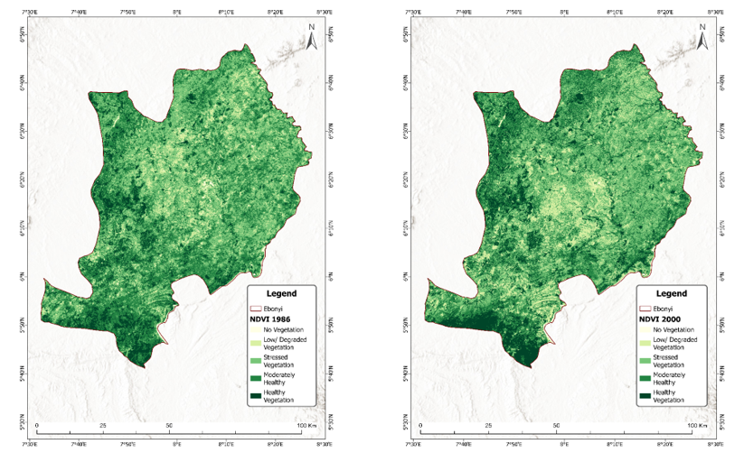
Figure 2: Normalized Difference Vegetation Index (NDVII) for 1986 Figure 3:Normalized Difference Vegetation Index (NDVII) for 1986

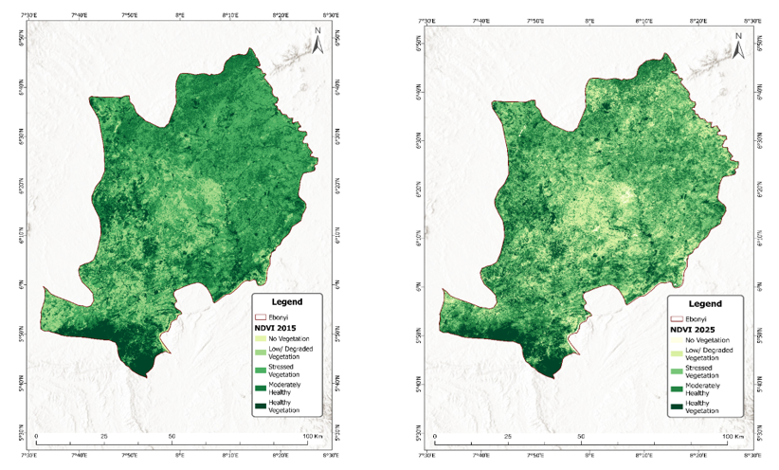
Figure 4: Normalized Difference Vegetation Index (NDVI) for 2015 Figure 5: Normalized Difference Vegetation Index (NDVII) for 2025

Table 5: Magnitude of Normalized Difference Vegetation Index (NDVI) for 1986 to 2025
NDVI | 1986 (km²) | 2000 (km²) | 2015 (km²) | 2025 (km²)
No Vegetation | 40.7808 | 23.0778 | 19.4994 | 40.7871
Low/ Degraded Vegetation | 618.8688 | 853.1118 | 889.4322 | 1058.554
Stressed Vegetation | 2636.77 | 2572.542 | 2627.101 | 2546.817
Moderately Healthy | 2469.672 | 2057.686 | 2108.327 | 2032.174
Healthy Vegetation | 659.0556 | 918.8316 | 780.8913 | 746.9181

Table 5 above shows the magnitude of Normalized Difference Vegetation Index (NDVI) for 1986 to 2025 covering a period of 39 years.
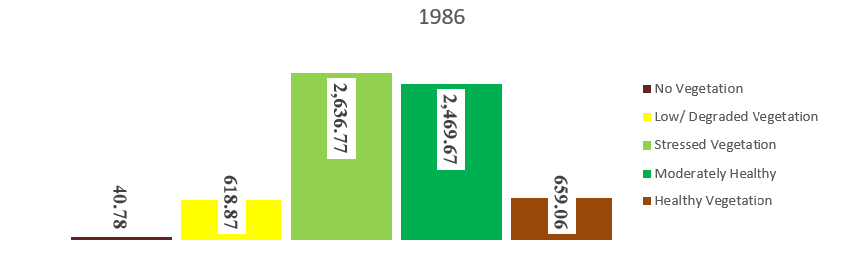
Figure 6: Showing a graphical illustration of Vegetation distribution or spread of 1986 across the entire landscape of Ebonyi State with Stressed Vegetation occupying the most area of 2,636.77km² followed by Moderately Healthy Vegetation with 2,469.67km², Healthy Vegetation with 659.06km², Low/degraded Vegetation with 618.87km² and No Vegetation with 40.78 km²
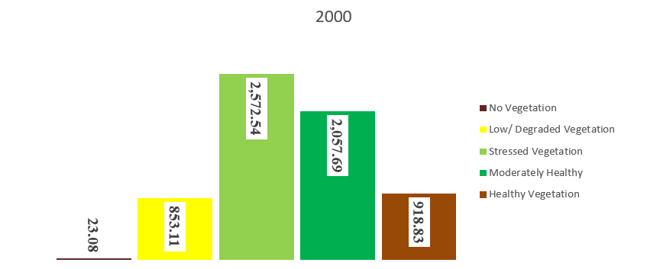
Figure 7: Showing a graphical illustration of Vegetation distribution or spread of 2000 with Stressed Vegetation occupying the most area of 2,572.54km² followed by Moderately Healthy Vegetation with 2,057.69km², Healthy Vegetation with 918.83km², Low/degraded Vegetation with 853.11km² and No Vegetation with 23.08 km²
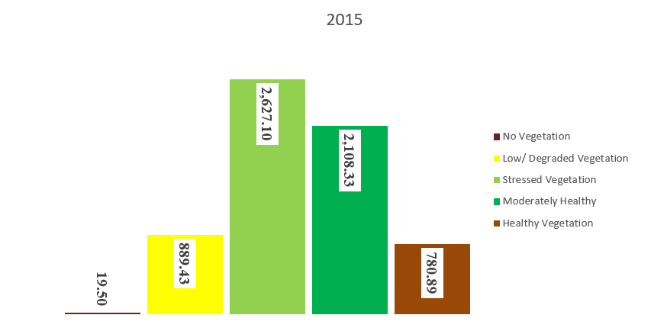
Figure 8: Showing a graphical illustration of Vegetation distribution or spread of 2015 with Stressed Vegetation occupying the most area of 2,627.10km² followed by Moderately Healthy Vegetation with 2,108.33km², Healthy Vegetation with 780.89km², Low/degraded Vegetation with 889.43km² and No Vegetation with 19.50 km²

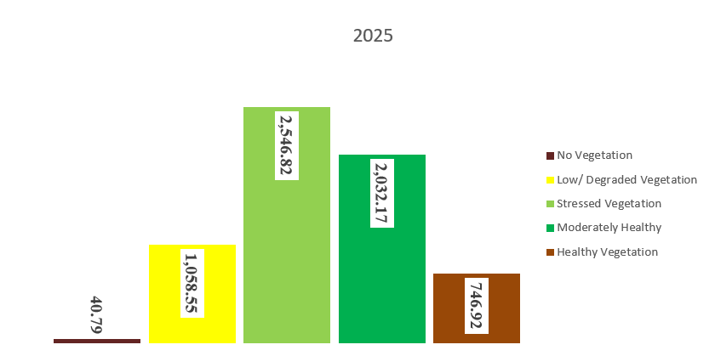
Figure 9: Showing a graphical illustration of Vegetation distribution or spread of 2025with Stressed Vegetation occupying the highest area of 2,546.82km² followed by Moderately Healthy Vegetation with 2,032.17km², Low/degraded Vegetation with 1,058.55km², Healthy Vegetation with 746.92km²and No Vegetation with 40.79 km²

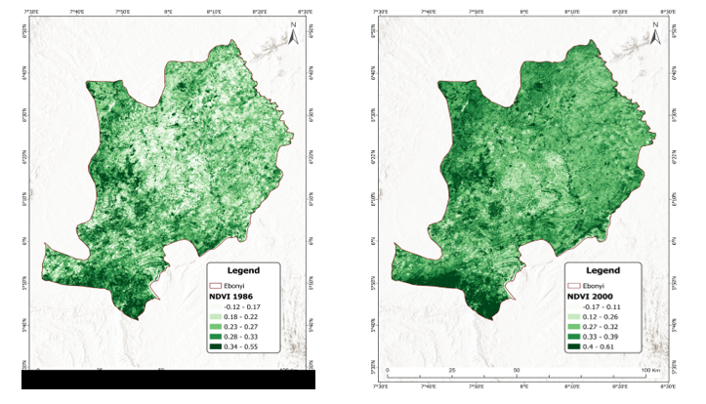

Figure 10: NDVII with figures for 1986 Figure 11: NDVII with figures for 2000

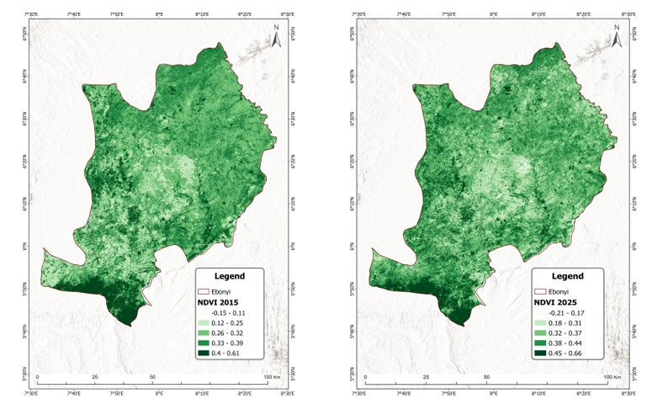

Figure 12: NDVII with figures for 2015 Figure 13: NDVII with figures for 2025

List 1- NDVI Index of different land types and areas
1986
Id NDVI INDEX Land type Area (km²)
1 -0.12 - 0.17 No Vegetation 40.7808
2 0.18 – 0.22 Low/Degraded Vegetation 618.8688
3 0.23 - 0.27 Stressed Vegetation 2636.77
4 0.28 - 0.33 Moderately Healthy Veg. 2469.672
5 0.34 - 0.55 Healthy Vegetation 659.0556

2000
Id NDVI INDEX Land type Area (km²)
1 -0.7 - 0.11 No Vegetation 23.0778
2 0.12 – 0.26 Low/Degraded Vegetation 853.1118
3 0.27 - 0.32 Stressed Vegetation 2572.542
4 0.33 - 0.39 Moderately Healthy Veg. 2057.686
5 0.4 - 0.61 Healthy Vegetation 918.8316

2015
Id NDVI INDEX Land type Area (km²)
1 -0.15 - 0.11 No Vegetation 19.4994
2 0.12 – 0.25 Low /Degraded Vegetation 889.4322
3 0.26 - 0.32 Stressed Vegetation 2627.101
4 0.33 - 0.39 Moderately Healthy Veg. 2108.327
5 0.4 - 0.61 Healthy Vegetation 780.8913
2025
Id NDVI INDEX Land type Area (km²)
1 -0.21 - 0.17 No Vegetation 40.7871
2 0.18 – 0.31 Low /Degraded Vegetation 1,058.554
3 0.32 - 0.37 Stressed Vegetation 2546.817
4 0.38 - 0.44 Moderately Healthy Veg. 2032.174
5 0.45 - 0.66 Healthy Vegetation 746.9181

Table 6: Percentage Change (1986–2025)
NDVI Category | 1986 (km²) | 2025 (km²) | % Change (1986 to 2025)
No Vegetation | 40.78 | 40.79 | +0.02%
Low/Degraded Vegetation | 618.87 | 1058.55 | +71.05%
Stressed Vegetation | 2636.77 | 2546.82 | –3.41%
Moderately Healthy | 2469.67 | 2032.17 | –17.71%
Healthy Vegetation | 659.06 | 746.92 | +13.33%
Largest increase: Low/Degraded Vegetation (+71.05%)
Largest decrease: Moderately Healthy Vegetation (–17.71%)
Source: Authors own Elaboration

Table 6 above shows the percentage change in magnitude of Normalized Difference Vegetation Index (NDVI) from 1986 to 2025 covering a period of 39 years which indicates that No vegetation area increased slightly from 40.7808km² in 1986 to 40.7871km² in 2025 representing an increase of 0.02%. Low vegetation/degraded area increased significantly from 618.8688km² in 1986 to 1058.554km² in 2025 representing an increase of +71%. Stressed vegetation area decreased from 2636.77km² in 1986 to 2546.817m² in 2025 representing a decrease of -3.41%. Moderately healthy vegetation area decreased from 2469.672km² in 1986 to 2032.174km² in 2025 representing a decrease of -17.71% while healthy vegetation increased from 659.0556km² in 1986 to 746.9181km² in 2025 representing an increase of +13.33%. The largest increase was in low vegetation/degraded area (+71.05%) followed by healthy vegetation (+13.33%) while the largest decrease was in moderately healthy vegetation (-17.71%) followed by stressed vegetation (-3.41%).
Table 7: Test of Significance (Paired Sample t-test)
Paired Samples Test
 |  | Paired Differences |  |  |  |  | t | df | Sig. (2-tailed)
 |  | Mean | Std. Deviation | Std. Error Mean | 95% Confidence Interval of the Difference |  | t | df | Sig. (2-tailed)
 |  |  |  |  | Lower | Upper | t | df | Sig. (2-tailed)
Pair 1 | 1986 - 2025 | -.02000 | 316.43923 | 141.51592 | -392.93119 | 392.89119 | .000 | 4 | 1.000

There is no statistically significant difference between the NDVI values in 1986 and 2025 overall (p > 0.05). This suggests that, despite individual category changes, the total distribution of vegetation types has not significantly changed in a statistical sense.
Table 8: Test of Relationship (Pearson Correlation)
Correlations
1986 | Pearson Correlation | 1 | .972**
1986 | Sig. (2-tailed) |  | .006
1986 | N | 5 | 5
2025 | Pearson Correlation | .972** | 1
2025 | Sig. (2-tailed) | .006
2025 | N | 5 | 5
**. Correlation is significant at the 0.01 level (2-tailed).

There is a very strong positive correlation between NDVI values in 1986 and 2025, which is statistically significant (p < 0.01). This indicates a consistent pattern in the relative magnitude of NDVI categories over time, despite some shifts in specific categories.

DISCUSSION
Table 7 shows the percentage change in magnitude of Normalized Difference Vegetation Index (NDVI) from 1986 to 2025 covering a period of 39 years which indicates that No vegetation area increased slightly from 40.7808km² in 1986 to 40.7871km² in 2025 representing an increase of 0.02%. Low vegetation/degraded area increased significantly from 618.8688km² in 1986 to 1058.554km² in 2025 representing an increase of +71%. Stressed vegetation area decreased from 2636.77km² in 1986 to 2546.817m² in 2025 representing a decrease of -3.41%. Moderately healthy vegetation area decreased from 2469.672km² in 1986 to 2032.174km² in 2025 representing a decrease of -17.71% while healthy vegetation increased from 659.0556km² in 1986 to 746.9181km² in 2025 representing an increase of +13.33%. The largest increase was in low vegetation/degraded area (+71.05%) followed by healthy vegetation (+13.33%) while the largest decrease was in moderately healthy vegetation (-17.71%) followed by stressed vegetation (-3.41%).
Interestingly, healthy vegetation increased slightly from 659.0556km² in 1986 to 746.9181km² in 2025 representing +13.33%. This could imply better land use practices in some parts of the state.
The NDVI Index for this study holds a lot of implications on agriculture and climate change in the study area, Ebonyi State and indeed Southeastern Nigeria as well. For instance, in 1986, 2636.77km² area of vegetation were stressed which could result from adverse climatic conditions like inadequate precipitations or anthropogenic activities like indiscriminate bush burning or other factors that could impact negatively on the health of vegetation or fertility of the soil. This trend of stressed vegetation continued from1986 through 2000, 2015 and 2025 meaning that its cause(s) have not been mitigated for the past 39 years.
Equally of great concern is the increase in low vegetation/degraded area in the state which increased from 618.8688km² in 1986 to 1,058.554km² in 2025. This sharp increase in degraded/low vegetation area could be as a result of increased mining activities in the state notable among these are lead mining in Ikwo Local Government Area, stones mining in areas like Ishiegu, Nkalagu, Afikpo, and others. Mining sites and degraded land may not be suitable for agriculture and in most cases the sludge are not contained and treated before discharge into the surrounding lands which eventually impact negatively on vegetation, humans and livelihoods of the inhabitants of areas where these activities are carried out unchecked.
CONCLUSION
This study provides valuable insights into the natural environment of Ebonyi State Southeastern Nigeria which encompasses vegetation health dynamics. Farming activities and practices must be made sustainable with innovative styles and approaches to check the continuous stress to vegetation health. Vegetation serves as purifiers and sequesters in natural environment and must be kept in balance in spite of humans’ dependence on forest and forest resources for livelihoods. Thus stressed vegetation or low vegetation and degradation have enormous consequences on human health, climate change, and agriculture in the state and beyond.
These findings reveal the current state of vegetation health dynamics and their implications for climate change and agriculture as well as ecosystem sustainability and resilience in study area. The study contributes to our understanding of the impacts of climate change and human activities on vegetation dynamics and land cover transformation in the region, informing evidence-based decision-making and sustainable land management practices.

Competing Interests/Conflict of Interest
Author(s) has/have no competing financial, professional, or personal interests from other parties or in publishing this manuscript. There is no conflict of interest with the publisher or the editorial team or the reviewers.

REFERENCES

ABK (2021). "Abakaliki". Encyclopædia Britannica. Retrieved 21 December 2021
Araya, Y. and Cabral, P. (2008). Urban Land Cover Change Detection Analysis Using GIS and Remote
- Sensing: A Case Study of Asamara, Eritrea. In: H. Mooney, A. Cropper, W. Reid (eds.), Assessment, Washington, DC: Island Press. DOI: https://doi.org/10.9790/2402-1410014155.
Blaschke, T. (2004). “Towards a Framework for Change Detection based on image object”. Erasmi, S., Cyffka, B. and M. Kappas (eds): Gottinger Geographische Abhandlungen 113: 1-9.. https://doi.org/10.1016/j.isprsjprs.2009.06.004.
Boisvenue, Céline & RUNNING, STEVEN. (2006). Impacts of climate change on natural forest productivity - Evidence since the middle of the 20th century. Global Change Biology. 12. 862 - 882. 10.1111/j.1365-2486.2006.01134.x.
CE (2022)"Climate Ebonyi: Temperature, climate graph, Climate table for Ebonyi - Climate-Data.org". en.climate-data.org. Retrieved 28 December 2022
Cleland, Elsa & Chuine, Isabelle & Menzel, Annette & Mooney, Harold & Schwartz, Mark. (2007). Shifting plant phenology in response to global change. Trends in ecology & evolution. 22. 357-65. 10.1016/j.tree.2007.04.003 .
Diagi B. Edewede (2018). Assessment of Changes in Landcover and Landuse in Ebonyi State, Using Remote Sensing Technique. Journal of Environment and Earth Science ISSN 2224-3216 (Paper) ISSN 2225-0948 (Online) Vol.8, No.9, 2018
DOI: 10.9790/2402-1410014155 www.iosrjournals.org
EO (2025) "Ebonyi Online - About Ebonyi State". www.ebonyionline.com.
ES (2020) "Ebonyi State". www.ebonyistate.gov.ng. Archived from the original on 14 February 2016. Retrieved 15 June 2020.
ES (2023). "Ebonyi State Showing the Study Area (Abakaliki) Source: Cartography/GIS. Download Scientific Diagram". Retrieved 11 March 2023.
Fan, F., Weng, Q. and Wang, Y. (2007). Land use Land cover change in Guangzhou, China, from 1998 to 2003, based on LandSat TM/ETM + Imagery. Sensors 7: 1323-1342.
https://doi.org/10.3390/s7071323
Hegazy.,I. R and Kaloop,,M. R.(2015). “Monitoring urban growth and land use change detection with GIS and remote sensing techniques in Daqahlia governorate Egypt,” International Journal of Sustainable Built Environment, vol. 4, no. 1, pp. 117–124. https://doi.org/10.1016/j.ijsbe.2015.02.005
Ibenegbu, George (5 April 2017). "Creation of states in Nigeria and their creators". Legit.ng - Nigeria news. Retrieved 10 June 2021.
IPCC. (2014). Climate Change 2014: Synthesis Report. Contribution of Working Groups I, II and III to the Fifth Assessment Report of the Intergovernmental Panel on Climate Change [Core Writing Team, R.K. Pachauri and L.A. Meyer (Eds.)]. IPCC, Geneva, Switzerland, 151 pp.
Li, X., et al. (2023). Remote Sensing Applications for Forest Carbon Estimation: A Review.Remote Sensing of Environment, 215, 132-147. Available online at: https://www.researchgate.net/publication/379741512_Remote_Sensing_Estimation_of_Forest_Carbon_Stock_Based_on_Machine_Learning_Algorithms [accessed on December 22, 2025].
MANR (2021) "Ministry of Agriculture And Natural Resources, Ebonyi State Government". www.ebonyistate.gov.ng. Retrieved 10 June 2021.

Moarrab, Yasser; Novin, Vahid. (2025). Scenario-based modelling of ecological security: Integrating land use and climate change impacts in the Lavasanat Watershed. Environmental Resources Research, 13(1), 137-158. 10.22069/ijerr.2025.23274.1475
Myneni, R. & Keeling, C. & Tucker, Compton & Asrar, G. & Nemani, Ramakrishna. (1997). Increased Plant Growth in the Northern High Latitudes from 1981 to 1991. Nature. 386. 698-702. doi:10.1038/386698a0
Perez Hoyos, Ana & Rembold, Felix & Kerdiles, Hervé & Gallego Pinilla, Francisco Javier. (2017). Comparison of Global Land Cover Datasets for Cropland Monitoring. Remote Sensing. 9. 10.3390/rs9111118.
Pettorelli, Nathalie & Vik, Jon Olav & Mysterud, Atle & Gaillard, Jean-Michel & Tucker, Compton & Stenseth, Nils Chr. (2005). Using the satellite-derived NDVI to assess ecological responses to environmental change. Trends in ecology & evolution. 20. 503-10. 10.1016/j.tree.2005.05.011.
Richards, J. A. (1993). Remote Sensing Digital image Analysis: An Introduction. 2nd Edition. ISBN:0387548408 Springer Verlag, New York. http://dx.doi.org/10.1007/978-3-642-88087-2
Shoumik, A. B., & Khan, F. A. (2023). Application of Remote Sensing and GIS in Land Use/Land Cover Change Detection: A Review. Journal of Geographic Information System, 15(2), 101-125
Singh, A. (1989). Digital Change Detection Technique Using Remotely-Sensed Data. International Journal of Remote Sensing 10: 989-1003. http://dx.doi.org/10.1080/01431168908903939
Sleeter, B. M., Loveland, T., Domke, G., Herold, N., Wickham, J., & Wood, N. (2018) Land Cover and Land-Use Change. In: Reidmiller, D.R., Avery, C.W., Easterling, D.R., Kunkel, K.E., Lewis, K.L.M., Maycock, T.K. and Stewart, B.C., Eds., Impacts, Risks, and Adaptation in the United States: Fourth National Climate Assessment, Vol. 2, US Global Change Research Program, Washington DC, 202-231.
https://doi.org/10.7930/NCA4.2018.CH5
Sterling, S.M., A. Ducharne, and J. Polcher. 2013. The impact of global land-cover change on the terrestrial water cycle. Nature Climate Change 3(4):385-39. https://ui.adsabs.harvard.edu/link_gateway/2013NatCC...3..385S/doi:10.1038/nclimate1690
Tardie PS, Congalton RG (2004). A Change-detection Analysis: Using Remotely Sensed Data to Assess the Progression of Development in Essex County, Massachusetts from 1990 to 2001. http://www.aarsacrs.org/acrs/proceeding/ACRS2008/Papers/PS%203.21.pdf
Tucker, Compton & Pinzon, Jorge & Brown, Molly & Slayback, Daniel & Pak, Edwin & Mahoney, Robert & Vermote, E. & Saleous, Nazmi. (2005). An extended AVHRR 8-km NDVI dataset compatible with MODIS and spot vegetation NDVI data. International Journal of Remote Sensing. 26. 4485-4498. 10.1080/01431160500168686.
Verbesselt, J., Hyndman, R., Newnham, G. and Culvenor, D. (2010) Detecting Trend and Seasonal Changes in Satellite Image Time Series. Remote Sensing of Environment, 114, 106-115.
http://dx.doi.org/10.1016/j.rse.2009.08.014

