Diversity, Ecology, and Significance of Formicidae in selected sites of Southern Western Ghats, Kerala

ABSTRACT

The Southern Western Ghats of India, part of the globally recognized biodiversity hotspot and World Heritage landscape, represent one of the most significant centers of endemism and species richness in the tropics (Myers et al., 2000; Bawa et al., 2007; Gunawardene et al., 2007). Within this region, the forested tracts of Thenmala, Aryankavu, Rosemala, Kulathupuzha, and Anchal in Kerala, falling under the Agasthyamalai Biosphere Reserve, encompass tropical evergreen, semi-evergreen, moist deciduous, riparian, plantation, and human-modified habitats across an elevational gradient of 100–1000 m, receiving 2500–3500 mm annual rainfall. Ants (Hymenoptera: Formicidae), which constitute a substantial proportion of terrestrial faunal biomass and perform critical ecosystem functions including soil engineering, nutrient cycling, predation, scavenging, seed dispersal, and mutualism, are widely acknowledged as sensitive bioindicators of habitat quality and disturbance (Hölldobler & Wilson, 1990; Andersen, 1997; Del Toro et al., 2012; Schultheiss et al., 2022). Despite the recognized ecological importance of ants in tropical forests, systematic documentation in the southern Western Ghats remains limited (Narendra & Kumar, 2006; Sabu & Shiju, 2010). The present year-long survey (April 2024–April 2025) employed standardized pitfall trapping, Winkler leaf-litter extraction, and active hand collection across stratified habitats (primary forest, secondary forest, riparian zones, plantations, and human-disturbed areas) to assess species richness, community composition, functional roles, and bioindicator potential of Formicidae. A total of 68 species belonging to six subfamilies—Myrmicinae (47%), Formicinae (28%), Ponerinae (12%), Dolichoderinae, Dorylinae, and Pseudomyrmicinae—were documented. Species richness varied markedly across sites, with Kulathupuzha (40 species) and Thenmala (38 species) supporting the highest diversity in structurally complex evergreen and semi-evergreen forests, whereas semi-urban Anchal exhibited the lowest richness (28 species) dominated by disturbance-tolerant taxa such as Paratrechina longicornis and Tapinoma melanocephalum. Forest-interior and litter-dependent predators including Diacamma rugosum and Odontomachus haematodus were restricted to relatively undisturbed habitats, indicating strong habitat specialization and high beta diversity among sites. Invasive and synanthropic species were more prevalent in fragmented landscapes, reflecting ecological homogenization under anthropogenic pressure (Lach & Hooper-Bui, 2010). Biodiversity indices revealed a high Shannon–Wiener value (H′ = 6) and low Simpson dominance (D = 0.04), signifying high diversity and evenness, although a low Menhinick index (0.02) suggested numerical dominance of certain taxa relative to total individuals. Functional trait analysis highlighted the role of ants as ecosystem engineers influencing soil structure, trophic regulation, seed dispersal, and mutualistic networks (Folgarait, 1998; Giladi, 2006). Collectively, the findings demonstrate that ant assemblages in the southern Western Ghats respond sensitively to gradients of forest integrity, elevation, and anthropogenic disturbance, reinforcing their value as ecological indicators and emphasizing the necessity of multi-site conservation strategies to preserve functional diversity and ecosystem resilience in this globally important biodiversity hotspot.

Keywords: [Formicidae, Western Ghats, species richness, Myrmicinae}

1. INTRODUCTION

With high species richness and endemism, the Southern Western Ghats of India, a UNESCO World Heritage Site, are regarded as one of the most significant hotspots for biodiversity worldwide (Myers et al., 2000; Bawa et al., 2007). Kerala's forests, which include montane shola–grassland systems, moist deciduous, semi-evergreen, and evergreen forests, sustain complex ecological relationships and distinctive plant and animal assemblages (Gunawardene et al., 2007). Ants (Formicidae: Hymenoptera) are among the most varied and ecologically important groups of invertebrates. Ants make up 15–25% of terrestrial animal biomass worldwide, and in many ecosystems, their biomass exceeds that of vertebrates (Schultheiss et al., 2022). Soil engineering, nutrient cycling, scavenging, predation, seed dispersal (myrmecochory), and mutualism with plants and insects are some of their ecological functions (Holldobler & Wilson, 1990; Del Toro et al., 2012). Because they react sensitively to pollution, habitat disturbance, and climate change, ants are also useful bioindicators (Andersen, 1997; Underwood & Fisher, 2006).
Preliminary surveys show a high diversity of ants in the Western Ghats, but little research has been done and many species are probably undocumented (Narendra & Kumar, 2006; Sabu & Shiju, 2010). Planning for conservation requires an understanding of ant diversity and ecology because of the continuous threats posed by invasive species, monoculture plantations, deforestation, and climate change (Laurance & Bierregaard, 1997). This study assessed the potential of Formicidae as ecological indicators and documented their diversity, ecological traits, and functional significance in a few forested areas of the Southern Western Ghats.
Study Area
Thenmala, Kulathupuzha, Aryankavu, Rosemala, and Anchal are the five biodiversity-rich areas of Kerala's southern Western Ghats where the study was carried out. These locations, which include tropical evergreen, semi-evergreen, and moist deciduous forest types, are located between latitudes 8.6°N and 9.0°N and longitudes 76.8°E and 77.2°E. They belong to the Agasthyamalai Biosphere Reserve, a hotspot for biodiversity known throughout the world for its high endemism. With elevations ranging from roughly 100 m to over 1000 m above sea level, the terrain is primarily hilly and supports a variety of flora and fauna. Five locations with unique habitat characteristics in the southern Western Ghats were included in the study. With 2500–3000 mm of rainfall and teak plantations, Thenmala (100–500 m) in Shendurney Wildlife Sanctuary is home to moist deciduous and semi-evergreen forests that encourage ecotourism. Rosemala (300–700 m) receives 2500–3500 mm of rainfall and is home to dense tropical evergreen and semi-evergreen forests with rich microhabitats made of rotting logs and leaf litter. With semi-evergreen and riparian habitats, bamboo clusters, lateritic soils, and 2800–3500 mm of rainfall, the 250–600 m Aryankavu forms a forested corridor. Wet evergreen and semi-evergreen forests with moist deciduous patches can be found in Kulathupuzha (150–600 m), which receives 3000–3500 mm of rainfall annually. The semi-urban site of Anchal (100–150 m) is made up of gardens, plantations, and semi-natural vegetation with a variety of microhabitats. Significant biodiversity, especially ants, is supported by high rainfall, diverse forest types, and heterogeneous microhabitats across sites. These factors are influenced by elevation gradients, vegetation structure, and human activity.
2. material and methods
In Kollam District, Kerala, field surveys were carried out in five forested locations that represented a gradient of habitat types and elevations between April 2024 and April 2025. A variety of common entomological methods (adapted from Andersen, 1997; Sabu & Shiju, 2010) were used to collect samples of ants:
Pitfall traps: 10 traps per site, separated by 10 meters, and left for 48 hours.
Leaf litter extraction: 1 m² litter plots are processed using Winkler bags.
Hand collection: Conduct active searches for one hour per plot along transects.
Using regional taxonomic keys and comparison with reference collections, specimens were identified to the species/morphospecies level after being preserved in 70% ethanol. The species richness, relative abundance, and functional group composition of the data were examined (Andersen, 1997). In order to sample during the pre-monsoon, monsoon, and post-monsoon periods—all crucial times for ant activity and diversity—fieldwork was carried out over a 12-month period (April 2024–April 2025). Frequent fieldwork documented changes in species distribution and richness over time.
Habitat Stratification in Sampling
Five different habitat categories were stratified and sampled in order to guarantee representative coverage of environmental heterogeneity. Variations in vegetation structure, microclimate conditions, and the extent of anthropogenic influence served as the basis for this stratification.
Primary Forests: These unaltered tropical evergreen or semi-evergreen forests are distinguished by their rich native flora, high humidity, closed canopy (>80% cover), dense, multilayered vegetation, and thick leaf litter. For rare and endemic ant species, locations like Rosemala and portions of Kulathupuzha were vital refuges. Regenerating forests that have experienced disturbances like logging, plantation conversion, or shifting cultivation are known as secondary forests. These forests serve as recovery transitional habitats and are frequently found in buffer zones around primary forests. Narrow strips of forest connected to rivers, streams, and other freshwater bodies are known as riparian zones. Because they provide habitat connectivity and are home to moisture-dependent ant species, these habitats are significant from an ecological standpoint. Plantations (Rubber and Teak): Hevea brasiliensis (rubber) and Tectona grandis (teak) are the predominant monoculture plantations, especially in Anchal and Kulathupuzha. In contrast to natural forests, these managed systems offer a more straightforward vegetation structure.
Human-Disturbed Zones: These include towns, highways, farms, and popular tourist destinations like Thenmala that are heavily populated by humans. These habitats reflect the most ecologically disturbed conditions.
Ecological Background
Ant diversity and distribution were influenced by a mosaic of microhabitats that were produced at each site by the combination of different elevations, forest types, and seasonal rainfall patterns. The most stable microclimates were found in primary and riparian habitats, which supported specialized species. In contrast, generalists and invasive taxa predominated in plantations and areas that had been disturbed by humans. Nesting behavior, foraging patterns, and species turnover were all impacted by seasonal variations in temperature and moisture, highlighting the significance of year-round sampling in capturing true diversity. 68 different ant species representing 6 subfamilies—Formicinae, Myrmicinae, Dolichoderinae, Ponerinae, Dorylinae, and Psuedomyrmicinae—were identified through a thorough field survey and sampling technique.

3. results and discussion

The five study sites—Thenmala, Aryankavu, Rosemala, Kulathupuzha, and Anchal—in the southern Western Ghats of Kerala yielded a total of 68 ant species. Because of variations in habitat quality, vegetation structure, and the degree of anthropogenic disturbance, species richness varied significantly among these sites. With 40 species, Kulathupuzha had the highest species richness. The wet evergreen forest at this location is comparatively undisturbed and is distinguished by its thick canopy cover, copious amounts of leaf litter, and low levels of human disturbance. The coexistence of both generalist species and habitat specialists is probably made easier by the structural complexity of the microhabitats in this landscape. With 35 species, Rosemala also promoted a high level of diversity. Ants living in both arboreal and terrestrial strata find appropriate nesting locations and food sources in its evergreen forest cover and comparatively intact environment. Thenmala's 38 species count was marginally less than Kulathupuzha and Rosemala. Because there are a variety of microhabitats, including open trails, undergrowth, and moist litter zones, the site's semi-evergreen vegetation supports a diverse ant community. However, development along the forest edge and tourism might be factors in the slightly decreased species richness. With 31 species, Aryankavu demonstrated a moderate level of diversity. This habitat, which was dominated by moist deciduous forest with patches of evergreen, was home to a community that was primarily made up of widespread generalists and a small number of forest specialists. With 28 species, Anchal had the lowest richness. Higher levels of disturbance and habitat fragmentation have resulted from close proximity to human settlements and extensive land-use change. As a result, there were comparatively few taxa that depended on forests in this ant community, which was dominated by generalist and disturbance-tolerant species.
Table : 1 Species richness by site
SI.No. | Study sites | No. of species | Remarks
1 | Kulathupuzha | 40 | Highest richness; dense evergreen forest
2 | Rosemala | 35 | High richness; largely undisturbed forest habitat
3 | Thenmala | 38 | Semi-evergreen forest; moderate human impact
4 | Aryancavu | 31 | Moist deciduous forest; moderate diversity
5 | Anchal | 28 | Lowest richness; fragmented habitat near settlements
Ant Community Composition in the Research Area
The study identified 68 ant species from five locations in Kerala's southern Western Ghats, belonging to the following six subfamilies: Myrmicinae, Formicinae, Ponerinae, Dolichoderinae, Dorylinae, and Pseudomyrmicinae. The species composition differed from site to site and was impacted by elevation, disturbance intensity, and habitat type. With 47% of all species identified, the Myrmicinae subfamily was the most prevalent. Because of their ecological adaptability, genera like Pheidole, Tetramorium, and Crematogaster were widely distributed and appeared in a variety of locations. Arboreal taxa like Camponotus and Polyrhachis, which were prevalent in both primary and secondary forests, made up the majority of the Formicinae, which accounted for 28% of the species richness. Twelve percent of the species were Ponerinae, which included predatory ants like Odontomachus haematodus and Diacamma rugosum. Their preference for structurally complex microhabitats was demonstrated by the fact that these species were mostly found in undisturbed, leaf-litter-rich habitats in Kulathupuzha and Rosemala. Together, the subfamilies Dorylinae and Dolichoderinae made up less than 10% of the entire assemblage, making them comparatively uncommon. Because of their cryptic, underground foraging habits, dorylines—like Aenictus—were restricted to dense forest habitats and are probably underrepresented. Due to their sensitivity to habitat disturbance, Dolichoderine species were also limited to well-preserved forest sites, particularly Kulathupuzha and Rosemala.

Table 2: Ecological Interpretation
Site | Dominant subfamily | Common genera | Habitat Features
Kulathupuzha | Myrmicinae | Pheidole, Diacamma | Dense, undisturbed evergreen forest
Rosemala | Formicinae | Camponotus,  Polyrhachis | Moist deciduous &  evergreen forest
Thenmala | Myrmicinae | Crematogaster, Camponotus | Mixed forest, moderate disturbance
Aryancavu | Formicinae | Polyrhachis, Monomorium | Transitional habitat, edge forest
Anchal | Myrmicinae | Monomorium, Tapinoma | Disturbed and semi-urban habitat
Venn Diagram Analysis Of Anchal And Kulathupuzha
(Fig: 1)
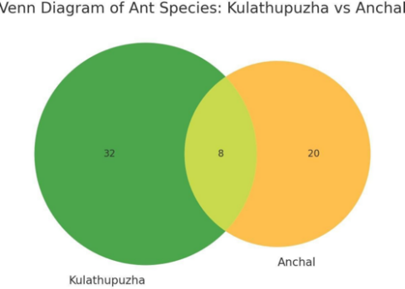
Ant species from Kulathupuzha and Anchal, two ecologically different locations (Highest and lowest) in Kerala's Southern Western Ghats, are visually compared in the Venn diagram. Forty ant species were identified by Kulathupuzha, primarily from unaltered evergreen forests. There were 28 species in Anchal, most of which came from semi-urban areas that were disturbed. Only eight common species were found to overlap between the two sites, suggesting that the communities were not very similar.
Ants' Functional Roles and Ecological Indicators
Several ant species were found to be trustworthy ecological indicators at the five study locations in the southern Western Ghats: Thenmala, Aryankavu, Rosemala, Kulathupuzha, and Anchal. Only in Kulathupuzha and Rosemala, two comparatively undisturbed evergreen forest habitats, were species like Diacamma rugosum and Odontomachus haematodus observed. Their existence is a sign of intact leaf litter and high habitat quality. Diacamma and Odontomachus are functionally important ants that live in leaf litter. Through their nesting and foraging habits, they contribute to microbial activity, decomposition, and nutrient cycling (Kaspari et al., 2000). According to Folgarait (1998), these functions underscore their significance as bioindicators of primary forest health. The integrity of the canopy structure in Rosemala and Thenmala was demonstrated by the fact that arboreal species, such as Polyrhachis lacteipennis and Crematogaster rogenhoferi, were primarily limited to these forests. On the other hand, species that could withstand disturbances, like Paratrechina longicornis, Tapinoma melanocephalum, and Monomorium pharaonis, were common, especially in areas that had been altered by humans, like Anchal and Aryankavu. Their relevance as markers of environmental disruption and synanthropic influence is highlighted by their correlation with agricultural regions and settlements.
Ants carried out a variety of ecological tasks at the study locations. Taxa that are predators include Diacamma rugosum, Odontomachus haematodus, and Pachycondyla sp. maintain ecological balance within the litter layer by regulating populations of soil arthropods and other invertebrates. Through litter decomposition, scavenger genera like Tetramorium and Phenol aid in the flow of energy and the cycling of nutrients. Additionally, myrmicine ants play a significant role in myrmecochory, the process of seed dispersal, which promotes plant recruitment and forest regeneration. As further evidence of their function as ecosystem engineers, mutualistic interactions were seen in species like Camponotus and Polyrhachis, which care for sap-sucking insects or occupy symbiotic niches in tree trunks. In semi-urban and degraded environments, ants that can withstand disturbance, like Tapinoma melanocephalum and Paratrechina longicornis, predominated. Because they colonize unstable environments and reproduce quickly, these generalist foragers are trustworthy markers of ecological stress and transitional zones.
Diversity of Species and the Integrity of Habitat
A total of 68 species from six subfamilies were identified in the study, with notable site-specific variation. With 40 species, Kulathupuzha had the greatest diversity, followed by Thenmala (38), Rosemala (35), Aryankavu (31), and Anchal (28). Variations in habitat type, vegetation complexity, elevation, disturbance level, and microclimatic conditions were all strongly correlated with variations in species richness. While Anchal and Aryankavu, which have experienced significant land-use change and fragmentation, supported fewer species dominated by disturbance-tolerant ants, Kulathupuzha, with its comparatively undisturbed evergreen forest, offered favorable conditions for taxa that depend on forests.
The species diversity gradient is a reflection of larger ecological trends where communities are homogenized through the growth of synanthropic species in disturbed sites, while undisturbed habitats maintain higher levels of richness and functional diversity. These results are in line with past research showing how sensitive ant assemblages are to changes in their surroundings (Hölldobler & Wilson, 1990; Andersen, 1997; Bestelmeyer & Wiens, 2001). Ants' varied nesting techniques—from underground systems to arboreal colonies—further highlight how sensitive they are to changes in the microclimate and the structure of the forest.
Fig:2
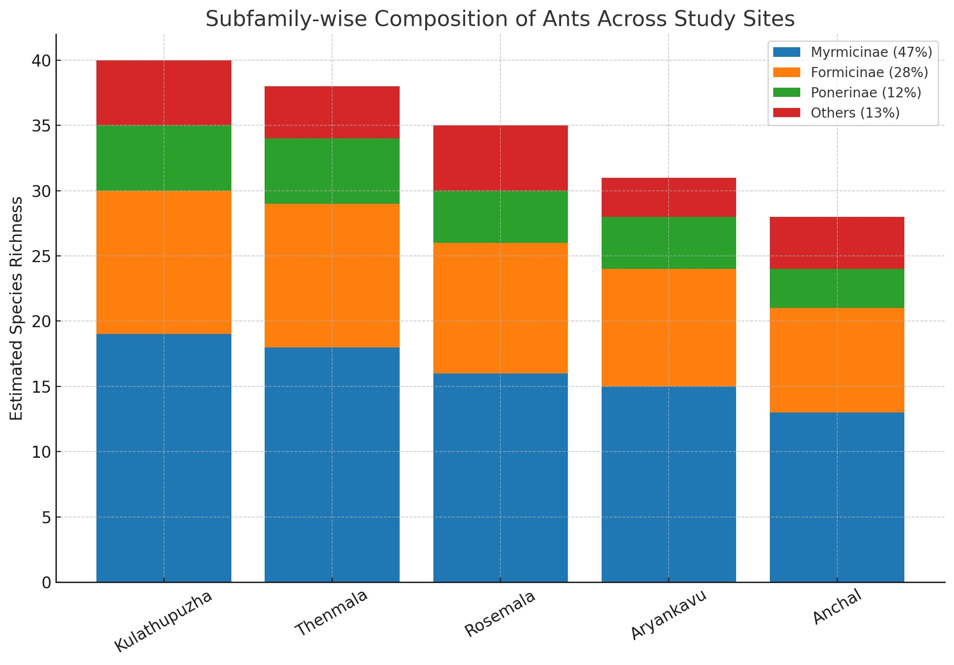
Overlap of Species and Beta Diversity
High beta diversity throughout the southern Western Ghats was indicated by the comparatively low species overlap among the five study sites. Comparisons of Venn diagrams showed that each site had a unique assemblage, with some species only found there. Ant communities are extremely sensitive to local ecological conditions, as this pattern demonstrates. For example, Monomorium pharaonis was common and dominant in disturbed habitats, while Diacamma rugosum and Odontomachus haematodus were limited to forested sites with intact leaf litter. Strong ecological specialization is reflected in this differentiation, which emphasizes the significance of implementing multi-site conservation tactics.
Elevation, forest type, canopy density, litter depth, and human pressure were the main factors linked to variation in species richness between sites. More cryptic and predatory ants were found in forests with dense canopy cover, thick litter, and moist soils, like those in Thenmala and Rosemala. On the other hand, opportunistic generalists and synanthropic taxa, such as Tapinoma melanocephalum and Paratrechina longicornis, predominated in open or disturbed habitats like Anchal. Invasive ants like Anaplolepis gracilipes and Paratrechina longicornis were prevalent in Anchal and portions of Aryankavu, where habitat fragmentation and land-use change were more noticeable. These species are known to disturb ecological interactions and displace native ant fauna, frequently resulting in imbalances at the community level (Lach & Hooper-Bui, 2010). Their predominance in disturbed landscapes emphasizes the susceptibility of fragmented habitats to biological invasions and acts as a potent indicator of ecological degradation.
Representation of Subfamilies
Myrmicinae, which made up 47% of the entire assemblage, was the most species-rich subfamily. Broad ecological amplitude and functional diversity define this group. Genera like Tetramorium, Crematogaster, and Pheidole were extensively dispersed throughout sites and carried out important ecological tasks like mutualism, seed dispersal, and scavenging. With 28% of all known species, Formicinae was the second most prevalent subfamily. Particularly prevalent were genera like Camponotus, Polyrhachis, and Paratrechina, many of which occupied arboreal niches and made significant contributions to ecological processes at the canopy level. Twelve percent of the species richness was accounted for by Ponerinae. Given the comparatively high habitat quality and intact leaf-litter microhabitats in Kulathupuzha and Rosemala, its presence is noteworthy as a subfamily that is normally sensitive to environmental disturbance. Together, the remaining subfamilies, Dorylinae, Dolichoderinae, and Pseudomyrmicinae, accounted for less than 10% of the total diversity, making them relatively uncommon. Their sensitivity to environmental change is highlighted by the fact that they are restricted to undisturbed habitats.
Functional Roles of Ants
The study area's ant communities carried out a variety of ecological tasks that are essential to preserving the processes and structure of the ecosystem. These roles fall into the following general categories: seed dispersal, mutualism, scavenging, predation, and soil engineering.

Species with large bodies, like Pheidole spp. and Camponotus compressus. build large underground nests that promote root penetration and soil porosity (Folgarait, 1998). These changes speed up the turnover of organic matter by changing the soil's chemical and physical characteristics (Del Toro, Ribbons, & Pelini, 2012). Ants redistribute significant amounts of organic matter in tropical systems, which affects the distribution of nutrients in both vertical and horizontal soil profiles (Kaspari & Weiser, 2000). In nutrient-poor soils, like those found in some areas of the Western Ghats, these contributions are especially noteworthy. The predatory function supports the biological control of possible pests and the stability of the food web (Way & Khoo, 1992). These ants deliver vital ecosystem services in both managed agroecosystems and natural forests by preserving equilibrium among arthropod populations. As scavengers, genera like Tetramorium and Monomorium consume organic waste and decaying materials. Mutualistic relationships with plants and hemipteran insects are common among arboreal taxa, such as Crematogaster and Polyrhachis. The ecological and economic significance of Oecophylla smaragdina has been demonstrated by its use in managed systems as a biological control agent against cashew, mango, and citrus pests (Peng et al., 1995). Plant reproduction, genetic diversity, and forest regeneration are all improved by seed dispersal of ants (Giladi, 2006).

Species that serve as indicators of habitat quality
Some species were useful bioindicators of habitat conditions because of their limited range. While widespread ants (Tapinoma melanocephalum, Paratrechina longicornis) were signs of habitat disturbance and fragmentation, species restricted to the interior of forests (such as Crematogaster rogenhoferi and Polyrhachis lacteipennis) showed intact canopies and microclimatic stability. Long-term forest health monitoring can benefit greatly from their distribution patterns. Additionally, ants have been observed to develop mutualistic relationships with mealybugs and aphids, providing protection to the sap-feeding insects in exchange for honeydew. Although these interactions are advantageous to the ants, they can occasionally encourage the spread of pest species in disturbed environments (Delabie et al., 2007). Ants function as competitors, mutualists, predators, and prey in food webs, occupying different trophic levels. They can affect the stability and structure of entire ecological communities because of their multifunctional nature (Lach et al., 2010).

Fig:3

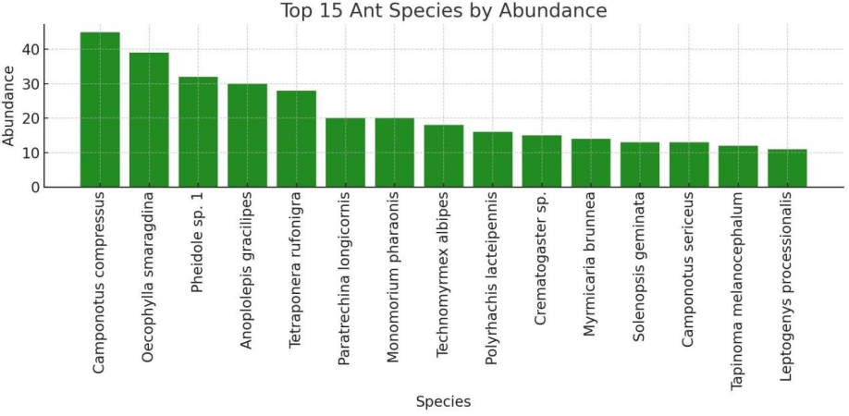
Biodiversity Indices of the southern western ghats
1. Diversity of Species (S)
The total number of distinct species in a sample is referred to as species richness. Although it provides a simple count, it does not represent the species' evenness or abundance (Whittaker, 1972). There are 163628 organisms observed in the study area.
2. The Shannon-Wiener Diversity Index (H')
Both species' evenness and abundance are taken into account by the Shannon Index (H'). It rises in proportion to the community's level of equality and richness. According to Shannon and Weaver (1949), a community that is more evenly distributed and diverse has a high H' value. An exceptionally high level of biodiversity within the ecosystem under study is indicated by a Shannon-Weiner Index (H') value of 6. Both species richness (the total number of species) and species evenness (the degree to which individuals are distributed equally among species) are reflected in this metric. This high index value indicates that there are many ant species in the area and that no one species dominates the community, which is comparatively uncommon in natural ecosystems.
3. Simpson's Diversity Index (1–D)
Dominant species are given more weight by Simpson's Index. The probability that two randomly chosen individuals from a sample are members of different species is represented by the form (1 – D) used in this study. Higher diversity is indicated by a value that is closer to 1 (Simpson, 1949). A high level of biodiversity is indicated by a Simpson's Index (D) value of 0.04; this means that there is very little chance that any two randomly chosen individuals from the sample are members of the same species. This illustrates a habitat that is stable, healthy, and ecologically balanced, where different species live side by side and support vital ecosystem processes.
4. The Menhinick index
With a Menhinick's Index of 0.02, the species richness is extremely low in relation to the total number of individuals sampled. The number of species (S) divided by the square root of the total number of individuals (√N) yields this index. Even though many individual ants may have been observed, only a few different species were represented, according to a low value like 0.02.
Table : 3 list of ant species recorded
Sl. No. | Species Name | Subfamily | Habitat Notes
1 | Oecophylla smaragdina | Formicinae | Arboreal, found in tree canopies, builds  leaf nests
2 | Camponotus compressus | Formicinae | Common in tree trunks, moist forests, alsohuman dwellings
3 | Camponotus sericeus | Formicinae | Open forest, dry leaf litter, tree bark
4 | Camponotus irritans | Formicinae | Evergreen forest canopy and bark crevices

5 | Camponotus mitis | Formicinae | Forest edges, twigs and decaying wood
6 | Polyrhachis illaudata | Formicinae | Moist evergreen forests, nests in dead wood
7 | Polyrhachis lacteipennis | Formicinae | Found in canopy and small twigs of shrubs
8 | Polyrhachis rastellata | Formicinae | Wet forest, builds silk nests among leaves
9 | Lepisiota frauenfeldi | Formicinae | Disturbed habitats, roadside vegetation
10 | Paratrechina longicornis | Formicinae | Synanthropic, moist leaf litter and indoors
11 | Anoplolepis gracilipes | Formicinae | Aggressive, invasive in forest edges, trails
12 | Formica rufa | Formicinae | Cool, moist upland areas (rare in Western Ghats)
13 | Technomyrmex albipes | Dolichoderinae | Ground litter and small twigs, often in gardens
14 | Tapinoma melanocephalum | Dolichoderinae | Human habitats, indoor and edge vegetation
15 | Dolichoderus thoracicus | Dolichoderinae | Dry twigs and forest leaf litter
16 | Crematogaster subnuda | Myrmicinae | Arboreal, in hollow twigs and leaf nests
17 | Crematogaster rogenhoferi | Myrmicinae | Found in moist forest twigs and shrubs

18 | Pheidole spathifera | Myrmicinae | Leaf litter, under stones, nesting underground
19 | Pheidole noda | Myrmicinae | Leaf litter, sometimes mound nesting
20 | Pheidole megacephala | Myrmicinae | Highly invasive, prefers disturbed areas
21 | Myrmica sp. | Myrmicinae | Wet highland forest, leaf litter (rare in India)
22 | Monomorium pharaonis | Myrmicinae | Synanthropic, kitchens, bathrooms, warm corners
23 | Monomorium floricola | Myrmicinae | Potted plants, moist and disturbed gardens
24 | Monomorium destructor | Myrmicinae | Indoors and garden vegetation
25 | Solenopsis geminata | Myrmicinae | Agricultural lands, disturbed areas
26 | Solenopsis invicta | Myrmicinae | Invasive, prefers open grasslands (emerging)
27 | Tetramorium bicarinatum | Myrmicinae | Under rocks, leaf litter, degraded forest
28 | Tetramorium lanuginosum | Myrmicinae | Moist forests, often near roots or stumps
29 | Myrmicaria brunnea | Myrmicinae | Common in leaf litter, nesting under bark

30 | Myrmicaria arachnoides | Myrmicinae | Damp shaded forest floor
31 | Carebara diversa | Myrmicinae | Nesting underground, active foragers in soil
32 | Carebara affinis | Myrmicinae | Small colonies in wet leaf litter, lowland forests
33 | Strumigenys sp. | Myrmicinae | Deep leaf litter, predatory species
34 | Pristomyrmex punctatus | Myrmicinae | Ground forager, dense forest leaf litter
35 | Trichomyrmex destructor | Myrmicinae | Urban and garden areas,nearfood sources
36 | Cardiocondyla wroughtonii | Myrmicinae | Nests in small cavities disturbed moist areas
37 | Meranoplus bicolor | Myrmicinae | Dry and semi- evergreen forests
38 | Meranoplus sp. | Myrmicinae | Nesting under logs in low canopy forests
39 | Paratopula ceylonica | Myrmicinae | Moist evergreen canopy, uncommon
40 | Proceratium sp. | Proceratiinae | Cryptic, under logs and deep litter
41 | Probolomyrmex sp. | Proceratiinae | Leaf litter specialist, rare, small colonies
42 | Leptogenys processionalis | Ponerinae | Forest floor, foraging in trails
43 | Leptogenys chinensis | Ponerinae | Moist leaf litter, predatory behavior
44 | Leptogenys diminuta | Ponerinae | Found in evergreen forests, under stones
45 | Odontomachus monticola | Ponerinae | Moist evergreen forests, active predators
46 | Odontomachus simillimus | Ponerinae | Open forest ground and disturbed forests
47 | Anochetus graeffei | Ponerinae | Forest floor, leaf, litter, hunting behavior
48 | Anochetus madaraszi | Ponerinae | Found near roots and moist decaying logs
49 | Pachycondyla rufipes | Ponerinae | Under logs and rocks, solitary forager
50 | Brachyponera luteipes | Ponerinae | Forest edge, moist substrates
51 | Diacamma rugosum | Ponerinae | Large, solitaryhunters, forest trails
52 | Diacamma indicum | Ponerinae | Leaf litter, shaded wet forests
53 | Ponera coarctata | Ponerinae | Deep litter and soil in moist forests
54 | Hypoponera ragusai | Ponerinae | Tiny cryptic ant, common in leaf litter
55 | Platythyrea parallela | Ponerinae | Arboreal, found in decayed woodor stems
56 | Euponera sjostedti | Ponerinae | Forest floor predator, under rocks
57 | Harpegnathos saltator | Ponerinae | Day-active, nests in forest soil

58 | Amblyopone sp. | Amblyoponinae | Rare, cryptic, deep forest leaf litter
59 | Discothyrea sp. | Proceratiinae | Tiny, under moss and wet leaves
60 | Stigmatomma sp. | Amblyoponinae | Hypogeic (below soil), rare, forest interior
61 | Tapinoma indicum | Dolichoderinae | Ground dwelling, trails in open area
62 | Myrmecina sp. | Myrmicinae | Very small, cryptic in deep litter layers
63 | Plagiolepis longicornis | Formicinae | In moist leaf litter and garden soils
64 | Prionopelta kraepelini | Amblyoponinae | Cryptic predatory ant, under rotting wood
65 | Eutetramorium sp. | Myrmicinae | Forest floor, under leaves and rocks
66 | Paraparatrechina sp. | Formicinae | Forest leaf litter, nests under debris
67 | Acropyga acutiventris | Formicinae | Lives in moist underground chambers
68 | Lioponera sp. | Dorylinae | Subterranean, predatory, forest soils

4. Conclusion

Important information about the ecological structure and health of the study area is revealed by the biodiversity analysis of the Formicidae community using standard indices. A community with high species richness and evenness, where no single species predominates and ecological interactions are well-balanced, is indicated by an exceptionally high biodiversity score of 6 on the Shannon-Wenner Index (H'). This points to a robust and stable ecosystem with little human disturbance. This conclusion is further supported by the Simpson's Index (D) value of 0.04, which emphasizes that there is very little chance of selecting two individuals from the same species at random. This further supports the idea that the ant population is diverse and widely distributed. On the other hand, when compared to the total number of individuals sampled, the Menhinick's Index value of 0.02 indicates relatively low species richness. This could suggest that some species are numerically dominant or that, perhaps as a result of sampling limitations or localized habitat conditions, the sampling captured many individuals but few species. When taken as a whole, these indices point out a complete picture of the biodiversity of ants, revealing high ecological complexity along with some indications of uneven species representation. These discoveries are essential for comprehending how ecosystems function and guiding conservation plans for the Southern Western Ghats' biodiversity rich habitats.
Competing interests
The authors declare that they have no known competing financial interests or personal relationships that could have appeared to influence the work reported in this paper.The research was conducted independently within the forested landscapes of Thenmala, Aryankavu, Rosemala, Kulathupuzha, and Anchal under the Agasthyamalai Biosphere Reserve in the Southern Western Ghats, India. The authors received no financial support from commercial organizations, private entities, or interest groups that could benefit from the outcomes of this study.

References
Andersen, A. N. (1997). Using ants as bioindicators: Multiscale issues in ant community ecology. Conservation Ecology, 1(1), 8. https://doi.org/10.5751/ES-00018-010108
Bawa, K. S., Das, A., & Krishnaswamy, J. (2007). Conservation of tropical forests in the Western Ghats of India: Ecosystem, landscape, and institutional perspectives. Journal of Biosciences, 32(3), 501–511. https://doi.org/10.1007/s12038-007-0049-x
Bestelmeyer, B. T., & Wiens, J. A. (2001). Ant biodiversity in semiarid landscape mosaics: The consequences of grazing vs. natural heterogeneity. Ecological Applications, 11(4), 1197–1210. https://doi.org/10.1890/1051-0761(2001)011[1197:ABISLM]2.0.CO;2
Del Toro, I., Ribbons, R. R., & Pelini, S. L. (2012). The little things that run the world revisited: A review of ant-mediated ecosystem services and disservices (Hymenoptera: Formicidae). Myrmecological News, 17, 133–146.
Delabie, J. H. C., Jahyny, B., Nascimento, I. C., Mariano, C. S. F., Lacau, S., Campiolo, S., Philpott, S. M., & Leponce, M. (2007). Contribution of cocoa plantations to the conservation of native ants (Insecta: Hymenoptera: Formicidae) with a special emphasis on the Atlantic Forest fauna of southern Bahia, Brazil. Biodiversity and Conservation, 16, 2359–2384. https://doi.org/10.1007/s10531-007-9190-6
Folgarait, P. J. (1998). Ant biodiversity and its relationship to ecosystem functioning: A review. Biodiversity and Conservation, 7(9), 1221–1244. https://doi.org/10.1023/A:1008891901953
Giladi, I. (2006). Choosing benefits or partners: A review of the evidence for the evolution of myrmecochory. Oikos, 112(3), 481–492. https://doi.org/10.1111/j.0030-1299.2006.14258.x
Gunawardene, N. R., Daniels, D. A., Gunatilleke, I. A. U. N., Gunatilleke, C. V. S., Karunakaran, P. V., Nayak, K. G., Prasad, S., Puyravaud, J. P., Ramesh, B. R., Subramanian, K. A., & Vasanthy, G. (2007). A brief overview of the Western Ghats—Sri Lanka biodiversity hotspot. Current Science, 93(11), 1567–1572.
Hölldobler, B., & Wilson, E. O. (1990). The ants. Harvard University Press.
Kaspari, M., Alonso, L., & O’Donnell, S. (2000). Three energy variables predict ant abundance at a geographical scale. Proceedings of the Royal Society of London. Series B: Biological Sciences, 267(1442), 485–489. https://doi.org/10.1098/rspb.2000.1026
Lach, L., & Hooper-Bui, L. M. (2010). Consequences of ant invasions. In L. Lach, C. L. Parr, & K. L. Abbott (Eds.), Ant ecology (pp. 261–286). Oxford University Press.
Laurance, W. F., & Bierregaard, R. O. (1997). Tropical forest remnants: Ecology, management, and conservation of fragmented communities. University of Chicago Press.
Myers, N., Mittermeier, R. A., Mittermeier, C. G., da Fonseca, G. A., & Kent, J. (2000). Biodiversity hotspots for conservation priorities. Nature, 403(6772), 853–858. https://doi.org/10.1038/35002501
Narendra, A., & Kumar, A. (2006). On the distribution of ants (Hymenoptera: Formicidae) in the Western Ghats of southern India. Myrmecological News, 8, 59–64.s.
Peng, R. K., Christian, K., & Gibb, K. (1995). The effect of the weaver ant, Oecophylla smaragdina (Hymenoptera: Formicidae), on the mango hopper, Idioscopus nitidulus (Homoptera: Cicadellidae), in Northern Australia. Bulletin of Entomological Research, 85(3), 279–284. https://doi.org/10.1017/S0007485300034360
Sabu, T. K., & Shiju, R. T. (2010). Impact of disturbance on the ant assemblages in the highland ecosystems of the Western Ghats, India. Journal of Insect Science, 10(1), 1–15. https://doi.org/10.1673/031.010.10701
Schultheiss, P., Nooten, S. S., Wang, R., Wong, M. K. L., Brassard, F., Guénard, B., & Economo, E. P. (2022). The abundance, biomass, and distribution of ants on Earth. Proceedings of the National Academy of Sciences, 119(40), e2201550119. https://doi.org/10.1073/pnas.2201550119
Shannon, C. E., & Weaver, W. (1949). The mathematical theory of communication. University of Illinois Press.
Simpson, E. H. (1949). Measurement of diversity. Nature, 163(4148), 688.
Simpson, E. H. (1949). Measurement of diversity. Nature, 163(4148), 688. https://doi.org/10.1038/163688a0
Underwood, E. C., & Fisher, B. L. (2006). The role of ants in conservation monitoring: If, when, and how. Biological Conservation, 132(2), 166–182. https://doi.org/10.1016/j.biocon.2006.03.022
Way, M. J., & Khoo, K. C. (1992). Role of ants in pest management. Annual Review of Entomology, 37(1), 479–503. https://doi.org/10.1146/annurev.en.37.010192.002403
Whittaker, R. H. (1972). Evolution and measurement of species diversity. Taxon, 21(2–3), 213–251. https://doi.org/10.2307/1218190

