Original Research Article

A Cloud-Based Machine Learning Approach for Surface Soil Moisture Mapping Using Multi-Sensor Remote Sensing Data for the Sher River Watershed

ABSTRACT
Soil moisture is often referred to as the "blood of the soil" because, just as blood sustains life, soil moisture is essential for plants to survive and thrive. It is not merely water present in the soil; rather, it plays an importance role in maintaining ecological balance, supporting agricultural productivity, and regulating the hydrological cycle. Gravimetric method provides precise measurements of soil moisture; it is limited in its ability to capture spatial and temporal variations across large areas. To address this limitation, the present study developed a soil moisture model using machine learning techniques, focusing specifically on the Sher River Basin located in the Narsinghpur district of Madhya Pradesh, India. This region exhibits diverse hydro-climatic conditions and land-use patterns. In situ soil moisture observations were collected on April 21, 2025, to support the modelling effort. The Sentinel-1 synthetic aperture radar parameters, namely, backscatter coefficients (VV, VH, and VV/VH), Sentinel-2 vegetation and moisture indices (NDVI, OSAVI, and NDWI), land surface temperature from Landsat-9 imagery, rainfall sums from CHIRPS datasets, and MODIS evapotranspiration and terrain features were used as predictor variables. Three modelling tools, namely Random Forest (RF), Classification and Regression Tree (CART) and Multiple Linear Regression (MLR), were evaluated for their effectiveness in modelling soil moisture. The dataset is split into two parts: training (70%) and testing (30%) for independent verification. Furthermore, the model exhibited robust predictive capabilities on the test dataset, achieving an R² of 0.73 and a minimum equation error of 0.07. This suggests the model's ability to recognize non-linear connections between soil moisture and various environmental elements. The CART model demonstrated marginally reduced accuracy compared to the top random forest model, while the linear regression method was less adept at identifying intricate relationships among predictors. Analysis of variable importance underscored the relevance of radar backscatter ratios, vegetation water indices, land surface temperature, and terrain characteristics in elucidating soil moisture variability. This highlights the promise of cloud-based machine learning algorithms and multi-sensor image analysis for precise soil moisture mapping, establishing a strong basis for upcoming research.
Keywords: Soil Moisture, Random Forest, Machine Learning, NDVI, NDWI, Multi-sensor image, Classification and Regression Tree.

- Introduction
Soil moisture is often referred to as the "blood of the soil" because, just as blood sustains life, soil moisture is essential for plants to survive and thrive. It is not merely water present in the soil; rather, it plays a vital role in maintaining ecological balance, supporting agricultural productivity, and regulating the hydrological cycle (Kumar et al., 2021; Liu et al., 2023). Without adequate soil moisture, a healthy environment would not be possible. Soil moisture indicates the percentage of water held within both macro and micro pores of the soil. In today's era of advanced technology and artificial intelligence, accurately measuring and monitoring soil moisture has become increasingly important. Although the gravimetric method provides precise measurements of soil moisture, it is limited in its ability to capture spatial and temporal variations across large areas. Additionally, point measurements often fail to capture the spatial variability of soil moisture arising from differences in soil texture, land-use patterns, topography, plant cover, and rainfall patterns (Srivastava et al., 2019; Yadav et. al, 2024).
Worldwide, agriculture is the foremost user of soil water, making up about 70% of all water withdrawals (FAO, 2020). The effective management of water resources in agriculture primarily relies on data regarding soil moisture levels. In areas where rain-fed farming is the mainstay, like in India, variations in rainfall are directly moderated by soil moisture, highlighting the importance of effective soil moisture monitoring. The advancement of satellite remote sensing technology has greatly improved the ability to track soil moisture consistently over extensive spatial regions. Satellite optical remote sensing data from Sentinel-2 and Landsat-9 have delivered crucial insights into vegetation health and soil moisture, derived through indices like the Normalized Difference Vegetation Index (NDVI), Normalized Difference Water Index (NDWI), and Soil Adjusted Vegetation Index (SAVI). These indices reflect soil moisture conditions indirectly by showing how vegetation responds. Despite cloud cover restricting observations, optical sensors deliver merely surface and vegetation conditions. Microwave remote sensing, especially SAR, offers a more direct assessment of soil moisture since its responsiveness to soil dielectric characteristics is heavily affected by moisture levels. The Sentinel-1 SAR, SMAP, and ASCAT sensors are capable of functioning in diverse weather conditions and can partially see through vegetation cover, rendering them especially beneficial in agricultural and forested areas (Sun et al., 2021; Ghasemloo et al., 2022; Yadav et. al, 2025). Nonetheless, SAR backscatter is influenced by not just soil moisture but also by surface roughness, vegetation structure, and land cover, making the simple extraction of soil moisture via traditional physical or empirical models more complex. To address this limitation, the present study developed a soil moisture model using machine learning techniques, focusing specifically on the Sher River Basin located in the Narsinghpur district of Madhya Pradesh, India. In situ soil moisture observations were collected on April 21, 2025, to support the modelling effort and minimise the limitations of individual remotely sensed data, recent research has focused on integrating multiple remotely sensed products to estimate soil moisture. Integrated remote-sensed products, such as SAR backscatter, optical vegetation indexes, thermal products, rainfall, evapotranspiration, and terrain, can improve the representation of various controlling factors of soil moisture. Integrated approaches outperformed traditional single-sensor approaches, particularly for heterogeneous surfaces characterised by complex land-surface interactions (Liu et al., 2023).
In addition to advancements in RS technology, ML approaches have emerged as powerful instruments in SMM studies. Machine learning techniques like RF, SVM, ANN, and CART can thoroughly utilize the intricate connections between SM and various EDV factors throughout training and validation. In contrast to traditional regression techniques, ML approaches do not necessitate any assumptions about data being normal or irregular, and they serve as efficient solutions for addressing multicollinearity issues (Mohamed et al., 2020; Wang & Fu, 2023). Any researcher can easily show that ML-based models outperform traditional methods in estimating soil moisture across different climatic and land-cover conditions Several regional and international works on the application of ML techniques have shown promise for efficient soil moisture estimation purposes. For instance, Liu et al. (2023) demonstrated the efficacy of Random Forest models in improving the precision of soil moisture prediction at agricultural sites in China by integrating multi-sensor satellite datasets. Similarly, Mohamed et al. (2020) highlighted the viability of ML techniques in the arid zones of Egypt. It is evident that the application of the implemented schemes to Indian watersheds is relatively scarce, particularly for cloud-based processing at finer spatial scales. The nation exhibits significant spatial and temporal diversity in climate, land use and land cover (LULC), soil, and topography, which significantly affect the soil moisture model. Thus, performing watershed-scale studies is crucial to grasp local soil moisture dynamics for efficient water resource management. Moreover, grasping the spatio-temporal fluctuations of soil moisture and its reactions to rainfall, vegetation, and topography is crucial. Nevertheless, inadequate point data and difficulties in data processing impede research and analysis (Wang & Fu, 2023). Google Earth Engine (GEE) is a system that enables effective workflows for handling extensive amounts of remote-sensing data and incorporates machine-learning techniques. The GEE platform facilitates the incorporation of multiple satellite datasets and additional geospatial data, allowing for scalable processes in soil moisture estimation. The GEE platform proves valuable for managing watershed research, as these studies frequently encounter various computational and data-related difficulties.
The proposed approach enables effective and non-destructive analysis of soil characteristics by integrating sensor data with advanced algorithms. This adaptable approach provides significant possibilities for managing the environment, monitoring soil, and advancing precision agriculture while being versatile enough for developing mobile applications. The combination of predictive modeling and real-time data processing enhances resource management efficiency while reducing the necessity for human involvement. To enhance the precision of forecasts and their application, while also promoting eco-friendly agricultural practices and environmental monitoring, additional research will undoubtedly focus on expanding the dataset, including diverse soil types, and accounting for environmental factors such as temperature and salinity (Sazzad et al., 2025).
- Materials and methods
  - Study Area
The present study was conducted in the Sher River watershed in Narsinghpur district, Madhya Pradesh, central India. The watershed is a vital component of the Narmada River basin, one of the major river systems supporting agricultural development, groundwater resources, and rural livelihoods, particularly in central India (CGWB, 2018). The geographical location of the Sher River watershed extends between 22°45′ N to 23°20′ N latitude and between 78°40′ E to 79°20′ E longitude. The Sher River watershed encompasses a diverse range of land-use patterns, including agricultural land, forests, settlements, and riverine systems. The location and geographical extent of the Sher River watershed are presented in Figure 1.
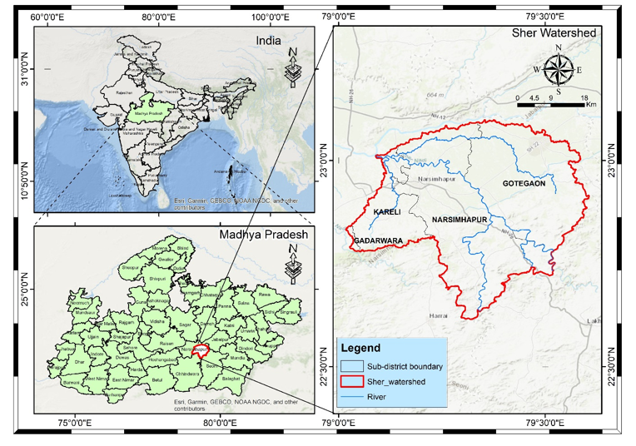
Figure 1: Map showing the location of the Sher River watershed in Narsinghpur district, Madhya Pradesh.
The region has a sub-tropical monsoon climate, with hot summers, a humid monsoon and relatively mild winters. The southwest monsoon, which prevails during July, August and September, supplies nearly 80-85% of the total rainfall in the region. The average annual rainfall in the region varies from 1100 mm to 1400 mm (IMD, 2020). Seasonal rainfall variability affects soil moisture levels, crop growth and groundwater recharge in the watershed. During summer, temperatures exceed 40°C, leading to high rates of evapotranspiration, whereas in winter temperatures are lower. The topography is gently to moderately undulating, with elevation slopes gradually increasing towards the Sher River and its tributaries. The drainage density is also dendritic, suggesting that the lithology is fairly uniform and that runoff is moderate (Horton, 1945). These topographic features would influence infiltration capacity, surface runoff, and the spatial variability of soil moisture content, particularly under intense rainfall during the monsoon season.
The land use and land cover of the watershed area are predominantly agricultural, with crops such as wheat, soybean, paddy, gram, and pulses grown under rainfed and irrigated conditions, respectively (DES, 2019). Forest cover is predominantly found along riverbanks and in upland areas, whereas built-up areas consist mostly of small towns and rural settlements. Differences in vegetation cover, crop types, and root depth affect the distribution of soil moisture through variations in interception and evapotranspiration rates (Zhang et al., 2021). The soils of the Sher River watershed are dominated by black cotton soils (Vertisols) and alluvial soils, which are rich in clay and exhibit good water-holding capacity (NBSS&LUP, 2017). Although the soils retain moisture well, they are susceptible to waterlogging during rainfall and to moisture stress during dry spells. Therefore, the need to monitor soil moisture and assess drought is evident in the region. Because of the rainfall-based agricultural practices, diversified land cover patterns, and vulnerability to climatic fluctuations in the Sher River watershed area, the region is an optimal case study for the application of machine learning algorithms in the estimation of soil moisture levels and the risk assessment of drought events through the analysis of remote sensing data. Assessing soil moisture levels in the region is vital for the development of irrigation systems and for monitoring drought events.
  - Data used
Various spatial, spectral, and field datasets were used in this study to support the estimation of soil moisture and the analysis of drought in the Sher River watershed. These datasets were obtained from reliable national and international sources. GIS, remote sensing, and cloud platforms were used for processing. Survey of India (SOI) toposheets of the Narsinghpur district were obtained from the Online Maps Portal of the Survey of India. These toposheets were utilised to develop base maps, identify drainage networks, settlements, and transportation features, and reference watershed boundaries. SOI toposheets provided essential cartographic information for spatial analysis and watershed development.
The Shuttle Radar Topography Mission (SRTM) Digital Elevation Model was procured from the USGS Earth Explorer Portal. The DEM data were utilised to derive topographic variables, including elevation, slope, flow direction, and flow accumulation. The topographic variables have been instrumental in delineating watershed boundaries and in modelling terrain-controlled soil moisture variability. In the present study, optical satellite data from various satellite systems were used to acquire parameters such as vegetation condition, surface reflectance, and moisture-related indices. For satellite data acquisition, Sentinel-2 MSI data with a spatial resolution of 10 m were obtained from the ESA Sentinel Data Hub for the derivation of vegetation- and soil-related indices. In addition, Landsat-9 Thermal Infrared Sensor data with a spatial resolution of 30 m were obtained from the USGS Earth Explorer Portal to derive surface temperature and moisture-related indices. MODIS data were obtained from the NASA Earth data Portal. Microwave data from Sentinel-1 Synthetic Aperture Radar data were obtained from the ESA Sentinel Datahub website. Dual-polarisation backscatter data (VV and VH) were used, as they are sensitive to surface roughness and soil moisture. Sentinel-1 SAR data were considered important because they are not affected by cloud cover and can be acquired under varying weather conditions. Ground-based soil moisture measurements were obtained through gravimetric soil sampling. Soil sampling was conducted in multiple locations across the study region. Soil sampling involved collecting soil samples within a depth of 0-5 cm, which reflects surface soil moisture conditions. The Soil Moisture Active Passive (SMAP) product with 9 km spatial resolution was used. It was obtained from the National Snow and Ice Data Center (NSIDC), which is affiliated with NASA. The data from this satellite were used to independently compare and validate model-derived estimates of soil moisture at the regional scale. The Soil Moisture Active Passive (SMAP) product with a spatial resolution of 9 km was used. The product is obtained from the National Snow and Ice Data Center (NSIDC), which is affiliated with NASA. The data from this satellite are used to validate model-derived estimates of soil moisture at the regional scale.
  - Methodology

An integrated approach was utilized to estimate soil moisture throughout the study area by merging satellite-derived data, topographic information, climatic conditions, and ground-based observations within the Google Earth Engine platform. Data from Sentinel were utilized to obtain backscatter (VV, VH) and vegetation indices, such as NDVI, OSAVI, and NDWI. Topographical features like slope, aspect, and elevation were derived from SRTM DEM, whereas land surface temperature was sourced from Landsat images. Climatic factors such as rainfall and evaporation were included to understand atmospheric impacts on soil moisture fluctuations. Alongside remotely sensed data, soil moisture samples were obtained through the gravimetric method, which involves measuring wet and dry soil weights. All datasets were merged and arranged to create predictive models. Algorithms for machine learning, such as Multiple Linear Regression (MLR), Random Forest (RF), and CART regression, were utilized to assess soil moisture. Figure 2 depicts the general workflow of methodology.

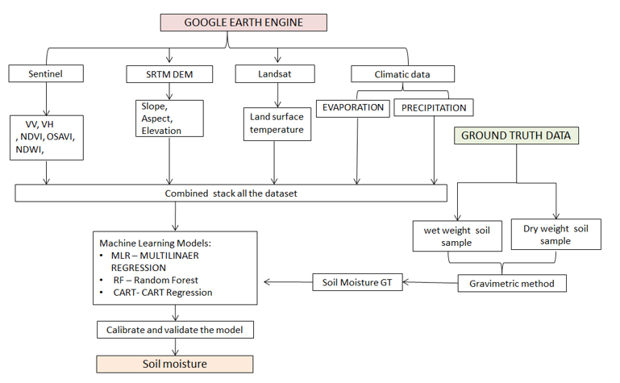
Figure: 2 Integrated flow chart of methodology
Environmental variables were selected based on their physical relevance to soil moisture processes and demonstrated performance in previous studies.
    - SAR Backscatter (VV, VH, VV/VH)
Sentinel-1 SAR backscatter coefficients are influenced by changes in the soil dielectric constant, which vary with soil moisture content. Dual-polarisation (VV and VH) has been used, with VH affected by volume scattering from vegetation and VV reflecting surface scattering. Using the VV to VH ratio helps reduce the effects of vegetation and surface roughness, thereby increasing the sensitivity of the data to soil moisture content (Wagner et al., 2013; Ulaby et al., 1986). It has been shown that SAR backscatter is a reliable predictor of soil moisture content in the topsoil.
    - Normalized Difference Vegetation Index (NDVI)
NDVI is a measurement that quantifies vegetation greenness and biomass by measuring reflectance between near-infrared and red light (Rouse et al., 1974). The density and health of vegetation regulate evapotranspiration and shade, both of which affect moisture levels. NDVI has been used as an indirect measure of soil moisture status. The Normalized Difference Vegetation Index (NDVI) was calculated using the standard formulation:
$$\text{NDVI}=\frac{\text{NIR}-\text{RED}}{\text{NIR}+\text{RED}}$$

    - Optimized Soil-Adjusted Vegetation Index (OSAVI)
OSAVI is an advancement over NDVI, where background effects due to soil are reduced, especially in regions where vegetation cover is sparse (Rondeaux et al., 1996). The Optimized Soil-Adjusted Vegetation Index (OSAVI) was computed as:
$$\text{OSAVI}=\frac{\text{NIR}-\text{RED}}{\text{NIR}+\text{RED}+0.16}$$
    - Normalized Difference Water Index (NDWI)
NDWI is sensitive to the liquid water content in vegetation canopies and soil surfaces by comparing green and near-infrared reflectance (Gao, 1996). Higher NDWI values are generally associated with greater water content, making NDWI useful for capturing moisture variations in both canopy and underlying soil. To assess vegetation water content and moisture dynamics, the Normalized Difference Water Index (NDWI) was derived from the green and NIR bands as:
$$\text{NDWI}=\frac{\text{GREEN}-\text{NIR}}{\text{GREEN}+\text{NIR}}$$
    - Land Surface Temperature (LST)
Land Surface Temperature (LST) was derived from Landsat-9 Thermal Infrared Sensor (TIRS) Band 10 data to characterise the thermal properties of the study area's surface. The retrieval of LST data followed the standard procedure: the digital number of the thermal band was converted to spectral radiance (Lλ), the radiance data were converted to at-sensor brightness temperature (BT), and an emissivity correction was applied to obtain the LST. The LST was calculated using the following equation:
$$\text{LST}=\frac{\text{BT}}{1+\left(\frac{λ\text{ BT}}{ρ}\right)ln⁡ε}$$
where:
"BT"= is the brightness temperature in Kelvin,
λ= is the wavelength of emitted radiance (for Landsat-9 Band 10, λ ≈ 10.9 µm),
ε= is the land surface emissivity
    - Cumulative Rainfall (CHIRPS)
Rainfall is a key determinant of soil water availability. Antecedent precipitation is known to affect soil moisture levels. It was found that cumulative rainfall over a significant period, such as a month, correlated well with surface moisture and improved model performance (Funk et al., 2015).
    - Evapotranspiration (ET)
ET measures water loss on vegetated and non-vegetated surfaces. Higher ET is associated with higher water loss, especially on vegetated surfaces. Therefore, ET is complementary to rainfall and LST. The addition of ET improves the estimation of the soil water balance.
    - Terrain Attributes (Elevation, Slope, Aspect)
Topography, for instance, impacts water redistribution, infiltration, and exposure to solar radiation. Terrain slope determines the rate of runoff and water accumulation, whereas aspect affects the rate of solar radiation and water evaporation (Moore et al., 1993). Terrain variables capture the variability of moisture conditions.
    - Land Use/Land Cover (LULC) and Soil Texture
LULC accounts for differences in surface cover and water demand, thereby affecting moisture retention and evapotranspiration. The texture of the soil is defined by the size distribution of its pores and its water-holding capacity. This directly affects the storage and release of moisture within the soil profile (Rawls et al., 2003).
In this study, a multi-sensor, machine-learning-based approach was employed to estimate surface soil moisture and investigate the spatial variability of soil moisture in the Sher River watershed. Ground truth soil moisture data at the depth of 0-5 cm were obtained by the gravimetric method and were used as the dependent variable. The predictor variables were the multi-source remote sensing data, including Sentinel-1 SAR data under VV and VH polarisation modes to obtain the dielectric properties of the soil, Sentinel-2 MSI data to obtain the indices of vegetation and soil moisture, such as NDVI, OSAVI, and NDWI, Landsat-9 thermal data to obtain the land surface temperature, MODIS MOD16A2 evapotranspiration data, and CHIRPS rainfall data to obtain the antecedent rainfall condition. Topographic variables, including elevation, slope, and aspect, were derived from the SRTM digital elevation model. In addition, land use/land cover and soil texture maps were incorporated to account for surface heterogeneity and soil retention capacity. Data preprocessing was performed in the Google Earth Engine environment. This involved generating a multi-band predictor stack and overlaying ground-truth points to obtain the corresponding pixel values. The dataset was randomly split into training and test sets at 70%/30 %. Machine learning regression algorithms, including Random Forest, Classification and Regression Tree, and Multiple Linear Regression, were used to develop relationships between soil moisture and other predictor variables. The performance of the regression algorithms was evaluated using R² and RMSE, and the best-performing algorithm was used to develop high-resolution soil moisture maps for the entire watershed. The generated maps were further used to identify spatial and temporal trends in soil moisture and to assess drought risk for water management purposes.
- Result and discussion
  - Spatial Distribution of Vegetation and Moisture Indices
The spatial arrangement of vegetation and moisture indices showed significant variability in surface conditions throughout the Sher River watershed. The NDVI values ranged from −0.2 to 0.8, indicating significant variability in vegetation cover (Fig. 3). The elevated NDVI values (0.6-0.8) were primarily located in farming regions and near the riverbed, indicating lush and robust vegetation with enhanced soil moisture availability. The intermediate NDVI values (0.3-0.5) signified areas with sparse vegetation or uncultivated lands, while the lower and negative NDVI values (−0.2 to 0.1) represented barren landscapes, exposed soil, and urban zones, typically associated with low soil moisture levels. This pattern of spatial distribution reinforces the indirect link between soil moisture availability and vegetation health.
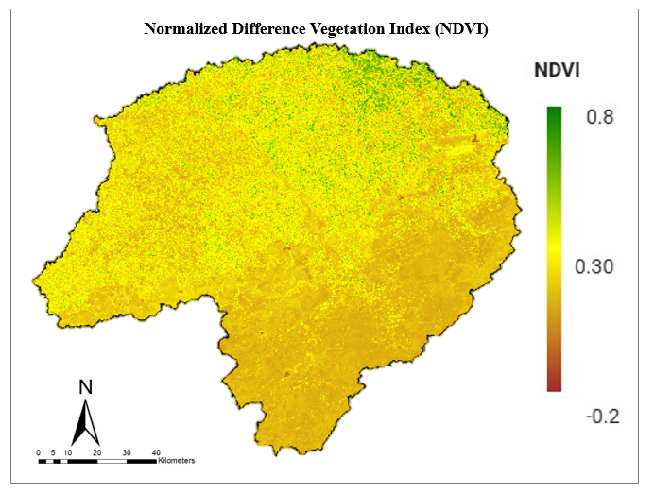
Figure 3: Spatial distribution of NDVI in the Sher River watershed
The Normalized Difference Water Index (NDWI) had a range of −0.5 to 0.5, indicating the differences in surface and vegetation water (Fig. 4). The positive NDWI index (0.2-0.5) was mainly linked to regions with high vegetation water content and wet soil conditions, mainly around irrigated agricultural fields and low-lying areas. On the other hand, the negative NDWI index (−0.5 to −0.1) indicated dry soil surfaces and vegetation, primarily in upland and rain-fed agricultural areas. The NDWI index distribution indicates its ability to detect spatial variations of moisture in vegetation and soil surfaces.
The OSAVI map of the Sher River watershed shows values between 0 and 1 (Fig. 5), clearly demonstrating the spatial variation in vegetation cover with reduced soil background effects. The elevated OSAVI values (0.6-0.9) are mainly restricted to the northern and northeastern parts of the watershed, signifying dense and healthy plant life, whereas moderate values (0.4-0.6) are primarily located in the central area, reflecting moderately vegetated farmland. Nonetheless, reduced OSAVI values (below 0.3) are primarily confined to the southern and southwestern areas, suggesting areas with sparse vegetation, exposed soil, or comparatively drier conditions. The spatial arrangement distinctly shows a shift from thicker vegetation in the upper areas of the watershed to comparatively thinner vegetation in the southern part, thus illustrating OSAVI's capacity to effectively detect vegetation conditions with limited impact from soil reflectance
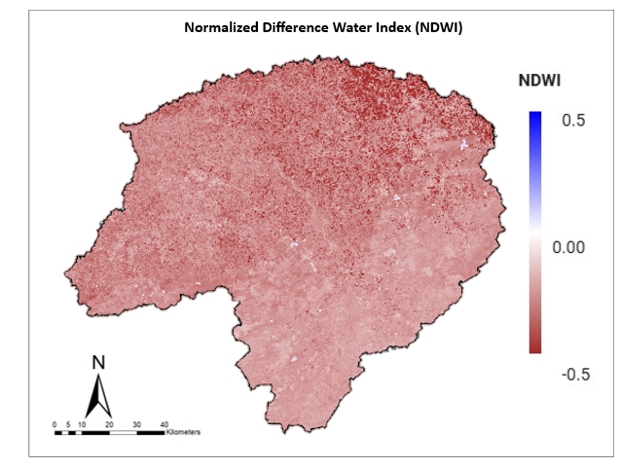
Figure 4: Spatial distribution of NDWI in the Sher River watershed.
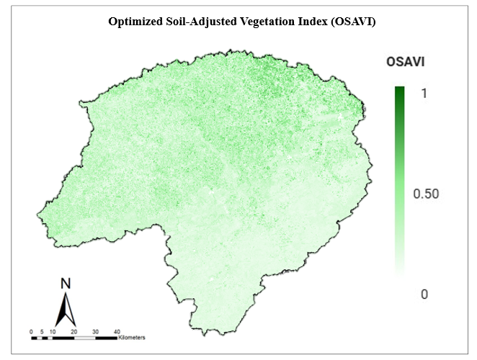
Figure 5: Spatial distribution of OSAVI in the Sher River watershed
  - Land Surface Temperature (LST) Distribution
The Land Surface Temperature (LST) in Landsat 9 data varied between 30°C and 45°C in the Sher River watershed, indicating high spatial variability in surface energy balance (Fig. 6). The lower LST values (30-34°C) were identified in vegetated and irrigated regions, where higher soil moisture content promotes evaporative cooling. Moderate LST values (35-40°C) were identified in regions of mixed land use, while higher LST values (41-45°C) were mainly identified in barren land, urban areas and soil surfaces. The negative spatial correlation between LST and vegetation indices suggests that regions with lower soil moisture content tend to have higher surface temperatures due to reduced evapotranspiration, thereby confirming the physical relationship among soil moisture availability, vegetation, and surface energy balance.
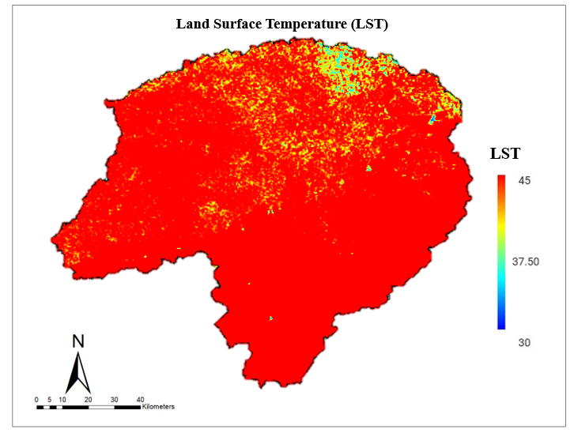
Figure 6: Spatial distribution of Land Surface Temperature (LST)
  - Sentinel-1 SAR Backscatter Characteristics (VV, VH, and VV/VH)
Besides optical indices, the data from the Sentinel-1 Satellite using Synthetic Aperture Radar (SAR) was employed to evaluate structural and moisture-related surface properties in the Sher River watershed. The SAR Ground Range Detected (GRD) data were pre-processed using Google Earth Engine with radiometric correction, Refined Lee speckle filtering, terrain correction using SRTM DEM, and transformation to sigma nought (σ⁰) sigma nought backscatter values. The derived VV and VH polarisation data demonstrated significant spatial variability in moisture status (Fig. 7). Higher VV backscatter values were noted over moist agricultural and low-lying areas, while lower values indicated dry and barren areas. VH polarisation data demonstrated higher sensitivity in vegetated areas due to volume scattering. The VV/VH ratio further enhanced soil moisture discrimination, validating its applicability as an input parameter for machine learning algorithms in soil moisture modelling.
To improve the sensitivity of the data to vegetation and soil moisture, the ratio of VH to VV polarisation (RVH/VV) was computed as follows:
$$R_{VH/VV}=\frac{σ_{VH}^{0}}{σ_{VV}^{0}}$$
The higher the values of (σ⁰) and the polarisation ratio, the rougher or more moist the surface, while lower values are associated with smoother or drier surfaces. Moreover, texture features were also extracted from SAR backscatter images using a Gray-Level Co-occurrence Matrix (GLCM) method, which included contrast, homogeneity and entropy features. The set of SAR-derived variables was thus comprehensive. These variables were then combined with optical vegetation indices to form a multi-source dataset, thereby facilitating improved characterisation of vegetation status, soil moisture patterns, and landscape diversity for hydrological and environmental modelling applications.
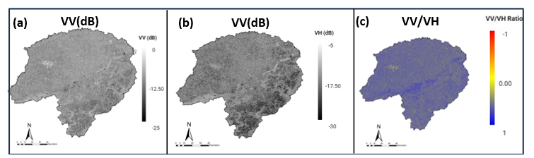
Figure 7: Sentinel-1 SAR backscatter characteristics: (a) VV, (b) VH, and (c) VV/VH ratio

  - Topographic Characteristics Derived from SRTM DEM
The topographic factors extracted from the SRTM DEM exhibited significant spatial variability across the Sher River watershed (Fig. 8) and were instrumental in shaping the spatial distribution of soil moisture. The elevation of the study area varied from 600 m to 900 m above mean sea level, signifying a moderately undulating topography. The lower elevation regions (600-700 m) were mainly confined to the valley bottoms and agricultural areas, where the surface runoff tends to concentrate and infiltration capacity is higher, thus favoring relatively higher soil moisture availability. Conversely, the higher elevation regions (800-900 m) tended to have lower soil moisture content due to increased runoff and low water-holding capacity.
The slope of the watershed ranged from 0° to 10°, indicating gently sloping terrain (Fig. 9). Regions with very gentle slopes (0°-3°) were conducive to water accumulation and infiltration, resulting in higher soil moisture content. Regions with moderate slopes (4°-7°) had relatively lower soil moisture content due to higher surface runoff, whereas slopes nearing 10° indicated faster drainage and lower soil water storage capacity. The correlation between slope and soil moisture content underscores the significance of terrain-controlled hydrological processes in shaping subsurface moisture patterns.
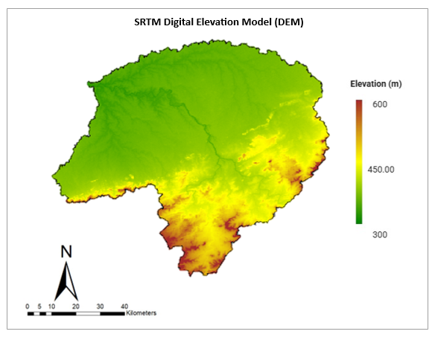
Figure 8: SRTM DEM–derived elevation map

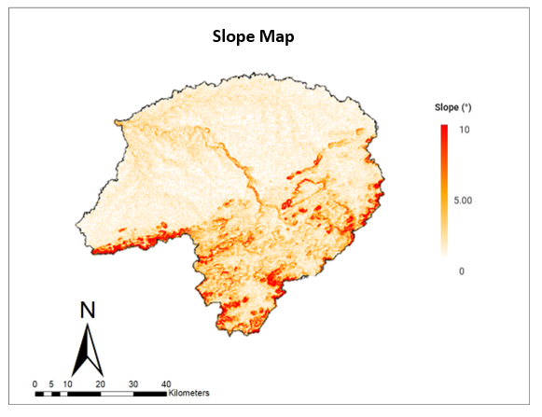
Figure 9: Slope map of Sher River Watershed
Aspect values ranged from 0° to 360°, symbolising all possible directions in the watershed (Fig. 10). Aspect affects solar radiation and evapotranspiration, thereby indirectly influencing soil moisture. South- and southwest-facing slopes, receiving more solar radiation, were likely to have lower soil moisture, while north- and northeast-facing slopes were likely to have higher soil moisture. The addition of Aspect as a predictor variable facilitated the simulation of microclimatic conditions and enhanced the realism of soil moisture simulations.
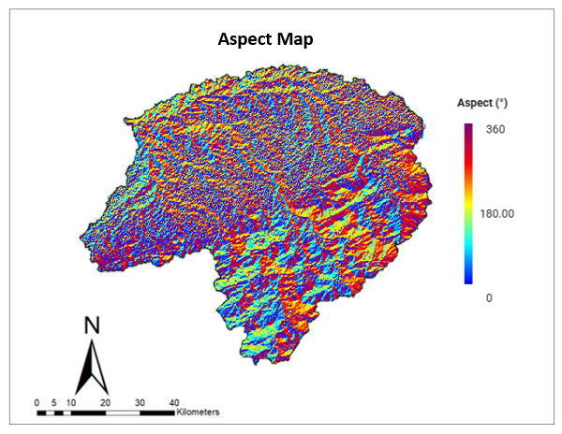
Figure 10: Aspect map of Sher River Watershed
In general, the inclusion of elevation, slope, and aspect parameters improved the machine learning model’s capability to simulate topographically controlled moisture redistribution processes in the watershed. The results are in line with previous studies that highlighted the importance of terrain parameters in modeling soil moisture and hydrological processes.
  - Influence of Climatic Variables (Rainfall and Evapotranspiration) on Soil Moisture Estimation
The role of climate variables in soil moisture estimation is evident in the results of the Random Forest (RF), CART, and Multiple Linear Regression (MLR) models. Among the climate variables, the CHIRPS rainfall and MODIS evapotranspiration datasets were the most influential, as they explained the variation in watershed soil moisture. The RF model posits that rainfall is more important than the CART and MLR models, which also report that the ensemble-based method we used performs better at recognising the nonlinear interactions among rain, land surface, and soil moisture.
Spatial analysis showed that areas with high cumulative rainfall exhibited increased soil moisture. We saw this in low-lying agricultural areas, which had better infiltration and water retention. Additionally, across all models, there was a positive relationship between rainfall and soil moisture, but RF performed best at incorporating rainfall data and producing realistic spatial results. As for CART it had issues of overfitting in some regions and with MLR we saw it’s ability which was limited to capture the complex rain soil moisture relationship because of its linear structure.
Soil moisture and MODIS derived evapotranspiration (ET) displayed an inverse relation - particularly during high atmospheric demand periods. ET increases are typically found in soil moisture depletion areas. This suggests higher moisture use by vegetation and increased evaporation. This is especially true for evapotranspiration in relation to RF results improving moisture loss process prediction. ET is said to have a weaker contribution to evaporation in CART and MLR models meaning vegetation, energy, and soil moisture dynamics were represented poorly in relation to evaporation.
  - Multiple Linear Regression (MLR) Model
The Multiple Linear Regression (MLR) model was developed using 12 predictor variables, including vegetation indices, thermal conditions, terrain parameters, climatic factors, and SAR backscatter. The model's performance statistics indicate moderate-to-good predictive capability for estimating soil moisture. The MLR model produced a Multiple R of 0.81, indicating a strong correlation between observed and predicted soil moisture. The coefficient of determination (R² = 0.65) indicates that approximately 65% of the spatial variation in soil moisture is explained by the predictors. However, the adjusted R² value (0.44) was much lower, indicating that the inclusion of multiple predictors, given the limited number of observations (32), had a greater impact. The ANOVA results show that the regression model is statistically significant (F = 3.00, p = 0.016), confirming that the combined effect of the predictor variables significantly explains soil moisture variability at the 95% confidence level.
Out of all the predictor variables, ‘aspect’ and ‘NDWI’ were established as statistically significant variables (p < 0.05). The positive value of the coefficient for ‘aspect’ (β = 0.00039, p = 0.002) indicates that the orientation of the terrain does influence the distribution of soil moisture. The positive relationship between ‘NDWI’ and ‘soil moisture’ (β = 3.56, p = 0.016) further established the effectiveness of ‘NDWI’ as an indicator of surface and vegetation water content. The positive values of ‘NDWI’ established the effectiveness of ‘NDWI’ in the context of the physical interpretation of the index values with respect to ‘soil moisture.’ Other variables made a moderate, statistically insignificant contribution (0.05 < p < 0.10), including VV, VH, VV/VH ratio, and LST. The positive coefficients for VV and the VV/VH ratio indicate that C-band SAR backscatter intensity can be affected by variations in soil moisture. The negative coefficient on VH indicates that SAR parameters can be affected by vegetation structure and surface roughness. The near-significant results for these variables indicate that SAR parameters play a role, although the linear model does not fully capture this effect.
The results for the vegetation indices NDVI and OSAVI were not statistically significant but had opposite signs with nearly equal magnitudes. This indicates multicollinearity among vegetation indices, and their combined effect on soil moisture may be redundant in a linear model. Similarly, rainfall and MODIS-derived evapotranspiration showed a weak, statistically insignificant relationship, suggesting that climatic factors may not directly affect soil moisture variation when time lags and nonlinear effects are not accounted for. Variables such as terrain, elevation and slope had limited explanatory power, suggesting that within the elevation range, variation in terrain factors played a smaller role than variation in vegetation and surface moisture indicators.
    - Limitations of the MLR Model
Although the MLR model accounts for a significant proportion of the variation in soil moisture, the lower adjusted R² and the fewer significant predictors indicate that the linear model's limitations limit its ability to account for complex soil moisture processes. The complex relationships among vegetation, SAR backscatter, terrain, and climatic factors are nonlinear, which explains the lower R² values compared with other models, such as Random Forest and CART.
  - CART Regression Model
The Classification and Regression Tree (CART) model has been employed to predict the soil moisture using the remotely sensed vegetation data, SAR parameters, terrain data and climatic data. In the study, 21 samples were used to train the CART model, and 11 independent samples were used to validate it. In the CART model, a maximum of 50 terminal nodes and a minimum of 5 leaves were used to prevent overfitting. In the study, a CART regression model was used to predict soil moisture, with an RMSE of 0.056 m³ m⁻³. This indicates a moderate error in predicting soil moisture using the CART regression model. In the study, the coefficient of determination (R²) was 0.48, indicating that 48% of the variation in soil moisture was explained by the CART regression model.
    - Interpretation of CART Model Performance
The moderate R² value suggests that the CART model successfully captured nonlinear relationships between soil moisture and predictor variables, particularly those related to vegetation condition (NDVI, NDWI, OSAVI), surface roughness (VV, VH, VV/VH), and thermal conditions (LST). Nevertheless, the model’s predictive potential was compromised by the limited training dataset, thereby limiting its capacity to learn complex decision rules. The relatively higher RMSE compared with the Random Forest model (discussed in the next section) suggests that single-tree models are more susceptible to data variability, particularly in heterogeneous landscapes. The CART model partitions the feature space using a hierarchical decision structure. Small changes in the training dataset can significantly affect the model’s stability. Despite these limitations, the CART model was more accurate than the Multiple Linear Regression model in estimating soil moisture. The model was capable of capturing nonlinear relationships among predictor variables, particularly those involving vegetation condition and SAR backscatter parameters.
  - Random Forest Regression Model
A Random Forest (RF) regression model was used to predict surface soil moisture content using multisource remote-sensing, terrain, and climatic data. The RF model was built with 500 decision trees, a bagging fraction of 0.8, and a minimum leaf population of 5 to prevent overfitting. The spatial distribution of the predicted surface soil moisture content for 21 April 2025 is shown in Fig. 11.
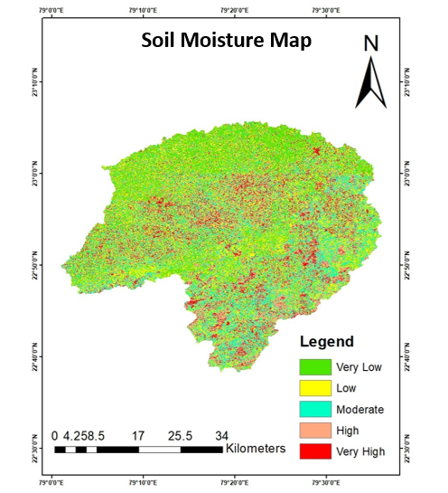
Figure 11: RF-based soil moisture map of Sher River Watershed (21 April 2025)
The R² value for the RF model was 0.73. This indicates that the model explained about 73% of the variation in observed soil moisture content. The RMSE was reasonable, at around 0.071 m³ m⁻³, considering the small sample size and heterogeneous surface. The training R² value was slightly lower, at approximately 0.52.
    - Observed versus Predicted Soil Moisture
As observed, the relationship between observed and RF-predicted soil moisture values revealed a positive and consistent trend, which confirms the RF model's ability to simulate the dynamics of soil moisture under varying conditions of moisture (Fig. 12). The range of the RF model's predicted soil moisture values varied between 0.13 and 0.16 m³ m⁻³, closely following the range of observed values (0.02 to 24 m³ m⁻³). Underestimation of the RF model was observed at higher soil moisture levels, which may be attributable to mixed land-cover conditions.
The residual error distribution indicated that most errors were concentrated around zero, confirming the stability of the RF model.
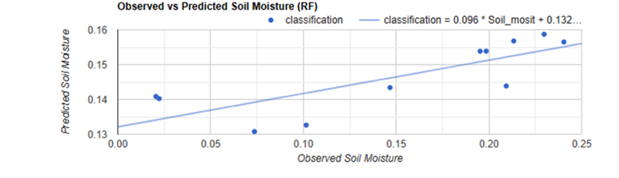
Figure 12: Comparison of observed and RF-predicted soil moisture
    - Variable Importance Analysis
The RF variable importance analysis also provided valuable insights into the contribution of various predictors used in the estimation of soil moisture (Fig. 13). It was observed that, of all the predictors, Aspect (37.55) and the VV/VH ratio (36.26) were identified as the most important factors, which indicate the joint contribution of surface roughness and orientation to the estimation of soil moisture.
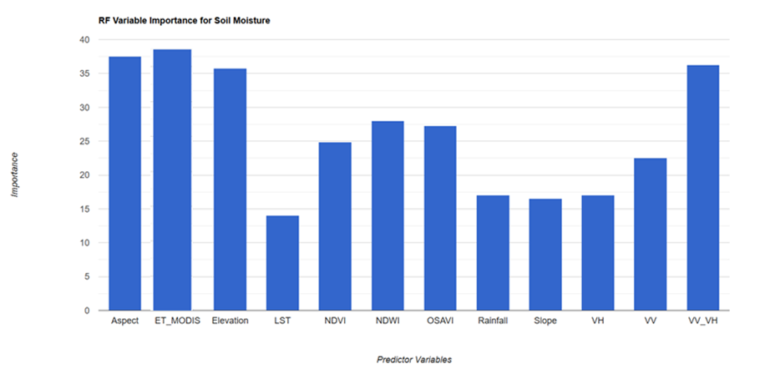
Figure 13: Relative importance of predictor variables in the Random Forest model
Elevation (35.73) was also identified as an important parameter influencing drainage patterns, soil depth, and microclimatic conditions. The contributions of vegetation indices, such as NDWI (27.99), OSAVI (27.25), and NDVI (24.87), were also high, indicating the importance of vegetation-related factors in regulating surface soil moisture.
Components of SAR backscatter, such as VV (22.49) and VH (17.06), also indicate the importance of surface roughness and soil dielectric constant. Climatic and terrain-related factors, such as Rainfall (17.02), Slope (16.54), and LST (14.02), also influenced the estimation of surface soil moisture. However, the contribution of evapotranspiration, as obtained from the MODIS satellite (ET_MODIS), was negligible.
    - Comparative Model Performance Analysis
The comparative assessment of the three models shows notable variations in their predictive accuracy for estimating soil moisture content (Table 1). The Multiple Linear Regression (MLR) model achieved an R² of 0.65 in the test set, suggesting a fairly robust linear connection between soil moisture content and the predictor variables. Nonetheless, the model's linear premise restricts its capacity to understand the intricacies of soil-vegetation-terrain interactions.
Table 1. Comparative performance evaluation of MLR, CART and Random Forest models for soil moisture estimation.
Model | Training Samples | Testing Samples | R² (Testing) | RMSE | Key Strengths | Limitations
Multiple Linear Regression (MLR) | 21 | 11 | 0.65 | 0.050 | Simple, interpretable, identifies statistically significant variables | Assumes linearity, sensitive to multicollinearity
CART Regression | 21 | 11 | 0.48 | 0.056 | Captures nonlinear relationships, easy rule-based structure | Unstable single-tree structure, lower generalization
Random Forest (RF) |  | 11 | 0.73 | 0.071 | Robust to noise, handles nonlinearity and interactions, variable importance | Slight underestimation at high soil moisture, data-intensive

The CART regression model demonstrated fairly low predictive accuracy, achieving an R² of 0.48 in the testing dataset. This underscores the model's responsiveness to small training datasets and the unpredictable nature of individual tree models. Even though the model can detect nonlinear connections, its capability to generalize across diverse land surfaces was constrained.
In contrast, the RF model delivered superior predictive performance, attaining an R² of 0.73, even while utilizing the same quantity of training and test samples as the CART model. This shows the efficiency of ensemble learning methods in minimizing variance. The outstanding performance of the RF model also demonstrates its capability to manage nonlinear interactions between vegetation indices, SAR backscatter parameters, terrain characteristics, and climatic elements, establishing it as the most dependable model for mapping soil moisture in the research region.
- Summery and conclusion
A cloud-based machine learning system was created to evaluate soil moisture changes in the Sher River watershed located in the Narsinghpur district of Madhya Pradesh, employing satellite datasets such as Sentinel-1, Sentinel-2, Landsat-9, CHIRPS, MODIS, and SRTM through the Google Earth Engine platform to develop an extensive model. Three models were assessed, Multiple Linear Regression (MLR), Classification and Regression Trees (CART), and Random Forest, with the Random Forest model attaining the best performance (R² of 0.73), highlighting its enhanced ability to capture intricate interactions among soil moisture and environmental factors, whereas MLR was limited by linear assumptions and CART exhibited diminished stability and generalization ability. Main elements affecting soil moisture estimation comprised terrain aspect, elevation, and the SAR-derived VV/VH ratio, emphasizing the significance of topography and radar sensitivity, while vegetation indices like NDWI and OSAVI additionally confirmed the vital vegetation-soil moisture connections in this area. The detailed soil moisture maps created provide valuable information on spatial variability within the watershed, confirming that integrating multi-source satellite data with ensemble machine learning methods is an effective strategy for tracking soil moisture at the watershed level, benefiting irrigation management, drought evaluation, and water resource planning in central India. Although these results are promising, the limited field observations may have impacted the model's generalization.
Conflicts of Interest
The authors declare no conflicts of interest.
Declaration of using AI
The Author, hereby declare that no generative AI technologies have been used during writing or editing of manuscript.

COMPETING INTERESTS DISCLAIMER:
Authors have declared that they have no known competing financial interests OR non-financial interests OR personal relationships that could have appeared to influence the work reported in this paper.

References
CGWB. (2018). Ground Water Year Book – Madhya Pradesh. Central Ground Water Board, Ministry of Jal Shakti, Government of India.
DES. (2019). Statistical Abstract of Madhya Pradesh. Directorate of Economics and Statistics, Government of Madhya Pradesh.
FAO. (2020). The State of Food and Agriculture 2020: Overcoming water challenges in agriculture. Food and Agriculture Organisation of the United Nations, Rome.
Funk, C., Peterson, P., Landsfeld, M., Pedreros, D., Verdin, J., Shukla, S., et al. (2015). The climate hazards infrared precipitation with stations (CHIRPS): A new environmental record for monitoring extremes. Scientific Data, 2, 150066.
Gao, B. C. (1996). NDWI—A normalized difference water index for remote sensing of vegetation liquid water. International Journal of Remote Sensing, 17(7), 1425–1432.
Ghasemloo, E., Saradjian, M. R., Mohammadzadeh, A., & Akhoondzadeh, M. (2022). Soil moisture estimation using Sentinel-1 SAR data and machine learning techniques. Remote Sensing, 14(3), 620.
Horton, R. E. (1945). Erosional development of streams and their drainage basins: Hydrophysical approach to quantitative morphology. Geological Society of America Bulletin, 56(3), 275–370.
IMD. (2020). Climatological Normals (1981–2010). India Meteorological Department, Government of India.
Kumar, L., Sinha, P., & Patel, N. R. (2021). Role of soil moisture in land–atmosphere interactions and agricultural productivity under changing climate conditions. Journal of Hydrology, 603, 126962.
Liu, Y., Zhang, X., Wang, J., & Li, Y. (2023). Estimation of surface soil moisture using multi-sensor remote sensing data and machine learning algorithms. Remote Sensing of Environment, 287, 113408.
Mohamed, E. S., Belal, A. A., Saleh, A. M., & Abd-Elmabod, S. K. (2020). Soil moisture prediction using machine learning algorithms and remote sensing data in arid environments. Agricultural Water Management, 240, 106266.
Moore, I. D., Grayson, R. B., & Ladson, A. R. (1993). Digital terrain modelling: A review of hydrological, geomorphological and biological applications. Hydrological Processes, 7, 3–30.
NBSS&LUP. (2017). Soil Resource Mapping of Madhya Pradesh. National Bureau of Soil Survey and Land Use Planning, ICAR, India.
Rawls, W. J., Pachepsky, Y. A., Ritchie, J. C., Sobecki, T. M., & Bloodworth, H. (2003). Effect of soil organic carbon on soil water retention. Soil Science Society of America Journal, 67, 818–824.
Rondeaux, G., Steven, M., & Baret, F. (1996). Optimization of soil-adjusted vegetation indices. Remote Sensing of Environment, 55, 95–107.
Rouse, J. W., Haas, R. H., Schell, J. A., & Deering, D. W. (1974). Monitoring vegetation systems in the Great Plains with ERTS. NASA Special Publication, 351.
Sazzad, M. M., Ahmed, T., Kibria, G., & Khan, I. (2025). IoT based soil moisture measurement and type prediction using advanced regression and machine learning models. Scientific Reports, 15, Article 35730.
Srivastava, P. K., Han, D., Ramirez, M. R., & Islam, T. (2019). Machine learning techniques for soil moisture estimation using remote sensing observations. Water, 11(3), 565.
Sun, L., Chen, J., Han, Y., & Zhang, X. (2021). Soil moisture retrieval from Sentinel-1 SAR data using physical and data-driven approaches. IEEE Journal of Selected Topics in Applied Earth Observations and Remote Sensing, 14, 10577–10590.
Ulaby, F. T., Moore, R. K., & Fung, A. K. (1986). Microwave Remote Sensing: Active and Passive (Vol. III). Artech House.
Vijay Shankar Yadav, R. V. Galkate, V. K. Chandola, Ankit Patel, Samikshya Panda, Archana Kaushal & H. R. Ahirwar. (2025). Evaluation of Rainfall Variability and Meteorological Drought in Bundelkhand Region, India. Journal of Experimental Agriculture International, 47(4), 181–200.
Vijay Shankar Yadav, R. V. Galkate, V.K. Chandola, Samikshya Panda & Ankit Patel. (2024). Trend Analysis and Change Point Detection of Climatic Parameters in Ambedkar Nagar District of Uttar Pradesh, India. International Journal of Environment and Climate Change, 14(9), 578–605.
Wagner, W., Lemoine, G., & Rott, H. (1999). A method for estimating soil moisture from ERS scatterometer and soil data. Remote Sensing of Environment, 70, 191–207.
Wang, L., & Fu, B. (2023). Spatiotemporal variability of soil moisture and its controlling factors based on machine learning methods. Journal of Hydrology, 617, 129067.
Yadav, V. S., Galkate, R. V., Chandola, V. K., Shukla, A. K., Panda, S., & Shukla, S. (2025). Spatiotemporal characterization of meteorological drought and rainfall variation during El Niño/La Niña event over Bundelkhand region of India. Discover Applied Sciences, 7(5), 464.
Yadav, V. S., Kaushal, A., Patel, A., Patel, L., Kumari, P., Panda, S., & Patel, A. (2025). Hydroclimatic Signatures of ENSO over India Understanding Rainfall Variability and Regional Sensitivity. International Journal of Environment and Climate Change, 15(10), 562–572.
Zhang, X., Liu, Y., Wang, J., & Li, Y. (2021). Influence of land use and vegetation cover on soil moisture variability at watershed scale. Journal of Hydrology, 603, 127015.

