Trend Analysis and Change Point Detection of Temperature Patterns and Relative Humidity in Enugu, South-Eastern Nigeria

Abstract
This study examined temporal variations and abrupt shifts in temperature patterns and relative humidity in Enugu, South-Eastern Nigeria. A 31-year daily record of temperature and relative humidity was obtained from the Nigerian Meteorological Agency (NiMET). The data were processed to obtain annual maximum series for the climatic variables. The climatic data were summarised using descriptive statistics. Three trend detection methods were used for the trend detection in the time series data. Linear regression analysis, Augmented Dickey-Fuller (ADF) test, and Mann-Kendall trend test with trend-free pre-whitening correction for autocorrelated series were employed for the trend detection. Sen's slope estimator was used to quantify the magnitude of the trend after Mann-Kendall trend detection. Abrupt changes in the time series data were investigated using Distribution-free CUSUM and Sequential Mann-Kendall methods. The results revealed that annual minimum temperature exhibited a statistically significant increasing trend through linear regression (slope = 0.068°C/year, p = 0.035, R² = 0.144) and Mann-Kendall test (tau = 0.284, p = 0.031; Sen's slope = +0.045°C/year). The ADF test confirmed non-stationarity in minimum temperature (ADF = -2.693, p = 0.075), implying a non-constant statistical parameter over time. However, no significant trend was observed in the annual maximum temperature and relative humidity using Linear regression and Mann-Kendall. Change point detection identified significant shifts in minimum temperature around 2020-2022 (CUSUM value = 7, critical value = 6.79). These findings provide critical baseline information for developing climate-responsive urban planning strategies, and public health intervention programmes tailored to Enugu's evolving thermal environment. It is recommended that further study should be carried out on how the results of this study can be useful in the Energy forecasting models.
Keywords: Temperature trends, Mann-Kendall test, Change point detection, CUSUM analysis, Autocorrelation, Climate change, Urban heat island, Enugu

1. Introduction
Two climatic variables namely temperature and relative humidity tend to influence climate change strongly (Morice et al., 2021). Many pressing environmental challenges are due to these two climatic variables. The Intergovernmental Panel on Climate Change (2021) have warned about the increasing trend of temperature pre-industrialisation and attributed CO₂ and methane gas as the major contributors to the increasing temperature. It was estimated that the temperature has risen by 1.1°C from 1850 to 2020, and it is predicted to rise as much as 2.1 to 3.5°C in the next 100 years (IPCC, 2021). Morice et al. (2021) also reported that warmer global average temperatures were observed using temperature data from 1850 to 2018. Temperature rise tends to significantly affect crop yield. An increase of temperature by 2 to 4°C can result in a 15 to 35% reduction in the crop yield (FAO, 2001; Jaiswal et al., 2014).
However, the warming of the Earth varies on a regional and local scale, with urban areas often experiencing amplified warming effects due to land use changes, increased impervious surfaces, and concentrated anthropogenic heat sources (Oguntunde et al., 2012; IPCC, 2021). It is reported that stronger temperatures are recorded over land than on ocean areas, with temperatures on land being 1.6times more than what is obtainable on ocean areas.
The strong evidence found on the increasing trend in temperature was not observed in relative humidity. IPCC (2021) stated that there has not been any long-term trend in the relative humidity since 1978. However, a slight decrease in relative humidity was observed over this period, which was attributed to the warming of the Earth. Shin et al. (2021) reported a significant decrease in relative humidity in South Korea from 1973 to 2018. The changes in climatic variables can be detected using either a parametric or non-parametric statistical approach.
Many climatic studies have relied solely on using trend detection in understanding the climatic variation of a region, without understanding when the abrupt change occurred in the time series. The change points are important as abrupt changes in the time series are characterised by relatively sudden transitions from one climatic state to another (Pacalal et al., 2004). Studying the climatic variability by just trend detection results in a partial understanding and limits one understanding of what activities occurred in that year that resulted in the change. Detecting such change points is essential for understanding the temporal evolution of climate patterns and for attributing changes to specific causal mechanisms (Patakamuri, 2022).
Limited studies have been done on climatic variability in Nigeria, especially in the eastern part. Given that some studies have documented temperature patterns in Nigerian cities broadly (Oguntunde et al., 2012; Eludoyin, 2018), location-specific analyses, including change point detection, are scarce. The primary aim of this study is to comprehensively analyse temperature trends and identify change points in Enugu's temperature patterns over the 31 years from 1992 to 2022.

2. Materials and Methods

2.1 Study Area
Enugu as a study area (Figure 1) for which the temperature and relative humidity changes were studied. Enugu is one of the five Eastern States located in the Southeastern part of Nigeria. Enugu is the capital of Enugu state and historically the administrative centre of Nigeria's former Eastern Region, representing a significant urban centre in South-Eastern Nigeria. Enugu lies between latitudes 6° 18′ 51.1″ N to 6° 28′ 26.0″ N and longitudes 7° 23′ 56.4″ E to 7° 32′ 33.7″ E. Enugu lies on a very hilly terrain with elevation ranging from 140 to 511m, which is above Sea level. The city experiences a tropical rainforest climate characterised by high temperatures throughout most of the year and abundant precipitation mostly during the rainy season. Mean annual temperature ranges between 26°C and 28°C, with relatively small seasonal variation characteristic of tropical locations. The Nigerian Meteorological Agency maintains a meteorological station in Enugu that has operated continuously since 1990.
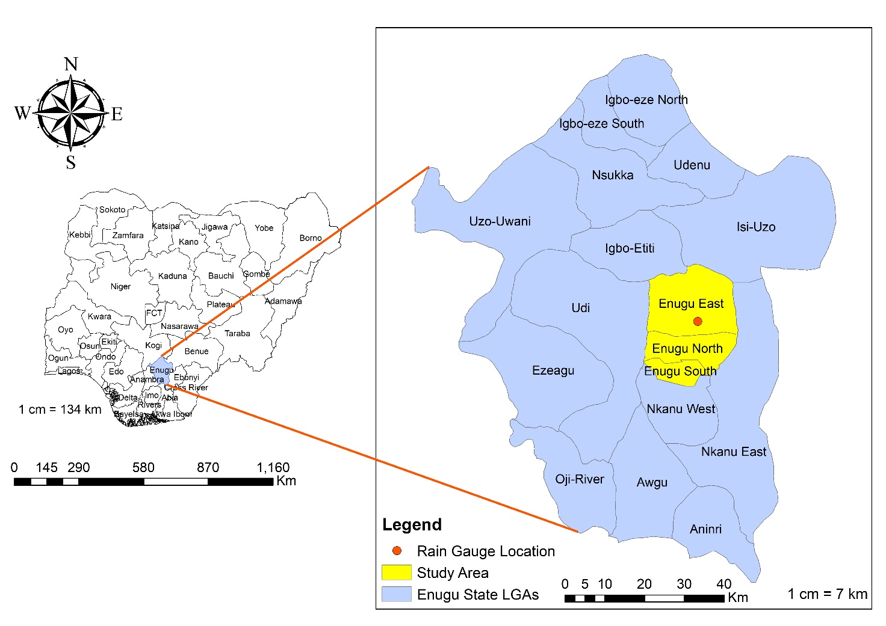
Figure 1: Location of Enugu and Rain Gauge Locations

2.2 Data Collection
Daily minimum, maximum Temperature and relative humidity data from 1992 to 2022 were obtained from the Nigerian Meteorological Agency (NIMET), which is the federal government agency responsible for meteorological observations and climate data archival across Nigeria. For the daily climatic data, the annual maximum data series were obtained. The annual maximum values of temperature and relative humidity were extracted from daily distributions. A total of 31 annual maximum and minimum temperature values were collected for data analysis.

2.3 Data Analysis

2.3.1 Descriptive Statistics
Descriptive statistics were employed to summarise the climatic data and detect the trends and change points. The average and standard deviation of the annual minimum and maximum temperatures and relative humidity were computed using Equations 1 and 2. The coefficient of variation was used in establishing the relative fluctuation in the climatic data, while the skewness was used in assessing the nature of the distribution. Time series plot of the climatic data was done for visualization of temporal patterns and potential anomalies.
$\overline{x}$ = $\frac{1}{N}\sum_{i=1}^{N}{x_{i}}$ (1)
S = $\sqrt{\frac{{\left(x_{i}- \overline{x}\right)}^{2}}{N-1}}$ (2)
2.3.2 Trend Detection
Three different methods were adopted in detecting the trend in the climatic data distribution. Linear Regression, Augmented Dickey-Fuller test, and Mann-Kendall were all utilised for the trend detection. Linear regression is usually employed for trend detection in hydro-meteorological time series such as temperature, precipitation, relative humidity, streamflow, etc (Suhaila & Yusop, 2017; Olali et al., 2024). Linear Regression is a parametric method and was used to quantify the magnitude and direction of the trend of the temperature or relative humidity distribution. A statistically significant slope indicates that there is an increasing or decreasing magnitude of the climatic variation, which is not due to chance. The simple linear regression model used is shown in Equation 3. The slope and intercept of the model were obtained by solving the normal equations, as shown in Equations 4 and 5, to obtain $a_{o}$ and $a_{1}$ (Nwaogazie, 2021).
$y= a_{o}+ a_{1}x$ 3
Where x = years, $a_{o}$ = intercept, $a_{1}$ = slope, and y = temperature
$\sum_{i=1}^{n}{y}$ = n$a_{o}$ + $a_{1}\sum{x}$ 4
$\sum_{i=1}^{n}{xy}$ = $a_{o}\sum{x}$ + $a_{1}\sum{x^{2}}$ 5
The Augmented Dickey–Fuller (ADF) test which is a parametric method was employed to examine the stationarity of minimum temperature, maximum temperature, and relative humidity time-series distribution. Stationarity in the time series ensures that the mean and variance remain constant over time (Dickey & Fuller, 1979; Mushtaq, 2011). When the time series is stationary, it indicates that no significant trend exists in the temperature and relative humidity distributions over time. Tests were conducted at the 5% significance level with optimal lag lengths determined using the Akaike Information Criterion (AIC).
The trend detection was also investigated using the Mann-Kendall test, which is a non-parametric test. This non-parametric test assesses whether there is a monotonic increasing or decreasing trend (Mann 1945; Kendall 1955; Masi et al., 2023; Ekwueme et al., 2024). The Mann-Kendall test doesn't require the temperature and relative humidity data to follow a normal distribution, thereby making it a more robust test for time series data distribution with extreme skewness (Yue et al., 2002; Sam et al., 2023; Ekwueme et al., 2024). Before the application of Mann-Kendall to detect for trend, autocorrelation analysis was carried out. Series correlation in the time series tends to affect the result of Mann-Kendall test (von Storch, 1999; Yue et al., 2002; Suhaila et al., 2010). Series correlation in the time series results increases the likelihood of a Type I error, whereby an increasing or decreasing trend is falsely established when no true trend exists.
When there is autocorrelation at lag 1, corrections must be applied to the time series before Mann-Kendall can be used to detect trend on the time series data. However, if no serial autocorrelation is found in the temperature data set, the Mann-Kendall test can be applied without the need for correction. Yue et al. (2002) developed a correction for time series with serial correlation known as “Trend Free Pre-whitening (TFPW)”. The trend analysis was done utilising a Python package called statsmodels (library-pymannkendal).
2.3.3 Theil Sen’s Slope
The Sen's Slope Estimator (SSE) test was used to determine the magnitude and variation of the trend. The Sen slope is estimated using the formula in Equation 6 (Sen, 1968; Theil, 1950).
$β$ = Median$\left(\frac{x_{i}- x_{j}}{t_{i}- t_{j}}\right)$ 6
Where $x_{i}$ and $x_{j}$ are rainfall data values at time $t_{i}$ and $t_{j}$ (i > j) respectively.
2.3.4 Change Point
Identification of abrupt changes in the minimum temperature, maximum temperature and relative humidity was done using Distribution-free CUSUM and Sequential Mann-Kendall. Both change point methods are non-parametric tests. The Cumulative Sum (CUSUM) test examines cumulative deviations from the series median to detect shifts in central tendency (McGilchrist & Woodyer, 1975). The distribution-free CUSUM statistic is calculated by cumulating differences between each observation and the overall median. The magnitude and timing of maximum absolute deviation indicate the strength and location of the change point. CUSUM values exceeding these thresholds indicate statistically significant change points (Team R Core, 2021; Patakamuri, 2022).

3 Results and Discussion

3.1 Results
3.1.1 Temperature and Relative Humidity Distribution in Enugu
The time series plot for annual minimum and maximum temperatures is shown in Figure 2. Both temperatures showed a dip in temperature from 2005 to 2006. Figure 3 presents the density of annual maximum and minimum temperatures. The annual maximum temperature in Enugu ranged from 35.2 to 39.20°C over the 31 years, with a mean of 37.87°C and a standard deviation of 1.1°C. The Annual minimum temperature exhibited greater relative variability, ranging from 24.1 to 32.5°C with a mean of 27.28°C and a standard deviation of 1.63°C. Table 1 presents the descriptive statistics of climate variables. The mean annual relative humidity is shown in Figure 4.
3.1.2 Trend Analysis
The trend analysis result using linear regression is shown in Table 2. Just one out of the three climatic data showed a significant increasing trend. The annual maximum temperature showed an increasing, but not significant, trend of 0.041°C per year with p-value = 0.061 > 0.05 and R² = 0.116. Similarly, the annual relative humidity demonstrated a significantly decreasing trend of -0.062% per year with p-value = 0.273 > 0.05 and R² = 0.041. However, the annual minimum temperature revealed a significant increasing trend with p-value = 0.035 < 0.05 and R² = 0.144.
The result from the Augmented Dickey-Fuller test is presented in Table 3 which illustrates a non-stationarity of the statistical parameters over time
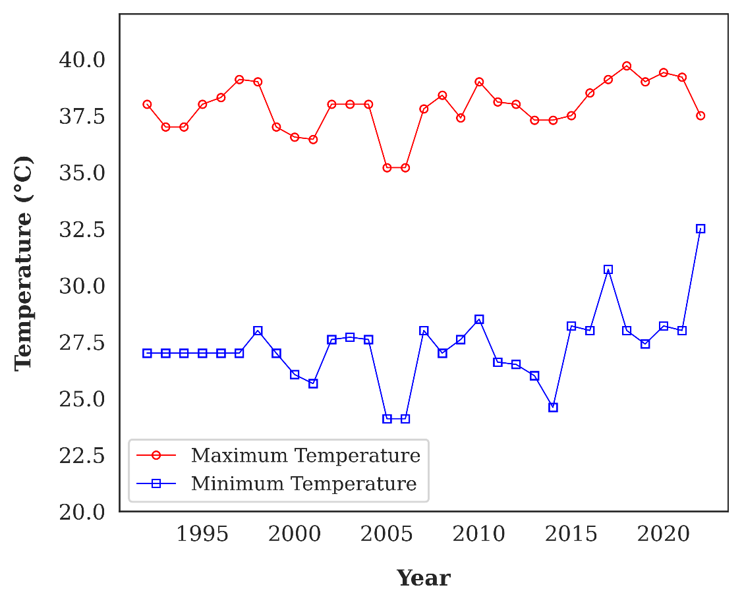
Figure 2: Annual minimum and maximum temperatures from 1992 to 2022
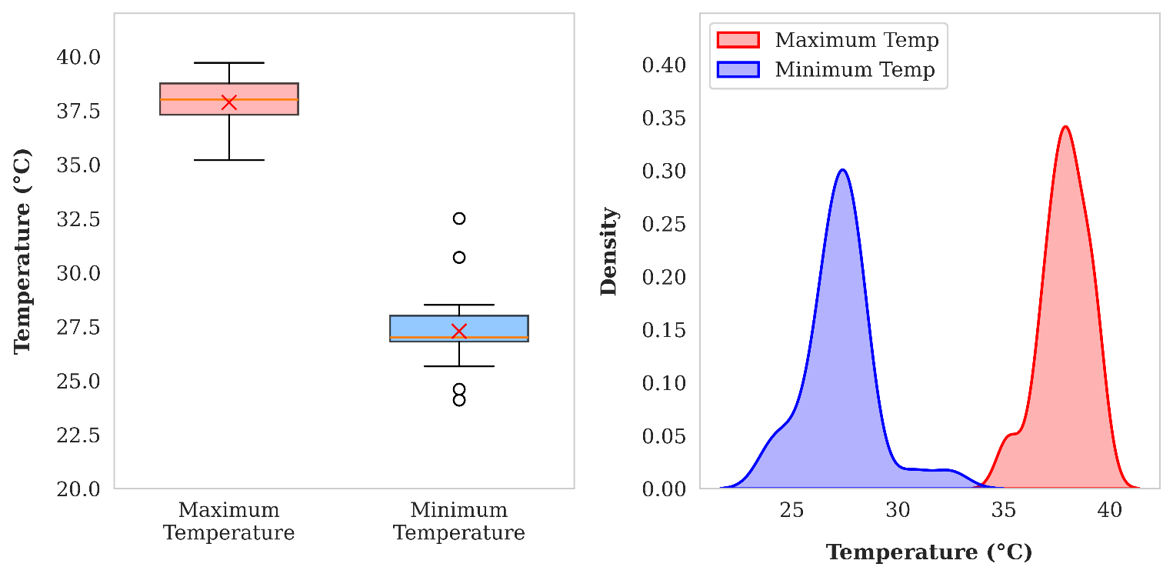
Figure 3: Annual Minimum and Maximum Temperature
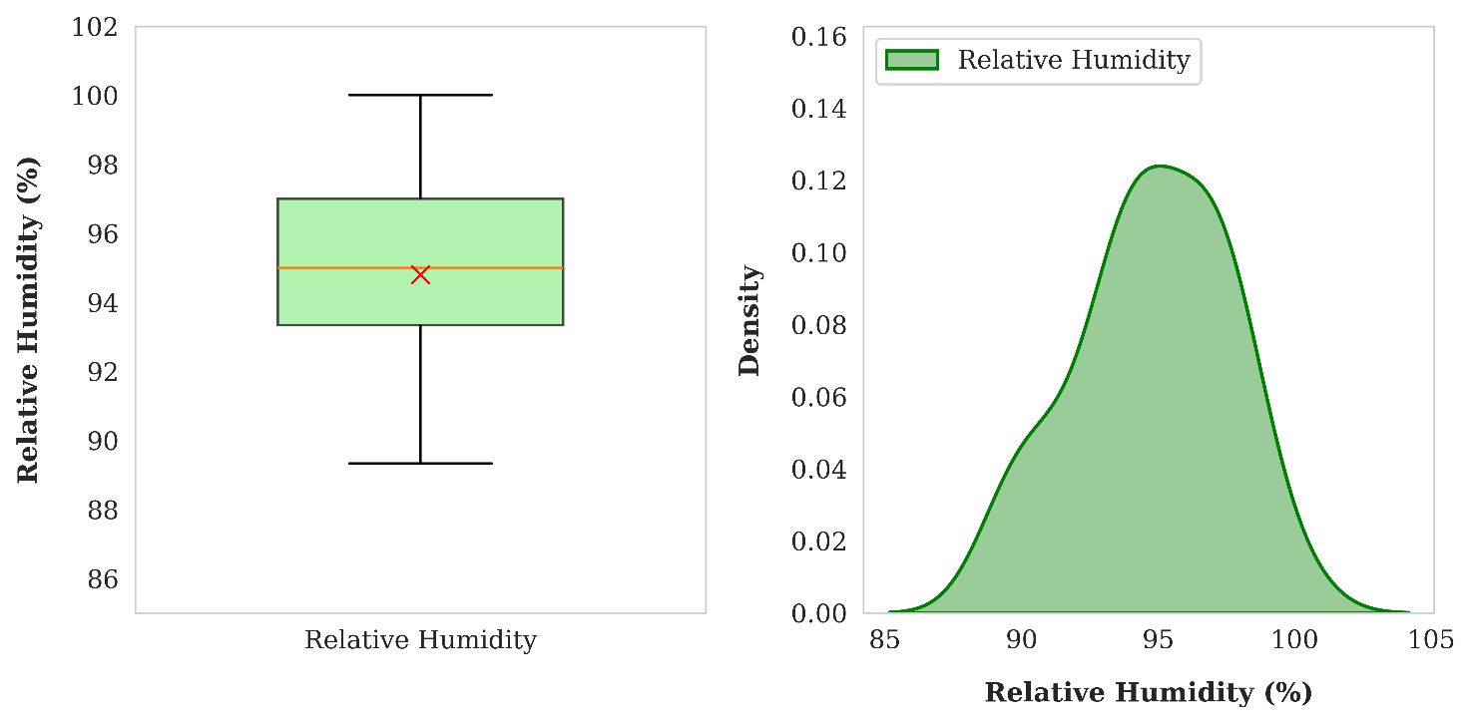
Figure 4: Relative Humidity

Table 1: Descriptive Statistics of Climate Variables
Parameter | Mean | Std Dev | Min | Max | CV (%) | Skewness | Fisher Error | Skew/Fisher | Remark
Annual Maximum Temperature (°C) | 37.87 | 1.11 | 35.2 | 39.7 | 2.92 | -0.664 | 0.421 | -1.578 | Approximately Normal
Annual Minimum Temperature (°C) | 27.28 | 1.63 | 24.1 | 32.5 | 5.99 | 0.779 | 0.421 | 1.853 | Approximately Normal
Relative Humidity (%) | 94.79 | 2.76 | 89.33 | 100 | 2.91 | -0.325 | 0.421 | -0.774 | Approximately Normal
Note: Skew/Fisher was used in evaluating the normality. Since the value is less than 1.96, assume normality.

Table 2: Linear Regression Analysis for Trend Detection at 5% Significance Level (Enugu, 1992-2022)
Climate Variable | Slope  (per year) | Intercept | R² | p-value | SE | 95% CI  Lower | 95% CI  Upper | Remark
Maximum Temperature | 0.041 | 37.249 | 0.116 | 0.061 | 0.021 | -0.002 | 0.085 | No significant trend
Minimum Temperature | 0.068 | 26.254 | 0.144 | 0.035 | 0.031 | 0.005 | 0.131 | Significant increasing trend
Relative Humidity | -0.062 | 95.718 | 0.041 | 0.273 | 0.055 | -0.174 | 0.051 | No significant trend
Note. SE = Standard Error; CI = Confidence Interval. Significance level (α) = 0.05. Positive slope indicates an increasing trend; negative slope indicates a decreasing trend. p-value < 0.05 indicates a statistically significant linear trend.

Table 3: Augmented Dickey-Fuller Test for Stationarity at 5% Significance Level (Enugu, 1992-2022)
Climate Variable | ADF Statistic | p-value | Critical Value (5%) | Test Result | Remark
Maximum Temperature | -2.924 | 0.043 | -2.964 | Reject H₀ | Stationary
Minimum Temperature | -2.693 | 0.075 | -2.964 | Fail to reject H₀ | Non-stationary
Relative Humidity | -2.589 | 0.095 | -2.986 | Fail to reject H₀ | Non-stationary
Note. ADF = Augmented Dickey-Fuller; H₀ = Null Hypothesis. Significance level (α) = 0.05. Null Hypothesis: Series has a unit root (non-stationary). Decision Rule: If p-value < 0.05, reject H₀ (series is stationary).

Before the detection of trend using Mann-Kendall, autocorrelation analysis was done, and the results of the correlograms are presented in Figures 5 and 6. The results indicate no significant serial correlation.
Mann-Kendall trend test results for annual maximum, minimum temperatures and annual relative humidity are presented in Table 4. The result presents a weak non-significant negative trend for relative humidity.

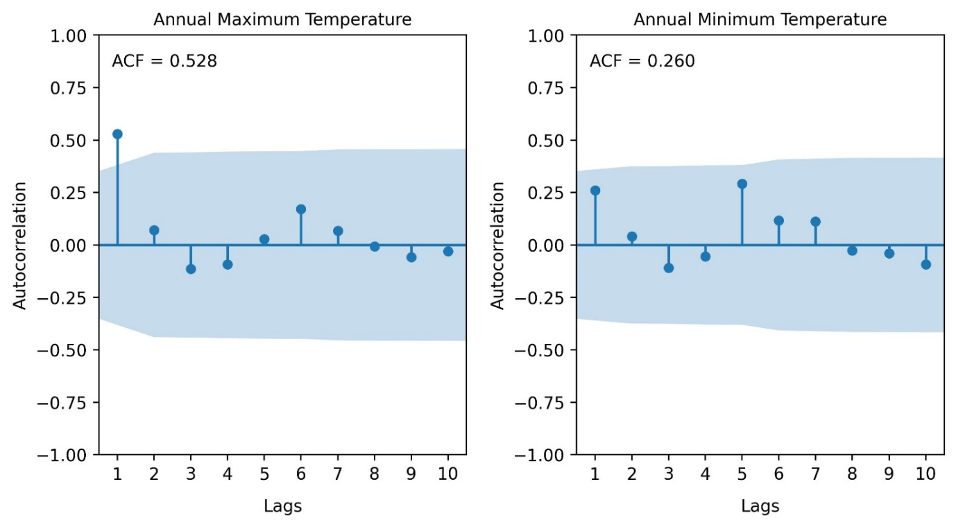
Figure 5: ACF for annual maximum and minimum temperature for Enugu

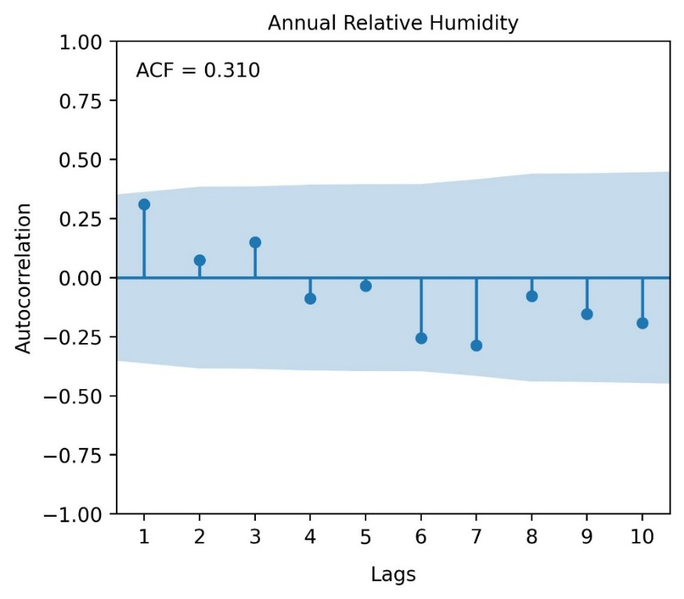
Figure 6: ACF for relative humidity for Enugu

Table 4: Mann-Kendall Trend Test Results for Enugu
Parameter | Kendall's Tau | p-value | Sen's Slope (°C/year)
Annual Maximum Temp (TFPW) | 0.156 | 0.232 | +0.028
Annual Minimum Temp | 0.284 | 0.031* | +0.045
Relative Humidity | -0.113 | 0.385 | -0.012
Note: * = Significant at α = 0.05; TFPW = Trend-Free Pre-Whitened

3.1.3 Change Point Detection
Change point detection for annual maximum, minimum and relative humidity for Enugu using distribution-free CUSUM analysis are illustrated in Figures 7, 9 and 11. Statistically significant change point occurred for annual minimum temperature and relative humidity. However, no statistically significant change point occurred for annual maximum temperature.
Sequential Mann-Kendall analysis corroborated these findings. For the annual minimum temperature (Figure 10), the change point occurred between 2020 and 2021 For maximum temperature (Figure 8), the Sequential Mann-Kendall test identified 2017 as a probable change point. For annual relative humidity (Figure 12), Sequential Mann-Kendall testing identified probable change points in 2001-2002 and again in 2013, suggesting possible multiple regimes shifts in humidity patterns.
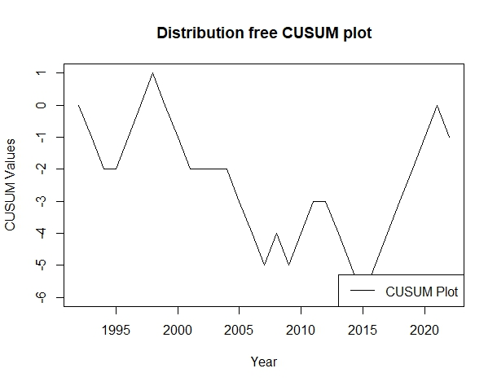
Figure 7: CUSUM change point plot for Annual Maximum temperature for Enugu

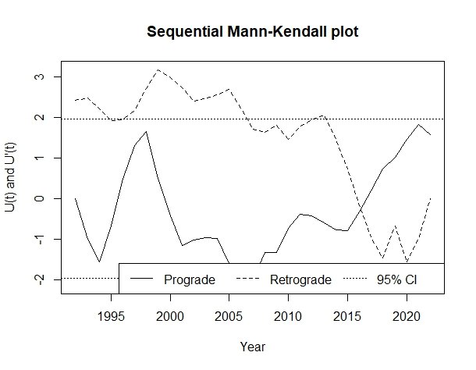
Figure 8: Sequential Mann-Kendall change point plot for Annual Maximum temperature for Enugu
Table 5: CUSUM Statistic for Trend Change Detection (Enugu)
Climate Variable | Maximum CUSUM Value | CI @ 90% | CI @ 95% | CI @ 99% | Change Point Year | Remark
Annual Maximum Temperature | 6 | 6.7927 | 7.5722 | 9.0755 | 2015 | No significant change point
Annual Minimum Temperature | 7 | 6.7927 | 7.5722 | 9.0755 | 2022 | Significant change point
Annual Relative Humidity | 8 | 6.7927 | 7.5722 | 9.0755 | 2012 | Significant change point
Note. CV = Critical Value. Sample size (n) = 31. Critical values calculated using: CV = k × √n, where k = 1.22 (90%), 1.36 (95%), 1.63 (99%). Decision rule: If Maximum |DF-CUSUM| > Critical Value, there is a significant change point at that confidence level.

Table 6: Sequential Mann-Kendall (SQMK) for Trend Change Detection (Enugu)
Climate Variable | Change Point Year(s) | Crossing Pattern | Remark
Annual Maximum Temperature | 2017 | Single Crossing | Probable change point
Annual Minimum Temperature | 2020, 2021 | Multiple Crossing | Probable change point
Annual Relative Humidity | 2001, 2002, 2013 | Multiple Crossing | Probable change point
Note: A Single crossing indicates a probable change point in the series. When there is no clear trend in the data, the series will intersect at several locations

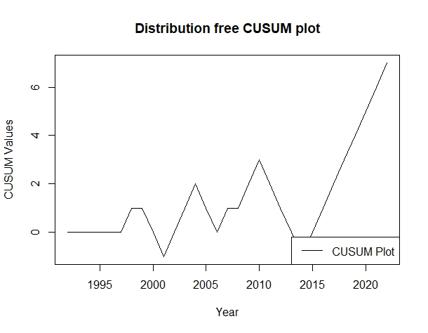
Figure 9: CUSUM change point plot for Annual Minimum Temperature for Enugu
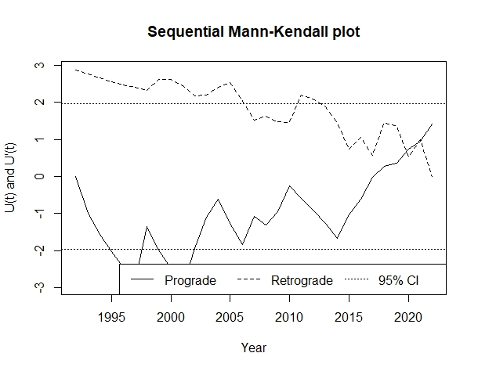
Figure 10: Sequential Mann-Kendall change point plot for Annual Minimum Temperature for Enugu

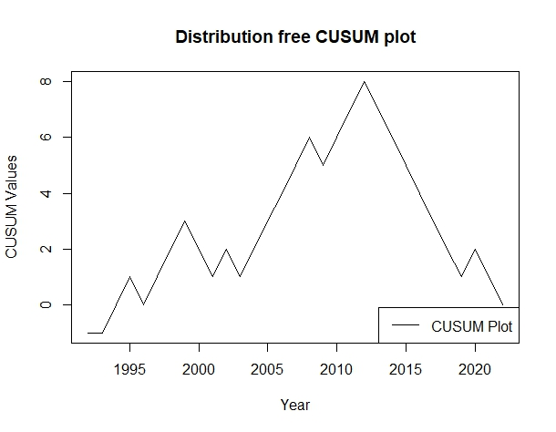
Figure 11: CUSUM change point plot for Annual Relative Humidity for Enugu

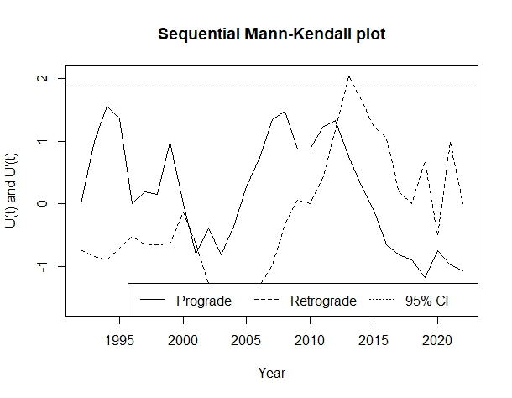
Figure 12: Sequential Mann Kendall change point plot for Annual Relative Humidity for Enugu

3.2 Discussion
3.2.1 Temperature and Relative Humidity Distribution in Enugu
The findings from the results showed that Enugu experienced relatively warmer temperatures, with the average annual maximum temperatures reaching as high as 37.87°C. This was relatively higher than what was obtainable in other Southern states in Nigeria. Olali et al. (2025) reported that the average annual maximum temperature in Bayelsa was 36.43°C, while that for Warri was 36.35°C. This relatively warmer temperature was also observed in the minimum temperature. Significant variation was observed in the annual minimum temperature in Enugu. Olaili et al. (2025) reported that the minimum temperature tends to exhibit higher variability than the annual maximum temperature.
3.2.2 Trend Analysis in Data Distribution
The trend analysis (Table 2) revealed that only the annual minimum temperature in Enugu showed a significantly increasing trend. The statistically significant warming trend in annual minimum temperatures were 0.045 to 0.068°C/year. Projection of the rise in the annual minimum temperature could rise as high as 6.8°C from the current mean values. Suhaila and Yusop (2017) reported a significant increasing trend in annual minimum temperature in Peninsular Malaysia. Minimum temperature time series tend to have more variation and a significant trend than the maximum temperature series (Suhaila & Yusop, 2017, Olali et al., 2025). They attributed this finding to urbanisation, stating that urbanisation tends to affect annual minimum temperatures more than it affects annual maximum temperatures. Urbanisation creates a phenomenon known as the urban heat island, which refers to the increased temperatures experienced in cities compared to their rural surroundings. This effect arises due to dense concentrations of buildings and roads, reduced vegetation, and human activities, all of which contribute to the retention and gradual release of heat, particularly at night. Additionally, urban areas often experience reduced nocturnal cooling due to decreased longwave radiation loss and reduced evaporative cooling from vegetation loss. Enugu is a city on the hill, very urbanised; this may explain the reason for the greater increasing trend in the annual minimum temperature. The rising minimum temperatures can have profound impacts on energy demand, as alternative methods of cooling, such as the use of air conditioners, would be required. The relative humidity at Enugu was relatively higher than in most Nigerian cities. Eludoyin et al. (2018) reported that most relative humidity in Nigerian cities is below 86%. However, the annual maximum relative humidity recorded in Enugu was as high as 94.79%. A non-significant negative trend was observed in the relative humidity in Enugu. The decreasing trend in relative humidity was also observed in other studies (Brown & DeGaetano, 2013; Shin et al., 2021). The decreasing decline in relative humidity might be attributed to the faster warming of the Earth. An increase in the Earth's temperature results in quicker evaporation of the water held in the air.
3.2.3 Change Point Detection
The identification of a change point in minimum temperature around 2020-2022 (Figure 9) suggests that warming has not proceeded uniformly but rather includes periods of accelerated change. Amadi et al. (2020) emphasised that recent change points in climate time series may indicate emerging responses to intensifying climate change that could signal the beginning of more rapid transitions.

5 Conclusion
Based on the data analysis carried out in this study, the following conclusions can be drawn:
- The trend analysis revealed that annual minimum temperature exhibited a statistically significant increasing trend, with linear regression showing a slope of 0.068°C/year (p-value = 0.035, R² = 0.144) and Mann-Kendall test confirming the trend (tau = 0.284, p-value = 0.031; Sen's slope = +0.045°C/year). This represents approximately 1.4°C warming over the study period, with projections suggesting a potential 4.5 to 6.8°C increase over the next century if current warming rates persist.
- In contrast, maximum temperature showed non-significant trends after trend-free pre-whitening correction (tau = 0.156, p-value = 0.232).
- Relative humidity exhibited no significant trend (tau = -0.113, p-value = 0.385); and
- A significant change point in minimum temperature occurred around 2020-2022 (CUSUM value = 7, Critical Value = 6.79), indicating a recent increase in warming in Enugu. The increasing trend in the warming of minimum temperatures over maximum temperatures strongly indicates urban heat island effects in Enugu.

References
Amadi, S. O., Udo, S. O., & Ewona, I. O. (2020). Trends and variations of monthly mean minimum and maximum temperature data over Nigeria for the period 1950-2012. International Journal of Pure and Applied Physics, 8(1), 1-18.
Brown, P. J., & DeGaetano, A. T. (2013). Trends in US surface humidity, 1930–2010. Journal of Applied Meteorology and Climatology, 52(1), 147-163.
Dickey, D. A., & Fuller, W. A. (1979). Distribution of the estimators for autoregressive time series with a unit root. Journal of the American statistical association, 74(366a), 427-431.
Douglas, E. M., Vogel, R. M., & Kroll, C. N. (2000). Trends in floods and low flows in the United States: impact of spatial correlation. Journal of hydrology, 240(1-2), 90-105.
Eludoyin, O. M. (2018). Daily minimum and maximum temperature in Nigeria: Trends, patterns and probabilistic modelling of extremes between 1950 and 2015. Journal of Spatial Science, 65(2), 265-283.
Eludoyin, O. M., Adelekan, I. O., Webster, R., & Eludoyin, A. O. (2014). Air temperature, relative humidity, climate regionalization and thermal comfort of Nigeria. International Journal of Climatology, 34(6), 2000-2018.
Ekwueme, C.M., Nwaogazie, I.F., & Ikebude, C. (2024). Assessing Rainfall Trends and Change Points in Owerri, Nigeria: Implications of Climate Change. Asian Journal of Advanced Research and Reports, 18(11), 225-234. https://doi.org/10.9734/ajarr/2024/v18i11790.
Gbode, I. E., Adeyeri, O. E., Menang, K. P., Intsiful, J. D. K., Ajayi, V. O., Omotosho, J. A., & Akinsanola, A. A. (2019). Observed changes in climate extremes in Nigeria. Meteorological Applications, 26(4), 642-654.
IPCC. (2021). Climate Change 2021: The Physical Science Basis. Contribution of Working Group I to the Sixth Assessment Report of the Intergovernmental Panel on Climate Change [Masson-Delmotte, V., Zhai, P., Pirani, A., Connors, S. L., et al. (Eds.)]. Cambridge University Press.
Jaiswal, R. K., Lohani, A. K., & Tiwari, H. L. (2015). Statistical analysis for change detection and trend assessment in climatological parameters. Environmental Processes, 2(4), 729-749.
Kendall, M. G. (1955). Rank correlation methods. Griffin.
Mann, H. B. (1945). Nonparametric tests against trend. Econometrica, 13(3), 245-259. https://doi.org/10.2307/1907187.
McGilchrist, C. A., & Woodyer, K. D. (1975). Note on a distribution-free CUSUM technique. Technometrics, 17(3), 321-325.
Morice, C. et al. (2021). An updated assessment of near-surface temperature change from 1850: the HadCRUT5 data set. Journal of Geophysical Research, 126, e2019JD032361.
Mushtaq, R. (2011). Augmented dickey fuller test. Available at SSRN: https://ssrn.com/abstract=1911068 or http://dx.doi.org/10.2139/ssrn.1911068.
National Population Commission. (2006). Population and Housing Census of the Federal Republic of Nigeria. Priority Tables (Volume I). National Population Commission, Abuja, Nigeria.
Nwaogazie, I. L. (2021). Probability and statistics for science and engineering practice. De-Adroit Innovation, Enugu, 125-126.
Oguntunde, P. G., Abiodun, B. J., & Lischeid, G. (2012). Spatial and temporal temperature trends in Nigeria, 1901–2000. Meteorology and Atmospheric Physics, 118, 95-105.
Olali, K., Nwaogazie, I. L., & Ikebude, C. F. (2025). Establishing Climate Change on Temperature Trend, Variation and Change Point Pattern in Warri, Nigeria. Hydrology, 13(2), 90-101.
Olali, K., Nwaogazie, I., & Ikebude, C. (2025). Climate Variability in Temperature Trends and Change Point in Yenagoa, Nigeria. International Journal of Environment and Climate Change, 15(3), 244-256.
Pacalal, S., Cole, J. E., Kim, S. J., & Smerdon, J. E. (2004). Empirical evidence for North Pacific regime shifts in 1977 and 1989. Progress in Oceanography, 60(2), 241-263.
Patakamuri, S. K. (2022). trendchange: Change Point and Trend Analysis in R. R Package Version 1.1.1.9000. Available at: https://github.com/patakamuri/trendchang.
Sam, M. G., Nwaogazie, I. L., & Ikebude, C. (2023). Establishing Climatic Change on Rainfall Trend, Variation and Change Point Pattern in Benin City, Nigeria. International Journal of Environment and Climate Change, 13(5), 202-212.
Sen, P. K. (1968). Estimates of the regression coefficient based on Kendall's tau. Journal of the American Statistical Association, 63(324), 1379-1389
Shin, J. Y., Kim, K. R., Kim, J., & Kim, S. (2021). Long‐term trend and variability of surface humidity from 1973 to 2018 in South Korea. International Journal of Climatology, 41(8), 4215-4235.
Suhaila, J., Deni, S. M., Wan Zin, W. Z., & Jemain, A. A. (2010). Spatial patterns and trends of daily rainfall regime in Peninsular Malaysia during the southwest and northeast monsoons: 1975–2004. Meteorology and Atmospheric Physics, 110, 1-18.
Suhaila, J., & Yusop, Z. (2017). Trend analysis and change point detection of annual and seasonal temperature series in Peninsular Malaysia. Meteorology and Atmospheric Physics, 131(2), 201-215.
Team, R. C. (2020). RA language and environment for statistical computing, R Foundation for Statistical. Computing.
Theil, H. (1950). A rank-invariant method of linear and polynomial regression analysis. Nederlandse Akademie van Wetenschappen, Afdeeling Verhandelingen, 53(3), 386-392
Von Storch, H. (1999). Misuses of statistical analysis in climate research. In Analysis of climate variability: applications of statistical techniques proceedings of an autumn school organized by the commission of the European community on Elba from October 30 to November 6, 1993 (pp. 11-26). Berlin, Heidelberg: Springer Berlin Heidelberg.
Yue, S., Pilon, P., & Cavadias, G. (2002). Power of the Mann–Kendall and Spearman's rho tests for detecting monotonic trends in hydrological series. Journal of hydrology, 259(1-4), 254-271.
Yue, S., Pilon, P., Phinney, B., & Cavadias, G. (2002). The influence of autocorrelation on the ability to detect trend in hydrological series. Hydrological processes, 16(9), 1807-1829.

