ANALYSIS OF THE EXTREME RAINFALL PATTERNS OF 2024 IN SOUTH-EASTERN NIGER (MARADI AND ZINDER)

ABSTRACT
Since the severe droughts of the 1970s, the Sahel, and Niger in particular, has faced a new precipitation regime. Although cumulative rainfall is improving, this recovery is accompanied by a resurgence of extreme weather events, such as torrential rains. The latter lead to recurring floods with devastating socio-economic consequences for local populations. This study aims to analyze the specific nature of the 2024 rainy season in south-eastern Niger (Maradi and Zinder) to determine whether it constitutes a climatic anomaly over the last three decades. The analysis is based on NASA data from the 1991–2024 period. Three statistical tools were employed: the Standardized Precipitation Index (SPI) to characterize the moisture levels of each year, interannual variability to compare annual totals against the 1991–2020 climate normal, and the Gumbel distribution to estimate the probability of occurrence and the rarity of the event. The results show that nearly the entire study area significantly exceeded the climate average of 281 mm. SPI values between 0.5 and 2 confirm a year ranging from moderately to extremely wet. With a record 560 mm, the year 2024 surpassed the previous extreme of 2020 (519 mm) within the 1991–2020 period, with a probability of exceedance of 0.41%. Thus, 2024 stands out as an exceptional event on the scale of recent decades. This study demonstrates that the 2024 season is a "breakout" year due to its extreme nature. The concentration of such events in the recent period (2020 and 2024) reflects a profound mutation of the climate in south-eastern Niger. These findings highlight the urgent need to adapt urban planning and risk management policies in the face of a probable intensification of the hydrological cycle in Niger.
Keywords: Climate change, precipitation, extreme event, and flooding
1. INTRODUCTION
Climate change observed in recent decades is characterized by an increase in average annual temperatures and disruptions in precipitation patterns. Changes in rainfall consist of an initial decline followed by a recovery phase, accompanied by significant spatio-temporal variability (Allechy and al., 2021, cited by Mamadou and al., 2024). Similar to other global climates, the West African climate system has experienced perturbations since the 1970s, manifested by sharp fluctuations including a rainfall deficit followed by a return toward the mean, albeit with a higher frequency of extreme events (Orou Seko and al., 2019). Due to these climatic shifts, West African countries specifically those in the Sahel are undergoing profound environmental, social, and economic changes (Ozer and Perrin, 2014; Karambiri, 2023). Indeed, several authors have noted an increase in extreme rainfall hazards, which projections suggest may intensify in the coming decades (Ozer and al., 2017; Sidiki, 2022). Given the impacts of extreme events on both natural environments and human populations, they have become a primary concern for researchers and policymakers worldwide (Nakou and al., 2022).
In Niger, the high spatio-temporal variability of precipitation has been demonstrated by authors such as Mounkaila and al., (2022) and Yacoubou and al. (2025). The occurrence of extreme events through flooding has been studied by Bahari and al. (2018) in riparian communities along the Niger River, and by Sigmohou and al. (2010), who attributed the 2010 floods to exceptional rainfall recorded between July 20 and 23. The 2024 rainy season in the Sahel was marked by torrential rains and flooding resulting from abnormally high precipitation across the entire belt from Sudan to Senegal, including northern Sahelian regions (ACMAD, 2024). Consistent with other Sahelian nations, Niger recorded severe rainfall events during 2024, triggering widespread flooding with heavy consequences across the country. According to the newspaper Le Sahel: "In the memory of the elders of Maradi, this locality has not recorded such rainfall in decades." On August 30, 2024, the region experienced heavy rainfall that resulted in fifteen deaths and significant material damage. The OCHA (2024) report indicates that the 2024 floods are by far the most catastrophic of the last 20 years: "As of October 16, 2024, the severe weather affected 1,438,627 people (195,697 households) and caused 391 deaths nationwide. Damages include the collapse of 152,232 houses, the destruction of 2,477 classrooms, and the loss of 25,728 head of livestock." Understanding years of extreme rainfall within the context of climate change is crucial for managing impacts and anticipating adaptation measures. To this end, this study analyzes the extreme nature of the 2024 rainfall over the southeastern belt of Niger, one of the areas most affected by heavy precipitation. The research questions addressed in this study are as follows:
- Is 2024 the wettest year in Niger over the last thirty years?
- Did the entire study area record an average cumulative rainfall exceeding the climatological mean calculated for the 1991–2020 reference period?
- Does the Gumbel statistical distribution confirm the extreme nature of the year 2024?
2. MATERIAL AND METHODS
2.1. Presentation of the Study Area
The study area, which encompasses the Maradi and Zinder regions, is located between longitudes 6°21’–12° East and latitudes 12°48’–17°30’ North in the southeastern part of Niger. Covering an area of 180,530 km², it accounts for 14.3% of Niger's total landmass (Fig 1).
The boxed area in Figure 1 corresponds to the study area, which features the following climatic zones: the Sahelian zone to the south, the Sahelo-Saharan zone in the center, and the Saharan zone to the north. The latter is located in the Zinder region. The main economic activities of the population in this area are agriculture and livestock farming, both of which are dependent on climatic conditions. However, trade is also prominent, particularly in Maradi, making this region an important cross-border commercial (HEA Report, 2016).

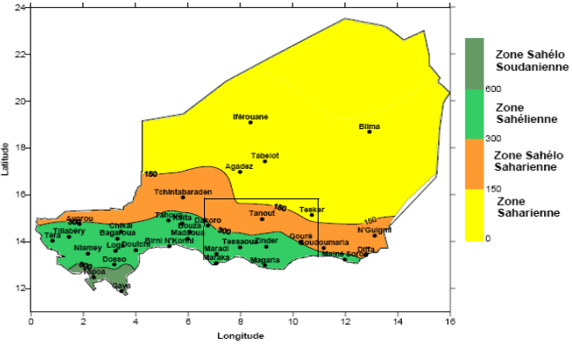
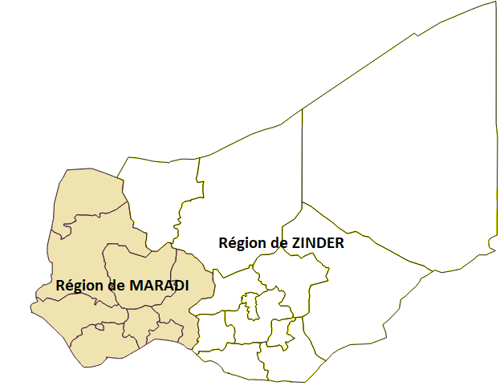
Fig 1: The different climatic zones of Niger (source DMN, 2006)

2.2. Data and Methodology
The data used in this study consist of monthly precipitation records for the period 1991–2020, as well as daily data for the year 2024. This information was retrieved from the data.nasa.gov portals, which provide climate data on temperature, precipitation, humidity, and more. Accessing these portals allows researchers who face difficulties obtaining long-term ground-based measurements to conduct their studies effectively. Furthermore, these datasets are free, continuously updated in real-time, and easily downloadable in CSV format. Their spatial resolution provides multiple grid points over a small study area, ensuring high-quality extrapolation.
To achieve the objective of this study, the Standardized Precipitation Index (SPI) and percentiles were employed to analyze the interannual variability of cumulative rainfall over the 1991–2020 reference period and to characterize the wet or dry conditions of the year 2024, respectively. Furthermore, Gumbel’s (1960) statistical distribution was applied to examine the extreme nature of the 2024 events within the study area. The Standardized Precipitation Index (SPI) is a robust and computationally straightforward index (McKee and al., 1993), proven effective for analyzing wet and dry periods or cycles (see Table 1).
Table 1: Drought severity class according to (Mckee and al., 1993)
SPI Index Values | Wet or Dry Characterization
SPI≥2 | Extremely wet
1.5≤SPI≤1.99 | Very wet
1.0≤SPI≤1.49 | Moderately wet
−0.99≤SPI≤0.99 | Near normal
−1.49≤SPI≤−1.0 | Moderately dry
−1.99≤SPI≤−1.5 | Very dry
SPI≤−2 | Extremely dry

This index is calculated using formula (1) below:
$$SPI=\frac{C_{i}-\overline{C}}{σ}$$
$C_{i}:$ Average cumulative total for year i
$\overline{C}$: Climatic average
𝜎: Standard deviation of the series from 1991 to 2020

The probability of exceedance p and the return period T are calculated using the method below:
$$p=1-F\left(x\right) et T=\frac{1}{p}$$
With $F\left(x\right)=exp\left[-exp⁡\left(-a\left(x-μ\right)\right)\right]$the probability of not exceeding

Where : $a= \frac{π}{σ\sqrt{6}} et μ=\overline{C}-\frac{γ}{a} and γ=0,5772 Euler^{'}s number$
$σ and \overline{C}$ are called the parameters of Gumbel's law.

3. RESULTS
3.1. Interannual variability of cumulative rainfall over the reference period 1991-202
Despite a recovery in rainfall across the Sahel (Ozer and al., 2017), interannual precipitation variability has been exacerbated by climate change. Fig 2 illustrates the interannual variability of total annual rainfall over the 1991–2020 period within the study area, which encompasses the Maradi and Zinder regions in southeastern Niger. During this period, mean annual rainfall totals ranged from 196 mm in 2004 to 519 mm in 2020, with a climatological mean of 292 mm (Figure 2). Over these 30 years, only 8 years (27%) recorded totals above the average. Relative to the climatological mean, the study area experienced a deficit period from 1999 to 2006, with only one year (2003) showing a near-normal trend. The year 2020 was the wettest of the period, with a positive anomaly of 257 mm compared to the climatological mean and a 353 mm difference compared to the driest year.

Fig 2: Interannual variability of cumulative rainfall over the reference period 1991-2020

Figure 2 illustrates a progressive increase across the trend line, which exhibits a positive coefficient (1.8). Despite significant interannual variability, this trend generally reflects an improvement in rainfall patterns within the study area from 1991 to 2020. The percentile calculations for the 1991–2020 annual rainfall series are presented in Table 2. The data indicate a drought risk for any year with total rainfall below 208 mm (10th percentile). Conversely, any year exceeding 367 mm is classified as 'very wet,' while 'extremely wet' years are characterized by totals surpassing 392.7 mm. Furthermore, Figure 2 reveals a sharp increase in precipitation toward the end of the 1991–2020 period. Should this upward trend persist in subsequent years, it may lead to a shift in the precipitation regimes of the study area.

Table 2: Percentiles of the series of annual rainfall totals for the period 1991-2020
Percentile | Value (mm) | Climatological Interpretation
10th (P10) | 208.65 | Extreme drought: Only 10% of years are drier than this threshold.
25th (Q1) | 240.43 | Dry year: 25% of years fall below this value (1st quartile).
50th (Median) | 272.39 | Central value: An equal number of drier years and wetter years.
75th (Q3) | 312.27 | Wet year: 75% of years receive less than this total.
90th (P90) | 363.2 | Extreme wetness: Only 10% of years exceed this total.
95th (P95) | 392.69 | Exceptional event: Threshold often used for flood risk assessment.

3.2. Distribution of annual rainfall totals
The spatial distribution of annual rainfall totals over the study area, which includes the regions of Maradi and Zinder, is shown in Fig3.

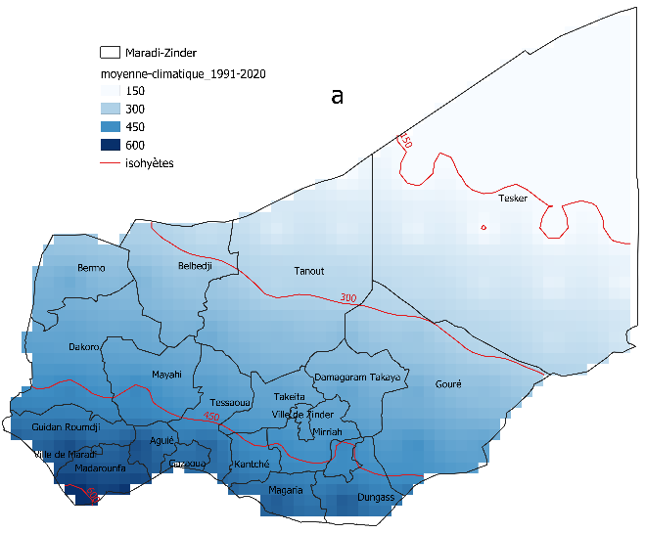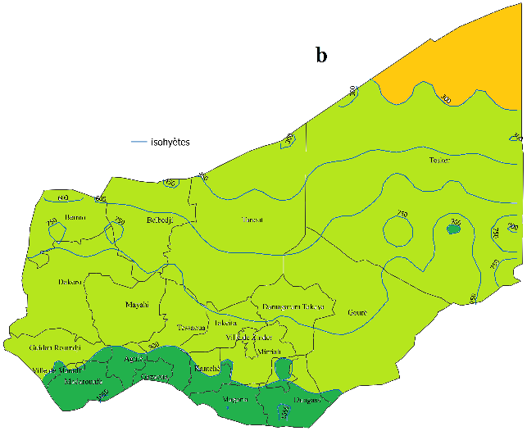
Fig 3: Spatial distribution of cumulative annual rainfall in the southeastern zone of Niger (Maradi and Zinder). Panel (a) corresponds to the rainfall climatology from 1991-2020 and panel (b) to that of the year 2024.
Fig3a presents the climatology (spatial distribution of annual rainfall totals) over the 1991–2020 period within the study area. During this period, average annual totals ranged from 100 mm in the north to 600 mm in the south. The isohyets display a positive latitudinal gradient from north to south. This gradient is characteristic of rainfall patterns in the Sahel and defines the region's various climatic zones. Thus, the northern part of Tasker, located in the Zinder region, is characteristic of a Saharan climate where annual precipitation is below 150 mm. The extreme southern part, which includes Madarounfa (Maradi), Magaria, and Dungas (Zinder), is characteristic of a Sahelo-Sudanian climate with annual precipitation of approximately 600 mm. However, the localities situated in the central part of the study area notably Dakoro, Belbedji, and Mayahi (Maradi), as well as Damagaram Takaya, Tanout, and Gouré (Zinder) exhibit a Sahelian climate, with annual cumulative rainfall ranging between 300 mm and 450 mm. The figure further illustrates the region's climatic vulnerability: as one moves northward (specifically toward Tanout and Tesker), water availability becomes the limiting factor for agriculture, which remains the primary livelihood for the rural population. The spatial distribution of annual cumulative rainfall over the study area for the year 2024 is shown in Figure 3b. This figure reveals a northward shift of the isohyets, reflecting an improvement in rainfall during 2024 across the study area, with an annual average of 560 mm. Compared to the 1991-2020 climatological period, the 600 mm isohyet was replaced by the 1050 mm isohyet, and the northern zone, where rainfall is typically limited to 150 mm, reached an average cumulative total of over 300 mm. Across the entire study area, the annual rainfall for 2024 nearly doubled the climatological average for the 1991-2020 period. In 2024, substantial cumulative rainfall exceeding 1,000 mm was recorded in Madarounfa, located in the eastern Maradi region, as well as in Magaria and Dungas in southern Zinder. Furthermore, localized areas within the near-desert department of Tesker reported significant accumulations ranging from 750 to 900 mm. These precipitation totals are attributed to isolated, intense convective storm events, likely driven by anomalous surface heating.

3.3. Analysis of the situation in 2024
3.3.1. Spatial variability of precipitation in 2024 in the study area compared to the 1991-2020 climatic period
Fig 4 illustrates the spatial distribution of the Standardized Precipitation Index (SPI) for the year 2014 across the study area. With the exception of the far northern reaches of Tesker, the entire study region exhibits a positive SPI, ranging from 0.5 to 2.
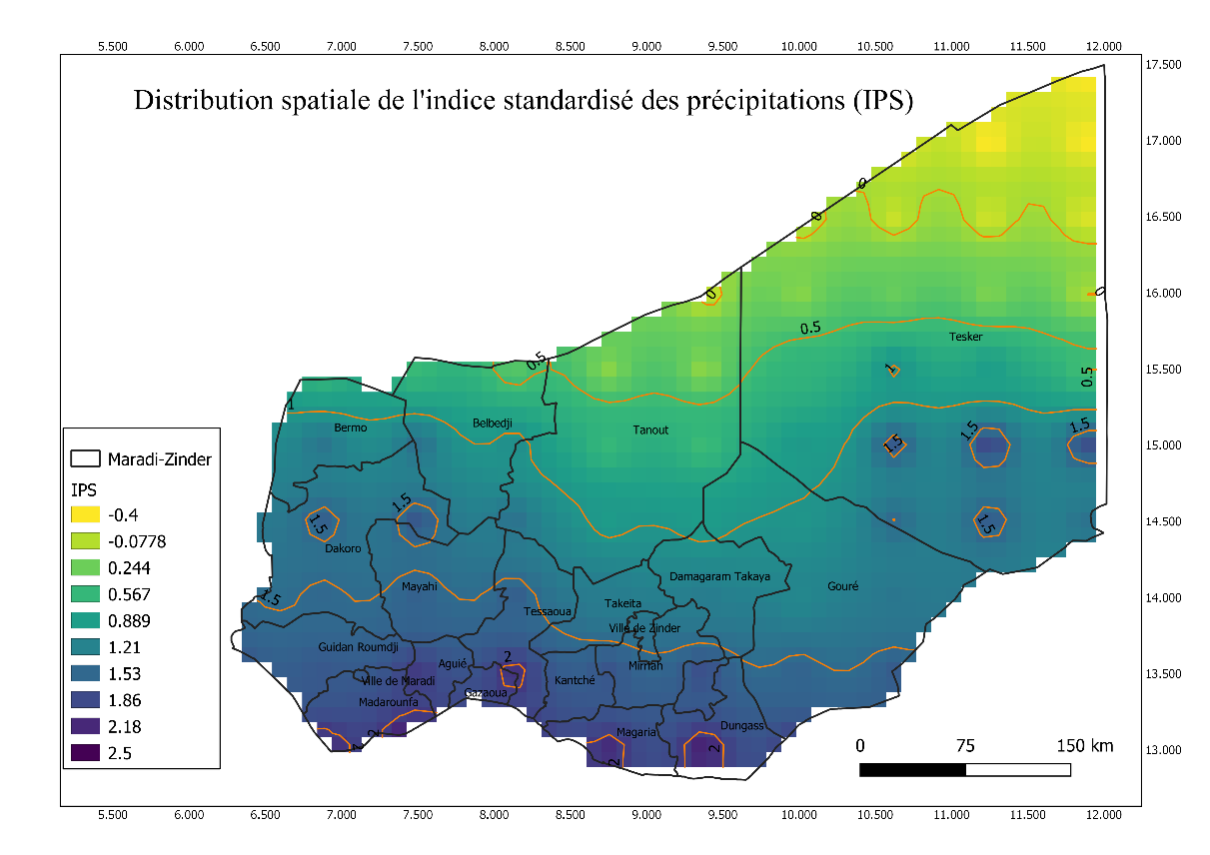
Fig 4: Spatial distribution of the standardized precipitation index (SPI) over the study area for the year 2024
Fig4 highlights a pronounced climatic contrast between the southern and northern regions, characterized by a latitudinal transition in SPI (Standardized Precipitation Index) values. This latitudinal gradient allows for the categorization of the study area into three distinct zones: the south, the center, and the north. Southern localities bordering Nigeria, such as Magaria, Dungass, and Madarounfa, exhibited SPI values exceeding 2.0 during the year 2024. Such values indicate that 2024 was an exceptional year relative to the 1991–2020 climatological baseline for the region. The central zone displays SPI values ranging from 0.5 to 1.2, corresponding to moderately wet conditions. Conversely, the extreme northern part of the region, including portions of Tanout and Tesker, experienced a rainfall deficit in 2024 compared to the 1991–2020 mean; in this area, the index drops to negative values, reaching as low as -0.4.
Figure 4 also reveals 'pockets' of high precipitation, with SPI values exceeding 2.0. The extreme Southeast, encompassing the Magaria and Dungass districts, represents the most intense focus. Closed cells are observed in this area, with indices fluctuating between 2.18 and 2.5, indicating that these regions received exceptional rainfall totals relative to their historical means. High-intensity clusters (SPI > 2.0) are also visible in the Gazaoua and Aguié districts, signaling a major hydric surplus in this high-output agricultural zone. Despite its typically arid climate, the Dakoro district situated at the transition between the Saharan and Sahelo-Saharan belts lso exhibited isolated pockets of heavy precipitation during the year 2024.
Ultimately, the analysis of the Standardized Precipitation Index (SPI) map for the year 2024 reveals that most of the study area experienced surplus conditions, with extreme precipitation clusters particularly concentrated within the southern belt.
3.3.2. Variability of the average daily cumulative total for the four months of June-July-August-September
Fig 5 illustrates the evolution of average daily rainfall totals (in mm) for four key months of the rainy season June, July, August and September calculated over the entire study area.

Fig5: Distribution of average daily rainfall across the entire area for the year 2024
This figure illustrates high daily precipitation variability, which fluctuates significantly from month to month. Early June is characterized by a near-total absence of rainfall. The first precipitation events occur toward the end of the month, with an average exceeding 20 mm/day, signaling the late onset of the rainy season. The scarcity of rain during June 2024 is attributed to the fact that the monsoon (moist air mass), blowing from the southwest to the northwest, had not yet become firmly established over the study area. In July, an irregular increase in rainfall events is observed, with daily peaks fluctuating between 10 mm and 20 mm. August emerges as the wettest month, characterized by a significant peak reaching 70 mm per day. During this period, precipitation is frequent, with recurring peaks ranging from 10 mm to 30 mm. The increased rainfall observed in Niger during these two months (July and August) is due to the northward migration of the monsoon, which pushes back the harmattan wind and the Intertropical Convergence Zone (ITCZ). The significant peaks followed by abrupt drops correspond to episodes of convective thunderstorms or squall lines. Finally, the month of September is characterized by intense rainfall activity at its onset, with peaks ranging between 30 and 40 mm, followed by a decline in precipitation intensity. This trend is accompanied by a reduction in daily water input resulting from the withdrawal of the monsoon.
The analysis of Figure 5 reveals three distinct stages of the rainy season within the study area specifically, and across the Sahel in general: the onset of the season, which progresses latitudinally; the peak of the season (core season); and the cessation of the season. Depending on their intensity, rainfall events can significantly impact the environment and agro-pastoral activities. In the Sahel, the intensification of rainfall—despite a sometimes stable annual precipitation—is leading to increased surface runoff and flooding, processes that are further exacerbated by degraded soils. (Decroix and al., 2013 ;Vischel and al., 2015 ; Bahari and al., 2018 ;).Table 3 summarizes the rainy season in the study area with the immediate consequences.

Table 3: Consequences due to rainfall patterns in each month during the season
Month | Season Status | Dominant Characteristic | Main Risk
June | Installation / Start | Water deficit | Sowing failure
July | Transition | Irregularity | Temporary water stress
August | Peak / Core | Extreme intensity | Flooding / Erosion
September | Withdrawal / End | Progressive decline | Root asphyxia (if waterlogged)

3.3.3. Caractéristiques extrêmes des précipitations de l'année 2024
Despite the alternation of wet and dry years throughout the reference period, a stabilization of precipitation levels has been observed, marking a clear departure from the severe drought cycles of the 1970s. However, the year 2024 disrupted this stability, recording extraordinary cumulative rainfall totals.
Figure 6 presents the statistical fit using the Gumbel distribution for annual precipitation over the 1991–2020 period. The blue dots represent the distribution of annual totals throughout the study period. These totals range from 150 mm to 550 mm, with an annual mean of 281 mm. This distribution is characteristic of semi-arid regions.

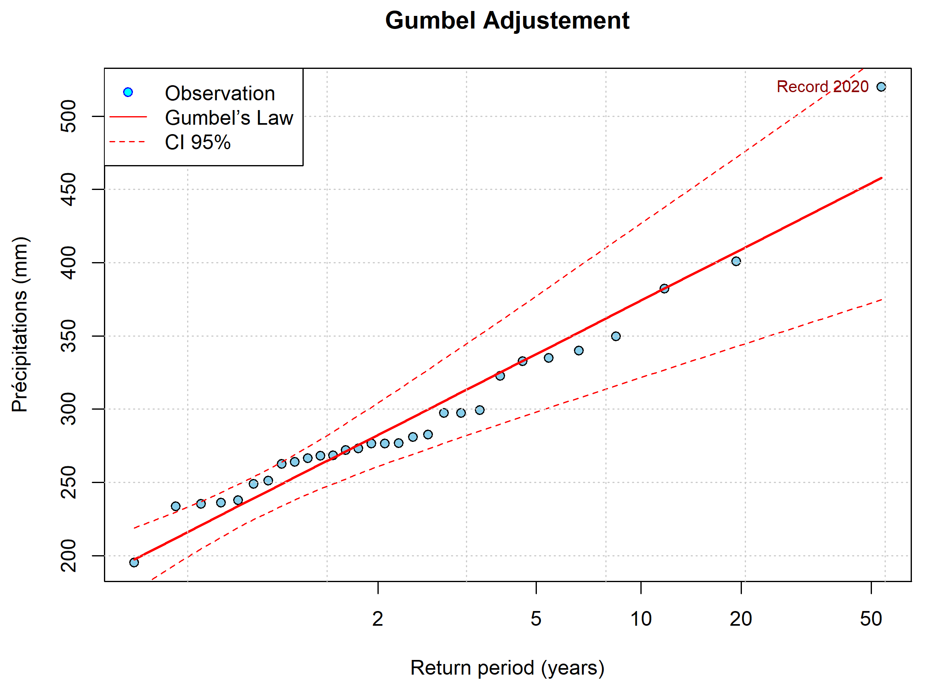
Fig 6 : Gumbel statistical adjustment for the series of average cumulative totals for the period 1991-2020
The high standard deviation of 62 mm indicates that during the 1991–2020 period, the study area (Maradi and Zinder) experienced significant interannual variability, with a coefficient of variation of approximately 22%. According to Figure 6, average annual totals between 400 and 450 mm are rare, with a return period exceeding 20 years. The year 2020, characterized by a total of 519 mm (represented by the red dot), deviates significantly from the Gumbel model (blue curve) and stands out as a centennial event. The theoretical calculation of the exceedance probability for such an event yields a value of p=0.41%; consequently, the return period for an event of this magnitude is 244 years. Thus, the year 2020 stands out as an exceptional year, suggesting either rare natural variability or a signal of climate change. During the year 2024, the study area recorded an average total of 560 mm, representing an increase of approximately 8% compared to the 2020 record. Consequently, the 2024 precipitation can be classified as an extreme event within the context of the last thirty (30) years. Should such events continue to occur in the near future, it would suggest a significant climatic shift within the study area.
4. DISCUSSION
Precipitation in the Sahel is characterized by high spatio-temporal variability (Faran, 2000). In the study area, this variability is reflected in the latitudinal distribution of rainfall as well as temporal fluctuations in annual totals. Furthermore, extreme rainfall events have emerged, driven by a decrease in the annual frequency of rainy days (Yacoubou et al., 2025).
Following the drought of the 1970s (Grist and Nicholson, 2001), the study area, like other regions of the Sahel, experienced a recovery in rainfall between 1991 and 2020, as observed by Nicholson (2013). Analysis of rainfall trends during this period confirms the hypotheses previously formulated by Ozer (2003).
Indeed, a slight upward trend in annual rainfall totals is observed, despite significant natural interannual fluctuations. However, the low coefficient of determination (R2=0.064) between annual totals and time indicates that only 6.4% of the rainfall variability can be attributed to the temporal progression.
The end of the 1991–2020 period is marked by a sharp increase in annual rainfall totals. If this trend persists, it could lead to a shift in the precipitation regime, transitioning the study area from an arid climate to a more humid system. The spatial distribution of rainfall reveals that all four of Niger's climatic zones are represented within the study area, namely:
- the Sahelian-Sudanian zone located south of the 600mm isohyet,
- the Sahelian zone located between the 600 and 300mm isohyets,
- the Sahelian-Saharan zone between 300 and 150mm,
- the Saharan zone above the 150mm isohyet.
Compared to figure 1 of the DMN (2006), we can see that the extreme south of Madarounfa is found in the Sahel-Sudanian zone, which shows a rise in the isohyets during this period 1991-2020.
The results of this study highlight a marked improvement in rainfall in the southern region in 2024. Indeed, isohyets have undergone an exceptional northward shift, with the Sahelian zone encroaching upon the Sahel-Saharan zone. This change observed in the study area aligns with the IPCC report (IPCC, 2007), which generally predicts that climate change will lead to a shift in climate zones and a modification of rainfall patterns. Thus, the year 2024 is characterized by exceptionally high humidity in the north, transforming semi-arid areas into very humid zones, while the southern regions experienced record levels of rainfall. Analysis of the monthly rainfall distribution for 2024 reveals that June was a dry period, with very little rain. The rainy season truly began in July, followed by a significant intensification in mid-August. However, the rainfall curve in July shows troughs characteristic of dry periods. These intraseasonal dry spells represent the main challenge for local farmers.
Even if the monthly total for this month seems satisfactory, a 10-day break without rain can stop the development of cereal crops.
August of the 2024 season, which represents the core of the rainy season in Niger specifically and the Sahel in general (Vishel and al., 2015), was characterized not only by consistent rainfall regularity but, more significantly, by extreme events, with a peak of 70 mm recorded around the 23rd day. These findings corroborate those of Papalexiou and Montanari (2019) and Dunn and al. (2020), which indicate that the frequency of extreme precipitation is observed at a regional scale. This concentration of rainfall events during this month suggests intense convective activity (Vincent and Henri, 2001) and a high risk of runoff and flooding in areas lacking drainage systems, such as the cities of Maradi (Mamadou et al., 2022) and Zinder (Mamadou I, 2014).
The end of the season typically occurs in September, coinciding with the monsoon withdrawal phase. However, during the 2024 season, the beginning of this month maintained significant cumulative totals (10 to 30 mm per day), ensuring crucial residual water availability for the completion of biological cycles.
This analysis reveals that the year 2024 experienced an intensification of precipitation, characterized by an extension of the rainy season throughout the entire month of September. This distinctive feature of 2024 is illustrated by the damage caused by heavy rainfall recorded across the southern belt of the study area. The end of August and the beginning of September were exceptionally severe in Niger following these intense rainfall events. According to a statement from the DGPC (General Directorate of Civil Protection), 'These rains resulted in approximately 273 fatalities, caused either by drowning or by the collapse of dwellings.' In Zinder, the heavy rains led to approximately thirty deaths, the collapse of hundreds of homes, and the destruction of two thousand hectares of cropland by hail. Infrastructure was also heavily impacted, including the damage of three schools and the collapse of two mosques notably the historic Friday Mosque of the Sultanate, constructed in 1885 by Sultan Tanimoune (tamtaminfo.com).
CONCLUSION
This study analyzes the extreme nature of the 2024 precipitation regime. The study area, comprising Maradi and Zinder, is situated in the southeastern part of Niger within a Sahelian-type climate. Based on NASA datasets used in this research for the 1991–2020 reference period, annual cumulative rainfall varied between 196 mm in 2004 and 519 mm in 2020. In addition to this interannual variability, spatial variability reveals three distinct climatic zones within the study area: the Sahelian, Sahelo-Saharan, and Saharan zones. The analysis of the 2024 rainfall situation was conducted using the Standardized Precipitation Index (SPI), isohyet displacement, and Gumbel’s statistical adjustment. The SPI values, calculated across the spatial domain, ranged between 0.5 and 2.0, indicating an intensification of precipitation, particularly in the southern portion of the study area. Seasonal variability analysis indicates that August, the wettest month, recorded average daily cumulative rainfall exceeding 70 mm across the entire study area. September, which typically marks the end of the season, experienced an intensification of rainfall events during its first week, with daily totals exceeding 30 mm/day. These events triggered widespread flooding, as the soil was already saturated due to the consistent rainfall regularity observed in August. According to Gumbel’s statistical adjustment, the year 2020 (within the 1991–2020 reference period) emerged as an extreme year, with an annual total of 519 mm and an exceedance probability of 0.41% per year. The defining characteristic of the 2024 season is that the average cumulative rainfall for the study area exceeded that of 2020 by 8%."
This study raises a critical question: is this an isolated event attributable to natural climate variability, or does it represent a signal of climate change? Should the upward trend observed since the end of the 1991–2020 reference period be confirmed in the coming years, the climate change hypothesis will be favored.

REFERENCES
ACMAD. (2024). Information Note: Flooding in the Sahel.

https://acmad.org/wp-content/uploads/2019/03/Note_Information_inondation.pdf

Bahari, I. M., Ibrahim, B. M. and Oumarou, F. M. (2018). Evolution of rainfall characteristics and resurgence of flooding in localities along the Niger River, VertigO [Online],Terrains, Online since 25 May 2018, connection on 24 January 2026. URL: http://journals.openedition.org/vertigo/19891; DOI: https://doi.org/10.4000/vertigo.19891
Dunn, Robert J. H., Alexander, L., Donat, Markus G., Zhang, X., Bador, M., Herold, N., Lippmann,
T. et al. (2020). Development of an Updated Global Land In Situ-Based Data Set of Temperature and Precipitation Extremes : HadEX3. en. Journal of Geophysical Research : Atmospheres. Vol. 125. no. 16.
Gumbel, E.J. (1960) “Distributions of extreme values ​​in several dimensions”. In: Publ. Inst.
Statist. Univ. Paris 9 (1960), p. 171-173.
Faran, M. O. (2000). Current dynamics in the Zarmaganda: Geomorphological research in western Niger. Doctoral thesis, Cheikh Anta Diop University of Dakar, 365 pp.
IPCC. (2007). Climate Change 2007: Contribution of Working Groups I, II and III to the Fourth Assessment Report of the Intergovernmental Panel on Climate Change [Core Writing Team: Pachauri, R.K. and Reisinger, A. (edited by)]. IPCC, Geneva, Switzerland… 103 pages.
Grist J. P., Nicholson S. E. (2001). A Study of the Dynamic Factors Influencing the Rainfall
Variability in the West African Sahel. J. Clim., 14: 1337-1359.
HEA. (2016). Livelihood Profile, Zinder, Magaria and Kantche Region – Southern Irrigated Zone
Cash Crop. Niger. Report, p. 20

Ibrahim, M., Moussa, M., Mahamadou, M., Sanoussi, I., Moutari, I. D.T., Moutari, I. M., AbdoulKarim, A. M., Ibrahim, B. M., Luc, D. (2022). Increased damage to public infrastructure and urban planning issues: the case of the Zaria district in the city of Maradi, Niger. Volume 12 / Number 26, Winter 2022, ISSN: 2247–2290, pp. 213–222.
.
Ibrahim, M., 2014. Rainwater management and flood risks in the city of Zinder, Niger.
Territories, Societies and Environment, No. 003, August 2014

Karambiri, B.L.C.N. and Gansaonre, R.N. (2023). Spatio-Temporal Variability of Rainfall in the Sudanian, Sudano-Sahelian, and Sahelian Zones of Burkina Faso. ESI Preprints. https://doi.org/10.19044/esipreprint.3.2023.p1
Luc Descroix, Aïda Diongue Niang, Honoré Dacosta, Gérémy Panthou, Guillaume Quantin, and Arona Diedhiou. (2013). Evolution of high rainfall totals and resurgence of flooding since 1951 in the middle Niger basin (Sahel). Climatology, vol. 10 (2013)

Mamadou, L., Kwéssé, M.S., and Cyriaque, S. (2024). Analysis of the variability of extreme rainfall in the commune of Boromo (Burkina Faso). Vol. 1, No. 1, November 2024, Relecture d’Afrique, pp. 205–233.

McKee, T.B., N.J. Doeskenet J. Kleist. (1993). The relationship of drought frequency and duration
to time scale. In: Proceedings of the Eighth Conference on Applied Climatology, Anaheim, California, du 17 au 22 janvier 1993. Boston, American Meteorological Society, 179–184.
Moussa. M. S, Mahamadou. Y et Inoussa A. S. (2022). The Projected Changes of Precipitations over
Niger Under the Scenarios RCP 4.5 and RCP 8.5. Journal of Environmental Science and Engineering B 11 (2022) 248-266 doi:10.17265/2162-5263/2022.06.004
NAKOU, R.T., François, P.C., Noel, C.W., Luc, O.S., Abdoukarim, A., and Nicaise, Y. (2022).
"Characterization of extreme rainfall events in the lower Mono River valley in Benin," in Afrique SCIENCE 21(5) (2022) 177–192

Nicholson S. E. (2013). The West African Sahel – A Review of Recent Studies on the Rainfall
Regime and Its Interannual Variability. ISRN Meteorol., 2013 : 1-32, doi :10.1155/2013/453521.
OCHA. (2024). Niger Floods Update (as of October 16, 2024). Niger - Flash Update #2.
https://www.unocha.org/publications/report/niger/niger-flash-update-2-bilan-desinondations-au-niger-au-16-octobre-2024. Accessed January 24, 2026 at 7:00 PM

Orou, S. S. M., Tabou, T. and Ogouwale, E. (2019). “Rainfall variability and quality of growing seasons in the Alibori department (Benin, West Africa)”, in Revue de Géographie de l’Université de Ouagadougou, No. 08, Volume, pp: 43-63

Ozer, P., Erpicum M., Demaree G. & Vandiepenbeeck, M. (2003). The Sahelian drought may
have ended during the 1990s. Hydrological Sciences Journal, 48, 489-492.

Ozer, P. and Perrin D. (2014). Water and climate change. Trends and perceptions in West Africa. In: BALLOUCHE A. & TAÏBI N.A. (Eds.), Water, environments and planning. Research serving territories. Angers, France: Presses de l’Université d’Angers, 227-245.

Papalexiou, S.M. et Montanari, A. (2019). Global and Regional Increase of Precipitation Extremes
under Global Warming. en. Water Resources Research. 2018WR024067.
Ozer, P., Ousmane, L. M., Adamou, D.T., Bakary, D. and Florence, D. L. (2017). Recent evolution of rainfall extremes in Niger (1950-2014). Geo-Eco-Trop., 2017, 41, 3, n.s.: 375-383. P: 375-384

Sidiki, S. (2022). Observations and modeling of precipitation extremes at seasonal to interannual scales in the Sahel. Earth Sciences. National Polytechnic Institute of Toulouse - INPT, 2022. French. 2022INNT: 2022INPT0020. tel-04124637v2

Sighomnou, D., A. Ilia and B. Tanimoun. (2010). Flood events from July to September 2010 in the Middle Niger, ABN, 8 p.

Vincent, M. and Henri, L. (2001). Life cycle of Sahelian mesoscale convective cloud systems.
Quarterly Journal of the Royal Meteorological Society, 127(572) :377–406, 2001. Publisher : Wiley Online Library
Vischel T., Lebel, T., Panthou G., Quantin G., Rossi A., Martinet M. (2015). The return of a humid period in the Sahel?: observations and perspectives. In: Sultan Benjamin (ed.), Lalou Richard (ed.), Amadou Sanni M. (ed.), Oumarou A. (ed.), Soumaré M.A. (ed.). Rural societies facing climatic and environmental changes in West Africa. Marseille: IRD, 2015, pp. 43-60. (Syntheses). ISBN 978-2-7099-2146-6

Mahamadou, Y., Souley, S. and Ouma, M. (2025). Analysis of Rainfalls in Niger during the Period
2008-2024. Journal of Environmental Science and Engineering B 14 (2025) 191-200 doi:10.17265/2162-5263/2025.05.002
Tamtaminfo
https://tamtaminfo.com/deluge-au-niger-maradi-et-zinder-ont-vecu-lenfer-fluvial/ Accessed on 17/01/2026.

