Seasonal Evolution of Surface Water Quality in the Tropical Sub-basin of the Tilé River, Guinea

.
ABSTRACT

This study assesses the physicochemical and microbiological quality of the Tilé River in N’Zérékoré (Republic of Guinea) according to seasonal variability. The study, conducted at five sampling sites, reveals that during the rainy season, the waters exhibit moderate temperatures (15.71-21.28 °C), a neutral to slightly acidic pH (6.93-7.27), high conductivity (up to 932.67 µS/cm), and high concentrations of suspended solids (up to 786.67 mg/L) and turbidity (130.67-184.33 NTU). Nitrate levels reach 60.3 mg/L, and fecal contamination is significant, with fecal coliform counts reaching up to 603.67 CFU/100 mL. During the dry season, the temperature increases (21.45-25.78 °C) and the pH become slightly alkaline (7.08–7.41), while conductivity, turbidity, and suspended solids decrease significantly. Nitrate concentrations remain low (4.60-8.96 mg/L) and fecal contamination is reduced (≤ 80 CFU/100 mL). Principal Component Analysis (PCA) highlights three key factors influencing seasonal variability: (i) suspended solids loading and turbidity, (ii) nutrients (NO₃⁻, PO₄³⁻), and (iii) microbiological indicators. The results indicate that the rainy season is characterized by a strong positive correlation between these parameters, reflecting the effect of runoff and anthropogenic inputs, while the dry season reflects generally better water quality, although locally affected by domestic and commercial discharges.
Keywords: Water pollution, Physico-chemical and microbiological quality, Tilé river, N’Zérékoré, Guinea

1. INTRODUCTION

Water is a vital resource for ecosystems and human societies, and its management is a major challenge for achieving Sustainable Development Goal 6, which aims for universal access to safe drinking water and sanitation (Smets, 2011; UN, 2020). In developing countries, population growth, unplanned urbanization, and agricultural and industrial practices are placing increasing pressure on water resources, exacerbating their vulnerability to pollution (Tabunschik et al., 2023; Djaffar and Kettab, 2015). Urban rivers are particularly exposed to microbiological and chemical contamination, thus becoming vectors of preventable waterborne diseases (UN, 2021; WaterAid, 2021). Several studies have shown that surface water quality depends on both natural conditions and anthropogenic pressures (Diawara et al., 2024). In West Africa, Cecchi et al. (2020) demonstrated the impact of riverside populations on turbidity in waterways in Burkina Faso, while other research conducted in Nigeria (IUCN, 2006) and Togo (Ameyapoh et al., 2005) confirms the extent of urban pollution. Similar cases observed in Asia, such as in South Korea (Chang, 2005) and China (He et al., 2007), serve as a reminder that the degradation of urban rivers is a global problem.
In Guinea, often called the “water tower of West Africa,” abundant water resources are increasingly threatened by rapid urbanization, poor waste management, and unsustainable agriculture, despite the existence of a legislative framework (FAO, 2005; RNI, 2008; Law L94/005/CTRN, 1994). The urban commune of N’Zérékoré exemplifies this situation: bisected by the Tilé River, it is a hub of diverse human activities that contribute to water quality degradation (Guilavogui et al., 2025). Yet, few scientific studies have conducted in-depth, comparative assessments of this river's water quality across different seasons. Existing research is often limited to isolated analyses or focuses on other transboundary waterways (Guilavogui et al., 2025).
In this context, the present study aims to address this knowledge gap by proposing an integrated seasonal assessment of the water quality of the Tilé River. Through a physicochemical and microbiological approach, it seeks to identify pollution sources, analyze their variations between the dry and rainy seasons, and discuss the implications for public health and the sustainability of aquatic ecosystems. The originality of this work lies in its application to a poorly documented urban basin in Guinea, thus providing useful scientific data for the development of local policies for integrated water resource management. Brief details of materials and methods are presented in Section 2. Before concluding the study in Section 4, the results are shown and discussed in Section 3.

2. material and methods
2.1 STUDY AREA DESCRIPTION
The urban commune of N’Zérékoré, located between 7°42’ and 7°47’ North latitude and between 8°46’ and 8°51’ West longitude, is the main administrative, commercial, and cultural center of the N’Zérékoré prefecture in southeastern Guinea. It comprises twenty-two districts and has an estimated population of over 300,000, making it the second largest urban area in the country after Conakry. This high population density results in considerable pressure on natural resources, particularly aquatic ecosystems, which are a vital source of water, agricultural production, and livelihoods for the surrounding communities (Camara et al., 2019; Keita and Diallo, 2021). The Tilé River, a major hydrological axis of the watershed, originates in the rural commune of Samoé, north of the city, then flows through the urban commune of N’Zérékoré before emptying into the Oulé River, a left-bank tributary of the Diani River basin. This hydrographic network is enriched by several secondary tributaries, among which the Zali stream occupies a unique position. Originating behind the N’Zérékoré civil prison and flowing through the heart of the city, it shapes the urban landscape while remaining particularly vulnerable to anthropogenic pressures related to domestic waste, intensive agricultural practices, and fishing activities (Soumah et al., 2020; Koulibaly et al., 2022). From a socio-economic perspective, the city of N’Zérékoré relies primarily on subsistence farming, small-scale trade, artisanal fishing, and forestry. While these activities are fundamental to survival and local economic development, they contribute to the progressive deterioration of surface water quality through increased organic and chemical pollution. Rapid population growth, coupled with unplanned urbanization and inadequate sanitation infrastructure, exacerbates these pressures, making the sustainable management of the Tilé River a major environmental, social, and health challenge for the region (Diallo et al., 2018; Bangoura et al., 2023).

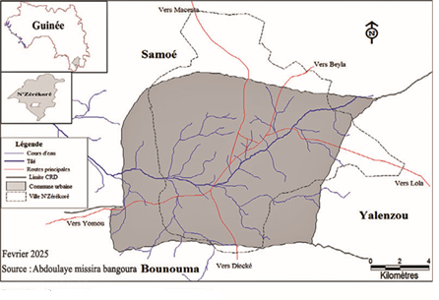
Figure 1: Map of the urban commune of N’Zérékoré

2.2 METHODS
2.2.1 IN SITU MEASUREMENTS

To assess the spatial evolution of pollution levels along the Tilé river, we sampled at several sites in Tilé, namely: Bellevue Wessoua, Commercial, Mohomou and Nakoyakpala. At each sampling site, dissolved oxygen and saturation levels were measured using a portable oximeter (HANNA HI9147). Electrical conductivity, pH, temperature, and turbidity were determined respectively using a conductivity meter (HANNA HI99301), a pH meter coupled with a thermometer (WTW 3110), and a turbidimeter (HACH 2100Q), with direct in situ readings (Rodier et al., 2009).
2.2.2 LABORATORY ANALYSIS
In the laboratory, a DR/850 spectrophotometer (HACH) was used to quantify for each sampling site the suspended solids (SS), nitrates, nitrites, and orthophosphates. Microbiological analysis was performed by membrane filtration followed by incubation on TTC and Tergitol media for the isolation and enumeration of total and fecal coliforms (APHA, 2017).
2.2.3 DATA PROCESSING
Direct observation was conducted in 44 sectors across the 22 districts of N’Zérékoré, supplemented by semi-structured interviews with 29 key stakeholders and a questionnaire survey administered to 50 riverside households. These surveys, focusing on water use, sanitation practices, waste management, and waterborne diseases, enabled the development of a diagnostic assessment of the interactions between the population and the Tilé River. The interviews were analyzed individually, and the data from the observation grids and questionnaires were processed using Sphinx 4.0 software for frequency calculation (Paillé & Mucchielli, 2021). Physicochemical and bacteriological parameters were analyzed according to spatial (upstream-downstream) and temporal (dry-rainy season) variables using SPSS 21. A one-way ANOVA was used to test the significance of the variations (Cooper & Schindler, 2014). Univariate correlations and principal component analysis (PCA) highlighted the interrelationships between variables.
3. results and discussion
3.1 Physico-chemical and bacteriological characteristics of the water

Figure 2 presents the spatial and seasonal comparison of the physical parameters of the Tilé River. It is observed that the physical parameters of the Tilé River vary seasonally depending on the site, with the exception of pH (Figure 2). pH generally ranges from 6.5 to 7 for all sites, regardless of the season (Figure 2b). The highest temperatures are recorded during the dry season (maximum 25°C) at the Wessoua and Commercial sites (Figure 2a). The lowest temperatures are recorded during the wet season, averaging around 15°C. The highest conductivity values ​​are recorded at the Mohomou (850 µS/cm) and Commercial (900 µS/cm) sites during the dry season (Figure 2c). Conductivity varies very little throughout the seasons at the other sampling sites (Belle-vue, Wessoua, Nakoyakpala). Turbidity also fluctuates seasonally (Figure 2d). Indeed, during the wet season, the highest turbidity value was recorded at the Belle-vue site (approximately 170 NTU), and the lowest during the dry season. However, it reached a value of over 200 NTU at the Commercial site during the dry season, followed by the Nakoyakpala site (approximately 175 NTU) (Figure 2d). The concentration of Total Dissolved Solids (TDS) at the different sites averages around 120 mg/L during the wet season (Figure 2e). Conversely, these same sampling sites show a Total Dissolved Solids concentration of around 50 mg/L during the dry season. The TDS concentrations at the different sites during the wet season are significantly higher than those during the dry season. Suspended solids (SS) are generally higher during the wet season, except at the Belle-Vue site (Figure 2f). The highest SS concentration is recorded at the Wessoua site (approximately 780 mg/L) during the wet season. During the dry season, the highest SS concentration is obtained at the Belle-Vue site (approximately 750 mg/L). This analysis shows that the physical parameters of the different sites along the Tilé River vary from one site to another depending on the season.

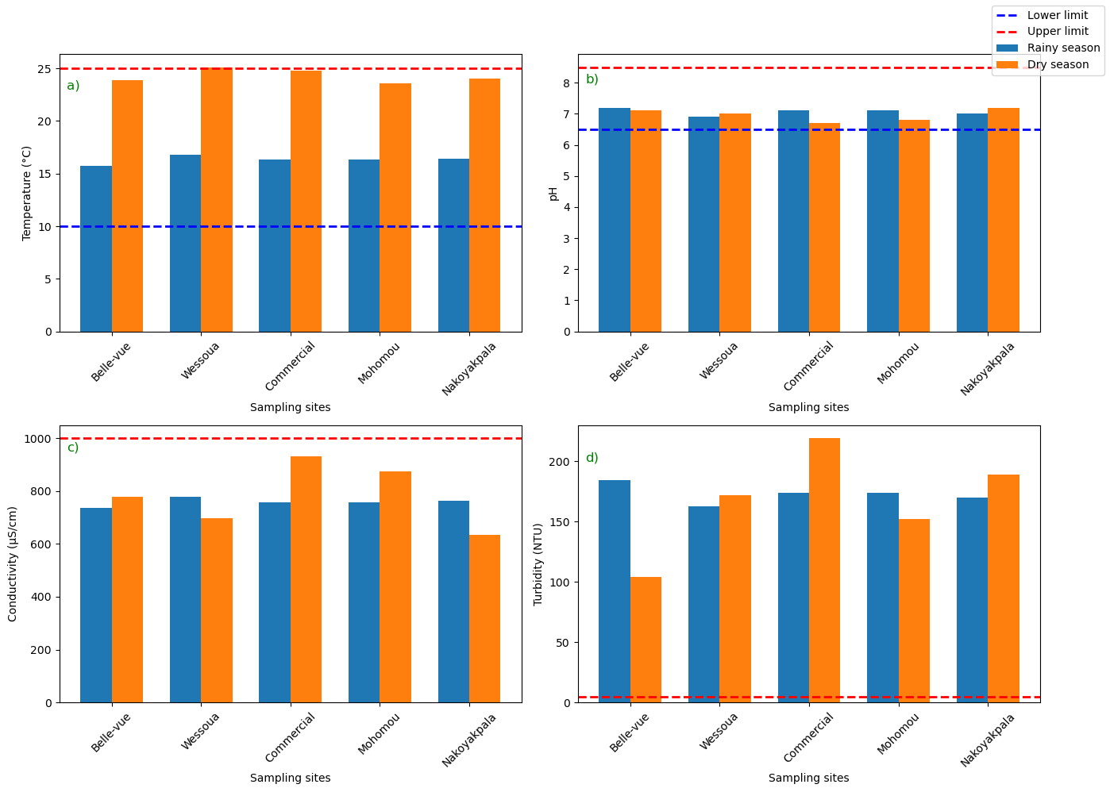
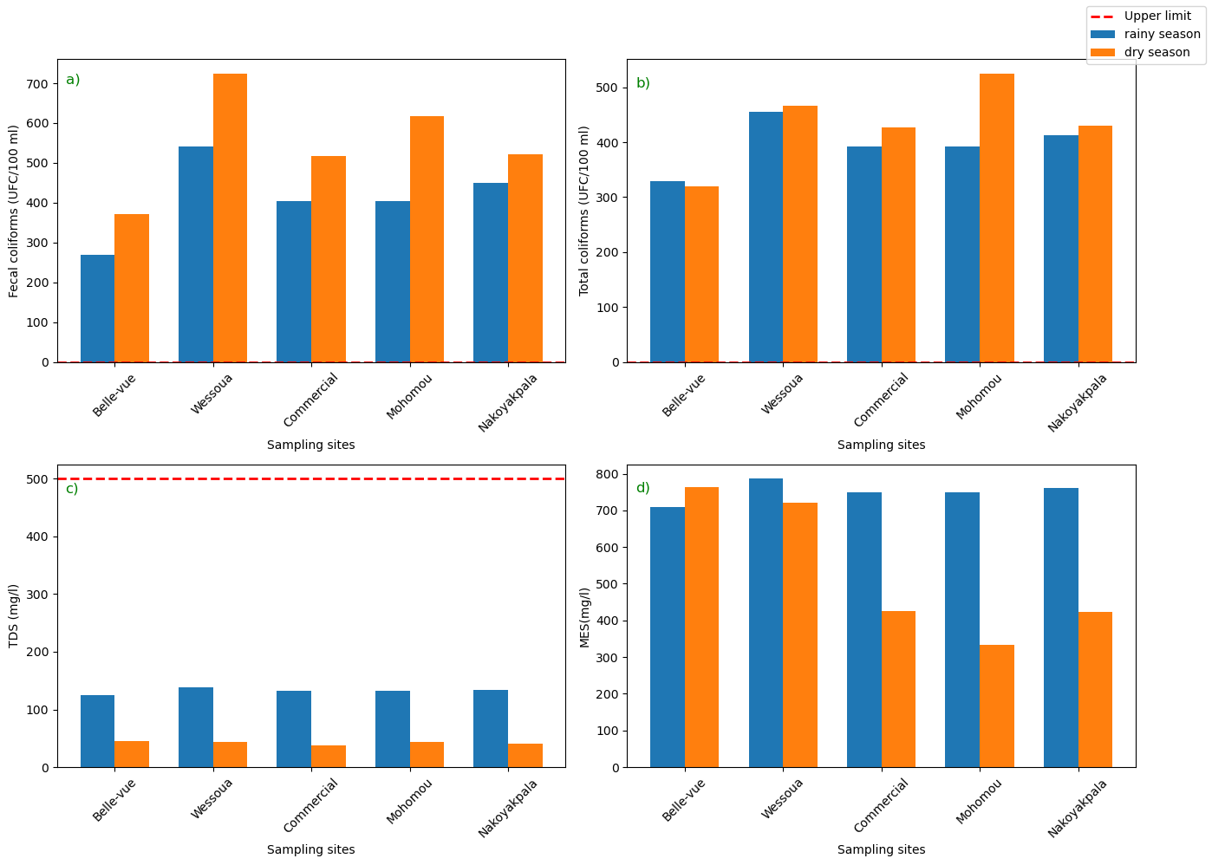
e
f

Figure 2: Spatial and seasonal comparison of the physical parameters of the Tilé River in the forest region (N’Zérékoré) of Guinea: a) Temperature; b) pH; c) Conductivity and d) Turbidity; e) TDS and f) suspended solids (SS)

Figure 3 presents the microbiological parameters of the different sites along the Tilé River. Indeed, high concentrations of fecal and total coliforms are recorded in the various water samples from the different sites, regardless of the season. However, fecal coliforms are more abundant during the dry season (ranging from 350 to 700 CFU/100 ml) than during the wet season (ranging from 250 to 520 CFU/100 ml) (Figure 3a). The same trend is observed for total coliforms (more abundant during the dry season than the wet season) (Figure 3b). The highest concentration of total coliforms during the dry season is recorded at Mohomou (approximately 520 CFU/100 ml).

Figure 3: Spatial and seasonal comparison of the microbiological parameters of the Tilé River in the forest region (N’Zérékoré) of Guinea: a) Fecal coliforms; b) Total coliforms

Figure 4 shows the spatial and seasonal comparison of the chemical parameters of the Tilé River in the forest region. The spatial and seasonal comparison of chemical parameters shows high concentrations of nitrate and phosphate during the wet season, at 60 mg/L and 1.75 mg/L respectively, at the Wessoua site (Figure 4a and c). Similarly, nitrate concentrations in the water at the Nakoyakpala site reached the upper limit of 50 mg/L during the wet season, followed by the Commercial and Mohomou sites (Figure 4a). During the dry season, low nitrate levels were observed at the different study sites (Figure 4a). However, the waters at the Nakoyakpala site have a higher concentration (approximately 35 mg/L) than the other sites. Nitrite concentrations at the different sites are relatively low, although they show higher average values ​​during the wet season than during the dry season (Figure 4b). As for phosphate concentrations, they are relatively high at the different sites studied during the wet season (between 1.5 and 1.75 mg/L) and low during the dry season (Figure 4c). The same trend is observed for potassium concentrations (Figure 4d).

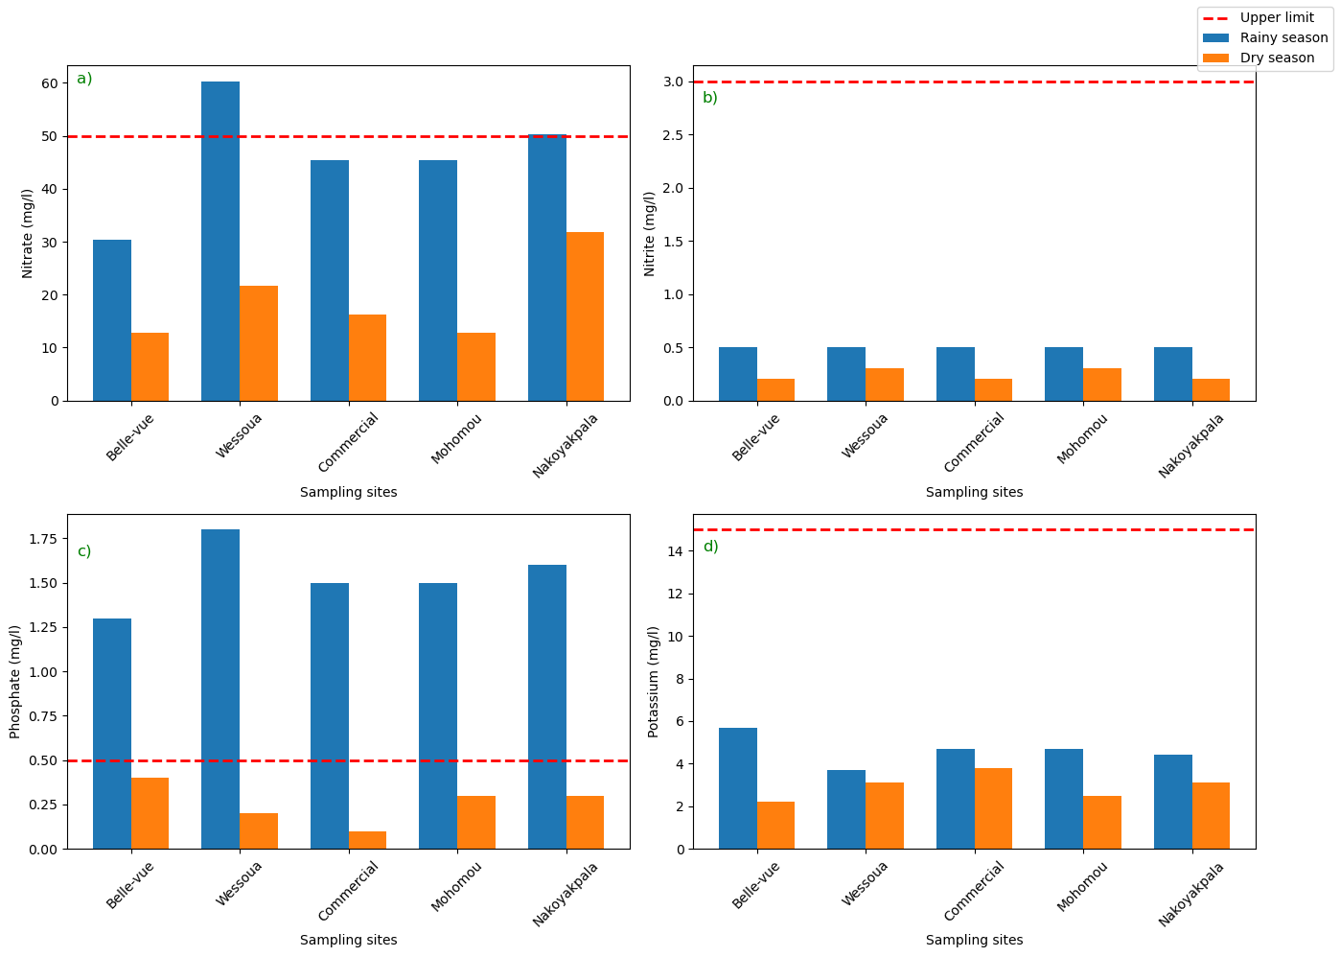

Figure 4: Spatial and seasonal comparison of the chemical parameters of the Tilé River in the forest region (N’Zézérkoré) of Guinea: a) Nitrate; b) Nitrite; c) Phosphate and d) Potasium

The Spatial and seasonal comparison of the chemical parameters of the Tilé River are depicted in Figure 5. Dissolved oxygen concentrations during the wet season were slightly above the lower limit at all study sites, unlike the concentrations at the same sites during the dry season (Figure 5a). The saturation level was above 70% during the wet season (Figure 5b), while it was around 50% during the dry season (Figure 5b). The Wessoua site had the highest manganese concentration, followed by the Nakoyapkala site (Figure 5c). The Belle-vue site recorded the highest iron concentration (greater than 4 mg/L) during the wet season. Furthermore, the iron concentrations at the various study sites during the wet season were higher than those during the dry season (Figure 5c).

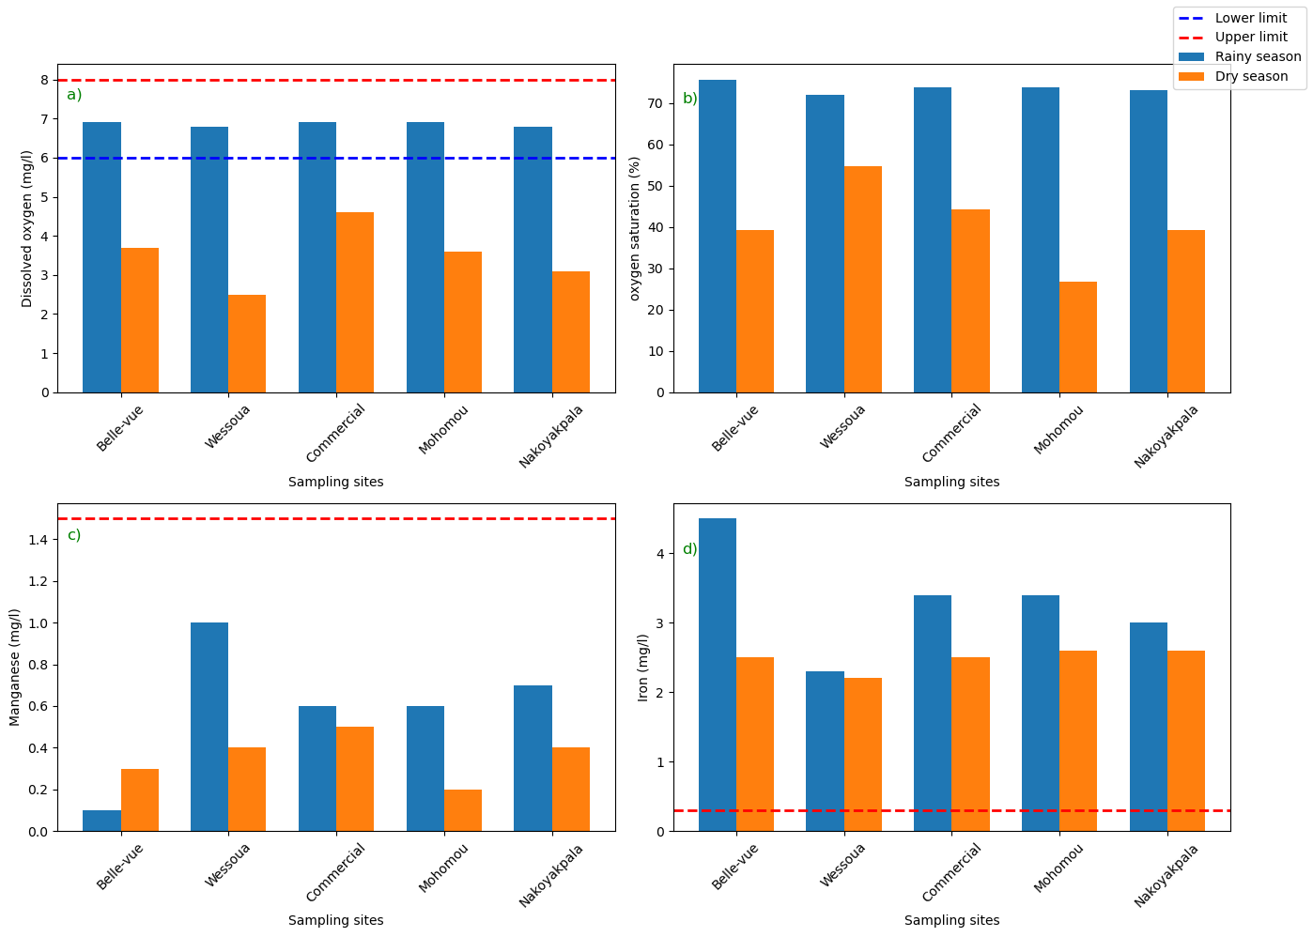

Figure 5: Spatial and seasonal comparison of the chemical parameters of the Tilé River in the forest region (N’Zérékoré) of Guinea: a) Dissolved oxygen; b) Oxygen saturation; c) Manganese and d) Iron

Principal component analysis of the physicochemical and microbiological parameters indicated that 73.2% of the total variance is explained by the first two principal components (PC1 and PC2), which contribute 55.5% and 17.7%, respectively (figure 6a). Concerning the correlation circle (figure 6a), axis 1 (PC1) is strongly and positively correlated with temperature, electrical conductivity, and fecal and total coliforms, while it was negatively correlated with temperature.

Axis 2 (PC2) showed strong positive correlations with manganese, nitrate, turbidity, phosphate, dissolved oxygen, and dissolved oxygen saturation, while suspended solids, iron, and pH showed negative correlations. Based on these correlations, Axis 2 defines a turbidity-phosphate-oxygen-nitrate gradient for particulate matter-laden waters (PM2). The distribution of the stations on the factorial plane (Figure 6b) shows a clear spatial differentiation. The commercial sites, Mohomou and Wessoua, characterized by the dry season, are located on the positive side of the PC1 axis, corresponding to waters with high levels of fecal and total coliforms and a lower dissolved oxygen concentration. Conversely, the Nakoyapkala and Belle-vue sites are negatively correlated with PC1 but are located positively on the PC2 axis, corresponding to waters with high concentrations of phosphates, nitrates, manganese, and dissolved oxygen, but during the rainy season (Figure 6b). The waters of the Belle-vue site are located negatively on the PC2 axis, associated with a high iron concentration and an acidic pH during the rainy season.

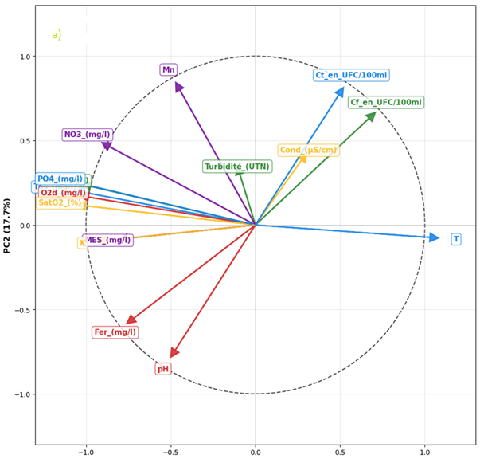

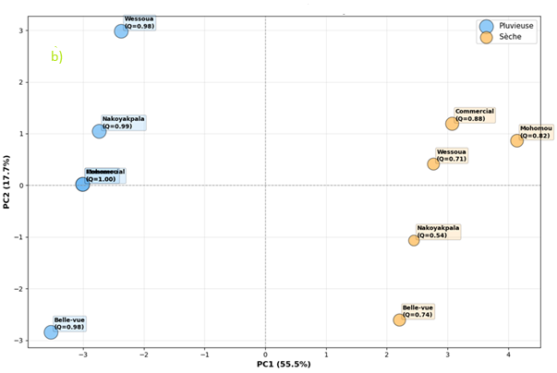

Figure 6: projection of water quality variables onto different sites (a) and sampled sites (b) in the factorial plane (PC1-PC2)

Discussion
The temperature of the Tilé River exhibits a marked seasonal pattern, being higher in the dry season than in the rainy season, consistent with observations made in other basins (Benyahia et al., 2024). The pH remains neutral to slightly alkaline and relatively stable between seasons, a result similar to that reported by Hassan et al. (2024). Conductivity and total dissolved solids (TDS) are higher in the dry season due to evaporation, while turbidity and suspended solids increase in the rainy season, linked to runoff and soil leaching (Kgopa et al., 2020; Benyahia et al., 2024). Dissolved oxygen concentrations are lower during the dry season, a consequence of high temperatures and organic runoff, as observed by Hussein et al. (2021). Nutrient levels show contrasting dynamics: phosphates increase during the dry season due to domestic and agricultural runoff (Ling et al., 2017), while nitrates are higher during the rainy season due to agricultural leaching (Wang et al., 2022). Nitrites reach a maximum in Nakoyakpala and Belle-Vue during the rainy season, reflecting the impact of agricultural and domestic runoff, which corroborates the observations of Kouassi et al. (2021) and Ousmane et al. (2019). Metals are present at concerning concentrations: iron far exceeds the WHO standard, particularly in Belle-Vue (Sawadogo et al., 2023; Hane et al., 2020; Fambi et al., 2021; Yameogo et al., 2024). Potassium shows spatiotemporal variability, being particularly high during the rainy season in Belle-Vue and Nakoyakpala, but persisting in Mohomou during the dry season, indicating local sources of pollution (Sawadogo et al., 2023; Yameogo et al., 2024). Manganese also remains high, especially during the wet season, confirming ongoing pollution of anthropogenic origin (Fambi et al., 2021; Sawadogo et al., 2023). Dissolved oxygen saturation levels decrease during the dry season (55–65%) and improve during the rainy season (75–85%), consistent with trends observed in West Africa (Sawadogo et al., 2023; Fambi et al., 2021; Yameogo et al., 2024). Finally, microbiological pollution persists: total and fecal coliform concentrations far exceed drinking water standards, particularly in Mohomou, Commercial, and Wessou during the rainy season, a phenomenon also reported by several regional studies (Sawadogo et al., 2023; Fambi et al., 2021; Yameogo et al., 2024).
The analysis highlights that the main sources of pollution in the Tilé River are anthropogenic, this situation is mainly exacerbated in Tilé River because it is located in N’Zérékoré where agricultural residues, domestic waste, and wastewater are discharged without treatment. This finding aligns with that of Kouamé et al. (2019) in Coast Ivory, who demonstrated that the intensive use of fertilizers and pesticides exacerbates pollution downstream from agricultural areas. Fecal contamination is an aggravating factor, linked to domestic waste and the lack of adequate sanitation. Rainy season leads to a significant increase in microbial loads (total and fecal coliforms) in the Tilé River as demonstrated by Diomandé et al. (2020) at others rivers in West Africa. Overall, the findings are in agree with those reported by Camara et al. (2018) in Conakry and Boubacar et al. (2021) on the Mékrou River in Benin, confirming the ongoing nature of urban and agricultural pollution in African watersheds. These results underscore the need for strict regulation of human activities and integrated water resource management in the municipality of N’Zérékoré.
4. Conclusion

The seasonal analysis of surface water quality in the Tilé River watershed, located in the urban commune of N’Zérékoré (Republic of Guinea), reveals a marked degradation of the physicochemical and microbiological quality of the water, particularly pronounced during the rainy season. The assessment, based on key pollution parameters (such as nutrients, metals, turbidity, and total and fecal coliforms), combined with the Physicochemical Biological Quality Index (IQBP), identified the main factors contributing to the degradation of this essential resource. The results indicate that all sampling sites at Belle-Vue, Wessou, Commercial, Mohomou, and Nakoyakpala exhibit significant levels of pollution, with water quality ranging from average to very poor depending on the season. The IQBP values are particularly low during the rainy season (often < 50), reflecting water quality that does not meet drinking water standards in more than 80% of the samples analyzed. This deterioration is linked to a combination of untreated domestic wastewater, pollutant-laden runoff, excessive use of chemical inputs in agriculture, and the near-total absence of sanitation infrastructure. This diffuse and chronic pollution represents a serious threat to human health, but also compromises agricultural, domestic, and fish farming uses of water resources. It reflects a worrying situation of environmental vulnerability that is part of a broader dynamic observed in several urban basins in West Africa as demonstrated by others studies. Faced with this problem, it is urgent to adopt an integrated approach to watershed management, based on reducing pollution at its source, implementing wastewater treatment systems, raising community awareness, and regularly monitoring water quality. The sustainable preservation of the Tilé River necessarily requires concerted actions, adapted to the local context, and taking into account both demographic changes and the effects of climate change.

References

ADEME. (2013). Water Quality Assessment System (SEQ-Eau). French Agency for Ecological Transition.
Adjagodo, D. A., Gbéassor, M., Gbéassor, M., Killi, K., & Gnazégbo, A. (2016). Monitoring of the physico-chemical quality of surface waters: The case of the Bè lagoon in Lomé (Togo). European Scientific Journal, 12(8), 1857–7881. https://doi.org/10.19044/esj.2016.v12n8p
Ameyapoh, Y., de Souza, C., & Traoré, A. S. (2005). Microbiological quality of traditional well water in the peripheral districts of Lomé (Togo). African Journal of Science and Technology, 6(2), 96–101.
APHA. (2017). Standard methods for the examination of water and wastewater (23rd ed.). American Public Health Association.
Bangoura, A. M., Condé, S., & Sylla, I. (2023). Urbanization, demographic pressure, and impacts on water resources in Forested Guinea. West African Journal of Environmental Sciences, 15(2), 45–61.
Benyahia, M., El Hmaidi, A., & Boulahfa, I. (2024). Impact of urban discharges on the water quality of the Nador Canal (Morocco). Moroccan Journal of Water Sciences, 12(1), 33–45.
Boubacar, I., Kpenou, F., & Adounkpe, J. (2021). Assessment of surface water pollution in the Mékrou basin (Benin): Contribution of anthropogenic activities. African Journal of Environmental Science and Technology, 15(4), 153–165.
Boukerche, S., Bensouiah, T., & Chabaca, M. (2021). Seasonal evolution of the microbiological quality of the Soummam River waters (Algeria). Applied Hydroecology, 24(3), 205–215.
Camara, M., Bah, O., & Traoré, K. (2019). Demographic dynamics and vulnerability of aquatic ecosystems in Guinea. African Journal of Environmental Studies, 11(1), 77–92.
Camara, M. S., Diallo, A., & Touré, K. (2018). Household solid waste management in Conakry: Between insufficient infrastructure and risky practices. African Journal of the Environment, 12(2), 45–59.
CCME. (2011). Canadian water quality guidelines. Canadian Council of Ministers of the Environment.
Cecchi, P., Dieulin, C., Guibert, B., & Sanou, B. (2020). Anthropogenic pressure and sedimentary dynamics in small dams in Burkina Faso: A participatory approach. VertigO – the electronic journal in environmental sciences, 20(2). https://doi.org/10.4000/vertigo.28044
Chang, H. (2005). Spatial and temporal variations of water quality in the Han River and its tributaries, Seoul, Korea. Water, Air, and Soil Pollution, 161, 267–284.
Cooper, D. R., & Schindler, P. S. (2014). Business research methods (12th ed.). McGraw-Hill Education.
Diallo, M., Keita, F., & Sy, B. (2018). Unplanned urbanization and surface water pollution in West African urban areas. African Journal of Science and Technology, 6(3), 101–118.
Diallo, M., Sylla, M., & Kourouma, L. (2008). Study on the quality of surface water in Conakry. National Institute of the Environment.
Diomandé, S., Kouassi, N. K., & Yao, K. M. (2020). Impact of urban runoff on the microbiological quality of rivers in Abidjan. Journal of Water Science, 33(1), 85–97.
Djaffar, S., & Kettab, A. (2015). Sustainable water management in developing countries. Applied Hydroecology, 19, 139–150.
Dongo, K., N’Goran, K. D., Kouadio, K. E., & Biemi, J. (2010). Impact of urbanization on the water quality of the Agnéby River: The case of the municipality of Agboville (Southern Côte d’Ivoire). Journal of Water Science, 23(2), 171–182. https://doi.org/10.7202/045360ar
FAO. (2005). Water and agriculture information system: Guinea. Food and Agriculture Organization of the United Nations. http://www.fao.org
Ghiglione, R., & Matalon, B. (2018). Sociological surveys: Theories and practices (9th ed.). Armand Colin.
Hassan, M. M., Rahman, M. S., & Akhter, S. (2024). Seasonal variation in physicochemical and microbial parameters of Korotoa River water, Bangladesh. Environmental Monitoring and Assessment, 196(2), 116.
He, X., Xi, B., Gao, R., & Tan, W. (2007). Water quality deterioration in the urban rivers of Xi’an, China. Environmental Geology, 52, 1501–1506.
Hussein, H. J., Al-Khafaji, R. R., & Salim, M. A. (2021). Spatial and temporal assessment of Tigris River water quality in Baghdad. Arabian Journal for Science and Engineering, 46(9), 8521–8533.
IUCN. (2006). Report on the state of the environment in Nigeria. International Union for Conservation of Nature.
Kambolé, M. S. (2003). Water pollution of Lake Togo and the coastal lagoon complex of Togo. International Journal of Biological and Chemical Sciences, 1(1), 1–11.
Keita, A., & Diallo, T. (2021). Anthropogenic pressure and water quality in urban areas of Guinea. Guinean Journal of Environment and Sustainable Development, 9(2), 25–39.
Kgopa, M. M., Mashele, H. T., & Phasha, M. M. (2020). Salinity and total dissolved solids dynamics in the Crocodile River, South Africa. Water SA, 46(1), 99–108.
Kouamé, J. K., Bamba, A., & N’Guessan, K. (2019). Effects of agricultural practices on surface water quality in the peri-urban areas of Bouaké. Ivorian Journal of Science and Technology, 33, 103–117.
Koulibaly, D., Souaré, Y., & Kaba, M. (2022). Socioeconomic activities and degradation of water resources in Forested Guinea. West African Scientific Review, 14(4), 89–104.
Ling, T. Y., Wong, Y. S., & Lee, N. S. (2017). Impact of land use on water quality in the Manatí River, Puerto Rico. Environmental Science and Pollution Research, 24(23), 18932–18947.
Law L94/005/CTRN. (1994). Water Code of the Republic of Guinea, promulgated on February 14, 1994.
MDDEP. (2012). Sampling Guide: Sediments of the St. Lawrence River. Ministry of Sustainable Development, Environment and Parks, Quebec.
Olivier, A., & Le Goff, M. (2020). Integrated approaches to water management: Between science, stakeholders, and territories. Presses de l’Université du Québec.
UN. (2020). The Sustainable Development Goals. https://sdgs.un.org/goals
UN. (2021). World water development report 2021: Valuing water. UNESCO. https://unesdoc.unesco.org
Paillé, P., & Mucchielli, A. (2021). Qualitative analysis in the humanities and social sciences (5th ed.). Armand Colin.
Rodier, J., Legube, B., & Merlet, N. (2009). Water analysis: Natural waters, wastewater, seawater (9th ed.). Dunod.
Smets, H. (2011). The human right to drinking water and sanitation. Revue Tiers Monde, 208, 99–114.
Soumah, I., Condé, B., & Camara, A. (2020). Anthropogenic pressures and pollution risks of urban watercourses in Forested Guinea. Cahiers Africains de l’Environnement, 8(1), 59–74.
Wang, Y., Li, L., & Zhang, X. (2022). Nitrate pollution and management strategies in the Miyun Reservoir watershed, China. Journal of Environmental Management, 308, 114630.
WaterAid. (2021). Global report on access to water and sanitation. https://www.wateraid.org
Yin, R. K. (2018). Case study research and applications: Design and methods (6th ed.). SAGE Publications
Diawara, B.L., Quoie Jr, G.D.S., Li, Z. and Loua, J.J. (2024) Water Scarcity in Conakry, Guinea: Challenges and Proposed Strategies for a Way Forward. Journal of Water Resource and Protection, 16, 264-280.
Tabunschik, V.; Gorbunov, R.; Bratanov, N.; Gorbunova, T.; Mirzoeva, N.; Voytsekhovskaya, V. Fatala River Basin (Republic of Guinea, Africa): Analysis of Current State, Air Pollution, and Anthropogenic Impact Using Geoinformatics Methods and Remote Sensing Data. Sustainability 2023, 15, 15798. https://doi.org/10.3390/su152215798
Guilavogui, K., Gbilimou, L.T., Bangoura, S., Sangaré, A. and Keita, A. (2025) Physico-Chemical and Microbiological Assessment of Borehole and Tap Water in Nzérékoré (Republic of Guinea). American Journal of Analytical Chemistry, 16, 161-173. https://doi.org/10.4236/ajac.2025.168010

