Case report

A case of Pseudo- bisalbuminemia and Nephrotic syndrome in an adult

.
ABSTRACT

Bisalbuminemia, whether hereditary or acquired, remains a rare electrophoretic abnormality of albumin; "pseudo-bisalbuminemia” is even rarer. It presents in several forms and is not a pathological condition in itself. In this paper, we report a rare case of "pseudo-bisalbuminemia” in an adult with nephrotic syndrome.

Keywords: Pseudo-bisalbuminemia, nephrotic, syndrome.

1. INTRODUCTION
Bisalbuminemia corresponds to a qualitative alteration of the albumin electrophoresis pattern. It can manifest in various ways: a "bifid albumin pattern" with two distinct peaks (of equivalent or unequal height), a broadening of the albumin peak, or the presence of a shoulder anterior to the main peak [1].
These abnormalities are generally not associated with any specific pathology, but they often raise clinical curiosity due to their unusual nature [2]. Two main origins are distinguished: a genetic form, which is permanent, and an acquired form, which is usually transient. In this paper, we present a rare and unusual case of electrophoresis associating pseudo- bisalbuminemia with nephrotic syndrome in an adult.

Case Presentation

2. oBSERVATION
This concerns patient X, a 69-year-old man, who presented with rapidly developing edema of the lower limbs, along with asthenia and pruritus. An abdominopelvic ultrasound revealed homogeneous hepatomegaly without focal lesions, poorly differentiated echogenic kidneys associated with mild ascites, and anectic cholestasis. Laboratory tests were performed: plasma protein = 40 g/L, plasma albumin = 27 g/L, proteinuria >3 g/24 h , and elevated gamma-glutamyl transferase (GGT) 5N, alkaline phosphatases (ALP) 6N and normal Unconjugated Bilirubin and serum protein electrophoresis shows a profile in favor of nephrotic syndrome.
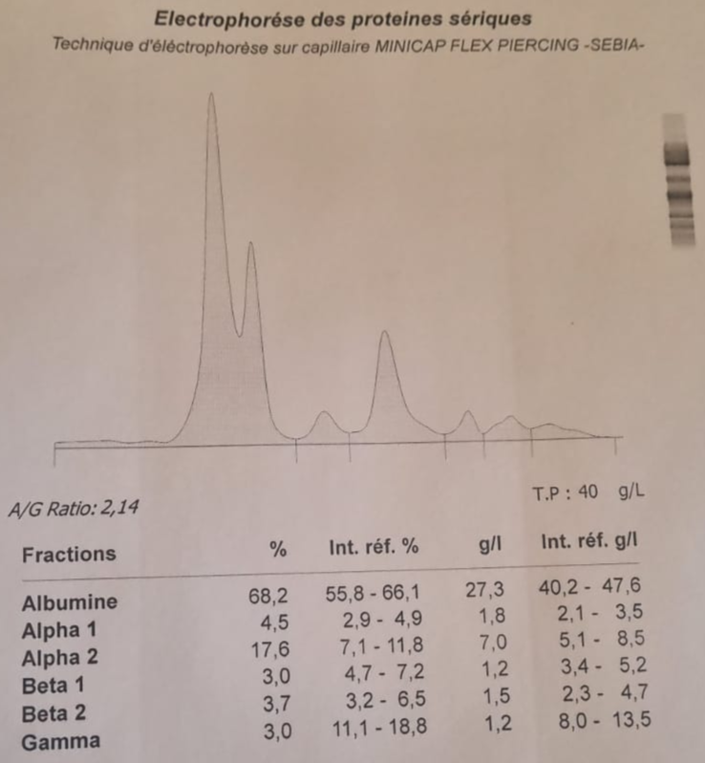
Figure 1: Profile in favor of a nephrotic syndrome (pseudo- bisalbuminemia with an increase in the alpha 2-globulin fraction).

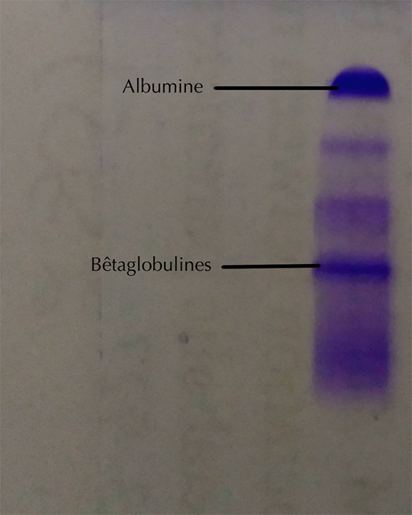
Figure 2: Serum protein electrophoresis on Hydrasys agarose gel (Sebia) showing the disappearance of all abnormalities and the appearance of a characteristic lipoprotein band at the level of beta globulins.

3. discussion

Serum protein electrophoresis is a laboratory test used to detect qualitative and/or quantitative abnormalities of circulating proteins [3]. Bisalbuminemias remain rare, but their frequency has increased with the development of capillary electrophoresis, which has higher resolution [2]. They can be either hereditary or therefore permanent, or acquired and generally transient.
Among the forms acquired, two mechanisms main are described:
- Pseudo - bisalbuminemia , corresponding to an electrophoretic appearance artifact related to the migration of interfering molecules in the albumin zone;
- A modification of the migration of a part of the albumin, which then appears with a more cathodic mobility than the variant during electrophoresis.
Certain endogenous substances such as unconjugated bilirubin , bile acids , or lipids , as well as various xenobiotics , can induce these changes by increasing their binding to albumin and altering its electrophoretic profile [4]. Dyslipidemias, in particular, constitute the most frequent interference observed in capillary electrophoresis, because lipoprotein molecules can migrate into a region close to that of albumin [3]. With this technique, and under the migration conditions of the "6-protein" buffer, beta-lipoproteins migrate in parallel with albumin (Figure 1). In our observation, serum protein electrophoresis was also performed on an agarose gel using the Sebia Hydrasys 2 Phoresis system. On this support, the pseudo- bisalbuminemia observed in the capillary is no longer visible and is replaced by a band migrating in the beta1 region. Densitometric analysis of the stained and dried gel confirms the lipoprotein nature of one of the peaks, due to its shift into the betaglobulin region (Figure 2).
Transient acquired bisalbuminemia has been described in various pathologies, including nephrotic syndrome (NS) [5]. The case presented here is distinguished by its occurrence in a 69-year-old adult. It corresponds to the biochemical definition of NS, characterized by proteinuria greater than 3 g/24 h in adults, hypoalbuminemia less than 30 g/L, and most often hyperlipidemia. Marked by elevated cholesterol and/or triglyceride levels. This hyperlipidemia results from hypoalbuminemia, which reactively and nonspecifically stimulates hepatic synthesis of all proteins, including lipoproteins. It is also linked to increased LDL and VLDL production, associated with reduced catabolism. This case also presents the peculiarity of an impure nephrotic syndrome; nearly 90% of nephrotic syndromes are pure, generally responsive to corticosteroids, and have a good prognosis [6]. The urine culture confirms this impure nature with the presence of microscopic hematuria.

4. Conclusion

Pseudo- bisalbuminemia induced by hyperlipidemia secondary to an impure nephrotic syndrome in an adult is a rarely described condition. The detection of bisalbuminemia on the electrophoresis, even without inherent pathological significance, should nevertheless alert the clinician, especially when clearly associated with nephrotic syndrome in an adult. Outside of this context, the presence of interfering molecules should also prompt the prescriber to adopt an appropriate approach to this abnormality.

Competing interests

Declaration of competing interest should be placed here. All authors must disclose any financial and personal relationships with other people or organizations that could inappropriately influence (bias) their work. Examples of potential conflicts of interest include employment, consultancies, honoraria, paid expert testimony, patent applications/registrations, and grants or other funding. If no such declaration has been made by the authors, SDI reserves to assume and write this sentence: “Authors have declared that no competing interests exist.”.

Consent (where ever applicable)

No manuscripts will be peer-reviewed if a statement of patient consent is not presented during submission (wherever applicable).
This section is compulsory for medical journals. Other journals may require this section if found suitable. It should provide a statement to confirm that the patient has given their informed consent for the case report to be published. Journal editorial office may ask the copies of the consent documentation at any time.

Authors may use a form from their own institution or SDI Patient Consent Form 1.0. It is preferable that authors should send this form along with the submission. But if already not sent during submission, we may request to see a copy at any stages of pre and post publication.

If the person described in the case report has died, then consent for publication must be collected from their next of kin. If the individual described in the case report is a minor, or unable to provide consent, then consent must be sought from their parents or legal guardians.

Authors may use the following wordings for this section: "All authors declare that ‘written informed consent was obtained from the patient (or other approved parties) for publication of this case report and accompanying images. A copy of the written consent is available for review by the Editorial office/Chief Editor/Editorial Board members of this journal."

Ethical approval (where ever applicable)

This section is compulsory for medical journals. Other journals may require this section if found suitable. If human subjects are involved, informed consent, protection of privacy, and other human rights are further criteria against which the manuscript will be judged. It should provide a statement to confirm that the authors have obtained all necessary ethical approval from suitable Institutional or State or National or International Committee. This confirms either that this study is not against the public interest, or that the release of information is allowed by legislation.

All manuscripts which deal with animal subjects must be approved by an Institutional Review Board (IRB), Ethical Committee, or an Animal Utilization Study Committee. , and this statement, and approval number, must accompany the submission. If required, author should be ready to submit a scanned copy of the IRB or Ethical Committee Approval at any stage of publication (Pre of post publication stage). The manuscript should contain information about any post-operative care and pain management for the animals.

For manuscripts involving animal experiments, Authors may use the following wordings for this section “All authors hereby declare that "Principles of laboratory animal care" (NIH publication No. 85-23, revised 1985) were followed, as well as specific national laws where applicable. All experiments have been examined and approved by the appropriate ethics committee”

All manuscripts which deal with the study of human subjects must be accompanied by Institutional Review Board (IRB) or Ethical Committee Approval, or the national or regional equivalent. The name of the Board or Committee giving approval and the study number assigned must accompany the submission. If required, author should be ready to submit a scanned copy of the IRB or Ethical Committee Approval at any stage of publication (Pre of post publication stage).

For manuscripts involving human experiments, Authors may use the following wordings for this section: “All authors hereby declare that all experiments have been examined and approved by the appropriate ethics committee and have therefore been performed in accordance with the ethical standards laid down in the 1964 Declaration of Helsinki.”

References

[1] Faviou E, Nounopoulos C, Dionyssiou-Asteriou A. Bisalbuminemia from a clinical chemist's viewpoint: a case report and review of the recent literature. Minerva Med. 2006; 97(3):287-93.
[2] Lefrere B, Dedôme E, Garcia- Hejl C et al. Bisalbuminemia: report of a case. Rev Internal Medicine . 2018; 39(12):950-4.
[3] Szymanowicz A, Cartier B, Couaillac JP et al. Proposal of ready-to-use interpretative comments for serum protein electrophoresis. Ann Biol Clin (Paris). 2006; 64(4):367-80.
[4] Cellier CC, Lombard C, Dimet I, Kolopp Sarda MN. Serum protein electrophoresis in medical biology: interferences and confounding factors. Rev Francoph Lab. 2018; 2018(499):47-58.
[5] Ahmad J, Khan AS, Siddiqui MA et al. Bisalbuminemia in nephrotic syndrome (a case report). Jpn J Med. 1984; 23(1):45-7
[6] Baudin B. Nephrotic syndrome. Rev Francoph Lab. 2013; 455:51-6.

