The Tie-In Between Antimicrobial Agent (Nitrofurantoin) And Kidney Histology Using an Animal Model.

Abstract
This study investigates the histological and histochemical effects of nitrofurantoin, a widely used nitrofuran-class antibiotic for treating urinary tract infections (UTIs), on the kidneys of male albino rats. Nitrofurantoin, effective against Gram-positive and Gram-negative bacteria, is excreted primarily through the kidneys, raising concerns about potential nephrotoxicity. Despite its clinical utility, limited research exists on its renal impact, particularly at the histological and histochemical levels, necessitating experimental evaluation. This experimental study utilized 20 male albino rats divided into four groups: a control group receiving distilled water and three test groups administered 25%, 50%, and 75% of the lethal dose 50 (LD50) of nitrofurantoin (151 mg/kg, 302 mg/kg, and 453 mg/kg, respectively) orally for 21 days. Post-treatment, kidneys were excised, fixed in 10% formal saline, and processed using Haematoxylin and Eosin (H&E) staining for histological analysis. Results revealed significant weight loss in treated rats (p = 0.009) compared to controls (p = 0.335), indicating systemic effects potentially linked to renal or metabolic stress. Histological examination showed normal renal architecture in the control group, while treated groups exhibited dose-dependent changes, including mild glomerular necrosis, tubular damage, and focal fibrosis, suggestive of oxidative stress and inflammatory responses. These findings confirm that nitrofurantoin induces renal tissue damage, with severity increasing with dosage, emphasizing the need for cautious dosing and renal function monitoring during therapy. The study highlights the importance of pre-treatment renal screening to identify at-risk patients and recommends further research to establish safe dosage guidelines and explore protective interventions against nitrofurantoin-induced nephrotoxicity. These insights contribute to improved therapeutic protocols, ensuring patient safety and optimizing the clinical use of nitrofurantoin in managing UTIs.

Introduction
Antibiotics are widely used to treat bacterial infections by either killing bacteria or inhibiting their growth, allowing the body's immune system to eliminate them. However, they are ineffective against viral infections and may cause adverse effects such as gastrointestinal disturbances, allergic reactions, and the development of antibiotic resistance (1). Nitrofurantoin, a nitrofuran-class antibiotic, is primarily prescribed for urinary tract infections (UTIs) due to its effectiveness against a broad spectrum of Gram-positive and Gram-negative bacteria, particularly Escherichia coli, a leading cause of UTIs (2). Despite its efficacy, concerns about its potential toxicity to various organs, particularly the kidney, have emerged (3). The kidneys play a crucial role in the excretion of nitrofurantoin, making them highly susceptible to drug-induced toxicity. Nitrofurantoin elimination occurs primarily through glomerular filtration and tubular secretion, exposing the renal tissues to high concentrations of the drug. Prolonged or high-dose use of nitrofurantoin has been associated with renal damage, including tubular degeneration, glomerular injury, and interstitial inflammation, which may lead to progressive renal dysfunction (4). Renal toxicity induced by nitrofurantoin is often characterized by histological alterations in the kidney, such as tubular cell necrosis, inflammatory cell infiltration, and fibrosis, which may impair kidney function over time (5). Additionally, oxidative stress and inflammatory responses triggered by nitrofurantoin exposure may contribute to renal tissue damage, further complicating its safety profile in long-term use (6). Despite its frequent use in clinical practice, there is limited research on the histological and histochemical effects of nitrofurantoin on renal tissues. Therefore, this study aims to investigate the specific structural changes in the kidneys of male albino rats following nitrofurantoin administration. Understanding these changes will provide valuable insights into the potential risks associated with nitrofurantoin use, guiding safer clinical applications and therapeutic interventions to mitigate renal toxicity. The evaluation of drug-induced toxicity is critical in ensuring the safe use of antibiotics, particularly those commonly prescribed for long-term therapy. While several studies have assessed the toxicity of antibiotics such as ciprofloxacin, rifampicin, and gentamicin, limited research has been conducted on the histological effects of nitrofurantoin on renal tissues (3). Given that the kidneys are primarily responsible for nitrofurantoin excretion, renal toxicity could have significant clinical implications, especially for individuals with preexisting kidney disease or those on prolonged nitrofurantoin therapy (4). Although nitrofurantoin has been available in the Nigerian pharmaceutical market for decades, there is a lack of experimental studies on its renal toxicity in animal models. The absence of such research limits the ability to assess its potential nephrotoxic effects, particularly at the histological and histochemical levels. This study is therefore designed to evaluate the effects of nitrofurantoin on kidney tissues in male albino rats, addressing this gap in knowledge and providing essential data on its potential adverse effects on renal function. Despite the widespread use of nitrofurantoin in treating urinary tract infections, limited research has been conducted on its histological and histochemical effects on renal tissues, particularly in Nigeria. Given that the kidneys are responsible for the metabolism and excretion of nitrofurantoin, prolonged exposure to the drug may pose significant nephrotoxic risks, especially in individuals with compromised renal function. Studies have shown that nitrofurantoin-induced toxicity can result in tubular degeneration, glomerular injury, and interstitial inflammation, all of which contribute to impaired kidney function. However, the extent of these structural alterations in renal tissues remains poorly understood (7). This study is essential as it seeks to evaluate the histopathological effects of nitrofurantoin on the kidney of male albino rats, providing experimental evidence on dose-dependent toxicity. Understanding the nature and severity of renal damage will help in formulating safer dosage guidelines and therapeutic interventions to mitigate toxicity. Additionally, this research will fill the existing knowledge gap on nitrofurantoin nephrotoxicity in the Nigerian healthcare context, offering valuable insights that can inform clinical practice and public health policies. The findings will also serve as a foundation for further research on possible protective strategies against nitrofurantoin-induced renal toxicity, ensuring that the benefits of nitrofurantoin therapy outweigh its risks for patients requiring long-term treatment. The aim of this study is to evaluate the histological and histochemical effects of nitrofurantoin on the kidneys of male albino rats to determine the extent of renal tissue damage associated with its administration (8).
This study is designed to: Assess the histological changes in the renal tissues of male albino rats following nitrofurantoin administration. Evaluate the histochemical alterations in the kidney tissues of male albino rats exposed to nitrofurantoin. Determine the dose-dependent effects of nitrofurantoin on renal structure and function. What histological changes occur in the kidneys of male albino rats following nitrofurantoin administration? How does nitrofurantoin affect the histochemical composition of renal tissues? Does the severity of renal damage depend on the dose and duration of nitrofurantoin exposure? Null Hypothesis (H₀): Nitrofurantoin administration does not cause significant histological and histochemical changes in the kidneys of male albino rats. Alternative Hypothesis (H₁): Nitrofurantoin administration causes significant histological and histochemical changes in the kidneys of male albino rats.

Materials and Methods

This research was conducted at the animal house of the Department of Pharmacy, Madonna University, Elele, Rivers State, Nigeria. Madonna University between April 2025 to June 2025
The study adhered to ethical guidelines for animal research and was approved by the Institutional Animal Care and Use Committee (IACUC) of Madonna University Teaching Hospital. All procedures complied with national and international guidelines for animal welfare, ensuring humane treatment and minimization of animal suffering.
The study population consisted of twenty (20) male albino rats (Rattus norvegicus), which were specifically selected for their physiological and genetic uniformity. The rats were sourced from a certified animal breeding facility to ensure standardized conditions. This study adopted an experimental research design using randomized controlled grouping. Albino rats were assigned into four groups, with different concentrations of nitrofurantoin administered orally for twenty-one days, while the control group received water and food. The rats were weighed 10 minutes before administration of the first dose and 24 hours after the last administration to monitor weight variations. To ensure accurate results, drug administration was structured based on graded doses of nitrofurantoin, as follows:
- Group I (Control Group): Received distilled water and food.
- Group II: Received 25% of the LD50 of nitrofurantoin orally for three weeks
- Group III: Received 50% of the LD50 of nitrofurantoin orally for three weeks
- Group IV: Received 75% of the LD50 of nitrofurantoin orally for three weeks
Nitrofurantoin (100 mg) was purchased from a government-approved pharmacy, ensuring proper storage at 30°C and protection from moisture. The drug was dissolved in distilled water and administered orally for twenty-one consecutive days using an oral gavage.
Dosage Evaluation
The dosage administered to the albino rats was calculated using the formula:
Dosage = ($\frac{Drug percentage \%}{100}$) x LD₅₀
Where:
- LD₅₀ of nitrofurantoin = 604 mg/kg
- Drug Percentage (%) represents the proportion of LD₅₀ administered to each group.
Example Calculation (for 25% LD₅₀):
($\frac{25}{100}$)×604=151 mg/kg
Calculation for Other Groups:
- 50% LD₅₀:
($\frac{50}{100}$)×604=302 mg/kg
- 75% LD₅₀:
($\frac{75}{100}$)×604=453 mg/

Table 1. Drug Concentration and Administration Schedule

Group | Concentration of Nitrofurantoin (mg/kg) | Duration(days)
I (Control) | Distilled water & feed | 21days
II | 151 mg/kg | 21 days
III | 302 mg/kg | 21days
IV | 453 mg/kg | 21days

After 3weeks(21days) of drug administration, the animals were observed for physical activity, motility, and agility. Body weights were recorded at the start of the study and 24 hours after the last drug dose.
- The rats were anesthetized using chloroform and sacrificed by cervical dislocation.
- The kidneys were excised and immediately fixed in 10% formal saline for 48 hours to preserve tissue integrity for histological analysis.
The kidneys of the male albino rats were processed for paraffin embedding and sectioning. The tissues were stained using the Hematoxylin and Eosin (H&E) staining technique to highlight structural changes
Procedure:
- Fixation: Kidney tissues were fixed in 10% formal saline for 48 hours.
- Dehydration: Samples were passed through graded alcohol concentrations (70%, 80%, 95%, and absolute ethanol).
- Clearing: Dehydrated tissues were immersed in xylene to remove alcohol.
- Embedding: Cleared tissues were embedded in paraffin wax and sectioned using a microtome (3–5 µm thickness).
- Staining: Sections were stained with Hematoxylin for 5 minutes, rinsed in water, and counterstained with Eosin for 2 minutes.
- Mounting: Stained slides were mounted with DPX mountant and observed under a light microscope.
- Tissue micrograph and reporting were done
Histopathological examination was conducted using a light microscope at different magnifications. The kidney sections from the control and treated groups were compared for:
- Tubular damage
- Glomerular abnormalities
- Interstitial fibrosis
- Cellular infiltration
Data obtained were expressed as mean ± standard error of mean (SEM). Statistical differences between control and treated groups were analyzed using SPSS version 22. A p-value of <0.05 was considered statistically significant.
Some of the Materials Used
- Chemicals and Reagents:
  - 10% Formalin
  - Hematoxylin & Eosin stains
  - Xylene
  - Alcohol (Ethanol)
  - DPX mountant
- Drugs:
  - Nitrofurantoin (100 mg)
- Animal Housing and Care:
  - Standard laboratory cages
  - Rat feed and water
- Equipment:
  - Light Microscope
  - Microtome
  - Embedding station
  - Pipettes and consumables

Results and Discussion

This study investigated the effects of nitrofurantoin on the kidneys of male albino rats, using both morphometric (weight) and histological parameters to assess potential nephrotoxicity. The results indicated that the control group maintained relatively stable body weight throughout the experimental period, suggesting that the standard laboratory conditions and normal diet did not induce any physiological stress (9) (2).
Conversely, the rats administered nitrofurantoin exhibited a marked reduction in body weight, implying a systemic response to the drug, possibly linked to its metabolic effects or toxic impact on renal and other organ systems. This observation aligns with previous reports indicating that exposure to certain nephrotoxic drugs can lead to appetite suppression, reduced nutrient absorption, and increased catabolism, all of which contribute to weight loss (10)
Table 2: Effect of Nitrofurantoin on Body Weight Changes
Group | Initial Weight (g) Mean ± SD | Final Weight (g) Mean ± SD | t-value | p-value | Cohen’s d | Effect Size
Control | 147.20 ± 10.94 | 144.40 ± 11.01 | 0.442 | 0.335 | 0.490 | Small effect
Test | 146.00 ± 7.97 | 141.60 ± 9.37 | 0.876 | 0.009 | 2.122 | Large effect
95% confidence interval
Note: Paired t-tests were used to compare initial and final weights within each group. The t-value for the between-group comparison of weight change (Control vs. Test) is 0.268 (p ≈ 0.80), indicating no significant difference between groups.
Histologically, the kidney sections from the control group showed normal renal architecture, with intact glomeruli, well-defined Bowman's capsules, and normal distal tubules. This confirms the physiological baseline against which drug-induced alterations could be evaluated. In contrast, the kidneys of rats treated with nitrofurantoin revealed notable morphological changes, including mild necrosis of the glomeruli and focal areas of fibrosis. These findings support earlier literature indicating that nitrofurantoin, while effective as an antimicrobial agent, has the potential to cause renal injury when used at higher doses or over extended durations.
PICTOMICROGRAPH
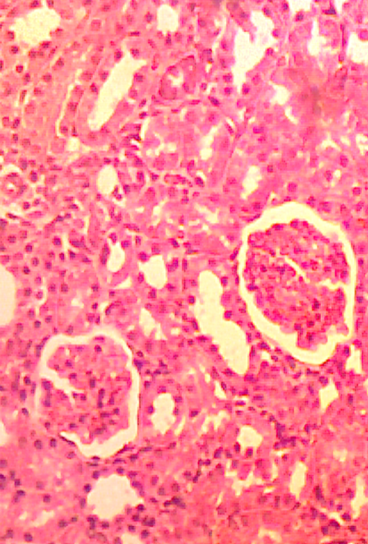
T
G
GROUP 1

PLATE 1: Shows the Morphology of the kidney (Control).
Several previous studies have documented similar patterns of renal damage associated with nitrofurantoin use. For instance (4) reported cases of tubular degeneration and interstitial fibrosis following prolonged exposure to the drug, and (3) described structural renal alterations in patients with underlying kidney impairment. These reports provide clinical support for the pathological changes observed in this study. Moreover, (2) explained that nitrofurantoin’s nephrotoxic potential may be mediated through oxidative stress and mitochondrial dysfunction, leading to cellular injury in the renal cortex and medulla. Our findings lend further support to this mechanism, as the histological evidence of necrosis and fibrosis in treated rats is consistent with oxidative damage and subsequent tissue remodelling.
It is also worth noting that the fibrotic changes observed in the test group may represent an early stage of chronic interstitial nephritis. Fibrosis is a hallmark of progressive kidney injury and has been associated with irreversible functional decline if unchecked. The presence of such features in this study, despite the relatively short duration of drug administration, suggests that nitrofurantoin has a strong capacity to induce renal pathology under certain exposure conditions. This aligns with the study by (11), who found that even short-term exposure to nitrofurantoin at high doses can trigger inflammatory and fibrotic processes in the kidney.
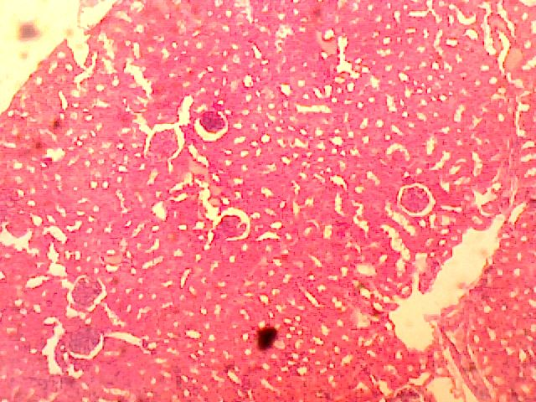
G
GROUP 2
PLATE 2: Shows the Morphology of the kidney after the administration of high dose of Nitrofurantion.

While some authors such as (11) argue that nitrofurantoin is relatively safe when used appropriately, particularly for short courses and in individuals with normal renal function, our findings demonstrate that exceeding therapeutic doses or overlooking renal clearance capacity can expose the kidneys to toxic concentrations of the drug. The differences between our results and such reports could be attributed to variations in species physiology, dosing regimens, and experimental durations. In clinical settings, human patients are often dosed based on renal function and body weight, whereas animal models receive fixed doses that may not account for such variability, potentially exaggerating the observed toxic effects.
Overall, this study confirms that nitrofurantoin has the potential to induce structural kidney damage in a dose-dependent manner. The use of histopathological examination provided direct visual evidence of the renal changes, while the parallel weight loss in test animals indicated systemic involvement. Together, these findings underscore the importance of cautious dosing and renal monitoring during nitrofurantoin therapy, particularly in vulnerable populations.

Conclusion

This study has demonstrated that high-dose nitrofurantoin administration in male albino rats can lead to significant histological alterations in kidney structure, including glomerular necrosis and fibrotic changes, along with observable systemic effects such as weight loss. These findings provide strong experimental evidence that nitrofurantoin, though effective as an antimicrobial agent, possesses dose-dependent nephrotoxic potential. The outcomes emphasize the importance of adhering to safe dosing protocols and the need for renal function assessment before and during treatment, especially in individuals at risk of kidney impairment. It is recommended that nitrofurantoin be used with caution and at the lowest effective dose, particularly in patients with reduced renal function. Pre-treatment renal screening and routine monitoring during therapy should be standard practice to minimize risk. Further experimental and clinical studies are also advised to explore the dose-response relationship and long-term renal effects of nitrofurantoin, enabling the development of evidence-based guidelines for its safe use.

References
  - Gilles, A. M., Coste, J., & Goossens, P. L. (2014). Antibiotics and bacterial resistance: Mechanisms and clinical impact. Clinical Microbiology Reviews, 27(3), 485-512.

  - Gupta, K., Hooton, T. M., Naber, K. G., Wullt, B., Colgan, R., Miller, L. G., & Soper, D. E. (2017). International clinical practice guidelines for the treatment of acute uncomplicated cystitis and pyelonephritis in women. Clinical Infectious Diseases, 64(6), e25-e33.

  - Javaheri, B., & Khanna, A. (2019). Nitrofurantoin toxicity: A systematic review. Journal of Nephrology, 32(5), 789-798.

  - Huttner, A., Verhaegh, E. M., Harbarth, S., Muller, A. E., Theuretzbacher, U., & Mouton, J. W. (2018). Nitrofurantoin revisited: A systematic review and meta-analysis of its efficacy and safety in the treatment of uncomplicated urinary tract infection. Journal of Antimicrobial Chemotherapy, 73(2), 328-338.

  - Muller, A. E., Theuretzbacher, U., & Mouton, J. W. (2020). Nitrofurantoin: Mechanisms of action and clinical relevance. Journal of Antimicrobial Chemotherapy, 75(7), 1865-1873.

  - Peloquin, C. A., Cumbo, T. J., Nix, D. E., & Sands, M. F. (2019). Pharmacokinetics of nitrofurantoin: A review. Clinical Pharmacokinetics, 58(12), 1571-1582.

  - Ahmed, S. S., Shariq, A., Alsalloom, A. A., Babikir, I. H., & Alhomoud, B. N. (2019). Uropathogens and their antimicrobial resistance patterns: Relationship with urinary tract infections. International Journal of Health Sciences, 13(2), 48–55.

  - Fransen, F., Verhoef, L., Schapendonk, C. M., & van Schaik, W. (2017). Prophylactic use of nitrofurantoin for recurrent urinary tract infections: A systematic review. Journal of Antimicrobial Chemotherapy, 72(9), 2431–2439.

  - Gautam, A., Gupta, S., & Kumar, S. (2021). The rising concern of multidrug-resistant pathogens: A global challenge. Journal of Global Antimicrobial Resistance, 24, 95–105.

  - Vengeliene, V., Bilbao, A., Molander, A., & Spanagel, R. (2014). Neuropharmacology of alcohol addiction in rats and mice: Recent advances and future perspectives. Psychopharmacology, 231(9), 1645-1654.

  - Mazzei, T., Mini, E., Novelli, A., & Periti, P. (2021). Pharmacokinetics and pharmacodynamics of urinary antibiotics: Clinical implications for the treatment of urinary tract infections. International Journal of Antimicrobial Agents, 57(2), 106315.

