Effect of Fortification and Processing on Antinutrients and Protein Content and Digestibility of Low- and High-Tannin Sorghum Cultivars

Abstract
This study aimed to examine the effects of wheat and pigeon pea fortification and processing on antinutrient levels, protein content, and in vitro protein digestibility (IVPD) of low-tannin (Tabat) and high-tannin (WadAhmed) sorghum cultivars. The sorghum cultivar WadAhmed exhibits elevated tannin and phytate concentrations and reduced protein content. Pigeon pea exhibited a markedly elevated IVPD value, while wheat demonstrated modest levels of tannins and phytates. The tannin, phytate, and protein contents, as well as the IVPD of the meals, were evaluated before and after processing. The incorporation of wheat and pigeon pea flours reduced antinutrient levels and increased protein content and in vitro protein digestibility (IVPD). Post-fermentation, antinutrient levels were markedly reduced (P ≤ 0.05), coinciding with a considerable increase in IVPD. Cooking the fermented dough of meals showed significantly greater improvement than cooking raw meals. The ratio of ingredients and fermentation diminished the impact of cooking on protein content and IVPD.

Keywords: Sorghum, fortification, kisra processing, antinutrients, in vitro protein digestibility.

Introduction
Sorghum (Sorghum bicolor L. Moench) has drought resistance and ranks as the fifth most significant cereal in output, following rice, wheat, maize, and barley. In Sub-Saharan Africa, it ranks second in terms of cultivation, following maize (Eggen et al., 2019). Notwithstanding this rating, sorghum constitutes less than 3% of worldwide cereal grain production, in contrast to corn, rice, wheat, and barley. Sorghum has recently been recognized as a future crop owing to its superior agronomic performance, particularly its significant tolerance to heat and drought, and its capacity to produce substantial yields on marginal soils (Cardone et al., 2021). This resistance makes sorghum a fundamental food source for hundreds of millions of people in the semi-arid areas of Asia and Africa. Consequently, processing sorghum grains is essential to enhance their nutritional value and optimize their potential as a sustainable, resilient staple (Tanwar et al., 2023).
Sorghum provides carbohydrates, protein, dietary fiber, vitamins, and minerals (USDA, 2018). Sorghum is inherently gluten-free, making it suitable for people with celiac disease and gluten sensitivity (Awika, 2017). Sorghum is a notable source of antioxidants that neutralize reactive oxygen and nitrogen species, thereby helping prevent oxidative illnesses (Abioye et al., 2018). Nonetheless, sorghum contains substantial levels of antinutrients, including tannins, phytates, and oxalates (Tamilselvan and Kushwaha, 2020). These antinutrients might impede the absorption of vital minerals. Tannins can specifically inhibit the digestion of energy and protein, whilst phytates can obstruct the absorption of minerals like zinc and calcium. Various techniques have been used to improve the nutritional quality of cereal grains, including fermentation.
Fermentation, as a method of food preservation, has been used since ancient times. It is cost-effective, supplies essential nutrients, promotes nutrient bioavailability, eliminates unwanted elements such as natural toxins and pathogenic microbes, and improves flavor (Masahid et al., 2021). Furthermore, fermentation breaks down complex chemicals into simpler forms (Masahid et al., 2021). The processes of dehulling, fermentation, and roasting of sorghum grains enhanced nutritional quality, particularly protein levels, while markedly reducing antinutritional factors (Gwekwe et al., 2024). The increase in protein concentration post-fermentation is attributed to the release of nitrogen as microbes metabolize carbohydrates for energy (Province and Sciences 2017). The pre-treatment of sorghum through dehulling, fermentation, and roasting enhanced its protein, moisture, fat, and ash content.
The reduction of undesired antinutrients, including alkaloids, tannins, and phytic acid, following sorghum pre-treatment indicates that integrating these processing techniques significantly improves sorghum's nutritional value (Gwekwe et al., 2024). Pigeon pea (Cajanus cajan (L.) Millsp.) is an important grain legume grown and consumed in tropical and semi-arid regions worldwide, including areas of Asia, Africa, Latin America, and the Caribbean (Fuller et al., 2019). Nonetheless, despite their nutritional benefits, the widespread utilization of pigeon peas is limited by elevated concentrations of antinutritional compounds, including phytic acid, oxalate, and tannins. These chemicals can reduce mineral bioavailability, promote kidney stone formation, and diminish nutritional digestibility, especially in complementary foods for infants (Amoah et al., 2023; Das et al., 2022).
A prior study has shown the efficacy of conventional processing techniques in markedly decreasing the concentrations of these antinutritional components in diverse legume grains. In black soybeans, germination, fermentation, and roasting effectively diminished antinutritional components, including phytic acid and tannins (Chauhan et al., 2022). Pigeon pea can be used as a substitute for wheat flour, thereby enhancing the nutritional quality of crackers (Olagunju et al., 2018). The composite biscuits, made from combining pigeon pea and wheat flour, had a low glycemic index, thereby reducing the postprandial glucose peak 30 minutes after consumption in diabetic patients (Gbenga-Fabusiwa et al., 2019). Sorghum-based fermented foods, including kisra, hulu-mur, merica, and nasha, are prevalent in many African nations, such as Sudan, Nigeria, and Tanzania, and serve as primary food sources for indigenous populations (Adebo 2020).

Enhancing these grains can render them more appealing and elevate their acceptance in the food sector. The grains have functional qualities, and the innovative products derived from them are poised to gain market penetration as consumers shift toward healthier food options. Both traditional and contemporary techniques can be employed to mitigate antinutritional effects in tiny grains. Milling, soaking, fermenting, debranning, and autoclaving are procedures used to reduce antinutritional factors in small grains. Employing diverse techniques, individually or in combination, can diminish antinutrient concentrations (Samtiya et al., 2020). This study aims to examine the effects of fortification with pigeon pea and wheat flour, as well as processing, on the antinutrient level and protein content, and digestibility of low- and high-tannin sorghum cultivars.

Materials and methods

Materials

Two sorghum cultivars, Tabat (low-tannin) and WadAhmed (high-tannin), were acquired from the Agricultural Research Corporation in WadMadani. Commercial Sudanese wheat flour (Debaria, 72% extraction rate) was procured from Seen Flour Mills. Pigeon pea seeds were procured from the local market in Omdurman. Sorghum and pigeon pea seeds, after being cleaned, were ground to pass through a 0.4 mm screen. Certain flours were preserved at 4 °C, while the remainder was utilized to create composite flour.

Preparation of Composite Flour Blends

Four distinct meals were prepared using sorghum, wheat, and pigeon pea flours in variable proportions, as illustrated in Table 1. The ingredients of each meal were combined with distilled water (1:2 w/v). Fermentation of the dough commenced with the addition of starters derived from previously fermented doughs of the same type. The dough underwent fermentation for 12 hours. After the incubation period, the fermented flour was spread onto aluminum plates and dehydrated in a hot-air oven at 60 °C for an additional 24 hours. The desiccated samples were subsequently pulverized to pass through a 0.4 mm sieve and preserved at 4 °C. A portion of the fermented dough was used to make kisra bread.

Table 1. Composite flour formulation.
Meals | Ingredients%
Meals | Tabat | WadAhmed | Wheat | Pigeon pea
T0 | 100
T1 | 70 |  | 20 | 10
T2 | 70 |  | 15 | 15
T3 | 70 |  | 10 | 20
W0 |  | 100
W1 |  | 70 | 20 | 10
W2 |  | 70 | 15 | 15
W3 |  | 70 | 10 | 20

Kisra Bread Preparation

Kisra bread was prepared, as reported by Mahgoub et al. (1999). Sorghum (Sorghum bicolor) cultivars were processed in a commercial mechanical stone mill. Whole-grain flour was procured and used to make kisra. A thin layer of fermented dough slurry was applied to the hot plate and baked for 20 to 30 seconds. The baked kisra sheets were subsequently removed using a wooden scraper. The meal sheets were stored at 4 °C for subsequent analysis after being oven-dried at 70 °C and ground to pass through a 0.4 mm sieve.

Protein Content Determination
The total nitrogen (micro-Kjeldahl) of the samples was determined according to AOAC (2005). Protein was determined by multiplying nitrogen by 6.25.
  - Phytate Content Determination
The AOAC (2005) method was employed to ascertain phytate concentration. Phytate was extracted with 0.5 M HNO3 and then digested with 0.5 mL of perchloric acid. The processed material was diluted to 25 mL with distilled water in a volumetric flask. A 2.5 mL aliquot of each extract was combined with 2.5 mL of nitric acid, and the phytic phosphorus interacted with 2.5 mL of vanadium molybdate to produce a yellow-orange complex. Absorbance was quantified at 460 nm utilizing a UV/Vis Spectrophotometer (PD-UV, Apel, Saitama, Japan). A blank reagent and a 2 mg standard of phytic acid were utilized to ascertain phytate concentration in mg/100 g.
  - Tannin Content Determination
The tannin concentration was measured utilizing the method outlined by Dykes (2019). A 100 mL conical flask containing 0.2 g of each sample was treated with 10 mL of 1% HCl in methanol (v/v); the mixture was thoroughly mixed and subsequently centrifuged at 2500 rpm for 5 minutes. Subsequently, approximately 5 mL of vanillin-HCl reagent was added to 1 mL of supernatant. Following a 20-minute incubation at 30 °C, the absorbance was quantified at 500 nm using a spectrophotometer (PD-UV, Apel, Saitama, Japan). Tannin content was determined using a standard curve of tannic acid, and results were reported in mg/100 g.
  - In vitro Protein Digestibility

According to the Monjula and John (1991) method, 200 mg of each sample was weighed into a 100 mL Erlenmeyer flask containing 35 mL of 0.1 mol/L sodium citrate tribasic dihydrate (pH 2.0) with pepsin (1.5 g/L). The mixture was incubated at 37 °C for 2 hours in a water bath, then centrifuged at 1000xg for 15 minutes; the supernatant was discarded. The residue was washed, dried, and analyzed for nitrogen concentration using the AOAC (2005) standard procedure. In vitro protein digestibility was calculated as the percentage of protein in the supernatant relative to the total protein content of the sample.
  - Statistical Analysis

An analysis of variance was performed on three data replicates utilizing IBM SPSS Statistics 23.0 software (SPSS Inc., USA). The means and standard deviations of the data are presented. Duncan's multiple-range tests were employed to determine the significance of differences between means. Statistical significance was deemed acceptable at P ≤ 0.05.

Results and Discussion

Antinutrients, Protein Content, and Digestibility of Ingredients
Figure 1 illustrates the concentrations of tannin and phytate (mg/100 gm) (A), as well as the protein content (%) and in vitro protein digestibility (IVPD, %) (B) of raw sorghum cultivars (Tabat and WadAhmed), wheat, and pigeon pea. Figure 1 illustrates that the WadAhmed cultivar exhibited much greater tannin content (960.47 mg/100 g) compared to Tabat (350.22 mg/100 g), pigeon pea (145.69 mg/100 g), with wheat displaying the lowest value (41.47 mg/100 g). The phytate concentration in sorghum WadAhmed (265.34 mg/100 gm) was markedly greater than that of other types, followed by pigeon pea (259.74 mg/100 gm), Tabat (233.13 mg/100 gm), and wheat flour (44.12 mg/100 gm). The tannin and phytate levels for sorghum Tabat and wheat were similar to those documented by Mustafa et al. (2024), and the results for sorghum WadAhmed aligned with those presented by Mustafa et al. (2025). The phytate value for pigeon pea was lower than that reported by Haji et al. (2024); however, the tannin value exceeded their findings. Iqbal et al. (2022) assert that wheat is a significant source of carbohydrates in many industrialized nations, in addition to providing protein and dietary fiber for human consumption. It also contains minerals, fats, and vitamins, all of which are sources of micronutrients. Moreover, wheat had negligible levels of antinutrients, indicating substantial nutritional value. Concerning the in vitro protein digestibility (IVPD) of the ingredients, pigeon pea had a much superior IVPD value of 65.15%, followed by wheat at 51.68%, Sorghum Tabat at 47.96%, while sorghum WadAhmed displayed the lowest value at 34.49%. The findings indicated that antinutrient levels substantially influenced the in vitro protein digestibility (IVPD) of the constituents, as documented by other authors (Rizvi et al., 2022; Singh et al., 2024; Shan & Tian, 2022). Furthermore, protein concentration and structure significantly influence IVPD; the data indicate that pigeon pea exhibited the highest protein percentage, followed by wheat, Sorghum Tabat, and lastly WadAhmed. The protein content of pigeon pea was similar to that documented by Okechukwu et al. (2024) and Garaniya et al. (2023).

Effect of Formulation and Processing on Antinutrient Content
Figure 2 illustrates the tannin concentration in the composite flour of sorghum cultivars Tabat and WadAhmed, which has been fermented and baked into kisra bread. Figure 2 illustrates that, relative to unformulated sorghum flour, the formulation of raw meal processing significantly (P ≤ 0.05) decreased the tannin level in both cultivars. The findings indicated that combining sorghum flour with wheat and pigeon pea significantly reduced (P ≤ 0.05) the tannin content of the composite raw flour from 350.22 mg/100g to 280.61, 271.24, and 274.46 mg/100g for meals T1, T2, and T3, respectively. Further reduction occurred post-fermentation, with the minimum value recorded for T2 meal at 170 mg/100g, and after cooking the fermented dough into kisra for T3 meal at 110 mg/100g. The treatment of WadAhmed meals resulted in a tannin reduction rate comparable to that of Tabat meals; however, after cooking into kisra, the meal composed of W1, which consists of sorghum (70%), wheat (20%), and pigeon pea (10%), exhibited a significantly lower tannin content (120 mg/100g) post-cooking.
Conventional food processing techniques, including heating and fermentation, significantly improve the nutritional value of staple crops like sorghum, particularly for economically disadvantaged populations. These approaches are readily available and cost-effective, rendering them particularly appropriate for low-resource environments. Eliminating unwanted food components is crucial to improving quality. Various procedures, including soaking, cooking, fermentation, radiation, germination, and chemical treatment, can effectively mitigate antinutritional elements (Popova & Mihaylova, 2019). Cooking is believed to enhance the digestion of macronutrients, soften fibrous structures, and diminish microbial contamination. It also facilitates the thermal decomposition of antinutritional compounds, such as phytates and tannins, thereby enhancing mineral bioavailability (Kumari & Roy, 2023; Savard et al., 2019). Cooking, a ubiquitous domestic activity, causes thermal and structural alterations that influence nutrient content via leaching and degradation (Savard et al., 2019). Fermentation is a proven method of preservation and enhancement that diminishes antinutritional elements and increases the bioavailability of grains, which is crucial in cereal-based diets (Siqueira et al., 2020). Fermentation is considered a transforming process that enhances the nutritional value of food. It enables the amalgamation of various plant-derived proteins and promotes the advancement of more sustainable dietary alternatives (Wairich et al., 2022).
Tannins have antinutritional effects by hindering the digestion of many nutrients and obstructing the body's absorption of beneficial, bioavailable compounds. Antinutrients are beneficial active compounds in food and beverages when consumed in small amounts. Although tannins have antinutrient activity, various categories of antinutrients, including tannins, have demonstrated potential antiviral, antibacterial, and antiparasitic properties (Popova & Mihaylova, 2019). Tannins have antinutritional effects by hindering the digestion of numerous nutrients and obstructing the absorption of beneficial bioavailable compounds (Ertop & Bektaş, 2018). Tannins can attach to and denature proteins. Tannin-protein complexes can inactivate digestive enzymes and diminish protein digestibility by binding to the protein substrate and to ionizable iron. Consistent with our findings, Adeyemo et al. [2016] evaluated the impact of sorghum fermentation on tannin levels and noted a substantial decrease of 72% in tannin content. Boua et al. (2020) reported that condensed tannins declined significantly after cooking.
Figure 3 illustrates the phytate concentration in the composite flour of the sorghum cultivars Tabat and WadAhmed, which has been fermented and cooked into kisra bread. Formulation of raw meals and processing significantly (P ≤ 0.05) decreased phytate concentration in both cultivars compared with the sorghum flour. The results indicated that the formulation of sorghum flour with wheat and pigeon pea significantly reduced (P ≤ 0.05) the phytate content of the composite raw flour of the Tabat cultivar (Figure 3A) from 233.13 mg/100g to 223.96, 208.77, and 219.55 mg/100g for meals T1, T2, and T3, respectively. Further reduction was noted post-fermentation, with the minimum value recorded for meal T1 at 154.9 mg/100g, and after cooking the fermented dough into kisra for meal T1 at 138.3 mg/100g.
The treatment of WadAhmed meals (Figure 3B) yielded a phytate reduction rate comparable to that of Tabat meals; however, after cooking into kisra, the meal formulated with W2, a composite of sorghum (70%), wheat (15%), and pigeon pea (15%), exhibited significantly lower tannin content (116.94 mg/100g). It has been reported that, in monocots such as maize, sorghum, and millet, phytate is located in the bran or aleurone layer [Samtiya et al., 2020] and must be removed or substantially reduced to enhance mineral and protein absorption from these foods. Fermentation creates an ideal pH for endogenous phytase activity in cereals, facilitating the degradation of phytic acid and enhancing mineral bioavailability [Nkhata et al., 2018]. Fermentation is said to enhance the protein content in chickpeas by 13% and reduce the phytic acid level by 45% [Valdez-González, et al. 2018]. Adeyemo et al. [2016] evaluated the impact of sorghum fermentation on phytate levels and noted a substantial decrease of 60% in phytate content. A comparable trend in phytate reduction was observed in a study in which maize was spontaneously fermented for 4 days at 30°C, resulting in a 61.5% decrease in phytate levels (Nsabimana et al., 2024). Nagessa et al. (2023) reported that roasting black small common beans markedly reduced phytate levels. Atuna et al. (2022) indicated that boiling slightly reduced phytic acid levels in cereal flours compared with fermentation and malting, since elevated temperatures are expected to inactivate phytase.

Effect of Formulation and Processing on Protein Content and Digestibility of Sorghum-based Kisra

Figure 4 illustrates the protein content of the sorghum cultivars Tabat (A) and WadAhmed (B) in composite flour that has been fermented and cooked into kisra bread. The protein concentration of the raw flour from the Tabat cultivar (Fig. 4A) was 11.42%. The incorporation of wheat and pigeon pea flour in varying proportions into the flour markedly (p ≤ 0.05) increased the protein content of the meals to 14.22%, 15.02%, and 15.82% for meals T1, T2, and T3, respectively. Fermenting raw flour markedly increased the protein content to 15.03% (p < 0.05), but heating the fermented dough reduced it to 13.30%, which remains significantly higher than that of the raw flour. Fermentation of the meals increased protein content, with the highest value recorded for meal T3 (17.51%). Nonetheless, boiling the fermented dough reduced the protein level, which remains substantially higher than that of raw meal flour. The protein concentration of the raw flour from the WadAhmed cultivar (Fig. 4B) was determined to be 10.41%. The treatment of the meals yielded protein content comparable to that of Tabat meals.
The findings suggest that higher-nutrient additives may contribute to increases in protein content pre- and post-processing. Moreover, as noted by Adebo et al. [2022], fermentation substantially enhanced protein content by facilitating the synthesis and solubilization of metabolic intermediates by microorganisms. Following fermentation, the protein concentration increases while the fiber content decreases, consistent with the findings of Makkawi et al. [2019], who investigated the quality of cooked and fermented sorghum flour using baobab fruit pulp as a starter. Elevated protein levels during fermentation are ascribed to various biochemical and microbiological mechanisms. Microorganisms, including bacteria and yeast, metabolize carbohydrates and other nutrients in the substrate, as well as nitrogen sources (amino acids and peptides), to synthesize their own proteins, thereby increasing bacterial biomass (Ismail et al., 2024). Proteolytic activity has been documented during fermentation, as this process entails the action of several enzymes, including proteases generated by both the microbe and the cereal. Proteolytic enzymes break down complex proteins into smaller peptides and free amino acids, potentially increasing protein content (Singh et al., 2015). Certain proteolytic enzymes can degrade the aleurone cell wall, thereby enabling the release of proteins confined within the grain bran. Consequently, the produced proteolytic enzymes enhance protein digestibility, and alterations in the amino acid profile yield beneficial effects, ultimately augmenting the overall nutritional quality of cereals. The increase in protein content is presumably due to the decrease in carbohydrates and fats during fermentation, resulting in a relative increase in protein in the dry matter (Nkhata et al., 2018). Cooking inconsistently affected protein levels, perhaps due to reduced moisture, resulting in an elevated protein concentration. At elevated temperatures, the protein concentration is expected to decrease due to the inactivation of enzymes that facilitate protein synthesis (Liu et al., 2019).

Figure 5 illustrates the in vitro protein digestibility (IVPD) of the sorghum cultivars Tabat (A) and WadAhmed (B) in composite flour that has been fermented and cooked as kisra bread. The IVPD of raw flour from the Tabat cultivar was 47.96%. The incorporation of wheat and pigeon pea flour in varying proportions to the flour markedly (p ≤ 0.05) enhanced the IVPD of the meals to 49.55%, 48.14%, and 51.73%, respectively, for meals T1, T2, and T3. Fermenting raw flour markedly increased the protein content to 51.73% (p < 0.05), but cooking the fermented dough reduced the IVPD to 57.12%, which remains significantly higher than that of raw wheat. Fermenting the meals resulted in an additional increase in IVPD, with the highest value recorded for meal T3 (67.59%). Nonetheless, boiling the dough-fermented meals reduced IVPD, but it remains considerably higher than that of raw meal flour. The IVPD of uncooked flour from the WadAhmed cultivar was 34.49%. The treatment of the meals yielded protein content findings comparable to those of Tabat meals.

The results indicated a fast rise in IVPD, which corresponded with a notable (P ≤ 0.05) reduction in antinutrients. Furthermore, fermentation of the meals resulted in a significant (P ≤ 0.05) reduction in antinutrients and an enhancement in in vitro protein digestibility (IVPD). Olagunju et al. (2018) reported that fermentation significantly reduced trypsin inhibitor activity, tannin concentration, and phytic acid, thereby enhancing protein bioavailability. The phytase activity generated during fermentation may account for this decline. Makawi et al. (2019) indicated that the enzyme tannase, produced by microorganisms during fermentation, may contribute to the reduction of tannin levels in cooked dishes. Mustafa et al. (2024) assert that processing sorghum-based meals with varying proportions of wheat and pumpkin flour enhances protein digestibility post-fermentation; however, subsequent cooking of the fermented dough reduces it, although it remains higher than that of the uncooked meal. They attributed the rise in IVPD to reduced antinutrient levels and increased protein degradation.

Conclusion
The results show that combining sorghum flour with wheat and pigeon pea flours decreased phytate and tannin levels while increasing in vitro digestibility. Following fermentation, antinutrient levels were further reduced, and IVPD improved. Cooking had an adverse effect on IVPD, whereas dough fermentation mitigated this effect. These findings emphasize the significance of traditional fermentation processes as a promising way to improve nutrient uptake from grains and support better dietary outcomes.

References
Abioye, V.F., Ogunlakin, G.O. & Taiwo, G. (2018). Effect of germination on antioxidant activity, total phenols, flavonoids and antinutritional content of finger millet flour. Journal of Food Processing & Technology, 9, 1–5. https://doi.org/10.4172/2157-7110.1000719
Adebo, O.A. (2020). African sorghum-based fermented foods: past, current and future prospects. Nutrients, 12 (4), 1111. https://doi.org/10.3390/nu12041111
Adebo, J. A., Njobeh, P. B., Gbashi, S., Oyedeji, A. B., Ogundele, O. M., Oyeyinka, S. A., & Adebo, O. A. (2022). Fermentation of cereals and legumes: Impact on nutritional constituents and nutrient bioavailability. Fermentation, 8(2), 63. https://doi.org/10.3390/fermentation8020063
Adeyemo, S. M., Onilude, A. A., & Olugbogi, D. O. (2016). Reduction of Antinutritional factors of sorghum by lactic acid bacteria isolated from Abacha-an African fermented staple. Frontier in Science. 6(1), 25-30. https://doi.org/10.5923/j.fs.20160601.03
Amoah, I., Ascione, A., Muthanna, F. M., Feraco, A., Camajani, E., Gorini, S., ... & Lombardo, M. (2023). Sustainable strategies for increasing legume consumption: culinary and educational approaches. Foods, 12(11), 2265. https://doi.org/10.3390/foods12112265
AOAC (2005). Official methods of the Association of Official Analyti cal Chemists, 16th edn. Arlington, TX: Association of Official Ana lytical Chemists.
Atuna, R. A., Ametei, P. N., Bawa, A. A., & Amagloh, F. K. (2022). Traditional processing methods reduced phytate in cereal flour, improved nutritional, functional and rheological properties. Scientific African, 15, e01063. https://doi.org/10.1016/j.sciaf.2021.e01063
Awika, J.M. (2017). Sorghum: its unique nutritional and health-promoting attributes. In: Gluten-free ancient grains. Pp. 21 54. Sawston: Woodhead publishing. https://doi.org/10.1016/B978-0-08-100866-9.00003-0
Boua, B. B., Ouattara, D., Traoré, L., Mamyrbekova-Békro, J. A., & Békro, Y. A. (2020). Effect of domestic cooking on the total phenolic, flavonoid and condensed tannin content from plantain of Côte d'Ivoire. Journal of Materials and Environmental Sciences, 11(3), 396-403.
Cardone, G., Rumler, R., Speranza, S., Marti, A., & Schönlechner, R. (2021). Sprouting time affects sorghum (Sorghum bicolor [L.] Moench) functionality and bread-baking performance. Foods, 10(10), 2285. https://doi.org/10.3390/foods10102285
Chauhan, D., Kumar, K., Ahmed, N., Thakur, P., Rizvi, Q. U. E. H., Jan, S., & Yadav, A. N. (2022). Impact of soaking, germination, fermentation, and roasting treatments on nutritional, antinutritional, and bioactive composition of black soybean (Glycine max L.). Journal of Applied Biology and Biotechnology, 10(5), 186-192. https://doi.org/10.7324/JABB.2022.100523
Das, G., Sharma, A., & Sarkar, P. K. (2022). Conventional and emerging processing techniques for the post-harvest reduction of antinutrients in edible legumes. Applied Food Research, 2(1), 100112. https://doi.org/10.1016/j.afres.2022.100112
Dykes, L. (2019) Tannin Analysis in Sorghum Grains. In: Zhao, ZY., Dahlberg, J. (eds) Sorghum. Methods in Molecular Biology, vol 1931. Humana Press, New York, NY. https://doi.org/10.1007/978-1-4939-9039-9_8
Eggen, M., M. Ozdogan, B. Zaitchik, D. Ademe, J. Foltz, and B. Simane. (2019). Vulnerability of Sorghum Production to Extreme, Sub-Seasonal Weather under Climate Change. Environmental Research Letters, 14(4). https://doi.org/10.1088/1748-9326/aafe19.
Ertop, M. H., & Bektaş, M. (2018). Enhancement of bioavailable micronutrients and reduction of antinutrients in foods with some processes. Food and Health, 4(3), 159-165.
Fuller, D. Q., Murphy, C., Kingwell-Banham, E., Castillo, C. C., & Naik, S. (2019). Cajanus cajan (L.) Millsp. origins and domestication: the South and Southeast Asian archaeobotanical evidence. Genetic Resources and Crop Evolution, 66(6), 1175-1188. https://doi.org/10.1007/s10722-019-00774-w
Garaniya, N., Bambhaneeya, S., Patel, S., & Bambharolia, R. (2023). Comparing antinutritional factors in pigeon pea: seeds vs. seed coats. Annals of Plant and Soil Research, 25(4), 614-619. https://doi.org/10.47815/apsr.2023.10312
Gbenga-Fabusiwa, F. J., Oladele, E. P., Oboh, G., Adefegha, S. A., Fabusiwa, O. F., Osho, P. O., ... & Oshodi, A. A. (2019). Glycemic response in diabetic subjects to biscuits produced from blends of pigeon pea and wheat flour. Plant Foods for Human Nutrition, 74(4), 553-559. https://doi.org/10.1007/s11130-019-00758-2
Gwekwe, B. N., Chopera, P., Matsungo, T. M., Chidewe, C., Mukanganyama, S., Nyakudya, E., ... & Nyanga, L. K. (2024). Effect of dehulling, fermentation, and roasting on the nutrient and antinutrient content of sorghum and pearl millet flour. International Journal on Food, Agriculture and Natural Resources, 5(1), 1-7. https://doi.org/10.46676/ij-fanres.v5i1.221
Haji, A., Teka, T. A., Bereka, T. Y., Astatkie, T., Woldemariam, H. W., & Urugo, M. M. (2024). Effect of processing methods on the nutrient, antinutrient, functional, and antioxidant properties of pigeon pea (Cajanus cajan (L.) Millsp.) flour. Journal of Agriculture and Food Research, 18, 101493. https://doi.org/10.1016/j.jafr.2024.101493
Iqbal, M. J., Shams, N., & Fatima, K. (2022). Nutritional quality of wheat, In: Wheat-Recent Advances. IntechOpen.
Ismail, T., Akhtar, S., Qamar, M., Esatbeyoglu, T., Sestili, P., Saeed, W., & Lazarte, C. E. (2024). Effect of crop maturity stages and lactic acid fermentation on nutrient absorption properties, and bioaccessibility of Fe, Zn and ca in Spinacia oleracea L. Journal of Food Composition and Analysis, 133, 106427. https://doi.org/10.1016/j.jfca.2024.106427
Kumari, A., & Roy, A. (2023). Enhancing micronutrient absorption through simultaneous fortification and phytic acid degradation. Food Science and Biotechnology, 32(9), 1235. https://doi.org/10.1007/s10068-023-01255-8
Liu, K., Zheng, J., & Chen, F. (2019). Effect of domestic cooking on rice protein digestibility. Food Science & Nutrition, 7(2), 608. https://doi.org/10.1002/fsn3.884
Mahgoub, S. E., Ahmed, B. M., Ahmed, M. M., & El Agib, E. N. A. (1999). Effect of traditional Sudanese processing of kisra bread andhulu-mur drink on their thiamine, riboflavin and mineral contents. Food Chemistry, 67(2), 129-133. https://doi.org/10.1016/S0308-8146(99)00074-6
Makawi, A. B., Mustafa, A. I., Adiamo, O. Q., & Mohamed Ahmed, I. A. (2019). Quality attributes of Kisra prepared from sorghum flour fermented with baobab fruit pulp flour as starter. Journal of Food Science and Technology, 56(8), 3754-3763. https://doi.org/10.1007/s13197-019-03848-w
Masahid, A. D., Belgis, M., & Agesti, H. V. (2021). Functional properties of adlay flour (Coix lacryma-jobi L. var. Ma-yuen) resulting from modified durations of fermentation using Rhizopus oligosporus. International Journal on Food, Agriculture and Natural Resources, 2(2), 1-6. https://doi.org/10.46676/ij-fanres.v2i2.32
Mustafa, M. A., Abdallh, A. H., & Babiker, E. E. (2024). Effect of Fermentation and/or Cooking on Some Nutritional Quality of Sorghum Meals Formulated with Different Ratios of Wheat and Pumpkin Flour. Food Science and Engineering, 418-432.https://doi.org/10.37256/fse.5220245361
Mustafa, M. A., Abdallh, A. H., & Babiker, E. E. (2025). The impact of processing on some nutritional properties of ready-to-eat meals made from composite flour. Innovative Romanian Food Biotechnology, (27), 1-23.
Nagessa, W. B., Chambal, B., & Macuamule, C. (2023). Effects of processing methods on phytate and tannin content of black small common beans (Phaseolus vulgaris L.) cultivated in Mozambique. Cogent Food & Agriculture, 9(2), 2289713. https://doi.org/10.1080/23311932.2023.2289713
Nissar, J., Ahad, T., Naik, H. R., & Hussain, S. Z. (2017). A review phytic acid: As antinutrient or nutraceutical. Journal Pharmacogn. Phytochemistry, 6(6), 1554-1560.
Nkhata, S.G., Ayua, E., Kamau, E.H., & Shingiro, J.B. (2018). Fermentation and germination improve nutritional value of cereals and legumes through activation of endogenous enzymes. Food Science and Nutrition, 6(8), 2446–2458. https://doi.org/10.1002/fsn3.846
Nsabimana, S., Ismail, T., & Lazarte, C. E. (2024). Enhancing iron and zinc bioavailability in maize (Zea mays) through phytate reduction: the impact of fermentation alone and in combination with soaking and germination. Frontiers in Nutrition, 11, 1478155. https://doi.org/10.3389/fnut.2024.1478155
Okechukwu, C. O., Okoye, J. I., Egbujie, A. E., Odo, P. C., & Eze, S. I. (2024). Evaluation of the effects of thermal processing treatments on the nutrient and antinutrient composition of pigeon pea (Cajanus cajan) seed flours. International Journal of Life Science and Agriculture Research, 03(11), 853-864 https://doi.org/10.55677/ijlsar/V03I11Y2024-04
Olagunju, A. I., Omoba, O. S., Enujiugha, V. N., & Aluko, R. E. (2018). Development of value‐added nutritious crackers with high antidiabetic properties from blends of Acha (Digitaria exilis) and blanched Pigeon pea (Cajanus cajan). Food Science & Nutrition, 6(7), 1791-1802. https://doi.org/10.1002/fsn3.748
Popova, A., & Mihaylova, D. (2019). Antinutrients in plant-based foods: A review. The Open Biotechnology Journal, 13(1). 68-76. https://doi.org/10.2174/1874070701913010068
Rizvi, Q. U. E. H., Kumar, K., Ahmed, N., Yadav, A. N., Chauhan, D., Thakur, P., ... & Sheikh, I. (2022). Influence of soaking and germination treatments on the nutritional, antinutritional, and bioactive composition of pigeon pea (Cajanus cajan L.). Journal of Applied Biology Biotechnology, 10(3), 127-134. https://doi.org/10.7324/JABB.2022.100317
Samtiya, M., Aluko, R. E., & Dhewa, T. (2020). Plant food antinutritional factors and their reduction strategies: an overview. Food Production, Processing and Nutrition, 2(1), 1-14. https://doi.org/10.1186/s43014- 020- 0020- 5
Savard, C., Lemieux, S., Weisnagel, S.J., Fontaine-Bisson, B., Gagnon, C., Robitaille, J., & Morisset, A.S. (2019). Trimester-specific Dietary intakes in a sample of French-Canadian pregnant women in comparison with national nutritional guidelines. Nutrients, 11(1), 84. https://doi.org/10.3390/nu11010084
Shan, Y., & Tian, S. (2022). Effects of Antinutritional Factors on the Digestibility, Bioavailability, and Quality of Protein. In Nutritional Toxicology. Singapore: Springer Nature, Singapore, pp. 43-52. https://doi.org/10.1007/978-981-19-0872-9_3
Singh, A. K., Rehal, J., Kaur, A., & Jyot, G. (2015). Enhancement of attributes of cereals by germination and fermentation: a review. Critical Reviews in Food Science and Nutrition, 55(11), 1575-1589. https://doi.org/10.1080/10408398.2012.706661
Singh, S., Habib, M., Mondal, D., Thakur, M., Kumar, Y., Bashir, K., ... & Jan, K. (2024). Effects of germination on the physicochemical, thermal, in vitro protein digestibility, Antinutrients, and antioxidant properties of sorghum flour. International Journal of Food Science and Technology, 59(9), 6513-6521. https://doi.org/10.1111/ijfs.17399
Siqueira, A.C.O., Mascarin, G.M., Gonçalves, C.R.N.C.B., Marcon, J., Quecine, M.C., Figueira, A., & Delalibera, Í. (2020). Multi-trait biochemical features of Metarhizium species and their activities that stimulate the growth of tomato plants. Frontiers in Sustainable Food Systems, 4, 535160. https://doi.org/10.3389/fsufs.2020.00137
Tamilselvan, T., & Kushwaha, A. (2020). Effect of traditional processing methods on the nutritional composition of sorghum (Sorghum bicolour L. Moench) flour. European Journal of Nutrition & Food Safety, 12(7), 69-77. https://doi.org/10.9734/ejnfs/2020/v12i730252
Tanwar, R., Panghal, A., Chaudhary, G., Kumari, A. & Chhikara, N. (2023). Nutritional, phytochemical and functional potential of sorghum: a review. Food Chemistry Advances, 3, 100501. https://doi.org/10.1016/j.focha.2023.100501
USDA (2018). Sorghum Grainm (SR Legacy, 169716). In: FoodData Central. U.S: Department of Agriculture, Agricultural Research Service. https://fdc.nal.usda.gov/fdc-app.html#/food-details/169716/ nutrients Accessed on June 25, 2024
Valdez-González, F. J., Gutiérrez-Dorado, R., García-Ulloa, M., Cuevas-Rodríguez, B. L., & Rodríguez-González, H. (2018). Effect of fermented, hardened, and dehulled of chickpea (Cicer arietinum) meals in digestibility and antinutrients in diets for tilapia (Oreochromis niloticus). Spanish Journal of Agricultural Research, 16(1), e0605-e0605. https://doi.org/10.5424/sjar/2018161-11830
Wairich, A., Ricachenevsky, F.K., & Lee, S. (2022). A tale of two metals: Biofortification of rice grains with iron and zinc. Frontiers in Plant Science, 13, 944624. https://doi.org/10.3389/fpls.2022.944624

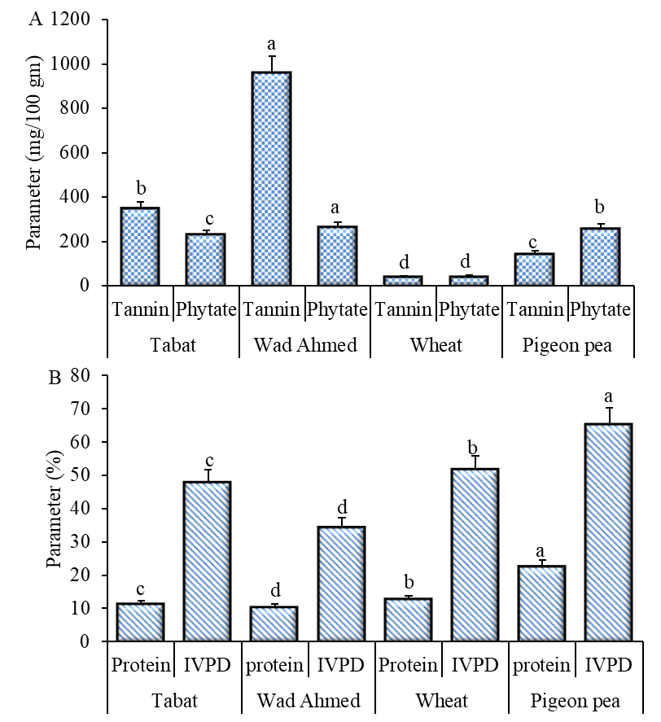

Fig. 1. Tannin and phytate content (mg/100 gm) (A) and protein content (%) and in vitro protein digestibility (IVPD, %) (B) of raw sorghum cultivars (Tabat and WadAhmed), wheat, and pigeon pea. Values are means of three samples. The error bar indicates standard deviation. Small letters denote a significant difference (P ≤ 0.05) between cultivar parameters.

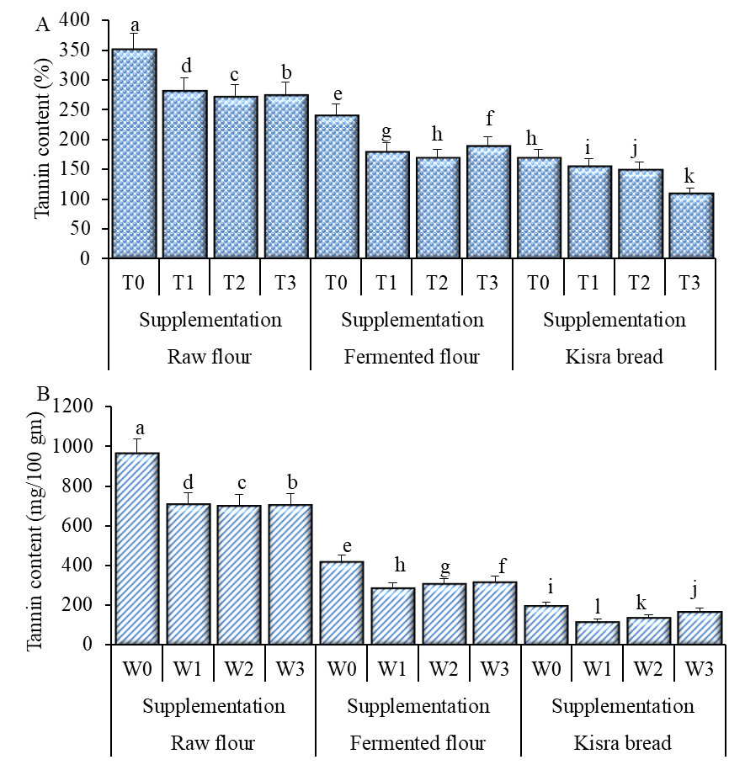
Fig. 2. Tannin content (mg/100 gm) of sorghum cultivars Tabat (A) and WadAhmed (B) composite flour fermented and cooked as kisra bread. T0 and W0, Tabat or WadAhmed flour; T1 and W1, Tabat or WadAhmed flour supplemented with 20% wheat and 10% pigeon pea seed flour; T2 and W2, Tabat or WadAhmed flour supplemented with 15% wheat and 15% pigeon pea seed flour; T3 and W3, Tabat or WadAhmed flour supplemented with 10% wheat and 20% pigeon pea seed flour. Values are means of three samples. The error bar indicates standard deviation. Small letters denote a significant difference (P ≤ 0.05) between treatments.
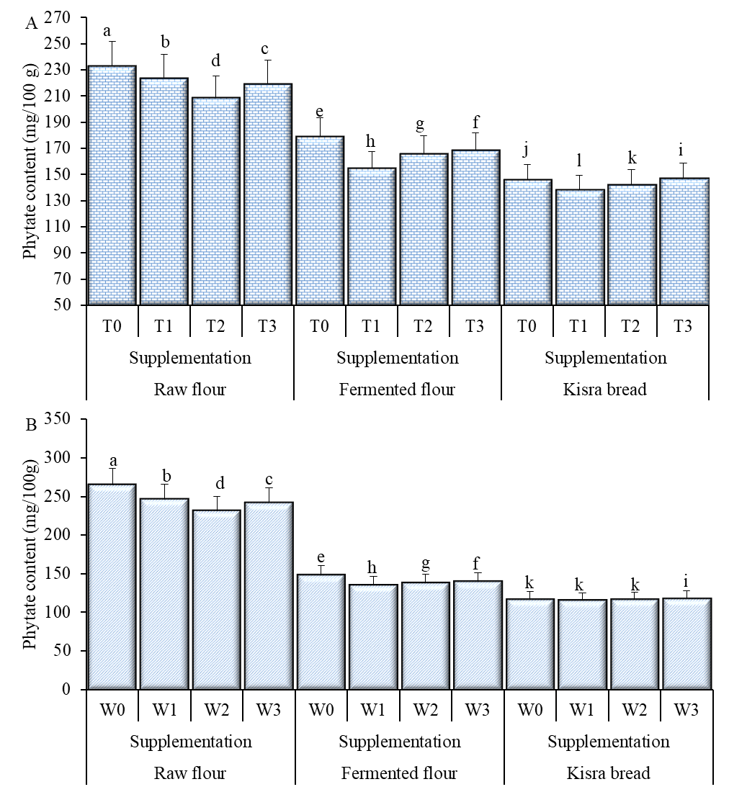

Fig. 3. Phytate content (mg/100g) of sorghum cultivars Tabat (A) and WadAhmed (B) composite flour fermented and cooked as kisra bread. T0 and W0, Tabat or WadAhmed flour; T1 and W1, Tabat or WadAhmed flour supplemented with 20% wheat and 10% pigeon pea seed flour; T2 and W2, Tabat or WadAhmed flour supplemented with 15% wheat and 15% pigeon pea seed flour; T3 and W3, Tabat or WadAhmed flour supplemented with 10% wheat and 20% pigeon pea seed flour. Values are means of three samples. The error bar indicates standard deviation. Small letters denote a significant difference (P ≤ 0.05) between treatments.

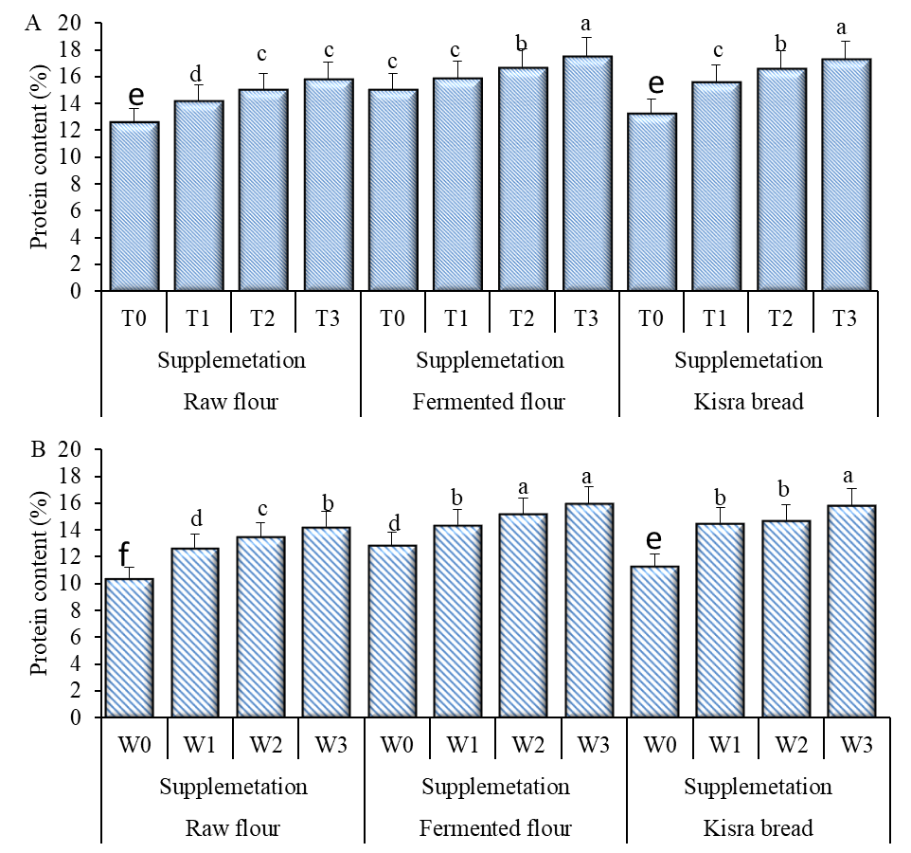

Fig. 4. Protein content (%) of sorghum cultivars Tabat (A) and WadAhmed (B) composite flour fermented and cooked as kisra bread. T0 and W0, Tabat or WadAhmed flour; T1 and W1, Tabat or WadAhmed flour supplemented with 20% wheat and 10% pigeon pea seed flour; T2 and W2, Tabat or WadAhmed flour supplemented with 15% wheat and 15% pigeon pea seed flour; T3 and W3, Tabat or WadAhmed flour supplemented with 10% wheat and 20% pigeon pea seed flour. Values are means of three samples. The error bar indicates standard deviation. Small letters denote a significant difference (P ≤ 0.05) between treatments.

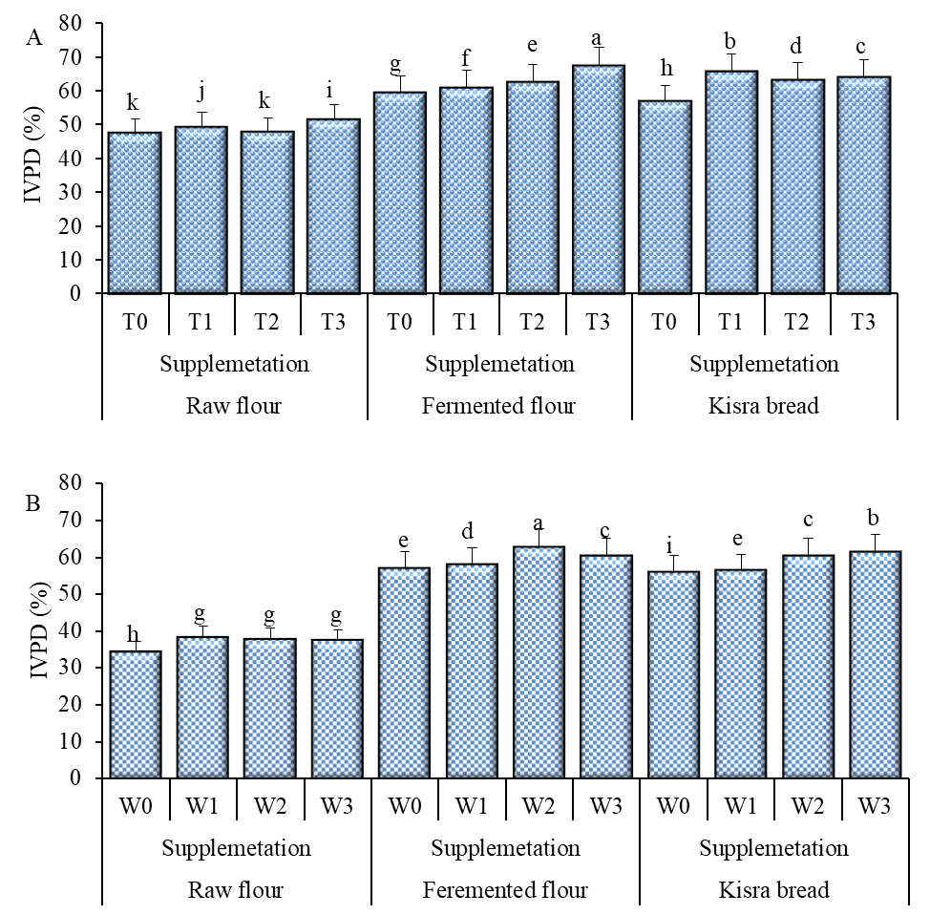
Fig. 5. In vitro protein digestibility (IVPD, %) of sorghum cultivars Tabat (A) and WadAhmed (B) composite flour fermented and cooked as kisra bread. T0 and W0, Tabat or WadAhmed flour; T1 and W1, Tabat or WadAhmed flour supplemented with 20% wheat and 10% pigeon pea seed flour; T2 and W2, Tabat or WadAhmed flour supplemented with 15% wheat and 15% pigeon pea seed flour; T3 and W3, Tabat or WadAhmed flour supplemented with 10% wheat and 20% pigeon pea seed flour. Values are means of three samples. The error bar indicates standard deviation. Small letters denote a significant difference (P ≤ 0.05) between treatments.

