Original Research Article

Leaf Proximate Compositions of Some Selected Species Belong to Solanaceae Family

Abstract
This study evaluated the proximate composition of some selected plants belong to Solanaceae family to assess their nutritional potential. The proximate analysis (carbohydrates, fats, proteins, moisture and ash) of all plant samples were determined by using AOAC methods.The analysis revealed that carbohydrates constituted the highest proportion, followed by proteins, ash, crude fibers, moisture and fats. the predominance of carbohydrates indicates a strong energy-suppling capcity, while the apprecable protein content suggests nutertional value for growth and maintanance. The ash content reflects the presence of essential menerals and the obtained Crude fiber in the current study indicates that the leaves are a good source of cellulose. the high level mostiure indicates physiological freshness, although it may reduce shelf life if not properly managed. The relative low fat content is consistent with typical leafy materials and is nutritionaly favorable. The obtained proximate profile highlights the neutritional and functional potential of the leaves, supporting their possible utization in food, feed and medicinal applications.
Keywords: Solanaceae family, proximate compositions, nuterutional values, medicinal applications, medicinl plants.

1. Introduction
Plants have long been used to treat a wide range of human and animal ailment. Their role in traditional healthcare systems has attracted increasing scientific interest, especially for the discovery of bioactive compounds with pharmacological potential. In addition to therapeutic properties, many medicinal plants also offer important nutritional benefits, containing essential macronutrients like carbohydrates, proteins, and fats that support various physiological and metabolic functions in the human body ( Kumari et al., 2025 ).
The Solanaceae family, commonly known as nightshades, plays a significant role in medicine and nutrition globally. For instance, capsaicin from chili peppers (Capsicum spp.) is used in topical analgesics (Fattori et al., 2016). Also, Atropa belladonna contains atropine, used for treating bradycardia and as an antidote for organophosphate poisoning. Nutritionally, tomatoes (Solanum lycopersicum) are rich in lycopene, an antioxidant (Giovannucci, 1999). Also, eggplants (Solanum melongena) and potatoes (Solanum tuberosum) contribute fiber and nutrients (Singh et al., 2014).
Proximate composition of plants refers to their main nutrition components: moisture, ash (minerals), crude, protein, crude fat, and carbohydrates. These elements vary by plant species, part (leaf, stem, root), and growth stage, providing essential nutrients, phytochemicals, vitamins, and minerals vital for human and animal nutrition, impacting food quality, safety, and potential medicinal uses (Shahid et al., 2023; Jones,2017). Leaf proximate analysis is An essential tool in plant science, nutrition and pharmacognacy because it provides a quantitative overview of the major nutritional components of leaves, typically including moisture, ash
( mineral content), crude protein, crude fiber, lipids, and carbohydrates. These parameters are widely used to evaluate the nutritional value, quality, and potential uses of plant leaves as food, feed, or medicinal resources (AOAC, 2019; Soetan et al., 2010).
Understanding the proximate composition of leaves is important for several reasons. First, it supports nutritional assessment by identifying plants that can contribute protein, energy and essential minerals to human and animal diets, especially where leafy vegetables are important dietary components (Gupta and parash, 2011). Second, proximate analysis aids in quality control and standardization of medicinal plants by providing baseline information on their chemical and nutritional composition, which is important for ensuring consistency and safety in herbal materials. Third, it contributes to ecological and agricultural research by showing how environmental conditions, soil fertility and plant genetic affect nutrients accumulation in leaves (soetan et al., 2010).
The current study aims to determine the basic nutritional composition of some selected plant species belong to solanaceae family by quantifying its major component including mostiure, ash, crude proein, crude fat, crude fiber, and carbohydrates. This analysis provides essential information for evaluating nutritional value, quality and suitability for food, feed, or medicinal use.

2. Material and Methods
2.1. The Study Area
The collection process included different regions of Sudan, as shown in table (1).

Table 1: The Coordination of the collected sites in the Study Areas.

Plant species | Site | Coordination
Capsicum annuum | Blue Nile- El-Rossers. | 11°47′20″ N 34°21′33″E
Datura ferox | Khartoum –Tutti island | 15° 37' 0" N 32° 31' 0" E.
Datura innoxia | Khartoum –Tutti island | 15° 37' 0" N 32° 31' 0" E.
Datura stramonium | Khartoum –Tutti island | 15° 37' 0" N 32° 31' 0" E.
Physalis angulata | Khartoum –Tutti island | 15° 37' 0" N 32° 31' 0" E.
Solanum americanum | Khartoum –Tutti island | 15° 37' 0" N 32° 31' 0" E.
Solanum dubium | Khartoum –Tutti island | 15° 37' 0" N 32° 31' 0" E.
Hyoscyamus muticus | North Sudan –Dongola | 19°10′11.37″N 30°28′29.62″E
Nicotiana glauaca | North Sudan –Dongola | 19°10′11.37″N 30°28′29.62″E
Lycium persicum | East Sudan-Arkawet Area | 14° 42' 52" N.  33° 18' 8" E
Solanim incanum | East Sudan-Arkawet Area | 14° 42' 52" N.  33° 18' 8" E
Solanum schimperianum | East Sudan-Arkawet Area | 14° 42' 52" N.  33° 18' 8" E
Solanum villosum | East Sudan-Arkawet Area | 14° 42' 52" N.  33° 18' 8" E
Withania somnifera | East Sudan-Arkawet Area | 14° 42' 52" N.  33° 18' 8" E

2.2. Plant Materials
Plant specimens were collected from different sites of the study areas. Preliminary species identification was carried out using a set of keys (Darbyshire et al., 2015; Broun and Massey, 1929; Andrews, 1950, 52, 56; Hutchinson et al., 1963; Braun et al., 1991). The identified species were compared with already identified herbarium specimens at the herbarium of Botany Department –University of Khartoum.
2.3. Proximate Analysis
The proximate analysis (carbohydrates, fats, proteins, moisture and ash) of all plant samples were determined by using AOAC methods (AOCS, 2000).
2.3.1. Determination of Moisture
3 gram of dry plant material was taken in a Petri plate and placed in oven at about 1050C for 6 hours, cooled in desiccator and moisture content was calculated using the following formula;
Moisture (%) = Weight of fresh sample – Weight of dry sample × 100
Weight of sample
2.3.2. Determination of Ash
1.0±.01 gm of dried plant materials was taken in a weighted crucible and burnt over low flame. The crucible was then placed in furnace at 5500C for 3 hours until white ash was obtained. The percent ash was calculated as;
Ash (%) = weight of sample after ashing × 100
Weight of sample

2.3.3. Determination of Fats
Soxhlet extractor was used to get fat content of the sample. 5gm of plant material were put on paper thimble and run for six hours on heating mantle. The percent crude fat was determined by using formula (AOCS, 2000);

Crude Fat (%) = Weight of beaker with fat – Weight of empty beaker × 100
Weight of original sample

2.3.4. Determination of proteins
Plant sample was added to the digestion mixture (copper sulphate: Potassium sulphate: ferrous sulphate: 1:18.5:0.25 (w/w/w) and 20 mL of concentrated sulphuric acid was added to the flask and boiled for 2 hours. The digest was transferred to the distillation assembly and 10 mL of 40% sodium hydroxide solution was added to the digest in the assembly. This process was followed by titration to remove the ammonium borate formed in distillation process. The percent protein was calculated by the following formula;
Protein (%) = 1.4 × 6.25 × 0.1N HCl × Vol OF H₂ SO₄ (used)
Weight of sample
2.3.5. Determination of Carbohydrates
Carbohydrate was determined by using the formula;
Carbohydrate (in grams) = 100-(%crude fat + %crude fiber + % Ash + % Protein).
3. Results
The proximate compositions (on dry weight basis) of the leaves of the selected plants species were investigated. The values of moisture, ash, fats, protein and carbohydrate of selected plants are shown in Table 2 and Figure 1.

Table 2: Proximate composition of the leaves of the selected species
Plant species | Moisture% | Ash % | Protein% | Fat % | Fiber % | Carbohydrate %
C.annuum | 5.786 | 19.855 | 23.63 | 3.75 | 9.52 | 37.64
D. ferox | 7.8 | 14.008 | 26.41 | 3.9 | 10.21 | 39.251
D. innoxia | 6.296 | 14.940 | 27.125 | 3.296 | 7.220 | 38.123
D.stramonium | 7.756 | 14.101 | 25.375 | 2.608 | 11.180 | 38.980
H. muticus | 5.74 | 30.38 | 14.00 | 2.64 | 11.70 | 35.54
L. persicum | 7.341 | 30.397 | 20.125 | 2.026 | 15.900 | 24.211
N.glauca | 6.237 | 19.804 | 21.000 | 5.858 | 11.190 | 35.911
P.angulata | 8.352 | 16.105 | 26.250 | 4.502 | 10.350 | 34.441
S.americanumm | 7.141 | 18.390 | 17.500 | 2.190 | 14.240 | 40.539
S. dubium | 6.079 | 20.325 | 20.125 | 1.740 | 19.650 | 32.081
S.incanum | 7.141 | 18.390 | 17.500 | 2.190 | 14.240 | 40.539
S. schimperianum | 7.648 | 12.941 | 27.125 | 2.614 | 21.100 | 28.572
S. villosum | 7.543 | 16.867 | 18.375 | 2.008 | 23.520 | 31.687
W.somnifera | 7.383 | 14.223 | 22.750 | 2.416 | 16.450 | 36.778

The proximate analysis of the investigated leaves of the studied species showed that the highest values were recorded for carbohydrates, followed by proteins, ash, fibers, moisture, and fats respectively (Figure 1).

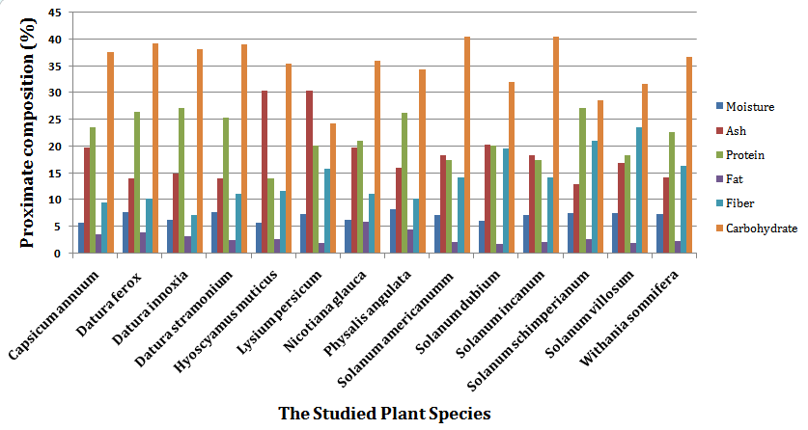
Figure (1): Comparative proximate composition of the leaves of the selected plants, using AOAC method.

3.1. Moisture content
The moisture content varied among the studied species. It varied from 8.35 - 5.73 % (Table 2). P. angulata leaves recorded the highest value of moisture content (8.352%) while the lowest value of moisture content was recorded by H. muticus.
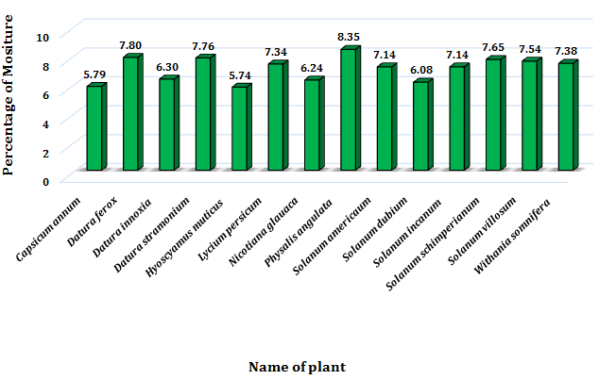
Figure 2: Moisture content of the selected plants showed different percentage of moisture content, using AOAC method.

3.2. Ash content
The ash content of the leaves varied from 30.397-12.941%, the overall highest (30.397%) ash content was recorded by the leaves of L. persicum while the lowest ash content (12.94 %) was recorded to the leaves of S.schimperianum . The results revealed that the ash content of the studied species is higher in the leaves.
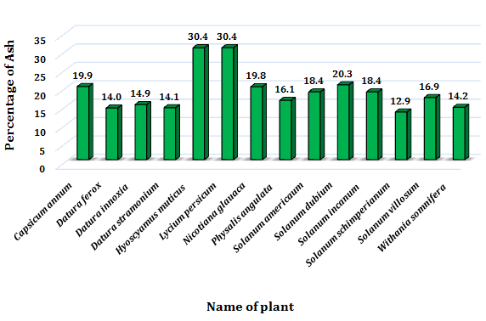
Figure 3: Ash content of the selected plants showed different percentage of ash content, using AOAC method.

3.3. Crude proteins
The leaves protein value contents is ranged from 27.12 - 14.00 %, while leaves of D.innoxia and S. schimperianum scored the highest value of crude protein content (27.12%) while the lowest crude protein of the leaves (14.00) was recorded to H.muticus.
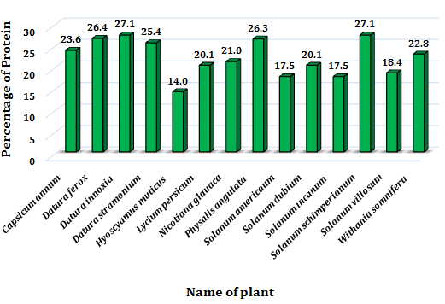
Figure 4: protein content of the selected plants showed different percentage of protein content, using AOAC method.

3.4. Crude fats
The crude fats of the leaves varied from 5.85-1.74%. The highest value of leaves crude fat (5.85%) scored by Nicotiana glauca while the lowest (1.74%) scored by Solanum dubium.
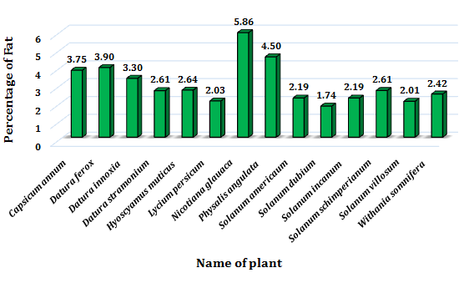
Figure 5: Fat content of the selected plants showed different percentage of fat content, using AOAC method.

3.5. Crude fibers
The data shows that the crude fibers varied from 23.52-7.22% in the leaves of the studied species. Solanum villosum scored the highest value of crude fiber (23.52%) while Datura innoxia scored the lowest value of crude fiber (7.22%).
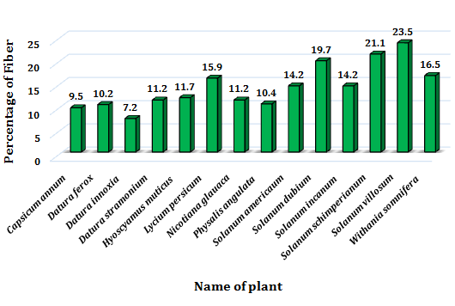
Figure 6: Fiber content of the selected plants showed different percentage of fiber content, using AOAC method.

3.6. Carbohydrates
The carbohydrates contents swayed from 40.53-24.21%. The leaves of Solanum americanumm and Solanum incanum scored the highest value of carbohydrate (40.53%) while the value of leaves carbohydrate of Lycium persicum recorded the lowest value (24.21%).

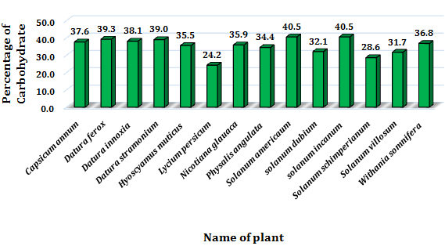
Figure 7: carbohydrates content of the selected plants showed different percentage of carbohydrates content, using AOAC method.

4. Discussion
Proximate and nutrient analyses of plants play a crucial role in assessing their nutritional significance (Pandey et al., 2006).Plant leaves are widely recognized as rich source of proximate constituents, making them voluble in nutrition and pharmacognacy. As result, leafy material can contribute significantly to human and animal diets.
In the current study, the result indicated that carbohydrates constituted the highest proportion, followed in descending order by proteins, ash, fibers mostiure and fats (figure1). The predominance of carbohydrates in the proximate composition suggests that the leaves serve as important source of energy, as carbohydrates are the primary products of photosynthenesis
And are commonly accumulated in plant tissues (Taiz et al., 2015). The restively high protein content also indicates good nutritional quality, since leaf proteins contribute essential amino acids required for growth and maintenance in humans and animals. This finding is consistent with what is reached by (Ayuba et al., 2011; Aliero and Usman, 2016; Niro et al., 2017; Iwansyah et al., 2020) in their study of some species of solanaceae.
According to the NRC (1993), crude protein of less than 20% indicates low protein content of that feed stuff. Ash content is an index of mineral contents in biota that it is the reflection of the mineral contents preserved in the plants parts. The results revealed that, the leaves of the studied species are rich in ash content. The results revealed that fiber content is higher in the leaves. Crude fiber is made up largely of cellulose together with a little lignin which is indigestible in human (Onwuka, 2005). Although crude fiber enhances digestibility, its presence in high level can cause intestinal irritation, lower digestibility and decreased nutrient usage (Oladiji et al., 2005). Moisture content is important because it influences freshness, palatability and shelf life, although high Moisture makes the plant parts perishable and susceptible to spoilage by microorganisms (Nnamani et al.2009). Low moisture content would hinder the growth of microorganisms and storage life would be high (Iniaghe et al., 2009). The current finds regarding the moisture is consistent with what obtained by Hameed and Hussain (2015) in their study of some selected plant species belong to solanaceae. Also, Das et al.,( 2009) and Hanif et al., (2006) concluded that green leafy had higher moisture. The lower fat content observed in the current study is typical for mot leaves and is naturally favorable, as leafy vegetables generally provide essential nutrients without contributing excessive lipid (Gupta and Prakash, 2011). A diet providing 1-2% of its calories of energy as fat is said to be sufficient to human beings as excess fat consumption is implicated in certain cardiovascular diseases such as atherosclerosis, cancer and ageing (Antia et al., 2006).
Together, this pattern of proximate composition highlights the nutritional potential of the leaves of the studied species and supports their use in food and medicinal applications.

5. Conclusion
The proximate compostion results demonstrate that the leaves of the studied species possess considrable nutritional value, with carbohydrtes forming the largest fraction, folled by proteins, ash, fibers, mositure and fats.this profile indicates that the leaves can serves as good energy source, provide essential proteins, and sipply supply important mineral elements. The obtained Crude fiber in the current study indicates that the leaves are a good source of cellulose. the relative high mostiure content reflects physiological freshness but also suggest the need for proper preservation to enhance shelf life.overall, the proximate profile highlights the neutritional and functional potential of the leaves, supporting their possible utization in food ,feed and medicinal applications.

Reference
Aliero, A. A., and Usman, H. (2016). Leaves of ground cherry (Physalis angulata L.) may be suitable in alleviating micronutrient deficiency. Food Sci Technol, 4(5), 89-94.
Andrews F. W. (1952) the flowirng plants of the Sudan (Vol. 3). T. Buncle and Co. Ltd. Arbroath.
Andrews, F. W. (1950). The flworing plants of the Anglo-Egyption, Sudan (Vol. 1) T. Buncle and Co. Ltd. Arbroath.
Andrews, F. W. (1956). The Flowering Plants of the Sudan. Vol. 3. (Compositae-Gramineae).
Antia, B. S., Akpan, E. J., Okon, P. A., and Umoren, I. U. (2006). Nutritive and anti-nutritive evaluation of sweet potatoes (Ipomoea batatas) leaves. Pakistan Journal of Nutrition.
AOAC,(2019). Official methods of analysis (21st ed.) AOAC International.
AOCS, (Americn Oil Chemist Socity) 2000. 5th edition section BC. 2-24, BC4-91.
Ayuba, V. O., Ojobe, T. O., and Ayuba, S. A. (2011). Phytochemical and proximate composition of Datura innoxia leaf, seed, stem, pod and root. Journal of Medicinal Plants Research, 5(14), 2952-2955.
Braun, M., Burgstaller, H., Hamdoun, A.M. and Walter, H. (1991). Common weeds of Central Sudan. GTZ, Eschborn, Germany. https://www.si.edu.
Broun, A.F. and Massey, R.E. (1929). Flora of the Sudan. Thomas Murby and Co., London.
Darbyshire, I., Kordofani, M., Farag, I., Candiga, R., & Pickering, H. (2015). The plants of Sudan and South Sudan: an annotated checklist.
Das P, Devi LP and Gogoi M (2009). Nutrientcomposition of some regional recipes of Assam, India. Ethno-Med., 3: 111-117.
Fattori, V., Hohmann, M. S., Rossaneis, A. C., Pinho-Ribeiro, F. A., and Verri Jr, W. A. (2016). Capsaicin: current understanding of its mechanisms and therapy of pain and other pre-clinical and clinical uses. Molecules, 21(7), 844.
Giovannucci, E. (1999). Tomatoes, Tomato-based products, lycopene, and cancer. Journal of Nutrition, 129(11), 2081S-2085S.
Gupta,S., and Prakash,J.(2011). Nutritional and Sensory quality of food products incorporated with green leafy vegetables. International food research journal.18(2),667-673.
Hameed, I., and Hussain, F. (2015). Proximate and elemental analysis of five selected medicinal plants of family Solanaceae. Pakistan journal of pharmaceutical sciences, 28(4).
Hanif R, Iqbal Z, Iqbal M, Hanif S and Rasheed M (2006). Use of vegetable as nutritional role in human health. J. Agric. Biol Sci., 1: 18-22.
Hutchinson, J., Dalziel, J. M., and Hepper, F. N. (1963). Flora of West Tropical Africa, vol II. London, SWI: Crown Agents for Oversea Government and Adminstration, 4, 435-6.
Iniaghe, O. M., Malomo, S. O., and Adebayo, J. O. (2009). Proximate composition and phytochemical constituents of leaves of some Acalypha species. Pakistan Journal of Nutrition, 8(3), 256-258.
Iwansyah, A. C., Surahman, D. N., Hidayat, D. D., Luthfiyanti, R., Indriati, A., and Ardiansyah, C. E. (2020, March). Comparative evaluation of proximate composition and vitamin C of Physalis angulata Linn and Physalis peruviana Linn in West Java, Indonesia. In IOP Conference Series: Earth and Environmental Science (Vol. 462, No. 1, p. 012012). IOP Publishing.
Jones, A. D. (2017). Critical review of the emerging research evidence on agricultural biodiversity, diet diversity, and nutritional status in low-and middle-income countries. Nutrition reviews, 75(10), 769-782.
Kumari, M., Singh, S., Puri, S., Thakur, N., Thakur, A., Dulta, K., ... & Ghosh, S. (2025). Investigation of nutritional and phytochemical properties of wild medicinal plant species. Scientific Reports, 15(1), 43405.
Niro, S., Fratianni, A., Panfili, G., Falasca, L., Cinquanta, L., and Alam, M. R. (2017). Nutritional evaluation of fresh and dried goji berries cultivated in Italy. Italian Journal of Food Science, 29(3).
NRC (National Research Council) (1993). Nutrient requirements by warm water fishes. Washington D.C. National Academy Press,102p. Novak WK, Haslberger AG (2000). Substantial equivalence of antinutrients and inherent plant toxins in genetically modified foods. Food Chem. Toxicol., 38: 473-483.
Oladiji, A. T., and Mih, F. O. (2005). Proximate composition mineral and phytochemical constituents of Eleusine coracana (finger millet). African Journal of Biotechnology, 4(12), 1440-1441.
Onwuka, G. I. (2005). Food analysis and instrumentation: theory and practice. Napthali prints.
Pandey, M., Abidi, A. B., Singh, S., and Singh, R. P. (2006). Nutritional Evaluation of Leafy Vegetable Paratha J. Hum. Ecol., 19 (2): 155-156.).
Shahid, M., Singh, R. K., & Thushar, S. (2023). Proximate composition and nutritional values of selected wild plants of the United Arab Emirates. Molecules, 28(3), 1504.
Singh ,S. et al. (2014). Nutritional and health aspects of eggplant. Journal of food science and technology, 51(11), 2821-2831.
Soetan, K.O., Olaiya.C.O., and Oyewole,O.E.(2010). The important of mineral elements for humans. domestic animals and plants: A review. African journal of food science, 4(5),200-222.
Taiz, L., Zeiger,E., Moler,I. M., and Murphy,A.(2015). Plant physiology and development (eth ed.) Sinaure Association.
Tomescu, A., Rus, C., Pop. G., Alexa, E., Radulov, I., Imbrea IM and Negrea, M. (2015). Researches regarding proximate and selected elements composition of some medicinal plants belonging to the lamiaceae family. Agronomy Series of Scientific Research/Lucrari Stiintifice Seria Agronomie, 58(2).

