Original Research Article
Effect of one-week Jaboticaba berry (M. cauliflora) consumption on macro- and microvascular function in individuals with cardiovascular risk factors: a randomized study

ABSTRACT
The consumption of berries has been recommended as part of a cardioprotective diet. Jaboticaba is a Brazilian berry that has been reported to exhibit high antioxidant activity. However, no human study has investigated the effect of jaboticaba consumption on the vascular function of individuals at risk of cardiovascular disease (CVD). Aims: This study aimed to investigate the effect of jaboticaba ingestion for seven days on macro and microvascular function in individuals with risk factors for CVD. Study design: In a randomized, parallel, placebo-controlled study. Methodology: 12 volunteers with CVD risk factors consumed 420 mL jaboticaba smoothies twice a day (1,457.28 ± 21.51 mg of total polyphenols per day) or placebo (247.95 ± 118.32 mg of total polyphenols per day) for one week. Brachial artery flow-mediated dilation (FMD) and tissue oxygen saturation (StO₂) responses to 5-minute cuff occlusion were assessed using Doppler ultrasound and near-infrared spectroscopy, respectively. Blood samples were taken for analysis of reduced glutathione (GSH) levels. Results: Supplementation with jaboticaba smoothies promoted improvements in macrovascular function, evidenced by a significant increase in ΔFMD when the data were analyzed on an allometric scale (p = 0.029), in addition to a moderate to large effect size in favor of jaboticaba (d = 0.72). On the other hand, no significant changes were observed in StO₂ parameters and plasma GSH (p > 0.05). Conclusion: This study demonstrated that jaboticaba smoothie consumption seems to improve macrovascular function but did not affect microvascular reactivity and redox balance in individuals at risk of CVD.
Keywords: Functional foods, antioxidants, vascular function, polyphenols, endothelial function, reactive hyperemia

- INTRODUCTION
Endothelial dysfunction is an early finding in the development of cardiovascular diseases (CVD) (Donato et al., 2015). Under physiological conditions, the endothelium is responsible for synthesizing vasoactive molecules, such as nitric oxide (NO), that play several functions, among them regulation of vascular tone. However, the presence of cardiovascular risk factors (i.e., hypertension, diabetes mellitus, hypercholesterolemia, among others) can negatively affect the endothelium, reducing the NO bioavailability (Feron et al., 1999; Hermann et al., 2006; Tessari et al., 2010).
The reduced NO bioavailability in cardiovascular risk factors may be partially explained by redox imbalance (i.e., overproduction of reactive oxygen species and reactive nitrogen species that overcome protective defense mechanism) observed in these conditions (Förstermann et al., 2017). This may occur through increased superoxide anion production, which may inactive the enzyme responsible for NO synthesis, the endothelial nitric oxide synthase (eNOS) enzyme. Furthermore, the persisting redox imbalance promotes eNOS uncoupling and increases superoxide anion production, which reacts with NO to produce peroxynitrite (Förstermann et al., 2017).
Several studies have evaluated the effect of antioxidant-rich foods to prevent or reverse endothelial dysfunction (Rodriguez-Mateos et al., 2013; 2014; Fuchs et al., 2016; Woolf et al., 2023). Berry fruits (e.g., blueberry, cranberry, raspberry, açaí) are a source of polyphenols, and their ingestion has been widely used to improve endothelial function (Rodriguez-Mateos et al., 2013; 2014; Fuchs et al., 2016; Woolf et al., 2023). However, little is known about the effect of jaboticaba (M. cauliflora) (a dark-colored Brazilian berry rich in phenolic compounds, especially anthocyanins and ellagitannins) on vascular function, mainly on flow-mediated dilation (FMD) (a gold standard of endothelial function of conduit arteries) and the reperfusion of tissue oxygen saturation (StO₂) (a measure of microvascular reactivity).
For this reason, the primary aim of the present was to evaluate the effect of jaboticaba ingestion for seven days on FMD and StO₂ parameters of individuals with cardiovascular risk factors. In addition, we sought to investigate whether jaboticaba ingestion could increase antioxidant defense by measuring plasma glutathione (GSH) concentration. It was hypothesized that one week of jaboticaba berry consumption would improve the redox balance and increase FMD response and StO₂ reperfusion in subjects with the presence of cardiovascular risk factors.
- MATERIAL AND METHODS
  - Participants
Thirteen adults with cardiovascular risk factors were recruited through advertisements at the Federal University of Rio de Janeiro. The presence of at least one of the following risk factors was considered as inclusion criteria: elevated triglycerides ≥ 150 mg/dL, reduced HDL-cholesterol < 50 mg/dL for women and < 40 mg/dL for men, elevated total cholesterol > 200 mg/dL, elevated LDL-cholesterol > 150 mg/dL, fasting blood glucose > 100 mg/dL and hypertension (systolic blood pressure: > 135 mmHg or diastolic blood pressure > 90 mmHg) or taking anti-hypertension medications (Visseren et al., 2021). Exclusion criteria were as follows: supplementation based on antioxidants and amino acids, alcohol or drug abuse within the past six months previous to the visit, pregnant or lactating women, and jaboticaba allergy. Eligible participants were fully informed of the nature and purpose of the investigation and provided written consent to participate.
  - Study design
The study was conducted in a randomized, double-blind (participants and investigator were blinded to allocation), parallel, and placebo-controlled way from May 2022 to March 2023. Both the participants and the investigators were blinded to the order of treatment, which was randomized (balanced 1:1) using the Research Randomizer (www.randomizer.org). The participants were randomized and assigned by laboratory staff to ensure blind measurement. All participants reported to the Dynamic Vascular Laboratory at the Federal University of Rio de Janeiro, Macaé City, Brazil on two occasions, with at least 1-week interval between visits. On the first visit, upon arrival at the laboratory, participants rested for 10 minutes in a quiet and temperature-controlled room before blood samples were collected (for plasma GSH analysis). Then, arterial blood pressure, flow-mediated dilation (FMD), and tissue oxygen saturation (StO₂) were assessed for baseline (PRE) measurements. Participants were asked to consume 420 mL of jaboticaba berry smoothie or the same volume of a placebo smoothie twice a day for seven days. On the eighth day, the participants returned to the laboratory for the second visit (POST), and the same measurements from the first visit were taken (see Figure 1). The two visits were held between 07:00 and 12:00 a.m. The participants were instructed to fast for at least 8 hours before each visit and to refrain from physical activity 24 hours prior to analysis.
Figure 1 – Experimental design
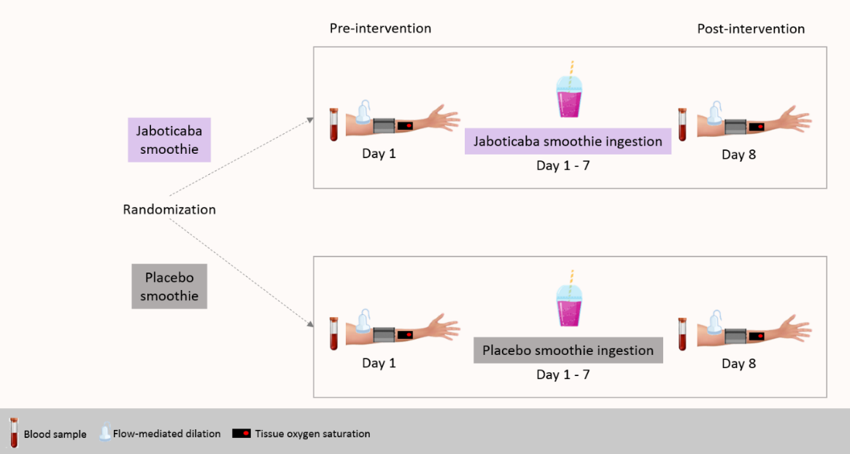
  - Nutritional intervention
The participants ingested 420 mL of jaboticaba smoothie or 420 mL of placebo smoothie twice a day for seven days. One portion of jaboticaba smoothie (420 mL) was obtained by mixing whole jaboticaba berries (126 g), banana (40 g), and milk (250 g), and in 420 mL jaboticaba berry smoothie contained 728.64 ± 10.76 mg of total polyphenols (totalizing 1,457.28 ± 21.51 mg of total polyphenols/day). One portion of the placebo smoothie consisted of maltodextrin (20 g) diluted with water (106 g), banana (40 g), and milk (250 g) containing 123.98 ± 59.16 mg of polyphenols (247.95 ± 118.32 mg of polyphenols/day). The placebo smoothie was colored with artificial non-energetic food colorings.
  - Flow-mediated dilation
Brachial artery flow-mediated dilation was assessed according to guidelines presented elsewhere (Thijssen et al., 2019). An ultrasound (Prosound Alpha 6®, Aloka) and linear transducer with a frequency of 5.0 to 13.0 MHz (model UST-5413, Aloka) were used to capture brachial artery diameter (B-mode). The insonation angle was set at approximately 60°, and image depth and focus settings were optimized for each participant. Brachial artery diameter was recorded continuously at the medial side of the arm to obtain a longitudinal image of the brachial artery (2-5 cm above the cubital fold) throughout the FMD procedure, and video recordings were saved for offline analysis. Brachial artery diameters were automatically determined using a wall-tracking software program (Cardiovascular Suite version 4.2.1, Quipu srl, Pisa, Italy). Absolute FMD was calculated as the difference between peak (PD, 3-sec average value) and baseline (BD, 30-sec average value) artery diameter. The FMD (%) was determined as the percentage change from baseline to peak arterial diameter. ΔFMD was calculated as the difference between FMD values POST and PRE intervention. In addition, we also presented FMD data adjusted using allometric scaling in accordance with a previous study (Atkinson and Batterham, 2013).
  - Tissue oxygen saturation (StO2)
Tissue oxygen saturation (StO₂) of forearm muscles was assessed by using near-infrared spectroscopy (NIRS) as described previously (Oliveira et al., 2020; Volino-Souza et al., 2023). The NIRS probes were placed on the muscle belly of the forearm muscles. A pneumatic cuff was connected to an automatic rapid inflation system. Occlusion pressure was set to 250 mm Hg for the occlusion time. Forearm StO₂ was recorded continuously throughout the vascular occlusion test (30 s baseline, 5 min of occlusion, and 3 min of reperfusion). The following NIRS parameters were calculated: (a) StO_{2min} was calculated as the lowest StO₂ value attained during occlusion; (b) StO_{2 magnitude of occlusion} was calculated as the difference between the StO_{2 baseline} and the StO_{2 min} values attained during occlusion; (c) StO_{2 downslope} (percentage per second, %·s⁻¹) was calculated as the downslope of the StO₂ values during the occlusion period; (d) StO_{2 upslope} (percentage per second, %·s⁻¹) was calculated as the upslope of the StO₂ values over initial 10 s immediately following occlusion (reperfusion period); (d) StO_{2 magnitude of reperfusion} was calculated as the difference between StO_{2 minimum} and higher value of StO₂ attained during the reperfusion period. In addition, ΔStO₂ parameters were calculated by the difference between StO₂ values POST and PRE ingestion.
  - Plasma Glutathione (GSH)
Plasma GSH analysis was performed by using a high-performance liquid chromatography (HPLC) system, as previously described (Giustarini et al., 2013). Briefly, 3 mL of blood sample was collected and added to the tube with 68 µL of tripotassium EDTA and 300 µL of NEM310 (3.88 g of NEM per 100 mL of water). The tube was mixed by slowly tilting for 1 min. The samples were stored at -80 ºC until analysis. For HPLC analysis, 250 µL of samples was mixed with 250 µL of trichloroacetic acid (TCA) 15 and was centrifuged at 14,000g for 2 min at room temperature. 15 µL of samples were injected into HPLC system. The HPLC system (Shimadzu, Kyoto, Japan) was fitted with a C18 column (150 × 4.6 mm Kromasil) and photodiode array detector monitoring absorbance at 265 nm. ΔGSH was calculated by the difference between GSH concentration POST and PRE ingestion.
  - Statistical analysis
The normality, homogeneity of variances, and sphericity of the data were examined with the Shapiro-Wilk, Levene, and Mauchly tests, respectively. An independent t-test was used to identify differences in baseline characteristics, ΔFMD, ΔFMD adjusted, and ΔGSH between groups. When the assumption of normality and homogeneity of variances were violated, a Mann-Whitney test was used. A two-way repeated-measures ANOVA was performed to identify differences in FMD, FMD adjusted, StO₂ parameters and plasma GSH between groups. Additional post-hoc tests with Bonferroni adjustment were performed when a significant F was found. For all variables, when sphericity was violated, a Greenhouse-Geisser correction was used. Cohen’s d effect size was used to determine the magnitude of the effect of the jaboticaba berry smoothie consumption compared with the control smoothies, where a value <0.2 is considered trivial, 0.2–<0.5 is a small effect, 0.5–<0.8 is a moderate effect and ≥0.8 is a large effect. A significance level (alpha) was set at 0.05. All analyses were performed using a commercially available statistical package (IBM SPSS Statistics version 26 for Mac, Chicago, IL), and the results were expressed as means ± standard deviation (SD). The figures were designed by using GraphPad Prism version 7.0.
- RESULTS
From thirteen participants recruited for eligibility assessment, twelve (n = 6 Jaboticaba; n = 6 Placebo) were randomized and completed the study (Figure 2). A significant difference was not observed between groups for baseline characteristics of participants (p > 0.05) (Table 1). The assumption of normality was violated only for ΔStO_{2 occlusion} and ΔStO_{2 reperfusion}.

Figure 2. Schematic of participant recruitment of the study.
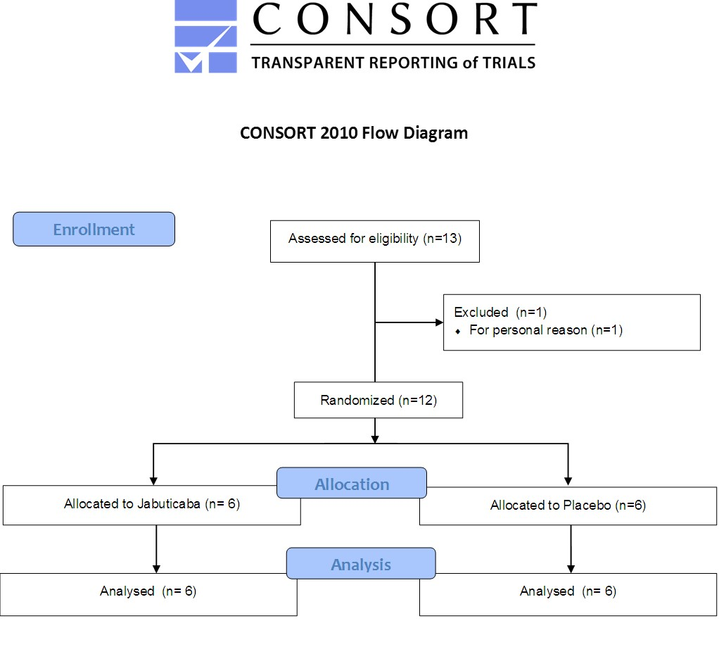
Table 1. Baseline characteristics of the participants.
Characteristic | Jaboticaba | Placebo | p
Demographics
n (M/F) | 6 (3/3) | 6 (2/4)
Age (years) | 56.83 ± 9.86 | 61.16 ± 9.06 | 0.447
Body mass (kg) | 69.56 ± 18.19 | 70.08 ± 8.85 | 0.951
Height (m) | 1.65 ± 0.09 | 1.58 ± 0.07 | 0.184
BMI (kg/m²) | 21.53 ± 11.61 | 27.31 ± 3.26 | 0.271
Waist circumference (cm) | 80.03 ± 7.45 | 84.70 ± 6.16 | 0.458
Forearm skinfold (mm) | 2.50 ± 0.89 | 1.98 ± 0.04 | 0.216
Biochemical
Glucose (mg/dL) | 137.50 ± 101.79 | 97.00 ± 5.36 | 0.412
Total cholesterol (mg/dL) | 174.83 ± 49.37 | 197.33 ± 75.92 | 0.556
LDL-c (mg/dL) | 107.67 ± 49.43 | 123.66 ± 71.37 | 0.661
VLDL-c (mg/dL) | 13.00 ± 5.05 | 15.16 ± 3.31 | 0.401
HDL-c (mg/dL) | 54.17 ± 7.25 | 68.33 ± 22.73 | 0.176
Triglycerides (mg/dL) | 72.33 ± 27.06 | 82.66 ± 18.35 | 0.457
Clinical
SBP (mmHg) | 120.50 ± 22.25 | 124.16 ± 18.22 | 0.733
DBP (mmHg) | 80.33 ± 7.73 | 82.83 ± 12.56 | 0.687
Heart rate (bpm) | 66.16 ± 12.89 | 67.51 ± 8.65 | 0.836
Values are expressed as mean ± standard deviation. DBP, diastolic blood pressure; HDL-c, high-density lipoprotein cholesterol; HDL-c, high-density lipoprotein cholesterol; LDL-c, low-density lipoprotein cholesterol; SBP, systolic blood pressure; VLDL-c; very low-density lipoprotein cholesterol.

3.1. Flow-mediated dilation (FMD)
There was no significant main effect for time (FMD: p = 0.811; FMD adjusted: p = 0.989) and interaction effect (time x treatment) (FMD: p = 0.116; FMD adjusted: p = 0.059) for FMD and FMD adjusted. In addition, no significant difference was observed for non-adjusted ∆FMD (p = 0.293). However, a significant difference was observed for adjusted ∆FMD (p = 0.029). Furthermore, a moderate to large effect size was observed for non-adjusted ∆FMD (d = 0.72) and adjusted ∆FMD (d = 1.23) (Figure 3).
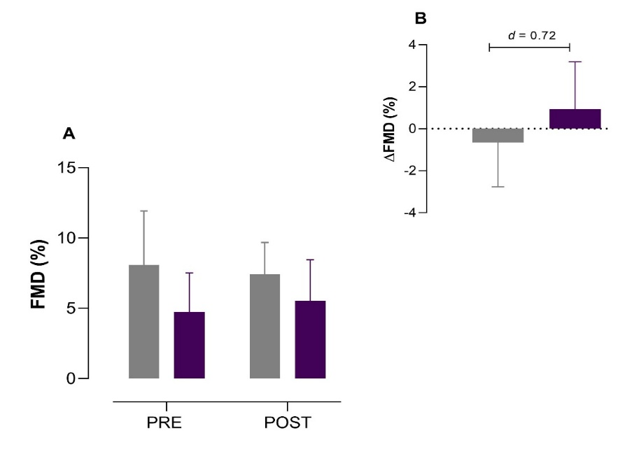
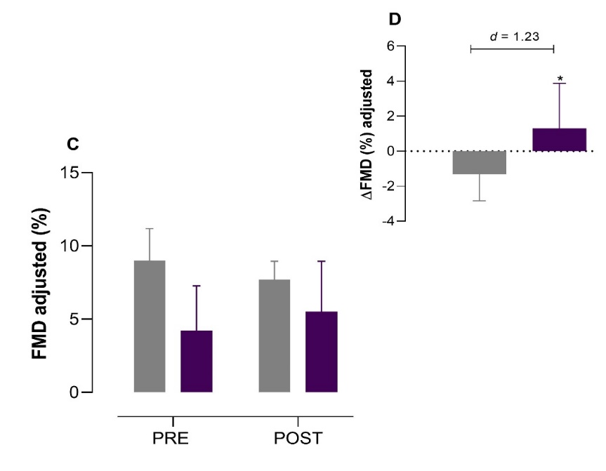
Figure 3. (A) Flow-mediated dilation (FMD), (B) ΔFMD, (C) FMD adjusted, and (D) ΔFMD adjusted before (PRE) and after (POST) jaboticaba berry smoothie (purple bars) and placebo smoothie (grey bars) ingestion. d, Cohen’s d.
3.2. Tissue oxygen saturation (StO2) parameters
There was no significant main effect for StO_{2 min} (p = 0.243), StO_{2 magnitude of occlusion} (p = 0.231), StO_{2 downslope} (p = 0.565), StO_{2 maximum} (p = 0.316), StO_{2 magnitude of reperfusion} (p = 0.159), and StO_{2 upslope} (p = 0.603). Furthermore, there was no interaction effect for StO_{2 min} (p = 0.491), StO_{2 magnitude of occlusion} (p = 0.531), StO_{2 downslope} (p = 0.393), StO_{2 maximum} (p = 0.922), StO_{2 magnitude of reperfusion} (p = 0.548), and StO_{2 upslope} (p = 0.332) (Table 2). Also, there was no difference between Jaboticaba and Placebo groups for ΔStO_{2 min} (p = 0.492), ΔStO_{2 magnitude of occlusion} (p = 0.240), ΔStO_{2 downslope} (p = 0.383), ΔStO_{2 maximum} (p = 0.925), ΔStO_{2 magnitude of reperfusion} (p = 0.631), and ΔStO_{2 upslope} (p = 0.326). In addition, a trivial to small effect size was observed for ΔStO_{2 maximum} (d = 0.05), ΔStO_{2 minimum} (d = 0.41), and ΔStO_{2 reperfusion} (d = 0.35). A moderate effect size was observed for ΔStO_{2 occlusion} (d = 0.56), ΔStO_{2 downslope} (d = 0.63), and ΔStO_{2 upslope} (d = 0.59) (Table 2).
3.3. Plasma GSH
No significant main effect (p = 0.313) and interaction effect (p = 0.777) were observed for plasma GSH between Jaboticaba berry and placebo groups. In addition, no significant changes in ΔGSH were observed between jaboticaba smoothie and placebo groups (p = 0.778). A trivial effect size was observed for ΔGSH (d = 0.16).
- Discussion
The primary aim of the present study was to evaluate the effect of consuming a jaboticaba berry smoothie for one week on macrovascular function (FMD response) and microvascular function (reperfusion of tissue oxygen saturation—StO₂) in individuals at cardiovascular risk. Secondarily, plasma GSH was also evaluated before and after jaboticaba intake as a measure of oxidative stress. We demonstrated that one week of jaboticaba berry smoothie consumption did not improve microvascular reactivity or antioxidant status in individuals with the presence of risk factors for CVD. However, it seems that jaboticaba berry consumption can positively affect macrovascular function.

Table 2. Flow-mediated dilation (FMD) and tissue oxygen saturation (StO₂) parameters before (PRE) and after (POST) jaboticaba and placebo ingestion for 7 days.
Variables | Jaboticaba |  |  | Placebo
Variables | PRE | POST | Δ | PRE | POST | Δ | d (Δ)**
Baseline diameter (cm) | 0.40 ± 0.06 | 0.41 ± 0.07 | 0.00 ± 0.01 | 0.43 ± 0.07 | 0.40 ± 0.03 | -0.02 ± 0.05 | 0.55
Peak diameter (cm) | 0.42 ± 0.06 | 0.43 ± 0.06 | 0.01 ± 0.01 | 0.46 ± 0.08 | 0.43 ± 0.03 | -0.03 ± 0.05 | 1.10
FMD (%) | 4.75 ± 2.77 | 5.53 ± 2.92 | 0.93 ± 2.25 | 8.08 ± 3.83 | 7.43 ± 2.25 | -0.65 ± 2.10 | 0.72
FMD adjusted | 4.23 ± 3.04 | 5.51 ± 3.43 | 1.30 ± 2.57* | 9.00 ± 2.19 | 7.70 ± 1.25 | -1.31 ± 1.52* | 1.23
Occlusion
StO_{2 minimum} (%) | 49.81 ± 6.53 | 48.80 ± 8.13 | -1.00 ± 5.22 | 57.43 ± 3.32 | 53.70 ± 6.78 | 3.72 ± 7.75 | 0.41
StO_{2 magnitude of occlusion} (%) | -17.43 ± 4.81 | -18.66 ± 6.40 | -0.34 ± 5.31 | -12.74 ± 3.13 | -16.16 ± 6.61 | -3.69 ± 6.40 | 0.56
StO_{2 downslope} (%.s⁻¹) | -0.06 ± 0.01 | -0.06 ± 0.02 | 0.00 ± 0.01 | -0.04 ± 0.01 | -0.05 ± 0.02 | -0.01 ± 0.02 | 0.63
Desocclusion
StO_{2 maximum} (%) | 74.85 ± 2.62 | 75.72 ± 2.91 | 0.86 ± 2.30 | 74.54 ± 2.20 | 75.25 ± 2.36 | 0.72 ± 2.86 | 0.05
StO_{2 magnitude of reperfusion} (%) | 25.04 ± 5.18 | 26.91 ± 8.62 | 1.87 ± 5.71 | 17.10 ± 3.51 | 21.55 ± 8.45 | 4.45 ± 8.39 | 0.35
StO_{2 upslope} (%.s⁻¹) | 1.04 ± 0.52 | 1.23 ± 0.32 | 0.20 ± 0.54 | 1.05 ± 0.43 | 0.99 ± 0.36 | -0.06 ± 0.29 | 0.59
Values are expressed as mean ± standard deviation. * denotes significant difference from Placebo. ** Cohen’s d effect size classification: < 0.2 represent a trivial effect; 0.2 – < 0.5 is a small effect; 0.5 – < 0.8 is a moderate effect, and ≥ 0.8 is a large effect.

It was expected that jaboticaba berry consumption could significantly improve FMD in individuals with cardiovascular risk factors since jaboticaba berry is an essential source of polyphenols, mainly anthocyanins, and ellagitannins, possessing antioxidant capacity (Abe et al., 2012). Increased plasma antioxidant activity has been observed after ingestion of jaboticaba (Plaza et al., 2016; Balisteiro et al., 2017). Previous studies have demonstrated that jaboticaba extract can increase the expression of antioxidant enzymes and prevent mitochondrial dysfunction, which explains the ability of jaboticaba phenolic compounds to scavenge free radicals (reducing oxidative stress) (Calloni et al., 2015; Mannino et al., 2020). Therefore, it was speculated that polyphenols from jaboticaba would reduce oxidative stress, increase NO bioavailability and, hence, improve vascular health.
In the present study, we observed that one week of consumption of jaboticaba berry smoothie improved the macrovascular function (i.e., as evaluated by FMD) of individuals at risk for CVD. However, it is important to point out that statistical significance was observed only in FMD change from pretreatment when data was converted to the allometric scale. Data conversion to an allometric scale has been recommended when base artery diameter differs between groups (Atkinson and Batterham, 2013). The present study was performed in a parallel design (i.e., different subjects for placebo and jaboticaba groups) which could result in differences in baseline diameter and, consequently, affect FMD values. Thus, in order to eliminate the influence of differences in baseline diameter in the observed results, we logarithmically transformed the baseline diameter to calculate the adjusted FMD.
In agreement with our results of adjusted FMD, previous evidence has been demonstrated that ingestion of polyphenols from berries can improve FMD (Rodriguez-Mateos et al., 2013; 2014; Woolf et al., 2023). For example, Rodriguez-Mateos et al. (2013) observed that three different doses of freeze-dried wild-blueberry powder (766, 1278, and 1791 mg of polyphenols) improved FMD 1h, 2h, and 6h after ingestion. Furthermore, Rodriguez-Mateos et al. (2014) showed an improved FMD 1h, 2h, and 6h after ingestion of blueberry products (blueberry drink or bun with 692 and 637 mg of polyphenols, respectively). Woolf et al. (2023) demonstrated that consuming 22 g of freeze-dried highbush blueberry powder for 12 weeks increased FMD in postmenopausal women with high-normal blood pressure.
In contrast to the adjusted FMD response after jaboticaba ingestion, changes in StO₂ parameters were not observed in the present study. A previous study demonstrated that consuming 300g of blueberry (containing 242.4 mg of total phenolic compounds per 100g) significantly improved microvascular function as evaluated by reactive hyperemia response of small finger arteries of subjects exposed to cigarette smoke (Del Bo et al., 2014). In addition, Fuchs et al. (2016) evaluated the effect of a single dose of black tea (228.1 mg of total polyphenols) on postprandial skeletal muscle blood flow in subjects with obesity and insulin resistance and observed that tea polyphenols reduced vascular resistance of forearm microvessels after a glucose load. Besides evidence showing a positive effect of polyphenols intake (e.g., anthocyanins, procyanidins, epicatechin) in the microvascular function, there is evidence demonstrating no significant effect of polyphenols from berries on the microvasculature (Dohadwala et al., 2011; Greyling et al., 2016). For example, Dohadwala et al. (2011) demonstrated that four weeks of supplementation of 480 mL cranberry juice (835 mg total polyphenols) did not change pulse amplitude tonometry, a measurement of microvascular function. However, in the Dohadwala et al. (2011) study, microvascular function was assessed several hours after the last dose of cranberry juice, which could explain the lack of a significant effect on microvascular response. Similarly, in the present study, the parameters of microvascular reactivity were performed on the day after the last dose of jaboticaba berry smoothie. This may explain the lack of significant changes in the microvascular function parameters investigated after jaboticaba berry intake. However, it is important to note that although no statistical differences in StO₂ response were observed after seven days of jaboticaba smoothie consumption, a moderate effect size was observed for ΔStO_{2 upslope}. Effect size is the magnitude of the difference between interventions (Barry et al., 2016). Therefore, the effect size observed in the present study suggests the presence of a moderate effect of jaboticaba berry consumption which may potentially affect the microvascular function.
It has been demonstrated that jaboticaba berry exhibits high antioxidant protection against reactive oxygen species (Mannino et al., 2020). For example, Mannino et al. (2020) demonstrated that when cancer cell line HepG2 incubated with hydrogen peroxide (H₂O₂) (a reactive oxygen species) was exposed to jaboticaba berry extract, a reactivation of glutathione peroxidase (GPx) genes (an intracellular antioxidant enzyme) was observed, suggesting antioxidant protection of jaboticaba berry extract. The GPx uses glutathione (GSH) as a cosubstrate to reduce H₂O₂ to water, and low GSH concentration suggests a redox imbalance (Lubos et al., 2011). In this context, the effect of jaboticaba berry consumption on plasma GSH concentration was also evaluated in the present study. However, in contrast to our hypothesis, seven days of consuming a jaboticaba berry smoothie (containing 1,457.28 mg of total polyphenols) did not change plasma GSH concentrations. Furthermore, we observed a trivial effect size for changes in plasma GSH after jaboticaba berry smoothie consumption, suggesting that jaboticaba berry smoothie has a small effect in modulating the antioxidant status in the participants of the present study.
4.1. Experimental considerations
A limitation of the present study was the small sample size (n = 12), which may have increased the probability of making a statistical type II error; thus, our findings should be interpreted with caution. However, the effect size was calculated in the present study in order to determine the magnitude of the effect of jaboticaba berry consumption on the investigated variables since the effect size reflects the magnitude of the effect of interventions without considering the sample size (Sullivan and Feinn, 2012). A moderate effect size (D = 0.72) was observed for ∆FMD between the jaboticaba berry and placebo group, suggesting a moderate to large effect of jaboticaba berry consumption on endothelial macrovascular function. In addition, plasma polyphenols were not evaluated in the present study after jaboticaba ingestion in order to estimate polyphenol’s bioavailability and correlate it with vascular responses. However, a previous study (Rodriguez-Mateos et al., 2014) demonstrated that acute and chronic blueberry intake (a polyphenol-rich fruit) increased plasma concentrations of polyphenol metabolites in healthy participants, which were significantly correlated with improvements in macrovascular function (as evaluated by FMD).
5. CONCLUSION
In conclusion, the present study demonstrated that one week of jaboticaba berry smoothie (containing 1,457.28 mg of total polyphenols) consumption improves macrovascular function in individuals with the presence of risk factors for cardiovascular disease. However, no significant changes were observed in microvascular reactivity and redox balance. Even though the overall response indicates that there might be beneficial effects on macrovascular function, the present findings need to be cautiously interpreted since they still rely on a small number of participants. Further studies with large sample sizes is warranted to determine the effect of polyphenols from jaboticaba berries on cardiovascular health.

Competing interests
There are no conflicts to declare.
AVAILABILITY OF DATA AND MATERIALS
The data that support the findings of this study are available on request from the corresponding author, TSA.
CONSENT FOR PUBLICATION
The authors give permission for the Journal to publish this work.
REFERENCES
- Donato AJ, Morgan RG, Walker AE, et al. (2015) Cellular and molecular biology of aging endothelial cells. Journal of molecular and cellular cardiology, 89(Pt B), 122–135.
- Feron O, Dessy C, Moniotte S, et al . (1999) Hypercholesterolemia decreases nitric oxide production by promoting the interaction of caveolin and endothelial nitric oxide synthase. The Journal of clinical investigation, 103(6), 897–905.
- Hermann M, Flammer A, Lüscher TF (2006) Nitric oxide in hypertension. Journal of clinical hypertension (Greenwich, Conn.), 8(12 Suppl 4), 17–29.
- Tessari P, Cecchet D, Cosma A, et al. (2010) Nitric oxide synthesis is reduced in subjects with type 2 diabetes and nephropathy. Diabetes, 59(9), 2152–2159.
- Förstermann U, Xia N, Li H. (2017) Roles of Vascular Oxidative Stress and Nitric Oxide in the Pathogenesis of Atherosclerosis. Circulation research, 120(4), 713–735.
- Rodriguez-Mateos A, Rendeiro C, Bergillos-Meca T, et al. (2013) Intake and time dependence of blueberry flavonoid-induced improvements in vascular function: a randomized, controlled, double-blind, crossover intervention study with mechanistic insights into biological activity. The American journal of clinical nutrition, 98(5), 1179–1191.
- Rodriguez-Mateos A, Del Pino-García R, George TW, et al. (2014) Impact of processing on the bioavailability and vascular effects of blueberry (poly)phenols. Molecular nutrition & food research, 58(10), 1952–1961.
- Fuchs D, Nyakayiru J, Draijer R, et al. (2016) Impact of flavonoid-rich black tea and beetroot juice on postprandial peripheral vascular resistance and glucose homeostasis in obese, insulin-resistant men: a randomized controlled trial. Nutrition & metabolism, 13, 34.
- Del Bo' C, Porrini M, Fracassetti D, et al. (2014) A single serving of blueberry (V. corymbosum) modulates peripheral arterial dysfunction induced by acute cigarette smoking in young volunteers: a randomized-controlled trial. Food & function, 5(12), 3107–3116.
- Woolf EK, Terwoord JD, Litwin NS, et al. (2023) Daily blueberry consumption for 12 weeks improves endothelial function in postmenopausal women with above-normal blood pressure through reductions in oxidative stress: a randomized controlled trial. Food & function, 14(6), 2621–2641.
- Visseren FLJ, Mach F, Smulders YM, et al. (2021) 2021 ESC Guidelines on cardiovascular disease prevention in clinical practice. European heart journal, 42(34), 3227–3337.
- Thijssen DHJ, Bruno RM, van Mil ACCM, et al. (2019) Expert consensus and evidence-based recommendations for the assessment of flow-mediated dilation in humans. European heart journal, 40(30), 2534–2547.
- Atkinson G, Batterham AM (2013) Allometric scaling of diameter change in the original flow-mediated dilation protocol. Atherosclerosis, 226(2), 425–427.
- Oliveira GV, Volino-Souza M, Leitão R, et al. (2020) Is flow-mediated dilatation associated with near-infrared spectroscopy-derived magnitude of muscle O2 desaturation in healthy young and individuals at risk for cardiovascular disease?. Microvascular research, 129, 103967.
- Volino-Souza M, Oliveira GV, Tavares AC, et al. (2023) The effect of microencapsulated watermelon rind (Citrullus lanatus) and beetroot (Beta vulgaris L.) ingestion on ischemia/reperfusion-induced endothelial dysfunction: a randomised clinical trial. Food & function, 14(17), 7959–7968.
- Giustarini D, Dalle-Donne I, Milzani A, et al. (2013) Analysis of GSH and GSSG after derivatization with N-ethylmaleimide. Nature protocols, 8(9), 1660–1669.
- Abe LT, Lajolo FM, Genovese MI (2012) Potential dietary sources of ellagic acid and other antioxidants among fruits consumed in Brazil: jabuticaba (Myrciaria jaboticaba (Vell.) Berg). Journal of the science of food and agriculture, 92(8), 1679–1687.
- Plaza M, Batista ÂG, Cazarin CB, et al. (2016) Characterization of antioxidant polyphenols from Myrciaria jaboticaba peel and their effects on glucose metabolism and antioxidant status: A pilot clinical study. Food chemistry, 211, 185–197.
- Balisteiro DM, Araujo RL, Giacaglia LR, et al (2017) Effect of clarified Brazilian native fruit juices on postprandial glycemia in healthy subjects. Food research international (Ottawa, Ont.), 100(Pt 2), 196–203.
- Calloni C, Agnol RD, Martínez LS, et al. (2015) Jaboticaba (Plinia trunciflora (O. Berg) Kausel) fruit reduces oxidative stress in human fibroblasts cells (MRC-5). Food Research International, 70, 15-22.
- Mannino G, Perrone A, Campobenedetto C, et al. (2020) Phytochemical profile and antioxidative properties of Plinia trunciflora fruits: A new source of nutraceuticals. Food chemistry, 307, 125515.
- Dohadwala MM, Holbrook M, Hamburg NM, Shenouda SM, Chung WB, Titas M, et al. Effects of cranberry juice consumption on vascular function in patients with coronary artery disease. Am J Clin Nutr. 2011 May;93(5):934-40. doi: 10.3945/ajcn.110.004242. Epub 2011 Mar 16. PMID: 21411615; PMCID: PMC3076649.
- Greyling A, Bruno RM, Draijer R, et al. (2016) Effects of wine and grape polyphenols on blood pressure, endothelial function and sympathetic nervous system activity in treated hypertensive subjects. Journal of Functional Foods, 27, 448-460.
- Barry AE, Szucs LE, Reyes JV, et al. (2016) Failure to Report Effect Sizes: The Handling of Quantitative Results in Published Health Education and Behavior Research. Health education & behavior : the official publication of the Society for Public Health Education, 43(5), 518–527.
- Lubos E, Loscalzo J, Handy DE (2011) Glutathione peroxidase-1 in health and disease: from molecular mechanisms to therapeutic opportunities. Antioxidants & redox signaling, 15(7), 1957–1997.
- Sullivan GM, Feinn R. (2012) Using Effect Size-or Why the P Value Is Not Enough. Journal of graduate medical education, 4(3), 279–282.

