Medicinal plants used in the treatment of high blood pressure by the staff of health facilities in Adzopé

Abstract
Context: High blood pressure remains a major public health issue. The high cost of treatment for this condition has led to the use of medicinal plants. This study was conducted in the city of Adzopé, Côte d’Ivoire, to identify medicinal plants traditionally used to treat hypertension.
Materials and Methods: An ethnobotanical survey was carried out in Adzopé among teachers and students in high schools and colleges. A random sampling method was used to select participants, and interviews were conducted using a semi-structured approach. A survey form was used to collect information on respondents’ profiles, the characteristics of the plants used, and users’ perceptions of the effects of these plants.
Results: The investigation included 80 participants who reported 13 plant species belonging to 12 botanical families, with Malvaceae being the most represented. The most frequently cited species was Hibiscus sabdariffa (26.6%). Leaves were the most commonly used plant parts (62.29%). Decoction (51.61%) was the most common preparation method, and all remedies were administered orally. More than half (62%) of the recipes were taken once daily. Perceived effectiveness was rated as moderate in 53% of cases, and only 23% of participants reported experiencing undesirable side effects. Half of the respondents (50%) preferred using medicinal plants over conventional medicine.
Conclusion:
The survey highlights the medicinal plants used by school staff to treat hypertension in Adzopé. These findings could serve as a basis for phytochemical and pharmacological evaluations to validate the traditional use of these plants, which may represent a therapeutic alternative.
Keywords: Ethnobotany, High schools and colleges in Adzopé, Hypertension.

1. INTRODUCTION
Hypertension (HTN) is a chronic condition characterized by a persistent elevation of blood pressure in the arteries and is one of the leading cardiovascular risk factors worldwide (Wangny et al., 2019). This disease, responsible for nearly 9.4 million deaths annually, accounts for half of the fatalities caused by strokes and heart diseases (WHO, 2023). According to the World Health Organization (WHO), hypertension affects more than 1.28 billion adults aged 30 to 79 years, with nearly two-thirds living in low- and middle-income countries (WHO, 2021).
In sub-Saharan Africa, the prevalence of HTN continues to rise due to population aging and exposure to multiple lifestyle-related risk factors, including dietary habits and physical inactivity (Houehanou et al., 2018). In West Africa, prevalence is estimated at around 20%. In Côte d’Ivoire, studies have reported a prevalence of approximately 20.4% (Euloge et al., 2019).
However, the cost of hypertension treatment remains high despite the low income levels of the population (Afassinou et al., 2022). For most of these populations, medicinal plants represent the primary means of addressing primary healthcare needs (Afassinou et al., 2024). Consequently, medicinal plants are commonly used in Côte d’Ivoire to treat various ailments, including hypertension, due to their relatively low cost and the richness of the local pharmacopoeia (Kouadio et al., 2015).
Several studies have been conducted to identify plants used in the traditional treatment of HTN. However, few investigations have focused on the city of Adzopé.
This study was therefore carried out to inventory and describe the ethnobotanical characteristics of plants commonly used by school staff in Adzopé for the treatment of hypertension.

2. MATERIALS AND METHODS

2.1 Study Area
The study was conducted in the city of Adzopé, located in the Mé region in southeastern Côte d’Ivoire. This region is bordered to the north by Indénié-Djuablin, to the northwest by Moronou, to the southwest by Agnéby-Tiassa and the Abidjan District, and to the southeast by Sud-Comoé. It covers an area of approximately 8,000 km² and is part of the Lagunes District. The Mé region comprises four departments: Adzopé (departmental capital), Akoupé, Alépé, and Yakassé-Attobrou (Figure 1) (Ouattara, 2017). According to the general population and housing census, the Mé region had 726,665 inhabitants in 2021. The population consists mainly of Akyé natives, along with other ethnic groups (Malinké, Abron, Agni, Baoulé, Koulango, etc.) and foreign communities (Burkinabé, Malians, Nigeriens, Mauritanians, etc.) attracted by trade and agricultural activities (RGPH, 2021).
Geographically, Adzopé lies in a transition zone between the humid evergreen forest of southern Côte d’Ivoire and the wooded savanna formations extending northward. The vegetation is dominated by semi-deciduous dense humid forest, composed of species such as Triplochiton scleroxylon (African whitewood), Khaya ivorensis (African mahogany), Terminalia superba (Fraké), and Nauclea diderrichii (Bilinga). This forest is in sharp decline due to agricultural and logging activities (Chatelain et al., 2017).
The Mé region has a subequatorial climate characterized by four distinct seasons: a major dry season from January to February; a major rainy season from March to July; a short dry season from mid-July to mid-September; and a short rainy season from mid-September to November.
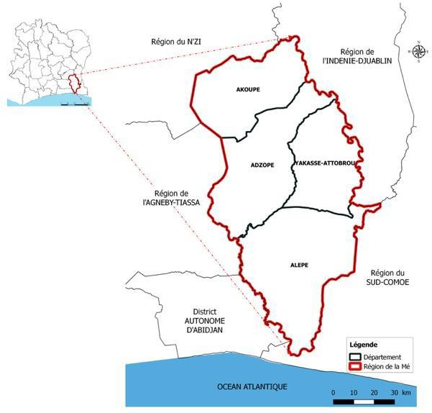

Figure 1: Location of the Mé Region (Ouattara, 2017)

2.2 Technical Equipment
The technical equipment consisted of survey forms, a camera for taking photographs, plastic bags for storing collected plant samples, labels for numbering plant samples, a pen, and a notebook for note-taking.

2.3 Plant Material
The plant material consisted of all species recorded and collected in the city of Adzopé.

2.4 Study Method

2.4.1 Ethnobotanical Survey
The survey, conducted in April 2025, followed a semi-structured interview method, including an interview and the completion of a pre-established questionnaire.
A convenience random sampling method was used to select two public high schools in Adzopé. These schools were chosen because they are the largest public institutions in the city and therefore have a large and representative number of teachers.
The interviews collected information on plants used to treat hypertension.
The survey form included the vernacular name of each species, the plant parts used, the preparation method, the frequency and mode of administration. Information on perceived effectiveness and possible side effects after using these plants was also recorded, as well as preferences between medicinal plants and modern medicines.
Survey forms were distributed to respondents after explaining the purpose of the study and providing instructions for proper completion. Each participant was given three days to fill out the form and return it.

2.4.2 Botanical Identification of Species
Species identification was carried out by comparing samples with specimens from the herbarium of the National Floristic Center (CNF) at Félix Houphouët-Boigny University. The APG II (2003) nomenclature was adopted for species identification.

2.4.3 Data Processing
To determine the list of the most frequently cited species, citation frequencies were calculated. The citation frequency (Fc) for each species was determined using the following formula (Ogni et al., 2014):
Fc = (Number of citations for the speciesTotal number of citations for all species)×100Fc = \left( \frac{\text{Number of citations for the species}}{\text{Total number of citations for all species}} \right) \times 100Fc=(Total number of citations for all speciesNumber of citations for the species​)×100
Data collected from the questionnaires were entered and processed using Sphinx software.

RESULTS AND DISCUSSION

3.1 Socioprofessional Status of Respondents
The survey interviewed 80 teachers from Modern High Schools 1 and 2 in Adzopé, including 23 women (28.75%) and 57 men (71.25%) (Table 1).

Table 1: Distribution of Teachers by School
School | Female Teachers | Male Teachers | Total
Modern High School 1 Adzopé | 15 | 35 | 128
Modern High School 2 Adzopé | 8 | 22 | 72

3.2. Characteristics of Medicinal Plants

3.2.1 List of Recorded Medicinal Plant Species
The study identified 13 species of medicinal plants traditionally used to treat hypertension in the Adzopé region (Table 2). These species belong to 12 genera and 12 families, with the most frequently cited family being Malvaceae.

Table 2 : Liste des plantes utilisées pour le traitement de l’hypertension artérielle
No. | Scientific Name | Vernacular Name | Plant Part Used | Preparation Method | Frequency of Administration | Mode of Administration
1 | Allium sativum L. | Kpakpa-gnan (Bété) | Bulb | Direct consumption, Infusion/Decoction | Twice a day | Oral
2 | Annona muricata L. | Asorô (Baoulé) | Leaves/Fruits, Bark/Roots | Infusion, Decoction | Once a day | Oral (herbal tea)
3 | Azadirachta indica A. Juss. | Akyé Djindé baté | Leaves | Infusion/Decoction | Once a day | Oral (drink)
4 | Hibiscus sabdariffa L. | Dabili (Malinké) | Leaves, Flowers | Infusion/Decoction | Once a day | Oral (herbal tea)
5 | Kalanchoe pinnata (Lam.) Pers. | Kélébani yira (Malinké) | Leaves/Stems, Flowers/Roots | Infusion, Decoction, Maceration | Twice a day | Oral
6 | Mangifera indica L. | Mangossou (Bété) | Leaves, Bark, Stems | Infusion/Decoction | Once a day | Oral (drink)
7 | Moringa oleifera Lam. | Kpatè (Agni) | Leaves/Seeds, Bark/Roots | Infusion, Decoction | Once a day | Oral (drink)
8 | Ocimum gratissimum L. | Atchikoumié (Akyé) | Leaves, Stem | Decoction | Once a day | Oral (drink)
9 | Parkia biglobosa (Jacq.) R.Br. ex G.Don | Soumara (Malinké) | Seeds/Bark, Leaves/Roots | Infusion, Decoction | Once or twice a day | Oral (drink)
10 | Persea americana Mill. | Aloko nzin (Baoulé) | Leaves/Bark, Fruit | Infusion, Decoction | Once or twice a day | Oral (drink)
11 | Theobroma cacao | Coco (Akyé) | Cocoa bean | Powder | Once a day | Oral
12 | Vernonia amygdalina Del. | Blêfouê (Baoulé) | Leaves/Bark, Stem/Root | Infusion, Decoction | Twice a day | Oral (drink)
13 | Zingiber officinale Roscoe | Nyan-nan (Akyé) | Rhizome | Infusion, Decoction | Once a day | Oral (drink)

3.2.2 Citation Frequency of Species
Among the recorded species, Hibiscus sabdariffa L. was the most frequently cited plant (26%) (Table 3).
Table 3 : Hibiscus sabdariffa L species
Scientific Name | Number of Citations | Citation Frequency (%)
Hibiscus sabdariffa L. | 17 | 26.6
Moringa oleifera Lam. | 12 | 18.8
Allium sativum | 7 | 10.9
Annona muricata L. | 5 | 7.8
Parkia biglobosa (Jacq.) R.Br ex G.Don | 4 | 6.3
Zingiber officinale Roscoe | 4 | 6.3
Mangifera indica L. | 3 | 4.7
Vernonia amygdalina Del. | 3 | 4.7
Azadirachta indica A.Juss. | 2 | 3.1
Ocimum gratissimum L. | 2 | 3.1
Persea americana Mill. | 2 | 3.1
Theobroma cacao | 2 | 3.1
Kalanchoe pinnata (Lam.) Pers. | 1 | 1.6

3.2.4 Plant Parts Used
Leaves, which accounted for 62.29%, were the most commonly used plant parts for remedy preparation (Figure 2).
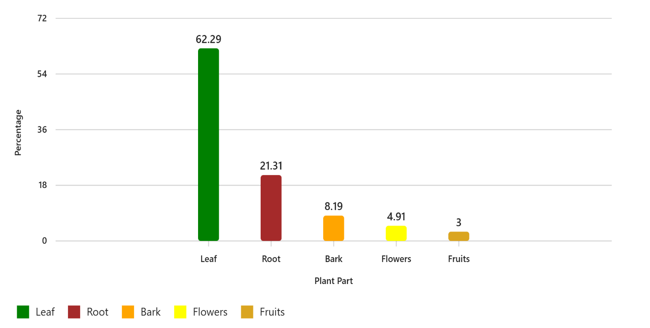

Figure 2: Distribution of Plant Parts Used

3.2.5 Method of Remedy Preparation
Four preparation methods were identified: infusion, decoction, maceration, and direct consumption. Among these methods, decoction was the most commonly used (51.61%) (Figure 3).
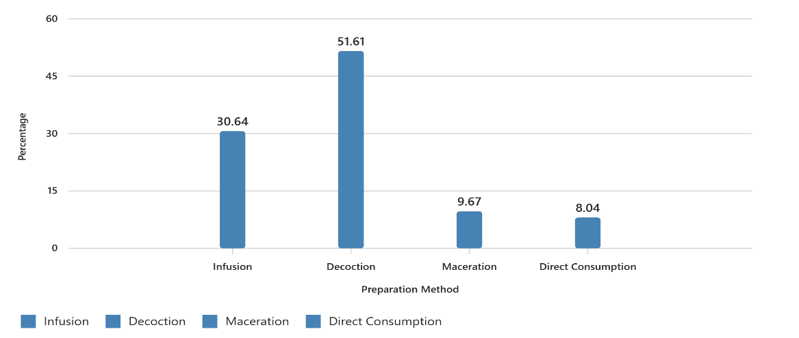
Figure 3: Distribution of Remedy Preparation Methods

3.2.6 Frequency of Administration of Preparations
The majority of remedies were administered once daily in 62% of cases (Figure 4). 
Occasionelly
2 time/day
1 time/day

17%

21%
62%
Figure 4: Distribution of the Frequency of Administration of Preparations

3.2.7 Perception of the Therapeutic Effectiveness of the Plants Used
Regarding the respondents’ opinion on the therapeutic effectiveness of the recorded species, about half (53%) considered the use of these plants to be moderately effective (Figure 5).
Figure 5: Distribution of the Perception of the Therapeutic Effectiveness of the Plants Used
3.2.8 Side Effects of Preparations
The use of the cited plants for the treatment of hypertension may be accompanied by side effects. In this regard, only 23% of respondents reported the occurrence of potential side effects (Figure 6).

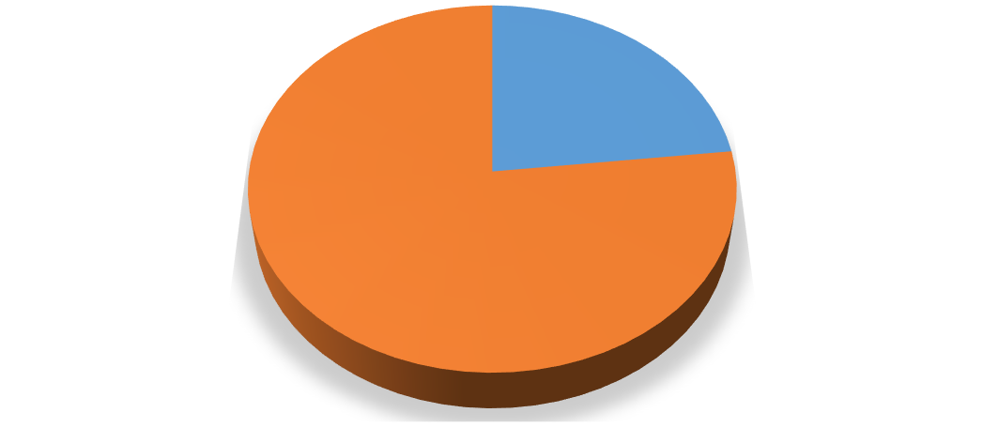





Yes
23%

No 77%
Yes

No
Figure 6: Distribution of Side Effects Reported by Participants

3.2.9 Preferences Between Medicinal Plants and Conventional Medicines
Half of the participants reported a preference for using medicinal plants against hypertension, unlike the others who favored the use of conventional medicine drugs called antihypertensives (Figure 7).

Yes

No

50% 50%
Figure 7: Distribution of Preference Between Medicinal Plants and Conventional Medicines

4. DISCUSSION
The high use of Hibiscus sabdariffa (26.6%) strongly confirms the findings of Yapi et al. (2015), who identified Hibiscus sabdariffa, Allium sativum, and Moringa oleifera among the most commonly used plants to combat hypertension in Adzopé. Similarly, Kamanzi et al. (2011) highlighted the antihypertensive effectiveness of these same species in a Ugandan context, showing a convergence of therapeutic knowledge across sub-Saharan Africa.
According to McKay et al. (2010), this plant helps reduce both systolic and diastolic blood pressure, which justifies its widespread use.
Moringa oleifera, the second most used plant, has hypocholesterolemic and antihypertensive effects according to Fahey (2005), who reported that its leaves contain bioactive compounds capable of modulating blood pressure, notably polyphenols and isothiocyanates. Although less frequently cited, other plants such as Annona muricata, Zingiber officinale, and Vernonia amygdalina, reported in the literature as having potential antihypertensive effects (Ojewole, 2002; Gbolade, 2009), reflect the breadth of local empirical knowledge on medicinal plants.
The predominance of leaves as the most used plant part confirms previous studies. According to Sofowora (1993), leaves are the most accessible organs and richest in active substances (flavonoids, alkaloids, tannins, etc.). Their ease of harvesting and processing (infusions, decoctions) makes them a preferred choice for traditional practitioners. The leaves of Hibiscus sabdariffa, Annona muricata, and Moringa oleifera contain compounds that have demonstrated antihypertensive effects in pharmacological studies (Fahey, 2005; McKay et al., 2010). Kouassi et al. (2025) also reported that more than half of medicinal preparations involved leaves as the used part.
Decoction was the most commonly used preparation method. This method, which consists of boiling plant organs (stems, bark, roots), is favored for its ease of implementation and lower cost due to water being used as the solvent. These results align with those of Jiofack et al. (2008) in Cameroon, who reported widespread use of decoction in treating chronic diseases, particularly cardiovascular ones. Gbekley et al. (2015), in a study conducted in Togo on phytotherapeutic practices for hypertension, also observed that decoction was used in more than 50% of cases.
Direct consumption, recorded in 8.04% of cases, mainly concerns plants such as Allium sativum or Moringa oleifera, commonly chewed or consumed as juice. Although less common, this method is deeply rooted in family and community practices. Olivier et al. (2012) emphasize that this mode of administration is common in rural areas, where plants are directly harvested and consumed. These observations echo Tra Bi et al. (2008), who indicate that direct consumption is often transmitted orally and lacks standardization.
Remedies were mostly administered once daily.
The perceived effectiveness observed here aligns with Sofowora (1993), who notes that herbal remedies are commonly judged based on traditional use and accessibility.
Regarding side effects, most respondents reported no adverse effects related to the use of these plants. However, a minority acknowledged having observed side effects. This agrees with Jiofack et al. (2008), who state that although plants are natural, their use is not without risks, particularly in cases of incorrect dosage or inadequate preparation. Furthermore, Adebayo et al. (2009) demonstrated that some plants, such as Moringa oleifera, although effective, can present toxicities at high doses or with prolonged use. Similarly, N’guessan et al. (2009) and Gbekley et al. (2018) highlight that side effects are often underreported, as users rarely attribute them to the plants themselves due to their “natural” character. These results therefore show a predominantly positive perception, which should not overshadow the need for rigorous scientific evaluation.
Half of the participants (50%) expressed a preference between medicinal plants and conventional medicines. This equal distribution reflects ambivalence in therapeutic choices in environments where modern and traditional medicine coexist. Ake Assi (2002) indicates that this coexistence is well established in African societies, where plants often represent the first line of treatment. Koffi et al. (2010) confirm this trend in their study in Adzopé, where many people combine or alternate traditional and modern treatments.

REFERENCES

- 1. Adebayo, A. H., & Ishola, O. R. (2009). Safety assessment of the methanolic extract of Moringa oleifera roots in rats. Journal of Medicinal Plants Research, 3(8), 586–591. https://doi.org/10.5897/JMPR.9001097
- 2. Afassinou, Y. M., Sossou, Y. I., Pessinaba, S., Tokou, L. K., Afanlovi, K., Koudouvo, K., & Agbonon, A. (2024). Ethnobotanical study of plants used in the treatment of hypertension in the Greater Lomé autonomous region. European Scientific Journal, ESJ, 20(27), 113. https://doi.org/10.19044/esj.2024.v20n27p113 https://doi.org/10.19044/esj.2024.v20n27p113
- 3. Chatelain, C., Dao, H., & Spichiger, R. (2017). Forests and floristic diversity in Côte d'Ivoire. Scientific Review of Tropical Botany, 15(2), 105–123.
- 4. Corine Houehanou, Arnaud Sonou, Philippe Adjagba, Hugues Dohou, Murielle Hounkponou, Gwladys Kpolédji, Dominique Saka, Gildas Assogba, Salimatou Assani, Wei Wang, Thomas Beaney, Neil R Poulter, Léopold Codjo, Martin D Houenassi, (2022). May Measurement Month 2018: an analysis of blood pressure screening results from Benin, European Heart Journal Supplements, Volume 24, Issue Supplement_F, September, pp. F9–F11, https://doi.org/10.1093/eurheartjsupp/suac039
- 5. Euloge KK, Daniel E, Audrey A, Florent KK, Justin KDB, Benedict B, et al. May Measurement Month 2017: an analysis of blood pressure screening results in Cote d’Ivoire-Sub-Saharan Africa. Eur Heart J Suppl. 1 Apr 2019;21(Supplement_D):D47 9. https://doi.org/10.1093/eurheartj/suz086
- 6. Fahey, J.W. (2005). Moringa oleifera: a review of the medical evidence for its nutritional, therapeutic, and prophylactic properties. Part 1. Trees for life Journal, 1(5), 1-15. http://www.tfljournal.org/article.php/20051201124931586
- 7. Fahey, J.W. (2005) Moringa oleifera: A Review of the Medical Evidence for Its Nutritional, Therapeutic, and Prophylactic Properties. Part 1. Trees for Life Journal, December, 1(5). http://www.tfljournal.org/article.php/20051201124931586
- 8. Gbekley Efui Holaly1, Karou Damintoti Simplice, Gnoula Charlemagne, Agbodeka Kodjovi, Anani Kokou, Tchacondo Tchadjobo, Agbonon Amegnona, Batawila Komlan, Simpore J. (2015). Ethnobotanical study of plants used in the treatment of diabetes in traditional medicine in the Maritime region of Togo. Pan African Medical Journal, 20: 437. https://doi.org/10.11604/pamj.2015.20.437.5660
- 9. Gbekley, H. E., Karou, S. D., Katawa, G., Tchacondo, T., Batawila, K., Ameyapoh, Y., & Simpore, J. (2017). ETHNOBOTANICAL SURVEY OF MEDICINAL PLANTS USED IN THE MANAGEMENT OF HYPERTENSION IN THE MARITIME REGION OF TOGO. African Journal of Traditional, Complementary and Alternative Medicines, 15(1): 85-97. https://doi.org/10.21010/ajtcam.vi15.1.9
- 10. Gbolade AA (2009). Inventory of antidiabetic plants in selected districts of Lagos State, Nigeria. Journal of Ethnopharmacology, 121:135-139. https://doi.org/10.1016/j.jep.2008.10.013
- 11. National Institute of Statistics, Ministry of Planning and Development, Côte d'Ivoire. (2021) General Population and Housing Census (RGPH). https://www.plan.gouv.ci/assets/fichier/RGPH2021-RESULTATS-GLOBAUX-VF.pdf
- 12. Issiaka TOGOLA1, Fanta SANOGO1, Nouhoum DIARRA, Rokia SANOGO (2022). Plants used in the traditional treatment of hypertension in the periphery of Bamako, Mali. Malian Society of Applied Sciences – 13th MSAS Conference.
- 13. Jiofack, T., Ayissi, I., Fokunang, C., et al. (2008). Ethnobotany and phytomedicine... African Journal of Pharmacy and Pharmacology, 2(8), 144–150. https://doi.org/10.5897/AJPP.9000140
- 14. Kamanzi, A., Niyongabo, T., & Nkunzimana, T. (2011). Medicinal plants... African Journal of Pharmacy and Pharmacology, 5(15), 1752–1756.
- 15. Koffi, K., Kone, K., & Kouadio, K. (2010). Ethnobotany... Journal of Applied Biosciences, 35, 2197–2207.
- 16. Kouadio, K., et al. (2015). Chemical and pharmacological studies... Journal of Applied Biosciences, 85, 7801–7808.
- 17. McKay, D. L., Chen, C. Y., Saltzman, E., & Blumberg, J. B. (2010). The Journal of Nutrition, 140(2), 298–303. https://doi.org/10.3945/jn.109.115097
- 18. N’Guessan, K., Kadja, B., Zirihi, G. N., Traoré, D., & Aké, A. L. (2009). Ethnobotanical study... Ethnopharmacologia, 44, 42–50. https://doi.org/10.4314/scinat.v6i1.48575
- 19. Ojewole, J. A. O. (2002). Antihypertensive properties... Journal of Ethnopharmacology, 89(2–3), 123–129. https://academic.oup.com/ajh/issue/15/1
- 20. Olivier, M., Zerbo, P., Boussim, J. I., & Guinko, S. (2012). Plants of forest galleries traditionally used by traditional health practitioners and Dozo Sénoufo hunters of Burkina Faso. International Journal of Biological and Chemical Sciences, 6(5), 2170-2191. https://doi.org/10.4314/ijbcs.v6i5.24
- 21. WHO. (2023). Hypertension. https://www.who.int/fr/news-room/fact-sheets/detail/hypertension
- 22. WHO. (2023). Hypertension. https://www.who.int/fr/news-room/fact-sheets/detail/hypertension
- 23. World Health Organization (WHO). (2021). Guideline for the pharmacological treatment of hypertension in adults. https://www.who.int/publications/i/item/9789240033986
- 24. Ouattara, T. A. (2017). Land use mapping of the Mé Region. Etc Terra Rongead, 28 p.
- 25. Sanou, A.; Konaté, K.; Belemnaba, L.; Sama, H.; Kaboré, K.; Dakuyo, R.; Nitiéma, M.; Dicko, M.H. In Vivo Diuretic Activity and Anti-Hypertensive Potential of Hibiscus sabdariffa Extract by Inhibition of Angiotensin-Converting Enzyme and Hypertension Precursor Enzymes. Foods 2024, 13, 534. https://doi.org/10.3390/foods13040534
- 26. Tra Bi, B. F., & Yao, K. D. (2019). Social representations of snakebite incidents and therapeutic pathways among the Gouro rural populations of Bouaflé (Côte d’Ivoire). Revue Espace, Territoires, Sociétés et Santé. https://retssa-ci.com/index.php?page=detail&k=66
- 27. Tra Bi, F.H., Irié, G.M., N’Gaman, K.C.C., & Mohou, C.H.B. (2008). Studies of some therapeutic plants used in the treatment of hypertension and diabetes: two emerging diseases in Côte d'Ivoire. Sciences & Nature, 5(1): 39-48. https://doi.org/10.4314/scinat.v5i1.42150
- 28. Wangny, A A S, Ouattara T V. Ethnobotanical Study of Plants Used in Traditional Medicine in the Treatment of Arterial Hypertension in Peoples of Divo Department, (Center-West, Côte d’Ivoire). European Scientific Journal August 2019 edition Vol.15, No.24. ISSN: 1857 -7881. https://doi.org/10.19044/esj.2019.v15n24p384

